FTU · NHA408E · GROUP 06
Group 06 Final Project Report
Free Fall 2.0 — An Interactive Market-Crash Survival Simulator (Condensed Edition)

Group 06 — Five Workstreams
Coordinator: Trần Hữu Dụ (2412380013) · Data: Nguyễn Hồng Nguyên (2412380038) · Scenario: Cáp Phan Quang Khánh (2412380020) · Full-Stack & Audio: Nguyễn Quang Minh (2412380031) · UI/UX: Triệu Đức Lương (2412380029)
Condensed 17-page submission preserving all core architectural diagrams, mathematical identities, benchmark tables, verification records, audio manifests, and individual member footprints from the group repository.
Course | NHA408E — Technology Applications in Finance and Banking
Institution | Foreign Trade University (FTU)
Group | Group 06 — five members
Project title | Free Fall 2.0 — Margin Trading, Behavioural Traps & Forced Liquidation Simulator
Repository | https://github.com/FTU-Legacy-63/G06
Live production deployment | https://phan-dung.ngqminh6979.workers.dev/ (Cloudflare Workers — deployed by Nguyễn Quang Minh)
Report date | 19 April 2026
Version / status | 2.0 · Condensed Submission (16–18 Pages)

Document control
Document | Group 06 Final Project Report — Free Fall 2.0 (Condensed Technical, Financial & Behavioural Specification)
Prepared from | Direct inspection of all committed files in FTU-Legacy-63/G06 across docs/, src/, test/, data/, analysis/, web/, contribution/, and the live production deployment at https://phan-dung.ngqminh6979.workers.dev/
Scope | Problem definition, system architecture, financial rulebook, dual-scenario datasets, DP/MILP calibration, scenario & news scripts, Python backend engine/API, frontend JS runtime & Cloudflare deployment, UI/UX design tokens, T01–T12 verification, BUG-01..06 remediation, post-midterm revisions, open reconciliations, and individual member footprints
Verification | 4 unit tests in test/test_simulation_engine.py executed (OK in 0.000s); 600 continuity & ±30% phase-limit checks passed across Scenario 1 and Scenario 2; 6 scenario-by-tier DP and Staggered MILP optimizations verified
Companion files | Individual Contribution Reports for Trần Hữu Dụ (2412380013) and Nguyễn Quang Minh (2412380031), plus repository evidence logs in contribution/evidence/

Contents
Right-click and choose “Update Field” to build the table of contents.

1. Purpose, problem definition and target user

1.1 Problem statement: overcoming leverage blindness
Undergraduate finance students and retail investors frequently encounter margin trading as static textbook definitions: initial margin, maintenance margin, and leverage ratios. Static formulas fail to convey non-linear path dependency — how a 4.0× leveraged position with a 20% maintenance margin floor is wiped out not by a 25% crash, but by a modest −6.25% adverse price drop (P = ₩93,750 from a ₩100,000 entry), and how a forced clearinghouse fire-sale with a 5% gross penalty destroys 96% of initial equity on a −20% shock (₩10,000,000 → ₩400,000). This gap between reciting a formula and surviving a volatile price path is termed leverage blindness.
Free Fall 2.0 addresses leverage blindness by placing the player inside a compressed 30-minute (1,800-tick) trading day modelled on South Korean equity and semiconductor dynamics across six behavioural phases. Unlike its predecessor (Free Fall 1.0, a K62 student project operating as a debt-free stock-picking puzzle), Free Fall 2.0 introduces four selectable margin tiers (1×, 2×, 3×, 4×), continuous mark-to-market margin revaluation, a T+0.5 settlement holding pen, and a Safe Haven Bank Savings facility (+4.75% per completed 150-tick session, immune to broker forced liquidation) while pursuing calibrated property targets (Small House 3×, Normal House 20×, ToLam Villa 100×).

1.2 Target user profile and decision task
Dimension | Specification in Free Fall 2.0 | Pedagogical & design rationale
Primary user segment | FTU finance & banking undergraduates (NHA408E) and novice retail traders | Understand basic stock concepts, but lack experiential intuition for margin calls, T+0.5 liquidity locks, and bull-trap drawdowns
Core decision task | Manage $10,000 USD (or ₩10,000,000 KRW) across six 300-second phases (1,800 ticks) across 50 assets | Requires balancing upside compounding against maintenance-margin survival and late-cycle profit locking
Player control levers | target_house_type (3×/20×/100×), margin_tier (1×/2×/3×/4×), orders (BUY/SELL), bank_savings (deposit/withdraw/repay_debt/emergency_reserve) | Restricts interface complexity to four core levers so every gain or wipeout is directly traceable to leverage and liquidity timing
Information environment | Deterministic 50-asset price path + staged macro and company news feeds across 6 psychological phases | Simulates asymmetric retail information: deceptive early rumours, fundamental confirmation, bull rally, FOMO, euphoria, and cascade crash
Win / loss evaluation | Solvency (is_solvent: equity > 0 without forced liquidation) AND Target Attainment (equity ≥ Initial Capital × House Multiplier) | Separates surviving the crash (Normie / Solvency ending) from achieving ambitious wealth multipliers (Middle-Class 20× or Chaebol 100× ending)
Table 1. Target user profile, decision task, and pedagogical structure (README.md, docs/user_flow.md, archive/Week 2/Project_Proposal.md).

1.3 MVP scope governance: keep, postpone, and remove decisions
During Week 5 (Refinement Studio), the group audited all proposed features against the core educational objective (archive/Week 5/Feature_map.md, docs/user_flow.md §3) and enforced a strict three-bucket scope freeze:
Scope bucket | Features and data elements | Reason for decision
KEEP (Core MVP — Implemented) | Scenario 1 & 2 assignment, starting capital, house target (3×/20×/100×) & margin tier (1×/2×/3×/4×) selection, 1,800-tick simulation across 6 phases, Phase 1 macro & 5 asset news feeds, order entry/validation/execution, T+0.5 holding pen, continuous mark-to-market valuation, 5-state margin monitor (HEALTHY to LIQUIDATED), forced liquidation + 5% gross penalty, Bank Savings & emergency reserve lock, live dark-mode terminal & REST API | Directly drives the core learning loop: Event → Decision → Revaluation → Risk State → Consequence → Feedback
POSTPONE (Phase 2 Backlog) | Tick-by-tick replay scrubber, automated player behavioural-bias classifier, advanced multi-indicator charting (MACD/RSI), PDF/CSV post-game export, full scripted news feeds for Phases 2–6 | Enhances post-game review but is non-essential for executing and verifying the core margin-survival loop
REMOVE (Out of Scope) | User authentication/login, global multiplayer leaderboard, limit order-book depth, dynamic price slippage, options/futures derivatives, live brokerage API feeds, macroeconomic FX/central-bank series | Would introduce non-deterministic execution or external dependencies that obscure the exact arithmetic of leverage and maintenance margin
Table 2. Week 5 MVP feature and data scope governance (docs/user_flow.md §3, docs/data_and_sources.md §8).

1.4 Headline results across the five group workstreams
- Workstream 1 — Mechanism Design & Coordination (Trần Hữu Dụ, 2412380013). Formulated the five rule families (docs/financial_logic.md): the 4-tier leverage ladder (1×/2×/3×/4×), the 20% maintenance floor with closed-form trigger prices (−37.50%, −16.67%, −6.25%), the 5% gross liquidation penalty, the T+0.5 holding pen, and the +4.75% Bank Savings facility; designed the 15-node Phase 1 workflow (docs/assets/phase_1_workflow.jpg); and consolidated docs/.
- Workstream 2 — Data Engineering & Quantitative Calibration (Nguyễn Hồng Nguyên, 2412380038). Built and audited two complete 50-asset × 1,800-tick market scenarios (passing 600 automated continuity and ±30% phase-band checks); authored the 850-line optimizer (analysis/best_case.py) combining Concentrated DP (25.01× to 2,249.17×) and Staggered MILP (31.53× to 5,990.44×); and calibrated the property target ladder to 3× / 20× / 100×.
- Workstream 3 — Scenario Design, Narrative & News Scripts (Cáp Phan Quang Khánh, 2412380020). Architected the six-phase psychological progression, the three branching player trajectories (Happy/Safe, Alternative Balanced, and Critical Wipeout), the Phase 1 macro and company profiles, and the four narrative endings (docs/user_flow.md).
- Workstream 4 — Backend Engine, Frontend JS Runtime, REST API & Cloud Deployment (Nguyễn Quang Minh, 2412380031). Implemented the 1,298-line pure-Python backend (src/), the 24,750-line interactive frontend (web/index.html), ClientEngine, AudioManager (17 MP3 tracks, 11 procedural SFX, 400 Hz panic filter), 5-tier ending UI with MP4 video cutscenes, and deployed on Cloudflare Workers at https://phan-dung.ngqminh6979.workers.dev/.
- Workstream 5 — Dark-Mode UI/UX Design System & Wireframes (Triệu Đức Lương, 2412380029). Formulated the institutional dark-mode visual design system (#05070A, #00E676, #EF4444, JetBrains Mono), designed the 3-card narrative onboarding flow (The Crisis, Our Mission, Your Takeaway), architected the 4-zone dashboard wireframe, and specified the real-time Margin Health (20.0% floor marker), Leverage, and Property Target progress gauges.

2. System architecture and end-to-end product flow

2.1 Five-workstream system architecture
The software architecture coordinates five specialized workstreams across data calibration, mechanism design, narrative scripting, full-stack engine implementation, and dark-mode interface design:
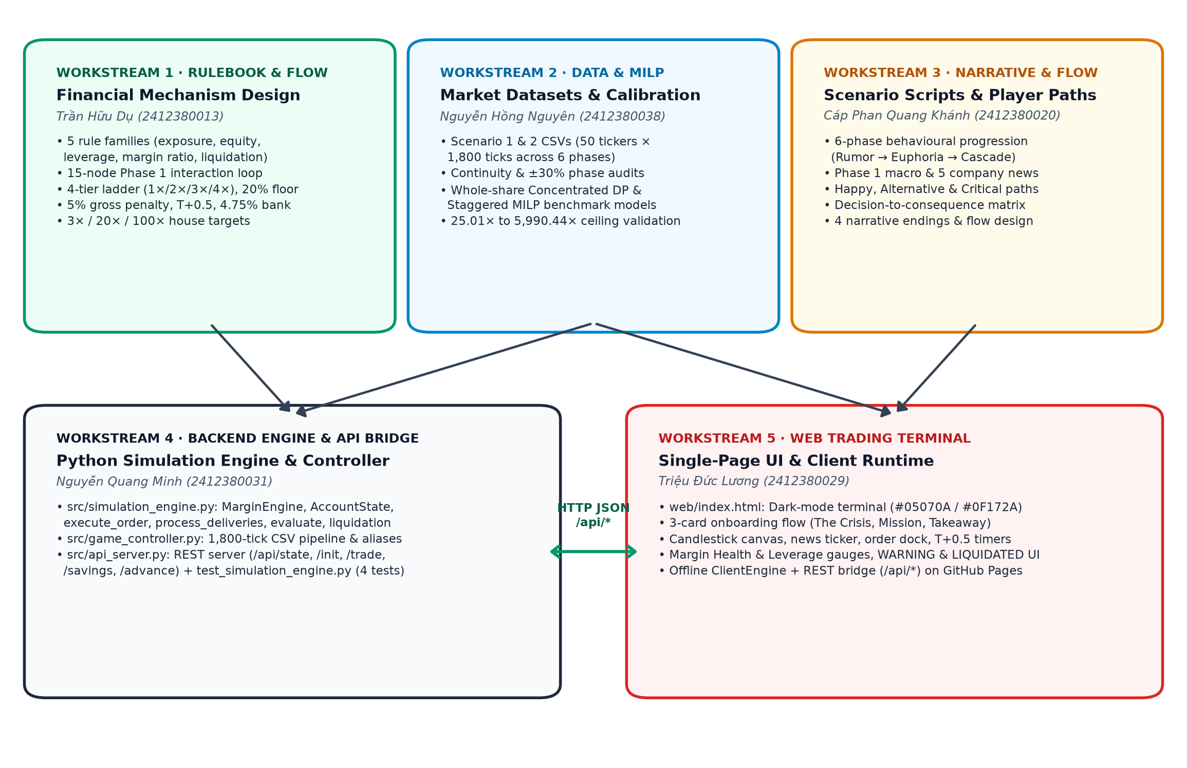
Figure 1. End-to-end architecture across all five Group 06 workstreams.

2.2 Input Dictionary and execution parameters
All components of the simulator communicate through the standardized nine-variable Input Dictionary (docs/data_and_sources.md §4):
Variable name | Type & format | Source / authority | Default / range in build | Downstream system effect
assigned_scenario_id | Integer (1 or 2) | System / player setup | Scenario 1 or Scenario 2 | Selects the 1,800 × 50 deterministic price matrix
initial_capital | Float (USD or KRW) | System / player setup | $10,000.0 USD or ₩10,000,000 KRW | Sets opening cash, purchasing power, and scales target_value
fixed_price_path | Matrix (1,800 × 50) | CSV dataset (data/) | 50 positive floats per tick; USD mode normalizes via / 1400 (/ 10000 for VNT) | Drives continuous mark-to-market valuation and margin checks
target_house_type | HouseType enum | Player pre-game choice | Small House (3×), Normal House (20×), ToLam Villa (100×) | Determines property_target_value and win condition
property_target_value | Float | Derived (capital × multiple) | $30,000 (3×), $200,000 (20×), $1,000,000 (100×) from $10k | Denominator of target_progress = (equity / target_value) × 100%
margin_tier | Float (initial_margin_ratio) | Player pre-game choice | 1.0 (1× Cash), 0.50 (2×), 0.3333 (3×), 0.25 (4×) | Sets max_purchasing_power = cash / initial_margin_ratio and debt creation
orders | Struct (ticker, action, shares, use_margin) | Player runtime action | BUY or SELL, positive shares, use_margin: bool | Mutates cash, margin_debt, pending_shares, pending_queue, or holdings
bank_savings | Float | Player runtime action | deposit, withdraw, repay_debt, emergency_reserve (≥ 0) | Moves cash into/out of liquidation-immune safe haven
savings_return_rate | Float (rate per session) | Rulebook parameter | +4.75% per completed 150-tick AM/PM session (+9.73% per phase) | Compounds idle cash outside the equity market
Table 3. Consolidated Input Dictionary (docs/data_and_sources.md §4, archive/Week 3/INPUT_DICTIONARY.md).

2.3 Phase 1 fifteen-node system workflow
The interaction loop of Phase 1 was specified by Trần Hữu Dụ as a 15-node decision graph (docs/assets/phase_1_workflow.jpg), directly mapping setup, tick progression, order validation, margin checks, forced liquidation, UI updates, and T+0.5 delivery routing:
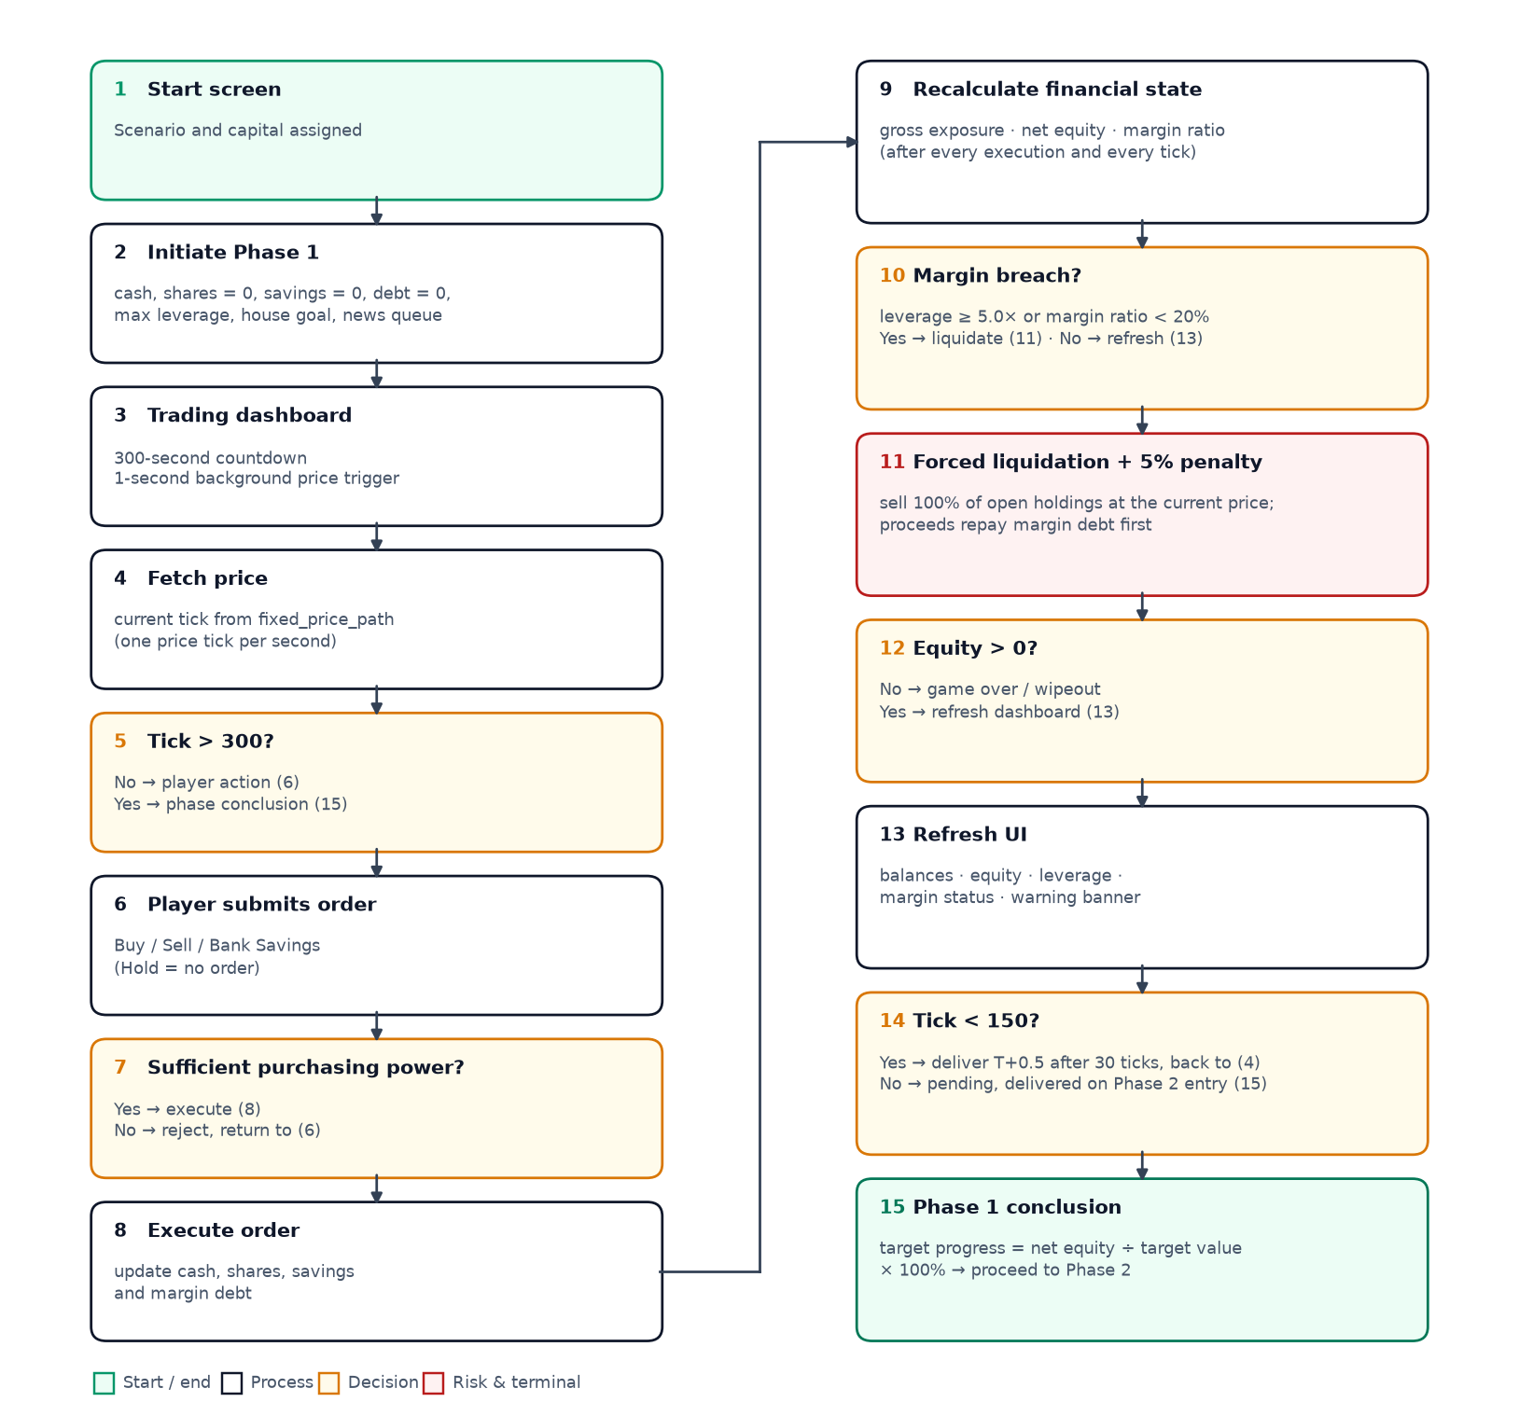
Figure 2. Phase 1 15-node workflow flowchart (Tran_Huu_Du_Individual_Contribution_Report.docx, §5).

3. Financial rulebook and mechanism design (Workstream 1 — Trần Hữu Dụ)

3.1 State variables and accounting identities
The simulator enforces strict mark-to-market accounting equations across eleven core state variables on every price tick and user trade (docs/financial_logic.md):
State variable | Mathematical definition in rulebook (docs/financial_logic.md) | Role in game mechanics
Liquid cash (C) | Uninvested cash balance available for immediate orders or savings deposits | Increases on SELL (after debt repayment) or savings withdrawal; decreases on BUY or savings deposit
Bank savings (B) | Safe-haven balance outside the stock market; earns +4.75% per completed 150-tick session | 100% immune from forced liquidation; optional emergency_reserve lock prevents accidental withdrawal
Gross exposure (S) | Σ (shares_i × P_i) across both settled holdings and unsettled pending_shares | Total mark-to-market stock value exposed to price fluctuations
Margin debt (D) | Cumulative broker loan used to finance leveraged BUY orders (D = max(0, cost − C)) | Accrues on leveraged BUY; repaid first on any voluntary SELL or forced liquidation
Net equity (E_net) | C + B + S − D | Player's total net worth; numerator of target_progress and solvency check
Trading equity (E_trade) | C + S − D (excludes B in rulebook; collateral base for broker) | Broker's collateral view of the leveraged trading account
Effective leverage (L) | S ÷ E_trade (0.0× when S = 0) | Measures gross stock exposure per unit of equity
Margin ratio (MR) | E_trade ÷ S = 1 ÷ L (100% when S = 0) | Primary safety indicator; triggers MARGIN_CALL when MR < 20% (L > 5.0×)
Property target value (G) | Initial Capital × House Multiplier (3×, 20×, or 100×) | Fixed final-equity goal selected at start screen
Target progress (%) | (E_net ÷ G) × 100% | Tracks completion toward Small House, Normal House, or ToLam Villa
Solvency flag (is_solvent) | E_net > 0 (and no terminal wipeout) | Determines survival at phase and session conclusion
Table 4. Financial state variables and definitions (docs/financial_logic.md §1–§2).
Gross exposure (S) = Σ (active_shares[i] + pending_shares[i]) × price[i]
Trading equity (E_trade) = C + S − D and Net equity (E_net) = C + B + S − D
Margin ratio (MR) = E_trade ÷ S = 1 ÷ L and P_call = D ÷ [ (1 − m) × Shares ] = D ÷ (0.80 × Shares)
Liquidation Waterfall: Gross = Σ S_i; Fee = 0.05 × Gross; Cash = max(0, C + 0.95 × Gross − D)

3.2 Leverage ladder and closed-form maintenance floor derivation
For a position opened at maximum buying power (L_0 = 1 / initial_margin_ratio) with initial capital E_0, stock value S_0 = L_0 × E_0, and margin debt D = (L_0 − 1) × E_0, setting margin_ratio = 0.20 yields the closed-form trigger price:
Leverage tier | Initial margin ratio | Max buying power (L_0) | Debt per ₩1 equity | Price drop to 20% margin floor (x_call) | Margin-call price from ₩100,000 entry | Theoretical 100% equity wipeout drop
Cash 1.0× | 100.00% (1.00) | 1.0× | ₩0 | n/a — no margin debt (D = 0) | None (immune to margin calls) | −100.00%
Margin 2.0× | 50.00% (0.50) | 2.0× | ₩1 | −37.50% (1 − 1 / 1.60) | ₩62,500 | −50.00%
Margin 3.0× | 33.33% (1/3) | 3.0× | ₩2 | −16.67% (1 − 2 / 2.40) | ₩83,333.33 | −33.33%
Margin 4.0× | 25.00% (0.25) | 4.0× | ₩3 | −6.25% (1 − 3 / 3.20) | ₩93,750.00 | −25.00%
Table 5. Four-tier leverage ladder and closed-form maintenance-margin trigger points (docs/financial_logic.md §3).
Worked Liquidation Case (Case A · T02 + T09): Initial capital ₩10,000,000 at 4.0× buys 400 shares of Vintrumite at ₩100,000 (order_cost = ₩40,000,000, debt = ₩30,000,000, cash = ₩0). On a −20% shock to ₩80,000: gross = ₩32,000,000, margin_ratio = 6.25% < 20% (MARGIN_CALL). Forced liquidation deducts 5% gross penalty (₩1,600,000), yielding net_proceeds = ₩30,400,000. Repaying ₩30,000,000 debt leaves exactly ₩400,000 final cash (−96% loss) and locks trading (is_liquidated = True).
Bank Savings Compounding: Compounding at +4.75% per 150-tick session yields (1.0475)¹² = 1.7452× (+74.52%) over 12 sessions. Because 1.75× < 3.0×, players cannot win the Small House target through passive deposits alone; Bank Savings serves strictly as a safe haven to lock in trading profits.

4. Market datasets and quantitative benchmark calibration (Workstream 2 — Nguyễn Hồng Nguyên)

4.1 Dual 50-asset × 1,800-tick datasets and 600-point validation
To prevent players from memorizing a single price trajectory, Nguyễn Hồng Nguyên built and validated two complete market datasets (market_scenario_1_corrected.csv and 2_corrected.csv), passing 600 automated tests across session continuity and phase price limits:
Validation check | Rule enforced by analysis/best_case.py | Scenario 1 (market_scenario_1_corrected.csv) | Scenario 2 (market_scenario_2_corrected.csv)
Grid dimensions | 1,800 consecutive ticks × 50 asset columns; six 300-tick phases | PASS (90,000 cells verified) | PASS (90,000 cells verified)
AM/PM boundary continuity | Tick 150 price == Tick 151 price within every phase (ticks 150–151, 450–451, ..., 1650–1651) | PASS (300/300 asset-boundary checks; fixed earlier tick 1650–1651 jump) | PASS (300/300 asset-boundary checks; fixed earlier session-boundary jumps)
Adjacent-phase continuity | Phase k closing tick == Phase k+1 opening tick (ticks 300–301, 600–601, ..., 1500–1501) | PASS (250/250 phase-transition checks) | PASS (250/250 phase-transition checks)
Full-phase ±30% price band | Every tick price in a phase remains within [0.70 × P_phase_open, 1.30 × P_phase_open] | PASS (300/300 asset-phase checks) | PASS (300/300 asset-phase checks)
Numeric & positive integrity | All cells parse as positive floats without text thousand-separator corruption | PASS | PASS (normalized text-formatted numbers)
Table 6. Pre-optimization dataset validation summary across Scenario 1 and Scenario 2 (docs/data_and_sources.md §2).

4.2 Concentrated DP vs. Staggered Re-Leveraging MILP benchmarks
analysis/best_case.py (850 lines) evaluates both scenarios using whole-share Concentrated Dynamic Programming (DP) and Staggered Re-Leveraging Mixed-Integer Linear Programming (MILP) under $10,000 capital and a 20.001% survival margin floor:
Scenario | Leverage tier | Concentrated DP multiple | Staggered MILP multiple | Staggered final equity ($) | MILP improvement vs. DP | DP cycles | Lowest margin ratio | Worst MIP gap / status
Scenario 1 | 2.0× | 25.007857× | 31.534604× | $315,346.04 | +26.10% | 9 | 48.4672% | 0.195264% (Cycle 5 time-limited)
Scenario 1 | 3.0× | 85.517668× | 156.869452× | $1,568,694.52 | +83.44% | 9 | 31.2896% | ~0.0999% (Optimal tol. met)
Scenario 1 | 4.0× | 257.709480× | 491.696973× | $4,916,969.73 | +90.80% | 10 | 22.7008% | ~0.0804% (Optimal tol. met)
Scenario 2 | 2.0× | 103.427759× | 137.817680× | $1,378,176.80 | +33.25% | 10 | 49.3840% | ~0.1000% (Optimal tol. met)
Scenario 2 | 3.0× | 545.345477× | 1,127.322099× | $11,273,220.99 | +106.72% | 10 | 32.5097% | ~0.1000% (Optimal tol. met)
Scenario 2 | 4.0× | 2,249.165859× | 5,990.443600× | $59,904,436.00 | +166.34% | 11 | 24.0734% | ~0.0901% (Optimal tol. met)
Table 7. Complete dual-scenario Concentrated DP and Staggered MILP benchmark results (analysis/best_case_calibration_targets_3x_20x_100x.md §1, §4).
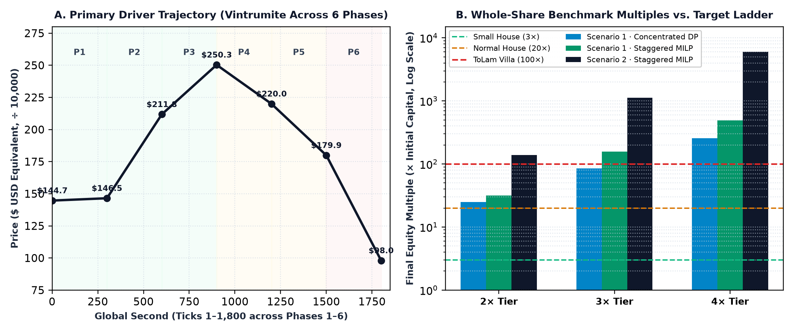
Figure 3. Left (A): Primary driver (Vintrumite) USD-normalized price trajectory. Right (B): Whole-share DP and MILP wealth multiples vs 3× / 20× / 100× property target ladder.

4.3 Property target attainment matrix
The quantitative calibration justifies recalibrating the target ladder from 2× / 8× to 3× / 20× / 100×:
Scenario & leverage tier | Staggered MILP multiple | Small House (3× = $30k) | Normal House (20× = $200k) | ToLam Villa (100× = $1.0m) | Calibration interpretation
Scenario 1 · 2.0× tier | 31.534604× ($315,346) | PASS | PASS | BELOW (-$684,654 shortfall) | At 2× in S1, reaches Normal House (20×) comfortably but cannot reach 100× without moving to 3× or 4×
Scenario 1 · 3.0× tier | 156.869452× ($1,568,695) | PASS | PASS | PASS | 3× leverage unlocks ToLam Villa (100×) in Scenario 1 under well-timed rotation
Scenario 1 · 4.0× tier | 491.696973× ($4,916,970) | PASS | PASS | PASS | 4× leverage provides ample upside headroom (491.7×) but narrows the margin buffer to −6.25%
Scenario 2 · 2.0× tier | 137.817680× ($1,378,177) | PASS | PASS | PASS | Scenario 2's stronger trend swings allow even the 2× staggered optimizer to clear 100×
Scenario 2 · 3.0× tier | 1,127.322099× ($11,273,221) | PASS | PASS | PASS | All three property targets attained
Scenario 2 · 4.0× tier | 5,990.443600× ($59,904,436) | PASS | PASS | PASS | All three property targets attained
Table 8. Property target attainment matrix across Scenario 1 and Scenario 2 (analysis/best_case_calibration_targets_3x_20x_100x.md §5).

5. Scenario narrative and behavioural progression (Workstream 3 — Cáp Phan Quang Khánh)

5.1 Six-phase behavioural progression
Cáp Phan Quang Khánh designed the 1,800-second timeline to test a sequence of behavioural biases:
Phase | Global seconds | Phase title | Market price & volatility dynamics | Target behavioural mechanism & pedagogical role
Phase 1 | 1 – 300s | Fake Positive News | Early uncertainty, noisy zigzags, and deceptive bullish spikes in decoy tickers | Tempts players out of cash (opportunity-cost anxiety) and baits early leverage adoption on unverified rumours
Phase 2 | 301 – 600s | True Positive News | Genuine earnings and AI-capex validation; sustained upward momentum in primary semiconductor drivers | Reinforces player confidence (confirmation bias) and rewards disciplined trend entry
Phase 3 | 601 – 900s | Bull Market | Broad-based sector rally (Vintrumite peaks at $250.33 at tick 900 in Scenario 1) | Induces aggressive re-leveraging (3× / 4×) as players chase the 20× and 100× property targets
Phase 4 | 901 – 1,200s | Strong Growth (FOMO) | Sharp intraday pullbacks followed by rapid rebounds; elevated borrowing across the board | Conditions players to buy every dip (recency bias & FOMO) and ignore narrowing margin cushions
Phase 5 | 1,201 – 1,500s | Market Euphoria | Stretched valuations (Vintrumite drifts from $220.0 to $179.9) punctuated by deceptive bull-trap bounces | Tests whether players de-risk and lock profits into Bank Savings or hold maximum leverage into the peak
Phase 6 | 1,501 – 1,800s | Negative Shock | Synchronized systemic sell-off (Vintrumite plunges from $179.93 to $98.00, a −45.5% phase-6 drop from peak) | Triggers MARGIN_CALL (margin_ratio < 20%) and forced clearinghouse liquidation on over-leveraged accounts
Table 9. Six-phase scenario progression and behavioural design (docs/user_flow.md §4).

5.2 Phase 1 news signals and narrative endings
News layer & timestamp | Headline / asset focus | Scripted narrative content & behavioural cue
Macro event 1 · 0:00 | South Korea's Semiconductor Outlook Strengthens | Strong AI-related demand supports expectations for Korean memory-chip exports; major tech stocks highlighted.
Macro event 2 · 2:30 | AI Infrastructure Investment Supports Korean Chipmakers | Continued global AI data-center capex strengthens expectations for HBM and advanced packaging.
Macro event 3 · 4:00 | Investor Sentiment Improves Across Korean Technology Stocks | Improving risk appetite draws retail capital back into large-cap technology shares despite valuation risks.
Company profile 1 · VNT | Primary driver (Vintrumite) | High-beta AI memory demand, High Bandwidth Memory (HBM), and 3D DRAM architecture.
Company profile 2 · 005930 | Samsung Electronics | Large-cap foundry strategy, ASML High-NA EUV collaboration, and next-generation node manufacturing.
Company profile 3 · 122630 | KODEX Leverage (2× ETF) | Reflects bullish Korean sentiment while embedding structural volatility decay when held on margin.
Table 10. Phase 1 macro and company-specific news scripts (docs/user_flow.md §6).
Trajectory / ending | Typical player configuration & phase actions | Margin & equity mechanics triggered | Final outcome & pedagogical takeaway
Happy / Safe Path → Normie / Solvency Ending | Selects Small House (3×) and Cash 1.0×; rides Phase 2–4 uptrend, sells before Phase 6, rotates into Bank Savings | margin_debt = 0, status = HEALTHY; Bank Savings compounds at +4.75% per session and is immune to the Phase 6 crash | Finishes solvent (~2.92×–3.5× capital); demonstrates capital preservation and late-cycle liquidity discipline
Alternative Path → Middle-Class Stability Ending | Selects Normal House (20×) and 2.0×–3.0× margin; compounds across Phases 2–4, voluntarily sells in Phase 5 to repay margin_debt | Voluntary SELL repays margin_debt first, restoring status to HEALTHY before the Phase 6 shock | Clears $200,000 (20×) target without triggering a margin call; illustrates active deleveraging
Alternative Path → Chaebol / ToLam Villa Ending | Selects ToLam Villa (100×) and 3.0×–4.0× margin; executes staggered re-leveraging across Phases 1–5 and exits into cash/savings prior to Tick 1,500 | Maintains margin_ratio ≥ 20% throughout holding windows; avoids the 5% forced-liquidation penalty | Clears $1,000,000 (100×) benchmark ceiling; requires near-optimal timing and strict stop-loss discipline
Critical-Risk Path → Forced Liquidation / Wipeout Ending | Selects ToLam Villa (100×) at 4.0× margin and holds full leveraged exposure into Phase 6 without cash or unlocked savings reserves | A −6.25% drop breaches the 20% floor (MARGIN_CALL); trigger_forced_liquidation() fire-sells all shares and deducts 5% gross fee | Loses up to 96%+ of trading equity (₩10m → ₩400k) and locks account (is_liquidated = True); exposes leverage blindness
Table 11. Player trajectories and narrative endings (docs/user_flow.md §5, §7).

6. Backend implementation, Web Audio engine and cloud deployment (Workstream 4 — Nguyễn Quang Minh)

6.1 Zero-dependency Python simulation engine (src/simulation_engine.py)
Nguyễn Quang Minh implemented the core Python simulation engine (src/simulation_engine.py, 387 lines) enforcing strict accounting invariants:
Class / method (src/simulation_engine.py) | Lines | Implemented logic & state invariants
MarginStatus & HouseType enums + HOUSE_MULTIPLIERS | 19–37 | Defines HEALTHY, NORMAL, WARNING, MARGIN_CALL, LIQUIDATED and maps SMALL_HOUSE: 3.0, NORMAL_HOUSE: 20.0, TOLAM_VILLA: 100.0
PendingDelivery, AccountState, FinancialMetrics | 40–76 | Dataclasses separating settled holdings from unsettled pending_shares, tracking pending_queue, cash, bank_savings, margin_debt, and is_liquidated
MarginEngine.__init__ | 86–116 | Validates initial_capital > 0 and 0 < initial_margin_ratio <= 1.0; computes target_value and initializes AccountState
deposit_to_savings, withdraw_from_savings, set_emergency_reserve | 118–133, 154–159 | Transfers cash to/from bank_savings and enforces available = bank_savings - emergency_reserve unless ignore_reserve=True (T12)
repay_margin_debt | 135–152 | Allows direct debt paydown (repay_amt = min(amount, margin_debt)) from either bank_savings or cash
calculate_max_purchasing_power & calculate_*_portfolio_value | 161–181 | Computes cash / initial_margin_ratio, marks holdings + pending_shares to market, and adds bank_savings for total portfolio value
evaluate(current_prices) | 183–240 | Computes equity, leverage, margin_ratio, target_progress, is_solvent, and classifies status across the 5 MarginStatus states; sets margin_call_triggered = True on breach
execute_order(...) | 242–313 | Blocks trades if is_liquidated; validates shares > 0, price > 0; enforces initial margin; routes BUY lots to pending_shares (<150 → +30s; ≥150 → Phase 2); repays debt first on SELL
process_deliveries(current_tick, current_phase) | 315–330 | Promotes matured PendingDelivery lots from pending_shares into active holdings when phase/tick conditions are met
trigger_forced_liquidation(current_prices) | 331–378 | Liquidates 100% of shares, deducts 5% penalty on gross_proceeds, repays margin_debt from cash + net_proceeds (keeping bank_savings 100% immune), locks account, returns 7-key audit dict
get_margin_call_price(ticker) | 380–387 | Computes closed-form breach price margin_debt / (total_shares * (1.0 - maintenance_margin_ratio))
Table 12. Architecture of src/simulation_engine.py (387 lines, authored by Nguyễn Quang Minh).

6.2 Multi-phase controller and HTTP REST API (src/game_controller.py, src/api_server.py)
src/game_controller.py (221 lines) wraps MarginEngine inside an 1,800-tick timeline controller, implementing USD/KRW divisor normalization (/ 10,000 for Vintrumite, / 1,400 for 49 KRX tickers) and a 10-ticker KRX alias resolution map (BUG-04). src/api_server.py (406 lines) exposes nine JSON REST endpoints:
HTTP route (src/api_server.py) | Lines | Request JSON payload | Backend controller / engine method invoked | Response contract
GET /api/state | 108–110, 51–84 | None | controller.engine.evaluate() + get_game_state_payload() | Returns {phase, target, bank, metrics, account, holdings, pending_shares, is_liquidated, prices}
POST /api/init | 146–164 | {initial_capital, target_house_type, initial_margin_ratio} | Re-instantiates GameController(...) | Returns {status: 'success', state: ...} (200 OK)
POST /api/trade | 165–208 | {ticker, action, shares, use_margin, price?} | Resolves alias, calls engine.execute_order(...) | 200 OK on fill; 400 Bad Request on insufficient funds/shares or post-liquidation
POST /api/savings & /api/transfer_* | 209–221, 239–255 | {action, amount, ignore_reserve?} | deposit_to_savings() / withdraw_from_savings() | 200 OK on transfer; 400 Bad Request if exceeds cash or unlocked savings
POST /api/repay_debt | 222–230 | {amount, source: 'bank'|'cash'} | engine.repay_margin_debt(amount, source) | 200 OK on debt paydown; 400 Bad Request if zero debt or insufficient funds
POST /api/emergency_reserve | 231–238 | {amount} | engine.set_emergency_reserve(amount) | 200 OK on reserve lock; 400 Bad Request if amount > bank_savings
POST /api/advance | 256–264 | None | controller.advance_phase() | Advances phase, triggers forced liquidation if in MARGIN_CALL, returns liquidation_info
Table 13. HTTP REST API routes in src/api_server.py (lines 106–266).

6.3 Dynamic Dual-Track BGM Audio Engine (AudioManager) and Cloudflare Workers deployment
Nguyễn Quang Minh architected the 24,750-line interactive frontend (web/index.html), ClientEngine (JavaScript replica of MarginEngine), and the Web Audio API soundtrack engine (AudioManager, lines 17249–18245) deployed live at https://phan-dung.ngqminh6979.workers.dev/:
Track key | MP3 filename | Soundtrack title | Simulation trigger & audio behaviour
menu | bgm_menu.mp3 | Midnight Audit | Pre-game onboarding and inter-phase pause (1.2s fade-in)
1_A / 1_B | bgm_phase1_a/b.mp3 | Ready Player One → Midnight Arbitrage | Phase 1: AM (1–149s) → 2.0s crossfade at Tick 150 → PM (150–300s)
2_A / 2_B | bgm_phase2_a/b.mp3 | Calculated Ascent → Thesis | Phase 2: AM (1–149s) → 2.0s crossfade at Tick 150 → PM (150–300s)
3_A / 3_B | bgm_phase3_a/b.mp3 | Capital Ascent → Spread Closure | Phase 3: AM (1–149s) → 2.0s crossfade at Tick 150 → PM (150–300s)
4_A / 4_B | bgm_phase4_a/b.mp3 | Sprinting → Liquidation Threshold | Phase 4: AM (1–149s) → 2.0s crossfade at Tick 150 → PM (150–300s)
5_A / 5_B | bgm_phase5_a/b.mp3 | Overextended → The Last Ticker Tape | Phase 5: AM (1–149s) → 2.0s crossfade at Tick 150 → PM (150–300s)
6_A / 6_B | bgm_phase6_a/b.mp3 | Concrete Fracture → Terminal Liquidation | Phase 6: AM (1–149s) → 2.0s crossfade at Tick 150 → PM (150–300s)
buy / sell | bgm_buy/sell.mp3 | Glass Balcony / The Overleveraged | Order modals; bookmarks & resumes exact timestamp on close/reopen
bank / news | bgm_bank/news.mp3 | Behind the Seal / The Midnight Dossier | Bank & news modals; bookmarks & resumes exact timestamp
Panic filter | Web Audio Biquad | 400 Hz Low-Pass Underwater Filter | Ramps cutoff 20,000 → 400 Hz (Q = 4.0) when margin_ratio < 25%
Table 14. Dual-Track BGM Audio Engine soundtrack manifest (AudioManager, lines 17255–18180).

7. UI/UX design system and interface architecture (Workstream 5 — Triệu Đức Lương)

7.1 Dark-mode design tokens and four-zone layout
Triệu Đức Lương formulated the institutional dark-mode visual design system, color tokens, and 4-zone dashboard wireframe (DUC_LUONG_CONTRIBUTION.md):
Design token / layer | Hex code / specification | Visual & functional role in web/index.html
Base canvas background | #05070A / #0A0E17 with subtle grid lines | Minimizes eye fatigue and visual noise during high-speed 1-second tick updates
Glassmorphism card surfaces | #0F172A (60% opacity) with #1E293B 1px slate borders | Separates Account Overview, Price Chart, Order Dock, and Risk Gauges into distinct visual zones
Terminal emerald green | #00E676 / #10B981 | Signals positive PnL, HEALTHY / NORMAL margin status, BUY execution buttons, and active system feeds
Warning amber | #F59E0B / #FACC15 | Highlights WARNING margin band, T+0.5 pending settlement timers, and elevated leverage
Danger crimson red | #EF4444 / #DC2626 | Flags negative price shocks, the 20.0% maintenance-margin liquidation floor line, and terminal lockouts
Typography hierarchy | Ultra-bold display headers + JetBrains Mono monospace | Ensures tabular alignment of live KOSPI/KRX prices, countdown timers, and margin ratios without horizontal jitter
Table 15. Dark-mode UI design system tokens (contribution/evidence/DUC_LUONG_CONTRIBUTION.md §2.1).
Dashboard operational zone | UX component specification (DUC_LUONG_CONTRIBUTION.md) | State variables bound in runtime | Player interaction & visual feedback
Zone 1 · Top Header Status Bar | Phase badge (PHASE 1–6), 300s countdown timer (05:00), + SYS.ACTIVE indicator, scenario badge | phase.id, phase.name, global_second | Shows remaining time before session/phase transition and current psychological regime
Zone 2 · Left Sidebar (Account & Safe Haven) | Net Worth card, Trading Cash, Margin Debt, Safe Haven Bank (+4.75%), Emergency Reserve lock, Flash News feed | equity, cash, margin_debt, bank_savings, emergency_reserve | One-click deposit, withdraw, debt paydown, and reserve locking; live scrolling macro/company news
Zone 3 · Center Floor (Chart & Order Dock) | HTML5 Canvas price chart, selected ticker header, BUY/SELL buttons, 25%/50%/100% presets, T+0.5 queue | prices[ticker], holdings[ticker], pending_shares[ticker], max_purchasing_power | Previews order cost and required margin cash; displays countdown timer on unsettled T+0.5 shares
Zone 4 · Right Sidebar (Watchlist & Risk Gauges) | 50-asset searchable watchlist, Margin Health Gauge (20.0% red line), Leverage Gauge, Property Target Bar | margin_ratio, margin_status, leverage, target_progress | Transitions badge color (#00E676 → #F59E0B → #EF4444) and triggers clearinghouse lockout overlay on breach
Table 16. Four-zone UX layout specification of the web trading terminal (docs/user_flow.md §8).

7.2 Division of labour: Foundational wireframes (Lương) vs. Interactive UI expansion (Minh)
Triệu Đức Lương (Workstream 5): Formulated base dark-mode design tokens (#05070A, #00E676, #EF4444, JetBrains Mono), Screen 3 3-card narrative onboarding (The Crisis, Our Mission, Your Takeaway), Screen 6 core 4-zone trading dashboard wireframe, the visual specifications of the three progress gauges (Margin Health with 20.0% red marker, Leverage Multiplier, and Property Target Bar), and diagnosed BUG-06 (1280×720 long ETF name truncation).
Nguyễn Quang Minh (Workstream 4): Designed and coded the 7-screen interactive progression (Screen 1 Hero Landing with cursor spotlight, Screen 2 Callsign Terminal, Screen 4 Target Tutorial, Screen 5 Target Showcase, #screen-briefing 4-Panel Codex), the Dense KRX Price Board with per-column tick flashing, the 5 tactical modals (Order Terminal with dynamic particle aura, T+0.5 Lock Gateway, Safe Haven Vault, News Archive, Settings Consoles), the 5-Tier Cinematic Ending UI (Tier F, D, C, B, A) with dual-layer video, and deployed the production application on Cloudflare Workers.

8. Verification, formal test suite (T01–T12) and bug triage (BUG-01..06)

8.1 Boundary check and formal verification matrix
Evaluating a 4× position (400 shares bought at ₩100,000, debt = ₩30,000,000) across five prices pins the exact boundary behavior in src/simulation_engine.py (lines 199–225):
Share price (P) | Price move from entry | Gross exposure (400 × P) | Trading equity (S − ₩30m) | Margin ratio (E ÷ S) | Effective leverage (S ÷ E) | Engine MarginStatus (line 217 strict <)
₩100,000 | 0.00% (Entry) | ₩40,000,000 | ₩10,000,000 | 25.0000% | 4.0000× | NORMAL (ratio >= 0.25)
₩93,760 | −6.24% | ₩37,504,000 | ₩7,504,000 | 20.0085% | 4.9979× | WARNING (0.20 <= ratio < 0.25)
₩93,750 | −6.25% (T03 floor) | ₩37,500,000 | ₩7,500,000 | 20.0000% | 5.0000× | WARNING (boundary tie; no liquidation)
₩93,740 | −6.26% (T04 breach) | ₩37,496,000 | ₩7,496,000 | 19.9915% | 5.0021× | MARGIN_CALL (ratio < 0.20 → liquidate)
₩80,000 | −20.00% (T09 shock) | ₩32,000,000 | ₩2,000,000 | 6.2500% | 16.0000× | MARGIN_CALL → final cash ₩400,000
Table 17. Five-price boundary verification of a 4× leveraged position (src/simulation_engine.py, lines 208–225; docs/testing.md §2).
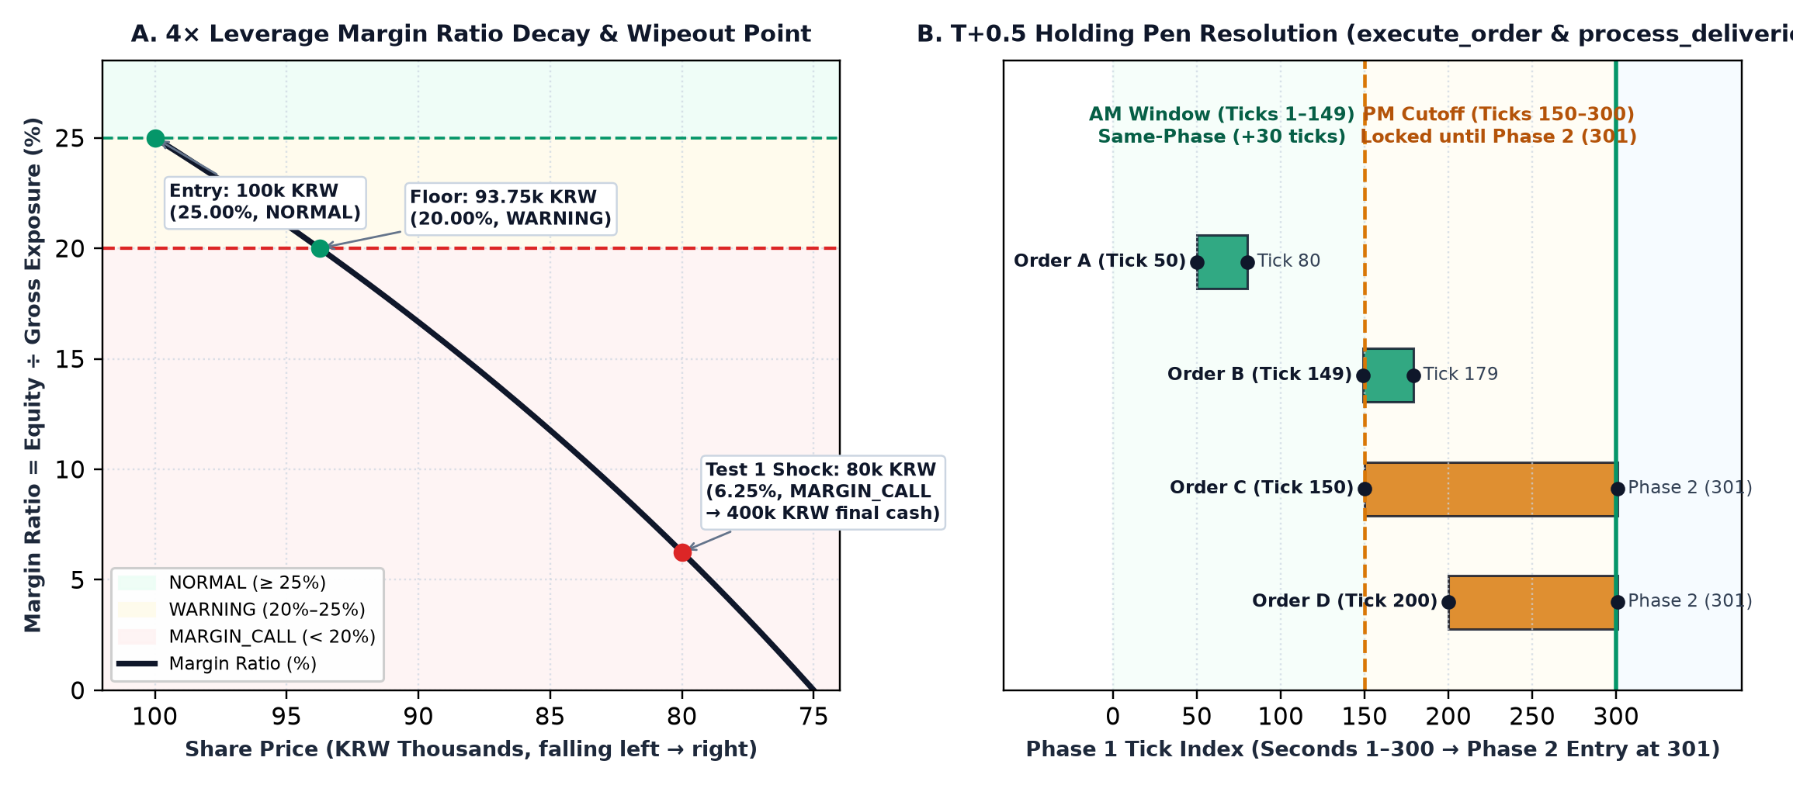
Figure 4. Left (A): 4× margin ratio decay curve showing the ₩93,750 boundary and ₩80,000 wipeout shock. Right (B): T+0.5 settlement holding-pen resolution across the tick-150 cutoff.
Test ID | Category & description (docs/testing.md) | Target input & expected outcome | Verification in src/ & test/test_simulation_engine.py
T01 | Unit · Cash-only buy (1.0×) | Buy shares with use_margin=False; margin_debt = 0, status = HEALTHY | Executable PASS — test_case_2_cash_only_safe_position (lines 72–98)
T02 | Unit · Max 4.0× leveraged buy | ₩10m capital buys ₩40m stock; cash = 0, debt = ₩30m, ratio = 25%, NORMAL | Executable PASS — test_case_1_high_leverage_wipeout_with_penalty (lines 32–52)
T03 | Boundary · Exact −6.25% drop (₩93,750) | equity = ₩7.5m, gross = ₩37.5m, ratio = 20.00% → WARNING (no fire-sale) | Hand & code verified — enforced by strict < at simulation_engine.py line 217
T04 | Boundary · −6.26% drop (₩93,740) | equity = ₩7,496,000, ratio = 19.9915% < 20% → MARGIN_CALL & liquidation | Hand & code verified — simulation_engine.py lines 217–218, 380–387
T05 | Validation · Exceed purchasing power | Order cost exceeds cash / initial_margin_ratio → rejected (return False) | Code verified — simulation_engine.py lines 263–264 & 268–269
T06 | Validation · Short-sell prevention | SELL quantity exceeds settled holdings[ticker] → rejected (return False) | Code verified — simulation_engine.py lines 297–299 (blocks selling pending_shares)
T07 | Validation · Non-positive quantity/price | shares <= 0 or price <= 0 → raises ValueError | Code verified — simulation_engine.py lines 256–257
T08 | Validation · Post-liquidation lockout | Any execute_order() call when is_liquidated == True → raises RuntimeError | Code verified — simulation_engine.py lines 252–253 (BUG-05 fix)
T09 | Stress · −20% crash wipeout + 5% fee | 400 sh @ ₩80k → gross = ₩32m, penalty = ₩1.6m, net = ₩30.4m, final_cash = ₩400k | Executable PASS — test_case_1_high_leverage_wipeout_with_penalty (lines 54–71)
T10 | Workflow · Bank Savings deposit & immunity | Deposit ₩10m of ₩20m into bank_savings; cash = ₩10m, equity = ₩20m, immune to liquidation | Executable PASS — test_bank_savings_workflow (lines 99–115) & line 355
T11 | Workflow · T+0.5 settlement holding pen | Tick 50 order settles at Tick 80; Tick 200 order stays pending at Tick 299 and settles in Phase 2 | Executable PASS — test_settlement_delay_holding_pen (lines 116–144)
T12 | Workflow · Emergency reserve lock | withdraw_from_savings above bank_savings - emergency_reserve rejected (return False) | Code verified — simulation_engine.py lines 126–133, 154–159
Table 18. Master verification matrix mapping formal cases T01–T12 (docs/testing.md) to src/ and test/.
Week 6 Defect Triage Summary: All six defects discovered during the Week 6 Build Clinic were resolved: BUG-01 (T+0.5 phase-2 delivery tracking via deliver_in_phase), BUG-02 (liquidation cash floored at 0.0 and strict savings exclusion), BUG-03 (round(..., 2) and inf → 0.0 JSON sanitization), BUG-04 (10-ticker KRX code aliasing), BUG-05 (is_liquidated guard on execute_order), and BUG-06 (CSS text-overflow: ellipsis for long ETF names).

9. Post-midterm revisions, known limitations and reconciliations

9.1 Summary of 15 post-midterm revisions
# | Revision area | Transition (From → To) | Rationale & repository evidence
1 | Core product identity | Debt-free stock game → Leveraged margin & forced-liquidation simulator | Establishes clear pedagogical differentiation (archive/Week 4/MIDTERM_REVIEW.md)
2 | Property target ladder | 2× / 8× → 3× / 20× / 100× (Small House, Normal House, ToLam Villa) | Recalibrated after whole-share DP/MILP showed 31.5×–491.7× attainable upside
3 | Leverage input UX | Raw margin ratios → Cash 1× / 2× / 3× / 4× tier buttons | Matches retail brokerage terminology and simplifies onboarding
4 | Dual market scenarios | Single path → Scenario 1 & Scenario 2 (market_scenario_1,2_corrected.csv) | Reduces pattern memorization across repeated playthroughs (data/)
5 | Phase 1 mechanics added | Basic buy/sell → Bank Savings (+4.75%), T+0.5 holding pen, 5% fee, ±30% band | Introduces realistic liquidity friction and a non-market de-risking channel
6 | Feature scope freeze | Open feature wishlist → Keep / Postpone / Remove governance table | Protects engineering focus on the margin-survival loop (archive/Week 5/Feature_map.md)
7 | Macro data pruning | Planned FX/macro series → 50 equity/ETF price paths + news | Eliminates unused macro variables (docs/data_and_sources.md §8)
8 | Primary driver naming | SK Hynix → Vintrumite (VNT) | Stylized game naming for the primary high-beta memory-chip driver
9 | Dataset continuity audit | Raw unverified CSVs → 600-check continuity & ±30% phase-limit audit | Repaired tick 1650–1651 jump in S1 and text-formatted numbers in S2
10 | Benchmark methodology | Stylized backtest → Whole-share Concentrated DP + Staggered MILP | Enforces integer shares, 20.001% survival margin, and intra-cycle pyramiding
11 | Verification framework | 4 midterm unit tests → 12 formal test cases (T01–T12) + 4 automated unit tests | Structured 4-tier verification matrix (docs/testing.md, test/)
12 | Defect triage | Unlogged build issues → BUG-01..BUG-06 root-cause & fix log | Stabilized settlement, liquidation floor, JSON rounding, and ticker aliases
13 | Technical stack route | Planned React/FastAPI → Zero-dependency Python (src/) + static web app | Runs anywhere with standard Python 3 or a static browser
14 | Public web hosting | Local script only → Live deployments on GitHub Pages & Cloudflare Workers | Provides instant browser access at https://phan-dung.ngqminh6979.workers.dev/
15 | Repository layout | Scattered weekly folders → Clean top-level docs/, src/, test/, data/, web/ | Ensures straightforward grading and artefact traceability (README.md)
Table 19. Fifteen post-midterm revisions across Weeks 4–6 (docs/revision_summary.md).
Declared Limitations (docs/limitations.md): Instant order fills at tick price without bid-ask spread; deterministic synthetic price paths; DP/MILP assumes perfect foresight; and amplified +4.75% per-session Bank Savings rate.

10. Group contribution map and individual member footprints

10.1 Master five-member responsibility matrix
Member & Student ID | Assigned role | Primary authored deliverables in repository | Core technical / analytical contribution
Trần Hữu Dụ  2412380013 | Coordinator · Mechanism Designer | docs/financial_logic.md · docs/assets/phase_1_workflow.jpg · docs/testing.md · docs/revision_summary.md | Designed the 5 rule families, 15-node workflow diagram, 4-tier leverage ladder, 20% floor & 5% penalty, T+0.5 settlement, 4.75% Bank Savings, and consolidated docs/
Nguyễn Hồng Nguyên  2412380038 | Data Gatherer · Quantitative Calibration | data/market_scenario_1,2_corrected.csv · analysis/best_case.py · analysis/*.md | Built and audited both 50-asset × 1,800-tick datasets (600 checks); authored the 850-line Concentrated DP & Staggered MILP optimizer; calibrated 3×/20×/100× ladder
Cáp Phan Quang Khánh  2412380020 | Scenario Designer · User Flow & News | docs/user_flow.md · archive/Week 5/User_flow.md · archive/Week 4/MIDTERM_REVIEW.md | Designed the 6-phase behavioural progression, Scenario Tree (Happy, Alternative, Critical paths), Phase 1 news scripts, player action mappings, and narrative endings
Nguyễn Quang Minh  2412380031 | Technical Developer · Full-Stack & UI Architect | src/simulation_engine.py · src/game_controller.py · src/api_server.py · test/ · web/index.html · Cloudflare Workers live | Architected 1,298-line Python backend, 24,750-line interactive frontend (7 screens, 5 modals, KRX flash board, 5-tier ending UI, ClientEngine), AudioManager (17 MP3s, 11 SFX, panic filter), and Cloudflare deployment
Triệu Đức Lương  2412380029 | UI/UX & Interface Designer | docs/user_flow.md (§8) · web/index.html (Design tokens, Screen 3 & Screen 6 wireframes) | Formulated foundational dark-mode design tokens (#05070A, #00E676, #EF4444, JetBrains Mono), Screen 3 3-card Crisis narrative wireframe, Screen 6 4-zone dashboard wireframe, and 3 visual gauges
Table 20. Group 06 five-member responsibility and deliverable matrix (contribution/contribution_map.md).

10.2 Individual footprint summaries
Trần Hữu Dụ (2412380013): Authored docs/financial_logic.md, the 15-node workflow flowchart (docs/assets/phase_1_workflow.jpg), and consolidated repository documentation.
Nguyễn Hồng Nguyên (2412380038): Constructed and verified both 1,800-tick datasets and authored the 850-line DP/MILP benchmark suite in analysis/best_case.py.
Cáp Phan Quang Khánh (2412380020): Structured the 6-phase narrative arc, Phase 1 news bulletins, decision paths, and the four end-of-game narrative debriefs.
Nguyễn Quang Minh (2412380031): Coded the entire Python backend (src/), unit tests (test/), the 24,750-line frontend (web/index.html), ClientEngine, AudioManager (17 MP3s, 11 SFX, 400 Hz panic filter), and deployed on Cloudflare Workers at https://phan-dung.ngqminh6979.workers.dev/.
Triệu Đức Lương (2412380029): Established the institutional dark-mode design tokens, Screen 3 onboarding concept, Screen 6 4-zone trading dashboard wireframe, and visual gauge specifications.

Appendix A. Full repository artefact trace
Index of committed repository files in FTU-Legacy-63/G06 and live deployment assets:
Repository path | Size / lines | Primary owner | What it establishes
README.md | 91 lines (7.6 KB) | All (ed. Trần Hữu Dụ) | Project overview, live demo links, repository map, quick-start commands
docs/financial_logic.md | 97 lines (8.6 KB) | Trần Hữu Dụ | Consolidated financial rulebook: variables, formulas, tiers, risk states, T+0.5, savings
docs/assets/phase_1_workflow.jpg | 425 KB image | Trần Hữu Dụ | 15-node Phase 1 visual flowchart (Figure 2)
docs/data_and_sources.md | 207 lines (14.1 KB) | Nguyễn Hồng Nguyên | Dataset schema, 600 validation checks, DP/MILP results, Input Dictionary
docs/user_flow.md | 84 lines (6.4 KB) | Cáp Phan Quang Khánh & Triệu Đức Lương | Core loop, Week 5 scope table, 6 phases, Phase 1 news script, UI summary
docs/testing.md | 60 lines (4.6 KB) | Trần Hữu Dụ & Nguyễn Quang Minh | 4-tier test framework, T01–T12 matrix, BUG-01..BUG-06 summary
docs/revision_summary.md | 23 lines (2.7 KB) | Trần Hữu Dụ | 15-item post-midterm revision table across Weeks 4–6
src/simulation_engine.py | 387 lines (15.9 KB) | Nguyễn Quang Minh | Core Python simulation engine: MarginEngine, AccountState, T+0.5, liquidation
src/game_controller.py | 221 lines (8.8 KB) | Nguyễn Quang Minh | 6-phase controller, CSV loader, USD/KRW normalization, 10-ticker alias map
src/api_server.py | 406 lines (18.8 KB) | Nguyễn Quang Minh | Zero-dependency HTTP REST server (/api/*), float sanitization, diagnostic GUI
test/test_simulation_engine.py | 147 lines (6.0 KB) | Nguyễn Quang Minh | 4 automated unittest cases pinning wipeout penalty, cash solvency, savings, and T+0.5
web/index.html | 24,750-line live SPA | Nguyễn Quang Minh (JS/Audio) & Triệu Đức Lương (Tokens/Wireframes) | Single-page trading terminal, onboarding cards, gauges, ClientEngine, AudioManager
https://phan-dung.ngqminh6979.workers.dev/ | Cloudflare Workers edge deployment | Nguyễn Quang Minh | Live production web deployment of Free Fall 2.0 with 17 MP3 tracks & 5 MP4 endings
data/market_scenario_1,2_corrected.csv | 1,801 lines each | Nguyễn Hồng Nguyên | Corrected Scenario 1 & 2 datasets (1,800 ticks × 50 assets across 6 phases)
analysis/best_case.py | 850 lines (34.8 KB) | Nguyễn Hồng Nguyên | Dual-scenario Concentrated DP and Staggered Re-Leveraging MILP optimizer
contribution/contribution_map.md | 20 lines (4.2 KB) | All (ed. Trần Hữu Dụ) | Master 5-member role and artifact map
contribution/evidence/*.md | 5 files (792 lines total) | All 5 members | Primary detailed contribution evidence logs for all 5 members
Table 21. Complete repository artefact trace across FTU-Legacy-63/G06.

