

**MACAU UNIVERSITY OF SCIENCE AND TECHNOLOGY**

**School of Computer Science and Engineering**

**Faculty of Innovation Engineering**

**Midterm Report of Senior Thesis for the Degree of Bachelor of Science**

Title: Tumor Detection in Brain MRI Images Based on the Improved U-Net

Student Name : Xiangyu Gao

Student No. : 19098535-I011-0055

Supervisor : Xiaolin Tian

December, 2022



澳門科技大學

創新工程學院

計算機科學與工程學院

理學學士學位畢業論文中期报告

論文題目: 基於改进的U-Net的腦部核磁共振圖像中的腫瘤检测

姓 名 : 高翔宇

學 號 : 19098535-I011-0055

指導老師 : 田小林

2022年12月

# Abstract

Brain tumor is a large number of abnormal cells growing in the brain. It is not good for human healthy life, only bad. Serious malignant tumors have a great chance to cause disability or even death of human beings. In the medical field, nuclear magnetic resonance (NMR) is often used for diagnosis. The doctor can analyze and diagnose the patient's illness through the abnormal state in the MRI image.

In recent years, it is more and more common and effective to use computer programs to automatically segment and assist doctors to judge and analyze various medical images. However, there is still room for improvement in its efficiency and accuracy, and computer aided segmentation is still a challenge so far. In this report, the author tried to use the network of U-Net family to segment brain MRI images to reduce doctors' work.

**Keywords:**Brain Tumor; Magnetic Resonance Image; Image Segmentation; Deep Learning; U-Net Family

# 摘要

脑肿瘤是大脑中生长的大量异常细胞，對人類的健康生活並無益處，只有壞處，嚴重的惡性腫瘤還有很大的幾率會造成人類的殘疾甚至死亡。在醫學領域，常常使用核磁共振技術來診斷。醫生可以通過核磁共振圖像中的異常狀態分析幷診斷病人的得病情況。

而近些年來，使用計算機程序自動分割輔助醫生來判斷、分析各種醫學成像的情況也越來越常見，並且頗有成效。但是，其效率、準確度還有上升的空間，使用計算機進行輔助分割目前為止仍是一項挑戰。在這篇報告中，作者嘗試使用U-Net家族的網絡，對腦部MRI圖像進行分割，以減輕醫生的工作。

**關鍵詞﹕**腦瘤﹔磁共振圖像﹔圖像分割﹔深度學習；U-Net家族

# Table of Contents

Abstract I

摘要 II

Table of Contents III

List of Figures V

Chapter 1 Introduction 1

1.1 Background and Motivation 1

1.2 Research Method 1

1.3 Thesis organization 2

Chapter 2 Literature Review 3

2.1 Research Status 3

2.2 Methods Proposed 3

Chapter 3 Process Dataset 5

3.1 Brain MRI Dataset 5

3.2 Convert the Data Format 5

Chapter 4 Experiment of U-Net 7

4.1 Experimental Set Up 8

4.1.1 Environment Configuration 8

4.1.2 Upload files 8

4.2 Test the Running 8

4.3 Run U-Net 8

Chapter 5 Conclusion 8

5.1 Conclusion 9

5.2 Future work 9

References 10

Appendix 11

Resume 13

Acknowledgements 14

# List of Figures

Figure 2‑1 Two Examples of Dataset 3

Figure 3‑1 The Result of U-Net Detection 5

# Introduction

## Background and Motivation

Brain tumors are large numbers of abnormal cells that grow in the brain. In 2016 alone, there were 330 000 cases of brain cancer and 227 000 related deaths worldwide [1]. Thus, Brain tumors have become one of the important diseases endangering human health, and their mortality and disability rates are very high. Because doctors do not have the means to see directly with the naked eye what is going on inside the brain, the only way to determine and determine a tumor is to use MRI. However, on the MRI image, the specific location, size, benign and malignant of the tumor are difficult to judge.

In addition, at present, China's medical industry has the problem of relatively insufficient total quality medical resources and uneven distribution. The diagnostic level of brain tumors varies from region to region and at different levels. And, even for an experienced doctor, screening brain tumors through MRI images takes at least 20 to 30 minutes, which is very time-consuming and labor-consuming.

Therefore, Automatic detection and identification of tumors is very important. Because deep learning has great advantages and wide applications in automatic recognition and detection, it is often used to deal with medical image segmentation. Due to its good performance and versatility, the U-Net network has received widespread attention and use since it was proposed and has continued to this day[2]. Since then, many researchers have also improved and improved it. The more popular ones are 3D U-Net, U-Net++[3] and so on.

Based on this, the writer decided to use the U-Net family to achieve the Tumor Segmentation in Brain MRI Images.

## Research Method

Various methods are available for brain tumor classification. Among various methods, artificial neural network (ANN), convolutional neural network (CNN) methods, and Fully Convolutional Networks (FCN) methods are widely used. Because of many advantages of U-Net, more and more U-Net based networks have been designed for image segmentation in recent years. In this article, writer will use a kind of improved U-Net to detect the brain tumor.

## Thesis Organization

Chapter 2 summarizes some previous research results

Chapter 3 describe writer’s work to process the dataset

Chapter 4 describe what did the writer do in the experiment.

Chapter 5 concludes the work this semester, and the work will do in the future time.

# Literature Review

## Research Status

In this paper a Brain Cancer Detection and Classification System have been developed with the use of ANN[5]. The image processing techniques such as histogram equalization, image segmentation, image enhancement, and feature extraction have been used. The proposed approach using ANN as a classifier for classification of brain images provides a good classification efficiency as compared to other classifiers. The sensitivity, specificity and accuracy is also improved. The proposed approach is computationally effective and yields good result.

The paper MRI Brain Tumor Image Classification Using a Combined Feature and Image-Based Classifier, DNN model based on ANN is used[6]. DNN is a branch of ANN, on which the number of hidden layers is increased. In this paper, the researchers use least square fitting (LSF) to obtain the vectors of minimizing sum squared error (SSE) and weight. A classifier combining feature and image based classification (CFIC) is selected. And got a good results.

N. Varuna Shree propose a method using PNN to detect the brain tumor[7]. Probabilistic neural network (PNN) is composed of four nodes or layers: input layer, hidden layer, pattern layer and output layer. Researcher use preprocess to remove a noise and smoothen the image, which also results in the improvement of signal-to-noise ratio. And use GLCM for feature extraction. And successfully segmented the tumor.

Long et al. first introduced fully convolutional networks (FCN), while U-Net was introduced by Ronneberger et al. [8]. They both share a key idea: skip connections. In FCN, up-sampled feature maps are summed with feature maps skipped from the encoder, while U-Net concatenates them and add convolutions and non-linearities between each up-sampling step. The skip connections have shown to help recover the full spatial resolution at the network output, making fully convolutional methods suitable for semantic segmentation.

## Methods Proposed

U-Net family is a kind of deep learning network based on FCN. Since its birth, it has been widely used in the field of medical image processing because it is excellent in using small data set training. What’s more, it also well known as it’s characteristic simple, efficient, easy to understand, easy to build. Later, many researchers improved U-Net and formed network structures such as U-Net++[3], U-Net3+[4]. which together formed the current U-Net family.

Based on the high performance, I choose to use a kind of improved U-Net to detect the brain tumor. Firstly, I will use U-Net++ to detect. Theoretically, it could detect the brain tumor similar to the traditional method. What’s more, it could also existing some advantages. Comparing to the classical U-Net and find the advantages and disadvantages. Then, I could find problem and inspiration in this process, which could teach me how to improve the network.

# Process the Dataset

The project is to run deep learning models on brain MRI dataset. This section gives the introduction of works to process the dataset.

## Brain MRI Dataset

My dataset is from [Medical Segmentation Decathlon (medicaldecathlon.com)](http://medicaldecathlon.com/). It contains 740 volumes (including 484 training volumes and 266 testing volumes). All of these are MRI data in .nii format. If we cut them into .jpg or .png format, we will get more picture.

Figure 2-1 shows an example of brain with tumor detected and an example of normal brain.

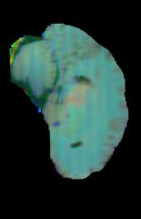 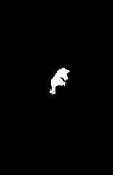 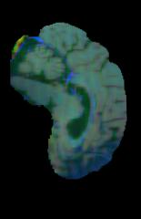 

Figure 2-1 Two examples of dataset. Case 1: (a) brain image with tumor and (b) its mask image. Case 2: (c) normal brain image with (d) its mask image

The MRI image itself is a grayscale image, but the dataset has given false colors to the image for our observation. The annotation image is only black and white.

## Convert the Data Format

After we downloaded the dataset from the web, we got the MRI information in .ii format. In order to use U-Net segmentation more conveniently and facilitate our observation, we need to convert the .nii format to the .jpg image format. The code for this automatic process is shown in the appendix. After this automatic process, we get the picture format of the dataset.

# Experiment of U-Net

To find which variety of U-Net family is good, I take the training volume into U-Net and U-Net++ network, and compare the determined image. And compare various varieties according to a series of information such as time and accuracy.

## Experimental Set Up

Because real training often requires a lot of computation, my own computer is not competent for this task, so I used the cloud computing platform and rented an RTX3080 GPU with 15G memory.

### Environment Configuration

Because the environment has been installed once, this environment installation is relatively easy. However, there are also some difficult problems encounter for the first time. But finally, I solve it.

### Upload files

Cause the cloud computing server is a server without GUI and also hard to take data transmission between my laptop and the server. So, I created a git repository and used github for hosting. In this way, after I update the data of a folder on my laptop, I just need to use “git push” to update the data in github. Then, in the server, I could use “git clone” to get the data easily. Then, we complete to upload the file to the server.

## Test the U-Net

After configuring the environment, I use a little dataset (including 25 images) of fundus vascular image to test the running and the possibility of the network first. If everything run successfully, then I could use the brain image to do the formal experiment. And after did some adaptability adjustment, finally got the result. I successfully use the U-Net model and the U-Net++ model to detect the position of vascular. The effect is as Figure 3-1 shows.

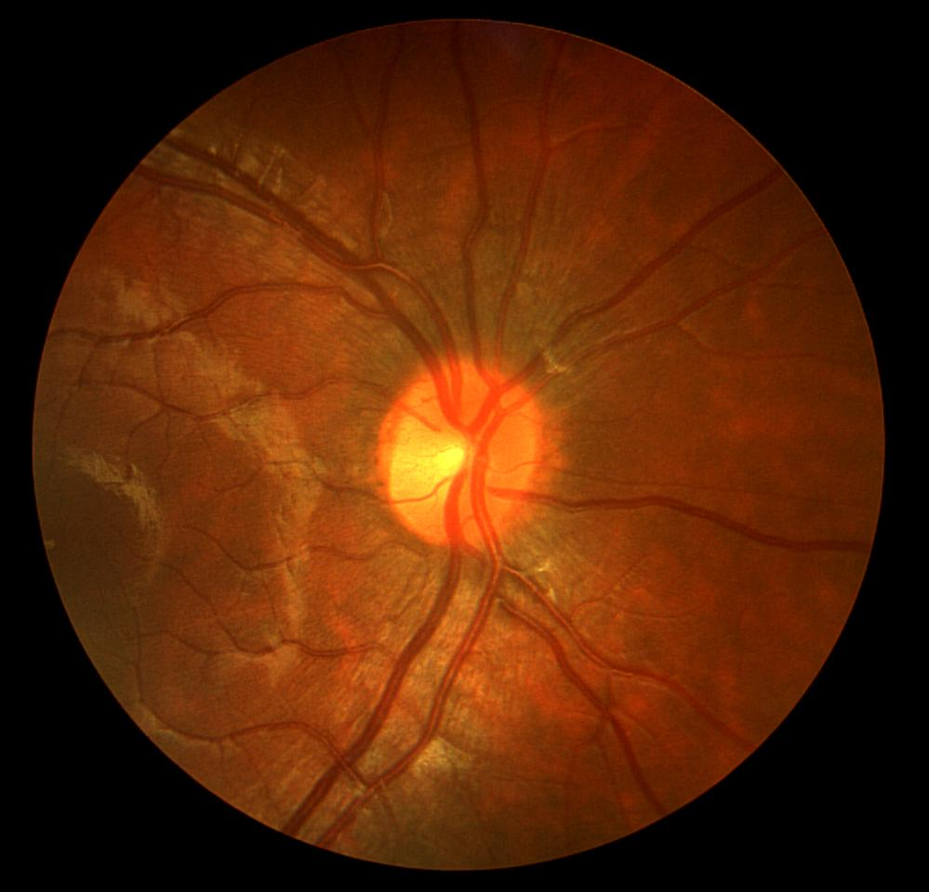 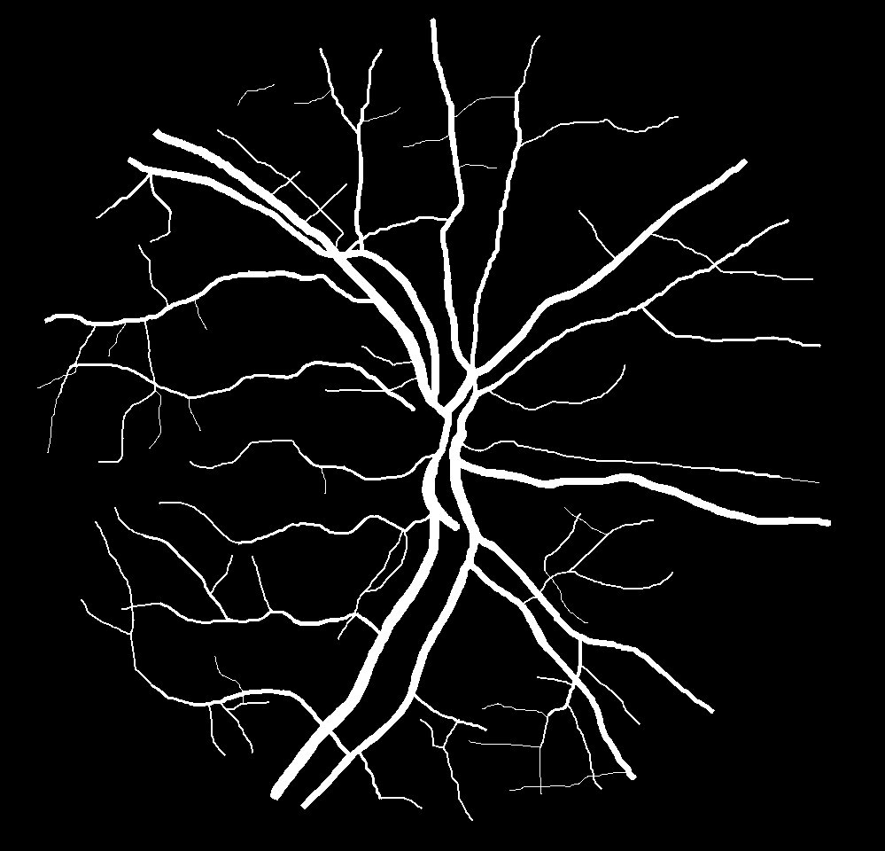 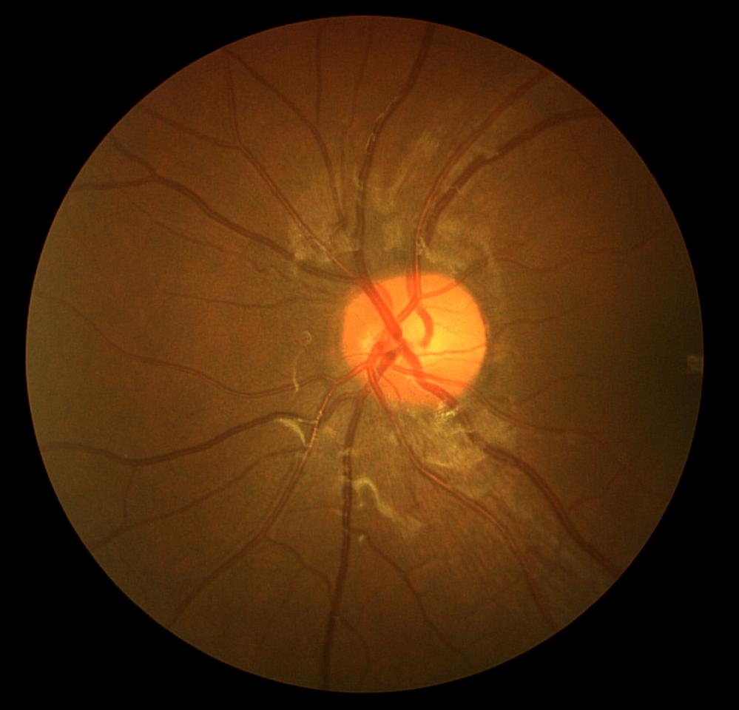 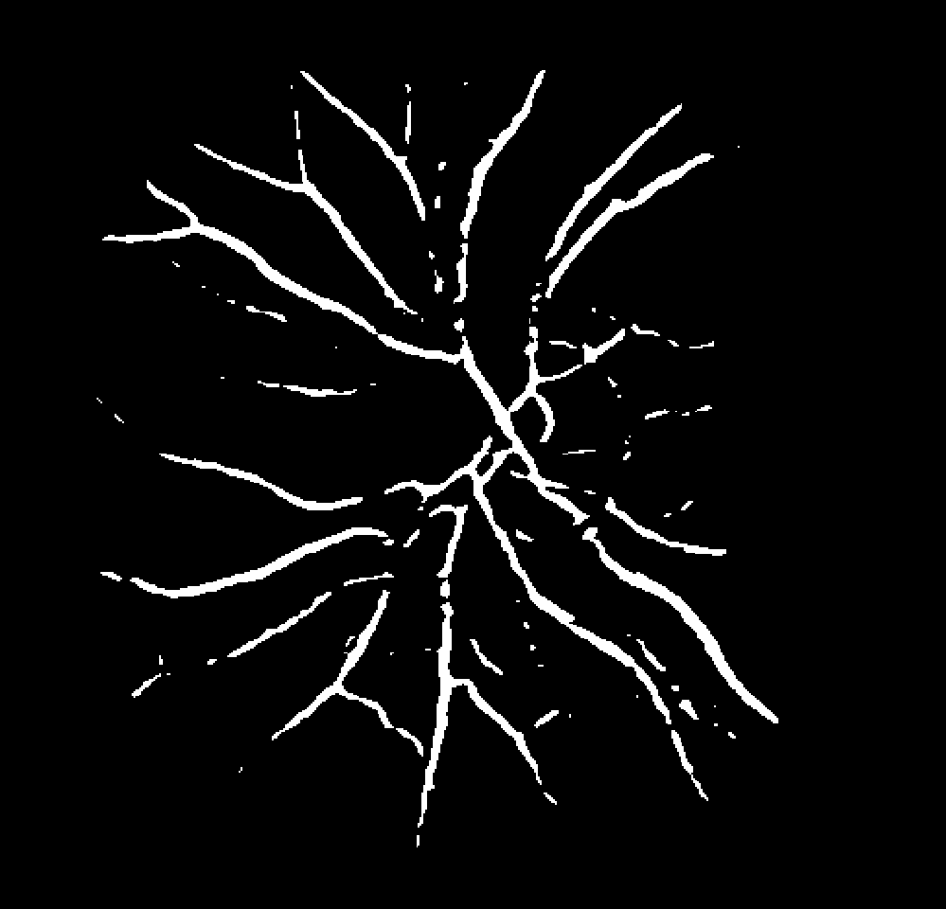

Figure 3-1 The effect of U-Net detection. Case 1: (a) a training image (b) its ground truth image. Case 2: (c) a test image (d) mask image detected by U-Net

From Figure 3-1 we can see that just under a short time training, U-Net can give quite a good detection effect. Although no tiny blood vessels are detected, as a test, this performance is acceptable after only using a very short training time.

Also same to the U-Net++ network, after a relatively short time training, it can determine a relatively satisfactory results. Cause it’s similar to the figure3-1. So, figure 3 is used here to represent the actual effect.

## Run U-Net for Detecting Brain Tumor in MRI

After process the dataset, I take the training volume and label into the U-Net network. It trained successfully. But after the training process, when I did the test process, the program reported errors. At present, I haven't found the root cause of the error and the solution. It needs me to take more time on it to solve the error. So, there is no result up to now.

# Conclusion

## Conclusion

In this semester, I learned some knowledge on image processing, and deep learning throw reading many recent papers on tumor segmentation in medical images. And have tested U-Net and U-Net++ in little dataset. The result can give quite a good detection effect. Although the effect of handling details is really limited, as a test, this performance is acceptable after only using a very short training time.

## Future work

2022.12.01~2022.12.15: Try to solve the error in testing the brain image of the U-Net network, and prepare for the 5 minutes report.

2022.12.16~2022.12.26: Try to take the brain image to the U-Net++ network to training and solve the error.

2022.12.27~2022.1.11: Prepare for the final exam.

2022.1.12~2022.1.30: Continue to solve the error which haven’t solved before. After that, try to take the test image to the U-Net++ network to test the training result and solve the error.

2022.2.1~2022.2.30: Find another better network in U-Net family (if it’s possible). After that, try to understand the principle of it and improve it by adding some attention mechanism and so on.

2022.3.1~2022.3.30: Try to improve a kind of network in U-Net family by adding some mechanism.

2022.4.1~2022.4.10: Make the final improvement to the paper

2022.4.11~2022.4.24: Prepare for the final presentation and defence

# References

1. “Global, regional, and national burden of brain and other CNS cancer,1990–2016: a systematic analysis for the Global Burden of Disease Study 2016” , Neurology
2. Ronneberger, Olaf, Philipp Fischer, and Thomas Brox. “U-Net: Convolutional Networks for Biomedical Image Segmentation.” (2015): n. pag. Print.
3. Zhou, Zongwei et al. “UNet++: A Nested U-Net Architecture for Medical Image Segmentation.” (2018): n. pag. Print.
4. Huang, Huimin et al. “UNet 3+: A Full-Scale Connected UNet for Medical Image Segmentation.” ICASSP 2020 - 2020 IEEE International Conference on Acoustics, Speech and Signal Processing (ICASSP). IEEE, 2020. 1055–1059.
5. Rajeshwar Nalbalwar Umakant Majhi Raj Patil Prof.Sudhanshu Gonge 2014 Detection of Brain Tumor by using ANN International Journal of Research in Advent Technology 2.
6. Veeramuthu, A et al. “MRI Brain Tumor Image Classification Using a Combined Feature and Image-Based Classifier.” Frontiers in psychology 13 (2022): 848784–848784. Web.
7. Varuna Shree, N., and T. N. R. Kumar. “Identification and Classification of Brain Tumor MRI Images with Feature Extraction Using DWT and Probabilistic Neural Network.” Brain informatics 5.1 (2018): 23–30. Web.
8. Long J, Shelhamer E, and Darrell T Fully convolutional networks for semantic segmentation. In Proceedings of the IEEE conference on computer vision and pattern recognition, pages 3431–3440, 2015.

# Appendix

1. Code to convert .nii format to .png format

import numpy as np

import os # 遍历文件夹

import nibabel as nib # nii格式一般都会用到这个包

import imageio # 转换成图像

def nii_to_image(niifile):

filenames = os.listdir(filepath) # 读取nii文件夹

slice_trans = []

for f in filenames:

# 开始读取nii文件

img_path = os.path.join(filepath, f)

img = nib.load(img_path) # 读取nii

img_fdata = img.get_fdata()

fname = f.replace('.nii', '') # 去掉nii的后缀名

img_f_path = os.path.join(imgfile, fname)

# 创建nii对应的图像的文件夹

if not os.path.exists(img_f_path):

os.mkdir(img_f_path) # 新建文件夹

# 开始转换为图像

(x, y, z) = img.shape

for i in range(z): # z是图像的序列

silce = img_fdata[i, :, :] # 选择哪个方向的切片都可以

imageio.imwrite(os.path.join(img_f_path, '{}.png'.format(i)), silce)

# 保存图像

if __name__ == '__main__':

filepath = 'E:\数据集\脑瘤\Task01_BrainTumour\labelsTr'

imgfile = 'E:\数据集\脑瘤\Task01_BrainTumour\picLabel'

nii_to_image(filepath)

# Resume

**1. Resume**

Name: GAO XIANGYU

Gender: Male

Email: dd201178@163.com

Education:

2016 ~ 2019, High School, ShiJiaZhuang JingYing High School.

2019 ~ 2023, Bachelor of Science, Macao University of Science and

Technology.

Awards:

2019, Excellent Scholarship

Work experience:

1. Industrial Bank Hebei Branch, ShiJiaZhuang, China, Assistant Software Engineer
2. Maintain the operation of network devices
3. Construction of network infrastructure
4. Develop small database projects

**2. Publications**

# Acknowledgements