Step-by-step guide on “how to work in COMSOL”

1. Always use *model wizard* instead of *blank model.* Blank model is literally blank, you will have to do more things manually and we do not want that
2. When choosing space dimensions: think about what you want to make.

Is it in 1D, 2D, or 3D; is there symmetry? Mostly you will use 2D axisymmetric

1. Choose the physics of your system. You don’t have to select everything here, within you space you can still add physics
2. There are two study options: stationary and time dependent. Do you want to simulate when it’s at equilibrium or over time?

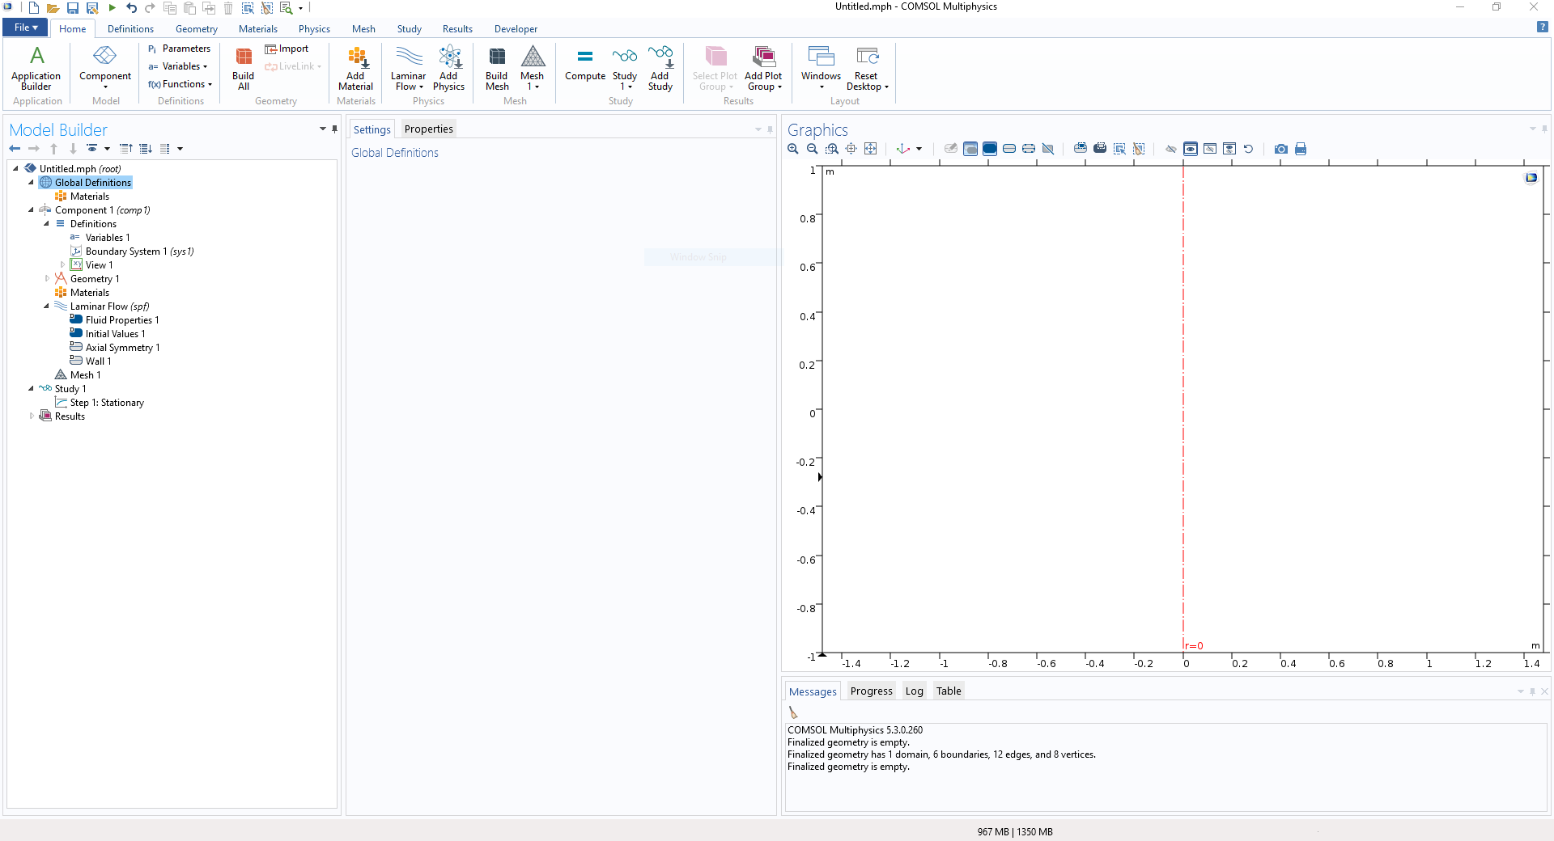When you’re done setting up your settings, we will go over the following things in order: parameters, geometry, materials, physics, mesh, study, results. For this example, I chose 2D-axissymmetric with laminar flow for my physics and stationary study.

1

2

5

6

7

3

4

1. In parameters, the global parameters of your system can be added with their units. Think about the dimensions, physical attributes of your material, etc. Like so, the rest will be added automatically:

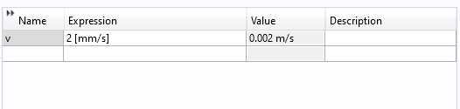

When you want to use one of the parameters, you can fill in the *Name* in the position where you would add the value of the parameter.

1. Click on the tab *Geometry* to build your structure. You can have two options to build (**a**) right click in the model builder (see box in Figure) to add a shape and input the dimensions or (**b**) click on the shape in the *Geometry* tab to “point-and-click” and make the shape (the dimensions can be changed after creating the shape). You can make as many shapes as you like and eventually merge them together or cut out shapes in the *Booleans and partition* tab.



So you can cut out a shape out of a shape like this:

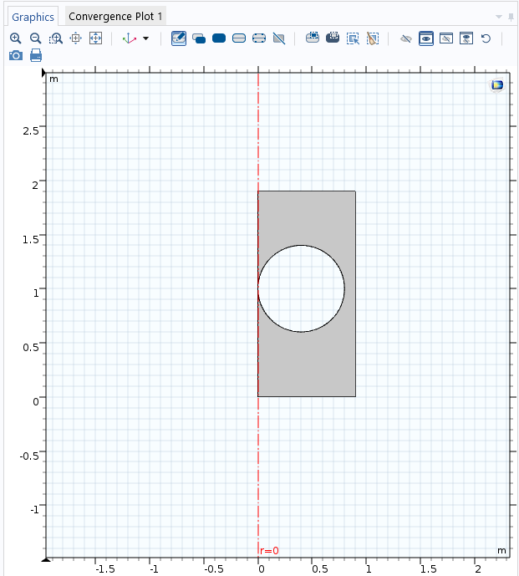

**A useful tip**: name your shapes to what they should be (ex: outer wall, stationary wall, hand, whatever that object may be).

When all objects are sketched, press build all.

1. In the *Materials* tab, COMSOL has their own library of materials when you click add material. A new window will pop up on the right with the material library.

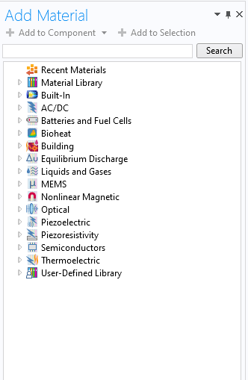

You can either choose your material from here (by double clicking or by clicking *add selection*) or click blank material to give your own material properties. When using blank material, don’t forget to name you material as this will be easier to find back in your model builder.

When choosing your material (blank material in this case), you can choose the area that has the material type. Do you want the whole domain, or only the boundaries of the domain?

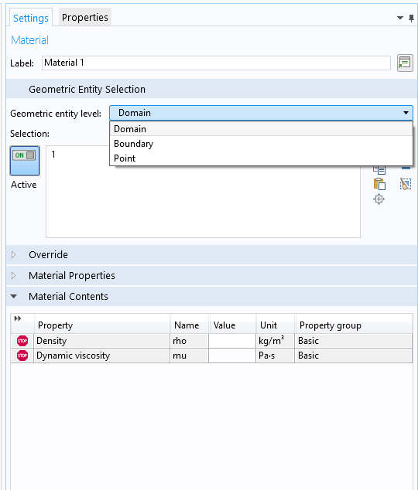

When filling in the material contents, additional properties can be added in the *Material Properties* tab, as this system has laminar flow physics, it will show the basic physical properties for laminar flow (density and dynamic viscosity).

1. In the *Physics* tab, you can add additional physics you might’ve forgotten in the beginning. In this tab you can also start adding physics to your system. Is there contact between different shapes, are there any moving particles, what are the boundary conditions, etc.
2. For the *Mesh*. I don’t really think, just press *Build Mesh* and Sequence type = Physics controlled mesh and press Build Mesh again for good measure and to be sure it changed to Physics controlled.

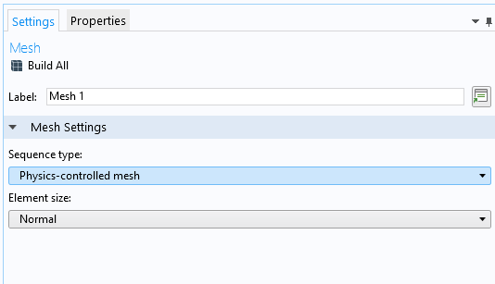

1. In *Study*, press compute to let COMSOL calculate your system. That’s all you need to know from this tab.
2. In *Results*, you can look up specific graphs for evaluation. A specific point in your system, or a line, or an area. In the Model Builder, you can export whatever graph/plots you made to your computer by right clicking export and selecting the data you want.

WOW! Now you know how basic COMSOL works, you can make your own systems and create your own failproof ideas :D