

SWP391 PROJECT REPORT
Software Design Specification

– Hanoi, Aug 2026 –

Table of Contents
Change Log 3
I. High Level Design 4
1. Software Architecture 4
2. Package Diagram 5
3. Database Design 5
3.1 table_name1 6
3.2 users 6
3.3 table_name3 6
II. Detailed Code Design 6
1. <Feature/Function Name1> 6
1.1 Class Diagram 6
1.2 Add New User 7
1.3 <Sequence Diagram Name2> 7
1.4 … 7
2. <Feature/Function Name2> 7
III. Other Design Specifications 7

Change Log
Date | A*  M, D | In charge | Change Description
13/09/2026  20/09/2026  22/09/2026  27/09/2026 | A  M  A  A | KienLC | I.3 Added Database Design and filled information into tables  I.3 Modified Database Design  II.1. Added User Management & User Details  II.1. Modified User Management & User Details  II.4. Modified Class diagram Quiz Submission & Scoring
20/09/2026  22/09/2026  27/09/2026 | A  M  A  M | NguyenLD | I.1 Software Architecture  I.1.1 Architecture component descriptions  I.2 Package Diagram  I.2.1 Package descriptions  I.1 Software Architecture  I.1.1 Architecture component descriptions  I.2 Package Diagram  I.2.1 Package descriptions  II.7.User Management & User Details  II.7.1 Class Diagram  II.7.2 View & Filter User Lists  II.7.2 Update User Profile & Status  I.1 Software Architecture  I.1.1 Architecture component descriptions  I.2 Package Diagram  I.2.1 Package descriptions
22/09/2026 | A | HuyLDA | II.4.Class diagram  II.4.1 Class diagram  II.4.2 Browse & Search Public Courses  II.4.3 View Public Course Detail
19/09/2026 | A | ThinhCX | II.1.Enrollment&Payment  II.1.1.Class diagram  II.1.2.Create Enrollment & Payment  II.1.3.Handle Payment Webhook  II.2.Content Management (Cloudinary)  II.2.1.Class diagram  II.2.2.Upload Lesson Material  II.2.3.Submit & Review Content  II.3.Quiz Submission & Scoring  II.3.1.Class diagram  II.3.2.Submit Quiz Attempt & Scoring  II.3.3.Auto-submit Expired Attempt
21/09/2026  22/09/2026  27/09/2026  28/09/2026 | A  A  M  M | GiangMT | II.4.1 Class Diagram  II.4.2 View Lesson Content  II.4.3 Mark Lesson Completed  II.5.1 Class Diagram  II.5.2 View Lesson Content  II.5.3 Mark Lesson Completed  II.2.1 Class Diagram  II.3.1 Class Diagram
*A - Added M - Modified D - Deleted

I. High Level Design

1. Software Architecture
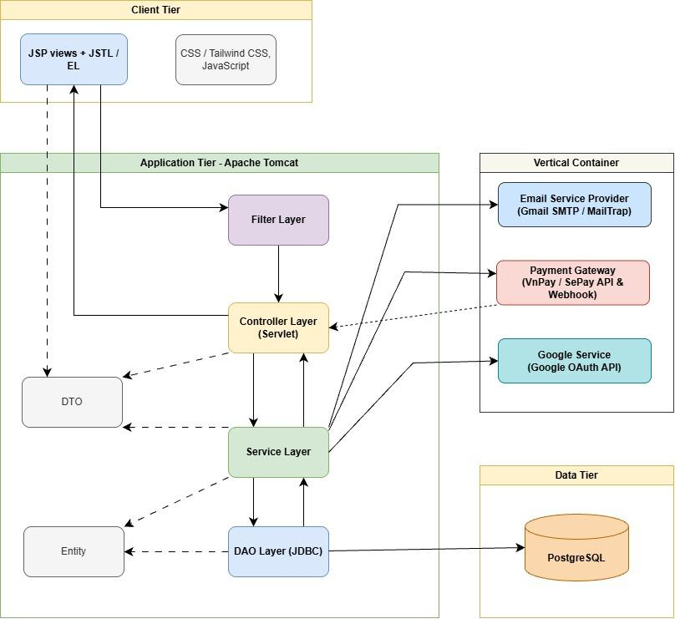
Architecture component descriptions
No | Component | Description
Client Tier
01 | JSP Views + JSTL / EL | Renders dynamic web pages for end-users (Guest, Student, Manager, Expert, Admin) using JSTL and Expression Language (EL) based on data passed from Controllers.
02 | CSS / TailwindCSS & JavaScript | Provides responsive UI styling, page layouts, and client-side interactions across all supported screen resolutions.
Application Tier (Apache Tomcat)
01 | Filter Layer | Intercepts incoming HTTP requests to handle character encoding and execute role-based authentication/authorization checks (Auth Filter) before reaching Servlets.
02 | Controller Layer (Servlet) | Acts as the HTTP request handler. Extracts parameters, invokes corresponding business logic in the Service Layer, and forwards/redirects to the appropriate JSP view.
03 | Service Layer | Contains core business logic (e.g., course enrollment, quiz evaluation, auto-submission timers, payment verification, and automated background tasks).
04 | DAO Layer (JDBC) | Manages database persistence operations. Executes parameterized SQL queries directly against PostgreSQL using raw JDBC connections.
05 | DTO (Data Transfer Object) | Lightweight POJO objects used to transfer data between the View, Controller, and Service layers without exposing database entity structures.
06 | Entity | Object model representing system domain data directly mapped to PostgreSQL database table schemas.
Data Tier
01 | PostgreSQL | Relational Database Management System (RDBMS) that securely stores system data, including user accounts, course structures, enrollment records, and audit logs.
External Services
01 | Google Service | Provides Google OAuth 2.0 Identity Service for rapid user registration and social authentication.
02 | VNPay / SePay | Handles course fee transactions via VnPay and SePay APIs, notifying the system asynchronously via Webhook / IPN callbacks upon payment completion.
03 | Email Service Provider | Sends system-generated transaction and notification emails (e.g., password reset OTPs, registration confirmations, and study reminders) via Gmail SMTP / MailTrap.

2. Package Diagram
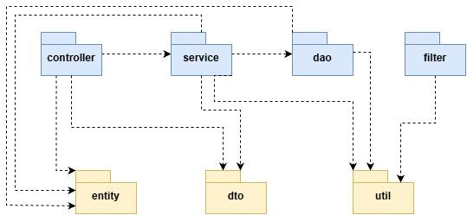
Package descriptions
No | Package | Description
01 | com.learnhub | Root package containing all server-side application components, core business logic, and database access mechanisms built with Java Servlets and JDBC.
02 | filter | Contains Java Servlet Filters (HttpFilter) handling cross-cutting concerns such as request authentication, authorization checks, character encoding, and session validation.
03 | controller | Contains Servlet classes that receive HTTP requests, coordinate use-case execution by invoking the appropriate Service, and forward the resulting data back to the client.
04 | service | Contains the business logic layer, implementing use cases (authentication, course management, enrollment, quiz processing, payment, etc.) and enforcing validation rules and transaction boundaries.
05 | dao | Contains Data Access Object classes that use plain JDBC (PreparedStatement, ResultSet) to query and persist data in the PostgreSQL database, mapping rows to Model objects.
06 | entity | Contains POJO (Plain Old Java Object) classes representing the system's core entities, mapped directly to database tables (e.g., User, Course, Registration, Quiz).
07 | dto | Contains Data Transfer Objects used to encapsulate and carry data between client views, servlets, and service layers to optimize data handling.
08 | util | Contains utility and helper classes providing common system functionality, such as JDBC connection pooling (DBContext), password hashing, and email dispatchers.

3. Database Design
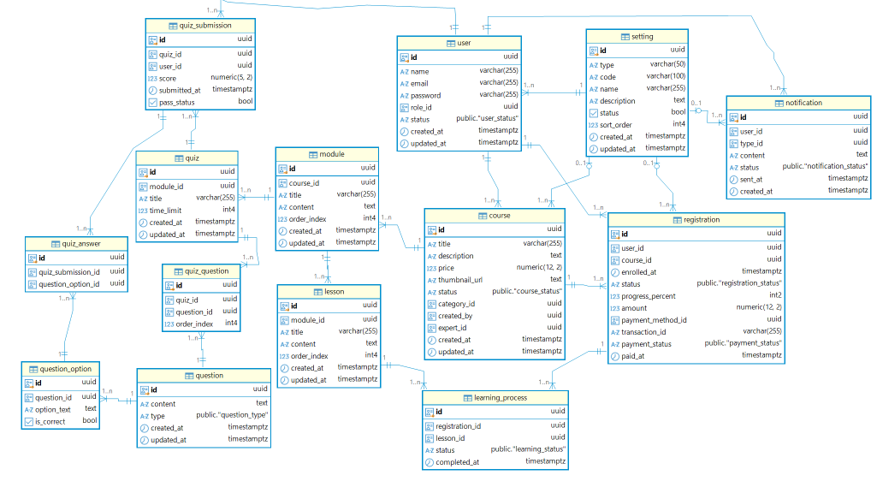

3.1 setting
Column | Constraints | Notes
id | PRIMARY KEY, DEFAULT gen_random_uuid() | Unique identifier
type | NOT NULL | Setting category such as role, category, payment_method, or notification_type
code | NOT NULL | Unique code identifying the setting
name | NOT NULL | Display name
description | NULL | Description of the setting
status | NOT NULL, DEFAULT TRUE | Indicates whether the setting is active
sort_order | NOT NULL, DEFAULT 0 | Display order
created_at | NOT NULL, DEFAULT NOW() | Creation timestamp
updated_at | NOT NULL, DEFAULT NOW() | Last update timestamp

3.2 user
Column | Constraints | Notes
id | PRIMARY KEY, DEFAULT gen_random_uuid() | Unique identifier
username | NOT NULL | User's full name
email | NOT NULL, UNIQUE | User's email address
password | NOT NULL | Encrypted/hashed password
role_id | NOT NULL, FK → setting(id) | User's role
status | NOT NULL, DEFAULT 'active' | Account status
created_at | NOT NULL, DEFAULT NOW() | Creation timestamp
updated_at | NOT NULL, DEFAULT NOW() | Last update timestamp

3.3 course
Column | Constraints | Notes
id | PRIMARY KEY, DEFAULT gen_random_uuid() | Unique identifier
title | NOT NULL | Course title
description | NULL | Course description
price | NOT NULL, DEFAULT 0 | Course price
thumbnail_url | NULL | URL of the course thumbnail
status | NOT NULL, DEFAULT 'draft' | Course status
category_id | NULL, FK → setting(id) | Course category
created_by | NOT NULL, FK → user(id) | Manager who created the course
expert_id | NULL, FK → user(id) | Expert assigned to the course
created_at | NOT NULL, DEFAULT NOW() | Creation timestamp
updated_at | NOT NULL, DEFAULT NOW() | Last update timestamp

3.4 registration
Column | Constraints | Notes
id | PRIMARY KEY, DEFAULT gen_random_uuid() | Unique identifier
user_id | NOT NULL, FK → user(id) | User who registers for the course
course_id | NOT NULL, FK → course(id) | Registered course
enrolled_at | NOT NULL, DEFAULT NOW() | Registration timestamp
status | NOT NULL, DEFAULT 'enrolled' | Registration status
progress_percent | NOT NULL, DEFAULT 0, CHECK 0–100 | Course completion percentage
amount | NOT NULL, DEFAULT 0 | Payment amount
payment_method_id | NULL, FK → setting(id) | Payment method
transaction_id | NULL | Payment transaction ID
payment_status | NOT NULL, DEFAULT 'pending' | Payment status
paid_at | NULL | Payment timestamp

3.5 module
Column | Constraints | Notes
id | PRIMARY KEY, DEFAULT gen_random_uuid() | Unique identifier
course_id | NOT NULL, FK → course(id), ON DELETE CASCADE | Course containing the module
title | NOT NULL | Module title
content | NULL | Module content or description
order_index | NOT NULL, DEFAULT 0 | Module order within the course
created_at | NOT NULL, DEFAULT NOW() | Creation timestamp
updated_at | NOT NULL, DEFAULT NOW() | Last update timestamp

3.6 lesson
Column | Constraints | Notes
id | PRIMARY KEY, DEFAULT gen_random_uuid() | Unique identifier
module_id | NOT NULL, FK → module(id), ON DELETE CASCADE | Module containing the lesson
title | NOT NULL | Lesson title
content | NULL | Lesson content
order_index | NOT NULL DEFAULT 0 | Lesson order within the module
created_at | NOT NULL, DEFAULT NOW() | Creation timestamp
updated_at | NOT NULL, DEFAULT NOW() | Last update timestamp

3.7 learning_process
Column | Constraints | Notes
id | PRIMARY KEY, DEFAULT gen_random_uuid() | Unique identifier
registration_id | NOT NULL, FK → registration(id), ON DELETE CASCADE | Registration being tracked
lesson_id | NOT NULL, FK → lesson(id) | Lesson being tracked
status | NOT NULL, DEFAULT 'not_started' | Learning status of the lesson
completed_at | NULL | Learning status of the lesson
created_at | NOT NULL, DEFAULT NOW() | Creation timestamp

3.8 quiz
Column | Constraints | Notes
id | PRIMARY KEY, DEFAULT gen_random_uuid() | Unique identifier
module_id | NOT NULL, FK → module(id), ON DELETE CASCADE | Module containing the quiz
title | NOT NULL | Quiz title
time_limit | NULL | Time limit in minutes
created_at | NOT NULL, DEFAULT NOW() | Creation timestamp
updated_at | NOT NULL, DEFAULT NOW() | Last update timestamp

3.9 question
Column | Constraints | Notes
id | PRIMARY KEY, DEFAULT gen_random_uuid() | Unique identifier
content | NOT NULL | Question context
type | NOT NULL, DEFAULT 'single_choice' | Question type
created_at | NOT NULL, DEFAULT NOW() | Creation timestamp
updated_at | NOT NULL, DEFAULT NOW() | Last update timestamp

3.10 question_option
Column | Constraints | Notes
id | PRIMARY KEY, DEFAULT gen_random_uuid() | Unique identifier
question_id | NOT NULL, FK → question(id), ON DELETE CASCADE | Question containing the option
option_text | NOT NULL | Option text
is_correct | NOT NULL, DEFAULT FALSE | Indicates whether the option is correct
updated_at | NOT NULL, DEFAULT NOW() | Last update timestamp

3.11 quiz_question
Column | Constraints | Notes
id | PRIMARY KEY, DEFAULT gen_random_uuid() | Unique identifier
quiz_id | NOT NULL, FK → quiz(id), ON DELETE CASCADE | Quiz containing the question
question_id | NOT NULL, FK → question(id) | Question included in the quiz
order_index | NOT NULL, DEFAULT 0 | Question order within the quiz

3.12 quiz_submission
Column | Constraints | Notes
id | PRIMARY KEY, DEFAULT gen_random_uuid() | Unique identifier
quiz_id | NOT NULL, FK → quiz(id) | Quiz being attempted
user_id | NOT NULL, FK → user(id) | User taking the quiz
score | NULL | Score obtained
submitted_at | NOT NULL, DEFAULT NOW() | Submission timestamp
pass_status | NULL | Indicates whether the user passed

3.13 quiz_answer
Column | Constraints | Notes
id | PRIMARY KEY, DEFAULT gen_random_uuid() | Unique identifier
quiz_submission_id | NOT NULL, FK → quiz_submission(id), ON DELETE CASCADE | Quiz attempt containing the answer
quiz_question_id | NOT NULL, FK → quiz_question(id) | Quiz question being answered
question_option_id | NOT NULL, FK → question_option(id) | Option selected by the user

3.14 notification
Column | Constraints | Notes
id | PRIMARY KEY, DEFAULT gen_random_uuid() | Unique identifier
user_id | NOT NULL, FK → user(id) | User receiving the notification
type_id | NULL, FK → setting(id) | Notification type
content | NOT NULL | Notification content
status | NOT NULL, DEFAULT 'unread' | Notification status
sent_at | NULL | Timestamp when the notification was sent
created_at | NOT NULL, DEFAULT NOW() | Creation timestamp

II. Detailed Code Design

1. User Management & User Details

1.1 Class Diagram
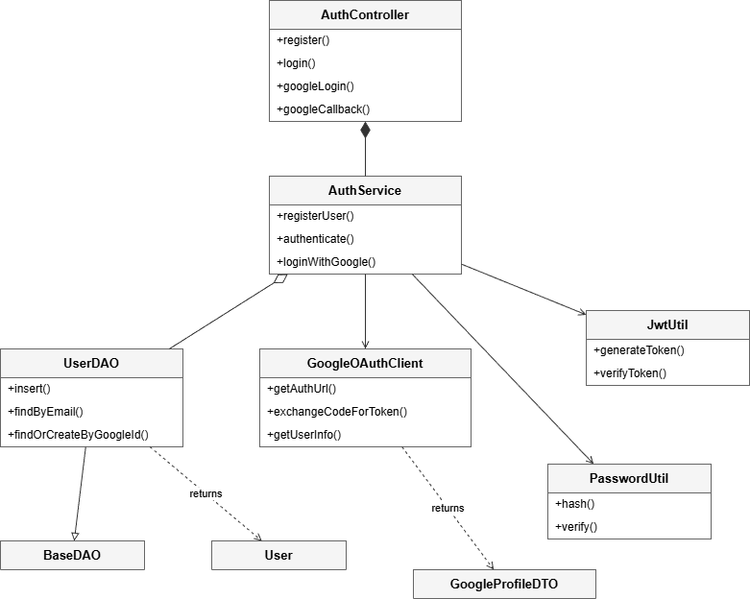

1.2 Register
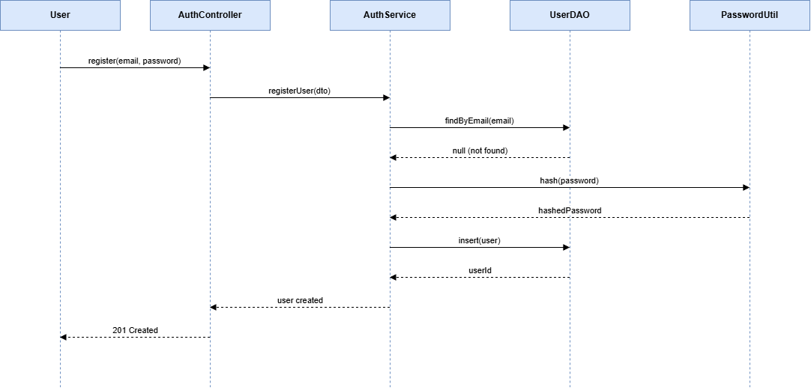

1.3 Login (email/password)

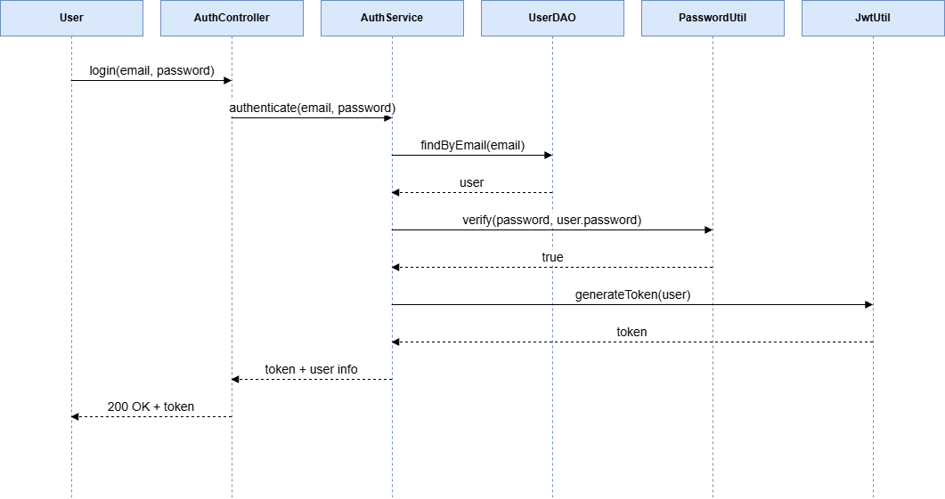

1.4 Login via Google OAuth
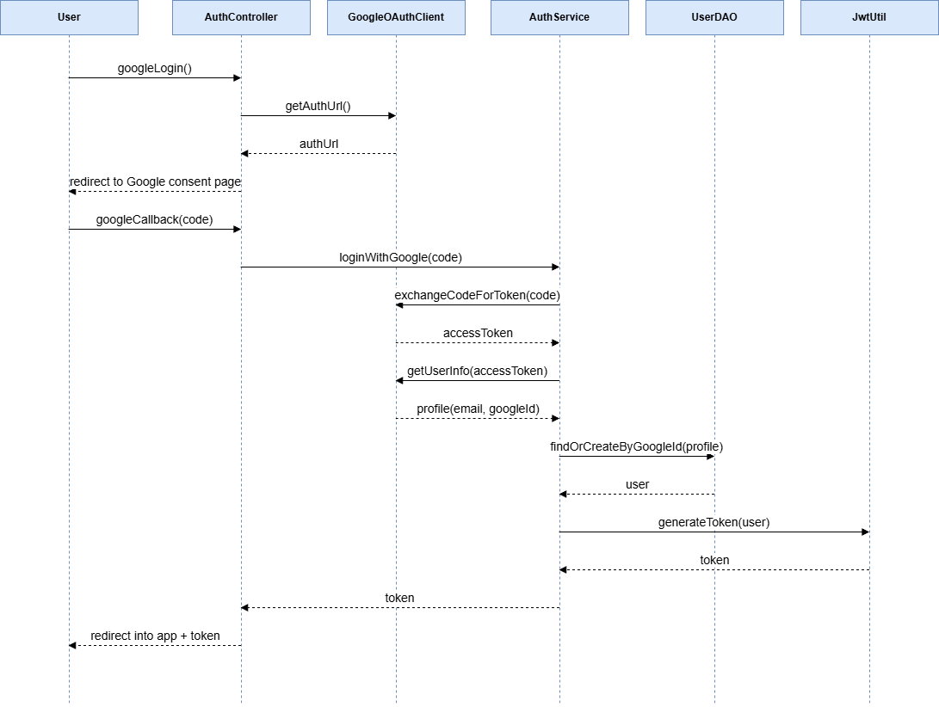

2. Enrollment & Payment

2.1 Class Diagram
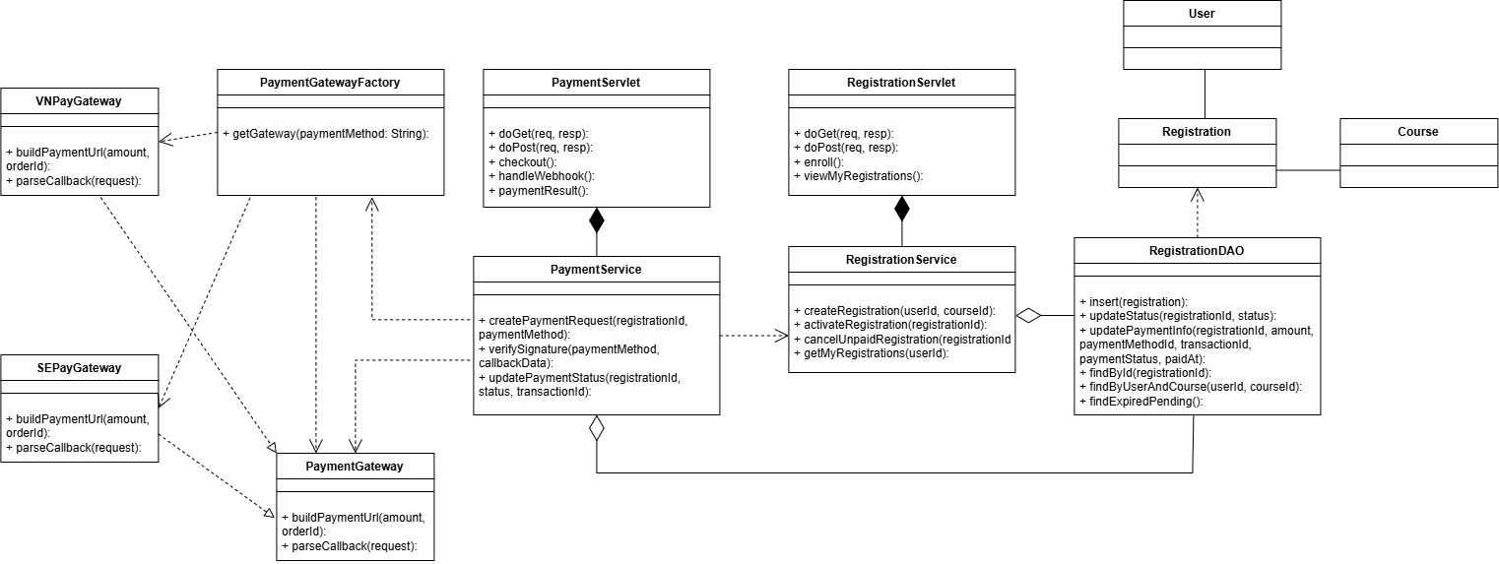

2.2 Create Enrollment & Payment
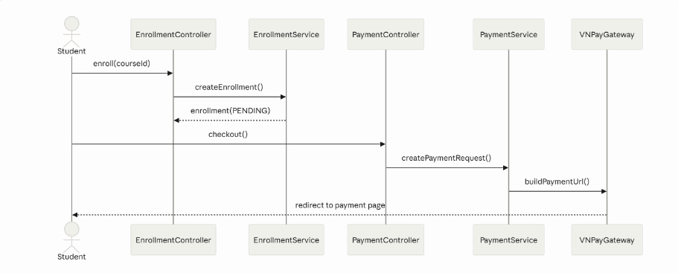

2.3 Handle Payment Webhook
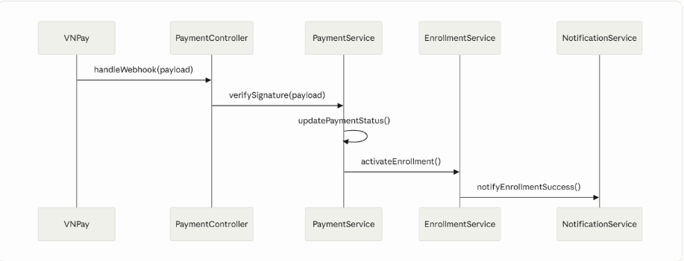

3. Lesson Management (Cloudinary)

3.1 Class Diagram
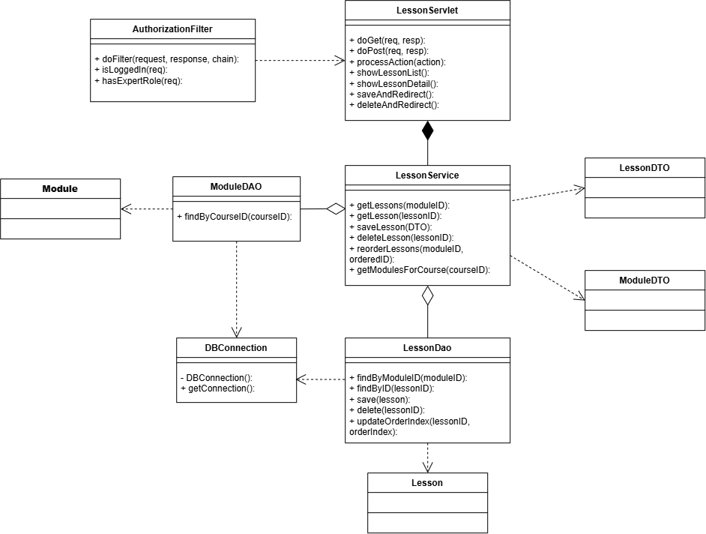

3.2 Upload Lesson Material
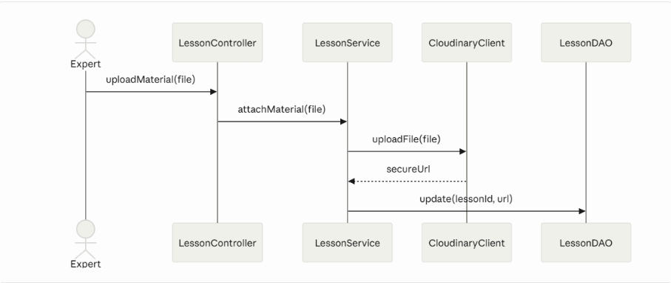

3.3 Submit & Review Content
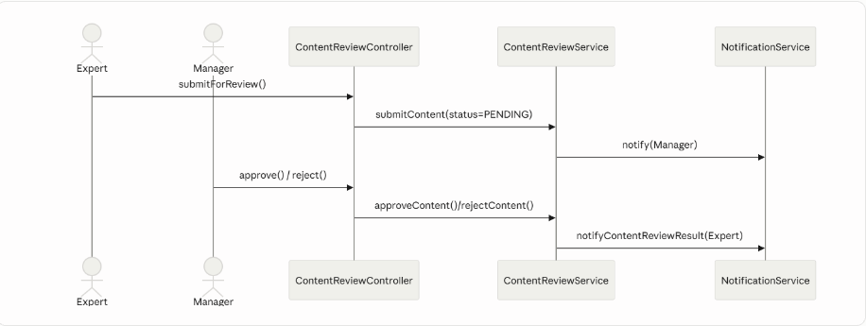

4. Quiz Submission & Scoring

4.1 Class Diagram
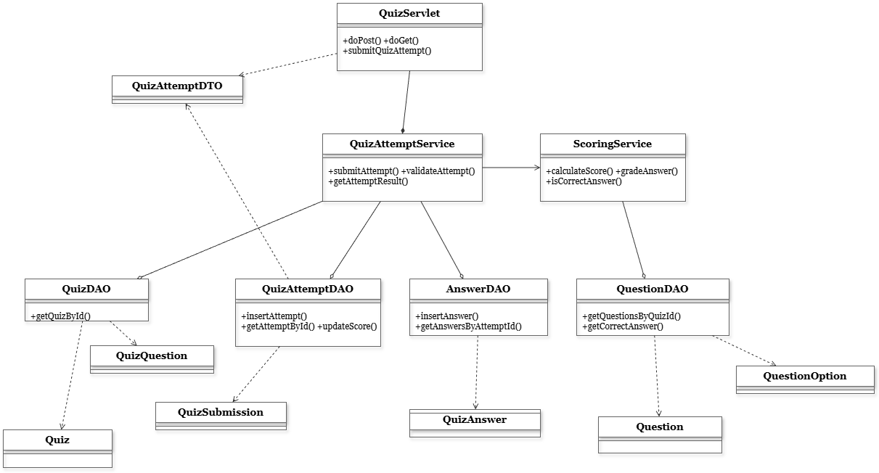

4.2 Submit Quiz Attempt & Scoring
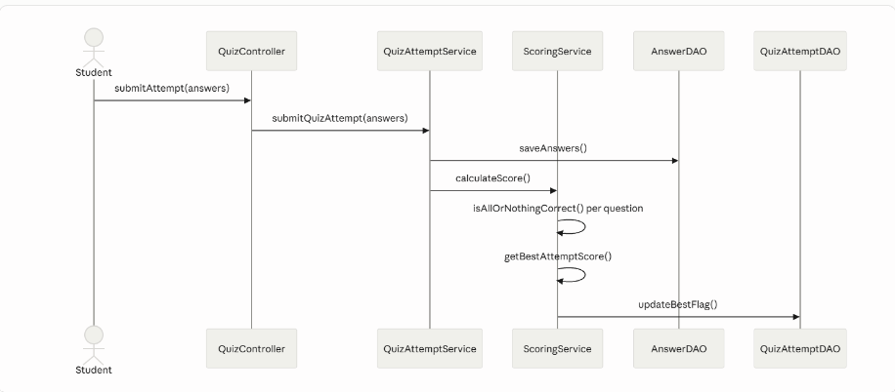

4.3 Auto-submit Expired Attempt
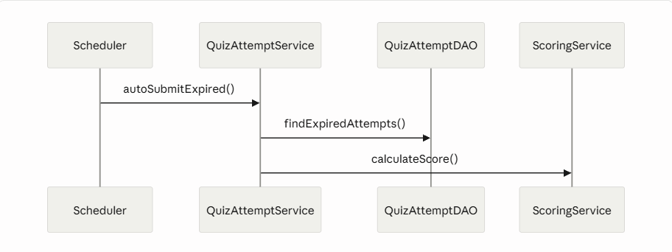

5. Lesson Learning

5.1 Class Diagram
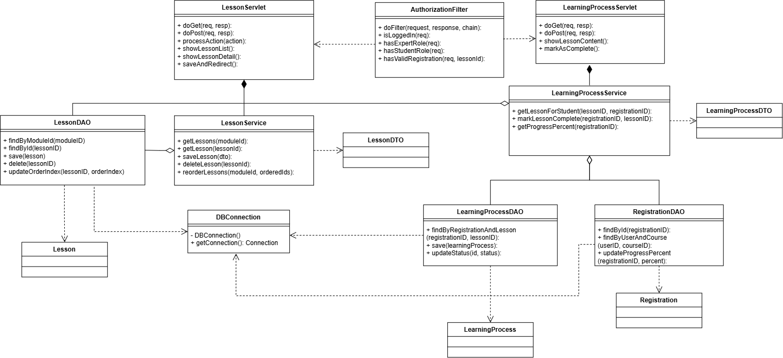

5.2 View Lesson Content
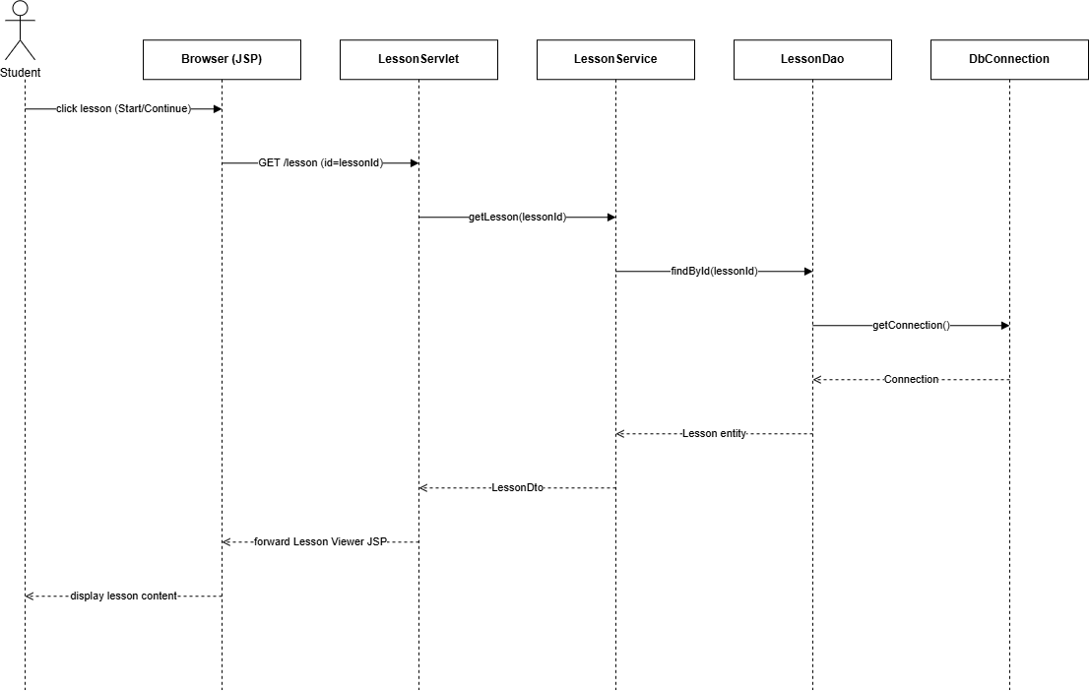

5.3 Mark Lesson Completed
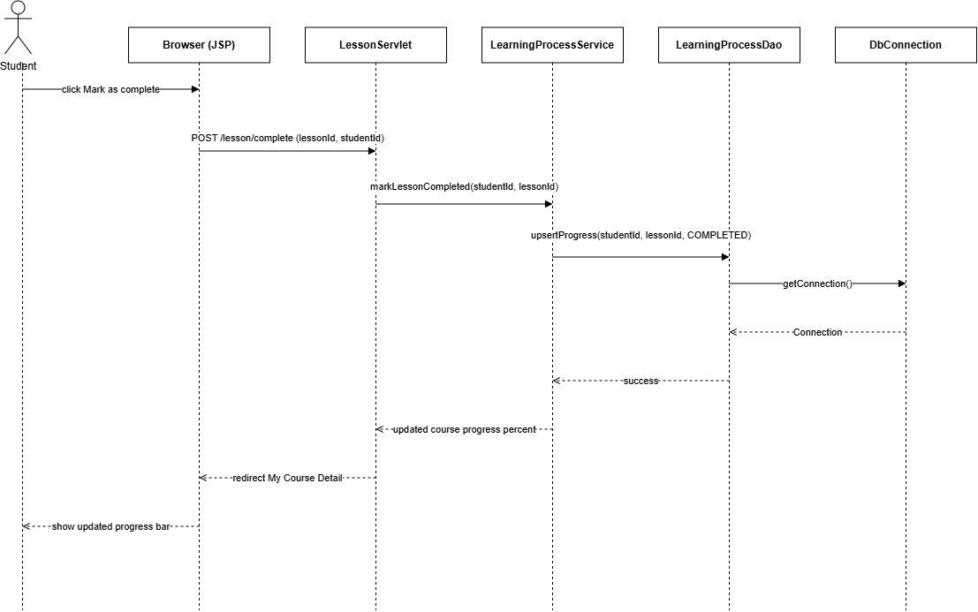

6. Course Browsing

6.1 Class Diagram
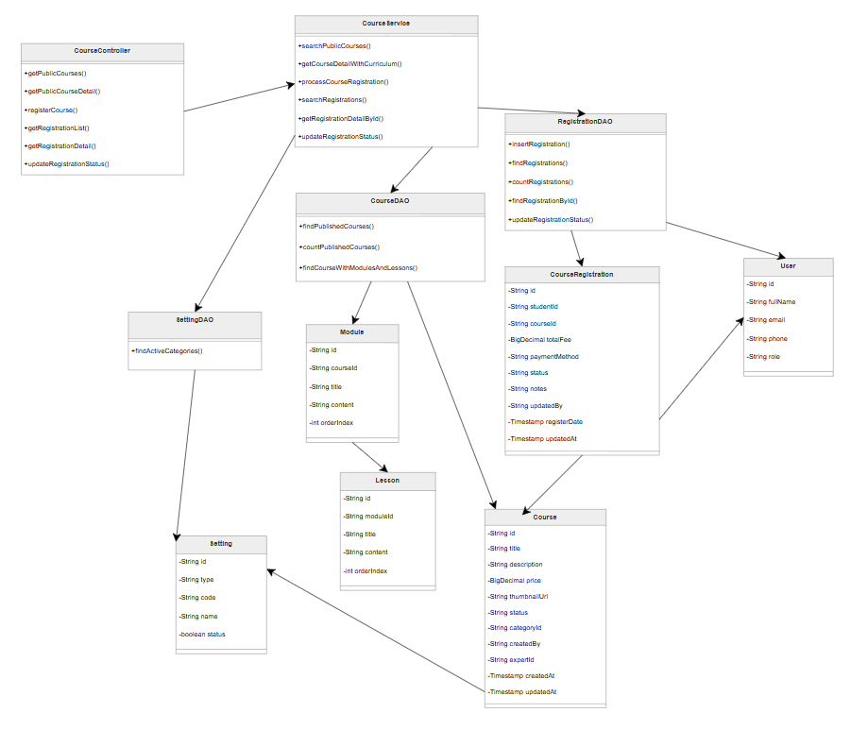

6.2 Search & View Public Course List
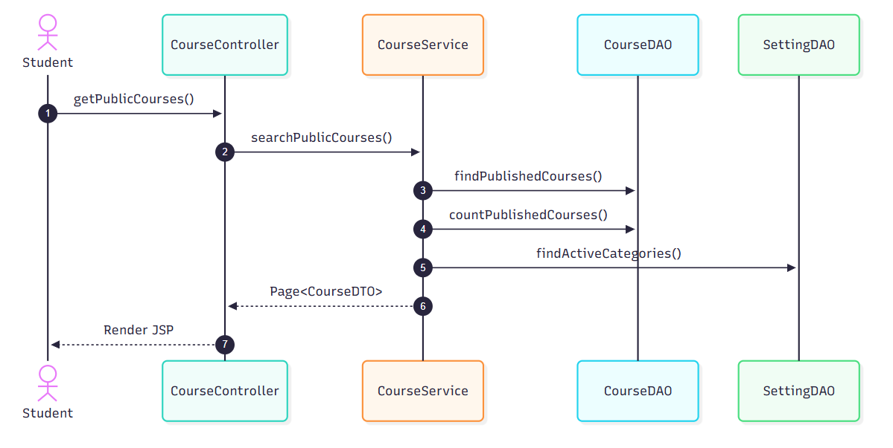

6.3 Registration List & Filter 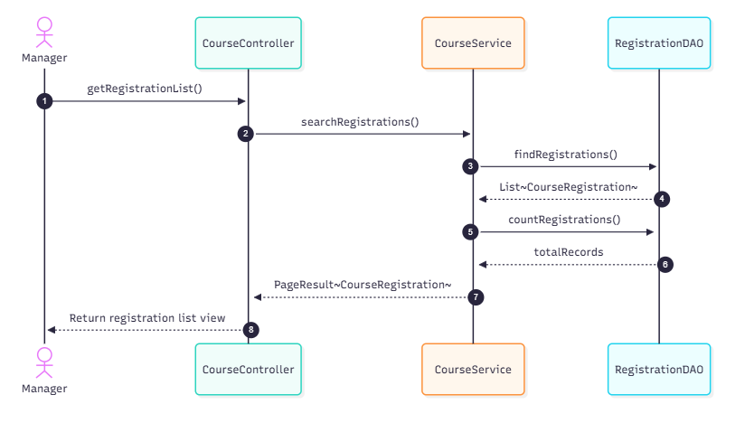

7. User Management & User Details

7.1 Class Diagram
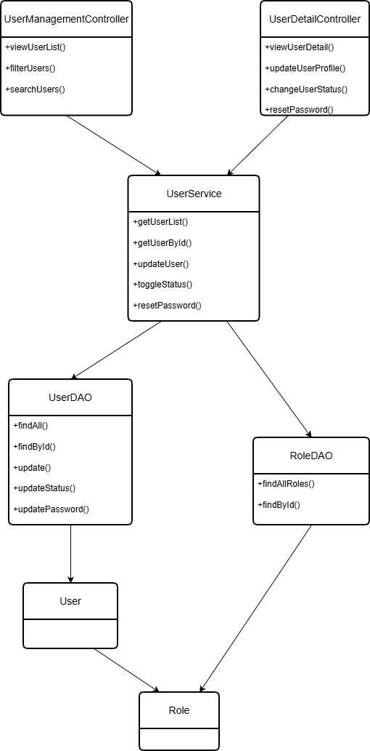

7.2 View & Filter User List
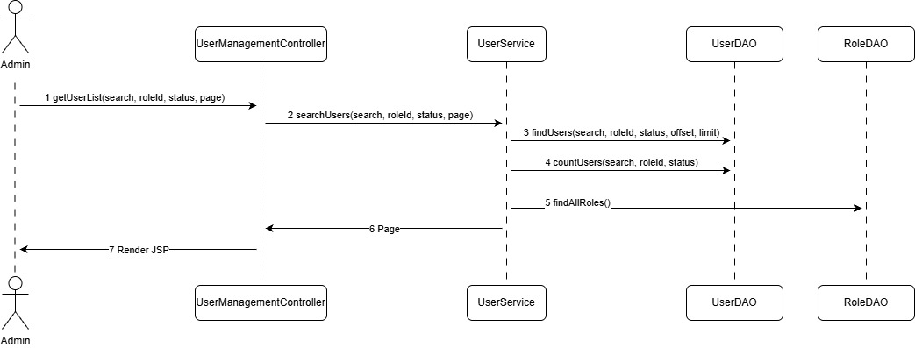

7.3 Update User Profile & Status
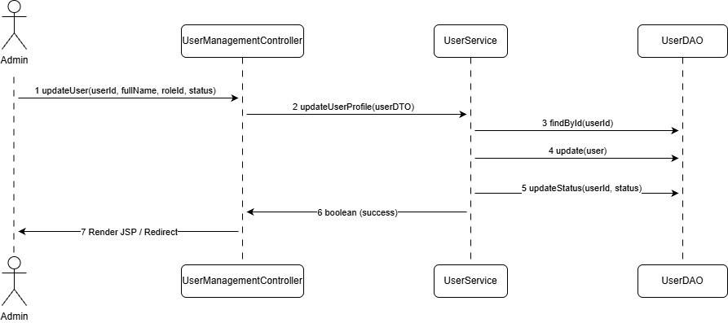

III. Other Design Specifications
[Provide any other design specifications here: algorithms, data design, system integrations, etc.]
…

