

SWP391 PROJECT REPORT
Software Requirement Specification

– Hanoi, Sep 2026 –
Table of Contents
Change Log 4
Definition and Acronyms 5
I. Overall Requirements 5
1. Context Diagram 5
2. Main Business Flow 5
2.1 Candidate Self-Service (BF-01) 5
2.2 End-to-End Recruitment (BF-02) 5
2.3 Business Flow Name (Code) 6
3. Conceptual Data Model 6
3.1 Entity Relationship Diagram 6
3.2 Entity Descriptions 7
3.3 Data Business Rules 8
4. User Requirements 8
4.1 Actors 8
4.2 Use Cases (UC) 9
4.3 Use Case Diagrams 9
4.4 Permission Matrix 10
5. System Functionalities 10
5.1 Screen Inventory 11
5.2 External API Inventory 11
5.3 Background Job Inventory 11
II. Functional Requirements 11
1. Feature Name1 12
1.1 SubFeature Name1.1 12
1.2 SubFeature Name1.2 12
2. User Authentication 12
2.1 User Register 12
2.2 User Login 12
3. System Administration 12
3.1 System Settings 12
3.2 User Management 13
4. Feature NameN 14
5. Background Job Inventory 14
5.1 Unlock Expired Locked Accounts (JOB-01) 14
5.2 Clean Up Old Audit Log Entries (JOB-02) 14
6. External API Inventory 15
6.1 HTTP Method: URL pattern (API-ID) 15
6.2 VnPay Webhook (API-02) 15
6.3 SePay Webhook (API-03) 15
III. Requirement Appendix 15
1. Business Rules 15
2. System Messages 16
3. Other Requirements 16

Change Log
Date | A*  M, D | In charge | Change Description
10/9/2026  11/9/2026  12/9/2026  17/9/2026  22/9/2026 | A  M  A  A | NguyenLD | I.3.2 Added entity descriptions for Setting and Category modules  I.4.2 Added Use Case Diagram for Expert actor  I.1 Modify ContextDiagram  II.5.1 Unlock Expired Locked Accounts (JOB-01)  II.5.2 Clean Up Old Audit Log Entries (JOB-02)  II.5.4 Send Course Reminder Emails (JOB-04)  II.5.5 Clean Up Old Activity Logs (JOB-05)  II.2.2.1 User management  II.2.2.2 User details
10/9/2026  11/9/2026  13/9/2026  19/9/2026  20/9/2026  21/9/2026 | A  A  M  M  A  A | GiangMT | I.2.1 Guest login, I.4.3.1 UCs for Guest  I.2.4 Student purchase course  I.2 Main Business Flow  I.2.1 User Authentication  I.2.2 System Administration  I.2.3 Course Registration  I.2.4 Lesson-Based Studying  I.2.5 Quiz-Based Studying  II.4.1 Student Dashboard  II.4.2 My Course Detail  II.4.3 Lesson Viewer
10/9/2026  11/9/2026  13/9/2026  16/09/2026  18/09/2026  20/09/2026 | A  M  M  M  M | KienLC | I.2.1 Added Context Diagram  I.3.1 Added Conceptual Data Model  I.5.1a Added Screen flow Diagram  I.3.1 Modified Conceptual Data Model  I.3.2 Filled Entity Descriptions table  I.3.3 Filled Data business rules  I.3.1 Modified Conceptual Data Model  I.3.2 Modified Entity Descriptions table  I.3.1 Modified Conceptual Data Model  I.3.2 Modified Entity Descriptions table  I.3.1 Modified Conceptual Data Model
10/9/2026  12/9/2026  22/09/2026 | A  M  M | ThinhCX | I.4.3.2 Added Use Case Diagram for Student actor  I.2.3 Lesson Learning and Assessment Workflow  I.5.1a Modified Screen flow diagram  I.5.1b Filled text in table screen list  I.5.2 External API Inventory  I.5.3 Background Job Inventory  I.5.1a Modified Screen flow diagram  I.6 Modified Background Job Inventory
10/9/2026  13/09/2026  22/09/2026 | A  M | HuyLDA | I.2.2 Add SwimLane for Create Course Flow  I.4.3.4 Add Use Case Diagram for mangager  I.4.3.1 Modify Guest Use Case diagram  I.4.3.2 Modify Student Use Case diagram  I.4.3.3 Modify Expert Use Case diagram  I.4.3.4 Modify Manager Use Case diagram  I.4.3.5 Modify Admin Use Case diagram  I.4.1 Complete Actor Table  I.4.2 Complete Use Case Table  I.4.4 Complete Permission Matrix  III. Complete Requirement Appendix
*A - Added M - Modified D - Deleted

Definition and Acronyms

Acronym | Definition
LHS | LearnHub System
LMS | Learning Management System
ESP | Email Service Provider

I. Overall Requirements

1. Context Diagram

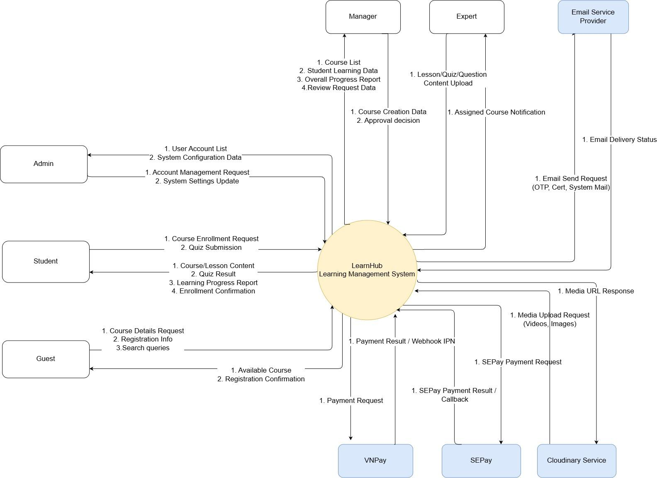

2. Main Business Flow

2.1 User Authentication (BF-01)
Trigger: User enters registration information.
End condition: User updates or views their profile information.
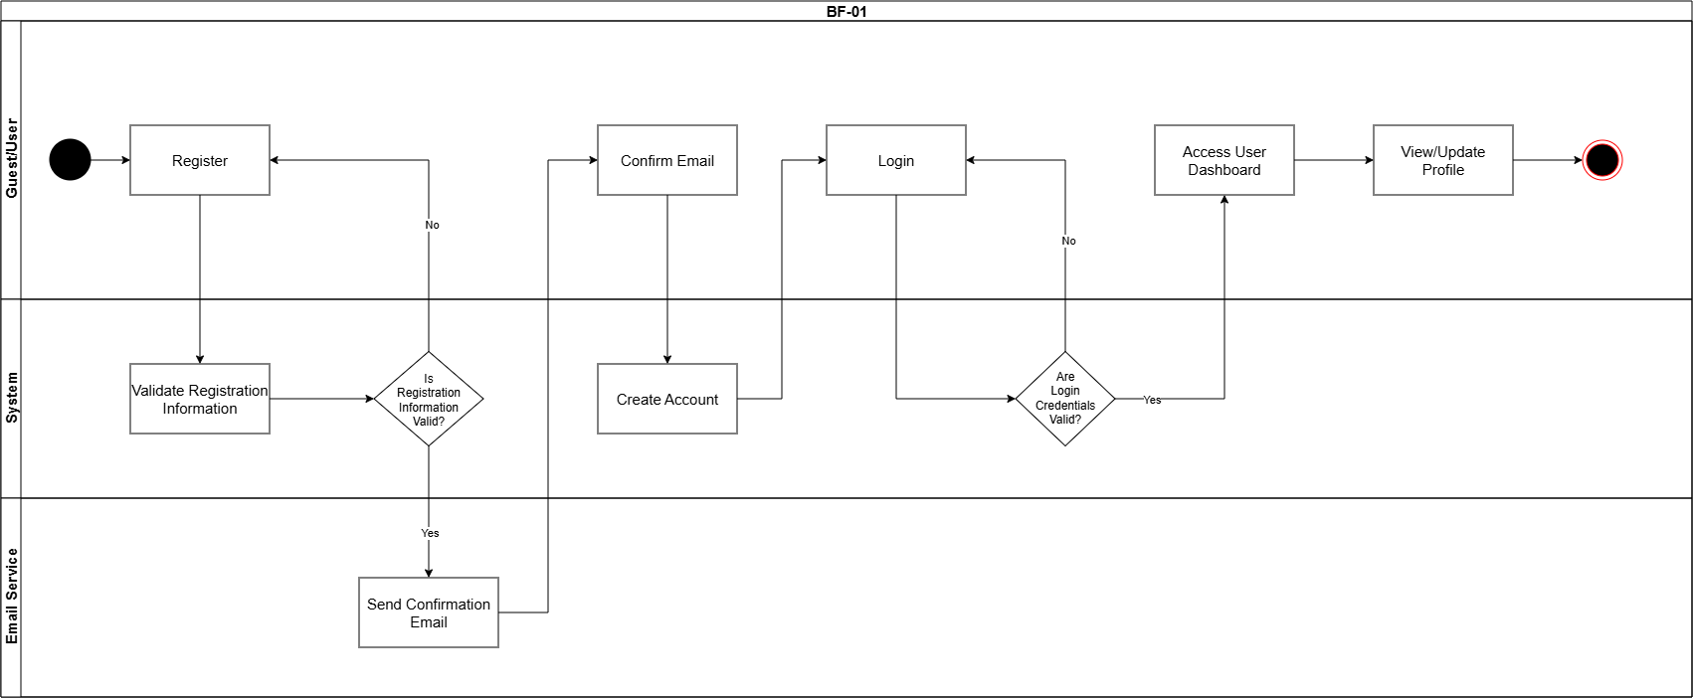

2.2 System Administration (BF-02)
Trigger: Admin access their dashboard.
End condition: Manager update course setting.
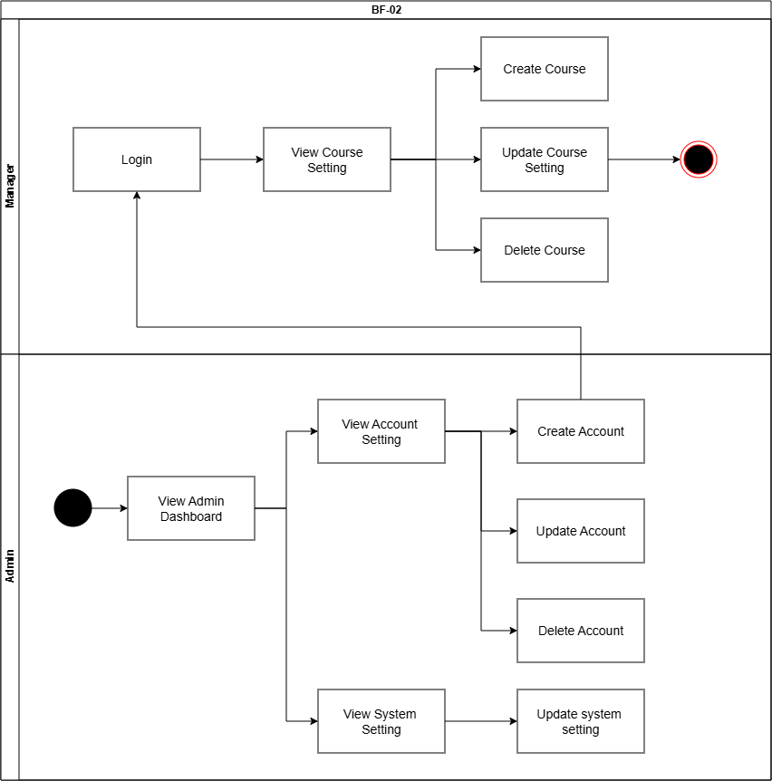

2.3 Course Registration (BF-03)
Trigger: Student view available courses.
End condition: Student view course content.
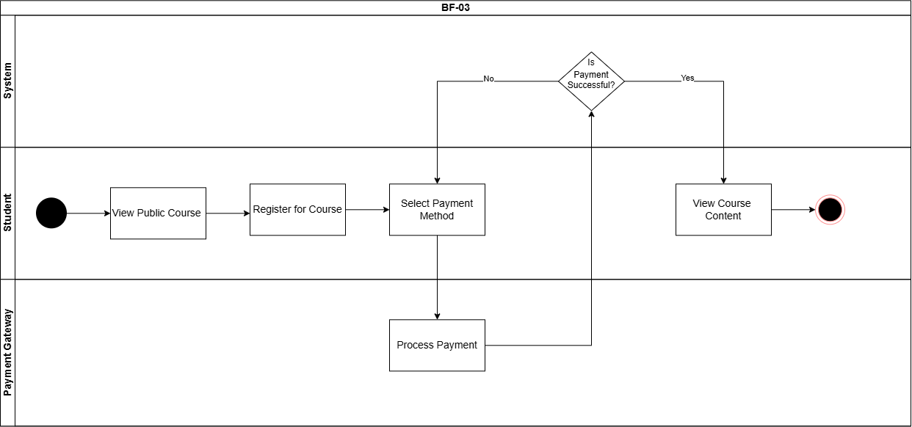

2.4 Lesson-Based Studying (BF-04)
Trigger: Expert creates or updates new lesson content.
End condition: System update study progress.
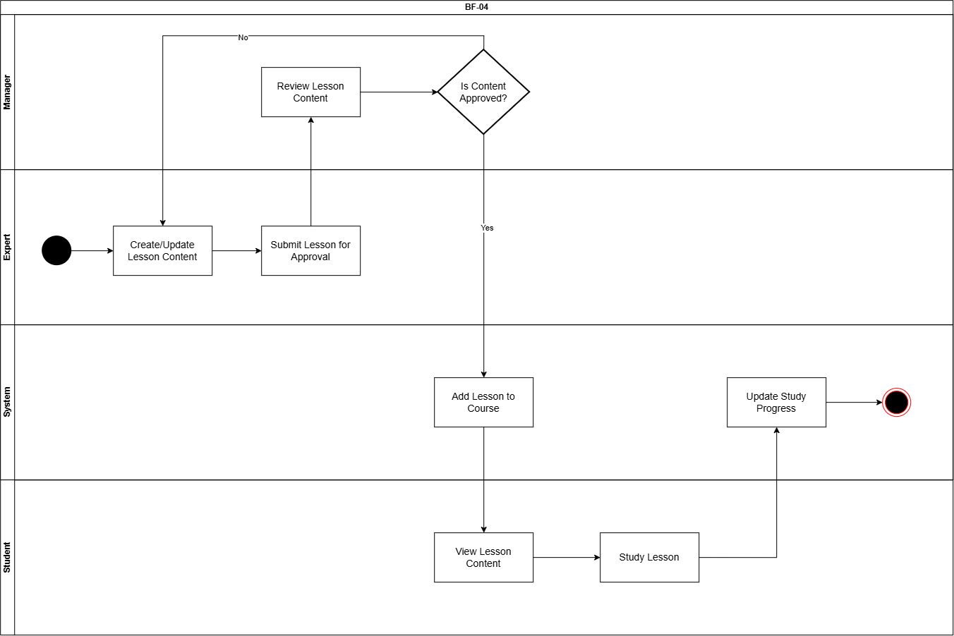

2.5 Quiz-Based Studying (BF-05)
Trigger: Expert creates or updates new quiz content.
End condition: System update study progress.
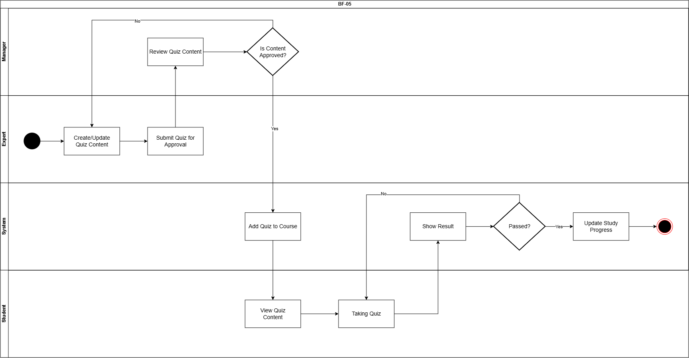

3. Conceptual Data Model

3.1 Entity Relationship Diagram

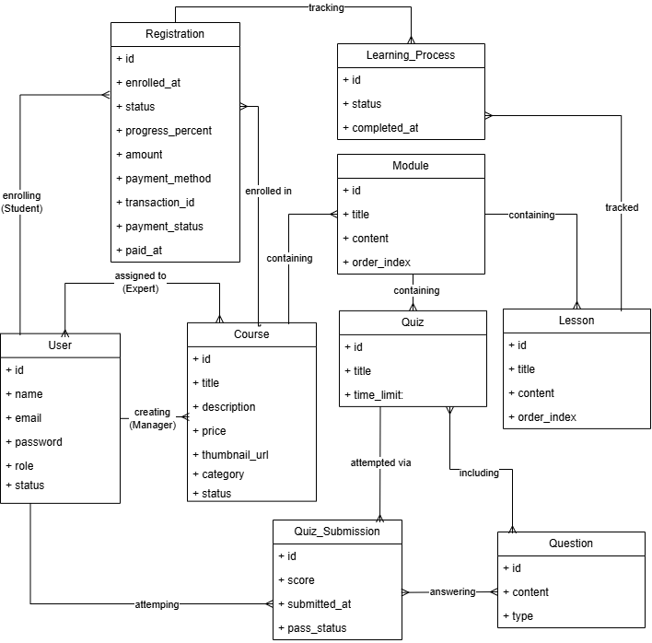

id | title | content | order_index | status | complete_at
1 | Bài 1 | oop | 1 | completed | 22/09
2 | Bài 2 | Abstract | 2

id | registation_id | lesson_id | status | completed_at
1 | 2 | 2 | Completed

3.2 Entity Descriptions
Entity: User
Field | Value
Purpose | Every person with an account in the system, regardless of role.
Key business attributes | Full name, email address, password, role (Admin / Manager / Expert / Student), account status
Business identity | Email unique across the entire system
Status / lifecycle | Active (normal) · Locked (deactivated by Admin — cannot sign in, but historical data is preserved)

Entity: Course
Field | Value
Purpose | A learning course created and managed by a Manager, made up of Modules and Lessons; may be free or paid.
Key business attributes | Title, description, price, thumbnail URL, status
Business identity | No natural uniqueness beyond system id — two courses may share the same title
Status / lifecycle | Draft (not visible to Guest/Student) → Published (visible, enrollable) → Unpublished (hidden again, existing Enrollments unaffected)

Entity: Module
Field | Value
Purpose | A chapter that groups a set of related Lessons within a Course, giving long courses a organized structure.
Key business attributes | Title, display order (order_index)
Business identity | Display order unique within the same Course
Status / lifecycle | Inherits visibility from its parent Course — no independent lifecycle

Entity: Lesson
Field | Value
Purpose | A single learning unit (text and image content) that a Student reads within a Module.
Key business attributes | Title, content (text/HTML), display order (order_index)
Business identity | Display order unique within the same Module
Status / lifecycle | Inherits visibility from its parent Course/Module — no independent lifecycle

Entity: Quiz
Field | Value
Purpose | A test that can be attached at one of three levels: after a Lesson, after a Module (review), or at the end of a Course (final).
Key business attributes | Title, time limit, scope (lesson / module / course)
Business identity | No uniqueness constraint — a Lesson, Module, or Course may each have multiple Quizzes (e.g. several short quizzes within the same lesson).
Status / lifecycle | None — availability follows its parent Lesson/Module/Course

Entity: Question
Field | Value
Purpose | A single question stored in the shared question bank, reusable across multiple Quizzes.
Key business attributes | Question content, question type (e.g. multiple choice)
Business identity | No uniqueness constraint — duplicate wording is allowed
Status / lifecycle | None

Entity: Registration
Field | Value
Purpose | Records that a Student has registered for a Course, and tracks the payment for that registration (amount, method, transaction, payment status). Access is permanent — there is no expiry date.
Key business attributes | Enrollment date, status, progress percent, amount, payment method, transaction id, payment status, paid at
Business identity | Enrollment date, status, progress percent, amount, payment method, transaction id, payment status, paid at
Status / lifecycle | Enrollment status: Active (studying) → Completed (auto-updated by the system once completion conditions are met) · Cancelled. Payment status: Unpaid → Paid → Refunded (independent lifecycle from enrollment status — e.g. a registration can be Cancelled while payment status remains Refunded)

Entity: Quiz_Submission
Field | Value
Purpose | Records one instance of a Student taking a Quiz. A Student may attempt the same Quiz multiple times.
Key business attributes | Score, submission timestamp
Business identity | No uniqueness constraint — multiple attempts per (student, quiz) are allowed and each is stored separately
Status / lifecycle | In progress → Submitted (scored)

Entity: Learning_Process
Field | Value
Purpose | Tracks a Student's completion status for each individual Lesson, within the context of one Enrollment.
Key business attributes | Status, completion timestamp
Business identity | Combination of (enrollment, lesson) must be unique — one progress record per lesson per enrollment
Status / lifecycle | Not started → In progress → Completed

3.3 Data Business Rules

Rule | Description | Enforced On
Unique username | Email address must be unique across the entire system; used as the login identifier. | User
Single role per user | A user account holds exactly one role at a time (Admin / Manager / Expert / Student); the system does not support multiple simultaneous roles. | User
Role/status change restricted | Only an Admin can change another user's role or account status (active/locked); users cannot modify their own role. | User
Locked account behavior | A `locked` account cannot sign in, but all related data (Enrollments, Payments, etc.) is preserved, not deleted. | User
Single owner per course | Each Course has exactly one Manager (`manager_id`), though it may have multiple assigned Experts. | Course
Free course skips payment | A Course with `price = 0` is free; enrolling in it does not trigger the payment flow. | Course, Payment
No duplicate expert assignment | The combination of (course, expert) must be unique in Course_Expert — the same Expert cannot be assigned twice to the same Course. | Course_Expert
Unique lesson order | The display order (`order_index`) of a Lesson must be unique within its parent Module. | Lesson
Reusable question bank | A Question is stored independently and can be linked to multiple Quizzes via Quiz_Question; editing a Question affects every Quiz that includes it. | Question, Quiz_Question
At least one correct option | Every Question must have at least one Question_Option with `is_correct = true`. | Question_Option
Quiz scope consistency | A Quiz's `scope` value (lesson / module / course) must match exactly one populated reference (`lesson_id`, `module_id`, or `course_id`); the other two must be null. Enforced at the application level, not by a database constraint. | Quiz
No enrollment expiry | Enrollment represents a one-time, permanent purchase — there is no expiry date or renewal concept. | Enrollment
No duplicate enrollment | The combination of (student, course) must be unique in Enrollment — a Student cannot enroll in the same Course twice. | Enrollment
Auto-computed progress | Progress is not stored as a static field; it is calculated in real time from the related Learning_Process records (completed lessons ÷ total lessons). | Enrollment, Learning_Process
Auto status transition | Enrollment.status changes from `active` to `completed` automatically once all completion conditions are met — never set manually by a Student or Manager. | Enrollment
One progress record per lesson | The combination of (enrollment, lesson) must be unique in Learning_Process — one progress entry per Lesson per Enrollment. | Learning_Process
Multiple quiz attempts allowed | A Student may attempt the same Quiz more than once; each attempt is stored as a separate Quiz_Submission record. | Quiz_Submission
Auto-calculated score and update pass status | Quiz_Submission.score is computed by the system from the related Quiz_Answer records and check pass condition, never entered manually. | Quiz_Submission
One answer per question per attempt | The combination of (attempt, question) must be unique in Quiz_Answer — a Student selects only one option per question within a single attempt. | Quiz_Answer
Payment confirmed by gateway only | A Payment is marked `success` only after receiving confirmation from the payment gateway (VNPay or SePay callback); the system never marks it successful on its own. | Payment
No duplicate transaction processing | The combination of (payment_method, transaction_id) must be unique — prevents processing the same gateway callback twice. | Payment
Enrollment follows successful payment | For a paid Course, the Enrollment record is created only after the related Payment reaches `success` status; for a free Course, Enrollment is created immediately. | Payment, Enrollment
System-generated notifications | A Notification is created automatically by the system when a relevant event occurs (e.g. course completion, payment result); users cannot create notifications manually. | Notification

4. User Requirements

4.1 Actors
# | Actor | Description
1 | Guest | An unauthenticated user who can access public pages of the system (homepage, list of published courses) and self-register an account to become a Student.
2 | Student | A user who owns an account (self-registered or created by Admin) and can register for courses, take lessons, take quizzes, and track their own learning progress. Student generalizes all use cases of Guest.
3 | Manager | The actor who owns and operates the course lifecycle: creating courses, assigning an Expert to build content, reviewing content before publishing, and tracking the learning progress of students in the courses under their management.
4 | Expert | The actor responsible for building learning content (lessons, modules/chapters, question banks) for courses assigned by the Manager, and for tracking student progress within the courses they are responsible for.
5 | Admin | The actor with the highest level of authority, responsible for managing all user accounts (Manager, Expert, Student) and configuring general system settings.

4.2 Use Cases (UC)
ID | Use Case | Feature | Use Case Description
01 | HomePage | Navigation | Guests access the system's homepage to view a general introduction and navigate to other public features.
02 | View Public Course | Course Browsing | Guest views the list of published courses that are displayed publicly without needing to log in.
03 | View Course Details | Course Browsing | Guest views detailed information of a specific course (title, description, category, lesson outline); detailed content inside the course (videos, materials, quiz questions) is not accessible
04 | Register Account | Account Management | Guest self-registers a new account by entering information (full name, email, password); the system temporarily stores the information and sends a confirmation email before creating the official account
05 | Login | Account Management | Guest who already has an account (created beforehand by Admin) logs into the system instead of registering a new one
06 | Reset Password | Account Management | Student requests a password reset when forgotten; the system sends a confirmation link/code via email.
07 | Register Course | Course Enrollment | Student registers to join a published course in order to begin learning.
08 | Pay Fee | Course Enrollment | Student pays the course fee (if the course is paid) before the enrollment is confirmed. (<<include>> of Register Course)
09 | View Course Content | Learning | Student opens a course they have enrolled in to start learning; this acts as an entry point before performing specific learning activities inside the course.
10 | View Lesson | Learning | Student views/studies the content of a specific lesson within the course. (<<extend>> of View Course Content)
11 | Take Quiz | Learning | Student takes a quiz associated with a lesson or a course. (<<extend>> of View Course Content)
12 | View Course Progress | Learning | Student views their own learning progress within a course (number of completed lessons, quiz scores). (<<extend>> of View Course Content)
13 | Create Course | Course Management | Manager creates a new course (name, description, category); the course is created in Draft status.
14 | Edit Course Info | Course Management | Manager edits the information of an existing course.
15 | Publish/Unpublish Course | Course Management | Manager publishes a course so it becomes visible and available for Student registration, or removes it from the public list.
16 | Assign Expert to Course | Course Management | Manager assigns an Expert to be responsible for building the content of a course.
17 | Review Course | Course Management | Manager reviews and evaluates the content (lessons, quizzes) built by the Expert before the course is published.
18 | View Enrollment List | Progress Tracking | Manager views the list of students who have registered for a specific course. (<<extend>> of Track Learning Progress)
19 | Upload Lesson Material | Content Development | Expert uploads documents and video lectures for the assigned course.
20 | Add/Edit Module & Chapters | Content Development | Expert creates or edits the module/chapter structure of a course.
21 | Submit Course Content | Content Development | Expert submits completed content (lessons, quizzes) for the Manager to review and approve.
22 | Create Question Bank | Content Development | Expert builds a bank of questions to be used for the course's quizzes.
23 | Create/Edit Account | Account Management | Admin creates a new account or edits the information of an existing account for Manager, Expert, or Student.
24 | Manage Account | Account Management | Admin locks or unlocks a user account to control system access.
25 | Change Account Role | Account Management | Admin changes the role of an existing account.
26 | Change System Setting | System Configuration | Admin configures the system's general settings (course categories, email templates, etc.).
…

4.3 Use Case Diagrams

4.3.1 UCs for Guest
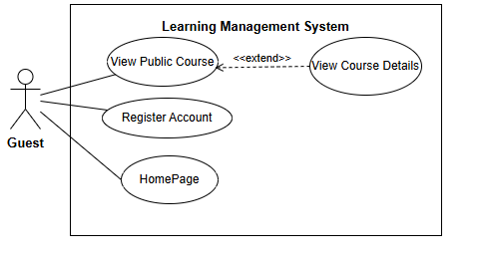

4.3.2 UCs for Student
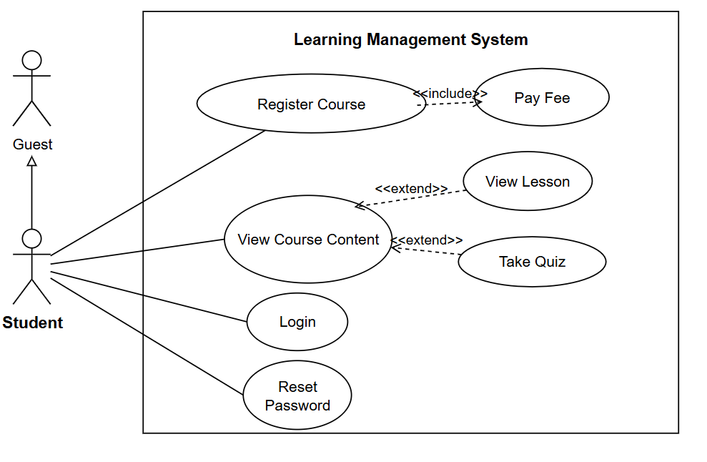

4.3.3 UCs for Expert
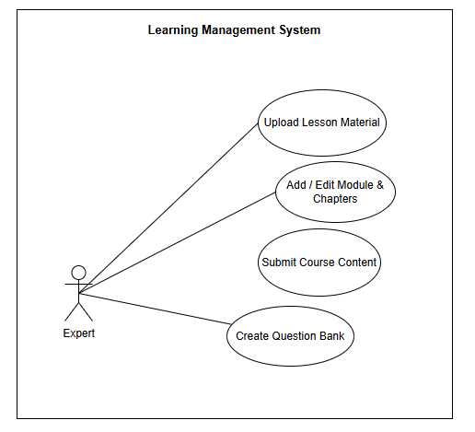
4.3.4 UCs for Manager

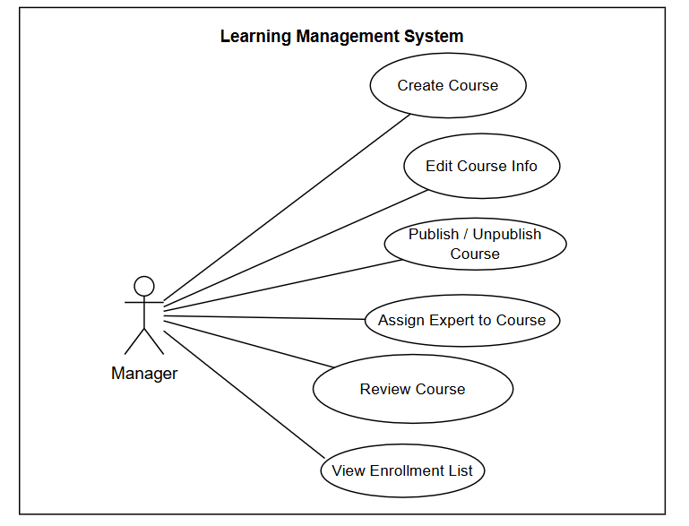

4.3.5 UCs for Admin
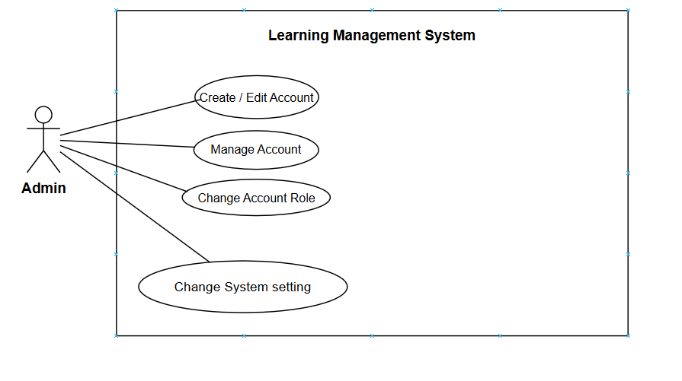

4.4 Permission Matrix
Full = unrestricted · Restricted = conditions apply (see footnotes) · No = denied

Entity | Action | Guest | Student | Manager | Expert | Admin
Homepage / Public Pages | View | Full | Full | Full | Full | Full
Public Course | View list | Full | Full | Full | Full | Full
Public Course | View details (info only, no locked content) | Full | Full | Full | Full | Full
Account | Self-register (creates Student account) | Full | No | No | No | No
Account | Login | No | Full | Full | Full | Full
Account | Reset own password | No | Full | Full | Full | Full
Account | Create (Manager / Expert / Student) | No | No | No | No | Full
Account | Edit info | No | No | No | No | Full
Account | Lock / Unlock | No | No | No | No | Full
Account | Change role | No | No | No | No | Full
Course | Create | No | No | Full | No | No
Course | Edit info | No | No | Full | No | No
Course | Publish / Unpublish | No | No | Full | No | No
Course | Assign Expert | No | No | Full | No | No
Course | Review content | No | No | Full | No | No
Course enrollment | Register (enroll) | No | Full | No | No | No
Course enrollment | Pay fee | No | Full | No | No | No
Course content | View (lessons) | No | Restricted | Restricted | Restricted | No
Quiz | Take quiz | No | Restricted | No | No | No
Learning progress | View own progress | No | Full | No | No | No
Learning progress | View enrollment list / completion rate | No | No | Full | Restricted | No
Lesson material | Upload | No | No | No | Restricted | No
Module / Chapter | Add / Edit | No | No | No | Restricted | No
Course content | Submit for review | No | No | No | Restricted | No
Question bank | Create | No | No | No | Restricted | No
Student progress report | Export | No | No | No | Restricted | No
System setting | Change | No | No | No | No | Full

5. System Functionalities

5.1 Screen Inventory

a. Screen Flow
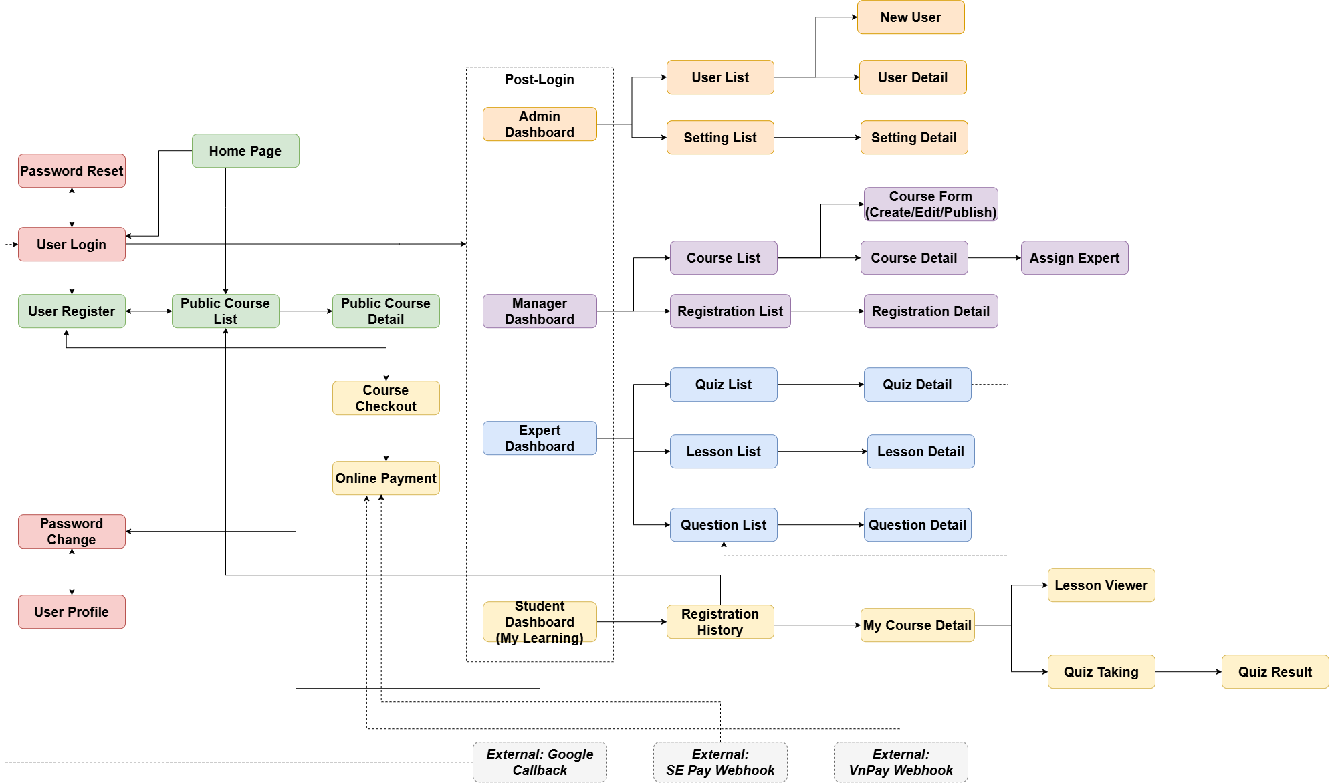

b. Screen List

# | Screen Name | Feature | Description
1 | Home Page | Authentication | Landing page for all visitors; lets Guests browse to Public Course List or go to Sign In
2 | Sign In | Authentication | Allows any user to authenticate and reach their role-specific dashboard (supports email/password and Google sign-in)
3 | User Register | Authentication | Allows a new Guest to create a Student account
4 | Password Reset | Authentication | Allows a user who forgot their password to reset it via email (sent through Gmail/MailTrap)
5 | Password Change | Authentication | Allows a logged-in user to change their current password
6 | User Profile | Authentication | Allows a logged-in user to view and edit their personal information
7 | Public Course List | Course Registration | Allows Guests to browse all publicly available courses
8 | Public Course Detail | Course Registration | Shows full course information and a Register action for Guests
9 | Course Checkout | Course Registration | Lets Student review the selected course and initiate payment before enrollment is confirmed
10 | Online Payment | Course Registration | Processes payment via SE Pay or VnPay and shows the transaction outcome (success or failure)
11 | Registration History | Course Registration | Lists all courses the Student has enrolled in and their payment status
12 | Admin Dashboard | System Administration | Central hub for Admin to manage accounts and system settings
13 | User List | System Administration | Lets Admin view and search all system accounts
14 | New User | System Administration | Lets Admin create a new account directly (any role)
15 | User Detail | System Administration | Shows and edits detailed profile/role/status of one account
16 | Setting List | System Administration | Lets Admin view and manage system master data/configuration
17 | Setting Detail | System Administration | Shows and edits one configuration item's details
18 | Manager Dashboard | Course Management | Central hub for Manager to manage courses, experts, and registrations
19 | Course List | Course Management | Lets Manager view all courses in the system
20 | Course Form | Course Management | Allows Manager to create, edit, or publish/unpublish a course
21 | Course Detail | Course Management | Shows full course info and lets Manager delete the course or assign an Expert
22 | Assign Expert | Course Management | Lets Manager assign one or more Experts to work on a course's content
23 | Registration List | Course Management | Lets Manager view all student course registrations (read-only — registration is automatic once payment is completed)
24 | Registration Detail | Course Management | Shows one registration's details
25 | Expert Dashboard | Lesson-Based Studying | Central hub for Expert to author lessons, questions, and quizzes
26 | Lesson List | Lesson-Based Studying | Shows all lessons the Expert has authored, across courses
27 | Lesson Detail | Lesson-Based Studying | Allows Expert to create, view, or edit lesson content
28 | Student Dashboard (My Learning) | Lesson-Based Studying | Central hub for Student to access enrolled courses and progress
29 | My Course Detail | Lesson-Based Studying | Shows the lesson list and progress for one enrolled course
30 | Lesson Viewer | Lesson-Based Studying | Displays lesson content for the Student to study
31 | Question List | Quiz-Based Studying | Shows all questions the Expert has authored in the shared question bank
32 | Question Detail | Quiz-Based Studying | Allows Expert to create or edit a question in the question bank
33 | Quiz List | Quiz-Based Studying | Shows all quizzes the Expert has authored
34 | Quiz Detail | Quiz-Based Studying | Allows Expert to set a quiz's passing grade, time limit, and select questions from the Question Bank to include
35 | Quiz Taking | Quiz-Based Studying | Lets Student answer quiz questions within a time limit; retakes are allowed
36 | Quiz Result | Quiz-Based Studying | Shows the score of this attempt and the Student's current best score (highest score is kept as final grade)
37 | Google Callback | External Integration | Handles the OAuth redirect from Google after social sign-in
38 | SePay Webhook | External Integration | Receives payment confirmation callbacks from SE Pay
39 | VnPay Webhook | External Integration | Receives payment confirmation callbacks from VnPay

5.2 External API Inventory
# | API Name | Calling Path | Description
1 | Google OAuth API | LearnHub → Google Identity Service | Allows users to sign in with their Google account instead of creating a new password
2 | Payment Gateway API | LearnHub → SE Pay / VnPay | Creates a payment request when a Student registers for a paid course
3 | Payment Webhook (IPN) | SE Pay/VnPay → LearnHub | Notifies LearnHub when a payment transaction succeeds or fails, so the enrollment status can be updated
4 | Email Sending API | LearnHub → Gmail SMTP / MailTrap | Sends system emails such as password reset links and course registration confirmations

5.3 Background Job Inventory

# | Job Name | Group | Description
1 | Cancel unpaid registrations | Scheduled | Every 15 minutes — cancels course enrollment that remain unpaid past the checkout deadline
2 | Auto-submit expired quiz attempts | Delayed Job | Automatically submits the quiz exactly when the time limit expires. A delayed job is created at the exact moment the user starts the quiz attempt.
3 | Send course reminder emails | Scheduled | Weekly — reminds Students to finish lessons they haven't completed
4 | Unlock expired locked accounts | Scheduled | Every 15 minutes — automatically unlocks user accounts that were temporarily locked by Admin once their lock duration has expired

II. Functional Requirements

1. User Authentication

1.1. Account Access
1.1.1. User Register
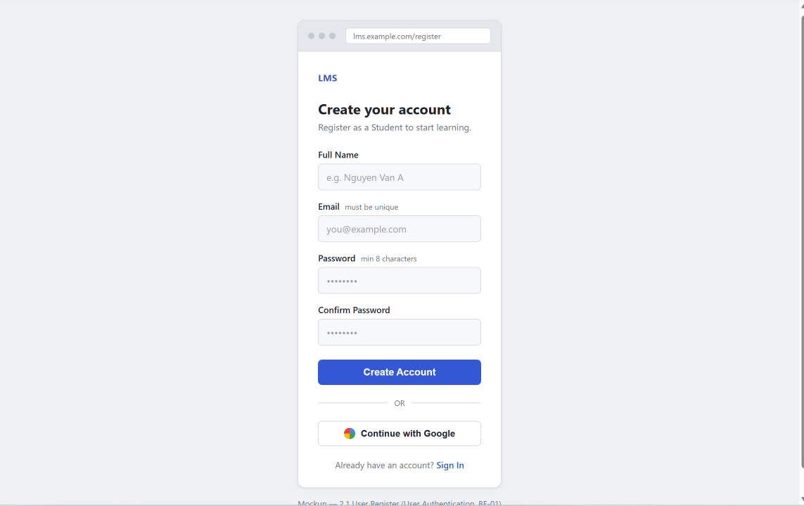
This screen allows the Guest to:
- Register Account: create a new Student account by entering personal information and a password.
Field Description
Field Name | Description
Full Name | Data type: string, max length of 50 characters
Email | Data type: string, valid email format, max length of 100 characters, must be unique in system
Password | Data type: string, min length of 8 characters, must contain at least 1 letter and 1 number
Confirm Password | Must match the value entered in the Password field

1.1.2. User Login
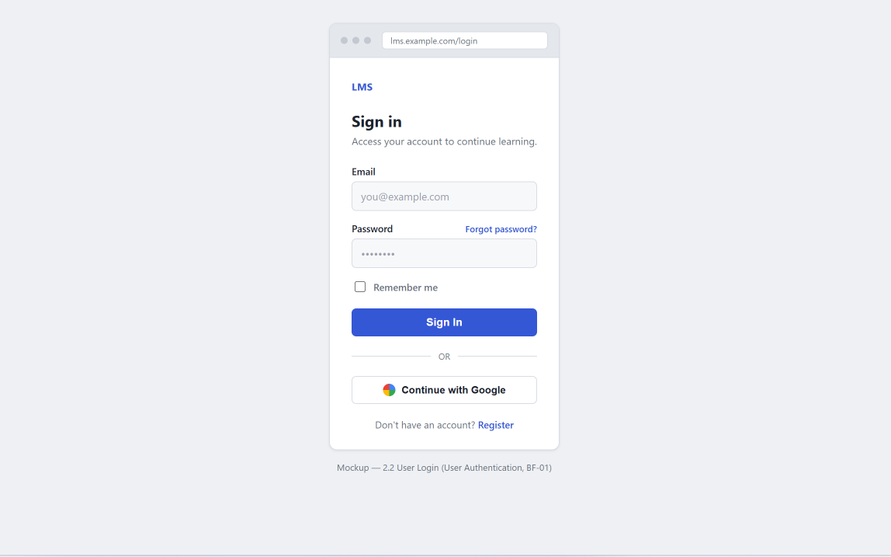
This screen allows any user to:
- Sign In: authenticate using registered email and password to reach their role-specific area.
- Sign In with Google: authenticate using an existing Google account.
On the screen, s/he can also:
- Remember Login: keep the session active for a longer period.
- Go to Password Reset: navigate to the Password Reset screen if the password is forgotten.
Field Description
Field Name | Description
Email | Data type: string, must be a registered account’s email
Password | Data type: string, min length of 8 characters
Remember me | Checkbox, unchecked by default
Forgot password | Link, navigates to the Password Reset screen

1.2. Account Security
1.2.1. Password Reset
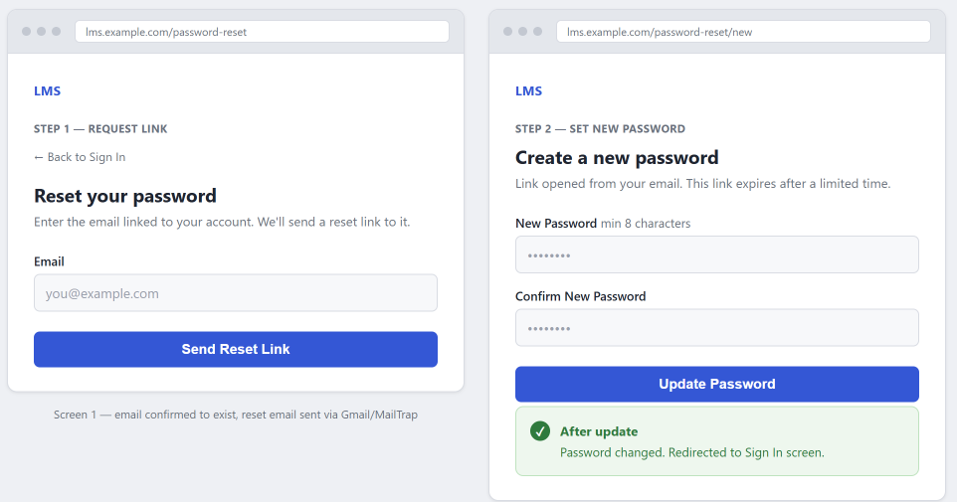
This screen allows a user who forgot their password to:
- Request Reset Link: enter their registered email to receive a password reset link (sent via Gmail/MailTrap).
Field Description
Field Name | Description
Email | Data type: string, valid email format, must belong to an existing account
New Password | Data type: string, min length of 8 characters
Confirm New Password | Confirm new password must be same new password

1.2.2. Password Change
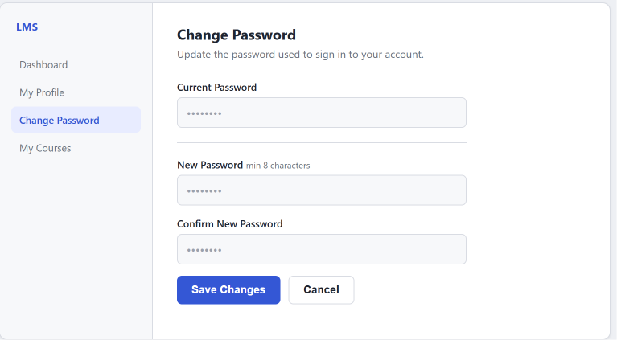
This screen allows a logged-in user to:
- Change Password: update their current password to a new one.
Field Description
Field Name | Description
Current Password | Data type: string, must match the user's current password
New Password | Data type: string, min length of 8 characters, must contain at least 1 letter and 1 number, must be different from Current Password
Confirm New Password | Must match the value entered in the New Password field

2. System Administration (Nguyên)
2.1. User Management
2.1.1 User List
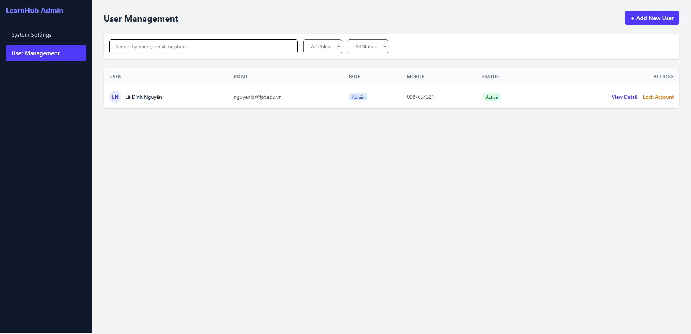

This screen allows the Administrator to:
- View User List: view list of registered user accounts in the system.
- Filter User List: filter users by roles (Student, Expert, Admin) and account statuses (Active, Locked).
- Search Users: enter keyword(s) to search users by their full name, email, or phone number.
- Sort User List: sort user list (ascending, descending) by clicking column headers.
On the screen, s/he can also:
- Activate/Deactivate Setting: change status of a specific inactive/active master data.
- Choose to go to the Setting Details screens for adding new or updating an existing master data by clicking the New Setting or Edit link.
Field Description
Field Name | Description
(1) | Initial values: All Roles, Student, Expert, Admin (default value “All Roles”).  Hover the mouse to show the field name: “User Role”.
(2) | Initial values: All Statuses, Active, Locked (default value “All Statuses”).  Hover the mouse to show the field name: “Account Status”.
(3) | The action is Lock or Unlock depending on the current status of the target user account (Active or Locked, respectively).

2.1.2 User Details
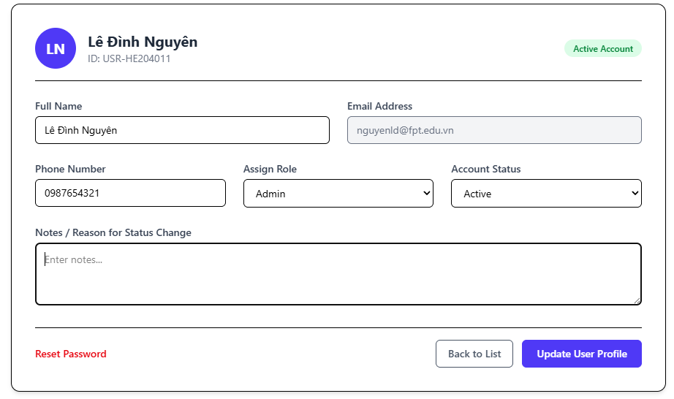

This screen allows the Administrator to:
- View User Profile: view comprehensive details of a user account including personal information, contact info, and current role.
- Update User Profile: update user personal information, phone number, and assign user roles.
- Change Account Status: toggle account status between Active and Locked with optional administrative notes.
On the screen, s/he can also:
- Reset Password: trigger a password reset request or issue a temporary password to the user via email.
- Save Profile Changes: submit updated user profile details to the database.
- Back to List: cancel changes and navigate back to the User List screen.
Field Description
Field Name | Description
Full Name | Text input field displaying and allowing edits to the user's full name.
Email Address | Read-only field displaying the unique registered email address of the user.
Assign Role | Dropdown list to select and reassign user authorization role (Student, Expert, Admin).
Account Status | Dropdown selection to set account state (Active, Locked).

3. Course Registration (Huy)

3.1 Course Browsing

3.1.1 Public Course List
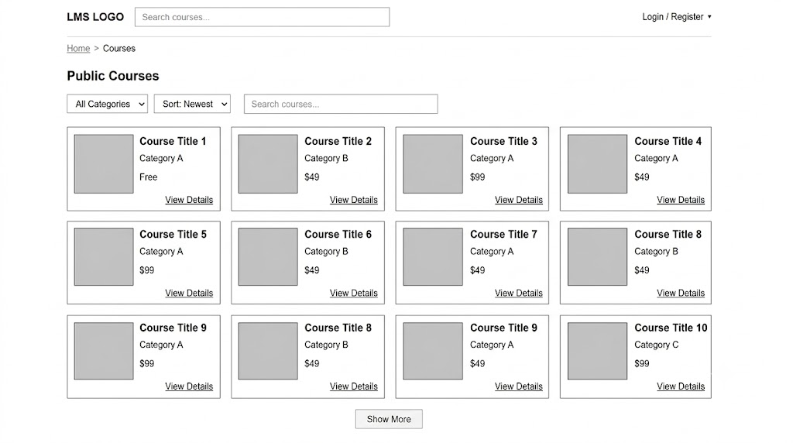
This screen allows Guests and Students to:
- View Public Course List: View all published courses available on the platform.
- Search Courses: Enter keyword(s) in the search bar to find courses by title.
- Filter Courses: Filter the displayed course list by category.
- Sort Courses: Sort courses by criteria such as Newest, Price (Low to High), or Price (High to Low).
On the screen, s/he can also:
- View Course Details: Click "View Details" or click on a course card to navigate to the Public Course Detail screen.
- Register / Enroll: Click "Register" on a course card to initiate the enrollment flow.

Field Name | Description
Search Bar | Data type: string. Initial value: empty, placeholder "Search courses...". Searches courses by title.
Category Filter | Dropdown list. Initial value: "All Categories". Displays active course categories
Sort By | Dropdown list. Initial value: "Newest". Options: Newest, Most Popular, Price: Low to High, Price: High to Low.
Course Card | Displays summary details for each course: Thumbnail Image, Title, Category, Price, and Instructor/Expert Name.
View Details (Button/Link) | Navigates the user to the Public Course Detail screen for the selected course.
Register (Button) | Navigates the user to the course registration/checkout flow (requires login if Guest).

3.1.2 Public Course Detail
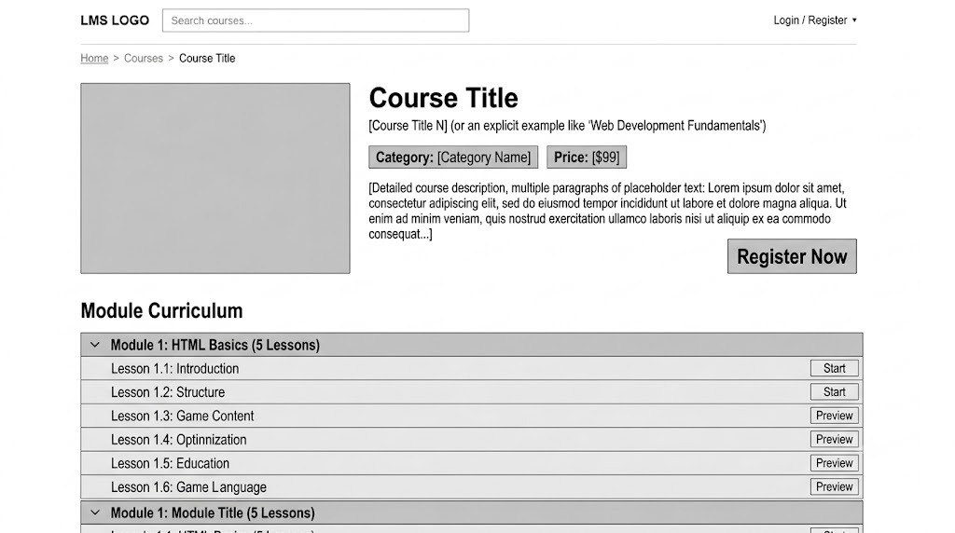
This screen allows Guests and Students to:
- View Course Overview: View comprehensive information about the course including title, full description, category, total duration, price, and thumbnail.
- View Course Curriculum Outline: Browse the list of modules and lesson titles included in the course (detailed content such as videos and quiz questions remain locked/inaccessible).
On the screen, s/he can also:
- Register Course: Click "Register Now" / "Enroll Now" to join the course (initiates payment if the course is paid).
- Navigate Back: Click "Back to Courses" or breadcrumb to return to the Public Course List screen.

Field Name | Description
Course Title | Data type: string. Displays the full title of the course.
Category Badge | Displays the category/subject tag assigned to the course.
Price Tag | Displays the course price (e.g., "$49" or "Free").
Course Description | Data type: text/HTML. Displays detailed introduction, learning objectives, and prerequisites.
Thumbnail Image | Image element. Displays the representative thumbnail URL of the course.
Module List (Curriculum) | Accordion list showing module titles and the nested list of lesson titles with display order.
Register Now (Button) | Action trigger: If user is Guest, redirects to Login/Register; if Student, opens Payment Checkout or confirms free enrollment.

3.2 Registration Management

3.2.1 Registration List
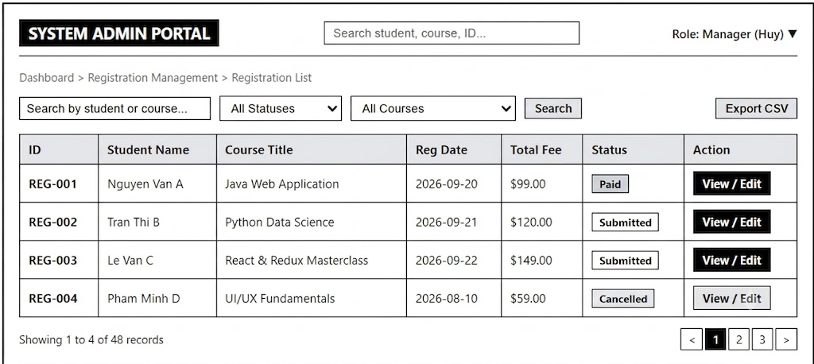
This screen allows Managers to:
- View Registration List: View all course registration/enrollment records in the system.
- Search Registrations: Search registrations by Student Name, Student Email, or Course Title.
- Filter Registrations: Filter the list by Status (e.g., Submitted, Approved, Cancelled, Paid) or Category.
- Sort Registrations: Sort records by Registration Date (Newest/Oldest), Total Fee, or Status.
On the screen, s/he can also:
- View Registration Detail: Click "View" / "Details" on a registration row to navigate to the Registration Detail screen.
- Update Status: Change status directly or approve/cancel pending registration requests.

Field Name | Description
Search Bar | Data type: string. Initial value: empty, placeholder "Search by student name, email, course...".
Status Filter | Dropdown list. Initial value: "All Statuses". Options: All, Submitted, Approved, Paid, Cancelled.
Category / Course Filter | Dropdown list. Initial value: "All Courses". Filters registrations by specific course.
Registration Table | Table container. Columns: ID, Student Name, Course Title, Registration Date, Total Fee, Status, Action.
Status Badge | Label. Displays current status with colored indicators (e.g., Green for Paid, Yellow for Submitted).
View Details (Button/Link) | Navigates the user to the Registration Detail screen for the selected registration record.

3.2.1 Registration Detail
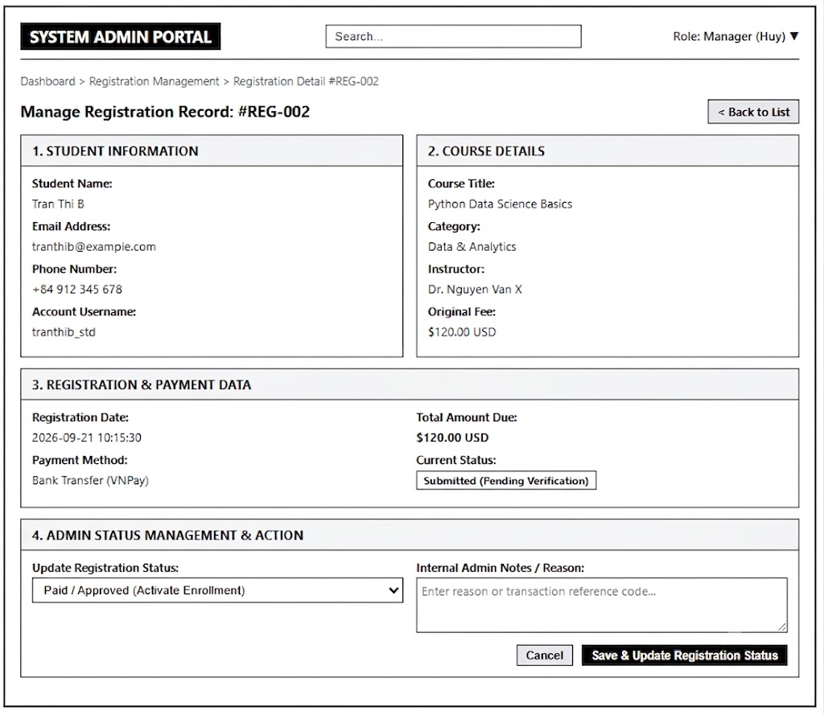
This screen allows Managers to:
- View Detailed Information: Review full registration information including Student Info, Course Info, Payment Details, and Status History.
- Update Registration Status: Modify the status of the registration (e.g., mark as Paid, Approve, Cancel).
- Notes / Comments: Add internal notes or reasons when changing status (e.g., reason for cancellation).
On the screen, s/he can also:
- Save / Update: Save changes made to the registration status or notes.
- Back to List: Click "Back" to return to the Registration List screen.

Field Name | Description
Registration ID | Data type: string. Read-only field displaying unique identifier.
Student Info | Read-only section: Full Name, Email, Phone Number, Account Username.
Course Info | Read-only section: Course Title, Category, Instructor Name, Original Price.
Registration Date | Data type: datetime. Read-only field showing when the registration was created.
Total Fee | Data type: number. Final amount calculated for this registration.
Payment Status / Status | Dropdown list. Allows updating status: Submitted, Approved, Paid, Cancelled.
Notes / Remarks | Data type: text (textarea). Optional field for staff to enter notes or reasons for status change.
Save Changes (Button) | Updates the registration record in the database and shows a success notification.
Back (Button/Link) | Navigates back to the Registration List screen.

4. Lesson Learning (Giang)

4.1 Student Dashboard
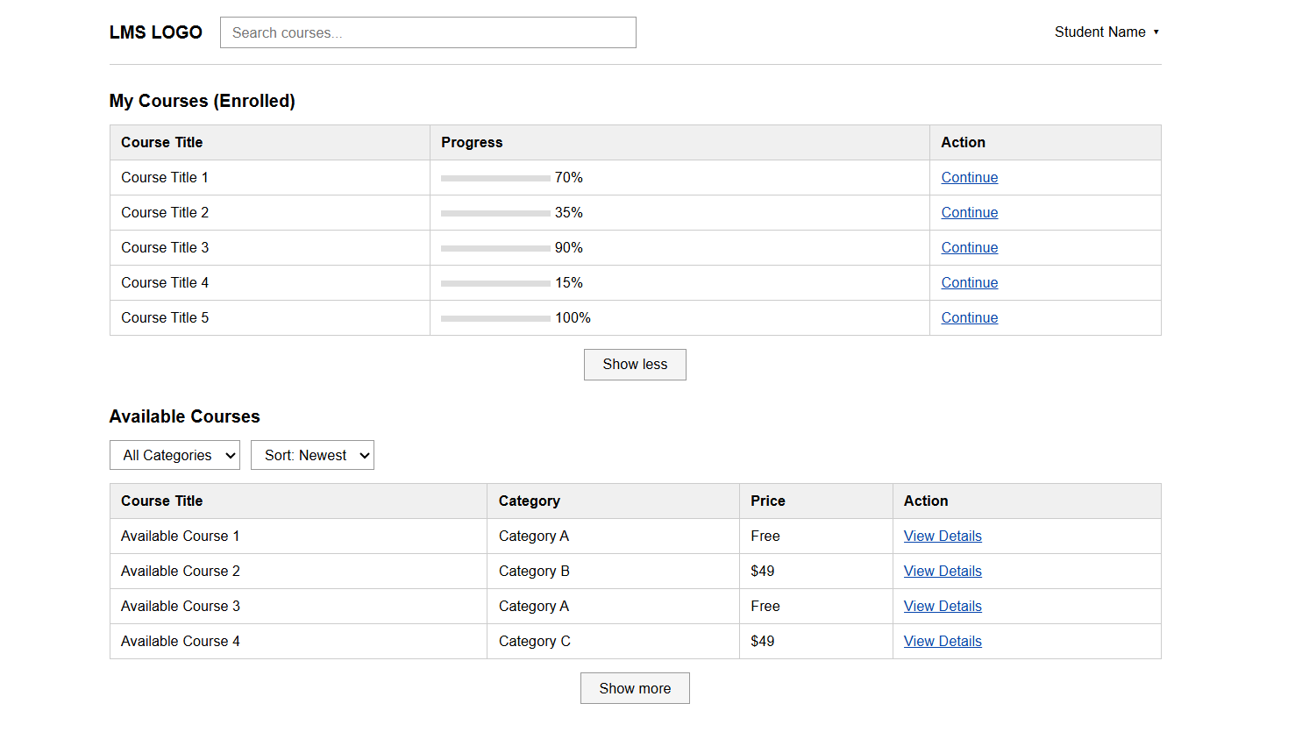
This screen allows the Student to:
- View Enrolled Course List: view the list of courses the Student is currently enrolled in ("My Courses"), each with a progress indicator.
- View Available Course List: view the list of published courses the Student has not yet enrolled in ("Available Courses").
- Search Course: enter keyword(s) to search for courses by title.
- Filter Available Courses: filter the "Available Courses" list by category.
- Sort Available Courses: sort the "Available Courses" list by a selected criterion.
On the screen, s/he can also:
- Continue Learning: click "Continue" on an enrolled course to jump directly to the last accessed lesson of that course.
- View Course Details: click "View Details" on an available course to go to the Public Course Detail screen before enrolling.
- Expand/Collapse Course List: click "Show more" to reveal additional courses within the same section; click "Show less" to collapse the list back to its initial state.
Field Description
Field Name | Description
Search Bar | Initial value: empty, placeholder "Search courses...".  Searches by course title across both "My Courses" and "Available Courses" sections.
Category Filter | Initial value: "All Categories" (default).  Applies to the "Available Courses" list only.
Sort By | Initial value: "Newest" (default).  Other options: Most Popular, Price (Low to High), Price (High to Low).
Continue | The destination lesson depends on the Student's learning history for that course: if no lesson has been started yet, it opens the first lesson; otherwise, it opens the most recently accessed lesson.
View Details | Navigates to the Public Course Detail screen of the selected course, allowing the Student to review full course information before enrolling.
Show more/ Show less | Toggles the display of additional courses within the same list (expand/collapse in place).

4.2 My Course Detail
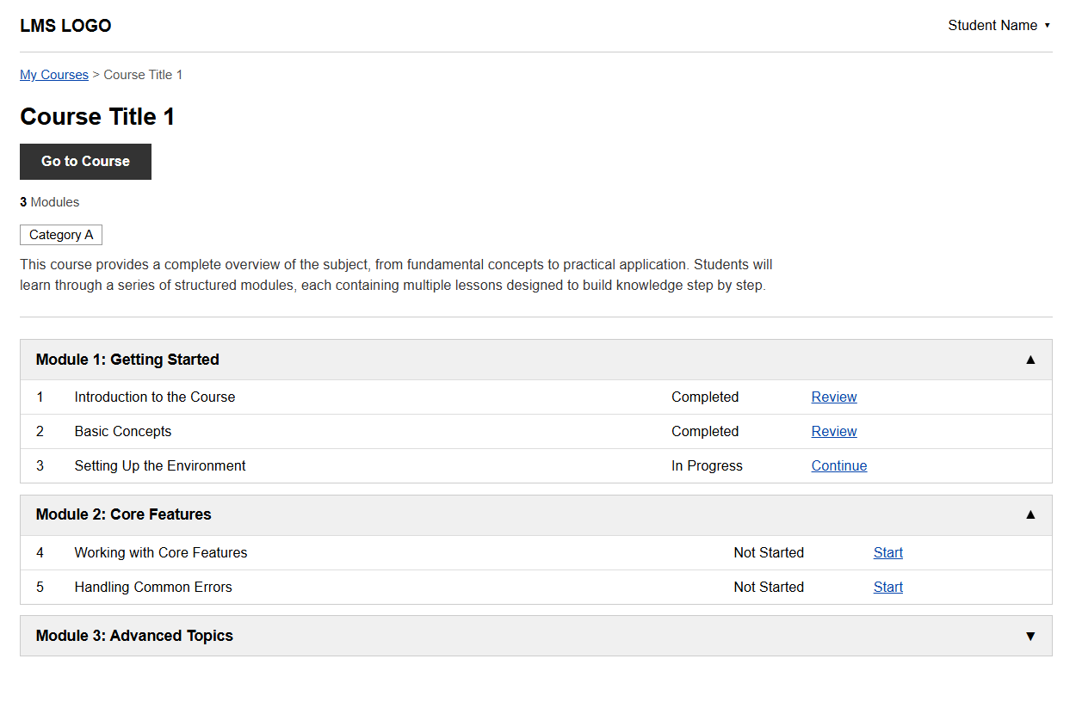
This screen allows the Student to:
- View Course Information: view the course title, module count, category, and description.
- View Module List: view the list of modules the course is divided into.
- View Lesson List per Module: expand a module to view its list of lessons, each with its own completion status.
On the screen, s/he can also:
- Go to Course: click "Go to Course" to jump directly into the Lesson Viewer, opening at the last lesson the Student accessed.
- Expand/Collapse Module: click a module header (or the arrow icon) to show or hide its lesson list.
- Access a Lesson: click the action link on a lesson row to open that lesson in the Lesson Viewer (the label and destination depend on the lesson's status).
- Navigate Back: click "My Courses" in the breadcrumb to return to the Student Dashboard / My Courses list.
Field Name | Description
Breadcrumb | Navigation link back to "My Courses".
Go to Course | Navigates directly to the Lesson Viewer, opening at the lesson the Student most recently accessed; if no lesson has been started yet, it opens the first lesson of the course.
Module Count | Total number of modules in the course, calculated automatically from the course data.
Module Header/ Arrow | Click to expand or collapse the module's lesson list. Initial state: the first module is expanded by default; all other modules are collapsed.
Status | One of: "Completed", "In Progress", "Not Started", reflecting the Student's learning progress for that specific lesson.
Action | The label and destination depend on the lesson's current status: "Start" (Not Started) opens the lesson from the beginning; "Continue" (In Progress) opens the lesson at the last viewed position; "Review" (Completed) reopens the lesson for reference without affecting the completion status.

4.3 Lesson Viewer
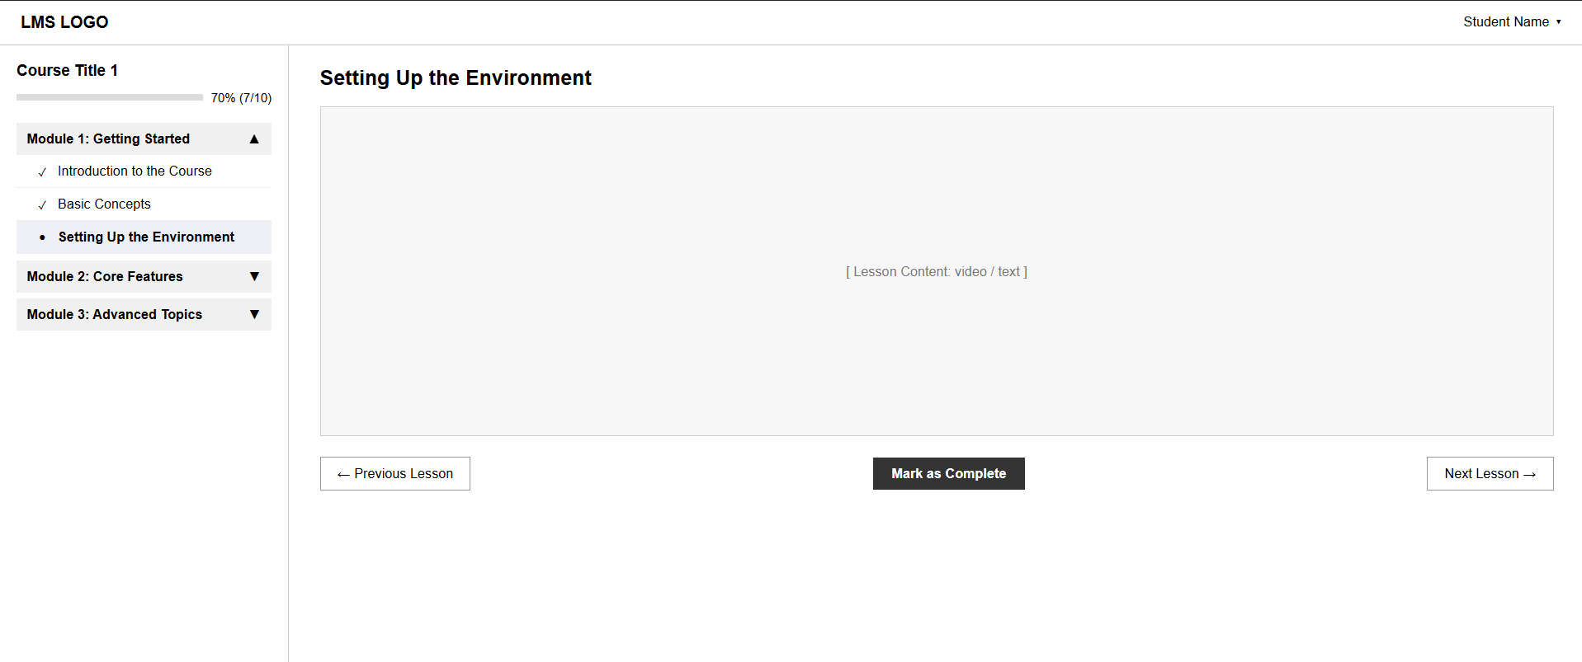
This screen allows the Student to:
- View Lesson Content: view the content of the currently selected lesson (video/text) in the main content area.
- View Course Progress: view the overall course progress (percentage and lesson count) at the top of the sidebar.
- View Course Curriculum: view the list of modules and lessons in the sidebar, with each lesson's completion status.
On the screen, s/he can also:
- Switch Lesson: click any lesson in the sidebar to load its content in the main area; the selected lesson is highlighted.
- Expand/Collapse Module: click a module header to show or hide its lesson list.
- Navigate Sequentially: use "Previous Lesson" / "Next Lesson" to move through the course in order without returning to the sidebar.
- Mark Lesson as Complete: click "Mark as Complete" to update the current lesson's status and the overall course progress.
Field Name | Description
Module Header/ Arrow | Click to expand or collapse the module's lesson list. Initial state: the module containing the current lesson is expanded by default.
Lesson Item | Clicking loads that lesson's content into the main area. The currently viewed lesson is visually highlighted; a status icon indicates Completed / In Progress / Not Started.
Previous Lesson / Next Lesson | Navigates to the adjacent lesson in course order. "Previous Lesson" is disabled on the first lesson of the course; "Next Lesson" is disabled on the last lesson of the course.
Mark as Complete | Updates the current lesson's status to "Completed" and recalculates the course's progress. Button is hidden or replaced with a "Completed" indicator if the lesson is already marked complete.

5. Quiz (Thịnh)

5.1 Quiz Management (Expert)

5.1.1 Quiz List
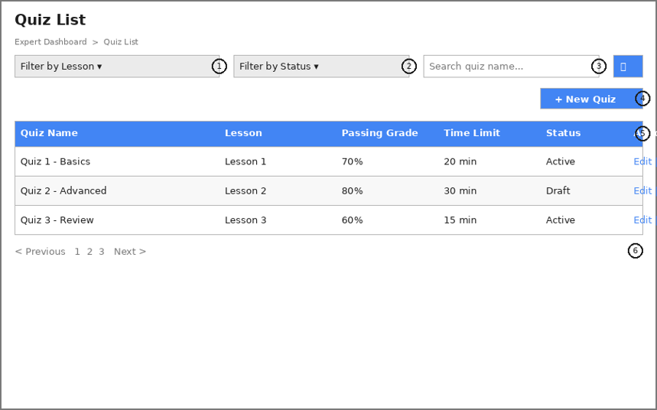
This screen allows the Expert to:
● View Quiz List: view the list of quizzes the Expert has authored across their assigned lessons.
● Filter Quiz List: filter quizzes by Lesson and by Status (Active, Draft).
● Search Quizzes: enter keyword(s) to search quizzes by their name.
On the screen, s/he can also:
● Create New Quiz: navigate to the Quiz Detail screen to author a new quiz, by clicking the New Quiz button.
● Edit/Delete Quiz: navigate to the Quiz Detail screen to update an existing quiz, or remove it from the system, by clicking the Edit or Delete link.
This screen maps to the following use case: UC – Manage Quiz (View/Filter/Search/Create/Edit/Delete Quiz).
Field Description:
Field Name | Description
(1) | Filter by Lesson: dropdown list of lessons belonging to the Expert's assigned courses. Initial value: "All Lessons".
(2) | Filter by Status: dropdown with values "All Status", "Active", "Draft" (default value "All Status").
(3) | Search box: accepts any string, max length 100 characters; searches by quiz name (case-insensitive, partial match).
(4) | New Quiz button: navigates to the Quiz Detail screen in "create" mode with all fields empty.
(5) | Quiz table columns: Quiz Name, Lesson, Passing Grade, Time Limit, Status, and Actions (Edit / Delete links).
(6) | Pagination control: navigates between pages of the quiz list; default page size is 10 rows.

5.1.2 Quiz Detail
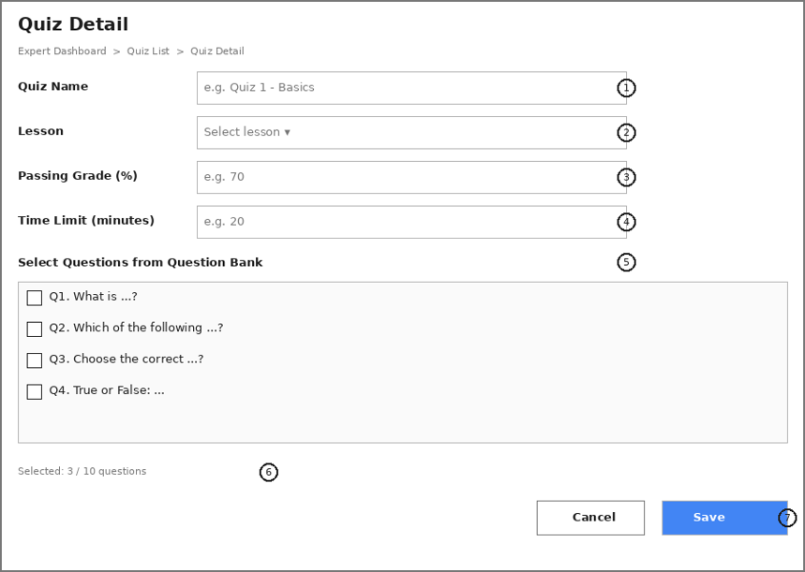
This screen allows the Expert to:
● Create Quiz: define a new quiz's name, associated lesson, passing grade, and time limit.
● Update Quiz: edit the details of an existing quiz.
● Select Quiz Questions: pick questions from the shared Question Bank to include in this quiz.
This screen maps to the following use cases: UC – Create/Edit Quiz, UC – Select Quiz Questions.
Field Description:
Field Name | Description
Quiz Name | Data type: non-empty string, max length 100 characters.
Lesson | Dropdown of lessons belonging to the Expert's assigned courses. Required field.
Passing Grade (%) | Data type: positive integer, range 1–100. Represents the minimum score required to pass the quiz.
Time Limit (minutes) | Data type: positive integer, range 1–180. Time allowed for a Student to complete one attempt.
Select Questions from Question Bank | Checklist of questions from the Question Bank filtered by the quiz's lesson/course. At least 1 question must be selected; there is no fixed maximum.
Selected count indicator | Read-only label showing the number of questions currently selected out of the total available (e.g., "3 / 10 questions").
Save / Cancel | Save persists the quiz (validates all required fields first); Cancel discards changes and returns to the Quiz List.

5.2 Quiz Taking (Student)

5.2.1 Quiz Taking
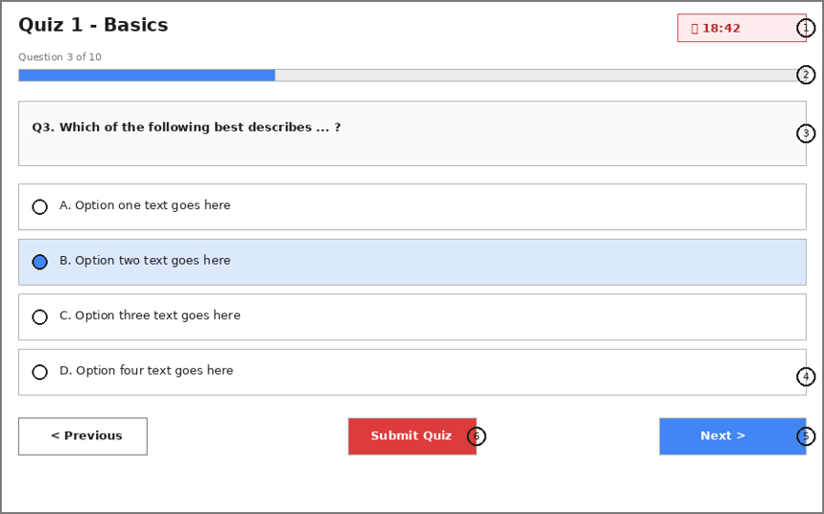
This screen allows the Student to:
● Answer Quiz Questions: select an answer for each question presented, one question at a time.
● Navigate Between Questions: move to the previous or next question using the navigation buttons.
● Track Remaining Time: monitor the countdown timer showing time left before the attempt is auto-submitted.
● Submit Quiz: manually submit the attempt before the time limit expires.
This screen maps to the following use case: UC – Take Quiz.
Field Description:
Field Name | Description
(1) | Countdown timer: displays remaining time in mm:ss format, starting from the quiz's configured Time Limit. When it reaches 00:00, the attempt is auto-submitted with the answers selected so far.
(2) | Progress bar: visually indicates how many of the total questions have been answered/viewed (e.g., "Question 3 of 10").
(3) | Question text: the current question's content, displayed one at a time.
(4) | Answer options: single-choice radio options (A, B, C, D); the previously selected option (if any) remains highlighted when navigating back to a question.
(5) | Previous / Next buttons: move between questions without losing previously selected answers.
(6) | Submit Quiz button: available at any point; triggers a confirmation before ending the attempt and navigating to the Quiz Result screen.

5.2.2 Quiz Result
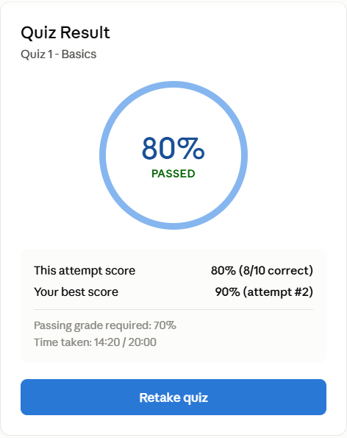
This screen allows the Student to:
● View Attempt Result: see the score and pass/fail outcome of the attempt just submitted.
● View Best Score: see the current highest (graded) score achieved across all attempts for this quiz.
● Access Quiz Retake: start a new attempt by clicking Retake Quiz.
This screen maps to the following use case: UC – View Quiz Result.
Field Description:
Field Name | Description
Score circle | Shows this attempt's percentage score and a Passed/Failed label, determined by comparing the score against the quiz's Passing Grade.
This attempt score | The percentage and raw correct/total count for the attempt just submitted (e.g., "80% (8/10 correct)").
Best score | The highest score across all of the Student's attempts for this quiz, which is kept as the final grade; includes which attempt achieved it.
Retake Quiz | Starts a new attempt at the Quiz Taking screen; retakes are always allowed and do not overwrite the recorded best score.

6. Background Job Inventory

6.1 Unlock Expired Locked Accounts (JOB-01)
Trigger: Scheduled — every 15 minutes
Purpose: Automatically unlocks accounts that were locked after failed sign-in attempts, once the lockout duration has elapsed
Processing steps:
- Find all accounts with status = Locked where the lockout timestamp is more than 10 minutes ago.
- For each account found: reset the failed sign-in count to zero, set status back to Active.
- Log the number of accounts unlocked in this run.
Failure behavior:
Scenario | System behavior
Database unreachable | Job retries up to 3 times with 30-second intervals. If still failing, logs a critical error. Accounts remain locked until the next successful run.
No locked accounts found | Job completes immediately with no action — this is normal and expected.

6.2 Auto-Cancel Unpaid Pending Registrations (JOB-02)
Trigger: Scheduled — every 15 minutes
Purpose: Cancels course enrollments that remain unpaid past the checkout deadline (e.g., 30 minutes) via VNPay or SePay.
Processing steps:
- Query all course enrollment orders with status = Pending where creation time is more than 30 minutes ago and no payment webhook notification was received.
- Update the status of these enrollment records and associated payment orders to Cancelled / Expired.
- Release any reserved transaction state or temporary locks on course seats.
- Log the number of cancelled registrations.
Failure behavior:
Scenario | System behavior
Payment Gateway webhook delay | System checks payment log before cancelling. If a late payment confirmation is recorded, marks enrollment as Active instead of Cancelled.
Database timeout | Current transaction is rolled back. Job logs a warning and retries during the next scheduled run 15 minutes later.

6.3 Auto-Submit Expired Quiz Attempts (JOB-03)
Trigger: Scheduled — every 5 minutes
Purpose: Automatically submits an active Quiz Taking session once the allocated quiz time limit expires for a student.
Processing steps:
- Find all ongoing quiz attempt sessions where current_time > start_time + quiz_duration.
- Evaluate submitted answers up to the expiration moment based on stored draft responses.
- Calculate score, record the submission timestamp, and change session status to Completed.
- Log the auto-submitted quiz attempt IDs.
Failure behavior:
Scenario | System behavior
Concurrent manual submission | System checks if session status is already Completed before processing. If already submitted manually, ignores auto-submit step.
Scoring calculation error | Session is marked as Submitted for Review; an error log is generated for admin inspection.

6.4 Send Course Reminder Emails (JOB-04)
Trigger: Scheduled — Weekly at 8:00 AM
Purpose: Sends automated reminder emails to students to finish ongoing courses or incomplete lessons.
Processing steps:
- Query students who have active course enrollments with uncompleted lessons and no progress recorded in the last 7 days.
- Construct reminder email payloads containing personalized course progress links.
- Queue reminder emails through the external Email Service Provider API (Gmail SMTP / MailTrap).
- Log the total number of queued email notifications.
Failure behavior:
Scenario | System behavior
Email Service Provider API down | Email tasks are moved to a retry queue with exponential backoff up to 3 times before failing gracefully.
No inactive students found | Job completes immediately with zero emails sent.

7. External API Inventory

7.1 HTTP Method: URL pattern (API-01)
URL | GET: /api/v1/auth/google/callback
Purpose | Receives the authorization response from Google Identity Service after the user grants consent; creates a new account or logs the user in if the Google account already exists
Caller | Google Identity Service (OAuth 2.0 redirect)
Auth | Authorization code + state parameter validation (no prior authentication required)

7.2 VnPay Webhook (API-02)
URL | POST: /api/v1/commerce/payment/webhook/vnpay
Purpose | Receives payment confirmation (IPN) from VNPay; triggers access grant creation
Caller | VNPay payment gateway
Auth | HMAC-SHA512 signature validation

7.3 SePay Webhook (API-03)
URL | POST: /api/v1/commerce/payment/webhook/sepay
Purpose | Receives payment confirmation from SePay; triggers access grant creation
Caller | SePay payment gateway
Auth | HMAC signature validation

III. Requirement Appendix

1. Business Rules
GBR-ID | Rule Statement | Applies To | Rationale | Enforced By
GB-01 | Email Uniqueness: Each email address can only be registered for one unique account across the entire system and serves as the login identifier. | Account / User | Prevents duplicate accounts and ensures secure user identity. | System Backend (Unique DB Constraint & Auth Validation).
GB-02 | Locked Account Data Retention: Accounts in locked status cannot log in, but all associated learning history, transactions, and user data must be strictly preserved. | Account / System Admin | Ensures financial/transaction data integrity and auditability. | System Backend (Auth Interceptor/Middleware & DB Policy).
GB-03 | Course Ownership: Each course must have exactly one primary Course Manager responsible for management, but can grant editing permissions to multiple Content Experts. | Course Management | Defines clear accountability for content creation and approval workflows. | RBAC / Permission Service.
GB-04 | Course Publication Criteria: A course can only be set to published status if it contains at least one completed Section and at least one completed Lesson. | Course Management | Prevents accidental publication of empty courses, preserving user experience. | Course Service Validation Logic.
GB-05 | Automated Payment Confirmation: Course enrollment status is only changed to paid and course content unlocked upon receiving a valid IPN/Webhook callback from the payment gateway (VNPay / SePay). | Payment / Enrollment | Prevents payment fraud or manual course activation prior to fund settlement. | Payment Webhook Callback / Signature Verification.
GB-06 | Automated Course Completion: Course completion status automatically transitions to completed when a student finishes 100% of the lessons/reading materials and passes the final assessment (Quiz/Exam). | Progress Tracking | Ensures objective and transparent course completion and certificate issuance. | Progress Service / Automated Event Trigger.
GB-07 | Secure Login Error Masking: Failed authentication attempts must generate generic errors and must not disclose whether the email or the password was incorrect. | Authentication | Protects against brute-force attacks and user account enumeration. | Authentication Service Response Handler.
GB-08 | OTP/Token Expiration: Verification tokens sent via email or Password Reset OTPs remain valid for a maximum of 15 minutes from generation. | Authentication / Email | Mitigates security risks if token links are leaked or intercepted. | Token Provider Service / Redis TTL.
GB-09 | Quiz Attempt Timer Enforcement: Upon starting a quiz, the countdown timer runs continuously and triggers automatic submission (Auto-submit) when time expires, even during temporary network disconnections. | Assessment / Quiz | Guarantees fairness and strict timekeeping integrity for assessments. | Frontend Timer Component & Backend Timeout Scheduled Job.
GB-10 | Notification Retention Period: In-app notifications are retained for a maximum of 90 days from creation, after which they are automatically purged. | Notification System | Minimizes database storage overhead and maintains query performance. | Database Cron Job / Cleanup Service.

2. System Messages
# | Message code | Message Type | Context | Content
1 | MSG_REQ_01 | In-line / Red | The user leaves a required input field empty during form submission. | This field is required.
2 | MSG_INV_01 | In-line / Red | Invalid input format for Email, Password, or Phone Number. | Invalid input format. Please check your entry.
3 | MSG_AUTH_01 | Toast / Error | Authentication failure due to incorrect login credentials. | Incorrect email or password. Please try again.
4 | MSG_AUTH_02 | Toast / Error | User attempts to access a resource or action without proper permissions. | Access denied. You do not have permission to perform this action.
5 | MSG_AUTH_03 | Toast / Error | User's session is expired, invalid, or missing. | Your session has expired. Please log in again.
6 | MSG_AUTH_04 | Toast / Success | Account registration successful, email verification required. | Registration successful! Please check your email to activate your account.
7 | MSG_AUTH_05 | Toast / Success | Email verification link successfully processed. | Your account has been verified successfully.
8 | MSG_PAY_01 | Toast / Success | Payment gateway confirms successful transaction. | Payment completed successfully! You can now access your course.

3. Other Requirements
Performance Requirements:
- API Response Time: Average API response time must be < 2.0 seconds for standard requests and < 3.0 seconds for complex transactions (e.g., payment processing or report generation).
- Real-time Latency: In-app real-time notification push latency (via WebSocket / SSE) must be < 1.0 second from event trigger to UI rendering.
- Concurrency: The system must support a minimum of 100 concurrent users without performance degradation.
Security Requirements:
- Password Hashing: All user passwords must be hashed to persistence in the database.
- Transport Security: All client-server communication must be encrypted using HTTPS (TLS 1.2 or higher).
Usability & Compatibility Requirements:
- Responsive Design: The UI must render responsively across common screen resolutions.
- Browser Compatibility: Cross-browser support for major modern web browsers, including Google Chrome, Mozilla Firefox, Microsoft Edge, and Safari.

