

**COHEN**

**INTERNATIONAL SCHOOL**

**2020-2023**

**COMPUTER SCIENCE PROJECT**

**PROJECT TOPIC :- RAILWAY RESERVATION**

**Submitted**

**In partial fulfillment of**

**AISSCE 2023 Examination**

**[As a part of the Computer Science Course (083)]**

**SUBMITTED BY :-**

**CLASS/SECTION :-**

**ROLL NO :-**

**UNDER GUIDANCE OF:**

**MR.SHRIKANT SINGH**

**PGT(COMPUTER SCIENCE)**

**Project Certificate**

I, **____________________________** of class XII A roll no_________________

would like to express my sincere gratitude to my computer science teacher

**Mr Srikant Singh**, **PGT COMPUTER SCIENCE,** for his vital support,

guidance and encouragement – without which this project would not have come forth.

I would also like to express my gratitude to my school **COHEN** **INTERNATIONAL SCHOOL** for letting me use the school laboratory.

Mr.Shrikant Singh

Teacher In-Charge

……………………………

Examiner’s Sign

Date…………………….

**ACKNOWLEDGEMENT**

This is to acknowledge all those without whom this project would not have been reality.

Firstly, I would wish to thank our Computer Science teacher

**Mr.** **Shrikant Singh** who gave his immense support, dedicated his/her time towards it and made us understand how to make this project. Without his guidance, the project would not have been complete.



**CONTENTS**

* **Need for computerization**
* **Hardware and Software specification requirements**
* **Program output and source code,Database Design**
* **Future scope of the project**
* **Bibliography**

**NEED FOR COMPUTERISATION:**

No one can easily plan the journey comfortably as the process is efficient and fast with being easy to access. Reservations can be made through the Indian railways site or at the ample reservation centers all over the country.

Also now there are authorized agencies which provide reservation facility on behalf of India railways and without waiting in long line one can easily book a ticket. The booking is done through an E- Ticket issue which has a PNR number of which one has to take a print and just have to show at the station.

It not only provides reservation but cancellation can also be done through this system at ease and one can use a credit card to complete the process. This being a big step in terms of improvement in the railway system it is widely accepted across the country.

**HARDWARE AND SOFTWARE SPECIFICATION REQUIREMENTS**

**Development Tools and Platforms:-**

To develop Railway Reservation, the following tools/platform is proposed to be used:

* Windows 7 or later
* IDLE 3.6 or spider
* Python 3.6
* MySQL 5.1.33

**Hardware Requirements:-**

Railway Reservation is proposed to be installed on having the following minimum hardware requirements:

* Intel R Pentium 4 processor having clock speed 1 GHz
* At-least 1GB DDR-2 RAM
* Hard Disk Drives having capacity of 40 GB
* At least 2 GB free space for the installation of MySQL
* DVD Writer and Pen Drives for backup purposes
* Optional: printer-Inkjet or Laserjet

**Software Requirements:-**

Railway Reservation will require at least the following software platform:

* Windows and or later
* MySQL Database Management System
* Pyinstaller

SOURCE CODE OF PYHTON&DBMS

**Python Code:**

import mysql.connector

import os

import platform

#import pandas as pd

pnr=1024

mydb=mysql.connector.connect(host="localhost",user="root",passwd="toor",database="rail");

mycursor=mydb.cursor()

def railresmenu():

print("Railway Reservation ")

print("1.Train Detail")

print("2.Reservation of Ticket")

print("3.Cancellation of Ticket")

print("4.Display PNR status")

print("5.Quit")

#print(" ",end="\n"*50)

n=int(input("enter your choice"))

if(n==1):

traindetail()

elif(n==2):

reservation()

elif(n==3):

cancel()

elif(n==4):

displayPNR()

elif(n==5):

exit(0)

else:

print("wrong choice")

def traindetail():

print("Train Details")

ch='y'

while (ch=='y'):

l=[]

name=input("enter train name :")

l.append(name)

tnum=int(input("enter train number :"))

l.append(tnum)

ac1=int(input("enter number of AC 1 class seats"))

l.append(ac1)

ac2=int(input("enter number of AC 2 class seats"))

l.append(ac2)

ac3=int(input("enter number of AC 3 class seats"))

l.append(ac3)

slp=int(input("enter number of sleeper class seats"))

l.append(slp)

train=(l)

sql="insert into traindetail(tname,tnum,ac1,ac2,ac3,slp)values(%s,%s,%s,%s,%s,%s)"

mycursor.execute(sql,train)

mydb.commit()

print("insertion completed")

print("Do you want to insert more train Detail")

ch=input("enter yes/no")

print('\n' *10)

print("===================================================================")

railresmenu()

def reservation():

global pnr

l1=[]

pname=input("enter passenger name=")

l1.append(pname)

age=input("enter age of passenger =")

l1.append(age)

trainno=input("enter train number")

l1.append(trainno)

np=int(input("Enter number of passanger:"))

l1.append(np)

print("select a class you would like to travel in")

print("1.AC FIRST CLASS")

print("2.AC SECOND CLASS")

print("3.AC THIRD CLASS")

print("4.SLEEPER CLASS")

cp=int(input("Enter your choice:"))

if(cp==1):

amount=np*1000

cls='ac1'

elif(cp==2):

amount=np*800

cls='ac2'

elif(cp==3):

amount=np*500

cls='ac3'

else:

amount=np*350

cls='slp'

l1.append(cls)

print("Total amount to be paid:",amount)

l1.append(amount)

pnr=pnr+1

print("PNR Number:",pnr)

print("status: confirmed")

sts='conf'

l1.append(sts)

l1.append(pnr)

train1=(l1)

sql="insert into passengers(pname,age,trainno,noofpas,cls,amt,status,pnrno)values(%s,%s,%s,%s,%s,%s,%s,%s)"

mycursor.execute(sql,train1)

mydb.commit()

print("insertion completed")

print("Go back to menu")

print('\n' *10) print("===================================================================")

railresmenu()

railresmenu()

def cancel():

print("Ticket cancel window")

pnr=input("enter PNR for cancellation of Ticket")

pn=(pnr,)

sql="update passengers set status='deleted' where pnrno=%s"

mycursor.execute(sql,pn)

mydb.commit()

print("Deletion completed")

print("Go back to menu")

print('\n' *10) print("===================================================================")

railresmenu()

railresmenu()

def displayPNR():

print("PNR STATUS window")

pnr=input("enter PNR NUMBER")

pn=(pnr,)

sql="select * from passengers where pnrno=%s"

mycursor.execute(sql,pn)

res=mycursor.fetchall()

#mydb.commit()

print("PNR STATUS are as follows : ")

print("(pname,age,trainno, noofpas,cls,amt,status, pnrno)")

for x in res:

print(x)

#print("Deletion completed")

print("Go back to menu")

print('\n' *10) print("===================================================================")

railresmenu()

railresmenu()

DBMS STRUCTURE:CREDINTIALS (**USER=root PASSWD=toor DB=rail**)

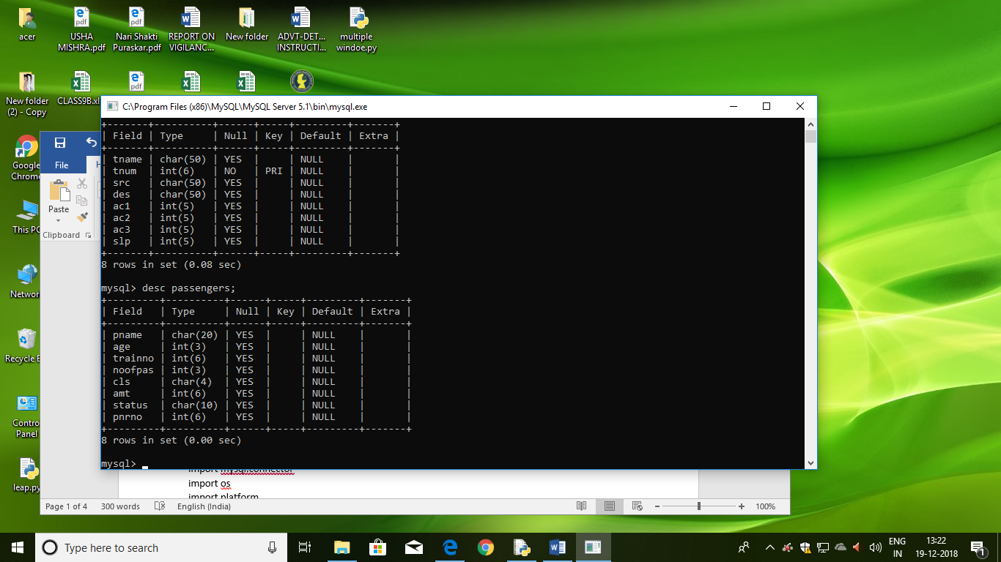

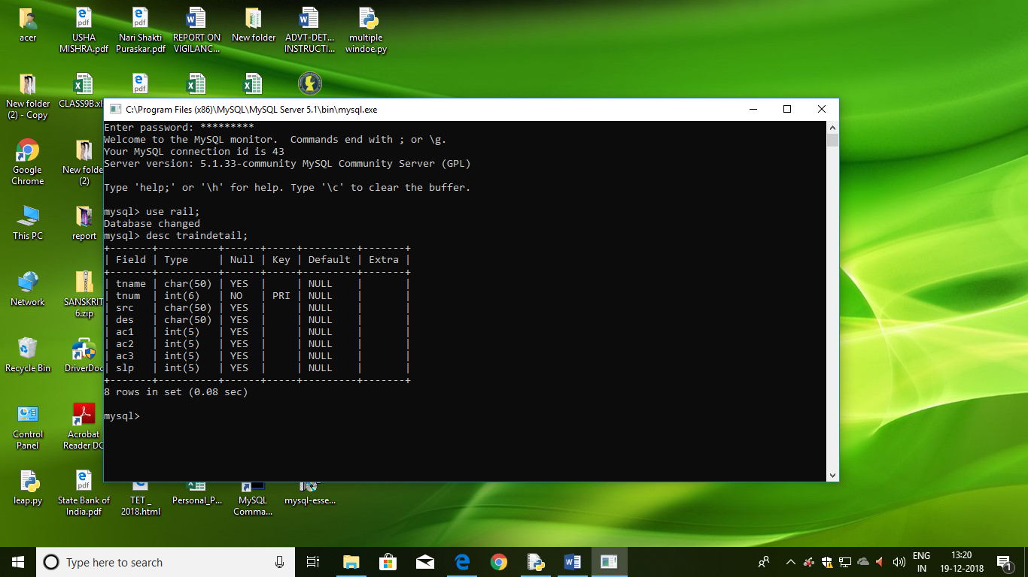

OUTPUT

**>>> railresmenu()**

Railway Reservation

1.Train Detail

2.Reservation of Ticket

3.Cancellation of Ticket

4.Display PNR status

5.Quit

enter your choice**1**

Train Details

enter train name :madurai chainnai

enter train number :22206

enter number of AC 1 class seats200

enter number of AC 2 class seats200

enter number of AC 3 class seats200

enter number of sleeper class seats4000

insertion completed

Do you want to insert more train Detail N

SCREEN 2

Railway Reservation

1.Train Detail

2.Reservation of Ticket

3.Cancellation of Ticket

4.Display PNR status

5.Quit

enter your choice**2**

enter passenger name=EREN

enter age of passenger =23

enter train number22206

Enter number of passenger:1

select a class you would like to travel in

1.AC FIRST CLASS

2.AC SECOND CLASS

3.AC THIRD CLASS

4.SLEEPER CLASS

Enter your choice:2

Total amount to be paid: 1600

PNR Number: 1025

status: confirmed

SCREEN 3

===================================================================

Railway Reservation

1.Train Detail

2.Reservation of Ticket

3.Cancellation of Ticket

4.Display PNR status

5.Quit

enter your choice 3

Ticket cancel window

enter PNR for cancellation of Ticket1025

Deletion completed

Go back to menu

SCREEN:4

===================================================================

Railway Reservation

1.Train Detail

2.Reservation of Ticket

3.Cancellation of Ticket

4.Display PNR status

5.Quit

enter your choice4

PNR STATUS window

enter PNR NUMBER1025

PNR STATUS are as follows :

(pname,age,trainno, noofpas,cls,amt,status, pnrno)

**('EREN', 23, 22206, 2, 'ac2', 1600, 'deleted', 1025)**

Go back to menu

**FUTURE SCOPE AND FURTHER ENCANCEMENT OF THE PROJECT**

Following modules can be added to enhance the feature of the Railway Reservation 2022-23.

Making online portal for peoples of the country using web framework like Django.

**BIBLIOGRAPHY:-**

Following are the sources, which helped me in completion of my first software development process:

Books and Websites:

1. Computer Science, Sumita Arora

2. Computer Science, NCERT

3. [www.csstudy.in](http://www.csstudy.in)

4. Search engine [www.google.co.in](http://www.google.co.in)

Resource Person:-

* Mr.Shrikant Singh ,Faculty (C.Sc.)