Authors:
Stephan Lange, Simon Helsen
 | Basic Query SPI Design
 | Version | Status | Date
 | 1.0 |  | 14 March 2006
 | 1.1 |  | 25 July 2006
Contents

1 Abstract 4
2 The Basic Query SPI as Part of the Overall Query Architecture 4
3 Design Considerations 5
3.1 Platform Independence 5
3.2 Features 5
3.3 Limitations 5
3.4 The Concept of the ModelElementClusterExpression 5
3.5 Justification of the Complexity of the Basic Query SPI 7
3.5.1 The similarity of the Basic Query SPI to SQL 7
3.5.2 Using Database Features of Facilities 7
3.5.3 Implementing the Basic Query SPI for a Facility with no Database Storage 7
4 The Building Blocks of a Basic Query 8
4.1 Class diagrams of the relevant classes 8
4.2 Specifying a Model Element 10
4.2.1 ModelElementExpression 10
4.2.2 PartitionExpression 10
4.3 Building Blocks for Expressing Attribute Conditions 11
4.3.1 AttributeExpression 11
4.3.2 MultinaryExpression 11
4.3.3 And 12
4.3.4 Or 12
4.3.5 Not 12
4.3.6 LeafExpression 12
4.3.7 The Comparison Operators Equal, Greater, GreaterOrEqual, Less and LessOrEqual 13
4.3.8 The Comparison Operator Interval 13
4.3.9 The Comparison Operator Like 14
4.3.10 The Present Operator 14
4.3.11 AttributeInModelElement 15
4.3.12 Multi-valued Attributes 15
4.4 Clusters of ModelElementExpressions 15
4.4.1 Purpose 15
4.5 Expressing Links 16
4.5.1 LinkExpression 16
4.6 Building Blocks for Expressing a Selection 17
4.6.1 SelectExpression 17
4.6.2 SelectList 18
4.7 The Result of a Basic Query 19
4.7.1 Reading the Query Result from a BasicQueryResultSet 19
5 Example 19

Abstract
This document describes the design of the Basic Query SPI.
It explains how the Basic Query SPI is integrated in the overall query architecture of MOIN and it introduces the building blocks a Basic Query is made of.
Finally the usage of the Basic Query SPI is illustrated with an example.

The Basic Query SPI as Part of the Overall Query Architecture
The Basic Query SPI is the query interface of the facilities. It is an abstraction of the query functionality which is provided by all facilities in MOIN.
While the Basic Query language is generally supported by all facilities in MOIN it is obvious that the efficiency of the query execution can differ significantly depending on the implementation. The query capability SPI as part of the basic query SPI is used by the facilities for expressing strengths, weaknesses or limitations in the query implementation. The query capability SPI is not discussed in this paper.
The diagram below illustrates the layers of query processing.
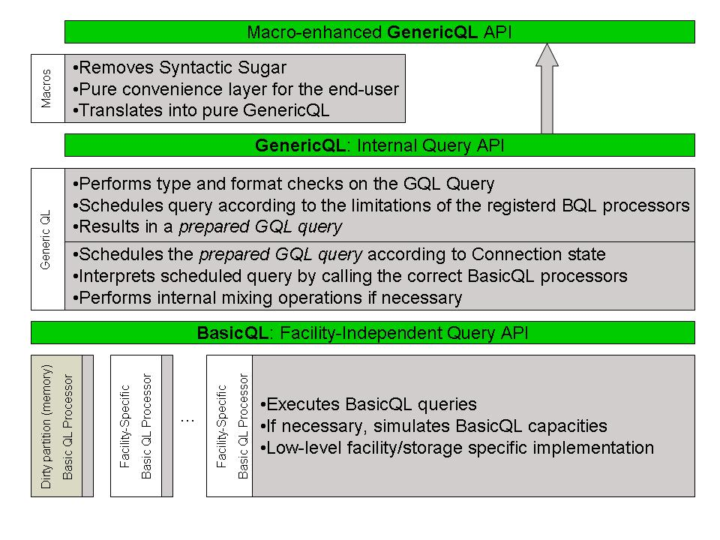

Design Considerations

Platform Independence
The Basic Query SPI describes a platform independent query interface which has to be supported by all facility implementations.
However, due to the importance of the NWDI facility with a database persistency the Basic Query SPI was designed in a way that this facility can support this SPI especially well.

Features
The Basic Query SPI allows the selection of model elements together with primitive attributes of the model elements. It is also possible to query model elements together with linked model elements including primitive attributes. The identifier of a model element which is returned by a Basic Query Processor is the MRI of the model element.
It is possible to express link conditions. A link condition expresses either the occurrence of a certain link or the absence of a certain link.
Model elements can also be further specified by attribute conditions. Attribute conditions can logically combine attribute values of multiple model elements.
Basic queries can be expressed by a hierarchical query data structure, each node in this hierarchy representing an own query. This allows an implementation of the Basic Query SPI to reduce query complexity by internally executing several sub-queries where the result of one sub-query is input of another sub-query. One disadvantage of the approach of splitting the query into sub-queries is of course that the intermediate results, which have to be held in the memory, can be large.
The Basic Query SPI provides means to express that the searched model elements should be part of certain partitions or that the model elements should not be part of certain partitions. This functionality is required for the Generic Query processor, which has to consider the client scope, which can comprise persistent partitions and dirty partitions, which are held in the memory.

Limitations
The result set can only contain model elements which are somehow linked to each other. The Basic Query SPI does not provide an equivalent to a “Left Outer Join”. Thus it is not possible to select a model element together with the MRI or primitive attributes of model elements which are not linked. However, it is possible to express a “not linked” condition although the “not linked” model elements can not be part of the query result.

The Concept of the ModelElementClusterExpression
The desired hierarchy of the query data somehow contradicts to the feature that attribute conditions can logically combine attribute values of different model elements (Join). This conflict is solved by the introduction of the so called ModelElementClusterExpression.
A ModelElementClusterExpression represents one node in the query hierarchy. A ModelElementClusterExpression can contain multiple ModelElementExpressions; one of them is the header ModelElementExpression. The ModelElementExpressions inside of a ModelElementClusterExpression can be logically combined via AttributeExpressions (Join).
A cluster internal LinkExpressions connects two ModelElementExpressions of the same cluster. A cluster external LinkExpression connects a ModelElementExpression with a ModelElementClusterExpression which represents a deeper node in the query hierarchy.
Due to the fact that “Outer Joins” are not supported, cluster internal LinkExpressions can only express the existence of links. Cluster external LinkExpressions can also express the absence of a link. In this case a non-existing link is equivalent to a negated nested query.
The root ModelElementClusterExpression also determines the scope of the SelectExpression. It is only possible to select model elements which are represented by the root ModelElementClusterExpression.
The figure below illustrates a sample query hierarchy.
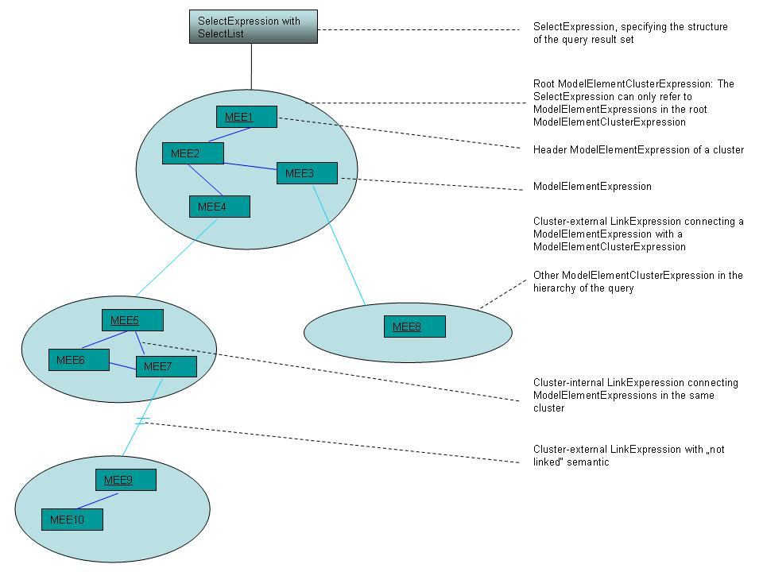
Figure 1: The concept of the ModelElementClusterExpression, sample query hierarchy

Justification of the Complexity of the Basic Query SPI
The Basic Query SPI is a quite complex service provider interface. A good implementation of this SPI can be challenging.
This paragraph discusses why the complexity of the Basic Query SPI is the way it is and it shows that the implementation is feasible for all kind of facilities.

The similarity of the Basic Query SPI to SQL
The Basic Query SPI contains some language features that are known from SQL.
The similarity of the Basic Query language to SQL helps developers, who want to implement the SPI, to recognize language features. The in-depths understanding of language features known from SQL facilitates the implementation of these features.
The popularity of SQL as query language leads to a high acceptance of the Basic Query SPI.

Using Database Features of Facilities
We still don’t know all the facilities that will be built in the future, but it is obvious that there will be very important facilities that store its data in a database.
One strategy of implementing the Basic Query SPI is to transform a Basic Query into one or more SQL queries that query the database persistency. If the Basic Query has to be transformed into multiple SQL statements then the intermediate results of these queries have to be processed in memory as input for further SQL queries or as part of the final query result.
In order to avoid large intermediate results the implementation should be optimized in a way that minimizes the number of SQL statements that are generated from one Basic Query. Enabling SPI implementations with database storage to transform Basic Queries into a minimized number of SQL statements is one design goal of the Basic Query SPI.
With the NWDI facility with DB storage it was proven that one Basic Query can be transformed to one SQL query. A ModelElementExpression including its AttributeExpression can be transformed to one (joined) SQL query. A ModelElementClusterExpression can be transformed by joining the SQL queries of the contained ModelElementExpressions. ClusterExternalLinks to child ModelElementClusterExpressions can be transformed to a nested SQL query.

Implementing the Basic Query SPI for a Facility with no Database Storage
Having discussed why the Basic Query SPI fits the needs of facilities with database storage this paragraph explains why the Basic Query SPI is appropriate for other facilities as well. Three different implementation strategies are discussed.

Using a Database as Persistent Cache
The idea of this strategy is to cache the data that are relevant for queries in a database. The cache has to be updated whenever relevant data of the primary data source are updated. Having the queried data in a database with an appropriate table schema, the Basic Query can be transformed into SQL as discussed above.

Using Query Capabilities of the Persistency of the Facility
If the persistency of the facility offers suitable query capabilities then it is a good idea to use those capabilities for the execution of a Basic Query.
Ideally, one Basic Query can be transformed into one query of the specific persistency. If a Basic Query is more complex it is very unlikely that such a query can be transformed into one single query of the persistency. Instead, the Basic Query implementation should try to split the Basic Query into sub-queries that can be executed on the persistency and process the results in memory.
The efficiency of this approach depends on the query capabilities of the facility. Therefore it is not further discussed here.

Calculating the Query Result in Memory
If the facility has no persistency or if the storage of the facility does not offer suitable query capabilities then the query result has to be calculated in memory. Also, if the persistency has only limited query capabilities then more complex queries have to be calculated at least partially in memory.
An implementation of the Basic Query functionality for memory contains the implementation of certain database functionality due to the similarity of the Basic Query SPI to SQL. The most challenging task for such an implementation is to implement the evaluation of ModelElementClusterExpressions which can be compared with a database join. However, this is doable.
ClusterExternalLinks which can be compared with nested selects can be implemented straight forward using recursion.
MOIN uses internally a Basic Query implementation for memory which has been implemented already. For more details see the design document of the Basic Query implementation for memory.
The success of the Basic Query implementation for memory proves the feasibility of a Basic Query implementation if there is no query support of a persistency at all. Such an implementation can be even optimized if the facility has a persistency with limited query functionality.

The Building Blocks of a Basic Query
A Basic Query is expressed by a data structure which consists of several building blocks. Each building block represents a certain aspect of the query such as what kind of model elements and attributes are to be selected or what attribute conditions should be met.
The basic query SPI also supports queries with link expressions. Using link expressions it is possible to express nested queries which are represented by a nested data structure.

Class diagrams of the relevant classes
This paragraph contains the class diagrams of the relevant classes for expressing a Basic Query. In the following paragraphs the classes are explained in detailed.
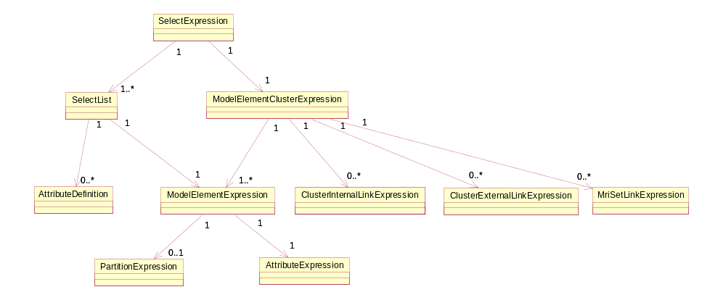
Figure 2: Structure of a select expression

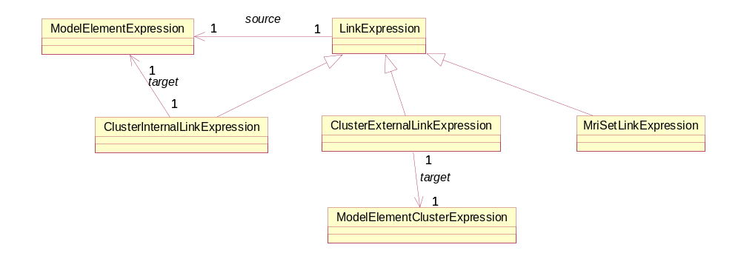
Figure 3: Link expressions

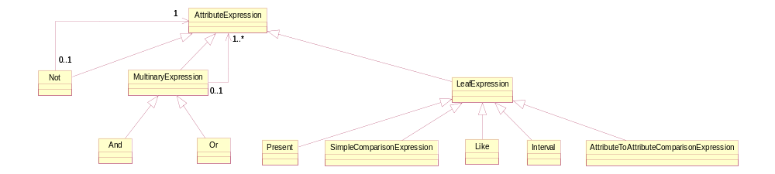
Figure 4: Attribute expressions

Specifying a Model Element

ModelElementExpression

Purpose
A ModelElementExpression specifies model elements.

Internal Structure
Inherits from: Object
Structure Element | Data Type | Description
types | Array of MRI | It is allowed to search for model elements of different types with the same ModelElementExpression. This feature is especially useful for expressing the “kind of” operator. “Kind of” a type is expressed by the MRIs of the type and all sub-types. The MRIs of these types can be retrieved from the meta model
partitionExpression | PartitionExpression | The PartitionExpression is used for filtering the model elements by its partition.
attributeExpression | AttributeExpression | The AttributeExpression is used for filtering the model elements by its attributes

PartitionExpression

Purpose
A PartitionExpression restricts the searched model elements to be either part of certain partitions or to be not part of certain partitions.

Internal Structure
Inherits from: Object
Structure Element | Data Type | Description
partitionList | Array of MRI | If partitionList is empty then there is no partition restriction.
isIncludeList | boolean | If isIncludeList is true then partitionList functions as partition include list, otherwise it functions as partition exclude list.  If isIncludeList is true then the searched model elements are part of one partition represented by partitionList.  If isIncludeList is false then the searched model elements are not part of one partition represented by partitionList.

Building Blocks for Expressing Attribute Conditions

AttributeExpression

Purpose
An AttributeExpression describes an attribute condition which is used in a query for specifying the model elements that are searched.
There are several types of attribute condition building blocks. AttributeExpression is the interface which is implemented by all attribute condition building blocks. It is possible to compose more complex AttributeExpressions from other AttributeExpressions.

MultinaryExpression

Purpose
A MultinaryExpression is an AttributeExpression which is used for the logical composition of AttributeExpressions. Examples are the Or and the And condition.

Internal Structure
Inherits from: AttributeExpression
Structure Element | Data Type | Description
operands | List of AttributeExpressions | Specifies the AttributeExpression instances that compose the MultinaryExpression.

And

Purpose
An And expression is a MultinaryExpression. An And expression is true if all operands are true.

Or

Purpose
An Or expression is a MultinaryExpression. An Or expression is true if at least one of its operands is true.

Not

Purpose
A Not expression is an AttributeExpression which is used to logically negate another AttributeExpression.

Internal Structure
Inherits from: AttributeExpression
Structure Element | Data Type | Description
operand | AttributeExpression | Specifies the AttributeExpression that is negated by the Not expression.

LeafExpression

Purpose
A LeafExpression is an AttributeExpression that cannot be composed from other AttributeExpressions. Examples for LeafExpressions are comparison operators such as Equal or Greater.

Internal Structure
Inherits from: AttributeExpression
Structure Element | Data Type | Description
attributeId | String | Specifies the attribute of the model element for which the expression is to be evaluated. The model element is specified by the containing ModelElementExpression.

The Comparison Operators Equal, Greater, GreaterOrEqual, Less and LessOrEqual

Purpose
The comparison operators Equal, Greater, GreaterOrEqual, Less and LessOrEqual are LeafExpressions. It is used in order to define a comparison operation with an attribute of the containing ModelElementExpression. The attribute specification is inherited from the LeafExpression.
The attribute can be compared against simple values such as int or double. The attribute can also be compared against another attribute which relates to the enclosing ModelElementExpression or to a linked ModelElementExpression in the same cluster.

Internal Structure
Inherits from: LeafExpression
Structure Element | Data Type | Description
object which is compared to | Object representing a simple type or an instance of AttributeInModelElement | The object which is compared to can be the object of a simple value such as Integer, Long, Double or Boolean.  Alternatively the object which is compared to is represented by an AttributeInModelElement which refers to an attribute of the same containing ModelElementExpression or it refers to an attribute of a ModelElementExpression in the same ModelElementClusterExpression.

The Comparison Operator Interval

Purpose
The comparison operation Interval is a LeafExpression. It is used in order to define a comparison operation with an attribute of the containing ModelElementExpression against an interval. The values of the attribute must be numbers.

Internal Structure
Inherits from: LeafExpression
Structure Element | Data Type | Description
lowerIntervalLimit | Object representing a simple type of a number | The lower interval limit.
isLowerIntervalLimitOpen | Boolean | Defines whether the lower interval limit is open or closed. (“< “or “<=”)
upperIntervalLimit | Object representing a simple type of a number | The upper interval limit.
isUpperIntervalLimitOpen | Boolean | Defines whether the lower interval limit is open or closed. (“< “or “<=”)

The Comparison Operator Like

Purpose
The comparison operator Like is a LeafExpression. It is used in order to define a “Like” comparison operation with a String attribute of the containing ModelElementExpression. The attribute specification is inherited from the LeafExpression.

Internal Structure
Inherits from: LeafExpression
Structure Element | Data Type | Description
pattern | String | Pattern comparable to the pattern of the SQL “like” operation. ‘%’ expresses 0-n arbitrary characters. ‘_’ Expresses 1 arbitrary character. ‘!’ is used as escape character.

The Present Operator

Purpose
The Present operator is a LeafExpression. It is used to check whether an attribute value exists.

Internal Structure
Inherits from: LeafExpression

AttributeInModelElement

Purpose
The AttributeInModelElement construct can be used in order to refer to an attribute of model elements which are specified by a ModelElementExpression.

Internal Structure
Inherits from: Object
Structure Element | Data Type | Description
modelElementExpression | ModelElementExpression | ModelElementExpression which specifies the relevant model elements
attributeId | String | ID of the attribute

Multi-valued Attributes
MOF supports multi-valued attributes. The Basic Query SPI provides limited support for multi-valued attributes.
An attribute condition which refers to a multi-valued attribute is true if there is an attribute value for which the condition is true. This means also that an attribute condition referring to a multi-valued attribute is false if there is no attribute value for which the condition is true. If an attribute is referenced multiple times in an attribute expression then these references can refer to different attribute values. There is no way to refer explicitly to a certain attribute value by the index of the attribute value.

Clusters of ModelElementExpressions

Purpose
A ModelElementClusterExpression is a bundle of ModelElementExpressions. It represents a node in the hierarchy of a query. Cluster external links which link ModelElementExpressions in the cluster with other ModelElementClusterExpressions define the hierarchy of the query.
The ModelElementExpressions of a cluster don’t have to constitute a hierarchy. This means that there is no easy way of splitting up a cluster. This means also that facilities should execute the sub-query represented by a ModelElementClusterExpression in “one step” (join). Nevertheless, it can also make sense to execute a sub-query represented by a sub-tree of ModelElementClusterExpressions in “one step”.
The Basic Query SPI does not support “outer joins” which means that all cluster internal links can only define the existence of a link while cluster external link can also define the non-existence of a link.

Internal Structure
Inherits from: Object
Structure Element | Data Type | Description
headerModelElementExpression | ModelElementExpression | The header model element expression constitutes the only model element expression of a cluster which can be linked from a higher level model element cluster expression.
clusterInternalLinks | Array of LinkExpression | Every internal link expression defines the occurrence of links between model element expressions of the cluster.
clusterExternalLinks | Array of LinkExpression | Every external link expression defines the occurrence or absence of a link between a model element of the cluster and the header model element expression of another cluster, which is represented by the other cluster itself.

Expressing Links

LinkExpression

Purpose
A LinkExpression describes the existence (isLinked == true) or non-existences of a link (isLinked == false) from a model element to an element of a set of model elements. The link expression is true if and only if isLinked is true and there is a linked element in the set of model elements or if isLinked is false and there is no linked element in the set of model elements.
There are three different sub classes of LinkExpressions. An MriSetLinkExpression expresses a link to a set of model elements expressed by their MRIs. A ClusterInternalLinkExpression expresses a link to a set of model elements expressed by a model element expression. A ClusterExternalLinkExpression expresses a link to a set of model elements expressed by a model element cluster expression.

Internal Structure
Inherits from: Object
Structure Element | Data Type | Description
isLinked | boolean | Boolean flag indicating whether fromModelElementExpression is linked or not.
linkType | MRI | Type of the link which is either the MRI of the association or the MRI of the attribute.
associationEndOfLinkedObject | Byte (0 or 1) | The association end describes the direction of the link.
fromModelElementExpression | ModelElementExpression | Model Element expression inside the cluster.
linkTarget | Object | Target of the link. Depending on the LinkExpression sub type it is an array of MRIs or a ModelElementExpression or a ModelElementClusterExpression.
toLinkable | Linkable (ModelElementExpression for cluster internal links or ModelElementClusterExpression for cluster external links) | Implicit alternative for expressing the set of model elements.  If toLinkable is a ModelElementExpression then this ModelElementExpression must be in the same cluster as fromModelElementExpression. This link then defines a cluster internal link (“Join”).  If toLinkable is a ModelElementClusterExpression then this link defines a cluster external link (“nested query”).

Building Blocks for Expressing a Selection

SelectExpression

Purpose
A SelectExpression defines a Basic Query which can be processed by the Basic Query processor. It represents the root building block of a query.

Internal Structure
Inherits from: Object
Structure Element | Data Type | Description
modelElementClusterExpression | ModelElementClusterExpression | Root ModelElementClusterExpression of the query. The selected model elements are defined by ModelElementExpressions in the root ModelElementClusterExpression.
selectLists | Array of SelectList | A SelectList can refer to a ModelElementExpression of modelElementClusterExpression.  For each SelectList the query returns the corresponding MRIs together with a defined set of primitive attributes.

SelectList

Purpose
Basic Queries can return MRIs and primitive attributes. A SelectList refers to a ModelElementExpression for which the corresponding MRIs of the selected model elements are to be returned by the query. Additionally it defines what primitive attributes are to be returned for each selected model element. The attributes are distinguished between single-valued and multi-valued attributes. This information is important for the Basic Query processor in order to be able to build a correct structure of the query result set.

Internal Structure
Inherits from: Object
Structure Element | Data Type | Description
modelElementExpression | ModelElementExpression | Defines the selected model elements for which the MRI is to be returned.
attributeDefinitions | ArrayList of AttributeDefinition | An attribute definition holds the ID of an attribute and the information whether it is single-valued or multi-valued.

The Result of a Basic Query
The execution of a Basic Query returns a BasicQueryResultSet. The result is created in one step which means that no lazy reading is applied.

Reading the Query Result from a BasicQueryResultSet
The structure of the query result depends on the Array of SelectLists in the SelectExpression, each SelectList referring to a ModelElementExpression in the root ModelElementClusterExpression. The query result contains for each SelectList the MRIs of the corresponding model element and depending on the specification of the SelectList a selection of primitive attributes.
The BasicQueryResultSet provides methods for reading the MRIs and the corresponding attribute data for each select list. In this way it is possible to retrieve attributes of a model element together with attributes of linked model elements with one query.

Example
This chapter presents a simple example for a query.
The metamodel contains the classes Car, Person and City.
The class Car contains the attributes color, numberOfWheels, brand and seats. The class Person contains the attribute age. The class City contains the attribute numberOfInhabitants.
There is the association owns which links cars with persons. There is also the association livesIn which links persons and cities.
It is searched for all cars including the attributes color and numberOfWheels for which the following conditions apply:
- The brand of the car =”Mercedes” OR the number of seats>5.
- The owner’s age < 60.
- The number of seats in the car must be equal to the number of children of the owner.
- The owner must not live in a city where the number of inhabitants is in the interval (100000, 200000].
- The cars must be part of partition X and Y.
- The owner must not be part of partition Z.
The class Car has the sub classes Bus and Truck which shall be considered as well. These three types are represented by one ModelElementExpression which is called Car in the following.
The class Person has the sub classes Teacher and Student which should also be considered. These three types are represented by one ModelElementExpression which is called Person in the following.
The ModelElementExpressions Car and Person shall be part of the same ModelElementClusterExpression. They are connected by a LinkExpression expressing the ownsowns association.
The ModelElementExpression City which represents the class City cannot be in the same cluster because the not existence of links of the association livesIn has to be expressed by a “not linked” LinkExpression.
Figure 2 illustrates the query hierarchy.
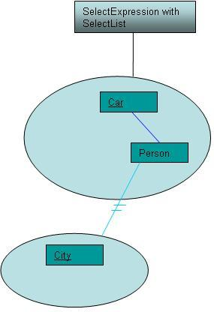
Figure 5: Simple query example, query hierarchy
The example code below illustrates how the query is constructed and executed and how the results are read.

try {
// MRIs of type for the example, normally must not be null
MRI typePerson = null;
MRI typeTeacher = null;
MRI typeStudent = null;
MRI typeCar = null;
MRI typeBus = null;
MRI typeTruck = null;
MRI typeCity = null;
// MRIs of partitions for the example, normally must not be null
MRI partitionX = null;
MRI partitionY = null;
MRI partitionZ = null;
// MRI of the associations for the example, normally must not be
// null
MRI associationOwner = null;
MRI associationLivesIn = null;
// Retrieve a moin connection, normally must not be null
Connection moinConnection = null;
// Retrieve instance of basic query processor, normally must not be
// null
BasicQueryProcessor basicQueryProcessor = null;

// Construct MRI[] for the type person including sub-types
MRI[] typePersonAndSubtypes = { typePerson, typeTeacher,
typeStudent };

// Construct MRI[] for the type car including sub-types
MRI[] typeCarAndSubtypes = { typeCar, typeBus, typeTruck };

// Construct MRI[] for the type city, it has not sub-types
MRI[] typeCityNoSubtypes = { typeCity };

// Construct the partition include list and partition expression for
// the cars
MRI[] partitionIncludeListCars = { partitionX, partitionY };
PartitionExpression partitionExpressionCars = new PartitionExpression(
partitionIncludeListCars, true);

// Construct the partition exclude list and partition expression for
// the persons which are owners of the cars
MRI[] partitionExcludeListPersons = { partitionZ };
PartitionExpression partitionExpressionPersons = new PartitionExpression(
partitionExcludeListPersons, false);

// Construct attribute expression for the owner of the car
AttributeExpression attributeExpressionPersons = new Less("age",
new Integer(60));

// Construct the model element expression for the persons
ModelElementExpression modelElementExpressionPersons = new ModelElementExpression(
typePersonAndSubtypes, partitionExpressionPersons);
modelElementExpressionPersons
.setAttributeExpression(attributeExpressionPersons);

// Construct the attribute expression for the car
Equal equal = new Equal("brand", "Mercedes");
Greater greater = new Greater("seats", new Integer(5));
ArrayList orList = new ArrayList();
orList.add(equal);
orList.add(greater);
AttributeExpression orExpressionCars = new Or(orList);
AttributeExpression seatChildrenComparison = new Equal("seats", new AttributeInModelElement(modelElementExpressionPersons, "numberOfChildren"));
ArrayList andList = new ArrayList();
andList.add(orExpressionCars);
andList.add(seatChildrenComparison);
AttributeExpression attributeExpressionCars = new And(andList);

// Construct the model element expression for the cars
ModelElementExpression modelElementExpressionCars = new ModelElementExpression(
typeCarAndSubtypes, partitionExpressionCars);
modelElementExpressionCars
.setAttributeExpression(attributeExpressionCars);

// Construct cluster with Car and Person
ModelElementClusterExpression modelElementClusterExpressionCars = new ModelElementClusterExpression(
modelElementExpressionCars);
modelElementClusterExpressionCars
.addModelElementExpressionToCluster(modelElementExpressionPersons);

// Construct attribute expression for the city
AttributeExpression attributeExpressionCity = new Interval("numberOfInhabitants",100000, true, 200000, false);

// Construct the model element expression for the city
ModelElementExpression modelElementExpressionCity = new ModelElementExpression(
typeCityNoSubtypes, null);
modelElementExpressionCity
.setAttributeExpression(attributeExpressionCity);

// Construct cluster with City
ModelElementClusterExpression modelElementClusterExpressionCity = new ModelElementClusterExpression(
modelElementExpressionCity);

// cluster internal link:
// Construct and add the link expression "owner" which links the car
// with a
// person represented by the modelElementExpressionPerson
LinkExpression linkAssociationOwner = new LinkExpression(true,
associationOwner, (byte) 1, (byte)0, modelElementExpressionCars,
modelElementExpressionPersons);
modelElementClusterExpressionCars
.addClusterInternalLink(linkAssociationOwner);

// cluster external link
// Construct and add the link expression "livesNotIn" which
// specifies that the person is not linked
// with a city which has more than 1000000 inhabitants
// city represented by the modelElementClusterExpressionCity
LinkExpression linkAssociationLivesNotIn = new LinkExpression(
false, associationLivesIn, (byte) 0, (byte) 1,
modelElementExpressionPersons,
modelElementClusterExpressionCity);
modelElementClusterExpressionCars
.addClusterExternalLink(linkAssociationLivesNotIn);

// Construct the select list for the cars containing two primitive
// attributes
SelectList selectListCar = new SelectList(
modelElementExpressionCars);
int positionInListColor = 0; // remember for result reading
selectListCar.addAttributeDefinition("color",
SelectList.ATTRIBUTE_SINGLE_VALUED);
int positionInListNumberOfWheels = 1; // remember for result
// reading
selectListCar.addAttributeDefinition("numberOfWheels",
SelectList.ATTRIBUTE_SINGLE_VALUED);

// Construct the select list for the persons containing one
// primitive attribute
SelectList selectListPerson = new SelectList(
modelElementExpressionPersons);
int positionInListAge = 0; // remember for result reading
selectListPerson.addAttributeDefinition("age",
SelectList.ATTRIBUTE_SINGLE_VALUED);

// Construct an array of the select lists
SelectList[] selectLists = new SelectList[2];
int positionOfSelectListCar = 0; // remember position for result
// reading
selectLists[positionOfSelectListCar] = selectListCar;
int positionOfSelectListPerson = 1; // remember position for result
// reading
selectLists[positionOfSelectListPerson] = selectListPerson;

// Construct the select expression
SelectExpression selectExpression = new SelectExpression(
modelElementClusterExpressionCars, selectLists);

// Retrieve the result
BasicQueryResultSet resultSet = basicQueryProcessor.execute(
moinConnection, selectExpression);
int sizeOfResult = resultSet.getSize();
// Loop over result and retrieve the MRI, the color and the
// numberOfWheels of the car and the MRI and the age of its owner.
for (int i = 0; i < sizeOfResult; i++) {
MRI mriOfCar = resultSet.getMRI(i, positionOfSelectListCar);
String colorOfCar = resultSet
.getSingleValuedAttributeStringValue(i,
positionOfSelectListCar, positionInListColor);
int numberOfWheelsOfCar = resultSet
.getSingleValuedAttributeIntValue(i,
positionOfSelectListCar, positionInListNumberOfWheels);
MRI mriOfOwner = resultSet
.getMRI(i, positionOfSelectListPerson);
int ageOfOwner = resultSet.getSingleValuedAttributeIntValue(i,
positionOfSelectListPerson, positionInListAge);
}

StringBuffer sb = new StringBuffer();
selectExpression.toString(sb, 0, false);
System.out.println(sb.toString());
} catch (BasicQueryException e) {
e.printStackTrace();
}

