Authors:
Simon Helsen
Stephan Lange
Christian Mohr (> 1.0)
Martin Strenge (> 1.0)
 | MQL: Design Aspects
 | Version | Status | Date
 | 1.0 | Initial Version | 23 Jan 2007
 | 1.5 | Revision and clean-up | July 2008
Contents
1 Intended audience and goal of this document 3
2 Overview 3
3 Internal MQL Query Format 6
3.1 Main IQF classes 7
3.2 The IQF withEntries 7
3.3 The IQF whereClauses 8
4 Internal Logic of the MQL Processor 8
4.1 Type Checking 8
4.2 Expanding 8
4.3 Assigning 10
4.4 Scheduling 10
4.4.1 Generalities 10
4.4.2 Problem description 11
4.4.3 No assoc or link predicate 12
4.4.4 One assoc predicate 12
4.4.5 One or more Link Predicates 16
4.4.6 More than one assoc predicate 17

Intended audience and goal of this document
This document describes the most important aspects of the design for the MQL (Moin Query Language) processor. It is intended for MOIN developers who have to work on the MQL processor within MOIN’s core component.

Overview
gives an overview of the architecture of MQL. It lists the main components and their interactions, starting at the MQL processor as it is provided to clients, all the way down towards the contract with the facility.

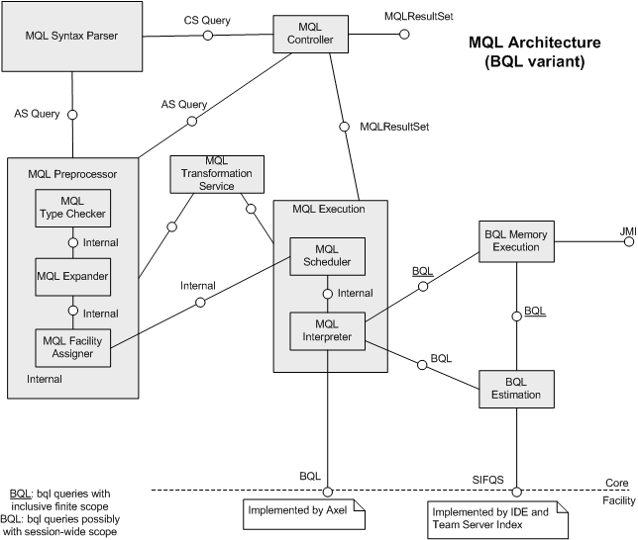

Figure 1: MQL Architecture

The MQL processor, being part of MOIN’s core, consists of the preprocessor, the execution engine and, the in-memory parts for BQL (aka Basic Query Language). Each MQL processor instance expects one Facility Query Service per registered facility, which – in the current implementation – is the “slim index facility query service” (SIFQS). Because SIFQS is in itself not capable of calculating queries, a memory BQL with associated estimation component is provided to the MQL interpreter. In this setup, the facility (slim) index is only used to restrict the maximum scope in which a query is executed. After the estimation is done, the actual query is executed in-memory using JMI and the restricted known scope. Alternatively, a facility may provide a full BQL, in which case the MQL interpreter will immediately access the full BQL facility implementation, except for the query bits which operate on dirty partitions (those are always calculated in-memory).
There is an alternative architecture for MQL, which replaces BQL with FQL (Facility Query Language). In contrast to BQL, FQL essentially wraps the internal MQL data structure (of the next section). illustrates the MQL architecture with FQL.

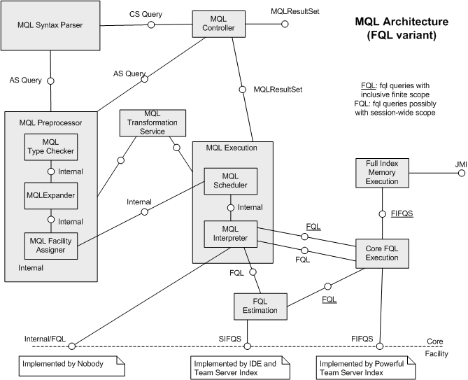

Figure 2: MQL Architecture with FQL
It is very similar to the BQL setup, except that the in-memory execution of FQL queries is achieved with two components instead of one. The Core FQL Execution engine provides a navigation and execution plan along the same strategy as the current BQL memory implementation, but does not actually execute the query with JMI means. The latter is achieved by a special core component which implements the FIFQS (Full Index Facility Query Service) interface, which is used by the Core FQL engine. The estimation engine for FQL is akin to the BQL estimation engine and again uses the slim index query service (SIFQS) to reduce the overall scope in which a query should be executed. As with BQL, it is also possible for a facility to provide a complete FQL execution engine if this is deemed more efficient. So, the FQL architecture has (currently) 3 different possibilities, which are illustrated in Figure 3, Figure 4, and Figure 5 respectively.
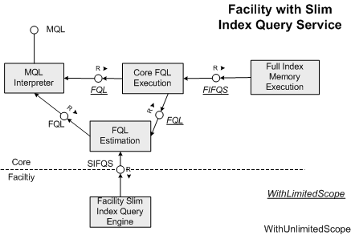
Figure 3: FQL with slim index service
If a facility only provides a slim index query service (SIFQS - Figure 3) similar to the BQL use-case above, then, it is up to the core to estimate and emulate the query in-memory.
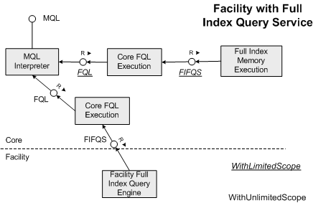
Figure 4: FQL with full index service
If the facility provides a full index query service (FIFQS - Figure 4), the facility execution of an FQL query can be done using the Core FQL Execution engine. This scenario does not rely on JMI anymore and therefore, does not load any partitions (except for dirty partitions, which are always executed inside the dirty partition).
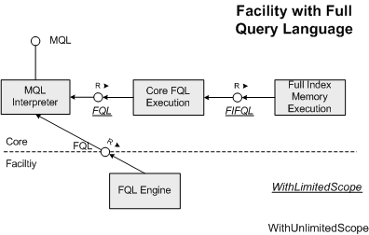
Figure 5: FQL with full query language
In the final scenario of Figure 5, the core does not execute FQL itself (except for dirty partitions) because the facility can handle it.
Returning to the overall MQL architecture, the preparation and execution of an MQL query is controlled by the MQL controller component. It also provides the API towards clients and returns result sets at the end of the execution.
Queries can be formulated either in a concrete syntax (described elsewhere) and a Java-based abstract syntax (only described in the JavaDocs). We will use something similar to the MQL concrete syntax for describing the examples in this document.
An MQL query is internally kept in a special format, which is described in more detail in the next section. MQL initially translates the abstract syntax into this internal format and then transforms the internal format over a series of different transformation phases until it is interpretable by the MQL interpreter. Parts of the internal format will be mapped and executed in BQL (or FQL).
The preprocessor is responsible to turn a client-specified MQL Query into the internal query format (which is provided to the tool client as a prepared query). The preprocessor has currently 3 phases:

- Type checking: Checks if the MQL query is type correct with respect to the MOF meta-model it operates on. Along the way, it translates the query into the internal format. In other words, the internal query format is always a correctly formulated query with respect to one or more meta-models.
- Expanding: The internal query is expanded such that it consists of query parts (leafs) which can be executed in one run on all registered BQL or FQL processors. The remaining (non-leaf) parts are then interpreted by the MQL interpreter. The expander also applies changes to the internal MQL format in order to make the query amenable for scheduling (described below).
- Facility assigning: In this phase, we the internal query is further examined so that it correctly executes over all registered BQL/FQLs (i.e. all registered facilities). This may break-up the query even in smaller parts, where again, the MQL interpreter is responsible of putting it all together.
The result of the preprocessor is a prepared query, which is returned to the client (although the client has no access to the details of the MQL internal format). The preprocessor is not dependent on MOIN’s dirty state, i.e. it does not need to know what partitions are dirty. It does need access to all deployed meta-models in order to perform the type-check.
The MQL execution engine is responsible for executing a prepared query on top of the registered BQL/FQL processors. It maintains two phases. The scheduler of the MQL engine checks if there is dirty state (i.e. some partitions are dirty) and transforms the internal query such that the memory-only results are properly mixed with the persistent data, where dirty partitions have way over persistent partitions. After scheduling, the interpreter actually interprets and executes the internal query (which by now has become a query tree with nodes and leafs) by executing the leaf queries on their responsible BQL/FQ processor and, if necessary, by combining (joining) the results in-memory to eventually produce the desired result set.

Internal MQL Query Format
All execution logic within the MQL processor (both the MQL preprocessor and MQL execution engine) is based on the Internal Query Format (IQF for short). An MQL prepared query, which a client obtains after preparation, is an instance of this data structure. The following three class diagrams describe the IQF structure.

Main IQF classes
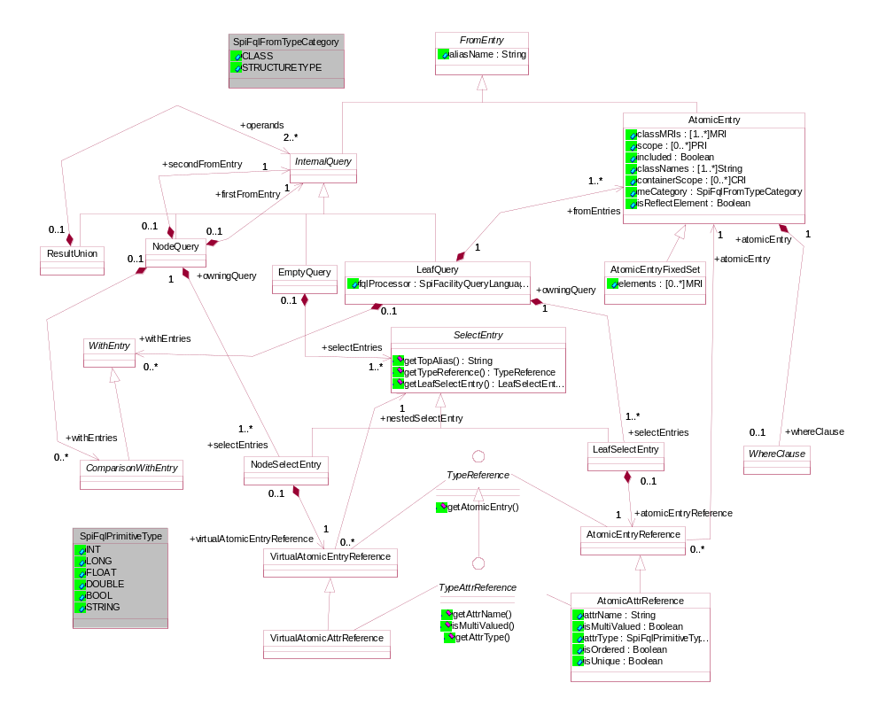

The IQF withEntries
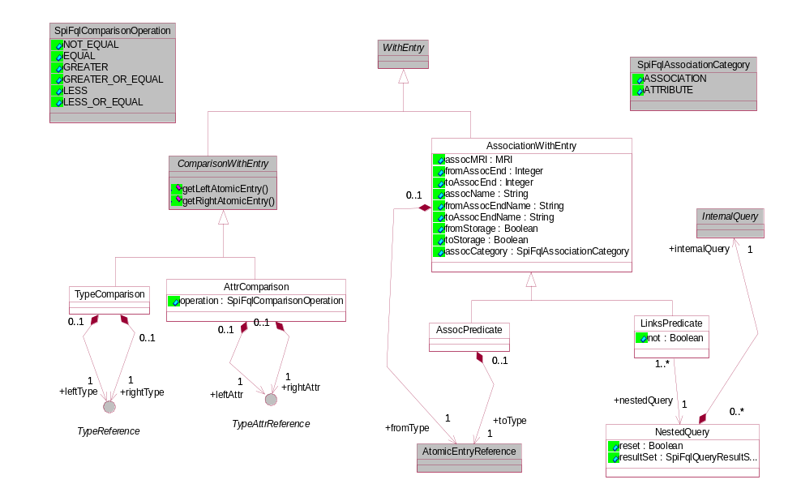

The IQF whereClauses
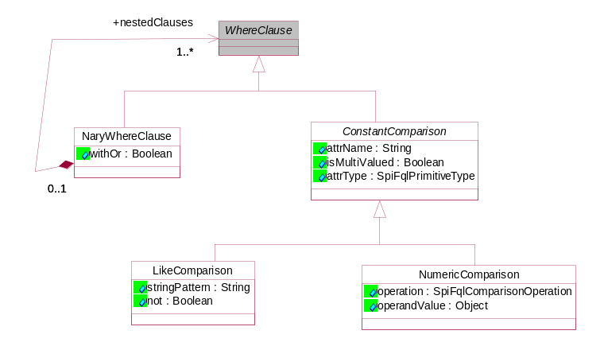

In the remaining of this document, we will use a concrete syntax akin to the MQL concrete syntax (provided elsewhere) to describe instances of this IQF meta-model. However, internally, we only handle this pointer-connected abstract syntax, no concrete syntax or string representation thereof.

Internal Logic of the MQL Processor

Type Checking
The type checker of the preprocessor performs all required type and format checks on the input MQL query as it is provided by a MOIN client. During this process, the type checker translates a query formulated in the MQL API into the IQF structure. The name-based references in the IQF are only there for debugging purposes. The resulting IQF is a true abstract syntax, i.e. everything is pointer-connected and there are no references-by-name left.

Expanding
The expander takes a consistent IQF query (resulting from the type checker) and translates it into a new IQF query, which guarantees that the participating leaf queries are executable by a complete FQL processor. A leaf query is an internal query which has no other internal queries in its from-clause.
Currently, the expander performs two transformations:

- Splitting: Each leaf query can only be a true “cluster”, i.e. a query where all from-entries are connected to each other via an association predicate. The splitter moves any attribute or alias comparisons which cross two clusters to a higher level (by introducing a node query) and constructs one leaf query for each cluster.
- Separating multi-associations: In general, it is possible that query has more than one association constraint between two aliases (atomic entries). This complicates the scheduling algorithm (discussed later on) and therefore, such a query is transformed to make sure that only one association predicate exists between two atomic entries. This can easily be achieved by cloning atomic entries and inserting alias (or type) comparisons. In a later phase, after the scheduling algorithm is finished, but before executing a query, a compression algorithm removes “unnecessary” alias comparisons. This guarantees that, if the scheduler did not need to take apart a query, it will take its original form again.
We only discuss the first expanding transformation (aka splitting), which detects strongly-connected atomic entries (where “connected” means “association-predicate connected”). It then produces a series of leaf queries for each such cluster of strongly connected atomic entries and puts them together by constructing one or more node queries to combine the results. Both alias comparisons and attribute comparisons may span clusters and can therefore be pushed “up” in the node query. At this point, it is important to note that only leaf queries are executed on the facility. Node queries (which combine leaf queries) are always executed in-memory with the MQL interpreter.
Let us investigate the splitting process by means of the following sample pseudo MQL query:
select a, a.n, b, b.m, c.n
from A as a, B as b, C as c, D as d, E as e
where a.p = b.m
where b.end12[assoc1] = c
where a.end22[assoc2] = d
where d.t > e.f
where a.end3[assoc3] in (select …)
where d.end4[assoc4] in (select …)
where e.end5[assoc5] in (select …)
where a.p > 5
where e.f < 5
where c.h = “test”
where d.k = 0
where d.s = true
where b.m != 3

The above example can be split as the following query, which introduces 2 node queries and 3 leaf queries.
select q3.q2.a, q3.q2.a.n, q3.q1.b, q3.q1.b.m, q3.q1.c.n
from (select q2.a, q2.a.n, q1.b, q1.b.m, q1.c.n, q2.d.t
from (select b, b.m, c.n
from B as b, C as c
where b.end12[assoc1] = c
where b.m != 3) as q1,
(select a, a.n, a.p, d.t
from A as a, D as d
where a.end22[assoc2] = d
where a.end3[assoc3] in (select …)
where d.end4[assoc4] in (select …)
where a.p > 5
where d.k = 0 and d.s = true) as q2
where q2.a.p = q1.b.m) as q3,
(select e.f
from E as e
where e.end5[assoc5] in (select …)
where e.f < 5) as q4
where q3.q2.d.t > q4.e.f
The two assoc predicates and the link predicate starting from alias e form three clusters represented by the leaf queries q1, q2, and q4. The selections in these queries always obtain the selections for the final result as well as the selections required to perform the attribute and alias comparisons, which cross cluster boundaries. We group the clusters always in pairs to avoid too large temporary results sets in memory. Moreover, we prefer grouping of leaf queries which have (more) cross-cluster attribute comparisons because this also reduces intermediate result sets as much as possible. For example, for the above query, it would not be as effective to group q4 with q2 or q1.

Assigning
MOIN allows multiple facilities to be connected. It is the assigner’s responsibility to execute the query over all registered facilities whenever it makes sense. Each leaf query resulting from the expansion is required to have exactly one FQL assigned.
Note: The current description ignores the existence of cross-facility links.
Generally, it is not guaranteed that each leaf query (as a result of the expander) has to be executed in exactly one facility. For instance, if no explicit scoping exists anywhere in the query, each leaf query has to be split over all facilities and the results have to be combined.
The current model simply clones each leaf query over all facilities and combines the results in a ResultUnion. The clone does not clone nested queries, so that underlying results are re-used. Obviously, it is possible that certain user-provided scopes or fixed elements make some of these queries empty. These are automatically removed in subsequent optimization phases.

Scheduling

Generalities
Before doing the actual query execution, the MQL scheduler adapts the query to the current state of the repository (from the scope of one session, which is defined by the compound client-spec). In order to prevent “significant” changes during the execution of a query, MQL acquires a read-lock on MOIN. In the future, the lock should only be obtained for partitions in the provided scope if such a finite scope exists.
Before the actual scheduling logic starts, we make a clone of the internally prepared query in order to guarantee that multiple executions of the same prepared query do not affect each other. Moreover, explicit scopes in terms of container names are resolved and expanded in the actual partitions they entail at the moment of execution. Observe that the latter expansion cannot be done during preparation time because partitions may still move from one container to the other before each query execution (but after query preparation).

Problem description
The basic idea behind the scheduler is to transform the internal query such that certain leaf queries are executed in the MEMORY processor and others in the facility-specific FQL processor. The results are always combined in-memory. However, cross-partition links may go from dirty partitions to persistent partitions and the other way around. Worse, dirty partitions may override persistent data giving them precedence in their correctness with regard to their peer (and out-of-date) facility partitions which still reside persistently.
Consider the following example situation with dirty state:

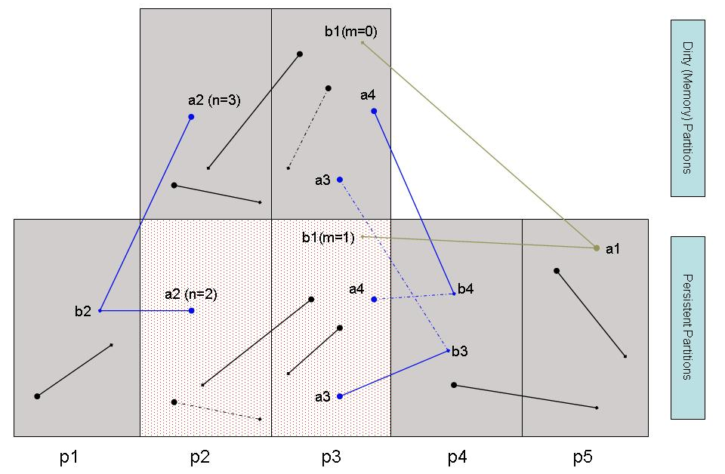
Figure 6: Mixing dirty and facility state

The blue and green links are cross-dirty-partition links, where the green links have no storage in the dirty partitions (e.g. the link from a1 to b2) and blue links have storage in the dirty partitions (e.g. the link from a2 to b2). We paint dashed links, whenever they do not exist in memory anymore (because they were deleted) or they do not yet exist in the facility, because they were newly created. Moreover, we assume the type of alias b* has an attribute m and the type of alias a* has an attribute n. We have included two example aliases with attribute values: b1 has attribute m with value 1 and a2 has attribute n with value 2 persistently. In the dirty partitions, these values changed to 0 and 3 respectively.
A query as simple as the following leads to considerable complications in the above scenario:
select[PF] a, a.attr1, b, b.attr2
from A as a, B as b
where a.end2[@ myAssoc] = b
where b.m > 0
where a.n = 3
We have to consider a whole series of different situations, where we will assume the invariant that two atomic from entries will always be connected by exactly one assocPredicate. Previous transformations in the preprocessor guarantee that this invariant holds.

No assoc or link predicate
The simplest case is when we have one from-entry, which has no assoc predicates. In that case, we simply look at the scope of the one from-entry. If its scope is spread over dirty and non-dirty partitions, we have to unify the results from both sources, i.e. in-memory from the dirty partitions and persistently over all partitions in scope, except the dirty partitions. If the scope comes exclusively from the dirty state, we only have to obtain the instances from the dirty partitions, and similarly if the scope comes exclusively from non-dirty state.
For instance, suppose the query before scheduling looks as follows:
select[PF] a, a.attr1
from A as a
where a.n = 3
Then scheduling process produces for the situation of Figure 6:
(select[PF] a, a.attr1
from A as a not in {p2, p3}
where a.n = 3)
union
(select[MEMORY] a, a.attr1
from A as a in {p2, p3}
where a.n = 3)

One assoc predicate
Scheduling becomes interesting whenever we have to take links into account, which occur in queries via the inclusion of assocPredicate conditions. Let us look at a simple sample query which is to operate on the state as it is depicted in Figure 6 above. We assume to have the PF processor working on persistent state. Now, assume that the query before scheduling looks like this:
select[PF] a, a.attr1, b, b.attr2
from A as a, B as b
where a.end2[@ myAssoc] = b
where a.n > b.m
where b.m > 0
where a.n = 3

We assume that all shown links in the figure above are instances of myAssoc, where we define that storage for myAssoc is only on the side of A (this is indicated by the @ sign in the query). This situation is depicted in the above figure by the fact that only aliases a* (all of type A) have thicker ends (bullets).

The following transformed query obtains all the model elements above as we would expect from this state.
(select[PF] a, a.attr1, b, b.attr2
from A as a not in {p2, p3}, B as b not in {p2, p3}
where a.end2[@ myAssoc] = b
where a.n > b.m
where b.m > 0
where a.n = 3)
union
(select[MEMORY] a, a.attr1, b, b.attr2
from A as a in {p2, p3}, B as b in {p2, p3}
where a.end2[@ myAssoc] = b
where a.n > b.m
where b.m > 0
where a.n = 3)
union
(select[MEMORY] a, a.attr1, b, b.attr2
from A as a in {p2, p3}, B as b in {p1, p4}
where a.end2[@ myAssoc] = b
where a.n > b.m
where b.m > 0
where a.n = 3)
union
(select q1.a, q1.a.attr1, q2.b, q2.b.attr2
from (select[PF] a, a.attr1, a.n, b_
from A as a not in {p2, p3}, B as b_ in {p2, p3}
where a.end2[@ myAssoc] = b_
where a.n = 3) as q1,
(select[MEMORY] b, b.attr2, b.m
from B as b in {p2, p3}
where b.m > 0) as q2
where q1.b_ = q2.b)
where q1.a.n > q2.b.m)
This query unifies four separate result sets. The first query runs on all persistent partitions, except those which are labeled dirty (i.e. p2 and p3). The second query runs on all partitions, which are in dirty memory only. These two queries produce all the results, which are connected via black links in the figure (i.e. links between model elements that are either both in dirty partitions or both in persistent partitions).

The two last (top-level) queries find results which are connected via cross-dirty-partitions links. For type A, this means a1, a2, and a4. For type B, this means b1, b2, and b4. The exact form of these two queries depends on storage ownership properties of the association. Because storage is on the side of A in this example, we find all the results connected via blue links by computing the third query above, which looks for all links, which have the end of A in one of the dirty partitions and the end of B in a non-dirty partition.
It is important to observe that, in order to calculate this, the MEMORY processor may load the partitions in which the instances of B exist via this link. In the example, these are the partitions p1 and p4, but not p5! The partitions p1 and p4 (together with the dirty partitions p2 and p3) can be calculated by investigating all links located in the dirty partitions and collecting all partitions used by those links. We conjecture that in practice, not many partitions (like p1 and p4) will be affected by this because of a locality-principle when querying data.
Finally, in order to find the model elements connected via a cross-dirty-partition link, which is green (in the example a1 and b1), i.e. where storage ownership is in a partition, which is not dirty, and therefore, not necessarily loaded, we fire the 4th query. This query is complex because we have to be careful to not accidentally include information from a persistent partition, which has changed in memory. In other words, we search persistently for a super-set of all relevant links because any conditions on the side of B may be outdated. We then filter the elements with the dirty state where the condition on the side of B are up to date. This is exactly what the query asks for: We join the instances of B that fulfill the condition from the dirty partitions with the instances we have found via links in the persistence layer.
We can slightly simplify the above by combining the 2nd and the 3rd query, leading to the following result query:
(select[PF] a, a.attr1, b, b.attr2
from A as a not in {p2, p3}, B as b not in {p2, p3}
where a.end2[@ myAssoc] = b
where a.n > b.m
where b.m > 0
where a.n = 3)
union
(select[MEMORY] a, a.attr1, b, b.attr2
from A as a in {p2, p3}, B as b in {p1, p2, p3, p4}
where a.end2[@ myAssoc] = b
where a.n > b.m
where b.m > 0
where a.n = 3)
union
(select q1.a, q1.a.attr1, q2.b, q2.b.attr2
from (select[PF] a, a.attr1, b_
from A as a not in {p2, p3}, B as b_ in {p2, p3}
where a.end2[@ myAssoc] = b
where a.n = 3) as q1,
(select[MEMORY] b, b.attr2
from B as b in {p2, p3}
where b.m > 0) as q2
where q1.b_ = q2.b
where q1.a.n > q2.b.m)

The process of transforming a query with respect to an association predicate and storage properties is called spreading, because it spreads the query over the memory and persistent facilities in such a way that it produces correct results. In the rest of this document, we will refer to these 3 sub-queries (where the 3rd is split again in 2 queries) as q1, q2, q31, and q32.
A very important optimization is possible whenever we do not have local constraints or selections on the non-storage side (B). More exactly, this implies
- No attribute selection on B exists in the select clause
- There exists no where clause for B
- There exists no attribute comparison which involves attributes of B
- B is not involved in a links predicate
When these conditions apply, we say that B’s participation in the association predicate is simple.
As an example, consider the following query, where b’s participation in the association predicate is simple:
(select[PF] a, a.attr1, b
from A as a, B as b
where a.end2[@ myAssoc] = b
where a.n = 3) as result
Because b is simple, we do not have to fetch data from the dirty partitions and therefore, we can collapse the two queries on the PF facility. The resulting simplified query looks like this:
((select[PF] a, a.attr1, b
from A as a not in {p2, p3}, B as b
where a.end2[@ myAssoc] = b
where a.n = 3)
union
(select[MEMORY] a, a.attr1, b
from A as a in {p2, p3}, B as b in {p1, p2, p3, p4}
where a.end2[@ myAssoc] = b
where a.n = 3)) as result

Again, for future referencing, we name these two subqueries q1’ and q2 because q1’ is a slight variation of q1 above and the second query is identical to second query above.
Query spreading is purely driven by storage properties with respect to an association predicate, in the above example, this is the fact that storage is on the side of A, and not on the side of B for association myAssoc. In order to simply the remaining discussions, we introduce the concept of a dominant and a sub-dominant assigned alias with respect to an association. In the above example, alias a is dominantly assigned with respect to myAssoc and alias b is sub-dominantly assigned with respect to myAssoc. By definition, an alias can only be assigned the dominant property with respect to an association if that association has storage on the side of the alias.

One or more Link Predicates
Links may also be queried via link predicates. Link predicates are not affected in the same way by the spreading algorithm because it is possible to compute the nested query first and put its result set in the link predicate. This ability is exploited as soon as a nested query is subject to any kind of mixing (i.e. results have to be combined in memory).
The only situation where we keep the nested query together with the encompassing query (which holds the link predicate) is whenever the following two conditions hold at the same time:

- The nested query is itself processed entirely (up to its own link predicates) in one FQL processor, and;
- The queries holding the link predicate are all leaf queries, which can be processed in the same FQL processor.
In such a scenario, MQL assumes that a facility knows better how to process a nested query inside another query.
In all other cases, we first calculate the nested query and then use the result set when computing the encompassing query. Whether or not a nested query is computed separately is indicated with the reset attribute in the NestedQuery class of IQF. During mixing, this attribute is used to decide whether the results of the nested query should be cached or not.
In all other aspects, dealing with link predicates is similar to the case where we have no link or assoc predicates at all. For instance, consider the following simple example, where we assume that the instances of B are taken from p4 to make sure that no scheduling was required for the nested query:
select[PF] a, a.attr1
from A as a
where a.end2[@ myAssoc] in
(select[PF] b
from B as b in {p4}
where b.m = 0)
where a.n = 3
This is translated as follows:
(select[PF] a, a.attr1
from A as a not in {p2, p3}
where a.end2[@ myAssoc] in
(select[PF] b
from B as b in {p4}
where b.m = 0) as q
where a.n = 3)
union
(select[MEMORY] a, a.attr1
from A as a in {p2, p3}
where a.end2[@ myAssoc] in
(select[PF] b
from B as b in {p4}
where b.m = 0) as q
where a.n = 3)
Actually, this pretty-printed result is somewhat misleading because the query q is internally shared (the original nested query was reset before the spreader started).

More than one assoc predicate
Generally, it is of course possible that we have to schedule with dirty partitions for a query which is a non-trivial cluster containing more than one assoc. In fact, in general, we have to assume that with each assoc predicate we may be forced to mix persistent and transient results. As an important invariant, we will assume that the to-be-scheduled leaf query has all atomic entries connected via exactly one association predicate.
So, because the spreading algorithm of the previous section works for two aliases with one association predicate, we have to somehow reduce the problem to the case for one assoc predicate and then combine the results.
The obvious way to reduce the general problem to the smaller problem is to break the entire cluster apart in many small clusters of exactly two atomic entries with one assoc predicate. This is possible by cloning all shared aliases and introducing alias comparisons which are resolved by the MQL mixer in memory. This method multiplies the number of required queries by the number of assoc predicates. Although in the general case, this negative behavior cannot be avoided, it does not incorporate the explicit scoping annotations of the client. Since a client is encouraged to give explicit scoping, we anticipate many situations in which a less conservative query break-up can be achieved. Moreover, simple pre-optimizations by MQL, may detect that some dirty partitions are not relevant because they do not contain instances of the relevant types. So, if we know that the maximum scope of the query is entirely contained in dirty (or even loaded) partitions, it would be very beneficial to not break up the query at all. The same holds if the query scope indicates that no dirty partitions are involved at all!
In this section, we discuss how we can optimize the break-up to at least optimize the query such that it will not break-up the query in these common scenarios. As we pointed out in the previous section, client-specific scope information may simplify the result of spreading considerably.
In order to define a (heuristically) optimizing algorithm to combine assoc predicates, we have to carefully understand what kind of assoc predicates lead to one query after spreading. In order to do this, we first construct an annotated graph of a leaf query, where each node is an alias (atomic entry) and each edge is an assoc predicate between two aliases (storage properties are also put on the edges). Moreover, nodes are categorized in three classes:

- () Non-dirty nodes, meaning that the explicit provided scope does not include dirty partitions.
- () Dirty nodes, meaning that the explicit provided scope does only include dirty partitions
- () Mixed nodes, meaning that the explicit or implicit scope includes both dirty and non-dirty partitions.
Finally, we also indicate whether an alias (atomic entry) is simple according to the conditions listed earlier.
Consider for example the following typical leaf query graph:
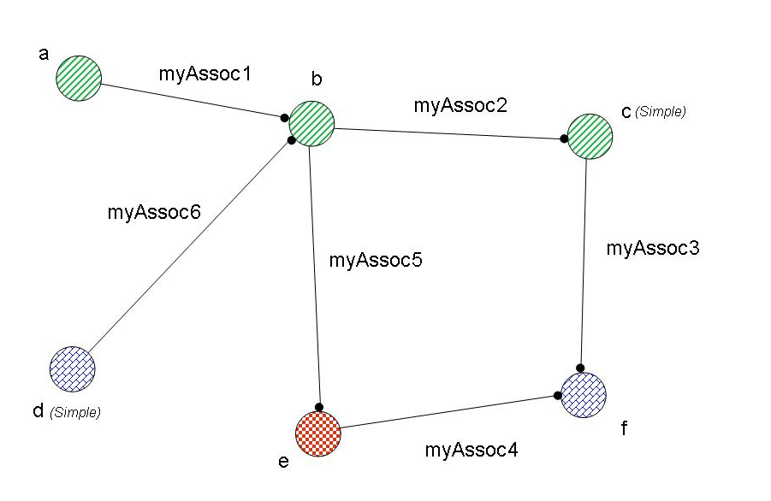
Observe that our invariant guarantees that all nodes are connected somehow to another graph node and that at most one association predicate exists between two nodes.
As we explained above, the naive approach would break this graph in sub-graphs of 2 nodes and with one edge between them. However, because of known node properties, we can do better. We formulate an algorithm below how this can be done.
We first have to look how spreading behaves between two colored nodes (i.e. regarding possible scoping properties). Recall from the previous section that in the non-simplified case we potentially need to construct and unify 3 queries – q1, q2, and q3 (the last one actually consists of 2 queries q31 and q32), whereas in the simplified case, we need to construct and unify 2 queries (q1’ and q2). The following table lists out what queries we have to use for spreading assoc predicates with different classes of atomic entries.

 |  | Non-simplified | Simplified (subdominant)
1 |  | Q1 | Q1
2 |  | Q2 | Q2
3 |  | Q1, Q2, Q3 | Q1’, Q2
4 |  | Q1, Q3 | Q1’
5 |  | Q3 | Q1’
6 |  | Q2 | Q2
7 |  | Q1, Q2 | Q1, Q2
8 |  | Q2 | Q2
9 |  | Q2, Q3 | Q1, Q2

We have 9 cases to consider. The first 3 are obvious. Either an assoc predicate connects two aliases that are entirely in the dirty space, entirely in the non-dirty space, or entirely in a mixed space. The 3rd case is the worst-case scenario whereas the 1st and 2nd cases are optimal.
The other 6 cases are mixed scenarios with provided dominance properties with respect to an assoc predicate (recall that dominance is determined by storage properties). Dominance is indicated by a thick circle. We note that cases 6 and 8 have the dirty nodes as being dominant, which allows them to be solved by query Q2 only. Cases 4 and 5 do something similar with non-dirty nodes being dominant, but expect the sub-dominant aliases for the association to be simple, i.e. not attribute selection or where-condition.
This table is simply the result of optimizing a spread query with regard to known scoping properties.
Generally, it seems beneficial to combine as much dirty nodes and non-dirty nodes. In the former case, we can always hang an isolated node of a different kind (texture/color) to the dirty node, provided the dirty node is dominant. In the latter case, we can also hang nodes of a different kind (texture/color) to the non-dirty node provided the added nodes are simple (and again, the non-dirty node itself is dominant). In all other cases, we have to break the graph in pair-graphs.
Based on this analysis, we define the following heuristic algorithm, which we expect to produce fine results (this is probably not an “optimal” algorithm; at least, this is not proven):

- Find the “largest” (i.e. the largest number of edges) possible sub-graph with at least one edge, constructed in one of the following two ways (in this priority):
  - Find a sub-graph, which is a connected graph of dirty nodes with possibly other-kinded subdominant nodes attached
  - If no sub-graph of type a) exists, find a sub-graph, which is a connected graph of non-dirty nodes with possibly other-kinded sub-dominant simple nodes attached
- If a sub-graph was found, “isolate” the identified sub-graph from the original graph (by cloning and introducing alias comparisons) and go back to step 1
- If no such sub-graph can be constructed anymore, we perform a complete break-up of whatever is left. So we produce sub-graphs which are pairs and are directly amenable to spreading as defined in the previous section
Along the way, the algorithm records for the sub-graphs introduced in step 1 with what type of query they have to be solved. Observe that the sub-graphs of step 1 can always be encoded with exactly one query (Q1, Q1’ or Q2), depending on the scoping properties of the “attached” nodes. All the remaining pair-wise graphs can be encoded with the other queries in the able above.
After breaking up the initial leaf query graph, we simply apply the splitting algorithm then, for each leaf query, apply the spreading algorithm with the found information.
The algorithm described here breaks up the earlier sample graph as follows:
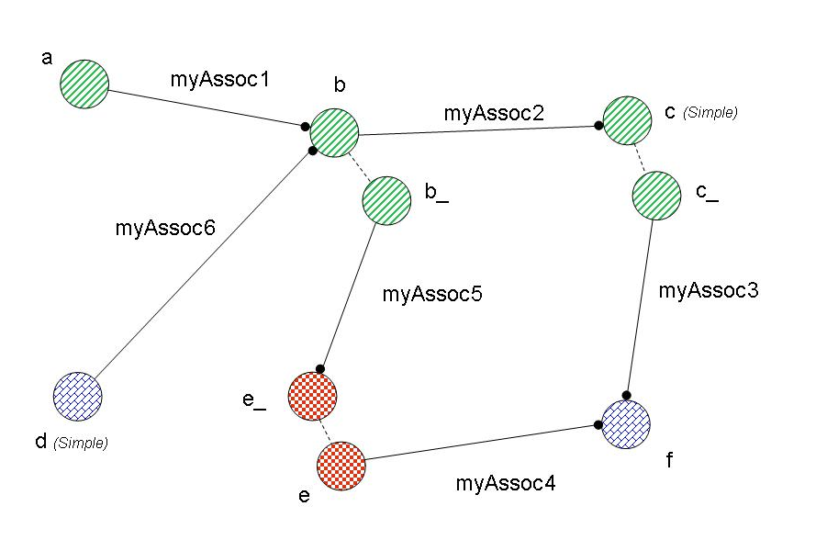

Notice that atomic entry d is “simple” and thus can be included in the strongly connected graph of non-dirty aliases. The result of this break-up is that the group with myAssoc1, myAssoc2, and myAssoc6 can be calculated with Q1’, the group with myAssoc3 and myAssoc4 can be calculated with Q2, and the group with myAssoc5 in the union of Q1 and Q2 (according to the table).
As an example query, which corresponds to the above graphs, we can assume the following sample query before scheduling:
select[PF] a, b, c, d, e, f.attr
from A as a in {p4, p5},
B as b in {p1},
C as c in {p6, p7},
D as d in {p2},
E as e,
F as f in {p2, p3}
where a.end12[myAssoc1 @] = b
where b.end22[myAssoc2 @] = c
where c.end32[myAssoc3 @] = f
where f.end42[@ myAssoc4] = e
where e.end52[@ myAssoc5] = b
where b.end61[@ myAssoc6] = d

Assuming that p2 and p3 are dirty, breaking up the leaf query graph produces:
select[PF] a, b, c, d, e, f.attr
from A as a in {p4, p5}
B as b in {p1},
B as b_ in {p1},
C as c in {p6, p7},
C as c_ in {p6, p7},
D as d in {p2},
E as e,
E as e_,
F as f in {p2, p3}
where a.end12[myAssoc1 @] = b
where b.end22[myAssoc2 @] = c
where c_.end32[myAssoc3 @] = f
where f.end42[@ myAssoc4] = e
where e_.end52[@ myAssoc5] = b_
where b.end62[@ myAssoc6] = d
where b = b_
where c = c_
where e = e_
The next step for the scheduler is to split up the above query:
(select iq3.iq1.a, iq3.iq1.b, iq3.iq1.c,
iq3.iq1.d, iq3.iq2.e, iq3.iq2.f.attr
from (select iq1.a, iq1.b, iq1.c, iq1.d, iq2.e, iq2.f.attr
from (select[PF] a, b, c, d
from A as a in {p4, p5}
B as b in {p1},
C as c in {p6, p7},
D as d in {p2}
where a.end12[myASsoc1 @] = b
where b.end22[myAssoc2 @] = c
where b.end62[@ myAssoc6] = d) as iq1,
(select[PF] c_, f, f.attr, e
from C as c_ in {p6, p7},
E as e,
F as f in {p2, p3}
where c_.end32[myAssoc3 @] = f
where f.end42[@ myAssoc4] = e) as iq2
where iq1.c = iq2.c_) as iq3,
(select[PF] b_, e_
from B as b_ in {p1},
E as e_
where e_.end52[@ myAssoc5] = b_) as iq4
where iq3.iq1.b = iq4.b_
where iq3.iq2.e = iq4.e_) as result

Finally, we can apply spreading (using the calculated annotations). We make the following assumptions for the sake of the example:
- The association dependent partitions for alias c_ from alias f via assoc myAssoc3 are p6 and p5
- The association dependent partitions for alias e from alias f via myAssoc4 are p3 and p4
- The association dependent partitions for alias b_ from alias e_ via myAssoc5 are p1, p2, and p5
The result looks as follows:
(select iq3.iq1.a, iq3.iq1.b, iq3.iq1.c,
iq3.iq1.d, iq3.iq2.e, iq3.iq2.f.attr
from (select iq1.a, iq1.b, iq1.c, iq1.d, iq2.e, iq2.f, iq2.f.attr
from (select[PF] a, b, c, d
from A as a in {p4, p5}
B as b in {p1},
C as c in {p6, p7},
D as d in {p2}
where a.end12[myAssoc1 @] = b
where b.end22[myAssoc2 @] = c
where b.end62[@ myAssoc6] = d) as iq1
(select[MEMORY] c_, f, f.attr, e
from C as c_ in {p6},
E as e in {p3, p4},
F as f in {p2, p3}
where c_.end32[myAssoc3 @] = f
where f.end42[@ myAssoc4] = e) as iq2
where iq1.c = iq2.c_) as iq3,
((select[PF] b_, e_
from B as b_ in {p1},
E as e_ not in {p2, p3}
where e_.end52[@ myAssoc5] = b_)
union
(select[MEMORY] b_, e_
from B as b_ in {p1, p2, p5},
E as e_ in {p2, p3}
where e_.end52[myAssoc5] = b_)) as iq4
where iq3.iq1.b = iq4.b_
where iq3.iq2.e = iq4.e_) as result
Observe that query iq1 is untouched. In query iq2 we have that f is dominant and thus incorporate the dependent partitions in the scopes of c_ and f. Similarly, in query iq4, we incorporate the dependent partitions in the scope of alias b_ in the memory-based query because e_ is dominant.

