Authors:
Stephan Lange, Simon Helsen
 | Basic Query Implementation for Memory - Design
 | Version | Status | Date
 | 1.0 |  | 6 July 2006
Contents

1 Abstract 3
2 Purpose of the Basic Query Implementation for Memory 3
3 Overview of the Implementation Classes 3
4 The Cluster Navigation Plan 4
4.1 Motivation of the Cluster Navigation Plan 4
4.2 The Structure of a Cluster Navigation Plan 5
4.2.1 The Start ModelElementExpression 5
4.2.2 The Navigation Steps 5
4.2.3 Other ModelElementExpressions 6
4.2.4 Holding the Current State of the Tuple Iteration 6
4.3 The Initialization of the Cluster Navigation Plan 6
4.3.1 The Goal of the Initialization of the Cluster Navigation Plan 6
4.3.2 The Initialization Procedure 6
4.4 Model Element Tuple Iteration using the Cluster Navigation Plan 7
5 The Cluster Evaluator 8
5.1 Motivation of the Cluster Evaluator 8
5.2 The Algorithm if the Cluster Navigation Plan 8

Abstract
This document describes the design of the Basic Query implementation for memory.
It explains the purpose of the Basic Query memory implementation. It gives an overview of the implementation classes and it explains the key algorithms in detail.

Purpose of the Basic Query Implementation for Memory
Currently there are two different use-cases known where the Basic Query implementation is needed.
If model elements which are relevant for a query are contained in dirty partitions then the MOIN Query layer delegates queries to the Basic Query implementation for memory and merges the results with the results of queries to the corresponding facility.
In the MOIN in the build scenario there is no database persistency available. The available file system does not provide sufficient query functionality. The strategy here is to load all relevant model data into memory. Queries can then be executed directly in memory. The assumption is that the amount of the relevant modeling data can be held in memory in such a use case.

Overview of the Implementation Classes
The classes that implement the Basic Query for memory are located in the package com.sap.tc.moin.query.memory in the core project. The class BasicQueryProcessorImplMemory implements the BasicQueryProcessor interface. It delegates the query execution to the class ClusterEvaluator which knows the root ModelElementClusterExpression of the query which is to be executed.
The query can consist of multiple ModelElementClusterExpressions which form a tree. The ClusterEvaluator creates for each ModelElementClusterExpression a ClusterNavigationPlan which helps in retrieving the tuples of model elements in a cluster that fulfill the cluster internal link expressions.
The graphic below shows a simplified UML diagram. The Basic Query implementation classes for memory are contained in the inner rectangle. A more detailed description of the LinkExpressions and the AttributeExpressions can be found in the design document for the Basic Query SPI.

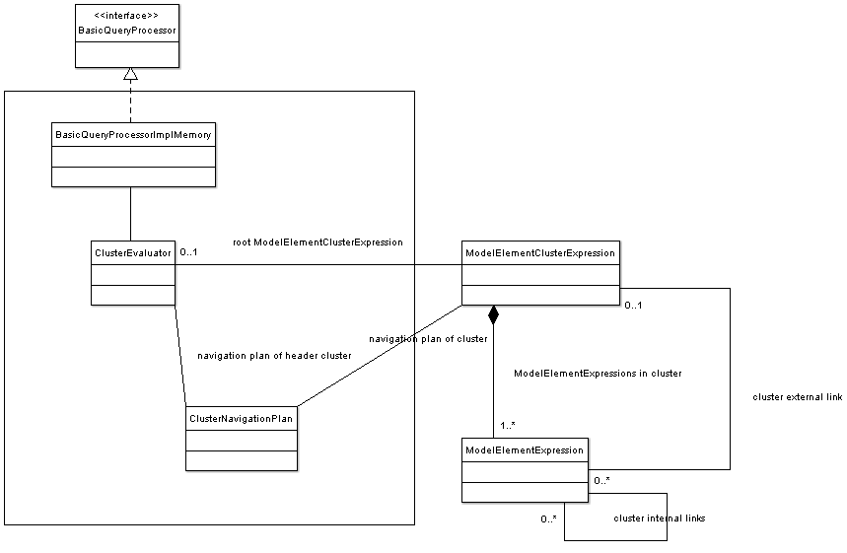

The Cluster Navigation Plan

Motivation of the Cluster Navigation Plan
A ModelElementClusterExpression may contain several ModelElementExpressions. Each ModelElementExpression contains a (sometimes nested) AttributeExpression. A cluster can contain several types of LinkExpressions: ClusterInternalLinkExpressions, MriSetLinkExpressions and ClusterExternalLinkExpressions. In order to evaluate a ModelElementClusterExpression it is necessary to find out all tuples of model elements that fulfill the respective ModelElementExpressions, and the different types of LinkExpressions.
A naïve approach would
- Generate all tuples of model elements where the model elements fulfill the type condition of the respective ModelElementExpressions.
- For each tuple and each model element in the tuple evaluate the attribute conditions of the ModelElementExpressions. If at least one attribute condition did not match then continue with the next tuple.
- Evaluate the ClusterInternalLinkExpressions. If at least one ClusterInternalLinkExpression did not match then continue with the next tuple.
- Evaluate the MriSetLinkExpressions. If at least one MriSetLinkExpressions did not match then continue with the next tuple.
- Evaluate the ClusterExternalLinkExpressions assuming that the child clusters have been evaluated before. If at least one ClusterExternalLinkExpressions did not match then continue with the next tuple.
The performance of this approach is not very good because in the first step a lot of RefObjects are instantiated and bundled to tuples which soon are discarded because they don’t fulfill one of the following checks. Since object instantiation is expensive in Java the task is to find an approach where less tuples of model elements are created.
The idea is to check the cluster internal link expressions first because they are very selective in the most cases. The so called cluster navigation plan provides the functionality to “navigate” from one model element of one ModelElementExpression to the model elements of another ModelElementExpression which fulfill the constraints of a ClusterInternalLinkExpression. By navigating the cluster internal links the cluster navigation plan allows finding all tuples of model elements which fulfill all cluster internal link expressions in the cluster.
This results in the following modified approach:
- Create and execute the cluster navigation plan of the ModelElementClusterExpression. This provides all tuples of model elements where the model elements fulfill the type condition of the respective ModelElementExpressions and all ClusterInternalLinkExpressions in the cluster.
- For each tuple and each model element in the tuple evaluate the attribute conditions of the ModelElementExpressions. If at least one attribute condition did not match then continue with the next tuple.
- Evaluate the MriSetLinkExpressions. If at least one MriSetLinkExpressions did not match then continue with the next tuple.
- Evaluate the ClusterExternalLinkExpressions assuming that the child clusters have been evaluated before. If at least one ClusterExternalLinkExpressions did not match then continue with the next tuple.

The Structure of a Cluster Navigation Plan
The cluster navigation plan of a ModelElementClusterExpression holds the information which is required to iterate over all tuples of model elements in the cluster which fulfill the ClusterInternalLinkExpressions.
The cluster navigation plan specifies one start ModelElementExpression which is used as navigation starting point. It defines navigation steps which define the link navigation from one ModelElementExpression to another ModelElementExpression and it holds the status of the tuple iteration.

The Start ModelElementExpression
The cluster navigation plan specifies one ModelElementExpression in the cluster as start ModelElementExpression. The idea is that the RefObjects that fulfill the type constraints of the start ModelElementExpression are used as starting point for the finding of model element tuples. This means that the first navigation step has the start ModelElementExpression as source.

The Navigation Steps
A navigation step consists of a navigation source ModelElementExpression, a navigation target ModelElementExpression, a navigation link expression and a navigation link direction flag describing the direction the link expression shall be navigated.
The cluster navigation plan holds an ordered sequence of navigation steps. The navigation source of the first navigation step is the start model element expression.
For each navigation step it is guarantied that the navigation step of the source is either the start model element expression or the navigation target of a previous navigation step. Every ModelElementExpression is either start ModelElementExpression or navigation target of exactly one navigation step.

Other LinkExpressions
It can happen that there are more ClusterInternalLinkExpressions than required for the definition of the navigation step. In such a case the ClusterInternalLinkExpressions that are not contained in the navigation steps are held as “other” LinkExpressions. When a tuple of model element was found by navigating the navigation steps then it has to be checked whether the other LinkExpressions are fulfilled as well.

Holding the Current State of the Tuple Iteration
For each ModelElementExpression in the cluster the cluster navigation plan holds one current model element list. If the ModelElementExpression is the start model element expression then the current model element list contains either all RefObjects which fulfill the type constraints of the ModelElementExpression. If the ModelElementExpression is not the start ModelElementExpression then the current model element list contains the result of the navigation step where the ModelElementExpression is the target.
For each current model element list the cluster navigation plan holds the current read position pointer. The current tuple in the navigation plan processing is defined by the current read positions in the current model element lists.

The Initialization of the Cluster Navigation Plan

The Goal of the Initialization of the Cluster Navigation Plan
Before a cluster navigation plan can be used for the model element tuple iteration for a ModelElementClusterExpression it has to be initialized.
The goal of the initialization of the cluster navigation plan is to determine the start ModelElementExpression and to calculate the navigation steps in order to have the necessary information for navigating in the cluster. The start ModelElementExpression and the navigation steps have to be set in a way that it is possible to find tuples of model elements that fulfill the ClusterInternalLinkExpressions by executing the ordered navigation steps subsequently.
Such a setting does not necessarily exist for a query which is constructed using the Basic Query SP. However, for Basic Queries which are generated by the MOIN QL processor the existence of such a setting is guarantied.

The Initialization Procedure
This paragraph describes the initialization procedure of the cluster navigation plan.
Definition: A ModelElementExpression M is navigable from a ModelElementExpression N if there is a ClusterInternalLinkExpression in the cluster which allows the link navigation from N to M. The link category of a ClusterInternalLinkExpression is either association or attribute. Associations can be navigated in both directions while attribute links can only be navigated in one direction.
Definition: A ModelElementExpression M is navigable in the cluster if M is navigable from the start ModelElementExpression or if M is navigable from an existing navigation target.
The algorithm of initializing the cluster navigation plan is described below.

1) | Iterate over all ModelElementExpressions in the cluster and set the current ModelElementExpression as start ModelElementExpression.
2) | Create or cleanup an array of navigation steps. The size of the array is cluster size – 1.
3) | Iterate over the remaining ModelElementExpressions.  If the current ModelElementExpression is navigable then add a new navigation step with the current ModelElementExpression as navigation target and the corresponding navigation source, ClusterInternalLinkExpression and link direction. Continue with 3) till all ModelElementExpressions in the cluster are either the start ModelElementExpression or navigation target of one navigation step.  If the current ModelElementExpression is not navigable then continue with the next start ModelElementExpression in 1)  If all ModelElementExpressions are either start ModelElementExpression or navigation target then set the “other” ClusterInternalLinkExpressions and finish.
4) | If the initialization of the cluster navigation plan failed for all ModelElementExpressions as start ModelElementExpression then throw an exception stating that the initialization failed.

Model Element Tuple Iteration using the Cluster Navigation Plan
Having the cluster navigation plan of a ModelElementClusterExpression initialized it can be used for iterating over all model element tuples that fulfill all ClusterInternalLinkExpressions.
The algorithm iterates over the model elements of the ModelElementExpressions of the cluster in a way that is defined by the start ModelElementExpression and the cluster navigation steps.
For a navigation step the following operations are executed:
- Calculate the model elements of the navigation target that are linked to a specified model element of the navigation source.
- Iterate over the linked model elements of the navigation target.
Definition: Updating a navigation target
If the linked model elements of the current model element of the navigation source have already been calculated then increment the current read position of the current model element list of the navigation target.
Otherwise calculate the linked model elements for the current model element of the navigation source using the navigation link expression and set the linked model elements as current model element list of the navigation target. Furthermore set the current read position of the current model element list of the navigation target on the first model element of the list.
The update of the navigation target was not successful if one of the following applies:
- The current model element of the navigation source is initial which can happen at the very beginning of the iteration.
- Calculating the linked model elements returned no model element.
- Incrementing the read position of the current model element list of the navigation target failed because the last position has been reached.
Having the definition of updating a navigation target the algorithm of tuple iteration becomes straightforward. For every iteration step it is tried to update the target of the last navigation step. If this was successful then a new navigation source is needed which is why it is tried to update the target of the previous navigation step. If the update of the target of the previous navigation step succeeds then it is tried to update the target of the last navigation step again. If the update of the previous navigation step fails also then it is tried to update the target of the navigation step before the previous navigation step and so on.
The activity diagram below describes the algorithm of iterating over the model elements that fulfill the type conditions of the ModelElementExpressions and the ClusterInternalLinkExpressions of the navigation steps.
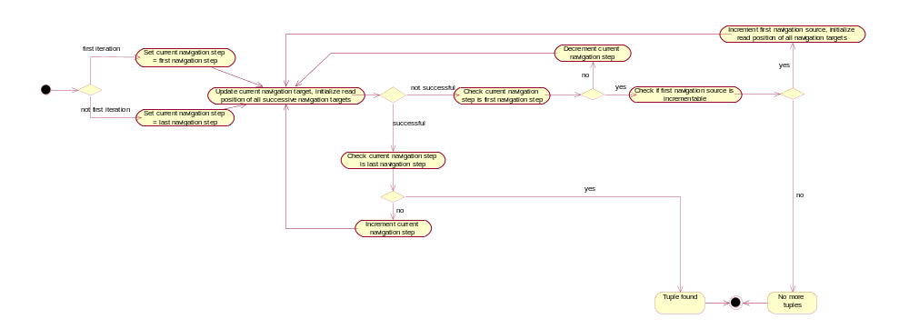
The algorithm described by the activity diagram does not regard the other ClusterInternalLinkExpressions. The complete algorithm that regards all ClusterInternalLinkExpressions iterates over all tuples that fulfill the ClusterInternalLinkExpressions of the navigation steps as described above, but it returns only tuples that fulfill the other ClusterInternalLinkExpressions as well.

The Cluster Evaluator

Motivation of the Cluster Evaluator
The cluster navigation plan provides the functionality to iterate over the tuples of model elements that fulfill all ClusterInternalLinkExpressions. It does not consider AttributeExpressions and MriSetLinks and ClusterExternalLinkExpressions.
The cluster evaluator executes the complete query on a ModelElementClusterExpression including all child ModelElementClusterExpressions.

Recursive Cluster Evaluation
The cluster evaluator recursively evaluates the child ModelElementClusterExpressions which are linked by ClusterExternalLinkExpressions.
It creates a navigation plan for the cluster and iterates over the model element tuples that fulfill the ClusterInternalLinkExpressions using the cluster navigation plan. For the tuples which are returned by the cluster navigation plan it checks whether the AttributeExpressions, the MriSetLinkExpressions and the ClusterExternalLinkExpressions are fulfilled as well.
For model element tuples fulfilling all these constraints an entry in the result is created. If the ModelElementClusterExpression is the root ModelElementClusterExpression then a result set whose structure is defined by the SelectExpression is created, otherwise a list of model elements of the header ModelElementExpression of the cluster is created.
The algorithm of the cluster evaluator is described below.

1) | Do the cluster evaluation recursively for all child clusters. The results of the evaluation of the child clusters are needed later for the evaluation of the ClusterExternalLinkExpressions.
2) | Create the cluster navigation plan for the current cluster. Iterate over the model element tuples that fulfill the ClusterInternalLinkExpressions using the navigation plan of the cluster.
3) | Check the AttributeExpressions for the model elements of the tuple.
4) | Check the MriSetLinks.
5) | Check the ClusterExternalLinkExpressions using the results of the evaluation of the child clusters.
6) | If all checks were successful then add a result entry.  If the current cluster is the root cluster then the result is a ResultSet whose structure is described in the SelectExpression. If there are attributes in the SelectLists then the corresponding attribute values have to be read.  If the current cluster is not the root cluster then the result consists of the model elements of the header ModelElementExpression. The header model element is part of the model element tuple.
7) | Continue with the next tuple in 2)

