Version: 1.0
Date: English
Doc. No.:
Language: English
 | Graphics Framework migration test

Copyright
Copyright © 2026 SAP AG. All rights reserved.
No part of this documentation may be reproduced or transmitted in any form or for any purpose without the express permission of SAP AG.
SAP reserves the right to change the information contained in this document without prior notice.

Author(s)
d043982

Contents
Introduction 4
1 Structure of the test 5
1.1 Demands to the test environment 5
1.2 Operation 5
1.2.1 Model creation 5
1.2.2 Loading the model 5
1.2.3 Modification 5
1.2.4 Loading the modified model 6
2 Construction of the test 6
2.1 GraphicsTestsUtil 6
2.2 Pictograms- and LinkTestsUtil 6
2.3 GraphicsModelManipulation 6
2.4 RepositoryFacade 6
2.5 The JUnit test and *RepositoryImpl 6
3 Pictograms test 6
3.1 Model structure before modification 6
3.2 What is tested 6
3.3 Steps of model modification and check if correct 6
3.4 Model structure after modification 6
4 Link test 6
4.1 Model structure before modification 6
4.2 Steps of model modification and check if correct 6
4.3 Model structure after modification 6
5 Known problems 6
6 Further steps after milestone 2 6

Introduction
This test case is used to check the creation and modification of models especially for the milestone 2 of MOIN. Additionally, this test assists in the migration of Graphics Framework by running at first with MMR and later with MOIN which is the similar to the situation in the Graphics Framework.

The test is split into two. One part is for the a more complex pictograms model with several MOF classes like associations (1:1 and 1:n) and compositions (1:1 and 1:n) and the other part is for a link between a Pictograms model and a MOF class. In both cases a model is created and modified with the JMI interfaces. Furthermore, the persistence of the models is tested.
The deployment of meta-models is not tested and therefore it is assumed that the relevant meta-models already exist.

Because Graphics Framework is running with an Eclipse plug-in, another demand to the test is to be platform independent. It must run with a JUnit test and an Eclipse test. Hence, the operation of the test case in the test environment must follow a given structure, but the realization is done in an independent class.

Structure of the test

Demands to the test environment
At the initialization, an instance of the class *TestUtil must be initialized. In the constructor of this object, the first parameter is an implementation of the interface RepositoryFacade, where the infrastructure dependent methods lie. The second parameter defines the filename of the XMI file with the reference model, which is later used to check the correct creation of the model.

To avoid a pollution of the persistence, the model should be deleted from the persistence after the test.

Execution
The test case has four steps which are dependant of each other and which are similar in both ways (the Pictograms test and the link test).

 | Creation | Modification
Memory | 1st: 1.2.1 Model creation | 3rd: 1.2.3 Modification
Persistence | 2nd: 1.2.2 Loading the model | 4th: 1.2.4 1 Loading the modified model
Table 1: Four steps of the test

It is possible to create a local test output in the file system to use the result for manual comparison. Therefore it exists the method called exportToXMI.

At the end of every step, the model is deleted from the memory so that a status is created similar to closing and opening the program that will later use MOIN.

Model creation
The model is created and persisted. The examination of the model is done by writing the created model with the XMI writer to an output stream and comparing it to the reference model which is loaded in an input stream. This means that whenever the creation of the model is modified, the reference has to be updated, too. With this step, the correctness of generating models is tested.

Loading the model
The persisted model is loaded and once again compared with the reference model to ensure the correct persistence of the infrastructure.

Modification
The model is loaded again from the persistence, modified according to the chapter of the executed test and persisted. This time, the correct modifications aren’t verified with a reference model but with special methods. This again means that whenever the modification of the model is changed, the methods to check the correct modifications have to be changed, too. With this step, the correct behavior when changing associations between elements is tested.

Loading the modified model
The modified model is loaded and once again checked with the methods to ensure correct modification.

Construction of the test
The test was constructed to be as reusable and independent as possible. Therefore, it was split up:

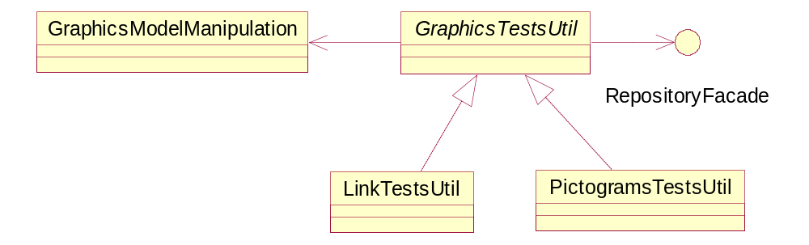
Figure 1: Construction of the test

GraphicsTestsUtil
It is an abstract class which contains abstract methods to check if a model is correct and to get all root elements of a model. Those methods, which are independent of the tested model, are not abstract, like getting a right diagram after loading or comparing. That guarantees that the test is reusable for tests with other meta-models.

Pictograms- and LinkTestsUtil
The methods of these classes are called by the test environment. PictogramsTestsUtil contains the methods for the Pictograms test and LinkTestsUtil contains those for the test of the links. They contain methods to manipulate, save and load the model. Therefore they are stateful.

GraphicsModelManipulation
This class contains the methods that use the JMI API of the meta-model. It is stateless and must be provided with all information for the special operation that is performed. The contained methods create the model according to the executed test, modify it and check the modifications.

RepositoryFacade
This interface must be implemented by the classes which manage the integration of the infrastructure. Its methods are called by the utility classes.

The JUnit test and *RepositoryImpl
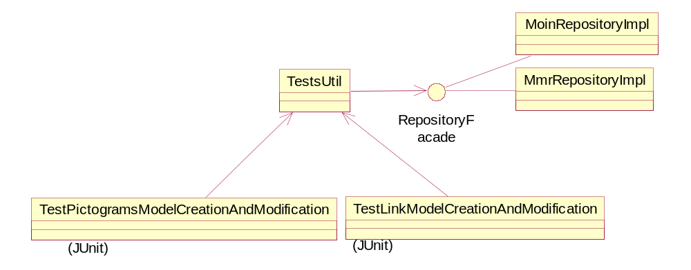
The test environment only calls the methods of the TestsUtil class. Moin- and MmrRepositoryImpl are the implementation of RepositoryFacade. They are stateful classes that manage the communication with the infrastructure.

Pictograms test

Model structure before modification
The following model is created by the method GraphicsModelManipulation.createPictogramsModel(...).

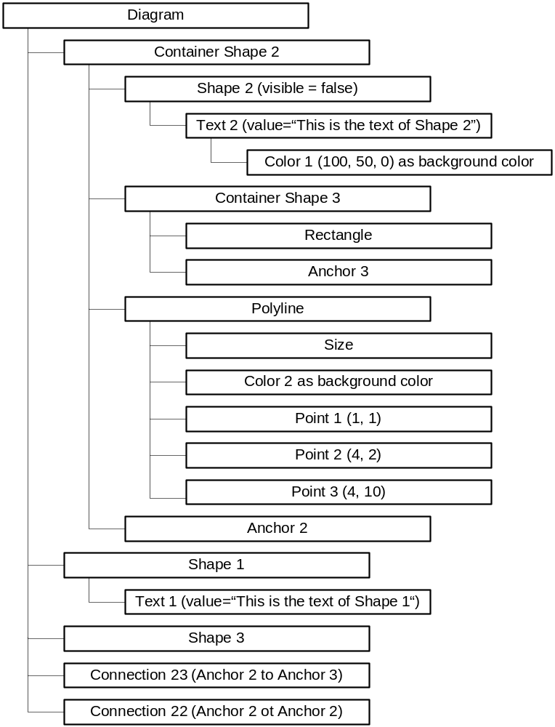

What is tested
The following table shows which type of associations are tested during the model modification and in which step.

 | Association |  | Composition |  | Attribute
 | 1 | n | 1 | n | 1 | n
Modify | 9 |  | 8 | 6, 7 | 3, 4 | 5
Delete | 10 |  |  | 1 | 2
Table 2: Steps of modification in Pictograms Test

Steps of model modification and check if correct
The modification is done in the method GraphicsModelManipulation.modifyPictogramsModel(...) and the check is executed with various methods of GraphicsModelManipulation.

- Delete Shape 1
  - Check if Shape 1 is removed in Diagram
  - Check if Shape 1 is deleted in extend
  - Check if Text 1 is deleted in extend

- Set value of Text 2 to null
  - Check if value of Text 2 is really null

- Override Color 1 with a new Color object
  - Check if Color 1 is really the new one
  - Check if the old Color 1 is deleted in extend

- Set visibility of Shape 2 to true
  - Check if visibility of Shape 2 is really true

- Delete Point 3 and add Point 4 to Polyline
  - Check if Point 4 is in Polyline and Point 3 isn’t
  - Check if Point 3 is deleted in extend

- Remove Shape 3 from Diagram and add it to ContainerShape 3 by using Shape3.setContainer()
  - Check if Diagram has not Shape 3 as child
  - Check if ContainerShape 3 has Shape 3 as child

- Remove ContainerShape 3 from ContainerShape 2 and add it to Diagram by using Diagram.getChildren().add(ContainerShape3)
  - Check if ContainerShape 2 has not ContainerShape 3 as child
  - Check if Diagram has ContainerShape 3 as child

- Replace Rectangle by a new Rectangle object
  - Check if the Rectangle is really the new one
  - Check if the old Rectangle is deleted in extend

- Remove Connection 22
  - Check if Diagram has only one Connection left
  - Check if Anchor 2 has only one outgoing connection to Connection 23
  - Check if Connection 22 is deleted in extend

- Set the beginning of Connection 23 from Anchor 2 to Anchor 3
  - Check if outgoing connection of A2 is not to Connection 23
  - Check if outgoing connection of A3 is to Connection23

Model structure after modification
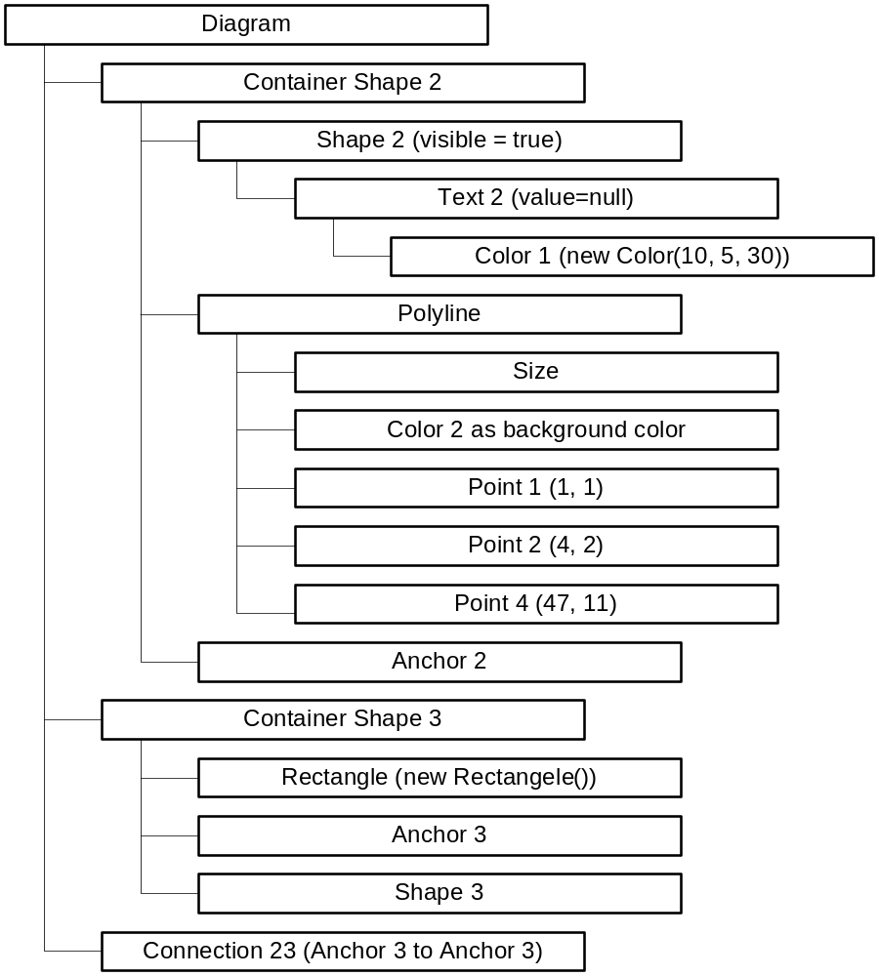

Link test

Model structure before modification
The following model is created by the method GraphicsModelManipulation.createLinkModel(...).
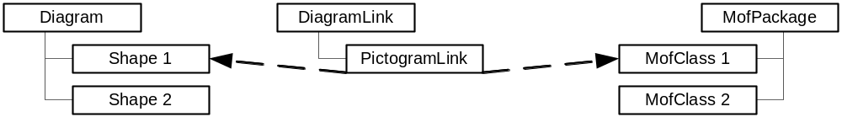

Steps of model modification and check if correct
The modification is done in the method GraphicsModelManipulation.modifyLinkModel(...) and the check is executed with GraphicsModelManipulation.Step1 and 2.

- Set Shape 2 as pictogram element of PictogramLink
  - Check if Shape 2 is really the pictogram element of PictogramLink
- Delete MofClass 1 as business object out of PictogramLink and set MofClass 2 as business object of PictogramLink
  - Check if MofClass 2 is really the business object of PictogramLink
  - Check if MofClass 1 isn't business object of PictogramLink anymore

Model structure after modification
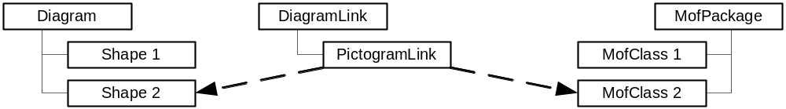

Known problems
So far, the used version of MMR has several bugs. They are noticed, when the Pictograms Test is executed and is failing. They are not a problem in the test but in the engine of the infrastructure. These problems should disappear when the MOIN milestone 2 is reached and MOIN can be used as infrastructure.

Up to now, it is not possible to load a persisted model and then use the XMI export. In this case a NullPointerException is raised for no obvious reason. Therefore, it is only possible to either get the XMI export or persist and load the model. But when choosing the way of persisting and loading, the second time of loading does not work probably. I assume that this is because of problems of MMR when saving a model a second time (after modifying) and identical mofIDs like before.

Other problems arise because some associations aren’t updated when changing them. But without these MMR specific problems, the test case itself is completed.

Further steps after milestone 2
- Creation of MoinRepositoryImpl
- Deletion of the comments in the JUnit tests so that the full test operation is executed (see TODO in TestPictogramModelCreationAndModification)
- Delete the comments in PictogramsTestsUtil so that the connection is closed after each step (see TODO in PictogramsTestsUtil)

