

MEDBOOKING - PLATFORM TO SUPPORT ONLINE HEALTHCARE BOOKING AND CONSULTATION
Software Design Specification

– DaNang, November 2024 –
Record of changes
Date | A*  M, D | In charge | Change Description
01/10/2024 |  | All | Initial
*A - Added M - Modified D - Deleted

Table of Contents
Table of Contents 4
I. Overview 7
1. 1. Code Packages 7
2. 2. Database Design 9
a. Database Schema 9
b. Table Description 9
II. Code Designs 12
3. Authentication 12
1.1. Register 12
1.2 Complete Onboarding Survey 15
1.3 Login 18
1.4. Reset Password 20
1.5. View & Update Profile: 22
2. Booking & Payment 26
2.1. Search Doctor 26
2.2. Filter Doctor by Specialty: 28
2.3. View Doctor Profile & Schedule 30
2.4. Search Department 32
2.5. Book Appointment 35
2.6. Select Package & Time Slot 38
2.7. Pay Deposit 40
2.8. View Upcoming Appointments 42
2.9. Cancel Appointment 44
2.10. Reschedule Appointment 46
2.11. View Payment History 49
3. Schedule & Appointment 51
3.1. View Work Schedule & Location 51
3.2. Add Time Slot 54
3.3. Edit Time Slot 57
3.4. Delete Time Slot 60
3.5. View Patient List 63
3.6. Confirm Appointment 65
3.7. Decline Appointment 67
3.8. State Decline Reason 69
4. Consultation 71
4.1. Join Video Call 71
4.2. Chat with Doctor 73
4.3. Conduct Video Call 75
4.4. Chat with Patient 78
5. Examination & Medical Record 80
5.1. View Diagnosis & Health Book 80
5.2. Download Prescription 82
5.3. Rate Doctor 84
5.4. Write Text Review 87
5.5. Submit Complaint 90
5.6. View Patient Record 93
5.7. Fill Examination Form 95
5.8. Order Lab Test 98
5.9. Write Diagnosis & Issue Prescription 100
6. Approval & Catalog 102
6.1. Review & Approve Doctor 102
6.2. Reject Doctor 105
6.3. Lock Account 107
6.4. Add Department 109
6.5. Edit Department 112
6.6. Assign Doctor to Department 114
6.7. View Doctors by Department 116
6.8. Add Specialty 118
6.9. Edit Specialty 121
6.10. Add Examination Package 124
6.11. Edit Examination Package 127
6.12. View Payment Statistics 130
7. Statistics & Moderation 133
7.1. View Booking Statistics 133
7.2. Export Statistics Report 136
7.3. View Cancellation Statistics 139
7.4. Handle Complaint 142
7.5 Post Epidemic Alert 145

I. Overview

1. Code Packages
No | Package | Description
1 | Presentation Layer | Contains the User Interface components, handling the user's interaction with the hospital system (booking, medical records, dashboards).
2 | Business Layer | Contains the core business logic and processing modules, managing data flow, appointment scheduling, and medical workflows.
3 | Data Layer | Manages the data access logic, handling storage and retrieval from the hospital database.
4 | Controller | Acts as a bridge between the User Interface and other modules in the Business Layer, routing HTTP requests to appropriate services.
5 | Utils | Provides utility functions and common services used across the application (date formatting, token generation, validators).
6 | Config | Manages configuration settings and application environment variables (database connection, JWT secret, mail server config).
7 | Filter / Middleware | Contains filters for data validation, authentication, authorization, and request processing (JWT verification, role checks).
8 | Models | Represents the data structure and entities used within the hospital domain (Users, Doctors, Patients, Appointments, etc.).
9 | DAL (Data Access Layer) | Handles database operations specifically for retrieving and saving data via ORM or raw SQL queries.
10 | Auth Service | Manages user authentication flows: login, registration, password reset via OTP, and session management.
11 | User Service | Handles CRUD operations for user accounts, profile management, and notification preference settings.
12 | Doctor Service | Manages doctor profiles, approval workflow by Admin, schedule creation, and specialty/department assignments.
13 | Appointment Service | Core service for booking, confirming, cancelling, and rescheduling appointments, and linking them to doctor schedules.
14 | Examination Service | Records clinical examination results (vitals, symptoms) and manages lab test requests per appointment.
15 | Medical Record Service | Creates and manages patient health records including diagnosis, doctor notes, and prescribed medicines per appointment.
16 | Messaging Service | Handles real-time or asynchronous messaging between doctors and patients within the context of an appointment.
17 | Video Call Service | Manages video call sessions initiated between doctor and patient for telemedicine consultations.
18 | Rating & Complaint Service | Handles post-visit appointment ratings submitted by patients and manages complaint submission and Admin review workflow.
19 | Payment Service | Manages deposit payment and refund flows when a patient books or cancels an appointment. Integrates with third-party payment gateway (e.g. VNPay/Momo). Tracks all transactions in Payment History.
20 | Email Notification Service | Sends automated emails to users for key events: appointment confirmation, appointment reminder (24h/1h before), lab result availability, prescription PDF, and deposit/refund receipts.
21 | Examination Package Service | Manages examination packages created by Admin: name, price, and included services. Provides package selection during the booking flow and links packages to appointments.
22 | Content Service | Manages creation and publishing of health-related articles and epidemic alerts by Admins for patient education and public health notification.

Package descriptions

2. Database Design

a. Database Schema
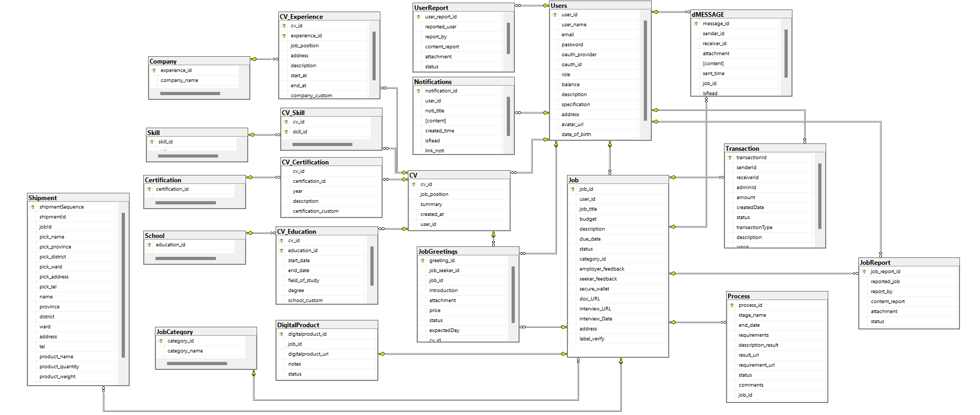

b. Table Description
No | Table Name | Description
1 | Roles | Danh sách vai trò trong hệ thống (ví dụ: admin, doctor, patient). Được tham chiếu bởi bảng Users để phân quyền người dùng.
2 | Users | Tài khoản đăng nhập cho mọi role (ADMIN / DOCTOR / PATIENT). Lưu thông tin cá nhân, trạng thái hoạt động, và cài đặt thông báo (email_notify, push_notify). Tích hợp Notification_Settings.
3 | Password_Resets | Quản lý token đặt lại mật khẩu. Mỗi token có thời hạn hết hạn (expires_at) và trạng thái xử lý (pending/used). Liên kết với Users qua user_id.
4 | Patients | Thông tin y tế của bệnh nhân: nhóm máu, tiền sử bệnh, bệnh hiện tại, dị ứng. Mỗi bệnh nhân tương ứng 1 tài khoản Users (1-1).
5 | Health_Books | Sổ sức khỏe điện tử của bệnh nhân. Mỗi bệnh nhân có đúng 1 sổ (1-1 với Patients). Làm đầu mối tập hợp toàn bộ hồ sơ bệnh án (Medical_Records).
6 | Specialties | Danh mục chuyên khoa y tế (Tim mạch, Nhi khoa, Da liễu...). Được tham chiếu bởi Doctors để xác định chuyên môn bác sĩ.
7 | Departments | Các khoa/phòng ban trong bệnh viện. Mỗi khoa có vị trí (location) và trạng thái hoạt động. Liên kết với Doctors.
8 | Doctors | Thông tin chuyên môn của bác sĩ: chuyên khoa, khoa phòng, kinh nghiệm, phí khám, chức vụ. Trạng thái mặc định là 'pending' cho đến khi được Admin duyệt.
9 | Doctor_Approvals | Lưu lịch sử phê duyệt/từ chối tài khoản bác sĩ. Admin xét duyệt kèm lý do từ chối nếu có. Theo dõi thời điểm xem xét (reviewed_at).
10 | Doctor_Schedules | Lịch làm việc của bác sĩ theo từng ngày: ngày làm, giờ bắt đầu/kết thúc, trạng thái còn chỗ (is_available). Dùng để bệnh nhân đặt lịch hẹn.
11 | Appointments | Lịch hẹn khám giữa bệnh nhân và bác sĩ. Liên kết với lịch làm việc (Doctor_Schedules). Ghi nhận loại khám, thời điểm đặt, trạng thái và lý do hủy.
12 | Examinations | Kết quả khám lâm sàng: nhiệt độ, huyết áp, nhịp tim, cân nặng, chiều cao, triệu chứng, ghi chú. Mỗi lịch hẹn có tối đa 1 phiếu khám (1-1 với Appointments).
13 | Lab_Tests | Các xét nghiệm được yêu cầu trong buổi khám. Lưu tên xét nghiệm, kết quả và trạng thái (pending/completed). Nhiều xét nghiệm có thể thuộc 1 lần khám.
14 | Medical_Records | Hồ sơ bệnh án sau mỗi lần khám: chẩn đoán và ghi chú của bác sĩ. Gắn với sổ sức khỏe (Health_Books) và lịch hẹn (Appointments). Tích hợp thông tin đơn thuốc qua Medicines.
15 | Medicines | Danh sách thuốc trong đơn kê của hồ sơ bệnh án: tên thuốc, liều dùng, phân loại, đơn vị. Thay thế bảng Prescriptions riêng lẻ, gắn trực tiếp vào Medical_Records.
16 | Messages | Tin nhắn trao đổi giữa bệnh nhân và bác sĩ trong khuôn khổ một lịch hẹn cụ thể. Ghi nhận người gửi, người nhận, nội dung và loại tin nhắn.
17 | Video_Calls | Cuộc gọi video giữa bệnh nhân và bác sĩ. Mỗi lịch hẹn có tối đa 1 cuộc gọi (1-1). Ghi nhận người khởi tạo, loại cuộc gọi, trạng thái và thời điểm bắt đầu.
18 | Appointment_Ratings | Đánh giá sau khám của bệnh nhân dành cho bác sĩ: điểm (1-5) và nhận xét. Mỗi lịch hẹn chỉ có 1 đánh giá (1-1 với Appointments).
19 | Complaints | Khiếu nại của bệnh nhân liên quan đến lịch hẹn: tiêu đề, mô tả, trạng thái xử lý và phản hồi của Admin. Hỗ trợ quy trình giải quyết khiếu nại nội bộ.
20 | Articles | Bài viết/tin tức y tế được đăng bởi người dùng trong hệ thống (Admin hoặc Doctor). Phân loại theo type và theo dõi thời gian tạo/cập nhật.

II. Code Designs

Authentication

1.1. Register

a. Class Diagram
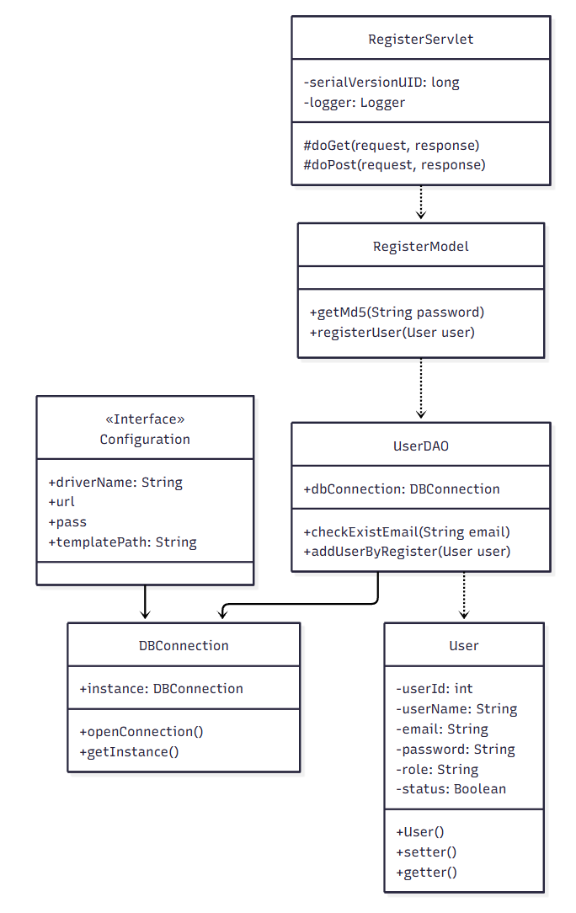

b.Class specifications

DBConnection
No | Method | Description
1 | openConnection() | Connects to the database using configuration details (driverName, url, user, pass) and returns a Connection object. If a connection error occurs, it throws an Exception.
2 | getInstance() | Implements the Singleton pattern to ensure only one DBConnection instance is created.

UserDAO class
No | Method | Description
1 | checkExistEmail(String email) | This method checks if a given email already exists in the Users table.
2 | addUserByRegister(User user) | This method inserts the new user's data into the database.

RegisterServlet class
No | Method | Description
1 | doGet(HttpServletRequest request, HttpServletResponse response) | Handles GET requests, renders the registration form.
2 | doPost(HttpServletRequest request, HttpServletResponse response) | Handles the registration form submission.

c. Sequence Diagram
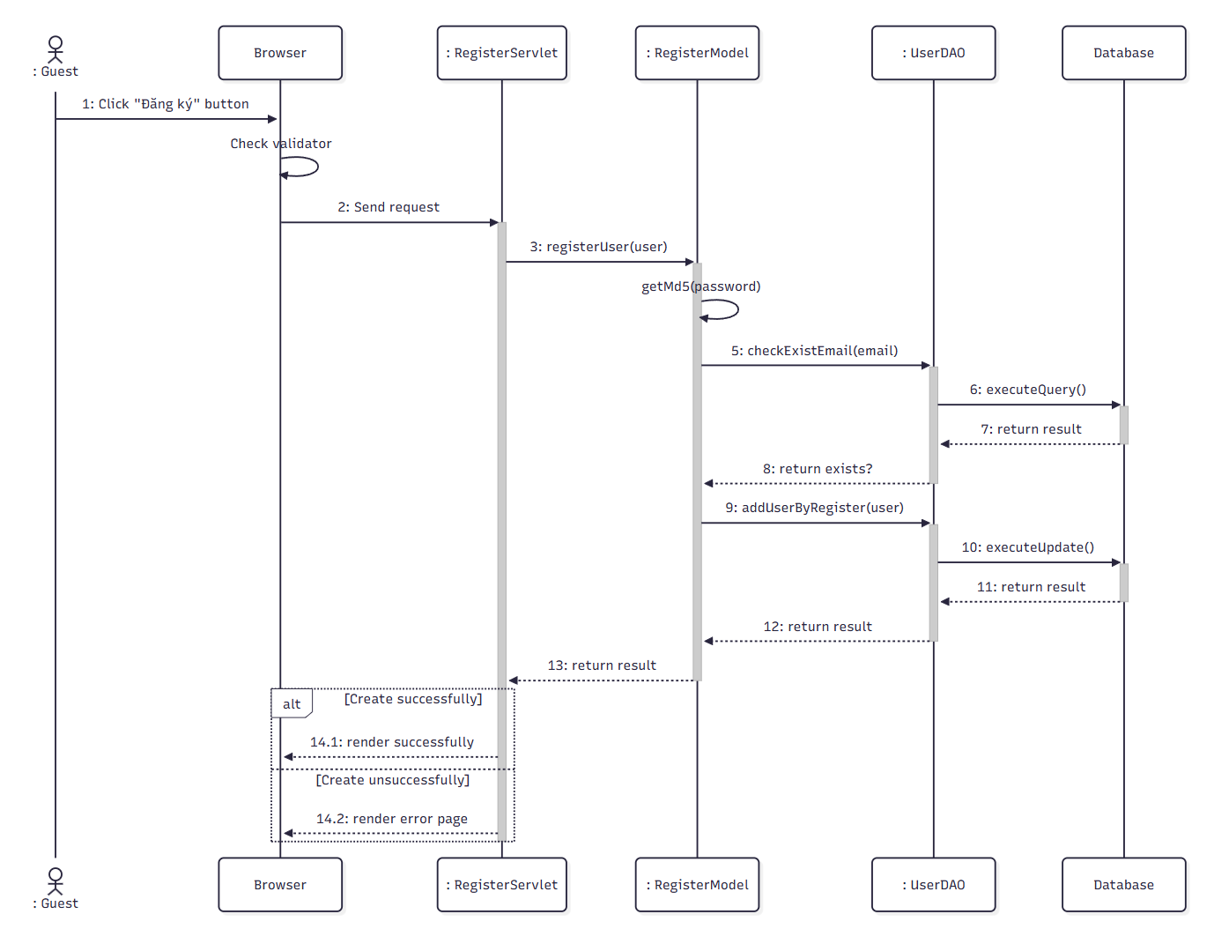

d.Database Queries
1.Verify UserName & Password information
INSERT INTO Users(user_name, email, oauth_provider, oauth_id, avatar_url, status) VALUES (?,?,?,?,?,?);
2.Check exist email
SELECT * FROM Users WHERE email = ?
3.Add user by login google
INSERT INTO Users (user_name, email, oauth_provider, oauth_id, balance, avatar_url, status) VALUES (?, ?, ?, ?, ?, ?, ?)
4.Get user by login google
SELECT * FROM Users WHERE email = ? AND password = ?

1.2 Complete Onboarding Survey

a. Class Diagram
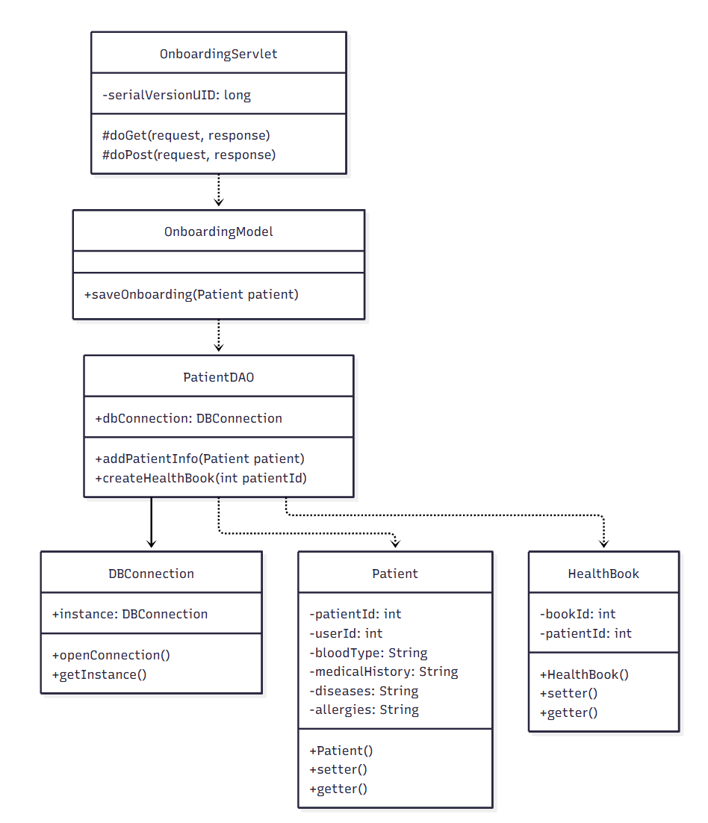

b. Class Specifications

UserDAO Class
No | Method | Description
1 | addPatientInfo(Patient patient) | Inserts the patient's medical info (blood type, history, diseases, allergies).
2 | createHealthBook(int patientId) | Creates a Health Book record linked to the newly onboarded patient.

OnboardingModel Class
No | Method | Description
1 | saveOnboarding(Patient patient) | Orchestrates Patient creation followed by Health Book creation.

OnboardingServlet Class
No | Method | Description
1 | doGet(HttpServletRequest request, HttpServletResponse response) | Renders the onboarding survey form.
2 | doPost(HttpServletRequest request, HttpServletResponse response) | Handles the submitted survey form.

c. Sequence Diagram(s)
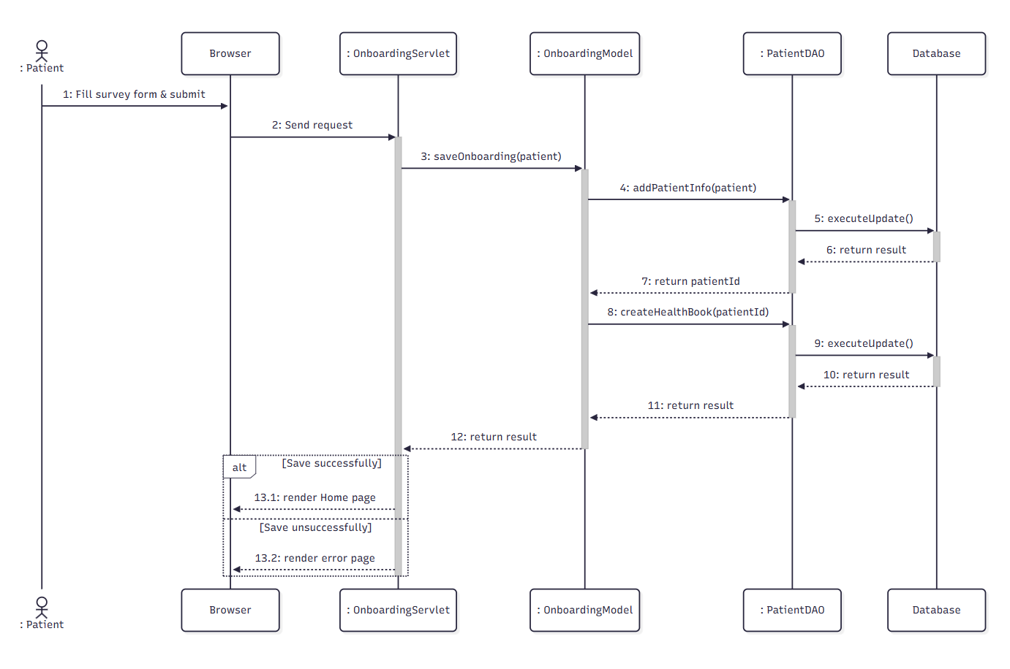

d. Database Queries
Check login:
SELECT * FROM Users WHERE email = ? AND password = ?

Get user by email:
SELECT * FROM Users WHERE email = ?

1.3 Login

a. Class Diagram
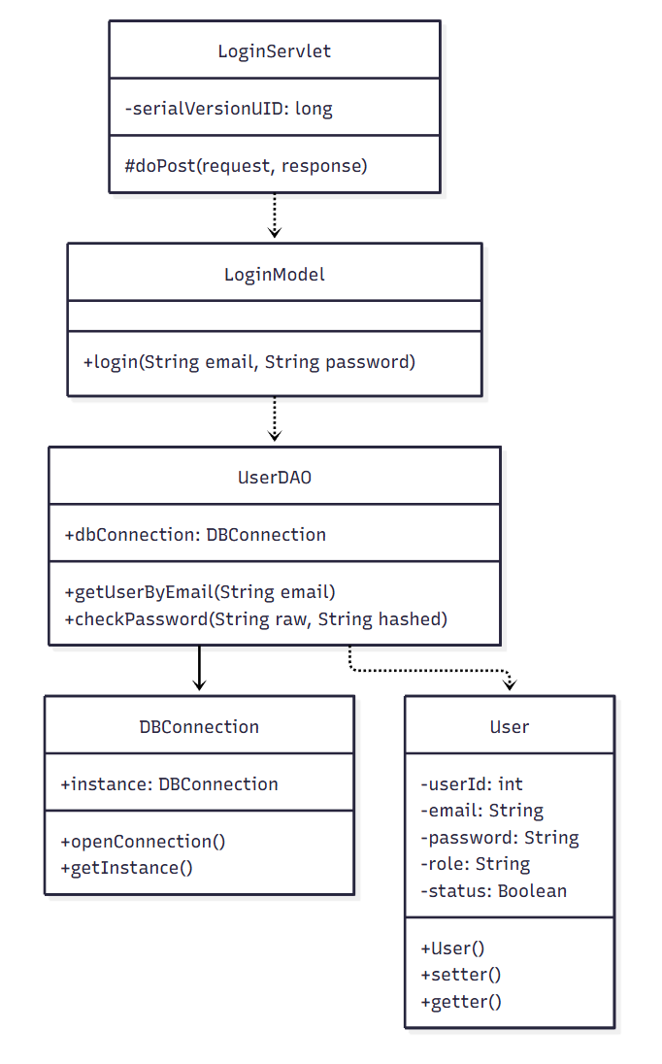

b. Class Specifications
UserDAO Class

No | Method | Description
1 | getUserByEmail(String email) | Input is a string of email, Output is User Object. Method is used to get User Object by email from database.
2 | checkPassword(String raw, String hashed) | Compares the raw input password (hashed) against the stored hash.

LoginModel Class
No | Method | Description
1 | login(String email, String password) | Business logic for authenticating a user and creating a session.

LoginServlet Class
No | Method | Description
1 | doPost(HttpServletRequest request, HttpServletResponse response) | Handles the login form submission.

c. Sequence Diagram(s)

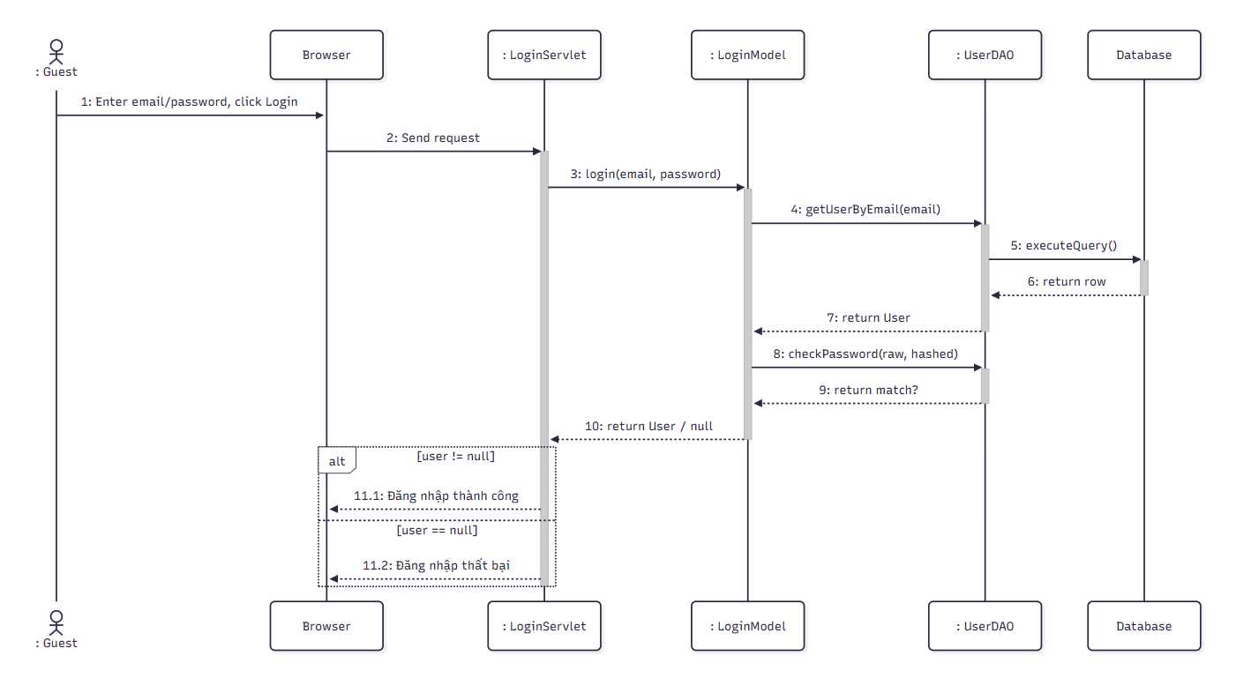

d. Database Queries
none

1.4. Reset Password

a. Class Diagram
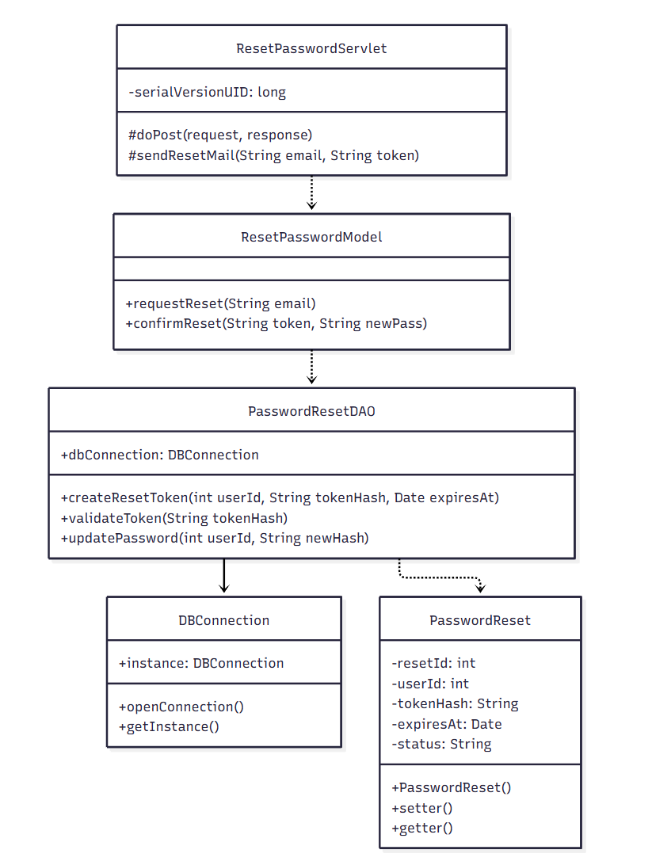

b. Class Specifications

PasswordResetDAO Class
No | Method | Description
1 | createResetToken(int userId, String tokenHash, Date expiresAt) | Creates a new password-reset token record with an expiration time.
2 | validateToken(String tokenHash) | Checks whether the token exists, is pending, and has not expired.
3 | updatePassword(int userId, String newHash) | Updates the user's password with the new hashed value.

ResetPasswordModel Class
No | Method | Description
1 | requestReset(String email) | Generates a reset token and triggers the reset email.
2 | confirmReset(String token, String newPass) | Validates the token and updates the password.

ResetPasswordServlet Class
No | Method | Description
1 | doPost(HttpServletRequest request, HttpServletResponse response) | Handles both 'request reset link' and 'submit new password' actions.
2 | sendResetMail(String email, String token) | Sends the password-reset email containing the reset link/token.

c. Sequence Diagram(s)
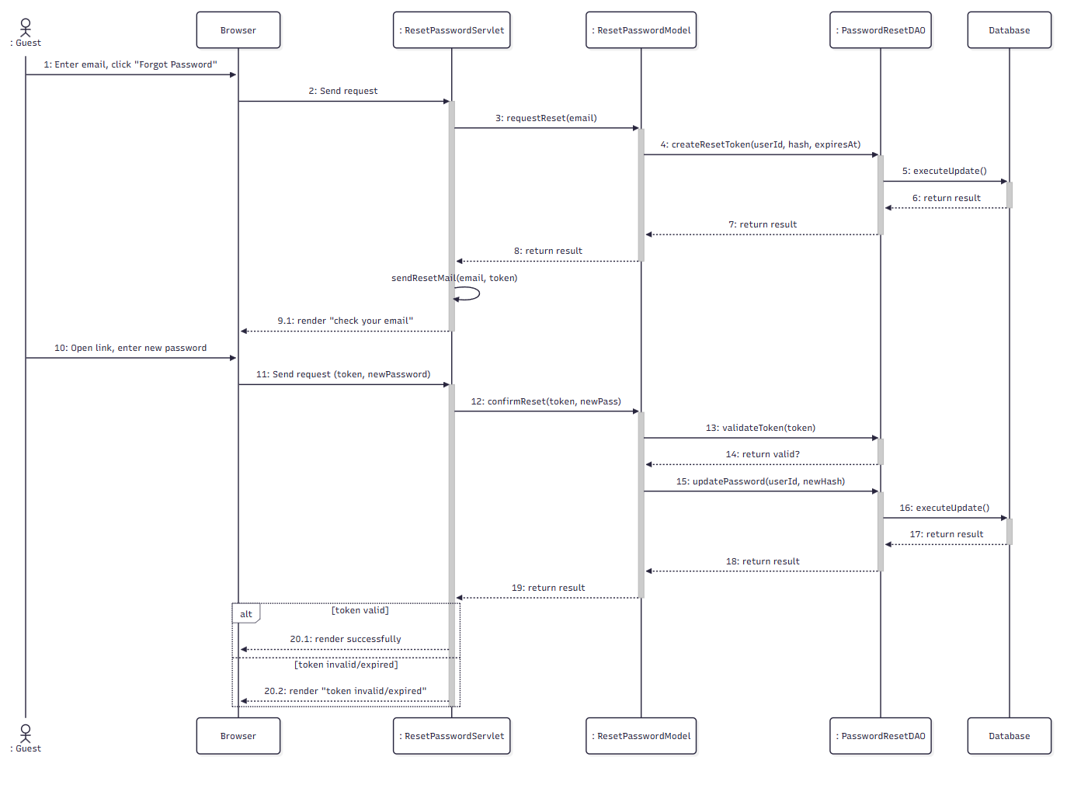

d. Database Queries
- Get User by email:
SELECT * FROM Users WHERE email = ?
- Change Password by email:
UPDATE Users SET password = ? WHERE email = ?

1.5. View & Update Profile:

a. Class Diagram

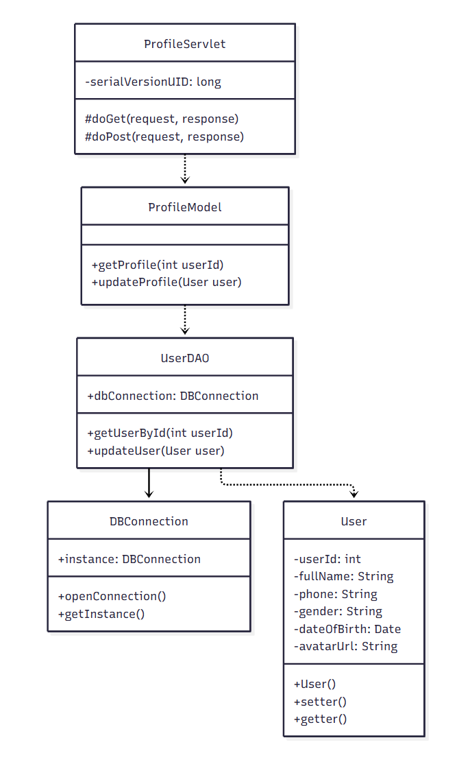

b. Class Specifications
UserDAO Class
No | Method | Description
1 | getUserById(int userId) | Retrieves the profile of the currently logged-in user.
2 | updateUser(User user) | Updates the editable profile fields of the user.

ProfileModel Class
No | Method | Description
1 | getProfile(int userId) | Retrieves the current user's profile data.
2 | updateProfile(User user) | Validates and persists profile changes.

ProfileServlet Class
No | Method | Description
1 | doGet(HttpServletRequest request, HttpServletResponse response) | Renders the profile page.
2 | doPost(HttpServletRequest request, HttpServletResponse response) | Handles the profile-update form submission.

c. Sequence Diagram(s)

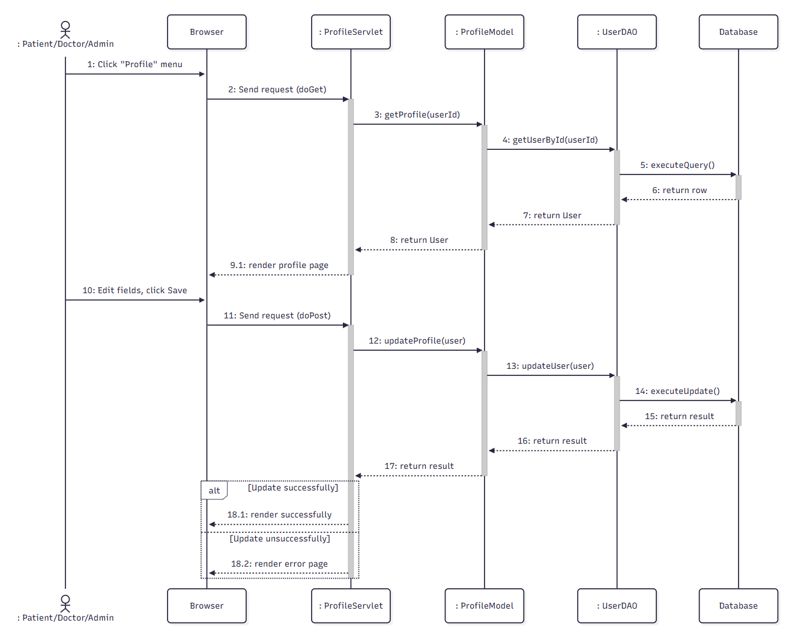

d. Database Queries

- Change new password:
UPDATE Users SET password = ? WHERE email = ?

Booking & Payment

2.1. Search Doctor

a. Class Diagram
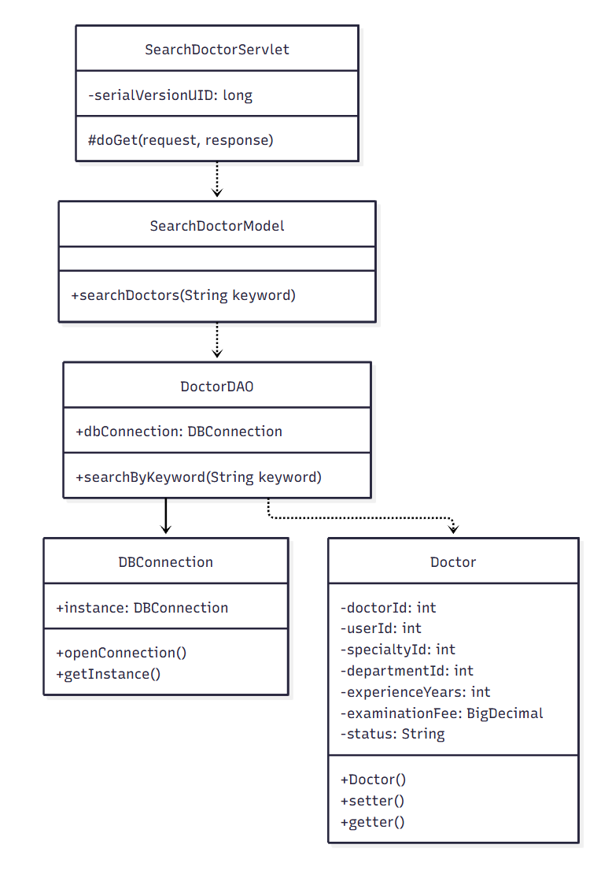

b. Class Specifications

DoctorDAO Class
No | Method | Description
1 | searchByKeyword(String keyword) | Searches approved doctors by name using a keyword (joined with Users).

SearchDoctorModel Class
No | Method | Description
1 | searchDoctors(String keyword) | Business logic wrapper for doctor keyword search.

SearchDoctorServlet Class
No | Method | Description
1 | doGet(HttpServletRequest request, HttpServletResponse response) | Handles the doctor search request and renders results.

c. Sequence Diagram(s)
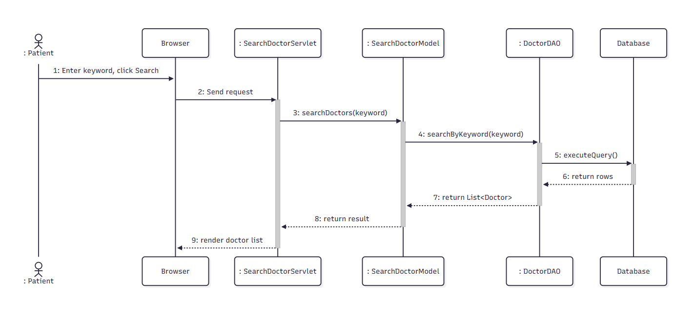

d. Database Queries
- Get User by email:
SELECT * FROM Users WHERE email = ?

2.2. Filter Doctor by Specialty:

a.Class diagram

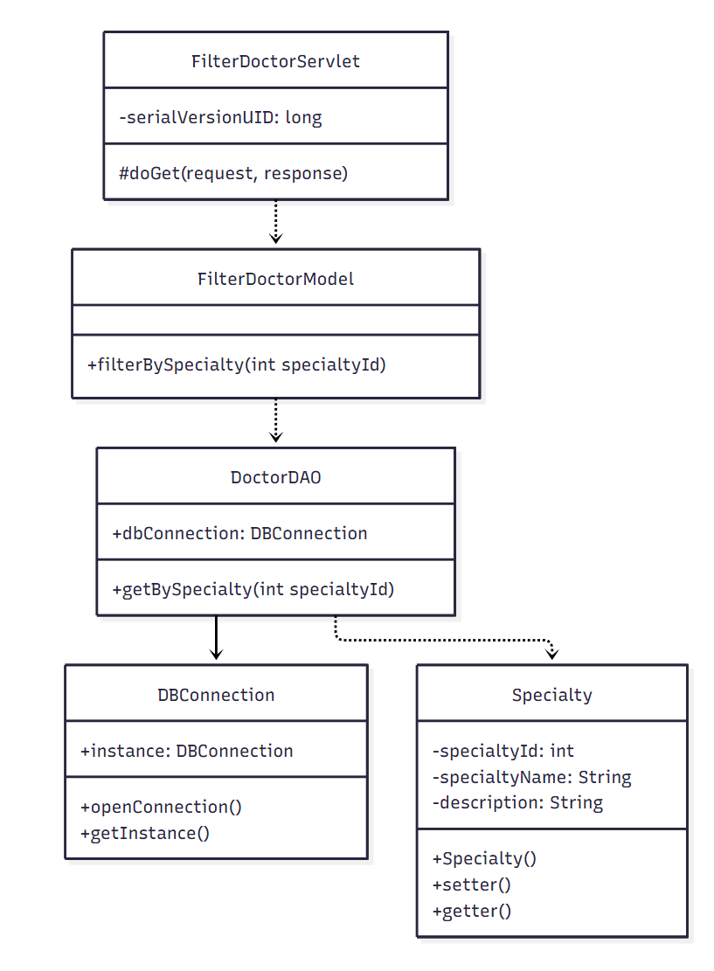

b.Class Specification
DoctorDAO Class
No | Method | Description
1 | getBySpecialty(int specialtyId) | Retrieves approved doctors filtered by specialty.

FilterDoctorModel Class
No | Method | Description
1 | filterBySpecialty(int specialtyId) | Business logic wrapper for specialty filtering.

FilterDoctorServlet Class
No | Method | Description
1 | doGet(HttpServletRequest request, HttpServletResponse response) | Handles the specialty-filter request and renders results.

c. Sequence Diagram(s)

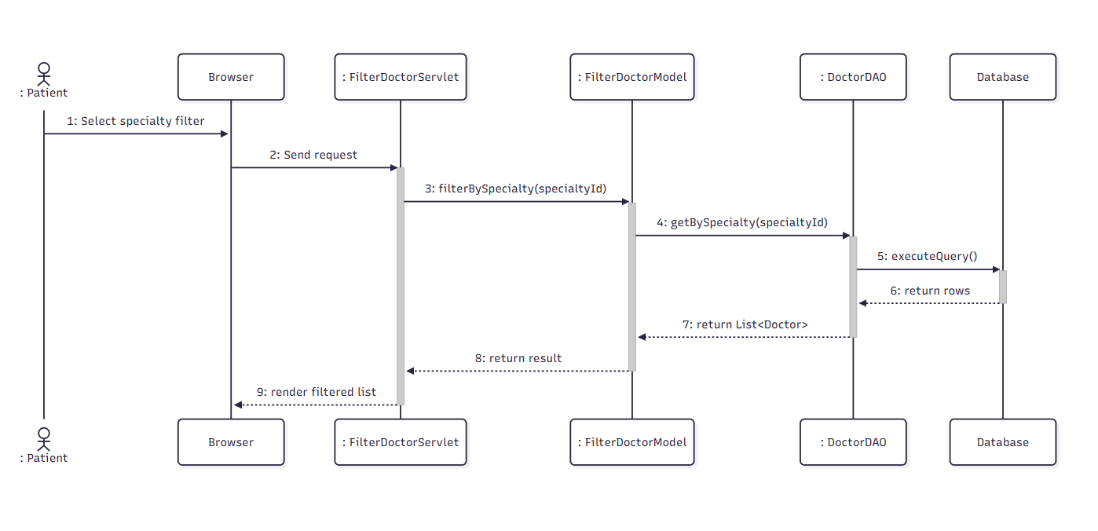

d. Database Queries:
Select user by email=?:
SELECT * FROM Users WHERE user_id = ?
Edit Profile:
UPDATE Users SET user_name = ?, description = ?, specification = ?, address = ?, avatar_url = ?, date_of_birth = ? WHERE email = ?

2.3. View Doctor Profile & Schedule

a. Class Diagram
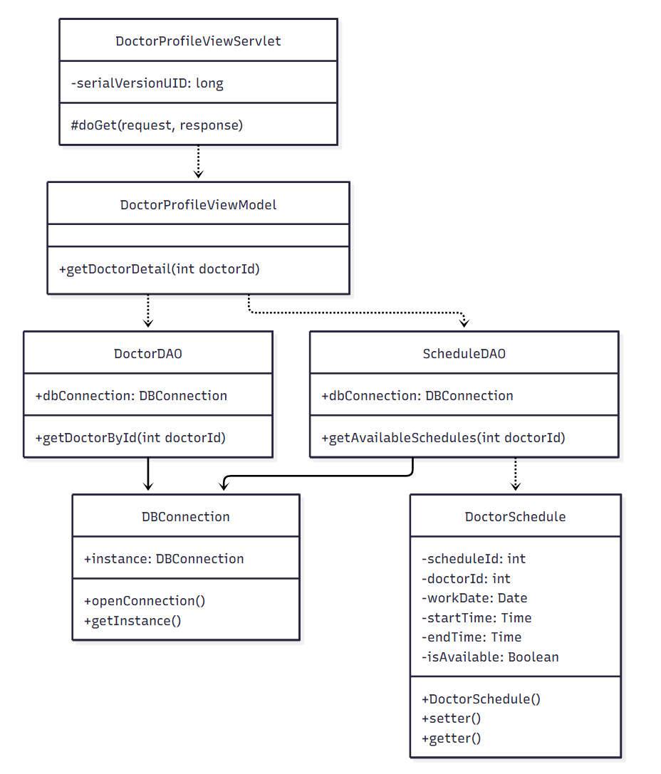

b. Class Specifications

DoctorDAO Class
No | Method | Description
1 | getDoctorById(int doctorId) | Retrieves full profile details of a single doctor.

ScheduleDAO Class
No | Method | Description
1 | getAvailableSchedules(int doctorId) | Retrieves the doctor's upcoming available time slots.

DoctorProfileViewModel Class
No | Method | Description
1 | getDoctorDetail(int doctorId) | Combines doctor profile and schedule data for display.

DoctorProfileViewServlet Class
No | Method | Description
1 | doGet(HttpServletRequest request, HttpServletResponse response) | Handles the doctor-profile view request.

c. Sequence Diagram(s)
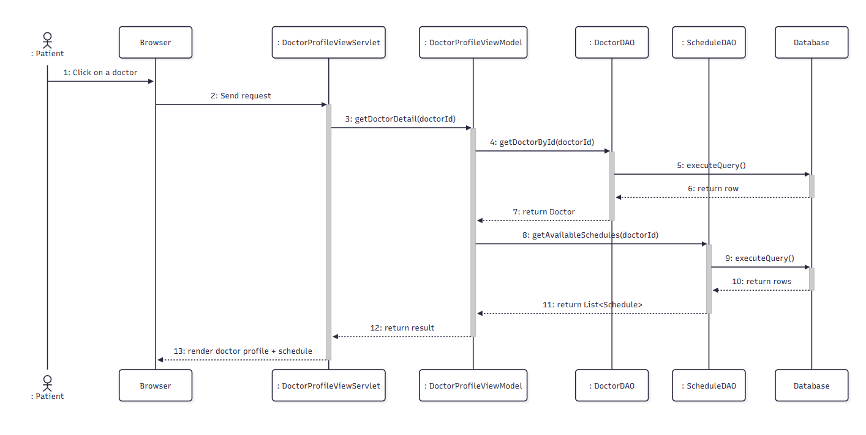

d. Database Queries

- Get user by email:
SELECT * FROM Users WHERE email = ?
- Update new Balance:
UPDATE Users SET balance = ? WHERE email = ?
- Add Transaction:
INSERT INTO [Transaction] (senderId, amount, createdDate, status, transactionType, description) VALUES (?, ?, ?, ?, ?, ?)

2.4. Search Department

a. Class diagram:

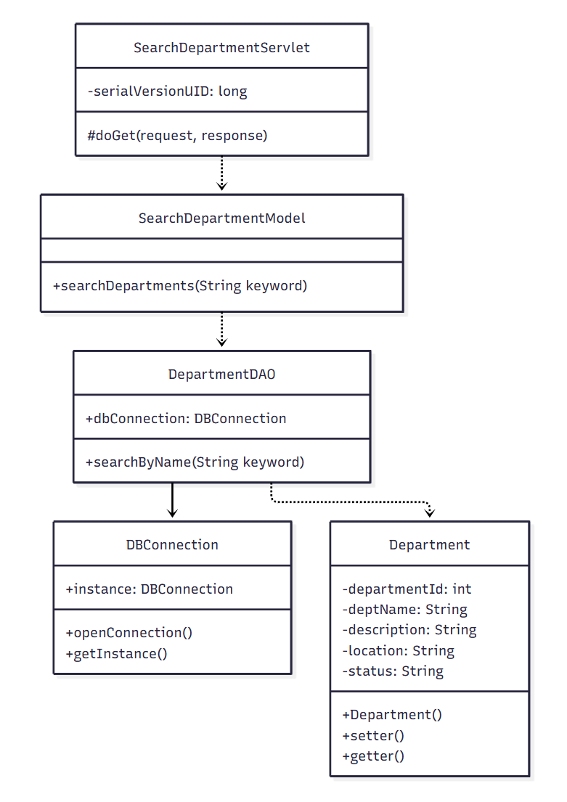

b. Class Specification

DepartmentDAO Class
No | Method | Description
1 | searchByName(String keyword) | Searches active departments by name keyword.

SearchDepartmentModel Class
No | Method | Description
1 | searchDepartments(String keyword) | Business logic wrapper for department keyword search.

SearchDepartmentServlet Class
No | Method | Description
1 | doGet(HttpServletRequest request, HttpServletResponse response) | Handles the department search request and renders results.

c. Sequence Diagram(s)
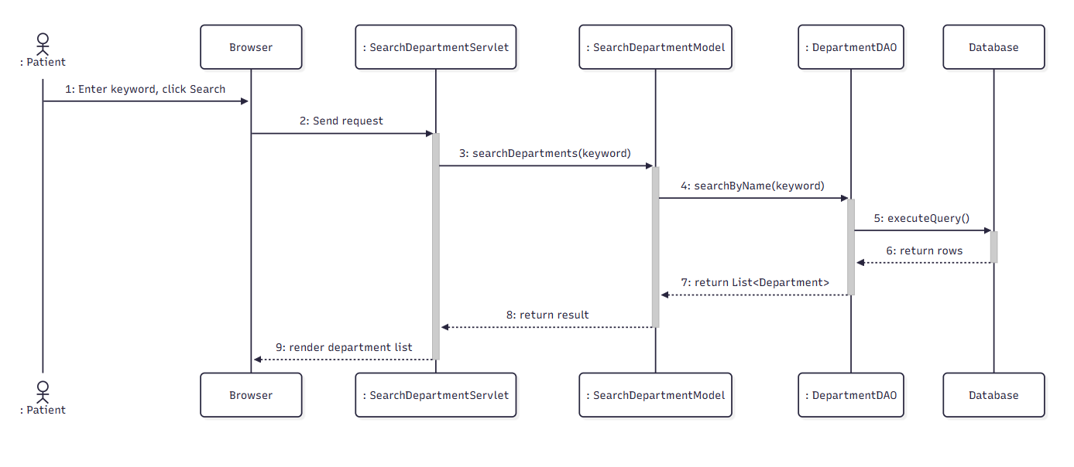

d. Database Queries:
Get user by email:
SELECT * FROM Users WHERE email = ?
Get Cv by id:
SELECT [cv_id], [job_position], [summary], [created_at], [user_id] FROM [JOBTRANS].[dbo].[CV] WHERE [cv_id] = ?
Add Cv:
INSERT INTO CV (job_position, summary, created_at, user_id) OUTPUT INSERTED.cv_id VALUES (?, ?, ?, ?)

2.5. Book Appointment

a. Class diagram:
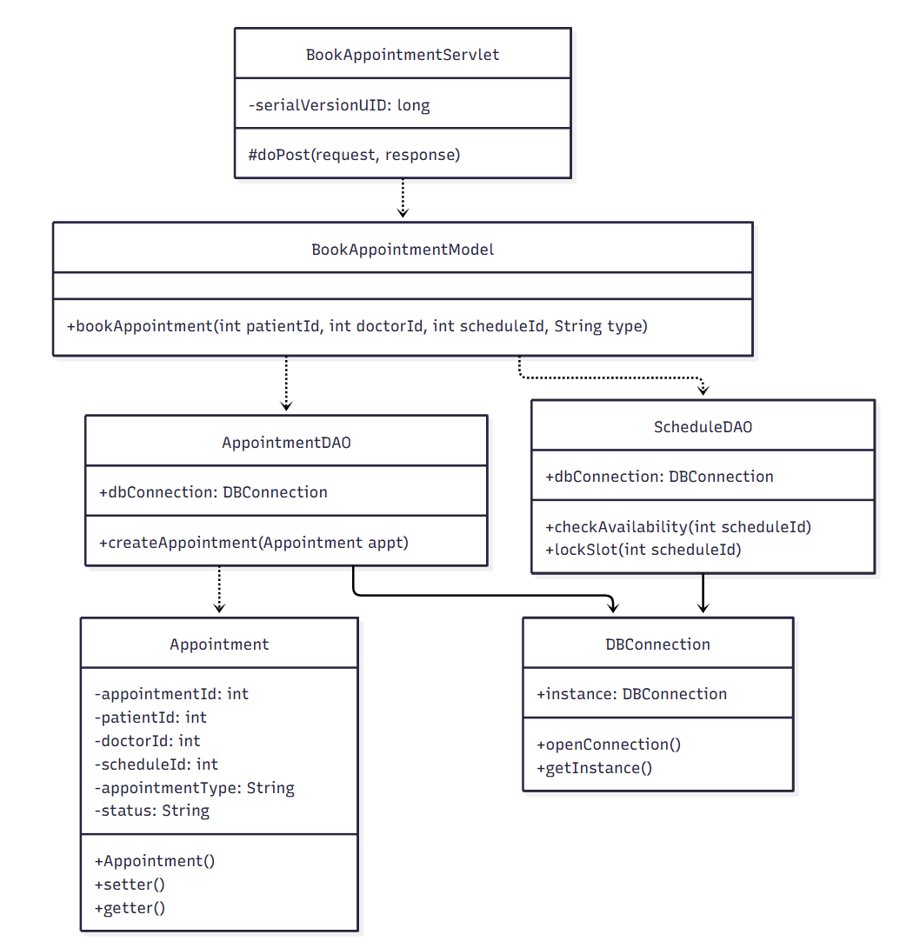

b. Class Specification

ScheduleDAO Class

No | Method | Description
1 | checkAvailability(int scheduleId) | Checks whether the selected time slot is still available.
2 | lockSlot(int scheduleId) | Marks the time slot as unavailable once booked.
AppointmentDAO Class
No | Method | Description
1 | createAppointment(Appointment appt) | Inserts a new appointment record with status 'pending'.

BookAppointmentModel Class
No | Method | Description
1 | bookAppointment(int patientId, int doctorId, int scheduleId, String type) | Validates slot availability then creates the appointment and locks the slot.

BookAppointmentServlet Class
No | Method | Description
1 | doPost(HttpServletRequest request, HttpServletResponse response) | Handles the booking confirmation submission.

c. Sequence Diagram(s)
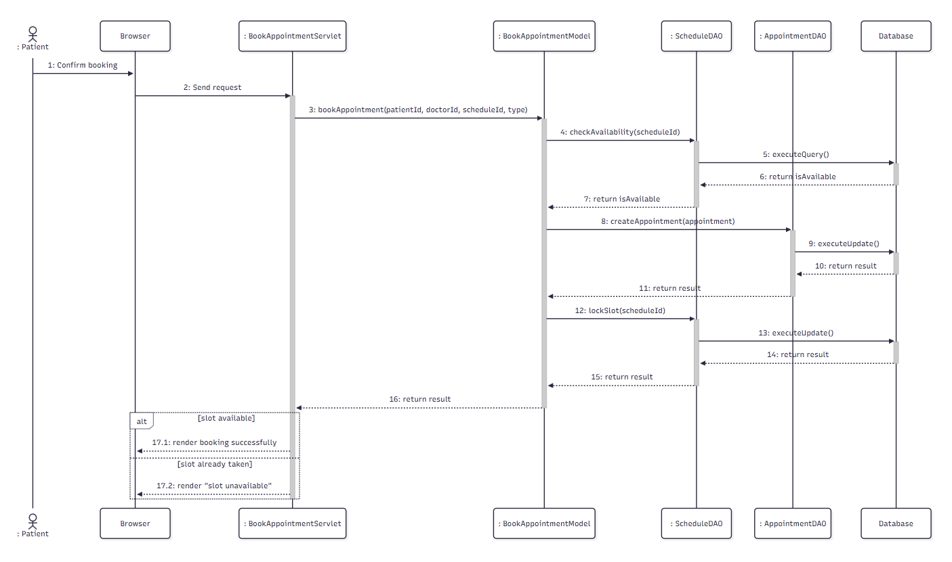

d. Database Queries:
Get Cv By CvId:
SELECT [cv_id], [job_position], [summary], [created_at], [user_id] FROM [JOBTRANS].[dbo].[CV] WHERE [cv_id] = ?
Get user by email:
SELECT * FROM Users WHERE email = ?

2.6. Select Package & Time Slot

a. Class diagram:
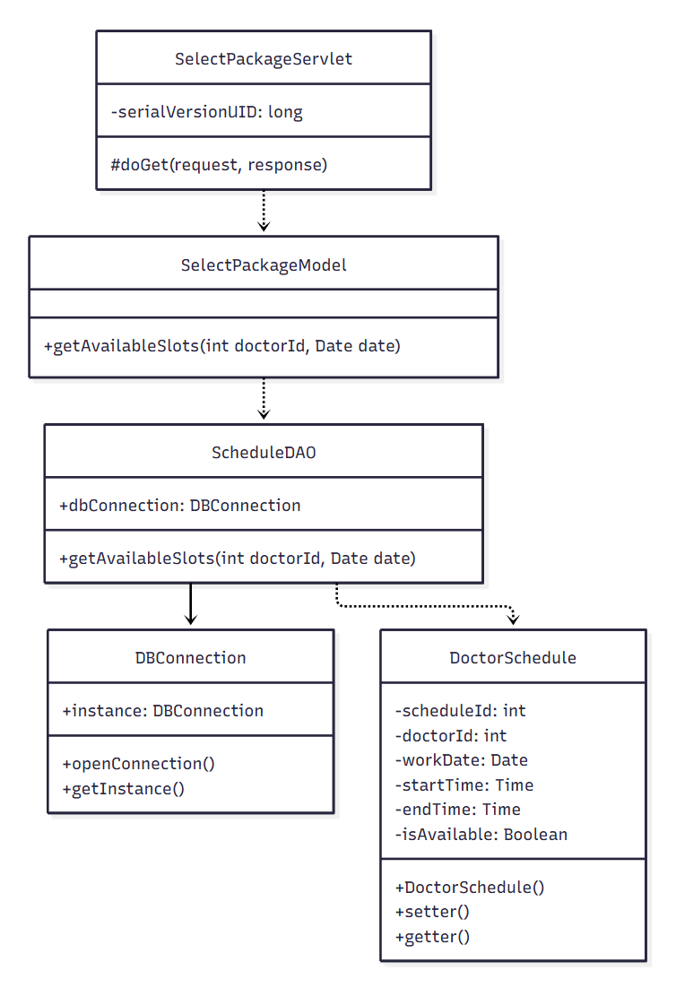

b. Class Specification

ScheduleDAO Class

No | Method | Description
1 | getAvailableSlots(int doctorId, Date date) | Retrieves available time slots for a doctor on a given date.

SelectPackageModel Class
No | Method | Description
1 | getAvailableSlots(int doctorId, Date date) | Business logic wrapper for retrieving selectable time slots.

SelectPackageServlet Class
No | Method | Description
1 | doGet(HttpServletRequest request, HttpServletResponse response) | Handles the package/time-slot selection step of booking.

c. Sequence Diagram(s)
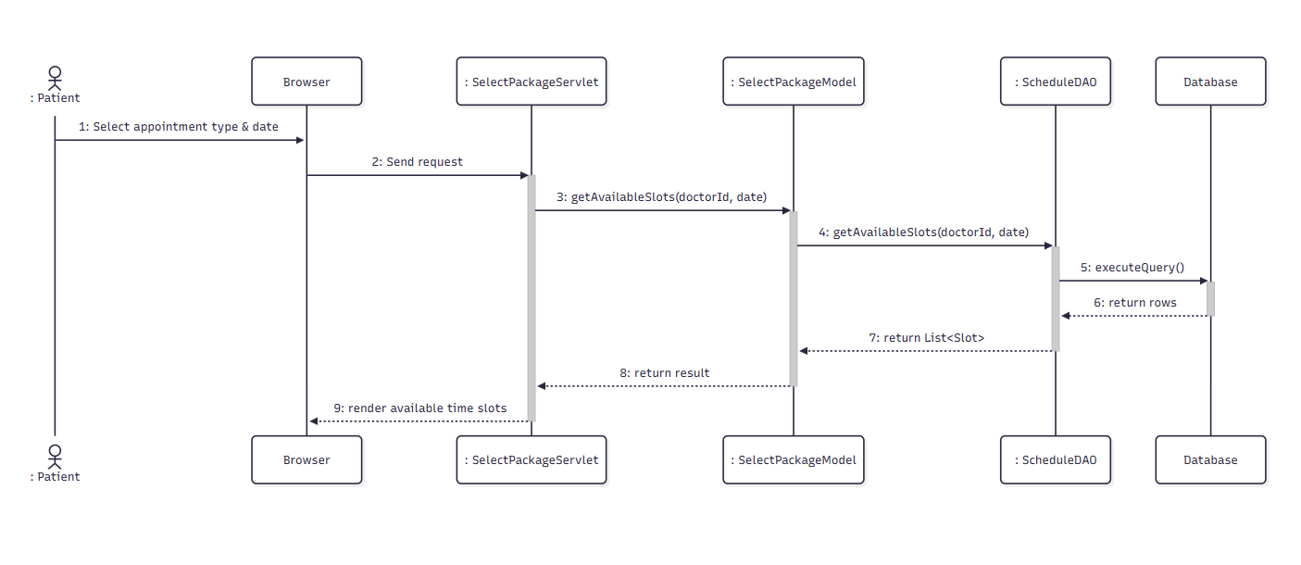

d. Database Queries:
Select user by email:
SELECT * FROM Users WHERE email = ?
Select Cv by id:
SELECT [cv_id], [job_position], [summary], [created_at], [user_id]
FROM [JOBTRANS].[dbo].[CV] WHERE [cv_id] = ?
Update CV:
UPDATE CV SET job_position = ?, summary = ?, created_at = ? WHERE cv_id = ?

2.7. Pay Deposit

a. Class diagram:
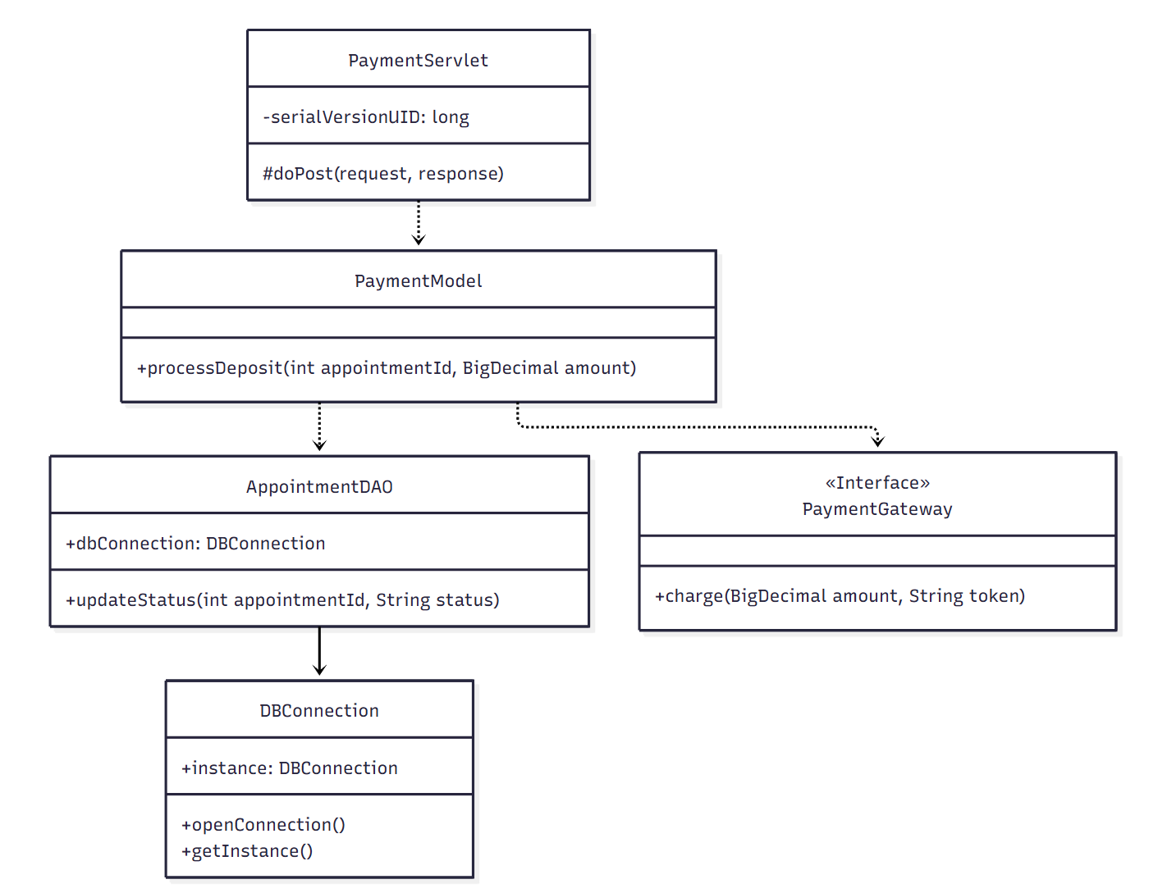

b. Class Specification

AppointmentDAO Class
No | Method | Description
1 | updateStatus(int appointmentId, String status) | Updates the appointment status after payment (e.g., to 'confirmed').

PaymentModel Class
No | Method | Description
1 | processDeposit(int appointmentId, BigDecimal amount) | Charges the deposit via the payment gateway and updates appointment status.

PaymentServlet Class
No | Method | Description
1 | doPost(HttpServletRequest request, HttpServletResponse response) | Handles the deposit-payment submission.

c. Sequence Diagram(s)
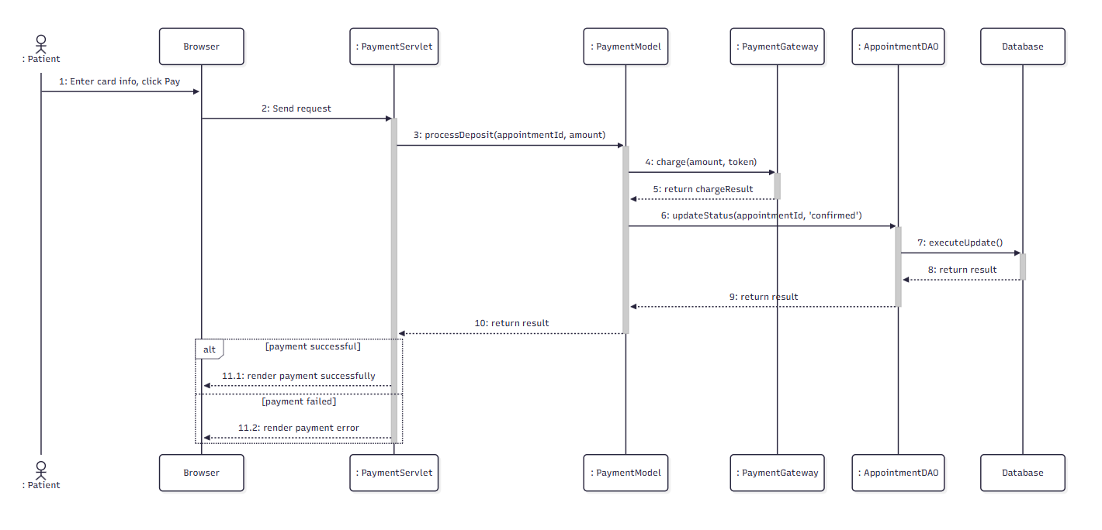

d. Database Queries.
Delete Cv By CvId:
DELETE FROM CV WHERE cv_id = ?
Get user by email:
SELECT * FROM Users WHERE email = ?

2.8. View Upcoming Appointments

a. Class Diagram
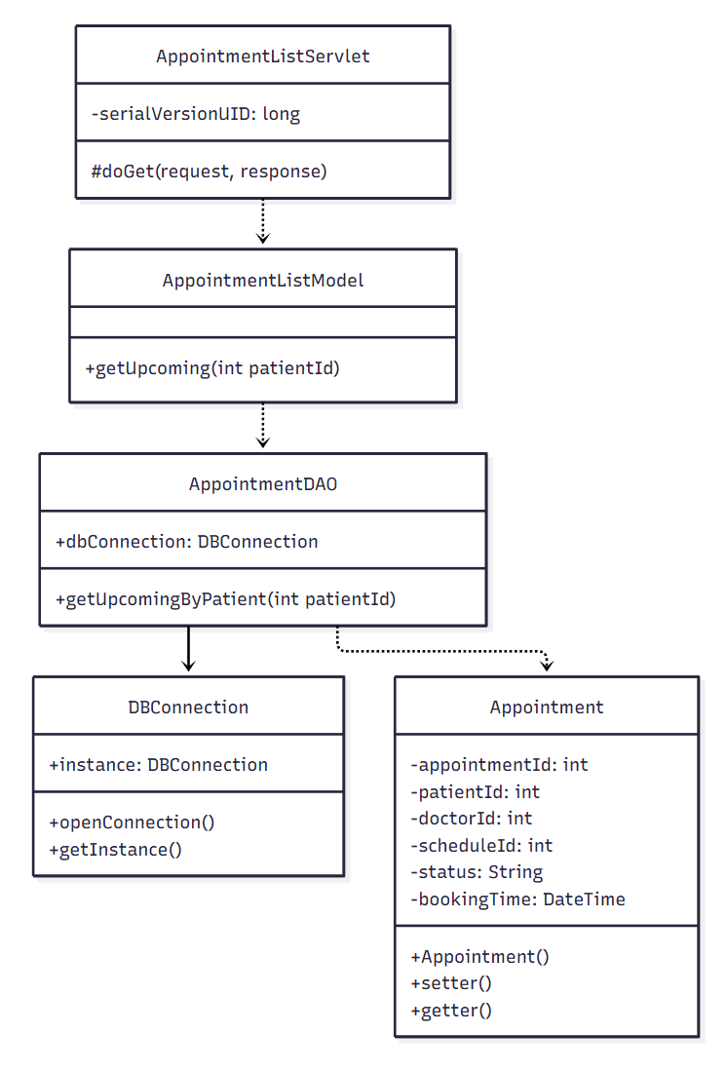

b. Class Specifications
AppointmentDAO Class
No | Method | Description
1 | getUpcomingByPatient(int patientId) | Retrieves the patient's pending/confirmed upcoming appointments.

AppointmentListModel Class
No | Method | Description
1 | getUpcoming(int patientId) | Business logic wrapper for listing upcoming appointments.

AppointmentListServlet Class
No | Method | Description
1 | doGet(HttpServletRequest request, HttpServletResponse response) | Handles the 'My Appointments' page request.

c. Sequence Diagram(s)
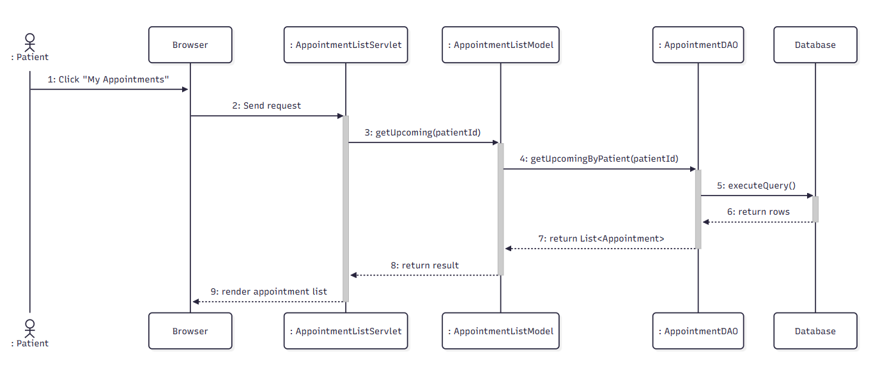

d. Database Queries
- Get User By Id:
SELECT * FROM Users WHERE user_id = ?
- Get Job By UserId:
SELECT * FROM Job WHERE user_id = ?
- Get Employer Feedback By UserId:
SELECT employer_feedback FROM Job WHERE user_id = ?

2.9. Cancel Appointment

a.Class diagram
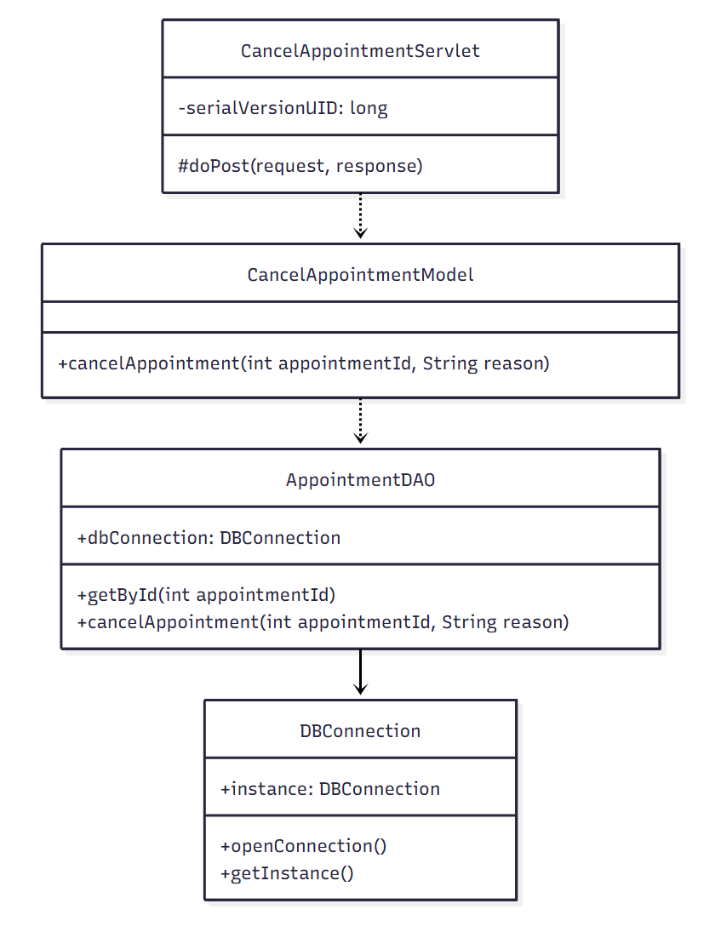

b.Class specifications

AppointmentDAO Class
No | Method | Description
1 | getById(int appointmentId) | Retrieves a single appointment record to validate its current status.
2 | cancelAppointment(int appointmentId, String reason) | Updates the appointment status to 'cancelled' with a reason.

CancelAppointmentModel Class
No | Method | Description
1 | cancelAppointment(int appointmentId, String reason) | Validates the appointment is cancellable, then cancels it.

CancelAppointmentServlet Class
No | Method | Description
1 | doPost(HttpServletRequest request, HttpServletResponse response) | Handles the cancel-appointment submission.

c.Sequence Diagram
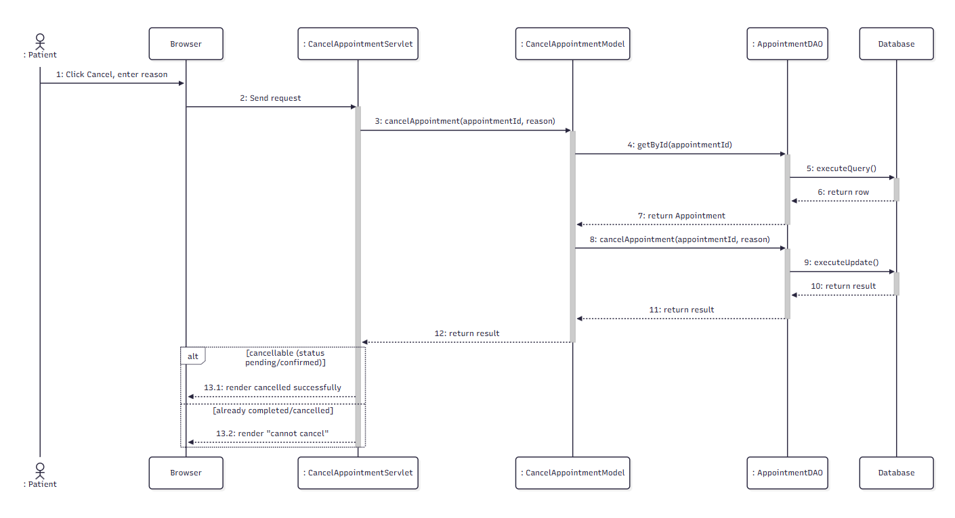

d.Database Queries
1.Select all from job table
SELECT * FROM Job WHERE job_id = ?
2. Get user by userId
SELECT * FROM Users WHERE user_id = ?

2.10. Reschedule Appointment

a.Class diagram
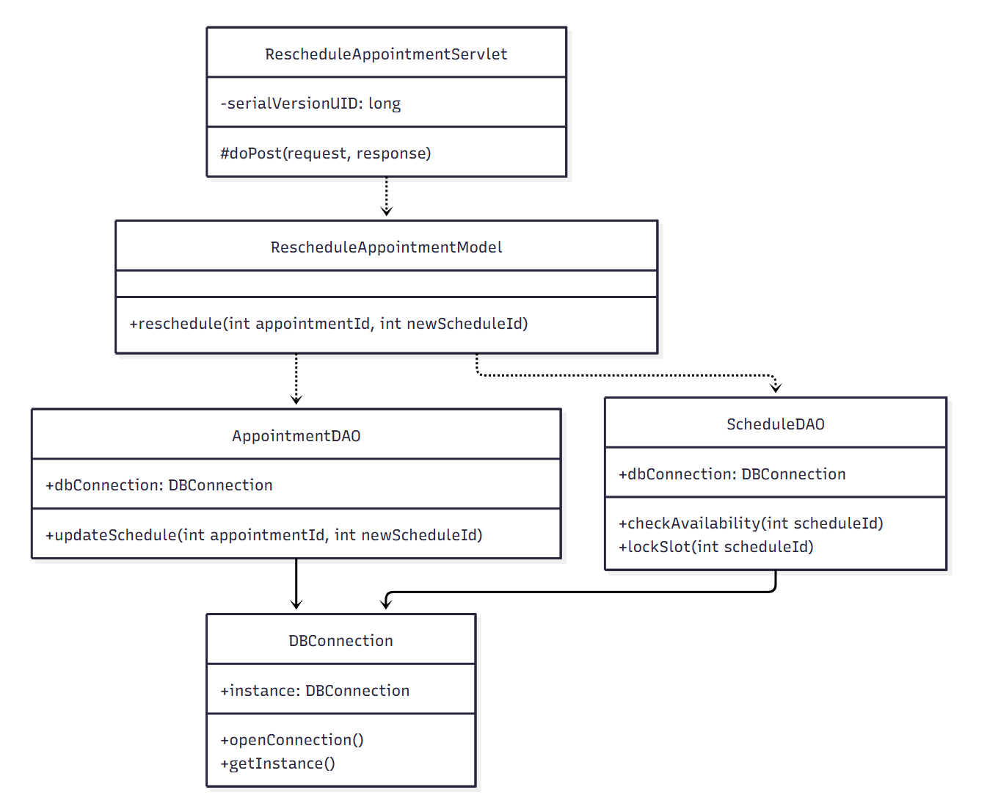

b.Class Specifications
ScheduleDAO Class
No | Method | Description
1 | checkAvailability(int scheduleId) | Checks whether the newly selected time slot is available.
2 | lockSlot(int scheduleId) | Marks the new time slot as unavailable once rescheduled.

AppointmentDAO Class
No | Method | Description
1 | updateSchedule(int appointmentId, int newScheduleId) | Updates the appointment's schedule_id to the new time slot.
RescheduleAppointmentModel Class
No | Method | Description
1 | reschedule(int appointmentId, int newScheduleId) | Validates new slot availability then updates the appointment schedule.
RescheduleAppointmentServlet Class
No | Method | Description
1 | doPost(HttpServletRequest request, HttpServletResponse response) | Handles the reschedule submission.

c.Sequence Diagram
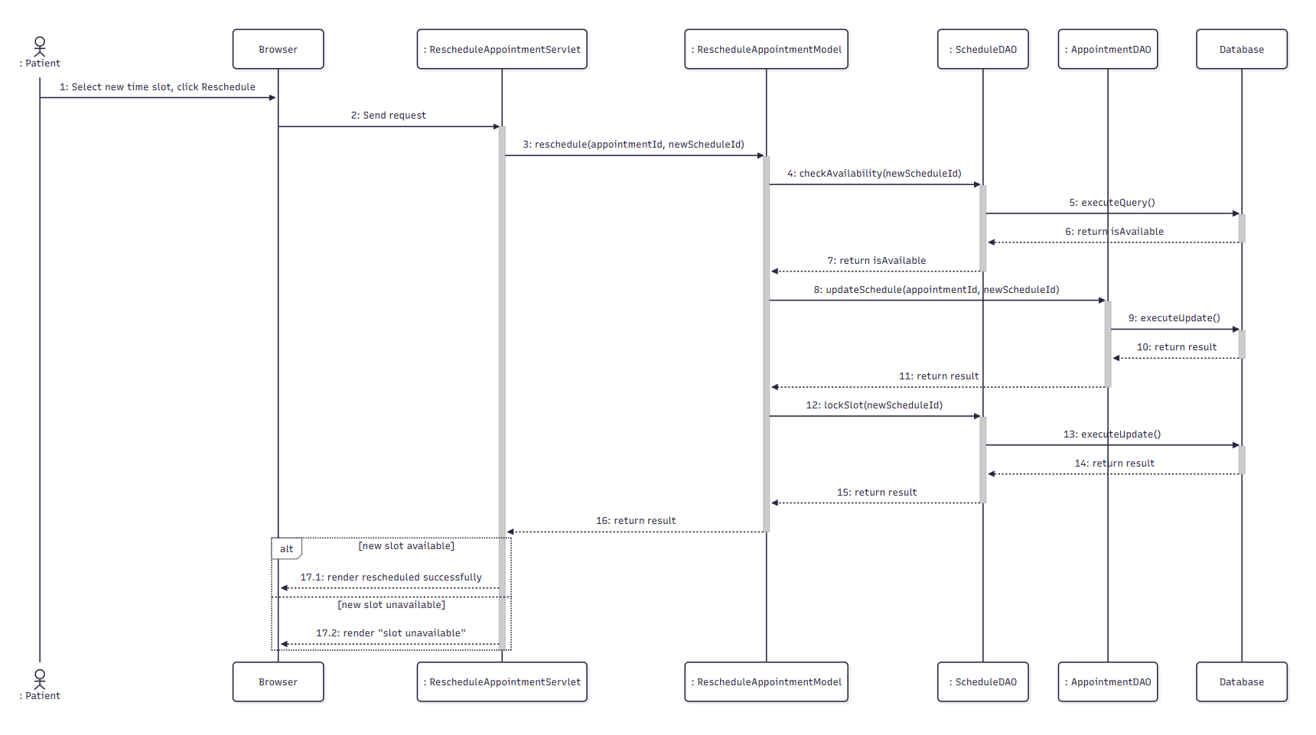

d.Database Queries
1.Get all user by role = employer:
SELECT * FROM Users WHERE role = 'employer’
2.Get job by user id:
SELECT * From Job where user_id=?
3.Get users by email
SELECT * FROM Users WHERE email = ?

2.11. View Payment History

a. Class Diagram
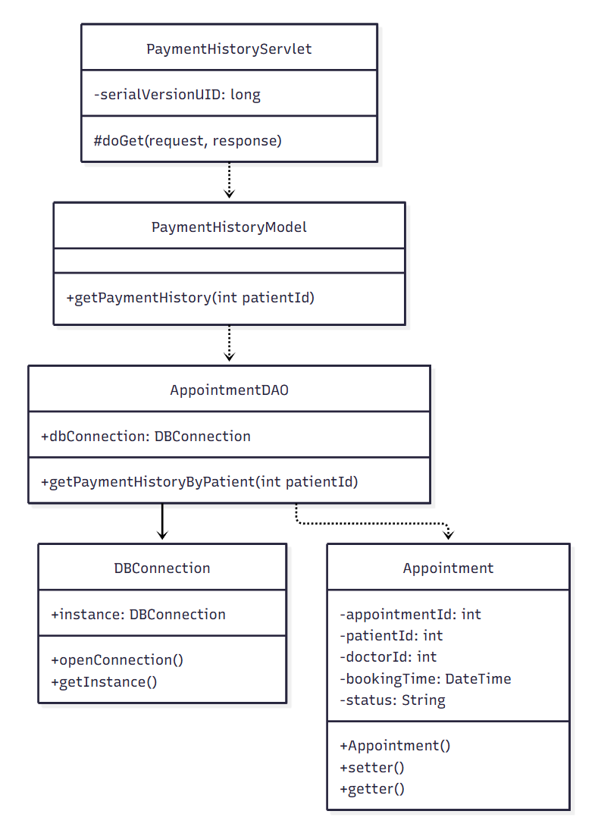

b. Class Specifications

AppointmentDAO Class
No | Method | Description
1 | getPaymentHistoryByPatient(int patientId) | Retrieves the patient's confirmed/completed appointments joined with doctor fee info, ordered by most recent booking.

PaymentHistoryModel Class
No | Method | Description
1 | getPaymentHistory(int patientId) | Business logic wrapper for retrieving the patient's payment history.

PaymentHistoryServlet Class
No | Method | Description
1 | doGet(HttpServletRequest request, HttpServletResponse response) | Handles the "Payment History" page request.

c. Sequence Diagram(s)
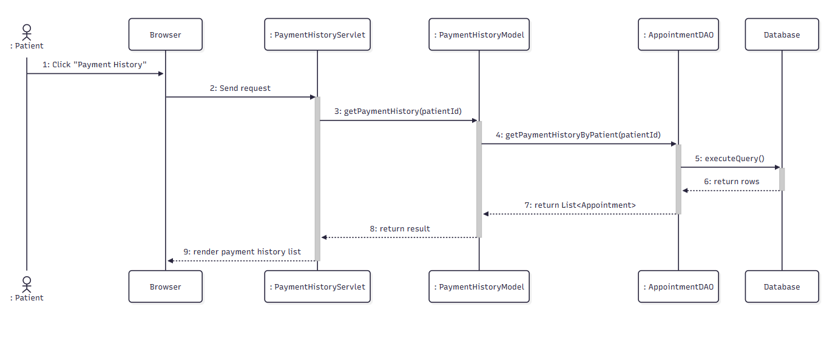

d. Database Queries
- Get Job Greeting By SeekerId:
SELECT * FROM JobGreetings WHERE job_seeker_id = ?
- Get User By Email:
SELECT * FROM Users WHERE email = ?

Schedule & Appointment

3.1. View Work Schedule & Location

a. Class Diagram
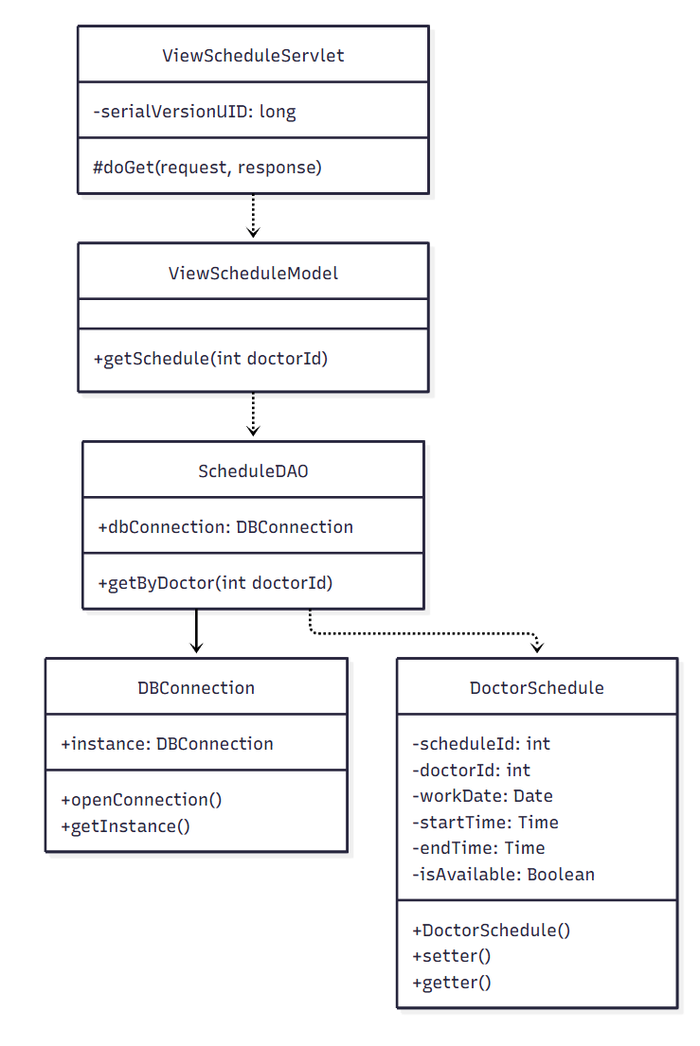

b. Class Specifications
ScheduleDAO Class
No | Method | Description
1 | getByDoctor(int doctorId) | Retrieves all schedule slots for the doctor.

ViewScheduleModel Class
No | Method | Description
1 | getSchedule(int doctorId) | Business logic wrapper for retrieving the doctor's schedule.

ViewScheduleServlet Class
No | Method | Description
1 | doGet(request, response) | Handles the "My Schedule" page request.

c. Sequence Diagram(s)

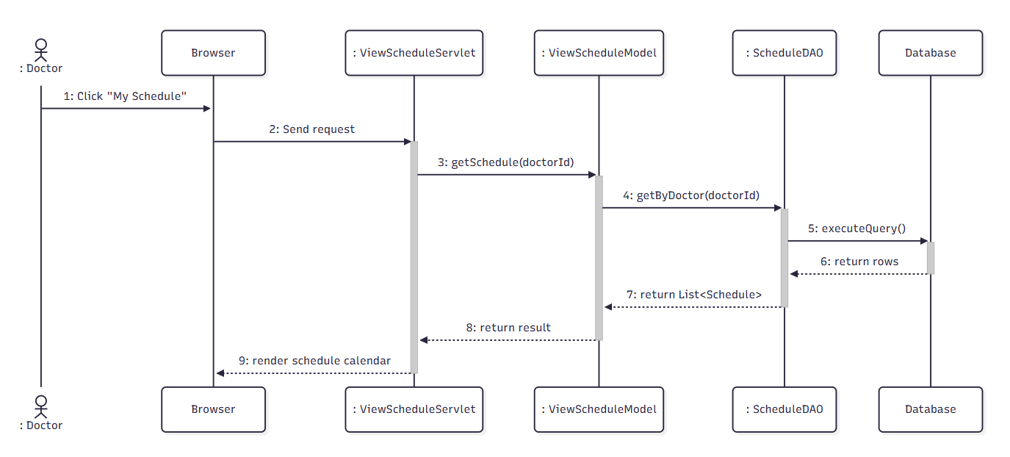

d. Database Queries
Get job by job id:
SELECT * FROM Job WHERE job_id = ?

Get user by email:
SELECT * FROM Users WHERE email = ?

Insert Job:
INSERT INTO Job (user_id, job_title, budget, description, due_date, status, category_id, secure_wallet, doc_URL, address) VALUES (?, ?, ?, ?, ?, ?, ?, ?, ?, ?)

Get category:
SELECT * FROM JobCategory WHERE category_name = ?

3.2. Add Time Slot

a. Class Diagram
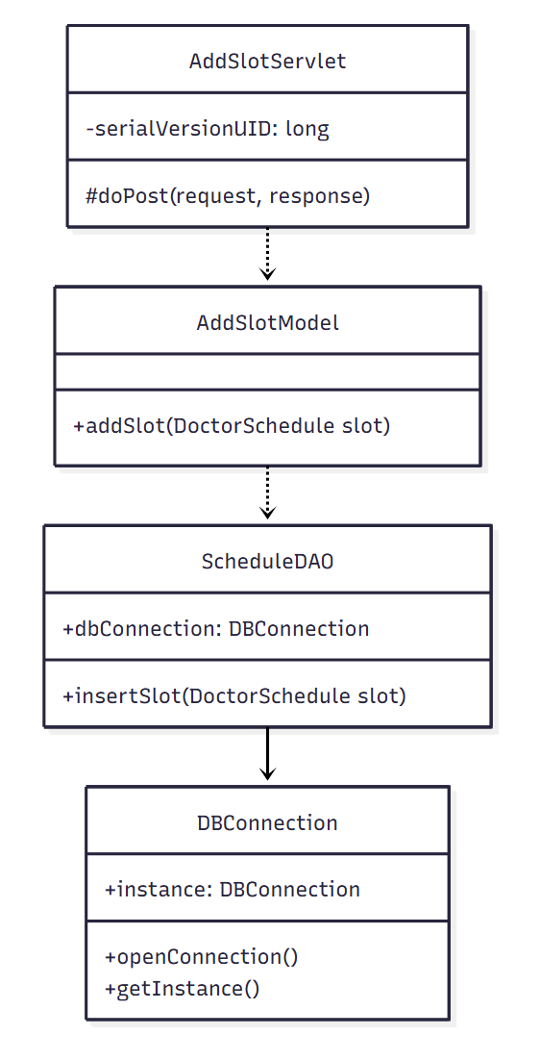

b. Class Specifications
ScheduleDAO Class
No | Method | Description
1 | insertSlot(DoctorSchedule slot) | Inserts a new work-schedule time slot for the doctor.

AddSlotModel Class
No | Method | Description
1 | addSlot(DoctorSchedule slot) | Validates and persists the new time slot.

AddSlotServlet Class
No | Method | Description
1 | doPost(request, response) | Handles the add-time-slot form submission.

c. Sequence Diagram(s)

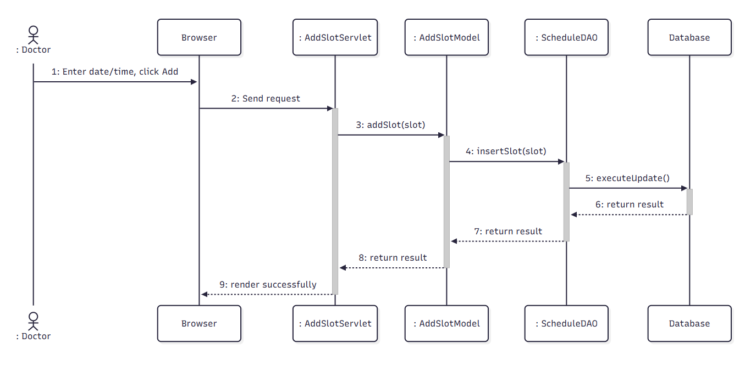

d. Database Queries
Get job by job id:
SELECT * FROM Job WHERE job_id = ?

Get user by email:
SELECT * FROM Users WHERE email = ?

Insert Job:
INSERT INTO Job (user_id, job_title, budget, description, due_date, status, category_id, secure_wallet, doc_URL, address) VALUES (?, ?, ?, ?, ?, ?, ?, ?, ?, ?)

Get category:
SELECT * FROM JobCategory WHERE category_name = ?

3.3. Edit Time Slot

a. Class Diagram
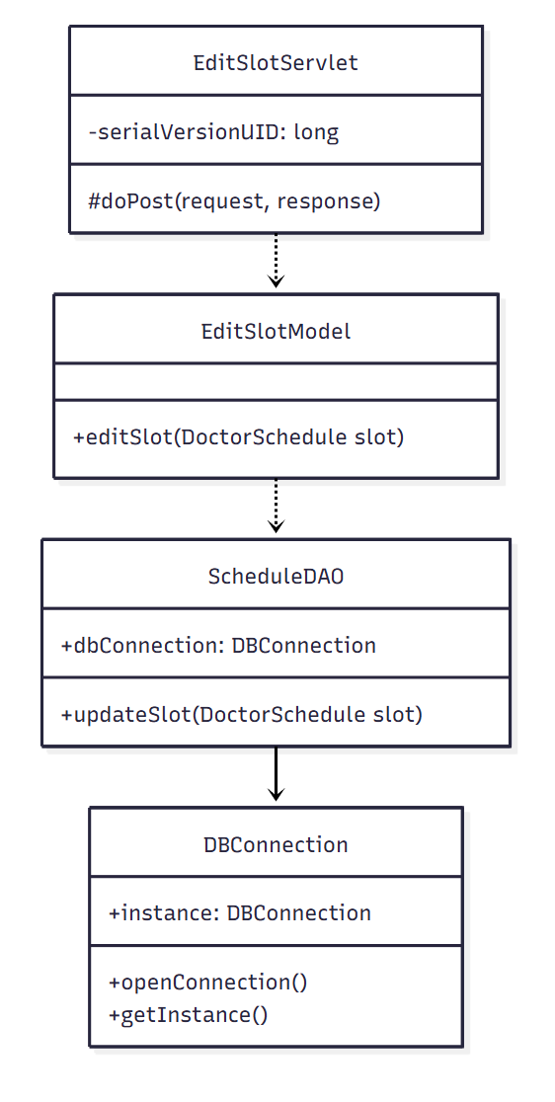

b. Class Specifications

ScheduleDAO Class
No | Method | Description
1 | updateSlot(DoctorSchedule slot) | Updates an existing time slot's date/time.

EditSlotModel Class
No | Method | Description
1 | editSlot(DoctorSchedule slot) | Validates and persists time-slot changes.

EditSlotServlet Class
No | Method | Description
1 | doPost(request, response) | Handles the edit-time-slot form submission.

c. Sequence Diagram(s)
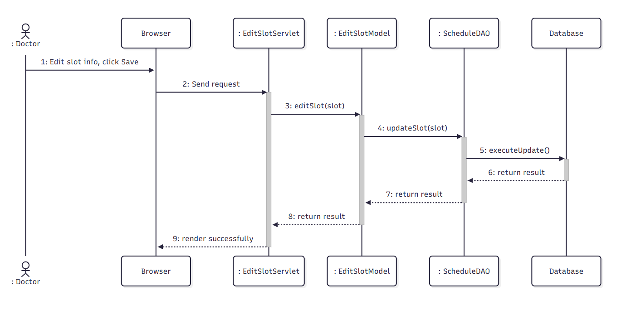

d. Database Queries
Get job by job id:
SELECT * FROM Job WHERE job_id = ?

Get user by email:
SELECT * FROM Users WHERE email = ?

Update Job:
UPDATE Job SET job_title = ?, budget = ?, description = ?, due_date = ?, category_id = ?, doc_URL = ?, address = ? WHERE job_id = ?

Get category by name:
SELECT * FROM JobCategory WHERE category_name = ?

3.4. Delete Time Slot

a. Class Diagram
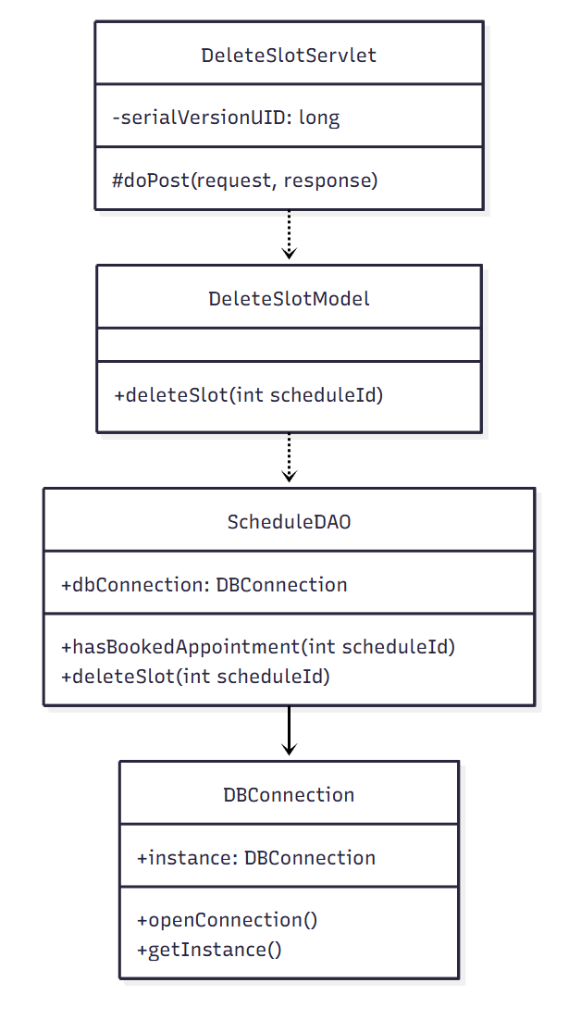

b. Class Specifications
ScheduleDAO Class
No | Method | Description
1 | hasBookedAppointment(int scheduleId) | Checks whether the slot already has a pending/confirmed appointment.
2 | deleteSlot(int scheduleId) | Deletes the time slot record.

DeleteSlotModel Class
No | Method | Description
1 | deleteSlot(int scheduleId) | Validates the slot is not booked, then deletes it.

DeleteSlotServlet Class
No | Method | Description
1 | doPost(request, response) | Handles the delete-time-slot request.

c. Sequence Diagram(s)
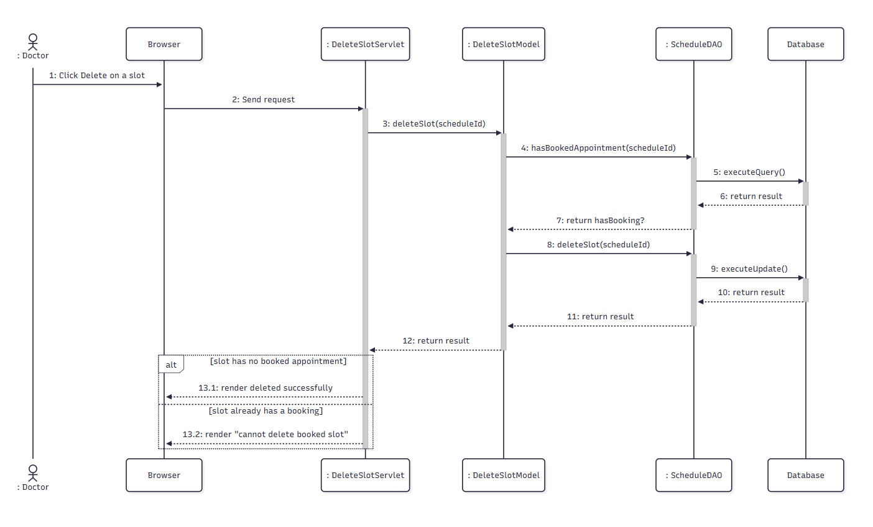

d. Database Queries
Get job by job id:
SELECT * FROM Job WHERE job_id = ?

Get job greeting by job id:
SELECT * FROM JobGreetings WHERE job_id = ?

Delete Job by id:
DELETE FROM Job WHERE job_id = ?

Delete job greeting by job id:
DELETE FROM JobGreetings WHERE job_id = ?

3.5. View Patient List

a. Class Diagram
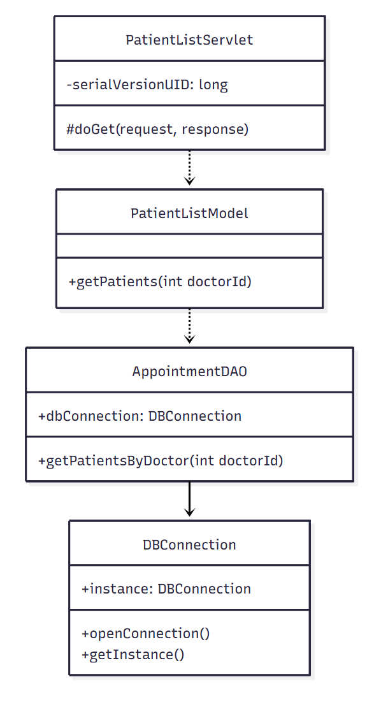

b. Class Specifications
AppointmentDAO Class
No | Method | Description
1 | getPatientsByDoctor(int doctorId) | Retrieves the distinct list of patients who have appointments with the doctor.

PatientListModel Class
No | Method | Description
1 | getPatients(int doctorId) | Business logic wrapper for retrieving the doctor's patient list.

c. Sequence Diagram(s)
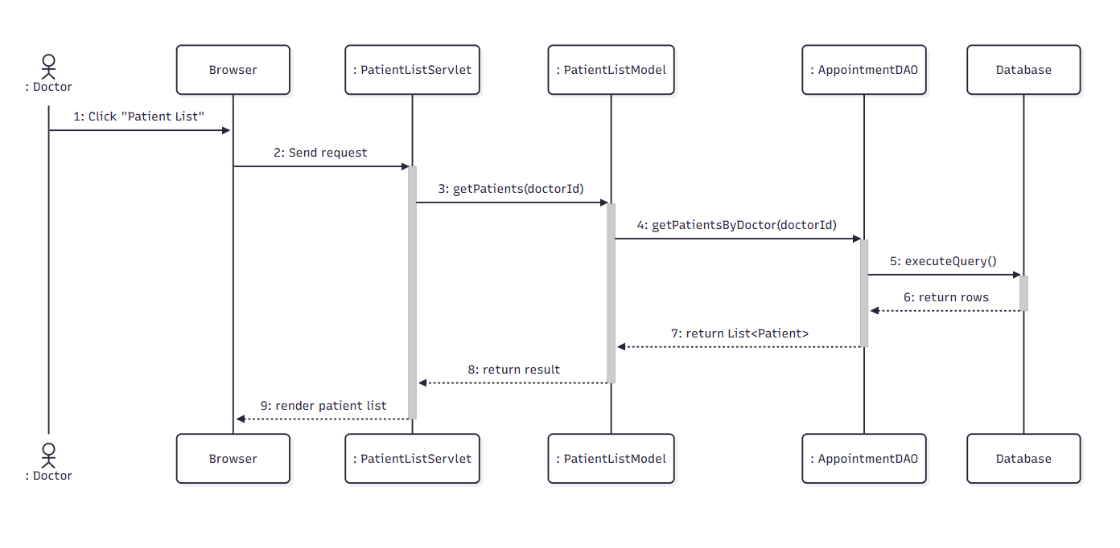

d. Database Queries
Update job interview:
UPDATE Job SET interview_URL = ?, interview_Date = ? WHERE job_id = ?

3.6. Confirm Appointment

a. Class Diagram
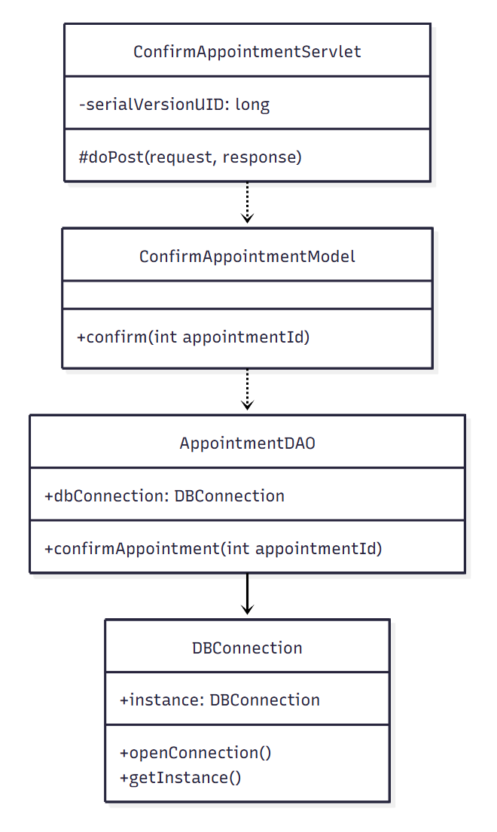

b. Class Specifications

AppointmentDAO Class
No | Method | Description
1 | confirmAppointment(int appointmentId) | Updates the appointment status to 'confirmed'.

ConfirmAppointmentModel Class
No | Method | Description
1 | confirm(int appointmentId) | Business logic wrapper for confirming an appointment.

ConfirmAppointmentServlet Class
No | Method | Description
1 | doPost(request, response) | Handles the confirm-appointment request.

c. Sequence Diagram(s)

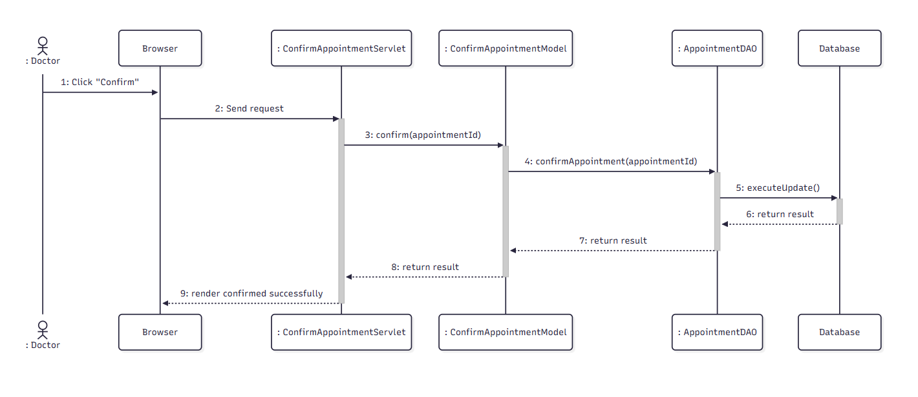

d. Database Queries
- Get Job By jobId:
SELECT * FROM Job WHERE job_id = ?
- Get JobGreeting By jobId:
SELECT * FROM JobGreetings WHERE job_id = ?

3.7. Decline Appointment

a. Class Diagram
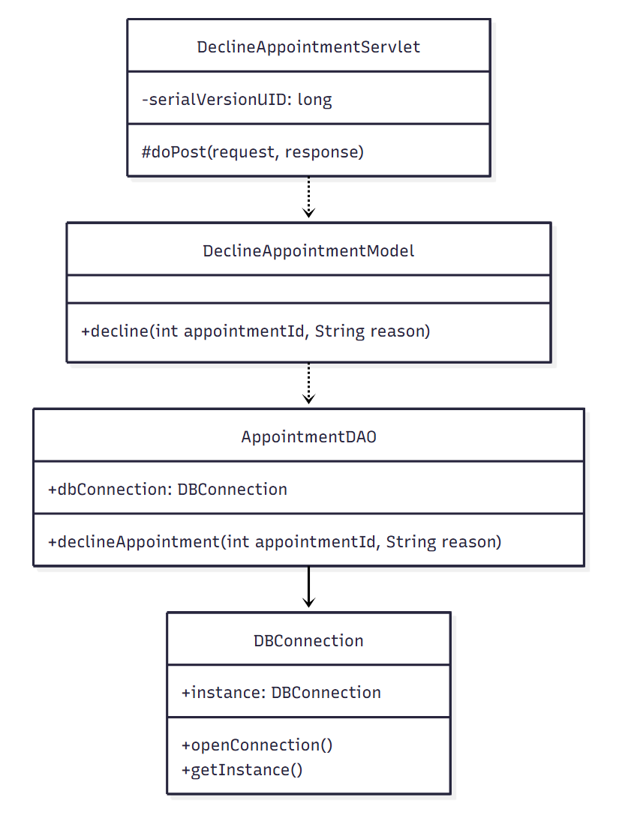

b. Class Specifications

AppointmentDAO Class
No | Method | Description
1 | declineAppointment(int appointmentId, String reason) | Updates the appointment status to 'cancelled' with the doctor's reason.

DeclineAppointmentModel Class

No | Method | Description
1 | decline(int appointmentId, String reason) | Business logic wrapper for declining an appointment.

DeclineAppointmentServlet Class

No | Method | Description
1 | doPost(request, response) | Handles the decline-appointment request.

c. Sequence Diagram(s)
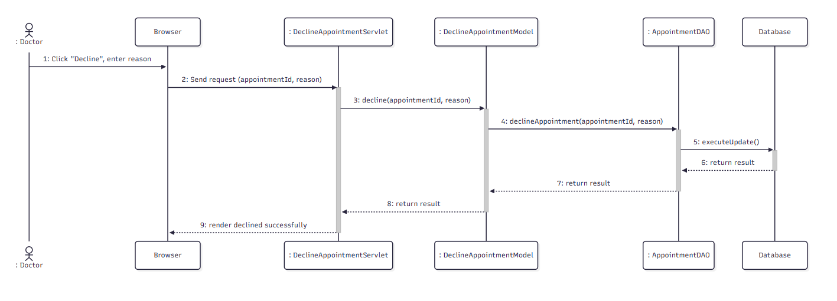

d. Database Queries
- Get user by email:
SELECT * FROM Users WHERE email = ?
- Get JobGreetings By JobId and status:
SELECT * FROM [dbo].[JobGreetings] WHERE job_id = ? AND status = “Được chấp nhận”
- Check transaction exists:
SELECT COUNT(1) FROM [dbo].[Transaction] WHERE description = “Trả trước” AND jobId = ?
- Get Job By jobId:
SELECT * FROM Job WHERE job_id = ?
- Update Job Status:
UPDATE Job SET status = “Đang làm việc” WHERE job_id = ?
- Add Transaction:
INSERT INTO [dbo].[Transaction] (senderId, amount, createdDate, status, transactionType, description, jobId) VALUES (?, ?, ?, ?, ?, ?, ?)
- Update Job Status And Secure Wallet
UPDATE Job SET status = ?, secure_wallet+=? WHERE job_id = ?

3.8. State Decline Reason

a. Class Diagram
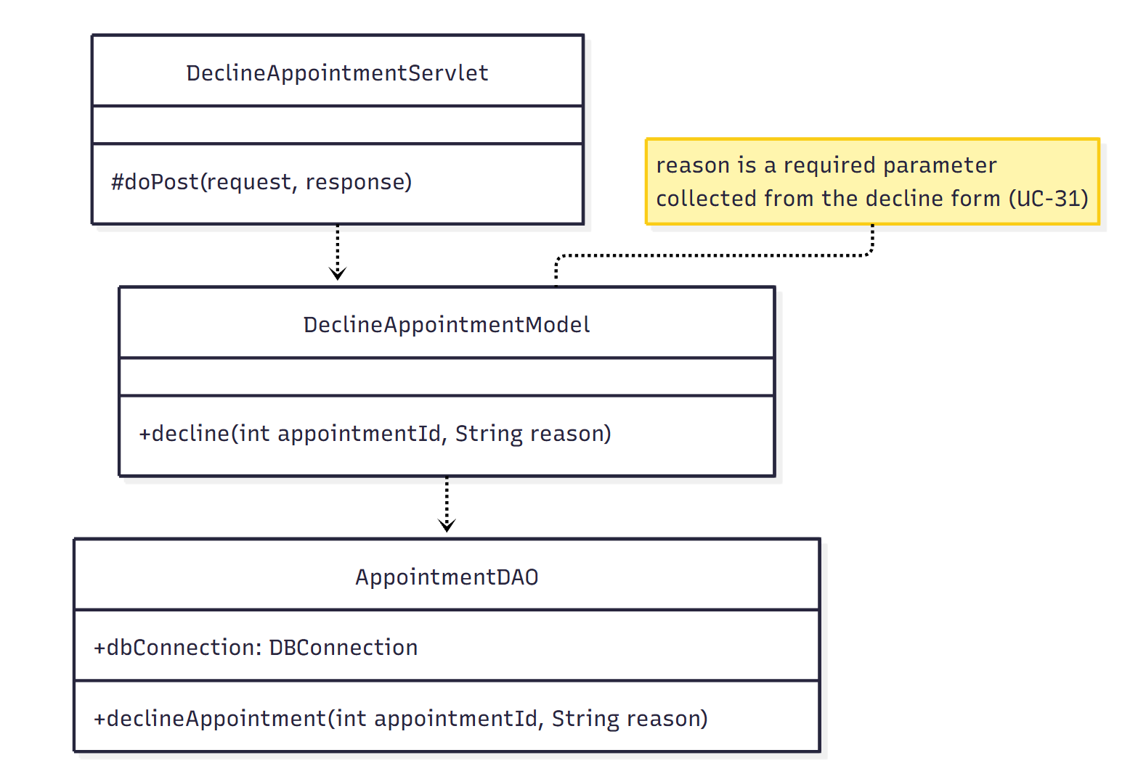

b. Class Specifications

DeclineAppointmentModel Class
No | Method | Description
1 | decline(int appointmentId, String reason) | The 'reason' parameter is a required field collected from the decline form; validated before the request in UC-31 is sent.

c. Sequence Diagram(s)
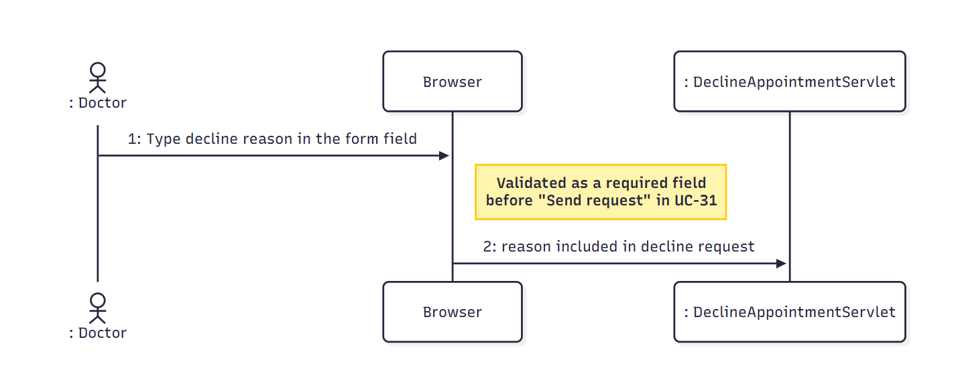

d. Database Queries
- Get user by email:
SELECT * FROM Users WHERE email = ?
- Get JobGreetings By JobId and status:
SELECT * FROM [dbo].[JobGreetings] WHERE job_id = ? AND status = “Được chấp nhận”
- Check transaction exists:
SELECT COUNT(1) FROM [dbo].[Transaction] WHERE description = “Đặt cọc” AND jobId = ?
- Get Job By jobId:
SELECT * FROM Job WHERE job_id = ?
- Update Job Status:
UPDATE Job SET status = “Đang làm việc” WHERE job_id = ?
- Add Transaction:
INSERT INTO [dbo].[Transaction] (senderId, amount, createdDate, status, transactionType, description, jobId) VALUES (?, ?, ?, ?, ?, ?, ?)
- Update Job Status And Secure Wallet
UPDATE Job SET status = ?, secure_wallet+=? WHERE job_id = ?

Consultation

4.1. Join Video Call

a. Class Diagram
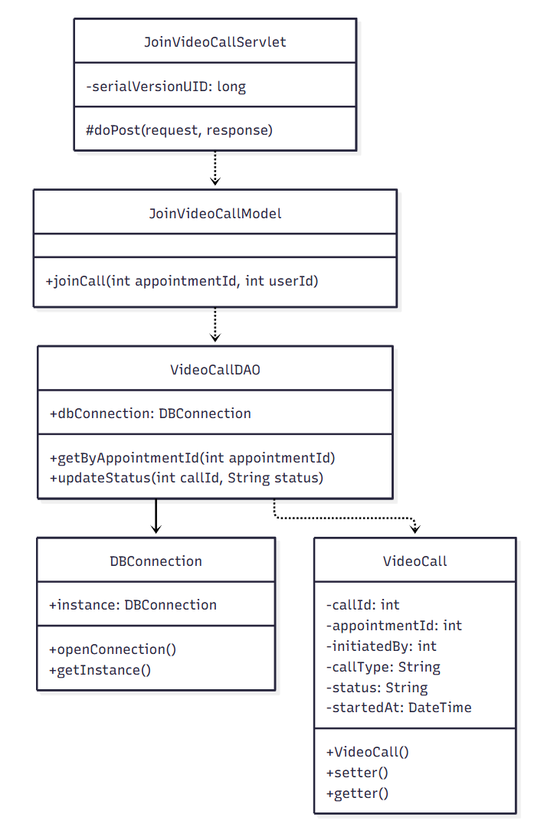

b. Class Specifications

VideoCallDAO Class
No | Method | Description
1 | getByAppointmentId(int appointmentId) | Retrieves the video call record linked to the appointment.
2 | updateStatus(int callId, String status) | Updates the video call status (e.g., to 'ongoing').

JoinVideoCallModel Class
No | Method | Description
1 | joinCall(int appointmentId, int userId) | Business logic for a patient joining an active video call.

JoinVideoCallServlet Class
No | Method | Description
1 | doPost(request, response) | Handles the "Join Call" request.

c. Sequence Diagram(s)

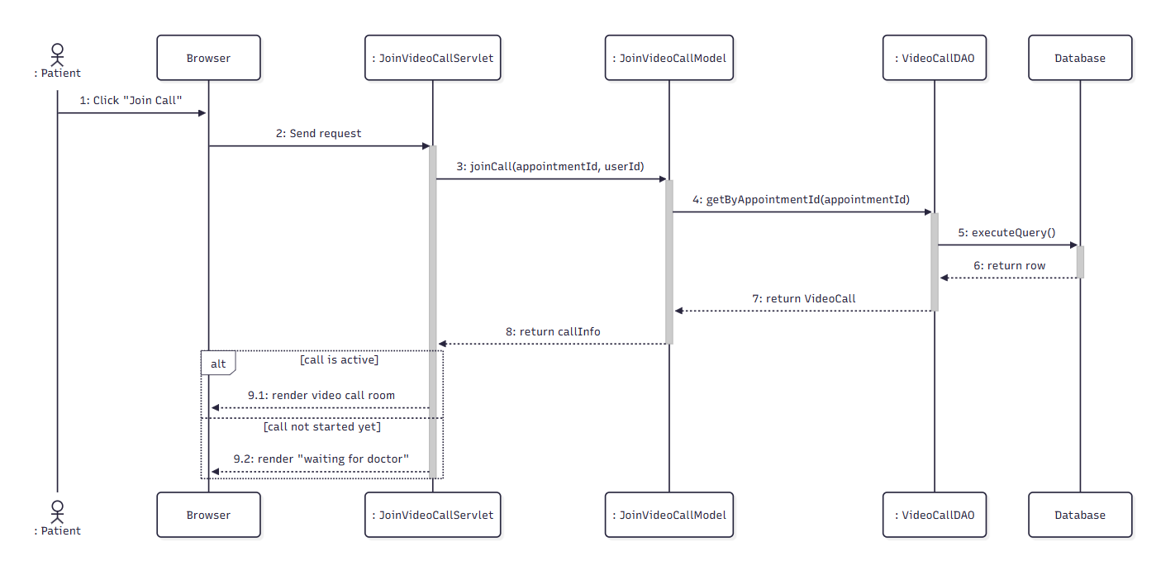

d. Database Queries
- Get All Message of a Job:
SELECT * FROM dMESSAGE WHERE job_id = ? ORDER BY sent_time ASC
- Add new message:
INSERT INTO dMESSAGE (sender_id, receiver_id, attachment, content, sent_time, job_id, isRead) VALUES (?, ?, ?, ?, ?, ?, ?)

4.2. Chat with Doctor

a. Class Diagram

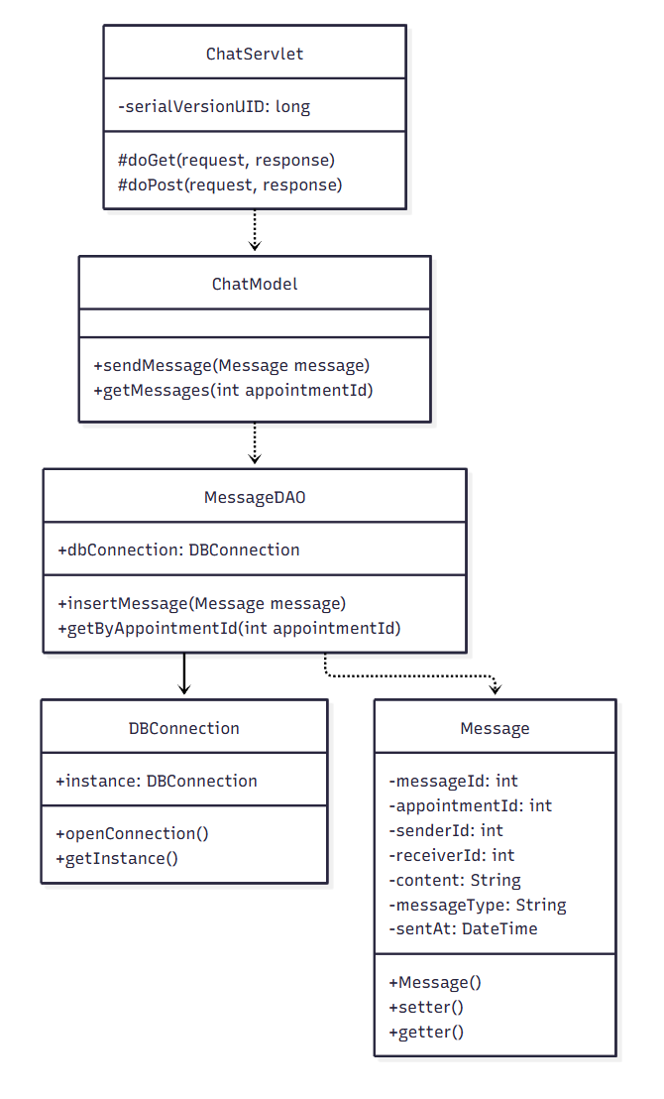

b. Class Specifications

MessageDAO Class
No | Method | Description
1 | insertMessage(Message message) | Inserts a new chat message linked to the appointment.
2 | getByAppointmentId(int appointmentId) | Retrieves the full chat history for the appointment.

ChatModel Class
No | Method | Description
1 | sendMessage(Message message) | Business logic wrapper for sending a chat message.
2 | getMessages(int appointmentId) | Business logic wrapper for retrieving chat history.

ChatServlet Class
No | Method | Description
1 | doGet/doPost(request, response) | Handles loading chat history and sending new messages.

c. Sequence Diagram(s)
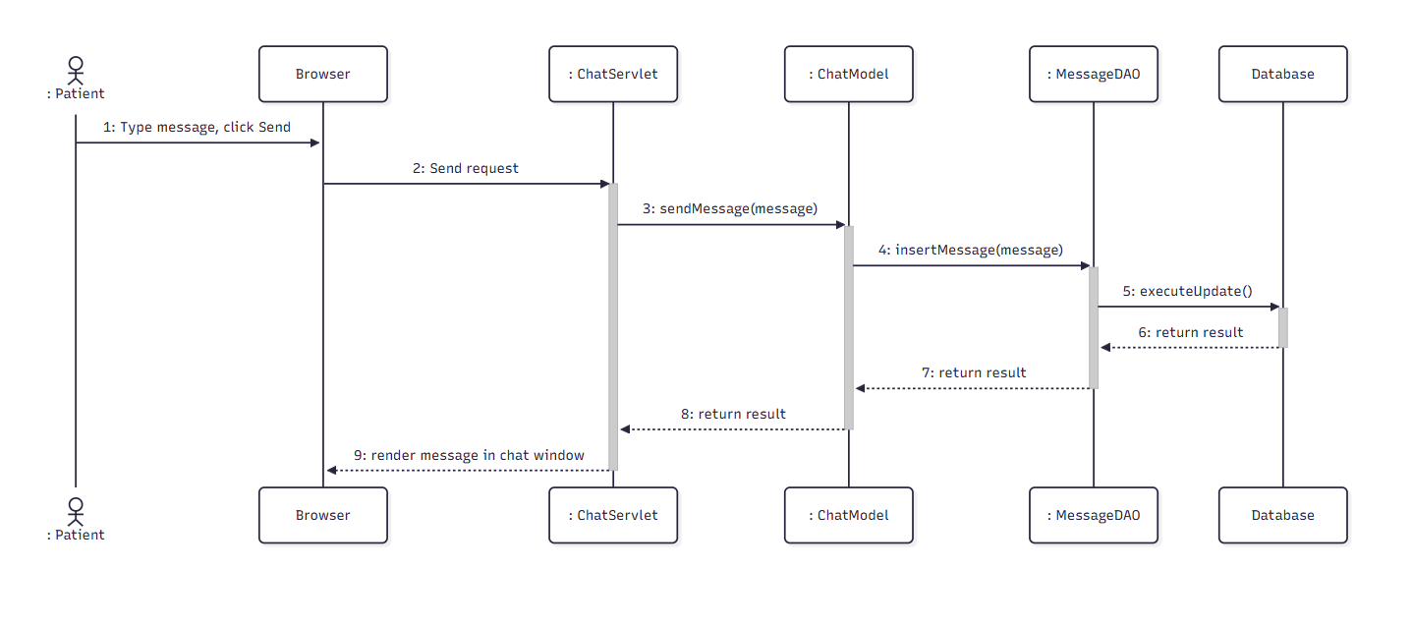

d. Database Queries
- Get Processes By JobId:
SELECT * FROM Process WHERE job_id = ?

4.3. Conduct Video Call

a. Class Diagram

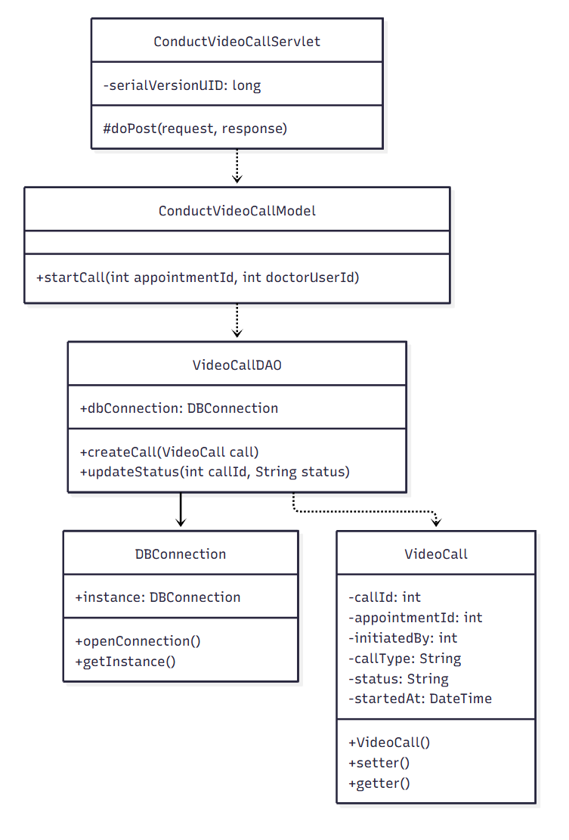

b. Class Specifications
VideoCallDAO Class
No | Method | Description
1 | createCall(VideoCall call) | Inserts a new video call record initiated by the doctor.
2 | updateStatus(int callId, String status) | Updates the video call status.
ConductVideoCallModel Class
No | Method | Description
1 | startCall(int appointmentId, int doctorUserId) | Business logic for a doctor starting a video call.

ConductVideoCallServlet Class
No | Method | Description
1 | doPost(request, response) | Handles the "Start Call" request.

c. Sequence Diagram(s)
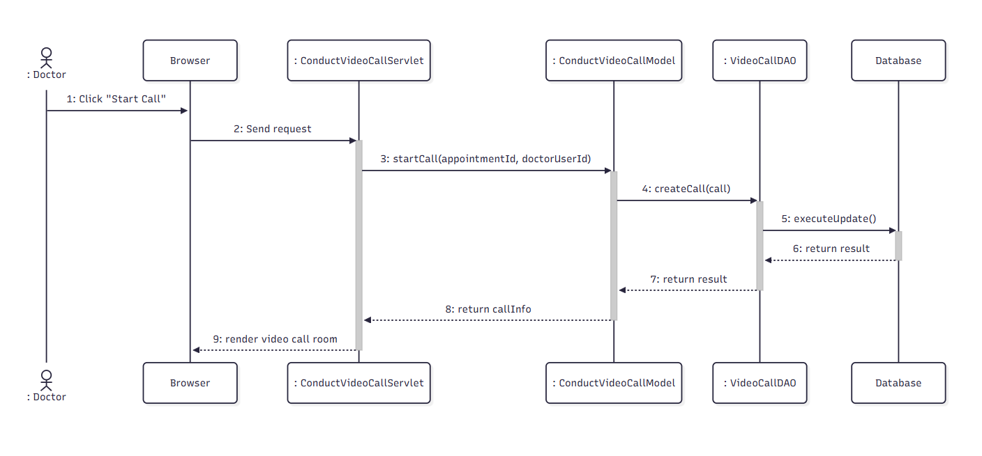

d. Database Queries
- Get Job By Job Id:
SELECT * FROM Job WHERE job_id = ?
- Get Job Greetings By Job Id And Status:
SELECT * FROM [dbo].[JobGreetings] WHERE job_id = ? AND status = ?
- Insert Notification:
INSERT INTO Notifications (user_id, noti_title, content, created_time, isRead, link_noti)
VALUES (?, ?, ?, ?, ?, ?)
- Create Process:
INSERT INTO Process (job_id, stage_name, requirements, end_date, requirement_url, status)
VALUES (?, ?, ?, ?, ?, ?)

4.4. Chat with Patient

a. Class Diagram
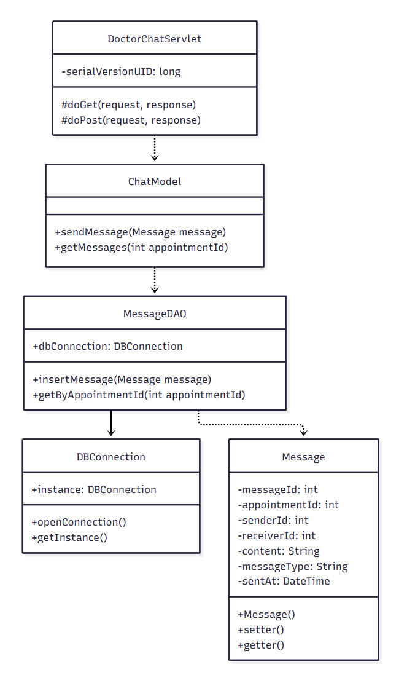

b. Class Specifications

MessageDAO Class
No | Method | Description
1 | insertMessage(Message message) | Inserts a new chat message linked to the appointment.
2 | getByAppointmentId(int appointmentId) | Retrieves the full chat history for the appointment.

ChatModel Class
No | Method | Description
1 | sendMessage(Message message) / getMessages(int appointmentId) | Shared business logic reused from UC-18 (Patient side).

DoctorChatServlet Class
No | Method | Description
1 | doGet/doPost(request, response) | Handles loading chat history and sending new messages from the doctor side.

c. Sequence Diagram(s)
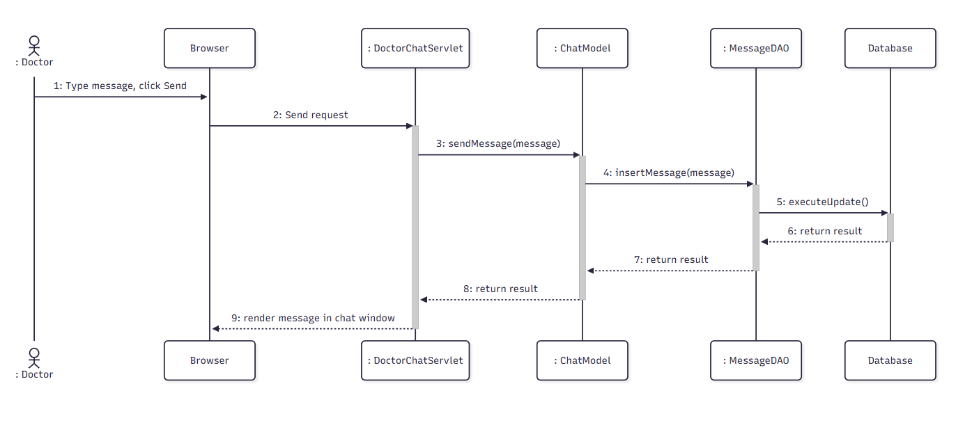

d. Database Queries
- View Details Process:
SELECT * FROM Process WHERE process_id = ?

Examination & Medical Record

5.1. View Diagnosis & Health Book

a. Class Diagram
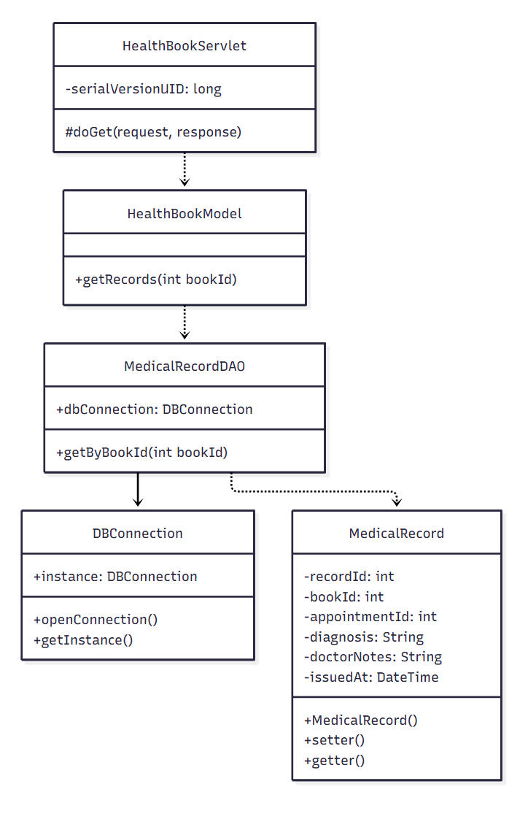

b. Class Specifications

MedicalRecordDAO Class
No | Method | Description
1 | getByBookId(int bookId) | Retrieves all medical records linked to the patient's health book.

HealthBookModel Class
No | Method | Description
1 | getRecords(int bookId) | Business logic wrapper for retrieving the health book records.

HealthBookServlet Class
No | Method | Description
1 | doGet(request, response) | Handles the "Health Book" page request.

c. Sequence Diagram(s)
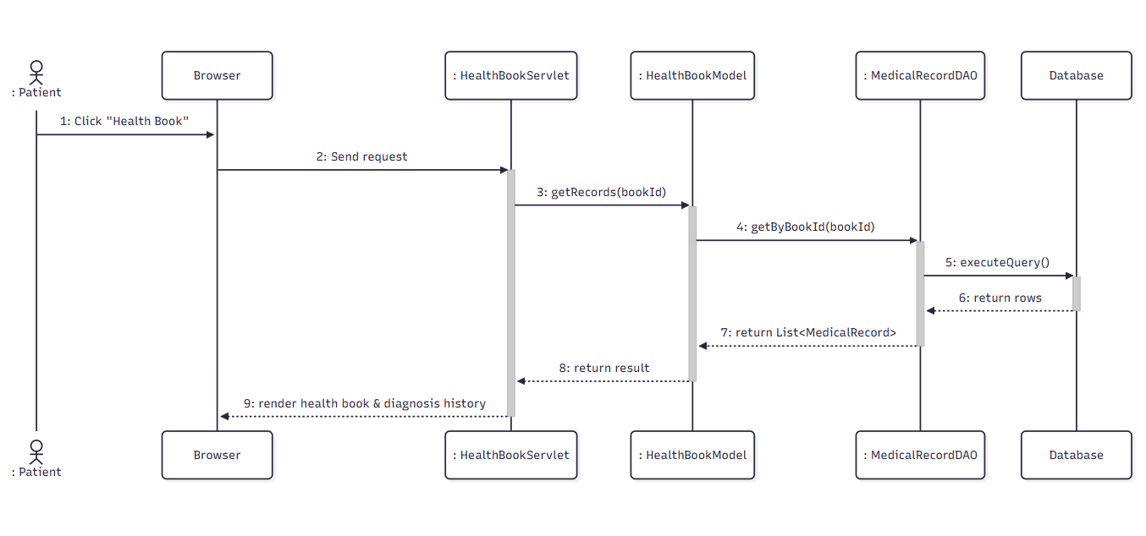

d. Database Queries
- Delete Job Process By Id:
DELETE FROM Process WHERE process_id = ?

5.2. Download Prescription

a. Class Diagram
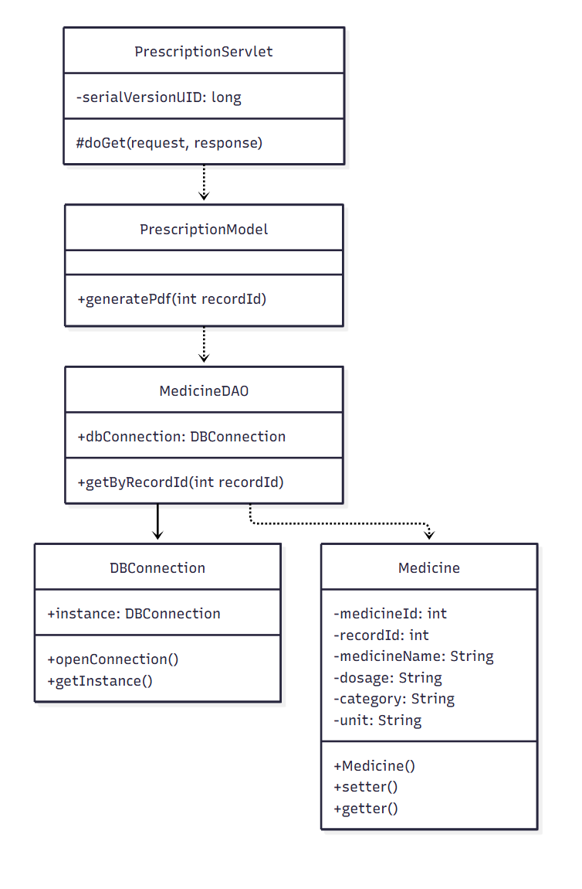

b. Class Specifications

MedicineDAO Class
No | Method | Description
1 | getByRecordId(int recordId) | Retrieves the list of prescribed medicines for a medical record.

PrescriptionModel Class
No | Method | Description
1 | generatePdf(int recordId) | Generates a downloadable PDF of the prescription.

PrescriptionServlet Class
No | Method | Description
1 | doGet(request, response) | Handles the "Download Prescription" request.

c. Sequence Diagram(s)
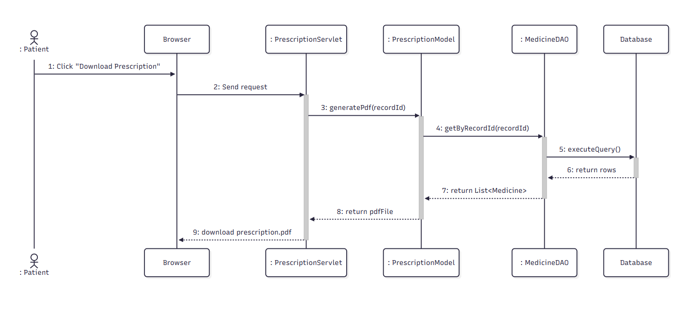

d. Database Queries
- Get Process By Process Id:
SELECT * FROM Process WHERE process_id = ?;

5.3. Rate Doctor

a. Class Diagram
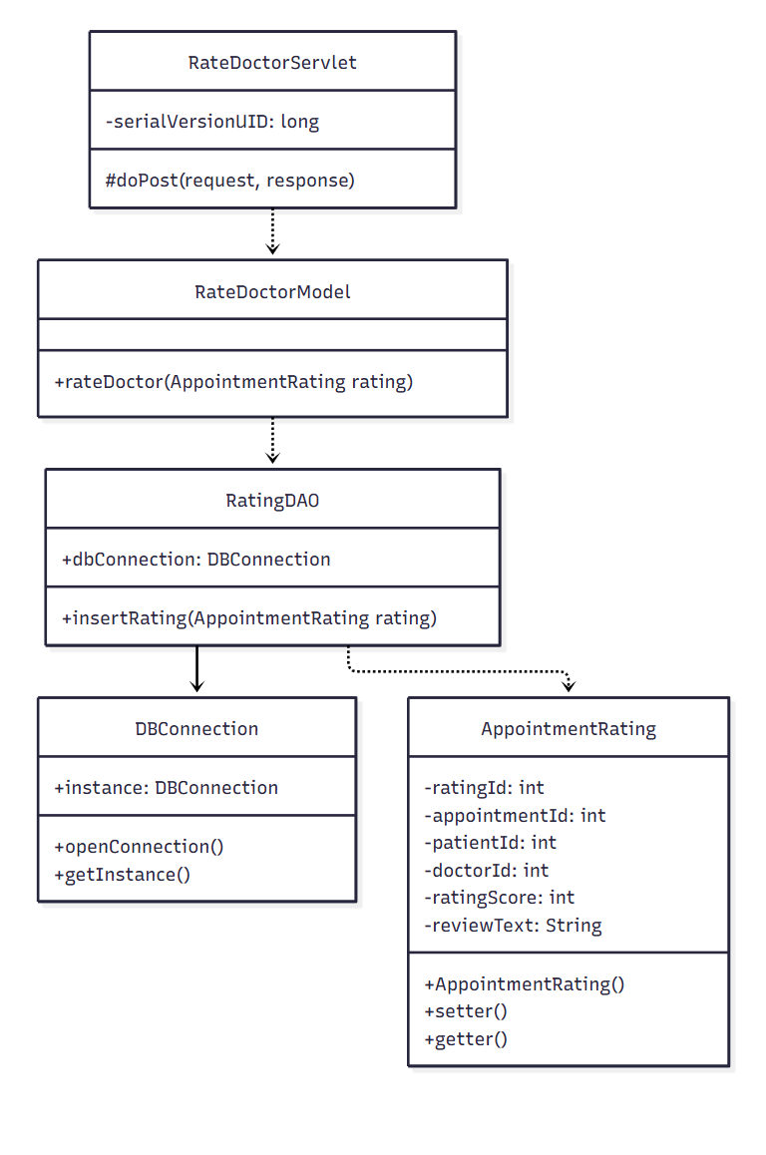

b. Class Specifications

RatingDAO Class
No | Method | Description
1 | insertRating(AppointmentRating rating) | Inserts a new rating record for a completed appointment.

RateDoctorModel Class
No | Method | Description
1 | rateDoctor(AppointmentRating rating) | Validates and persists the doctor rating.

RateDoctorServlet Class
No | Method | Description
1 | doPost(request, response) | Handles the star-rating submission.

c. Sequence Diagram(s)
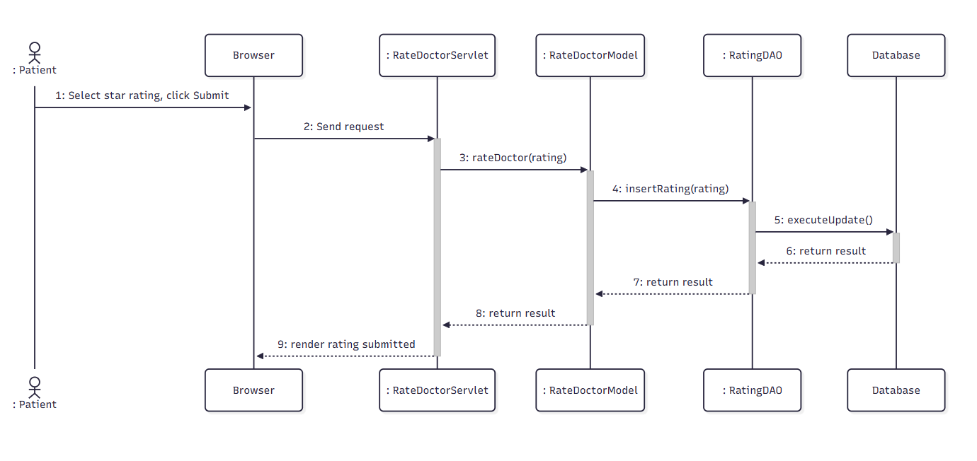

d. Database Queries
- Accept Result:
UPDATE Process SET status = 'Chấp nhận', comments = ? WHERE process_id = ?;
- Get Job Greetings By Job Id And Status:
SELECT * FROM JobGreetings WHERE job_id = ? AND status = N“Được chấp nhận”;
- Get Process By Id:
SELECT * FROM Process WHERE process_id = ?;
- Insert Notification:
INSERT INTO Notifications (user_id, noti_title, content, created_time, isRead, link_noti)
VALUES (?, ?, ?, ?, ?, ?);

5.4. Write Text Review

a. Class Diagram
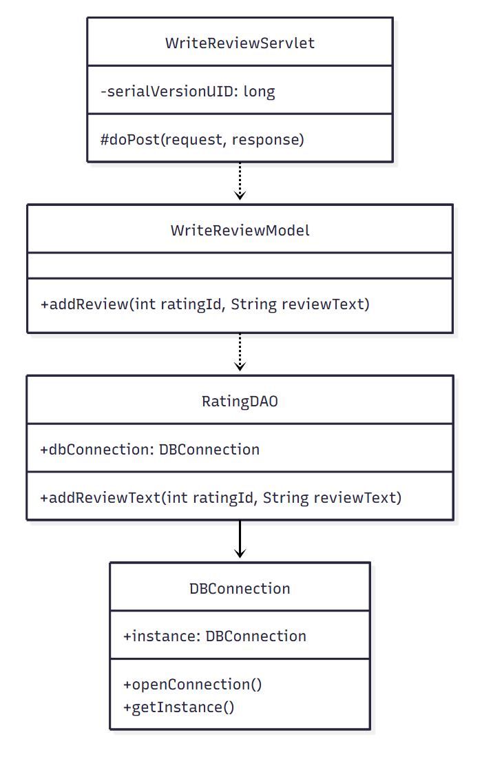

b. Class Specifications

RatingDAO Class
No | Method | Description
1 | addReviewText(int ratingId, String reviewText) | Updates the rating record with the written review text.

WriteReviewModel Class
No | Method | Description
1 | addReview(int ratingId, String reviewText) | Business logic wrapper for saving a text review.

WriteReviewServlet Class
No | Method | Description
1 | doPost(request, response) | Handles the text-review submission.

c. Sequence Diagram(s)
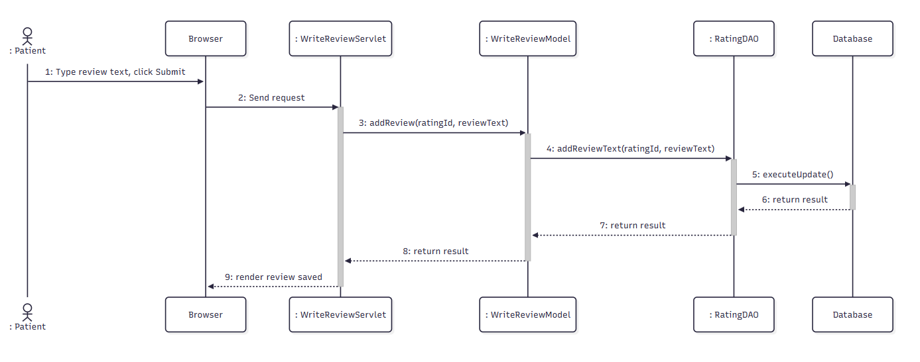

d. Database Queries

- Refuse Result:
UPDATE Process SET status = 'Từ chối', comments = ? WHERE process_id = ?;
- Get Job Greetings By Job Id And Status:
SELECT * FROM JobGreetings WHERE job_id = ? AND status = N“Được chấp nhận”;
- Get Process By Id:
SELECT * FROM Process WHERE process_id = ?;
- Insert Notification:
INSERT INTO Notifications (user_id, noti_title, content, created_time, isRead, link_noti)
VALUES (?, ?, ?, ?, ?, ?);

5.5. Submit Complaint

a) Class diagram:
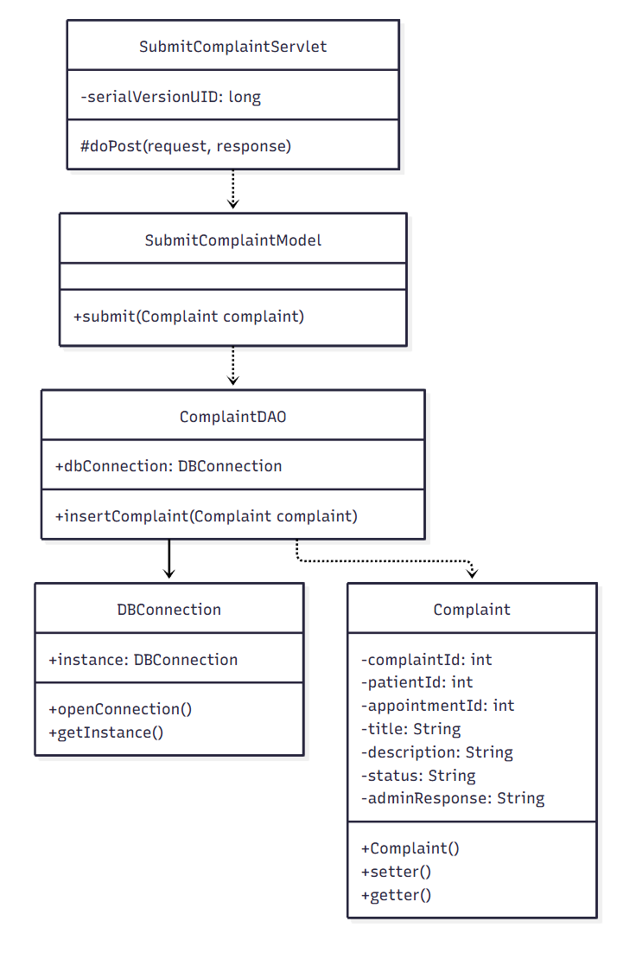

b) Class Specification

ComplaintDAO Class
No | Method | Description
1 | insertComplaint(Complaint complaint) | Inserts a new complaint record linked to the patient and appointment.

SubmitComplaintModel Class

No | Method | Description
1 | submit(Complaint complaint) | Validates and persists the complaint submission.

SubmitComplaintServlet Class
No | Method | Description
1 | doPost(request, response) | Handles the complaint form submission.

c. Sequence Diagram(s)
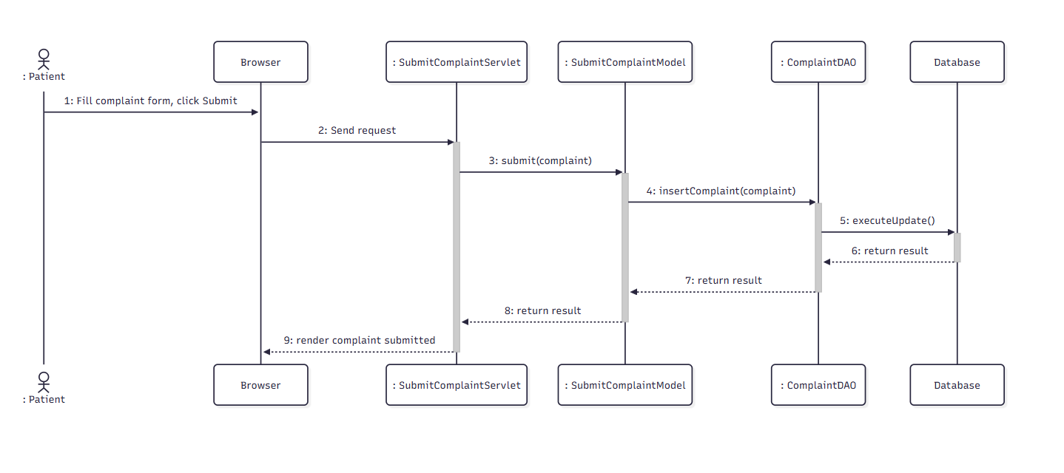

d. Database Queries:
Get job by JobId:
SELECT * FROM Job WHERE job_id = ?
Get Process by ProcessId:
SELECT * FROM Process WHERE process_id = ?
Update Process description:
UPDATE process SET description_result = ? WHERE process_id = ?
Update Process File:
UPDATE process SET result_url = ? WHERE process_id = ?
Get User by jobID:
SELECT U.* FROM [dbo].[Users] U JOIN Job J ON U.user_id = J.user_id
WHERE J.job_id = ?
Insert notification:
INSERT INTO Notifications (user_id, noti_title, content, created_time, isRead, link_noti)
VALUES (?, ?, ?, ?, ?, ?)

5.6. View Patient Record

a. Class Diagram
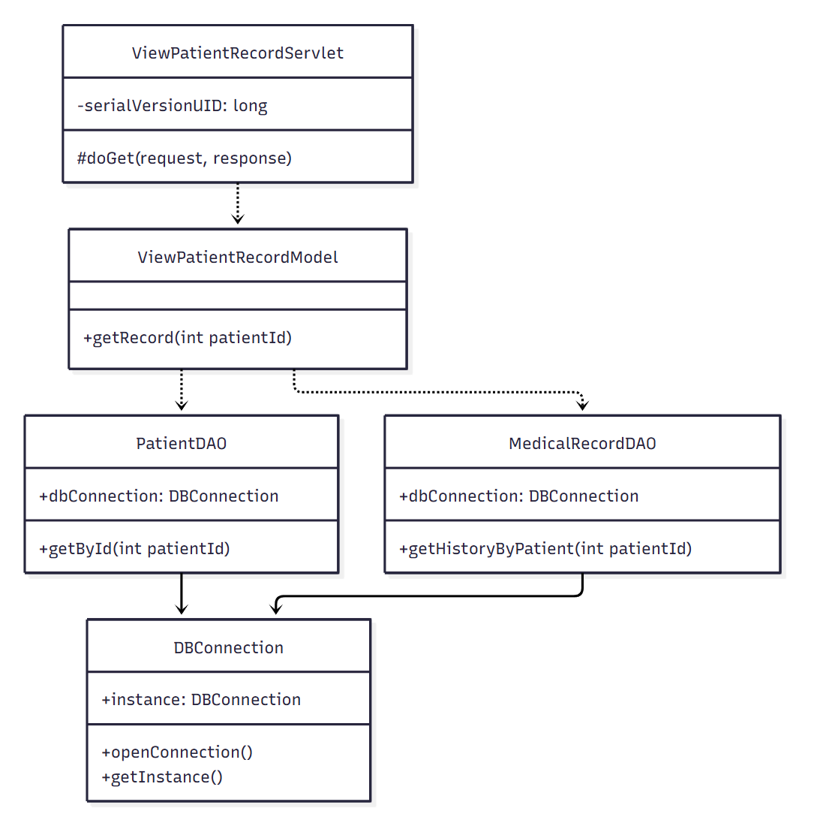

b. Class Specifications

PatientDAO Class
No | Method | Description
1 | getById(int patientId) | Retrieves the patient's core medical profile (blood type, allergies, etc.).

MedicalRecordDAO Class
No | Method | Description
1 | getHistoryByPatient(int patientId) | Retrieves the patient's full medical record history.

ViewPatientRecordModel Class
No | Method | Description
1 | getRecord(int patientId) | Combines patient profile and record history for display.

ViewPatientRecordServlet Class
No | Method | Description
1 | doGet(request, response) | Handles the patient-record view request.

c. Sequence Diagram(s)
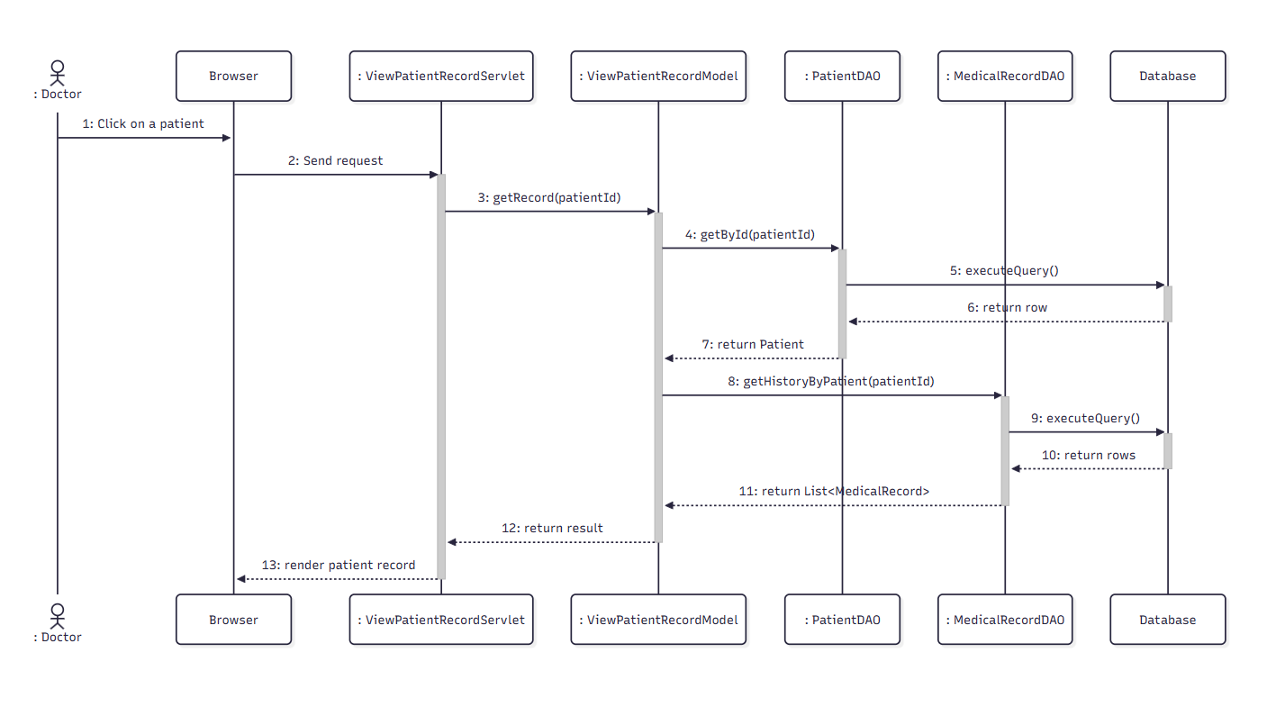

d. Database Queries

My Job For Employer:
SELECT * FROM Job WHERE status != 'Đang tuyển' AND user_id = ?;

- Get User by email:
SELECT * FROM Users WHERE email = ?

5.7. Fill Examination Form

a. Class Diagram

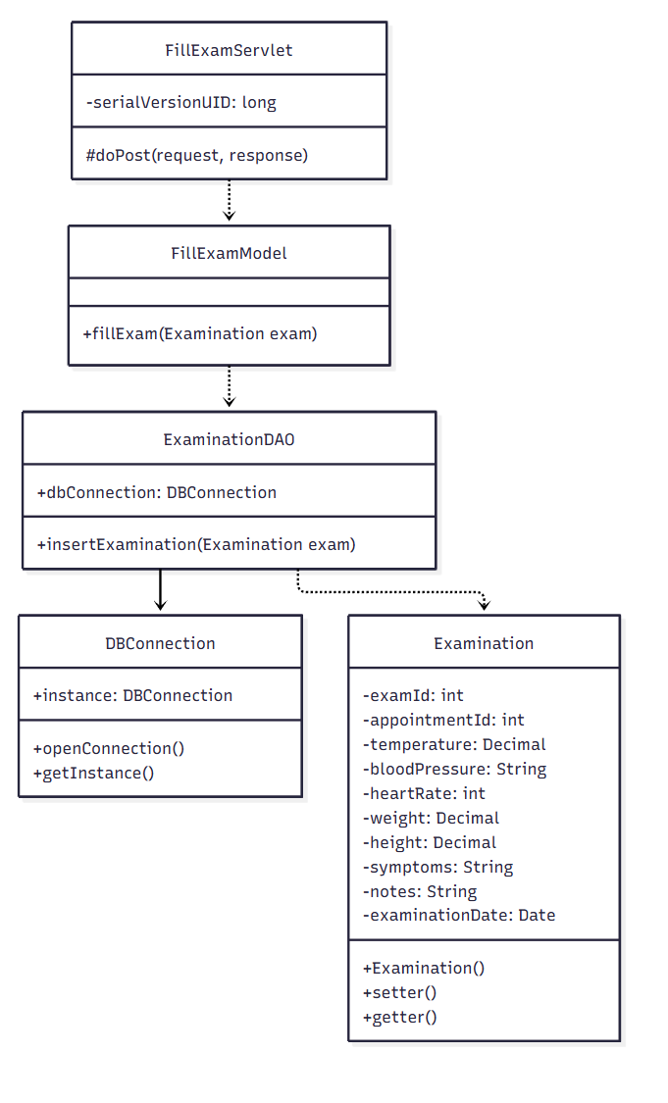

b. Class Specifications

ExaminationDAO Class
No | Method | Description
1 | insertExamination(Examination exam) | Inserts the examination record with vitals and symptoms.

FillExamModel Class
No | Method | Description
1 | fillExam(Examination exam) | Validates and persists the examination form.

FillExamServlet Class
No | Method | Description
1 | doPost(request, response) | Handles the examination-form submission.

c. Sequence Diagram(s)
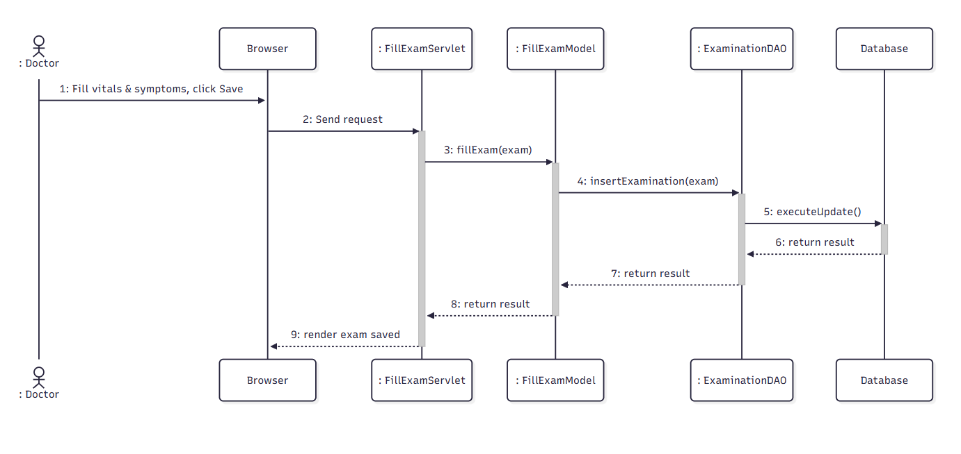

d. Database Queries

My Job For Seeker:
SELECT * FROM Job j JOIN JobGreetings jg ON j.job_id = jg.job_id
WHERE jg.job_seeker_id = ? AND jg.status = N'Được chấp nhận';

- Get User by email:
SELECT * FROM Users WHERE email = ?

5.8. Order Lab Test

a) Class diagram:
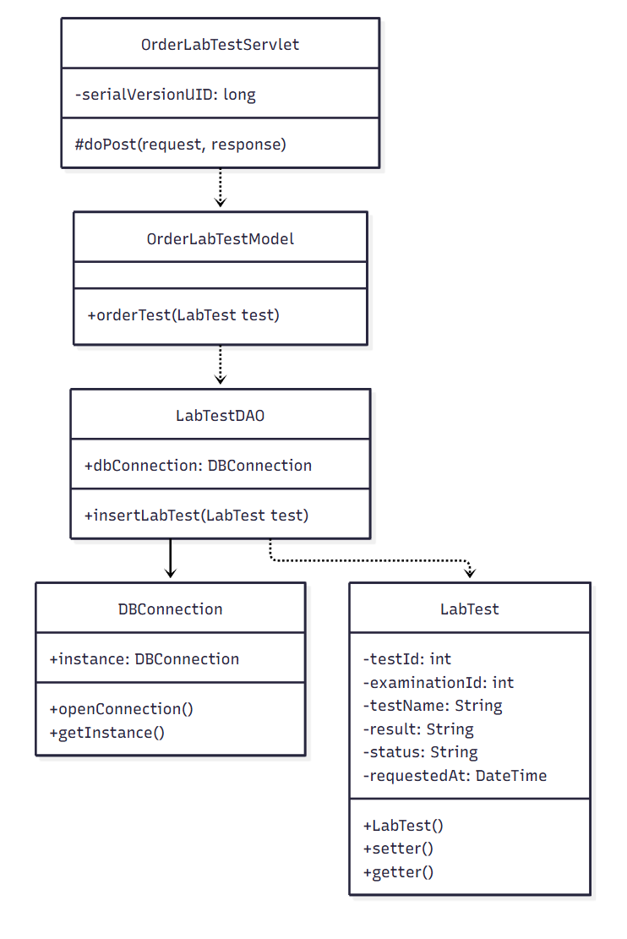

b) Class Specification

LabTestDAO Class

No | Method | Description
1 | insertLabTest(LabTest test) | Inserts a new lab test request linked to the examination.

OrderLabTestModel Class
No | Method | Description
1 | orderTest(LabTest test) | Business logic wrapper for ordering a lab test.

OrderLabTestServlet Class
No | Method | Description
1 | doPost(request, response) | Handles the order-lab-test request.

c. Sequence Diagram(s)
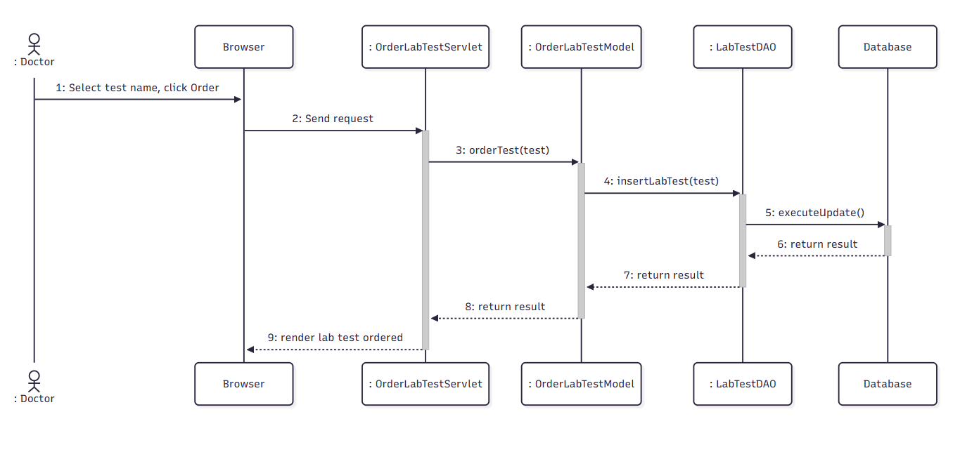

d. Database Queries:
Get Product by JobId:
SELECT * FROM DigitalProduct WHERE job_id = ?
Update Product by id:
UPDATE DigitalProduct SET notes = ?, digitalproduct_url = ?, status = ? WHERE job_id = ?
Create Product by id:
INSERT INTO DigitalProduct (job_id, digitalproduct_url, notes, status) VALUES (?, ?, ?, ?)
Update Job status by id:
UPDATE Job SET status = ? WHERE job_id = ?
Get job by jobId:
SELECT * FROM Job WHERE job_id = ?
Insert notification:
INSERT INTO Notifications (user_id, noti_title, content, created_time, isRead, link_noti) VALUES (?, ?, ?, ?, ?, ?)

5.9. Write Diagnosis & Issue Prescription

a. Class Diagram

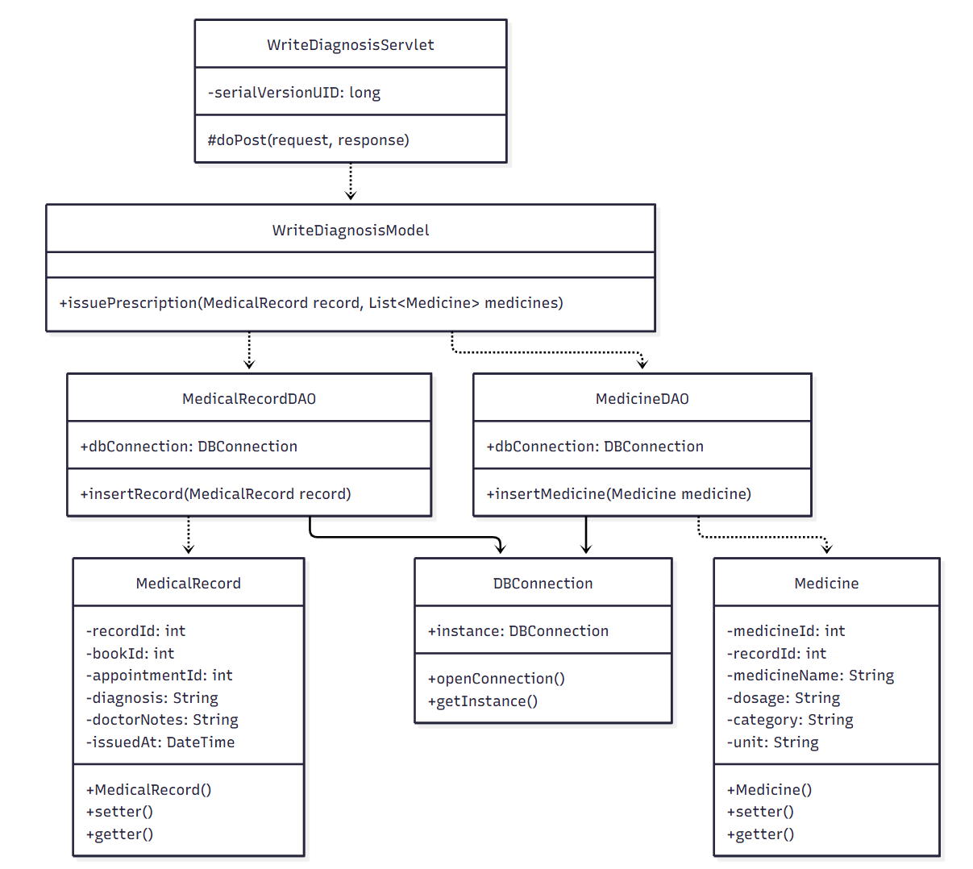

b. Class Specifications

MedicalRecordDAO Class
No | Method | Description
1 | insertRecord(MedicalRecord record) | Inserts the diagnosis record linked to the patient's health book.

MedicineDAO Class

No | Method | Description
1 | insertMedicine(Medicine medicine) | Inserts a prescribed medicine linked to the medical record.

WriteDiagnosisModel Class

No | Method | Description
1 | issuePrescription(MedicalRecord record, List<Medicine> medicines) | Orchestrates saving the diagnosis record followed by each prescribed medicine.

WriteDiagnosisServlet Class
No | Method | Description
1 | doPost(request, response) | Handles the diagnosis & prescription form submission.

c. Sequence Diagram(s)
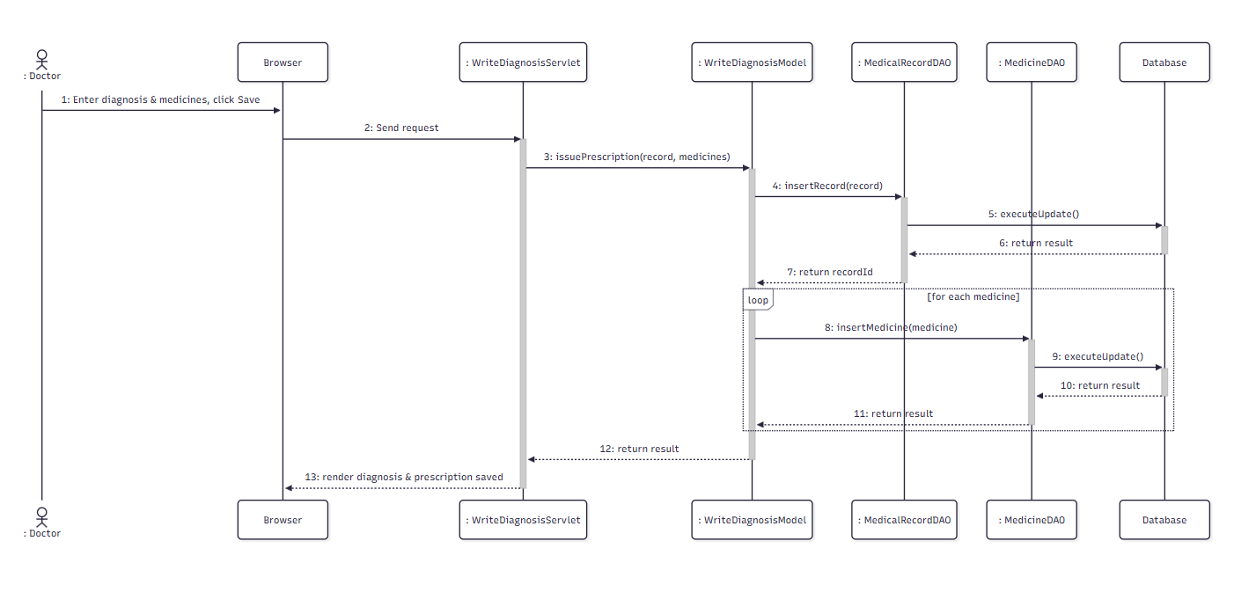

d. Database Queries

- Insert Shipment into Shipment:

INSERT INTO Shipment (jobId, pick_name, pick_province, pick_district, pick_ward, pick_address, pick_tel, name, province, district, ward, address, tel, product_name, product_quantity, product_weight, status, tracking_id) VALUES (?, ?, ?, ?, ?, ?, ?, ?, ?, ?, ?, ?, ?, ?, ?, ?,?,?)

Approval & Catalog

6.1. Review & Approve Doctor

a.Class diagram
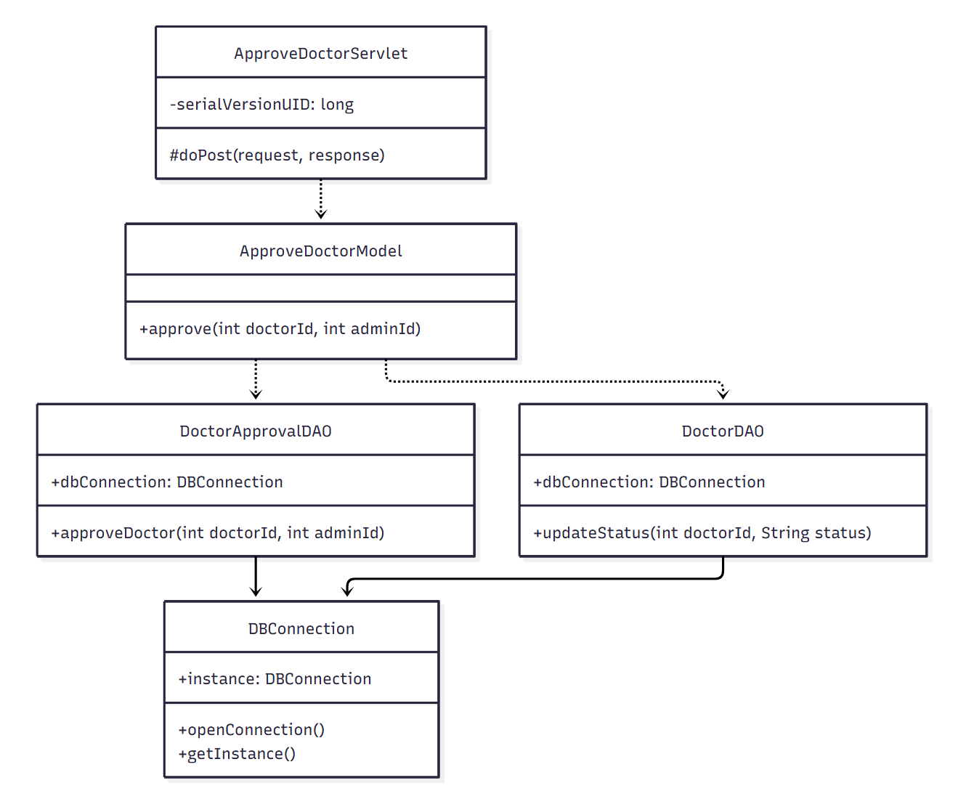

b.Class specifications

DoctorApprovalDAO Class
No | Method | Description
1 | approveDoctor(int doctorId, int adminId) | Updates the approval record to 'approved' with the reviewing admin.

DoctorDAO Class
No | Method | Description
1 | updateStatus(int doctorId, String status) | Updates the doctor's account status.

ApproveDoctorModel Class
No | Method | Description
1 | approve(int doctorId, int adminId) | Orchestrates approving the doctor application.

ApproveDoctorServlet Class
No | Method | Description
1 | doPost(request, response) | Handles the approve-doctor request.

c.Sequence diagram
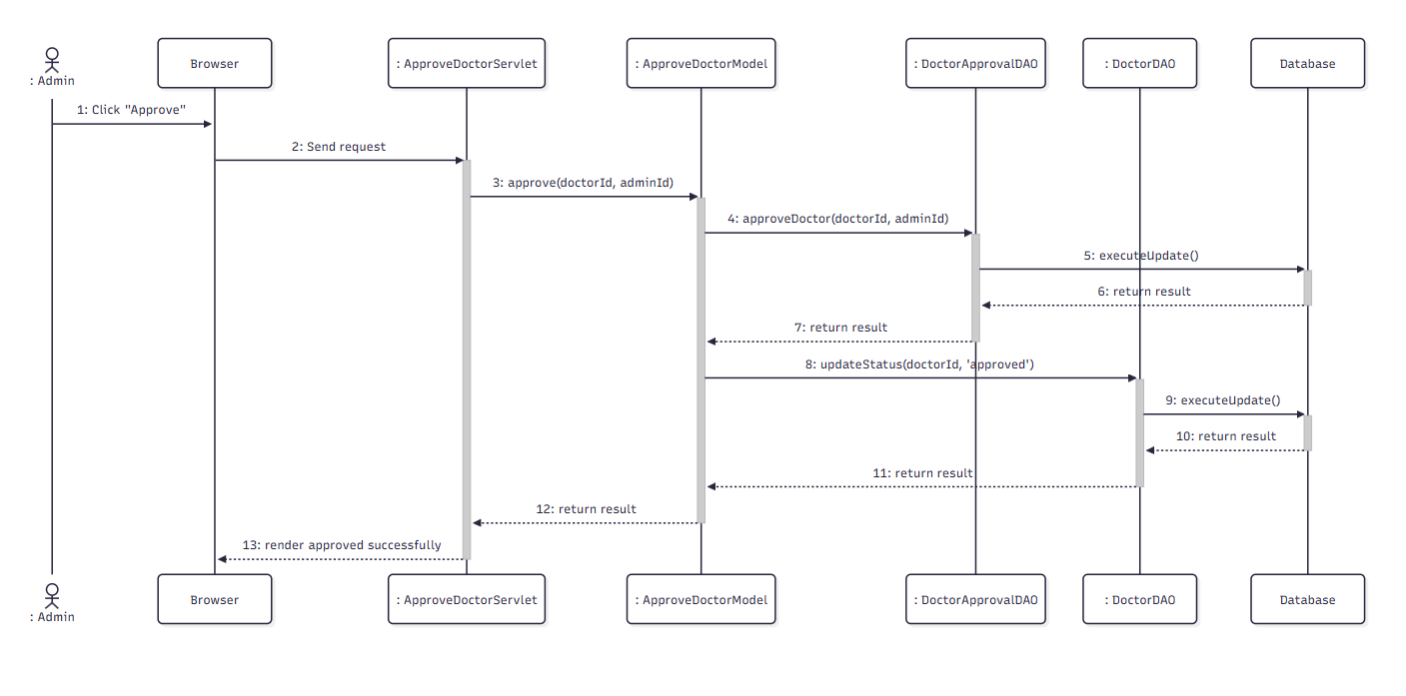

d.Database Queries
1.Update feedback employer
UPDATE Job SET employer_feedback =? WHERE job_id = ?
2.Get users by email
SELECT * FROM Users WHERE email = ?
3.Get accepted job
SELECT * FROM Job j JOIN JobGreetings jg ON j.job_id = jg.job_id WHERE jg.job_seeker_id = ? AND jg.status = N'Được chấp nhận'

6.2. Reject Doctor

a.Class diagram
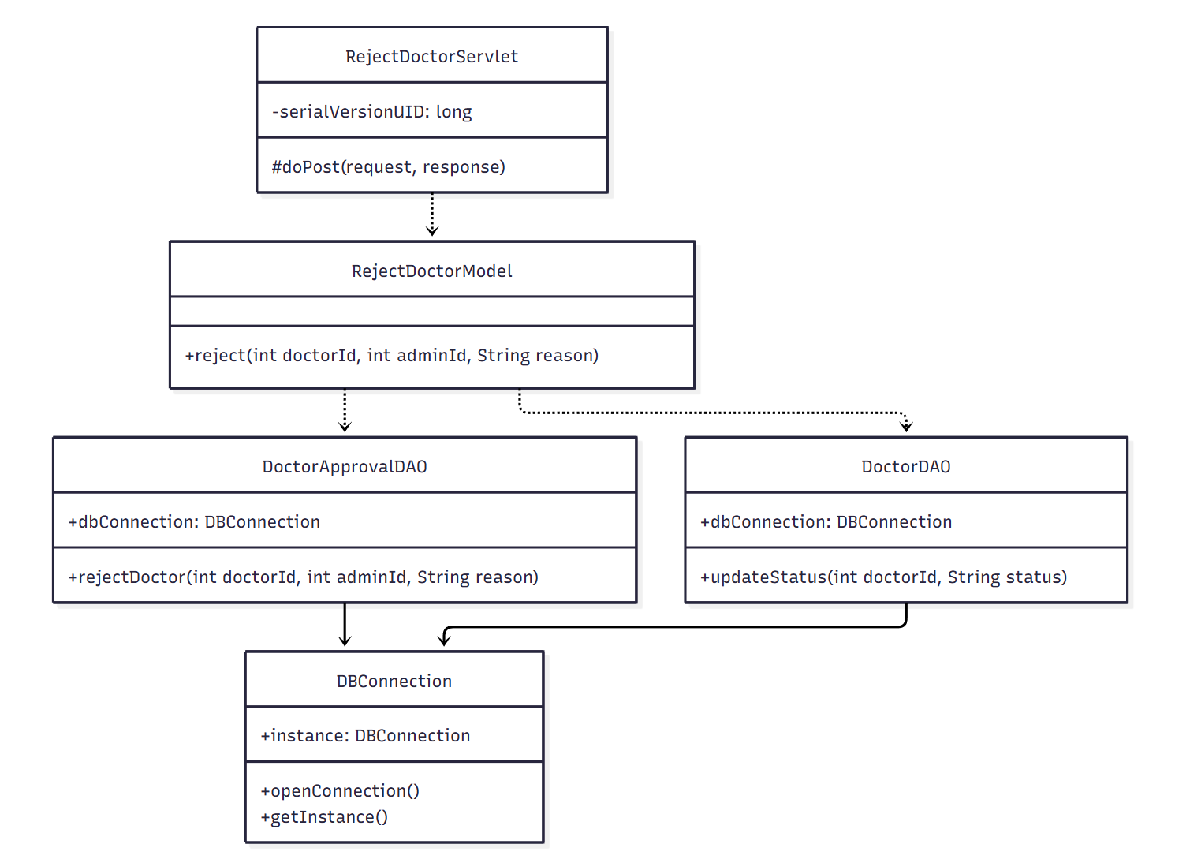

b.Class specifications

DoctorApprovalDAO Class
No | Method | Description
1 | rejectDoctor(int doctorId, int adminId, String reason) | Updates the approval record to 'rejected' with reason.

DoctorDAO Class
No | Method | Description
1 | updateStatus(int doctorId, String status) | Updates the doctor's account status.

RejectDoctorModel Class
No | Method | Description
1 | reject(int doctorId, int adminId, String reason) | Orchestrates rejecting the doctor application.

RejectDoctorServlet Class
No | Method | Description
1 | doPost(request, response) | Handles the reject-doctor request.

c.Sequence diagram

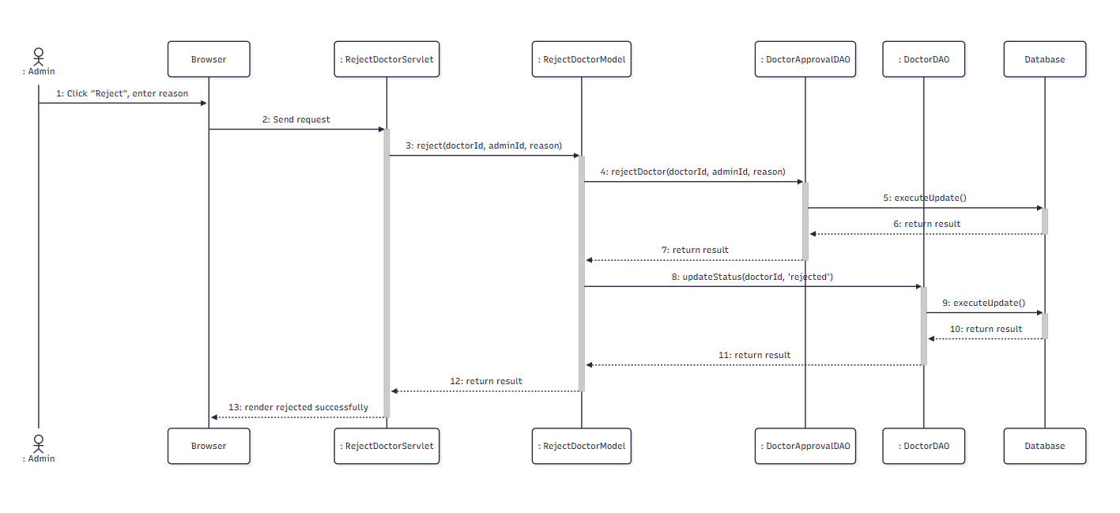

d.Database Queries
1.Update feedback employer
UPDATE Job SET employer_feedback =? WHERE job_id = ?
2.Get users by email
SELECT * FROM Users WHERE email = ?
3.Get accepted job
SELECT * FROM Job j JOIN JobGreetings jg ON j.job_id = jg.job_id WHERE jg.job_seeker_id = ? AND jg.status = N'Được chấp nhận'

6.3. Lock Account

a.Class Diagram

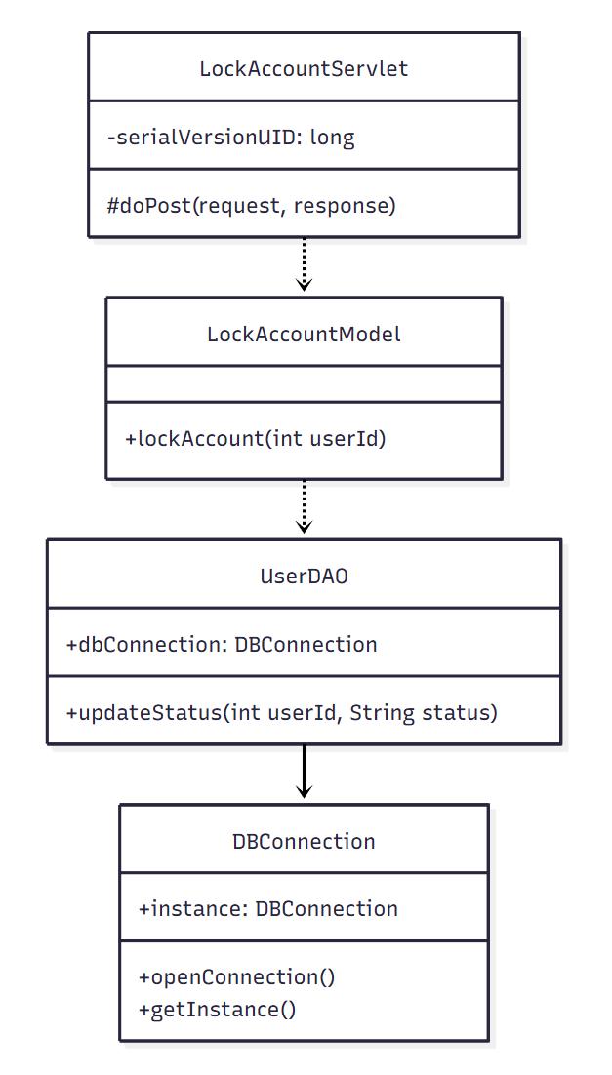

b.Class specification
UserDAO Class
No | Method | Description
1 | updateStatus(int userId, String status) | Updates the user's account status to 'locked'.

LockAccountModel Class
No | Method | Description
1 | lockAccount(int userId) | Business logic wrapper for locking a user account.

LockAccountServlet Class
No | Method | Description
1 | doPost(request, response) | Handles the lock-account request.

c.Sequence Diagram
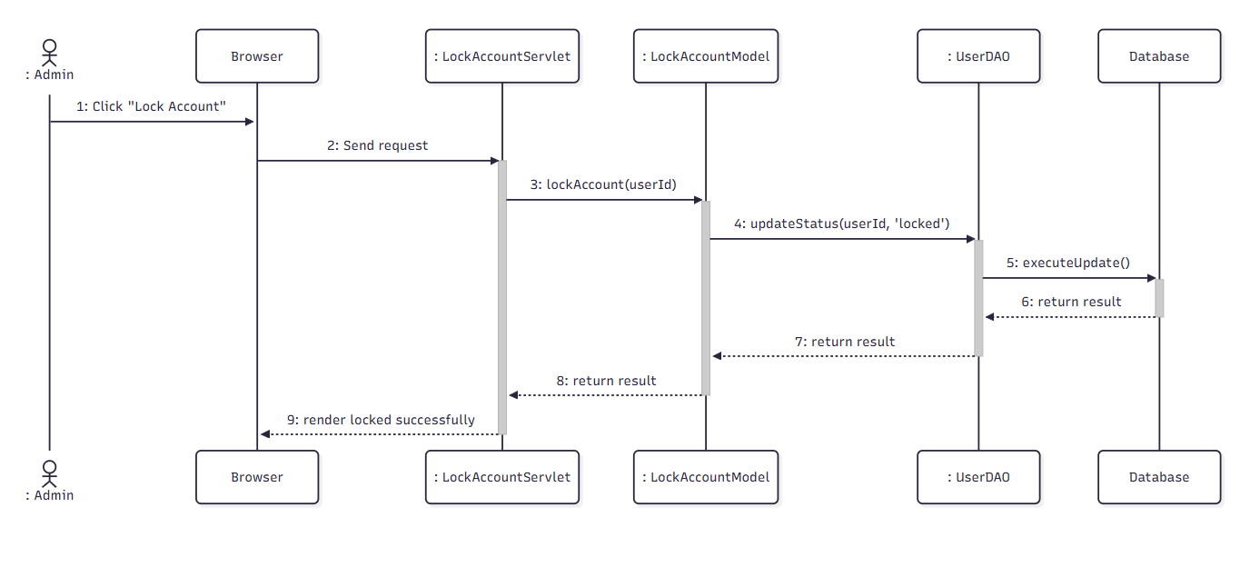

d.Database Queries
1.Get job by jobId
SELECT * FROM Job WHERE job_id = ?
2.Get jobGreeting by jobId and status
SELECT * FROM [dbo].[JobGreetings] WHERE job_id = ? AND status = ?
3.Get users by email
SELECT * FROM Users WHERE email = ?

6.4. Add Department

a. Class Diagram
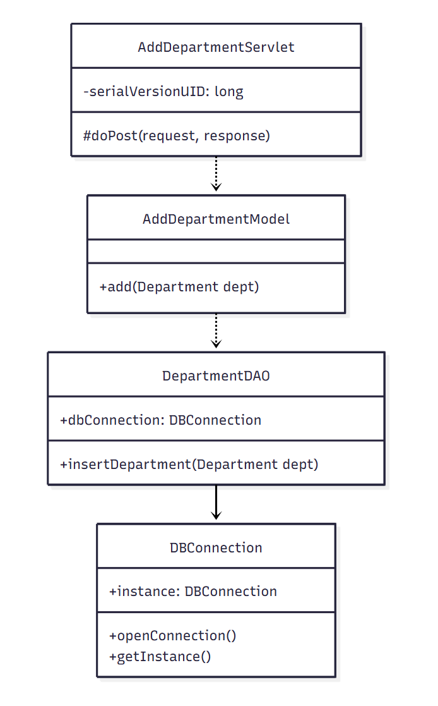

b. Class Specifications
DepartmentDAO Class
No | Method | Description
1 | insertDepartment(Department dept) | Inserts a new department record.

AddDepartmentModel Class
No | Method | Description
1 | add(Department dept) | Validates and persists the new department.

AddDepartmentServlet Class
No | Method | Description
1 | doPost(request, response) | Handles the add-department form submission.

c. Sequence Diagram(s)

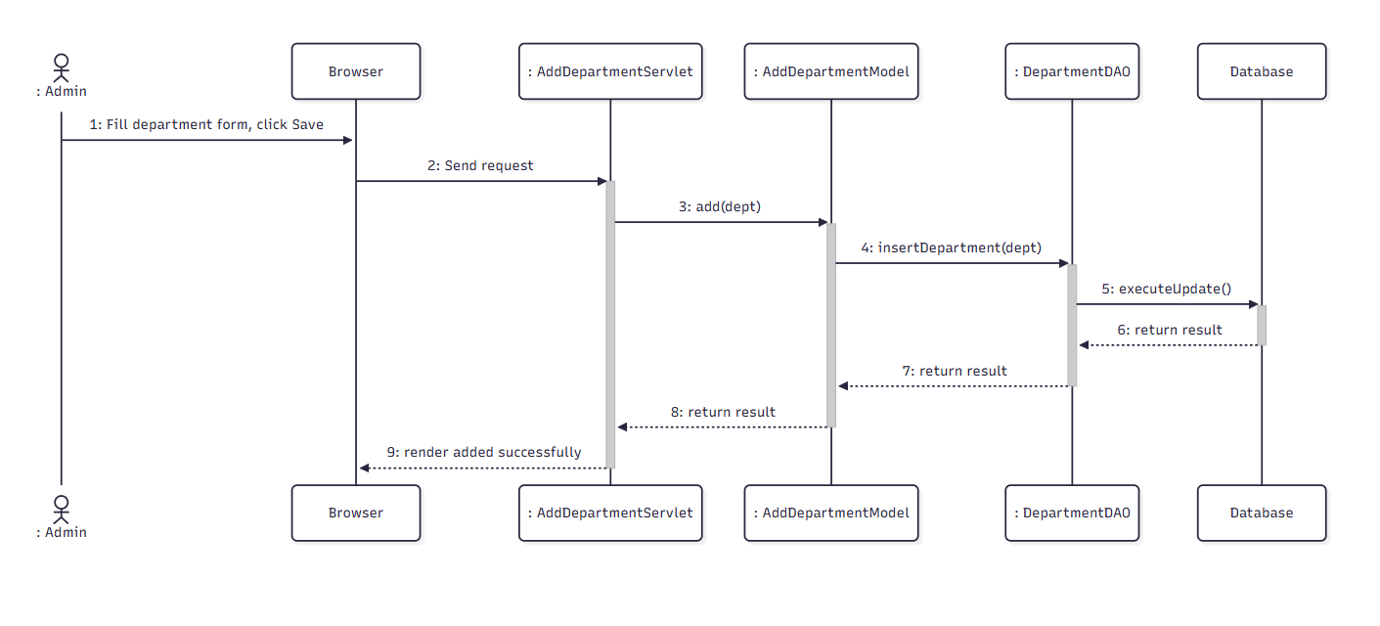

d. Database Queries
SELECT * FROM Job

With coun AS ( SELECT job_id, user_id, job_title, budget, description, due_date, status, category_id, employer_feedback, seeker_feedback, secure_wallet, doc_URL, interview_URL, interview_Date, address, label_verify, ROW_NUMBER() OVER (order by job_id) as RowNumber FROM Job)

select * from coun Where RowNumber Between ? and ?

6.5. Edit Department

a. Class Diagram
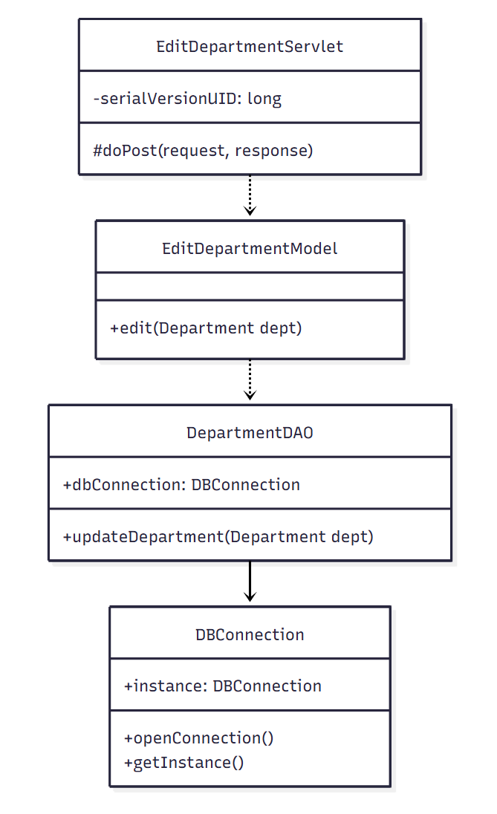

b. Class Specifications
DepartmentDAO Class
No | Method | Description
1 | updateDepartment(Department dept) | Updates an existing department's information.

EditDepartmentModel Class
No | Method | Description
1 | edit(Department dept) | Validates and persists department changes.

EditDepartmentServlet Class
No | Method | Description
1 | doPost(request, response) | Handles the edit-department form submission.

c. Sequence Diagram(s)

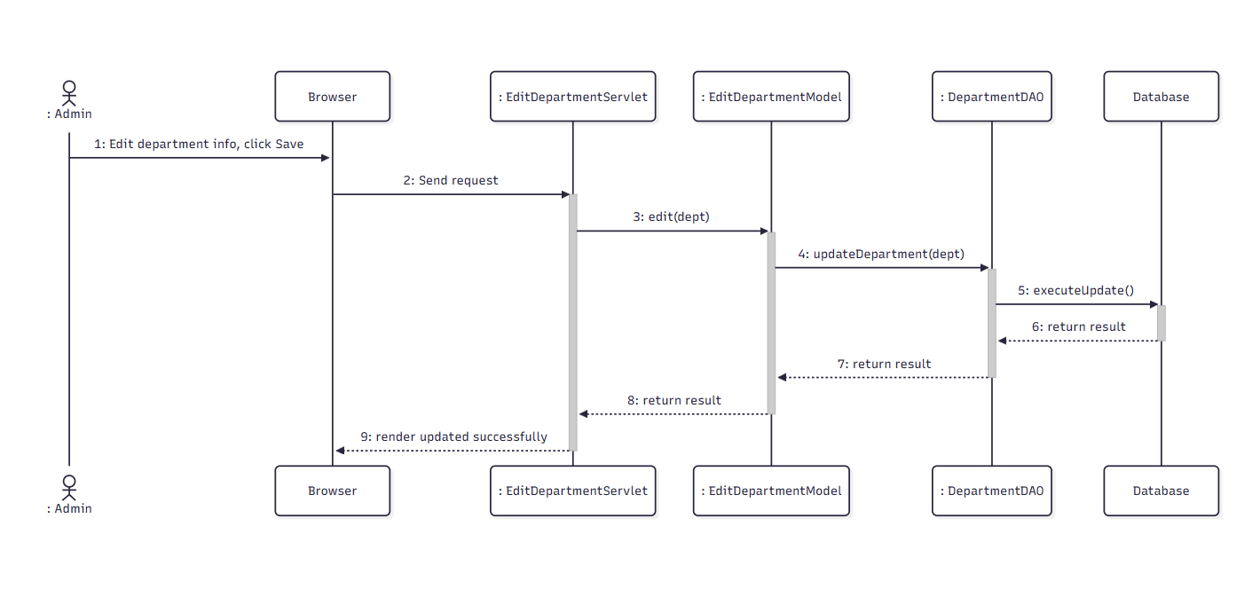

d. Database Queries
Update Job SET label_verify = N'Được duyệt' WHERE job_id = ?

6.6. Assign Doctor to Department

a. Class Diagram
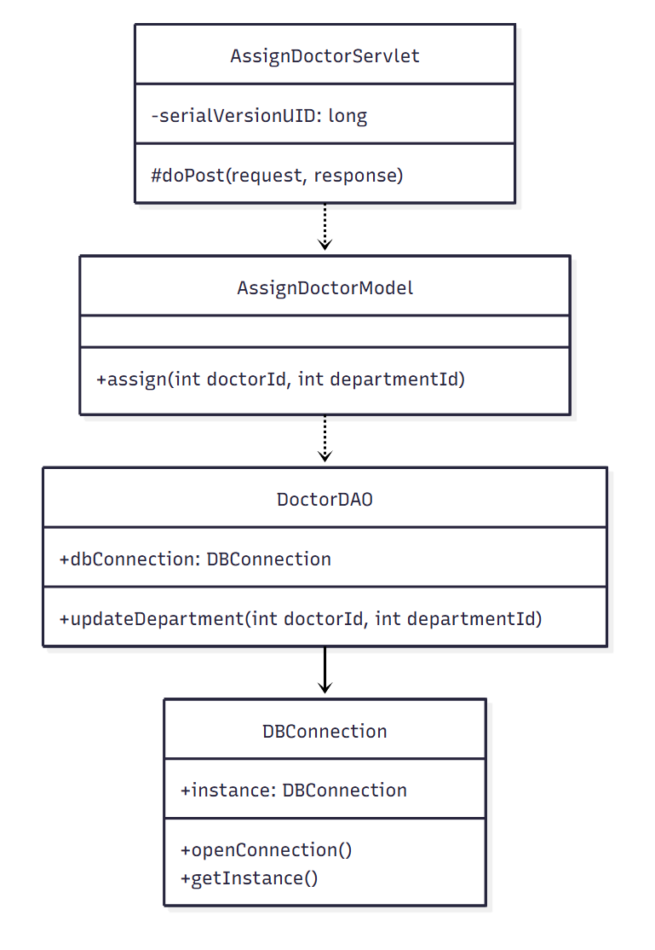

b. Class Specifications
DoctorDAO Class
No | Method | Description
1 | updateDepartment(int doctorId, int departmentId) | Updates the doctor's assigned department.

AssignDoctorModel Class
No | Method | Description
1 | assign(int doctorId, int departmentId) | Business logic wrapper for assigning a doctor to a department.

AssignDoctorServlet Class
No | Method | Description
1 | doPost(request, response) | Handles the assign-doctor request.

c. Sequence Diagram(s)

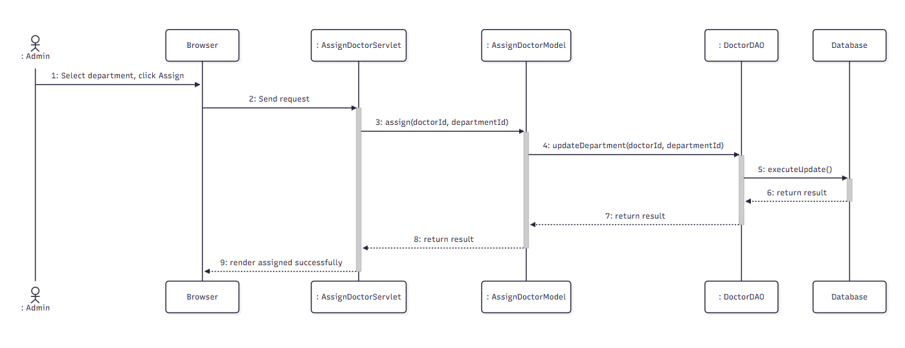

d. Database Queries
SELECT * FROM Job WHERE job_id = ?

6.7. View Doctors by Department

a. Class Diagram
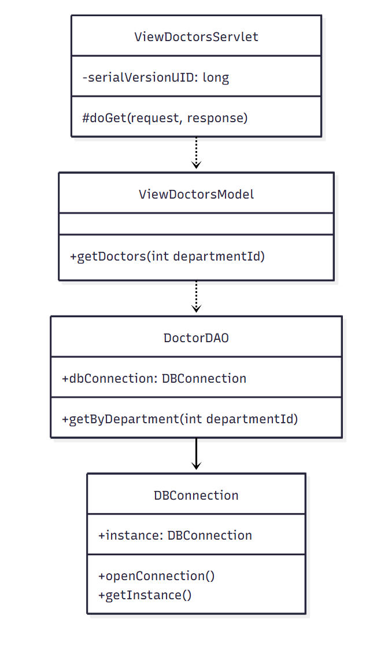

b. Class Specifications

DoctorDAO Class
No | Method | Description
1 | getByDepartment(int departmentId) | Retrieves all doctors assigned to a department.

ViewDoctorsModel Class
No | Method | Description
1 | getDoctors(int departmentId) | Business logic wrapper for listing doctors by department.

ViewDoctorsServlet Class
No | Method | Description
1 | doGet(request, response) | Handles the view-doctors-by-department request.

c. Sequence Diagram(s)

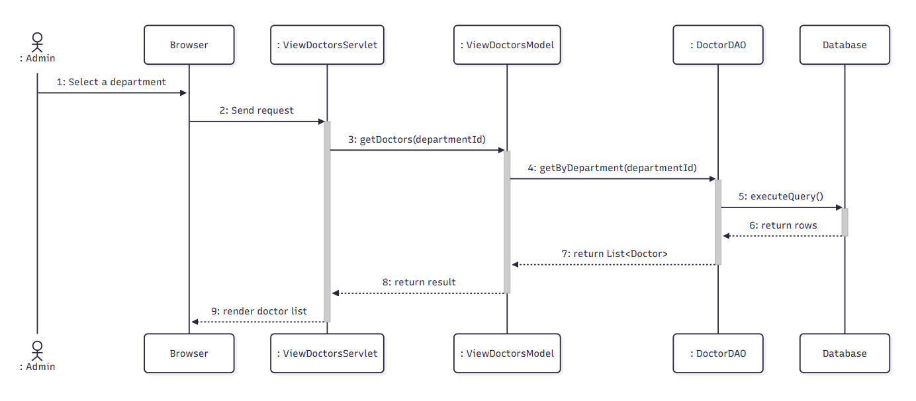

d. Database Queries
SELECT * FROM JobReport WHERE reported_job = ?

6.8. Add Specialty

a. Class Diagram
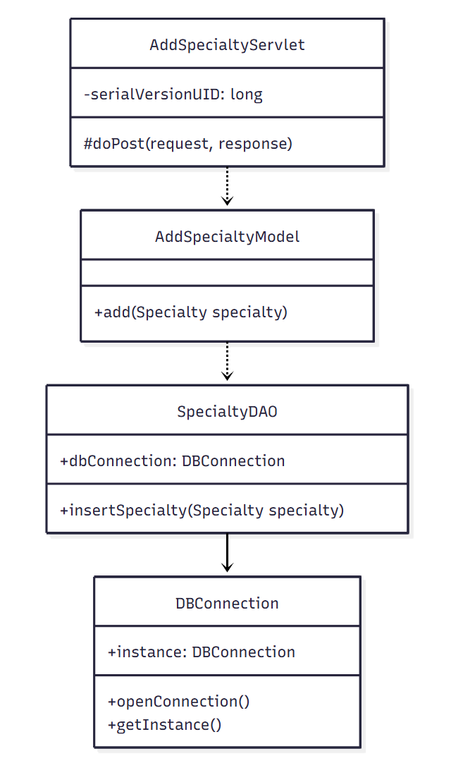

b. Class Specifications

SpecialtyDAO Class
No | Method | Description
1 | insertSpecialty(Specialty specialty) | Inserts a new specialty record.

AddSpecialtyModel Class
No | Method | Description
1 | add(Specialty specialty) | Validates and persists the new specialty.

AddSpecialtyServlet Class
No | Method | Description
1 | doPost(request, response) | Handles the add-specialty form submission.

c. Sequence Diagram(s)

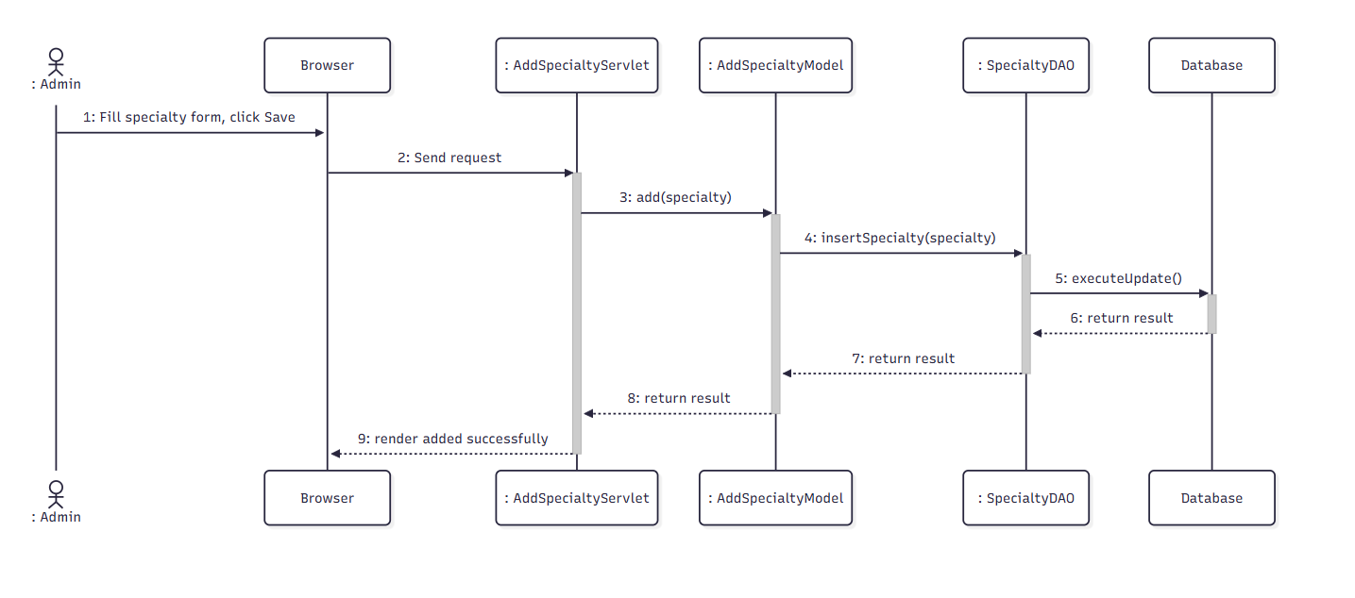

d. Database Queries
Get user(admin) by email:
SELECT * FROM Users WHERE email = ?

Get job by id:
SELECT * FROM Job WHERE job_id = ?

Get user(employer) by id:
SELECT * FROM Users WHERE user_id = ?

Get jobGreeting by jobId and status:
SELECT * FROM [dbo].[JobGreetings] WHERE job_id = ? AND status = ?

Insert new transaction:
INSERT INTO [dbo].[Transaction] (receiverId, adminId, amount, createdDate, status, transactionType, description, jobId ) VALUES (?, ?, ?, ?, ?, ?, ?, ?)

6.9. Edit Specialty

a. Class Diagram
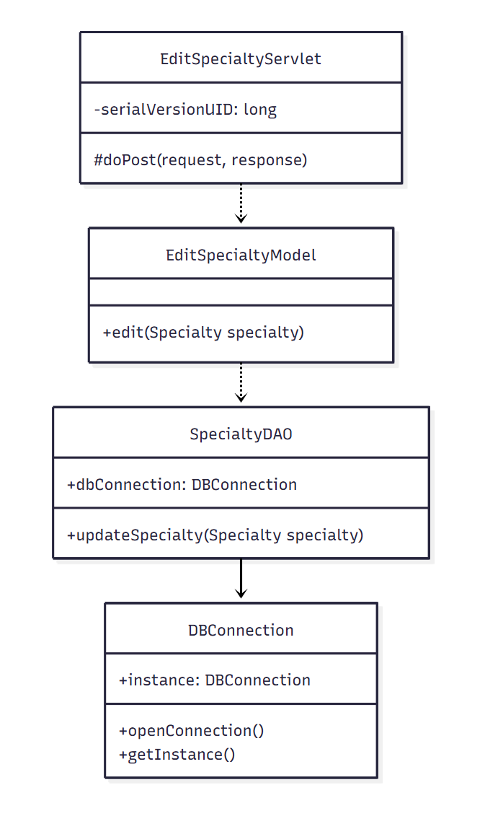

b. Class Specifications
SpecialtyDAO Class
No | Method | Description
1 | updateSpecialty(Specialty specialty) | Updates an existing specialty's information.

EditSpecialtyModel Class
No | Method | Description
1 | edit(Specialty specialty) | Validates and persists specialty changes.

EditSpecialtyServlet Class
No | Method | Description
1 | doPost(request, response) | Handles the edit-specialty form submission.

c. Sequence Diagram(s)

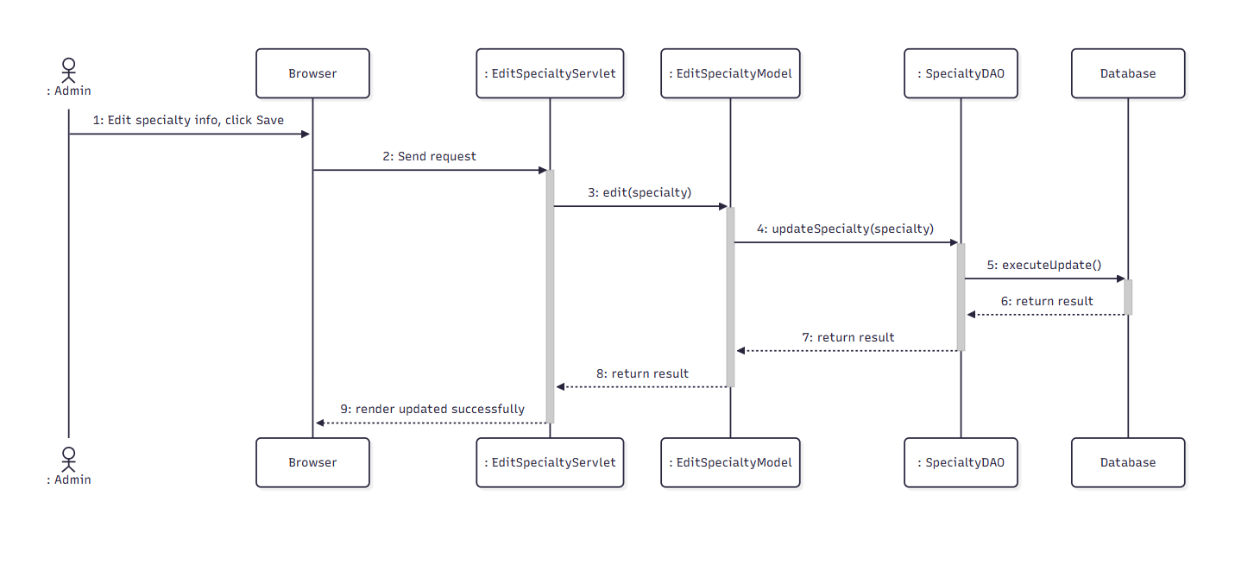

d. Database Queries
Get user(admin) by email:
SELECT * FROM Users WHERE email = ?

Get job by id:
SELECT * FROM Job WHERE job_id = ?

Get user by id:
SELECT * FROM Users WHERE user_id = ?

Get jobGreeting by jobId and status:
SELECT * FROM [dbo].[JobGreetings] WHERE job_id = ? AND status = ?

Insert new transaction:
INSERT INTO [dbo].[Transaction] (receiverId, adminId, amount, createdDate, status, transactionType, description, jobId ) VALUES (?, ?, ?, ?, ?, ?, ?, ?)

6.10. Add Examination Package

a. Class Diagram
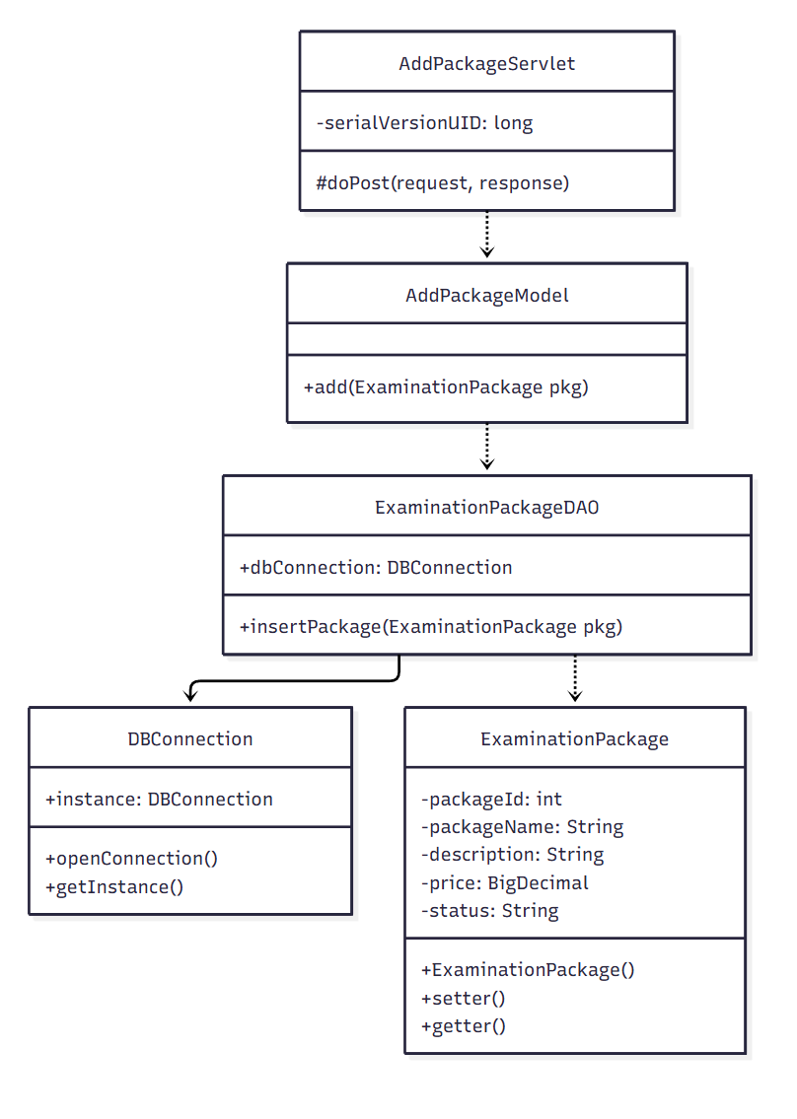

b. Class Specifications
ExaminationPackageDAO Class
No | Method | Description
1 | insertPackage(ExaminationPackage pkg) | Inserts a new examination package record.

AddPackageModel Class
No | Method | Description
1 | add(ExaminationPackage pkg) | Validates and persists the new package.

AddPackageServlet Class
No | Method | Description
1 | doPost(request, response) | Handles the add-package form submission.

c. Sequence Diagram(s)
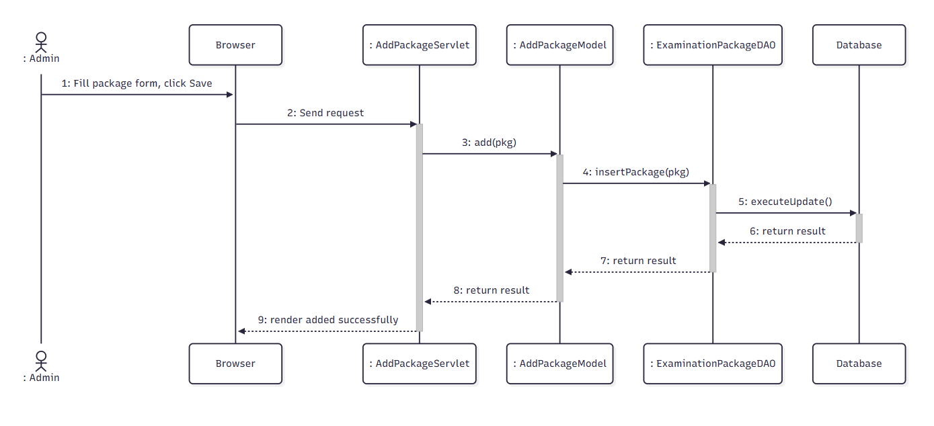

d. Database Queries
Get user(admin) by email:
SELECT * FROM Users WHERE email = ?

Get job by id:
SELECT * FROM Job WHERE job_id = ?

Get user(employer) by id:
SELECT * FROM Users WHERE user_id = ?

Get jobGreeting by jobId and status:
SELECT * FROM [dbo].[JobGreetings] WHERE job_id = ? AND status = ?

Insert new transaction:
INSERT INTO [dbo].[Transaction] (receiverId, adminId, amount, createdDate, status, transactionType, description, jobId ) VALUES (?, ?, ?, ?, ?, ?, ?, ?)

6.11. Edit Examination Package

a. Class Diagram
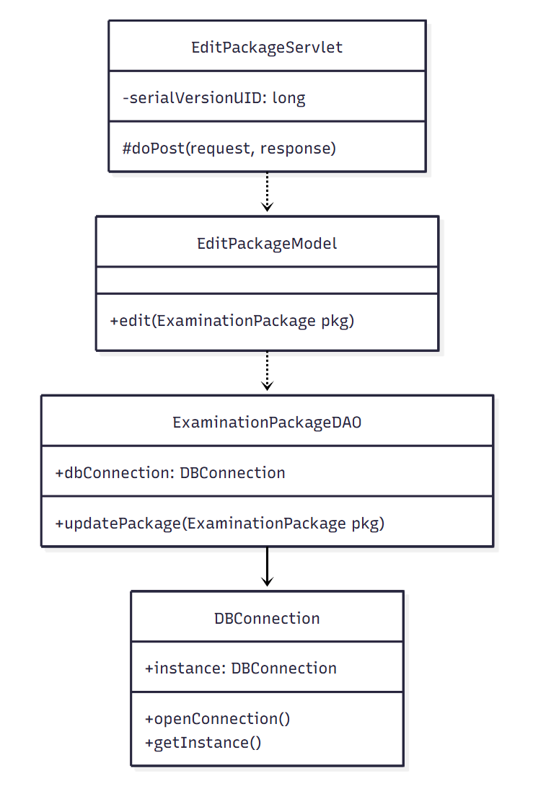

b. Class Specifications

ExaminationPackageDAO Class
No | Method | Description
1 | updatePackage(ExaminationPackage pkg) | Updates an existing examination package's information.

EditPackageModel Class
No | Method | Description
1 | edit(ExaminationPackage pkg) | Validates and persists package changes.

EditPackageServlet Class
No | Method | Description
1 | doPost(request, response) | Handles the edit-package form submission.

c. Sequence Diagram(s)
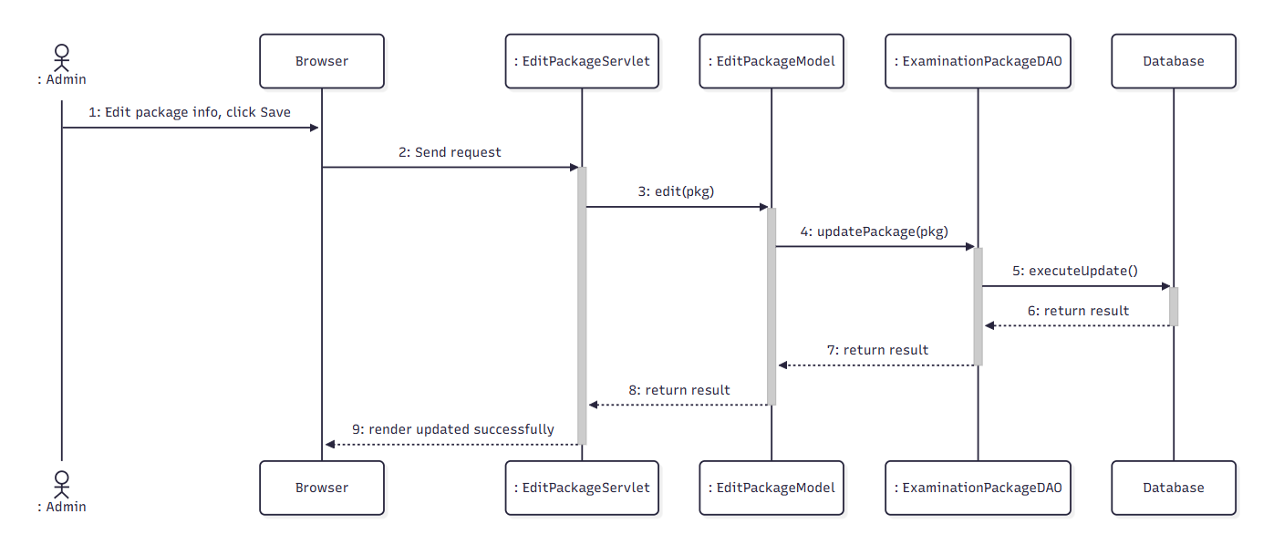

d. Database Queries
Get user(admin) by email:
SELECT * FROM Users WHERE email = ?

Get job by id:
SELECT * FROM Job WHERE job_id = ?

Get user(employer) by id:
SELECT * FROM Users WHERE user_id = ?

Get jobGreeting by jobId and status:
SELECT * FROM [dbo].[JobGreetings] WHERE job_id = ? AND status = ?

Insert new transaction:
INSERT INTO [dbo].[Transaction] (receiverId, adminId, amount, createdDate, status, transactionType, description, jobId ) VALUES (?, ?, ?, ?, ?, ?, ?, ?)

6.12. View Payment Statistics

a. Class Diagram
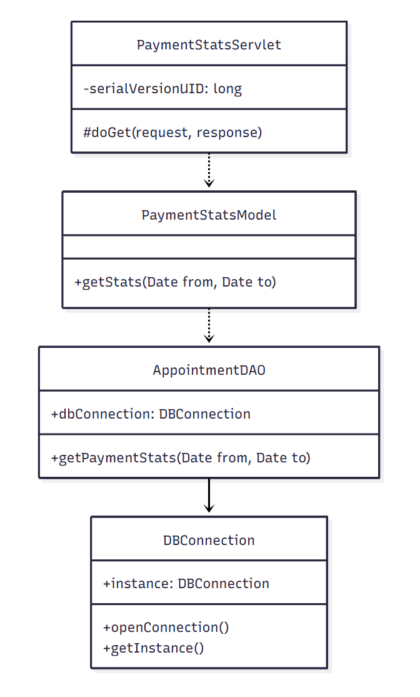

b. Class Specifications

AppointmentDAO Class
No | Method | Description
1 | getPaymentStats(Date from, Date to) | Aggregates confirmed appointment fees grouped by day within a date range.

PaymentStatsModel Class
No | Method | Description
1 | getStats(Date from, Date to) | Business logic wrapper for payment statistics.

PaymentStatsServlet Class
No | Method | Description
1 | doGet(request, response) | Handles the payment-statistics page request.

c. Sequence Diagram(s)

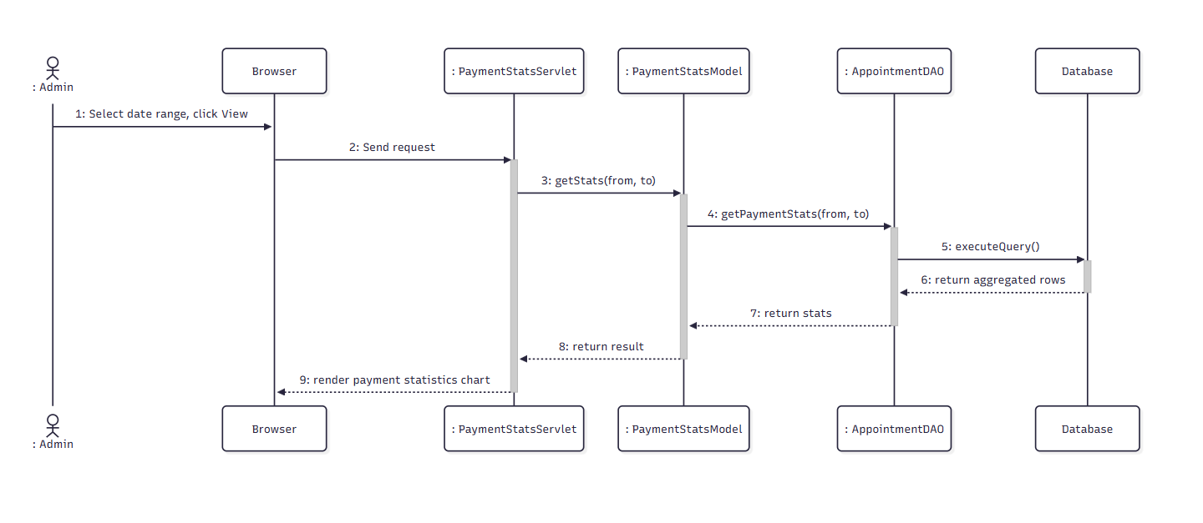

d. Database Queries
Get user(admin) by email:
SELECT * FROM Users WHERE email = ?

Get job by id:
SELECT * FROM Job WHERE job_id = ?

Get user(employer) by id:
SELECT * FROM Users WHERE user_id = ?

Get jobGreeting by jobId and status:
SELECT * FROM [dbo].[JobGreetings] WHERE job_id = ? AND status = ?

Insert new transaction:
INSERT INTO [dbo].[Transaction] (receiverId, adminId, amount, createdDate, status, transactionType, description, jobId ) VALUES (?, ?, ?, ?, ?, ?, ?, ?)

Statistics & Moderation

7.1. View Booking Statistics

a. Class Diagram
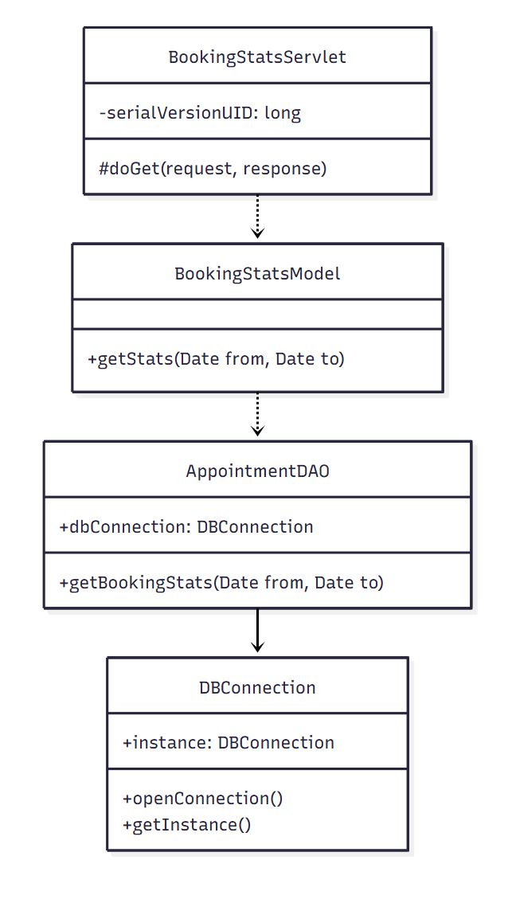

b. Class Specifications
AppointmentDAO Class
No | Method | Description
1 | getBookingStats(Date from, Date to) | Aggregates total bookings grouped by day within a date range.

BookingStatsModel Class
No | Method | Description
1 | getStats(Date from, Date to) | Business logic wrapper for booking statistics.

BookingStatsServlet
No | Method | Description
1 | doGet(request, response) | Handles the booking-statistics page request.

c. Sequence Diagram(s)
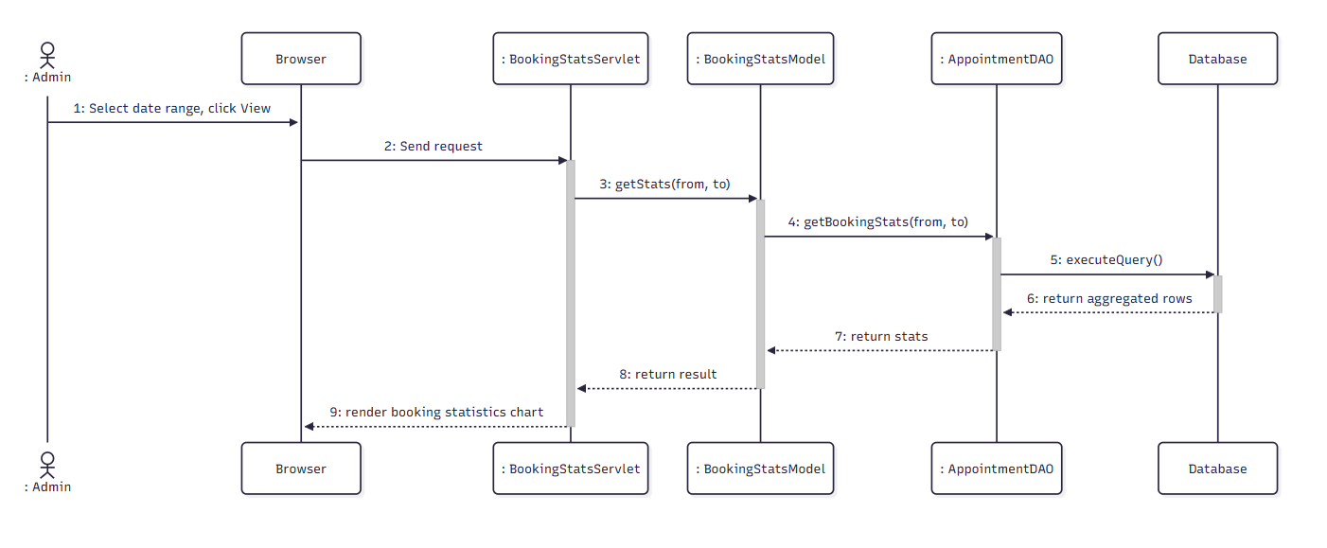

d. Database Queries
Get user(admin) by email:
SELECT * FROM Users WHERE email = ?

Get job by id:
SELECT * FROM Job WHERE job_id = ?

Get user(employer) by id:
SELECT * FROM Users WHERE user_id = ?

Get jobGreeting by jobId and status:
SELECT * FROM [dbo].[JobGreetings] WHERE job_id = ? AND status = ?

Insert new transaction:
INSERT INTO [dbo].[Transaction] (receiverId, adminId, amount, createdDate, status, transactionType, description, jobId ) VALUES (?, ?, ?, ?, ?, ?, ?, ?)

7.2. Export Statistics Report

a. Class Diagram
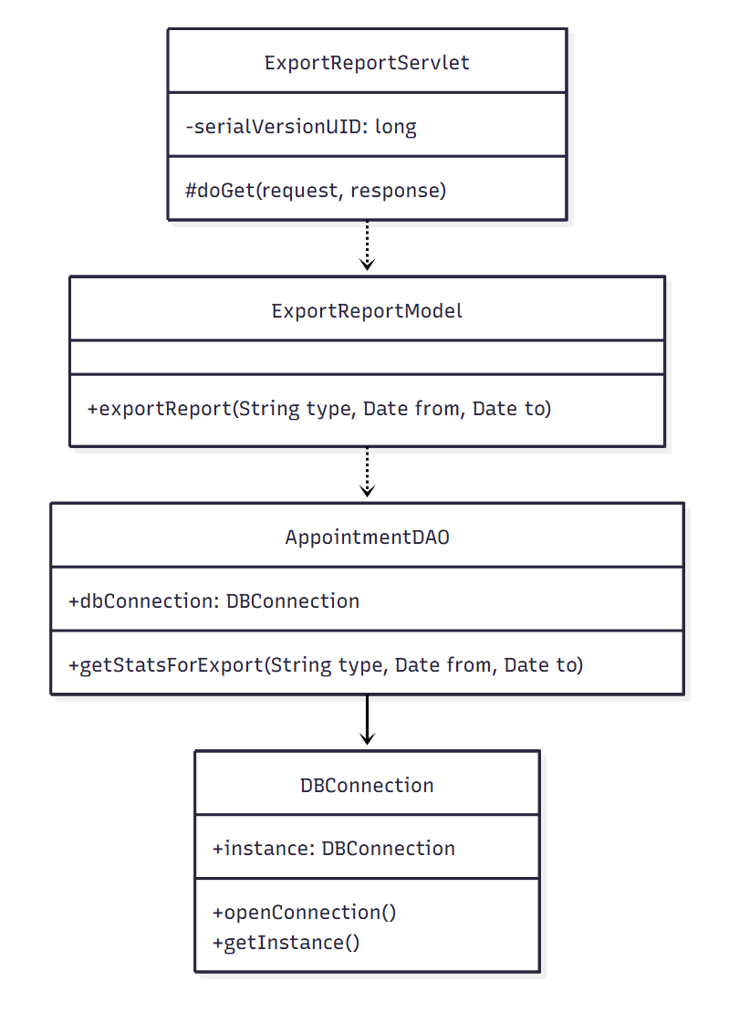

b. Class Specifications

AppointmentDAO Class
No | Method | Description
1 | getStatsForExport(String type, Date from, Date to) | Retrieves the raw/aggregated data set matching the selected statistics type for export.

ExportReportModel Class
No | Method | Description
1 | exportReport(String type, Date from, Date to) | Builds the Excel report file from the retrieved statistics.

ExportReportServlet Class
No | Method | Description
1 | doGet(request, response) | Handles the export-report request and streams the file download.

c. Sequence Diagram(s)
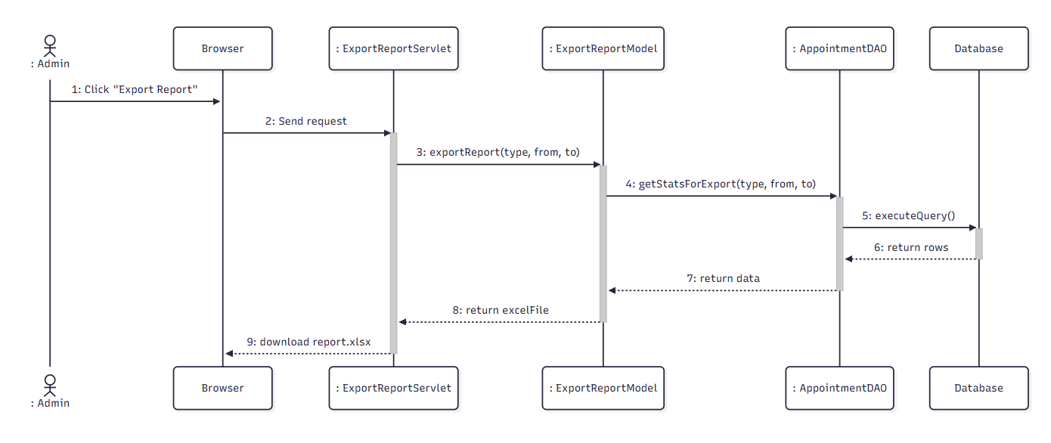

d. Database Queries
Get user(admin) by email:
SELECT * FROM Users WHERE email = ?

Get job by id:
SELECT * FROM Job WHERE job_id = ?

Get user(employer) by id:
SELECT * FROM Users WHERE user_id = ?

Get jobGreeting by jobId and status:
SELECT * FROM [dbo].[JobGreetings] WHERE job_id = ? AND status = ?

Insert new transaction:
INSERT INTO [dbo].[Transaction] (receiverId, adminId, amount, createdDate, status, transactionType, description, jobId ) VALUES (?, ?, ?, ?, ?, ?, ?, ?)

7.3. View Cancellation Statistics

a. Class Diagram
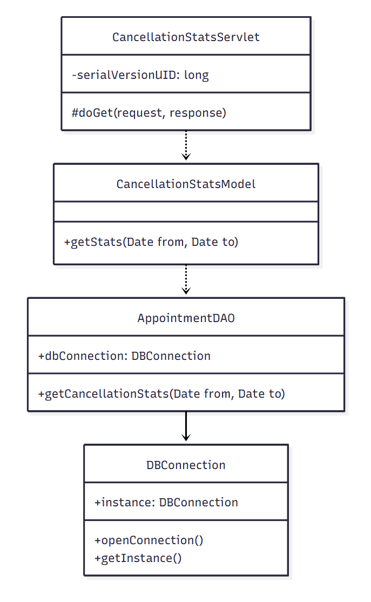

b. Class Specifications

AppointmentDAO Class
No | Method | Description
1 | getCancellationStats(Date from, Date to) | Aggregates cancelled appointments grouped by day within a date range.

CancellationStatsModel Class
No | Method | Description
1 | getStats(Date from, Date to) | Business logic wrapper for cancellation statistics.

CancellationStatsServlet Class
No | Method | Description
1 | doGet(request, response) | Handles the cancellation-statistics page request.

c. Sequence Diagram(s)
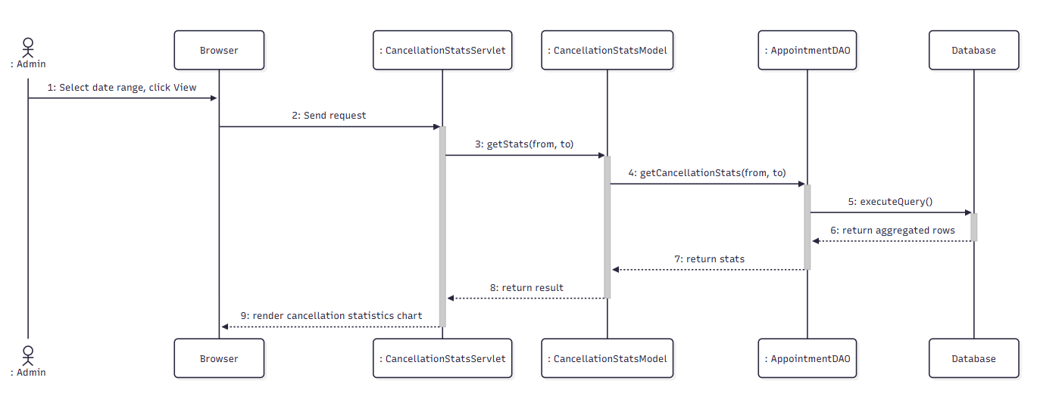

d. Database Queries
Get user(admin) by email:
SELECT * FROM Users WHERE email = ?

Get job by id:
SELECT * FROM Job WHERE job_id = ?

Get user(employer) by id:
SELECT * FROM Users WHERE user_id = ?

Get jobGreeting by jobId and status:
SELECT * FROM [dbo].[JobGreetings] WHERE job_id = ? AND status = ?

Insert new transaction:
INSERT INTO [dbo].[Transaction] (receiverId, adminId, amount, createdDate, status, transactionType, description, jobId ) VALUES (?, ?, ?, ?, ?, ?, ?, ?)

7.4. Handle Complaint

a. Class Diagram
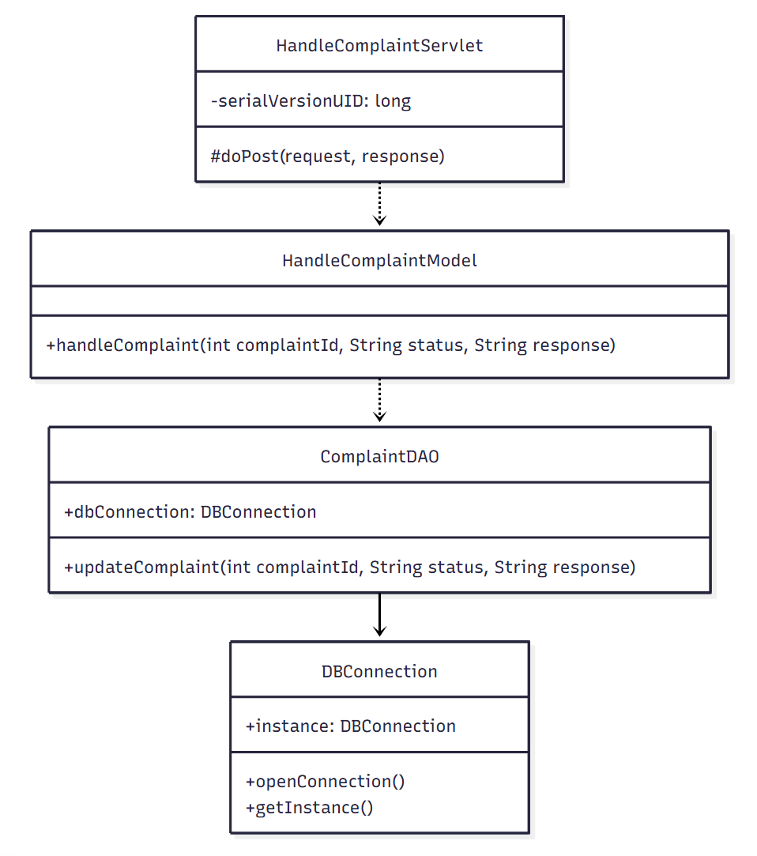

b. Class Specifications
ComplaintDAO Class
No | Method | Description
1 | updateComplaint(int complaintId, String status, String response) | Updates the complaint's status and records the admin's response.

HandleComplaintModel Class
No | Method | Description
1 | handleComplaint(int complaintId, String status, String response) | Business logic wrapper for resolving a complaint.

HandleComplaintServlet Class
No | Method | Description
1 | doPost(request, response) | Handles the resolve-complaint form submission.

c. Sequence Diagram(s)
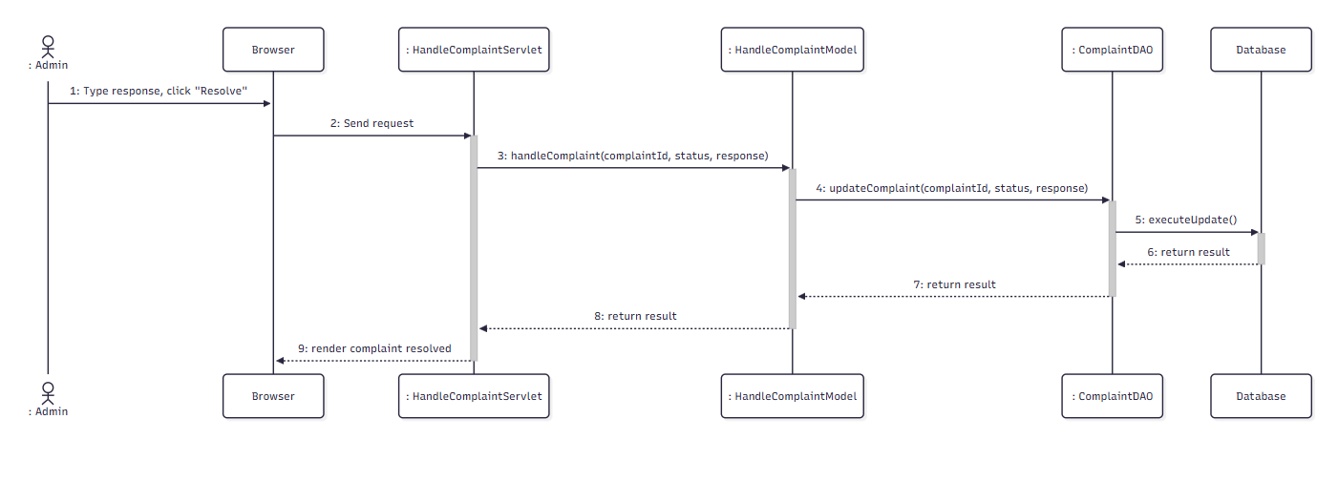

d. Database Queries
Get user(admin) by email:
SELECT * FROM Users WHERE email = ?

Get job by id:
SELECT * FROM Job WHERE job_id = ?

Get user(employer) by id:
SELECT * FROM Users WHERE user_id = ?

Get jobGreeting by jobId and status:
SELECT * FROM [dbo].[JobGreetings] WHERE job_id = ? AND status = ?

Insert new transaction:
INSERT INTO [dbo].[Transaction] (receiverId, adminId, amount, createdDate, status, transactionType, description, jobId ) VALUES (?, ?, ?, ?, ?, ?, ?, ?)

7.5 Post Epidemic Alert

a. Class Diagram
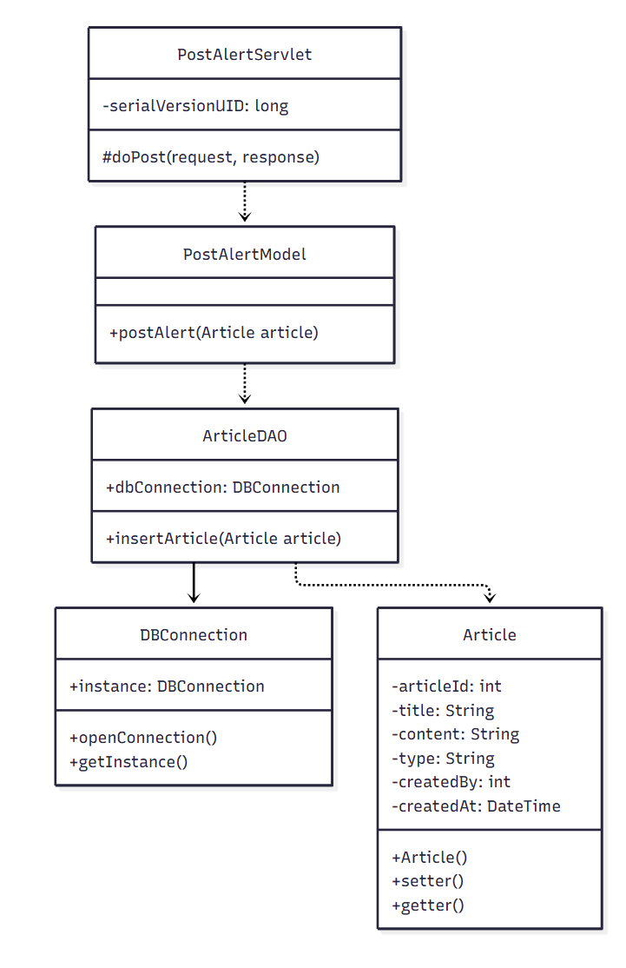

b. Class Specifications
ArticleDAO Class
No | Method | Description
1 | insertArticle(Article article) | Inserts a new alert/article record.

PostAlertModel Class
No | Method | Description
1 | postAlert(Article article) | Validates and persists the epidemic alert content.

PostAlertServlet Class
No | Method | Description
1 | doPost(request, response) | Handles the publish-alert form submission.

c. Sequence Diagram(s)
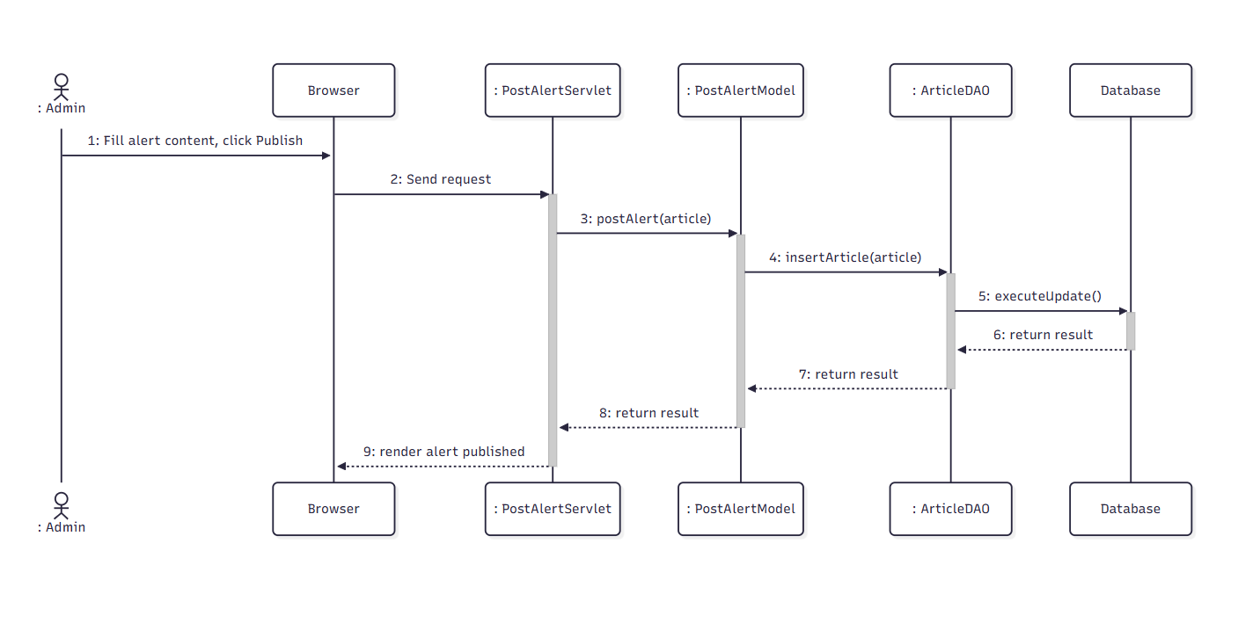

d. Database Queries
Get user(admin) by email:
SELECT * FROM Users WHERE email = ?

Get job by id:
SELECT * FROM Job WHERE job_id = ?

Get user(employer) by id:
SELECT * FROM Users WHERE user_id = ?

Get jobGreeting by jobId and status:
SELECT * FROM [dbo].[JobGreetings] WHERE job_id = ? AND status = ?

Insert new transaction:
INSERT INTO [dbo].[Transaction] (receiverId, adminId, amount, createdDate, status, transactionType, description, jobId ) VALUES (?, ?, ?, ?, ?, ?, ?, ?)

