

FUExam360 (FUE360) – Software Requirements Specification
Question 1: First page of the Software Requirements Specification
Complete all parts of the first page of the SRS template below.
Project Title | FU Exam360 (FUE360) – Online Exam Check-in/Check-out System
Document Version | 1.0
Project Code | FUE360-SRS-001
Prepared by (Student name) | Phạm Văn Quyết
Student ID | DE190425
Class | SE20A11

Question 2: Organization Chart
Draw 1 Organization Chart that has ≥ 3 levels and ≥ 2 FU Campuses by using Visual Paradigm offline, based on the content of this exam paper. Insert the image below.
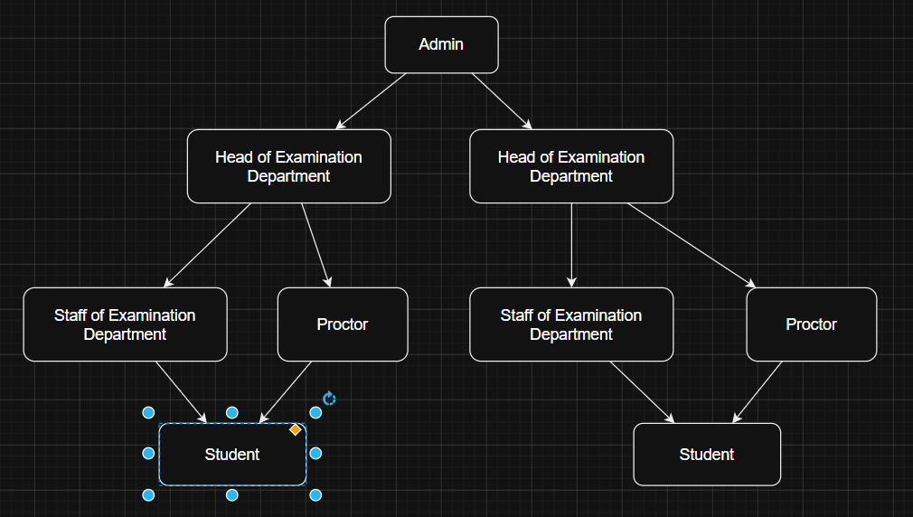
Question 3: Use Case Diagram
Draw 1 use case diagram (using Visual Paradigm offline) based on the content of this exam paper. Insert the image below, then answer the questions that follow.
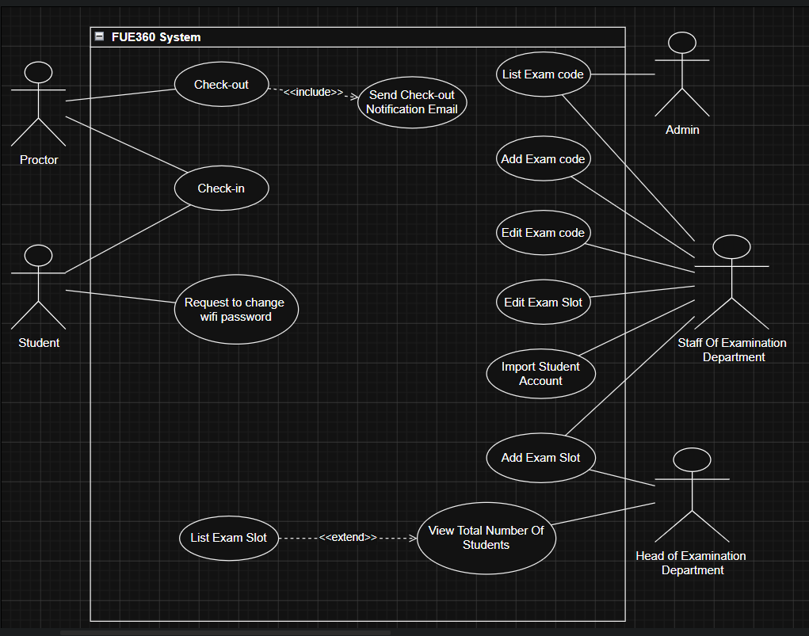Question 4: Detailed Use Case – Add Exam Slot
Write in detail the use case Add Exam Slot using the template below.
Use Case ID | UC-04
Use Case Name | Add Exam Slot
Actors | Primary: Staff of Examination Department. Secondary: Head of Examination Department and Proctor.
Description | The Staff of Examination Department creates a new final-exam slot by entering its course, date, time, room, campus, and assigned proctor.
Trigger | The staff selects “Add Exam Slot” on the Exam Slot Management page.
Precondition | The staff has logged into FUE360 with a valid @fpt.edu.vn account and has permission to manage exam slots.
Postcondition | The valid exam slot is saved, displayed in the exam slot list, and made available to relevant users.

Basic Flow
Step | Actor Action | System Response
1 | Staff selects “Add Exam Slot”. | The system displays the Add Exam Slot form.
2 | Staff enters the course, date, start time, end time, room, campus, and selects a proctor. | The system checks that all required fields are completed and that the date and time are valid.
3 | Staff clicks “Submit”. | The system checks for room, proctor, and duplicate-slot conflicts.
4 | Staff reviews the entered information. | If no conflict exists, the system saves the new exam slot.
5 | Staff confirms the successful creation. | The system updates and displays the exam slot list.
6 | — | The system makes the new slot visible to the assigned proctor and relevant students.
Question 5: Non-functional Requirements
Yêu Cầu | Nội Dung
Performance 1 | The system shall respond to common user requests within 3 seconds under normal operating conditions with up to 500 concurrent users.
Performance 2 | The system shall process at least 200 check-in or check-out transactions per minute during peak examination periods.
Security 1 | The system shall authenticate users through a valid FPT University account using an @fpt.edu.vn email address.
Security 2 | The system shall automatically lock an account for 15 minutes after five consecutive failed login attempts.

