
CAPSTONEPROJECTREPORT Acadex – Software Requirement Specification
– Da Nang, May 2026 –

Table of Contents
1. Introduction
- 1.1. Purpose
- 1.2. Scope
- 1.3. Intended Audience
- 1.4. Definitions, Acronyms, and Abbreviations

2. Overall Description
- 2.1. Product Perspective
- 2.2. Product Functions
- 2.3. User Classes and Characteristics
- 2.4. Operating Environment
- 2.5. Design Constraints
- 2.6. Assumptions and Dependencies

3. System Features / Functional Requirements
- 3.1. Authentication Module
- 3.2. Student Management Module
- 3.3. Class Management Module
- 3.4. Subject Management Module
- 3.5. Score Management Module
- 3.6. Attendance Management Module
- 3.7. Notification Module
- 3.8. Reporting Module
- 3.9. User Management Module
- 3.10. System Management Module

4. External Interface Requirements
- 4.1. User Interface
- 4.2. Hardware Interface
- 4.3. Software Interface
- 4.4. Communication Interface

5. Non-functional Requirements
- 5.1. Performance Requirements
- 5.2. Security Requirements
- 5.3. Reliability Requirements
- 5.4. Availability Requirements
- 5.5. Usability Requirements
- 5.6. Maintainability Requirements

6. Use Case Specification
- 6.1. Actor List
- 6.2. Use Case Diagram
- 6.3. Detailed Use Case Descriptions

7. Database Design
- 7.1. ERD Diagram
- 7.2. Database Tables
- 7.3. Relationships Between Tables

I. Record of Changes

Date | A*  M,  D | In charge | Change Description
20/6/2026 | A |  | Add database, Erd diagram
24/6/2026 | M |  | Update UCD
1/7/2026 | A |  | Fix context diagram

*A - Added M - Modified D – Deleted

II. Software Requirement Specification

1. Introduction
1.1 Purpose
The purpose of this Software Requirements Specification (SRS) document is to define the functional and non-functional requirements of the Acadex Student Management System. This document serves as a clear, shared agreement between the development team, testers, project managers, and stakeholders. It acts as the primary blueprint for the implementation phase, system testing, and future maintenance of the software.

1.2 Scope
Acadex is a web-only student management system designed to digitalize and centralize academic workflows within the school. The system replaces manual, paper-and-spreadsheet-based administrative tasks with a single, unified platform.

In-Scope Core Features:
- Authentication & Role-Based Access Control (RBAC): Secure login and session management for three specific roles: Admin, Teacher, and Student.
- Student & Academic Management: CRUD operations (Create, Read, Update, Delete) on core data including Student Profiles, Classes, and Subjects.
- Performance Tracking: Modules for online attendance tracking, grade entry, and automated Cumulative Grade Point Average (GPA) calculations.
- Reporting & Notifications: System notifications and generation of academic reports (transcripts, attendance summaries) exportable to Excel and PDF formats.

Out-of-Scope (Explicit Exclusions):
To maintain focus on core academic management, the current version of Acadex strictly excludes:
- Desktop applications or Mobile Apps (Web-only platform).
- AI-based features (such as facial recognition for attendance check-in).
- Online tuition fee payment gateways or financial systems.
- Real-time chat apps or video call platforms.

1.3 Intended Audience
This document is designed for use by the following stakeholders:
- Project Managers: To monitor project progress, milestones, and resource allocation.
- System Architects & Business Analysts: To validate requirements and guide technical design.
- Developers: To use as a direct coding blueprint for user interfaces, APIs, and database scripts.
- Testers (QA): To write accurate functional, validation, and security test cases.
- School Administrators & Faculty: To verify that the system satisfies institutional requirements and workflows.

1.4 Definitions, Acronyms, and Abbreviations
The following technical terms and acronyms are used throughout this document:

Term / Acronym | Full Definition | Description in Context
SRS | Software Requirements Specification | This technical document defining the requirements of Acadex.
RBAC | Role-Based Access Control | Enforcing system permissions based on user roles (Admin, Teacher, Student).
CRUD | Create, Read, Update, Delete | The four basic operations for database management.
GPA | Grade Point Average | Automated calculation of a student's average academic score.
DB | Database | The relational database used to store system data.
PK / FK | Primary Key / Foreign Key | Database constraints used to uniquely identify and link data tables.
NFR | Non-Functional Requirement | System operational criteria such as security, speed, and reliability.

2. Overall Description
2.1. Product Perspective
Acadex is a web-based Student Management System developed to support and centralize academic management activities in educational institutions. The system provides a single platform for managing students, teachers, classes, subjects, attendance, scores, academic reports, notifications, and user accounts.
The system adopts a three-tier client-server architecture, consisting of:
- Presentation Layer: Web browser interface for users.
- Application Layer: Backend services responsible for business logic and request processing.
- Data Layer: SQL Server database used to store academic and system information.
Users access the system through a standard web browser without requiring additional software installation. All requests are processed by the application server, which validates user permissions, executes business logic, and stores or retrieves data from the database.
The system supports three primary user roles:
- Administrator: Manages user accounts, students, teachers, classes, subjects, notifications, reports, system backup, database restoration, and system logs.
- Teacher: Records attendance, manages student scores, views student information, and generates academic reports.
- Student: Views personal information, attendance records, scores, GPA, transcripts, and notifications, and updates personal profiles.
Acadex is designed as a standalone academic management system. It currently operates independently but is designed to support future integration with external educational services such as Learning Management Systems (LMS), Single Sign-On (SSO), email services, or other educational platforms if required.
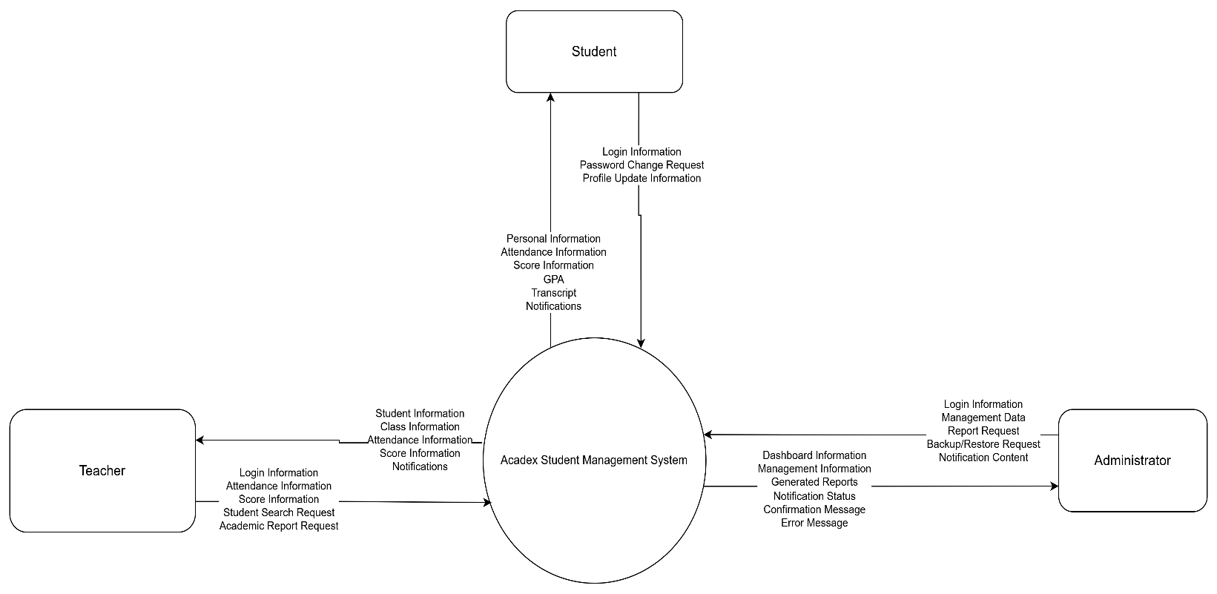
2.2 Product Functions
The major functions provided by Acadex include:

Authentication Module
- User login and logout
- Password management (Change Password, Forgot Password, Reset Password)
- Role-Based Access Control (RBAC) enforcement

User & Account Management Module
- Manage user accounts (Create, disable, and update accounts)
- View admin/teacher dashboard metrics
Student Management Module
- Create, update, and delete student profiles
- Search and filter students based on multiple criteria
- Import and export student data via Excel
- Assign or remove students from classes

Class Management Module
- Create and edit class information
- Assign homeroom teachers to specific classes
- View class lists and student assignments

Subject Management Module
- Create, update, and delete academic subjects
- Assign subjects to specific classes

Score Management Module
- Record, update, and delete student scores
- View student scores and transcripts
- Calculate Cumulative Grade Point Average (GPA) automatically

Attendance Module
- Record daily student attendance online
- View attendance history and details
- Generate attendance reports

Notification Module
- Create and send system announcements to students and teachers

Reporting Module
- Generate comprehensive academic and attendance reports
- Export official transcripts and reports to PDF or Excel formats

System Management Module
- View system operation logs
- Archive and restore student academic records
- Perform database backup and recovery operations

2.3 User Classes and Characteristics
Administrator
Administrators have full access to all system functions and are responsible for managing academic and administrative data.
- Characteristics: Experienced computer users authorized to manage system configuration, data integrity, and security.
- Main Activities: Manage accounts, manage students, manage classes, manage subjects, generate reports, and manage system operations.

Teacher
Teachers are responsible for academic-related activities and student performance tracking.
- Characteristics: Basic to intermediate computer skills with system access limited only to assigned classes and subjects.
- Main Activities: Record attendance, manage student scores, view assigned class information, and generate academic reports.

Student
Students use the system to access their personal academic information and records.
- Characteristics: Basic computer and internet skills with limited read-only permissions.
- Main Activities: View personal profile, view attendance records, view grades, download transcripts, and receive notifications.

2.4 Operating Environment
Client Environment
Users access the system through modern web browsers over an internet connection:
- Web Browsers: Google Chrome.
- Frontend Technologies: HTML5, CSS3, JavaScript.

Server Environment
- Backend Framework: Java 17, Spring Boot 3.x
- Database Management System: Microsoft SQL Server
- Web Server: Apache Tomcat (embedded within Spring Boot).

Hardware Requirements
- Server Host: Minimum 4 GB RAM, Dual-Core Processor, 20 GB available storage.
- Client Device: Internet-enabled computer, Minimum 2 GB RAM.

Network Requirements
- Stable Internet connection.
- Communication Protocol: HTTP/HTTPS.

2.5 Design Constraints
Technology Constraints
- The backend application must be developed using Java Spring Boot.
- The database management system must use Microsoft SQL Server.
- The system must be a web-based application supporting modern web browsers.

Functional Constraints
- Only authenticated and authorized users can access protected system resources.
- Students can strictly access only their own academic profiles and grades.
- Teachers can only manage data for their assigned classes and subjects.

Project Constraints
- The project is developed strictly for academic purposes.
- The initial release supports only a single educational institution.
- Mobile applications and AI-based features (such as facial recognition for attendance check-in) are completely excluded from the current scope.

2.6 Assumptions and Dependencies
Assumptions
- Users have access to a stable Internet connection and a compatible web browser.
- Users possess valid system credentials and accounts.
- All academic and personal data entered into the system is accurate and authorized.
- School educational policies and grading systems remain consistent during system operation.

Dependencies
The system operations depend directly on the availability and stability of the following components:
- Java Runtime Environment (JRE).
- Spring Boot Framework dependencies.
- Microsoft SQL Server Database Instance.
- Active Internet Connectivity and web browser stability.

3. System Features / Functional Requirements
3.1 Authentication Module
Description: This module manages user authentication and access control, ensuring that only authorized users can access system resources based on their assigned roles.

Related Use Cases: UC01, UC02, UC03, UC04, UC05

ID | Functional Requirement
FR-AUTH-01 | The system shall allow users to log in using a valid username and password.
FR-AUTH-02 | The system shall allow users to log out securely, terminating the active session.
FR-AUTH-03 | The system shall allow logged-in users to change their own passwords.
FR-AUTH-04 | The system shall support a password recovery function via registered email for users who forgot their passwords.
FR-AUTH-05 | The system shall allow administrators to reset passwords for any user account.
FR-AUTH-06 | The system shall enforce Role-Based Access Control (RBAC) to restrict access to unauthorized views and actions.

3.2 User & Dashboard Management Module
Description: This module allows administrators to administer user accounts and credentials, and provides analytical summaries for faculty members.

Related Use Cases: UC06, UC07, UC08, UC09

ID | Functional Requirement
FR-USER-01 | The system shall allow administrators to manage and review all user accounts.
FR-USER-02 | The system shall allow administrators to create new user accounts and assign corresponding roles.
FR-USER-03 | The system shall allow administrators to disable or reactivate user accounts.
FR-USER-04 | The system shall display statistical metrics and data overviews on the dashboard for administrators and teachers.

3.3 Student Management Module
Description: This module handles student profiles and institutional data throughout their academic lifecycle.

Related Use Cases: UC10 to UC24, UC46

ID | Functional Requirement
FR-STU-01 | The system shall allow administrators to add new student profiles manually or approve new student registrations.
FR-STU-02 | The system shall allow administrators to edit student information.
FR-STU-03 | The system shall allow administrators to delete student records from the active system.
FR-STU-04 | The system shall allow administrators and teachers to search for students by name or student ID.
FR-STU-05 | The system shall allow administrators and teachers to filter student lists by class, gender, or academic status.
FR-STU-06 | The system shall display detailed profiles of students to authorized administrators, teachers, and the respective students themselves.
FR-STU-07 | The system shall allow administrators and students to upload or update profile avatars.
FR-STU-08 | The system shall allow administrators to import bulk student data using structured Excel files.
FR-STU-09 | The system shall allow administrators to export student lists to standardized files.
FR-STU-10 | The system shall allow students to update specific personal contact fields in their profiles.

3.4 Class Management Module
Description: This module manages organizational class units, homeroom assignments, and student positioning.

Related Use Cases: UC20, UC21, UC25 to UC30

ID | Functional Requirement
FR-CLASS-01 | The system shall allow administrators to create new classes.
FR-CLASS-02 | The system shall allow administrators to edit class designations and information.
FR-CLASS-03 | The system shall allow administrators to delete classes that contain zero active students.
FR-CLASS-04 | The system shall display class lists to administrators and teachers.
FR-CLASS-05 | The system shall allow administrators to search for classes by class code or name.
FR-CLASS-06 | The system shall allow administrators to assign a teacher as a homeroom teacher to a class.
FR-CLASS-07 | The system shall allow administrators to assign individual or multiple students to a class.
FR-CLASS-08 | The system shall allow administrators to remove or reassign students from a class.

3.5 Subject Management Module
Description: This module controls the course catalogs and maps academic subject boundaries to designated classes.

Related Use Cases: UC31 to UC34

ID | Functional Requirement
FR-SUB-01 | The system shall allow administrators to add new academic subjects.
FR-SUB-02 | The system shall allow administrators to edit existing subject details.
FR-SUB-03 | The system shall allow administrators to delete subjects from the curriculum.
FR-SUB-04 | The system shall allow administrators to assign specific subjects to designated classes.

3.6 Score Management Module
Description: This module oversees numerical and systematic evaluation of student academic performance.

Related Use Cases: UC35 to UC39

ID | Functional Requirement
FR-SCORE-01 | The system shall allow teachers to enter academic scores for students in their assigned subjects.
FR-SCORE-02 | The system shall allow teachers to update or edit previously submitted scores.
FR-SCORE-03 | The system shall allow teachers to delete incorrect score entries.
FR-SCORE-04 | The system shall allow teachers and students to view detailed grade transcripts.
FR-SCORE-05 | The system shall automatically calculate the Cumulative Grade Point Average (GPA) based on recorded module marks.

3.7 Attendance Module
Description: This module provides day-to-day online attendance tracking and records presence metrics.

Related Use Cases: UC43, UC44

ID | Functional Requirement
FR-ATT-01 | The system shall allow teachers to record daily student attendance online (Present, Absent with permission, Absent without permission).
FR-ATT-02 | The system shall allow teachers to view class attendance logs, and allow students to view their own attendance history.

3.8 Notification Module
Description: This module manages institutional communication broadcast streams from administrators to the school population.

Related Use Cases: UC42

ID | Functional Requirement
FR-NOTI-01 | The system shall allow administrators to create and publish notifications.
FR-NOTI-02 | The system shall deliver notifications instantly to the target role groups (Teachers, Students).
FR-NOTI-03 | The system shall allow users to view current notifications on their dashboard interface.
FR-NOTI-04 | The system shall maintain an archival history of all sent notifications for verification.

3.9 Reporting Module
Description: This module isolates and processes systematic raw metrics into formal, downloadable academic documents.
Related Use Cases: UC40, UC41, UC45

ID | Functional Requirement
FR-REP-01 | The system shall allow administrators and teachers to generate student academic performance reports.
FR-REP-02 | The system shall allow administrators and teachers to generate class attendance summary reports.
FR-REP-03 | The system shall allow students to download their official personal academic transcripts.
FR-REP-04 | The system shall support exporting all generated reports and transcripts into Adobe PDF format.
FR-REP-05 | The system shall support exporting data grids and reports into Microsoft Excel format.

3.10 System Management Module
Description: This module houses configuration utilities, integrity checks, log operations, and automated safety routines.

Related Use Cases: UC47 to UC50

ID | Functional Requirement
FR-SYS-01 | The system shall allow administrators to archive historical student records to clean up active storage.
FR-SYS-02 | The system shall allow administrators to restore previously archived student data back to the relational database.
FR-SYS-03 | The system shall record and display system activity logs to administrators for auditing purposes.
FR-SYS-04 | The system shall automatically execute database backups to safeguard data integrity against hardware failures.

4. External Interface Requirements
4.1 User Interface
4.1.8 Screen Flow Diagram
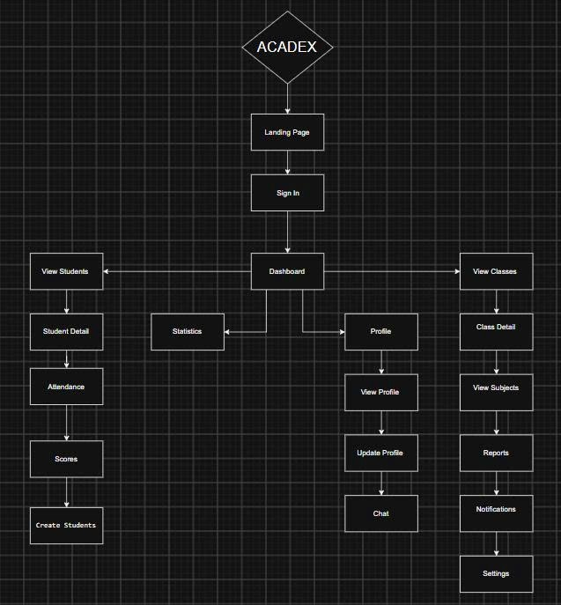

Screen Descriptions
Screen ID | Screen | Description | Main Functions
SCR-01 | Landing Page | The first screen displayed when users access the system. | Access system, navigate to Sign In.
SCR-02 | Sign In | Allows users to authenticate using their accounts. | Login, validate credentials.
SCR-03 | Dashboard | Main interface after successful login, providing navigation to system modules. | Access Students, Classes, Statistics, Profile.
SCR-04 | View Students | Displays the list of all students. | Search, filter, select a student.
SCR-05 | Student Detail | Shows detailed information of a selected student. | View profile, access attendance and scores.
SCR-06 | Attendance | Displays attendance records of the selected student. | View attendance history.
SCR-07 | Scores | Displays academic scores and GPA information. | View scores, GPA, transcript.
SCR-08 | Create Students | Allows administrators to add new student records. | Create student account and profile.
SCR-09 | Statistics | Displays statistical information and summary reports. | View charts, academic statistics.
SCR-10 | Profile | Entry page for user profile management. | Open personal profile.
SCR-11 | View Profile | Displays current user's personal information. | View profile details.
SCR-12 | Update Profile | Allows users to modify their personal information. | Edit profile, save changes.
SCR-13 | Chat | Provides communication between users. | Send and receive messages.
SCR-14 | View Classes | Displays the list of classes. | Browse available classes.
SCR-15 | Class Detail | Displays detailed information of a selected class. | View class information.
SCR-16 | View Subjects | Displays subjects offered in the selected class. | View subject list.
SCR-17 | Reports | Displays generated academic reports. | View and download reports.
SCR-18 | Notifications | Displays system announcements and notifications. | Read notifications.
SCR-19 | Settings | Allows users to configure system preferences. | Change settings, update preferences.

4.1.2 Login Interface
Description
The Login Interface allows users to securely access the Acadex Student Management System using their registered credentials. The system verifies user authentication and grants access according to the assigned role.

Components
- Username input field
- Password input field
- Login button
- Forgot Password link
- System logo and application title
- Error message display area

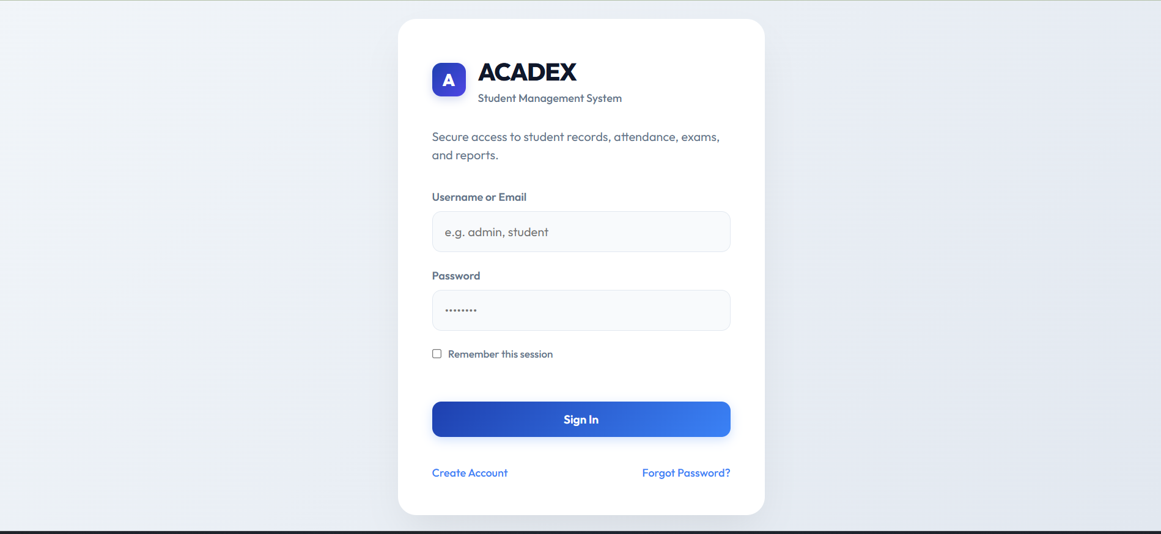

4.1.3 Dashboard Interface
Applicable Users:
- Administrator
- Teacher
- Student
Description:
The Dashboard Interface serves as the main page after successful login. It provides users with quick access to system functions and displays information relevant to their assigned roles.

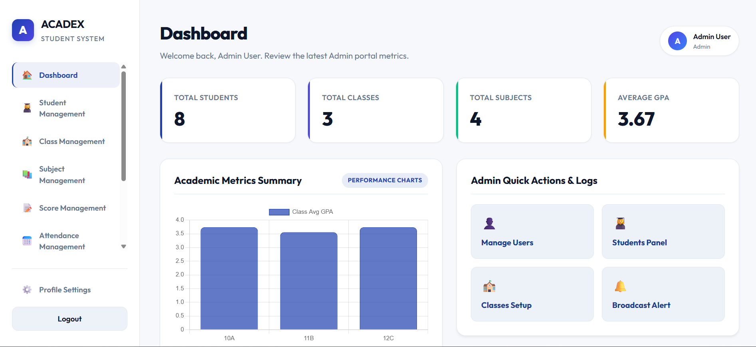

4.1.4 Student Management Interface
Description
The Student Management Interface enables administrators to manage student information efficiently. Users can add, update, search, filter, and view student records.

Components
- Student list table
- Search box
- Filter options
- Add Student button
- Edit Student button
- Delete Student button
- Student detail form
- Pagination controls

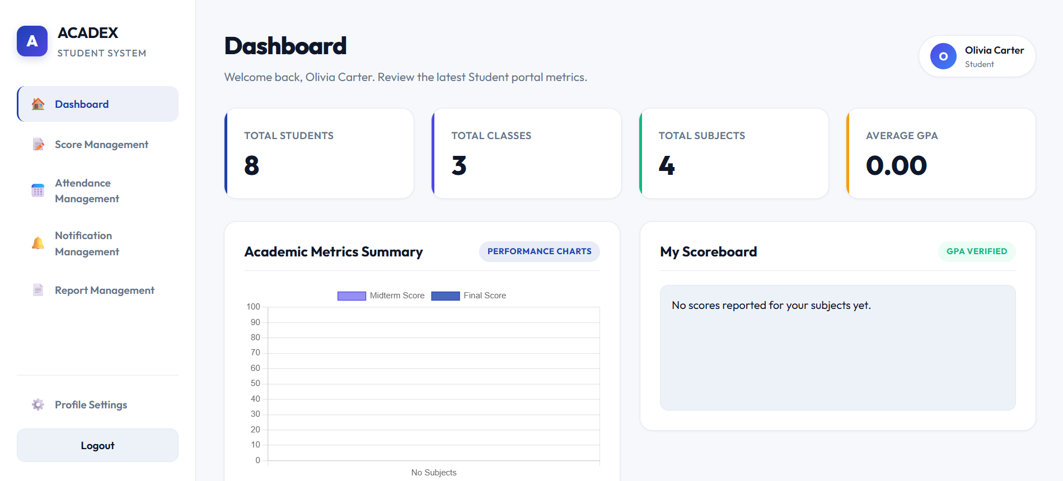

4.1.5 Class Management Interface
Description
The Class Management Interface allows administrators to manage classes, assign students, and assign homeroom teachers.

Components
- Class list table
- Search box
- Add Class button
- Edit Class button
- Delete Class button
- Student assignment section
- Homeroom teacher assignment section
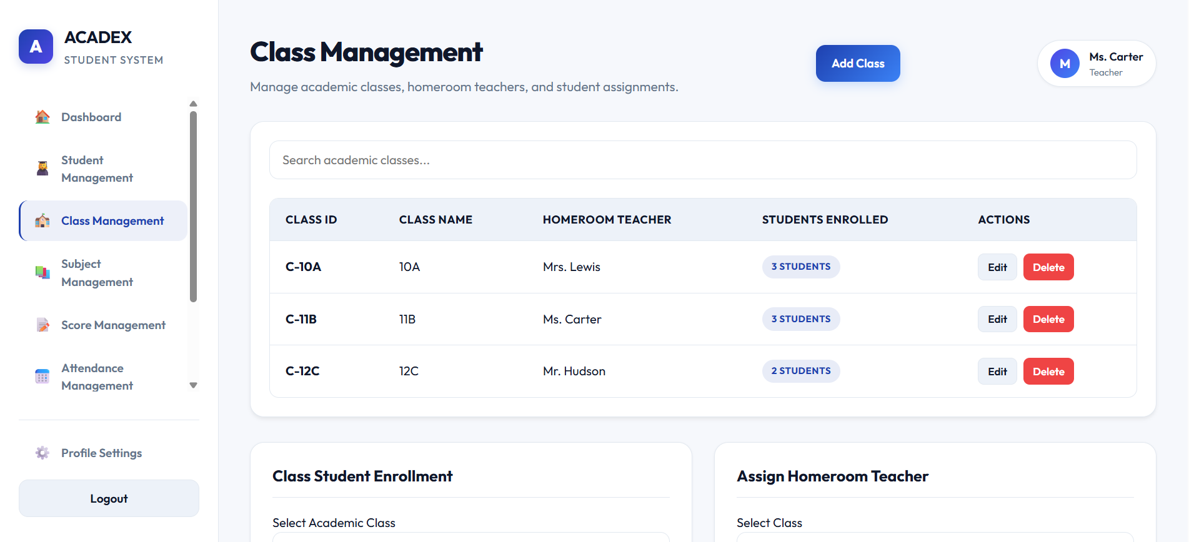

4.1.6 Subject Management Interface
Description
The Subject Management Interface allows administrators to manage academic subjects and assign them to classes.

Components
- Subject list table
- Add Subject button
- Edit Subject button
- Delete Subject button
- Subject assignment form
- Search and filter controls
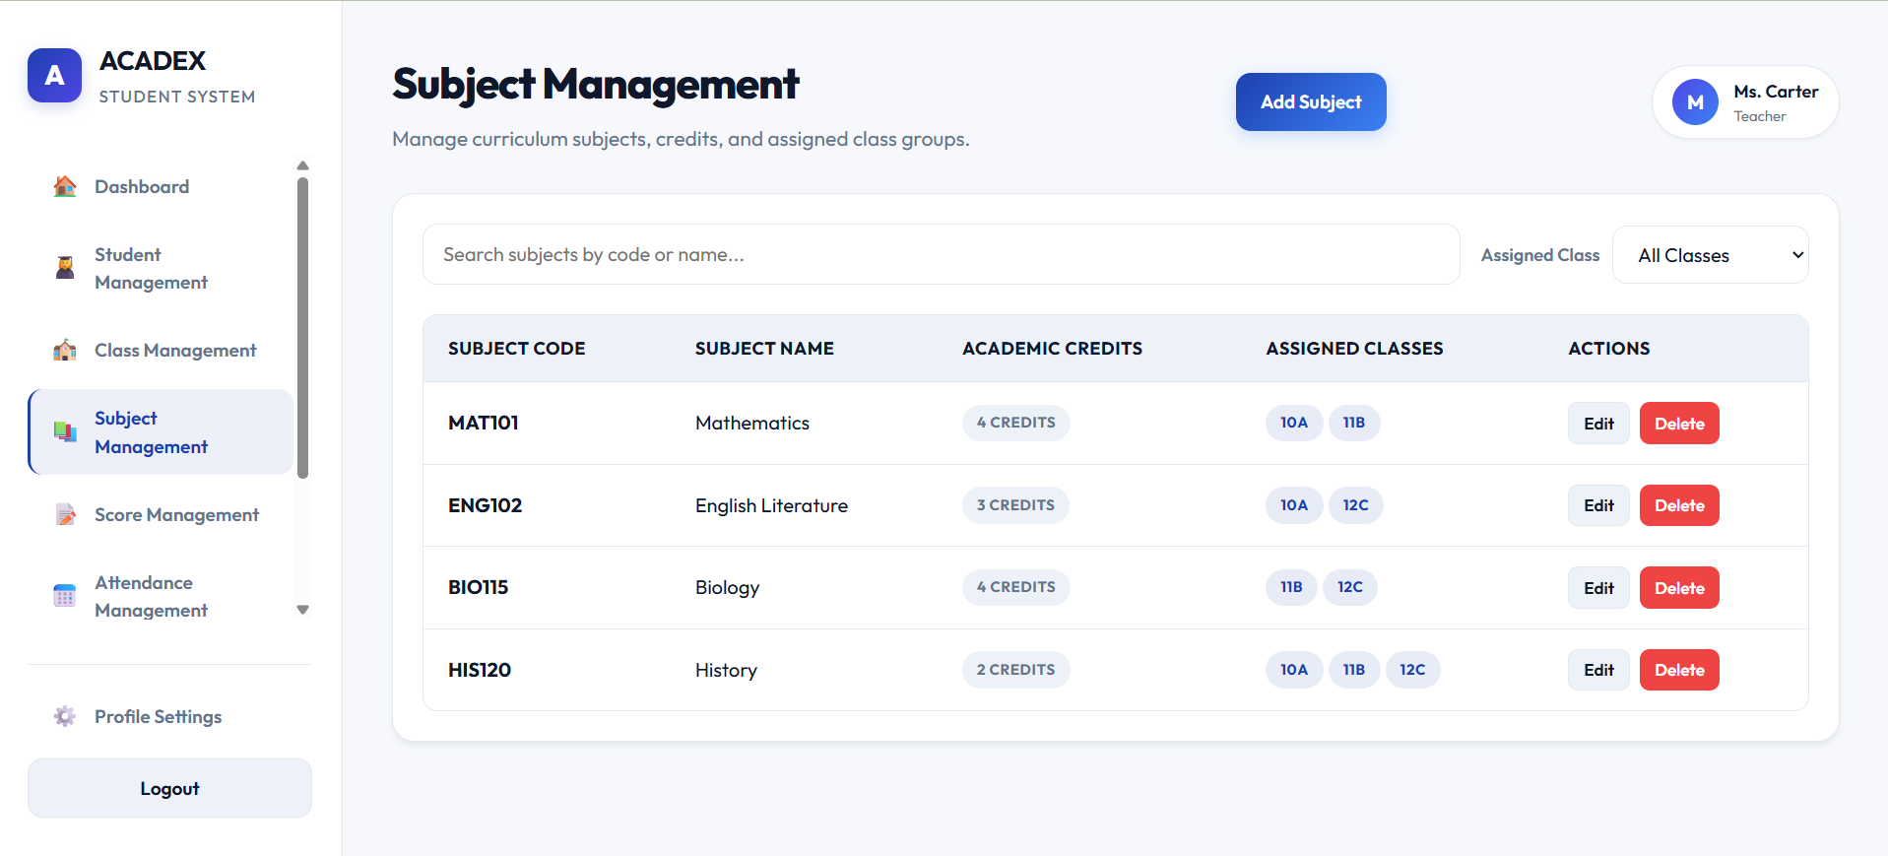

4.1.7 Score Management Interface
Description
The Score Management Interface allows teachers to record, update, and review student academic performance.

Components
- Student score table
- Score input form
- GPA display section
- Save button
- Edit button
- Delete button
- Academic report generation button
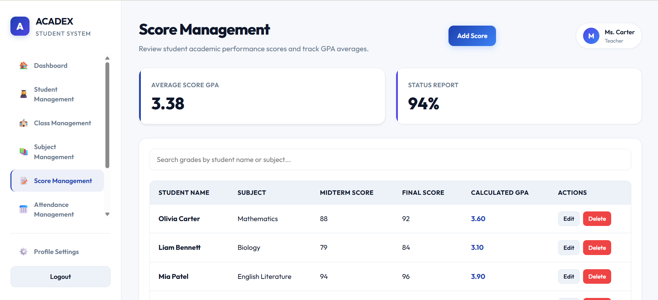

4.1.8 Attendance Management Interface
Description
The Attendance Management Interface enables teachers to record and monitor student attendance records.

Components
- Attendance table
- Student list
- Attendance status selector
- Save attendance button
- Attendance summary section
- Attendance report button
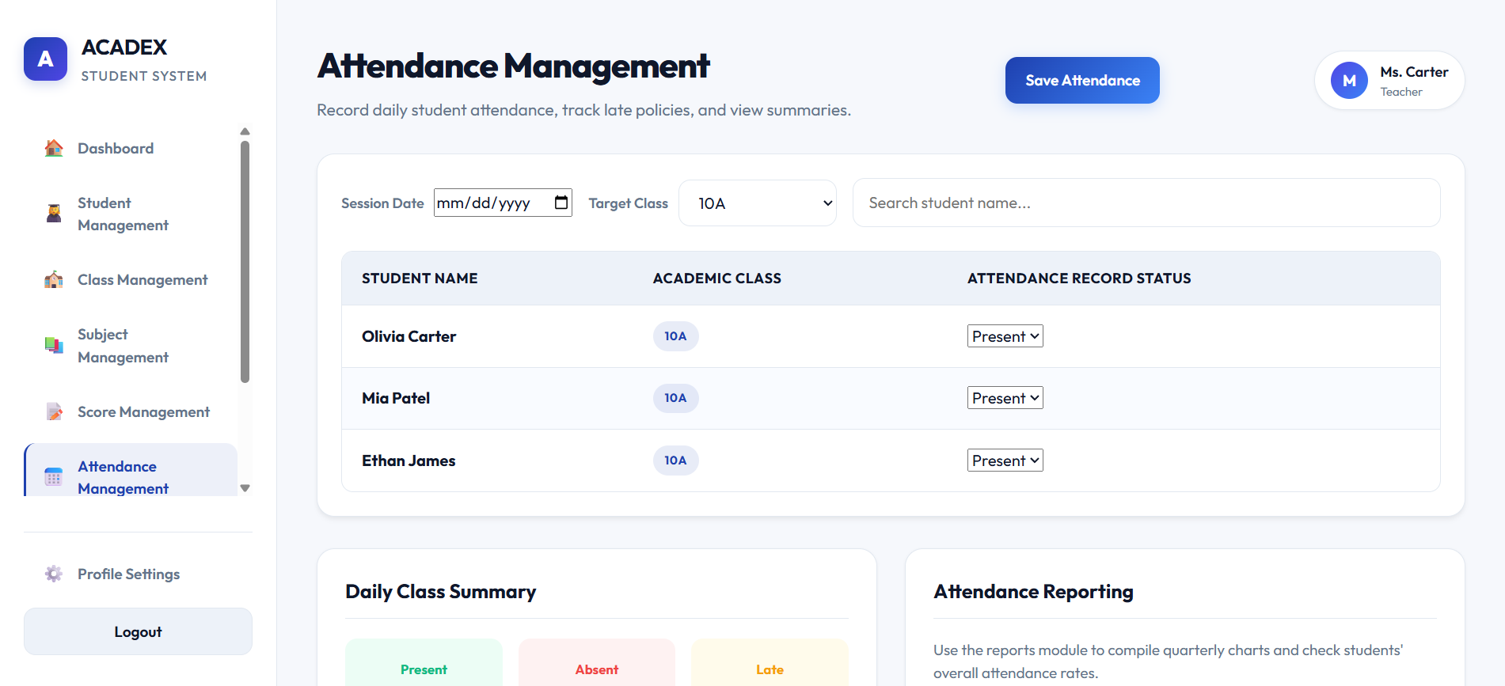

4.1.9 Notification Interface
Description
The Notification Interface allows administrators to create and send announcements to students and teachers.

Components
- Notification list
- Create notification form
- Recipient selection panel
- Send button
- Notification history section
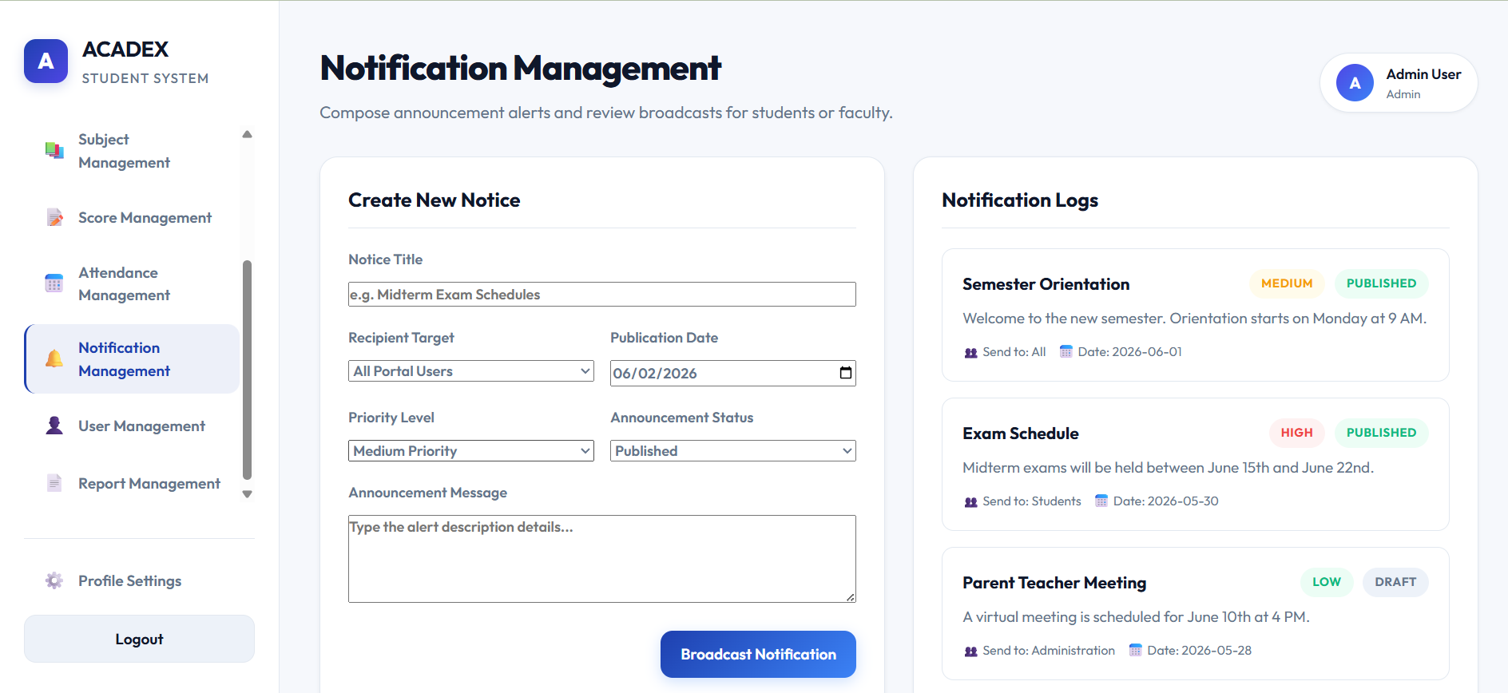

4.1.10 Report Interface
Description
The Report Interface provides access to academic reports, attendance reports, and student transcripts.

Components
- Report selection panel
- Report preview area
- Export PDF button
- Export Excel button
- Download transcript button
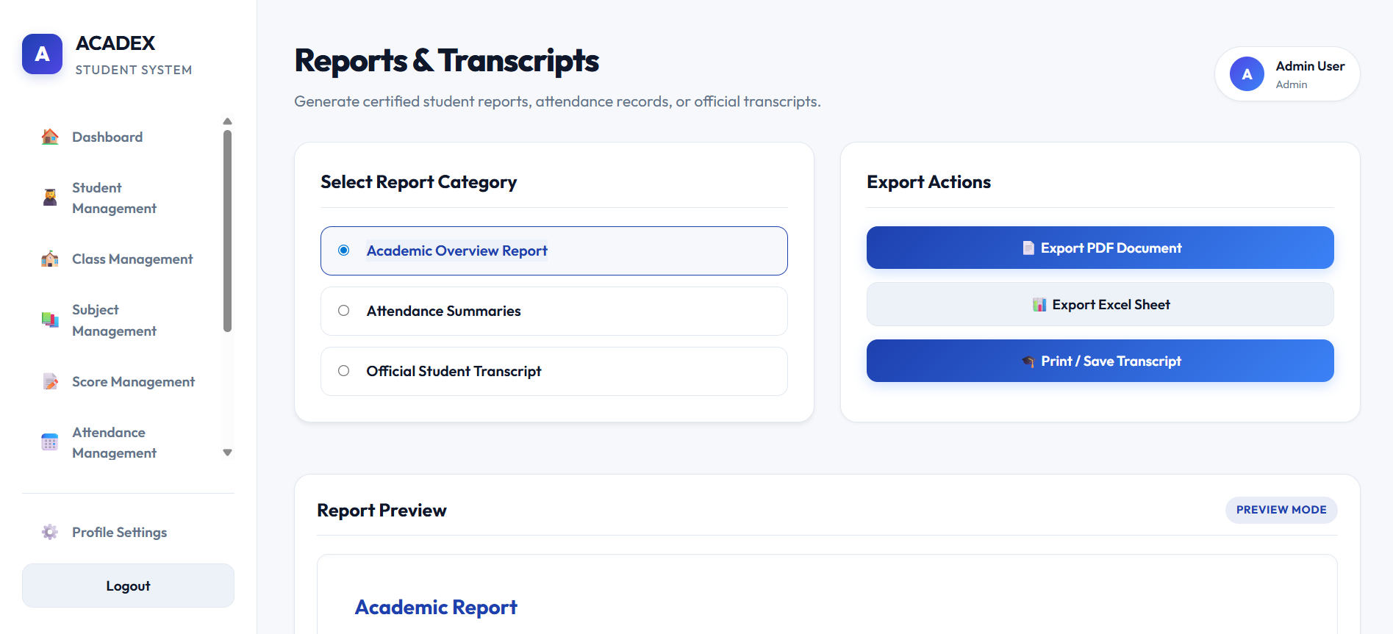

4.2 Hardware Interface
Description
The system interacts with standard computing devices and network hardware.

Client Hardware Requirements
- Desktop or Laptop Computer
- Minimum 2 GB RAM
- Keyboard and Mouse
- Internet Connection

Server Hardware Requirements
- Processor: Dual-Core or higher
- RAM: Minimum 4 GB
- Storage: Minimum 20 GB available space

Peripheral Devices
Optional:
- Printer (for report printing)
- External Storage Device (for backups)

4.3 Software Interface
Description
The system interacts with various software components and services.

Database Interface
Component | Description
Microsoft SQL Server | Stores system data

Backend Interface
Component | Description
Spring Boot | Business logic and REST APIs

Development Tools
Software | Purpose
Git & GitHub | Version control
Postman | API testing
Figma | UI/UX design
SQL Server Management Studio (SSMS) | Database management

File Export Interface
The system shall support:
- PDF export
- Excel export

4.4 Communication Interface
Description
The system communicates through web-based network protocols.

Communication Protocols
Protocol | Purpose
HTTP | Client-server communication
HTTPS | Secure communication

Network Requirements
- Internet connection required
- Support for LAN and Internet access
- Client requests processed through web browser

Authentication Communication
- User credentials transmitted securely
- Session management maintained by backend server

5. Non-functional Requirements
5.1 Performance Requirements
Description: This section defines the quantifiable operational speed, throughput, and resource utilization metrics of the Acadex system under specified workloads.

ID | Non-Functional Requirement
NFR-PER-01 | Response Time: The system shall return page views and simple data queries within 3.0 seconds under normal load conditions.
NFR-PER-02 | Login Processing: Authentication requests (login validation and token generation) shall be processed within 2.0 seconds.
NFR-PER-03 | Report Generation: Complex analytical reports (such as class attendance metrics or institutional transcripts) shall be compiled and ready for download within 10.0 seconds.
NFR-PER-04 | Concurrency Support: The system infrastructure shall support at least 100 concurrent active user sessions without causing performance degradation or HTTP 504 gateway timeouts.
NFR-PER-05 | Database Optimization: Database indexing and queries within Microsoft SQL Server must be optimized to ensure that execution time for any singular transactional query does not exceed 1.0 second.

5.2 Security Requirements
Description: This section specifies the mechanisms applied to safeguard the confidentiality, integrity, and availability of student and institutional data within Acadex.

ID | Non-Functional Requirement
NFR-SEC-01 | Authentication Check: The system must intercept and block all unauthorized or unauthenticated requests targeting protected API endpoints and internal system routes.
NFR-SEC-02 | Password Encryption: All user account passwords must be securely encrypted using a strong one-way hashing algorithm (e.g., BCrypt with a workload factor of 10) prior to database persistence. Plain text passwords must never be stored.
NFR-SEC-03 | Access Control (RBAC): The system shall strictly enforce Role-Based Access Control. Users holding the Student role shall have read-only access limited exclusively to their own data profiles and transcripts.
NFR-SEC-04 | Input Validation: All input forms and API payloads must undergo rigorous server-side validation and sanitization to protect against malicious injections (e.g., SQL Injection, Cross-Site Scripting - XSS).
NFR-SEC-05 | Session Timeout: Active user sessions shall automatically expire and invalidate security tokens after 15 minutes of user inactivity, requiring re-authentication.
NFR-SEC-06 | Audit Logging: The system shall generate immutable logs recording critical activities, including administrative user modifications, score alterations, and database archival actions, capturing the user ID and timestamp.
NFR-SEC-07 | Data Transport Security: All data transmitted between the client web browser and the server host must be encrypted using Transport Layer Security (TLS 1.2 or higher) via HTTPS protocol.

5.3 Reliability Requirements
Description: This section defines the system's capacity to remain functional, maintain total data integrity, and handle runtime exceptions gracefully.

ID | Non-Functional Requirement
NFR-REL-01 | Transaction Management: The system must utilize database transaction controls (@Transactional states in Spring Boot) to ensure that if a complex multi-table insert fails (e.g., bulk student importing), the entire database rolls back to its original state to avoid partial data corruption.
NFR-REL-02 | Exception Handling: The application must utilize a global exception handler to intercept runtime errors, preventing raw stack traces from leaking to the user interface, and instead displaying clear, user-friendly error messages.
NFR-REL-03 | Mathematical Precision: Automated GPA calculations must be processed with absolute decimal precision, rounding strictly to two decimal places based on institutional grading rules.

5.4 Availability Requirements
Description: This section outlines the system operational uptime standards and service recovery parameters.

ID | Non-Functional Requirement
NFR-AV-01 | Uptime Target: The Acadex system shall achieve an operational availability uptime of 99.5% during institutional semesters, excluding pre-announced scheduled maintenance windows.
NFR-AV-02 | Peak Load Availability: The system must maintain 100% availability during peak academic periods, specifically registration weeks and examination submission phases.
NFR-AV-03 | Scheduled Maintenance: Routine maintenance activities that require service interruption must be configured to execute between 11:00 PM and 4:00 AM (local time) and must be announced via system notifications 48 hours in advance.
NFR-AV-04 | Automated Recovery: The server environment must feature automated process monitoring utilities to automatically restart the embedded Apache Tomcat web service within 60 seconds following an unexpected application crash.

5.5 Usability Requirements
Description: This section defines the user interface consistency, learning thresholds, and accessibility criteria for user roles.

ID | Non-Functional Requirement
NFR-USA-01 | UI/UX Consistency: The web interface must maintain uniform typography, color palettes, spacing, and layout elements across all modules by strictly utilizing a shared Bootstrap 5 styling sheet framework.
NFR-USA-02 | Learnability: The interface layout must be intuitive enough that any user holding basic computer literacy can execute primary common workflows (e.g., student search or attendance marking) within 15 minutes of initial exposure without formal training.
NFR-USA-03 | Input Guidance: All input forms must provide live validation feedback (e.g., marking required fields, validating email syntax, and displaying error prompts instantly upon invalid inputs).
NFR-USA-04 | Cross-Browser Compatibility: The application front-end must remain fully responsive and clear of visual distortion across major modern web browsers, including Google Chrome, Microsoft Edge, Mozilla Firefox, and Safari.

5.6 Maintainability Requirements
Description: This section details the architectural rules, version management, and standards required to ensure easy system evolution and code readability.

ID | Non-Functional Requirement
NFR-MNT-01 | Modular Architecture: The application code must strictly follow a layered architecture pattern (Controller, Service, Repository, Entity layers provided by Spring Boot) to isolate business logic from database operations.
NFR-MNT-02 | Coding Standards: Source code must conform to standard Java coding conventions (e.g., camelCase variable names, descriptive method naming) and must be documented using clean inline comments for non-trivial logic block components.
NFR-MNT-03 | Version Control: All source code changes, branch operations, and feature additions must be structured and managed through Git, using centralized cloud repositories on GitHub to preserve historic rollback capabilities.
NFR-MNT-04 | Extensibility: The system database schema and API configurations must be designed with loose coupling to support future expansion (such as the integration of a future Mobile App API layer) without requiring a rewrite of core architectural layers.

6. Use Case Specification
6.1 Actor List
Actor | Description
Administrator | Responsible for managing user accounts, students, classes, subjects, reports, notifications, and system maintenance activities.
Teacher | Responsible for managing attendance records, student scores, academic reports, and viewing class information.
Student | Responsible for viewing personal information, attendance records, academic results, transcripts, and notifications.

6.2 Use Case Diagram
6.2.1 Overall Use Case Diagram

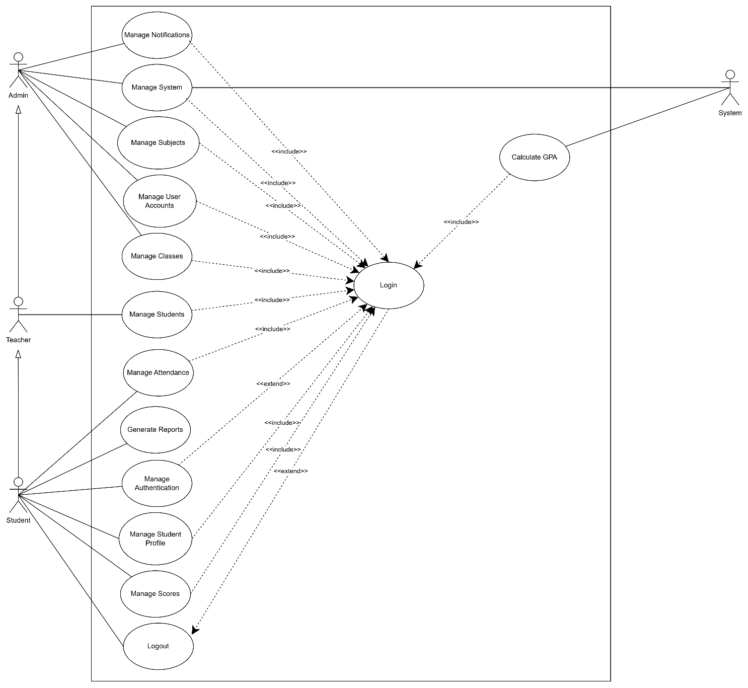

6.2.2 Authentication Use Case Diagram
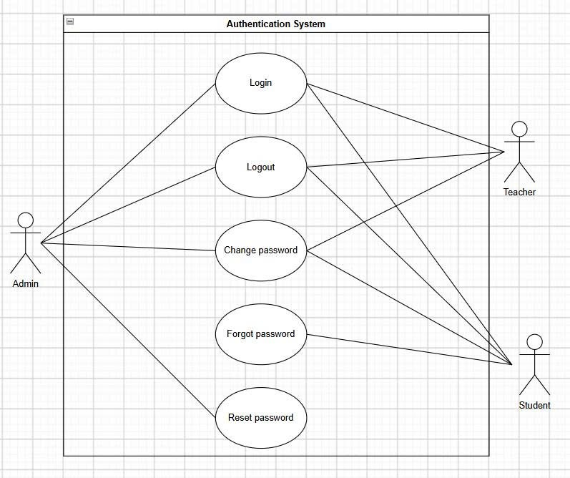

6.2.3 Student Management Use Case Diagram
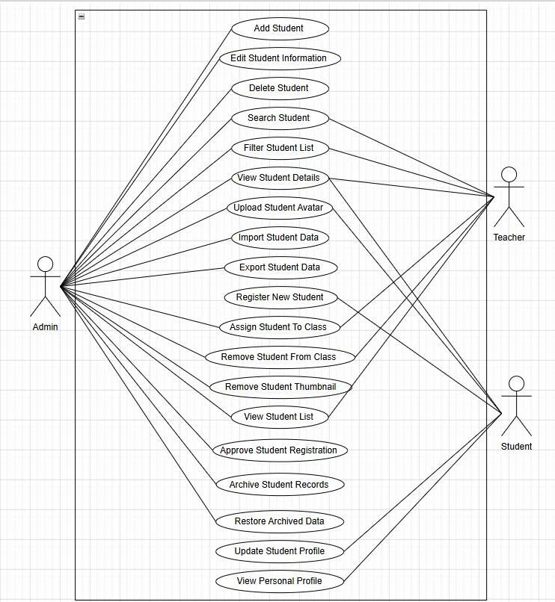

6.2.4 Class Management Use Case Diagram
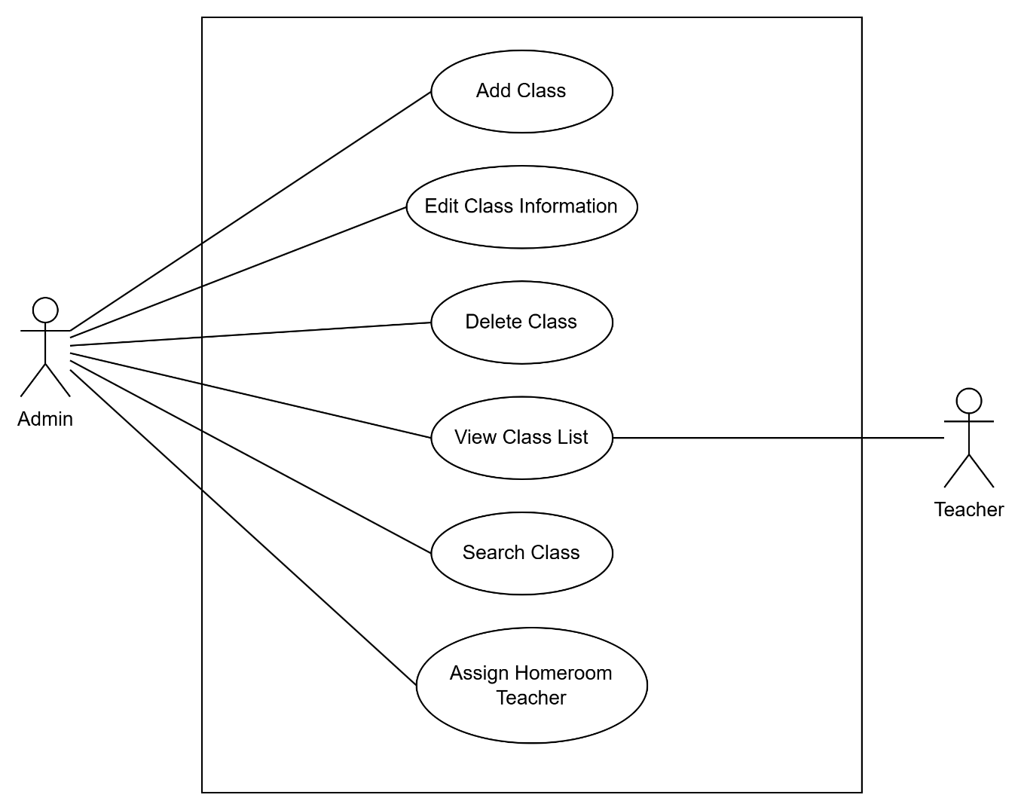

6.2.5 Academic Management Use Case Diagram
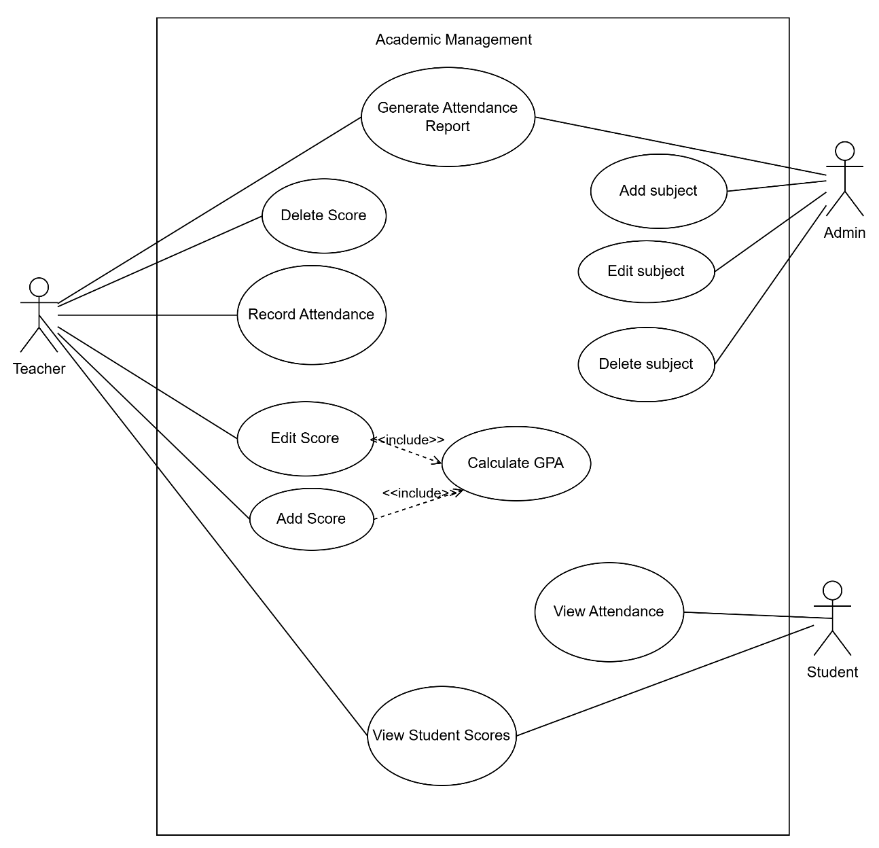

6.2.6 Reporting & System Management Use Case Diagram

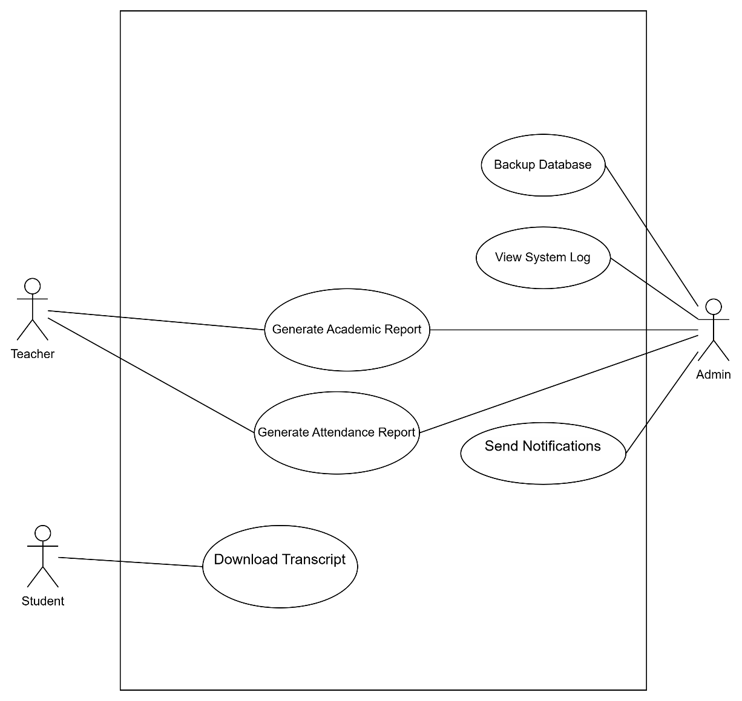

7. Database Design
7.1 ERD Diagram

The Acadex Student Management System uses a relational database implemented in Microsoft SQL Server. The database consists of entities such as Account, Student, Teacher, Class, Subject, Semester, Score, Score Component, Attendance, Notification, Backup Log, and System Log, together with associative entities including Class Subject and Teacher Subject. These entities support authentication, academic management, attendance tracking, grading, notification services, reporting, and system administration.

The Entity Relationship Diagram (ERD) illustrates how these entities are connected through primary keys and foreign keys to maintain data consistency and enforce business rules. The database design follows normalization principles to reduce redundancy, preserve referential integrity, and improve scalability and maintainability.
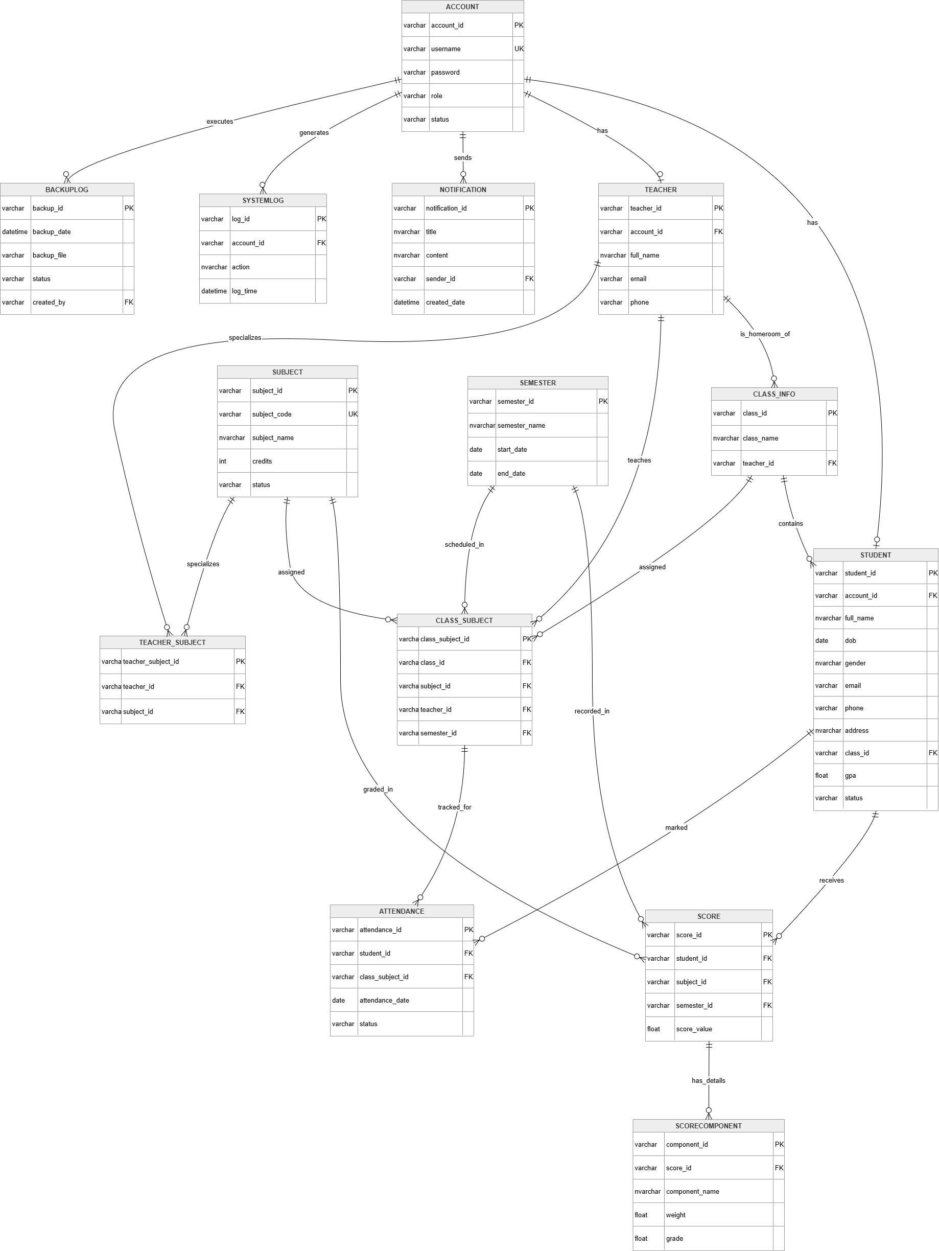

Entities Description
# | Entity | Description
1 | Account | Stores authentication and authorization information for all system users, including administrators, teachers, and students.
2 | Student | Stores personal information, academic status, GPA, and class assignment of each student. Each student is associated with one system account.
3 | Teacher | Stores teacher profile information and is linked to an account for authentication and system access.
4 | Class_Info | Stores information about academic classes, including class name and the assigned homeroom teacher.
5 | Subject | Stores subject information such as subject code, subject name, number of credits, and status.
6 | Semester | Stores semester information, including semester name, start date, and end date, for organizing academic activities.
7 | Class_Subject | Stores semester information, including semester name, start date, and end date, for organizing academic activities.
8 | Teacher_Subject | Represents the many-to-many relationship between teachers and subjects, indicating which subjects each teacher is qualified to teach.
9 | Attendance | Stores students' attendance records for each class subject on specific dates.
10 | Score | Stores students' academic scores for each subject and semester.
11 | ScoreComponent | Stores detailed score components (e.g., Assignment, Midterm, Final Exam) together with their weights and grades for each score record.
12 | Notification | Stores notifications created and sent by system users to inform teachers or students about academic activities or announcements.
13 | SystemLog | Stores audit logs of user activities performed within the system for monitoring and security purposes.
14 | BackupLog | Stores database backup history, including backup time, backup file, status, and the account that initiated the backup.

Figure 7.1. Acadex ERD Diagram
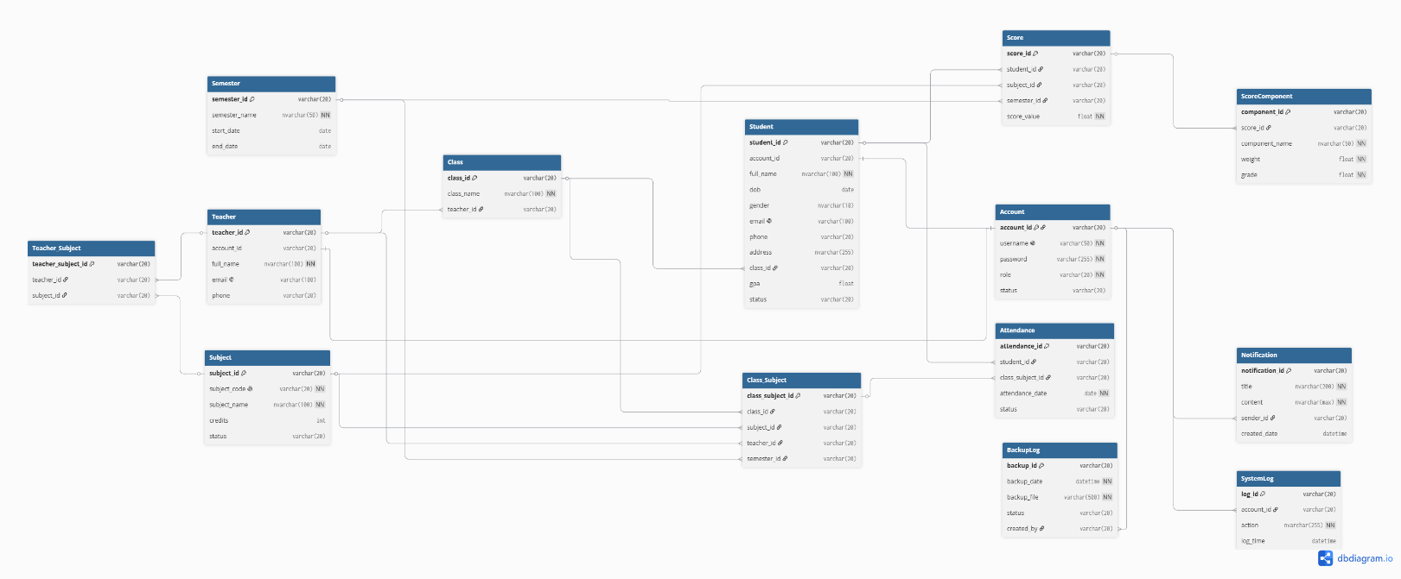

Main Entities
The database consists of the following entities:
No. | Entity
1 | Account
2 | Student
3 | Teacher
4 | Class
5 | Subject
6 | Semester
7 | Class_Subject
8 | Teacher_Subject
9 | Score
10 | ScoreComponent
11 | Attendance
12 | Notification
13 | StudentRequest
14 | LearningMaterial
15 | SystemLog

7.2 Database Tables
7.2.1 Account
Stores authentication and authorization information for all system users.
Field | Type | Key | Description
account_id | varchar(20) | PK | Account identifier
username | varchar(50) | Unique | Login username
password | varchar(255) |  | Encrypted password
role | varchar(20) |  | Admin, Teacher, Student
status | varchar(20) |  | Active / Disabled

7.2.2 Student
Stores student personal and academic information.
Field | Type | Key
student_id | varchar(20) | PK
account_id | varchar(20) | FK
full_name | nvarchar(100)
dob | date
gender | nvarchar(10)
email | varchar(100)
phone | varchar(20)
address | nvarchar(255)
class_id | varchar(20) | FK
gpa | float
status | varchar(20)

7.2.3 Teacher
Stores teacher information.
Field | Type | Key
teacher_id | varchar(20) | PK
account_id | varchar(20) | FK
full_name | nvarchar(100)
email | varchar(100)
phone | varchar(20)

7.2.4 Class
Stores class information.
Field | Type | Key
class_id | varchar(20) | PK
class_name | nvarchar(100)
teacher_id | varchar(20) | FK

7.2.5 Subject
Stores academic subjects.
Field | Type | Key
subject_id | varchar(20) | PK
subject_code | varchar(20) | Unique
subject_name | nvarchar(100)
credits | int
status | varchar(20)

7.2.6 Semester
Stores semester information.
Field | Type | Key
semester_id | varchar(20) | PK
semester_name | nvarchar(50)
start_date | date
end_date | date

7.2.7 Class_Subject
Maps classes, teachers, subjects, and semesters.
Field | Type | Key
class_subject_id | varchar(20) | PK
class_id | varchar(20) | FK
subject_id | varchar(20) | FK
teacher_id | varchar(20) | FK
semester_id | varchar(20) | FK

7.2.8 Teacher_Subject
Maps teachers to subjects.
Field | Type | Key
teacher_subject_id | varchar(20) | PK
teacher_id | varchar(20) | FK
subject_id | varchar(20) | FK

7.2.9 Score
Stores final scores of students.
Field | Type | Key
score_id | varchar(20) | PK
student_id | varchar(20) | FK
subject_id | varchar(20) | FK
semester_id | varchar(20) | FK
score_value | float

7.2.10 ScoreComponent
Stores detailed score components.
Field | Type | Key
component_id | varchar(20) | PK
score_id | varchar(20) | FK
component_name | nvarchar(50)
weight | float
grade | float

Example:
- Assignment: 20%
- Midterm: 30%
- Final Exam: 50%

7.2.11 Attendance
Stores attendance records.
Field | Type | Key
attendance_id | varchar(20) | PK
student_id | varchar(20) | FK
class_subject_id | varchar(20) | FK
attendance_date | date
status | varchar(20)

Possible status values:
- Present
- Absent
- Late

7.2.12 Notification
Stores notifications sent by administrators.
Field | Type | Key
notification_id | varchar(20) | PK
title | nvarchar(200)
content | nvarchar(max)
sender_id | varchar(20) | FK
created_date | datetime

7.2.13 SystemLog
Stores audit logs and system activities.
Field | Type | Key
log_id | varchar(20) | PK
account_id | varchar(20) | FK
action | nvarchar(255)
log_time | datetime

7.2.13 BackupLog
Stores information about database backup operations performed by administrators.
Field | Type | Key
backup_id | varchar(20) | PK
backup_date | datetime
backup_file | varchar(255)
status | varchar(20)
created_by | varchar(20) | FK

7.3 Relationships Between Tables
The database relationships are designed to maintain referential integrity and support all functional requirements of the Acadex system.

One-to-One Relationships
Parent Table | Child Table
Account | Student
Account | Teacher

One-to-Many Relationships
Parent Table | Child Table | Parent Table
Teacher | Class | Teacher
Class | Student | Class
Student | Attendance | Student
Student | Score | Student
Subject | Score | Subject
Semester | Score | Semester
Account | Notification | Account
Account | SystemLog | Account

Many-to-Many Relationships
Relationship | Intermediate Table
Teacher ↔ Subject | Teacher_Subject
Class ↔ Subject | Class_Subject

