LUXEWAY – Trusted E-commerce Platform for Vehicle Rental

Research Paper & Literature Review

Course: SWR302
Class: SE20A02
Group: 02

Prepared by:
Lê Văn Hậu
Nguyễn Văn Dạng
Nguyễn Bùi Quang Vinh
Hồ Thành Trung
Trần Phú Thịnh

Date: 22/05/2026

1. Introduction
This document provides a comprehensive specification of the software requirements for LuxeWay, a decentralized e-commerce marketplace for vehicle rental and sharing. It is intended to serve as a primary reference for developers, quality assurance testers, project managers, and future maintainers to ensure a clear understanding of the system's functional and non-functional goals.

2 Scope of the System

2.1 In Scope
LuxeWay is designed as a Peer-to-Peer (P2P) platform that bridges the gap between individuals/businesses (Owners) and customers (Consumers). Unlike traditional centralized rental models, LuxeWay leverages a strategic synergy between short-term Car Sharing (CS) and long-term Car Rental (CR) to maximize vehicle utilization and profitability.
The platform's core capabilities include:
- Decentralized Listing: Allowing vehicle owners to list assets with detailed features, pricing, and availability.
- Seamless Booking & Verification: A digital solution for browsing, filtering, and reserving vehicles with integrated driving license authentication to enhance security.
- Secure Transactions: Utilizing Smart Contracts to automate rental agreements and payment processing, thereby eliminating high intermediary commissions and ensuring trust through blockchain-based immutability.
- Privacy & Trust: Implementing encrypted booking details and algorithm-based reputation systems to protect user identities and prevent fraud.

2.2 Out of Scope
The following functionalities are not included in the current version:
- Mobile application
- AI recommendation system
- Blockchain implementation
- Real-time GPS tracking
- Voice assistant support

3. Existing Systems Analysis

3.1 Introduction
The rapid growth of digital commerce and smart transportation services has significantly increased the demand for online vehicle rental platforms. Many companies and transportation providers have developed vehicle rental systems to improve customer convenience, booking efficiency, and online transaction management.
Existing rental platforms commonly provide features such as vehicle searching, online booking, payment integration, and reservation management. However, many systems still face limitations regarding security, trust management, user experience, and system flexibility.
This section analyzes several existing vehicle rental platforms to identify their strengths, weaknesses, and limitations. The findings will help define the requirements and improvements proposed in the LUXEWAY system.

3.2 Existing Vehicle Rental Systems

3.2.1 Grab Rentals
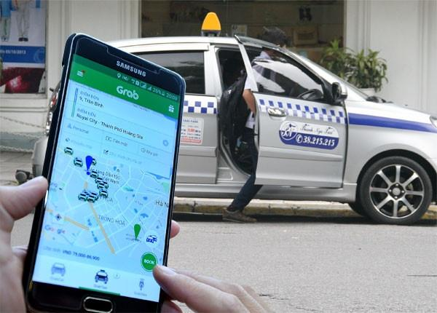
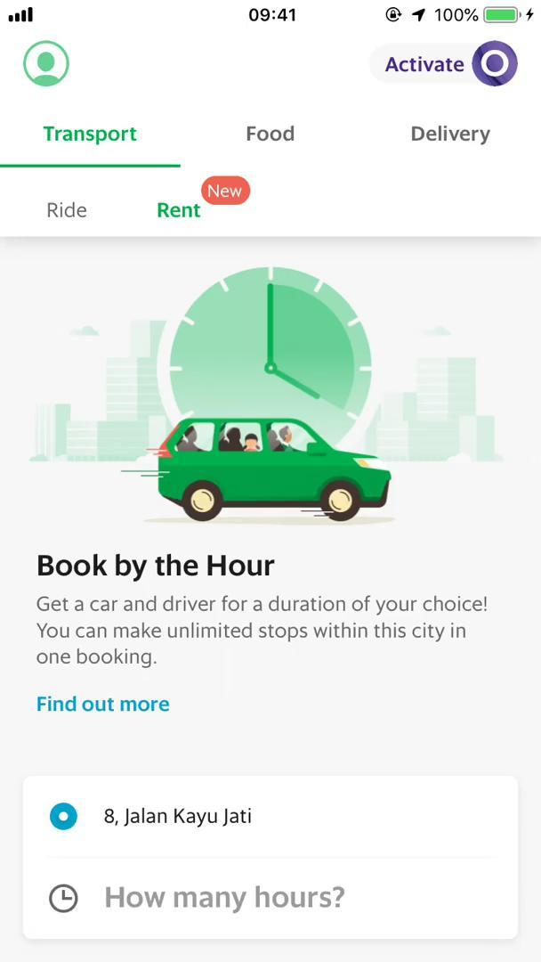

Overview
Grab Rentals is a transportation service platform that allows users to rent vehicles and book transportation services through a mobile application. The platform focuses on convenience, accessibility, and quick booking processes.

Strengths
- User-friendly booking workflow
- Integrated online payment system
- Real-time booking confirmation
- Strong mobile application support
- Large customer base and trusted brand

Weaknesses
- Limited customization for rental duration
- Vehicle information is sometimes insufficient
- Limited review transparency
- Heavy dependence on mobile platform
- Complex pricing structure during peak hours

Analysis
Grab Rentals provides a highly efficient booking experience with strong payment integration and responsive interfaces. However, the platform focuses more on transportation convenience than transparent vehicle rental management. The review and trust evaluation mechanisms are relatively limited compared to modern e-commerce standards.

3.2.2 Traveloka Car Rental
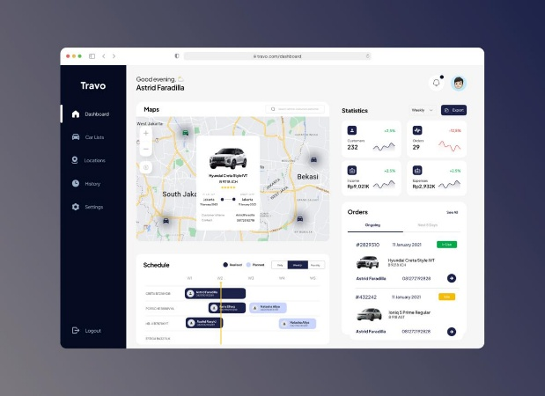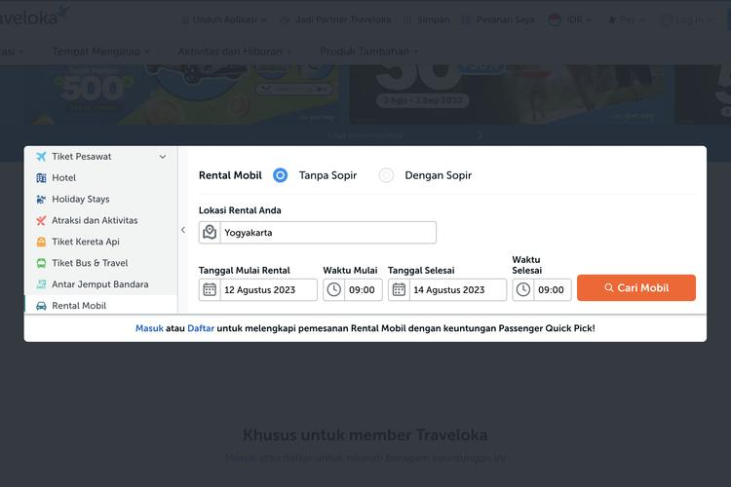

Overview
Traveloka Car Rental is an online travel and transportation booking platform that offers vehicle rental services integrated with tourism and accommodation systems.

Strengths
- Well-integrated booking ecosystem
- Wide range of vehicle options
- Secure online payment support
- Trusted platform reputation
- Multiple booking filters and search tools

Weaknesses
- User interface can be complex for beginners
- Limited direct communication between renters and vehicle owners
- Some booking processes require manual confirmation
- Limited trust verification for reviews

Analysis
Traveloka provides a comprehensive booking ecosystem with effective payment and search functionalities. However, the system emphasizes large-scale booking services rather than personalized rental experiences. The communication and trust mechanisms between users and vehicle providers remain limited.

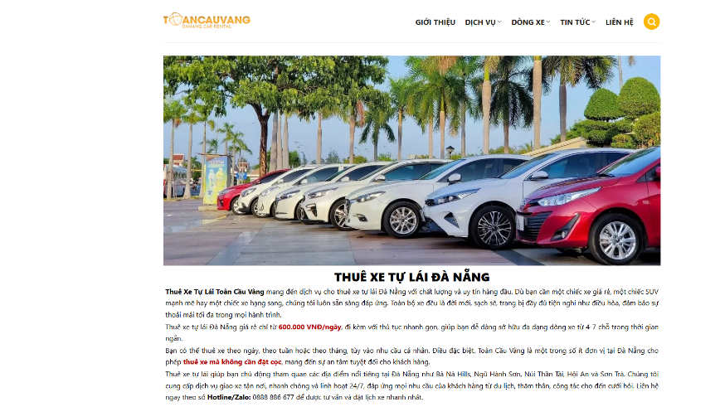
3.2.3 Local Vehicle Rental Websites

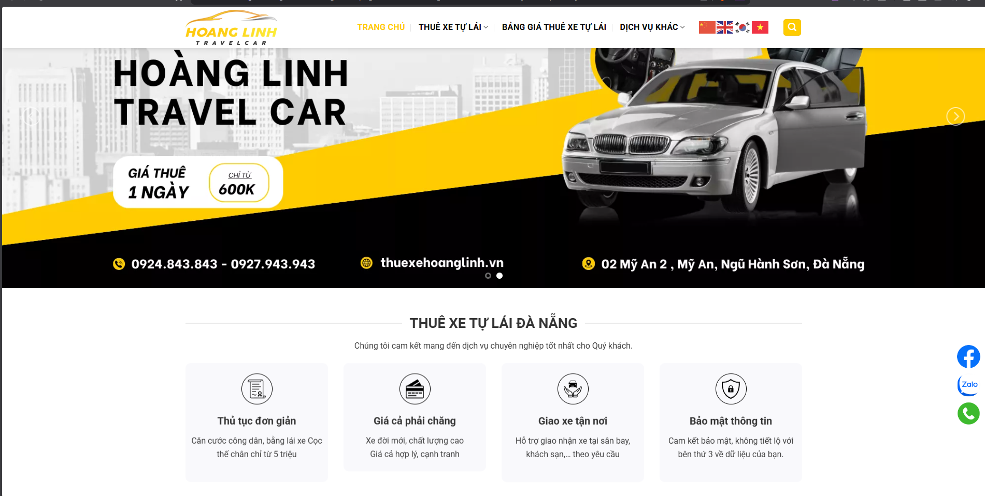

Overview
Many local vehicle rental businesses provide independent rental websites for booking and vehicle management. These systems are commonly used by small and medium-sized rental providers.

Strengths
- Flexible pricing
- Personalized customer support
- Easier negotiation between customers and owners
- Simple booking workflows

Weaknesses
- Weak authentication and security mechanisms
- Outdated UI/UX design
- Limited payment integration
- Poor booking management systems
- Lack of verified review systems
- Low scalability

Analysis
Local rental websites provide flexibility and personalized services but often suffer from technical limitations. Many systems lack modern responsive interfaces, secure authentication workflows, and reliable trust mechanisms. These limitations reduce customer confidence and overall service quality.
3.3 Comparative Analysis
System | Strengths | Weaknesses
Grab Rentals | Easy booking process | Limited customization
Traveloka Car Rental | Popular platform | Complex UI
Local Rental Websites | Competitive pricing | Low trust and poor security

3.4 Findings and Observations
Based on the analysis of existing systems, several important observations can be identified:
- Most existing platforms focus heavily on booking and payment functionalities.
- Trust management and verified review mechanisms remain limited in many rental systems.
- Some platforms provide strong infrastructure but lack personalized user experiences.
- Small rental websites often suffer from outdated interfaces and insufficient security.
- Modern responsive UI/UX design plays a major role in customer satisfaction and usability.

3.5 Implications for LUXEWAY
The analysis of existing systems provides valuable insights for the development of the LUXEWAY platform. To address the limitations identified in current platforms, LUXEWAY aims to:
- Provide secure JWT-based authentication
- Implement efficient booking and payment workflows
- Develop a modern responsive UI/UX design
- Support trusted review and rating mechanisms
- Improve transparency between renters and vehicle owners
- Create a scalable and user-friendly rental ecosystem

4. Literature Review

4.1 Vehicle Rental Systems
Traditional vehicle rental systems often rely on manual booking processes and in-person driver license verification, which lead to operational inefficiencies and increased risks of fraud. To address these limitations, modern studies propose the adoption of AI-based digital identity verification and biometric authentication to enhance security in online rental platforms.
Blockchain technology and Smart Contracts have also been identified as key solutions for creating immutable and transparent transactions while eliminating the single point of failure commonly found in centralized intermediary systems. In particular, the SePCAR protocol introduces an advanced security mechanism using Multi-Party Computation (MPC) to generate secure access tokens, ensuring both privacy and security even when vehicles operate without an internet connection.
Furthermore, several studies recommend implementing off-chain encryption mechanisms such as the Elliptic Curve Integrated Encryption Scheme (ECIES) to protect sensitive booking information, including vehicle license plates and location data, from public exposure on blockchain networks.

4.2 Authentication & Security
Authentication and security mechanisms are critical components in modern vehicle rental platforms due to the increasing number of online transactions and identity verification requirements. Traditional centralized authentication systems are vulnerable to unauthorized access, data leakage, and identity fraud.
Recent research emphasizes the integration of biometric authentication, AI-based identity verification, and blockchain-supported authorization frameworks to improve security and trust. JWT-based authentication and role-based authorization are also commonly proposed to provide scalable and secure session management for web applications.
In addition, advanced cryptographic approaches and decentralized identity management systems are increasingly adopted to strengthen user privacy and prevent tampering with sensitive rental information.

4.3 Payment Systems
Payment systems in vehicle rental services are gradually transitioning from manual bookkeeping and insecure payment methods to secure online payment gateways and decentralized transaction mechanisms.
In decentralized platforms, cryptocurrencies such as Ether or BNB enable direct peer-to-peer transactions between vehicle owners and renters, thereby reducing operational costs by eliminating third-party commission fees. Smart Contracts function as escrow mechanisms that automatically hold and release deposits once predefined conditions, such as return time and vehicle condition, are satisfied.
Moreover, several systems incorporate automated cost calculation mechanisms based on real-time vehicle data. These features allow platforms to dynamically compute additional charges for late returns, excessive mileage, or violations of rental agreements.

4.4 Review & Rating Systems
Review and rating systems play a fundamental role in establishing trust within peer-to-peer vehicle rental ecosystems. Most current sharing economy platforms rely heavily on voluntary customer feedback to evaluate service quality and user credibility.
However, traditional review systems frequently suffer from issues such as fake reviews, rating bias, and score inflation. To overcome these limitations, recent studies propose algorithm-based reputation systems integrated with telematics data collected directly from vehicles.
These technologies enable the monitoring of actual driving behaviors, including speed, braking patterns, and vehicle location, to generate objective trust scores rather than relying solely on subjective user opinions. A next-generation reputation system should also be capable of filtering misleading or manipulated reviews in order to maintain transparency, fairness, and safety across the entire vehicle-sharing community.

5. Comparative Analysis

5.1. Comparative Table of Related Research Studies for LUXEWAY
Research Paper | Main Contribution | Strengths | Limitations | Relation to LUXEWAY
A Double-Blinded Research Paper on Car Rental System (Source 1) | Proposed a modern vehicle rental platform using web technologies based on the MERN stack. | Provides a standard UI/UX workflow for vehicle booking, admin management, and driver license verification. | Uses a centralized database system (MongoDB), which may introduce single point of failure and data security risks. | Serves as the foundational framework for LUXEWAY’s web architecture and basic user experience design.
Applying Smart Contracts to Secure Car Sharing (Source 2) | Designed a fully decentralized booking and payment system on Ethereum blockchain. | Provides extremely high security through ECIES encryption and automated fraud penalty mechanisms using Smart Contracts. | Ethereum gas fees are relatively high, and transaction confirmation times may be slow. | Contributes the core “Trusted” logic of LUXEWAY through Smart Contracts and secure transaction processing.
Decentralized Car Rental System – CarChain (Source 3) | Proposed a hybrid architecture combining Flutter (Mobile), Firebase (Off-chain), and Binance Smart Chain (On-chain). | Optimizes both performance and operational costs by using Binance Smart Chain for lower fees and faster transactions. | Still partially depends on centralized backend services (Firebase) for fast data storage. | Represents an ideal implementation model for LUXEWAY’s cross-platform mobile application with reduced operating costs.
On the Benefit of Combining Car Rental and Car Sharing (Source 4) | Analyzed the economic benefits of integrating long-term rental (CR) and short-term car sharing (CS) within a unified fleet. | Mathematically demonstrated revenue increases ranging from 23% to 120% while optimizing idle vehicle usage. | Mainly focuses on business-owned fleets (B2C) and does not deeply address legal challenges in peer-to-peer (P2P) environments. | Provides business strategies that help LUXEWAY maximize profitability and attract private vehicle owners.
Trust-Building in P2P Carsharing (Source 7) | Proposed a reputation system based on algorithms and telematics data collected from vehicles. | Eliminates fake or biased reviews by evaluating customers through real driving behaviors such as speed and braking patterns. | Requires hardware integration into vehicles, which may be difficult for small-scale private car owners. | Introduces an innovative trust-building mechanism that enables LUXEWAY to establish strong trust between strangers in the sharing economy.
Research Directions for Sharing Economy Issues (Source 5) | Provided an overview of “Match-maker” business models and regulatory challenges in the sharing economy. | Offers strategic insights into sustainable platform development and government-related barriers. | Highly theoretical and lacks detailed technical implementation guidance. | Helps LUXEWAY position itself as a legitimate and sustainable matchmaking platform within the vehicle-sharing market.

5.2. General Observations for the LUXEWAY Project
- Technology Perspective:
LUXEWAY should combine the Hybrid Architecture proposed in Source 3 for high performance and scalability with the strong security protocols presented in Source 2 to prevent fraud and improve transaction reliability.
- Business Perspective:
Applying the combined hourly and daily rental model from Source 4 can significantly increase attractiveness for private vehicle owners by maximizing vehicle utilization and profitability.
- Trust Perspective:
Integrating Blockchain technology together with a Telematics-based reputation system from Source 7 could become LUXEWAY’s strongest competitive advantage in establishing a truly “Trusted Marketplace” for peer-to-peer vehicle rental services.

6. Research Gaps

6.1 Lack of Truly Decentralized P2P Platforms
Although the peer-to-peer (P2P) vehicle rental market is rapidly growing, existing studies indicate a significant lack of secure and trustworthy communities where individuals can safely rent out their personal vehicles without relying on centralized intermediaries.
Most current systems remain highly centralized, such as eKar and Sharik, resulting in risks related to single points of failure, high commission fees, and potential misuse of personal data. These limitations reduce transparency and trust within the sharing economy ecosystem.

6.2 Research Gap in Combined Rental Systems
One of the most significant research gaps identified in the literature is the insufficient exploration of combined systems integrating traditional Car Rental (CR) and Car Sharing (CS) models.
In practice, modern service providers have started blurring the boundaries between these two approaches, as seen in platforms such as Sixt Share. However, mathematical optimization models capable of simultaneously managing both long-term rental and short-term sharing within a unified fleet remain relatively new and underexplored.
As a result, there is still limited research addressing efficient fleet utilization, pricing optimization, and operational management for hybrid rental ecosystems.

6.3 Lack of Technical Implementation Details and User Experience (UX) Research
Existing blockchain-based vehicle rental studies, such as HireGo and Volvero, often lack detailed technical implementation documentation and practical usability analysis.
Several limitations have been identified:
- Limited programming and system architecture documentation
- Insufficient explanations regarding wallet management and Smart Contract monitoring
- Lack of large-scale real-world testing scenarios
- Heavy dependence on theoretical models and simulations
- Minimal focus on UI/UX design and customer interaction flows
Furthermore, many decentralized systems prioritize security and blockchain functionality while neglecting navigation simplicity, accessibility, and overall user experience.

6.4 Trust Issues and Algorithm-Based Reputation Systems
Current review and rating systems primarily rely on voluntary customer feedback, which is highly vulnerable to fake reviews, rating bias, and score inflation.
There is a major research gap in developing algorithm-based reputation systems supported by telematics data collected directly from vehicles. Such systems could objectively evaluate driving behaviors, including speed, braking patterns, and route compliance, instead of depending solely on subjective user opinions.
An advanced reputation system capable of filtering manipulated reviews and generating objective trust scores remains an important challenge in peer-to-peer vehicle-sharing ecosystems.

6.5 Legal and Insurance Challenges in P2P Models
The literature also highlights unresolved legal and insurance-related challenges within peer-to-peer vehicle rental systems.
Current Smart Contract solutions still struggle to effectively handle risks such as vehicle theft, traffic accidents, and dispute resolution between renters and vehicle owners. In addition, establishing a comprehensive legal framework that allows P2P car-sharing services to coexist with traditional B2C rental businesses remains an ongoing research challenge.
Therefore, future systems must address not only technical security but also legal compliance, insurance integration, and regulatory sustainability.

7. Proposed Solution
The proposed solution for LUXEWAY is a decentralized e-commerce platform that adopts a Hybrid Architecture to optimize both operational performance and high-level security for peer-to-peer (P2P) vehicle rental services.

7.1.System Architecture
LUXEWAY will utilize a modern technology stack consisting of React.js for the web frontend and Node.js with Express.js for the backend to develop a scalable, responsive, and user-friendly vehicle rental platform.
The system uses SQL Server for centralized data storage and management, supporting core functionalities such as user management, vehicle booking, payment processing, and transaction history tracking. JWT Authentication will also be integrated to enhance security and provide secure session management for users.
In addition, the platform will adopt a RESTful API architecture to facilitate communication between the frontend and backend systems, making development, maintenance, and future scalability more efficient. This architecture enables LUXEWAY to maintain stable performance, support collaborative team development, and align with the requirements of a modern e-commerce platform.

7.2.Strategic Business Model
The platform will implement a strategic synergy between traditional Car Rental (CR) for long-term trips and short-term Car Sharing (CS) services charged on an hourly basis.
This combined model allows private vehicle owners to maximize vehicle utilization by filling idle time slots, thereby increasing potential revenue by approximately 23% to 120% compared to traditional single-purpose rental models.
The integration of CR and CS also improves asset efficiency and provides flexible rental options for customers with different transportation needs.

7.3.Security and Trust Mechanisms

Smart Contracts
Smart Contracts will automate deposit holding and payment execution once rental conditions are fulfilled. The contracts will also include automatic penalty mechanisms if vehicle owners fail to deliver vehicles or if renters violate return conditions such as late returns or excessive mileage.
This automation minimizes human intervention and improves transparency within the P2P ecosystem.

ECIES Encryption
Sensitive information such as vehicle license plates, precise vehicle locations, and contact information will be encrypted off-chain using the Elliptic Curve Integrated Encryption Scheme (ECIES).
This approach ensures that only verified renters who have completed successful payments can decrypt and access sensitive rental information, thereby protecting user privacy and reducing data exposure risks on public blockchain networks.

Algorithm-Based Reputation System
Instead of relying solely on subjective customer reviews, LUXEWAY will integrate telematics data collected directly from vehicles to evaluate driver reputation objectively.
The system will analyze driving behaviors such as speed, braking patterns, travel distance, and route compliance to generate reliable trust scores. This mechanism helps eliminate fake reviews and biased ratings while establishing stronger trust between vehicle owners and renters within the P2P sharing economy.

8. Conclusion
The research and system design of LUXEWAY demonstrate that transitioning from traditional centralized vehicle rental platforms to a blockchain-based decentralized ecosystem is a necessary step toward addressing major challenges related to trust, security, and high intermediary costs.
LUXEWAY not only provides a technological solution that optimizes personal vehicle utilization through the combined CR and CS business model, but also ensures data privacy and transaction security for users within the sharing economy.
Findings from related studies indicate that decentralized vehicle rental systems can achieve lower operational costs, stronger resistance against cyberattacks, and significant economic benefits for both vehicle owners and consumers.
By integrating Smart Contracts with an algorithm-based reputation system supported by real driving data, LUXEWAY positions itself as a trustworthy marketplace capable of promoting sustainable growth in the smart transportation and sharing economy industries.

9. References
[1] N. Gupta et al., “A Double-Blinded IEEE Research Paper on Car Rental System,” IJIRT, vol. 11, no. 10, 2025.
https://ijirt.org/publishedpaper/IJIRT173737_PAPER.pdf
[2] A. Madhusudan, “Applying Smart Contracts to Secure Car Sharing Systems,” Master’s Thesis, KU Leuven, 2019.
https://cosicdatabase.esat.kuleuven.be/backend/publications/files/these/313
[3] C. El Hog et al., “Decentralized Car Rental System: Ensuring Security with Blockchain Smart Contracts,” SciTePress, 2025.
https://www.scitepress.org/Papers/2025/135054/135054.pdf
[4] M. Soppert et al., “On the Benefit of Combining Car Rental and Car Sharing,” Journal of Business Economics, 2024.
https://link.springer.com/article/10.1007/s11573-024-01204-9
[5] R. J. Kauffman and M. Naldi, “Research Directions for Sharing Economy Issues,” Electronic Commerce Research and Applications, 2020.
https://ink.library.smu.edu.sg/cgi/viewcontent.cgi?params=/context/sis_research/article/6996/&path_info=Sharing_Economy_2020_av.pdf
[6] M. Hu (Ed.), Sharing Economy: Making Supply Meet Demand, Springer Series in Supply Chain Management, 2019.
https://www.springerprofessional.de/sharing-economy/16393268#TOC
[7] T. Neifer et al., “Trust-Building in Peer-to-Peer Carsharing: Design Case Study for Algorithm-Based Reputation Systems,” Computer Supported Cooperative Work (CSCW), 2024.
https://dl.eusset.eu/items/1fc5f365-900d-4aff-aa69-d8cfbc49034f

