

CVerify
AI-Native Evidence-Based IT Talent Platform
Software Requirement Specification

TABLE OF CONTENT
I. Record of Changes 3
Non-Screen Functions 4
Modify and over view non-functional requirement 4
Add swimlane diagram 4
Modify and check SwimlaneDiagram 4
II.Software Requirement Specification 5
1. Introducing 5
1.1 Purpose 5
1.2 Scope 5
2. Product Overview 7
2.1 Context Diagram 7
2.2 Main Workflows (Swimlane) 8
2.2.1:Business — registration & verification 8
2.2.2:Create CV 9
2.2.3: Apply for a Job 10
2.2.4: JD ↔ CV Matching — so khớp JD với hồ sơ ứng viên 11
2.3: ERD Diagram: 16
2.3.1: ERD_01_ Identity & Access Management 16
2.3.3: ERD_03_Candidate Profile & Portfolio 17
2.3.4: ERD_04_Talent Intelligence Graph 18
2.2.5: ERD_05_Recruitment & Job Vacancy Matching 19
2.2.6: ERD_06_Candidate Assessment & Skill Attribution 20
2.2.7: ERD_07_Source Code Intelligence & Repository Analysis 20
2.2.8: ERD_08_Community Forum 21
2.2.9: ERD_09_Audit, Security Telemetry & Messaging 22
2.2.10: ERD_10_System Administration & Staff 23
2.2.11:ERD_11_Platform Orchestration & AI Engine 23
2.2.12: ERD_12_Overview Model of Inter-Module Relationships 24
3. User Requirements 25
3.1 Actors 25
3.2 Use Cases 26
3.2.1 Diagram(s) 26
1. Module Authentication & Identity Management (UCD-01) 38
2. Module Account & Organization Recovery (UCD-02) 39
3. Module Organization & Workspace Management (UCD-03) 41
4. Module Candidate Profile & Evidence Verification (UCD-04) 44
5. Module Source Code & Git Repository Analysis (UCD-05) 46
6. Module Candidate AI Assessment & Intelligence (UCD-06) 49
7. Module AI Interactive Chat & Interview Guidance (UCD-07) 51
8. Module Recruitment & Job Vacancy Management (UCD-08) 52
9. Module Community Forum & Moderation (UCD-09) 55
10. Module Notification & Communication System (UCD-10) 57
11. Module System Administration & Governance (UCD-11) 58
4. Functional Requirements 61
4.1 Screen flow 61
4.1.1 Candidate 61
4.1.2 Guest 62
4.1.3 Hiring Manager 62
4.1.4 Recruiter 63
4.1.5 Organization Admin 64
4.1.6 Super Admin 64
4.2 Screen description 65
4.3 Screen Authorization 75
4.4 Non-Screen Functions 78
4.5 Entity Relationship Diagram 81
5. Element screenshot 81
5.1 User Account Management & Authentication 81
5.1.1 Create an Account 81
3.2.2 Sign in With Email and Password 84
3.2.3 Sign in with Google 88
3.2.4 Sign Out 91
3.2.5 Forgot Password 94
3.2.6 View Profile 96
3.2.7 Update Profile 99
5.2 Job & Recruitment Management 101
3.3.1 Job Posting Management 101
3.3.2 Job Application Management 114
5.4 Workspace Management 117
3.4.1 Create Workspace 117
3.4.2 Edit WorkSpace 120
3.4.3 Delete WorkSpace 122
3.4.5 Open WorkSpace 124
5.5 CV Management 126
3.5.1 Create CV 126
6. Database Design 144
7. State Diagram 145
7.1 User Account Lifecycle 145
7.2 Organization Verification & Recovery 146
7.3 CV / Candidate Profile 147
7.4 Job Post 148
7.5 Job Application 149
7.6 Repository Analysis 150
7.7 Forum Topic Moderation 151
7.8 Email Outbox Message 152
III: NON-FUNCTIONAL REQUIREMENTS 153
1. External Interfaces 153
1.1 User Interface 153
1.2 Hardware Interface 153
1.3 Software Interface 153
1.4 Communication Interface 154
2. Quality Attribute 154
2.1 Performance 154
2.2 Reliability 154
2.3 Security 154
2.4 Scalability 154
2.5 Maintainability 155
2.6 Availability 155
2.7 Usability 155
2.8 Compatibility 155
2.9 Portability 155
IV: REQUIREMENT APPENDIX 155
1. Business Rules 155
1.1 Authentication & Security (BR-AUTH & BR-SEC) 155
1.2 Candidate & Resume Intelligence (BR-CAND & BR-RES) 156
1.3 GitHub Intelligence (BR-GIT) 157
1.4 AI Evaluation & Matching Engine (BR-AI & BR-MATCH) 157
1.5 Recruitment & Application (BR-JOB & BR-APP) 158
1.6 Organization & Billing (BR-ORG & BR-BIL) 158
2. Application Messages List 159

I. Record of Changes

Date | A*  M,  D | In charge | Change Description
19/05/2026 | A | Ngọc Ánh | Create initial project structure
20/5/2025 | A | Ngọc Ánh | Create base document and introducing for SRS CVerify project
21/5/202 | A | Ngọc Ánh | Update Scope
10/6/205 |  | Thế Lực | Add Context diagram description
15/6/2025 | M | Nhất Long | Integrate AI functional requirements
15/6/2025 |  | Hiếu | Add Non-Functional Requirements
15/6/2025 |  | Thế Lực | Update Content of context diagram and description
13/6/2025 |  | Ngọc Ánh | Create Usecase diagram, user requirement.
15/6/2025 |  | Hiếu | Create content External Interface
19/6/2025 |  | Hòa An | Element screen shoot
20/6/2025 |  | Thế Lực | Screen flow
20/6/2025 |  | Nhất Long | Non-Screen Functions
25/6/2025 |  | Ngọc Ánh | Modify and over view non-functional requirement
25/06/2026 |  | Thế Lực | Add swimlane diagram
25/06/2026 |  | Ngọc Ánh | Modify and check SwimlaneDiagram
25/6/2025 |  | Hòa An | Update UI/UX Design Mockups
28/6/2025 |  | Thế Lực | Update Screen flow description
1/7/2025 |  | Ngọc Ánh | Update Usecase diagram
1/7/2025 |  | Nhất Long | Create content business rule
1/7/2025 |  | An | Add ERD diagarm
2/7/2025 |  | Hiếu | Add state diagram
2/7/2025 |  | Long | Add database desgign
4/7/2025 |  | Hiếu | Update application message
7/7/2025 |  | Thế Lực | Check correctness / validity and give feedback
7/7/2025 |  | Ngọc Ánh | Review and finalize project documentation
10/7/2025 |  | Group 5 | Final version approved for submission

*A - Added M - Modified D – Deleted

II.Software Requirement Specification

1. Introducing

1.1 Purpose
CVerify is an AI-native, evidence-based IT talent platform that addresses a critical gap in the Southeast Asian technology recruitment market, where the disconnect between self-declared developer skills and verifiable technical capability leads to prolonged hiring cycles and mismatched placements.
Rather than relying on traditional self-reported CVs, CVerify extracts Proof-of-Work directly from candidates' GitHub and GitLab repositories through a Hybrid 2-Phase AI pipeline — performing AST-aware code chunking, commit complexity classification, and ownership detection — before generating a hierarchical Skill Tree with evidence-backed confidence scores and a Trust Score (0–100) via a Multi-Model Router orchestrating GPT-4.1, Claude Sonnet 4.5, and Gemini 2.5 Flash.
The platform serves three primary actors. Candidates build structured CV profiles, link repositories for AI analysis, and receive real-time Gap Analysis when browsing job listings. Recruiters create AI-assisted Job Descriptions, manage applicant pipelines through a Kanban board, and — for Tier 2 enterprise workspaces — unlock proactive AI talent discovery powered by HNSW vector search with ATS scoring and explainability reports. System Administrators oversee user management, company verification queues, immutable audit logs, and AI usage analytics.
Built as a Modular Monolith on ASP.NET Core 10 with PostgreSQL 16 and pgvector for semantic indexing, Redis 7, and a dedicated Python FastMCP AI microservice, the system spans eighty-three specified use cases, seventy-seven screens, and twenty-three database tables across a fourteen-week development roadmap.

1.2 Scope
The project focuses on developing CVerify, an AI-powered technical recruitment platform that enables evidence-based candidate evaluation through GitHub repository analysis and intelligent recruitment support. The platform assists candidates in showcasing their real technical capabilities while helping recruiters identify the most suitable candidates using AI-driven insights.
The system comprises the following core functional modules:
- Authentication & User Management Module: Provides secure user registration and authentication using Email or Google OAuth, role-based access control, profile management, and account verification for Candidates, Recruiters, and Administrators.
- AI Candidate Intelligence Module: Enables candidates to upload CVs, connect GitHub repositories, and receive AI-generated technical assessments. The system analyzes repository quality, programming skills, technology stacks, and candidate profiles to generate comprehensive technical reports and career recommendations.
- Recruitment Management Module: Allows recruiters to create and manage job postings, search verified candidates, review AI-generated candidate reports, manage recruitment workflows, and communicate with applicants throughout the hiring process.
- AI Recruitment Assistant Module: Assists recruiters by automatically generating optimized job descriptions and performing AI-powered semantic matching between candidate profiles and job requirements to recommend the most suitable candidates.
- Administration & System Management Module: Provides centralized tools for administrators to manage users, moderate platform content, monitor system activities, handle reports and violations, send notifications, and maintain the security and reliability of the platform.
Project Limitations (Out of Scope):
To ensure the project can be completed within the scope, the current version of CVerify does not include native mobile applications, integration with external HRIS platforms (e.g., Workday, SAP, Greenhouse), AI-powered interview video analysis, or real online payment gateway integration. These features are considered future enhancements and are outside the scope of the MVP.

2. Product Overview

2.1 Context Diagram

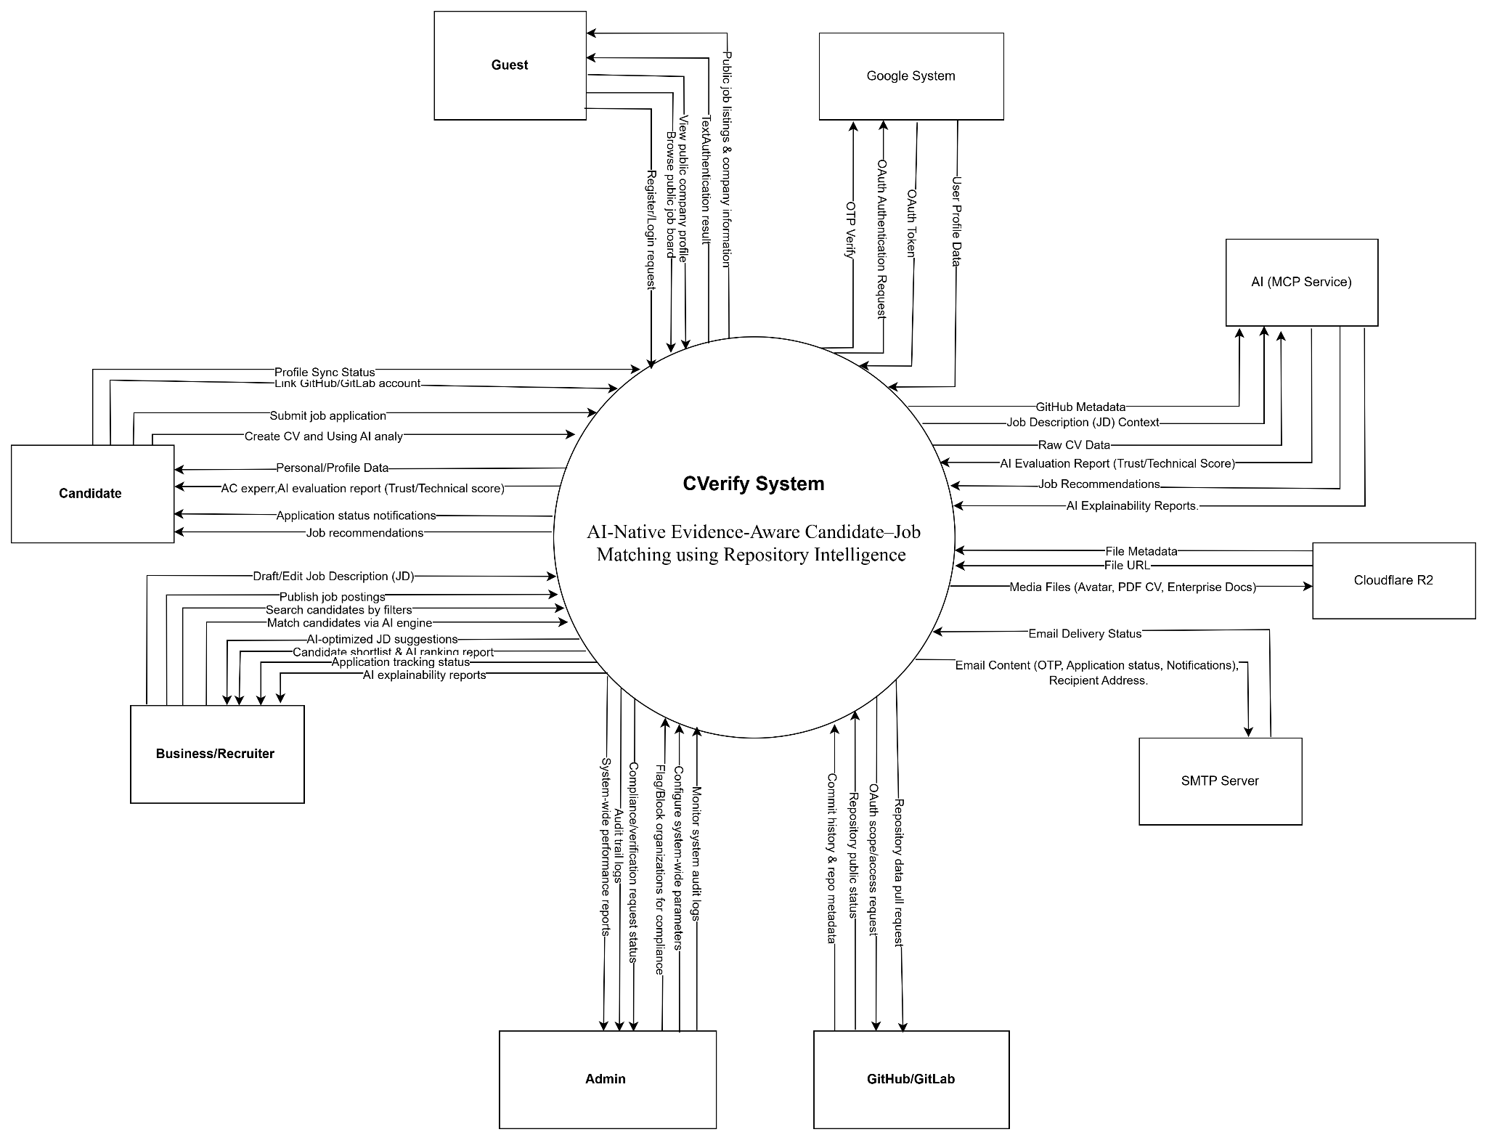

2.2 Main Workflows (Swimlane)

2.2.1:Business — registration & verification
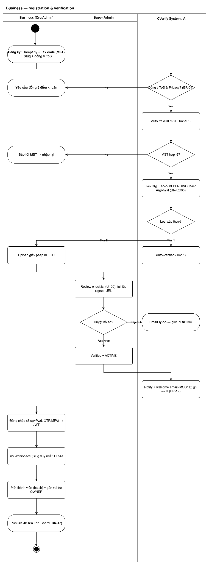

2.2.2:Create CV
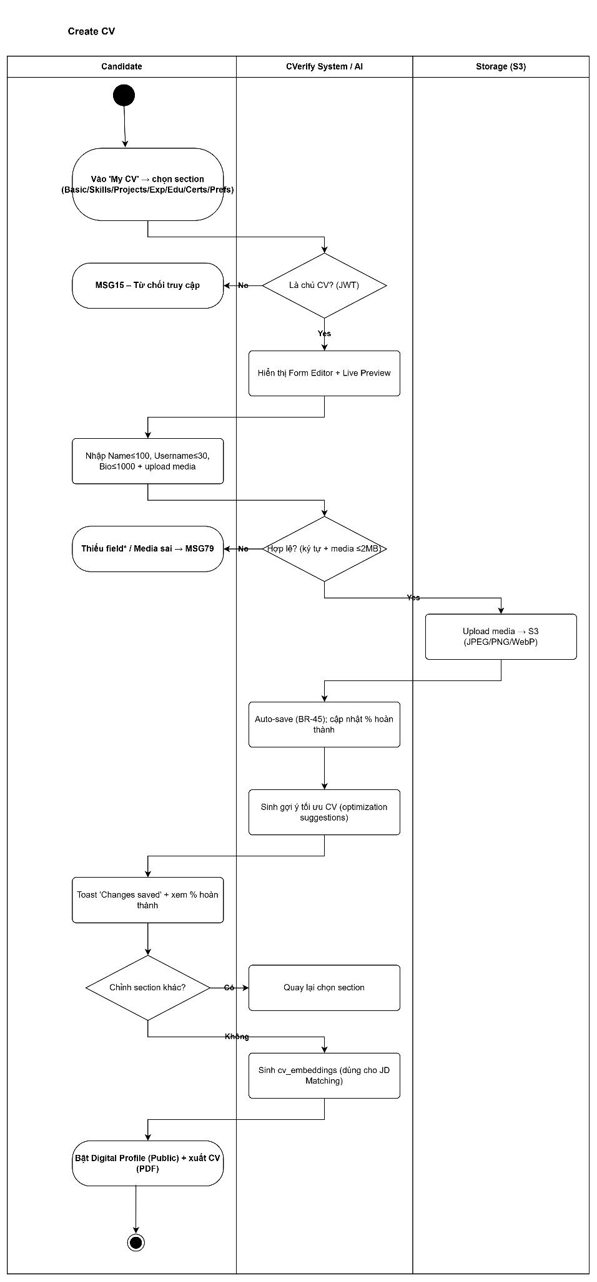

2.2.3: Apply for a Job

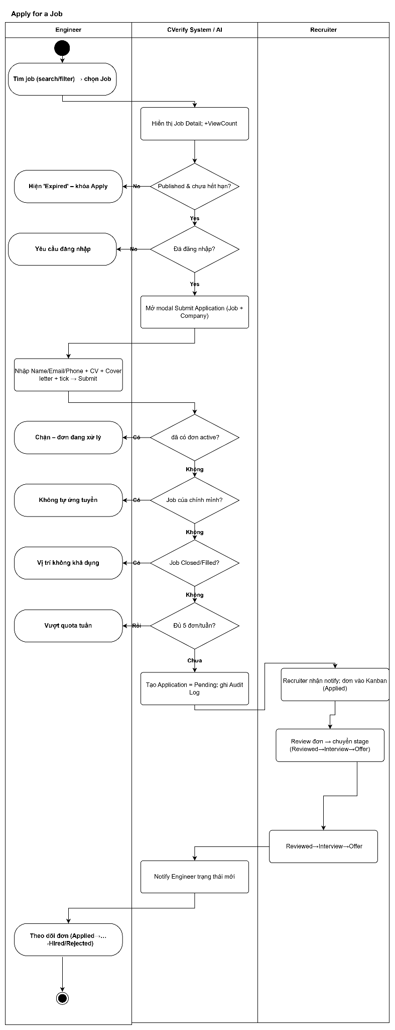

2.2.4: JD ↔ CV Matching — so khớp JD với hồ sơ ứng viên
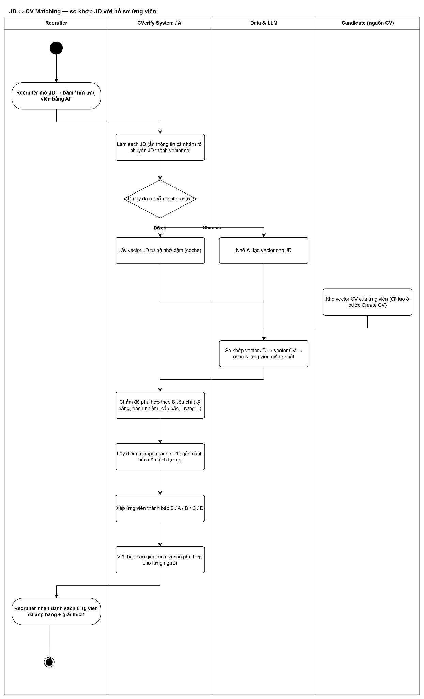
2.2.5 Organization — Level-2 Recovery & Dispute Voting Flow
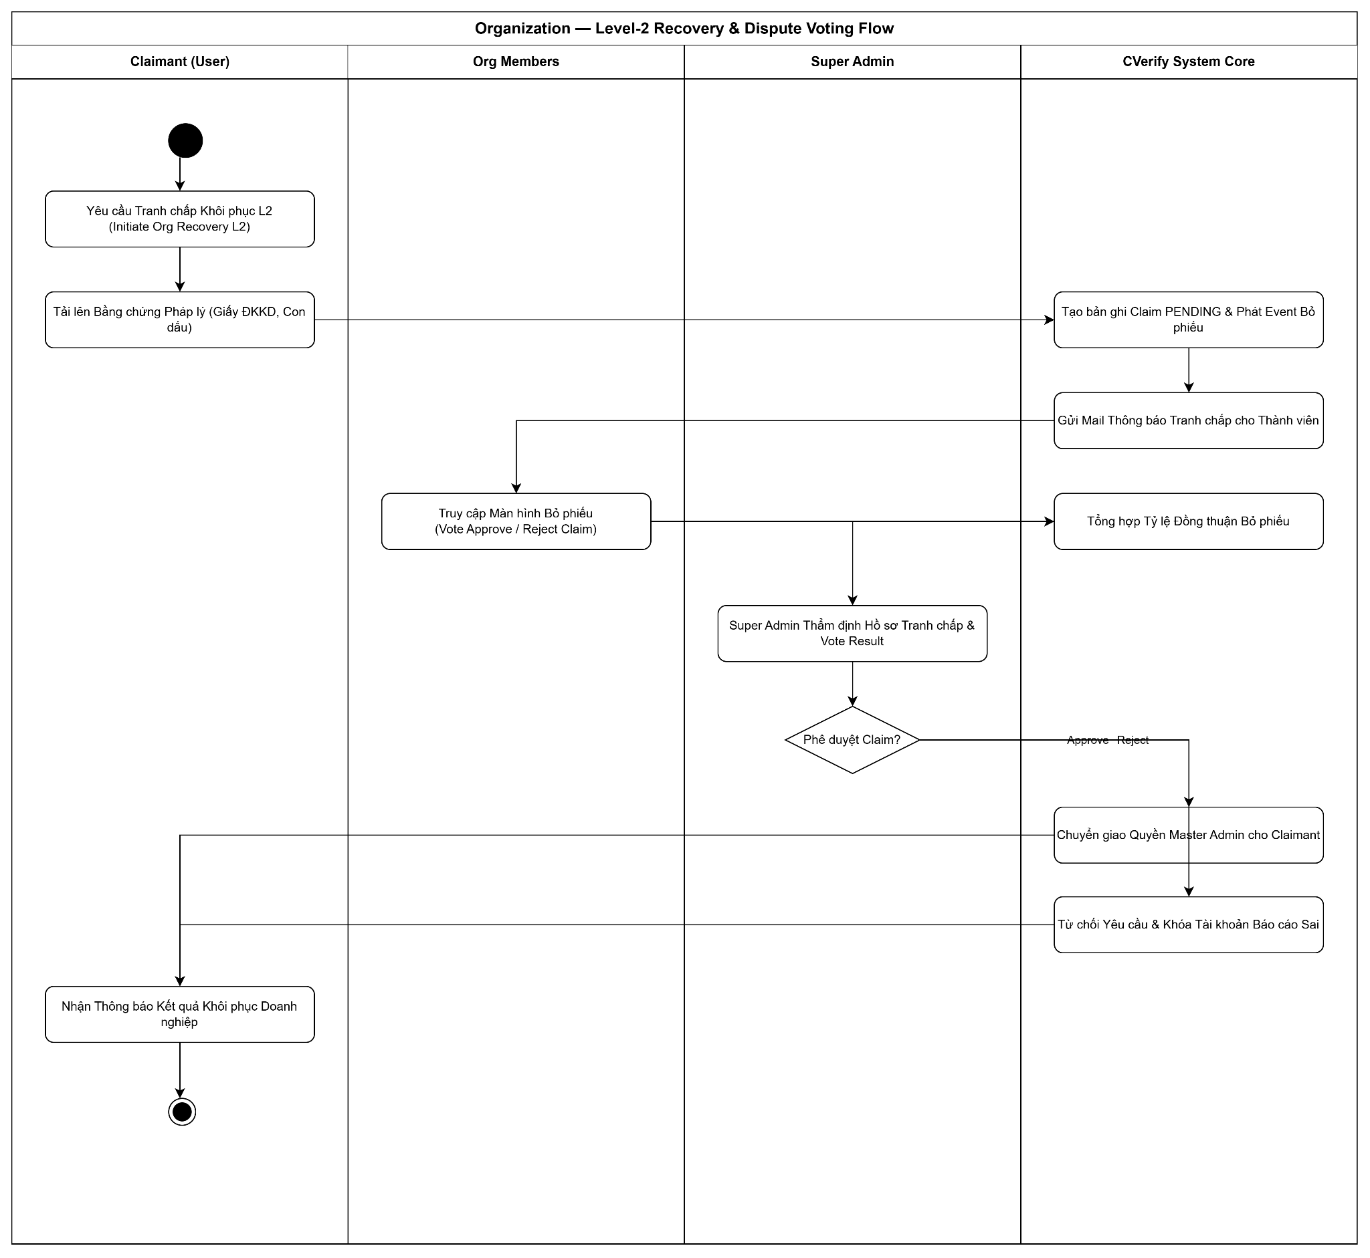

2.2.6 Candidate — Source Code & Git Repository AI Audit Flow
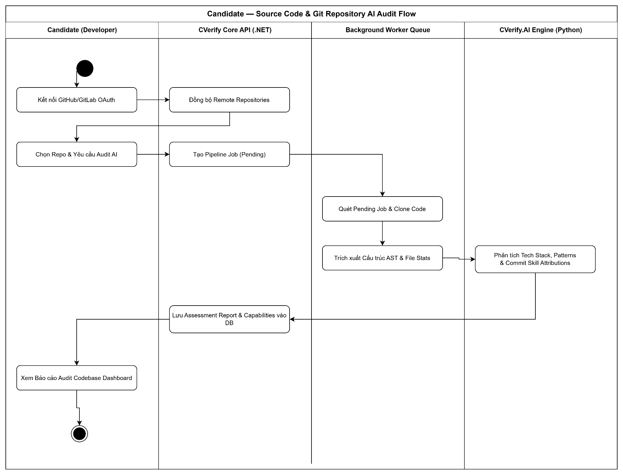

2.2.7 Candidate — AI Assessment Pipeline & Skill Tree Flow
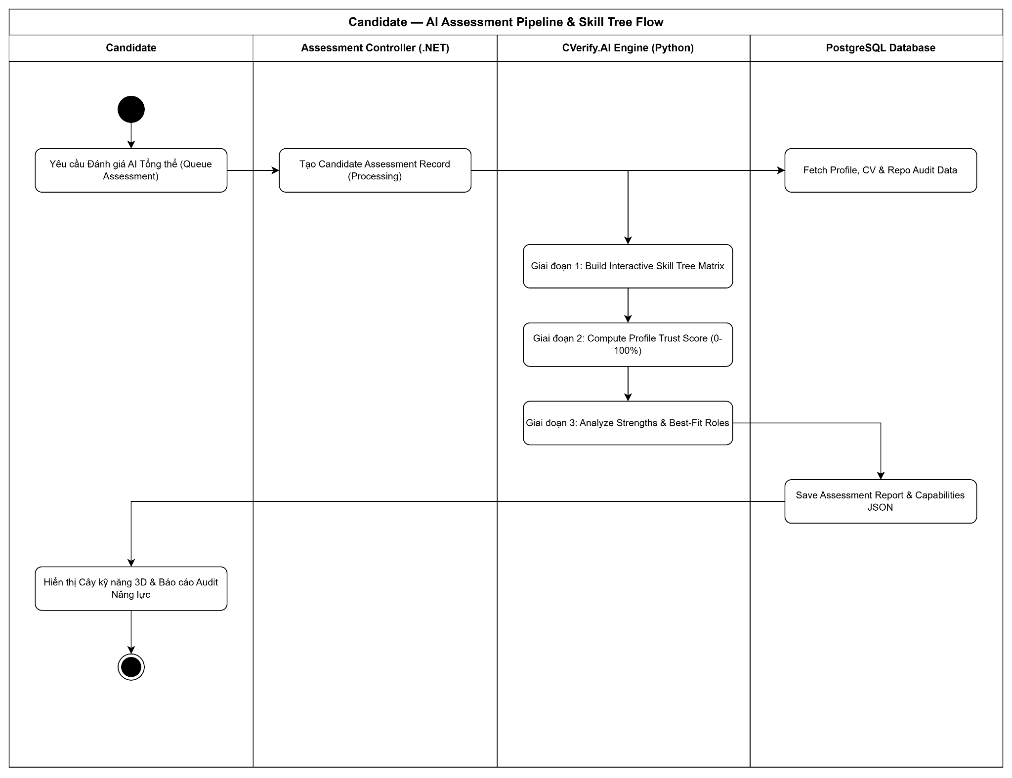

2.2.8 Recruitment — Job Vacancy, AI Requirement & Publishing Flow
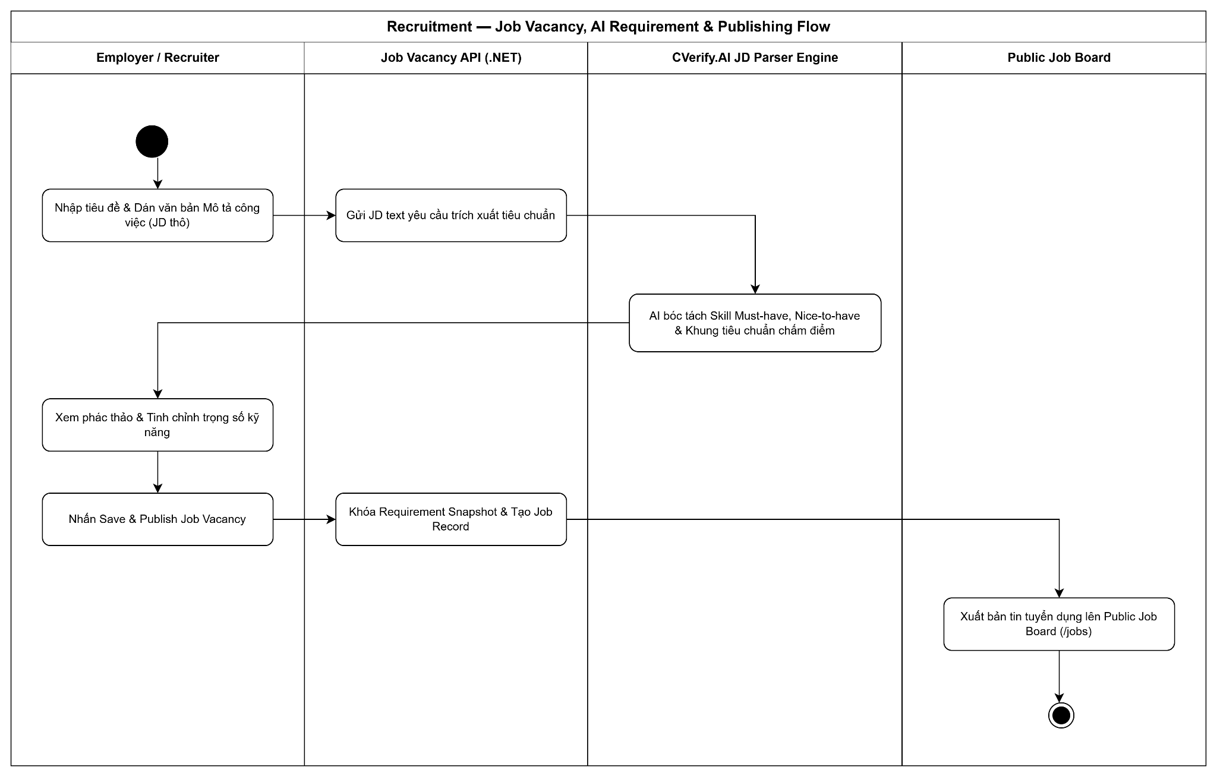

2.2.9 Recruitment — Candidate Application & AI Job-Fit Ranking Flow

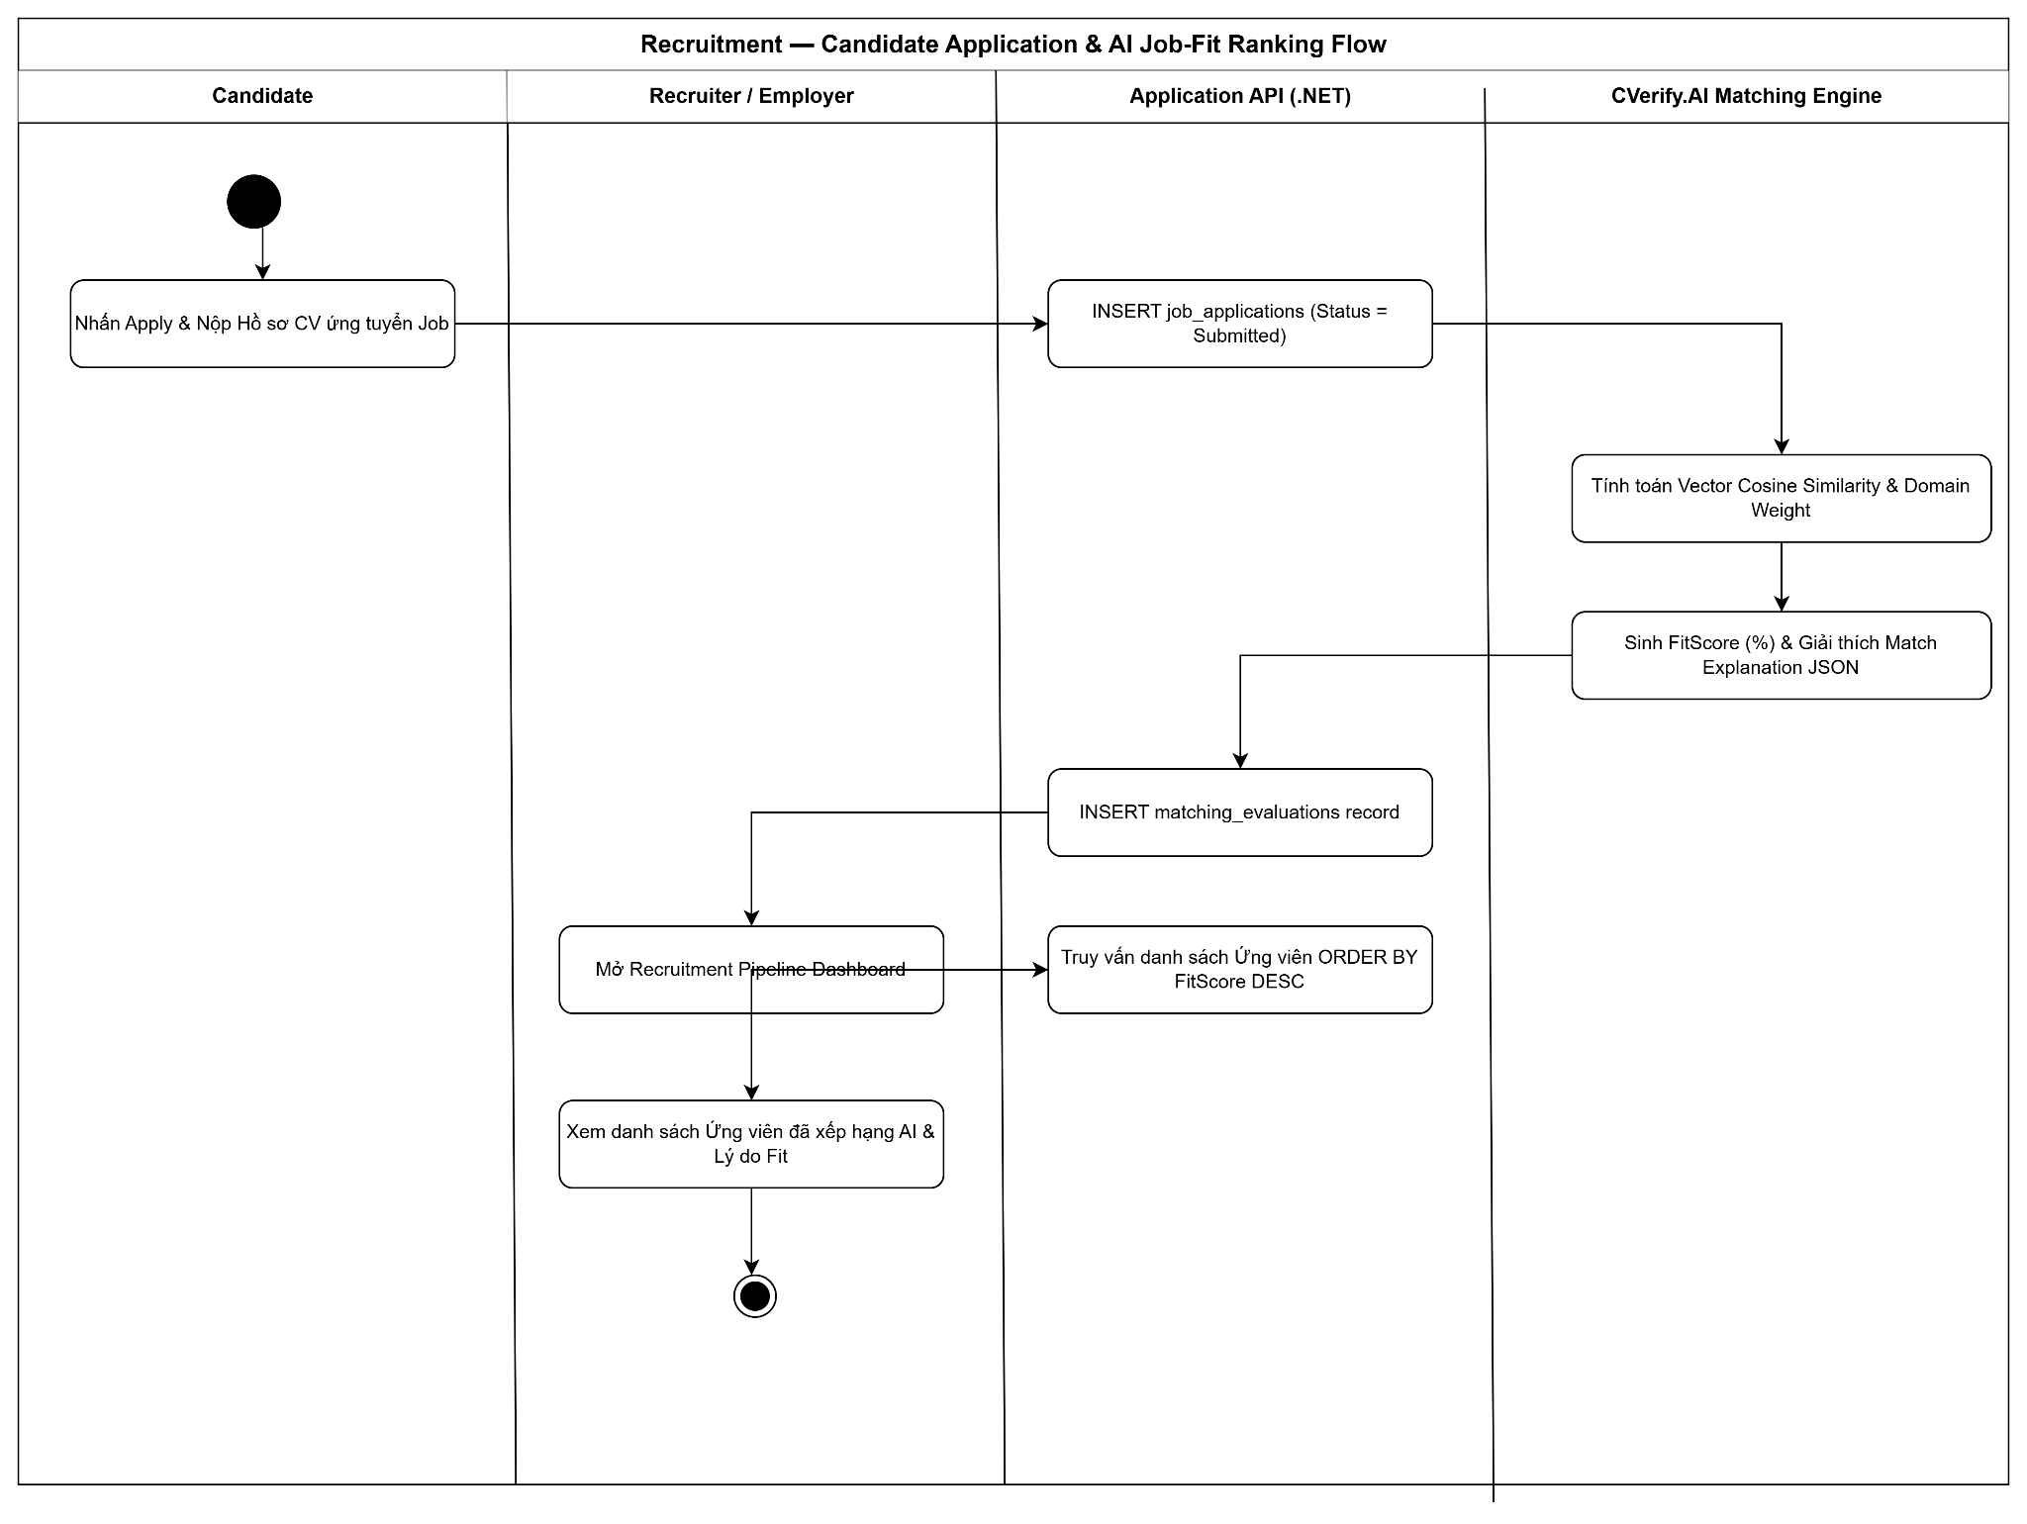

2.3: ERD Diagram:

2.3.1: ERD_01_ Identity & Access Management
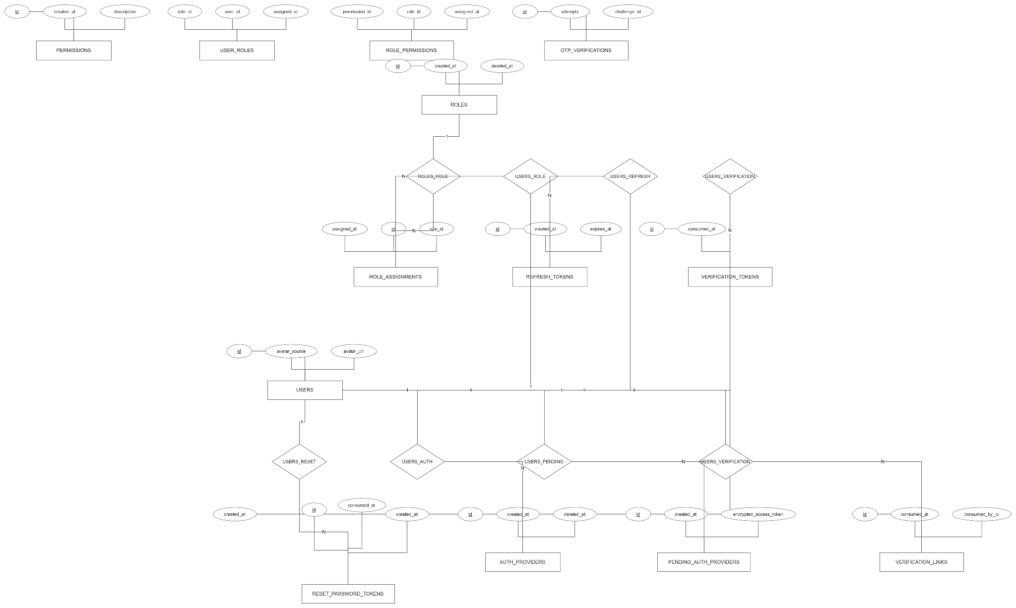

2.3.2:ERD_02_Organizations & Workspaces
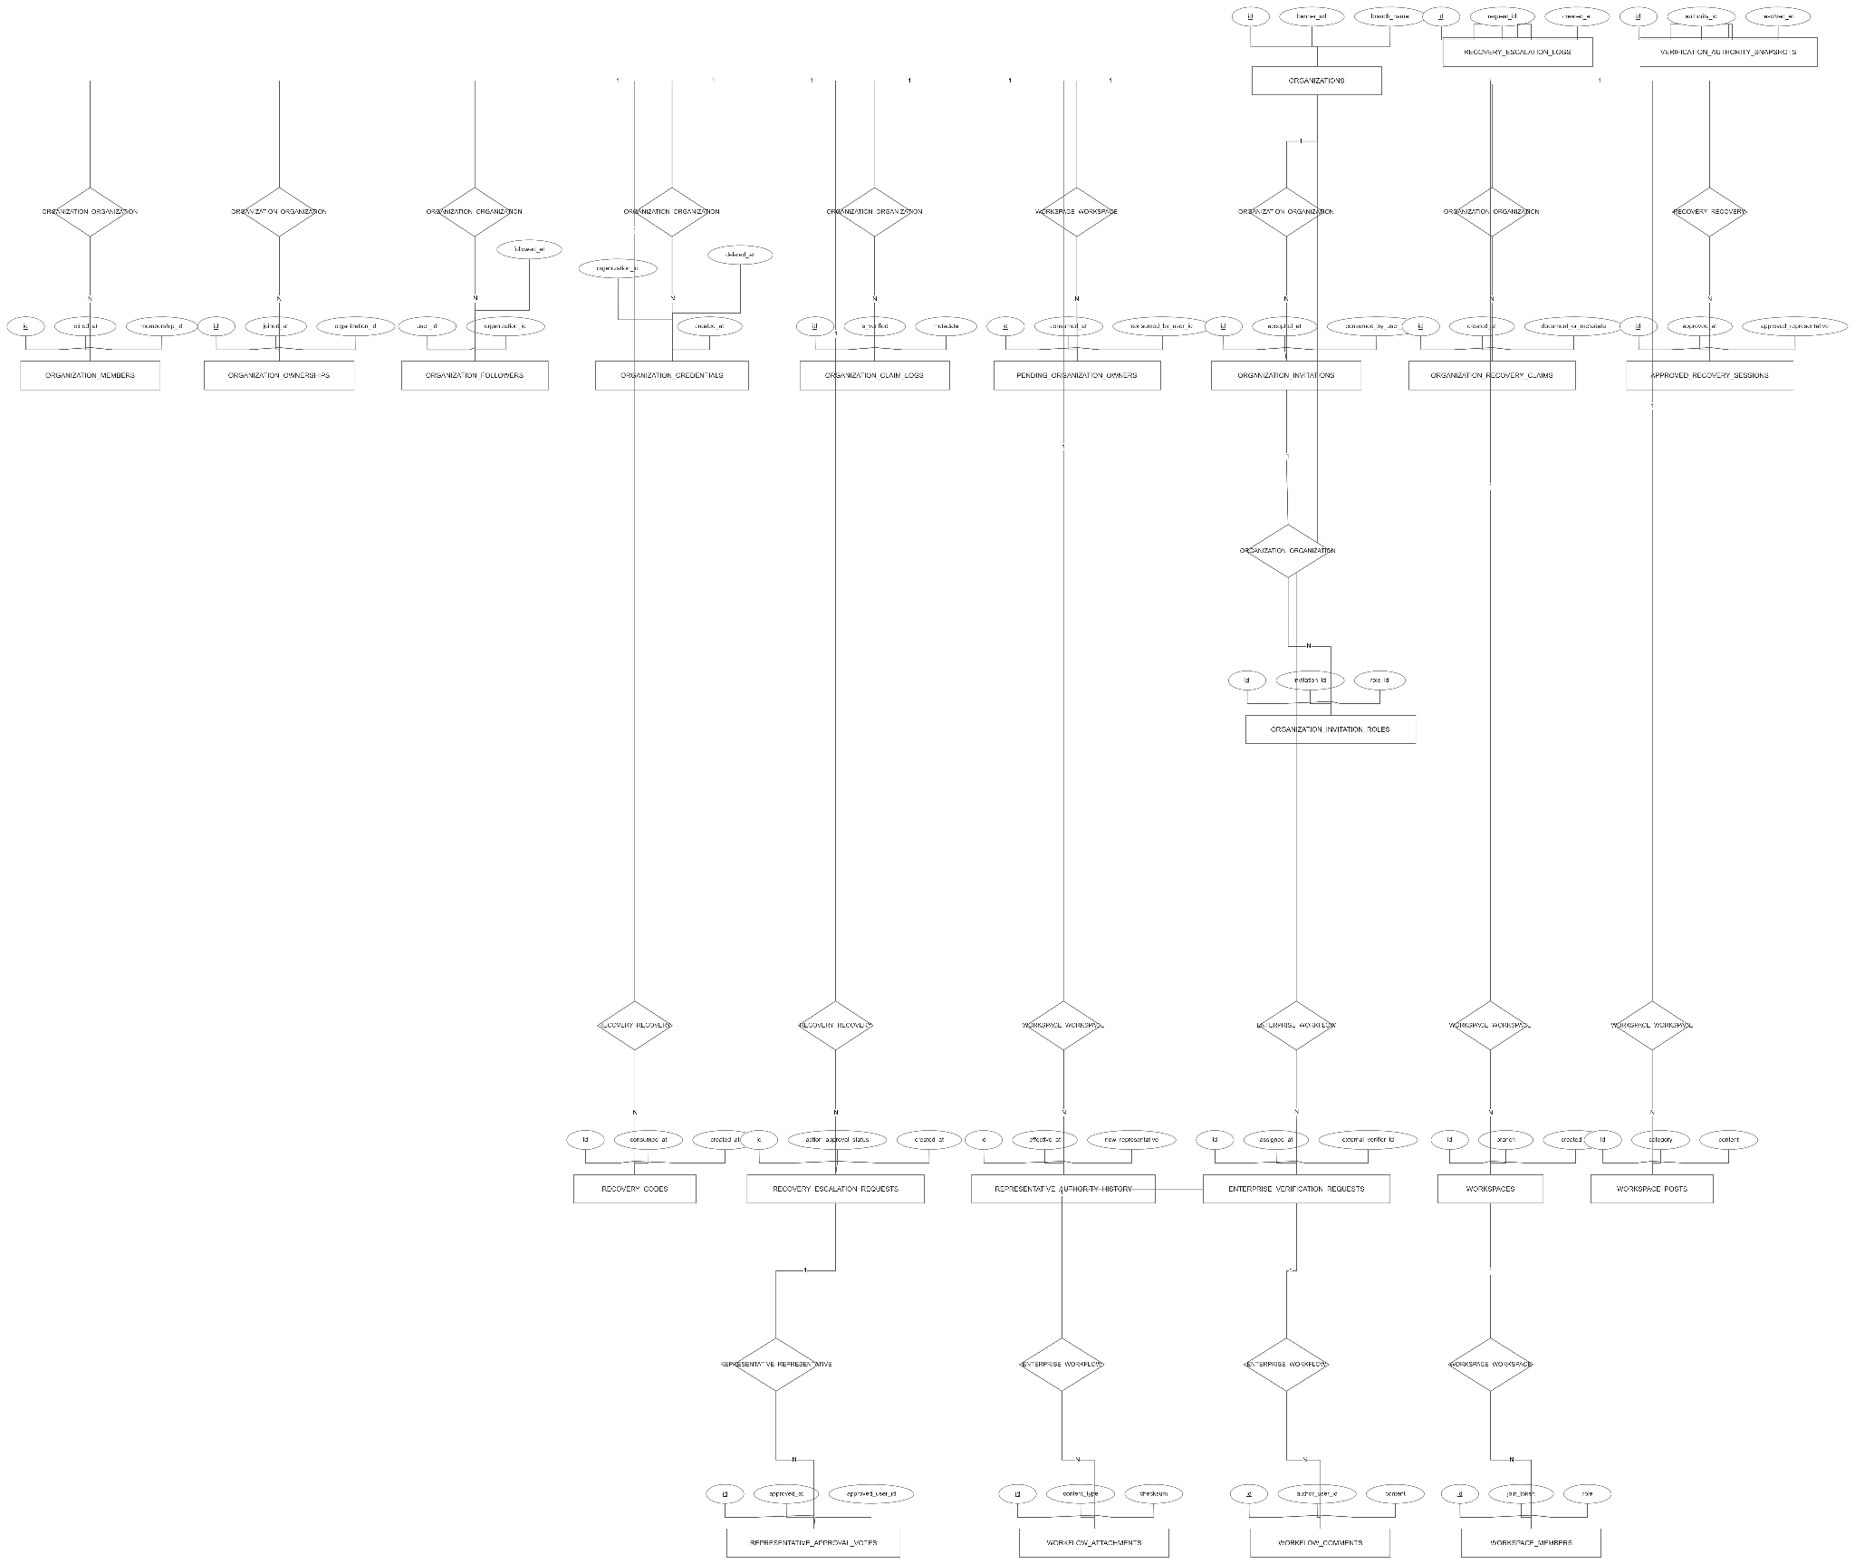

2.3.3: ERD_03_Candidate Profile & Portfolio
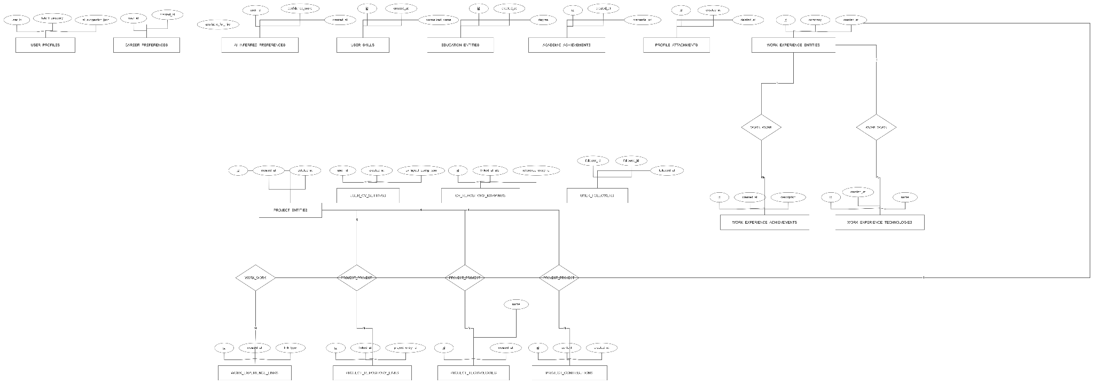

2.3.4: ERD_04_Talent Intelligence Graph
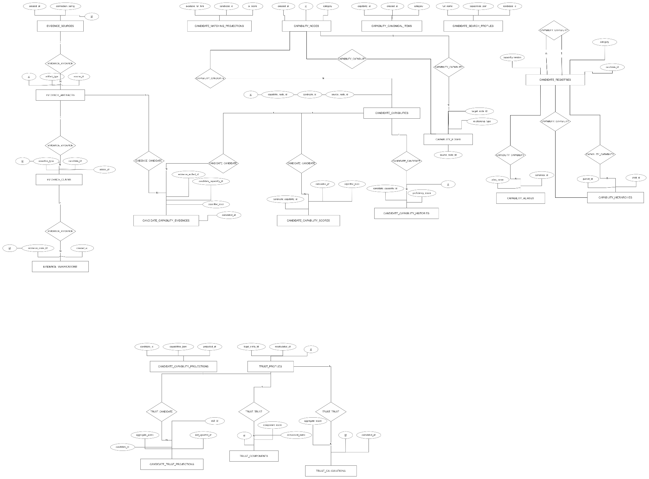

2.2.5: ERD_05_Recruitment & Job Vacancy Matching
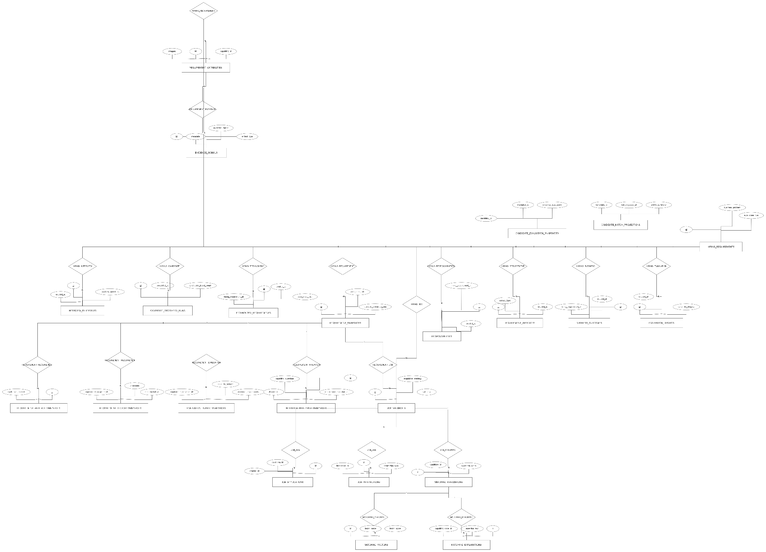

2.2.6: ERD_06_Candidate Assessment & Skill Attribution

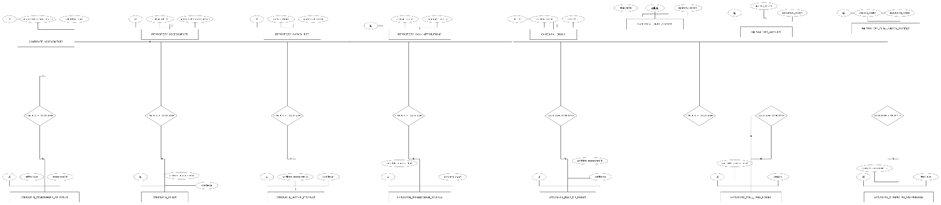

2.2.7: ERD_07_Source Code Intelligence & Repository Analysis
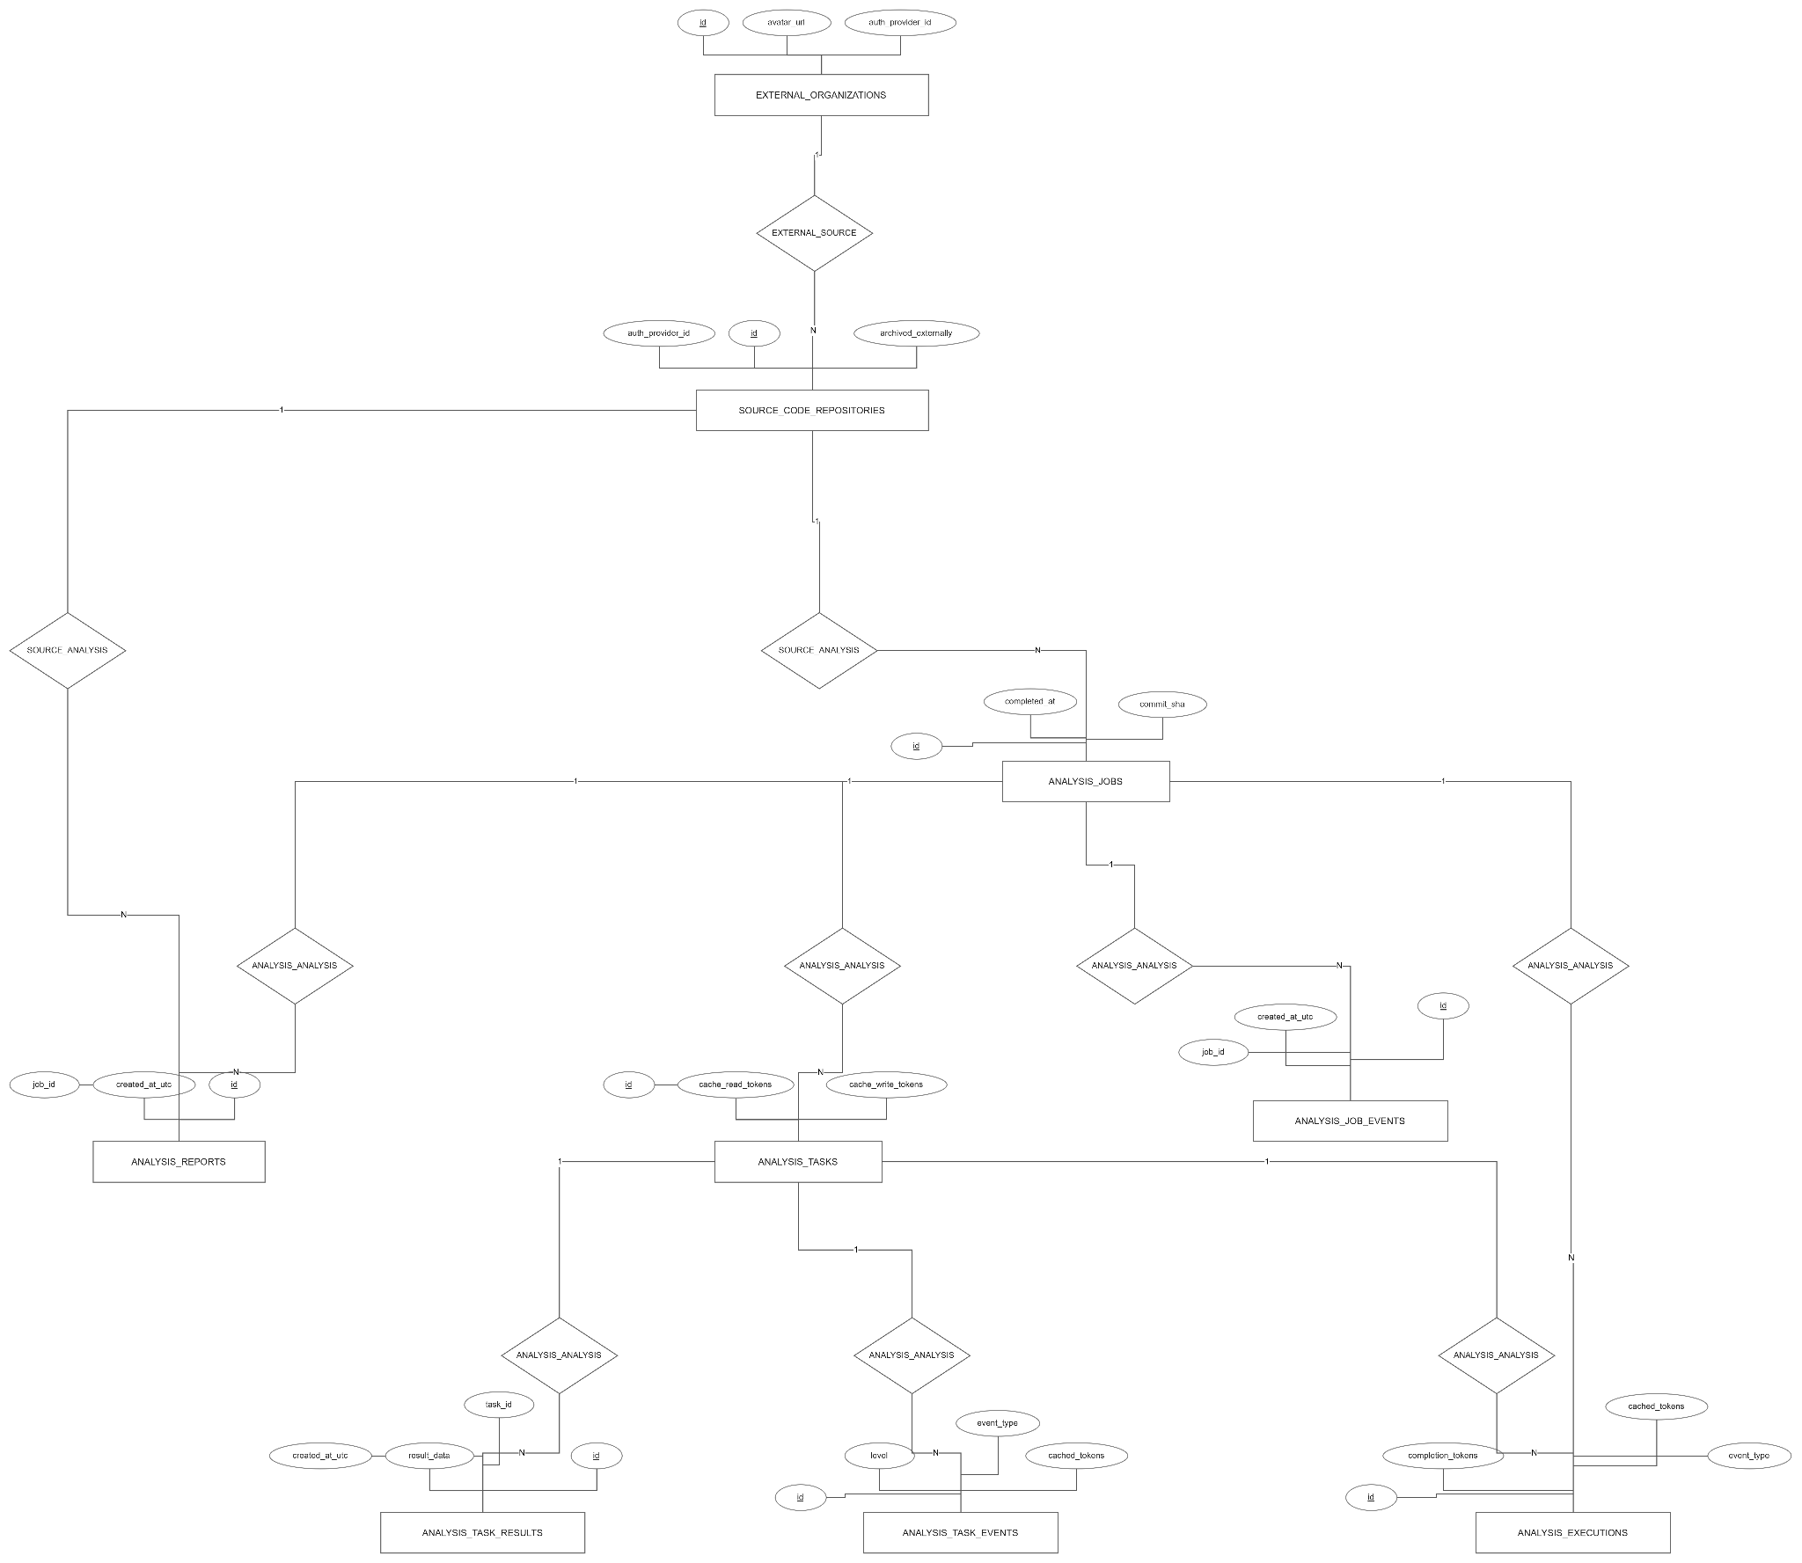

2.2.8: ERD_08_Community Forum
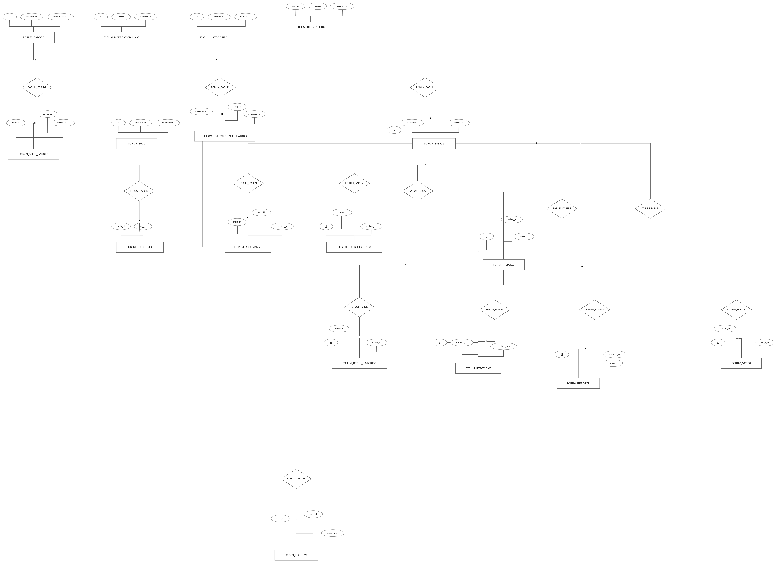

2.2.9: ERD_09_Audit, Security Telemetry & Messaging
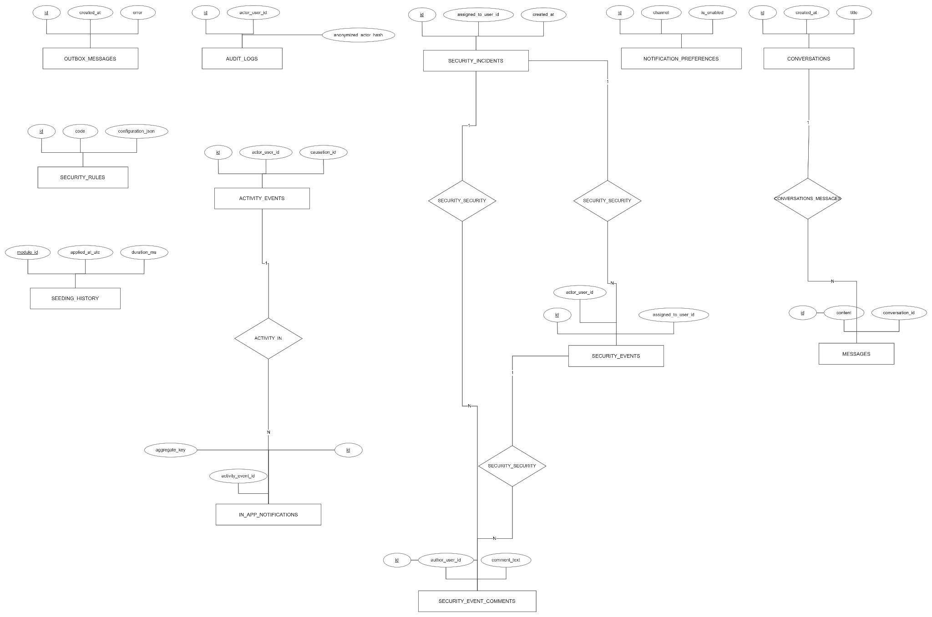

2.2.10: ERD_10_System Administration & Staff
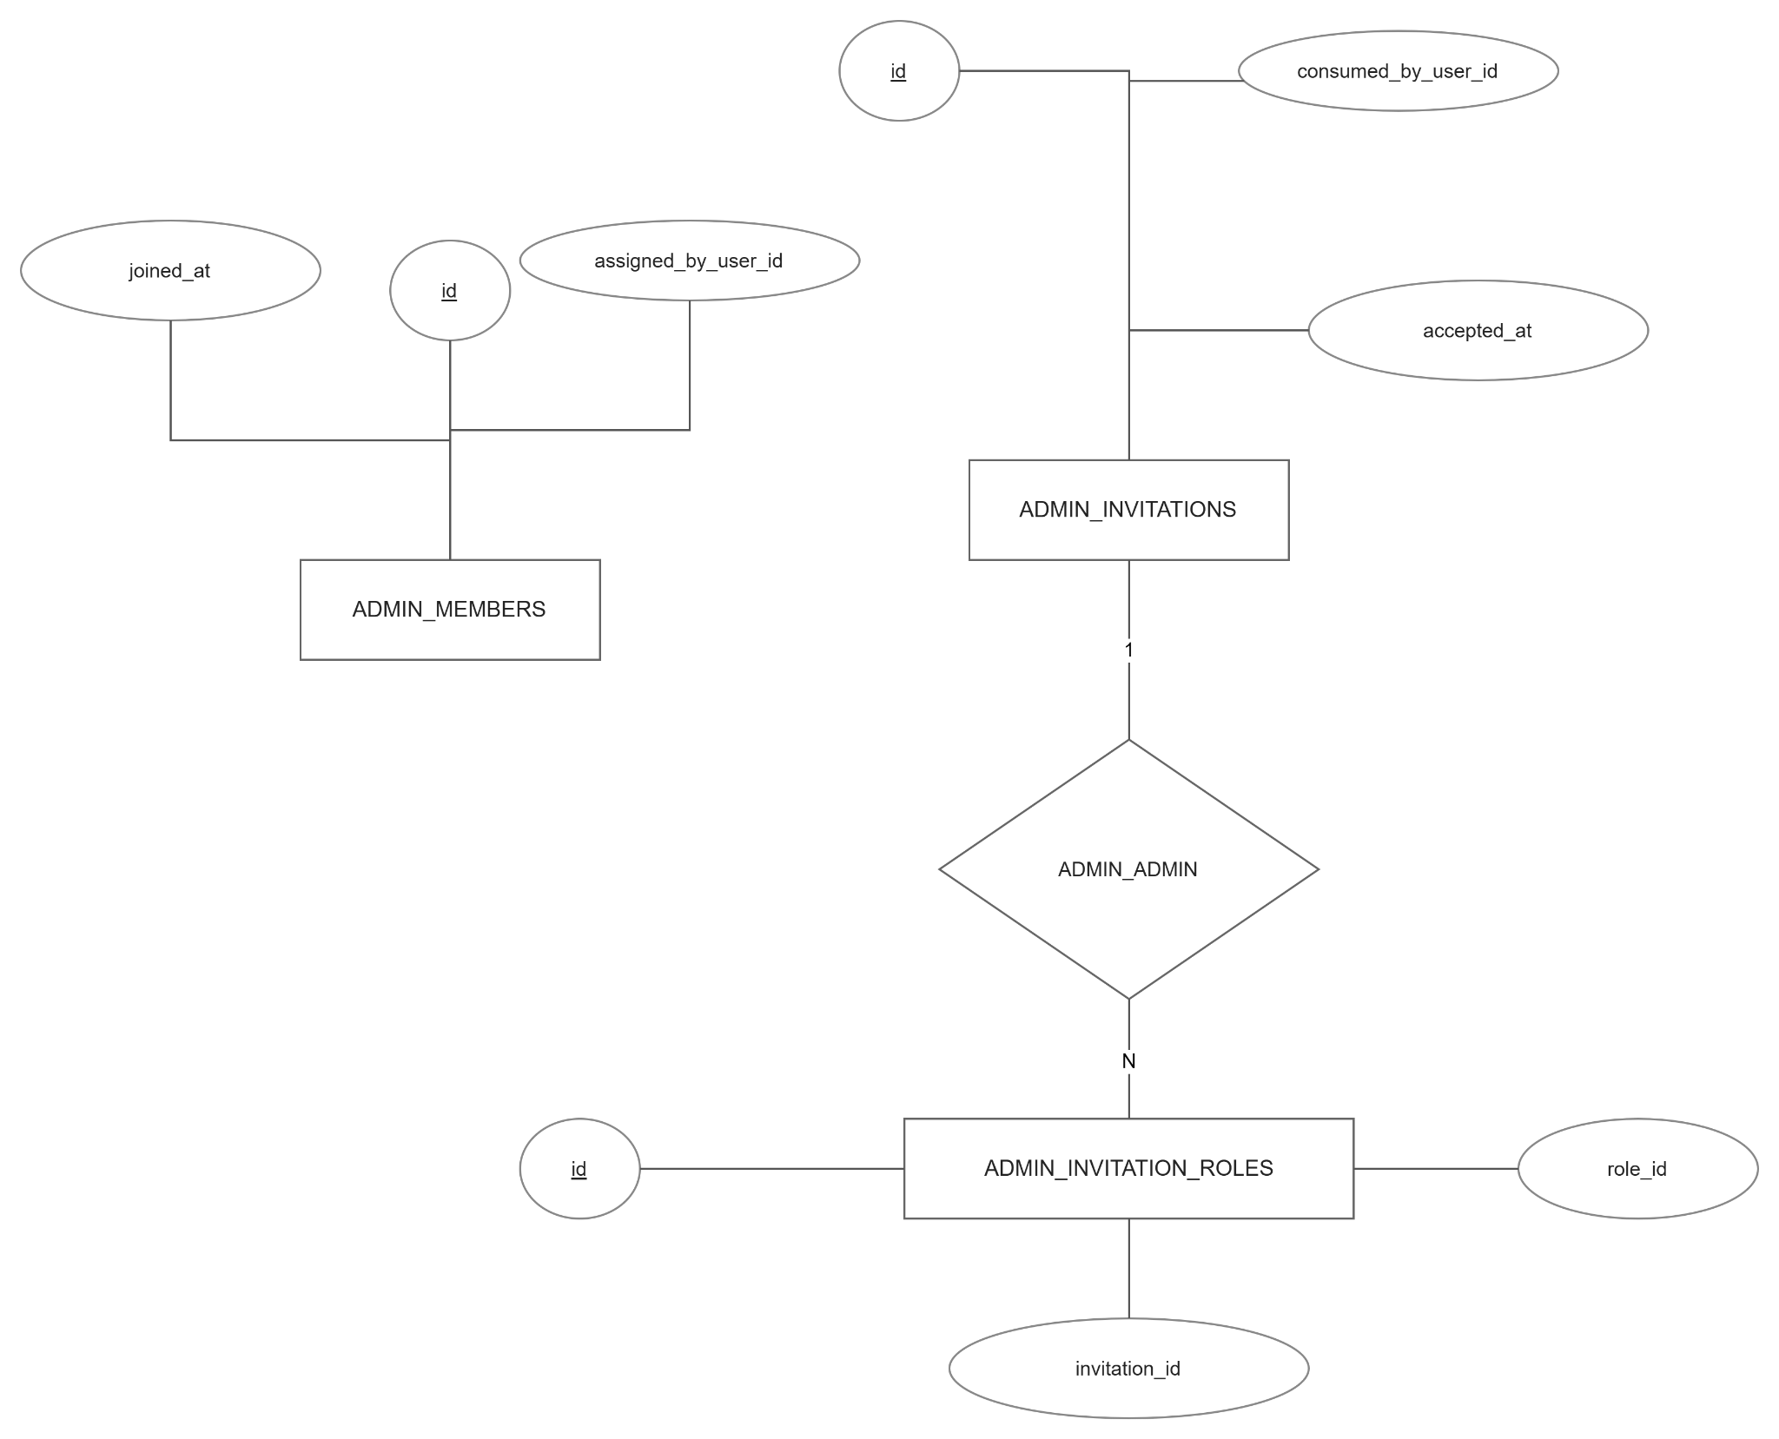

2.2.11:ERD_11_Platform Orchestration & AI Engine
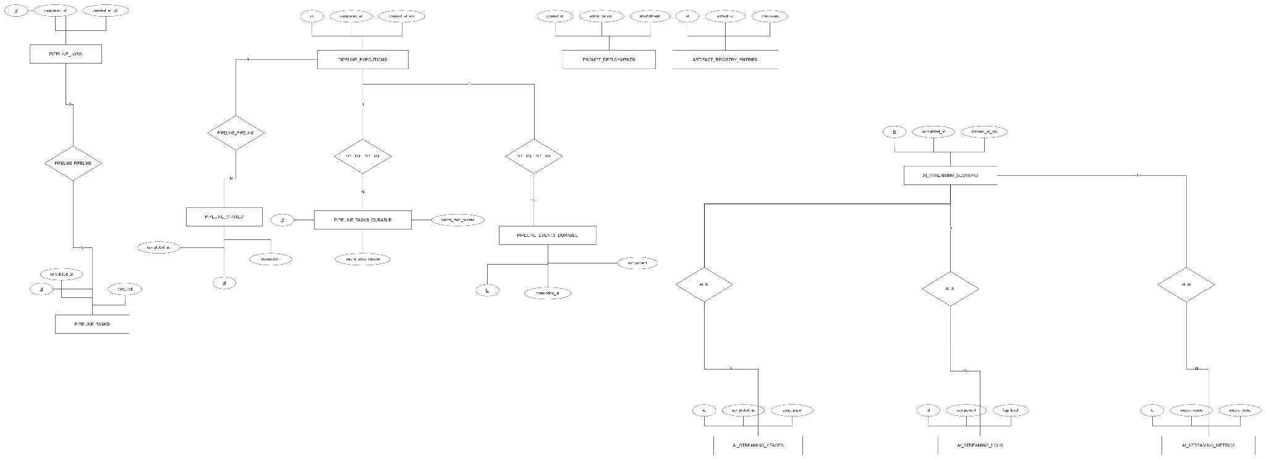

2.2.12: ERD_12_Overview Model of Inter-Module Relationships
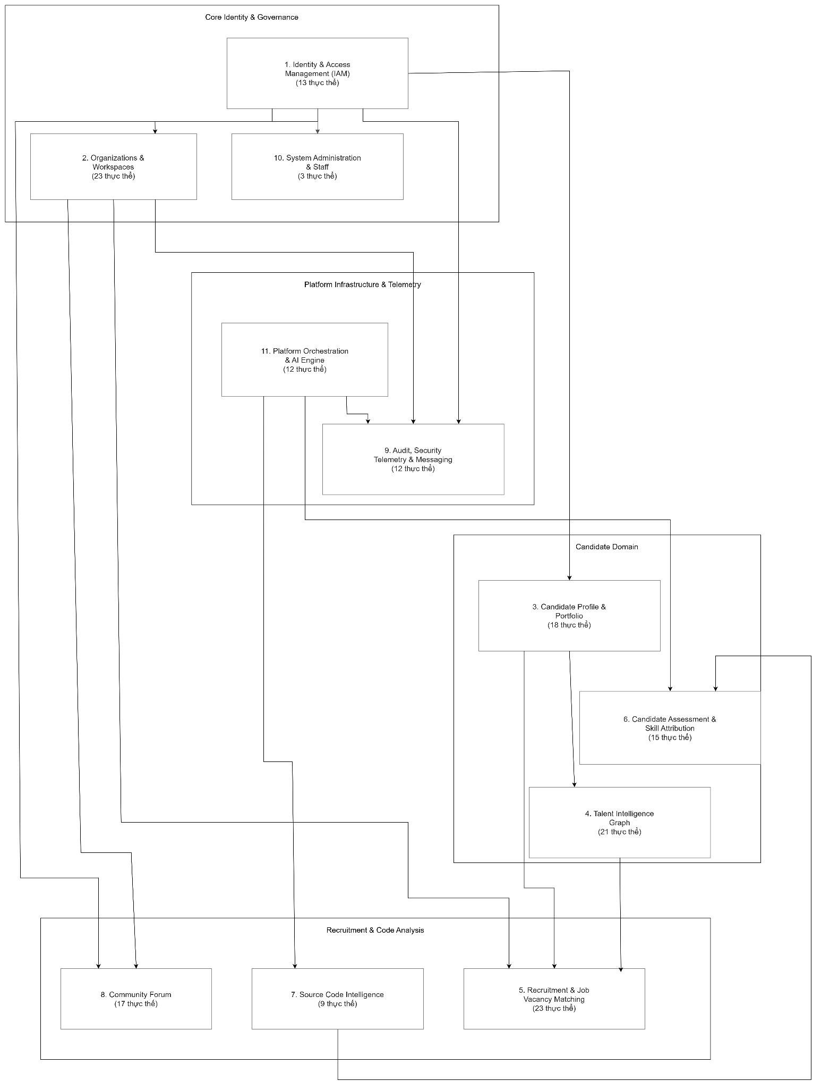

3. User Requirements

3.1 Actors
# | Actor | Type | Description
1 | Guest | Primary | Unregistered users who can browse public job listings, view company profiles, and explore the platform's capabilities without full interactive access.
2 | Candidate | Primary | IT professionals who use the platform as their primary tool to build and manage evidence-based CVs. They link their GitHub/GitLab repositories to undergo technical repository analysis, receive a holistic assessment of their entire CV content, and perform AI-driven matching against job descriptions to ensure eligibility before submitting applications based on their verified Proof-of-Work (PoW).
3 | Business | Primary | A verified entity participating in the recruitment process, structured into two levels: Tier 1 (Standard), providing access to manual recruitment workflows, JD posting, and basic applicant management; and Tier 2 (AI-Native), granting full access to the Intelligence Engine for semantic ATS matching, multi-dimensional candidate scoring, and detailed explainability reports to evaluate candidates based on Proof-of-Work (PoW).
4 | Admin | Primary | Platform governance authority responsible for maintaining system integrity. Responsibilities include auditing Tier 2 verification requests via National Tax API (MST) integration, managing system-wide fraud signals (e.g., repository farming), monitoring AI model token consumption, and auditing platform logs to ensure adherence to data privacy (PDPA) standards.
 | GitHub / GitLab | Secondary | External version control platforms that serve as the primary source of Proof-of-Work evidence. The system communicates with their APIs to retrieve repository metadata, commit histories, contributor statistics, and file trees during the Hybrid 2-Phase Ingestion pipeline. Webhook events from these providers also trigger incremental re-analysis when new commits are pushed to a linked repository.
6 | AI Provider (OpenAI / Anthropic / Google) | Secondary | External large language model services that power the platform's core intelligence features. GPT-4.1 handles Job Description generation via Function Calling, Claude Sonnet 4.5 performs Skill Tree extraction and Gap Analysis, and Gemini 2.5 Flash handles high-throughput repository description tasks. All requests are routed through the Multi-Model Router with circuit-breaker failover and Redis Semantic Cache to manage cost and reliability.
7 | Vietnam Tax Authority API | Secondary | An external national business registry service used during company workspace onboarding to automatically validate submitted Tax Codes (MST) and retrieve verified company metadata for Tier 1 verification. If the API is unavailable, the system falls back to a manual Admin review queue.
8 | Email Service (SMTP Provider) | Secondary | An external mail delivery service responsible for all transactional email communication on the platform, including OTP verification codes, password reset links, workspace invitations, application status notifications, and AI analysis completion alerts. Email dispatch is handled asynchronously through the outbox pattern via Hangfire to ensure reliable delivery with exponential backoff retry logic.
Table 1: Actor description

3.2 Use Cases

3.2.1 Diagram(s)
- Overall System Use Case Diagram
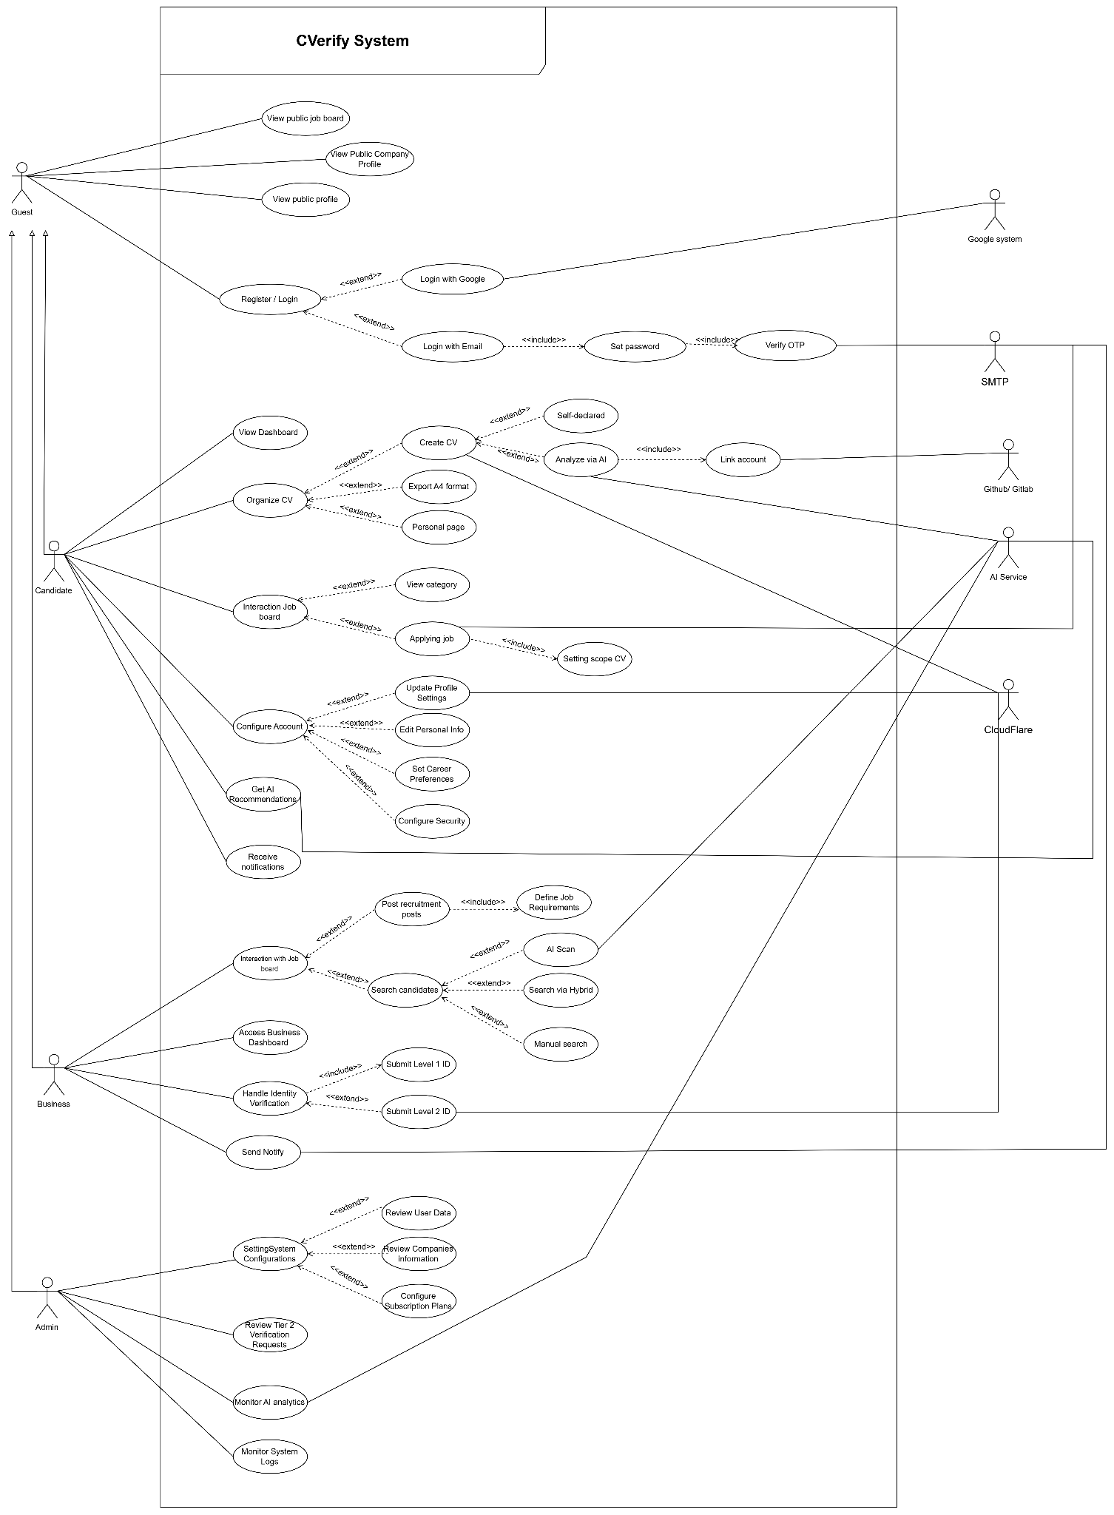

- Authentication & Identity Management System
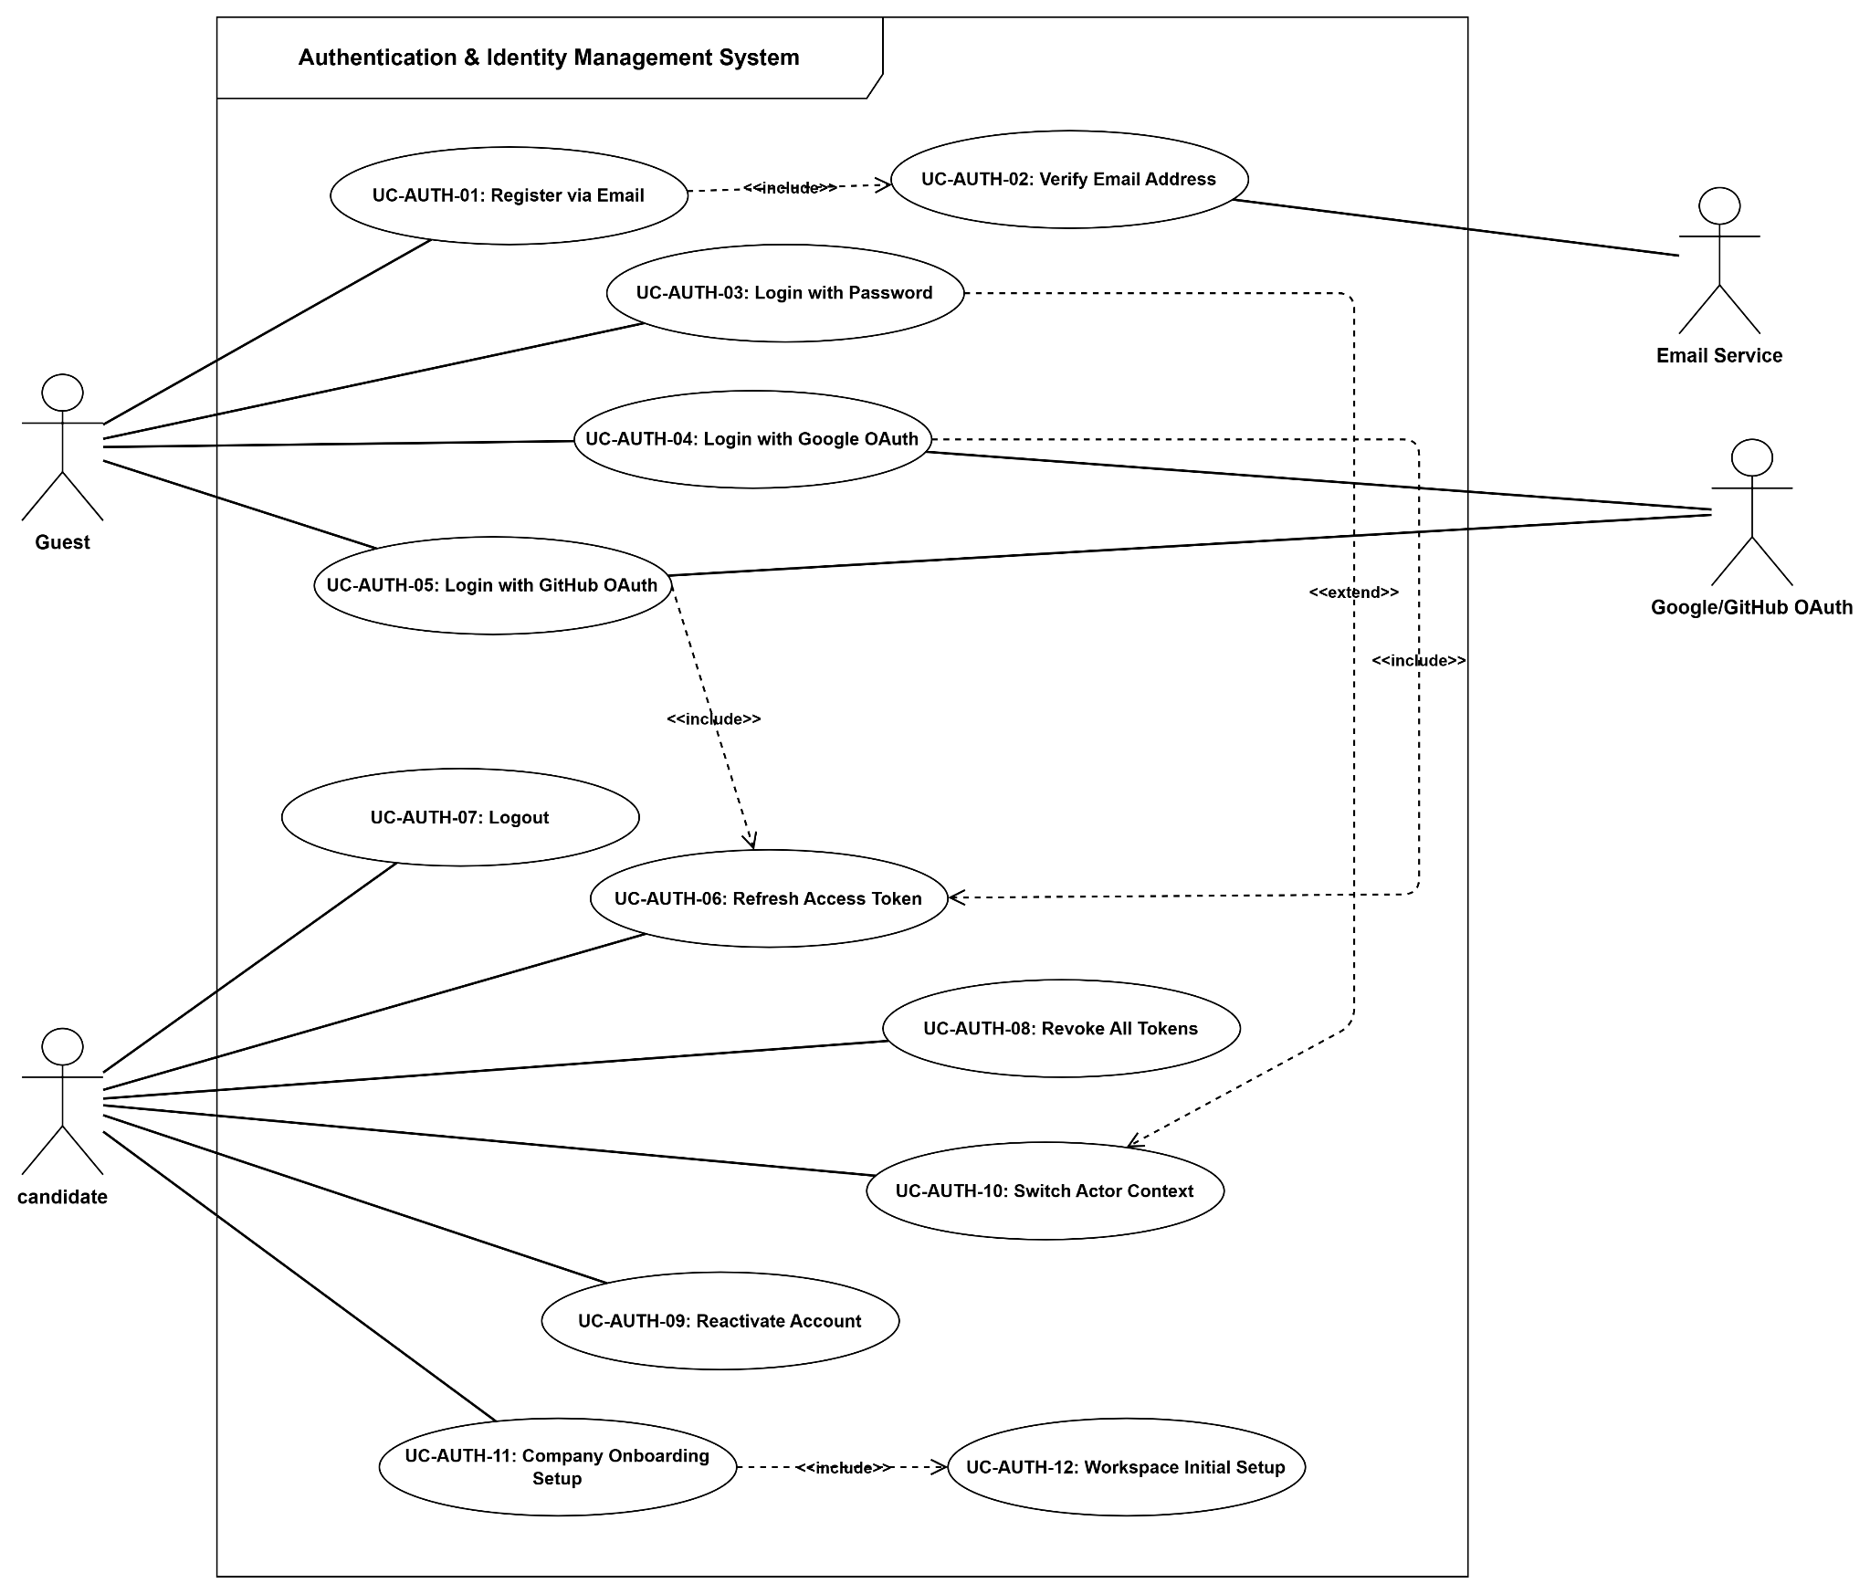

- Account & Organization Recovery System

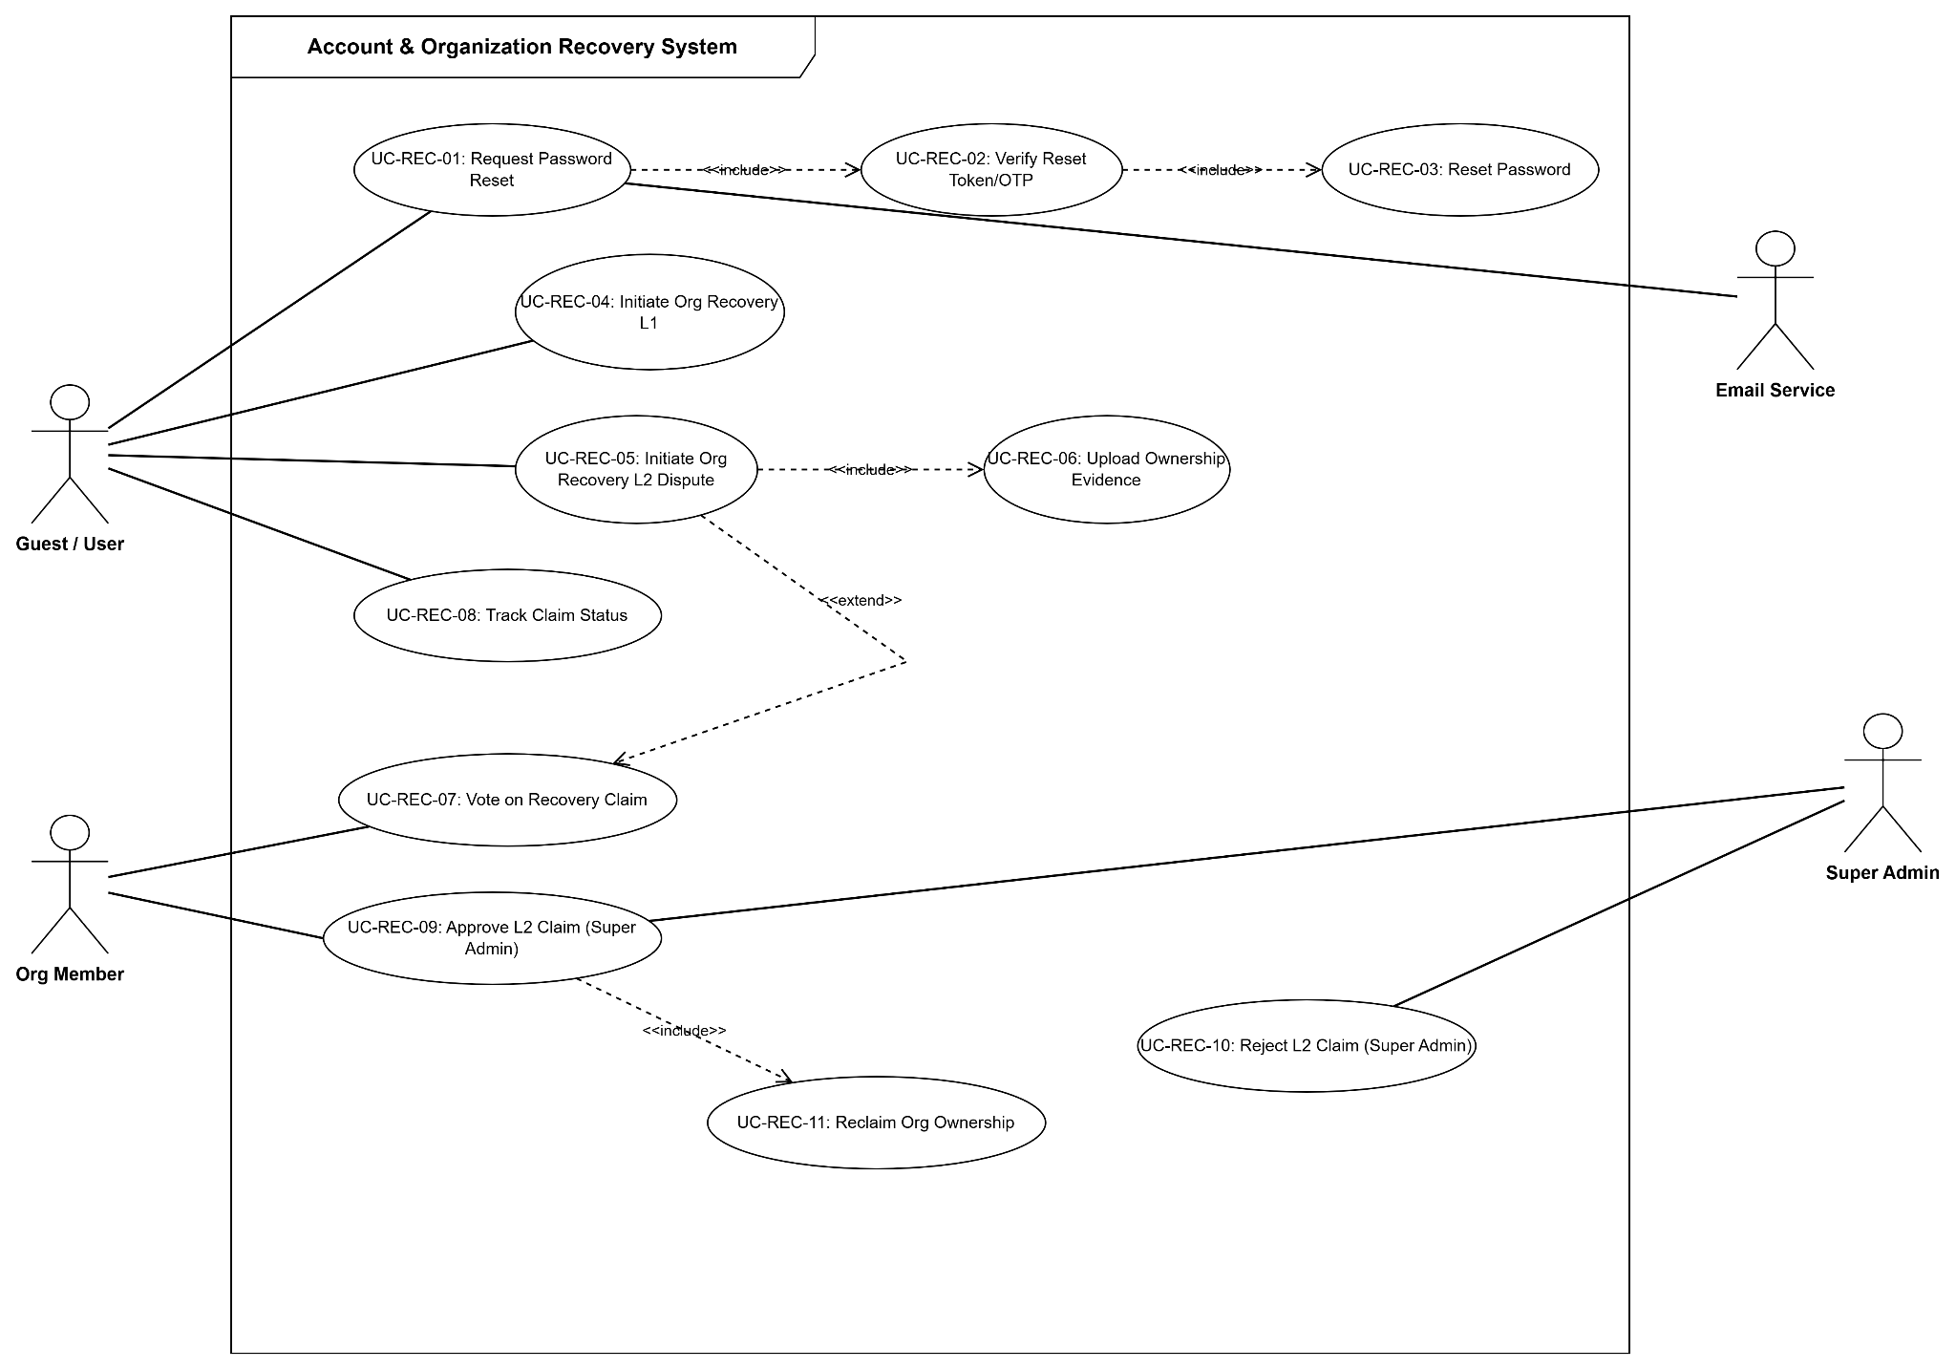

- Organization & Workspace Management System
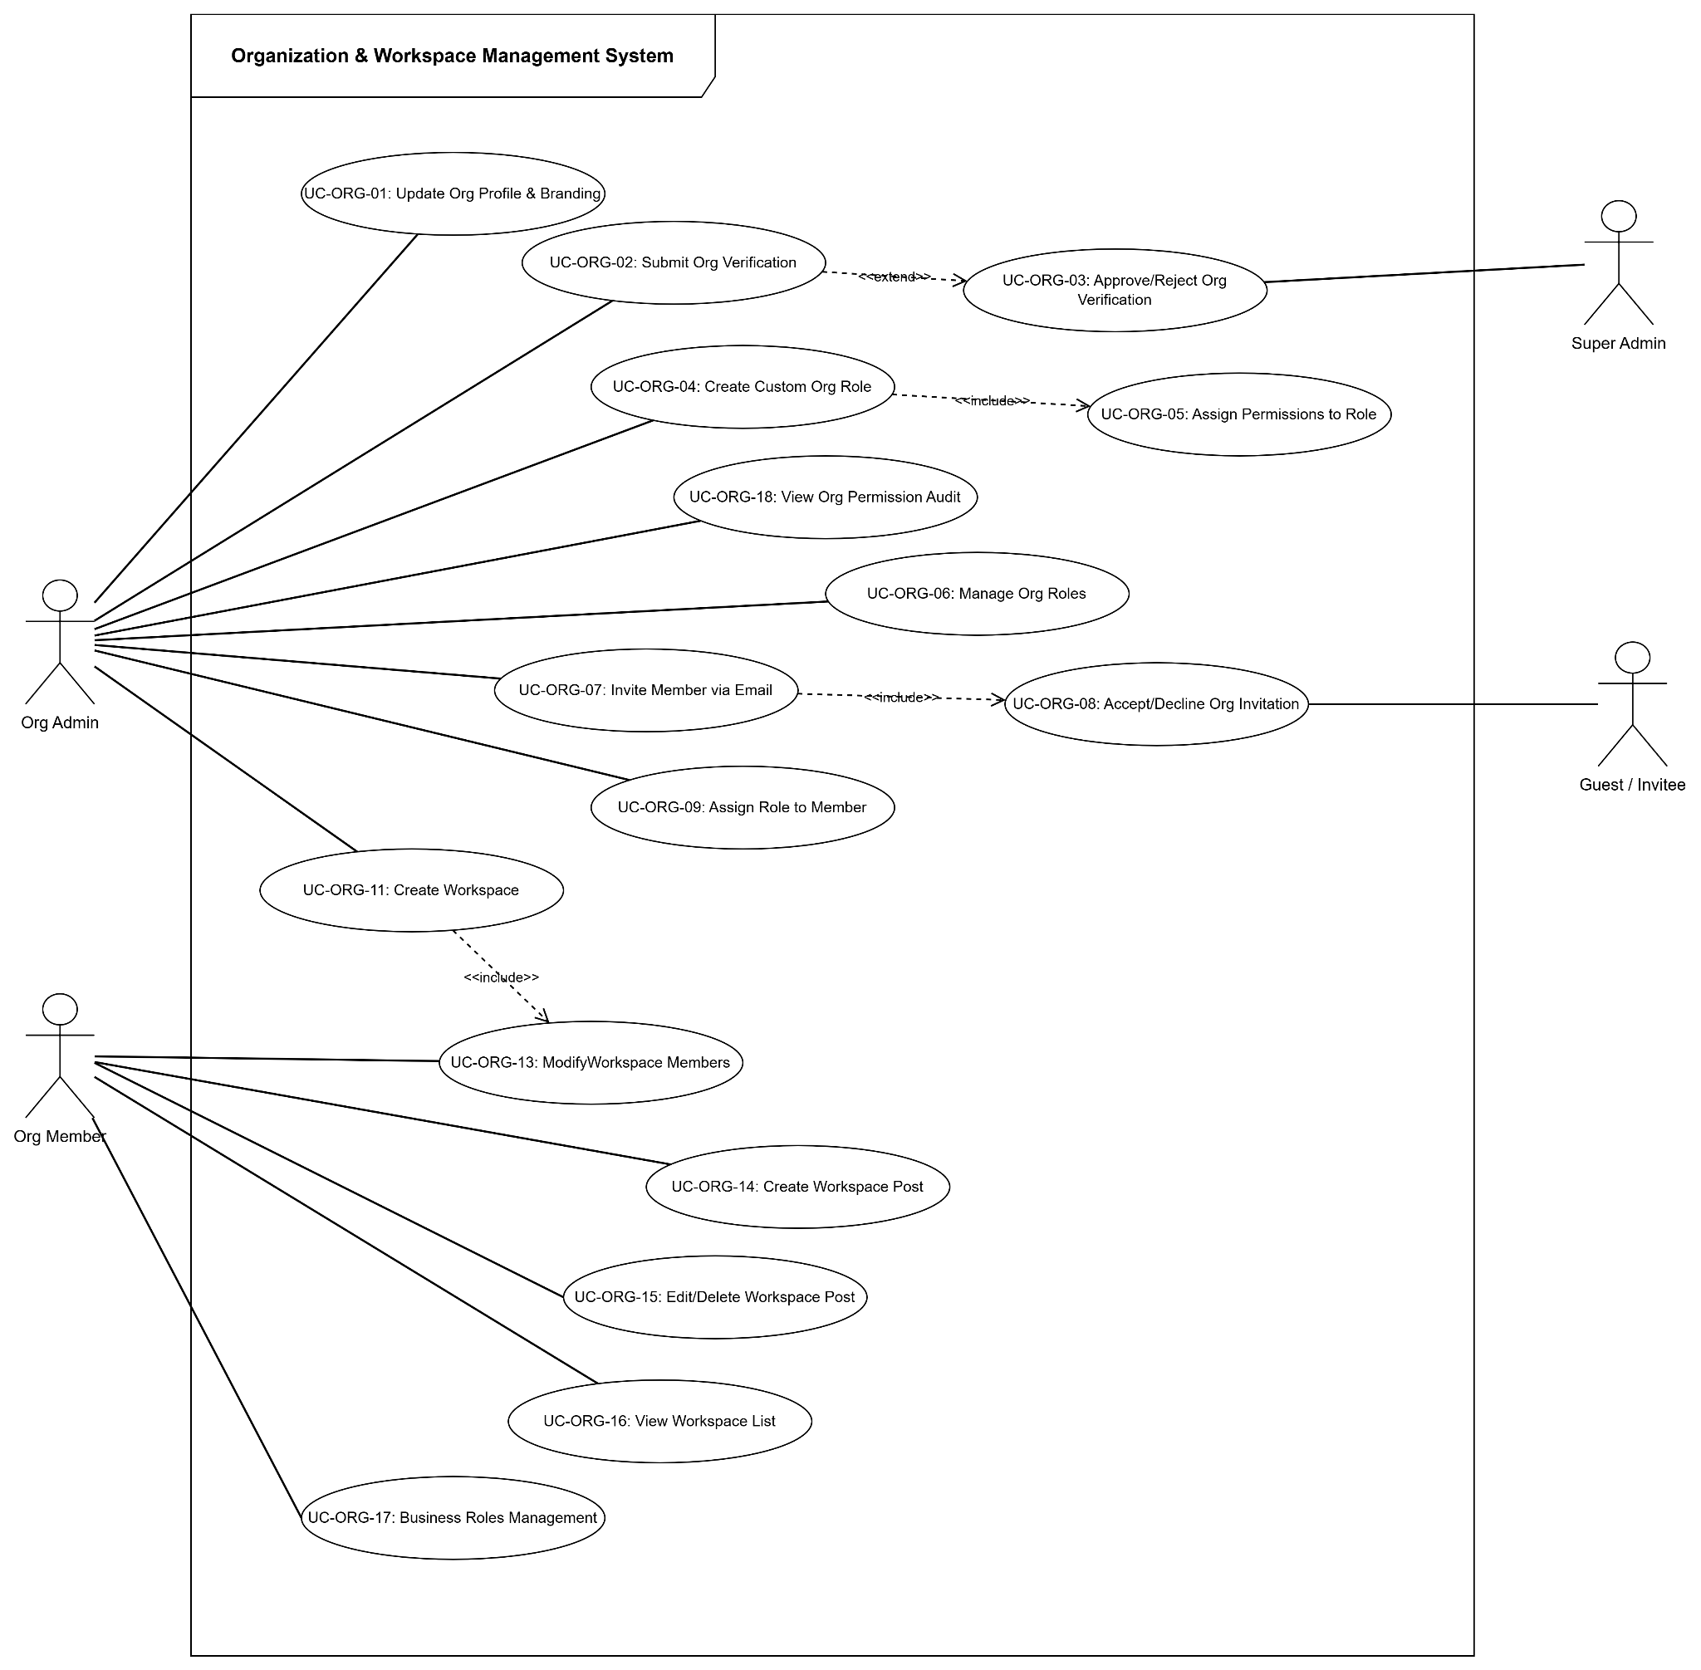

- Candidate Profile & Evidence Verification System
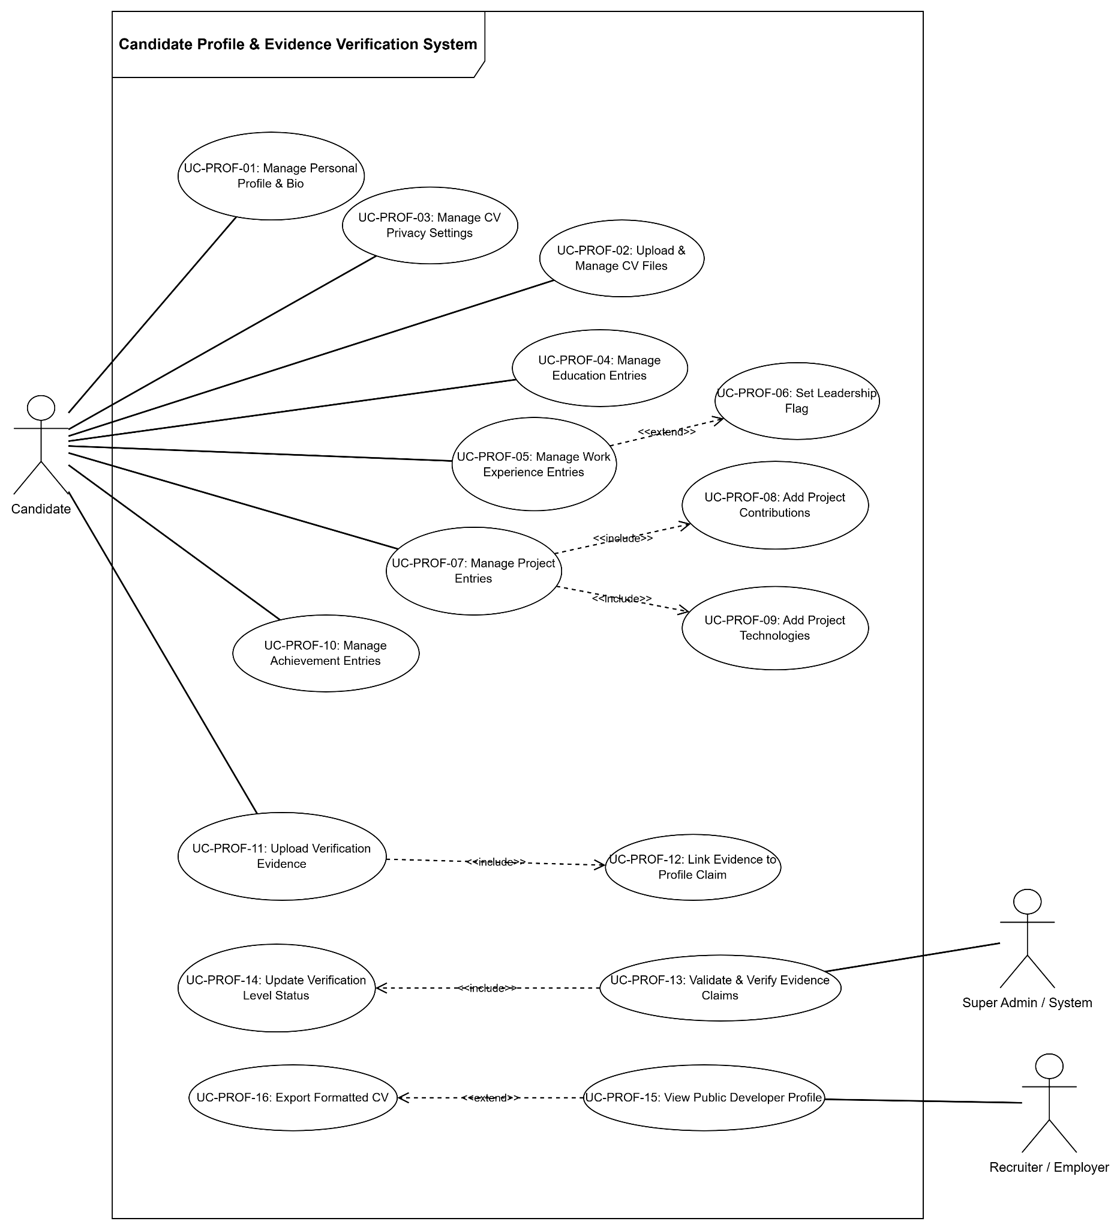

- Source Code & Git Repository Analysis System
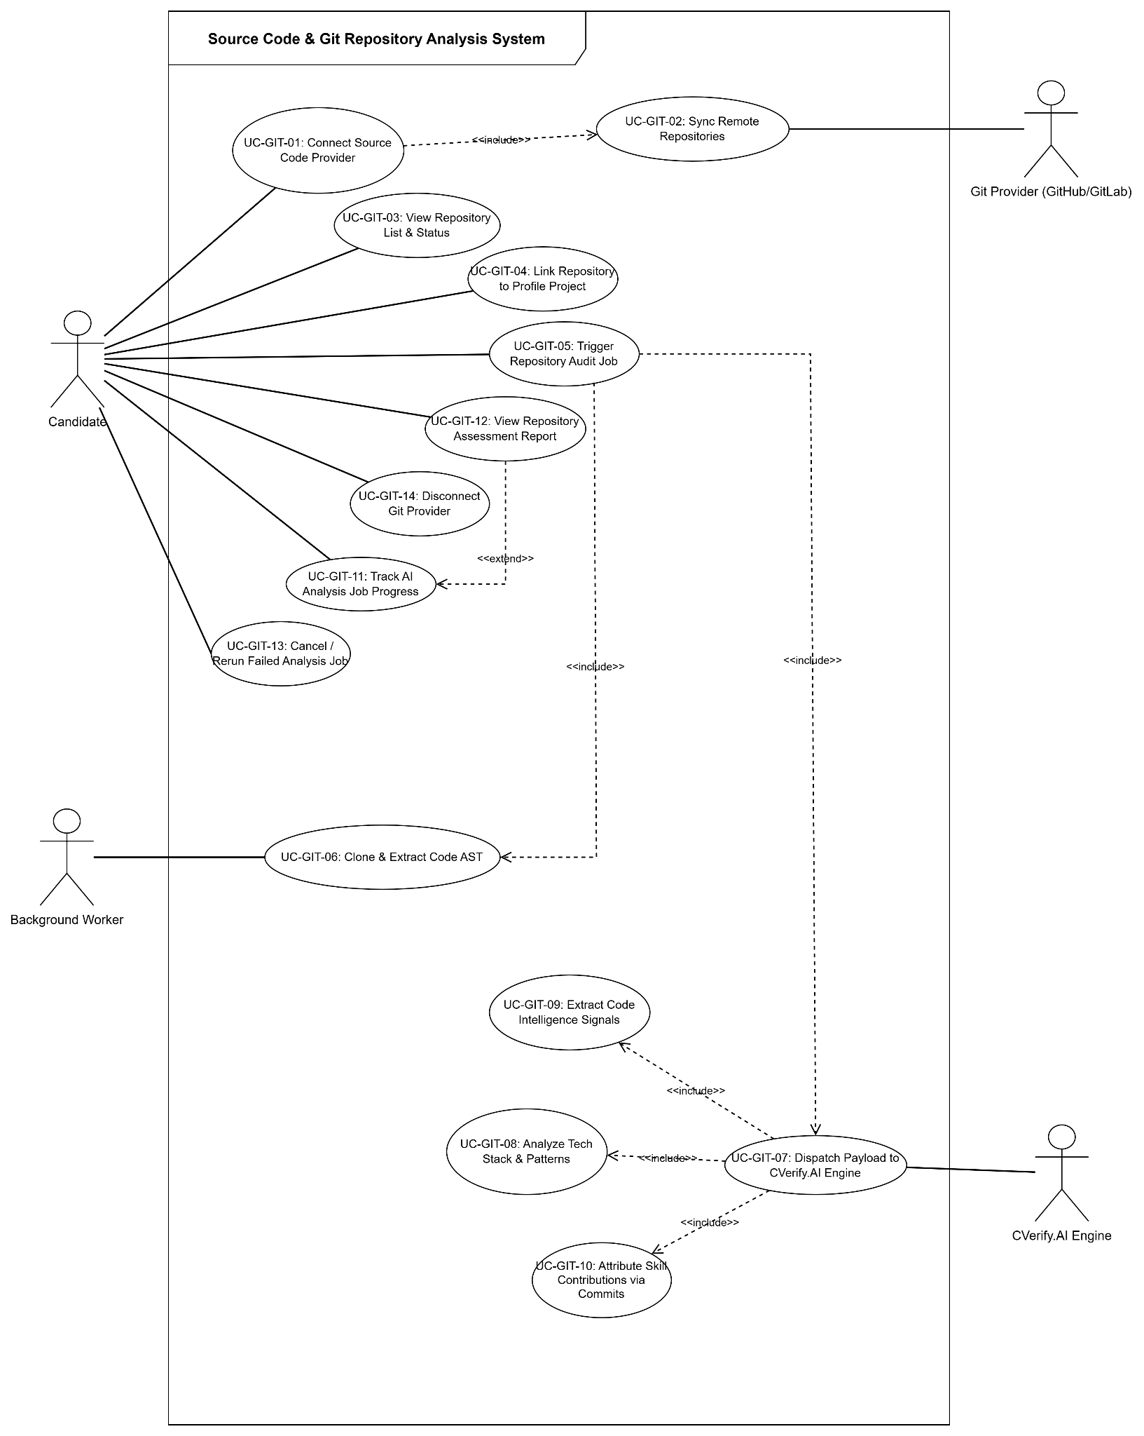

- Candidate AI Assessment & Intelligence System

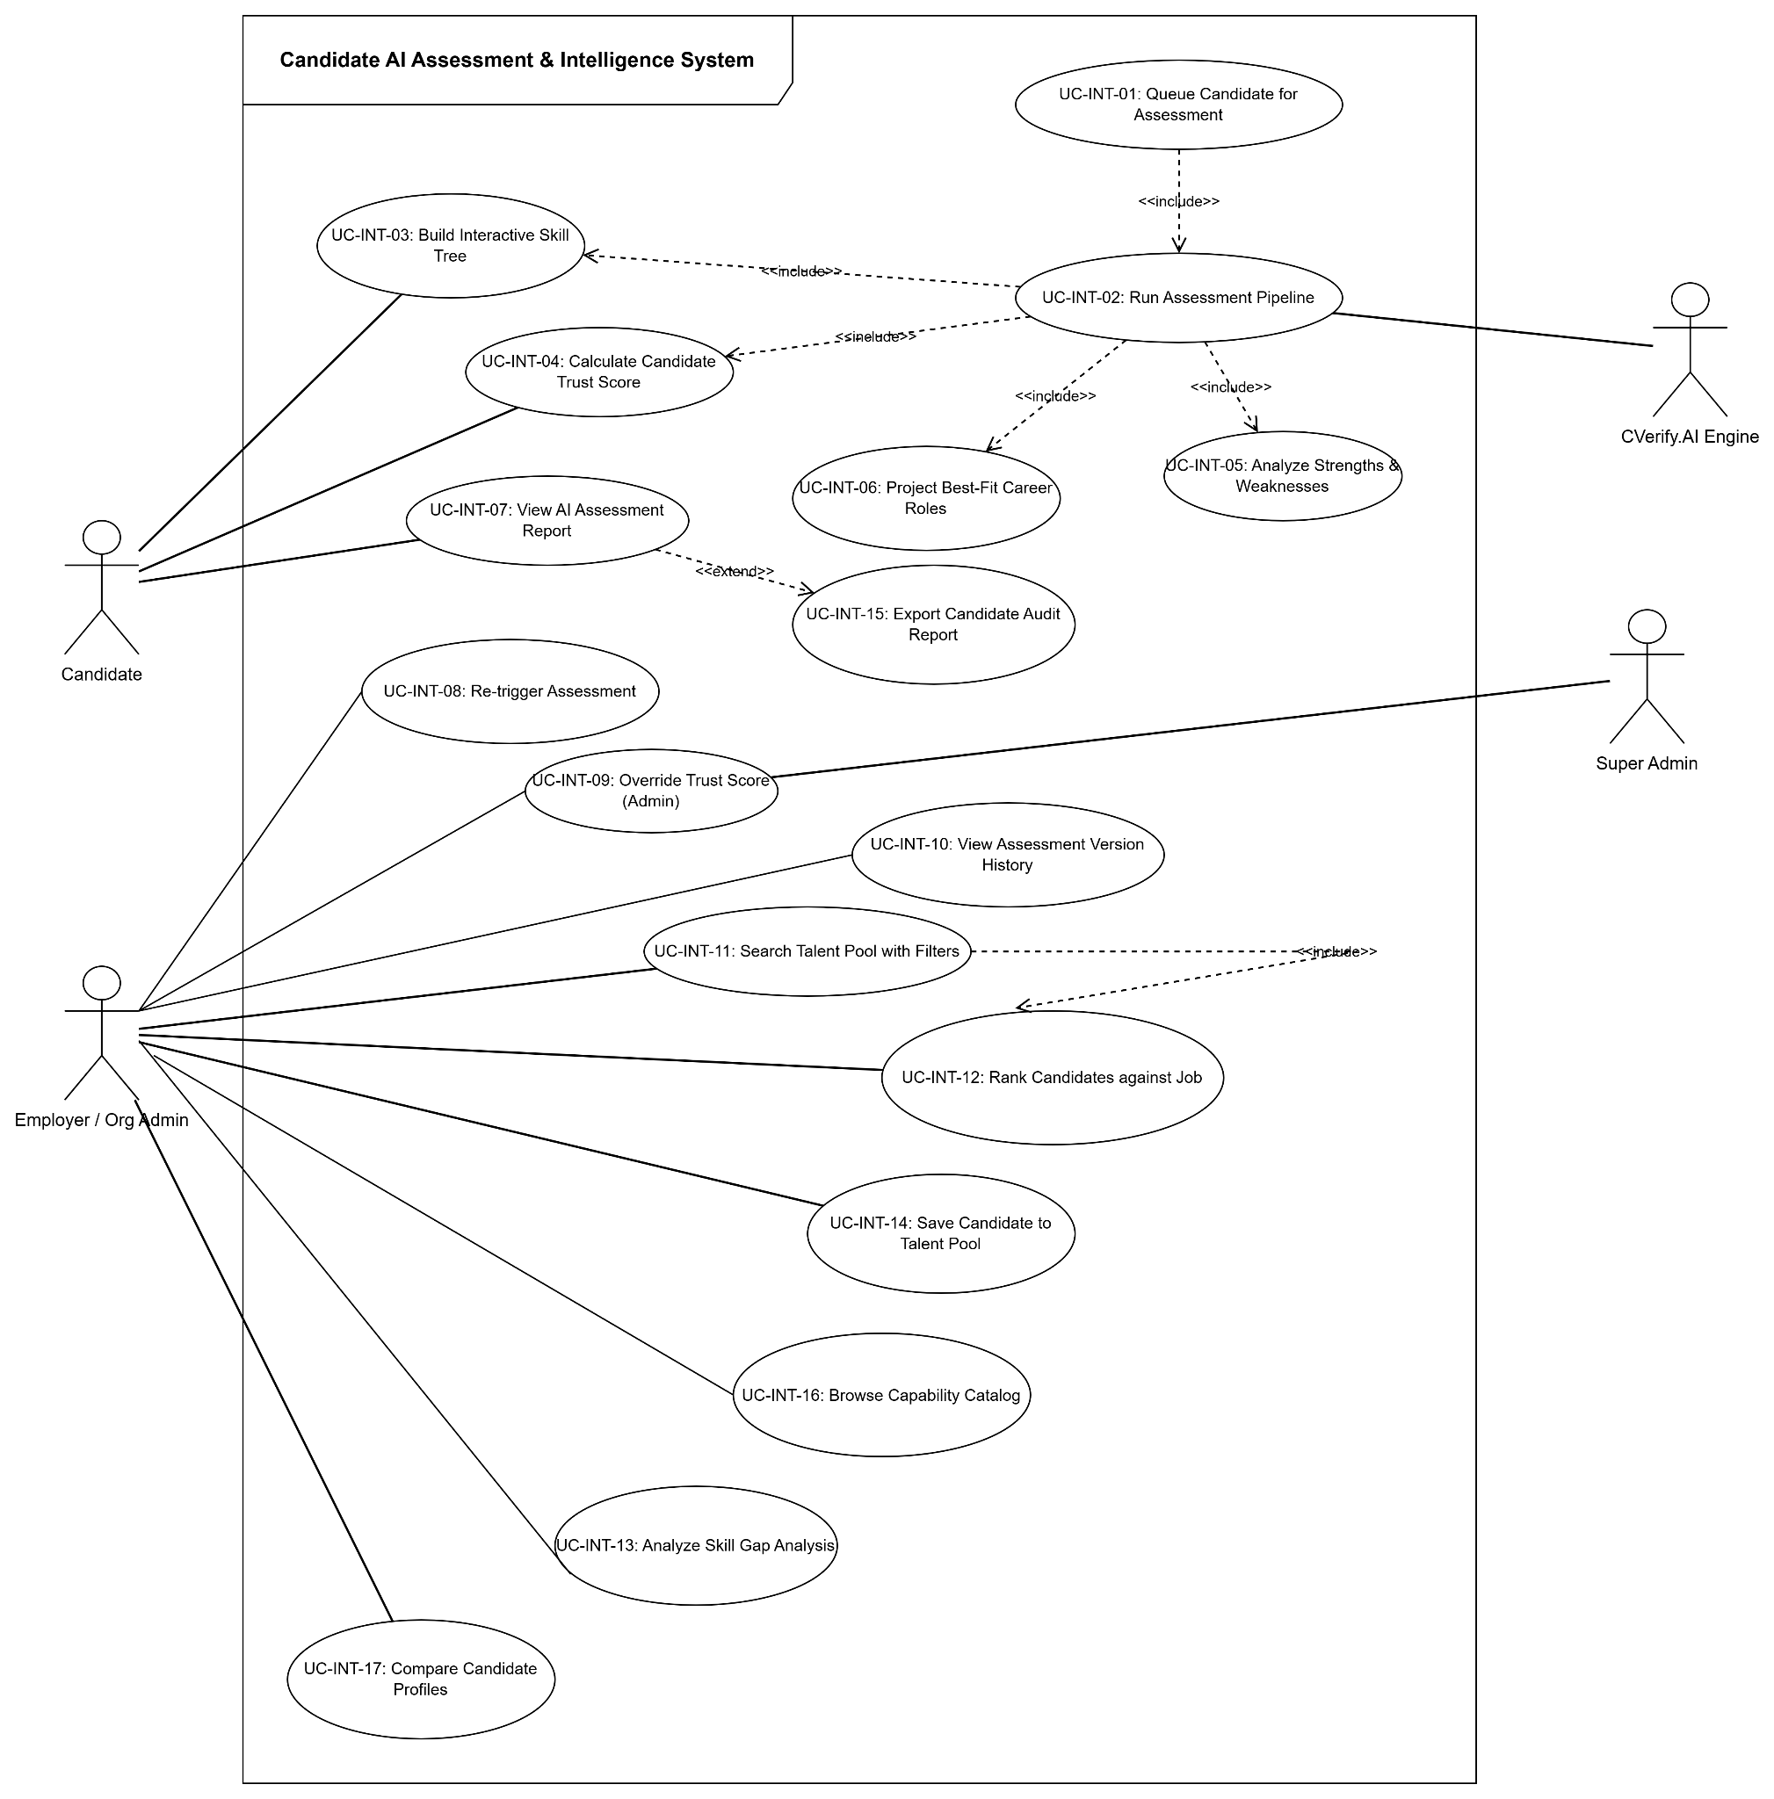

- AI Interactive Chat & Interview Guidance System
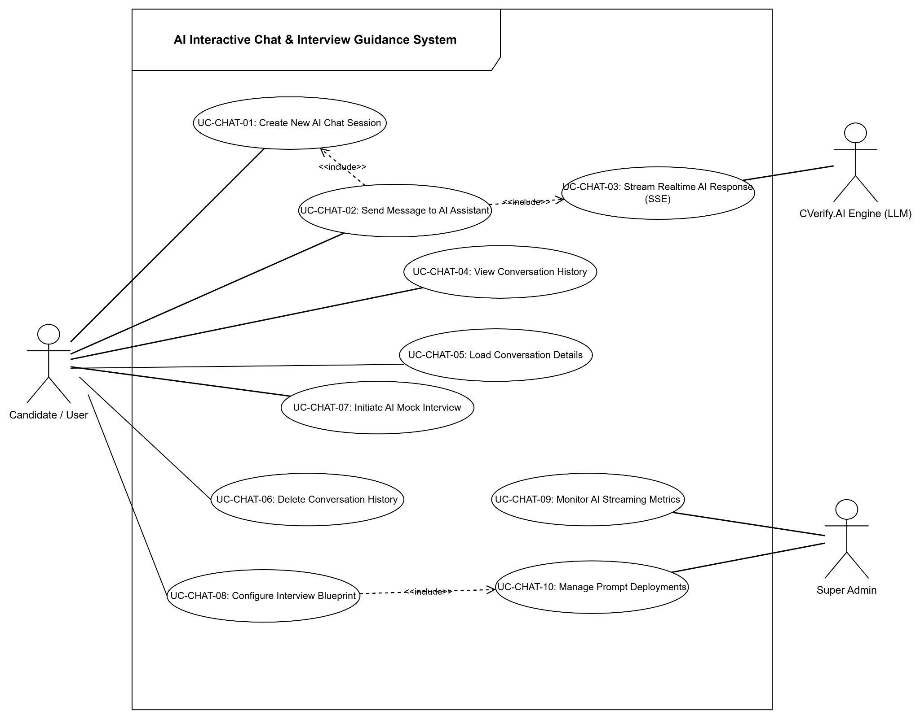

- Recruitment & Job Vacancy Management System
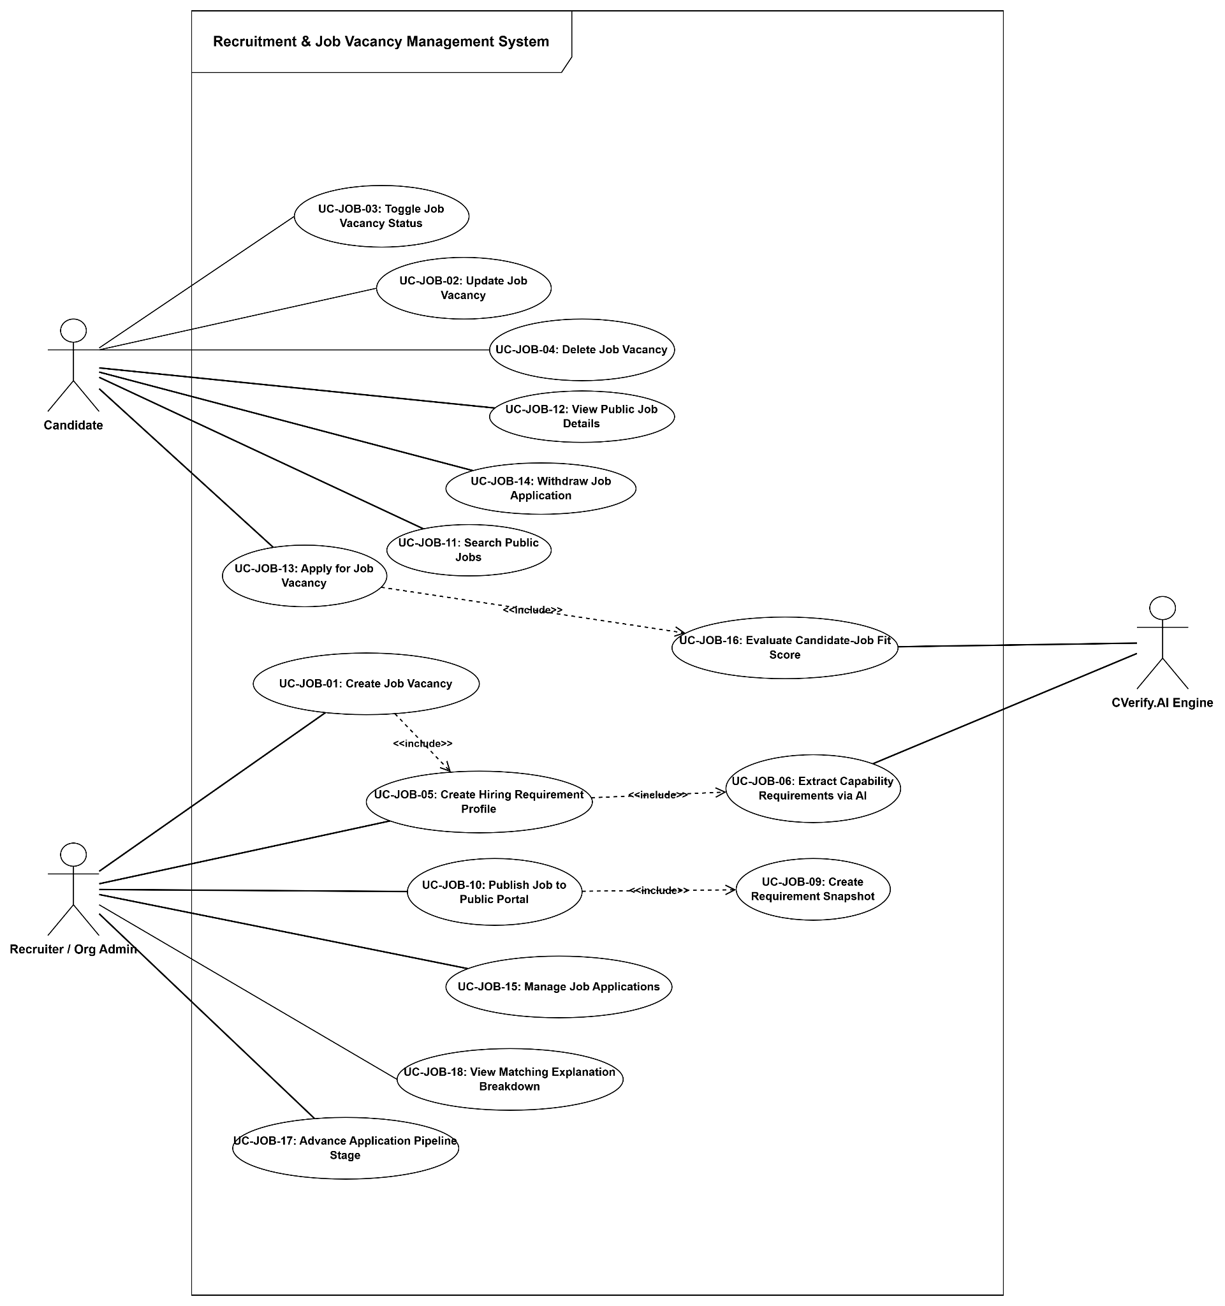

- Community Forum & Moderation System

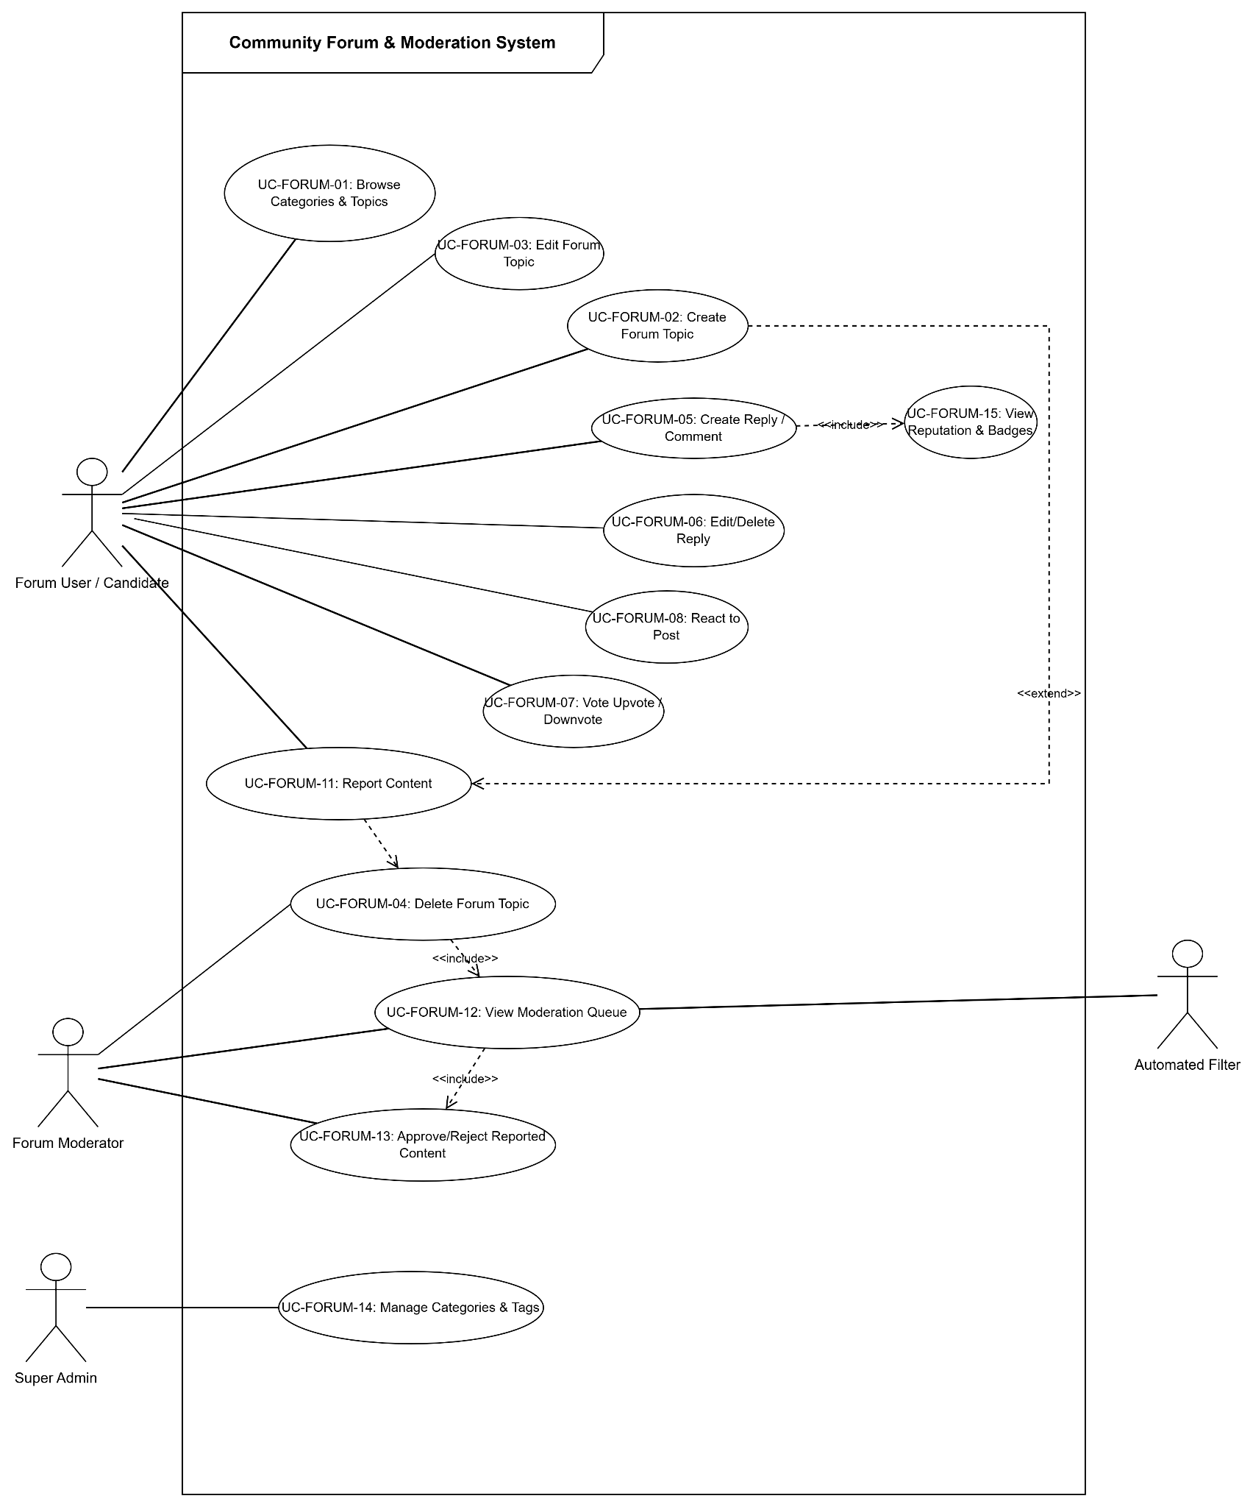

- Notification & Communication System
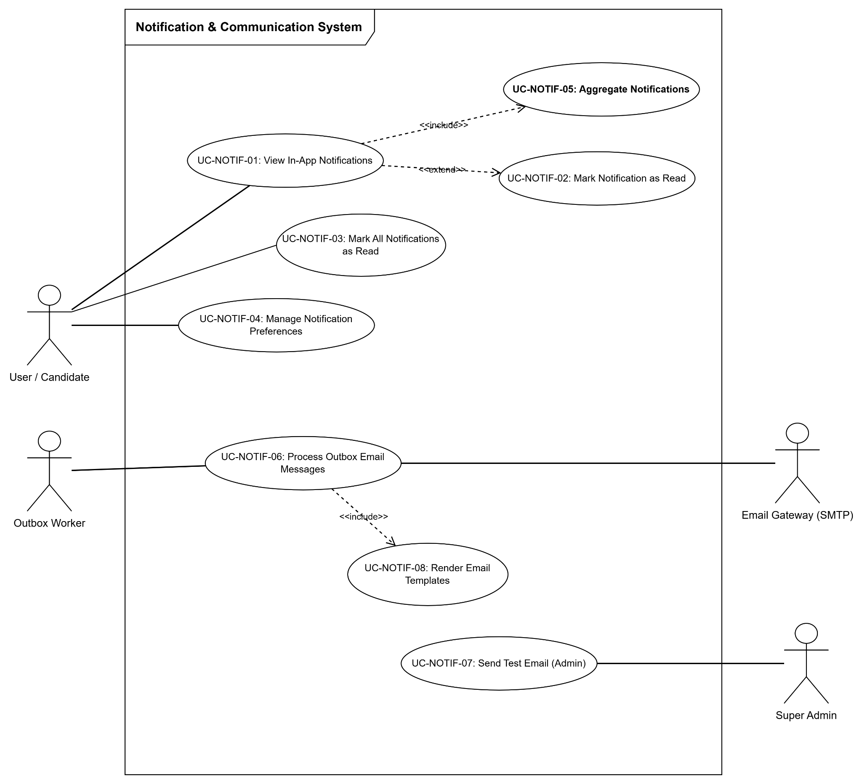

- System Administration & Governance System
- 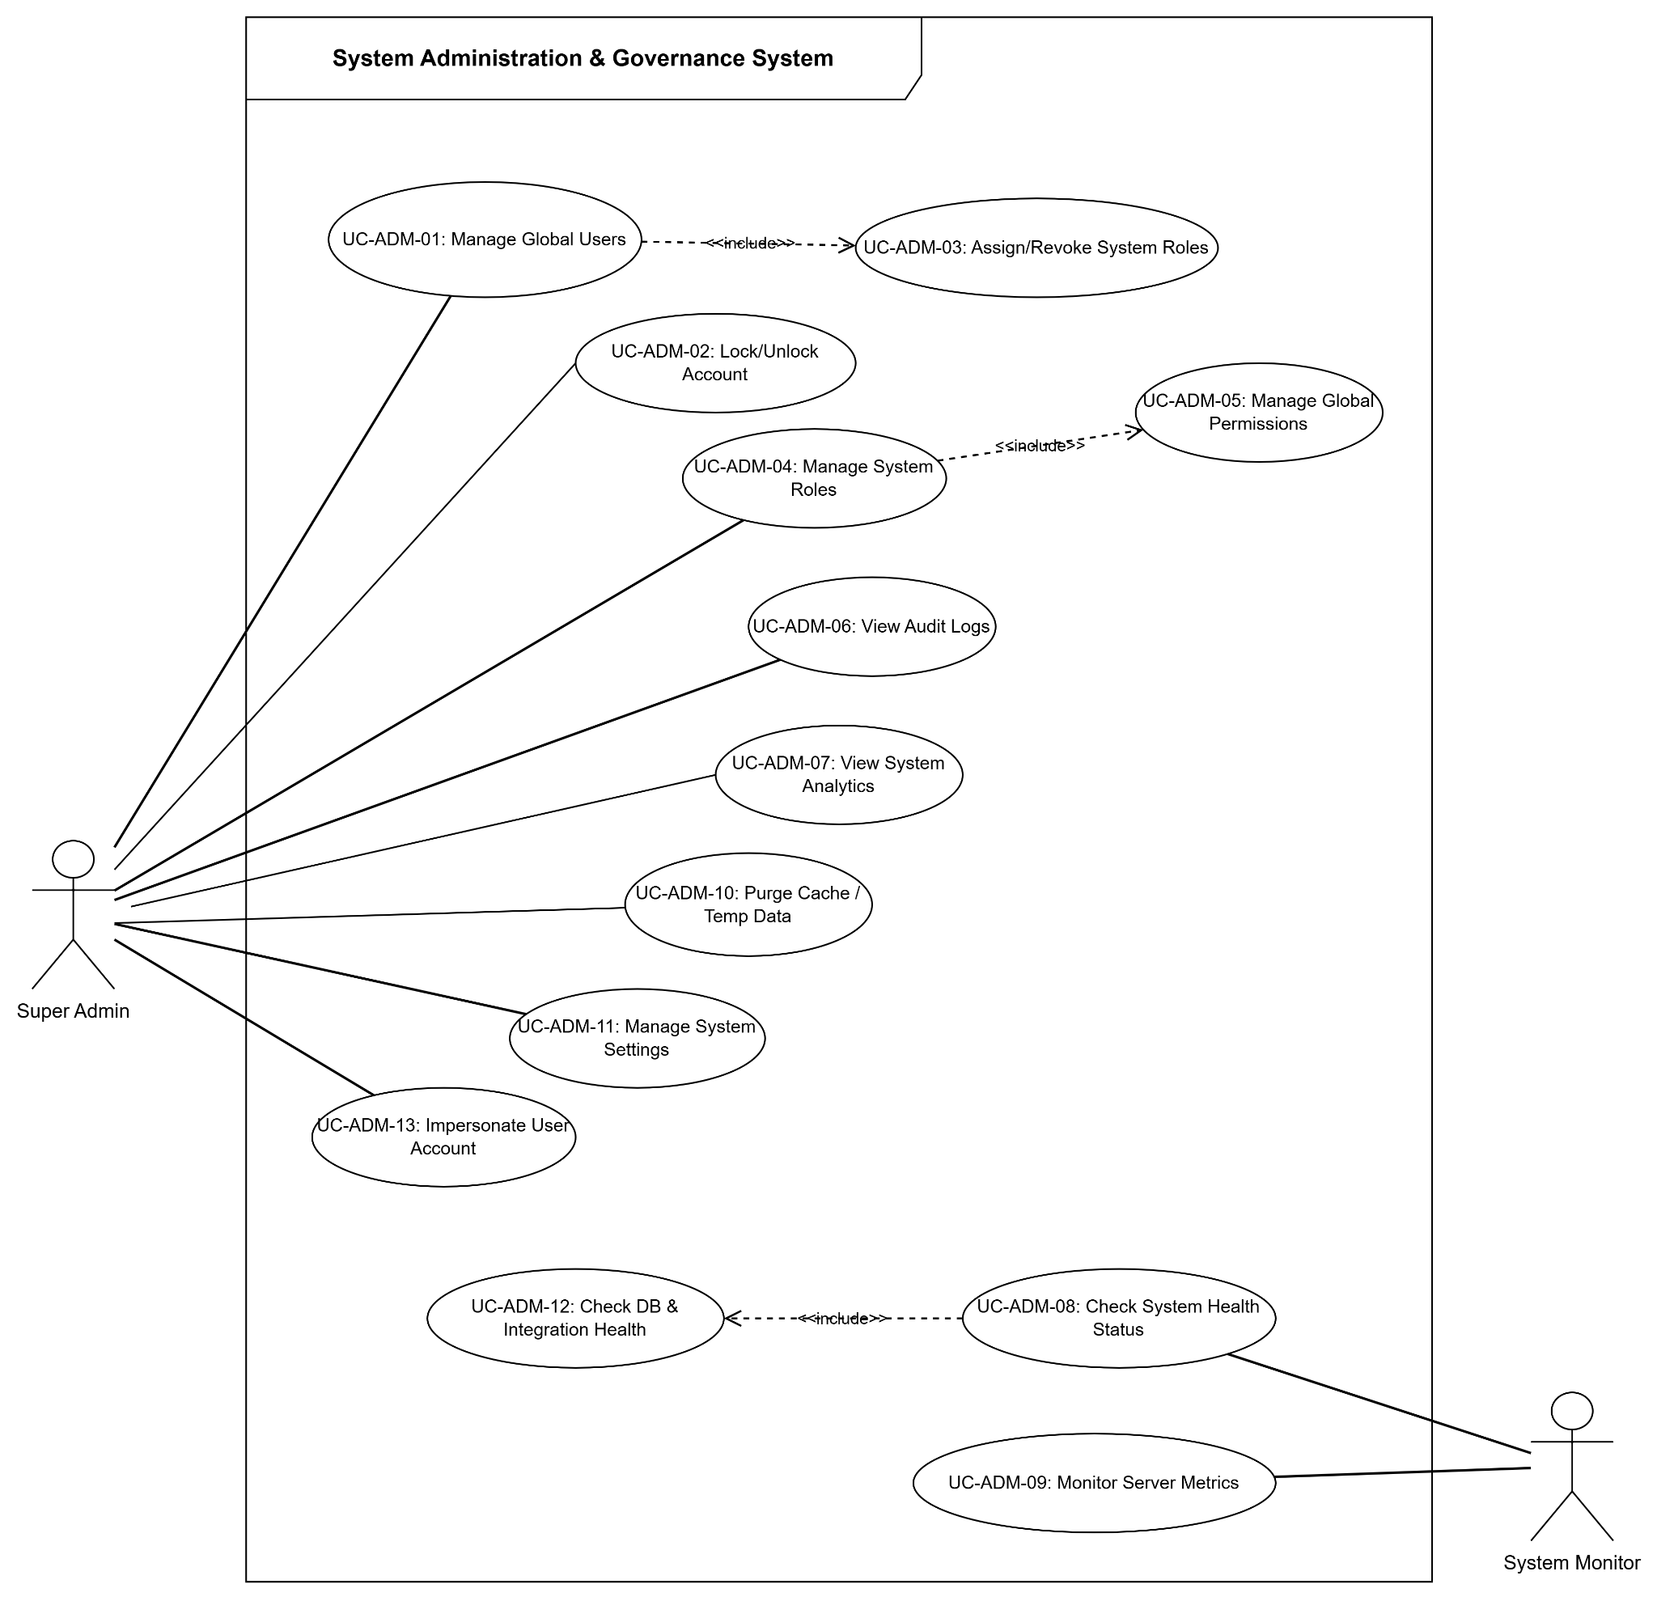

3.2.2 Description Diagram(s)

1. Module Authentication & Identity Management (UCD-01)
ID | Module | Use Case | Actors | Description
UC-AUTH-01 | Auth | Register via Email | Guest, Email Service | Đăng ký tài khoản người dùng mới bằng Email & Password, kích hoạt luồng tự động tạo mã xác minh gửi qua Email.
UC-AUTH-02 | Auth | Verify Email Address | Guest, Email Service | Xác thực địa chỉ email tài khoản thông qua mã OTP hoặc Token xác minh được gửi tới hộp thư người dùng.
UC-AUTH-03 | Auth | Login with Password | Guest | Đăng nhập hệ thống bằng Email và Mật khẩu, nhận về cặp JWT Token (AccessToken & RefreshToken).
UC-AUTH-04 | Auth | Login with Google OAuth | Guest, Google OAuth | Đăng nhập hoặc đăng ký tài khoản nhanh chóng thông qua dịch vụ xác thực Google OAuth 2.0.
UC-AUTH-05 | Auth | Login with GitHub OAuth | Guest, GitHub OAuth | Đăng nhập hoặc đăng ký tài khoản nhanh chóng thông qua dịch vụ xác thực GitHub OAuth 2.0.
UC-AUTH-06 | Auth | Refresh Access Token | User | Cấp lại AccessToken mới bằng RefreshToken hợp lệ còn hạn mà không yêu cầu người dùng nhập lại mật khẩu.
UC-AUTH-07 | Auth | Logout | User | Đăng xuất phiên làm việc hiện tại, thu hồi và vô hiệu hóa RefreshToken tương ứng trên trình duyệt.
UC-AUTH-08 | Auth | Revoke All Tokens | User | Thu hồi toàn bộ RefreshToken đang hoạt động trên tất cả các thiết bị để bảo vệ an toàn tài khoản.
UC-AUTH-09 | Auth | Reactivate Account | User | Khởi chạy luồng kích hoạt lại tài khoản người dùng đã tạm khóa hoặc yêu cầu vô hiệu hóa trước đó.
UC-AUTH-10 | Auth | Switch Actor Context | User | Chuyển đổi ngữ cảnh quyền hạn làm việc linh hoạt giữa Hồ sơ cá nhân (Candidate) và Hồ sơ Doanh nghiệp (Organization).
UC-AUTH-11 | Auth | Company Onboarding Setup | User | Khởi tạo thông tin Doanh nghiệp ban đầu cho nhà tuyển dụng (Tên công ty, Username, Thông tin liên hệ).
UC-AUTH-12 | Auth | Workspace Initial Setup | User | Khởi tạo Không gian làm việc (Workspace) mặc định đi kèm trong quá trình thiết lập Doanh nghiệp mới.

2. Module Account & Organization Recovery (UCD-02)
ID | Module | Use Case | Actors | Description
UC-REC-01 | Recovery | Request Password Reset | Guest / User, Email Service | Yêu cầu khôi phục mật khẩu khi bị quên, hệ thống khởi tạo Token khôi phục và gửi email chứa liên kết đặt lại.
UC-REC-02 | Recovery | Verify Reset Token/OTP | Guest / User | Kiểm tra tính hợp lệ và thời gian hiệu lực của Token/OTP đặt lại mật khẩu trước khi cho phép nhập mật khẩu mới.
UC-REC-03 | Recovery | Reset Password | Guest / User | Tiến hành cập nhật mật khẩu mới cho tài khoản sau khi xác minh Token khôi phục thành công.
UC-REC-04 | Recovery | Initiate Org Recovery L1 | Guest / User | Khởi tạo yêu cầu khôi phục quyền sở hữu Doanh nghiệp Cấp 1 thông qua email quản trị Master cũ.
UC-REC-05 | Recovery | Initiate Org Recovery L2 Dispute | Guest / User | Tạo yêu cầu tranh chấp quyền sở hữu Doanh nghiệp Cấp 2 khi tài khoản Master bị chiếm đoạt hoặc mất truy cập.
UC-REC-06 | Recovery | Upload Ownership Evidence | Guest / User | Tải lên các tài liệu bằng chứng pháp lý (Giấy ĐKKD, dấu bản quyền, ủy quyền) để chứng minh quyền sở hữu Doanh nghiệp.
UC-REC-07 | Recovery | Vote on Recovery Claim | Org Member | Các thành viên hiện hữu trong Doanh nghiệp tiến hành bỏ phiếu đồng thuận để khôi phục quyền Master cho người yêu cầu.
UC-REC-08 | Recovery | Track Claim Status | Guest / User | Theo dõi tiến trình xử lý, kết quả bỏ phiếu và trạng thái xét duyệt yêu cầu khôi phục Doanh nghiệp.
UC-REC-09 | Recovery | Approve L2 Claim (Super Admin) | Super Admin | Super Admin thẩm định bằng chứng pháp lý và phê duyệt yêu cầu khôi phục, trao lại quyền Ownership cho Doanh nghiệp.
UC-REC-10 | Recovery | Reject L2 Claim (Super Admin) | Super Admin | Super Admin từ chối yêu cầu khôi phục Doanh nghiệp Level 2 nếu phát hiện bằng chứng giả mạo hoặc không hợp lệ.
UC-REC-11 | Recovery | Reclaim Org Ownership | Guest / User | Hoàn tất tiếp nhận và khôi phục lại quyền quản trị Master Admin vào Doanh nghiệp.

3. Module Organization & Workspace Management (UCD-03)
ID | Module | Use Case | Actors | Description
UC-ORG-01 | Auth, Shared | Update Org Profile & Branding | Org Admin | Cập nhật thông tin công ty, logo, mô tả, website, giá trị cốt lõi và thương hiệu Doanh nghiệp.
UC-ORG-02 | Auth, Shared | Submit Org Verification | Org Admin | Gửi hồ sơ và giấy phép đăng ký kinh doanh yêu cầu Super Admin xác minh Doanh nghiệp chính thức.
UC-ORG-03 | Auth, Shared | Approve/Reject Org Verification | Super Admin | Super Admin xem xét thẩm định và phê duyệt hoặc từ chối trạng thái xác minh Doanh nghiệp.
UC-ORG-04 | Auth, Shared | Create Custom Org Role | Org Admin | Tạo các vai trò tùy chỉnh nội bộ trong Doanh nghiệp (vd: Senior Recruiter, Team Leader, HR Manager).
UC-ORG-05 | Auth, Shared | Assign Permissions to Role | Org Admin | Gán danh mục các chuỗi quyền hạn (Permission strings) chi tiết cho từng vai trò Doanh nghiệp.
UC-ORG-06 | Auth, Shared | Manage Org Roles | Org Admin | Quản lý, xem danh sách, cập nhật thông tin hoặc xóa các vai trò nội bộ Doanh nghiệp.
UC-ORG-07 | Auth, Shared | Invite Member via Email | Org Admin | Gửi thư mời tham gia Doanh nghiệp tới địa chỉ email của thành viên / nhân sự mới.
UC-ORG-08 | Auth, Shared | Accept/Decline Org Invitation | Guest / Invitee | Người được mời chấp nhận hoặc từ chối lời mời tham gia vào Doanh nghiệp.
UC-ORG-09 | Auth, Shared | Assign Role to Member | Org Admin | Phân bổ vai trò công việc và quyền hạn phù hợp cho từng thành viên trong Doanh nghiệp.
UC-ORG-10 | Auth, Shared | Manage/Remove Member | Org Admin | Quản lý trạng thái hoạt động hoặc xóa thành viên ra khỏi Doanh nghiệp khi nghỉ việc.
UC-ORG-11 | Auth, Shared | Create Workspace | Org Admin | Khởi tạo Không gian làm việc / Phòng ban mới trong Doanh nghiệp để quản lý dự án & tuyển dụng.
UC-ORG-12 | Auth, Shared | Manage Workspace Settings | Org Admin | Cấu hình cài đặt, thay đổi thông tin và thiết lập quyền riêng tư của Không gian làm việc.
UC-ORG-13 | Auth, Shared | Manage Workspace Members | Org Member | Thêm hoặc xóa thành viên tham gia trực tiếp vào Không gian làm việc cụ thể.
UC-ORG-14 | Auth, Shared | Create Workspace Post | Org Member | Đăng bài viết, tin tức, tài liệu hoặc thông báo nội bộ trong Không gian làm việc.
UC-ORG-15 | Auth, Shared | Edit/Delete Workspace Post | Org Member | Chỉnh sửa nội dung hoặc xóa bài viết nội bộ do chính mình tạo trong Workspace.
UC-ORG-16 | Auth, Shared | View Workspace List | Org Member | Xem danh sách các Không gian làm việc mà mình có quyền truy cập trong Doanh nghiệp.
UC-ORG-17 | Auth, Shared | Business Roles Management | Org Admin | Quản lý danh mục chức danh vị trí công việc chuyên môn trong tổ chức (Business Roles).
UC-ORG-18 | Auth, Shared | View Org Permission Audit | Org Admin | Tra cứu nhật ký kiểm toán phân quyền và lịch sử thay đổi truy cập trong Doanh nghiệp.

4. Module Candidate Profile & Evidence Verification (UCD-04)
ID | Module | Use Case | Actors | Description
UC-PROF-01 | Profiles | Manage Personal Profile & Bio | Candidate | Cập nhật thông tin cá nhân, ảnh đại diện, tiêu đề nghề nghiệp, tiểu sử và liên kết mạng xã hội.
UC-PROF-02 | Profiles | Upload & Manage CV Files | Candidate | Tải lên các file CV (PDF/DOCX), quản lý danh sách CV và cấu hình CV mặc định.
UC-PROF-03 | Profiles | Manage CV Privacy Settings | Candidate | Cấu hình cài đặt quyền riêng tư hồ sơ: Cho phép tìm kiếm công khai hoặc ẩn CV với Nhà tuyển dụng.
UC-PROF-04 | Profiles | Manage Education Entries | Candidate | Thêm, sửa, xóa thông tin quá trình học vấn, trường đại học, bằng cấp và chuyên ngành đào tạo.
UC-PROF-05 | Profiles | Manage Work Experience Entries | Candidate | Thêm, sửa, xóa lịch sử kinh nghiệm làm việc tại các công ty, vị trí đảm nhiệm và thời gian công tác.
UC-PROF-06 | Profiles | Set Leadership Flag | Candidate | Đánh dấu thông tin các mốc kinh nghiệm có đảm nhận vị trí Lãnh đạo / Quản lý đội ngũ (Leadership).
UC-PROF-07 | Profiles | Manage Project Entries | Candidate | Thêm, sửa, xóa thông tin các dự án thực tế đã tham gia làm việc.
UC-PROF-08 | Profiles | Add Project Contributions | Candidate | Mô tả chi tiết các công việc, đóng góp cụ thể và kết quả đạt được trong từng dự án.
UC-PROF-09 | Profiles | Add Project Technologies | Candidate | Gắn danh mục các công nghệ, ngôn ngữ lập trình, framework đã sử dụng trong dự án.
UC-PROF-10 | Profiles | Manage Achievement Entries | Candidate | Thêm, sửa, xóa các thành tựu, giải thưởng cuộc thi hoặc chứng chỉ chuyên môn đã đạt được.
UC-PROF-11 | Profiles | Upload Verification Evidence | Candidate | Tải lên tài liệu bằng chứng minh chứng (Bằng tốt nghiệp, chứng chỉ, hợp đồng, xác nhận công tác).
UC-PROF-12 | Profiles | Link Evidence to Profile Claim | Candidate | Liên kết tài liệu bằng chứng đã tải lên với từng mục Kinh nghiệm làm việc hoặc Dự án cụ thể.
UC-PROF-13 | Profiles | Validate & Verify Evidence Claims | Super Admin / System | Hệ thống hoặc Admin thực hiện thẩm định tính chính xác và hợp lệ của bằng chứng tải lên.
UC-PROF-14 | Profiles | Update Verification Level Status | Super Admin / System | Tự động nâng hoặc cập nhật cấp độ uy tín dữ liệu hồ sơ ứng viên (Verification Level 0 -> Level 3).
UC-PROF-15 | Profiles | View Public Developer Profile | Recruiter / Employer | Nhà tuyển dụng tìm kiếm và xem trang Hồ sơ năng lực lập trình viên công khai của Ứng viên.
UC-PROF-16 | Profiles | Export Formatted CV | Recruiter / Employer | Xuất hồ sơ ứng viên dưới dạng file CV được định dạng chuẩn hóa theo chuẩn CVerify.

5. Module Source Code & Git Repository Analysis (UCD-05)
ID | Module | Use Case | Actors | Description
UC-GIT-01 | SourceCode | Connect Source Code Provider | Candidate, Git Provider | Thực hiện kết nối tài khoản GitHub/GitLab OAuth để cấp quyền đọc repository mã nguồn.
UC-GIT-02 | SourceCode | Sync Remote Repositories | Candidate, Git Provider | Đồng bộ danh sách tất cả các repository cá nhân và tổ chức từ tài khoản Git Provider.
UC-GIT-03 | SourceCode | View Repository List & Status | Candidate | Xem danh sách các repository đã đồng bộ và trạng thái phân tích Audit AI hiện tại.
UC-GIT-04 | SourceCode | Link Repository to Profile Project | Candidate | Liên kết repository mã nguồn thực tế với một Dự án cá nhân trong Profile ứng viên.
UC-GIT-05 | SourceCode | Trigger Repository Audit Job | Candidate | Yêu cầu hệ thống khởi chạy Job phân tích mã nguồn AI (Audit Repository) cho repo đã chọn.
UC-GIT-06 | SourceCode | Clone & Extract Code AST | Background Worker | Tiến trình ngầm thực hiện clone source code và bóc tách cây cú pháp Abstract Syntax Tree (AST).
UC-GIT-07 | SourceCode | Dispatch Payload to CVerify.AI Engine | CVerify.AI Engine | Gửi payload mã nguồn đã trích xuất sang microservice Python CVerify.AI để phân tích chuyên sâu.
UC-GIT-08 | SourceCode | Analyze Tech Stack & Patterns | CVerify.AI Engine | AI phân tích phát hiện chính xác stack công nghệ, kiến trúc phần mềm và design patterns được sử dụng.
UC-GIT-09 | SourceCode | Extract Code Intelligence Signals | CVerify.AI Engine | Trích xuất các tín hiệu năng lực mã nguồn (độ phức tạp, độ sạch của code, tính nhất quán).
UC-GIT-10 | SourceCode | Attribute Skill Contributions via Commits | CVerify.AI Engine | Phân tích chi tiết lịch sử commit để quy đổi đóng góp kỹ năng thực tế cho từng lập trình viên.
UC-GIT-11 | SourceCode | Track AI Analysis Job Progress | Candidate | Theo dõi tiến trình, phần trăm hoàn thành và trạng thái thực thi của Job Audit AI.
UC-GIT-12 | SourceCode | View Repository Assessment Report | Candidate | Xem báo cáo kết quả đánh giá Audit AI chi tiết cho repository (điểm chất lượng, kỹ năng, pattern).
UC-GIT-13 | SourceCode | Cancel / Rerun Failed Analysis Job | Candidate | Hủy bỏ Job đang chạy hoặc khởi chạy lại các Job phân tích bị lỗi/quá hạn.
UC-GIT-14 | SourceCode | Disconnect Git Provider | Candidate | Ngắt kết nối tích hợp với tài khoản Git Provider khỏi hệ thống CVerify.

6. Module Candidate AI Assessment & Intelligence (UCD-06)
ID | Module | Use Case | Actors | Description
UC-INT-01 | Profiles, Intelligence | Queue Candidate for Assessment | Candidate | Đưa hồ sơ ứng viên vào hàng đợi xử lý đánh giá năng lực AI tổng thể.
UC-INT-02 | Profiles, Intelligence | Run Assessment Pipeline | CVerify.AI Engine | Thực thi pipeline AI tổng hợp dữ liệu CV, kết quả Audit Git và bài đánh giá để tạo báo cáo.
UC-INT-03 | Profiles, Intelligence | Build Interactive Skill Tree | Candidate | Tự động dựng Cây kỹ năng lập trình (Skill Tree) trực quan dựa trên năng lực thực tế.
UC-INT-04 | Profiles, Intelligence | Calculate Candidate Trust Score | Candidate | Tính toán chỉ số Điểm tin cậy hồ sơ (Trust Score) dựa trên mức độ minh chứng và audit mã nguồn.
UC-INT-05 | Profiles, Intelligence | Analyze Strengths & Weaknesses | Candidate | AI phân tích tự động chỉ ra các điểm mạnh nổi bật và điểm yếu cần bổ sung của ứng viên.
UC-INT-06 | Profiles, Intelligence | Project Best-Fit Career Roles | Candidate | AI dự báo các vị trí công việc và định hướng lộ trình phát triển sự nghiệp phù hợp nhất.
UC-INT-07 | Profiles, Intelligence | View AI Assessment Report | Candidate | Xem báo cáo đánh giá AI tổng thể trực quan dưới dạng Dashboard năng lực.
UC-INT-08 | Profiles, Intelligence | Re-trigger Assessment | Candidate | Khởi chạy lại pipeline đánh giá AI khi ứng viên vừa bổ sung dự án hoặc commit mã nguồn mới.
UC-INT-09 | Profiles, Intelligence | Override Trust Score (Admin) | Super Admin | Super Admin thực hiện điều chỉnh hoặc ghi đè chỉ số Trust Score trong các trường hợp đặc biệt.
UC-INT-10 | Profiles, Intelligence | View Assessment Version History | Candidate | Tra cứu lịch sử các phiên bản đánh giá AI của ứng viên qua các lần audit trước đó.
UC-INT-11 | Profiles, Intelligence | Search Talent Pool with Filters | Employer / Org Admin | Tìm kiếm ứng viên tiềm năng trong Talent Pool theo các tiêu chí kỹ năng và điểm đánh giá AI.
UC-INT-12 | Profiles, Intelligence | Rank Candidates against Job | Employer / Org Admin | AI tự động xếp hạng thứ tự phù hợp của danh sách ứng viên so với mô tả công việc (JD).
UC-INT-13 | Profiles, Intelligence | Analyze Skill Gap Analysis | Employer / Org Admin | Phân tích khoảng cách kỹ năng (Skill Gap) giữa năng lực ứng viên và yêu cầu tuyển dụng.
UC-INT-14 | Profiles, Intelligence | Save Candidate to Talent Pool | Employer / Org Admin | Lưu hồ sơ ứng viên tiềm năng vào danh sách Talent Pool lưu trữ của Doanh nghiệp.
UC-INT-15 | Profiles, Intelligence | Export Candidate Audit Report | Candidate | Xuất báo cáo đánh giá năng lực AI của ứng viên dưới dạng file PDF/JSON.
UC-INT-16 | Profiles, Intelligence | Browse Capability Catalog | Candidate | Tra cứu danh mục năng lực và kỹ năng lập trình đã được chuẩn hóa trên toàn hệ thống.
UC-INT-17 | Profiles, Intelligence | Compare Candidate Profiles | Employer / Org Admin | So sánh đối chiếu trực quan các chỉ số năng lực giữa nhiều ứng viên với nhau.

7. Module AI Interactive Chat & Interview Guidance (UCD-07)
ID | Module | Use Case | Actors | Description
UC-CHAT-01 | AiChat, System | Create New AI Chat Session | Candidate / User | Khởi tạo phiên trò chuyện tương tác mới với Trợ lý AI CVerify.
UC-CHAT-02 | AiChat, System | Send Message to AI Assistant | Candidate / User | Gửi tin nhắn câu hỏi hoặc yêu cầu tư vấn kỹ thuật/sự nghiệp cho AI Assistant.
UC-CHAT-03 | AiChat, System | Stream Realtime AI Response (SSE) | CVerify.AI Engine (LLM) | Nhận phản hồi tin nhắn trực tuyến từ AI Assistant theo thời gian thực dạng Streaming (SSE).
UC-CHAT-04 | AiChat, System | View Conversation History | Candidate / User | Xem danh sách lịch sử các cuộc hội thoại đã thực hiện với AI Assistant.
UC-CHAT-05 | AiChat, System | Load Conversation Details | Candidate / User | Tải nội dung chi tiết các tin nhắn trong một cuộc hội thoại đã chọn.
UC-CHAT-06 | AiChat, System | Delete Conversation History | Candidate / User | Xóa cuộc hội thoại khỏi danh sách lịch sử lưu trữ.
UC-CHAT-07 | AiChat, System | Initiate AI Mock Interview | Candidate / User | Khởi tạo kịch bản phỏng vấn giả lập thử nghiệm với Trợ lý AI theo vị trí ứng tuyển.
UC-CHAT-08 | AiChat, System | Configure Interview Blueprint | Super Admin | Cấu hình kịch bản phỏng vấn chuẩn và bộ khung câu hỏi đánh giá cho AI.
UC-CHAT-09 | AiChat, System | Monitor AI Streaming Metrics | Super Admin | Giám sát các chỉ số hiệu năng, tốc độ phản hồi Token và độ trễ của dịch vụ AI Streaming.
UC-CHAT-10 | AiChat, System | Manage Prompt Deployments | Super Admin | Cấu hình, phát hành và quản lý các phiên bản Prompt AI (Prompt Deployments).

8. Module Recruitment & Job Vacancy Management (UCD-08)
ID | Module | Use Case | Actors | Description
UC-JOB-01 | System, Shared | Create Job Vacancy | Recruiter / Org Admin | Tạo tin tuyển dụng mới với thông tin tiêu đề, mức lương, địa điểm, hình thức làm việc.
UC-JOB-02 | System, Shared | Update Job Vacancy | Recruiter / Org Admin | Cập nhật và chỉnh sửa nội dung chi tiết tin tuyển dụng đã tạo.
UC-JOB-03 | System, Shared | Toggle Job Vacancy Status | Recruiter / Org Admin | Bật/tắt trạng thái ẩn tin hoặc đóng/mở nhận hồ sơ ứng tuyển cho tin tuyển dụng.
UC-JOB-04 | System, Shared | Delete Job Vacancy | Recruiter / Org Admin | Xóa tin tuyển dụng khỏi danh sách tuyển dụng của Doanh nghiệp.
UC-JOB-05 | System, Shared | Create Hiring Requirement Profile | Recruiter / Org Admin | Khởi tạo hồ sơ tiêu chuẩn yêu cầu tuyển dụng chi tiết cho vị trí công việc.
UC-JOB-06 | System, Shared | Extract Capability Requirements via AI | CVerify.AI Engine | AI tự động trích xuất các kỹ năng và yêu cầu năng lực từ văn bản Mô tả công việc (JD).
UC-JOB-07 | System, Shared | Configure Interview Blueprint | Recruiter / Org Admin | Thiết lập cấu trúc các vòng phỏng vấn và bộ khung tiêu chuẩn đánh giá ứng viên.
UC-JOB-08 | System, Shared | Setup Evaluation Rubrics | Recruiter / Org Admin | Thiết lập các tiêu chí chấm điểm và thang đánh giá chi tiết (Evaluation Rubrics).
UC-JOB-09 | System, Shared | Create Requirement Snapshot | Recruiter / Org Admin | Lưu bản chụp cố định tiêu chí tuyển dụng (Requirement Snapshot) trước khi xuất bản.
UC-JOB-10 | System, Shared | Publish Job to Public Portal | Recruiter / Org Admin | Xuất bản tin tuyển dụng lên Cổng thông tin việc làm công khai để ứng viên tiếp cận.
UC-JOB-11 | System, Shared | Search Public Jobs | Guest / Candidate | Tìm kiếm tin tuyển dụng công khai theo từ khóa, địa điểm, mức lương và lĩnh vực.
UC-JOB-12 | System, Shared | View Public Job Details | Guest / Candidate | Xem nội dung mô tả chi tiết công việc, yêu cầu tuyển dụng và quyền lợi được hưởng.
UC-JOB-13 | System, Shared | Apply for Job Vacancy | Guest / Candidate | Nộp hồ sơ ứng tuyển việc làm kèm CV và lời giới thiệu tới Nhà tuyển dụng.
UC-JOB-14 | System, Shared | Withdraw Job Application | Guest / Candidate | Rút lại hồ sơ đã nộp ứng tuyển cho tin tuyển dụng.
UC-JOB-15 | System, Shared | Manage Job Applications | Recruiter / Org Admin | Quản lý danh sách ứng viên đã nộp hồ sơ ứng tuyển vào từng vị trí công việc.
UC-JOB-16 | System, Shared | Evaluate Candidate-Job Fit Score | CVerify.AI Engine | AI tự động tính toán điểm phù hợp (% Fit Score) giữa năng lực ứng viên và yêu cầu Job.
UC-JOB-17 | System, Shared | Advance Application Pipeline Stage | Recruiter / Org Admin | Cập nhật chuyển trạng thái hồ sơ ứng viên qua các vòng tuyển dụng (Screening -> Interview -> Offer).
UC-JOB-18 | System, Shared | View Matching Explanation Breakdown | Recruiter / Org Admin | Xem giải thích chi tiết lý do AI đánh giá mức độ phù hợp của ứng viên với Job.

9. Module Community Forum & Moderation (UCD-09)
ID | Module | Use Case | Actors | Description
UC-FORUM-01 | Forum | Browse Categories & Topics | Forum User / Candidate | Xem danh sách các chuyên mục và chủ đề bài thảo luận trên Diễn đàn cộng đồng.
UC-FORUM-02 | Forum | Create Forum Topic | Forum User / Candidate | Tạo bài thảo luận mới kèm tiêu đề, nội dung chi tiết và gán thẻ đánh dấu (Tags).
UC-FORUM-03 | Forum | Edit Forum Topic | Forum User / Candidate | Chỉnh sửa nội dung bài thảo luận do chính mình đăng trên diễn đàn.
UC-FORUM-04 | Forum | Delete Forum Topic | Forum User / Candidate | Xóa bài thảo luận cá nhân khỏi Diễn đàn cộng đồng.
UC-FORUM-05 | Forum | Create Reply / Comment | Forum User / Candidate | Gửi bình luận hoặc câu trả lời vào bài thảo luận của thành viên khác.
UC-FORUM-06 | Forum | Edit/Delete Reply | Forum User / Candidate | Chỉnh sửa nội dung hoặc xóa bình luận do mình đã đăng.
UC-FORUM-07 | Forum | Vote Upvote / Downvote | Forum User / Candidate | Thực hiện bình chọn Upvote (thích) hoặc Downvote (không thích) cho bài viết/bình luận.
UC-FORUM-08 | Forum | React to Post | Forum User / Candidate | Bày tỏ cảm xúc (Reactions) tương tác trên bài viết diễn đàn.
UC-FORUM-09 | Forum | Bookmark Topic | Forum User / Candidate | Đánh dấu lưu trữ bài thảo luận hay để dễ dàng tra cứu lại sau này.
UC-FORUM-10 | Forum | Follow Topic/Author | Forum User / Candidate | Theo dõi bài viết hoặc tác giả để nhận thông báo tự động khi có bài đăng mới.
UC-FORUM-11 | Forum | Report Content | Forum User / Candidate | Gửi báo cáo nội dung bài viết hoặc bình luận nghi ngờ vi phạm quy định diễn đàn.
UC-FORUM-12 | Forum | View Moderation Queue | Forum Moderator, Automated Filter | Xem danh sách các nội dung bị báo cáo nằm trong Hàng đợi kiểm duyệt.
UC-FORUM-13 | Forum | Approve/Reject Reported Content | Forum Moderator | Kiểm duyệt viên thẩm định phê duyệt giữ lại bài hoặc xóa bỏ nội dung vi phạm.
UC-FORUM-14 | Forum | Manage Categories & Tags | Super Admin | Tạo mới, cập nhật hoặc xóa các chuyên mục diễn đàn và quản lý danh sách thẻ Tags.
UC-FORUM-15 | Forum | View Reputation & Badges | Forum User / Candidate | Xem điểm uy tín cộng đồng (Reputation) và các danh hiệu/huy hiệu đã đạt được.

10. Module Notification & Communication System (UCD-10)
ID | Module | Use Case | Actors | Description
UC-NOTIF-01 | System, Email | View In-App Notifications | User / Candidate | Xem danh sách toàn bộ các thông báo nhận được ngay trong ứng dụng.
UC-NOTIF-02 | System, Email | Mark Notification as Read | User / Candidate | Đánh dấu một thông báo cụ thể là đã đọc.
UC-NOTIF-03 | System, Email | Mark All Notifications as Read | User / Candidate | Đánh dấu tất cả thông báo hiện có thành trạng thái đã đọc.
UC-NOTIF-04 | System, Email | Manage Notification Preferences | User / Candidate | Cấu hình bật/tắt nhận thông báo theo từng loại sự kiện và từng kênh (Email, In-App).
UC-NOTIF-05 | System, Email | Aggregate Notifications | System | Tự động gộp các thông báo cùng loại trong khoảng thời gian ngắn để tránh lặp lại.
UC-NOTIF-06 | System, Email | Process Outbox Email Messages | Outbox Worker, Email Gateway | Tiến trình ngầm quét bảng Outbox tin nhắn và thực hiện gửi email tới người dùng.
UC-NOTIF-07 | System, Email | Send Test Email (Admin) | Super Admin | Gửi email kiểm thử hệ thống để đánh giá kết nối dịch vụ Mail Gateway.
UC-NOTIF-08 | System, Email | Render Email Templates | Outbox Worker | Tiến trình ngầm dựng nội dung HTML email theo các mẫu thiết kế (Templates) sẵn có.

11. Module System Administration & Governance (UCD-11)
ID | Module | Use Case | Actors | Description
UC-ADM-01 | Admin, System | Manage Global Users | Super Admin | Quản lý danh sách, xem thông tin chi tiết toàn bộ tài khoản người dùng trên hệ thống.
UC-ADM-02 | Admin, System | Lock/Unlock Account | Super Admin | Thực hiện khóa tạm thời hoặc mở khóa tài khoản người dùng vi phạm điều khoản.
UC-ADM-03 | Admin, System | Assign/Revoke System Roles | Super Admin | Phân bổ hoặc thu hồi các vai trò quản trị hệ thống (SUPER_ADMIN, USER).
UC-ADM-04 | Admin, System | Manage System Roles | Super Admin | Tạo mới, cập nhật hoặc xóa các vai trò quản trị toàn hệ thống.
UC-ADM-05 | Admin, System | Manage Global Permissions | Super Admin | Quản lý và cấu hình danh mục các quyền hạn (Permission strings) toàn cục.
UC-ADM-06 | Admin, System | View Audit Logs | Super Admin | Tra cứu nhật ký kiểm toán (Audit Logs) ghi nhận các hành vi và tác vụ trong hệ thống.
UC-ADM-07 | Admin, System | View System Analytics | Super Admin | Xem thống kê số liệu báo cáo tổng quan về lượt người dùng, số vụ audit và tải hệ thống.
UC-ADM-08 | Admin, System | Check System Health Status | System Monitor | Kiểm tra trạng thái hoạt động (HealthCheck) của các service API, CSDL và Redis.
UC-ADM-09 | Admin, System | Monitor Server Metrics | System Monitor | Giám sát thông số tài nguyên máy chủ (CPU, RAM, Disk I/O, Network Metrics).
UC-ADM-10 | Admin, System | Purge Cache / Temp Data | Super Admin | Xóa dữ liệu bộ nhớ dệm Redis/Cache và dọn dẹp các tệp tin tạm trên hệ thống.
UC-ADM-11 | Admin, System | Manage System Settings | Super Admin | Quản lý và thay đổi các cấu hình tham số vận hành dynamic của hệ thống.
UC-ADM-12 | Admin, System | Check DB & Integration Health | System Monitor | Kiểm tra độ trễ và kết nối tới CSDL PostgreSQL cùng các dịch vụ bên ngoài.
UC-ADM-13 | Admin, System | Impersonate User Account | Super Admin | Đăng nhập dưới danh nghĩa một người dùng khác (Impersonate) để hỗ trợ kiểm thử/kỹ thuật.

4. Functional Requirements

4.1 Screen flow

4.1.1 Candidate
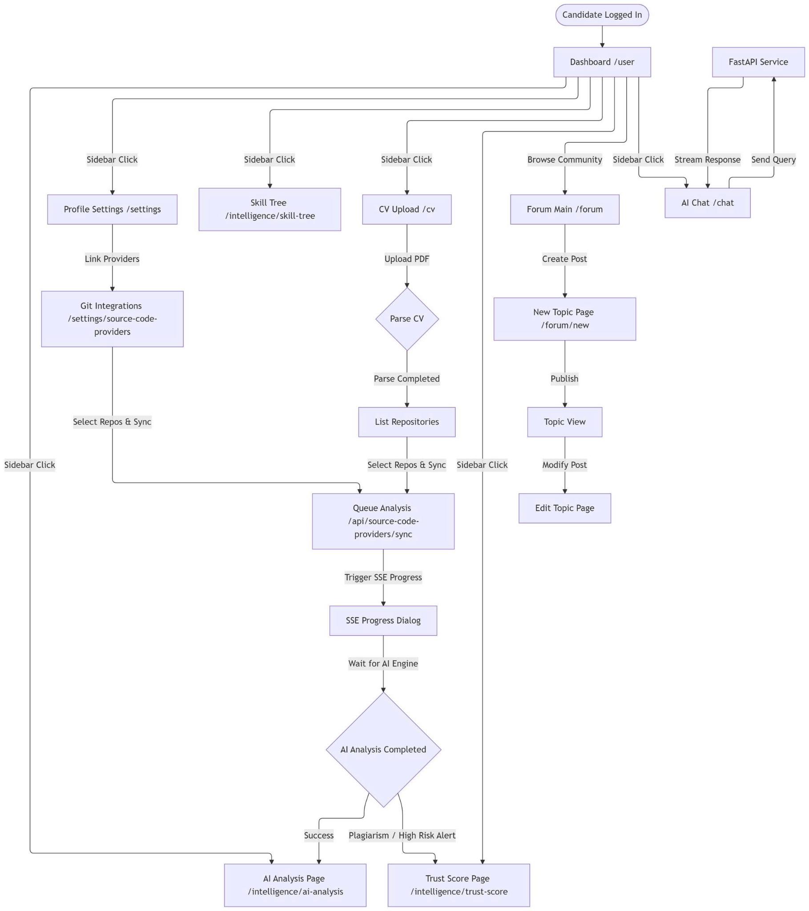

4.1.2 Guest
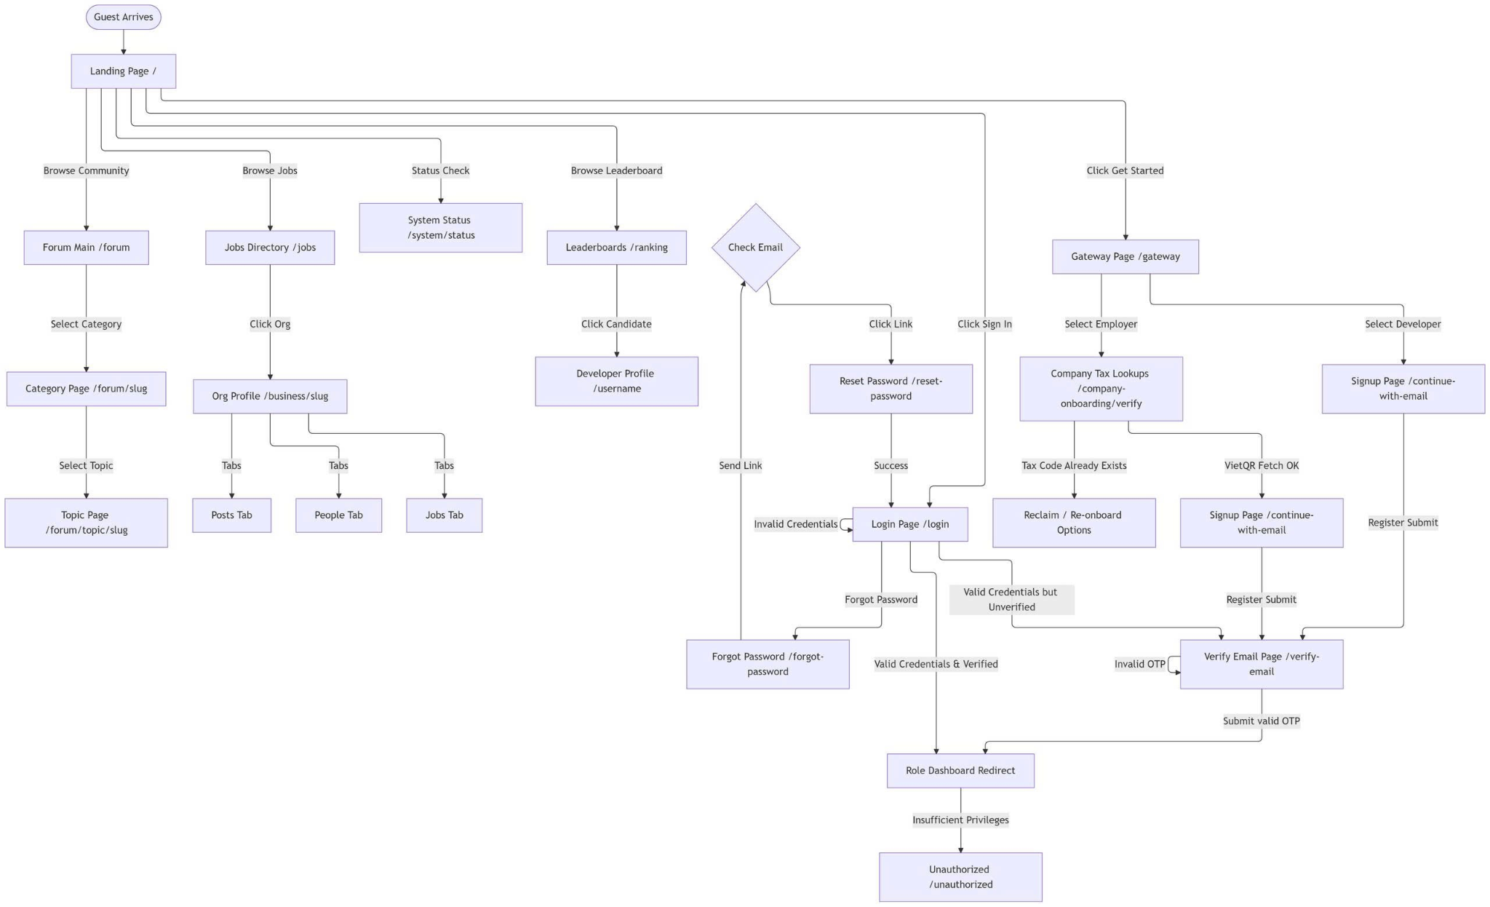

4.1.3 Hiring Manager
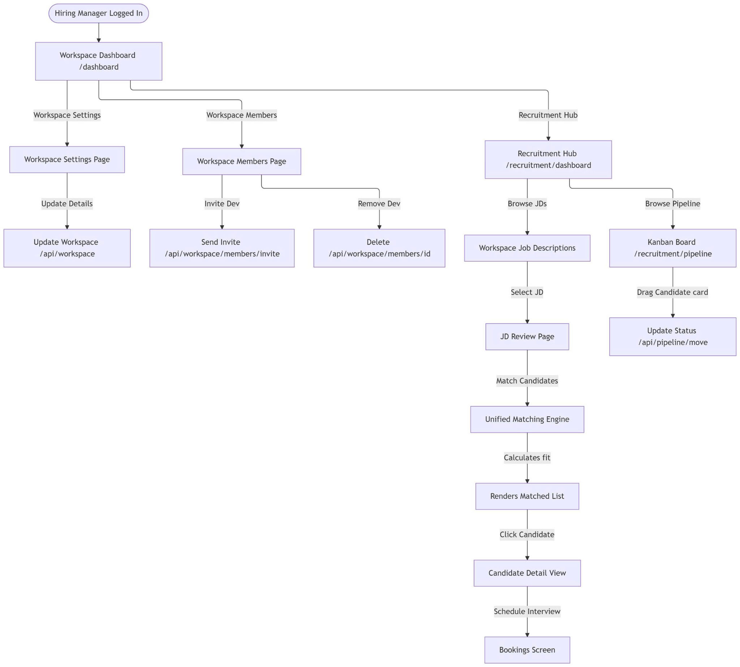

4.1.4 Recruiter
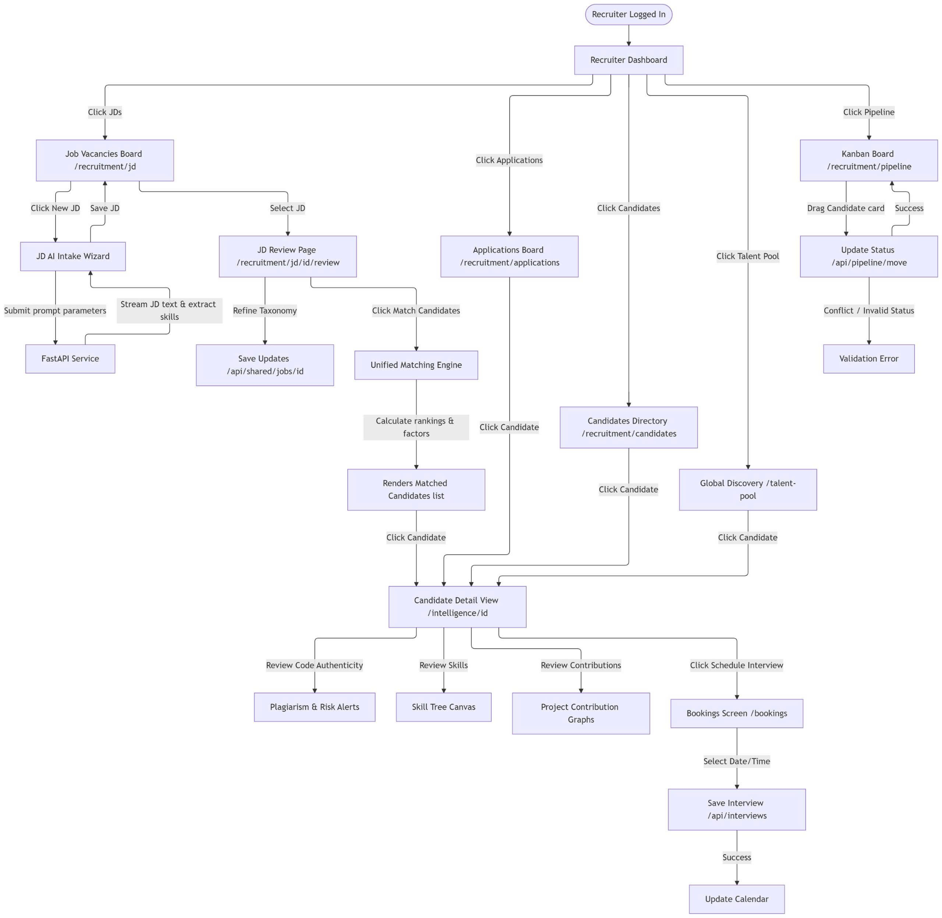

4.1.5 Organization Admin
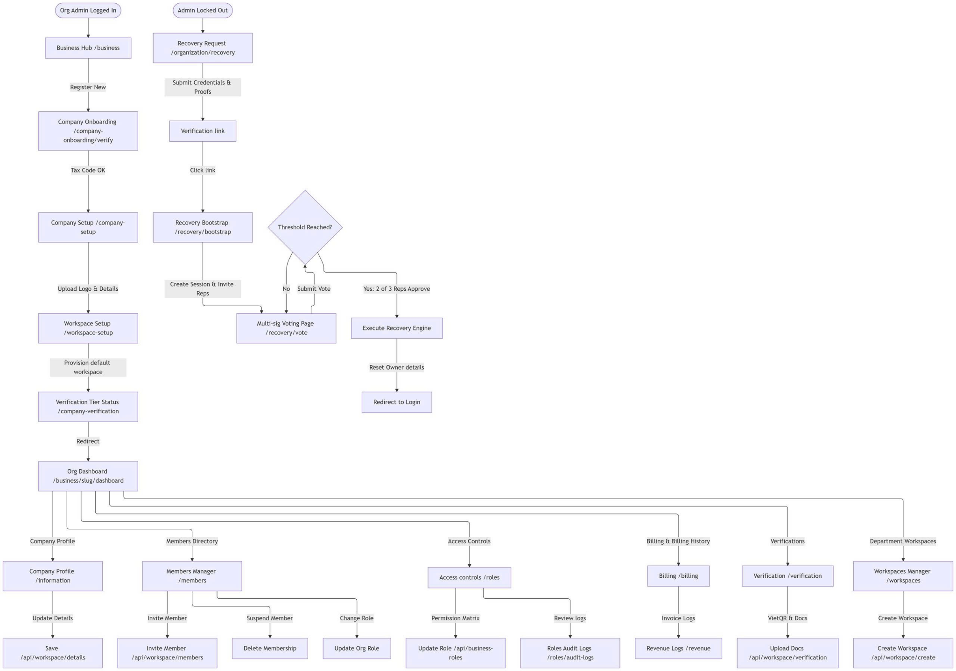

4.1.6 Super Admin
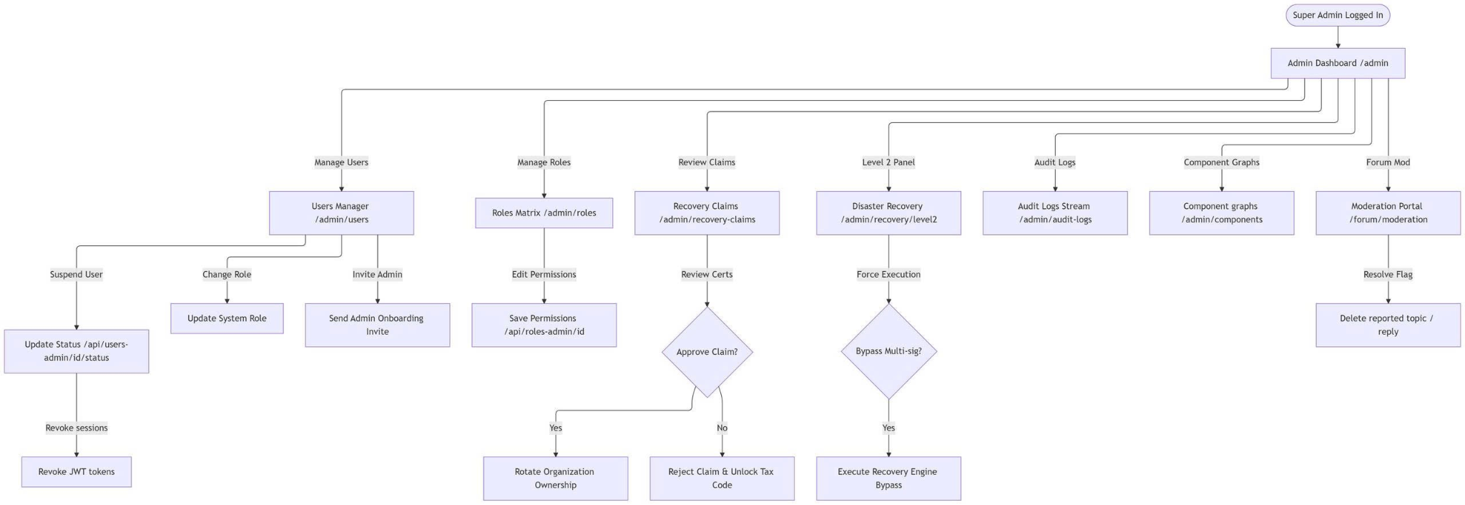

4.2 Screen description

STT | Feature | Screen | Description
1 | Landing | Home Page | The main landing page, the first entry point for Guests.
2 | Landing | Features Intro | Page introducing core features (Evidence-based verification).
3 | Landing | Pricing/Credit Info | Information regarding Active Window Credits for recruiters.
4 | Landing | Legal Notice | Displays Terms of Service and Privacy Policy.
5 | Auth | Unified Login | Centralized login interface for all roles.
6 | Auth | Login Loading | Loading screen during JWT authentication processing.
7 | Auth | MFA Setup | Interface for configuring 2-Factor Authentication via app.
8 | Auth | Password Recovery | Email input screen to initiate password recovery.
9 | Auth | OTP Input | Input screen for OTP verification.
10 | Auth | New Password Input | Form for setting a new password after verification.
11 | Onboarding | Gateway Selection | Branching screen to select Developer or Business paths.
12 | Business | Tax Validation | Input business Tax Code (MST) and VietQR validation.
13 | Business | Org Detail Setup | Input organization name, slug, and industry.
14 | Business | Logo Upload | Interface for uploading Workspace branding.
15 | Business | Representative Auth | Verification of legal representative identity.
16 | Business | Onboarding Success | Notification screen upon successful workspace setup.
17 | Candidate | Traveler Dashboard | Overview of profile status and technical skills progress.
18 | Candidate | Personal Info Edit | Update basic profile data (Bio, Headline, Pronouns).
19 | Candidate | Career Preference | Configuration for salary, position, and work model.
20 | Candidate | Integration List | List of connected providers (GitHub/GitLab).
21 | Candidate | Git Auth Redirect | Waiting screen during the Git OAuth handshake.
22 | Candidate | Repo Picker | Selection of public repositories to sync.
23 | Candidate | Sync Progress | Real-time SSE progress bar for repository crawling.
24 | Candidate | Analysis Summary | Summary table of AI analysis results post-crawl.
25 | Candidate | Skill Tree | Visual tree of skills verified via source code.
26 | Candidate | Skill Badge Detail | Detailed evidence link for a specific skill.
27 | Candidate | Trust Score Gauge | Radial chart displaying the profile Trust Score.
28 | Candidate | Fraud Detection Note | Alert for duplicate or boilerplate code detected.
29 | Candidate | CV Form Builder | Structured form-based CV editor.
30 | Candidate | CV Import Wizard | Upload and AI-parsing interface for PDF/Docx files.
31 | Candidate | CV Template Gallery | Collection of CV layout templates.
32 | Candidate | CV Live Preview | Real-time preview of optimized CV layout.
33 | Candidate | Job Board Main | AI-recommended job listings.
34 | Candidate | Job Search Filter | Search bar with salary, location, and seniority filters.
35 | Candidate | Job Detail Page | Detailed job requirements and required tech stack.
36 | Candidate | AI Gap Analysis | Visual comparison of candidate skills vs. JD requirements.
37 | Candidate | Roadmap Suggestion | AI-generated learning milestones.
38 | Candidate | Application Modal | Confirmation dialogue to submit application.
39 | Candidate | Application Status | Dashboard tracking: Pending, Interview, Hired.
40 | Candidate | AI Chat Interface | Interaction screen for technical queries with the AI.
41 | Candidate | Chat History | Archived list of previous AI interactions.
42 | Community | Forum Dashboard | Featured topic list for technical discussions.
43 | Community | Category Listing | Organization of forum topics by categories.
44 | Community | Topic Thread | View of article content and user replies.
45 | Community | Post Editor | Markdown-based editor for creating new posts.
46 | Business | Workspace Hub | High-level metrics: Active Listings, Revenue.
47 | Business | Workspace Settings | General administrative settings for the workspace.
48 | Business | Members Directory | List of team members within the workspace.
49 | Business | Member Role Edit | Assign permissions to team members.
50 | Business | Recruitment Hub | Central hub for all recruitment activities.
51 | Business | JD AI Intake Wizard | AI-assisted wizard to generate job descriptions.
52 | Business | JD Review | Screen to verify AI-generated content before publication.
53 | Business | Matching Engine List | Top-ranked candidates via AI semantic search.
54 | Business | Candidate Summary | Overview of a candidate's Trust Score and skill nodes.
55 | Business | Pipeline Kanban | Drag-and-drop board for candidate management.
56 | Business | Application Review | Detailed review of applicant profile and PoW evidence.
57 | Business | Interview Calendar | Team calendar for scheduled interviews.
58 | Business | Booking Screen | Slot selection for interview scheduling.
59 | Business | Billing History | Log of service invoices and credit transactions.
60 | Business | Verification Tier 2 | Upload legal documents for enterprise verification.
61 | Admin | Super Dashboard | System-wide statistics: AI tokens, fraud rates.
62 | Admin | Token Analytics | Granular monitoring of AI API consumption costs.
63 | Admin | User Management | Admin tools to suspend or restore user access.
64 | Admin | Role Configuration | Permission matrix editing for global roles.
65 | Admin | Recovery Claims | Approval interface for organizational ownership recovery.
66 | Admin | Disaster Recovery | Execution console for system restore scripts.
67 | Admin | Audit Log Viewer | Immutable logs for forensic analysis.
68 | Admin | Component Graphs | Visual monitoring of microservice health.
69 | Admin | Forum Moderation | Moderation queue for flagged content.
70 | Admin | Skill Taxonomy Edit | Management of global skill ontologies.
71 | Admin | AI Model Routing | Switch primary/fallback models (GPT-4/Claude/Gemini).
72 | System | Error 400 | Bad Request error notice.
73 | System | Error 401 | Unauthorized access error.
74 | System | Error 403 | Forbidden/Permission denied error.
75 | System | Error 500 | Internal Server Error notice.
76 | System | Error 503 | Service Unavailable notice.
77 | System | Network Timeout | Connection latency notice.
78 | System | WebSocket Conn | Real-time connection waiting animation.
79 | Candidate | Search Result Grid | Visual grid of job listing cards.
80 | Candidate | Saved Jobs | List of favorited listings.
81 | Candidate | Export PDF | Generator for A4-ready CV documents.
82 | Candidate | Link Share View | Public-facing view of the profile.
83 | Business | Pipeline Filters | Filtering tool for recruitment funnels.
84 | Business | Conflict Resolution | Screen to handle status update conflicts.
85 | Business | Interview Request | Interface to send interview invites.
86 | Business | Revenue Statistics | Analytics on subscription plan performance.
87 | Admin | Fraud Log | List of flagged suspicious user activities.
88 | Admin | Multi-sig Approve | Interface to confirm multi-sig owner recovery.
89 | Admin | Config Parameter | Global system limits and credit configurations.
90 | Candidate | Notification Center | Central inbox for system and recruiter alerts.
91 | Business | Notification Inbox | Alerts regarding incoming applications.
92 | Candidate | Quiz/Assessment | Optional capability verification quizzes.
93 | Candidate | Workspace Task | Individual task management for the candidate.
94 | Candidate | Roadmap Milestone | Progress visualization for career roadmaps.
95 | Business | Talent Pool Discovery | Global candidate discovery outside specific jobs.
96 | Business | Interview Feedback | Post-interview comments entry form.
97 | Business | Candidate Match % | Numerical visual of JD-to-Candidate compatibility.
98 | System | API Status Badge | Real-time health indicators for third-party services.
99 | Candidate | Dark Mode Toggle | UI theme selector.
100 | Auth | Session Expired | Notification to re-authenticate the user.

4.3 Screen Authorization

STT | Screen | Guest | Candidate | Business | Admin
1 | Landing Page | X | X | X | X
2 | Login / Register Page | X
3 | Forgot Password / Reset | X
4 | Company Onboarding (Onboarding) | X
5 | Candidate Dashboard |  | X
6 | Profile Settings |  | X
7 | Source Code Integration (Git) |  | X
8 | AI Skill Tree / Analysis |  | X
9 | CV Management / Editor |  | X
10 | Job Search Directory | X | X
11 | Job Detail Page | X | X
12 | AI Gap Analysis (Candidate) |  | X
13 | Application History |  | X
14 | Workspace Hub |  |  | X
15 | Member Management |  |  | X
16 | Recruitment Hub (Dashboard) |  |  | X
17 | JD Management / AI Wizard |  |  | X
18 | Kanban Pipeline Board |  |  | X
19 | Candidate Matching List |  |  | X
20 | Interview Calendar / Booking |  |  | X
21 | Billing / Transaction Logs |  |  | X
22 | Tier 2 Verification Upload |  |  | X
23 | Admin Dashboard |  |  |  | X
24 | User & Role Management |  |  |  | X
25 | System Monitoring (Logs/Health) |  |  |  | X
26 | Fraud Detection Portal |  |  |  | X
27 | Recovery Claims Manager |  |  |  | X
28 | Moderation Portal (Forum) |  |  |  | X
29 | AI Token Usage Analytics |  |  |  | X
30 | System Configuration |  |  |  | X

4.4 Non-Screen Functions
Here is the Non-Screen Functions table for the CVerify project, translated into English and formatted for direct copy-pasting into Google Docs:

STT | Feature | System Function | Description
1 | Authorization | Middleware Access Control | Automatically authenticates and authorizes every request to Candidate, Business, and Admin APIs based on JWT.
2 | Real-time Communication | WebSocket / SignalR Connection | Establishes real-time connections to deliver instant notifications regarding application status or system messages.
3 | AI Pipeline Processing | Asynchronous Background Job | Processes resource-intensive tasks such as GitHub crawling, AST analysis, and Trust Score calculation in the background via Hangfire.
4 | Data Embedding | Vectorization Engine | Automatically converts JD content and candidate profiles into vectors (embeddings) and stores them in pgvector to support semantic search.
5 | Cache Management | Semantic Caching | Automatically checks Redis to return pre-computed AI results if semantic similarity (cosine similarity) exceeds the >0.95 threshold, optimizing token costs.
6 | System Alerting | Automated Event Notifier | Automatically sends emails/system notifications for critical events (e.g., new job applications, profile status changes).
7 | Data Integrity | Anti-Fraud Detection | Runs background algorithms to detect fraudulent activities such as repo-farming, commit-bursting, or non-authentic data.
8 | Model Orchestration | Multi-Model Router | Routes AI analysis tasks to the appropriate model (Claude, GPT, or Gemini) based on task complexity and token budget constraints.
9 | Logging & Audit | Immutable Audit Logger | Automatically logs all sensitive data access actions into the database in a fixed format for auditing purposes.
10 | Disaster Recovery | Data Backup Service | Performs continuous Write-Ahead Logging (WAL) backups from PostgreSQL to S3 to ensure data recoverability.

4.5 Entity Relationship Diagram

5. Element screenshot

5.1 User Account Management & Authentication

5.1.1 Create an Account
Function Trigger
The function is triggered when Guest wants to submit the registration form with the required information to create an account and become an authenticated user in the system.
Function Description
● Actors / Roles: Guest
● Purpose: Allows new users to create an accountas either Renter or Landlord and become authenticated users in the system.
● Interface: Registration form with required fields including email, phone number, password, first name, last name, and user type selection.
● Data Processing:
○ The system validates the submitted information.
○ Passwords are encrypted using a password encoder.
○ The system assigns appropriate roles and sets the user status (ACTIVE for RENTER, PENDING/INACTIVE for LANDLORD).
○ The system stores data in the database.
○ The account is created, and a welcome email is sent to the user.
Screen Layout
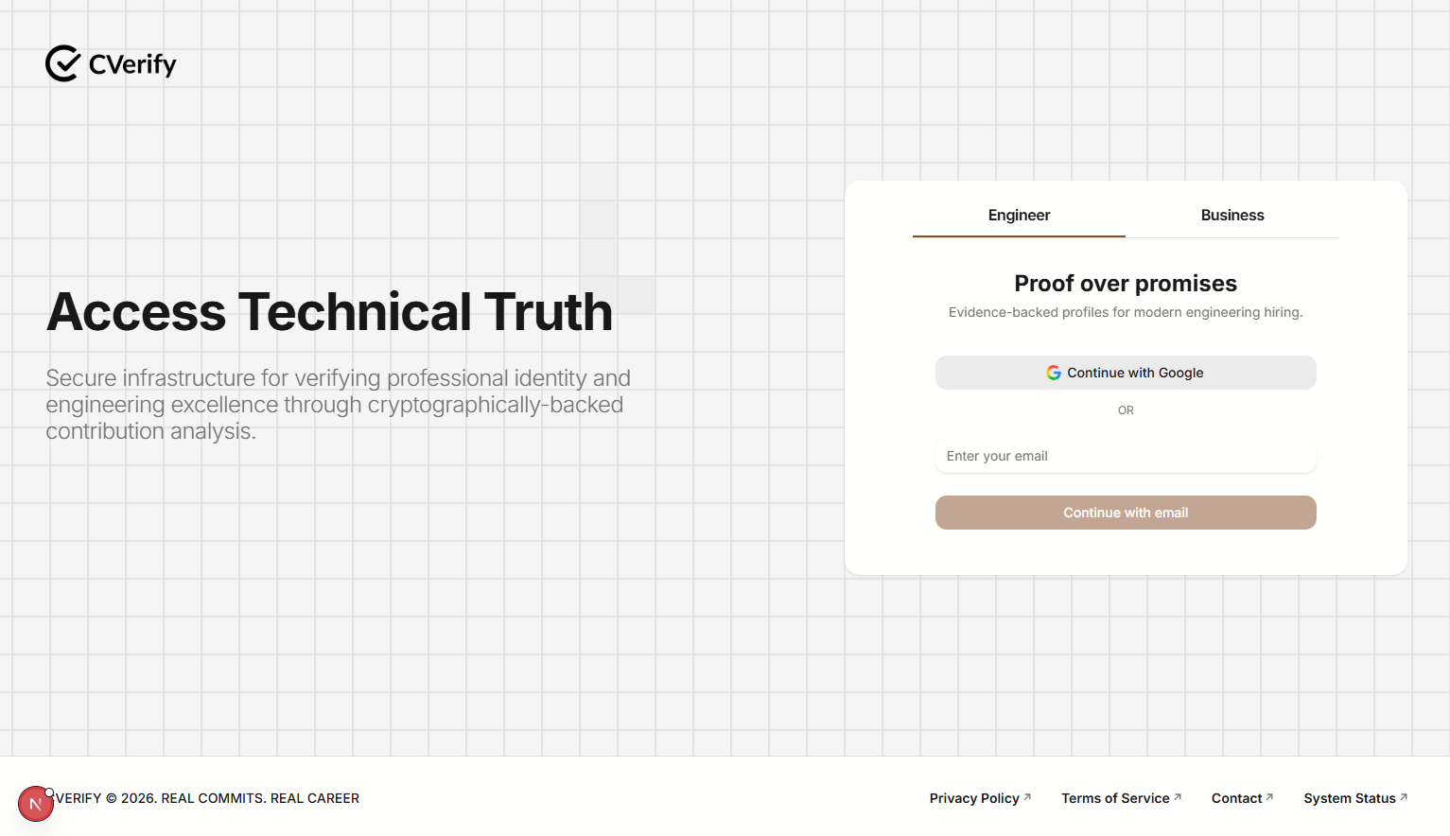Figure 9 - Engineer Login Page
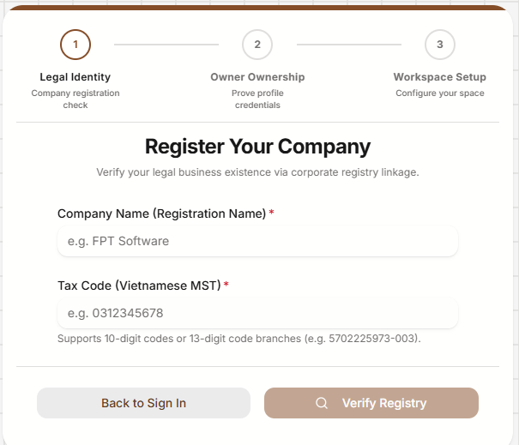
Figure 10 - Business Login Page
Registration Form: Engineer
● Required Fields: Email, Password
● Buttons: [Continue with email]
Registration Form: Business
● Required Fields: Company Name, Tax code
● Buttons: [Verify Registry], [Back to Login].

Function Details
Data
Credentials Required: * Engineer: Email, Password
Business: Company Name, Tax code
Business Rules:
BR-01: Each account must have a unique email address; duplicate emails are not allowed.
BR-02: Passwords must meet security requirements (≥ 8 characters, at least 1 uppercase letter, 1 number, and 1 special character).
BR-03: The user type must be either ENGINEER or BUSINESS.
BR-04: The user must accept the Terms of Service and Privacy Policy before registration can be completed.
BR-05: BUSINESS accounts are created with PENDING/INACTIVE status for verification, while ENGINEER accounts are created with ACTIVE status.
BR-06: Each BUSINESS account must be associated with a unique ORGANIZATION SLUG to identify the organization's workspace.
Validation
Invalid email format → Display: MSG03
Invalid password → Display: MSG07
Email already exists → Display: MSG04
Invalid user type → Display: MSG05
Invalid Organization Slug → Display: MSG08
Organization Slug already exists → Display: MSG09
Missing field (covers Email, Password, or Organization Slug) → Display: MSG02

Functionalities
Normal Flow
The user navigates to the registration page.
The user enters required information:
- For Engineer: email, and password.
- For Business: Company Name, tax code
The user selects their User Type (ENGINEER or BUSINESS) and accepts the Terms of Service and Privacy Policy.
The user clicks the [Continue with email] button.
The system validates all required fields and business rules.
The system assigns the appropriate role and sets the account status (ACTIVE for ENGINEER, PENDING for BUSINESS).
The system creates the account, sends a welcome email, and displays MSG11.

Abnormal Cases
2.a1. If the user enters invalid input data (e.g., incorrect password format or invalid user type), the system displays the corresponding error code: MSG07 (Invalid password) or MSG05 (Invalid user type).
2.a2. The user corrects the invalid fields and returns to step 3 of the Normal Flow.
2.b1. If the email or Organization Slug already exists in the system, the system displays MSG04 (Email already exists) or MSG09 (Organization Slug already exists).
2.b2. The user enters a unique email or Organization Slug and returns to step 3 of the Normal Flow.
2.c1. If the user is missing any required fields, the system displays error MSG02 (Missing field).
2.c2. The user fills in the empty required fields and returns to step 3 of the Normal Flow.
2.d1. If the user fails to accept the Terms of Service and Privacy Policy, the system prompts them to agree before registration can proceed.

3.2.2 Sign in With Email and Password
Function Trigger:
Actors / Roles: Engineer, Business.
Purpose: Allows authenticated users to access their respective workspaces or profiles using previously registered credentials.
Interface: A dual-tab Sign-in form providing specific input fields based on the selected role:
- Engineer Tab: Input fields for Email and Password, with an option for Google authentication.
- Business Tab: Input fields for Organization Slug and Password.
Data Processing (Sign-In)
- Credential Validation: The system validates the credentials submitted by the user.
- Authentication & Retrieval: Upon successful validation, the system authenticates the user and retrieves the corresponding account information.
- Multi-Factor Authentication (MFA):
  - If MFA is enabled, the system enforces OTP verification prior to the issuance of any tokens.
  - If MFA is disabled, the system proceeds directly to issuing JSON Web Token (JWT) access and refresh tokens.
- Token Management: The refresh token is stored in Redis, including an expiration time to facilitate token lifecycle management.
- Response: The system provides a sign-in response containing the necessary tokens and relevant user information.

Screen Layout:
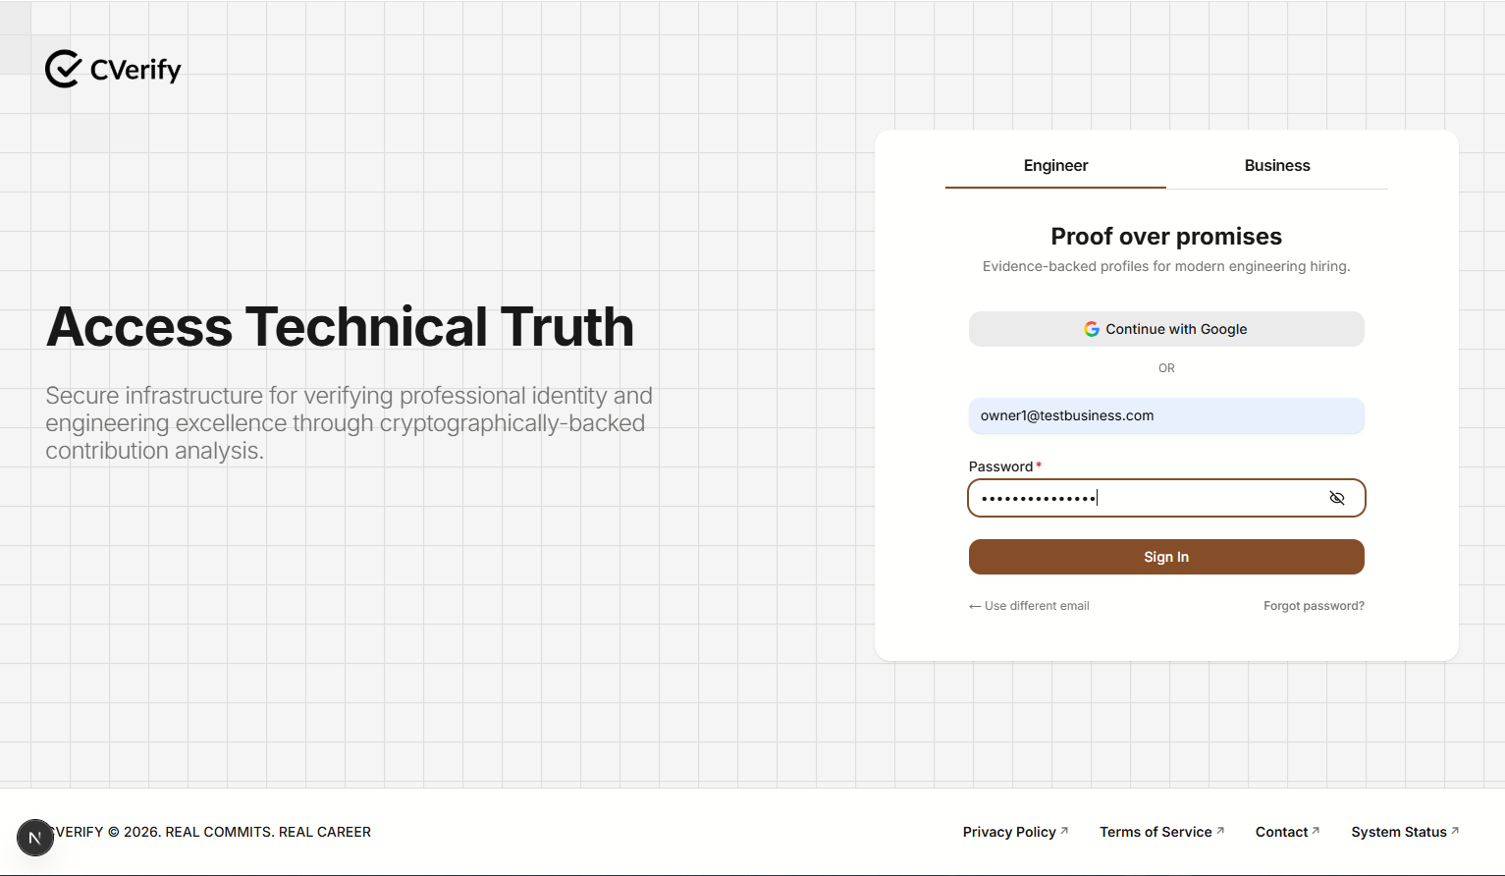
Figure 10 - Engineer Sign in Page
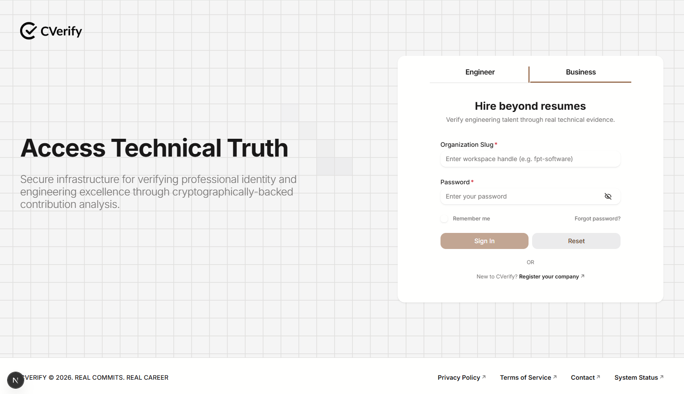

Figure 11 Business Sign in Page
Engineer Sign-in form with required fields:
● Email and Password
● Submit button: “Sign In”
Business Sign-in form with required fields:
● Organization Slug and Password
● Submit button: “Sign in”
Function Details:
Data:
● Credentials Required:
For Engineer: Email, Password.
For Business: Organization Slug, Password.
● System Data:
○ User ID, User Type (Engineer/Business).
○ Account status (ACTIVE/INACTIVE).
○ Access token (JWT), Refresh token (JWT).
○ Refresh token stored in Redis with expiry.

Business Rules
● BR-06: Serves as a security gate, ensuring that only verified or active users can access the system. .
● BR-01: Ensures data integrity by preventing duplicate email registration.
Validation
● Invalid email format → Display: MSG03
● Invalid Organization Slug format → Display: MSG10
● Invalid password → Display: MSG07
● Non-existent account (Email or Organization Slug) → Display: MSG08
● Inactive account → Display: MSG09
● Missing field → Display: MSG02

Functionalities:
Normal Flow
1. The user navigates to the sign-in page.
2. The user selects the appropriate tab: Engineer or Business.
3. The user enters the required credentials based on their selection:
- Engineer: Email and Password.
- Business: Organization Slug and Password.
4. The user clicks the Sign In button.
5.The system validates the input format, account existence, and status (ACTIVE).
6. The system authenticates the user, issues the necessary JWT access and refresh tokens, and redirects the user to the Home Page or Dashboard corresponding to their role.
Abnormal Cases
2.a1. If the user enters an invalid email format (Engineer) or invalid Organization Slug format (Business), the system displays MSG03 or MSG10.
2.a2. The user enters a valid email or Organization Slug and returns to step 4 of the Normal Flow.
2.b1. If the user enters an invalid password, the system displays MSG07.
2.b2. The user enters a valid password and returns to step 4 of the Normal Flow.
2.c1. If the user leaves any required field empty, the system displays error MSG02.
2.c2. The user fills in the missing required fields and returns to step 4 of the Normal Flow.
2.d1. If the user signs in with an email or Organization Slug that is not registered, the system displays MSG08.
2.d2. The user is redirected to the Registration Page to create an account.
2.d3. After registration, the user returns to step 1 of the Normal Flow.
2.e1. If the user attempts to sign in with an INACTIVE account, the system displays MSG09.
2.e2. The user must contact the administrator for account activation or support.
2.e3. The user returns to step 1 of the Normal Flow.

Post-Conditions
● PC-01: Upon successful authentication, the system redirects the Engineer to their personal profile dashboard or the Business user to their specific organization workspace, according to their assigned role.

3.2.3 Sign in with Google
Function Trigger:
The function is triggered when a user clicks the “Continue with Google” button, completes the Google OAuth2 authorization flow, and the system receives an authorization code.
Function Description:
● Actors / Roles: Engineer.
● Purpose: Allows Engineers to sign in using their Google account via OAuth2. The system retrieves user information from Google, authenticates existing Engineers, or creates a new account if it is their first-time signing in.
● Interface:
- “Continue with Google” button as shown in image_5ea51a.png.
- OAuth2 redirect flow (Google login screen → redirect back with authorization code).
- Data Processing:
- The system exchanges the authorization code for an access token with Google.
- User information (email, name, etc.) is retrieved from Google.
- If the Engineer already exists → authenticate.
- If the Engineer does not exist → create a new account with ACTIVE status and assign an ENGINEER role.
- For new accounts → publish ProfileEvent via Kafka and send a welcome email.
- The system generates JWT tokens (access + refresh), stores refresh tokens in Redis, and sets them in an HTTP-only cookie.
- Returns a sign-in response with user info and tokens.

Screen Layout
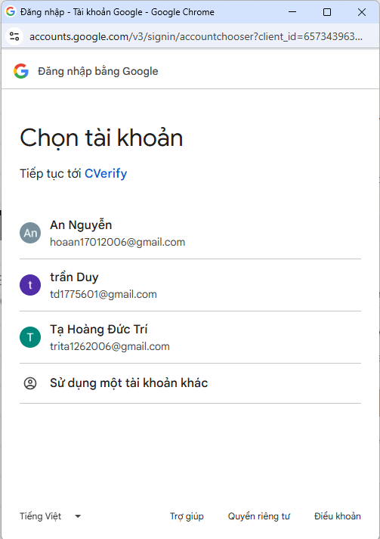
Figure 12 Google OAuth login
● Button: “Sign In with Google”
● Redirect to Google OAuth login
● Redirect back to application after successful authorization
Function Details
Data
● Credentials Required: Google authorization code (exchanged for access token) ● System Data:
○ Google access token
○ Google user info (email, name, etc.)
○ JWT access & refresh tokens
○ Refresh token stored in Redis + HTTP-only cookie
○ New user account with RENTER role (if first-time sign-in)
Business Rules
BR-07: Authorization code must be valid and unexpired.
BR-08: Google OAuth service must be available and responsive.
BR-09: If the user does not exist, signing in with Google will create a new account with ACTIVE status and assign the ENGINEER role.
Validation
● OAuth denied (User cancels or service error) → Display: MSG12

Functionalities
Normal Flow
1. The user clicks the “Continue with Google” button on the Engineer sign-in tab.
2. The user completes the Google OAuth2 flow and the system receives the authorization code.
3. The system exchanges the authorization code for an access token with Google.
4.The system retrieves user profile information from Google.
5. The system checks if the user exists in the database.
6. If the user does not exist, the system creates a new account with ACTIVE status and assigns the ENGINEER role.
7. For new accounts, the system publishes a ProfileEvent via Kafka and sends a welcome email.
8. The system generates JWT tokens (access + refresh), stores the refresh token in Redis, and sets it in an HTTP-only cookie.
9. The system returns a successful sign-in response with user information and tokens, then redirects the user to the Home Page.
Abnormal Cases
5.a1. Nếu người dùng đã có tài khoản liên kết với Google, hệ thống sẽ xác thực người dùng và điều hướng họ đến trang Home Page tương ứng với vai trò ENGINEER.
5.b1. Nếu tài khoản người dùng chưa tồn tại, hệ thống sẽ tạo một tài khoản mới với trạng thái ACTIVE.
5.b2. Hệ thống gán vai trò ENGINEER cho người dùng mới này.
5.b3. Hệ thống sẽ thực hiện publish ProfileEvent qua Kafka, gửi email chào mừng đến người dùng và tiếp tục thực hiện các bước tạo token (bước 8) trong luồng Normal Flow.
Post-Conditions
● PC-01: Người dùng được xác thực thành công (tài khoản hiện có hoặc tài khoản mới).
● PC-02: Tài khoản mới được tạo với trạng thái ACTIVE và được gán vai trò ENGINEER.
● PC-03: Hệ thống tạo thành công bộ JWT access token và refresh token.
●PC-04: Refresh token được lưu trữ trong Redis và thiết lập dưới dạng HTTP-only cookie trong trình duyệt của người dùng.
● PC-05: Hệ thống xuất bản sự kiện ProfileEvent thông qua Kafka cho các tài khoản mới tạo.
● PC-06: Hệ thống phản hồi thông tin đăng nhập bao gồm thông tin người dùng và bộ token (access & refresh token), đồng thời điều hướng người dùng đến trang Home Page tương ứng với vai trò ENGINEER.

3.2.4 Sign Out
Function Trigger
The function is triggered when an authenticated user clicks the “Sign Out” button or initiates the logout process.
Function Description
● Actors / Roles: Engineer, Business.
● Purpose: Allows authenticated users (Engineer or Business) to securely log out of the system. Logging out ensures that access tokens are disabled, refresh tokens are deleted, session cookies are cleared, and the login session ends to prevent unauthorized access.
● Interface:
○ “Sign Out” button on UI
● Data Processing:
○ The system extracts the access token (from the Authorization header) and the refresh token (from the HTTP-only cookie).
○ The access token is validated and added to the Redis blacklist until it expires.
○ The refresh token is removed from Redis storage if valid.
○ The authentication cookie is deleted from the user's browser.
○ The system returns a successful logout response and redirects the user to the login page or the corresponding public page.

Screen Layout
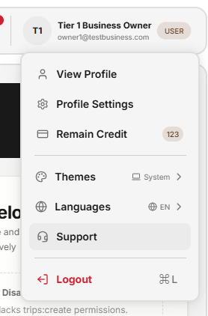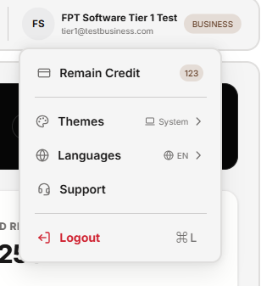
Figure 13 User Sign out Figure 14 Business Sign out

● Button: “Sign Out”
● Redirect to login page or home page after logout
Function Details
Data
● Credentials Required:
○ Access token (from Authorization header)
○ Refresh token (from HTTP-only cookie)
● System Data:
○ The Redis blacklist stores disabled access tokens.
○ Refresh token data is stored in Redis.
○ Logs record the process of ending a login session (Session termination logs).

Validation & Business Rules
● BR-10: Authentication cookies (especially those containing refresh tokens) must always be cleared from the browser after a user logs out, regardless of the server-side processing outcome.
● BR-11: All user sessions (Engineer or Business) must be terminated synchronously on Redis to ensure security after logging out.

Validation
● Thiếu access token (Missing Authorization header) → Hiển thị: MSG14
● Sai định dạng Authorization header → Hiển thị: MSG15
● JWT token không hợp lệ (Malformed/Expired) → Ghi log lỗi, hiển thị: MSG16
Functionalities
Normal Flow
1. The user clicks the “Sign Out” button.
2. System extracts access token from Authorization header.
3. System extracts refresh token from HTTP-only cookie.
4. System validates that access token is provided.
5. System parses access token and refresh token to extract JWT information. 6. If the access token is valid → add it to the Redis blacklist with expiration. 7. If the refresh token is valid → remove it from Redis storage.
8. The system clears authentication cookies from the browser.
9. System logs successful logout operation.
10. The system returns a successful sign-out response and redirects users.
Abnormal Cases
● Access token missing → MSG15, logout cannot proceed.
● Invalid Authorization header format → MSG16.
● Malformed JWT token → Log error, still clear cookies and terminate session. ● Redis failure (blacklist or removal) → Log error, but continue logout flow. Post-Conditions
● PC-01: Authentication cookies are cleared.
● PC-02: Session is fully terminated.
● PC-03: User is redirected to login page

3.2.5 Forgot Password
Function Trigger
The function is triggered when an authenticated user navigates to the Forgot Password page, enters their current password and a new password, then submits the form.
Function Description
● Actors / Roles: Engineer
● Purpose: Allows users to update their account password securely.
● Interface: Form with fields for Email Address
● Data Processing:
○ The user enters their registered account email address
○ The system checks if the email exists in the database.
○ If the email is valid, the system creates a unique Reset Token (with a time limit - e.g., 15 minutes) and temporarily stores it in Redis along with the user ID.
○ The system sends a recovery email containing an authentication link (with the Reset Token attached) to the user's email address.
○ The system logs the password recovery request.
Screen Layout
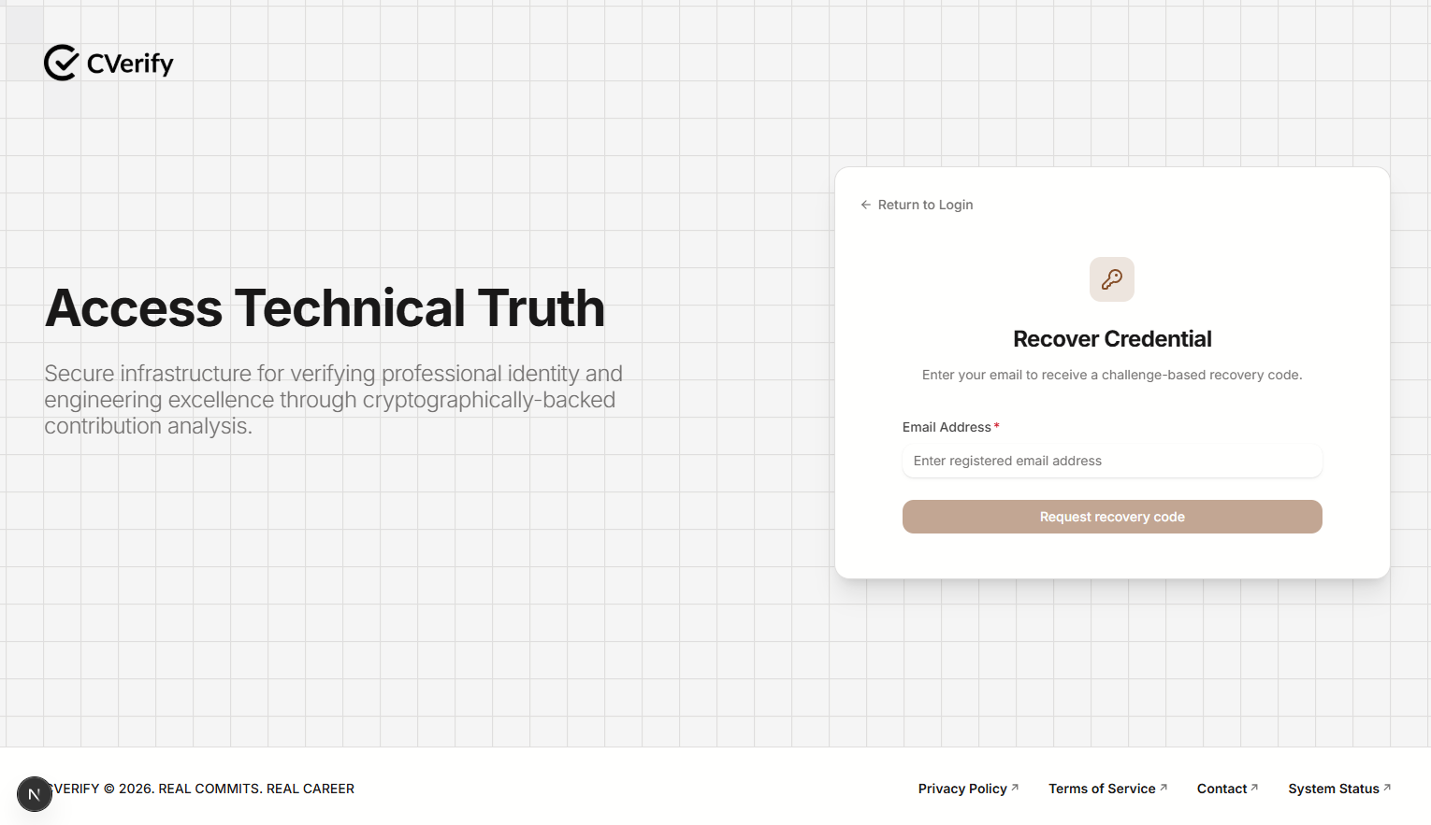
Figure 15 - Change Password
Page with:
● Input field: Email Address
Function Details
Data
● Credentials Required: Email Address
● Session Data: User ID, Session token
● Business Rules:
○ BR-11: Current password must match the stored password hash.
○ BR-02: Password must meet security requirements (≥ 8 chars, at least 1 uppercase, 1 number, 1 special char).
○ BR-12: Passwords are always stored in encrypted form.
Validation
● Incorrect current password → Display: MSG17
● Weak or invalid new password → Display: MSG18
● Database update failure → Display: MSG19
Functionalities
Normal Flow:
1. User enters current password and new password.
2. System validates input format and security rules.
3. The system verifies the current password.
4. If valid, the system encrypts and updates the new password.
5. The system records the password change timestamp.
6. The system generates new tokens and replaces old ones.
7. The user receives a confirmation message.
Abnormal Cases:
● If user enter the invalid current password, the system will show MSG17.
● If user enter the weak or invalid new password, the system will show MSG18. ● If the database connection has an issue, the system will show MSG19.
Post-Conditions
● The user’s password is securely updated.
● New access and refresh tokens are issued.
● Old tokens are invalidated.
● Password change timestamp is recorded for security auditing.

3.2.6 View Profile
Function Trigger
Triggered when a user clicks the “View Profile” tab from header
Function Description
● Actors / Roles: Admin, Engineer
● Purpose: Displays detailed user profile information. The system ensures access is reserved exclusively for the account owner (Engineer) and system administrator.
● Interface: Page or modal displaying profile details.
● Data Processing:
- Access Verification: The system verifies the JWT token to ensure users have permission to view the profile (only Admins or the Engineer owner).

- Profile Data Query: The system downloads the Engineer's detailed information, including:

Personal Information (UserProfile): Name, email, account status.

Professional Information (ProfessionalData): Skill sets, projects participated in, or certifications related to Backend/IoT (matching your profile).

Authentication Documents (Documents): Documents related to the Engineer's On-the-Job Training process or competency profile.

- Security Processing:

- Hide/Mask sensitive information (such as full email address, phone number, or unnecessary internal information) if the viewer is not the account owner or does not have the highest level of access.

- Activity logging: The system automatically records the history of viewing files with ViewerID, TargetUserID (the person being viewed), and Timestamp for auditing purposes (Audit Log).

Screen Layout
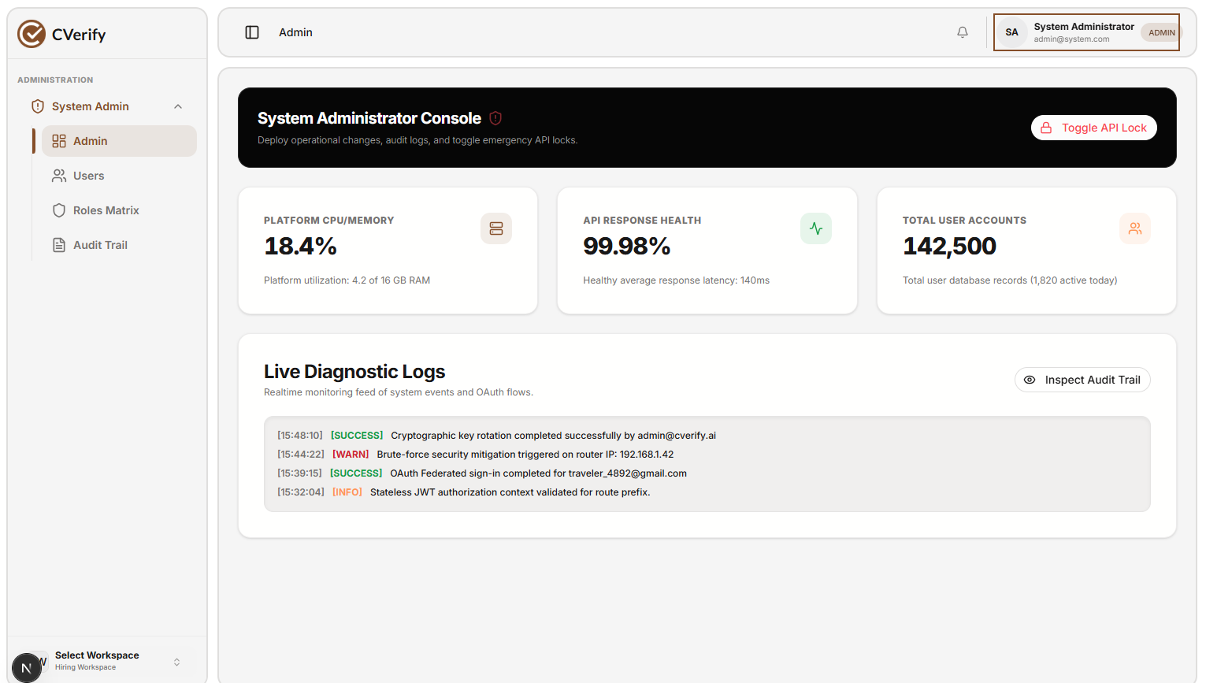
Figure 16 - Admin View Profile
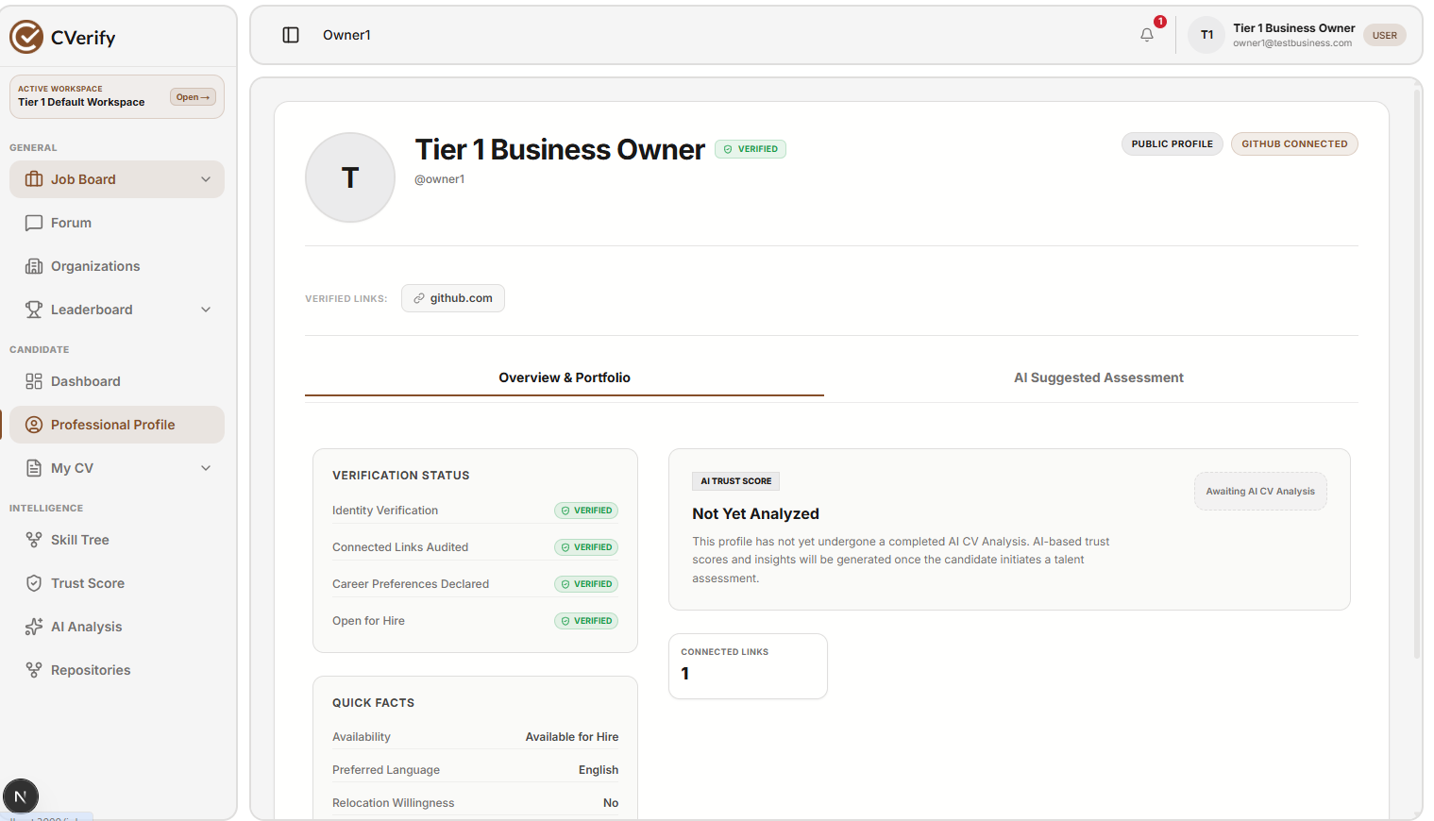
Figure 17 - Engineer View Profile
Function Details
● Data:
- UserProfile: Name, avatar, professional summary, contact details.
- Account: Account status, role (Engineer/Admin), and registration date.
- ProfessionalData: Skills (e.g., Java, .NET, IoT), project experience, and certifications.
- Documents: Professional certificates and training verification records.

● Audit Log: “ViewProfile” with AI suggested Assesment, Overview & Portfolio.
● Validation & Business Rules
Privacy Control:
Sensitive fields (e.g., personal email, phone number) are masked or restricted unless the requester is the Owner (the Engineer themselves) or an Admin.
BR-69: Profile visibility is strictly governed by user role:
Engineers can only view their own profile.
Admins have global access to view any Engineer's profile.
BR-70: Every profile access request must be recorded in the audit log for security monitoring.
Normal Flow
1. User Trigger: The user (Engineer or Admin) clicks the “View Profile” tab/icon in the header or menu.
2. Authorization Check: The system validates the session via the JWT access token and checks the user's role (Admin or Engineer) against the requested ProfileID.
3. Data Retrieval: The system fetches the comprehensive profile information from the database, including UserProfile, Account details, ProfessionalData, and Documents.
4. Privacy Application: The system checks if the requester is the authorized owner or an Admin; it masks restricted fields (e.g., personal contact info) if the requester lacks high-level permissions.
5. Rendering: The system displays the Profile Detail page, populated with the authorized data fields.
6. Audit Logging: The system asynchronously publishes a "ViewProfile" event to the audit log service, recording the ViewerID, ProfileID, and Timestamp.

Abnormal Cases
1.a.1: The requested ProfileID does not exist in the database → Display: MSG120.
2.a.1: User attempts to access a profile they are not authorized to view (Access Denied) → Display: MSG15.
3.a.1: System encounters a database connectivity or retrieval error → Display: MSG67.
5.a.1: Profile assets (e.g., specific documents, project thumbnails, or avatar) fail to load → Display: MSG121 (Render the profile page with a placeholder image or empty state for missing documents).
6.a.1: System fails to write the Audit Log (e.g., service timeout) → Log a fallback warning in the backend server and proceed to display the profile (non-blocking action).

Post-Conditions
PC-01: The Profile Detail page is rendered successfully for the authorized user (with fields displayed or masked based on permission levels).
PC-02: The ViewProfile audit event is successfully persisted in the system logs (or a warning is triggered if the log service is temporarily unreachable).

3.2.7 Update Profile
Function Trigger
Triggered when a user opens the Profile Detail page and clicks the “Profile Setting” button.
Function Description
● Actors: User (primary), System
● Purpose: Allow the user to update their personal information.
● Interface: Profile Edit form.
● Data Processing:
○ Validate all input fields (name, phone, DOB, address, etc.).
○ Upload and validate a new profile avatar (if provided).
○ Save updated profile information to the database.
○ Record audit log “UserProfile” with timestamp and UserID.
Screen Layout
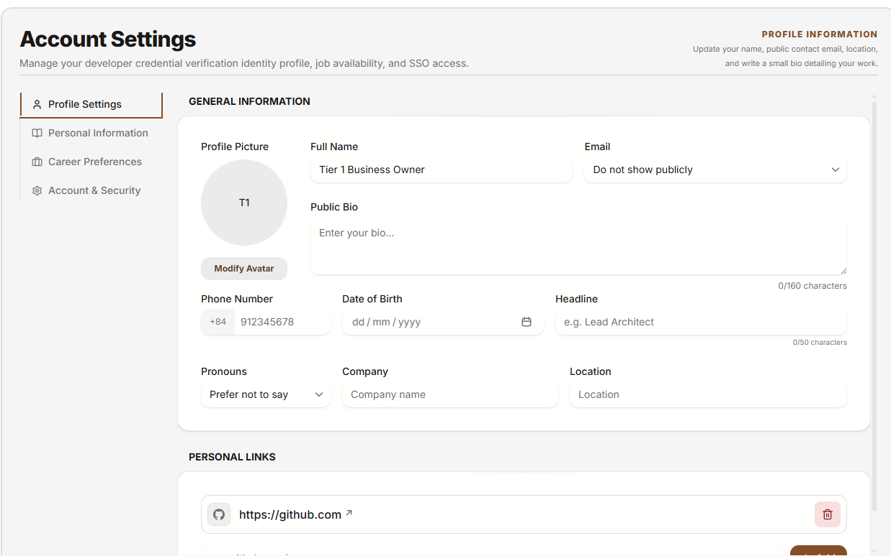
Figure 18 - Update Profile
Function Details
● Data: UserProfile, Account
● Audit Log: “Profile Setting” with UserID and timestamp.
● Validation & Business Rules
○ Required fields must be filled (Name, Phone).
○ Phone/email formats must be valid.
○ Avatar: JPG/PNG ≤5MB.
○ BR-71: Some fields (Email, Identity Number) may be locked and cannot be edited. Normal Flow
1. User clicks “Profile Setting” button.
2. The system displays the editable form.
3. Users update information and save changes.
4. The system validates the input.
5. The system saves the updated profile data.
6. The system displays a success message MSG122.
Abnormal Cases
● 2a1. Profile is locked or user is not allowed to edit → show MSG72.
● 4a1. Invalid input format (e.g., phone/email) → show MSG02.
● 4a2. Invalid avatar file (size/type) → show MSG24.
● 5a1. Database/system error during save → show MSG67.
Post-Conditions
● Updated profile information stored in the database.
● Audit log created.
● The user is redirected back to Profile Detail with updated information.

5.2 Job & Recruitment Management

3.3.1 Job Posting Management
3.3.1.1 Create Job Post
Function Trigger
● This function is triggered when a Business clicks the “Post new Job” button on the Jobs page.
● It can also be opened as a modal from the dashboard.
Function Description
● Actors / Roles: Business.

● Purpose: Allows businesses to create and post information about job opportunities or internship/training projects for Engineers.

● Interface: Form includes fields: Job Title, Job Description, Requirements (Skills: Java, .NET, IoT...), Location, Salary Range, Deadline.

● Data Processing:

- Business account verification system.

- Saves job information to the database with default status of DRAFT or PUBLISHED.

- Publishes a JobCreatedEvent via Kafka (if you want to notify suitable Engineers).

- Logs post creation activity.

45 | Page
Screen Layout
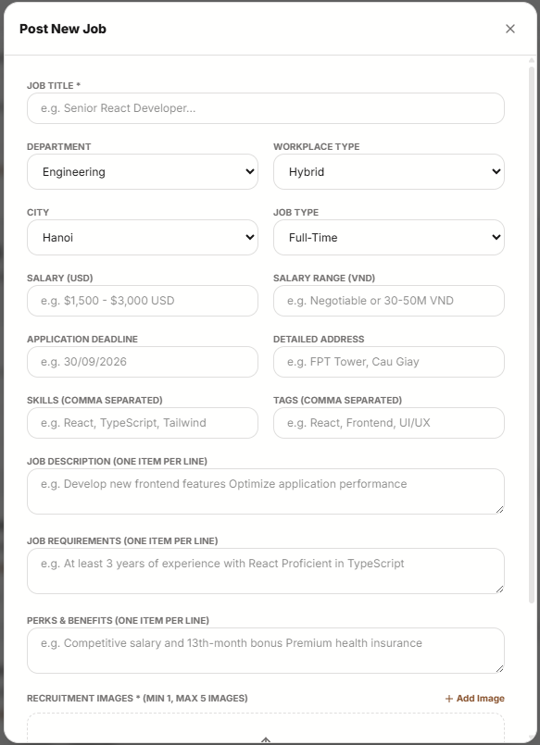
Figure 19 - Post New Job
● Input Fields (Job Posting):

- Job Title (required, 5–100 characters): Job title (Example: "Backend Tech Lead (.NET Core)").
- Job Description (required, ≥50 characters): Detailed description of job responsibilities and required skills
- Required Skills (required, multiple tags): Required skills (Example: Dotnet, CSharp, Backend, React, TypeScript).
- Company/Department (required, dropdown): Select the department posting the job.
- Location (required, dropdown): Work location (Example: Da Nang, Ho Chi Minh).
- Workplace Type (required, dropdown): Work type (Example: Remote, Hybrid, On-site).
- Salary Range (required, min/max values): Expected salary range for this position.
- Application Deadline (required, date picker): The deadline for submitting applications for this position.
- Job Thumbnail (optional, JPG/PNG, ≤5MB): The image representing the job posting.
● Action buttons: Post Job Cancel.
Function Details
● Data:
○ Post Data:JobId, UserId, JobTitle, Department, WorkplaceType, City, JobType, SalaryUSD, SalaryVND, ApplicationDeadline, DetailedAddress, Skills, Tags, JobDescription, JobRequirements, PerksBenefits, RecruitmentImages[], Status (e.g., Published/Draft), CreatedAt.
○ Audit Log:Ghi lại hành động "CreateJobPost" kèm theo ViewerID (hoặc UserId), JobId, và Timestamp để phục vụ công tác kiểm toán.

● Validation & Business Rules:
BR-16: Job posts require: Job Title, Department, Workplace Type, City, Job Type, Salary (USD or VND), Application Deadline, Detailed Address, Skills, Job Description, Job Requirements, Perks & Benefits, and Recruitment Images.
BR-17: Job posts remain active until the Application Deadline or until manually closed/updated by the Business user.
Validation Rules:
- Job Title: 5–100 characters, required.
- Job Description/Requirements/Perks: Must be filled, with a minimum length of 50 characters suggested for clarity.
- Media: Minimum 1, maximum 5 images, format JPG/PNG, ≤5MB each.
- Salary: Must be > 0.
Error Handling:
- Missing mandatory fields → Display: MSG22
- Invalid media file (format/size) → Display: MSG24

Normal Flow
- User Trigger: The Business user clicks the "Post New Job" button on the Job Board page.
- Input Entry: The user enters the required information into the modal: Job Title, Department, Workplace Type, City, Job Type, Salary, Application Deadline, Detailed Address, Skills, Tags, Job Description, Job Requirements, and Perks & Benefits.
- Image Upload: The user uploads at least 1 and up to 5 recruitment images (JPG/PNG, ≤5MB each).
- Submission: The user clicks the publish button to submit the job posting.
- Validation: The system validates all mandatory fields and data formats against the defined business rules.
- Processing: The system creates the job post in the database, sets the status to "Published," and records the creation action in the audit log.
- Completion: The system redirects the user to the Job Board or Post Management page to view the newly created listing.

Abnormal Cases
● 2.a.1: The Job Title length is <5 or >100 characters → Display validation error.
● 4.a.1: The user uploads an invalid media file (incorrect format or exceeds 5MB) → The system rejects the upload and displays MSG24.
● 5.a.1: Mandatory fields (Department, Workplace Type, Salary, Deadline, etc.) are missing → Display validation error and MSG22.
● 6.a.1: Network loss during submission → The system stores the job post data as a local draft and allows the user to retry once the connection is restored.

Post-Conditions
● PC-01: A new job post is successfully created and becomes visible on the Job Board.
● PC-02: The Job ID, detailed job metadata, and recruitment images are securely stored in the database.
● PC-03: The Business user is redirected to the Job Board or Post Management page.
● PC-04: The system generates an audit log entry recording the creation event with the user's ID and timestamp.

3.3.1.2 Search job Posts
Function Trigger
● Triggered when a Renter opens the Jobs page and enters a keyword or selects a filter..
● Triggered when a Renter clicks the Search button on the Jobs page or from the quick search widget on the dashboard.
Function Description
● Actors/Roles: Engineer.
● Purpose: Allows engineers to discover and search for job vacancies or training opportunities posted by Businesses, using keywords and specific filtering criteria.
● Interface: Job Board discovery page consisting of:
- Search Bar: Supports keyword searching by job title, specific skills, or general keywords.
- Filtering Options: Dropdowns for Department, Location (City), and Workplace Type (e.g., Remote, Hybrid, On-site).
- Results List: A display list or grid of active job postings showing key details like title, company, salary range, and required skills.
Data Processing
Input Handling: The system captures the keyword from the search bar and the selected values from filters (Department, Location, and Workplace Type).
Query Execution: The system queries the JobPosts database, strictly filtering for posts where status = Published and the ApplicationDeadline has not passed.
Filtering & Matching:
- Keyword Matching: The system performs a search across JobTitle, RequiredSkills, and Tags.
- Filter Application: The system applies the selected Department, Location, and Workplace Type as strict query parameters.
Sorting: The system sorts the results based on the chosen criteria (e.g., Latest as default, or other available sorting logic).
Rendering: The system displays the filtered list of job cards, each containing: JobTitle, CompanyName/Department, SalaryRange, Location, Deadline, and SkillTags
Screen Layout
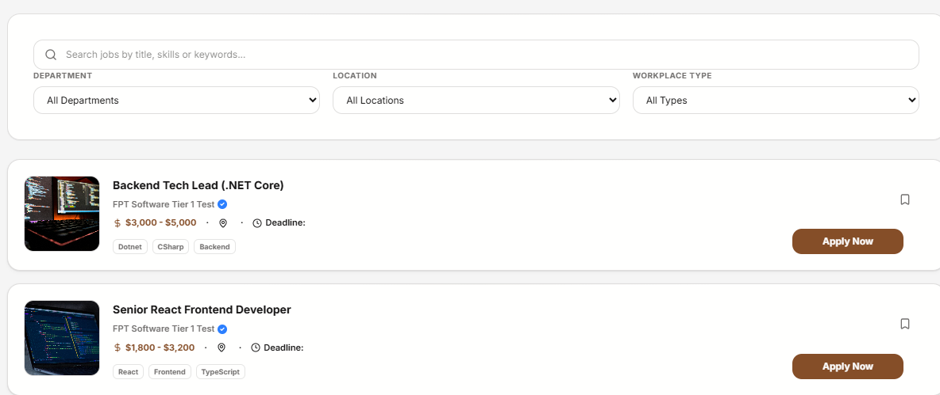

Figure 20 - Jobs Post Listing Page
Search Bar: Users can enter free-text keywords to search by Job Title, Skills (e.g., React, .NET), or General Keywords.
Filter Options:
- Department: Filter by specific company departments (e.g., Engineering, HR).
- Location: Filter by job location (e.g., Hanoi, Da Nang, Ho Chi Minh).
- Workplace Type: Select by environment (e.g., Remote, Hybrid, On-site).
Sort Options:
- Sort by: Latest (Default), Salary: Low to High, or Salary: High to Low.
Result Cards: Each job card displays the following information:
- Thumbnail: Company or project representative image.
- Title: Job position name.
- Salary Range: The expected compensation package.
- Location: Workplace city or region.
- Deadline: Application closing date.
- Skill Tags: A list of technical skills required for the role (e.g., Dotnet, CSharp, Backend).
Function Details
Job Post Data:Job ID, UserId, Job Title, Department, Workplace Type, City, Job Type, SalaryRange (USD/VND), ApplicationDeadline, DetailedAddress, Skills[], Tags[], JobDescription, JobRequirements, PerksBenefits, RecruitmentImages[], Status (Published / Closed / Draft), CreatedAt, UpdatedAt.
User Data: UserId (Engineer or Business account identifier).
Audit Log:Records search queries (keywords and active filters), ViewerID, and Timestamp for search behavior analytics and platform improvement.

● Validation & Business Rules:
● BR-22: Only job posts within the active validity period (i.e., the ApplicationDeadline has not passed) are displayed.
● Validation Rules:
- Empty search: Allowed; if no keywords or filters are applied, the system returns all job posts with status = Published and a valid deadline.
- Keyword Sanitization: All input text in the search bar is sanitized (e.g., removing special characters and preventing SQL injection) before being processed by the database query.

Normal Flow
User Trigger: The Engineer logs into the platform and navigates to the Job Board page.
Input Entry: The Engineer enters an optional keyword in the search bar and/or selects specific filters (Department, Location, Workplace Type).
Validation: The system validates and sanitizes the search input to ensure security and data integrity.
Data Query: The system queries the database for all posts that meet the following criteria:
- Match the provided keyword (or returns all available posts if the search bar is empty).
- Have a status = Published.
- Have an ApplicationDeadline that has not yet passed.
Sorting: The system sorts the resulting list based on the user's selected criteria (e.g., Latest, Salary: Low to High, Salary: High to Low).
Display: The system renders a paginated list of job cards containing key information: title, company/department, salary, location, deadline, and technical skill tags.

Abnormal Cases
● 2.a.1: Invalid or malicious characters detected in the search keyword → The system sanitizes the input automatically and continues the search process.
● 4.a.1: No job posts match the search criteria or filters → The system displays MSG27 (e.g., "No jobs found matching your criteria").
● 4.b.1: Database connectivity or retrieval error occurs → The system displays MSG67.
● 4.c.1: Network error occurs during the request → The system displays cached data or fallback results if available, and provides a "Retry" option to the user.
Post-Conditions
● PC-01: The Engineer sees a list of active job posts that match their selected search keywords and applied filters.
● PC-02: The Engineer can click on any individual job card to navigate to the detailed job description and application page.
● PC-03: The search query (including filters) and user ID are recorded in the system logs to support platform analytics and improve future job recommendation accuracy.

3.3.1.3 View Jobs Post Details
Function Trigger
● Triggered when a Renter clicks on a Jobs post card from the result research
Function Description
● Actors/Roles: Business
● Purpose:Allows an Busniess to view the comprehensive details of a specific job posting, including job description, requirements, benefits, salary range, and company/recruiter information to make an informed application decision.
● Interface:
Header: Job Title, Company/Workspace name, and verification status.
Key Info Bar: Salary Range, Location, and Application Deadline.
Job Overview: Full job description, technical requirements (e.g., specific skills like React, .NET), and perks/benefits.
Recruiter/Company Contact: Contact name, email, and phone number of the recruitment manager.
Action Area: Button to "Apply Now" or save the job.

Data Processing
` Retrieval: The system retrieves the full record of the selected job post using the unique JobId.
Status Check: The system validates the post status to determine accessibility:
- Published: Fully visible to all Engineers, allowing application actions.
- Closed/Draft: Visible only to the Business owner or internal administrators.
- Expired: Visible for reference only, with application actions disabled.
Analytics: The system increments the ViewCount and logs the interaction in the Audit Log with the EngineerID and Timestamp to track candidate interest.
Rendering: The system compiles and displays all relevant job content sections, including description, requirements, benefits, and recruiter contact details.

Screen Layout:
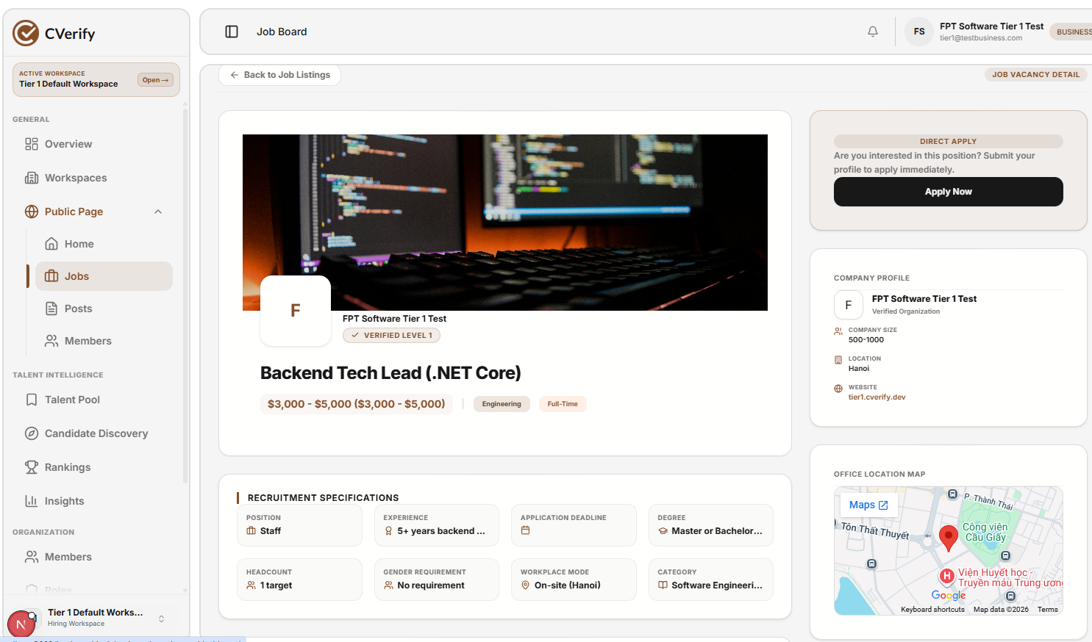
Figure 21 - Jobs Post Detail Page

● Header: Job Title (e.g., Backend Tech Lead), Company Name, Verified Status badge, and key metadata such as Salary Range, Department, and Job Type.
● Media Section: Cover image representing the recruitment post or the company's work environment.
● Action Section: A prominent "Apply Now" button located in the top-right corner to allow Engineers to submit their profiles directly.
● Company Profile: Details about the recruiter/business, including Company Name, Verification Level, Company Size, Location, and Official Website.
● Recruitment Specifications: A grid-based section detailing: Position, Required Experience, Application Deadline, Degree, Headcount, Gender Requirement, Workplace Mode, and Category.
● Location Section: An integrated office location map with a link to view the exact location on Google Maps.
● Detailed Content: (Main body of the page) Contains full job descriptions, technical requirements, and employee benefits.
● Action Buttons: Apply Now ,Back to Job Listings ,Maps
Function Details
● Data:
Job Post Data:Job ID, Company ID, Job Title, Job Description, Salary Range, Department, Job Type (Full-time/Part-time), Workplace Mode (On-site/Remote), Application Deadline, Cover Image, Status (Published/Closed/Draft), CreatedAt, UpdatedAt.

Recruitment Specifications (Nested Data):Position, Required Experience, Degree, Headcount, Gender Requirement, Category, Office Location (Address, Coordinates).

Company/Recruiter Data:Company ID, Company Name, Verification Level, Company Size, Website URL, Logo/Avatar.

Audit Log:Record of the "View" action, including Engineer ID, Job ID, Timestamp, and device information for candidate interest analytics.

● Validation & Business Rules:
BR-24 (Expiration Policy): Jobs where the ApplicationDeadline has passed must be displayed with an "Expired" status badge. All primary actions (e.g., "Apply Now", "Save/Favorite") are disabled.
BR-21 (Post Lifecycle):
- Only Published job posts are visible to Engineers in the job discovery and search interface.
- Hidden or Draft posts are visible only to the Business/Recruiter who owns the post.
BR-20 (Permissions): A Business account can only manage its own job posts; a user cannot modify or view the restricted administrative settings of posts belonging to another company.
Validation Rules:
- Post Not Found: If the provided JobId does not exist in the database, the system displays MSG28 (e.g., "Job posting not found").
- Access Control: If an Engineer attempts to access a Hidden or Unpublished post that they do not have authorization to view, the system denies access and redirects to a "Not Authorized" or "Job Board" page.

Normal Flow
- Selection: The Engineer selects a job post from the Job Board discovery page or their saved jobs list.
- Data Retrieval: The system retrieves the job details from the database using the unique JobId.
- Validation: The system validates the post visibility based on its current status (e.g., ensuring Published posts are visible).
- Display: The system renders the full job details page, including:
- Header: Job Title, Company Name, and verification status.
- Media: Company or project cover image.
- Job Overview: Detailed job description, requirements, and benefits.
- Specifications: Grid containing Position, Experience, Application Deadline, Degree, Headcount, Workplace Mode, and Category.
- Location: Office location map with an external link to Google Maps.
- Analytics: The system increments the ViewCount for the job post.
- Follow-up Actions: The Engineer may proceed with available actions: "Apply Now" (via Direct Apply), or navigate back to the job listings.
- Logging: The system logs the view event in the Audit Log for analytics and interest tracking.

Abnormal Cases
2.a.1: The requested JobId is not found in the database or has been deleted → The system displays MSG68.
3.a.1: The job post is expired (past the ApplicationDeadline) → The system displays the full job details for reference, but disables "Apply Now" and other interactive action buttons.
3.b.1: An unauthorized user (not the owner) attempts to access a Hidden or Draft job post → The system denies access and displays MSG29.
4.a.1: A database connectivity or network error occurs during retrieval → The system displays MSG69 and provides an option to retry.

Post-Conditions
PC-01: The job details, including specifications, description, and location, are successfully rendered and displayed to the Engineer.
PC-02: The ViewCount for the job post is successfully incremented in the database.
PC-03: The Engineer can perform follow-up actions (e.g., "Apply Now" or "Save") if the post status is Published and not expired.
PC-04: The access event is logged in the Audit Log for platform analytics and to refine future job recommendations for the Engineer.
3.3.1.4 Saved Jobs Post
Function Trigger
● Triggered when a Renter clicks the “Save” button on a Jobs post detail page or search result card.
Function Description
● Actors/Roles: Engineer.
● Purpose: Allows an Engineer to save a job post to their "Favorites" or "Saved Jobs" list for quick access later, or to remove it if they are no longer interested in the position.
● Interface: A toggle-style "Favorite" (heart icon) button located on both the individual job detail page and within the job search result cards for convenient access.

Data Processing :
Existence Check: The system queries the database to determine if a "Saved Job" record already exists for the specific combination of EngineerID and JobID.
Toggle Logic:
- If not found: The system creates a new entry in the SavedJobs table, associating the EngineerID with the JobID, and returns a "Saved" status to the UI.
- If found: The system removes the existing record from the SavedJobs table, and returns an "Unsaved" status to the UI.
Audit: The system updates the interaction state in the database to ensure the "Favorite" icon/button reflects the correct current state for the Engineer.

Screen Layout
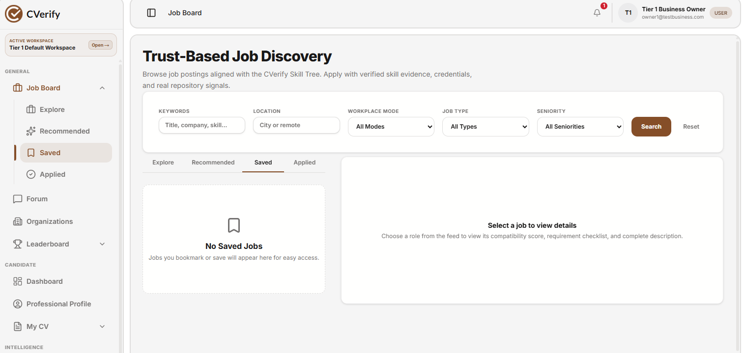
Figure 22 - Saved Jobs Post
60 | Page
Save button:
- Empty State: Indicates the job is not yet saved; clicking adds the job to the Engineer's "Favorites" list.
- Filled State: Indicates the job is already saved; clicking removes the job from the "Favorites" list.
Job Detail Page: The favorite icon is positioned prominently near the header/action bar to ensure high visibility while the Engineer reviews job specifications.

Search Results/Discovery Page: A compact favorite icon overlay is displayed on the corner of each job card, allowing Engineers to quickly bookmark opportunities while browsing the list.

Function Details
● Data:
Job Post Data:Job ID, FavoriteCount (total number of times the post has been saved by Engineers).
Favorite Data:Engineer ID, Job ID, CreatedAt (timestamp indicating when the job was added to the favorites list).
User Data:Engineer ID (the unique identifier for the user performing the action).
Audit Log:A comprehensive record of all "Add to Favorites" and "Remove from Favorites" actions, including Engineer ID, Job ID, ActionType, and Timestamp for user behavior tracking.

● Validation & Business Rules:
- BR-25 (Status Restriction): Only job posts with the status Published can be favorited by Engineers. Jobs in Hidden, Draft, or Archived states are ineligible for the favorites list.
- BR-26 (Expiration Policy): Jobs that have passed their ApplicationDeadline are considered expired and cannot be added to the favorites list.
- BR-27 (Ownership Restriction): A business owner (Recruiter) cannot add their own job posts to a favorites list.
Validation Rules:
- Authentication Check: If an Engineer is not logged into the system, clicking the "Favorite" button prompts the system to display MSG30.
- Post Eligibility Check: If an Engineer attempts to favorite a post that is invalid, expired, or not currently Published, the system displays MSG31.

Normal Flow
- Selection: The Engineer views a job post via the job detail page or the job search results card.
- Trigger Action: The Engineer clicks the "Add to Favorites" (empty heart) icon.
- Validation: The system validates that the job post status is Published, the ApplicationDeadline has not passed, and that the Engineer is not the owner of the job post.
- Database Update: The system creates a new favorite record containing the EngineerID and JobID in the SavedJobs table.
- Post Metadata Update: The system increments the FavoriteCount for the respective job post.
- UI Feedback: The button toggles to the "Filled" (heart icon) state to confirm the job has been saved.

Abnormal Cases
- Database/Network Error: If a connectivity or system error occurs while processing the request to save or remove a job from favorites, the system displays MSG70.
- Invalid Post State: If a job post is expired, Hidden, Draft, or Archived, the system disables the favorite button (or reverts the icon to a disabled state) and displays MSG31 if the user attempts to interact with it.
Post-Conditions
PC-01: The Engineer's "Saved Jobs" list is successfully updated to reflect the new addition or removal.
PC-02: The FavoriteCount for the job post is accurately incremented or decremented in the database.
PC-03: The interaction is recorded in the Audit Log, capturing the timestamp and nature of the action for platform analytics and recommendation engine refinement.

3.3.2 Job Application Management
3.3.2.1 Apply for a Job
Function Trigger
● Triggered when a user clicks “Apply” on a roommate post detail page. Function Description
● Actors/Roles: Renter
● Purpose: Allows a user to submit a formal application for a published job post to express interest in the vacancy.
● Interface:
A modal form or dedicated application page requesting:
- Curriculum Vitae (CV) upload or link.
- Cover letter or introduction message.
- Contact information (e.g., email, phone number).
- Confirmation checkbox for terms and conditions.

Data Processing
System Initialization: The system retrieves and displays essential job information (Job Title and Hiring Company) to ensure the user is applying for the correct position.
User Input: The user populates the required fields (CV, contact details, and personal message).
Submission: The system validates the input format, saves the application data into the database, and links it to both the UserID and JobID.

Screen Layout:
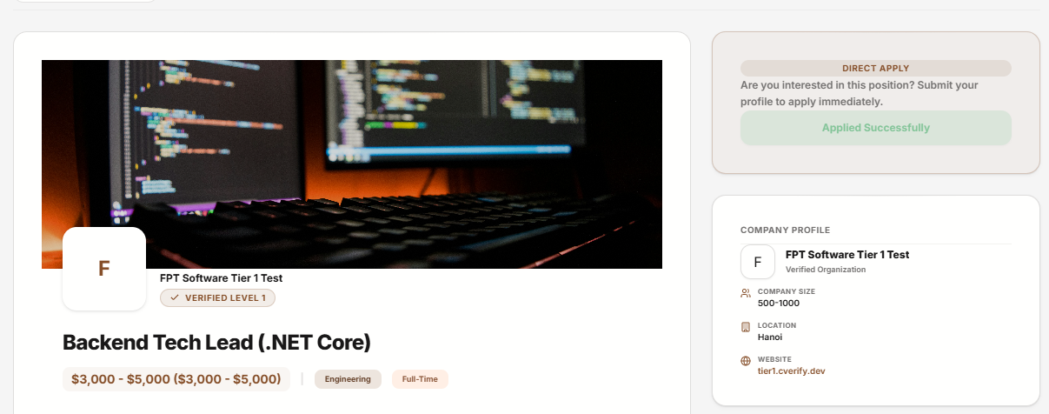
Figure 23 - apply job
Modal Title: Submit Job Application
Fields:
- Full Name: The user's full name for recruiter reference.
- Email Address: The primary contact email.
- Phone Number: The user's contact number.
- CV/Resume: An upload field or link to the user's professional portfolio/CV.
- Cover Letter/Message (Optional): A brief introduction or summary of qualifications.
Checkbox: “I confirm that all information provided in this application is accurate and truthful.”
Buttons:
- Cancel: Closes the modal and cancels the application process.
- Submit Application: Finalizes and sends the application to the hiring company.

Function Details
● Data:
Application Data:ApplicationId, JobId, ApplicantId, FullName, Email, PhoneNumber, CoverLetter, CVUrl (or file reference), Status (e.g., Pending, Reviewed, Accepted), and CreatedAt.
Job Post Data:JobId, RecruiterId (the entity that posted the job), and JobTitle.
Audit Log:A comprehensive record of all job application submissions, including ApplicantId, JobId, ActionType (e.g., Application Submitted), and Timestamp for tracking user activity and application history.

● Validation & Business Rules:
- BR-37 (Application Quota): Each Engineer can submit a maximum of 5 job applications per week to prevent spamming recruiters.
- BR-38 (Position Availability): Users cannot submit an application to a job post that is marked as "Closed" or "Filled".
- BR-39 (Ownership Restriction): An Engineer cannot apply to a job post that they have created.
- BR-40 (Active Application Policy): An Engineer may hold at most one active "Pending" or "Under Review" application for the same specific job position at any given time.
Validation Messages:
- Weekly Quota Exceeded: If the user exceeds their weekly application limit, the system displays MSG36.
- Position Unavailable: If the job is already filled or closed, the system displays MSG37.
- Self-Application: If a user attempts to apply to their own job post, the system displays MSG38.

Normal Flow
- Job Selection: The Engineer opens a job post from the search results or job board.
- Trigger Action: The Engineer clicks the "Apply" button on the job detail page.
- Modal Display: The system displays an application modal containing the job title and hiring company name for verification.
- Data Entry: The Engineer inputs their contact details (Full Name, Phone Number), uploads/links their CV, enters an optional cover letter, marks the confirmation checkbox, and clicks "Submit Application."
- Validation: The system validates the application against the weekly quota, ensures the job is not owned by the applicant, and checks if the position is still open.
- Record Creation: If valid, the system creates a new application record in the database with the status set to Pending.
- Notification: The system triggers a notification to the recruiter (post owner) regarding the new application.
- Confirmation: The system displays a confirmation message to the Engineer: MSG39.

Abnormal Cases
- Quota Exceeded: If an Engineer attempts to submit an application after reaching their weekly application limit, the action is blocked and the corresponding error message is displayed.
- Position Unavailable: If the job post is already filled or has been closed, the application submission is blocked and the corresponding error message is displayed.
- Self-Application: If an Engineer attempts to apply to a job post that they personally created, the action is blocked and the corresponding error message is displayed.
- System/Network Failure: In the event of a database connectivity issue or network error during the application process, the system displays MSG67.

Post-Conditions
PC-01: A new job application is successfully created in the database with the status set to Pending.
PC-02: The recruiter (post owner) is notified of the new application via the platform's notification system.
PC-03: The application submission is captured in the Audit Log, including the ApplicantID, JobID, and the exact timestamp of the action.
PC-04: The Engineer receives visual confirmation on the platform that their application has been successfully submitted.

5.4 Workspace Management

3.4.1 Create Workspace
Function Trigger: Triggered when the landlord clicks “Create WorkSpace”. 76 | Page
Function Description
Actors: Engineer (Primary), Business (Secondary).
Purpose: Register a new operational workspace within the organization to categorize different environments (e.g., Recruiting, Engineering).
Interface: Modal form.
Process: Input workspace details → Validate → Save → Confirm.

Screen Layout:
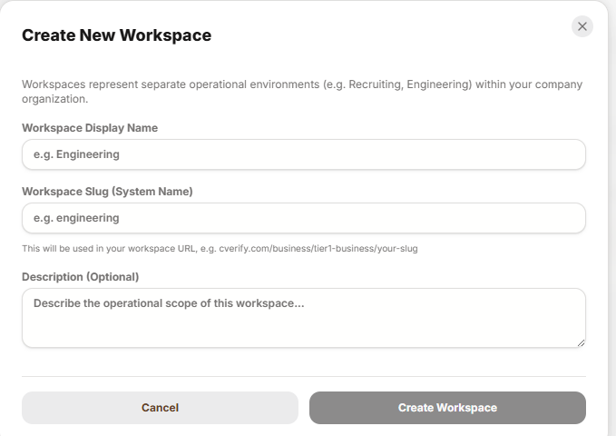
Figure 30 - Create Work Space
Step 1 – Initialization: The recruiter triggers the "Create Workspace" modal from the organization dashboard.
Step 2 – Input Form: The user enters the required workspace details:
- Workspace Display Name: The name for the operational environment (e.g., Engineering).
- Workspace Slug (System Name): A unique identifier for the workspace URL structure
- Description (Optional): A brief summary of the workspace's operational scope.
Step 3 – Submission: The user clicks "Create Workspace" to save the new environment, or "Cancel" to abort the process.

Function Details
● Data: Workspace Data:WorkspaceId, OrganizationId, DisplayName, Slug, Description, CreatedAt
● Audit Log:
Action Tracking: The system records the creation event of a new workspace, including the OrganizationId (replacing LandlordID), the user ID of the creator, and the exact timestamp of the action.
● Validation & Business Rules
BR-41 (Unique Slug): The Workspace Slug must be unique within the organization to ensure proper URL routing.
BR-42 (Naming Convention): The Workspace Display Name and Slug are mandatory fields and must adhere to system character limits.
BR-43 (Operational Scope): Workspaces must be associated with a valid, active organization account.
BR-44 (Validation Messages):
- Duplicate Slug: If the chosen slug already exists, the system displays MSG40 (e.g., "This URL identifier is already in use").
- Missing Fields: If mandatory fields (Display Name or Slug) are left empty, the system displays MSG41.

Normal Flow
- Trigger Action: The recruiter clicks the "Create Workspace" button from the organization dashboard.
- Modal Display: The system displays the "Create New Workspace" modal.
- Data Entry: The recruiter fills in the required fields: Workspace Display Name, Workspace Slug, and an optional Description.
- Submission: The recruiter clicks "Create Workspace" to submit the data.
- System Validation: The system validates the input (e.g., ensuring mandatory fields are filled and the slug is unique).
- Data Persistence: If the input is valid, the system saves the new workspace to the database and records the event in the audit log.
- Confirmation: The system displays a success confirmation to the recruiter.

Abnormal Cases
Missing Required Fields: If the recruiter leaves mandatory fields (Workspace Display Name or Slug) empty, the system displays MSG44 and returns the user to the input modal.
Invalid Slug Format: If the recruiter enters a Workspace Slug that contains unsupported characters or fails the format validation, the system displays MSG45 and returns the user to the input modal.
Database Error: In the event of a database connectivity issue during the saving process, the system displays MSG67.
System/Validation Error: If the system fails to process the new workspace creation due to internal conflicts, the system displays MSG46 and returns the user to the input modal.

Post-Conditions
PC-01: The new workspace is successfully created and becomes available within the organization's environment.
PC-02: The workspace is associated with the organization's account and ready to have job posts assigned to it.
PC-03: The workspace creation event is securely logged in the system's Audit Log for administrative tracking.
PC-04: The recruiter receives a success notification confirming that the workspace is now live and ready for use.

3.4.2 Edit WorkSpace
Function Trigger
● Triggered when a recruiter selects an existing workspace and clicks "Edit" or "Settings".
Function Description
Actors: Engineer, Business
Purpose: Update the configuration and status of an existing workspace.
Interface: Edit modal form.
Process: Load current details → Modify fields → Validate → Save changes → Confirm.

Screen Layout
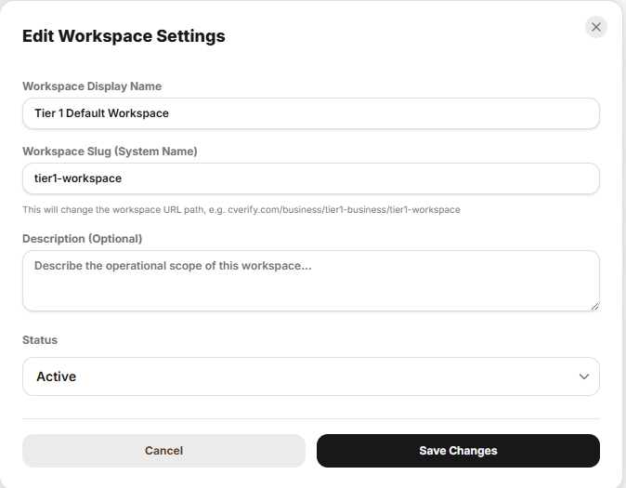
Figure 31 - Edit WorkSpace
79 | Page
Inputs:
- Workspace Display Name
- Workspace Slug (System Name)
- Description (Optional)
- Status (e.g., Active)
Actions:
- Save Changes: Commits the modifications to the database.
- Cancel: Discards all pending edits and closes the modal.
Display:
- The system displays a success toast notification or confirmation message upon the successful update of workspace settings.

Function Details
● Workspace Data: WorkspaceId, OrganizationId, DisplayName, Slug, Description, Status (e.g., Active), UpdatedAt
Audit Log
- Change Tracking: The system records all modifications to the workspace, storing the previous value, the new value, the exact timestamp of the update, and the UserId of the recruiter who performed the change.
Validation & Business Rules
- BR-45 (Mandatory Fields): The Workspace Display Name and Workspace Slug are required and cannot be left empty.
- BR-46 (Slug Uniqueness): The Workspace Slug must remain unique across the organization to ensure the integrity of the URL structure.
- BR-47 (Status Management): If a workspace is set to "Inactive," any associated job posts may be automatically hidden or set to a "Paused" state based on organization policy.
- BR-48 (Validation Messages):
  - Invalid Changes: If the user attempts to save invalid data, the system displays MSG47.
  - Database/Connectivity Error: If an error occurs during the save process, the system displays MSG67.

Normal Flow
Step 1 – Initialization: The recruiter selects an existing workspace from the dashboard and clicks the "Edit" or "Settings" button.
Step 2 – Data Loading: The system opens the "Edit Workspace Settings" modal and pre-populates the form with the workspace's current details.
Step 3 – Data Modification: The recruiter updates the necessary fields, which may include the Workspace Display Name, Workspace Slug, Description, or the workspace Status.
Step 4 – Submission: The recruiter clicks the "Save Changes" button.
Step 5 – System Validation & Execution: The system validates the modified inputs (e.g., checking for mandatory fields and verifying slug uniqueness).
- If valid: The system updates the workspace record in the database, records the changes in the Audit Log, closes the modal, and displays a success toast notification.
- If invalid: The system blocks the update and displays the relevant validation error message directly on the form (e.g., MSG44 for missing fields or MSG47 for invalid data formats). (Note: MSG67 is typically reserved for database or network connectivity errors).

Abnormal Cases
Missing Required Fields: If the recruiter leaves mandatory fields (Workspace Display Name or Slug) empty, the system displays MSG44 and returns the user to the edit modal.
Invalid Slug Format: If the recruiter enters a Workspace Slug that is already in use or violates naming conventions, the system displays MSG45 and returns the user to the edit modal.
Database/Network Error: In the event of a connectivity issue during the saving process, the system displays MSG67.
System/Validation Error: If the system fails to process the update due to internal conflicts, the system displays MSG46 and returns the user to the edit modal.

Post-Conditions
PC-01: The workspace details are successfully updated in the database and reflect the new configuration across the platform.
PC-02: The modification is securely recorded in the Audit Log, including the timestamp, the ID of the user who made the changes, and the specific field values before and after the update.
PC-03: The recruiter receives a confirmation message indicating that the workspace settings have been updated.

3.4.3 Delete WorkSpace
Function Trigger
● Triggered when a recruiter clicks the "Delete" or "Remove" option for a specific workspace.
Function Description
- Actors: Business (Primary).
- Purpose: Permanently remove a workspace from the organization's account, provided there are no active dependencies (e.g., active job posts or ongoing recruitment processes).
- Interface: Delete confirmation modal.
- Process: Validate conditions (check for active dependencies) → Delete from system → Confirm removal.
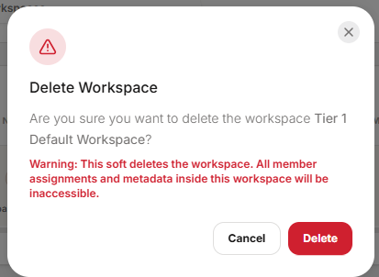
.
Figure 32 - Delete WorkSpace
Display: The system shows a warning modal: "Are you sure you want to delete the workspace {WorkspaceDisplayName}?".
Warning Notice: "Warning: This soft deletes the workspace. All member assignments and metadata inside this workspace will be inaccessible."
Actions:
- Cancel: Closes the modal and aborts the deletion process.
- Delete: Confirms the soft deletion of the workspace.
Validation & Business Rules
- BR-50 (Dependency Check): The system verifies if the workspace contains active dependencies (e.g., ongoing recruitment campaigns or assigned members) before allowing the deletion.
- BR-51 (Soft Delete Policy): The deletion is a "soft delete," meaning data is marked as inaccessible rather than permanently removed from the database immediately.
- BR-52 (Authorization): Only users with appropriate administrative privileges are authorized to perform this action.
Normal Flow
- Trigger Action: The recruiter clicks the "Delete" button for the target workspace.
- Confirmation Modal: The system displays a warning modal requesting confirmation, including the workspace name and a notice regarding data accessibility.
- User Decision:
  - If Cancel: The system closes the modal without changes.
  - If Delete: The system validates the request and proceeds with the soft delete.
- Completion: The system updates the workspace status, records the action in the Audit Log, and provides a success notification.
Abnormal Cases (Delete Workspace)
- 4.a1: Active Dependencies Found: If the system detects active member assignments or ongoing metadata processes within the workspace, it displays MSG43 and returns the user to the workspace management view.
- 5.a1: System/Database Error: If a database or internal system error occurs during the deletion process, the system displays MSG67 and cancels the request.
Post-Conditions
- PC-01: The workspace is successfully soft-deleted and is no longer accessible within the organization’s environment.
- PC-02: The deletion event is securely logged in the Audit Log for administrative tracking, documenting the action and the timestamp.
- PC-03: If the deletion was blocked due to active dependencies, the system maintains the workspace's original state and displays the appropriate error message to the recruiter.

3.4.5 Open WorkSpace
Function Trigger
● Triggered when landlord navigates to “Open WorkSpace”
Function Description
- Actors: Business (Primary).
- Purpose: Access a workspace to monitor recruitment metrics, view hiring funnel data, and manage organizational operations.
- Interface: Workspace Dashboard (as seen in image_93dbac.png).
- Process: Select workspace → Load workspace context → Display "Recruitment Analytics" and hiring funnel data.
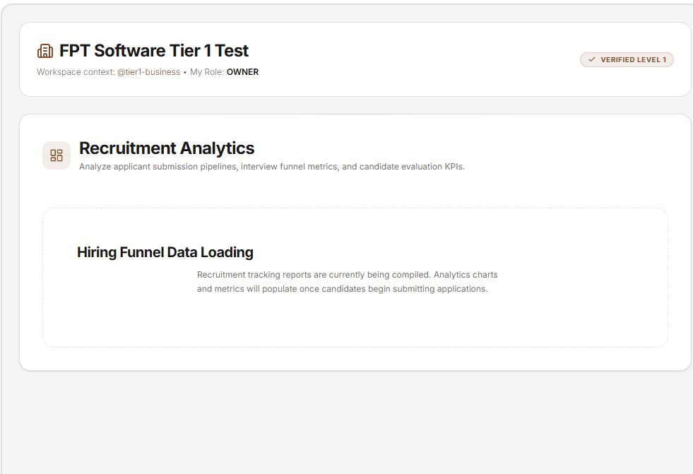
Figure 33 - WorkSpace
Workspace List View (Dashboard):
- Display Fields: Displays the workspace context, user role (e.g., OWNER), and verification status.
- Actions: Navigate to workspace dashboard, view recruitment analytics, and manage workspace settings.
Function Data:
- Workspace Metadata: Workspace ID, Organization ID, Display Name, Slug, Description, Status, and Creation Date.
- Contextual Data: Workspace context (e.g., @tier1-business) and verification level (e.g., VERIFIED LEVEL 1).
Audit Log:
- The system logs recruiter access actions, including the specific workspace accessed, the timestamp, and the user performing the action.
Validation & Business Rules:
- Ownership Access: Recruiters can only access workspaces where they have assigned roles (e.g., OWNER).
- Visibility: Workspace data, such as recruitment analytics, is only populated and visible based on the current submission status of candidates within that specific workspace.
Normal Flow (Open Workspace)
- Step 1: The recruiter navigates to the workspace selection or management dashboard.
- Step 2: The system fetches and displays all workspaces associated with the recruiter's account context.
- Step 3: The recruiter selects a specific workspace to view its dashboard, which includes the workspace context, user role (e.g., OWNER), and verification status.
- Step 4: The system displays the Recruitment Analytics and hiring funnel metrics for the selected workspace.
Abnormal Cases (Open Workspace)
- No Workspaces Found: If the system fails to retrieve any workspaces associated with the recruiter's account, it displays MSG82 (e.g., "No workspaces found"), indicating that the user currently does not have access to any active workspaces.
Post-Conditions
- PC-01: The recruiter successfully accesses the selected workspace dashboard and gains visibility into the "Recruitment Analytics" and relevant hiring funnel data for that specific workspace.
- PC-02: The recruiter has clear visibility of their current role (e.g., OWNER) and the workspace verification status (e.g., VERIFIED LEVEL 1).
- PC-03: The system maintains an accurate audit trail of the workspace access event for security and tracking purposes.

5.5 CV Management

3.5.1 Create CV
Function Trigger
- Triggered when a user navigates to the "My CV" section and selects a specific category (e.g., "Basic Information") or clicks the "Form Editor" button.
Function Description
- Actors / Roles: Recruiter (or Job Applicant).
- Purpose: To allow users to create and maintain a comprehensive professional profile by inputting essential details such as personal identification, work experience, education, and career preferences.
- Interface: Multi-step form editor.
Data Processing
- Authentication: The system verifies user identity to ensure authorized access to the profile data.
- Input Validation: The system validates all mandatory fields (e.g., Full Name, Username) and enforces character limits (e.g., 21/100 characters for Full Name, 6/30 for Username, 0/1000 for Professional Bio).
- Auto-Save: Changes made within the "Form Editor" are saved directly into the CVerify CV data.
- Submission/Confirmation: The system confirms the successful update or creation of CV components to the user.
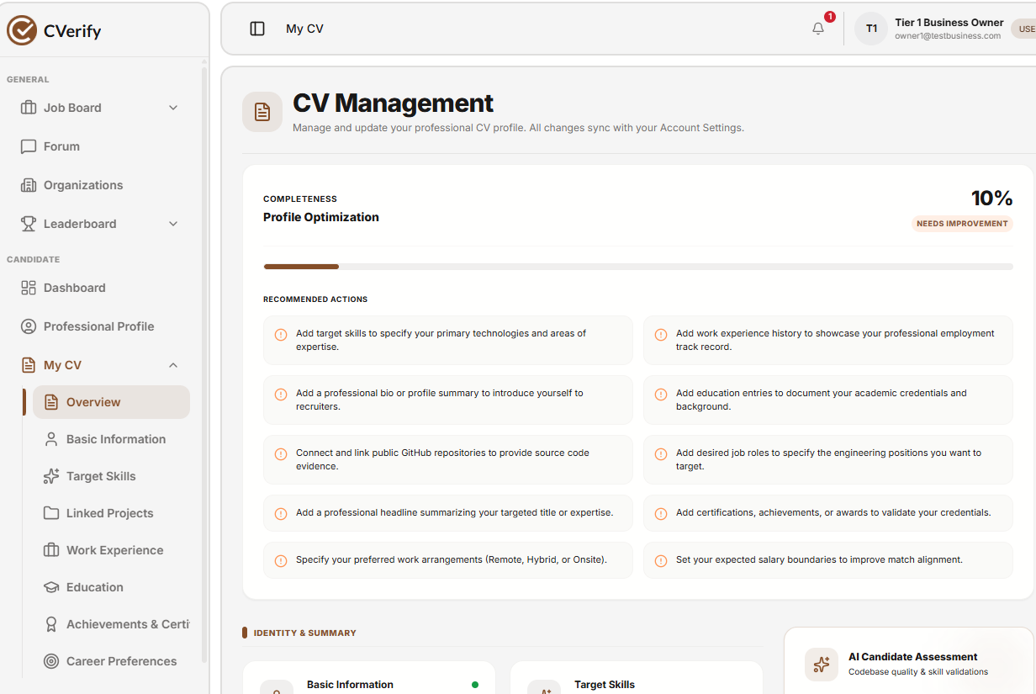
Figure 36 - Create CV
Function Details (CV Management)
- Data: The system manages comprehensive professional profile data, including:
  - Personal Information: Full Name, Username, Professional Headline, and Professional Bio/Summary.
  - Profile Media: Profile photo (supports JPEG, PNG, or WebP formats, max size 2MB).
  - Career Sections: Target Skills, Linked Projects, Work Experience, Education, Achievements & Certifications, and Career Preferences.
- Validation:
  - Character Limits: The system enforces specific character counts for input fields (e.g., Full Name: 100 characters max, Username: 30 characters max, Bio: 1000 characters max).
  - Media Constraints: Images must adhere to specified file formats (JPEG, PNG, WebP) and size restrictions (≤ 2MB).
- Business Rules:
  - BR-45 (Data Integrity): Updates made within the "Form Editor" are saved directly into the CVerify CV data.
  - Visibility: User profile sections are structured into distinct tabs (Basic Information, Target Skills, etc.) for organized management.
Normal Flow
- The user selects a specific CV section (e.g., "Basic Information") from the side navigation menu.
- The system displays the corresponding "Form Editor" for that section.
- The user enters the required data (e.g., Full Name, Professional Headline, Bio) and uploads profile media.
- The system validates all inputs against defined constraints (e.g., character limits, file size).
- The system automatically saves the changes directly into the CVerify CV data.
Alternative Flow
- No alternative flow defined.
Abnormal Cases
- Missing Required Fields: If mandatory fields (indicated by an asterisk "*") are left empty, the system displays an error message prompting the user to complete them.
- Invalid File Type/Size: If the uploaded profile image exceeds the 2MB limit or is not in an accepted format (JPEG, PNG, WebP), the system shows MSG79.
3.5.2 Edit CV
Function Trigger
- Triggered when a user clicks on a specific section within the "My CV" sidebar navigation menu.
Function Description
- Actors / Roles: Recruiter (or Job Applicant).
- Purpose: To allow users to access and modify the information of their existing professional profile.
- Interface: Editable "Form Editor" interface pre-filled with existing CV data.
Data Processing
- Data Retrieval: The system retrieves and displays the existing information for the selected CV section.
- Validation: The system validates all modified fields against defined constraints (e.g., character limits and media requirements) as the user makes changes.
- Data Update: The system updates the CV data directly into the database upon modification.
Function Details (Edit CV)
- Data: The system manages and updates existing professional profile data, including:
  - Personal Information: Full Name, Username, Professional Headline, and Professional Bio/Summary.
  - Profile Media: Profile photo (JPEG, PNG, or WebP; max 2MB).
  - Career Sections: Target Skills, Linked Projects, Work Experience, Education, Achievements & Certifications, and Career Preferences.
- Validation & Business Rules:
  - Authorization: Only the owner of the professional profile is permitted to edit their own CV information.
  - Data Integrity: All modified fields must adhere to the defined validation constraints (e.g., character limits and file format requirements) to ensure the CV data remains valid.
Normal Flow (Edit CV)
- The user clicks on a specific section in the "My CV" sidebar navigation menu.
- The system loads the current data for the selected section into the "Form Editor".
- The user updates the necessary fields or replaces the profile media.
- The system validates the modified fields against constraints (e.g., character limits, file formats) and automatically saves the changes to the CVerify CV data.
- The CV profile updates immediately.
Abnormal Cases
- Unauthorized Access: If a user attempts to edit a profile they do not own, the system displays MSG15.
- Invalid Input: If the modified data violates validation rules (e.g., exceeding character limits or incorrect file types), the system displays MSG67.
Post-Conditions
- The CV data is successfully updated in the database, reflecting the latest changes made by the user.
3.6 Leaderboard & Talent Insights
Function Description
- Purpose: To provide a comprehensive overview of the CVerify ecosystem and the engineering talent market through key performance metrics and data-driven rankings.
- Interface: A centralized dashboard titled "Top Stats & Market Insights," which includes functionality to filter data by specific timeframes (e.g., "Last 30 days").
Key Metrics & Data
The dashboard displays critical market intelligence, including:
- Verified Engineers: The count of engineers with high trust and verified profiles.
- Verified Repositories: The count of high-quality, verified code repositories.
- Represented Geographies: The number of countries featuring active, verified talent.
- Platform Intelligence: Advanced metrics such as "Fastest Rising Skills," "Trending Engineers," and the "Talent Quality Index," which assess maturity and ecosystem quality.
- Top Technologies: A ranking of language or framework capabilities based on popularity and verification across candidate repositories.
Business Rules
- Data Population: Metrics, charts, and rankings are populated automatically once sufficient data is generated from verified repositories and candidate profiles.
- Intelligence Metrics: Rankings and indices are contingent upon the accumulation of platform intelligence data; placeholder states are displayed when insufficient data exists to populate these sections.
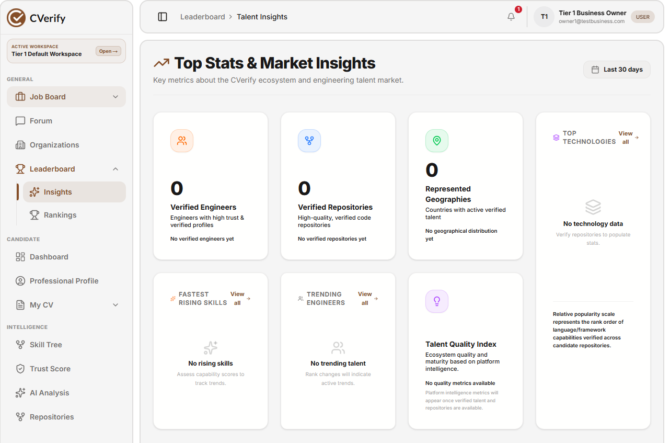
Figure 36 - Leader Board
Normal Flow
- The user navigates to the "Leaderboard" section from the main navigation menu.
- The system loads the "Talent Insights" dashboard, displaying real-time metrics and market trends.
- The user selects a desired timeframe (e.g., "Last 30 days") to filter the displayed data.
- The system updates and displays the corresponding statistics, including "Verified Engineers," "Verified Repositories," and "Represented Geographies".
- The user reviews the platform intelligence data, such as "Fastest Rising Skills," "Trending Engineers," and "Top Technologies".
Abnormal Cases
- Insufficient Data: If the platform has not yet gathered enough verified data, the system displays the "No data" placeholder state (e.g., "No verified engineers yet," "No technology data") for the respective sections.
- System Timeout/Fetch Error: If the dashboard fails to retrieve the latest stats, the system displays an error message indicating a connectivity issue or inability to load the requested reports.
3.7 Community Forum
3.7.1 Create and Manage Discussions
Function Trigger
- Triggered when a user clicks the "Create Discussion" button or selects a specific category (e.g., Programming, Career Discussions) within the Community Forum.
Function Description
- Actors / Roles: Candidates, Businesses, and Experts.
- Purpose: To enable users to collaborate, share knowledge, and seek verified answers on various professional topics.
- Interface: A forum dashboard featuring a list of categories (e.g., Frontend Development, Security, Admin Announcements), a discussion search bar, and tab filters for viewing discussions by "Latest," "Trending," "Solved," and "Unanswered" status.
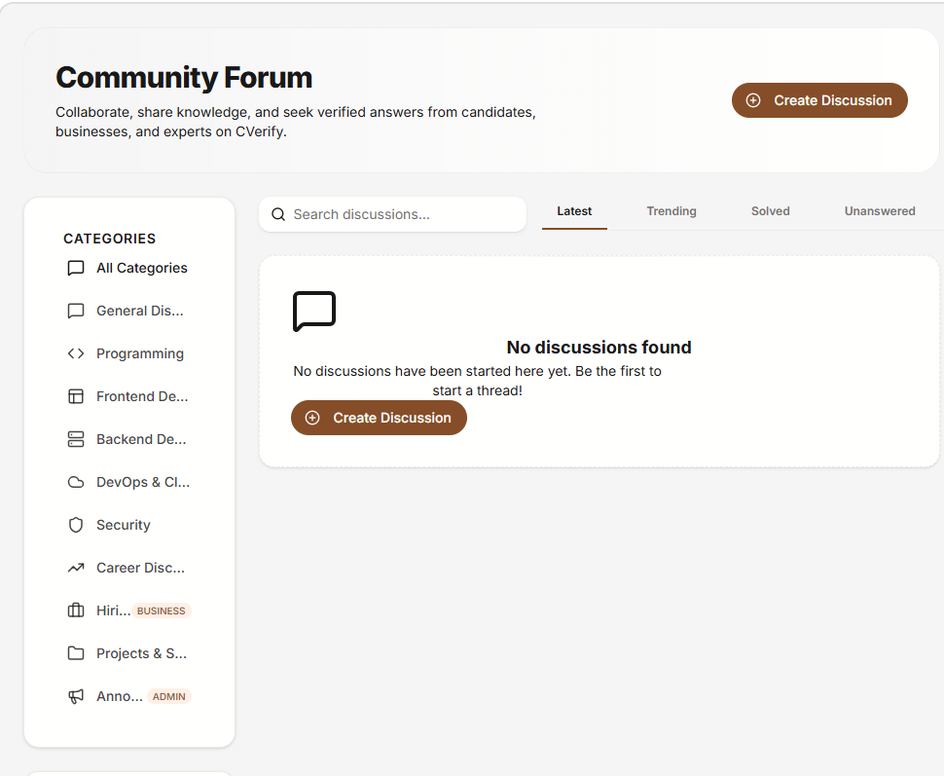
Figure 36 - Forum
Function Details (Create and Manage Discussions)
- Message List: Displays threads within a selected category, sorted by criteria such as "Latest," "Trending," "Solved," or "Unanswered."
- Input/Interaction: Includes a "Create Discussion" button and a search bar to filter existing discussions.
- Indicators: Discussion status (e.g., Solved/Unanswered) and metadata (author, time, category).
Data
- Credentials Required: Logged-in user (Candidates, Businesses, or Experts).
- Session Data: User identity, forum category ID, and discussion thread identity.
Validation & Business Rules
- Authentication: Users must be authenticated to create or participate in discussions.
- Content Integrity: Discussion titles and body content cannot be empty.
- Category Validation: Discussions must be posted under valid, predefined forum categories (e.g., Programming, Security, Career Discussions).
Abnormal Cases
- Unauthorized Access: If a non-authenticated user attempts to create a discussion, the system displays MSG15 (or appropriate authentication prompt).
- Empty Content: If the discussion title or body is empty, the system displays MSG59.
- System Error: If the discussion fails to post due to a server error, the system displays MSG67.
Normal Flow
- The user navigates to the "Community Forum" and selects a category (e.g., "Programming").
- The user clicks the "Create Discussion" button.
- The user enters the discussion title, selects a category, and inputs the content.
- The system validates the inputs and stores the new thread in the database.
- The system updates the forum feed, and the new discussion appears under the "Latest" tab for all users.
Post-Conditions
- The new discussion thread is saved successfully in the database.
- The community forum view is updated to reflect the most recent thread.
- The discussion is visible to other authorized users in real-time.

3.7.2 Create Conversation
Function Description
- Purpose: To allow users to share ideas, ask questions, or announce details to the CVerify community.
- Interface: A "Start a Discussion" form featuring a category dropdown, input fields for title and body text (supporting Markdown), a tag input field, and action buttons ("Cancel" and "Publish Discussion").
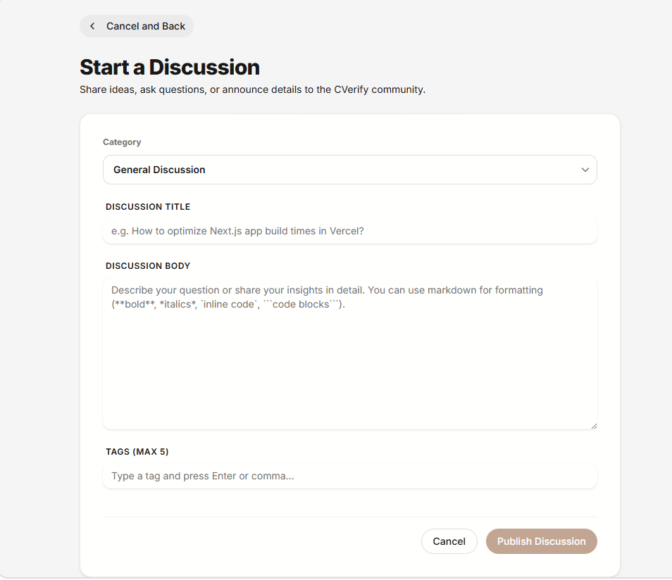
Figure 36 - Create a Discussion
Data
- Category: Selection from available forum categories.
- Discussion Title: The subject of the thread.
- Discussion Body: Detailed content, supporting formatting like bold, italics, and code blocks.
- Tags: A maximum of 5 tags to categorize the discussion.
Normal Flow
- The user clicks "Create Discussion" and is redirected to the "Start a Discussion" page.
- The user selects a category from the dropdown menu.
- The user enters the discussion title and the content body.
- The user adds up to 5 relevant tags.
- The user clicks "Publish Discussion" to submit the thread to the community.
Abnormal Cases
- Incomplete Fields: If required fields are missing, the system will highlight the error and prevent publication.
- Tag Limit Exceeded: If the user attempts to add more than 5 tags, the system restricts the input.
- Submission Failure: If the "Publish Discussion" action fails due to network issues, the system displays an error message (e.g., MSG67).
Post-Conditions
- The new discussion is published and becomes visible to the CVerify community.
- The user is redirected back to the forum main view.
3.8 AI Repository Analysis
3.8.1 Repositories
- Function Trigger: Triggered when the user navigates to the "Repositories" tab or clicks the "Sync Now" button to refresh data from linked accounts.
- Function Description: Acts as the central management hub for connected codebases. It allows users to sync, search, and filter repositories by account, language, category, visibility, or sort order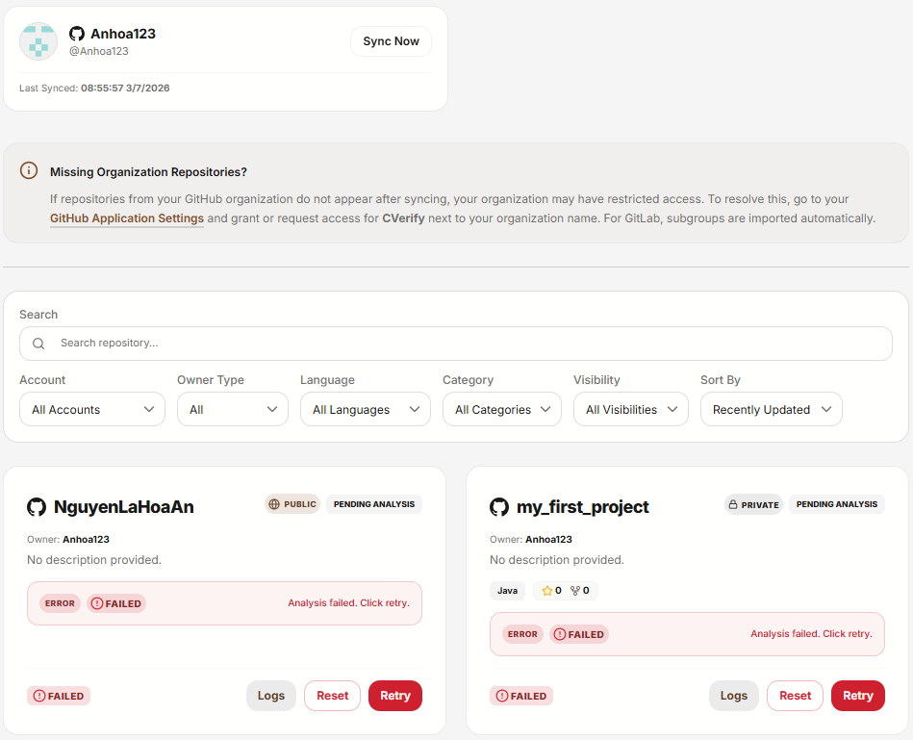
Figure 36 - AI repo analysis
- Function Detail: Users can manage organization access, view the last sync time, and initiate the AI analysis pipeline for specific repositories.
- Abnormal Case: If a repository does not appear after syncing due to restricted access, the system displays instructions to check "GitHub Application Settings" to grant the necessary permissions.
3.8.2 Skill Tree
- Function Trigger: Triggered automatically upon the successful completion of the "Code Capability Extraction" and "Architecture & Modularity" stages of the AI analysis pipeline.
- Function Description: Provides a visual representation and structured map of the technical skills, programming languages, and coding patterns extracted from the repository codebase.

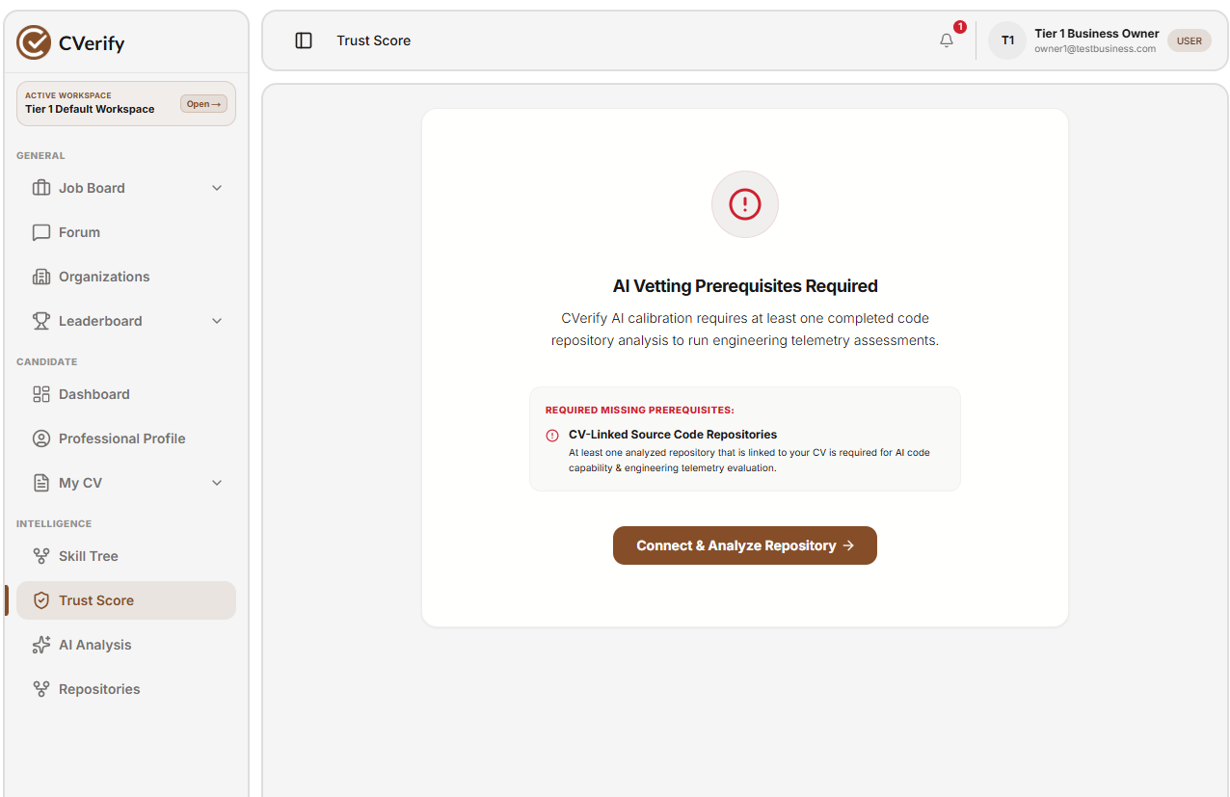
Figure 36 - Trust Score
- Function Detail: This module automatically categorizes and displays proficiency levels based on patterns identified during the AI analysis pipeline.
- Abnormal Case: If the AI analysis fails to extract sufficient data, the system displays a "No data available" placeholder, indicating that more repository commits or code volume are required to generate the skill map.
3.8.3 Trust Score
- Function Trigger: Triggered automatically upon the successful completion of the "Authorship & Git History" and "Code Quality & Complexity" stages of the AI analysis pipeline.
- Function Description: Generates a reliability rating for the repository owner, calculated based on verified Git history, authorship, and code quality assessments.
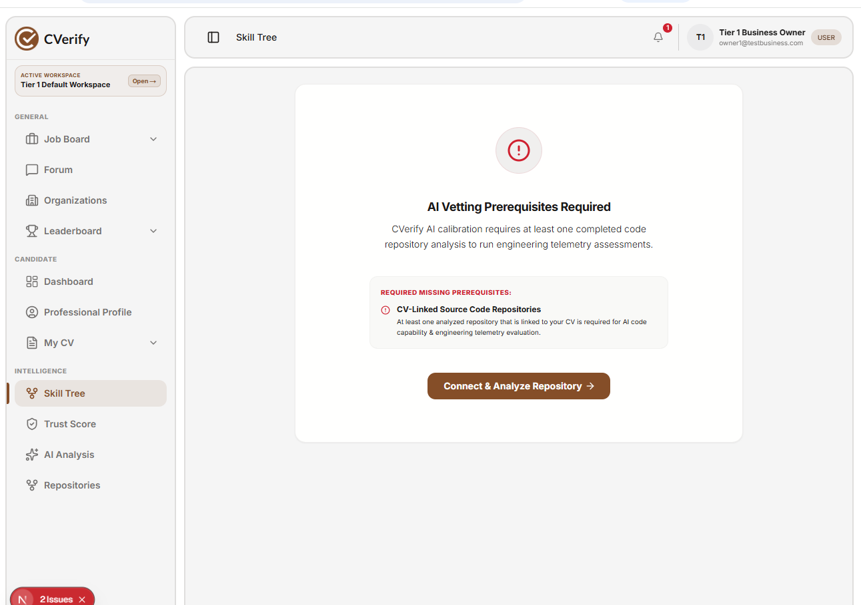
Figure 36 - Skill Tree

- Function Detail: The system aggregates data from the AI analysis to generate a quantitative score, indicating the trustworthiness and quality of the engineer's contributions.
- Abnormal Case: If the repository has insufficient historical data (e.g., a new or empty repository), the system displays a "Cannot calculate" status or a default baseline score, notifying the user that more activity is needed for an accurate assessment.
3.9 Admin Dashboard & Moderation Management
3.9.1 User Management
3.9.1.1 View User Account
Function Trigger: Triggered when an Admin navigates to the "User Account Directory" section via the Admin Dashboard.
Function Description:
- Actors / Roles: Admin, System.
- Purpose: Allows an administrator to manage user accounts, toggle access, adjust permissions, and track status.
- Interface: A dashboard-style web page displaying a "Sync Records" button, a search bar (by name or email), filter dropdowns (Status, Roles), a paginated table of users, and an action menu button ("...") for each user record.
Data Processing:
- System loads the directory with default filters (all statuses, all roles).
- If the admin enters search text, the system performs a filtered query based on the input.
- If the admin selects filters (Status/Roles), the system refreshes the list to display matching results.
- The table displays core user information: Full Name, Email Address, Status, Assigned Roles, Session version, and an Action menu.
- Admin can trigger the "Sync Records" button to update the directory.
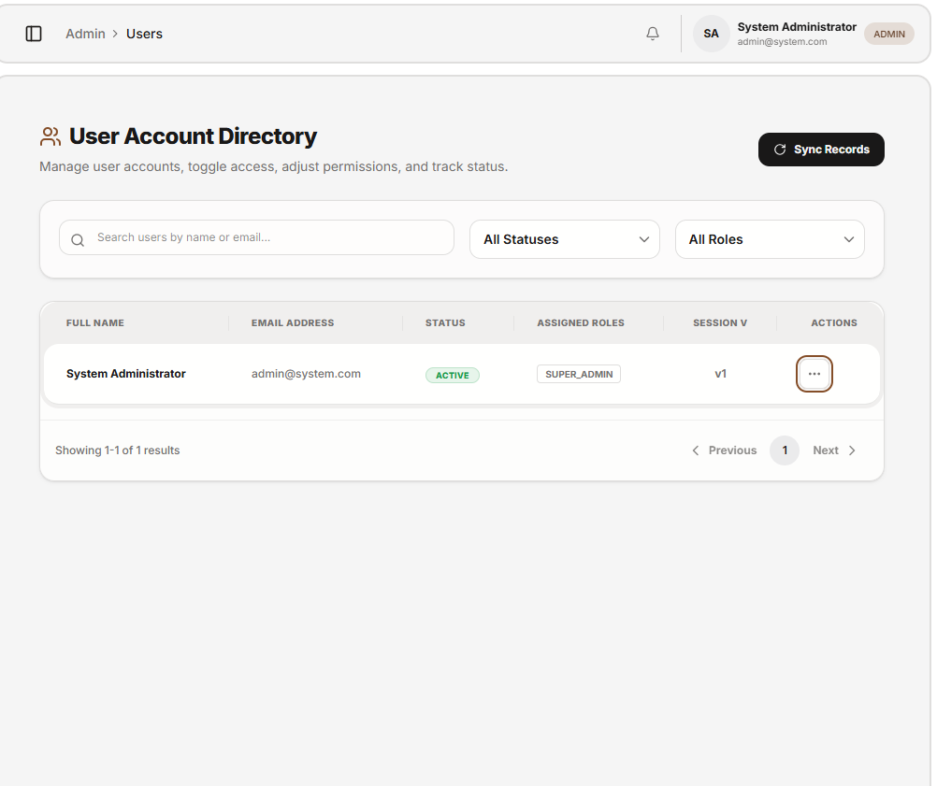
Figure 36 - View User Account
Function Details
- User Data: Displays Full Name, Email Address, Status, Assigned Roles, and Session Version.
- Search & Filters:
  - Search Bar: Search users by name or email.
  - Filters: Role (e.g., SUPER_ADMIN) and Status (e.g., ACTIVE) dropdowns.
- Pagination: Includes "Previous" and "Next" page controls.
- Action Menu: Each row contains an action menu button ("...") to perform functions such as verifying, disabling, or viewing user details.
- Audit Log: Logs all administrative actions, including search queries, filter adjustments, and user management operations.
Validation & Business Rules
- Default View: An empty search returns all users.
- Filter Logic: Invalid filter options revert to the default state.
- Empty State: If no users match the search or filter criteria, the system displays an empty state message.
- Sync Requirement: Admin can click "Sync Records" to manually refresh the user directory data.
Normal Flow
- Admin navigates to the "User Account Directory" via the Admin Dashboard.
- The system loads the user list using default "All Statuses" and "All Roles" filters.
- Admin enters text into the search bar or selects specific filters.
- The system refreshes the table to return matching user results.
- Admin selects a user row and clicks the action menu button ("...") to view available options.
- Admin selects an action (e.g., Verify, Disable, View Details).
- The system updates the user record and refreshes the table display.
3.9.2 Delete Custom Role
- Function Trigger: Triggered when an Admin clicks the action menu button ("...") on a custom role row and selects “Delete”.
- Function Description:
  - Actors / Roles: Admin, System.
  - Purpose: Permanently removes a custom role from the platform, ensuring it is no longer available for assignment or permission mapping.
  - Interface: Action menu dropdown → Confirmation dialog.
- Data Processing:
  - Admin selects "Delete" from the action menu.
  - System displays a confirmation dialog to prevent accidental deletion.
  - Admin confirms the action.
  - System removes the role record from the database.
  - System logs the deletion event in the audit log.
  - System updates the UI immediately by removing the role from the "Roles & Permissions Matrix" table.
- Business Rules:
  - Only roles with the CUSTOM type can be deleted.
  - Roles marked as SYSTEM LOCKED cannot be deleted.
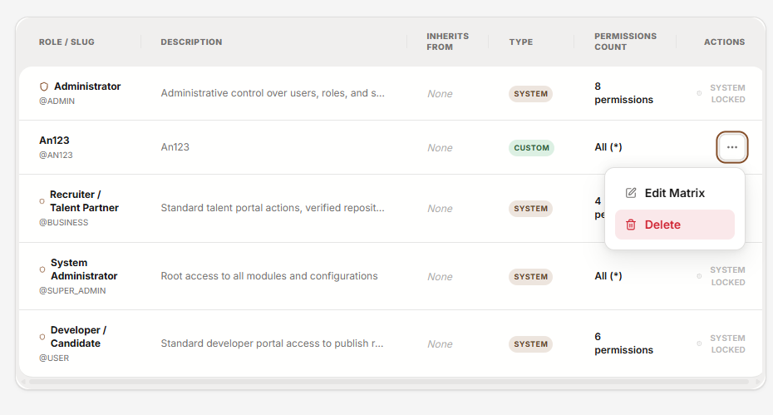
Figure 36 - Delete Account
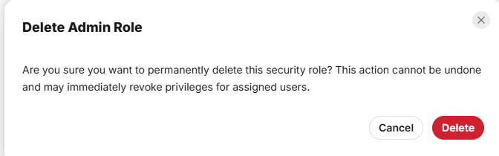
Figure 36 -Notification
3.9.3 Security Audit Log (Audit Trail)
Function Description
- Purpose: Provides the capability to trace critical system activities, including admin logins, role modifications, credential events, and system errors.
- Interface: A system log table that displays event details, supporting searches by email, event type, or description.
Function Details
- Log Data: Each log entry includes:
  - Timestamp: The time the event occurred.
  - Triggered By: The entity or system that performed the action.
  - Event Type: The classification of the event (e.g., USER_LOGIN_SUCCESS, TOKEN_ROTATED, PROVIDER_LINK_CONFIRMED).
  - Action Detail: A detailed description of the action performed.
  - Connection Origin: Information regarding the IP address and User Agent (UA) that initiated the connection.
- Management Features: Administrators can click the "Sync Records" button to update the list with the latest log entries.
Business Rules
- The system automatically records critical security events to facilitate monitoring and periodic auditing.
- The data in the table is presented in chronological order to allow administrators to easily track the flow of system events.
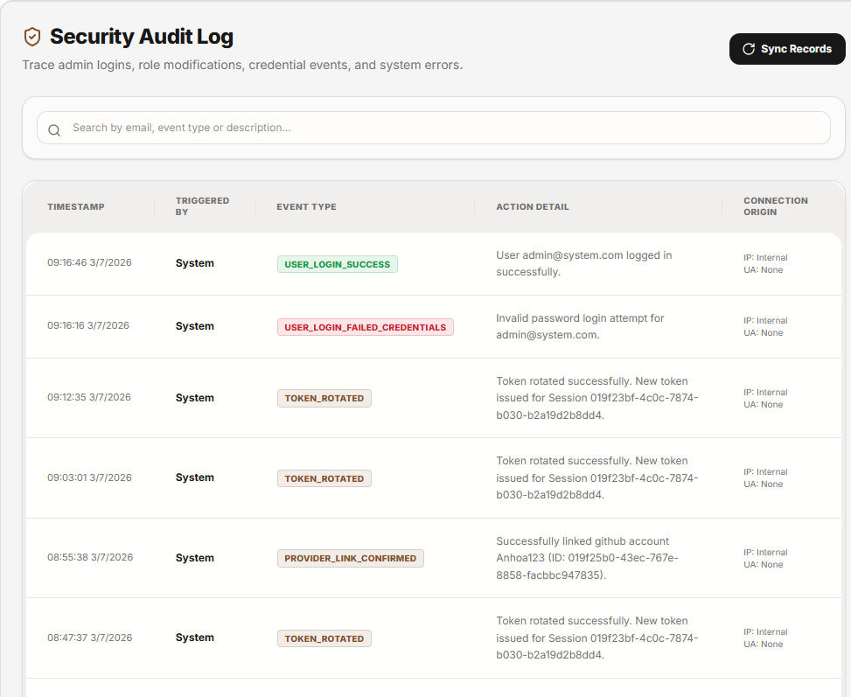
Figure 36 -Audit trail
Normal Flow: Monitoring and Searching Audit Logs
- Access: The administrator navigates to the "Audit Trail" section via the administration menu on the left.
- View Logs: The system loads and displays the most recent security events in chronological order, including details such as Timestamp, Triggered By, Event Type, Action Detail, and Connection Origin.
- Search/Filter: The administrator enters information into the search bar (user email, event type, or specific description).
- Display Results: The system automatically filters and updates the log table to display records matching the search criteria.
- Manual Refresh: The administrator can click "Sync Records" at any time to update the display with the latest system events.

6. Database Design
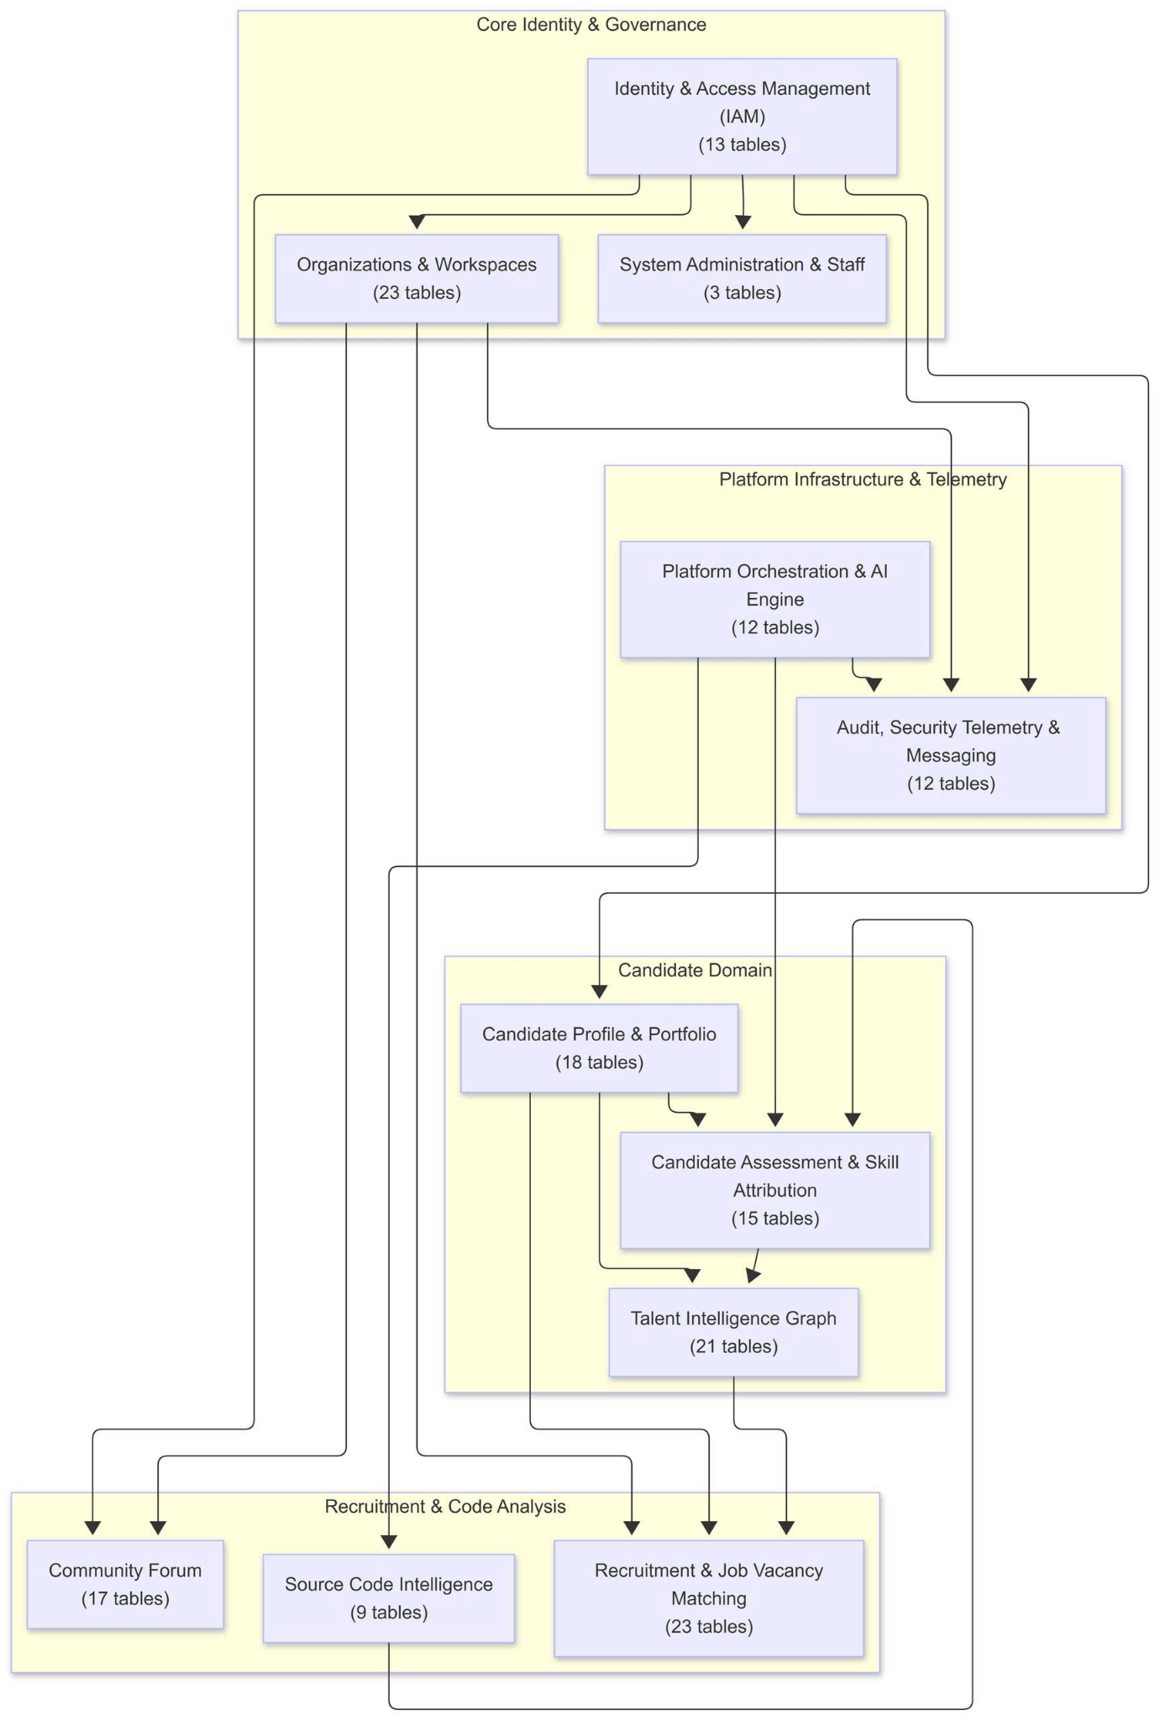

Over view High-level

6.1 Core Identity, Profile & Workspace
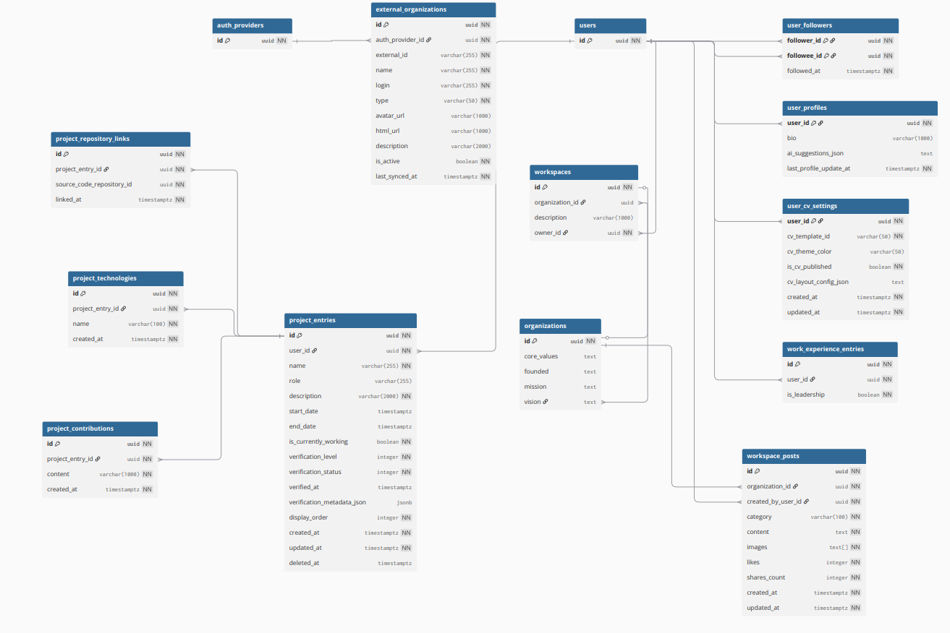

6.2 Recruitment Pipeline & Job Vacancy Matching
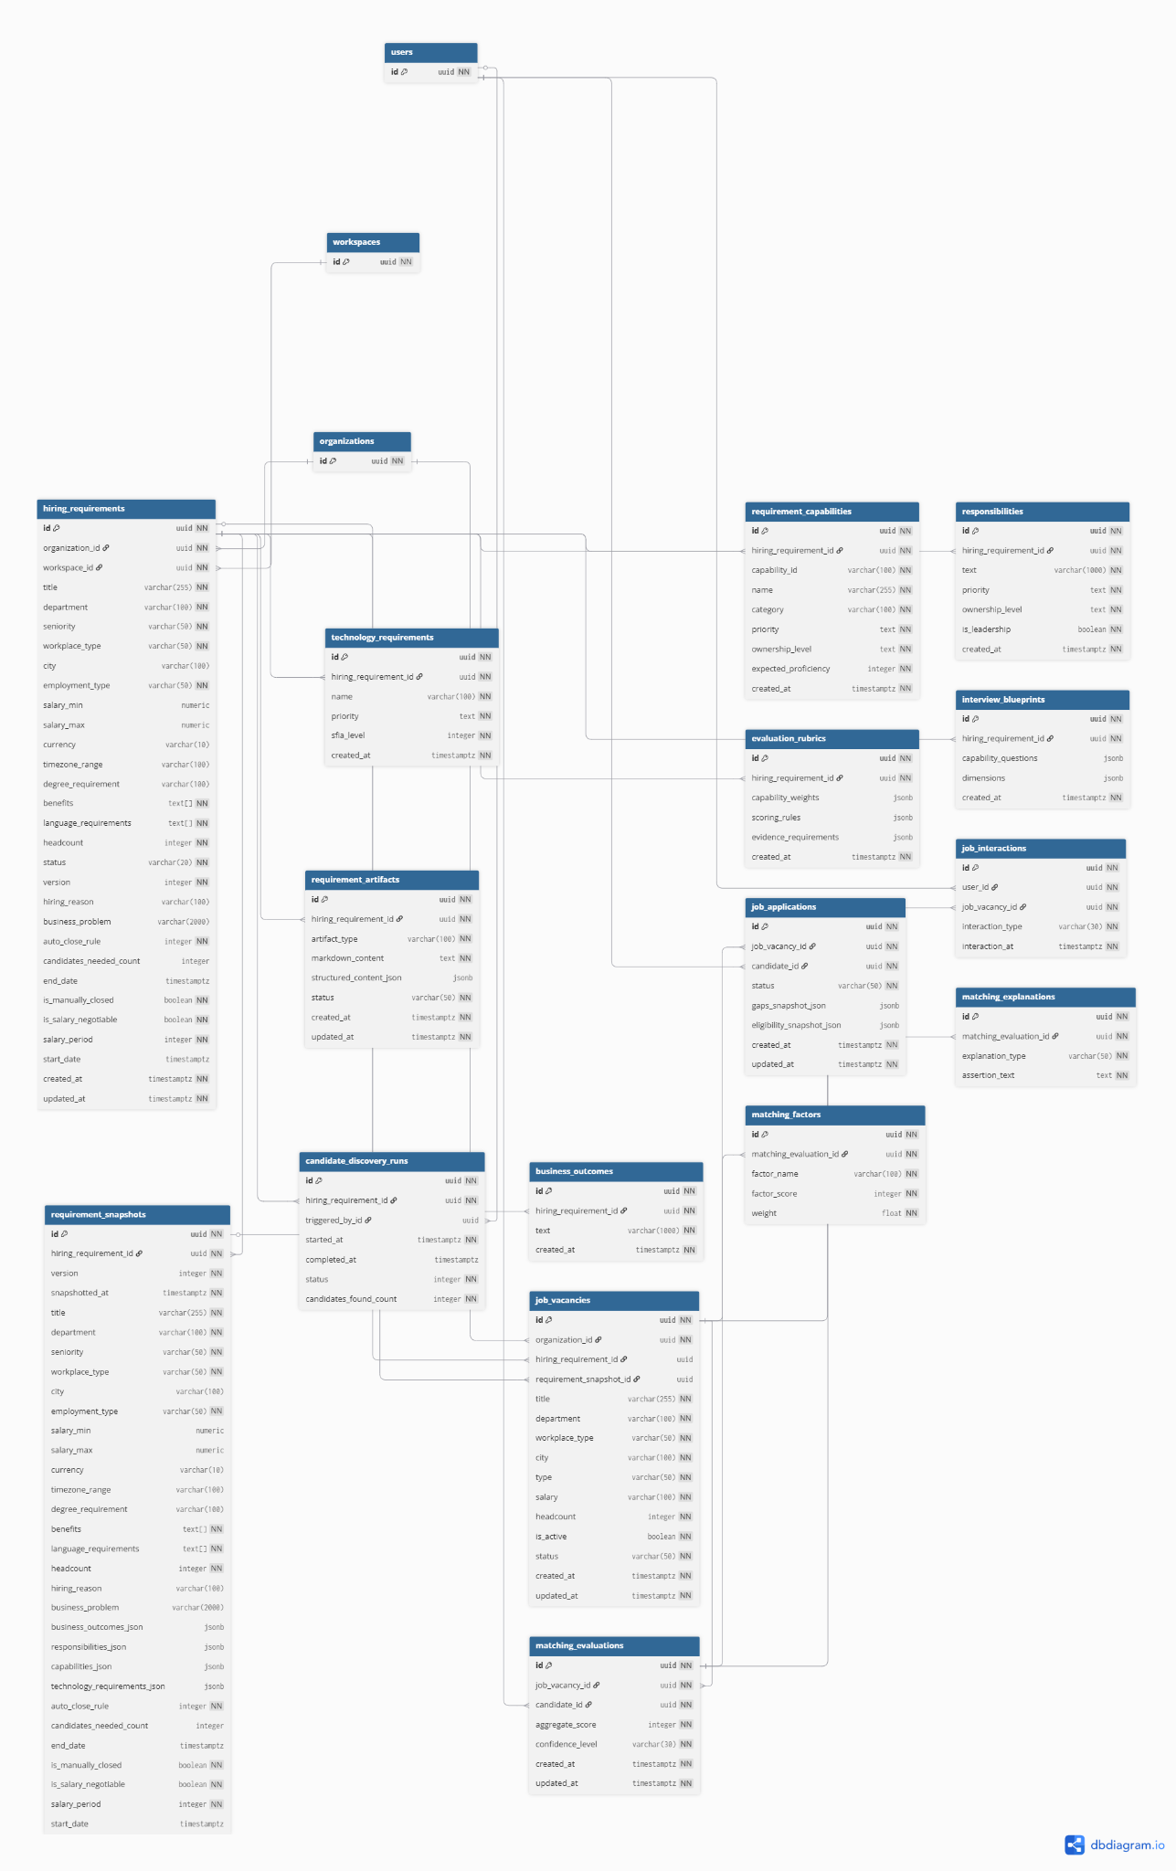

6.3 AI Candidate Assessment, Code Analysis & Talent Graph
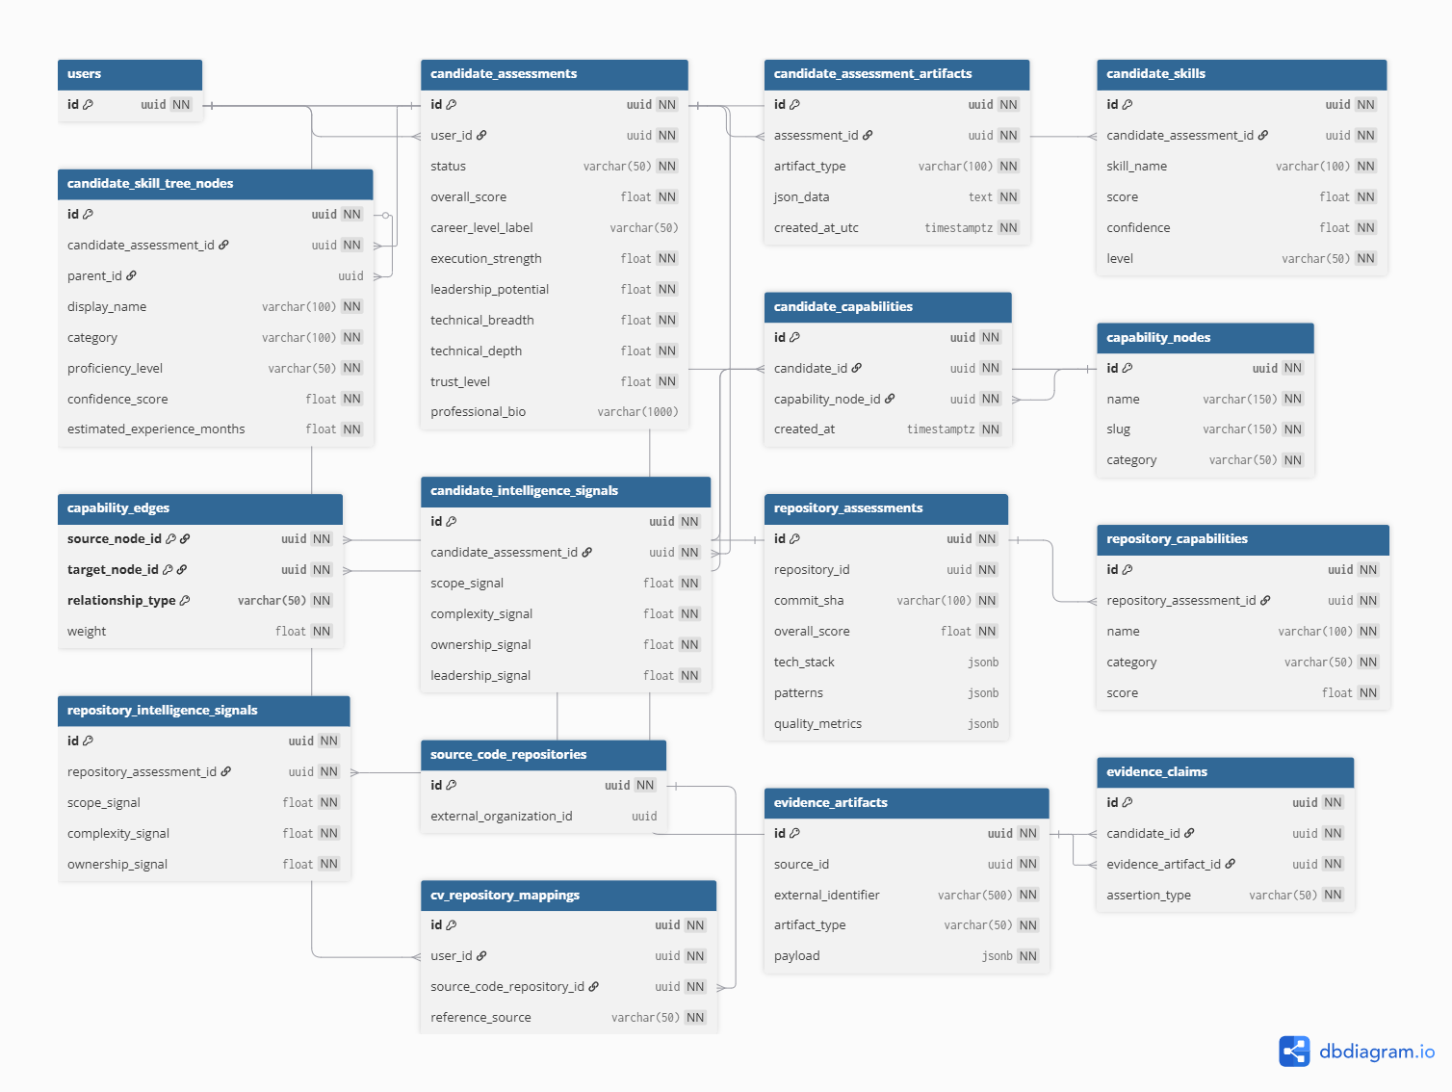

6.4 Community Forum, System Trust & AI Engine Orchestration
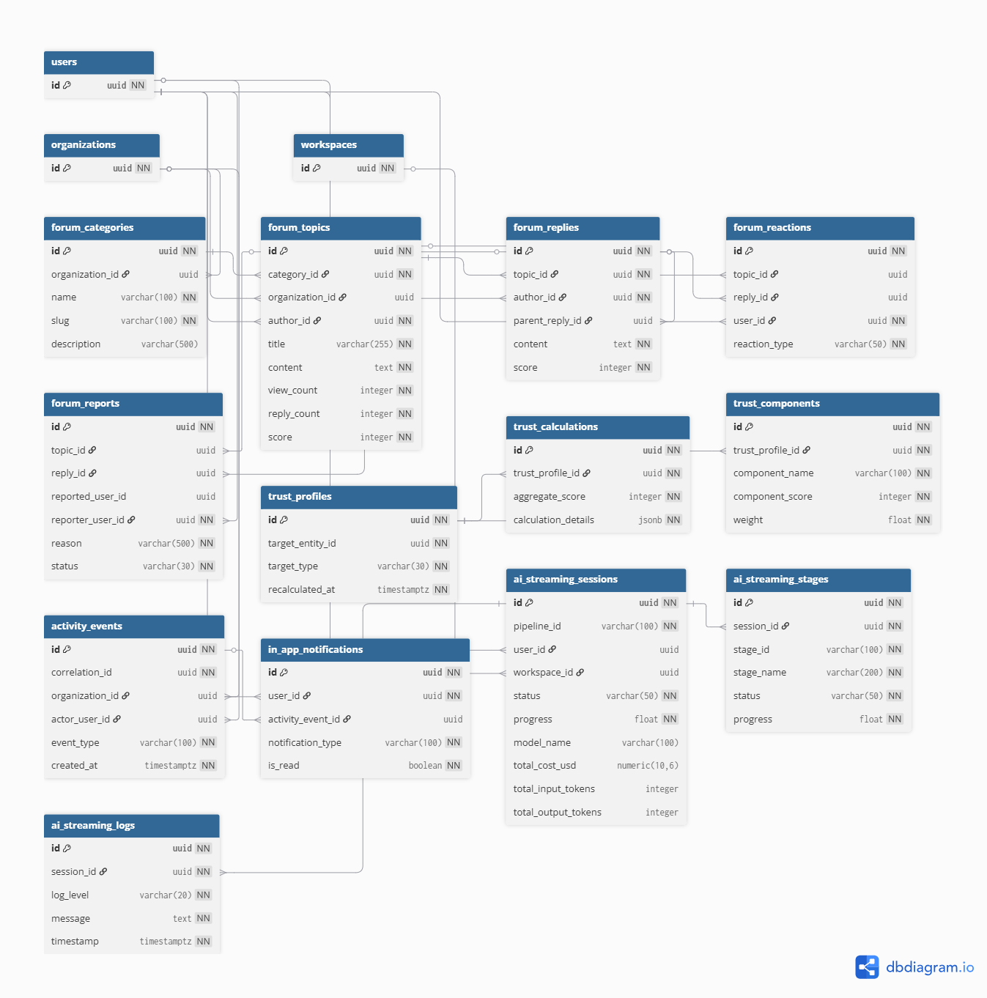

7. State Diagram
This section describes the lifecycle of the main stateful entities of the CVerify platform. Each diagram defines the valid states, the events that trigger a transition, and the guard conditions ([...]) that must hold for the transition to be accepted by the system.

7.1 User Account Lifecycle

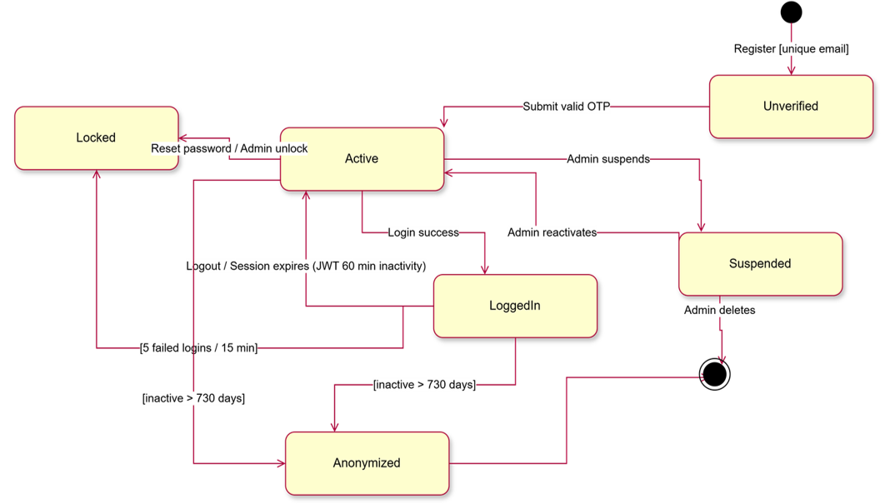

Figure 7.1 - State diagram of a User Account, from registration and OTP verification through login sessions, lockout, suspension and anonymization.

7.2 Organization Verification & Recovery

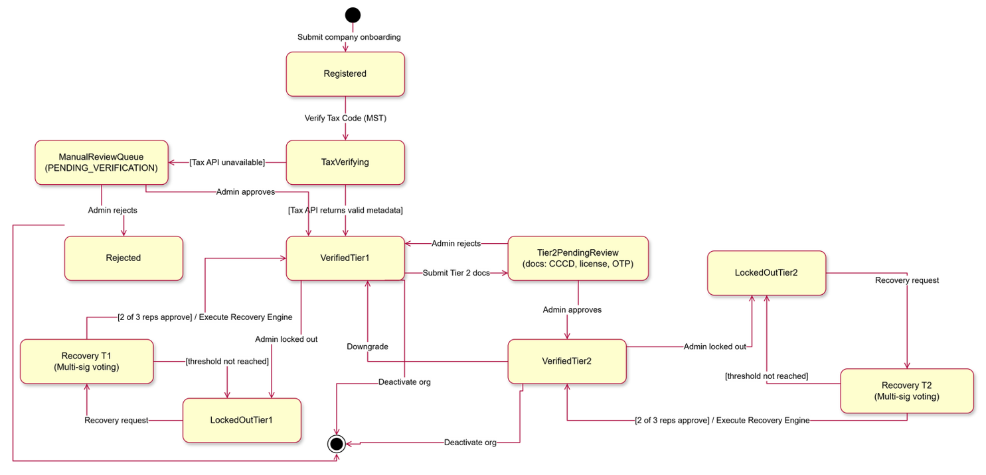

Figure 7.2 - State diagram of an Organization, covering Tax Code (MST) verification, Tier 1 / Tier 2 upgrade, lockout and multi-signature recovery.

7.3 CV / Candidate Profile

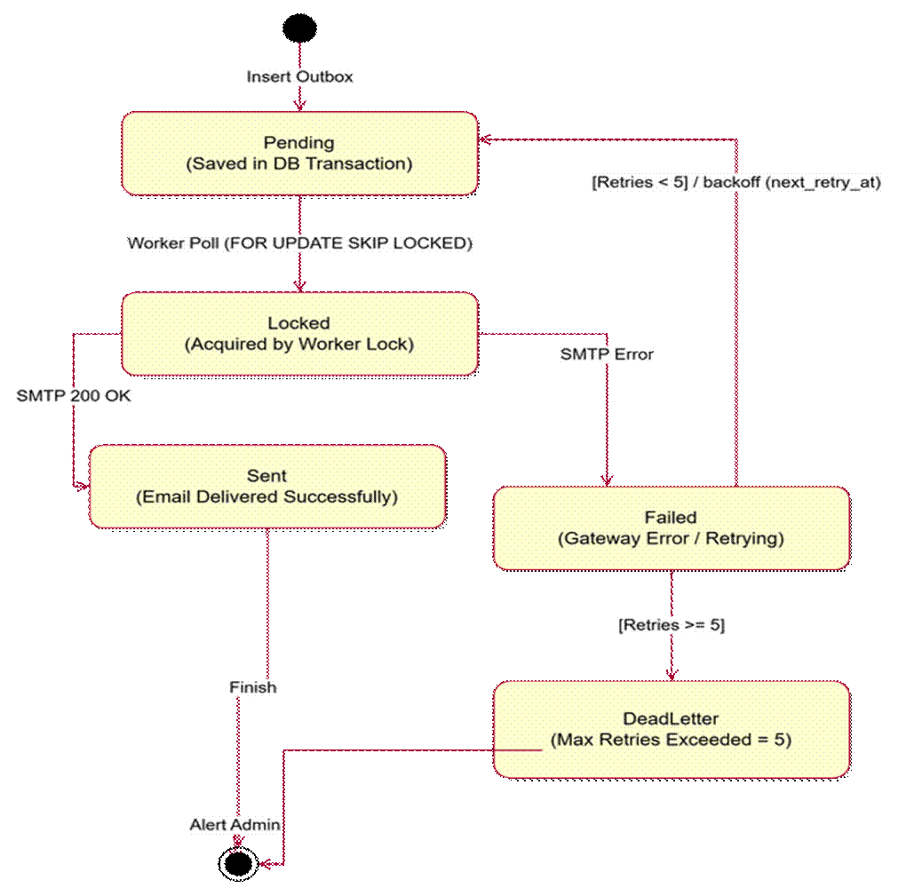

Figure 7.3 - State diagram of a CV, from upload and AI parsing through manual review to private/public profile visibility.

7.4 Job Post

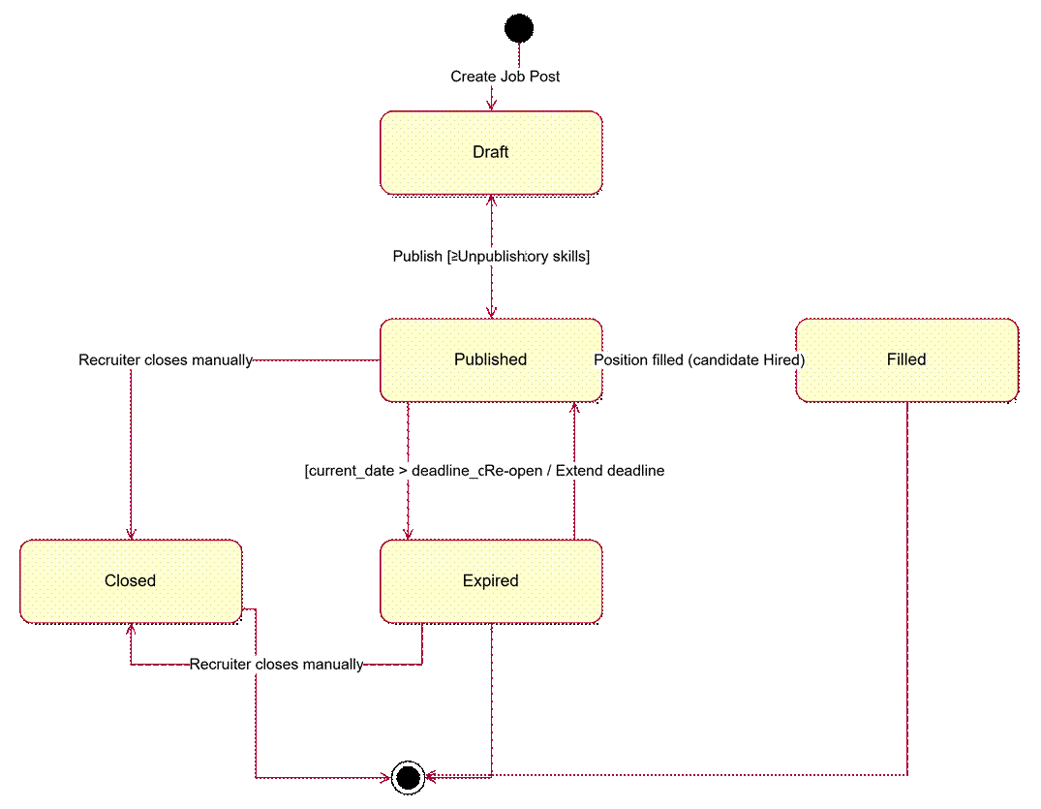

Figure 7.4 - State diagram of a Job Post, covering draft editing, publication rules, expiry, re-opening and manual closure.

7.5 Job Application

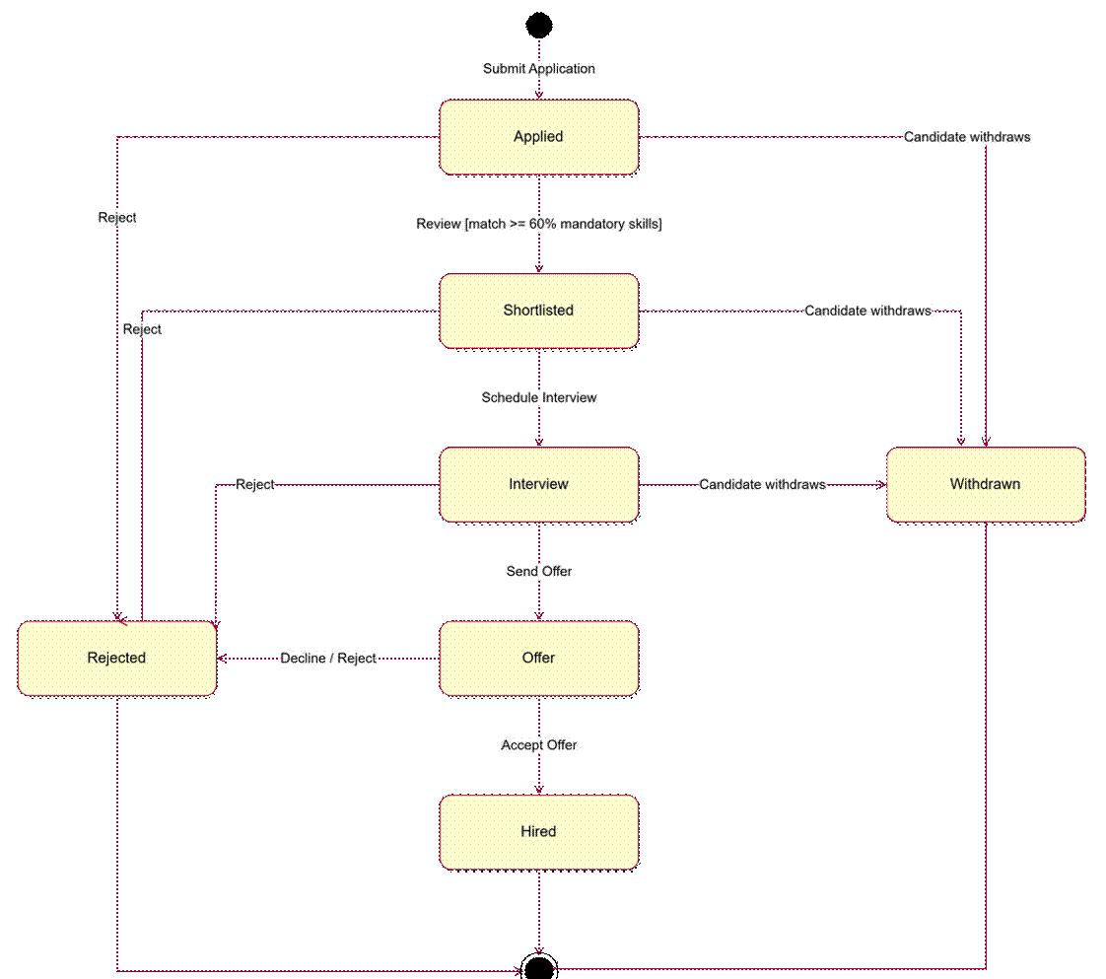

Figure 7.5 - State diagram of a Job Application through the recruitment pipeline: applied, shortlisted, interview, offer, hired, rejected or withdrawn.

7.6 Repository Analysis

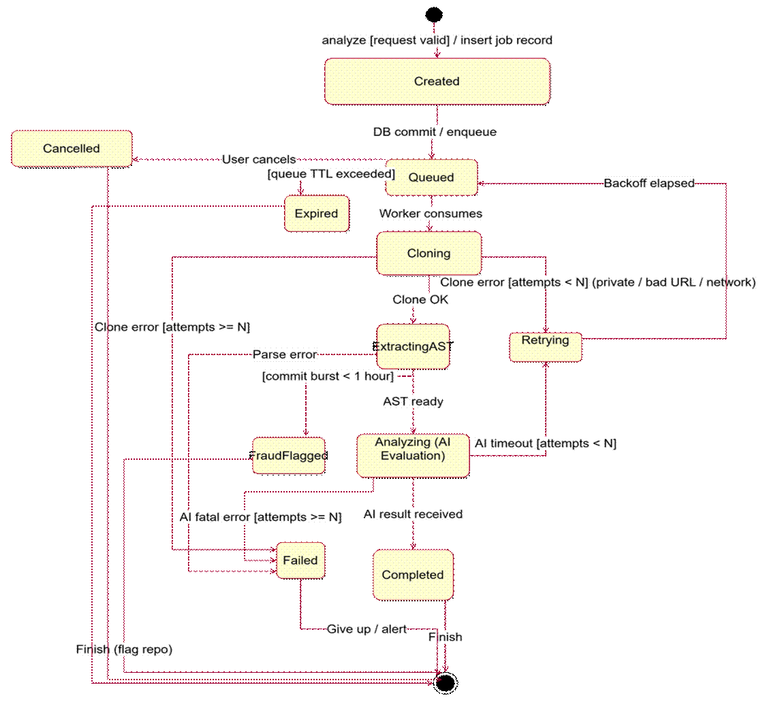

Figure 7.6 - State diagram of an Ownership Claim, covering evidence upload, the 7-day member voting period, admin decision and ownership transfer.

7.7 Forum Topic Moderation

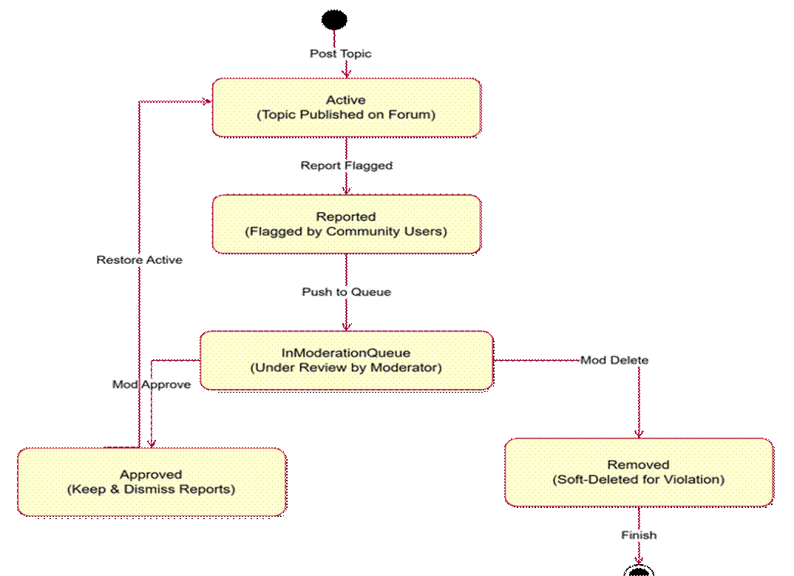

Figure 7.7 - State diagram of a Forum Topic, covering community reports, the moderation queue, approval/restoration and soft deletion.

7.8 Email Outbox Message

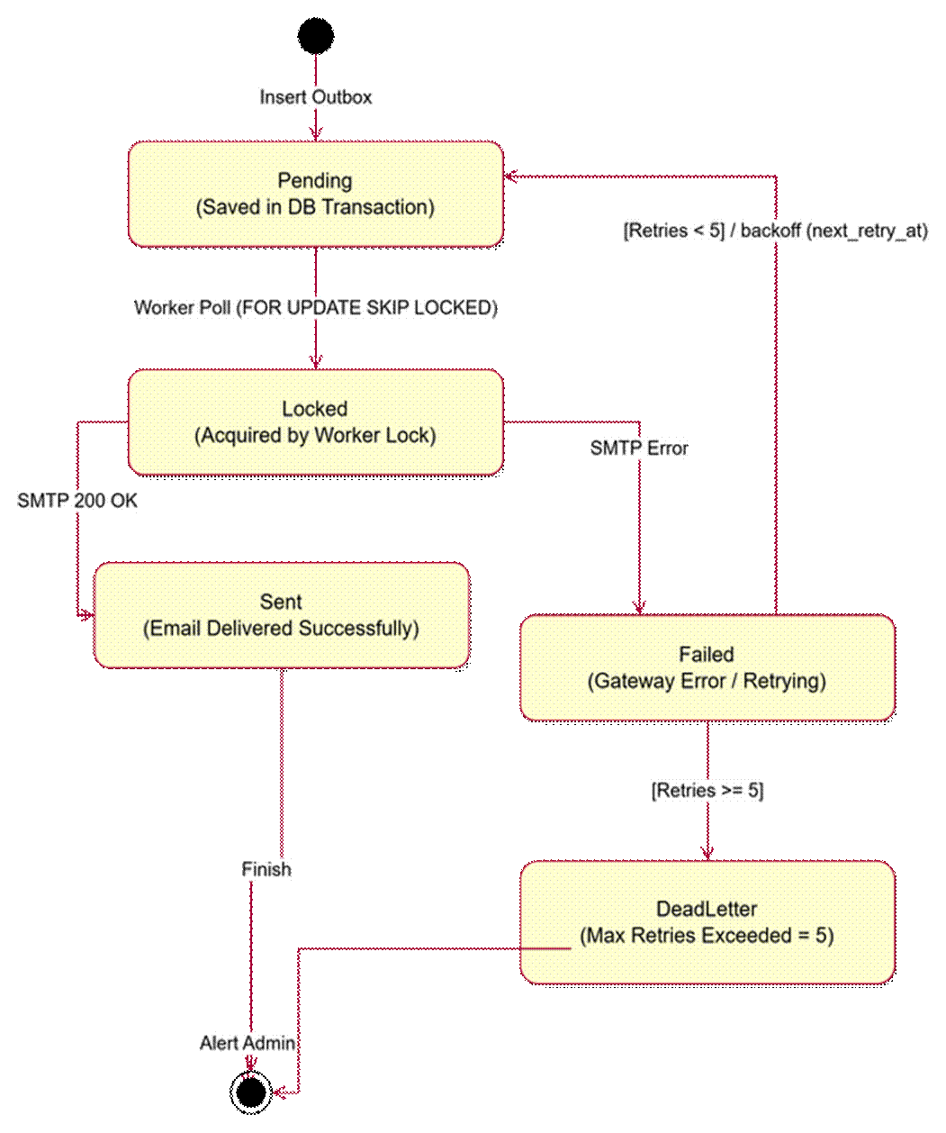

Figure 7.8 - State diagram of an Email Outbox message, covering worker locking, SMTP delivery, retry with backoff and dead-lettering.

7.9 Organization Recovery Claim

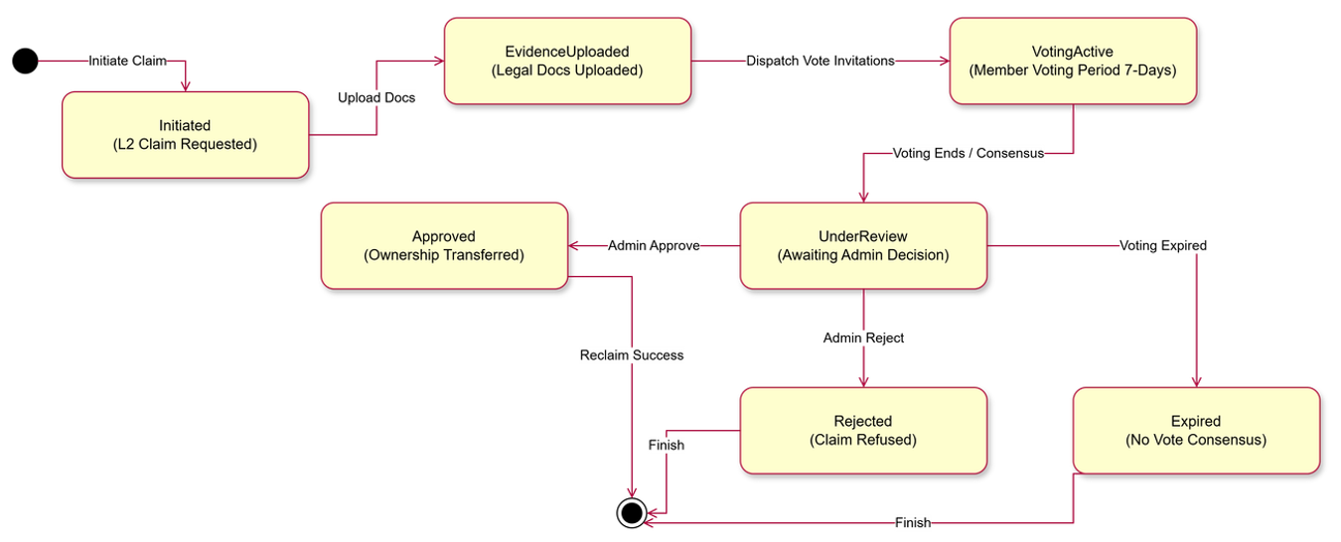

Figure 7.9 - State diagram of an Ownership Claim, covering evidence upload, the 7-day member voting period, admin decision and ownership transfer.

III: NON-FUNCTIONAL REQUIREMENTS

1. External Interfaces

1.1 User Interface
The CVerify User Interface (UI) shall provide a unified, responsive experience across all user roles.
- Navigation: A consistent sidebar-based navigation structure shall be maintained for the Candidate, Recruiter, and Admin dashboards to ensure high learnability.
- Responsive Design: The UI shall be fully responsive, supporting viewports from mobile (320px) to ultra-wide desktop monitors using PWA standards.
- Accessibility: The interface shall adhere to WCAG 2.1 Level AA standards, ensuring high color contrast ratios and keyboard navigability for all interactive components.
- Search and Forms: All input forms shall provide real-time validation feedback. Search functionality for candidates and job postings shall include dynamic filtering and faceted search capabilities.
- AI Analysis & Reports: AI-generated reports (e.g., skill trees, trust scores) shall be visualized using accessible charting libraries, ensuring data is interpretable by screen readers where possible.

1.2 Hardware Interface
- Client Devices: The system shall be compatible with modern desktops, laptops, tablets, and smartphones running current versions of Windows, macOS, Linux, iOS, and Android.
- Cloud Infrastructure: The backend shall be hosted on enterprise-grade cloud compute instances with a minimum of 8GB RAM per node to handle LLM-context caching and concurrent WebSocket connections.
- Storage: The system shall interface with Object Storage (S3-compatible) for candidate CVs and document artifacts.
- Compute: AI inference services shall be load-balanced across GPU-accelerated clusters to ensure sub-second response times for embedding generation.

1.3 Software Interface
- GitHub API: Integration for repository crawling shall use OAuth2 scopes with rate-limiting awareness.
- LLM Providers: The system shall interface with GPT-4, Claude Sonnet, and Gemini via RESTful APIs, implementing a fallback routing mechanism.
- Database: The system shall interface with PostgreSQL 16+ (with pgvector extension) for relational and vector storage, and Redis for caching session data and semantic results.
- Email Service: Integration with SMTP/Transactional Email APIs (e.g., SendGrid/AWS SES) for notification dispatch.

1.4 Communication Interface
- Protocol: All client-server communication shall occur over HTTPS (TLS 1.3).
- Data Exchange: All data shall be exchanged in JSON format over RESTful APIs.
- Security: JWT tokens shall be passed via HTTP-only, Secure cookies or Authorization headers for all authenticated requests.
- Real-time: WebSocket connections shall be utilized for asynchronous progress reporting during long-running AI repository sync tasks.

2. Quality Attribute

2.1 Performance
Requirement ID: NFR-PER-001 Description: The system shall respond to 95% of standard API requests within 200ms. Rationale: High responsiveness is required to ensure a smooth recruitment workflow. Acceptance Criteria: API latency monitored via telemetry; 95th percentile (P95) response time < 200ms.
Requirement ID: NFR-PER-002 Description: AI repository analysis shall return an initial progress event within 2 seconds. Rationale: Immediate feedback prevents user abandonment during heavy background compute tasks. Acceptance Criteria: SSE (Server-Sent Events) trigger time < 2s from request initiation.

2.2 Reliability
Requirement ID: NFR-REL-001 Description: The system shall achieve a monthly uptime of 99.9%. Rationale: Recruitment operations require high availability to support continuous hiring pipelines. Acceptance Criteria: Monitoring logs confirm < 43 minutes of unplanned downtime per month.

2.3 Security
Requirement ID: NFR-SEC-001 Description: All user passwords shall be hashed using Argon2id with a salt factor of 12. Rationale: To protect against brute-force and dictionary attacks. Acceptance Criteria: Compliance audit confirms no plaintext password storage.
Requirement ID: NFR-SEC-002 Description: System shall implement automated rate-limiting per IP address for all public endpoints. Rationale: To prevent DDoS attacks and data harvesting. Acceptance Criteria: 429 Too Many Requests response after 100 requests/minute.

2.4 Scalability
Requirement ID: NFR-SCA-001 Description: The system architecture shall support horizontal scaling of application nodes. Rationale: AI inference and data ingestion require elastic resource scaling during high-traffic periods. Acceptance Criteria: Successful instantiation and load-balancing of 3+ application nodes under 50% CPU threshold.

2.5 Maintainability
Requirement ID: NFR-MAI-001 Description: The codebase shall strictly follow the Onion/Clean Architecture pattern. Rationale: To ensure decoupling of business logic from external frameworks (GitHub API, LLMs). Acceptance Criteria: Dependency rule violations reported by static analysis tools (e.g., ArchUnit) are zero.

2.6 Availability
Requirement ID: NFR-AVA-001 Description: The system shall perform automated daily database backups with a Recovery Point Objective (RPO) of 24 hours. Rationale: Essential for data integrity and disaster recovery. Acceptance Criteria: Automated backup logs confirm successful daily S3 synchronization.

2.7 Usability
Requirement ID: NFR-USA-001 Description: The time to complete the "Job Intake Wizard" shall be less than 5 minutes for first-time users. Rationale: Streamlining the recruitment setup is critical for user adoption. Acceptance Criteria: UX testing with target recruiters results in task completion time < 5 minutes.

2.8 Compatibility
Requirement ID: NFR-COM-001 Description: The UI shall be fully functional on the two latest major versions of Chrome, Firefox, Safari, and Edge. Rationale: Ensuring accessibility for a diverse recruiter and developer population. Acceptance Criteria: Automated Cross-Browser testing passes with 100% success rate.

2.9 Portability
Requirement ID: NFR-POR-001 Description: The system shall be containerized using Docker, with all environment configurations managed via externalized environment variables. Rationale: To enable consistent deployment across development, staging, and production environments. Acceptance Criteria: System deployment to an isolated environment using only docker-compose up without manual configuration.

IV: REQUIREMENT APPENDIX

1. Business Rules

1.1 Authentication & Security (BR-AUTH & BR-SEC)

ID | Rule Name | Description & Condition
BR-AUTH-01 | Email Uniqueness | System shall reject registration if the email exists in the users table.
BR-AUTH-02 | Password Policy | Passwords must be $\ge 12$ chars, include 1 uppercase, 1 digit, and 1 special char.
BR-AUTH-03 | Account Lockout | Account status changes to LOCKED after 5 failed login attempts within 15 minutes.
BR-AUTH-04 | Session Validity | JWT tokens shall expire after 60 minutes of inactivity; refresh tokens valid for 7 days.
BR-SEC-01 | Audit Immutability | Every UPDATE or DELETE on sensitive entities must create a read-only entry in audit_logs.
BR-SEC-02 | Data Privacy | Personal data must be anonymized for accounts inactive for $> 730$ days.

1.2 Candidate & Resume Intelligence (BR-CAND & BR-RES)

ID | Rule Name | Description & Condition
BR-CAND-01 | Profile Completeness | Candidates must populate "Skills" and "Experience" before setting visibility to PUBLIC.
BR-CAND-02 | File Validation | Resume uploads restricted to PDF/DOCX format, size $\le 5$ MB.
BR-RES-01 | Version Control | System must retain the original CV file upon every upload; maximum 5 versions per profile.
BR-RES-02 | Parsing Integrity | AI parsing must extract at least 80% of contact/skill data; otherwise, flag for manual review.

1.3 GitHub Intelligence (BR-GIT)

ID | Rule Name | Description & Condition
BR-GIT-01 | Linkage Constraint | A CVerify profile is restricted to exactly one active GitHub account link.
BR-GIT-02 | Repo Eligibility | Only Public repositories with $\ge 5$ commits are processed for AST/Trust analysis.
BR-GIT-03 | Sync Frequency | Automated repository sync occurs every 24 hours via background worker.
BR-GIT-04 | Anomaly Flagging | Repositories with sudden, high-frequency commit bursts within < 1 hour are flagged for fraud review.

1.4 AI Evaluation & Matching Engine (BR-AI & BR-MATCH)

ID | Rule Name | Description & Condition
BR-AI-01 | Evaluation Freshness | All Trust and Technical scores are re-computed automatically every 30 days.
BR-AI-02 | Explainability | Any ATS score generated must be supported by at least 3 ranking factors in JSONB format.
BR-AI-03 | Cache Logic | Semantic search results returned from Redis if cosine similarity threshold $> 0.95$.
BR-MATCH-01 | Eligibility Check | Candidate must match $\ge 60\%$ of mandatory Job Skills to be added to the Shortlist.

1.5 Recruitment & Application (BR-JOB & BR-APP)

ID | Business Rule Name | Description & Condition
BR-JOB-01 | Publication Logic | Job posts require a minimum of 3 mandatory skills to reach PUBLISHED status.
BR-JOB-02 | Expiration Rules | Tin tuyển dụng automatically transition to EXPIRED status if current date $>$ deadline_date.
BR-APP-01 | Application Limit | Candidates restricted to exactly one active application per job post.
BR-APP-02 | Status Transition | Application status cannot skip stages (e.g., cannot move from APPLIED to OFFER without INTERVIEW).

1.6 Organization & Billing (BR-ORG & BR-BIL)

ID | Business Rule Name | Description & Condition
BR-ORG-01 | Admin Authority | Organization Admin role is required to manage team members or billing configurations.
BR-BIL-01 | Credit Consumption | 1 AI Screening event deducts exactly 1 credit from organizational balance.
BR-BIL-02 | Billing Threshold | Operations requiring credits are disabled if balance is $< 1$ credit.
BR-SYS-01 | Notification Timing | Email notifications must be triggered within 5 minutes of a status transition event.

2. Application Messages List

# | Message code | Message Type | Content
1 | AUTH-001 | Error | Email address already exists. Please use another one.
2 | AUTH-002 | Error | Password does not meet complexity requirements.
3 | AUTH-003 | Warning | Account locked for 30 minutes due to multiple failed attempts.
4 | AUTH-004 | Success | Registration successful. Please verify your email.
5 | CAND-001 | Error | File format not supported. Only PDF and DOCX allowed.
6 | CAND-002 | Error | File size exceeds 5MB limit.
7 | GIT-001 | Error | GitHub account already linked to another profile.
8 | GIT-002 | Warning | Repository has fewer than 5 commits; analysis skipped.
9 | JOB-001 | Error | Job post requires at least 3 skills to be published.
10 | JOB-002 | Warning | Job post deadline has passed.
11 | APP-001 | Error | You have already submitted an application for this job.
12 | APP-002 | Warning | Application withdrawal is only allowed in PENDING status.
13 | BIL-001 | Error | Insufficient credit balance. Please top up your account.
14 | SYS-001 | Success | Data synchronized successfully.
15 | SYS-002 | Error | Internal server error. Please try again later.

