

INTEGRATED CODING EDUCATION & COMPETITIVE PROGRAMMING PLATFORM
Software Requirement Specification
CVerify
AI-Native Evidence-Based IT Talent Platform

Software Requirements Specification (SRS)
Version 2.0 | June 2026

Course | SWP391
Institution | FPT University – Da Nang
Status | Draft – Internal Review
Confidentiality | Confidential – CVerify Team

1. INTRODUCTION 4
1.1 Purpose 4
1.2 Document Conventions 4
1.3 Intended Audience and Reading Suggestions 4
1.4 Project Scope 5
1.4.1 In-Scope 5
1.4.2 Out-of-Scope 5
1.5 References 6
2. PROJECT OVERVIEW 7
2.1 Project Summary 7
2.2 System Objectives 7
2.3 Technology Stack 7
3. BUSINESS REQUIREMENTS 9
3.1 Business Problems to Solve 9
3.2 Business Objectives 9
4. STAKEHOLDERS AND USER CLASSES 10
4.1 Stakeholder Overview 10
4.2 User Classes and Characteristics 10
5. PRODUCT SCOPE 11
5.1 Context Diagram – System Overview 11
5.2 System Architecture Overview 11
6. OVERALL SYSTEM DESCRIPTION 12
6.1 Product Perspective 12
6.2 Operating Environment 12
6.3 Design and Implementation Constraints 12
6.4 Assumptions and Dependencies 13
6.4.1 Assumptions 13
6.4.2 Dependencies 13
7. FUNCTIONAL REQUIREMENTS OVERVIEW 14
8. AUTHENTICATION AND AUTHORIZATION REQUIREMENTS 15
8.1 Authentication Requirements 15
8.2 Detailed Requirement Sample – FR-01 15
9. CANDIDATE MODULE REQUIREMENTS 17
9.1 Profile Management 17
9.2 GitHub/GitLab Integration 17
9.3 AI Skill Analysis 17
10. RECRUITER AND COMPANY MODULE REQUIREMENTS 19
10.1 Company Onboarding 19
10.2 Job Description Management 19
10.3 Manual Recruitment (Tier 1) 19
10.4 AI-Powered Recruitment (Tier 2) 20
11. AI MODULE REQUIREMENTS 21
11.1 AI Architecture Overview 21
11.2 AI Model Routing Strategy 21
11.3 AI CV Analysis Requirements 21
11.4 AI Repository Analysis Requirements 21
11.5 AI Matching Requirements 22
11.6 AI Constraints and Limitations 22
12. ADMINISTRATOR MODULE REQUIREMENTS 23
13. USE CASE MODEL 24
13.1 Use Case Overview 24
13.2 Detailed Use Case – UC-11: AI-Powered Candidate Matching 24
14. EXTERNAL INTERFACE REQUIREMENTS 26
14.1 User Interface Requirements 26
14.2 Software Interfaces (Third-Party APIs) 26
14.3 Communication Interfaces 26
15. DATA REQUIREMENTS 28
15.1 Data Dictionary – Core Entities 28
15.1.1 users 28
15.1.2 candidate_profiles 28
15.1.3 cv_embeddings 28
15.1.4 repositories 28
15.1.5 organizations 29
15.1.6 job_posts 29
15.1.7 applications 29
15.1.8 audit_logs 29
15.1.9 notifications 30
15.1.10 credit_transactions 30
16. DATABASE REQUIREMENTS AND ERD 31
16.1 Logical Data Model – Entity Relationships 31
16.2 Vector Embedding & Semantic Search Architecture 31
16.3 Database Requirements 31
17. NON-FUNCTIONAL REQUIREMENTS 33
17.1 Performance Requirements 33
17.2 Security Requirements 33
17.3 Reliability and Availability 34
17.4 Maintainability and Scalability 34
17.5 Usability Requirements 34
17.6 Privacy and Compliance 35
18. BUSINESS RULES 36
19. UI/UX REQUIREMENTS AND PROTOTYPE 37
19.1 Design System 37
19.2 Key UI Requirements 37
19.3 Prototype / Wireframe 37
20. REQUIRED DIAGRAMS IN THE SRS 39
21. REQUIREMENT VALIDATION, TRACEABILITY AND CHANGE MANAGEMENT 40
21.1 SRS Completeness Checklist 40
21.2 Requirements Traceability Matrix (RTM) 40
21.3 Change Management Process 41
21.4 Version History 41
22. RELATED WORK 42
22.1 CV Intelligence — Phân Tích và Xếp Hạng CV 42
22.2 Semantic Matching — Khớp Ngữ Nghĩa Ứng Viên và Mô Tả Công Việc 42
22.3 Job Recommender Systems — Hệ Thống Gợi Ý Việc Làm 43
22.4 Repository Intelligence — Phân Tích Dữ Liệu Kỹ Thuật từ GitHub/GitLab 43
22.5 Khoảng Trống Nghiên Cứu (Research Gap) 43
23. PHƯƠNG PHÁP NGHIÊN CỨU (METHOD) 45
23.1 Tổng Quan Kiến Trúc Hệ Thống 45
23.2 Module CV Intelligence 45
23.2.1 Layout-Aware CV Parsing 45
23.2.2 LLM Embedding và Skill Extraction 45
23.2.3 Skill Tree Auto-Generation 45
23.3 Module Repository Intelligence 46
23.3.1 Heterogeneous Network Construction 46
23.3.2 Knowledge Unit-Based Expertise Profiling 46
23.3.3 Fraud Detection 46
23.4 Module Semantic Matching 46
23.5 Trust Score Aggregation và Explainability 46
24. TÀI LIỆU THAM KHẢO HỌC THUẬT (ACADEMIC REFERENCES) 48
APPENDIX A: GLOSSARY 49
APPENDIX B: AI MODEL ROUTING STRATEGY AND CIRCUIT-BREAKER POLICY 50
APPENDIX C: IMPLEMENTATION ROADMAP AND RISK MATRIX 51
Sprint Plan 51
Risk Matrix 51

1. INTRODUCTION

1.1 Purpose
This Software Requirements Specification (SRS) document formally defines all functional and non-functional requirements for CVerify – an AI-Native, Evidence-Based IT Talent Platform.
This document is produced to:
- Provide a single authoritative reference for all stakeholders involved in the design, development, testing, and deployment of the CVerify system.
- Establish a contractual baseline between the development team and academic supervisors at FPT University (SWP391).
- Serve as the primary input for system architecture design, test plan creation, and sprint planning activities.
- Define the boundaries of the system clearly so that scope creep can be identified and controlled throughout the project lifecycle.

1.2 Document Conventions
Keyword | Meaning / Example
SHALL | Mandatory requirement. The system must fulfill this unconditionally.
SHOULD | Recommended requirement. Deviation requires documented justification.
MAY | Optional feature included at the team's discretion.
[FR-xx] | Unique identifier for a Functional Requirement (e.g., [FR-01]).
[NFR-xx] | Unique identifier for a Non-Functional Requirement (e.g., [NFR-01]).
[UC-xx] | Unique identifier for a Use Case (e.g., [UC-01]).
[BR-xx] | Unique identifier for a Business Rule (e.g., [BR-01]).
TBD | To Be Determined – item requires further stakeholder input.
High / Medium / Low | Priority level of the requirement.

1.3 Intended Audience and Reading Suggestions
Audience | Primary Sections | Reading Guidance
Software Developer | Chapters 7–12, 14–16 | Read all sections in full. Focus on [FR] identifiers, ERD, and API interfaces.
QA / Test Engineer | Chapters 7–12, 17 | Map each [FR] to a test case. Pay attention to edge cases.
Project Manager | Chapters 1–3, 19–20 | Focus on scope boundaries, assumptions, and change management.
System Architect | Chapters 6, 14–16 | Review operating environment, data architecture, and AI modules.
FPT Academic Supervisor | Chapters 1–3, 7–12, 17 | Evaluate functional and non-functional completeness.
Business Stakeholder | Chapters 2–5, 7–12 | Focus on user-facing features. Technical sections may be skipped.

1.4 Project Scope
CVerify is an AI-native, Evidence-Based IT Talent Platform designed to address three core failures of traditional recruitment: falsified self-reported CVs, inefficient manual candidate screening, and candidates' inability to identify skill gaps relative to a target job description.

1.4.1 In-Scope
- Multi-provider authentication: Google OAuth + Email/OTP, hybrid provider linking.
- Two-tier company onboarding: Tier 1 via MST auto-verify; Tier 2 via legal document submission + Admin manual review.
- GitHub OAuth integration: repository crawling, contribution analysis, AI-generated descriptions.
- AI Skill Tree: build labelled skill tree (AI-inferred vs. Self-declared) per candidate.
- Trust Score & Fraud Detection: detect forked repos, commit bursts, and skill mismatches.
- pgvector HNSW semantic search: candidate-to-JD and reverse JD-to-candidate matching.
- 8-Factor ATS Score with Explainability Report and configurable weights.
- Active Window Credit Model: 3-tier visibility (Hidden / Passive / Active).
- Hybrid Credit Anti-Harvesting: deter bulk data harvesting via economic deterrence.
- Real-time AI streaming via SSE and SignalR notifications.
- Admin dashboard: Tier 2 review management, AI analytics, fraud alerts.

1.4.2 Out-of-Scope
- Video interview, salary negotiation, offer letter generation.
- Integration with external ATS platforms (Workday, Greenhouse, BambooHR).
- GitLab repository analysis in MVP phase (GitHub only in Sprint 2).
- Mobile native apps (iOS/Android) – PWA via Next.js only.
- Live payment gateway (mock UI in v1.0 only).
- Multi-language support beyond Vietnamese and English in v1.0.

1.5 References
# | Document / Resource | Source
[1] | CVerify Technical Documentation v1.3 | CVerify Team – Internal, May 2026
[2] | Software Requirements Engineering (Wiegers & Beatty) | Microsoft Press, 4th Ed.
[3] | GitHub REST API – Repository Statistics | docs.github.com/en/rest/metrics/statistics
[4] | pgvector HNSW Documentation | github.com/pgvector/pgvector
[5] | Decree 13/2023/ND-CP – Vietnam PDPA | Government of Vietnam, 2023
[6] | WCAG 2.1 AA Guidelines | w3.org/WAI/WCAG21
[7] | ASP.NET Core v10 Documentation | learn.microsoft.com/aspnet/core
[8] | Next.js 16 App Router Documentation | nextjs.org/docs
[9] | OpenAI Function Calling Documentation | platform.openai.com/docs
[10] | Vietnam Tax ID Lookup API | esgoo.net/api-mst / api.vietqr.io

2. PROJECT OVERVIEW

2.1 Project Summary
CVerify is a software project developed under the SWP391 course at FPT University – Da Nang. It is a web-based SaaS platform designed to solve IT recruitment problems in Vietnam and the Southeast Asian region.

System Name | CVerify – AI-Native Evidence-Based IT Talent Platform

Problem Statement | Traditional CVs are easily falsified. Recruiters cannot verify candidates' actual skills. Candidates do not know their skill gap relative to a target job description.

Solution | Build candidate profiles from real evidence (GitHub repositories), AI-analyze verifiable skills, and perform semantic candidate-to-JD matching using vector embeddings.

2.2 System Objectives
- Help IT candidates build credible capability profiles grounded in real evidence from GitHub/GitLab.
- Help recruiters find suitable candidates based on skills, labels, and project evidence.
- AI-analyze CVs, repositories, and suggest skills and candidate-JD fit scores.
- Allow recruiters to post candidate-search requests by label, skill, and specific requirements.
- Allow AI to automatically find candidates matching a posted job description.
- Allow administrators to manage users, content, and system moderation activities.

2.3 Technology Stack
Layer | Technology | Version | Role
Frontend | Next.js / React | Next.js 16 App Router | Web UI, SSE streaming, PWA
Backend | ASP.NET Core | v10 (.NET) | REST API, Business Logic, AI Orchestration
AI Service | Python / Multi-model Router | GPT-4.1, Claude Sonnet 4, Gemini 2.5 Flash | CV analysis, Repository analysis, Matching
Database | PostgreSQL + pgvector | PostgreSQL 16 | Relational data + Vector embedding store
Cache | Redis | Latest | Distributed cache, Semantic cache
Job Queue | Hangfire | Latest | Background jobs: repo sync, email, ATS recalculation
UI Library | HeroUI + Tailwind CSS | v3 / v4 | Component library, OKLCH color space
Real-time | SignalR | ASP.NET Core | WebSocket notifications
CDN / Deploy | Vercel (Frontend) | Pro plan | Edge functions, auto scaling

3. BUSINESS REQUIREMENTS

3.1 Business Problems to Solve
The IT recruitment market in Vietnam currently faces several core problems:
Problem | Description | Impact
CV Inflation | Candidates exaggerate or fabricate skills and experience on their resumes | Recruiters waste time screening hundreds of dishonest CVs
Inefficient Screening | HR relies on manual reading and basic keyword matching | High-quality candidates are missed; 40–60% of recruitment time is wasted
Unclear Skill Gap | Candidates do not know what they need to improve to meet a target JD | Candidates apply for unsuitable roles; low success rate
Data Harvesting | Recruiters bulk-download candidate data and contact them outside the platform | PII exposure, reduced platform value

3.2 Business Objectives
ID | Objective | KPI Measurement | Timeline
BO-01 | Improve candidate profile quality through real evidence | >=70% of profiles have at least 1 linked GitHub repo | Sprint 2
BO-02 | Reduce time-to-hire for recruiters | Recruiter finds top-5 candidates in < 5 minutes | Sprint 3
BO-03 | Increase candidate application accuracy | >=60% of applications pass initial screening | Sprint 3
BO-04 | Prevent data harvesting | < 10 contact reveals per recruiter per day (system-enforced) | Sprint 4
BO-05 | Increase transparency in candidate ranking | 100% of ATS rankings include an Explainability Report | Sprint 4

4. STAKEHOLDERS AND USER CLASSES

4.1 Stakeholder Overview
The following stakeholders are involved in the CVerify project:
Stakeholder | Type | Role | Primary Concern
Candidate / IT Job Seeker | Primary User | Main user who creates profiles | Get hired; showcase real skills
Recruiter Tier 1 | Primary User | Posts JDs; views profiles manually | Find suitable candidates quickly and cost-effectively
Recruiter Tier 2 | Primary User | AI-powered recruitment | AI auto-suggests candidates; accurate ranking
System Admin | Internal User | System administration | System stability; content moderation
FPT University Supervisor | External Stakeholder | Project evaluation | Completeness and professionalism of SRS and system
CVerify Dev Team | Internal Stakeholder | System development | Clear requirements; achievable within timeline

4.2 User Classes and Characteristics
Role | Core Permissions | Access Condition | Technical Proficiency
Job Seeker (Candidate) | Create CV, link GitHub, toggle visibility, search JDs, purchase Active Window | Register via email or Google OAuth; verify email | Low to High (all IT levels)
Company Tier 1 (Recruiter) | Post JDs, view applicants, manage pipeline (Pending → Accepted) | Register with company name + MST code (auto-verified in < 5 min) | Medium – basic HR software skills
Company Tier 2 (AI Recruiter) | All Tier 1 + AI auto-recommend, semantic search, ATS ranking, Explainability Reports | Submit legal documents; pass Admin manual review (SLA: 1–2 business days) | Medium–High – professional HR teams
System Admin | Full system management, Tier 2 review, AI routing config, fraud alerts | Internal account provisioned by the CVerify team | High – internal technical staff

4.2.1:Overview


4.2.2:Login flow

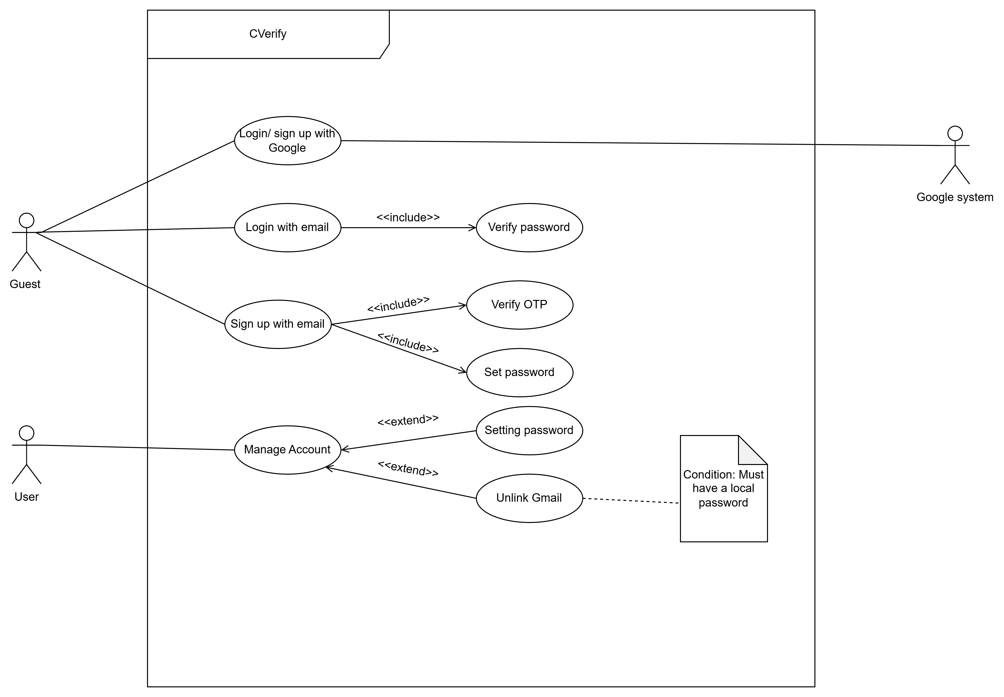

4.2.3: PersonalAuthentication

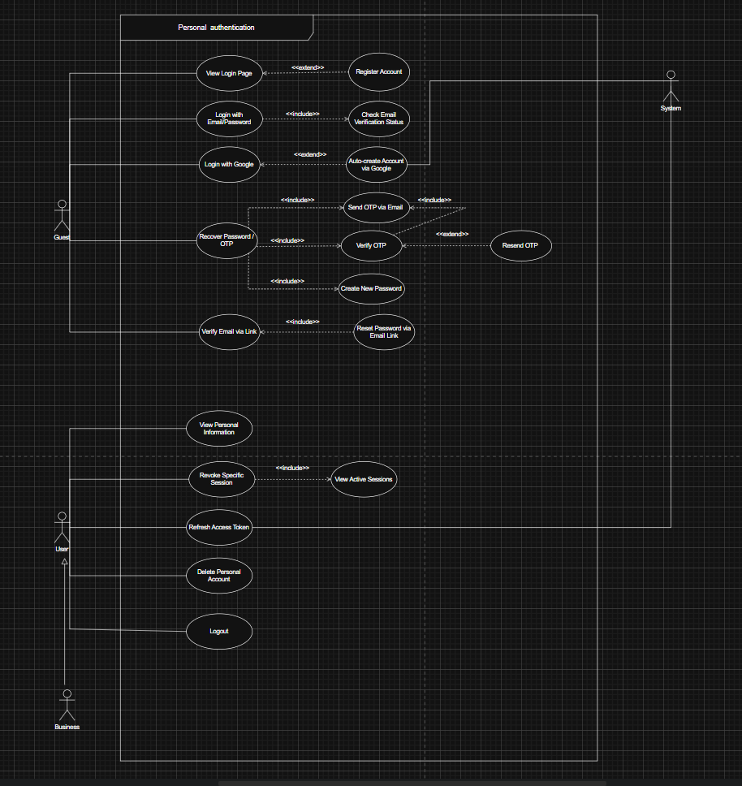

4.2.4:Business Onboarding

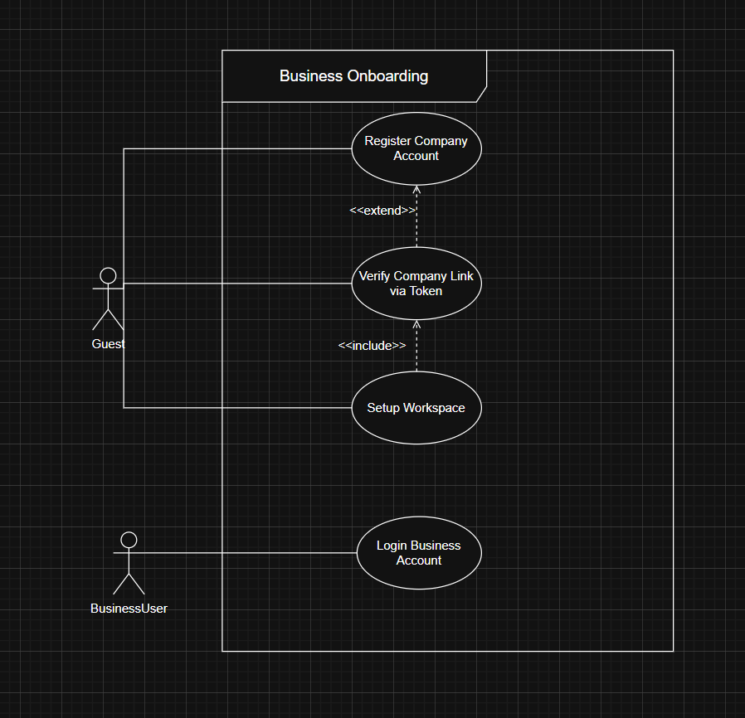

4.2.5: AI flow

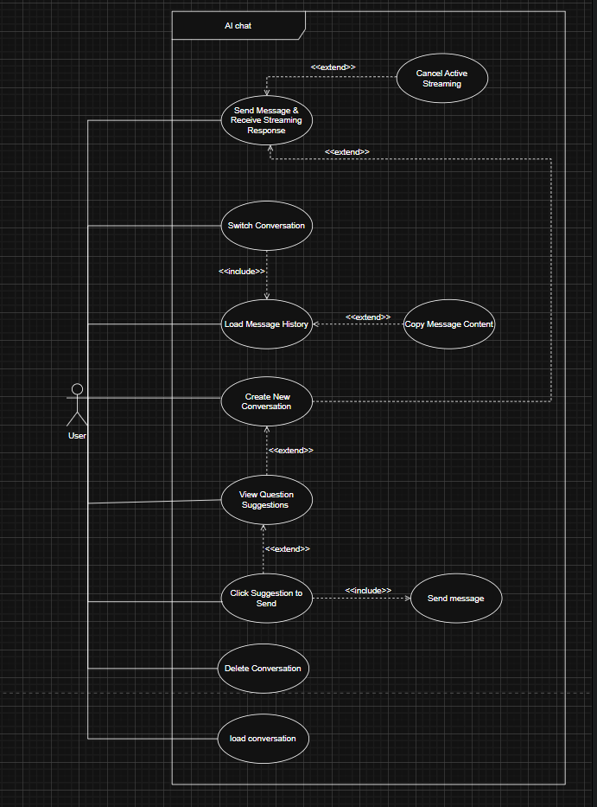

4.2.6:Admin Dashboard

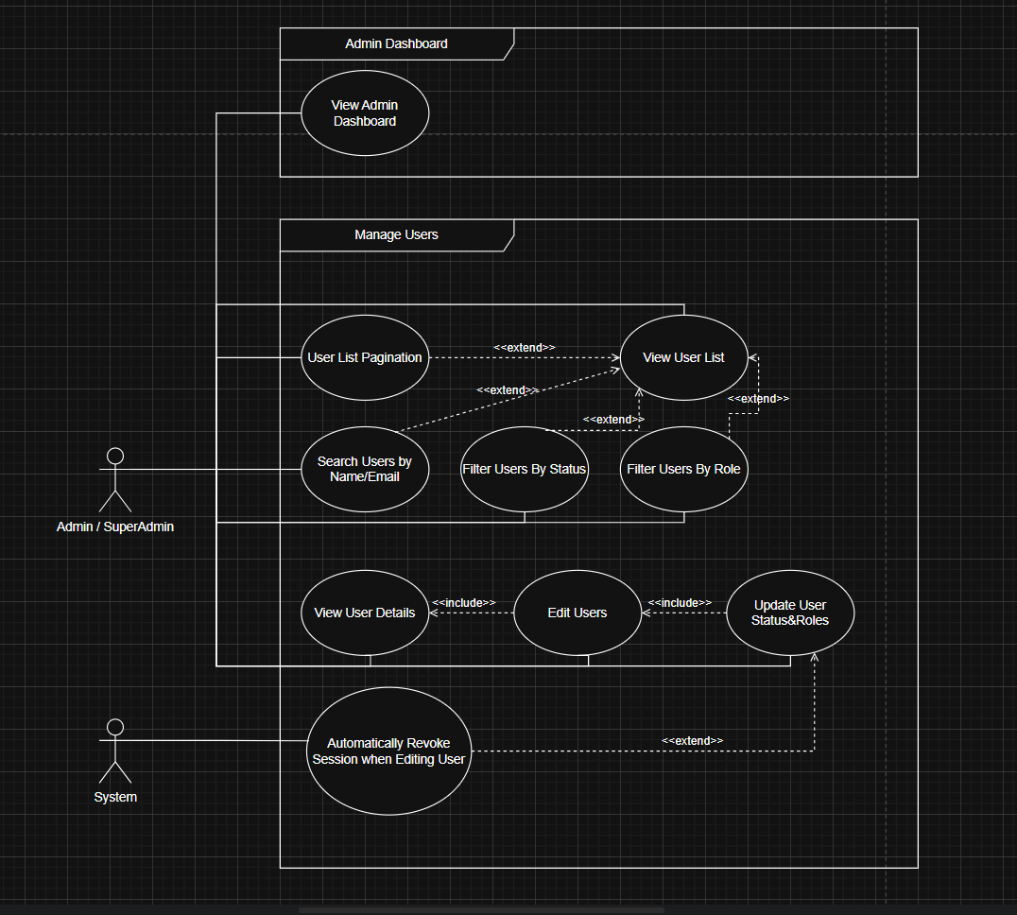

4.2.7:System Monitoring

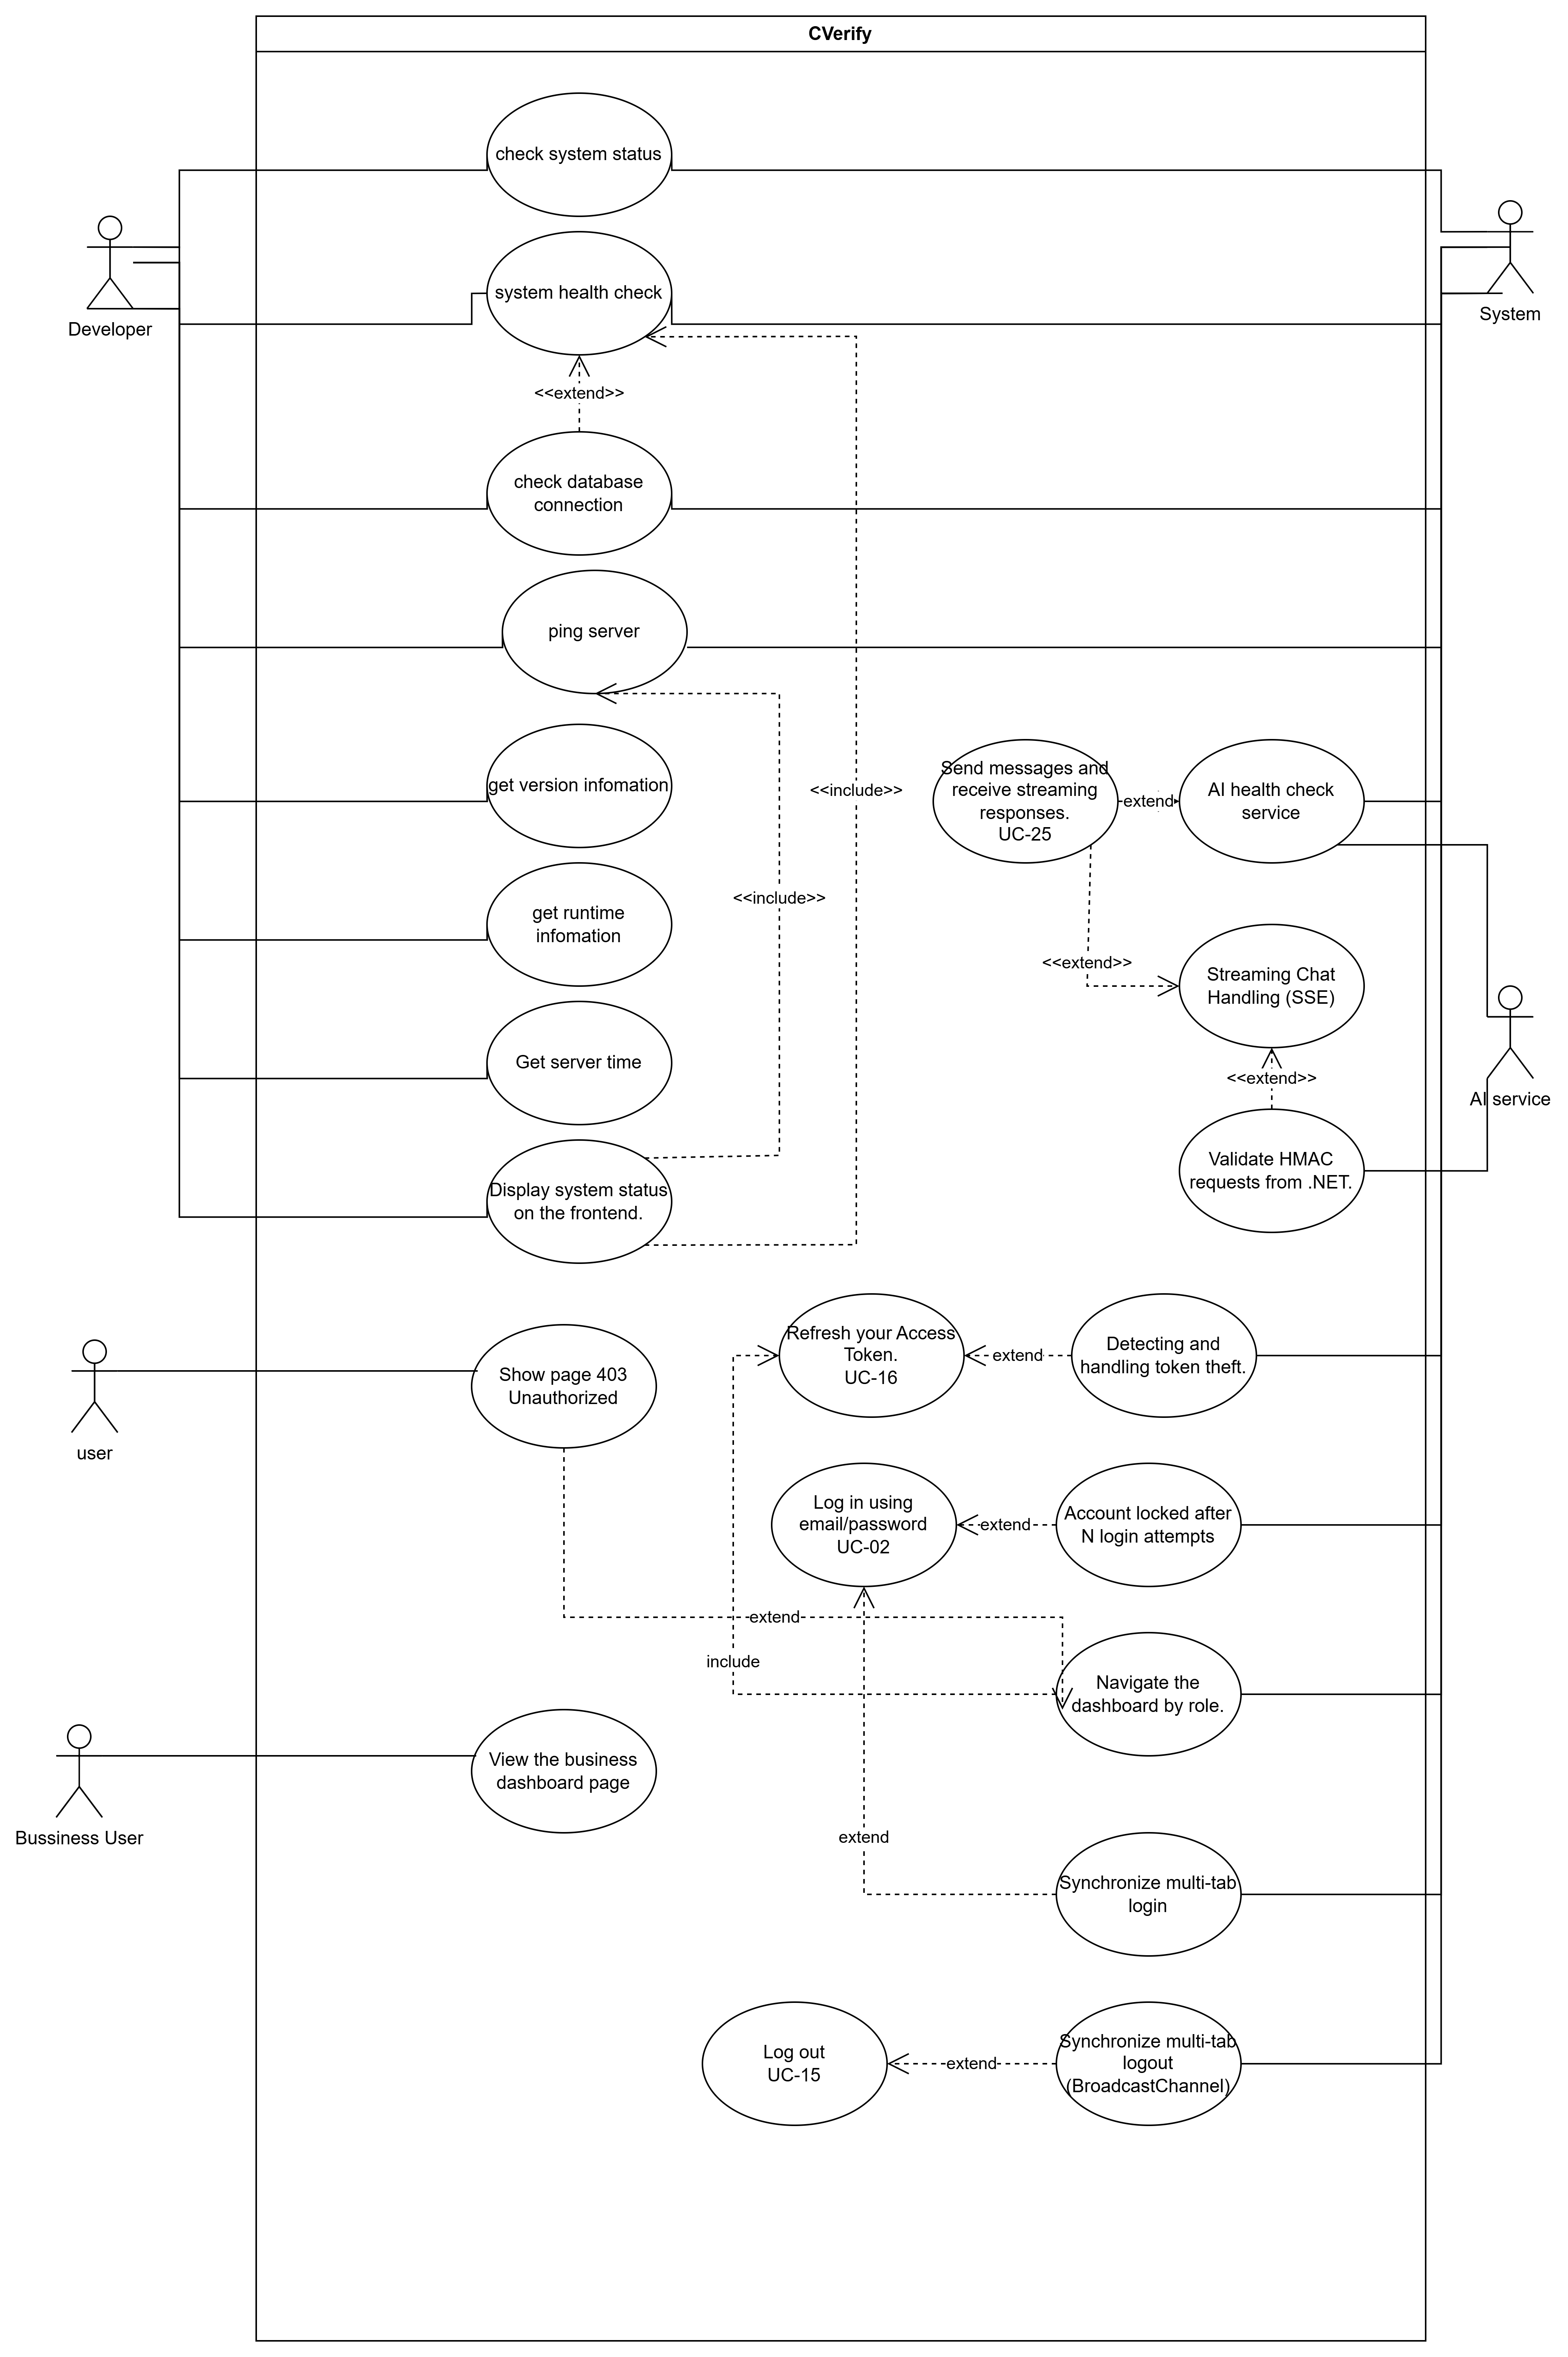

5. PRODUCT SCOPE

5.1 Context Diagram – System Overview
CVerify is the central system interacting with the following external systems:
External System | Interaction Direction | Purpose
GitHub REST/GraphQL API | CVerify → GitHub | Crawl public repositories, commit stats, contributor data
Google OAuth 2.0 | CVerify ↔ Google | Authenticate candidates via Google login
OpenAI API (GPT-4.1) | CVerify → OpenAI | JD analysis, Gap Analysis, embedding generation
Anthropic Claude API | CVerify → Anthropic | Skill Tree inference, complex reasoning
Google Gemini API | CVerify → Google AI | High-throughput repository description generation
Vietnam Tax API (MST) | CVerify → esgoo.net/VietQR | Auto-verify Tier 1 companies via tax code
SMTP Email Provider | CVerify → Email Server | OTP, notifications, daily digest emails
GitHub Webhooks | GitHub → CVerify | Push events trigger repository re-analysis

5.2 System Architecture Overview
The system follows a 5-tier layered architecture:
- Tier 1 – Presentation: Next.js 16 (App Router), HeroUI v3, Tailwind CSS v4.
- Tier 2 – API Gateway: ASP.NET Core v10, REST endpoints, JWT Auth, FluentValidation.
- Tier 3 – Business Logic: Domain services, Credit Engine, Trust Score Calculator.
- Tier 4 – AI Orchestration: Multi-model Router (GPT-4.1 / Claude Sonnet 4 / Gemini 2.5 Flash) with circuit-breaker.
- Tier 5 – Data: PostgreSQL 16 + pgvector (HNSW) + Redis cache.

6. OVERALL SYSTEM DESCRIPTION

6.1 Product Perspective
CVerify is a greenfield standalone web platform. It does not inherit or extend any existing system. It operates as an independent SaaS application accessible via web browser.

6.2 Operating Environment
Environment | Component | Minimum Spec | Notes
Development | Local Docker Compose | 4 CPU, 8 GB RAM | PostgreSQL + pgvector + Redis + Backend + Frontend
Staging | Single VPS / EC2 t3.medium | 2 vCPU, 4 GB RAM | Mirrors production at reduced scale
Production | AWS ECS / Azure Container Apps | 4 vCPU, 8 GB RAM min | Auto-scaling based on Hangfire queue depth
Database | AWS RDS PostgreSQL 16 + pgvector | db.t3.medium, 100 GB SSD | Multi-AZ for high availability
Cache | AWS ElastiCache Redis | cache.t3.micro | Single node sufficient for MVP
Frontend CDN | Vercel (Next.js native) | Pro plan | Edge functions, automatic scaling
Client Browser | Chrome 120+, Firefox 120+, Safari 17+, Edge 120+ | — | Mobile-first PWA; no native app required

6.3 Design and Implementation Constraints
ID | Constraint
C-01 | The system SHALL use the approved technology stack: Next.js 16 (Frontend), ASP.NET Core v10 (Backend), PostgreSQL 16 + pgvector (DB), Redis (Cache).
C-02 | All AI calls SHALL be routed through the Multi-model Router with circuit-breaker. No component may call AI provider APIs directly.
C-03 | All API keys and secrets SHALL be stored in Azure Key Vault / AWS Secrets Manager. Committing secrets to version control is prohibited.
C-04 | The system SHALL comply with WCAG 2.1 Level AA for all interactive elements.
C-05 | Candidate personal data SHALL comply with Vietnam Decree 13/2023/ND-CP (PDPA).
C-06 | Background jobs SHALL use Hangfire with PostgreSQL as the persistent job queue.

6.4 Assumptions and Dependencies

6.4.1 Assumptions
- GitHub API is stable and available >= 99% of the time; rate limit of 15,000 req/hour for GitHub App.
- Candidates have GitHub public repositories that reflect their actual skills.
- Vietnam Tax API (esgoo.net/VietQR) is available for MST code auto-verification.
- AI providers (OpenAI, Anthropic, Google) maintain SLA >= 99.5% uptime.

6.4.2 Dependencies
- GitHub OAuth App/App registration must be created and configured before Sprint 2.
- OpenAI API key with billing account to call text-embedding-3-large.
- Anthropic API key and Google Gemini API key.
- pgvector extension must be installed on the database server.

7. FUNCTIONAL REQUIREMENTS OVERVIEW
The table below summarizes all functional requirements by module and role:

Module | FR Range | Roles Involved | Sprint
Authentication & Authorization | FR-01 – FR-05 | Candidate, Recruiter, Admin | Sprint 1
Candidate Profile & CV Management | FR-06 – FR-16 | Candidate | Sprint 1–2
GitHub/GitLab Repository Integration | FR-17 – FR-22 | Candidate | Sprint 2
AI Skill Tree & Analysis | FR-23 – FR-26 | Candidate | Sprint 2–3
Job Search & Recommendation | FR-27 – FR-30 | Candidate | Sprint 3
Active Window Credit Model | FR-31 – FR-35 | Candidate | Sprint 4
Enterprise Onboarding | FR-36 – FR-37 | Recruiter Tier 1 & 2 | Sprint 1–2
Manual Recruitment (Tier 1) | FR-38 – FR-39 | Recruiter Tier 1 | Sprint 2
AI-Powered Recruitment (Tier 2) | FR-40 – FR-45 | Recruiter Tier 2 | Sprint 3–4
Anti-Harvesting Credit System | FR-46 – FR-48 | Recruiter | Sprint 4
Admin Management | FR-49 – FR-52 | Admin | Sprint 1, 4
Notification System | FR-53 – FR-55 | All roles | Sprint 3–4

8. AUTHENTICATION AND AUTHORIZATION REQUIREMENTS

8.1 Authentication Requirements
ID | Requirement | Priority | Sprint
FR-01 | The system SHALL allow Candidates to register via Email + OTP (6-digit, expires in 10 minutes) or Google OAuth 2.0. After registration, the email must be verified before login is permitted. | High | Sprint 1
FR-02 | The system SHALL allow Companies to register with a company email + company name + MST code. The MST code SHALL be auto-verified via API within < 5 minutes (Tier 1). | High | Sprint 1
FR-03 | The system SHALL support hybrid provider linking: a candidate registered via email may link an additional Google account to the same profile (and vice versa), with duplicate email detection. | High | Sprint 1
FR-04 | The system SHALL implement JWT Access Token (15-minute expiry) + Refresh Token (7-day expiry). Refresh tokens SHALL rotate on every use. | High | Sprint 1
FR-05 | The system SHALL implement RBAC (Role-Based Access Control) with 4 roles: job_seeker, recruiter (Tier 1), recruiter_ai (Tier 2), admin. | High | Sprint 1

8.2 Detailed Requirement Sample – FR-01
Requirement ID | FR-01 | Priority | High
Req. Name | Candidate Account Registration | Actor | Candidate (No existing account)

Description | The system SHALL allow a Candidate to register a new account using an email address or Google OAuth. The email must be verified via a 6-digit OTP before the account is activated.
Preconditions | 1. The user does not have a CVerify account. 2. The user navigates to /register.
Main Flow | 1. The user selects a registration method (Email or Google). 2. If Email: enter email + password → system sends 6-digit OTP → user enters OTP → account is activated. 3. If Google: redirect to Google OAuth → grant permissions → account is created and automatically verified.
Alternative Flow | AF-01: If the email already exists → display 'Email already in use' and suggest login or provider linking. AF-02: If OTP expires → allow resend after 60 seconds.
Postconditions | A new candidate account is created with role job_seeker, email_verified = true, and an empty candidate_profile is initialized.
Acceptance Criteria | 1. Registration completes in < 30 seconds. 2. OTP expires after exactly 10 minutes. 3. Duplicate email is rejected with a clear error message. 4. JWT token is issued immediately upon successful registration.

9. CANDIDATE MODULE REQUIREMENTS

9.1 Profile Management
ID | Requirement | Priority | Sprint
FR-06 | The system SHALL provide a structured CV editor with the following sections: Personal Information, Education, Work Experience, Skills (self-declared), and Projects (manually added). All fields SHALL be validated before submission. | High | Sprint 2
FR-07 | Manually added projects SHALL display a 'Self-declared' label (yellow badge). AI-verified projects SHALL display a 'Verified' label (green badge) in all public-facing views. | High | Sprint 2
FR-08 | Candidates SHALL be able to upload a CV file (PDF/DOCX, <= 5 MB) for AI parsing to automatically extract information into the structured CV editor. | High | Sprint 2
FR-09 | Candidates SHALL be able to manage Career Preferences: expected salary, preferred location, work type (full-time/part-time/remote), and level (Intern/Fresher/Junior/Senior/Master). | Medium | Sprint 2
FR-10 | Candidates SHALL be able to control profile visibility: Hidden (not discoverable), Passive (keyword search only), Active (AI auto-recommend, credit-based). | High | Sprint 4

9.2 GitHub/GitLab Integration
ID | Requirement | Priority | Sprint
FR-11 | The system SHALL allow candidates to link their GitHub account via OAuth 2.0. After linking, the system SHALL crawl all public repositories via the GitHub REST and GraphQL APIs. | High | Sprint 2
FR-12 | Each repository crawl SHALL collect: commit history, lines of code, language breakdown, contributor statistics, fork status, and open-source PR contributions. | High | Sprint 2
FR-13 | Candidates SHALL be able to toggle the public/private visibility of individual repositories on their CVerify profile, independently of their GitHub visibility settings. | High | Sprint 2
FR-14 | The system SHALL use AI Function Calling to generate a structured description for each repository using a strict JSON Schema: project_title, description (100–200 chars), tech_stack, primary_language, contribution_level (maintainer/contributor/forker), skills_demonstrated, complexity_score (1–10). | High | Sprint 2
FR-15 | AI-generated descriptions SHALL be streamed to the frontend via SSE. Candidates SHALL be able to edit the AI-generated description before saving. | High | Sprint 2

9.3 AI Skill Analysis
ID | Requirement | Priority | Sprint
FR-16 | After analyzing all linked repositories and the CV, the system SHALL generate a Skill Tree for the candidate. Each skill node SHALL include: skill name, proficiency level (inferred), and evidence source (ai-inferred or self-declared). | High | Sprint 3
FR-17 | The Skill Tree SHALL be converted into a 1536-dimensional vector embedding (OpenAI text-embedding-3-large) and stored in cv_embeddings with an HNSW index. | High | Sprint 3
FR-18 | The system SHALL compute a Trust Score (0–100). The score decreases when any of the following fraud signals are detected: forked repo, commit burst anomaly, skill not found in code, boilerplate project. | High | Sprint 4
FR-19 | Flagged repositories SHALL display one of the following labels visible to recruiters: 'Forked – Low Originality', 'Unusual Activity Pattern', or 'Tutorial/Boilerplate'. | High | Sprint 4
FR-20 | Candidates SHALL view real-time AI Gap Analysis results when viewing a specific JD: matched skills, missing skills, and a recommended learning roadmap (streamed via SSE, completing in < 10 seconds). | High | Sprint 3

10. RECRUITER AND COMPANY MODULE REQUIREMENTS

10.1 Company Onboarding
ID | Requirement | Priority | Sprint
FR-21 | Tier 1 company registration SHALL auto-verify the MST code via Vietnam Tax API (esgoo.net / VietQR). If both APIs fail, queue the registration for Admin manual review. | High | Sprint 1
FR-22 | A Tier 1 company SHALL be able to upgrade to Tier 2 by submitting: full name + CCCD (12-digit national ID) of the legal representative, a scanned business license (JPEG/PNG/PDF <= 10 MB), and a phone number verified via OTP SMS. | High | Sprint 1
FR-23 | The Admin Tier 2 review checklist SHALL include: MST match, company name match, document validity, representative identity match, and EXIF metadata integrity check. | High | Sprint 1

10.2 Job Description Management
ID | Requirement | Priority | Sprint
FR-24 | Tier 1 & Tier 2 companies SHALL be able to create a JD with the following fields: title, full description (text/PDF/Word upload), required tech stack tags, seniority level, location, and salary range. | High | Sprint 2
FR-25 | Upon JD submission, the system SHALL trigger an AI pipeline: (1) extract structured requirements via LLM Function Calling, (2) embed the JD using text-embedding-3-large, (3) store jd_embedding. | High | Sprint 3
FR-26 | Recruiters SHALL be able to manage their JD list: edit, pause, close, and view applicant counts by status. | High | Sprint 2

10.3 Manual Recruitment (Tier 1)
ID | Requirement | Priority | Sprint
FR-27 | Tier 1 companies SHALL have access to a recruitment pipeline dashboard with status transitions: Pending → Reviewing → Interview → Accepted / Rejected. | High | Sprint 2
FR-28 | Tier 1 companies SHALL be able to view the full CV, Skill Tree, and Proof-of-Work indicators (repository metrics, Trust Score) of candidates who have applied. | High | Sprint 2
FR-29 | Recruiters SHALL be able to save a candidate to a shortlist (costs 3 credits). The shortlist is accessible via a dedicated dashboard panel. | High | Sprint 3
FR-30 | Recruiters SHALL be able to reveal a candidate's contact information (email/phone) (costs 30 credits, hard cap of 5 reveals per account per day). | High | Sprint 4

10.4 AI-Powered Recruitment (Tier 2)
ID | Requirement | Priority | Sprint
FR-31 | When a Tier 2 company posts a JD, the system SHALL automatically scan the Active Candidate Pool (visibility_mode = 'active') using HNSW search and return the top-K candidates with an ATS score >= 75%. | High | Sprint 3
FR-32 | The system SHALL send a real-time SignalR notification to the recruiter when new matching candidates are found, including a preview card (masked name, ATS score, top matching skills). | Medium | Sprint 4
FR-33 | A daily AI Digest email SHALL be sent each morning to Tier 2 recruiters listing the top-5 new candidate matches for each open JD, including a brief explainability summary per candidate. | Medium | Sprint 4
FR-34 | Tier 2 recruiters SHALL be able to adjust the weight of each of the 8 ATS factors in the dashboard (total must always equal 100%). The ATS score SHALL recalculate live upon weight adjustment. | Medium | Sprint 4

11. AI MODULE REQUIREMENTS

11.1 AI Architecture Overview
CVerify uses a Multi-model Router with 3 AI providers: GPT-4.1 (OpenAI), Claude Sonnet 4 (Anthropic), and Gemini 2.5 Flash (Google). The router selects the optimal model per task based on quality, cost, and availability.

11.2 AI Model Routing Strategy
AI Task | Primary Model | Fallback Model | Selection Rationale
JD Analysis & Structured Extraction | GPT-4.1 (Function Calling) | Claude Sonnet 4 | Best strict JSON output and structured field accuracy
Repository Auto-Description Generation | Gemini 2.5 Flash | GPT-4.1 mini | High throughput, low cost, smooth streaming
Skill Tree Inference | Claude Sonnet 4 | GPT-4.1 | Superior complex reasoning; 200K context window for large codebases
Semantic Embedding Generation | text-embedding-3-large (1536d) | Gemini text-embedding-005 | State-of-the-art MTEB score; native pgvector support
Gap Analysis | GPT-4.1 | Claude Sonnet 4 | High-quality recommendations with structured reasoning
Trust Score / Fraud Detection | Fine-tuned classifier | GPT-4.1 (few-shot) | Fast pattern detection in commit history at low latency

11.3 AI CV Analysis Requirements
ID | Requirement | Priority
AI-01 | AI SHALL parse uploaded CVs (PDF/DOCX) and extract: Personal Info, Education, Work Experience, Skills, and Projects into a structured JSON format. | High
AI-02 | AI SHALL compare self-declared skills in the CV against actual code evidence from repositories and assign a confidence level (High/Medium/Low) to each skill. | High
AI-03 | AI output from CV parsing SHALL be validated against a JSON Schema before being stored. Validation failure SHALL trigger a retry with exponential backoff (max 3 attempts). | High
AI-04 | AI SHALL NOT automatically accept or reject a candidate. All AI output is advisory only and supports recruiter decision-making. | High

11.4 AI Repository Analysis Requirements
ID | Requirement | Priority
AI-05 | AI SHALL analyze each repository and output in strict JSON Schema format: project_title, description (100–200 chars), tech_stack, primary_language, contribution_level (maintainer/contributor/forker), skills_demonstrated, complexity_score (1–10). | High
AI-06 | The system SHALL compute repository metrics: Contribution Ratio, Code Ownership Score, Gini Coefficient, Bus Factor, Originality Score (AST similarity), and Activity Momentum (90-day exponential decay). | Medium
AI-07 | AI descriptions SHALL be streamed via SSE. Candidates may edit the AI-generated description before confirming. | High
AI-08 | GitHub API rate limits (15,000 req/hr) SHALL be monitored. When approaching the limit, the system SHALL use a queue-based crawler with exponential backoff. | High

11.5 AI Matching Requirements
ID | Requirement | Priority
AI-09 | The 8-Factor ATS Score SHALL be computed for every candidate-JD pair: Skills Match (25%), GitHub Activity (20%), Experience (15%), Project Relevance (15%), Open Source Contribution (10%), Education (5%), Tech Stack Similarity (5%), Profile Similarity (5%). | High
AI-10 | All 8 factor scores and their weights SHALL be stored in applications.ranking_factors (JSONB) for audit and Explainability Report generation. | High
AI-11 | Each ranking SHALL include an AI-generated Explainability Report (3–5 sentences) describing the key reasons for the candidate's rank, explicitly citing strong and weak dimensions. | High
AI-12 | AI matching SHALL use pgvector HNSW cosine similarity. P99 query latency SHALL be <= 10ms for a dataset of up to 1 million candidate vectors. | High
AI-13 | All AI-generated content SHALL be sanitized using DOMPurify before DOM insertion to prevent XSS via model output injection. | High

11.6 AI Constraints and Limitations
- AI SHALL NOT make automated hiring or rejection decisions. AI output is advisory only.
- AI output does not constitute legal evidence of a candidate's competence.
- AI SHALL NOT expose unnecessary personal data from candidates in prompts sent to AI providers.
- Circuit-breaker: if an AI provider fails 3 consecutive times within 60 seconds, the router automatically switches to the fallback model.
- Redis Semantic Cache (cosine similarity > 0.95) reduces redundant AI API calls.

12. ADMINISTRATOR MODULE REQUIREMENTS
ID | Requirement | Priority | Sprint
FR-35 | The Admin dashboard SHALL display all pending Tier 2 upgrade requests with a structured checklist UI. Admin SHALL be able to approve or reject each request with a mandatory reason field. | High | Sprint 1
FR-36 | Admin SHALL be able to manage users: view, deactivate, reactivate, change role, and view activity history. | High | Sprint 1
FR-37 | Admin SHALL be able to manage companies: view, verify/unverify, deactivate, and view the JD list and activity log. | High | Sprint 1
FR-38 | Admin SHALL be able to manage labels/categories: create, edit, and delete skill labels and tech stack categories. | Medium | Sprint 2
FR-39 | The Admin dashboard SHALL display AI usage analytics: tokens consumed per model per day, cost per request, cache hit rate, and total AI spend to date. | Medium | Sprint 4
FR-40 | Admin SHALL be able to configure AI model routing rules (primary model, fallback, circuit-breaker thresholds) via the dashboard without a code deployment. | Medium | Sprint 4
FR-41 | The system SHALL surface fraud alerts to the Admin dashboard when Trust Score anomalies are detected (e.g., Trust Score drops below 40, or a honeypot profile is viewed more than 5 times per week by a single recruiter). | High | Sprint 4
FR-42 | Admin SHALL be able to view system statistics: user count by role, new JDs per week, application rate, AI usage, and credit revenue. | Medium | Sprint 4
FR-43 | Admin SHALL have access to a full Audit Log: all data access events (profile views, contact reveals, AI searches) with timestamps and actor identities. Logs SHALL be retained for a minimum of 12 months. | High | Sprint 2
FR-44 | Admin SHALL be able to fulfill candidate/recruiter data deletion requests within 72 hours. Deletion SHALL cascade across all related tables. | High | Sprint 3

13. USE CASE MODEL

13.1 Use Case Overview
Use Case ID | Use Case Name | Actor(s) | Priority
UC-01 | Register / Log In to Account | Candidate, Recruiter | High
UC-02 | Create and Manage Candidate Profile | Candidate | High
UC-03 | Upload CV and AI Parsing | Candidate | High
UC-04 | Connect GitHub and Crawl Repositories | Candidate | High
UC-05 | View AI Skill Tree and Trust Score | Candidate | High
UC-06 | Search for Jobs and View Gap Analysis | Candidate | High
UC-07 | Purchase Active Window | Candidate | High
UC-08 | Register / Company Onboarding | Recruiter | High
UC-09 | Post a Job Description | Recruiter Tier 1 & 2 | High
UC-10 | Manual Candidate Search (Tier 1) | Recruiter Tier 1 | High
UC-11 | AI-Powered Candidate Matching (Tier 2) | Recruiter Tier 2 | High
UC-12 | View Candidate Profile and Explainability Report | Recruiter | High
UC-13 | Shortlist Candidate and Reveal Contact | Recruiter | Medium
UC-14 | Manage Recruitment Pipeline | Recruiter | High
UC-15 | Review Tier 2 Company Upgrade Request | Admin | High
UC-16 | Manage Users and Companies | Admin | High
UC-17 | View AI Analytics and Fraud Alerts | Admin | Medium
UC-18 | Configure System and AI Routing | Admin | Medium

13.2 Detailed Use Case – UC-11: AI-Powered Candidate Matching
Attribute | Content
Use Case ID | UC-11
Use Case Name | AI-Powered Candidate Matching (Tier 2)
Actors | Recruiter Tier 2 (Primary), AI Orchestration Service (Secondary)
Preconditions | Recruiter is Tier 2 verified. JD has been posted and embedded. At least 1 candidate exists in the Active Pool.
Main Flow | 1. Recruiter posts a JD. 2. System triggers AI pipeline to embed the JD. 3. HNSW search returns top-K candidates (ATS >= 75%). 4. System computes 8-factor ATS Score for each candidate. 5. Generates Explainability Report per candidate. 6. SignalR notification sent to recruiter. 7. Recruiter views ranked list with preview cards.
Alternative Flow | AF-01: No Active candidates match → display 'No active candidates found; consider broadening requirements.' AF-02: AI provider timeout → fallback model automatically used; no disruption visible to recruiter.
Postconditions | Recruiter has a ranked candidate list. Each profile view costs credits per the credit table.

14. EXTERNAL INTERFACE REQUIREMENTS

14.1 User Interface Requirements
- The frontend SHALL be built with Next.js 16 (App Router), HeroUI v3, and Tailwind CSS v4 (OKLCH color space). All pages SHALL follow mobile-first responsive design with breakpoints at sm/md/lg/xl.
- AI-generated streaming content SHALL be rendered incrementally as SSE tokens arrive, with a visible streaming indicator (e.g., a blinking cursor or spinner).
- The Active Window credit balance SHALL be displayed persistently in the candidate navigation bar and updated in real-time after each purchase or expiry event.
- The Admin dashboard SHALL display Tier 2 review requests in a sortable queue with a structured checklist UI. Raw document uploads SHALL only be viewable within an authenticated Admin session.

14.2 Software Interfaces (Third-Party APIs)
External System | Purpose | Protocol / Auth | Failure Handling
GitHub REST API v3 | Repository crawl, contributor stats, commit history | GitHub App token (15K req/hr) | Exponential backoff on 429; queue-based crawler
GitHub GraphQL API v4 | Batch repository metadata fetch | GitHub App token | Fallback to REST API if GraphQL fails
GitHub Webhooks | Push events trigger repo re-analysis | Webhook secret HMAC-SHA256 validation | Re-sync job queued on next scheduled run
Google OAuth 2.0 | Candidate social authentication | OAuth 2.0 / OIDC (verify aud, exp claims) | Fallback to email/OTP flow
OpenAI API (GPT-4.1) | JD analysis, embeddings, Gap Analysis | Bearer token / Azure Key Vault | Circuit breaker; switch to Claude Sonnet 4 after 3 consecutive failures
Anthropic Claude API | Skill Tree inference, complex reasoning | Bearer token / Azure Key Vault | Fallback to GPT-4.1
Google Gemini API | High-throughput repo description generation | API key / Secret Manager | Fallback to GPT-4.1 mini
esgoo.net MST / VietQR | Tier 1 company MST auto-verification | HTTPS GET (public / API key) | Cascade to secondary; queue for Admin review if all sources fail

14.3 Communication Interfaces
- All client-server communication SHALL use HTTPS (TLS 1.3 minimum). HTTP connections SHALL be redirected via HSTS.
- AI streaming responses SHALL be delivered via Server-Sent Events (SSE) over HTTP/2, with Last-Event-ID reconnect support.
- Real-time notifications SHALL be delivered via ASP.NET Core SignalR (WebSocket with Long Polling fallback).
- Background jobs SHALL use Hangfire with PostgreSQL as the persistent job queue.
- Outbound email SHALL be sent via SMTP/API using SPF/DKIM/DMARC-authenticated domains.

15. DATA REQUIREMENTS

15.1 Data Dictionary – Core Entities

15.1.1 users
Attribute | Content
Meaning | Primary identity table. Normalized email is the primary identity key.
Key Fields | id (UUID, PK), email (UNIQUE NOT NULL), email_verified (BOOL), role (ENUM: job_seeker/recruiter/admin), created_at, updated_at
Relationships | 1-1 with candidate_profiles, 1-N with auth_providers, N-1 with organizations
Security / Visibility Rules | Password hashed using BCrypt cost 12. PII fields encrypted at rest.

15.1.2 candidate_profiles
Attribute | Content
Meaning | Extended candidate profile with flexible CV data.
Key Fields | id, user_id (FK), cv_data (JSONB: education, experience, skills, projects), skill_labels (TEXT[]), trust_score (0-100), visibility_mode (hidden/passive/active), window_expires_at (TIMESTAMPTZ)
Relationships | 1-1 with users, 1-1 with cv_embeddings, 1-N with repositories, 1-N with applications
Security / Visibility Rules | visibility_mode determines discoverability. Contact info is hidden until the recruiter pays credits.

15.1.3 cv_embeddings
Attribute | Content
Meaning | Vector table for semantic candidate search with HNSW index.
Key Fields | id, candidate_id (FK), embedding (vector(1536)), model_version, created_at, last_synced_at
Relationships | 1-1 with candidate_profiles
Security / Visibility Rules | Only aggregate/similarity search is permitted; raw embeddings are not exposed.

15.1.4 repositories
Attribute | Content
Meaning | GitHub/GitLab repositories linked by candidates.
Key Fields | id, candidate_id (FK), github_repo_id, name, description (AI-generated), tech_stack (JSONB), contribution_level, complexity_score, trust_signals (JSONB), is_visible_on_profile (BOOL)
Relationships | N-1 with candidate_profiles
Security / Visibility Rules | is_visible_on_profile allows candidates to hide specific repositories.

15.1.5 organizations
Attribute | Content
Meaning | Company / recruiter entity table.
Key Fields | id, name, slug (UNIQUE), mst_code, verification_level (1 or 2), legal_docs (JSONB), subscription_plan, credit_balance
Relationships | 1-N with organization_members, 1-N with job_posts
Security / Visibility Rules | Legal documents are accessible to Admin only. MST code is not exposed publicly.

15.1.6 job_posts
Attribute | Content
Meaning | Job Descriptions posted by companies.
Key Fields | id, org_id (FK), title, jd_text (TEXT), jd_embedding (vector(1536)), tech_stack_tags, seniority, location, salary_range, status (active/paused/closed)
Relationships | N-1 with organizations, 1-N with applications
Security / Visibility Rules | jd_embedding is used for internal matching only.

15.1.7 applications
Attribute | Content
Meaning | Junction table between job_posts and candidate_profiles.
Key Fields | id, job_id (FK), candidate_id (FK), status (ENUM), ats_score (NUMERIC), ranking_factors (JSONB – 8 factors + weights), applied_at
Relationships | N-1 with job_posts, N-1 with candidate_profiles
Security / Visibility Rules | ranking_factors provides an audit trail for Explainability Reports.

15.1.8 audit_logs
Attribute | Content
Meaning | Immutable audit log for all data access events.
Key Fields | id, actor_id, actor_role, action (ENUM), target_entity, target_id, ip_address, user_agent, timestamp
Relationships | N-1 with users
Security / Visibility Rules | Immutable. Retained for a minimum of 12 months. Readable by Admin only.

15.1.9 notifications
Attribute | Content
Meaning | In-app and email notification records.
Key Fields | id, user_id (FK), type (ENUM), title, body (JSONB), is_read, delivery_channel (in-app/email/signalr), created_at
Relationships | N-1 with users
Security / Visibility Rules | Must not contain raw personal data of other users.

15.1.10 credit_transactions
Attribute | Content
Meaning | Credit transaction history (inflows and outflows).
Key Fields | id, org_id or candidate_id, type (debit/credit), amount, action (ENUM), balance_after, reference_id, created_at
Relationships | N-1 with organizations or candidate_profiles
Security / Visibility Rules | Immutable transaction log. Records may not be modified or deleted.

DATABASE REQUIREMENTS AND ERD

16.1 Logical Data Model – Entity Relationships
- users (1) ──< (N) auth_providers: Each user may have multiple authentication providers (Google, password, GitHub, LinkedIn, Passkey).
- users (1) ──── (1) candidate_profiles: One-to-one profile record per Job Seeker.
- candidate_profiles (1) ──── (1) cv_embeddings: Stores the 1536-dimensional vector of the full candidate profile.
- candidate_profiles (1) ──< (N) repositories: Multiple GitHub repositories linked per candidate.
- organizations (1) ──< (N) organization_members: Multiple recruiter/HR users per company workspace.
- organizations (1) ──< (N) job_posts: Multiple active JDs per company.
- job_posts (1) ──< (N) applications: Many candidates may apply to one JD.
- applications stores the ATS Score breakdown (ranking_factors JSONB) and pipeline status enum.

16.2 Vector Embedding & Semantic Search Architecture
The system uses pgvector with Hierarchical Navigable Small World (HNSW) indexing for approximate nearest-neighbor search:
- HNSW parameters: m=16, ef_construction=64 → ~97% recall, P99 < 8ms for up to 5 million vectors.
- Redis Semantic Cache: caches AI responses keyed by similarity (cosine > 0.95). TTL: 1 hour for JD analysis, 24 hours for repository descriptions.
- Two primary vector tables: cv_embeddings (candidate search) and job_posts.jd_embedding (reverse JD search).

16.3 Database Requirements
ID | Requirement | Priority
DB-01 | PostgreSQL 16 with the pgvector extension SHALL be installed in all environments. HNSW indexes SHALL be created on cv_embeddings.embedding and job_posts.jd_embedding. | High
DB-02 | All database queries involving user-supplied parameters SHALL use EF Core parameterized queries. Raw SQL string concatenation is strictly prohibited. | High
DB-03 | Database connection pooling SHALL be configured with Npgsql. Pool size minimum 10, maximum 100. | High
DB-04 | Database backups SHALL run daily (full) and hourly (incremental). Retention period: 30 days. Recovery Time Objective (RTO): < 4 hours. | High
DB-05 | The HNSW index SHALL support parallel index building to reduce re-indexing time by approximately 60% (PostgreSQL 16 parallel workers). | Medium

16.4 ERD Diagram
16.4.1: AI Recruitment ERD
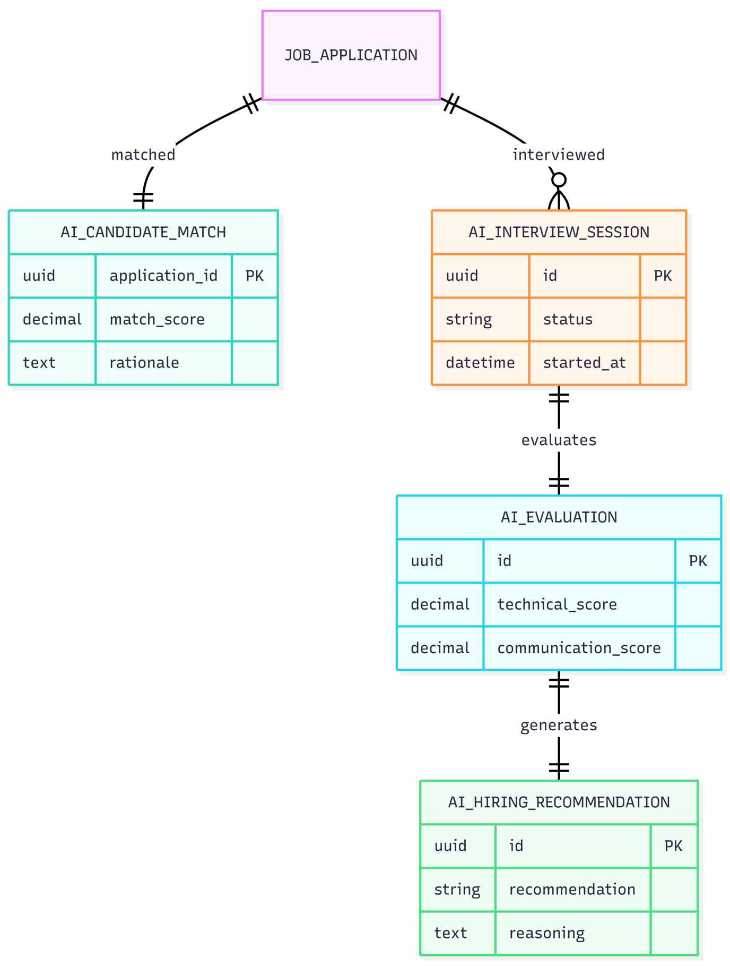

16.4.2:Master CVerify Platform ERD
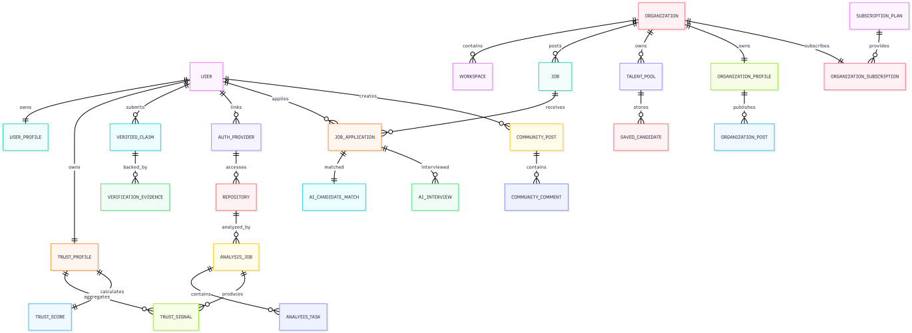

16.4.3: Recruitment ERD
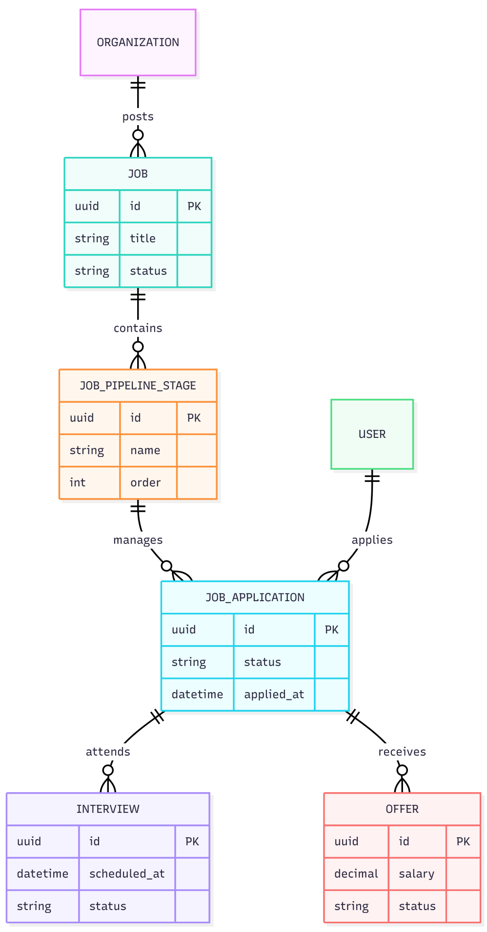

16.4.4:Repository Intelligence ERD
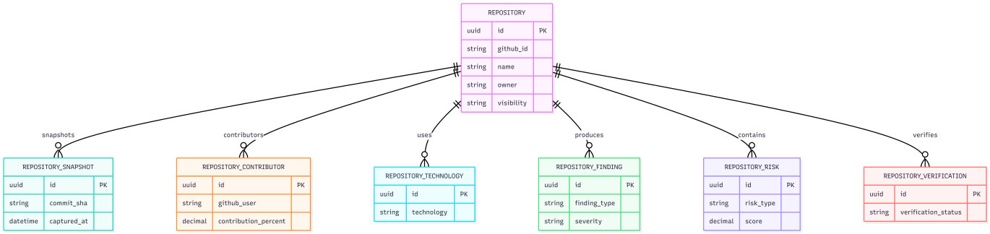

16.4.5:Trust Intelligence ERD
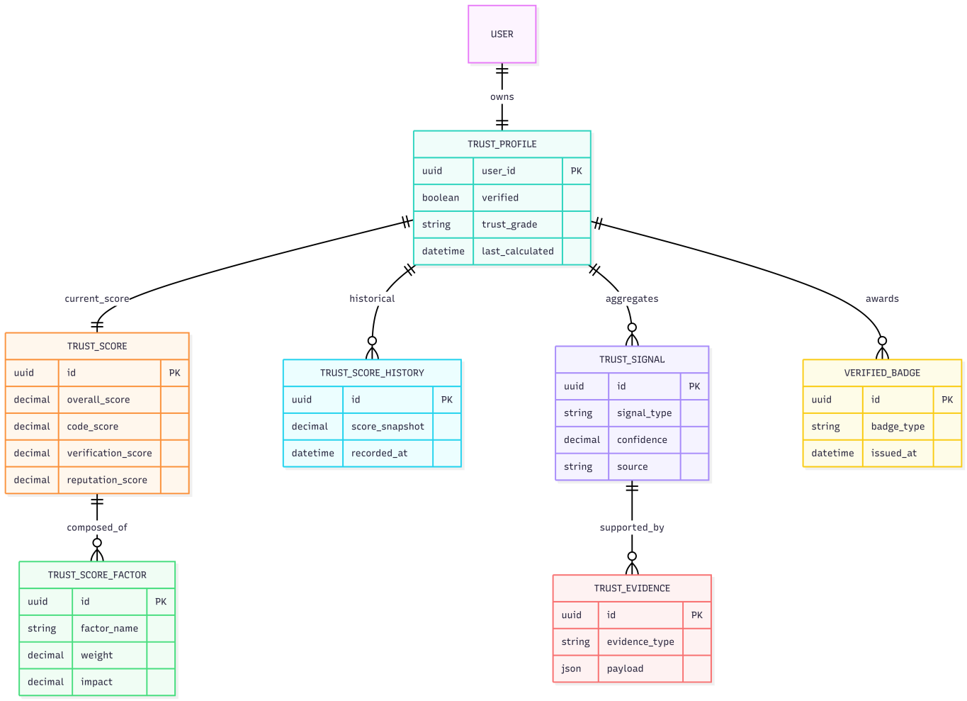

16.4.6:Verification Platform ERD
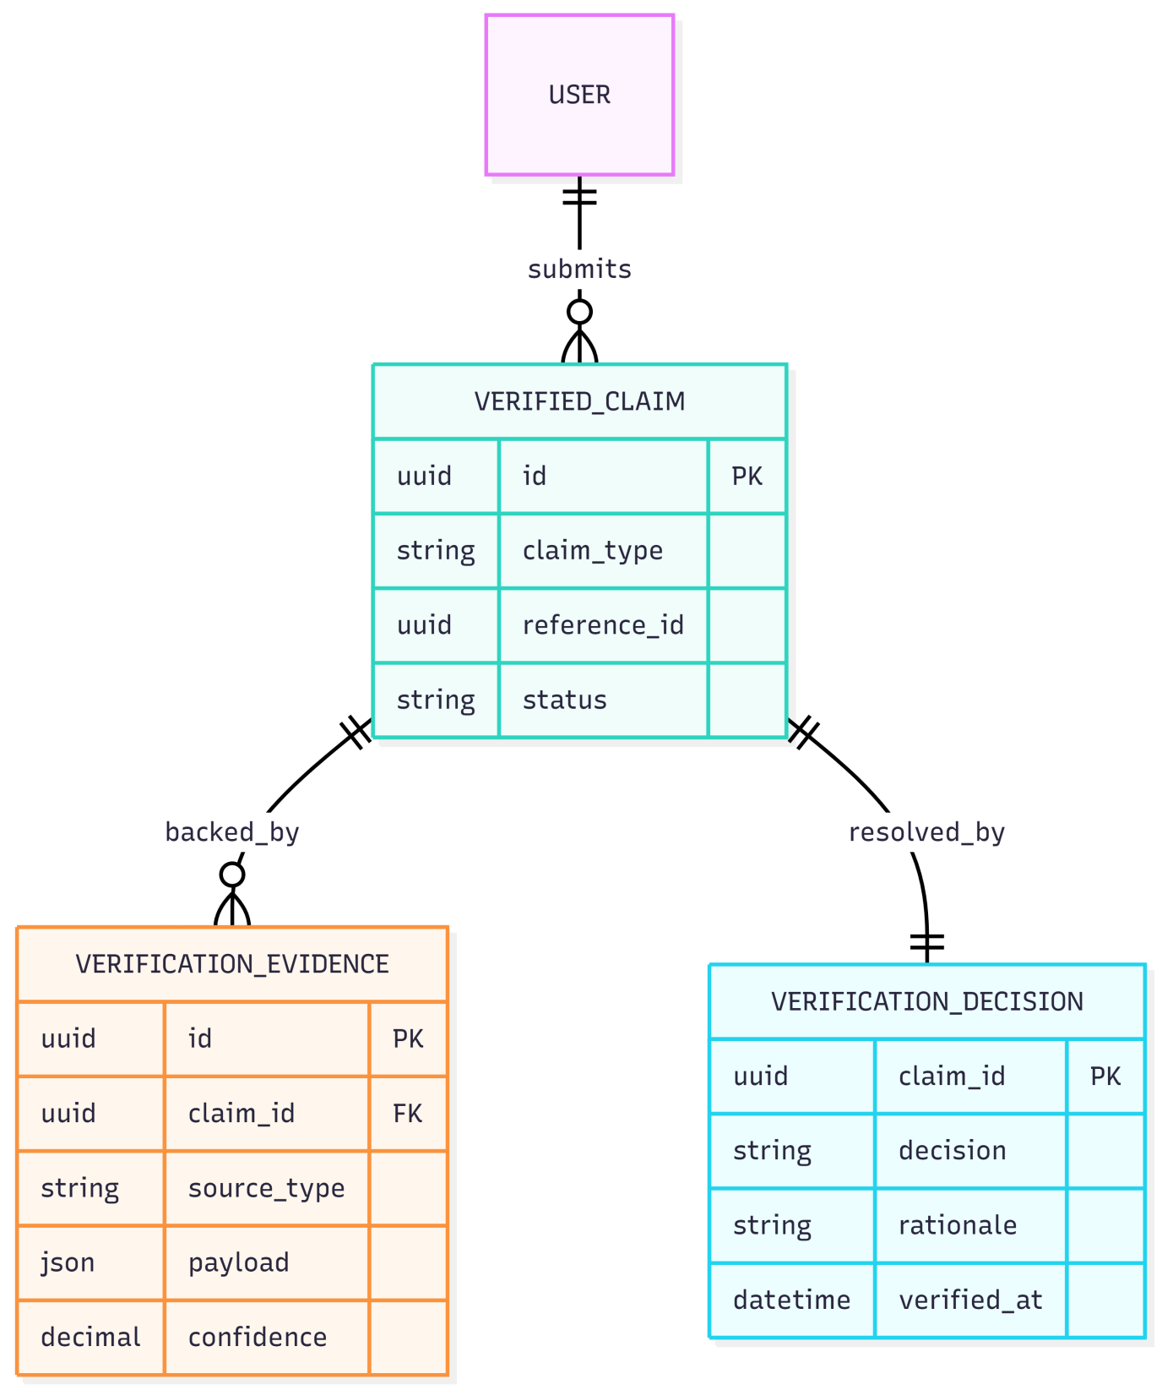

17. NON-FUNCTIONAL REQUIREMENTS

17.1 Performance Requirements
ID | Requirement | Metric / Target | Priority
NFR-01 | Core Web Vitals: LCP < 2.5s, FID < 100ms, CLS < 0.1 on the candidate and recruiter dashboards. | Google Lighthouse >= 90 | High
NFR-02 | Semantic candidate search queries SHALL respond within 200ms at P95 under a load of 500 concurrent users. | P95 <= 200ms @ 500 CU | High
NFR-03 | pgvector HNSW index queries SHALL complete in under 10ms P99 for a dataset of up to 1 million candidate vectors. | P99 <= 10ms @ 1M vectors | High
NFR-04 | SSE streaming token delivery from AI provider to frontend SHALL exhibit a UI update latency of less than 50ms per token. | UI update <= 50ms/token | Medium
NFR-05 | The initial JavaScript bundle size SHALL not exceed 250 KB (gzipped) for the critical path. Lazy loading SHALL be applied to all AI-feature modules. | Bundle <= 250 KB gzip | Medium
NFR-06 | Redis Semantic Cache SHALL achieve a minimum hit rate of 40% for AI calls within the first month of production operation. | Cache hit rate >= 40% | Medium

17.2 Security Requirements
ID | Requirement | Metric / Target | Priority
NFR-07 | All API endpoints accepting user input SHALL enforce FluentValidation rules. No raw user input SHALL reach the database layer without validation. | 0 unvalidated inputs | High
NFR-08 | All database queries involving user-supplied parameters SHALL use EF Core parameterized queries. Raw SQL string concatenation is prohibited. | 0 raw SQL with user input | High
NFR-09 | The system SHALL implement OWASP Top 10 mitigations including CSRF tokens (SameSite cookie), Content Security Policy headers, X-Frame-Options, and HSTS. | OWASP ZAP: 0 Critical findings on staging | High
NFR-10 | All API keys and secrets SHALL be stored in Azure Key Vault or AWS Secrets Manager. No secrets SHALL be committed to version control or appear in logs. | 0 secrets in code/logs | High
NFR-11 | Refresh token rotation SHALL be enforced: each use of a refresh token SHALL issue a new token and invalidate the old one. | Token rotation on every use | High
NFR-12 | AI-generated content displayed in the frontend SHALL be sanitized with DOMPurify before DOM insertion to prevent XSS via model output injection. | 0 XSS via AI content | High

17.3 Reliability and Availability
ID | Requirement | Metric / Target | Priority
NFR-13 | The production environment SHALL target 99.5% uptime (< 3.6 hours downtime per month), excluding scheduled maintenance windows. | Uptime >= 99.5% | High
NFR-14 | All Hangfire background jobs SHALL implement retry logic with exponential backoff (max 3 retries). Failed jobs SHALL be moved to a dead-letter queue and surfaced in the Admin dashboard. | Max 3 retries; dead-letter alert | High
NFR-15 | The AI Multi-model Router SHALL implement a circuit-breaker pattern: if a primary AI provider fails 3 consecutive times within a 60-second window, the router SHALL automatically switch to the configured fallback model. | Circuit breaker: 3 failures / 60s | High

17.4 Maintainability and Scalability
ID | Requirement | Metric / Target | Priority
NFR-16 | Unit test coverage SHALL achieve >= 80% line coverage for backend business logic and AI parsers (xUnit), and >= 80% for frontend utilities (Jest). | >= 80% line coverage | High
NFR-17 | Integration test coverage SHALL achieve >= 60% of API endpoints verified via xUnit + TestContainers. | >= 60% endpoint coverage | Medium
NFR-18 | The backend API tier SHALL support horizontal scaling via stateless JWT authentication and externalized session state in Redis. | Stateless API (0 server-side session) | High

17.5 Usability Requirements
ID | Requirement | Metric / Target | Priority
NFR-19 | The frontend SHALL comply with WCAG 2.1 Level AA for all interactive elements, including AI streaming output containers. | WCAG 2.1 AA (automated + manual audit) | High
NFR-20 | All interactive elements SHALL be fully keyboard-navigable (Tab, Enter, Escape, Arrow keys). Focus indicators SHALL be visible and compliant with WCAG 2.1 SC 2.4.7. | Full keyboard coverage | High
NFR-21 | All text elements SHALL maintain a color contrast ratio of >= 4.5:1 for normal text and >= 3:1 for large text, consistent with WCAG 2.1 SC 1.4.3. | Contrast >= 4.5:1 (normal text) | High
NFR-22 | A new user (candidate) SHALL be able to complete the core onboarding flow (register → link GitHub → view Skill Tree) in <= 10 minutes. | Onboarding <= 10 minutes | Medium

17.6 Privacy and Compliance
ID | Requirement | Priority
NFR-23 | The system SHALL comply with Vietnam Decree 13/2023/ND-CP (PDPA). Candidate PII SHALL not be exposed to recruiters beyond what is permitted by the candidate's visibility settings. | High
NFR-24 | Contact information SHALL only be revealed to a recruiter after spending the designated credit amount (30c) – ensuring transactional consent for each data access event. | High
NFR-25 | Candidate data deletion requests SHALL be honored within 72 hours. Deletion SHALL cascade across all related tables. | High
NFR-26 | Candidate PII SHALL NOT be transferred outside Vietnam's jurisdiction unless required by DPA-covered AI providers. | High
NFR-27 | Invisible Unicode zero-width character watermarks unique to each recruiter-candidate pair SHALL be embedded in all exported profile text for forensic tracking in the event of a data leak. | Medium

18. BUSINESS RULES
ID | Business Rule | Applies To | Priority
BR-01 | A candidate may have only one profile on the system. Email is the primary identity key (normalized: lowercase, Gmail dot/plus aliases removed). | Candidate | High
BR-02 | Tier 2 access is granted only after Admin manually approves the legal documents. Review SLA: 1–2 business days. | Recruiter, Admin | High
BR-03 | An Active Window may only be purchased when the credit balance is sufficient. No credit may be borrowed. Auto-renewal deducts credits 24 hours before expiry. | Candidate | High
BR-04 | A recruiter may not be charged twice for revealing the contact information of the same candidate (idempotent; only charged once). | Recruiter | High
BR-05 | Hard cap: 5 contact reveals per recruiter account per day, regardless of credit balance. | Recruiter | High
BR-06 | Self-declared skills CANNOT be marked 'Verified' through candidate self-declaration alone. Only AI-verified skills from code evidence may receive a green badge. | Candidate | High
BR-07 | Recruiters may only view profiles of candidates with visibility_mode = 'passive' or 'active'. Hidden candidates do not appear in any search. | Recruiter | High
BR-08 | AI SHALL NOT automatically reject a candidate. The ATS Score is advisory only. The final decision rests with the recruiter. | All | High
BR-09 | A Trust Score below 40 SHALL trigger a fraud alert to the Admin and display a warning to any recruiter viewing the profile. | Candidate, Admin | High
BR-10 | All credit transactions must be logged immutably. credit_transactions records may not be modified or deleted. | All | High
BR-11 | If a company is deactivated by Admin, all of that company's JDs are automatically set to status = 'closed'. | Recruiter, Admin | Medium
BR-12 | When a candidate deletes their account, all their applications are anonymized rather than deleted, to preserve recruiter data integrity. | Candidate, Admin | High

19. UI/UX REQUIREMENTS AND PROTOTYPE

19.1 Design System
Component | Specification
UI Framework | Next.js 16 App Router + HeroUI v3 component library
Styling | Tailwind CSS v4 with OKLCH color space for P3 gamut support
Design Tokens | Standardized in tailwind.config: brand colors, spacing, typography
Icons | Heroicons (Tailwind) + Lucide React
Typography | Inter (headings) + JetBrains Mono (code snippets)
Responsive | Mobile-first with breakpoints: sm(640px), md(768px), lg(1024px), xl(1280px)
Dark Mode | Light/dark mode support via Tailwind dark: prefix

19.2 Key UI Requirements
ID | Requirement | Priority
UI-01 | The Skill Tree SHALL be rendered as a visual graph (node-link diagram). Each node displays the skill name, a proficiency bar, and an evidence badge (green = AI verified, yellow = self-declared). | High
UI-02 | AI streaming content SHALL have a visible streaming indicator. Users may cancel a running stream. | High
UI-03 | The repository list SHALL display: name, description (AI or user-edited), tech stack badges, complexity score (1–10), Trust Score indicator, and a visibility toggle. | High
UI-04 | The recruitment pipeline SHALL be rendered as a Kanban board: Pending | Reviewing | Interview | Accepted | Rejected. Drag-and-drop to change stage. | Medium
UI-05 | Gap Analysis SHALL be displayed in 3 columns: Matched Skills (green), Missing Skills (red), and Recommended Roadmap (yellow). | High
UI-06 | The ATS Score SHALL be displayed as a radar chart with 8 axes weighted by color, accompanied by a bar chart for each factor. | Medium
UI-07 | Candidate search results SHALL display a profile card: avatar, name (masked before reveal), ATS score badge, top 3 skills, and a Trust Score bar. | High
UI-08 | The credit balance SHALL always be visible in the navbar. A warning badge SHALL appear when the balance falls below 10 credits. | High

19.3 Prototype / Wireframe
Figma Link | https://stitch.withgoogle.com/projects/15595109852778882620 (Internal – CVerify Team)

The prototype covers the following primary screens:
- Candidate: Register/Login, Profile Setup, Repository Linking, Skill Tree View, Job Search, Gap Analysis, Active Window Purchase.
- Recruiter: Company Onboarding, JD Creation, Candidate Search (Tier 1), AI Matching Dashboard (Tier 2), Pipeline Kanban, Profile View.
- Admin: Tier 2 Review Queue, User Management, Company Management, AI Analytics, Fraud Alerts, System Configuration.

20. REQUIRED DIAGRAMS IN THE SRS
Diagram | Purpose | Chapter | Actors / Entities | Required?
Context Diagram | Describes CVerify as a black box and all external systems that interact with it | Chapter 5 | CVerify System, GitHub, Google OAuth, AI APIs, Tax API, Admin, Candidate, Recruiter | Mandatory
Use Case Diagram | High-level overview of all use cases organized by role | Chapter 13 | Candidate, Recruiter Tier 1/2, Admin, AI Service, GitHub | Mandatory
Activity Diagram – Onboarding | Flow for candidate registration and company onboarding | Chapter 8 | Candidate, System, Email Server, Admin (Tier 2) | Mandatory
Activity Diagram – AI Matching | Flow from JD posting to Explainability Report generation | Chapter 11 | Recruiter, AI Router, pgvector, Candidate Pool | Mandatory
ERD (Entity Relationship Diagram) | Full database structure with all relationships | Chapter 16 | users, candidate_profiles, repositories, cv_embeddings, organizations, job_posts, applications, audit_logs | Mandatory
Sequence Diagram – GitHub Integration | Detailed interaction when a candidate links GitHub and triggers a repo crawl | Chapter 9 | Candidate, Frontend, Backend, GitHub OAuth, GitHub API, AI Service, DB | Mandatory
System Architecture Diagram | 5-tier architecture: Presentation, API Gateway, Business Logic, AI Orchestration, Data | Chapter 6 | Next.js, ASP.NET Core, Multi-model Router, PostgreSQL, Redis, Hangfire | Mandatory
Data Flow Diagram (DFD) Level 0 | Data flow from GitHub through AI processing to database and search index | Chapter 15 | GitHub API, AI Parser, Embedding Engine, pgvector, Redis Cache | Recommended
UI Wireframe / Mockup | Interface design for each user role | Chapter 19 | Candidate Dashboard, Recruiter Dashboard, Admin Dashboard | Mandatory
Sequence Diagram – Credit Transaction | Flow for credit debit when a recruiter views a profile and reveals contact info | Chapter 10 | Recruiter, Frontend, Backend, Credit Engine, DB, Notification Service | Recommended

21. REQUIREMENT VALIDATION, TRACEABILITY AND CHANGE MANAGEMENT

21.1 SRS Completeness Checklist
Use the following checklist to assess whether the SRS is complete:
# | Criterion | Status
1 | Every requirement has a unique ID (FR-xx, NFR-xx, BR-xx) | Done
2 | Each FR is written unambiguously (no vague terms like 'reasonable', 'sufficient', 'fast' without measurable definitions) | Done
3 | Each FR has a priority (High/Medium/Low) and sprint assignment | Done
4 | Each FR is testable – it has measurable acceptance criteria | Done
5 | All 3 user roles (Candidate, Recruiter, Admin) have defined functional requirements | Done
6 | All external systems are described in the External Interface chapter (Ch. 14) | Done
7 | Non-functional requirements include specific metrics (ms, %, KB, etc.) | Done
8 | Business rules are separated from functional requirements | Done
9 | AI requirements clearly define input, output, constraints, and limitations | Done
10 | Data dictionary covers all entities, key fields, relationships, and security rules | Done
11 | Use case model contains at least 15 use cases covering all roles | Done
12 | Scope (in-scope / out-of-scope) is clearly defined | Done
13 | Assumptions and dependencies are listed | Done
14 | Diagram list has been identified and assigned to the appropriate chapters | Done
15 | Requirements Traceability Matrix (RTM) has been prepared | Pending
16 | Change management process is defined | Done
17 | Document has been reviewed by at least 2 team members | Pending
18 | Document has a cover page, table of contents, and version history | Done
19 | No conflicting requirements exist within the document | Pending
20 | All TBD items are tracked with assigned deadlines | Pending

21.2 Requirements Traceability Matrix (RTM)
The RTM maps each Functional Requirement to: Use Case → Database Entity → Test Case → Sprint:
FR ID | FR Name | Use Case | DB Entity | Test Case | Sprint
FR-01 | Candidate Registration | UC-01 | users, auth_providers | TC-AUTH-01 | Sprint 1
FR-11 | Link GitHub | UC-04 | repositories | TC-REPO-01 | Sprint 2
FR-16 | AI Skill Tree | UC-05 | cv_embeddings, candidate_profiles | TC-AI-01 | Sprint 3
FR-27 | Semantic Job Search | UC-06 | job_posts, cv_embeddings | TC-SEARCH-01 | Sprint 3
FR-31 | AI Candidate Matching | UC-11 | applications, job_posts | TC-AI-MATCH-01 | Sprint 3
FR-35 | Admin Tier 2 Review | UC-15 | organizations | TC-ADMIN-01 | Sprint 1

21.3 Change Management Process
- All changes to requirements after the SRS baseline must go through a formal Change Request (CR) process.
- Each CR must be documented with: CR ID, requestor, change description, justification, impact analysis, and priority.
- CRs are reviewed during sprint planning. Impact on deadline, scope, and resources must be assessed before approval.
- CRs must be approved by the Project Lead and Supervisor before the SRS is updated.
- Version history must be updated each time the SRS is changed (version number, date, author, summary of changes).

21.4 Version History
Version | Date | Author | Summary of Changes
v1.0 | May 2026 | CVerify Team | Initial SRS draft – 8 chapters + 3 appendices
v2.0 | June 2026 | CVerify Team | Expanded to 21 chapters: added Business Requirements, Stakeholders, Use Case Model, Data Dictionary, Business Rules, UI/UX, Diagrams, Traceability, and detailed AI Requirements

22. RELATED WORK
Phần này tổng hợp các công trình nghiên cứu liên quan đến bốn hướng kỹ thuật nền tảng của CVerify: (1) CV Intelligence — phân tích và xếp hạng CV, (2) Semantic Matching — khớp ngữ nghĩa ứng viên–công việc, (3) Job Recommendation Systems — hệ thống gợi ý việc làm, và (4) Repository Intelligence — khai thác dữ liệu kỹ thuật từ GitHub/GitLab.

22.1 CV Intelligence — Phân Tích và Xếp Hạng CV
Bài toán tự động hóa quy trình sàng lọc hồ sơ ứng viên đã thu hút sự quan tâm đáng kể trong cộng đồng NLP và Machine Learning. Các nghiên cứu sờm dựa chủ yếu vào kỹ thuật biểu diễn thống kê như TF-IDF kết hợp với các classifier truyền thống (SVM, Logistic Regression). Sự ra đời của kiến trúc Transformer đã tạo ra bước ngoặt lớn trong khả năng hiểu ngữ nghĩa của văn bản CV.
- M’haouach et al. [R1] (2026) đề xuất pipeline phân loại CV tự động so sánh ba thế hệ embedding: TF-IDF, DistilBERT và Llama3.1. Kết quả thực nghiệm trên 1.500 CV từ LinkedIn và Kaggle cho thấy Logistic Regression kết hợp Llama3.1 embedding đạt 99% accuracy, chứng minh sự vượt trội rõ rệt của LLM-based embedding so với các phương pháp truyền thống.
- Priyanka & Parveen [R2] (2024) giới thiệu DeepSkillNER — kiến trúc lai PDCNN-Bi-GRU kết hợp CRF layer cho Named Entity Recognition trên CV, giải quyết bài toán thiếu dữ liệu annotated bằng Spectral Clustering không giám sát. Hệ thống đạt 99.3% trên public dataset và 99.83% trên real-time dataset.
- Kinger et al. [R3] (2024) tiếp cận CV parsing từ góc độ Computer Vision, kết hợp YOLOv5 cho document layout detection và DistilBERT cho semantic understanding. Pipeline hai giai đoạn này giải quyết vấn đề CV có cấu trúc đa dạng mà ATS truyền thống không xử lý được, đạt 96.2% accuracy trong resume parsing.
- Priyanka & Parveen [R8] (2024) đề xuất CGRUN (Convolutional GRU Network) kết hợp AGT-optimized K-means clustering cho skill extraction từ CV đa cấp độ. Đóng góp kỹ thuật chính là sử dụng Artificial Gorilla Troops Optimizer để cải thiện độ ổn định của K-means centroid initialization.
Nhìn chung, các nghiên cứu trong hướng CV Intelligence đã đạt độ chính xác cao trên benchmark nhưng còn thiếu cơ chế xác minh tính trung thực của thông tin được khai báo — đây chính là gap cốt lõi mà CVerify giải quyết thông qua evidence-based verification từ repository data.

22.2 Semantic Matching — Khớp Ngữ Nghĩa Ứng Viên và Mô Tả Công Việc
Bài toán Person-Job Fit đã chuyển dịch từ keyword matching đơn giản sang các phương pháp học biểu diễn ngữ nghĩa sâu. Xu hướng nổi bật nhất trong giai đoạn 2023–2025 là tích hợp Graph Neural Networks để mô hình hóa mối quan hệ phức tạp giữa ứng viên, công việc và lịch sử tuyển dụng.
- Frazzetto et al. [R4] (2025) đề xuất phương pháp GNN bipartite graph với 14 nodes đại diện cho ứng viên, công việc và các thuộc tính được trích xuất bằng LLM. Được đánh giá trên 62 selection processes thực tế với 8.360 ứng viên, GNN consistently outperform standard neural networks; GCN xác định đúng 48.9% ứng viên qualified so với chỉ 8.5% của MLP.
- Xue et al. [R5] (2025) giới thiệu mô hình GPJFNNF kết hợp BERT cho local semantic representation và GNN cho global semantic representation từ lịch sử tuyển dụng thành công. Cơ chế Adaptive Feature Fusion tự động điều chỉnh trọng số mà không cần hard-coded parameters.
- Peña et al. [R6] (2023) nghiên cứu yêu cầu Human-Centric AI trong tuyển dụng tự động, đề xuất framework 4 tiêu chí: utility, privacy, transparency và fairness. Testbed multimodal của họ phân tích bias theo demographic attributes, cung cấp checklist audit cho AI hiring systems.
Hạn chế chung của các phương pháp Semantic Matching hiện tại là phụ thuộc hoàn toàn vào dữ liệu tự khai báo trong CV và JD mà không có cơ chế cross-validate với bằng chứng kỹ thuật thực tế. GNN-based approaches cũng gặp cold-start problem nghiêm trọng khi không có historical recruitment data.

22.3 Job Recommender Systems — Hệ Thống Gợi Ý Việc Làm
- Ertuğrul & Bitirim [R7] (2025) thực hiện Systematic Literature Review toàn diện, bao phủ 13 năm nghiên cứu với phương pháp PRISMA protocol. SLR xác định taxonomy của các approach: collaborative filtering, content-based filtering, hybrid, knowledge-based và deep learning-based. Gap analysis chỉ ra ba vấn đề chưa được giải quyết đầy đủ: cold-start problem, explainability, và evidence-based verification.
SLR này xác nhận rằng hướng evidence-based verification — tức kết hợp phân tích repository để xác minh năng lực thực tế của ứng viên — là gap chưa được nghiên cứu giải quyết trong lĩnh vực JRS tính đến 2025.

22.4 Repository Intelligence — Phân Tích Dữ Liệu Kỹ Thuật từ GitHub/GitLab
Hướng nghiên cứu khai thác dữ liệu repository để đánh giá năng lực kỹ thuật của developer là hướng mới nhất và ít được nghiên cứu nhất trong bối cảnh HR Technology. CVerify xác định đây là điểm khác biệt cốt lõi (differentiator) so với các platform tuyển dụng hiện tại.
- Oliveira et al. [R9] (2022) mô hình hóa sự cộng tác giữa developers trên GitHub như mạng lưới đa chiều (heterogeneous network) với ba khía cạnh: social collaboration, temporal collaboration và technical features. Phát hiện quan trọng: social metrics (stars, followers) không tương quan với technical depth — insight này trực tiếp ủng hộ thiết kế của CVerify khi phân tích commit graphs thay vì GitHub star count.
- Ahasanuzzaman et al. [R10] (2023) đề xuất hệ thống KUREC sử dụng Knowledge Units (KUs) của ngôn ngữ lập trình để xây dựng developer expertise profiles từ lịch sử commit và pull request. Được đánh giá trên 290K commits và 65K PRs từ 10 dự án Java mã nguồn mở, KUREC outperforms các tool reviewer recommendation hiện tại.

22.5 Khoảng Trống Nghiên Cứu (Research Gap)
Từ tổng quan 10 paper trên, có thể xác định rõ các khoảng trống nghiên cứu mà CVerify hướng đến giải quyết:
- Thiếu tích hợp CV Intelligence và Repository Intelligence: Không có công trình nào kết hợp đồng thời phân tích CV text và phân tích kỹ thuật từ GitHub/GitLab để tạo composite scoring.
- Thiếu fraud detection và originality scoring: Các paper về CV parsing không đề cập đến cơ chế phát hiện thông tin gian lận hoặc đánh giá tính gốc của contribution.
- Cold-start problem của GNN-based approaches: Phương pháp GNN yêu cầu historical recruitment data không khả dụng với platform mới.
- Thiếu explainability trong AI scoring: Đa số hệ thống hiện tại không cung cấp breakdown điểm số hay giải thích có thể kiểm tra được.

23. PHƯƠNG PHÁP NGHIÊN CỨU (METHOD)
CVerify được thiết kế theo kiến trúc AI-Native Evidence-Based Talent Intelligence, tích hợp bốn module kỹ thuật chính: CV Intelligence, Repository Intelligence, Semantic Matching và Trust Score Aggregation. Phần này mô tả phương pháp thiết kế, pipeline xử lý và các quyết định kỹ thuật được đưa ra dựa trên foundation từ các nghiên cứu liên quan.

23.1 Tổng Quan Kiến Trúc Hệ Thống
CVerify hoạt động theo pipeline hai luồng song song: (A) luồng CV Intelligence xử lý thông tin tự khai báo từ hồ sơ ứng viên; (B) luồng Repository Intelligence khai thác bằng chứng kỹ thuật từ GitHub/GitLab. Hai luồng này hội tụ tại module Trust Score Aggregation để tạo ra điểm đánh giá tổng hợp có thể giải thích được (Explainable Trust Score).
Module | Nguồn dữ liệu | Kỹ thuật chính | Paper tham chiếu
CV Intelligence | CV PDF / DOCX upload | Layout detection + LLM NER + Skill clustering | [1][2][3][8]
Repository Intelligence | GitHub / GitLab API | Heterogeneous network + KU-based expertise profiling | [9][10]
Semantic Matching | CV vector + JD vector | pgvector ANN (MVP) → GNN bipartite (Phase 2) | [4][5][7]
Trust Score | CV score + Repo score | Weighted fusion + Explainable breakdown | [6]

23.2 Module CV Intelligence

23.2.1 Layout-Aware CV Parsing
Tiếp cận từ paper [R3], CVerify sử dụng pipeline hai giai đoạn cho CV parsing: giai đoạn đầu áp dụng document layout detection để phân đoạn CV thành các section (header, education, experience, skills); giai đoạn hai áp dụng LLM-based NER để trích xuất entities có cấu trúc từ từng section. Cách tiếp cận này tránh lỗi “garbage in, garbage out” của ATS truyền thống khi xử lý CV có format phức tạp.

23.2.2 LLM Embedding và Skill Extraction
Dựa trên kết quả của paper [R1], CVerify lựa chọn LLM-based embedding (OpenAI text-embedding-3-large) cho CV representation thay vì TF-IDF hay DistilBERT. Skill extraction tuân theo kiến trúc NER trong paper [R2] với các entity types: SKILL, TECHNOLOGY, EXPERIENCE_YEAR, EDUCATION_LEVEL và CERTIFICATION.

23.2.3 Skill Tree Auto-Generation
Áp dụng ý tưởng clustering từ paper [R8], CVerify tự động nhóm các skill đã trích xuất thành cấu trúc Skill Tree theo domain (Frontend, Backend, DevOps, Data, Mobile) mà không cần hard-coded taxonomy. Clustering sử dụng embedding similarity thay vì K-means truyền thống để phù hợp với high-dimensional embedding space.

23.3 Module Repository Intelligence

23.3.1 Heterogeneous Network Construction
Dựa trên framework từ paper [R9], CVerify xây dựng heterogeneous network từ GitHub API với ba loại node: Developer, Repository và ProgrammingLanguage; và ba loại edge: contributed_to (có trọng số theo commit count), collaborates_with (có trọng số theo PR interaction) và uses_language. Social metrics (stars, followers) được loại khỏi network construction dựa trên phát hiện của paper [R9] rằng chúng không tương quan với technical depth.

23.3.2 Knowledge Unit-Based Expertise Profiling
Mở rộng từ phương pháp KUREC trong paper [R10], CVerify định nghĩa Knowledge Units cho các ngôn ngữ phổ biến: TypeScript (React, Node.js, async patterns), Python (ML libraries, async, decorators) và Java (Collections, Streams, Concurrent). KU detection thực hiện qua static analysis trên commit diffs, với time-weighted frequency để phản ánh recency của expertise.

23.3.3 Fraud Detection
CVerify bổ sung một lớp fraud detection không có trong các paper đã khảo sát: (1) clone detection — phát hiện commit chứa code copy từ StackOverflow/GitHub Copilot với tỉ lệ cao bất thường; (2) contribution originality scoring — tỉ lệ additions/deletions và file diversity để phân biệt real contributor vấ repository inflator; (3) bot activity detection — phân tích commit timestamp patterns.

23.4 Module Semantic Matching
CVerify áp dụng chiến lược hai giai đoạn dựa trên phân tích scalability của các paper [R4][R5][R7]:
- MVP Phase — pgvector ANN Search: Candidate vector (từ CV embedding) và Job vector (từ JD embedding) được lưu trong PostgreSQL với pgvector extension. Cosine similarity search với latency < 100ms cho phép real-time candidate-job matching không cần historical data.
- Phase 2 — GNN-based Matching: Khi CVerify đã tích lũy đủ dữ liệu lịch sử tuyển dụng, tích hợp GNN bipartite graph approach từ paper [R4] để cải thiện recall cho minority class (qualified candidates trong pool lớn).
Bias mitigation được tích hợp theo Human-Centric AI framework từ paper [R6]: scoring không dựa trên historical hiring patterns mà dựa trên verified technical evidence, giảm propagation của demographic bias trong dữ liệu lịch sử.

23.5 Trust Score Aggregation và Explainability
Trust Score tổng hợp từ hai nguồn chính theo công thức có trọng số:
TrustScore = α × CVScore + β × RepoScore + γ × MatchScore
Trong đó α, β, γ là trọng số có thể điều chỉnh theo từng job role (ví dụ: β cao hơn cho vị trí Senior Engineer, α cao hơn cho vai trò quản lý). Mỗi thành phần được hiển thị riêng biệt trong breakdown UI, cùng với Verified (xác nhận bằng repository data) và Self-Declared (chỉ từ CV) badges, thực hiện transparency principle từ paper [R6].

24. TÀI LIỆU THAM KHẢO HỌC THUẬT (ACADEMIC REFERENCES)
Tất cả 10 tài liệu dưới đây được thu thập từ Springer Link và đã được xác minh DOI. Định dạng theo Springer Numbered Reference Style. Các tài liệu này được sử dụng để xây dựng nền tảng kỹ thuật cho các Chương 22 và 23.
[1] | M’haouach, M., Choukhairi, M., Alami, H., Bouraqqadi, H., Fardouss, K., Berrada, I.: Towards smarter hiring solutions: artificial intelligence-driven resume classification with advanced embedding techniques. Multimedia Tools and Applications, 85(16) (2026). https://doi.org/10.1007/s11042-026-21263-0 — https://link.springer.com/article/10.1007/s11042-026-21263-0
[2] | Priyanka, J.H., Parveen, N.: DeepSkillNER: An automatic screening and ranking of resumes using hybrid deep learning and enhanced spectral clustering approach. Multimedia Tools and Applications, 83, 47503–47530 (2024). https://doi.org/10.1007/s11042-023-17264-y — https://link.springer.com/article/10.1007/s11042-023-17264-y
[3] | Kinger, S., Kinger, D., Thakkar, S., Bhake, D.: Towards smarter hiring: resume parsing and ranking with YOLOv5 and DistilBERT. Multimedia Tools and Applications, 83, 82069–82087 (2024). https://doi.org/10.1007/s11042-024-18778-9 — https://link.springer.com/article/10.1007/s11042-024-18778-9
[4] | Frazzetto, P., Ul Haq, M.U., Fabris, F., Sperduti, A.: Graph Neural Networks for Candidate-Job Matching: An Inductive Learning Approach. Data Science and Engineering, 1–18 (2025). https://doi.org/10.1007/s41019-025-00293-y — https://link.springer.com/article/10.1007/s41019-025-00293-y
[5] | Xue, X., Wang, F., Wang, B., et al.: Graph-based adaptive feature fusion neural network model for person-job fit. Complex & Intelligent Systems (2025). https://doi.org/10.1007/s40747-025-01834-8 — https://link.springer.com/article/10.1007/s40747-025-01834-8
[6] | Peña, A., Serna, I., Ortega-Garcia, J., et al.: Human-Centric Multimodal Machine Learning: Recent Advances and Testbed on AI-Based Recruitment. SN Computer Science (2023). https://doi.org/10.1007/s42979-023-01733-0 — https://link.springer.com/article/10.1007/s42979-023-01733-0
[7] | Ertuğrul, D.Ç., Bitirim, S.: Job recommender systems: a systematic literature review, applications, open issues, and challenges. Journal of Big Data (2025). https://doi.org/10.1186/s40537-025-01173-y — https://link.springer.com/article/10.1186/s40537-025-01173-y
[8] | Priyanka, J.H., Parveen, N.: An efficient resume skill extraction using deep feature-based AGT optimized K-means clustering. Multimedia Tools and Applications (2024). https://doi.org/10.1007/s11042-024-18220-0 — https://link.springer.com/article/10.1007/s11042-024-18220-0
[9] | Oliveira, G.P., Moura, A.F.C., Moro, M.M., et al.: How do developers collaborate? Investigating GitHub heterogeneous networks. Software Quality Journal (2022). https://doi.org/10.1007/s11219-022-09598-x — https://link.springer.com/article/10.1007/s11219-022-09598-x
[10] | Ahasanuzzaman, M., Oliva, G.A., Hassan, A.E.: Using knowledge units of programming languages to recommend reviewers for pull requests: an empirical study. Empirical Software Engineering (2023). https://doi.org/10.1007/s10664-023-10421-9 — https://link.springer.com/article/10.1007/s10664-023-10421-9

APPENDIX A: GLOSSARY
Term | Definition
ATS Score | Applicant Tracking System Score: the 8-factor weighted AI ranking score (0–100) computed for each candidate-JD pairing.
Active Window | A credit-purchased, time-limited visibility tier that enables AI auto-recommendation for the candidate.
Bus Factor | The minimum number of contributors required to cover 50% of commits in a repository. A Bus Factor of 1 indicates a single point of failure.
Credit | The in-platform currency unit (~200 VND per credit), used by both candidates (Active Windows) and recruiters (data access).
Explainability Report | An AI-generated 3–5 sentence summary explaining the key reasons behind a candidate's ranking, citing strong and weak dimensions.
HNSW | Hierarchical Navigable Small World: a graph-based approximate nearest-neighbor index algorithm used in pgvector for fast vector similarity search.
JD | Job Description: a structured recruitment posting created by a recruiter describing a role's requirements, tech stack, and seniority level.
MST | Ma so thue (Vietnamese Tax Code): the official legal identifier for Vietnamese enterprises, issued by the General Department of Taxation (GDT). Format: 10 or 13 digits.
Multi-model Router | CVerify's AI Orchestration layer that selects the optimal provider (GPT-4.1, Claude Sonnet 4, Gemini 2.5 Flash) per task type based on quality, cost, and availability.
Originality Score | A computed metric based on AST similarity and commit timestamps indicating whether a repository is an original work or a fork/copy.
Passive Visibility | A free candidate visibility tier where the profile appears in recruiter keyword search results but is excluded from AI auto-recommendation.
pgvector | An open-source PostgreSQL extension that adds support for vector data types and HNSW/IVFFlat approximate nearest-neighbor index algorithms.
Proof-of-Work (PoW) | In CVerify context: verifiable evidence of a candidate's coding activity derived from GitHub/GitLab repository data (commits, contributions, ownership metrics).
Semantic Cache | A Redis-based caching strategy that stores AI responses keyed by embedding similarity (cosine > 0.95) rather than exact string matching, reducing redundant AI API calls.
Skill Tree | A structured, AI-generated graph of a candidate's technical competencies, where each node includes the skill name, inferred proficiency level, and evidence source.
SSE | Server-Sent Events: a one-directional HTTP streaming protocol used to push AI-generated tokens from the backend to the frontend in real-time.
Trust Score | A candidate integrity metric (0–100) that decreases when fraud signals are detected: forked repositories, commit bursts, skill-code mismatches, or boilerplate projects.

APPENDIX B: AI MODEL ROUTING STRATEGY AND CIRCUIT-BREAKER POLICY
AI Task | Primary Model | Fallback Model | Selection Rationale
JD Analysis & Structured Extraction | GPT-4.1 (Function Calling) | Claude Sonnet 4 | Best strict JSON output and structured field accuracy.
Repository Auto-Description Generation | Gemini 2.5 Flash | GPT-4.1 mini | High throughput, low cost, smooth streaming.
Skill Tree Inference | Claude Sonnet 4 | GPT-4.1 | Superior complex reasoning; 200K context window for large codebases.
Semantic Embedding Generation | text-embedding-3-large (1536d) | Gemini text-embedding-005 | State-of-the-art MTEB score; native pgvector support.
Gap Analysis | GPT-4.1 | Claude Sonnet 4 | High-quality recommendations with structured reasoning.
Trust Score / Fraud Detection | Fine-tuned classifier | GPT-4.1 (few-shot) | Fast pattern detection in commit history at low latency.

Circuit-Breaker Policy: If the primary model returns errors on 3 consecutive requests within a 60-second sliding window, the Multi-model Router SHALL automatically switch to the fallback model and alert the Admin dashboard. The primary model is retried after a 5-minute cool-down period.

APPENDIX C: IMPLEMENTATION ROADMAP AND RISK MATRIX

Sprint Plan
Sprint | Timeline | Key Deliverables | AI Features Delivered
Sprint 1 | Weeks 1–2 | Multi-provider auth, user roles, company onboarding (Tier 1 & 2), basic CV CRUD, database schema, CI/CD pipeline | Email OTP verification; MST auto-verify workflow
Sprint 2 | Weeks 3–4 | GitHub OAuth integration, repository crawler, basic skill extraction, JD CRUD, Tier 1 recruiter pipeline dashboard | Repository Intelligence; AI Function Calling auto-description
Sprint 3 | Weeks 5–6 | pgvector setup, cv_embeddings pipeline, semantic search, ATS scoring engine, Gap Analysis endpoint, reverse JD matching | Embedding pipeline; HNSW index; 8-factor ATS ranking; Gap Analysis streaming
Sprint 4 | Weeks 7–8 | Active Window credit system, Hybrid Credit anti-harvesting, Admin dashboard (AI analytics + Tier 2 review), load testing, production deployment | AI streaming UX; Redis Semantic Cache; Fraud Detection; Explainability Reports; Daily AI Digest

Risk Matrix
Risk | Prob. | Impact | Mitigation Strategy
GitHub API rate limit exceeded during bulk crawl | High | High | Use GitHub App authentication (15K req/hr); queue-based crawler with exponential backoff; cache repo metadata for 24 hours.
AI API costs exceed project budget | Medium | High | Deploy Redis Semantic Cache before any AI feature reaches production; implement hard spending caps per environment; use Gemini 2.5 Flash for high-volume tasks.
pgvector query latency degrades at scale | Low | Medium | Tune HNSW parameters (m=16, ef_construction=64); implement connection pooling; add a read replica for search queries.
LLM output inconsistency / hallucination in structured fields | Medium | Medium | Enforce strict JSON Schema via Function Calling; add Zod validation on frontend; implement retry logic with exponential backoff on schema validation failure.
VietQR / esgoo.net MST API unavailability | Low | Medium | Cascade to secondary API source; if all sources fail, queue registration for Admin manual review rather than rejecting immediately.
Sprint timeline overrun due to AI integration complexity | Medium | High | Prioritize AI features as independent sprint items; mock AI responses in earlier sprints for UI development parallelism; designate a technical lead per AI module.

— End of Document — CVerify SRS v2.0 —
CVerify SRS v2.0 | FPT University SWP391 | June 2026 | Confidential

