

INTEGRATED CODING EDUCATION & COMPETITIVE PROGRAMMING PLATFORM

Software Requirement Specification

CVerify
AI-Native Evidence-Based IT Talent Platform

Software Requirements Specification (SRS)

Course: SWP391 – Software Development Project
Institution: FPT University – Da Nang
Status: Draft – Internal Review

Confidential – CVerify Team

Table of Contents
1. | Introduction | 1
1.1 | Purpose | 1
1.2 | Document Conventions | 1
1.3 | Intended Audience and Reading Suggestions | 2
1.4 | Project Scope | 2
1.5 | References | 3
2. | Overall Description | 3
2.1 | Product Perspective | 3
2.2 | Product Functions | 4
2.3 | User Classes and Characteristics | 4
2.4 | Operating Environment | 5
2.5 | Design and Implementation Constraints | 5
2.6 | Assumptions and Dependencies | 6
3. | System Features | 6
3.1 | Authentication & Account Management Module | 6
3.1.1 | Candidate Authentication (Multi-Provider) | 6
3.1.2 | Enterprise Identity – Tier 1 (Auto-Verify) | 7
3.1.3 | Enterprise Identity – Tier 2 (Manual Review) | 7
3.2 | Candidate Profile & Proof-of-Work Module | 8
3.2.1 | CV Creation and Management | 8
3.2.2 | Repository Linking (GitHub / GitLab OAuth) | 8
3.2.3 | Repository Intelligence & Auto-Description | 9
3.2.4 | Skill Tree Builder & AI Labeling | 9
3.2.5 | Trust Score & Fraud Detection | 9
3.3 | Job Search & Recommendation Module | 10
3.3.1 | Semantic Job Search | 10
3.3.2 | Gap Analysis (Candidate vs. JD) | 10
3.3.3 | Active Window Credit Model | 10
3.4 | Enterprise Recruitment Module | 11
3.4.1 | Job Description (JD) Management | 11
3.4.2 | Manual Recruitment – Tier 1 | 11
3.4.3 | AI-Powered Recruitment – Tier 2 | 12
3.4.4 | AI Candidate Ranking (8-Factor ATS Score) | 12
3.4.5 | Explainability Report | 12
3.4.6 | Hybrid Credit Anti-Harvesting System | 13
3.5 | Admin Management Module | 13
4. | Data Requirements | 14
4.1 | Logical Data Model | 14
4.2 | Data Dictionary – Core Entities | 14
4.3 | Vector Embedding & Semantic Search Architecture | 15
5. | External Interface Requirements | 15
5.1 | User Interfaces | 15
5.2 | Hardware Interfaces | 16
5.3 | Software Interfaces (Third-Party APIs) | 16
5.4 | Communication Interfaces | 16
6. | Quality Attributes | 17
6.1 | Performance Requirements | 17
6.2 | Security Requirements | 17
6.3 | Reliability and Availability | 18
6.4 | Maintainability and Scalability | 18
6.5 | Accessibility | 18
7. | Internationalization and Localization | 19
8. | Other Requirements | 19
8.1 | Legal and Regulatory Compliance | 19
8.2 | Licensing | 19
Appendix A: | Glossary | 20
Appendix B: | AI Model Routing Strategy | 21
Appendix C: | Implementation Roadmap & Risk Matrix | 21

1. Introduction

1.1 Purpose
This Software Requirements Specification (SRS) document formally defines the functional and non-functional requirements for CVerify – an AI-Native, Evidence-Based IT Talent Platform. The document is produced to:
- Provide a single authoritative reference for all stakeholders involved in the design, development, testing, and deployment of the CVerify system.
- Establish a contractual baseline between the development team and project supervisors at FPT University (SWP391 – Software Development Project).
- Serve as the primary input for system architecture design, test plan creation, and sprint planning activities.
- Define the boundaries of the system clearly so that scope creep can be identified and controlled throughout the project lifecycle.

CVerify is a next-generation recruitment platform that replaces claim-based CVs with verifiable Proof-of-Work evidence derived from candidates' GitHub and GitLab repositories. It serves three primary user groups: Job Seekers (IT candidates), Recruiters / Companies, and System Administrators.

1.2 Document Conventions
The following conventions are used throughout this document:

Convention | Meaning / Example
SHALL | Mandatory requirement. The system must fulfill this unconditionally.
SHOULD | Recommended requirement. Deviation requires documented justification.
MAY | Optional feature included at the team's discretion.
[FR-xx] | Unique identifier for a Functional Requirement (e.g., [FR-01]).
[NFR-xx] | Unique identifier for a Non-Functional Requirement (e.g., [NFR-01]).
TBD | To Be Determined – item requires further stakeholder input.
N/A | Not Applicable in the given context.
AI / LLM | Artificial Intelligence / Large Language Model.
JD | Job Description posted by a Recruiter/Company.
PoW | Proof-of-Work: verifiable evidence of coding activity from repositories.
ATS Score | Applicant Tracking System Score: the 8-factor AI ranking score (0–100).

Priority levels for requirements are defined as follows:
- High – Core functionality; the system cannot operate without this feature.
- Medium – Important feature that significantly impacts user value but has a workaround.
- Low – Enhancement or nice-to-have; can be deferred to a future release.

1.3 Intended Audience and Reading Suggestions
This document is intended for the following audiences:

Audience | Sections of Primary Interest | Reading Guidance
Software Developers | Sections 3, 4, 5, Appendix B | Read all sections in full. Focus on [FR] identifiers, data schema, and API interface requirements.
QA / Test Engineers | Sections 3, 6, Appendix C | Map each [FR] and [NFR] to a corresponding test case. Pay attention to edge cases in Section 3.
Project Manager / Scrum Master | Sections 1, 2, 8, Appendix C | Focus on scope boundaries (Section 1.4), assumptions (Section 2.6), and the risk matrix in Appendix C.
System Architect | Sections 2, 4, 5, 6, Appendix B | Review operating environment, data architecture, external interfaces, and AI routing strategy.
Academic Supervisors (FPT) | Sections 1, 2, 3, 6 | Read the executive summary and scope in Sections 1–2, then evaluate functional completeness in Section 3.
Business Stakeholders / Clients | Sections 1, 2, 3.1–3.4 | Focus on user-facing features and business rules. Technical detail in Sections 4–6 may be skipped.

1.4 Project Scope
CVerify is an AI-Native, Evidence-Based IT Talent Platform designed to address three core failures of traditional recruitment: falsified self-reported CVs, inefficient manual candidate screening, and candidates' inability to identify skill gaps relative to a target job description.

The platform achieves this by:
- Constructing candidate profiles from verifiable Proof-of-Work (PoW) sourced from GitHub and GitLab repository activity – commits, contributions, ownership, and open-source participation.
- Applying a multi-model AI layer (GPT-4.1, Claude Sonnet 4, Gemini 2.5 Flash) to analyze repositories, build Skill Trees, perform semantic matching, and rank candidates using an 8-factor ATS Score.
- Implementing a two-tier enterprise verification system (Tier 1: auto-verified via Vietnamese Tax ID; Tier 2: manual legal document review by Admin) to ensure recruitment quality.
- Introducing an Active Window Credit Model that aligns candidate visibility with genuine job-seeking intent, reducing stale profile noise and enabling AI auto-recommendation.
- Deploying a Hybrid Credit Anti-Harvesting mechanism to protect candidate data through economic deterrence rather than purely technical rate limiting.

In-Scope (System WILL do):
- Multi-provider authentication for candidates (Google OAuth + Email/OTP) with hybrid provider linking.
- Two-tier company onboarding: Tier 1 via MST (Vietnamese Tax Code) auto-verification; Tier 2 via legal document submission and Admin manual review.
- GitHub and GitLab OAuth integration for repository crawling, contribution analysis, and auto-description generation via AI Function Calling.
- AI-powered Skill Tree construction with evidence labeling (AI-inferred vs. Self-declared).
- Trust Score computation and fraud detection (forked repos, commit bursts, skill mismatch).
- pgvector HNSW-based semantic search for both candidate-to-JD and JD-to-candidate (reverse) matching.
- 8-Factor AI Candidate Ranking with configurable weights and per-candidate Explainability Reports.
- Active Window Credit Model with three visibility tiers (Hidden / Passive / Active) and credit-based purchasing.
- Hybrid Subscription + Credit monetization model with anti-harvesting economic deterrence.
- Real-time AI output streaming via Server-Sent Events (SSE) and SignalR notifications.
- Admin dashboard for system management, Tier 2 review, AI usage analytics, and fraud alert handling.
- Background job processing via Hangfire for repository sync, embedding refresh, ATS recalculation, and email notifications.
- WCAG 2.1 AA accessibility compliance and mobile-first responsive design.

Out-of-Scope (System WILL NOT do):
- Video interview scheduling, recording, or asynchronous video assessment tools.
- Salary negotiation workflows or offer letter generation.
- Integration with external ATS platforms (e.g., Workday, Greenhouse, BambooHR).
- GitLab repository analysis in the MVP phase (GitHub only for Sprint 2; GitLab added in a future release).
- Support for non-IT job categories (the platform is exclusively focused on technology roles in v1.0).
- Real-time coding challenge or technical assessment modules (e.g., HackerRank-style tests).
- Mobile native applications (iOS / Android); the platform is delivered as a Progressive Web App (PWA) via Next.js.
- Enterprise SSO (SAML/OIDC) integration – architecture is prepared but not implemented in v1.0.
- Multi-language localization beyond Vietnamese and English in v1.0.
- Payment gateway integration for credit purchase (credit top-up UI will be mocked in v1.0; payment processing is deferred).

1.5 References
# | Document / Resource | Source
[1] | CVerify Technical Documentation v1.3 | CVerify Team – Internal, May 2026
[2] | Software Requirements Engineering (Wiegers & Beatty) | Microsoft Press, 4th Ed.
[3] | GitHub REST API – Repository Statistics | docs.github.com/en/rest/metrics/statistics
[4] | pgvector HNSW Documentation | github.com/pgvector/pgvector
[5] | OpenAI Function Calling Documentation | platform.openai.com/docs
[6] | Vietnam Tax ID Lookup API | esgoo.net/api-mst / api.vietqr.io
[7] | Decree 13/2023/ND-CP – Vietnam Personal Data Protection (PDPA) | Government of Vietnam, 2023
[8] | WCAG 2.1 AA – Web Content Accessibility Guidelines | w3.org/WAI/WCAG21
[9] | ASP.NET Core v10 Documentation | learn.microsoft.com/aspnet/core
[10] | Next.js 16 App Router Documentation | nextjs.org/docs

2. Overall Description

2.1 Product Perspective
CVerify is a greenfield, standalone web platform developed as a final project for SWP391 at FPT University. It does not replace or extend any existing internal system. The platform operates as an independent Software-as-a-Service (SaaS) application accessible via web browser and integrates with the following external systems:
- GitHub REST API and GitHub GraphQL API – for repository crawling and contribution analysis.
- Google OAuth 2.0 – for candidate social authentication.
- OpenAI API (GPT-4.1, text-embedding-3-large) – for JD analysis, embedding generation, and ranking.
- Anthropic Claude API (Claude Sonnet 4) – for Skill Tree inference and complex reasoning tasks.
- Google Gemini API (Gemini 2.5 Flash) – for high-throughput repo description generation.
- Vietnam Tax Authority APIs (esgoo.net, VietQR) – for Tier 1 company MST auto-verification.
- Redis – for distributed caching and semantic AI response caching.
- PostgreSQL + pgvector – as the unified relational and vector database.

The system follows a 5-tier layered architecture: Presentation (Next.js 16), API Gateway (ASP.NET Core v10), Business Logic, AI Orchestration (Multi-model Router), and Data (PostgreSQL/pgvector + Redis).

2.2 Product Functions
At a high level, CVerify provides the following major functional areas:
- Proof-of-Work Profile Generation: Automatically construct verifiable IT candidate profiles from GitHub repository analysis, replacing self-declared CVs.
- AI-Powered Skill Assessment: Build a structured Skill Tree per candidate, labeling each skill with its evidence source (AI-inferred from code vs. self-declared from CV text).
- Semantic Talent Matching: Match candidates to job descriptions using vector embeddings and HNSW approximate nearest-neighbor search, achieving sub-10ms P99 query latency at scale.
- 8-Factor Candidate Ranking: Rank candidates using a weighted composite score across: Skills Match, Experience, GitHub Activity, Project Relevance, Open-Source Contribution, Education, Tech Stack Similarity, and Skill Profile Similarity.
- Two-Tier Enterprise Verification: Validate companies via Vietnamese Tax Code (auto) and legal documents (manual Admin review) before granting tiered recruitment capabilities.
- Active Window Visibility System: Allow candidates to purchase time-limited visibility windows using credits, creating a strong demand signal for the AI recommendation engine.
- Anti-Harvesting Credit Economy: Require recruiters to spend credits per high-value action (profile view, contact reveal, AI search), making bulk data harvesting economically unattractive.
- Real-Time AI Streaming: Stream AI-generated content token-by-token to the frontend via SSE for a responsive perceived performance.

2.3 User Classes and Characteristics
Role | Core Permissions | Access Condition | Technical Proficiency
Job Seeker (Candidate) | Create CV; link GitHub/GitLab; toggle project visibility; search jobs; apply; purchase Active Windows. | Register via email or Google OAuth; verify email. | Low to High – all IT professionals regardless of seniority.
Company Tier 1 (Recruiter) | Post JDs; view applicants; manage pipeline (Pending → Reviewing → Interview → Accepted/Rejected); view Candidate Profiles. | Register with company name + MST + company email (auto-verified < 5 min). | Medium – HR personnel with basic software skills.
Company Tier 2 (AI Recruiter) | All Tier 1 permissions + AI auto-recommend candidates; advanced semantic search; full 8-factor ranking with Explainability Reports; daily AI digest. | Submit legal documents (business license, representative ID); pass Admin manual review (SLA: 1–2 business days). | Medium to High – professional HR teams.
System Admin | Full system management; review/approve/reject Tier 2 applications; manage users and companies; configure AI model routing; view usage analytics; handle fraud alerts. | Internal account provisioned by the CVerify team. | High – internal technical staff.
2.3.1:PersonalAuthentication
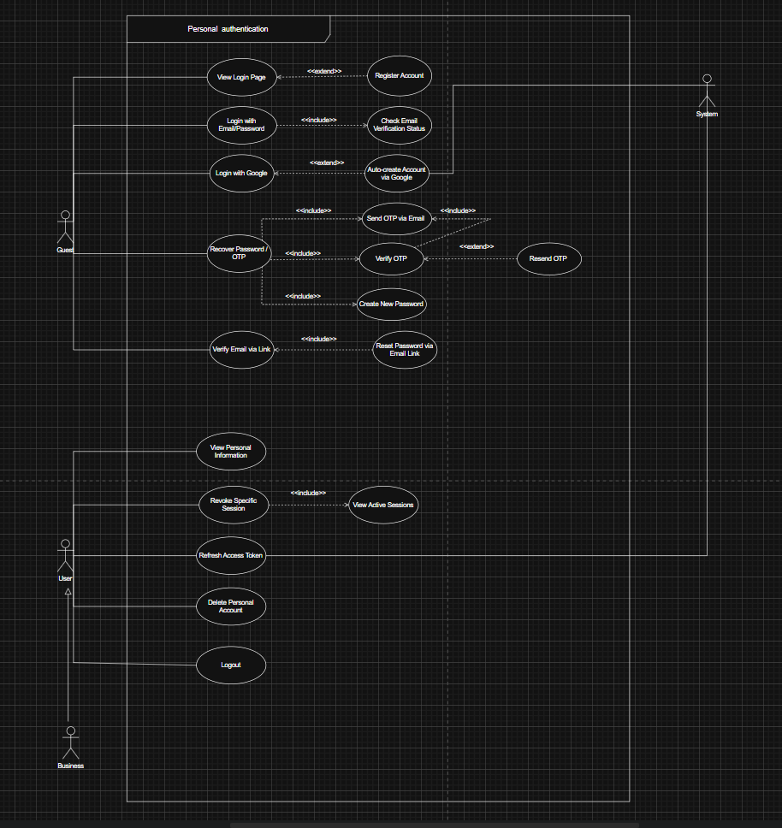

2.3.2 Business Onboarding
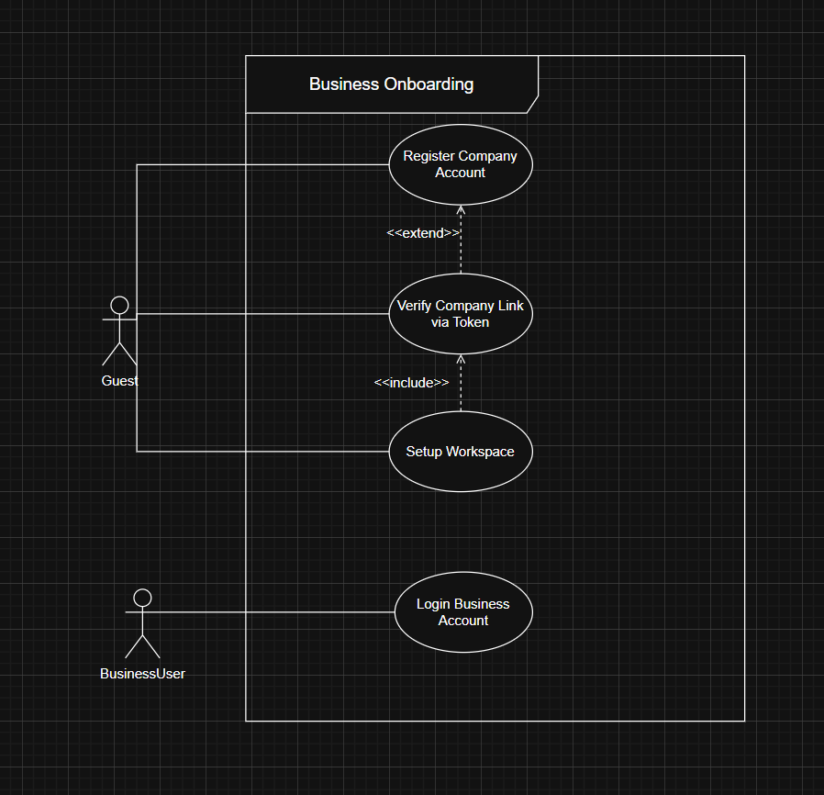

2.3.3: AI Chat
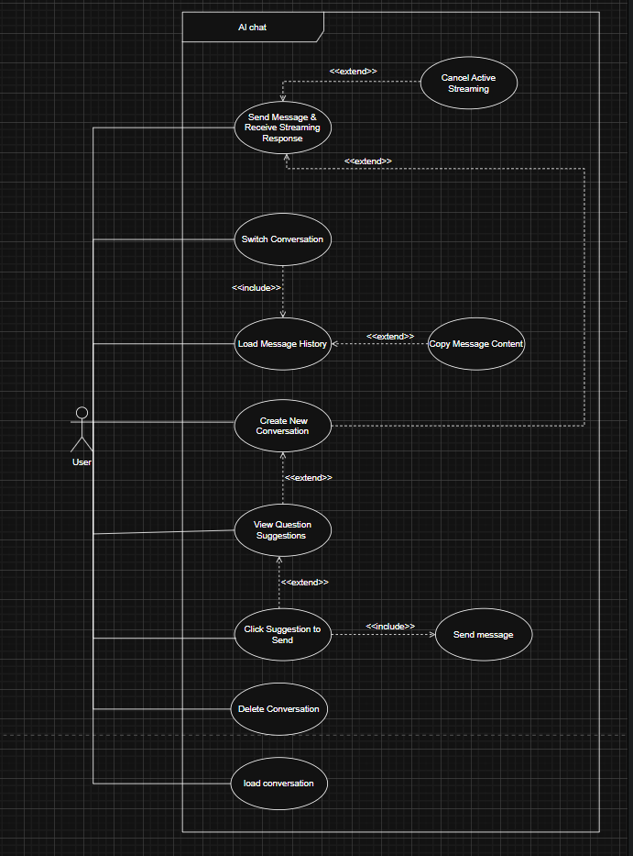

2.3.4 Admin Dashboard
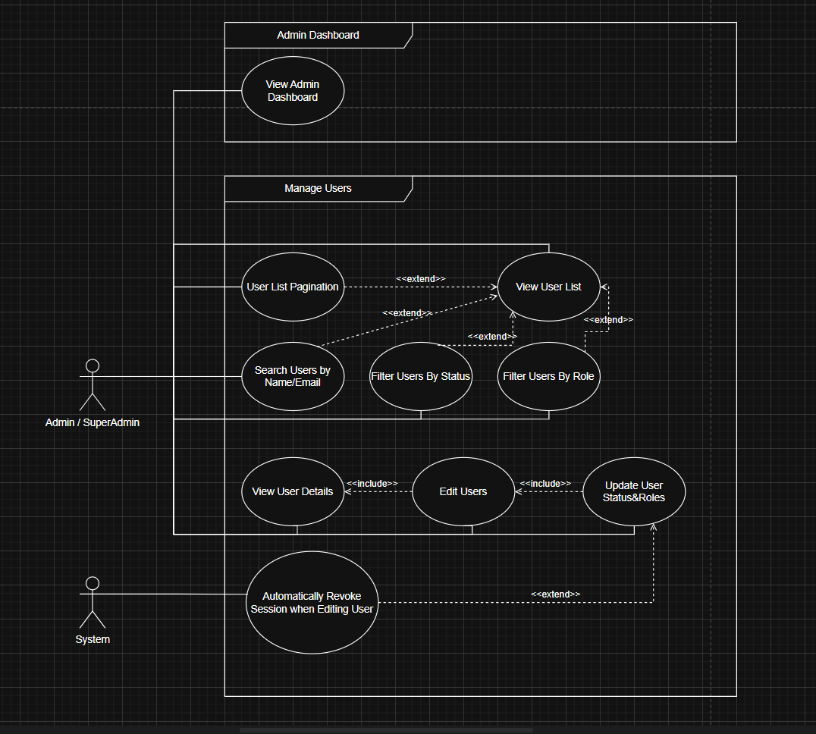

2.3.5: System Monitoring
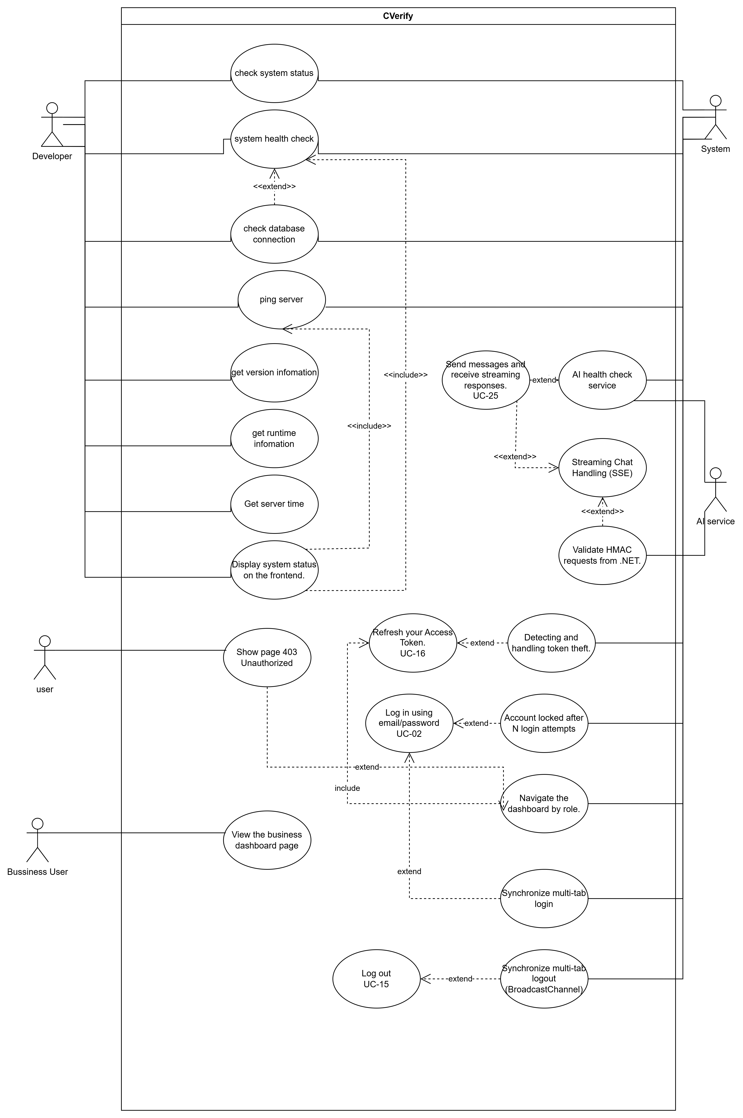

2.3.6: Email Test

2.4 Operating Environment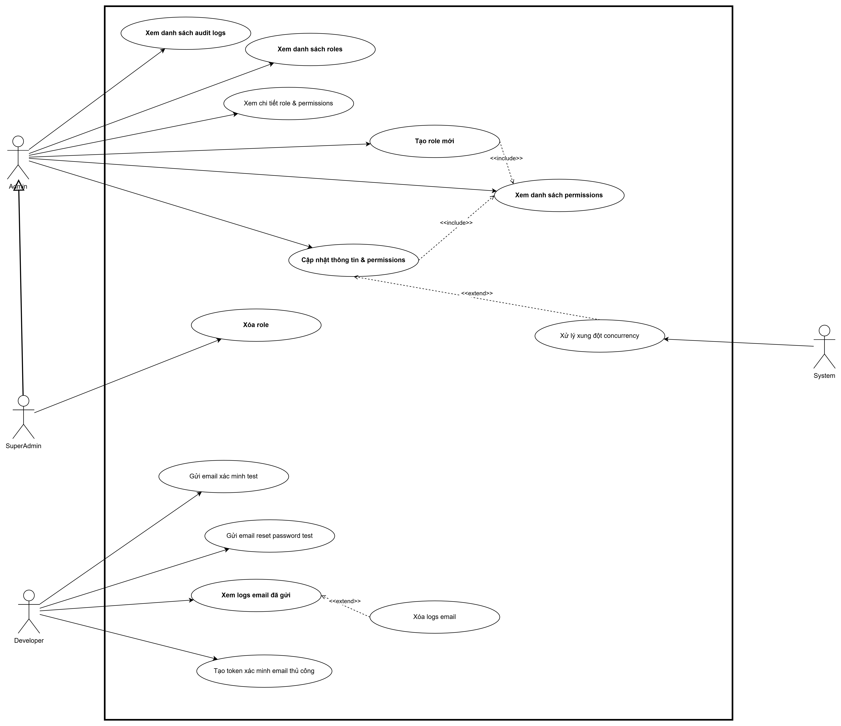

Environment | Component | Minimum Spec | Notes
Development | Local Docker Compose | 4 CPU, 8 GB RAM | PostgreSQL + pgvector + Redis + Backend + Frontend
Staging | Single VPS / EC2 t3.medium | 2 vCPU, 4 GB RAM | Mirrors production at reduced scale.
Production | AWS ECS / Azure Container Apps | 4 vCPU, 8 GB RAM min | Auto-scaling based on Hangfire queue depth.
Database | AWS RDS PostgreSQL 16 + pgvector | db.t3.medium, 100 GB SSD | Multi-AZ for high availability.
Cache | AWS ElastiCache Redis | cache.t3.micro | Single node sufficient for MVP.
Frontend CDN | Vercel (Next.js native) | Pro plan | Edge functions, automatic scaling.
Client Browser | Chrome 120+, Firefox 120+, Safari 17+, Edge 120+ | — | Mobile-first PWA; no native app required.

2.5 Design and Implementation Constraints
- [C-01] The system SHALL be implemented using the approved technology stack: Next.js 16 (Frontend), ASP.NET Core v10 (Backend), PostgreSQL 16 + pgvector (Database), Redis (Cache).
- [C-02] All AI calls SHALL be routed through a centralized Multi-model Router with circuit-breaker and fallback logic; no component SHALL call AI provider APIs directly.
- [C-03] The project SHALL be delivered within 4 sprints of 2 weeks each (8 weeks total), aligned with the SWP391 academic calendar.
- [C-04] All authentication tokens SHALL use RS256-signed JWTs. Access tokens expire in 15 minutes; refresh tokens expire in 7 days.
- [C-05] The system SHALL comply with Vietnam's Personal Data Protection Decree 13/2023/ND-CP (PDPA) for all candidate personal data.
- [C-06] AI spending SHALL be controlled via hard budget caps per environment; Redis Semantic Cache SHALL be deployed before any AI feature reaches production.
- [C-07] The frontend WCAG 2.1 AA compliance SHALL be verified before each production release.
- [C-08] All database queries involving user-supplied input SHALL use parameterized queries via Entity Framework Core – no raw SQL string concatenation is permitted.

2.6 Assumptions and Dependencies
Assumptions:
- Candidates are assumed to have at least one public GitHub repository to benefit from the Proof-of-Work analysis. Self-declared CV fields remain available as a fallback.
- Company representatives registering for Tier 1 are assumed to have a valid, active Vietnamese MST (10 or 13 digits) as defined by the General Department of Taxation.
- MST 9-digit codes (pre-2010 individual tax codes) are assumed to have been converted to CCCD by July 2025 and are not supported in this system.
- GitHub API rate limits are assumed to be managed via GitHub App authentication (15,000 requests/hour), not Personal Access Tokens.
- AI provider APIs (OpenAI, Anthropic, Google) are assumed to maintain availability of ≥ 99.5% during production operation hours.

Dependencies:
- The pgvector extension must be available on the PostgreSQL 16 instance prior to Sprint 3 delivery.
- GitHub OAuth App and GitHub App credentials must be provisioned by the team before Sprint 2 begins.
- VietQR API (api.vietqr.io) and esgoo.net MST API must remain publicly accessible for Tier 1 auto-verification to function.
- Vercel Pro plan must be active before the Sprint 4 production deployment.

3. System Features

3.1 Authentication & Account Management Module

3.1.1 Candidate Authentication (Multi-Provider)
The system SHALL support two primary authentication methods for candidates: Google OAuth 2.0 and Email/OTP. Both methods SHALL resolve to a single, unified candidate identity (1 verified email = 1 candidate account). The system SHALL support hybrid provider linking, allowing a candidate to attach both Google and Email/Password credentials to the same account at any time.

ID | Requirement Statement | Priority | Sprint
FR-01 | The system SHALL allow candidates to register and log in via Google OAuth 2.0 (Google ID token validation). Successful Google authentication SHALL mark the account email as verified instantly. | High | Sprint 1
FR-02 | The system SHALL allow candidates to register via email address. The system SHALL send a 6-digit OTP with a 15-minute TTL. The OTP endpoint SHALL return an identical response ('OTP sent') regardless of whether the email exists (anti-enumeration). | High | Sprint 1
FR-03 | The system SHALL apply email normalization prior to account creation: lowercase conversion, Gmail dot-normalization (john.doe → johndoe), and Gmail plus-tag removal (john+tag → john). Disposable email domains (temp-mail, yopmail, 10minutemail) SHALL be rejected. | High | Sprint 1
FR-04 | The system SHALL prevent duplicate account creation by auto-linking a new OAuth provider to an existing account when the normalized email matches an existing record. | High | Sprint 1
FR-05 | The system SHALL implement a password reset flow using OTP (anti-enumeration). Upon successful reset, the system SHALL revoke all active reset sessions and rotate the refresh token to force re-login on other devices. | High | Sprint 1
FR-06 | The system SHALL implement brute-force protection: OTP attempts SHALL be locked after N consecutive failures. Rate-limiting SHALL apply per IP and per email address. | High | Sprint 1

3.1.2 Enterprise Identity – Tier 1 (Auto-Verify)
Tier 1 company onboarding SHALL be completed within 5 minutes using a 3-Step Stepper Wizard with HMAC-signed step tokens to prevent step-skipping and replay attacks. Auto-verification is based on Vietnam's Tax Authority data.

ID | Requirement Statement | Priority | Sprint
FR-07 | The system SHALL validate the company's MST (10 or 13 digits, regex: ^\d{10}(-\d{3})?$) against the VietQR API. Inactive or invalid MSTs SHALL be rejected immediately. | High | Sprint 1
FR-08 | The system SHALL perform fuzzy name matching (Levenshtein similarity ≥ 80%) between the company name entered by the user and the name returned from VietQR, to prevent impersonation. | High | Sprint 1
FR-09 | The system SHALL detect duplicate company registrations by tax code or normalized company name. If a duplicate is detected, the system SHALL redirect the user to a Workspace Recovery Screen displaying only Organization Display Name and Slug (no private member data). | High | Sprint 1
FR-10 | The system SHALL issue HMAC-signed tokens at each onboarding step with an expiration timestamp and single-use flag. Step tokens SHALL be verified server-side before advancing to the next step. | High | Sprint 1
FR-11 | The system SHALL validate Organization Slugs against a reserved-terms blocklist (admin, root, api, system, cverify, support, billing, help) and SHALL detect leet-speak impersonation patterns (e.g., g00gle, faceb00k). | High | Sprint 1

3.1.3 Enterprise Identity – Tier 2 (Manual Review)
Tier 2 grants access to AI-powered recruitment features. It requires submission of legal documents and is subject to Admin review within a 1–2 business day SLA.

ID | Requirement Statement | Priority | Sprint
FR-12 | The system SHALL allow Tier 1 verified companies to initiate a Tier 2 upgrade by submitting: (a) full name and CCCD (12-digit national ID) of the legal representative, (b) a scanned business license (JPEG/PNG/PDF ≤ 10 MB), and (c) a contact phone number verified via OTP SMS. | High | Sprint 1
FR-13 | The Admin dashboard SHALL present a structured review checklist: MST match, company name match (allowing minor diacritic differences), document validity, representative identity match, and image EXIF metadata integrity check. | High | Sprint 1
FR-14 | Upon Admin approval, the system SHALL atomically update the organization's verification_level to 2 and unlock all Tier 2 features. Rejection SHALL trigger an automated notification email with a reason. | High | Sprint 1

3.2 Candidate Profile & Proof-of-Work Module

3.2.1 CV Creation and Management
ID | Requirement Statement | Priority | Sprint
FR-15 | The system SHALL provide a structured CV editor with the following sections: Personal Information, Education, Work Experience, Skills (self-declared), and Projects (manually added). All fields SHALL be validated before submission. | High | Sprint 2
FR-16 | Manually added projects SHALL be labeled 'Self-declared' (yellow badge) in all public-facing views. AI-verified projects SHALL be labeled 'Verified' (green badge). This distinction SHALL be persistent and auditable. | High | Sprint 2

3.2.2 Repository Linking (GitHub / GitLab OAuth)
ID | Requirement Statement | Priority | Sprint
FR-17 | The system SHALL allow candidates to link their GitHub account via OAuth 2.0. Upon linking, the system SHALL crawl all public repositories via the GitHub REST and GraphQL APIs using GitHub App authentication (rate limit: 15,000 requests/hour). | High | Sprint 2
FR-18 | Each repository crawl SHALL collect: commit history, lines of code, language breakdown, contributor statistics, fork status, and open-source PR contributions to upstream repositories. | High | Sprint 2
FR-19 | The system SHALL allow candidates to toggle the public/private visibility of individual repositories on their CVerify profile independently of their GitHub public/private setting. | High | Sprint 2

3.2.3 Repository Intelligence & Auto-Description
ID | Requirement Statement | Priority | Sprint
FR-20 | The system SHALL use AI Function Calling with a strict JSON Schema to generate a structured description for each repository, including: project_title, description (100–200 chars), tech_stack, primary_language, contribution_level (maintainer/contributor/forker), skills_demonstrated, and complexity_score (1–10). | High | Sprint 2
FR-21 | AI-generated descriptions SHALL be streamed to the frontend via SSE. The candidate SHALL be able to edit the AI-generated description before saving. | High | Sprint 2
FR-22 | The system SHALL compute the following repository metrics: Contribution Ratio, Code Ownership Score, Gini Coefficient of contributions, Bus Factor, Originality Score (AST similarity vs. fork date), and Activity Momentum (90-day exponential decay weighted average). | Medium | Sprint 2

3.2.4 Skill Tree Builder & AI Labeling
ID | Requirement Statement | Priority | Sprint
FR-23 | After analyzing all linked repositories and the CV, the system SHALL generate a Skill Tree for the candidate. Each skill node SHALL include: skill name, proficiency level (inferred), and evidence source (ai-inferred or self-declared). | High | Sprint 3
FR-24 | The Skill Tree SHALL be converted into a 1536-dimensional vector embedding using OpenAI text-embedding-3-large and stored in the cv_embeddings table with an HNSW index for semantic search. | High | Sprint 3

3.2.5 Trust Score & Fraud Detection
ID | Requirement Statement | Priority | Sprint
FR-25 | The system SHALL compute a Trust Score (0–100) for each candidate profile. The score SHALL decrease when any of the following fraud signals are detected: forked repository presented as original (AST similarity check), skill claimed in CV not present in repository code, sudden commit burst anomaly (IQR method), or generic/boilerplate project (LLM-based assessment). | High | Sprint 4
FR-26 | Flagged repositories SHALL display one of the following labels visible to recruiters: 'Forked – Low Originality', 'Unusual Activity Pattern', or 'Tutorial/Boilerplate'. | High | Sprint 4

3.3 Job Search & Recommendation Module

3.3.1 Semantic Job Search
ID | Requirement Statement | Priority | Sprint
FR-27 | The system SHALL provide a job search interface that combines semantic vector search (pgvector cosine similarity via HNSW) with structured filters: location, salary range, seniority level (Intern/Fresher/Junior/Senior/Master), and tech stack tags. | High | Sprint 3
FR-28 | Semantic search queries SHALL be embedded using text-embedding-3-large and matched against jd_embedding vectors in the job_posts table. Query latency SHALL be < 200ms end-to-end at the P95 percentile. | High | Sprint 3

3.3.2 Gap Analysis (Candidate vs. JD)
ID | Requirement Statement | Priority | Sprint
FR-29 | When a candidate views a specific JD, the system SHALL perform a real-time AI Gap Analysis comparing the candidate's Skill Tree against the JD requirements. The output SHALL list: matched skills (with confidence), missing skills, and a recommended learning roadmap. | High | Sprint 3
FR-30 | Gap Analysis results SHALL be streamed to the frontend via SSE. The response SHALL complete within 10 seconds for 95% of requests under normal load. | Medium | Sprint 3

3.3.3 Active Window Credit Model
ID | Requirement Statement | Priority | Sprint
FR-31 | The system SHALL implement three candidate visibility tiers: HIDDEN (default; not discoverable), PASSIVE (free; appears in organic recruiter keyword search but not in AI auto-recommend), and ACTIVE (credit-purchased; appears in AI auto-recommend with a badge showing remaining days). | High | Sprint 4
FR-32 | The system SHALL offer Active Window purchase options of 1, 3, 7, 15, and 30 days at non-linear credit pricing (urgency premium for shorter windows, commitment discount for longer windows). | High | Sprint 4
FR-33 | The system SHALL support early window cancellation with a pro-rated credit refund (rounded to whole days). Refunded credits SHALL be returned to the candidate's wallet for future use. | High | Sprint 4
FR-34 | The system SHALL support opt-in auto-renewal. The system SHALL deduct credits and renew the window 24 hours before expiry. If insufficient credits exist, the system SHALL send an email notification and allow the window to expire normally. | Medium | Sprint 4
FR-35 | A Hangfire background job SHALL run every minute to identify expired Active Windows and transition the candidate's visibility_mode from 'active' to 'passive'. The job SHALL be idempotent. | High | Sprint 4

3.4 Enterprise Recruitment Module

3.4.1 Job Description (JD) Management
ID | Requirement Statement | Priority | Sprint
FR-36 | Tier 1 and Tier 2 companies SHALL be able to create a JD with the following structured fields: title, full description (text/PDF/Word upload), required tech stack tags, seniority level, location, and salary range. | High | Sprint 2
FR-37 | Upon JD submission, the system SHALL trigger an AI pipeline: (1) extract structured requirements via LLM Function Calling, (2) embed the JD using text-embedding-3-large, (3) store jd_embedding in the job_posts table. | High | Sprint 3

3.4.2 Manual Recruitment – Tier 1
ID | Requirement Statement | Priority | Sprint
FR-38 | Tier 1 companies SHALL have access to a recruitment pipeline dashboard showing candidates who have applied to their JDs. The pipeline SHALL support status transitions: Pending → Reviewing → Interview → Accepted / Rejected. | High | Sprint 2
FR-39 | Tier 1 companies SHALL be able to view a candidate's full CV, Skill Tree, and Proof-of-Work indicators (repository metrics, Trust Score). | High | Sprint 2

3.4.3 AI-Powered Recruitment – Tier 2
ID | Requirement Statement | Priority | Sprint
FR-40 | When a Tier 2 company posts a JD, the system SHALL automatically scan the Active Candidate Pool (candidates with visibility_mode = 'active') using HNSW nearest-neighbor search and return the top-K candidates with an overall match score ≥ 75%. | High | Sprint 3
FR-41 | The system SHALL send a real-time SignalR notification to the recruiter when new matching candidates are found. The notification SHALL include a preview card with the candidate's name (masked), ATS score, and top matching skills. | Medium | Sprint 4
FR-42 | A daily AI Digest email SHALL be sent each morning to Tier 2 recruiters listing the top-5 new candidate matches for each of their open JDs, including a brief explainability summary per candidate. | Medium | Sprint 4

3.4.4 AI Candidate Ranking (8-Factor ATS Score)
The ATS Score (0–100) is a weighted composite computed from 8 factors. Recruiter-adjustable weights are supported in the Tier 2 dashboard.

Factor | Description | Data Source | Default Weight
Skills Matching | Cosine similarity between candidate skill vector and JD requirements. | pgvector (HNSW) | 25%
GitHub Activity | Commit frequency, streak, contribution diversity. | GitHub API stats | 20%
Experience Matching | Years of experience + role alignment. | CV fields + repo history | 15%
Project Relevance | LLM-scored relevance of portfolio projects to JD domain. | LLM similarity scoring | 15%
Open Source Contribution | PRs merged into external repos, issues resolved. | GitHub API + web search | 10%
Education | Degree level, major, institution. | CV + verification | 5%
Tech Stack Similarity | Overlap between candidate tech stack and JD stack. | Exact + semantic match | 5%
Skill Profile Similarity | Full profile vector similarity. | pgvector full embed | 5%

ID | Requirement Statement | Priority | Sprint
FR-43 | The system SHALL compute the 8-factor ATS Score for every candidate-JD pairing. All 8 factor scores and their weights SHALL be stored in the applications.ranking_factors JSONB column for audit and explainability purposes. | High | Sprint 3
FR-44 | Tier 2 recruiters SHALL be able to adjust the weight of each of the 8 ranking factors within the dashboard. The sum of all weights SHALL always equal 100%. The ATS score SHALL be recalculated live upon weight adjustment. | Medium | Sprint 4

3.4.5 Explainability Report
ID | Requirement Statement | Priority | Sprint
FR-45 | Each candidate-JD ranking SHALL include an AI-generated Explainability Report (3–5 sentences) describing the key reasons for the candidate's rank, explicitly citing strong and weak dimensions (e.g., 'Strong React and TypeScript match via 12 verified repos; missing Docker and Kubernetes experience required by the JD.'). | High | Sprint 4

3.4.6 Hybrid Credit Anti-Harvesting System
The credit system applies to recruiter actions to deter bulk data harvesting through economic deterrence. Subscription plans include a monthly credit allowance; additional credits may be purchased via top-up packages.

Recruiter Action | Credit Cost | ~VND Equivalent | Rationale
Basic text search | 0c (Free) | — | Baseline feature; low data sensitivity.
AI Semantic Search (1 query, returns 20 names) | 10c | ~2,000 VND | Returns valuable ranked data.
View profile summary card | 2c | ~400 VND | General info; low sensitivity.
View full CV + Skill Tree | 8c | ~1,600 VND | Detailed profile; high sensitivity.
AI Recommend batch (top-20 for 1 JD) | 35c | ~7,000 VND | Highest value bundle.
Reveal contact info (phone/email) | 30c | ~6,000 VND | Most sensitive; limited to 5/day/account.
Save candidate to pipeline | 3c | ~600 VND | Creates durable link.
AI Gap Analysis (candidate vs. JD) | 5c | ~1,000 VND | Insight; no raw data exposure.

ID | Requirement Statement | Priority | Sprint
FR-46 | The system SHALL deduct credits from the recruiter's wallet for each billable action in real-time. If the wallet balance is insufficient, the action SHALL be blocked and the recruiter SHALL be prompted to top up. | High | Sprint 4
FR-47 | The system SHALL enforce a hard daily cap of 5 contact reveals per account per day, regardless of credit balance, to prevent burst harvesting of contact information. | High | Sprint 4
FR-48 | The system SHALL embed invisible Unicode zero-width character watermarks unique to each recruiter×candidate pair in all exported profile text, to enable forensic tracking if data is leaked outside the platform. | Medium | Sprint 4

3.5 Admin Management Module
ID | Requirement Statement | Priority | Sprint
FR-49 | The Admin dashboard SHALL display all pending Tier 2 company upgrade requests with a structured checklist UI. Admin SHALL be able to approve or reject each request with a mandatory reason field. | High | Sprint 1
FR-50 | The Admin dashboard SHALL display AI usage analytics: tokens consumed per model per day, cost per request, cache hit rate, and total AI spend to date. | Medium | Sprint 4
FR-51 | The Admin SHALL be able to configure AI model routing rules (primary model per task type, fallback model, circuit-breaker thresholds) via the dashboard without a code deployment. | Medium | Sprint 4
FR-52 | The system SHALL surface fraud alerts to the Admin dashboard when Trust Score anomalies are detected (e.g., Trust Score drops below 40, or honeypot profile viewed > 5 times/week by a single recruiter). | High | Sprint 4

4. Data Requirements

4.1 Logical Data Model
The CVerify data model is implemented in PostgreSQL 16. The pgvector extension adds HNSW-indexed vector columns for semantic search. Core entity relationships are as follows:
- users (1) ──< (many) auth_providers: Each user may have multiple authentication providers (Google, password, future: GitHub, LinkedIn, Passkey).
- users (1) ──── (1) candidate_profiles: One-to-one profile record per Job Seeker.
- candidate_profiles (1) ──── (1) cv_embeddings: Stores the 1536-dimensional vector of the full candidate profile.
- candidate_profiles (1) ──< (many) repositories: Multiple linked GitHub/GitLab repos per candidate.
- organizations (1) ──< (many) organization_members: Multiple HR/Recruiter users per company workspace.
- organizations (1) ──< (many) job_posts: Multiple active JDs per company.
- job_posts (1) ──< (many) applications: Many candidates can apply to one JD.
- applications stores the ATS Score breakdown (ranking_factors JSONB) and pipeline status enum.

*ERD Diagram
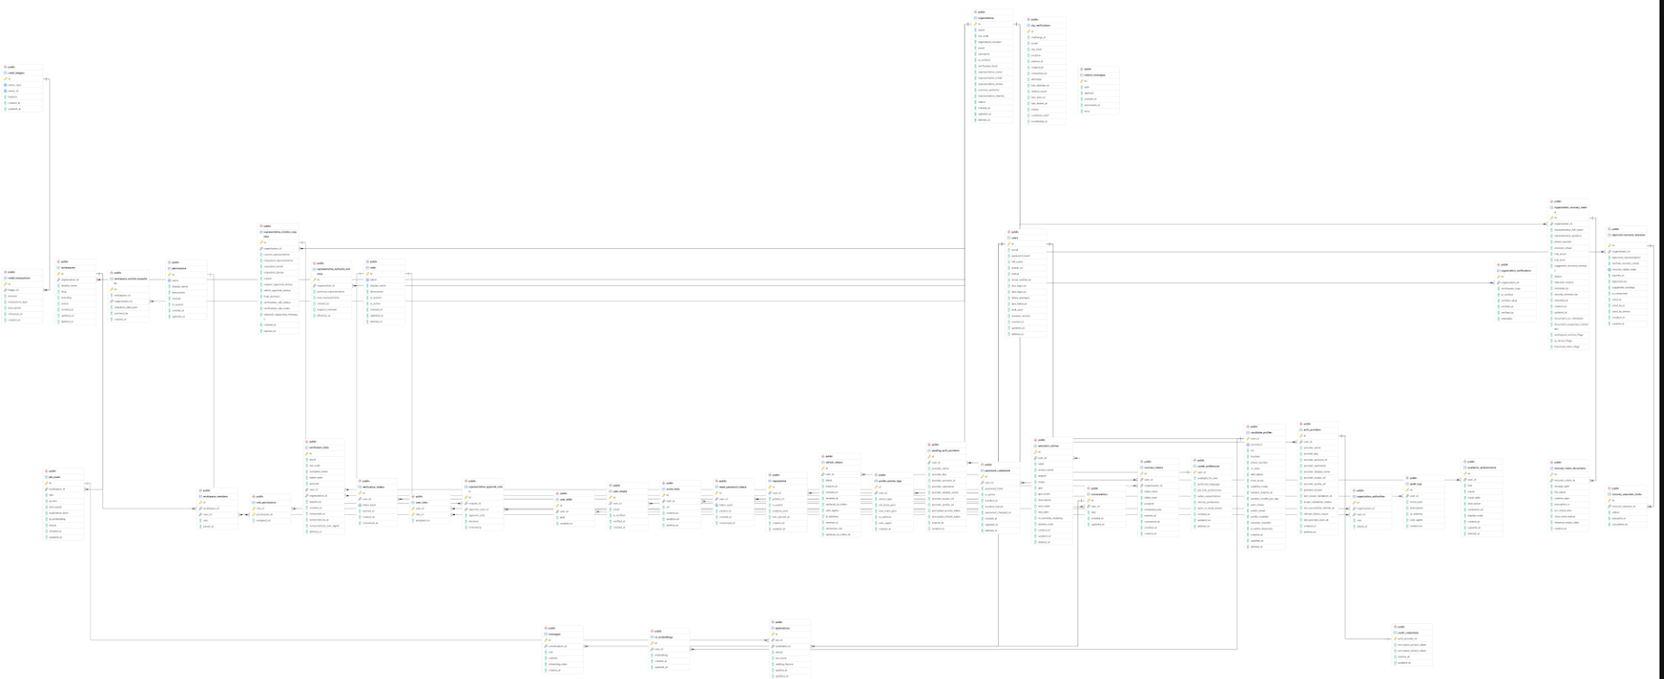

4.2 Data Dictionary – Core Entities
Column | Type | Constraints | Description
users |  |  | Identity table. Normalized email is the primary identity key.
id | UUID | PK | System-generated unique identifier.
email | VARCHAR | UNIQUE, NOT NULL | Normalized email (lowercase, Gmail dot/plus removed). Primary login identity.
email_verified | BOOLEAN | DEFAULT false | Set to true after OTP verification or Google OAuth login.
role | ENUM | NOT NULL | 'job_seeker' | 'recruiter' | 'admin'
auth_providers |  |  | Multi-provider auth table. Unique constraint: (user_id, provider_type).
provider_type | ENUM | NOT NULL | 'google' | 'password' | 'github' | 'linkedin' | 'passkey'
password_hash | VARCHAR | NULLABLE | BCrypt hash (cost 12). NULL for non-password providers.
provider_metadata | JSONB | NULLABLE | OAuth access/refresh tokens and extra claims from the provider.
candidate_profiles |  |  | Extended candidate profile. cv_data is a flexible JSONB column.
cv_data | JSONB | NOT NULL | Full structured CV: education, experience, skills, manually declared projects.
skill_labels | TEXT[] | NULLABLE | AI-generated skill tag array from Skill Tree Builder.
trust_score | NUMERIC(5,2) | DEFAULT 100 | Fraud-adjusted trust score (0–100). Updated on each repo sync.
visibility_mode | VARCHAR(10) | CHECK IN ('hidden','passive','active') | Candidate discoverability tier for the AI recommendation engine.
window_expires_at | TIMESTAMPTZ | NULLABLE | Expiry timestamp of the active visibility window. NULL if not active.
cv_embeddings |  |  | Primary vector table for semantic candidate search. HNSW index: m=16, ef_construction=64.
embedding | vector(1536) | NOT NULL | Candidate profile embedding (OpenAI text-embedding-3-large). HNSW cosine index.
job_posts |  |  | JD table. Both text and vector are stored to support reverse matching.
jd_text | TEXT | NOT NULL | Full job description text.
jd_embedding | vector(1536) | NOT NULL | JD embedding for reverse matching (candidate searches for jobs). HNSW cosine index.
applications |  |  | Junction table between job_posts and candidate_profiles.
status | ENUM | NOT NULL | 'pending' | 'reviewing' | 'interview' | 'accepted' | 'rejected'
ranking_factors | JSONB | NOT NULL | Breakdown of all 8 ATS factor scores and weights. Used for Explainability Report.

4.3 Vector Embedding & Semantic Search Architecture
The system uses pgvector with Hierarchical Navigable Small World (HNSW) indexing for approximate nearest-neighbor search. HNSW is configured with m=16 and ef_construction=64, providing ~97% recall at sub-8ms P99 query latency for datasets up to 5 million vectors. Redis Semantic Cache reduces AI embedding costs by caching responses to semantically similar queries (cosine similarity > 0.95), with TTLs of 1 hour for JD analysis and 24 hours for repository descriptions.

5. External Interface Requirements

5.1 User Interfaces
- The frontend SHALL be built with Next.js 16 (App Router), HeroUI v3 component library, and Tailwind CSS v4 (OKLCH color space). All pages SHALL follow a mobile-first responsive design with breakpoints at sm/md/lg/xl as defined by Tailwind v4.
- AI-generated streaming content (repository descriptions, Gap Analysis, Explainability Reports) SHALL be rendered incrementally in the UI as SSE tokens arrive, with a visible streaming indicator (e.g., a blinking cursor or spinner).
- The Active Window credit balance SHALL be displayed persistently in the candidate navigation bar and updated in real-time after each purchase or expiry event.
- The Admin dashboard SHALL display Tier 2 review requests in a sortable queue with a structured checklist UI. No raw document uploads SHALL be viewable without Admin session authentication.

*Figma: https://stitch.withgoogle.com/projects/15595109852778882620

5.2 Hardware Interfaces
CVerify is a cloud-native web application. No dedicated hardware interfaces are required beyond standard web browser capabilities (camera/microphone access is not needed in v1.0). The system relies on the hosting infrastructure specified in Section 2.4.

5.3 Software Interfaces (Third-Party APIs)
External System | Purpose | Protocol / Auth | Failure Handling
GitHub REST API v3 | Repository crawl, contributor stats, commit history. | GitHub App token (15K req/hr) | Exponential backoff on 429; queue-based crawler.
GitHub GraphQL API v4 | Batch repository metadata fetch. | GitHub App token | Fallback to REST API if GraphQL fails.
GitHub Webhooks | Receive push events to trigger repo re-analysis. | Webhook secret validation (HMAC-SHA256) | Re-sync job queued on next scheduled run.
Google OAuth 2.0 | Candidate social authentication. | OAuth 2.0 / OIDC (verify aud, exp claims) | Fallback to email/OTP flow.
OpenAI API (GPT-4.1 / text-embedding-3-large) | JD analysis (Function Calling), embeddings, Gap Analysis. | Bearer token / Azure Key Vault | Circuit breaker; switch to Claude Sonnet 4 after 3 consecutive failures.
Anthropic Claude API (Claude Sonnet 4) | Skill Tree inference, complex reasoning. | Bearer token / Azure Key Vault | Fallback to GPT-4.1.
Google Gemini API (Gemini 2.5 Flash) | High-throughput repo description generation. | API key / Secret Manager | Fallback to GPT-4.1 mini.
esgoo.net MST API / VietQR API | Tier 1 company MST auto-verification. | HTTPS GET (public / API key) | Cascade to secondary; reject registration if all sources fail (TBD: manual admin review).

5.4 Communication Interfaces
- All client-server communication SHALL use HTTPS (TLS 1.3 minimum). HTTP connections SHALL be redirected to HTTPS via HSTS headers.
- AI streaming responses SHALL be delivered via Server-Sent Events (SSE) over HTTP/2. The SSE endpoint SHALL support reconnect logic with Last-Event-ID.
- Real-time notifications (new candidate applied, new AI match found) SHALL be delivered via ASP.NET Core SignalR over WebSocket, with Long Polling as a fallback.
- Background jobs (repository sync, embedding refresh, ATS recalculation, email dispatch) SHALL use Hangfire with PostgreSQL as the persistent job queue.
- Outbound email (OTP, notification, daily digest) SHALL be sent via a transactional email provider (SMTP/API) using SPF/DKIM/DMARC-authenticated domains.

6. Quality Attributes

6.1 Performance Requirements
ID | Requirement Statement | Metric / Target | Priority
NFR-01 | The system SHALL achieve Core Web Vitals targets: LCP < 2.5s, FID < 100ms, CLS < 0.1 on the candidate and recruiter dashboards. | Core Web Vitals (Google Lighthouse ≥ 90) | High
NFR-02 | The system SHALL respond to semantic candidate search queries within 200ms at P95 under a load of 500 concurrent users. | P95 ≤ 200ms @ 500 CU | High
NFR-03 | pgvector HNSW index queries SHALL complete in under 10ms P99 for a dataset of up to 1 million candidate vectors. | P99 ≤ 10ms @ 1M vectors | High
NFR-04 | SSE streaming token delivery from AI provider to frontend SHALL exhibit a UI update latency of less than 50ms per token received. | UI update ≤ 50ms/token | Medium
NFR-05 | The initial JavaScript bundle size SHALL not exceed 250 KB (gzipped) for the critical path. Lazy loading SHALL be applied to all AI-feature modules. | Bundle ≤ 250 KB gzip | Medium
NFR-06 | Redis Semantic Cache SHALL achieve a minimum cache hit rate of 40% for AI calls within the first month of production operation. | Cache hit rate ≥ 40% | Medium

6.2 Security Requirements
ID | Requirement Statement | Metric / Target | Priority
NFR-07 | All API endpoints accepting user input SHALL enforce FluentValidation rules. No raw user input SHALL reach the database layer without validation. | 0 unvalidated inputs | High
NFR-08 | All database queries involving user-supplied parameters SHALL use EF Core parameterized queries. Raw SQL string concatenation is prohibited. | 0 raw SQL with user input | High
NFR-09 | The system SHALL implement OWASP Top 10 mitigations including CSRF tokens (SameSite cookie), Content Security Policy headers, X-Frame-Options, and HSTS. | OWASP ZAP: 0 Critical findings on staging | High
NFR-10 | All API keys and secrets SHALL be stored in Azure Key Vault or AWS Secrets Manager. No secrets SHALL be committed to version control or logged. | 0 secrets in code/logs | High
NFR-11 | Refresh token rotation SHALL be enforced: each use of a refresh token SHALL issue a new token and invalidate the old one. | Token rotation on every use | High
NFR-12 | AI-generated content displayed in the frontend SHALL be sanitized with DOMPurify before DOM insertion to prevent XSS via model output injection. | 0 XSS via AI content | High

6.3 Reliability and Availability
ID | Requirement Statement | Metric / Target | Priority
NFR-13 | The production environment SHALL target 99.5% uptime (< 3.6 hours downtime/month), excluding scheduled maintenance windows. | Uptime ≥ 99.5% | High
NFR-14 | All Hangfire background jobs SHALL implement retry logic with exponential backoff (max 3 retries). Failed jobs SHALL be moved to a dead-letter queue and surfaced in the Admin dashboard. | Max 3 retries; dead-letter alert | High
NFR-15 | The AI Multi-model Router SHALL implement a circuit-breaker pattern: if a primary AI provider fails 3 consecutive times within a 60-second window, the router SHALL automatically switch to the configured fallback model. | Circuit breaker: 3 failures / 60s | High

6.4 Maintainability and Scalability
ID | Requirement Statement | Metric / Target | Priority
NFR-16 | Unit test coverage SHALL achieve ≥ 80% line coverage for backend business logic and AI parsers (xUnit), and ≥ 80% for frontend utilities (Jest). | ≥ 80% line coverage | High
NFR-17 | Integration test coverage SHALL achieve ≥ 60% of API endpoints verified via xUnit + TestContainers. | ≥ 60% endpoint coverage | Medium
NFR-18 | The system SHALL support horizontal scaling of the backend API tier via stateless JWT authentication and externalized session state in Redis. | Stateless API (0 server-side session) | High
NFR-19 | The pgvector HNSW index SHALL support parallel index building to reduce re-indexing time by approximately 60% compared to sequential build, using PostgreSQL 16 parallel worker configuration. | ~60% build time reduction | Medium

6.5 Accessibility
ID | Requirement Statement | Metric / Target | Priority
NFR-20 | The frontend SHALL comply with WCAG 2.1 Level AA for all interactive elements, including AI streaming output containers. | WCAG 2.1 AA (automated + manual audit) | High
NFR-21 | All interactive elements SHALL be fully keyboard-navigable (Tab, Enter, Escape, Arrow keys). Focus indicators SHALL be visible and meet WCAG 2.1 SC 2.4.7. | Full keyboard coverage | High
NFR-22 | All text elements SHALL maintain a color contrast ratio of ≥ 4.5:1 for normal text and ≥ 3:1 for large text (≥ 18pt or ≥ 14pt bold), consistent with WCAG 2.1 SC 1.4.3. | Contrast ≥ 4.5:1 (normal text) | High

7. Internationalization and Localization

- The v1.0 release SHALL support two languages: English (default) and Vietnamese. Language selection SHALL be persisted per user account.
- All date and time values SHALL be stored in UTC in the database and converted to the user's local timezone for display, using the browser's Intl API on the frontend.
- Currency values displayed in the platform (credit pricing, subscription pricing) SHALL be shown in Vietnamese Dong (VND) for the v1.0 release, targeting the Vietnamese market.
- Vietnamese company verification workflows (MST, CCCD, business license) are specific to the Vietnamese regulatory environment. International company verification is designated as a future release feature.
- All AI-generated text output (repository descriptions, Skill Tree labels, Explainability Reports) SHALL be generated in English in v1.0. Vietnamese language AI output is targeted for v1.5.

8. Other Requirements

8.1 Legal and Regulatory Compliance
- The system SHALL comply with Vietnam's Personal Data Protection Decree 13/2023/ND-CP (PDPA). Candidate personal data (name, email, CCCD, contact info) SHALL not be exposed to recruiters beyond what is explicitly permitted by the candidate's visibility settings and the credit access model.
- Contact information (phone number, personal email) SHALL only be revealed to a recruiter after the recruiter spends the designated credit amount (30c), ensuring explicit transactional consent for each data access event.
- The system SHALL maintain a full audit log of all data access events (profile views, contact reveals, AI searches) with timestamps and actor identities. Audit logs SHALL be retained for a minimum of 12 months.
- Candidate data deletion requests SHALL be honored within 72 hours. Deletion SHALL cascade to cv_embeddings, repositories, applications, and auth_providers tables. Anonymized aggregate analytics data may be retained.
- The system SHALL not transfer candidate personal data outside Vietnam's jurisdiction without explicit candidate consent, except where required by integrated third-party services (e.g., AI API providers) under their data processing agreements.

8.2 Licensing
- The CVerify codebase is developed as an academic project under FPT University's SWP391 course. All intellectual property rights belong to the CVerify development team.
- Third-party open-source libraries used in the project must carry OSI-approved licenses (MIT, Apache 2.0, BSD). Any GPL-licensed dependencies must be reviewed and approved by the team lead before inclusion.
- AI model usage is subject to the terms of service of OpenAI, Anthropic, and Google. Generated outputs may not be used to train competing AI models without explicit provider permission.

Appendix A: Glossary

Term | Definition
ATS Score | Applicant Tracking System Score: the 8-factor weighted AI ranking score (0–100) computed for each candidate-JD pairing.
Bus Factor | The minimum number of contributors required to cover 50% of commits in a repository. A Bus Factor of 1 indicates a single point of failure.
Claim-Based CV | A traditional resume where all information (skills, experience, projects) is self-reported by the candidate without independent verification.
Credit | The in-platform currency unit used by both candidates (for Active Windows) and recruiters (for accessing candidate data). ~200 VND per credit.
Evidence-Based Profile | A CVerify candidate profile where skills and experience are derived from verifiable Proof-of-Work (repository activity) rather than self-declaration.
HNSW | Hierarchical Navigable Small World: a graph-based approximate nearest-neighbor index algorithm used in pgvector for fast vector similarity search.
JD | Job Description: a structured posting created by a recruiter describing a role's requirements, tech stack, and seniority level.
MST | Mã số thuế (Vietnamese Tax Code): the official legal identifier for Vietnamese enterprises, issued by the General Department of Taxation (GDT). Format: 10 or 13 digits.
Multi-model Router | The CVerify AI Orchestration layer that selects the optimal AI provider (GPT-4.1, Claude Sonnet 4, Gemini 2.5 Flash) per task type based on quality, cost, and availability.
Originality Score | A computed metric (AST similarity + commit timestamp analysis) indicating whether a repository is an original work or a fork/copy of another project.
Passive Visibility | A free candidate visibility tier where the candidate's profile appears in recruiter keyword search results but is excluded from AI auto-recommendation.
pgvector | An open-source PostgreSQL extension that adds support for vector data types and HNSW/IVFFlat approximate nearest-neighbor index algorithms.
PoW (Proof-of-Work) | In CVerify context: verifiable evidence of a candidate's coding activity, derived from GitHub/GitLab repository data (commits, contributions, ownership metrics).
Semantic Cache | A Redis-based caching strategy that stores AI responses keyed by embedding similarity (cosine > 0.95) rather than exact string matching, reducing redundant AI API calls.
Skill Tree | A structured, AI-generated graph of a candidate's technical competencies, where each node includes skill name, inferred proficiency level, and evidence source.
SSE (Server-Sent Events) | A one-directional HTTP streaming protocol used to push AI-generated tokens from the backend to the frontend in real-time.
Trust Score | A computed candidate integrity metric (0–100) that decreases when fraud signals are detected: forked repositories, commit bursts, skill-code mismatches, or boilerplate projects.
Active Window | A time-limited visibility tier purchased by a candidate using credits, enabling AI auto-recommendation and displaying a badge showing remaining days to recruiters.
Workspace Recovery Screen | A UI screen shown when a duplicate company registration is detected. Displays only Organization Name and Slug; no private member data is exposed.

Appendix B: AI Model Routing Strategy

AI Task | Primary Model | Fallback Model | Selection Rationale
JD Analysis & Structured Extraction | GPT-4.1 (Function Calling) | Claude Sonnet 4 | Best strict JSON output and structured field accuracy.
Repository Auto-Description Generation | Gemini 2.5 Flash | GPT-4.1 mini | High throughput, low cost, smooth streaming.
Skill Tree Inference | Claude Sonnet 4 | GPT-4.1 | Superior complex reasoning; 200K context window for large codebases.
Semantic Embedding Generation | text-embedding-3-large (1536d) | Gemini text-embedding-005 | State-of-the-art MTEB score; native pgvector support.
Gap Analysis | GPT-4.1 | Claude Sonnet 4 | High-quality recommendations with structured reasoning.
Trust Score / Fraud Detection | Fine-tuned classifier | GPT-4.1 (few-shot) | Pattern detection in commit history at low latency.

Circuit-Breaker Policy: If a primary model returns errors on 3 consecutive requests within a 60-second sliding window, the Multi-model Router SHALL automatically switch to the fallback model and alert the Admin dashboard. The primary model is retried after a 5-minute cool-down period.

Appendix C: Implementation Roadmap & Risk Matrix

Sprint Plan
Sprint | Timeline | Key Deliverables | AI Features Delivered
Sprint 1 | Weeks 1–2 | Multi-provider auth system, user roles, company onboarding (Tier 1 & 2), basic CV CRUD, database schema, CI/CD pipeline. | Email OTP verification; MST auto-verify workflow.
Sprint 2 | Weeks 3–4 | GitHub OAuth integration, repository crawler, basic skill extraction, JD CRUD, Tier 1 recruiter pipeline dashboard. | Repository Intelligence; AI auto-description via Function Calling.
Sprint 3 | Weeks 5–6 | pgvector setup, cv_embeddings pipeline, semantic search, ATS scoring engine, Gap Analysis endpoint, reverse JD matching. | Embedding pipeline; HNSW index; 8-factor ATS ranking; Gap Analysis streaming.
Sprint 4 | Weeks 7–8 | Active Window credit system, Hybrid Credit anti-harvesting, Admin dashboard (AI analytics + Tier 2 review), load testing, production deployment. | AI streaming UX; Redis Semantic Cache; Fraud Detection; Explainability Reports; Daily AI Digest.

Risk Matrix
Risk | Probability | Impact | Mitigation Strategy
GitHub API rate limit exceeded during bulk crawl. | High | High | Use GitHub App authentication (15K req/hr); queue-based crawler with exponential backoff; cache repo metadata for 24 hours.
AI API costs exceed project budget. | Medium | High | Deploy Redis Semantic Cache before any AI feature reaches production; implement hard spending caps per environment; use Gemini 2.5 Flash for high-volume tasks.
pgvector query latency degrades at scale. | Low | Medium | Tune HNSW parameters (m=16, ef_construction=64); implement connection pooling; add read replica for search queries.
LLM output inconsistency / hallucination in structured fields. | Medium | Medium | Enforce strict JSON Schema via Function Calling; add Zod validation on frontend; implement retry logic with exponential backoff on schema validation failure.
VietQR / esgoo.net MST API unavailability. | Low | Medium | Cascade to secondary API source; if all sources fail, queue registration for manual Admin review rather than rejecting immediately.
Candidates misunderstand Trust Score labels. | Medium | Low | Provide inline tooltip explanations for each fraud label; include a Trust Score FAQ page; allow candidates to contest flags via support ticket.
Sprint timeline overrun due to AI integration complexity. | Medium | High | Prioritize AI features as independent sprint items; mock AI responses in earlier sprints for UI development parallelism; designate a technical lead per AI module.

— End of Document —
CVerify SRS v1.0 | FPT University SWP391 | May 2026 | Confidential

