SOFTWARE REQUIREMENTS SPECIFICATION (SRS)
RESTAURANT MANAGEMENT SYSTEM (RMS)

7.1 Use Case List

A. Customer Functions
- UC01 View Menu
- UC02 Search Food
- UC03 Filter Food By Category
- UC04 View Food Detail
- UC05 Add Food To Cart
- UC06 Update Cart
- UC07 Remove Food From Cart
- UC08 Apply Coupon
- UC09 Place Order
- UC10 Cancel Order
- UC11 Track Order Status
- UC12 View Order History
- UC13 Reorder Previous Order
- UC14 Make Online Payment
- UC15 Reserve Table
- UC16 Cancel Reservation
- UC17 View Reservation History
- UC18 Review Food
- UC19 Review Restaurant
- UC20 Chat With Restaurant
- UC21 Chat With AI Chatbot
- UC22 Get Food Recommendation
- UC23 View Personalized Suggestions

B. Staff Functions
- UC24 View Table Status
- UC25 Configure Tables
- UC26 Update Table Status
- UC27 Create Order
- UC28 Update Order Status
- UC29 Transfer Table
- UC30 Print Invoice
- UC31 Confirm Payment
- UC32 View Reservation Requests
- UC33 Provide Customer Support

C. Kitchen Staff Functions
- UC34 View Cooking Orders
- UC35 Update Food Status
- UC36 View Order Details
- UC37 Cancel Cooking Order
- UC38 Predict Cooking Time
- UC39 Accept Cooking Order

D. Admin Functions
- UC40 View Customer Information
- UC41 Maintain Employee Records
- UC42 Assign Roles And Permissions
- UC43 Update Food Menu
- UC44 Upload Food Images
- UC45 Configure Coupons
- UC46 View Revenue Reports
- UC47 View Dashboard Statistics
- UC48 View Best Selling Foods
- UC49 View Customer Feedback

E. Advanced Features
- UC50 Access QR Menu
- UC51 Make QR Payment
- UC52 Receive Email Notification
- UC53 Export Invoice PDF

8. Use Case Diagram

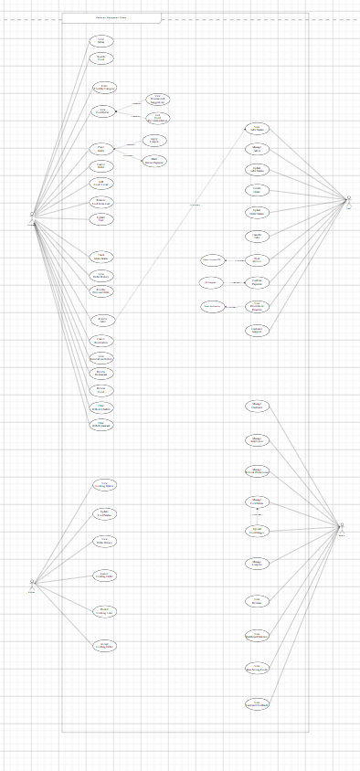

9. Database Design
Insert ERD Diagram here and describe major entities: User, Customer, Employee, Order, Food Item, Payment, Reservation, Inventory Item, Supplier, Review.

10. User Interface Design
- Home Page
- Menu Page
- Food Detail Page
- Cart Page
- Checkout Page
- Reservation Page
- Order Tracking Page
- Staff Dashboard
- Kitchen Dashboard
- Admin Dashboard
