FPT UNIVERSITY DA NANG
Subject: SWR302 | Group: 5
SOFTWARE REQUIREMENT SPECIFICATION
Project: Citizen Connection System
(Da Nang Listening System)
Version 1.0
2025

Document Revision History
Version | Date | Author(s) | Description
1.0 | 2025 | Group 5 | Initial Release

Table of Contents
1. Introduction 4
1.1 Purpose 4
1.2 Scope 4
1.3 Definitions, Acronyms, and Abbreviations 4
2. Overall Description 5
2.1 Product Perspective 5
2.2 User Classes and Characteristics 5
3. Functional Requirements 6
3.1 Module 1: Administration & Authentication 6
3.2 Module 2: Incident Reporting Pipeline 6
3.3 Module 3: AI Automation 6
3.4 Module 4: Operations & Real-Time Interaction 7
4. Non-Functional Requirements 8
4.1 UI/UX & Accessibility 8
4.2 Performance 8
4.3 Security 8
5. System Architecture 9
5.1 Technology Stack 9
6. Use Case Diagram 10
6.1 Actors 10
6.2 Core Use Cases by Actor 10
6.3 Use Case Diagram 11
7. Database Design (ERD) 12
7.1 ERD Diagram 12
7.2 Table Descriptions 12
7.3 Key Relationships Summary 15
8. Screens Flow 16
8.1 Citizen Screens 16
8.2 Ward Staff / Police Staff Screens 18
8.3 Super Admin Screens 19
8.4 Screen Flow Summary Table 20

1. Introduction

1.1 Purpose
This document defines the Functional and Non-Functional requirements for the "Thanh Pho Lang Nghe" (City Listening) platform deployed in Da Nang city. It serves as the authoritative reference for developers, testers, and project acceptance stakeholders.

1.2 Scope
The system is a centralized digital urban-management coordination hub comprising three main subsystems:
- Citizen-facing layer: Field incident reporting with GPS coordinates, high-quality photos and videos (>10 seconds).
- Authority-facing layer (Ward Staff / Police): Receive, assign, process incidents in real time, and return results to citizens.
- Background AI components: Emergency Chatbot (Hybrid RAG) and Image Data Extraction Engine (OCR license-plate recognition).

1.3 Definitions, Acronyms, and Abbreviations
Term / Acronym | Definition
SRS | Software Requirement Specification
RAG | Retrieval-Augmented Generation - AI architecture that queries a knowledge store
OCR | Optical Character Recognition - extracts text from images or video frames
RBAC | Role-Based Access Control - permission system based on user roles
GPS | Global Positioning System - satellite-based location service
JWT | JSON Web Token - stateless authentication token standard
KPI | Key Performance Indicator - measurable metric for unit performance

2. Overall Description

2.1 Product Perspective
The system operates independently on a Web/Mobile environment with direct integration to the following third-party platform services:
- Google Maps API - geolocation and map rendering.
- Gemini API - AI logic processing.

2.2 User Classes and Characteristics
The system applies a direct inheritance hierarchy among its principal Actors:
- Citizen: Primary input activator. The interface is intentionally simplified (large UX, oversized buttons) and optimized specifically for elderly users (aged 40-70).
- Ward Staff (Commune People's Committee Officer): Inherits from Citizen. Receives and processes urban infrastructure and community incidents.
- Police Staff (Traffic / Fire Police): Inherits from Citizen. Receives and processes public-order incidents, accidents, and violations.
- Super Admin / City Leadership: Inherits from Ward Staff. Holds the highest-level authority for coordination, category management, and KPI monitoring of all units.

3. Functional Requirements
Functional requirements are mapped directly from the 35 Use Cases of the system.

3.1 Module 1: Administration & Authentication
ID | Requirement Description
FR-01 (UC00) | The system must enforce access control using Spring Security JWT tokens. Due to the actor inheritance hierarchy, permissions granted to Citizen actors must automatically propagate to higher-level actors.
FR-02 (UC01-UC02) | The system must allow citizens to register an account via phone number (OTP verification) or email address.

3.2 Module 2: Incident Reporting Pipeline
ID | Requirement Description
FR-03 (UC04) | The citizen reporting flow must follow a strictly linear 3-step design: Evidence -> Location -> Description. No branching or optional paths permitted.
FR-04 (UC06) | The Spring Boot backend must reject video files shorter than 10 seconds to eliminate junk submissions and ensure evidentiary authenticity.
FR-05 (UC05) | The system must automatically capture the citizen's latitude and longitude via the Google Maps API and assign the corresponding ward_id automatically for case routing.

3.3 Module 3: AI Automation
ID | Requirement Description
FR-06 (UC23) | When Police Staff receive a violation report, the system must automatically scan the submitted image/video evidence using OCR to extract the license-plate character string and persist it in the ocr_plate_number data field.
FR-07 (UC09) | The emergency AI assistant must use RAG technology to query the Da Nang legal-text knowledge base and emergency contact directory to return accurate responses. Hallucination (fabricated data) is strictly prohibited.

3.4 Module 4: Operations & Real-Time Interaction
ID | Requirement Description
FR-08 (UC17-UC20) | When an officer taps "Request Additional Information", the system must automatically activate a real-time online chat flow (UCChat) powered by WebSockets, connecting the officer directly to the citizen.
FR-09 (UC31) | The Admin management dashboard must display analytical charts (bar charts, pie charts) that auto-refresh with the real-time count of incidents distributed by district/ward across Da Nang.

4. Non-Functional Requirements

4.1 UI/UX & Accessibility
ID | Requirement Description
NFR-01 | The user navigation header (Header bar) must include [A+] / [A-] buttons to globally increase or decrease font size across the entire screen, specifically designed to accommodate elderly users.
NFR-02 | All primary interactive buttons on the citizen screen (Submit Report, Record Video, Voice Microphone) must have a minimum tap area of 48px x 48px.

4.2 Performance
ID | Requirement Description
NFR-03 | Upload and chunked-processing time for video files under 50 MB must not exceed 5 seconds on a standard 4G mobile network.
NFR-04 | Message delivery latency in the real-time chat flow (UCChat) and push notifications (UC12) must be held below 200ms.

4.3 Security
ID | Requirement Description
NFR-05 | All user passwords stored in the MySQL database must be one-way encrypted using the BCryptPasswordEncoder algorithm provided by Spring Security.
NFR-06 | All sensitive data transmission (phone number, email, GPS coordinates) between client and server must be secured using the HTTPS (SSL/TLS) encryption protocol.

5. System Architecture

5.1 Technology Stack
Layer | Technology
Frontend | ReactJS + TailwindCSS
Backend | Java Spring Boot - MVC architecture (Controller -> Service -> Repository)
Database | MySQL (Relational DBMS)
AI Services | Gemini API (RAG Chatbot + OCR Engine)
Maps & Location | Google Maps API
Real-time | WebSocket (chat) + Push Notification service
Containerization | Docker + docker-compose.yml

6. Use Case Diagram

6.1 Actors
- Citizen
- Super Admin
- Commune People's Committee Officer (Ward Staff)
- Police Staff
- AI Service

6.2 Core Use Cases by Actor

Citizen
- Register account (phone OTP / email)
- Submit new feedback (3-step linear flow)
- Update profile
- View reflected history
- View counter status
- Evaluate treatment results
- Receive notifications
- Create Community Campaign
- Chatbot AI Q&A

Ward Staff
- Receive and respond to feedback
- Request supplement information (triggers real-time chat)
- Manage schedule implementation
- Discard to trash
- Forward inter-sectoral dossier
- Report results (attach supporting documents)
- Issue a regional warning order

Police Staff
- Receive and respond to feedback
- Store and share video footage
- Record violation handling record (OCR license plate)
- Forward inter-sectoral dossier

Super Admin
- Account management & moderation
- Lock/unlock account
- Incident category configuration management
- System knowledge management
- Management of enterprise administrative boundaries
- Urban statistics dashboard
- Unit KPI performance monitoring
- Reflective navigation
- Export PDF/Excel briefing report

AI Service
- AI classify feedback
- AI detect duplicate reflections
- AI checks photo evidence (OCR)
- Chatbot AI questions and answers (Hybrid RAG)

6.3 Use Case Diagram
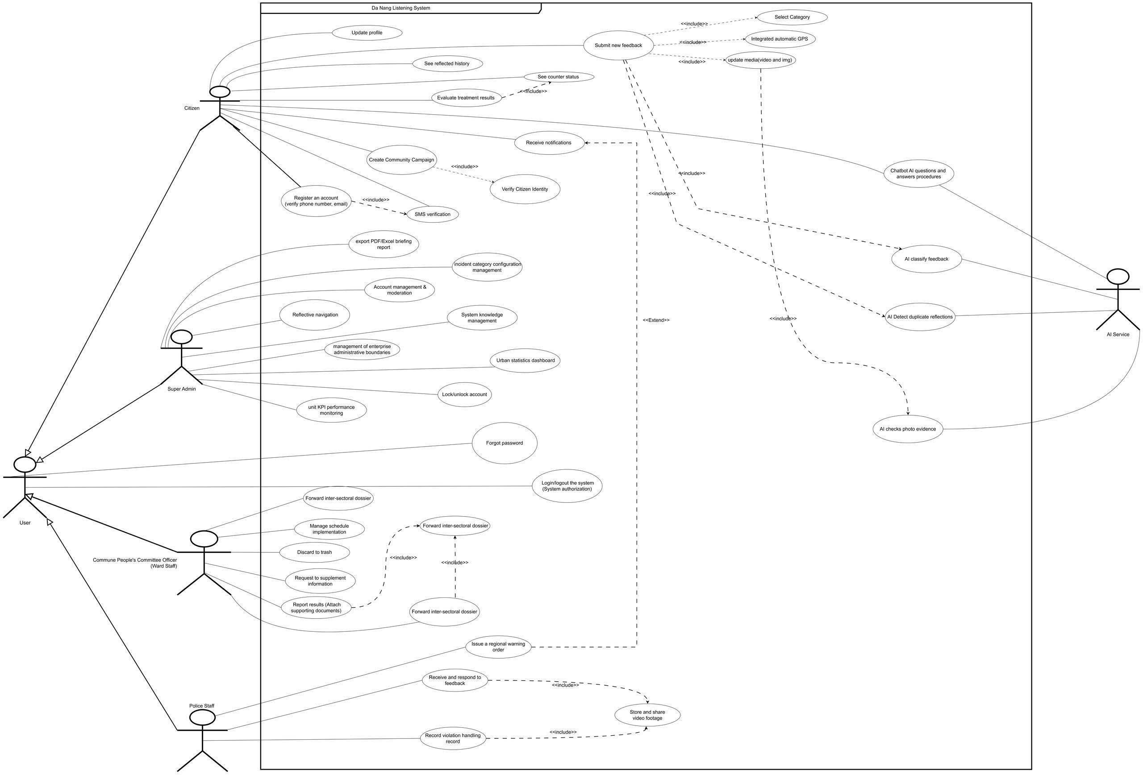

7. Database Design (ERD)
The following section describes all primary database tables, their columns, data types, and key relationships. The ERD diagram is provided at the end of this section.

7.1 ERD Diagram


Click tại đây
7.2 Table Descriptions

profiles
Central user table storing identity and role information for all system actors (citizens, ward staff, police, admin).
Column Name | Data Type | Constraints | Description
id | BIGINT | PK, AUTO_INC | Unique user identifier
phone_number | VARCHAR(20) | UNIQUE, NOT NULL | Registered phone number (used for OTP login)
email | VARCHAR(255) | UNIQUE | Registered email address
password_hash | VARCHAR(255) | NOT NULL | BCrypt-hashed password
full_name | VARCHAR(255) | NOT NULL | Full name of the user
role | ENUM | NOT NULL | CITIZEN | WARD_STAFF | POLICE | ADMIN
ward_id | BIGINT | FK -> admin_boundaries | Associated administrative ward
is_locked | BOOLEAN | DEFAULT FALSE | Account lock status (managed by Admin)
created_at | TIMESTAMP | NOT NULL | Account creation timestamp

feedbacks
Core incident/feedback record submitted by citizens.
Column Name | Data Type | Constraints | Description
id | BIGINT | PK, AUTO_INC | Unique feedback identifier
citizen_id | BIGINT | FK -> profiles | Submitting citizen
category_id | BIGINT | FK -> categories | Incident category (traffic, infrastructure, etc.)
ward_id | BIGINT | FK -> admin_boundaries | Auto-assigned ward from GPS coordinates
title | VARCHAR(500) | NOT NULL | Short incident title
description | TEXT |  | Detailed incident description
latitude | DECIMAL(10,7) | NOT NULL | GPS latitude of reported location
longitude | DECIMAL(10,7) | NOT NULL | GPS longitude of reported location
status | ENUM | NOT NULL | PENDING | IN_PROGRESS | RESOLVED | REJECTED
created_at | TIMESTAMP | NOT NULL | Submission timestamp

feedback_media
Stores image attachments associated with a feedback submission.
Column Name | Data Type | Constraints | Description
id | BIGINT | PK, AUTO_INC | Unique media record identifier
feedback_id | BIGINT | FK -> feedbacks | Parent feedback record
media_url | TEXT | NOT NULL | Cloud storage URL of the image
media_type | ENUM | NOT NULL | IMAGE | VIDEO
created_at | TIMESTAMP | NOT NULL | Upload timestamp

video_footages
Stores video evidence files (minimum 10 seconds). Shared between citizens and Police Staff.
Column Name | Data Type | Constraints | Description
id | BIGINT | PK, AUTO_INC | Unique video record identifier
feedback_id | BIGINT | FK -> feedbacks | Parent feedback
uploader_id | BIGINT | FK -> profiles | User who uploaded the video
video_url | TEXT | NOT NULL | Cloud storage URL
duration_sec | INT | NOT NULL | Duration in seconds (must be >= 10)
created_at | TIMESTAMP | NOT NULL | Upload timestamp

violation_records
Stores traffic/public-order violation records created by Police Staff, including OCR-extracted license plate data.
Column Name | Data Type | Constraints | Description
id | BIGINT | PK, AUTO_INC | Unique violation record identifier
feedback_id | BIGINT | FK -> feedbacks | Source feedback
police_id | BIGINT | FK -> profiles | Handling police officer
ocr_plate_number | VARCHAR(20) |  | License plate number extracted by OCR engine
violation_type | VARCHAR(255) | NOT NULL | Type of violation recorded
resolution_note | TEXT |  | Officer's resolution note
created_at | TIMESTAMP | NOT NULL | Record creation timestamp

notifications
Push notifications sent to citizens and staff regarding feedback status updates.
Column Name | Data Type | Constraints | Description
id | BIGINT | PK, AUTO_INC | Unique notification identifier
user_id | BIGINT | FK -> profiles | Recipient user
feedback_id | BIGINT | FK -> feedbacks | Related feedback (nullable)
message | TEXT | NOT NULL | Notification message content
is_read | BOOLEAN | DEFAULT FALSE | Whether the notification has been read
created_at | TIMESTAMP | NOT NULL | Sent timestamp

categories
Configurable incident categories managed by Super Admin (e.g., Environment, Traffic, Infrastructure).
Column Name | Data Type | Constraints | Description
id | BIGINT | PK, AUTO_INC | Unique category identifier
name | VARCHAR(255) | NOT NULL | Category name
description | TEXT |  | Detailed category description
is_active | BOOLEAN | DEFAULT TRUE | Whether the category is currently active

admin_boundaries
Administrative boundary definitions (districts, wards) for Da Nang city, used for GPS-based case routing.
Column Name | Data Type | Constraints | Description
id | BIGINT | PK, AUTO_INC | Unique boundary identifier
name | VARCHAR(255) | NOT NULL | Ward or district name
type | ENUM | NOT NULL | WARD | DISTRICT
parent_id | BIGINT | FK -> admin_boundaries (self) | Parent boundary (district for wards)
geo_json | LONGTEXT |  | GeoJSON polygon defining boundary shape

kpi_reports
Auto-generated KPI performance reports per ward/unit for Super Admin monitoring dashboard.
Column Name | Data Type | Constraints | Description
id | BIGINT | PK, AUTO_INC | Unique report identifier
ward_id | BIGINT | FK -> admin_boundaries | Target ward/unit
period_start | DATE | NOT NULL | Report period start date
period_end | DATE | NOT NULL | Report period end date
total_feedback | INT | DEFAULT 0 | Total feedback received in period
resolved_count | INT | DEFAULT 0 | Number of resolved cases
avg_resolve_hours | DECIMAL(6,2) |  | Average resolution time in hours
generated_at | TIMESTAMP | NOT NULL | Report generation timestamp

chatbot_sessions
Records of citizen interactions with the Hybrid RAG emergency chatbot.
Column Name | Data Type | Constraints | Description
id | BIGINT | PK, AUTO_INC | Unique session identifier
citizen_id | BIGINT | FK -> profiles | Citizen user in session
started_at | TIMESTAMP | NOT NULL | Session start timestamp
ended_at | TIMESTAMP |  | Session end timestamp (null if active)

chatbot_messages
Individual messages within a chatbot session.
Column Name | Data Type | Constraints | Description
id | BIGINT | PK, AUTO_INC | Unique message identifier
session_id | BIGINT | FK -> chatbot_sessions | Parent chatbot session
role | ENUM | NOT NULL | USER | ASSISTANT
content | TEXT | NOT NULL | Message content
created_at | TIMESTAMP | NOT NULL | Message timestamp

7.3 Key Relationships Summary
- feedbacks -> profiles (citizen_id): many-to-one - each feedback belongs to one citizen.
- feedbacks -> admin_boundaries (ward_id): many-to-one - GPS auto-assigns ward.
- feedbacks -> categories (category_id): many-to-one - each case has one category.
- feedback_media / video_footages -> feedbacks: many-to-one - multiple media files per feedback.
- feedback_assignments / feedback_processing_logs / feedback_evaluations -> feedbacks: one-to-many workflow tables.
- violation_records -> feedbacks + profiles (police_id): links to source feedback and handling officer.
- profiles -> admin_boundaries: staff are bound to their administrative ward.
- admin_boundaries -> kpi_reports + regional_warnings: boundary-based performance and alert data.
- chatbot_sessions -> chatbot_messages: one session contains many messages.

8. Screens Flow
This section describes the key screens of the Citizen Connection System, organized by actor role. For each screen, a brief functional description is provided along with a placeholder for the UI screenshot or Figma design export.

8.1 Citizen Screens
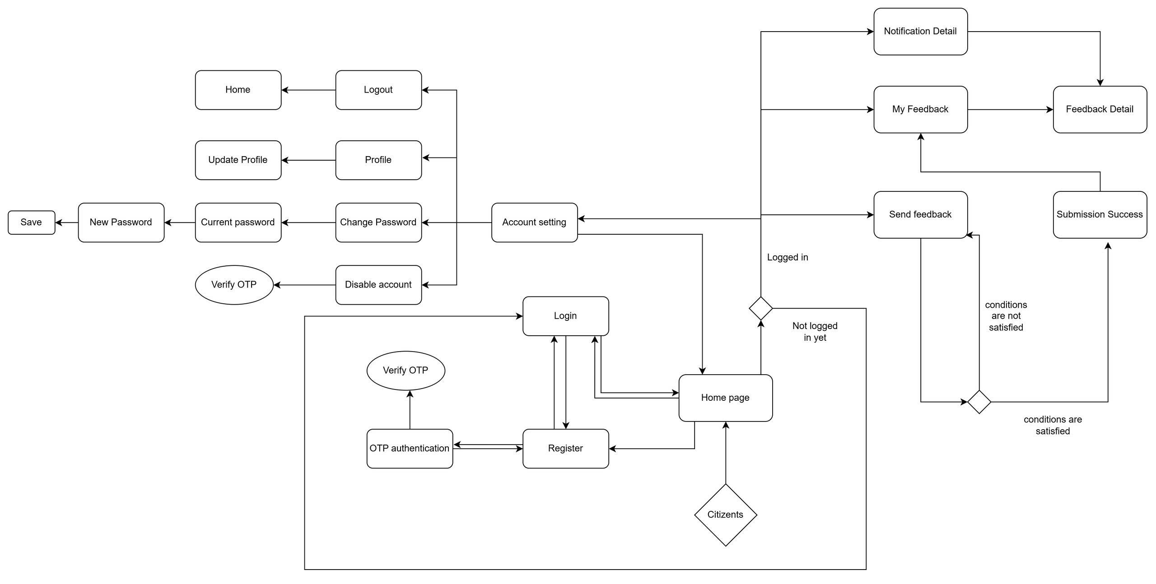

8.2 Ward Staff / Police Staff Screens
Police Staff Screens
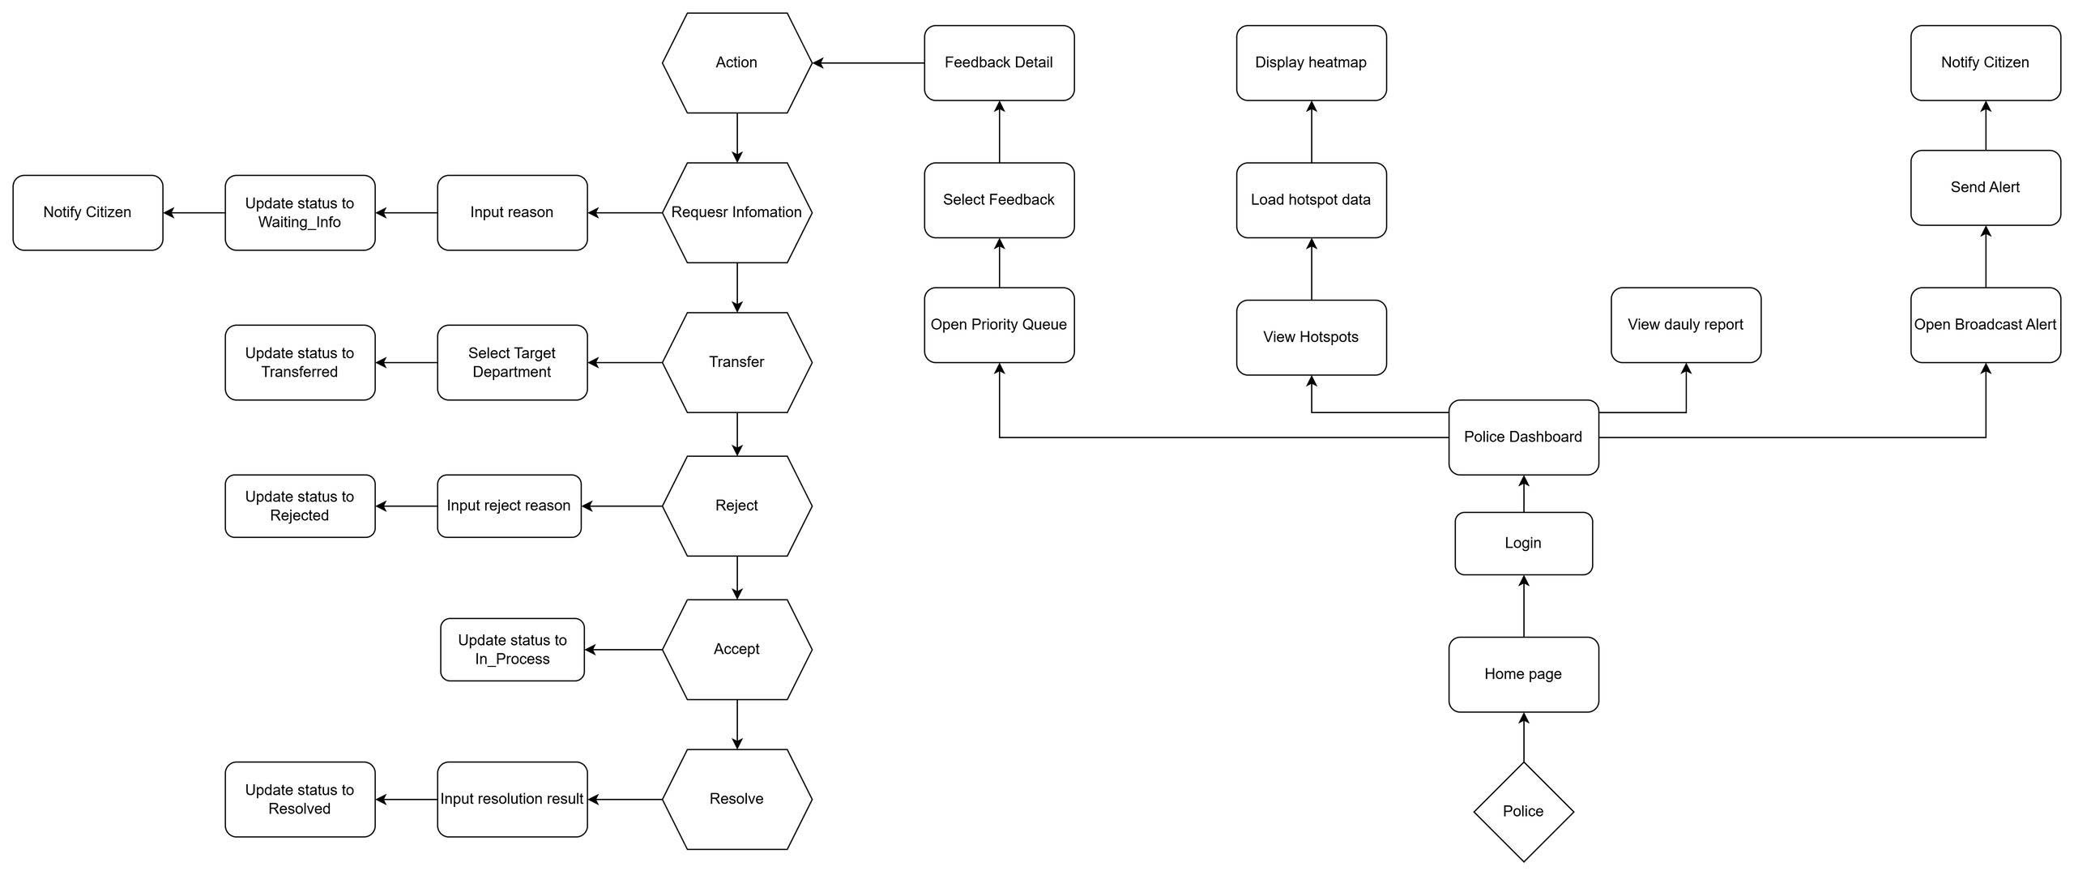

Ward Staff
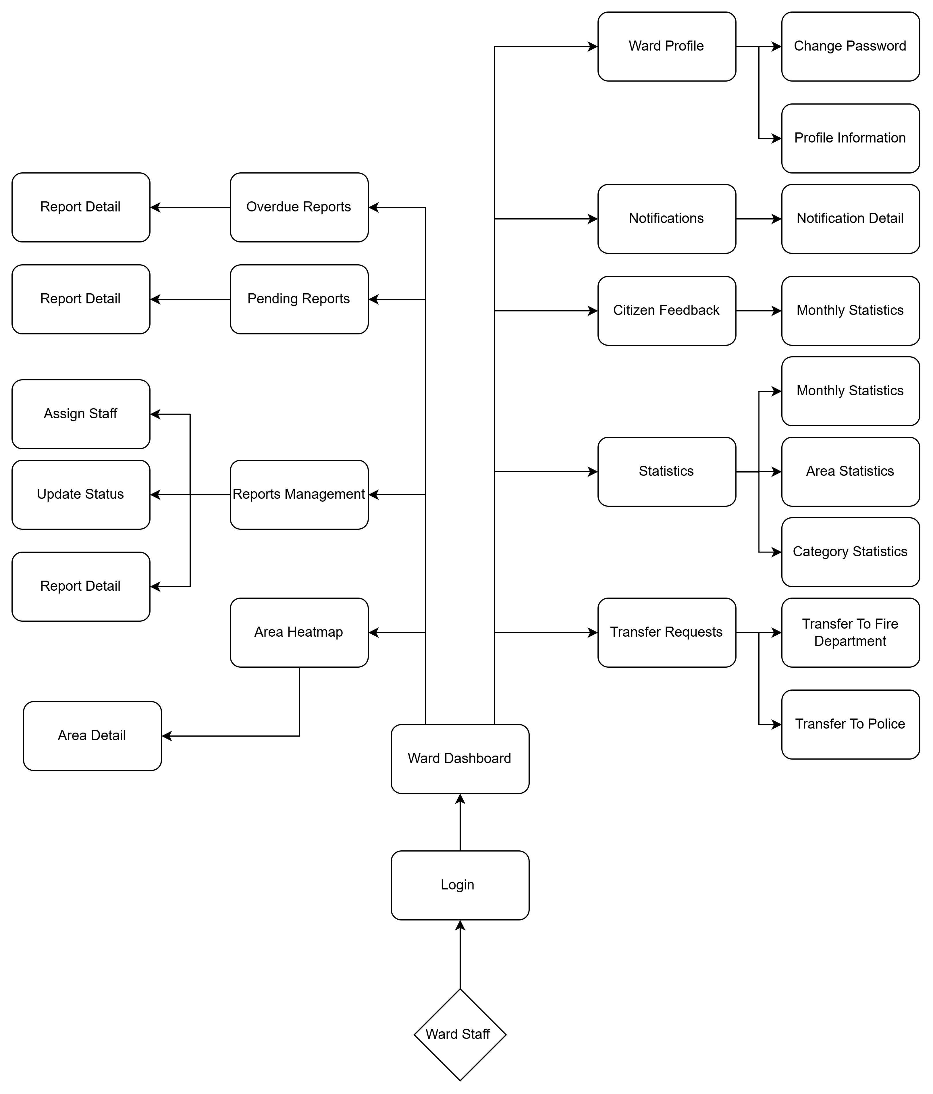

8.3 Super Admin Screens
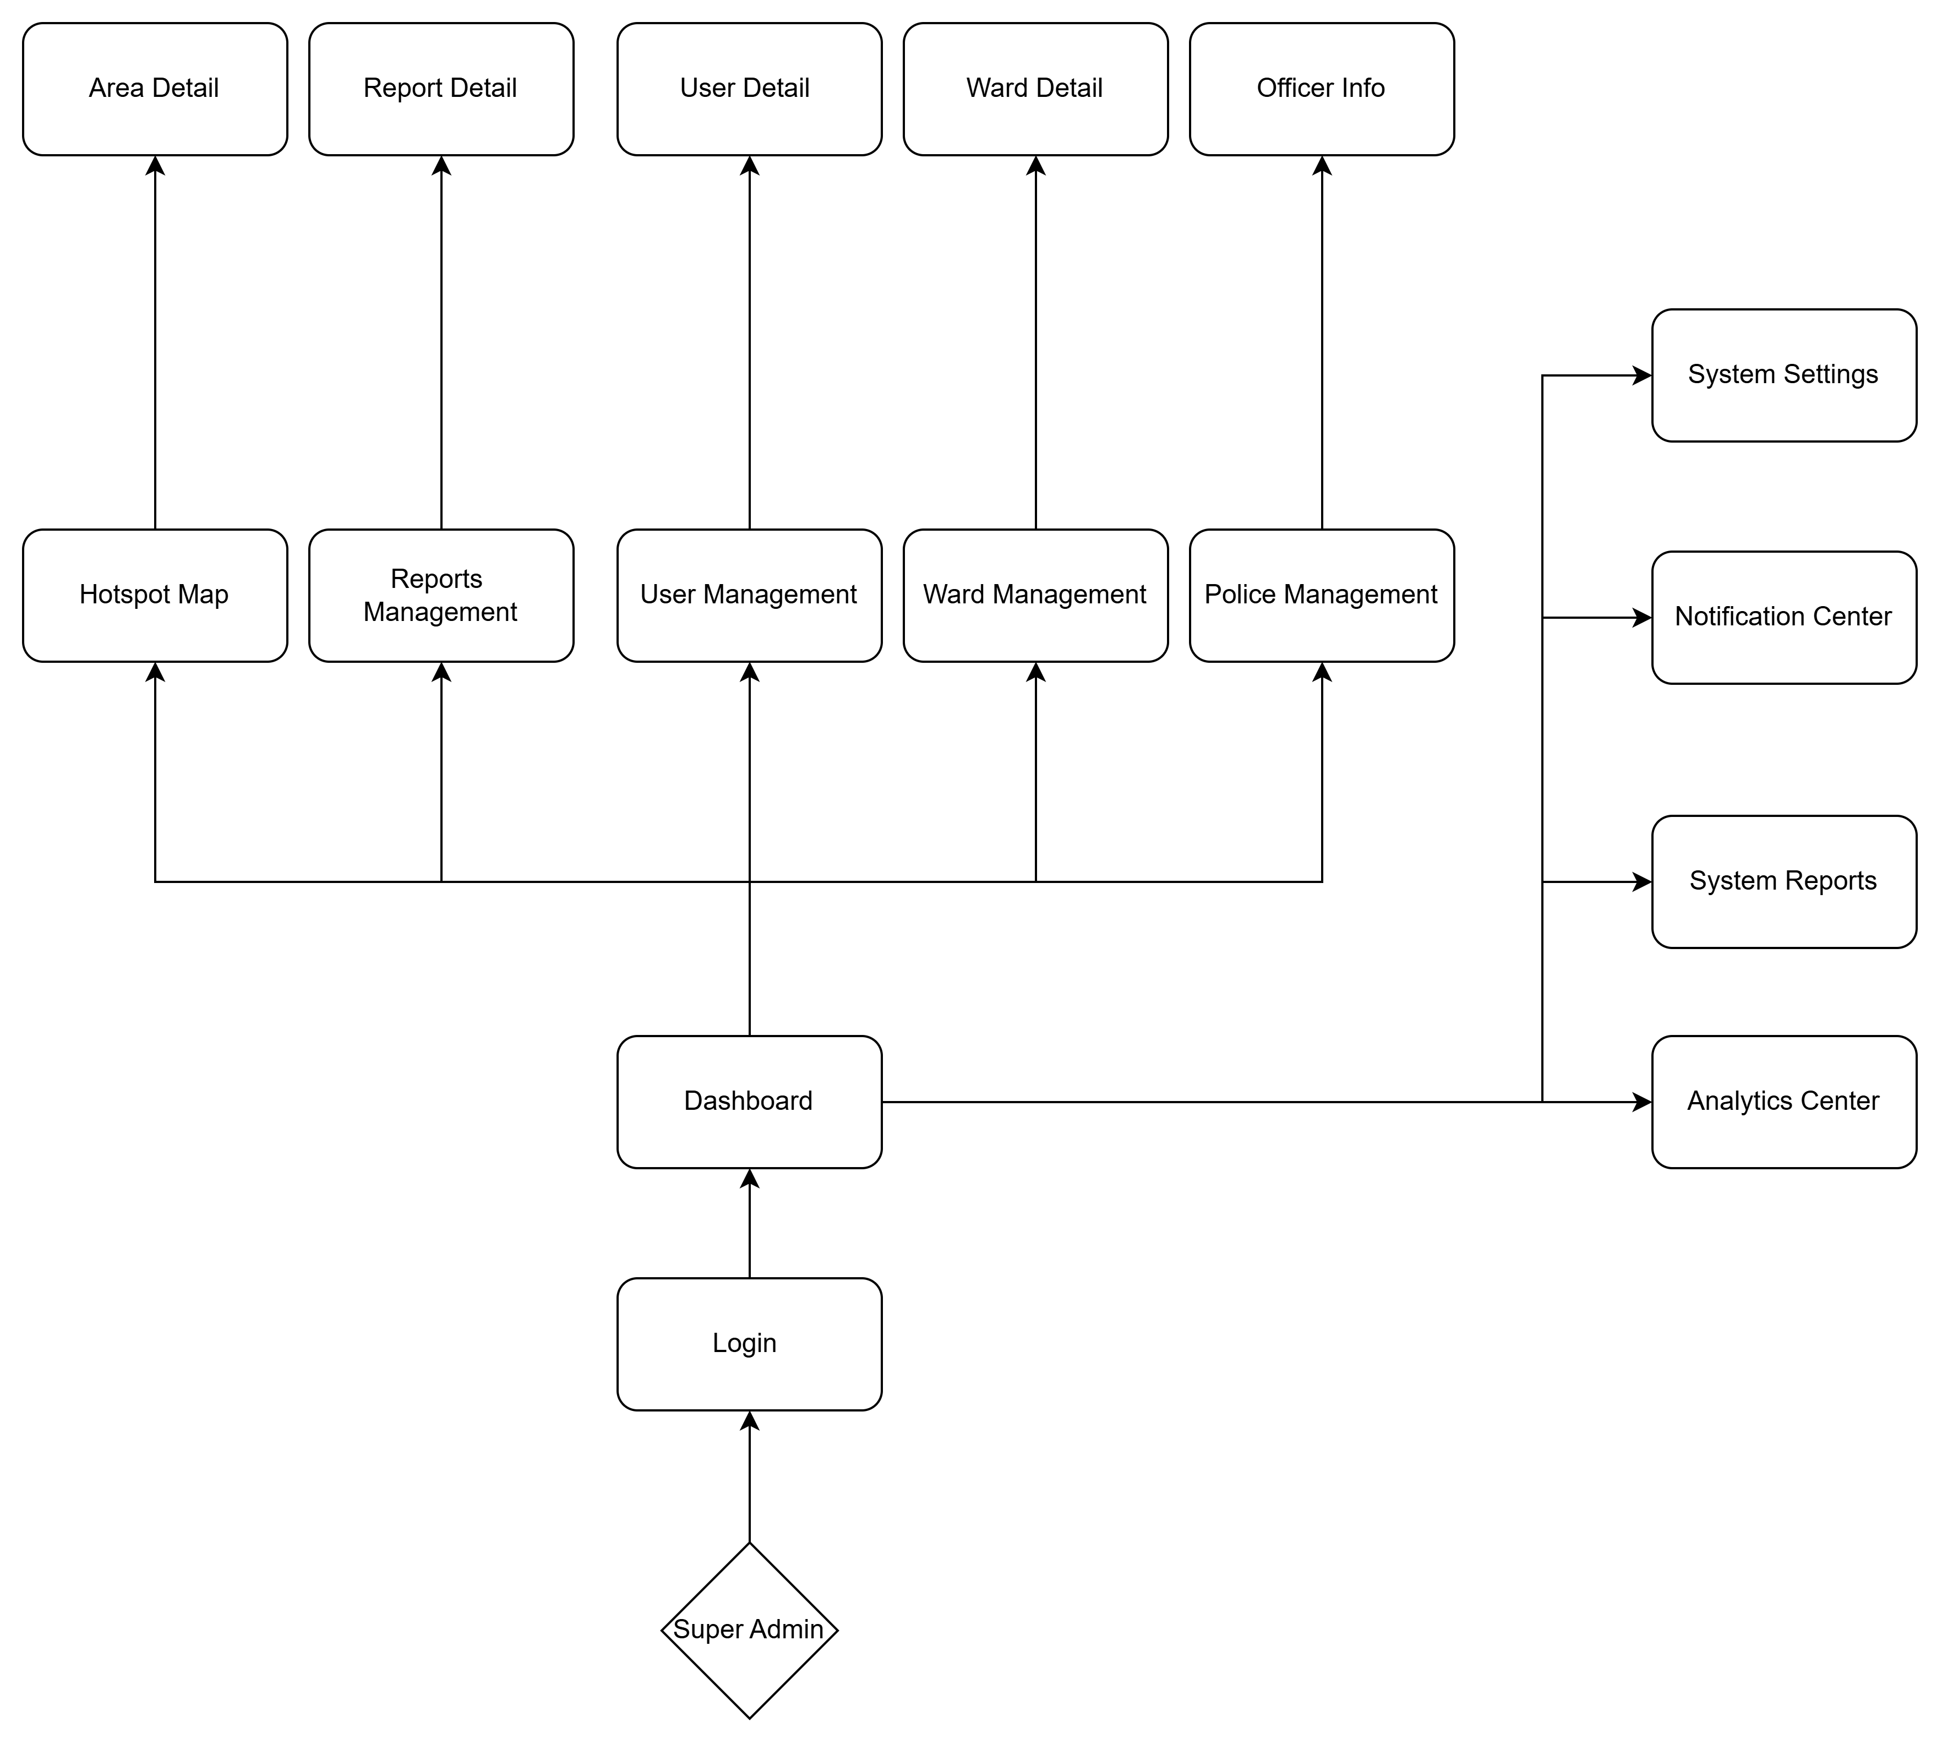

8.4 Screen Flow Summary Table
Screen ID | Actor | Description
SCR-C01 | Citizen | Home / Landing Page - entry point with accessibility controls
SCR-C02 | Citizen | Account Registration via phone OTP or email
SCR-C03 | Citizen | Submit Feedback Step 1: Upload evidence media
SCR-C04 | Citizen | Submit Feedback Step 2: GPS location + category selection
SCR-C05 | Citizen | Submit Feedback Step 3: Title + description (voice input)
SCR-C06 | Citizen | Feedback history list + KPI summary + map view
SCR-C07 | Citizen | Real-time WebSocket chat with assigned officer
SCR-C08 | Citizen | Hybrid RAG AI Emergency Chatbot
SCR-W01 | Ward / Police | Incoming feedback dashboard with filters
SCR-W02 | Ward / Police | Feedback detail view + action panel
SCR-W03 | Ward / Police | Resolution report form with document attachment
SCR-P01 | Police | Violation record form with OCR license plate extraction
SCR-A01 | Super Admin | Real-time urban statistics dashboard (charts)
SCR-A02 | Super Admin | User account management & moderation
SCR-A03 | Super Admin | KPI performance monitoring + export
SCR-A04 | Super Admin | System knowledge management for RAG chatbot

