

CAPSTONE PROJECT REPORT

Report 3 – Software Requirement Specification

DevTrack AI

Academic Project Management Platform

I. Record of Changes

Version | Date | Author | Description

1.0

Table 0: Record of Changes

II. Software Requirement Specification

1. Product Overview

1.1 Context Diagram

DevTrack AI is a modern academic project management platform designed to improve how student teams and mentors collaborate and track progress together. While traditional tools like Trello, Jira, or Notion are often generic and lack academic context, DevTrack AI uses smart features and AI to create a more structured and transparent experience for every project stakeholder.

Our platform helps Project Leaders create workspaces, break down requirements into tasks, and manage the full development lifecycle more easily. At the same time, Team Members can receive assignments, upload evidence, run test cases, and track their individual contributions in one place.

DevTrack AI supports secure logins and role-based access control per project. Users are verified and assigned roles — Leader, Member, or Mentor — to ensure the right level of access. The platform offers an intuitive interface, helping teams manage requirements by priority, status, and acceptance criteria. Members can link tasks to requirements, attach evidence to completed work, and monitor the entire traceability chain from a single dashboard.

Teams can also generate tasks automatically with AI assistance, receive suggested test cases based on acceptance criteria, and get proactive alerts when artifacts are missing. They receive weekly progress reports and AI-driven insights based on actual project activity. Project Leaders can upgrade requirements to tracked entities with owners and deadlines, organize work into sprints, and manage candidates using tags and roles. They can conduct code reviews through built-in GitHub integration, monitor commit activity, and export traceability reports in Excel or PDF format.

Mentors have read-only access to monitor assigned projects. They can review the full Requirement Traceability Matrix, view contribution analytics for each member, leave feedback on requirements and weekly reports, and access a shareable report link without needing to log in.

DevTrack AI is designed to make academic project management easier and smarter. Whether you are a Project Leader coordinating a team or a Mentor evaluating student progress, DevTrack AI gives you the tools to deliver and assess quality software projects with confidence.

2. User Requirements

2.1 Actors
# | Actor | Description
1 | Guest | A guest is someone who has not created an account on the system. Guests can view the platform's landing page and general information about DevTrack AI's features. They cannot access any project workspace, requirements, tasks, or any internal data.
2 | Team Member | A team member is a registered individual who has been invited to join a project. They can receive and update assigned tasks, upload evidence, create and execute test cases, log bug reports, and track their personal contribution history within the project.
3 | Project Leader | A project leader is a registered user who creates and owns a project workspace. They can manage team members and roles, define requirements and use cases, organize sprints, monitor the full traceability matrix, and export progress reports. Project Leaders can also trigger AI features such as task generation, test case suggestions, and weekly report generation.
4 | Mentor / Supervisor | A mentor is an authorized read-only observer assigned to one or more projects. They can review the full Requirement Traceability Matrix, view contribution analytics for each member, leave feedback on requirements, tasks, and weekly reports, and access shareable report links without modifying any project data.
5 | Admin | An admin is responsible for overall platform governance. They can manage all user accounts, monitor system usage, handle policy violations, oversee platform-wide notifications, and track AI performance and infrastructure health. Admins also manage role assignments and ensure the platform remains stable and reliable for all users.

Table 1: Actor Description

2.2 Use Cases

2.2.1 Diagrams

2.2.1.1 Use Case for Authentication

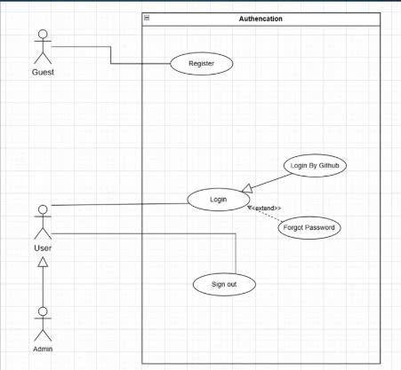

Figure 3: Use case diagram for Authentication

2.2.1.2 Use Case for Project Workspace

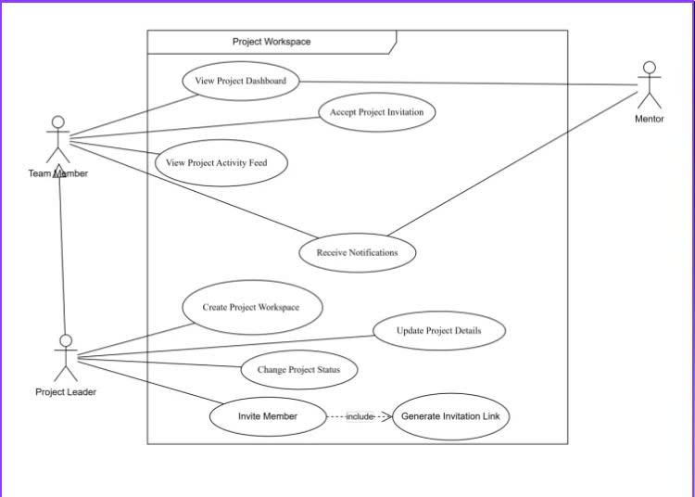

Figure 4: Use case diagram for Project Workspace

2.2.1.3 Use Case for Requirement and Use Case Management

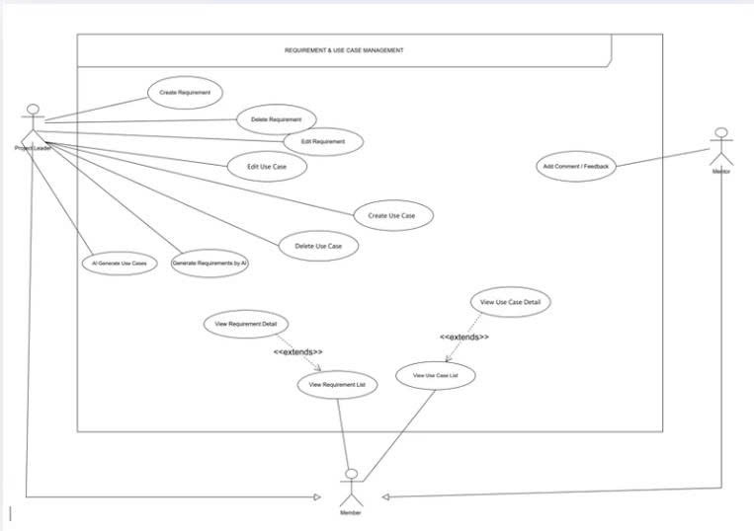

Figure 5: Use case diagram for Requirement & Use Case Management

2.2.1.4 Use Case for Requirement Traceability Matrix & Code Insight

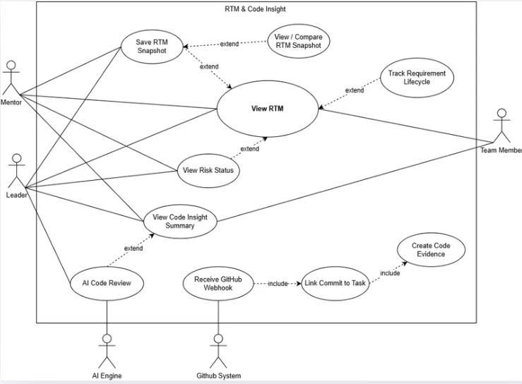

Figure 6: Use case diagram for RTM & Code Insight

2.2.1.5 Use Case for Task, Sprint, Contribution Rules

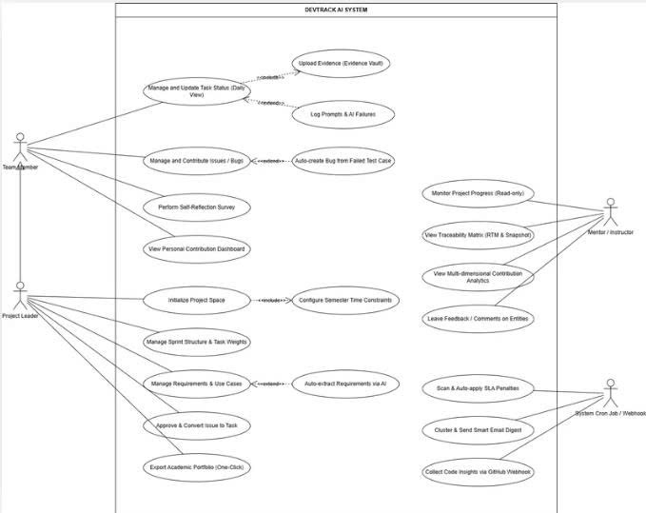

Figure 7: Use case diagram for Task, Sprint & Contribution

2.2.1.6 Use Case for Issue & Bug Tracker

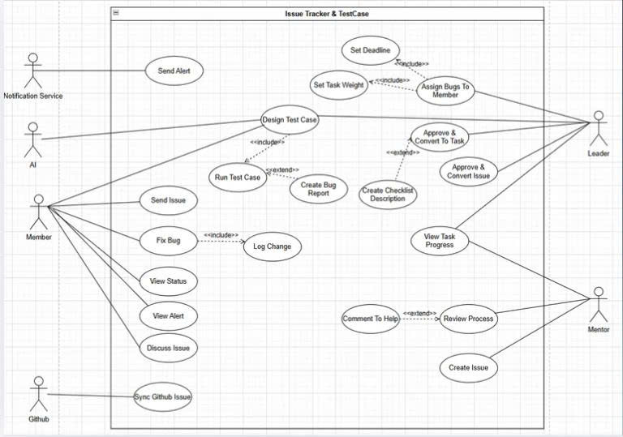

Figure 8: Use case diagram for Issue & Bug Tracker

2.2.2 Descriptions
ID | Use Case | Actors | Description
UC-01 | Register Account | Guest | A guest creates a new account by providing their email and password to access the platform.
UC-02 | Login | Guest, Team Member, Project Leader, Mentor, Admin | A user authenticates into the system using their registered credentials to access their workspace and features.
UC-03 | Logout | Team Member, Project Leader, Mentor, Admin | A logged-in user ends their current session and is redirected to the landing page.
UC-04 | View Landing Page | Guest | A guest browses the platform's public landing page to learn about DevTrack AI's features before registering.
UC-05 | Create Project | Project Leader | A project leader creates a new project workspace by providing a name, description, type, subject, semester, and overall deadline.
UC-06 | Edit Project Information | Project Leader | A project leader updates the project's name, description, status, avatar, or deadline after the project has been created.
UC-07 | Archive Project | Project Leader | A project leader marks a completed project as archived to preserve its data without cluttering the active workspace list.
UC-08 | View Project Dashboard | Project Leader, Team Member, Mentor | A user views the project's overview including overall progress, sprint burndown, activity feed, risk status, and days remaining until deadline.
UC-09 | Invite Member | Project Leader | A project leader invites a registered user to join the project via email, username, or a time-limited invitation link.
UC-10 | Accept Invitation | Team Member | A registered user accepts a project invitation and is added to the project with the assigned role.
UC-11 | Remove Member | Project Leader | A project leader removes a member from the project. The removed member's tasks are automatically moved to Unassigned.
UC-12 | Change Member Role | Project Leader | A project leader changes a team member's role within the project.
UC-13 | View Member List | Project Leader, Team Member, Mentor | A user views all current members of the project along with their roles and join dates.
UC-14 | Create Sprint | Project Leader | A project leader creates a new sprint by defining its name, goal, start date, and end date.
UC-15 | Manage Sprint | Project Leader | A project leader updates sprint details, moves tasks in or out of the sprint, or marks the sprint as completed.
UC-16 | View Sprint Board | Project Leader, Team Member | A user views the current sprint's task board including task statuses and assignments.
UC-17 | Receive Notification | Project Leader, Team Member, Mentor | A user receives in-app notifications triggered by events such as task assignments, deadline warnings, test failures, or mentor comments.
UC-18 | Create Requirement | Project Leader | A project leader creates a new requirement by providing a title, description, type, priority, acceptance criteria, owner, and tags.
UC-19 | Edit Requirement | Project Leader | A project leader updates the details of an existing requirement including its status, priority, or acceptance criteria.
UC-20 | Delete Requirement | Project Leader | A project leader removes a requirement that is no longer relevant to the project scope.
UC-21 | View Requirement List | Project Leader, Team Member, Mentor | A user browses all requirements in the project filtered by status, priority, type, or tags.
UC-22 | Import Requirements from Text | Project Leader | A project leader pastes a block of text and the AI automatically extracts and generates a list of draft requirements for review.
UC-23 | Create Use Case | Project Leader | A project leader creates a use case linked to a requirement defining actors, preconditions, main flow, alternative flow, and postconditions.
UC-24 | Edit Use Case | Project Leader | A project leader updates the details of an existing use case including its flows and linked actors.
UC-25 | Link Use Case to Requirement | Project Leader | A project leader establishes a link between one or more use cases and a specific requirement to maintain traceability.
UC-26 | Create Task | Project Leader, Team Member | A user creates a task by providing a title, description, type, priority, assignee, and due date linked to a requirement.
UC-27 | Edit Task | Project Leader, Team Member | A user updates the details of an existing task including its status, assignee, description, or due date.
UC-28 | Delete Task | Project Leader | A project leader removes a task that is no longer needed from the board.
UC-29 | Move Task on Kanban Board | Project Leader, Team Member | A user drags and drops a task across columns to update its status from To Do to In Progress to In Review to Done.
UC-30 | Comment on Task | Project Leader, Team Member, Mentor | A user adds a comment to a task to provide updates, ask questions, or leave feedback.
UC-31 | Assign Task to Member | Project Leader | A project leader assigns an existing task to a specific team member within the project.
UC-32 | AI Generate Tasks from Requirement | Project Leader | The system uses AI to automatically generate a list of suggested tasks based on a requirement's title, description, and acceptance criteria for the leader to review and confirm.
UC-33 | Create Test Case | Project Leader, Team Member | A user creates a test case linked to a requirement defining steps, expected results, and priority.
UC-34 | Edit Test Case | Project Leader, Team Member | A user updates an existing test case including its steps, expected results, or linked requirement.
UC-35 | Execute Test Case | Team Member | A team member runs a test case and records the actual result marking it as Pass or Fail.
UC-36 | AI Suggest Test Cases | Project Leader, Team Member | The system uses AI to generate suggested test cases based on a requirement's acceptance criteria for the user to review and confirm.
UC-37 | Create Bug Report | Team Member | A team member logs a bug report linked to a failed test case providing a title, description, severity, and steps to reproduce.
UC-38 | Update Bug Status | Project Leader, Team Member | A user updates the status of an existing bug report from Open to In Progress to Resolved to Closed.
UC-39 | Link Bug to Task | Project Leader, Team Member | A user links a bug report to the corresponding development task responsible for fixing the issue.
UC-40 | Upload Evidence | Team Member | A team member uploads evidence such as a screenshot, API link, test result, or document linked to a completed task to prove the work was done.
UC-41 | View Evidence | Project Leader, Team Member, Mentor | A user views the evidence attached to a task including file previews and metadata.
UC-42 | Delete Evidence | Team Member, Project Leader | A user removes an evidence entry that is incorrect or no longer relevant.
UC-43 | Link Evidence to Task | Team Member | A team member associates an uploaded evidence file with a specific task to support traceability.
UC-44 | Auto-capture Code Evidence from Commit | Team Member | The system automatically creates an evidence entry linked to a task when a GitHub commit message references the task ID.
UC-45 | View Traceability Matrix | Project Leader, Team Member, Mentor | A user views the full RTM showing the coverage status of all requirements across tasks, test cases, and evidence.
UC-46 | Filter RTM by Status | Project Leader, Team Member, Mentor | A user filters the RTM to display only requirements with a specific coverage status such as At Risk or Fully Covered.
UC-47 | Export RTM | Project Leader | A project leader exports the current traceability matrix as an Excel or PDF file for submission or review.
UC-48 | Connect GitHub Repository | Project Leader | A project leader links the project's GitHub repository to DevTrack AI to enable commit tracking and code insight features.
UC-49 | View GitHub Metrics | Project Leader, Team Member | A user views commit counts, active days, languages used, and contribution breakdown per member pulled from the linked GitHub repository.
UC-50 | View AI Code Review Summary | Project Leader, Mentor | A user views the AI-generated summary of code quality, highlights of risky changes, and style issues based on recent pull request diffs.
UC-51 | AI Detect Missing Artifacts | System, Project Leader | The AI engine scans all requirements daily and generates alerts for requirements that are missing linked tasks, test cases, or evidence notifying the responsible owner.
UC-52 | AI Generate Weekly Report | Project Leader | The system automatically compiles a weekly progress report summarizing completed tasks, test results, bug status, and risk areas using AI ready for export or sharing.
UC-53 | View Contribution Analytics | Project Leader, Team Member, Mentor | A user views a multi-dimensional analytics dashboard showing each member's task completion rate, evidence upload count, test execution count, and bug resolution count.
UC-54 | View Personal Contribution Summary | Team Member | A team member views their own contribution history and performance across all projects they have participated in.
UC-55 | View Mentor Dashboard | Mentor | A mentor views a consolidated overview of all assigned projects including progress percentage, current sprint status, and risk count sorted by deadline or risk level.
UC-56 | Comment on Requirement | Mentor, Project Leader | A mentor or project leader leaves a comment on a specific requirement to provide scope feedback or clarification.
UC-57 | Comment on Weekly Report | Mentor | A mentor leaves feedback directly on a generated weekly report to acknowledge progress or flag concerns to the team.
UC-58 | Generate Shareable Report Link | Project Leader | A project leader generates a time-limited read-only public link to the project report for sharing with a mentor or submitting to an instructor without requiring login.
UC-59 | Manage User Accounts | Admin | An admin views, suspends, or deletes user accounts and oversees platform-wide role assignments to maintain system integrity.
UC-60 | Monitor Platform Statistics | Admin | An admin views overall platform usage metrics including active projects, registered users, AI usage, and infrastructure health indicators.

Table 2: Use Case Description

