

CAPSTONE PROJECT REPORT DEVTRACK
Software Project Management System for IT Student Teams
Item | Description
Course | SWP391
Class | SE20A11
Semester | SU26
Group | 04
Topic | Software Project Management System for IT Student Teams

Team Members
No | Student ID | Full Name | GitHub Username | Role
1 | DE190330 | Pham Duy Hung | hung2689 | Leader
2 | DE190465 | Nguyen Thanh Dat | NguyenThanhDat3004 | Member
3 | DE190364 | Nguyen Le Trung Tin | Tinnguyen13-7 | Member
4 | DE190313 | Tran Cong Tu | TuTran205 | Member
5 | DE200322 | Nguyen Minh Hieu | hieu2816 | Member

Da Nang, June 2026

Table of Contents
I. Record of Changes 1
II. Software Requirement Specification 2
1. Product Overview 2
1.1 Context Diagram 2
2. User Requirements 3
2.1 Actors 3
2.2 Use Cases 3
2.2.1 Diagram(s) 3
2.2.2 Descriptions 9
3. Functional Requirements 12
3.1 System Functional Overview 12
3.1.1 Screens Flow 12
3.1.1.1 Screen Flow of Guest/User 12
3.1.1.2 Screen Flow of Project Leader 12
3.1.1.3 Screen Flow of Team Member 13
3.1.1.3 Screen Flow of Team Member 14
3.1.2 Screen Descriptions 14
3.1.3 Screen Authorization 14
3.1.4 Non-Screen Functions 15
3.1.5 Entity Relationship Diagram 15
3.2 Register 16
3.3 Login 17
3.4 Forgot Password 18
3.5 Project Workspace Management 19
3.6 Requirement Management 20
3.7 Task and Sprint Management 21
3.8 Test Case and Bug Tracking 22
3.9 Evidence Vault 23
3.10 Requirement Traceability Matrix 24
3.11 Code Insight and GitHub Integration 25
3.12 AI Engine and Weekly Report 26
3.13 Mentor Dashboard 27
4. System Requirements 28
4.1 External Interfaces 28
4.1.1 User Interfaces 28
4.1.2 Software Interfaces 28
4.2 Quality Attributes 28
5. Other Requirements 28
5.1 Business Rules 28
5.2 Application Messages List 28

List of Figures
Figure 1: Context Diagram for the system 2
Figure 2: Use Case Diagram for Authentication 4
Figure 3: Use Case Diagram for Project Workspace 5
Figure 4: Use Case Diagram for Requirement and Use Case Management 6
Figure 5: Use case diagram for Requirement Traceability 7
Figure 6: Use case diagram for Task, Sprint, Contribution Rules 8
Figure 7: Use case diagram for Issue & Bug Tracker 9
Figure 8: Screen Flow of Guest/User 12
Figure 9: Screen Flow of Project Leader 13
Figure 10: Screen Flow of Team Member 13
Figure 11: Screen Flow of Mentor 14
Figure 12: Entity Relationship Diagram 15
Figure 13: Register page 17
Figure 14: Login page 18
Figure 15: Forgot password page 19
Figure 16: Project work space 20
Figure 17: Requirement list page 21
Figure 18: Task page 22
Figure 19: Sprint page 22
Figure 20: Evidence vault page 24
Figure 21: Traceability Matrix page 25
Figure 22: Github integration page 26
Figure 23: Weekly view page 27

List of Tables
Table 1 - Record of Changes 1
Table 2 - Actors Description 3
Table 3 - Use Case Description 12
Table 4 - Screen Descriptions 14
Table 5 - Screen Authorization 15
Table 6 - Non-Screen Functions 15
Table 7 - Entities Description 16
Table 8 - Software Interfaces 28
Table 9 - Quality Attributes 28
Table 10 - Application Messages List 29

I. Record of Changes
Version | Date | Author | A/M/D | Change Description
1.0 | 10/06/2026 | Nguyễn Lê Trung Tín | A | Create DevTrack AI SRS based on provided DOCX template, PDF sample, Markdown feature report, and source code.
1.1 | 12/06/2026 | Trần Công Tú | M | Replace unrelated sample content about candidate/company/job posting with DevTrack AI content.
1.2 | 12/06/2026 | Phạm Duy Hưng | A | Added UI Screen Flow, Use Case Diagrams, Use Case Specifications, and Database Design documentation.
Table 1 - Record of Changes
*A - Added M - Modified D - Deleted

II. Software Requirement Specification

1. Product Overview

1.1 Context Diagram
DevTrack AI is a specialized workspace designed to optimize the academic project management process for IT student teams. While traditional management tools are often generic, DevTrack AI uses end-to-end traceability combined with proactive AI to create a more transparent and practical working environment.
Our platform helps development teams easily break down requirements, assign tasks, and closely track progress. At the same time, members can execute test cases, report bugs, and store work evidence directly on the system to verify their actual contributions.
DevTrack AI provides an intuitive Kanban board interface closely linked to specific project requirements. Users can create projects associated with their courses, set overall deadlines, and track the entire project status through the Requirement Traceability Matrix (RTM). The system strictly controls the workflow, requiring users to provide valid evidence or receive confirmation from another member before closing a task.
Users can also leverage AI features to automatically analyze assignments into task lists and suggest test cases. The Code Insight system automatically extracts evidence from GitHub commits, while background AI proactively detects missing artifacts and warns of risks. Additionally, the platform automatically generates weekly progress reports in natural language and provides a multi-dimensional contribution analytics dashboard for each individual.
Supervisors or Mentors have a dedicated, read-only dashboard to oversee the entire system. They can accurately grasp progress via the RTM, compare students' contribution charts, and leave comments directly on specific projects or tasks.
DevTrack AI is designed to make the academic project workflow more professional and fair. Whether you are a student striving to perfect source code or a lecturer needing to monitor actual quality, DevTrack AI provides all the necessary tools to support your project completion journey.

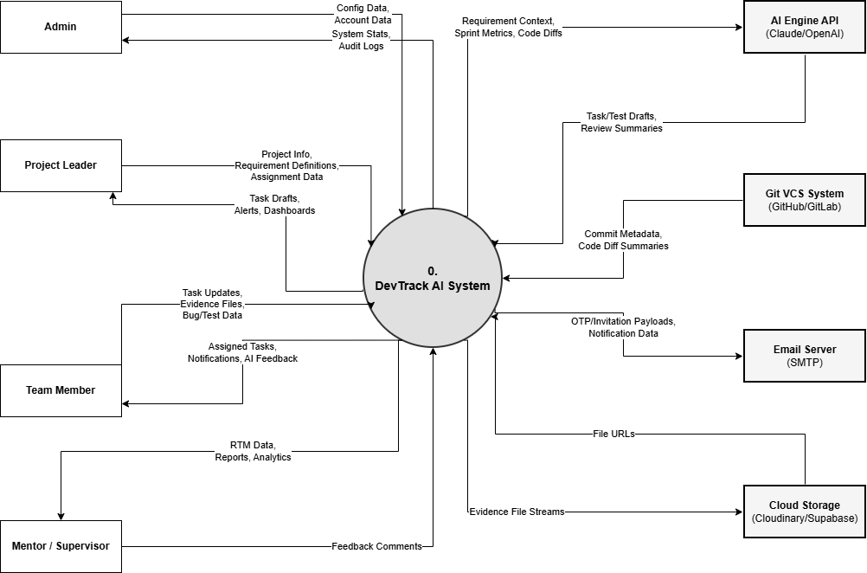
Figure 1: Context Diagram for the system

2. User Requirements

2.1 Actors
Actor | Description | Main Permissions
Guest | A user who has not logged in or has not created an account yet. This actor can only access public authentication-related features before becoming a registered user | Register a new account, verify OTP, login, and request password reset.
Admin | The system administrator responsible for maintaining the whole DevTrack AI platform. Admin ensures that user accounts, system activities, and moderation functions operate correctly. | Manage users, monitor system activity, handle moderation, and support system-level administration.
Project Leader | Create and update projects, invite members, manage requirements, assign tasks, manage sprints, review evidence, and generate reports. | Create and update projects, invite members, manage requirements, assign tasks, manage sprints, review evidence, and generate reports.
Team Member | A student who participates in a project as a working member. Team Members are responsible for completing assigned tasks, providing evidence, creating tests, and reporting issues during development. | View project workspace, update assigned tasks, upload evidence, create test cases, execute tests, report bugs, and comment on project artifacts.
Mentor | A lecturer, supervisor, or academic reviewer who monitors project progress without directly editing the team’s working data. Mentor focuses on reviewing traceability, contribution, evidence, and reports. | View project data, inspect RTM, view contribution analytics, review evidence, read weekly reports, and leave comments or feedback.
AI Service | An external or internal AI-supported service used by DevTrack AI to assist the team during planning, testing, risk detection, and reporting. AI output is treated as a suggestion and should be reviewed by users. | Generate task suggestions, suggest test cases, summarize missing artifacts, identify risk patterns, and draft weekly progress reports.
GitHub Integration | An external repository integration that connects DevTrack AI with the team’s GitHub source code repository. It helps collect commit metadata and convert development activity into traceable evidence. | Provide commit metadata, repository activity, changed-file information, contribution signals, and code-related evidence.
Table 2 - Actors Description

2.2 Use Cases

2.2.1 Diagram(s)
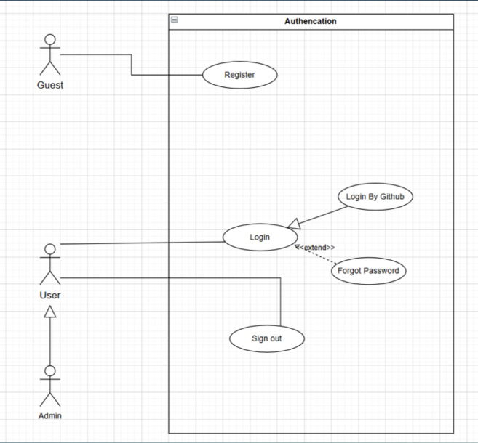
Figure 2: Use Case Diagram for Authentication

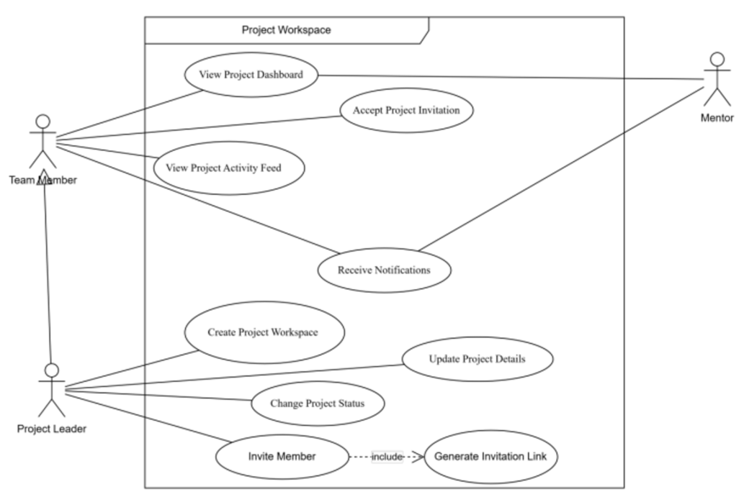
Figure 3: Use Case Diagram for Project Workspace
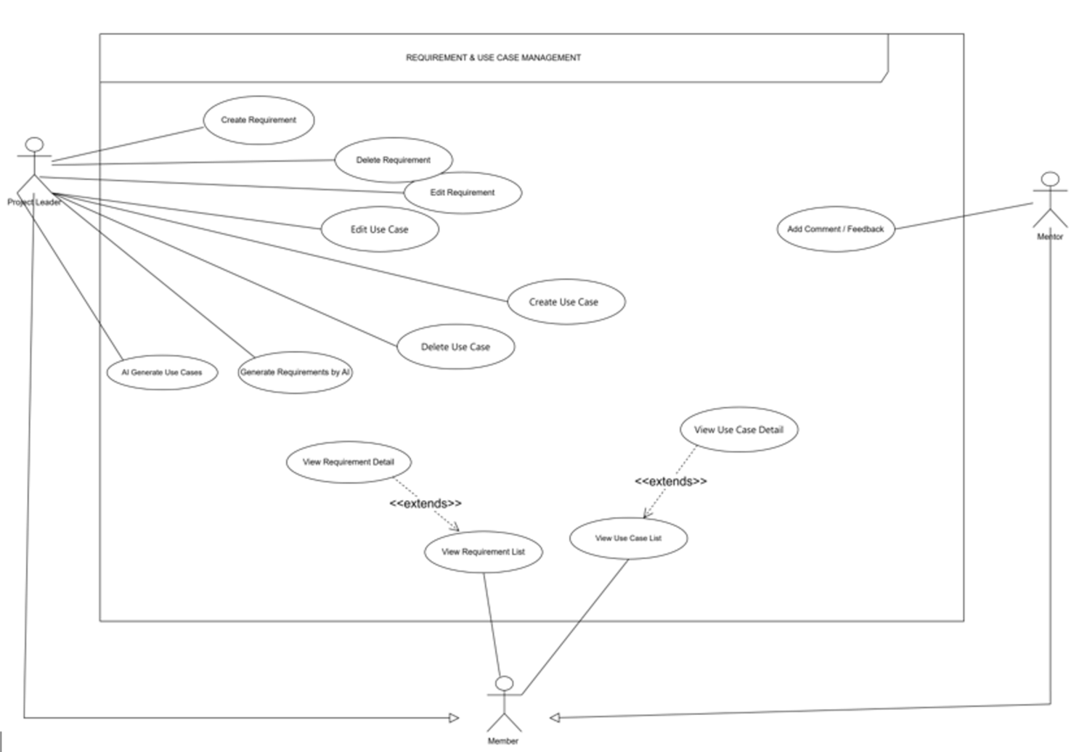
Figure 4: Use Case Diagram for Requirement and Use Case Management

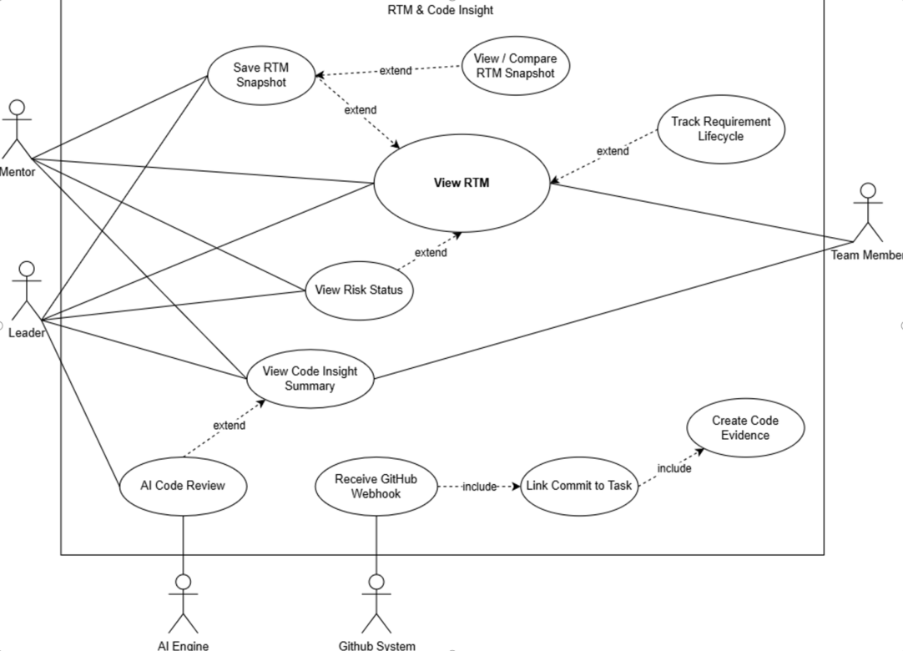
Figure 5: Use case diagram for Requirement Traceability

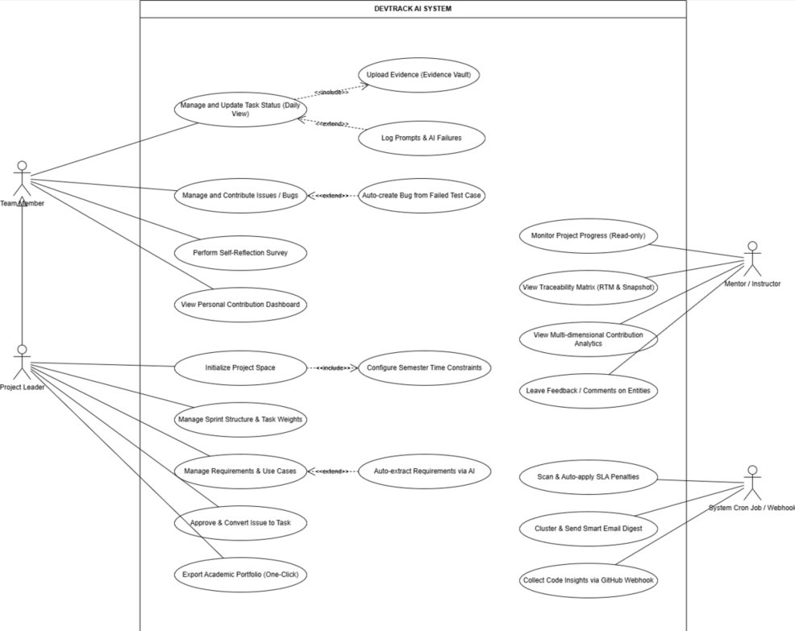
Figure 6: Use case diagram for Task, Sprint, Contribution Rules

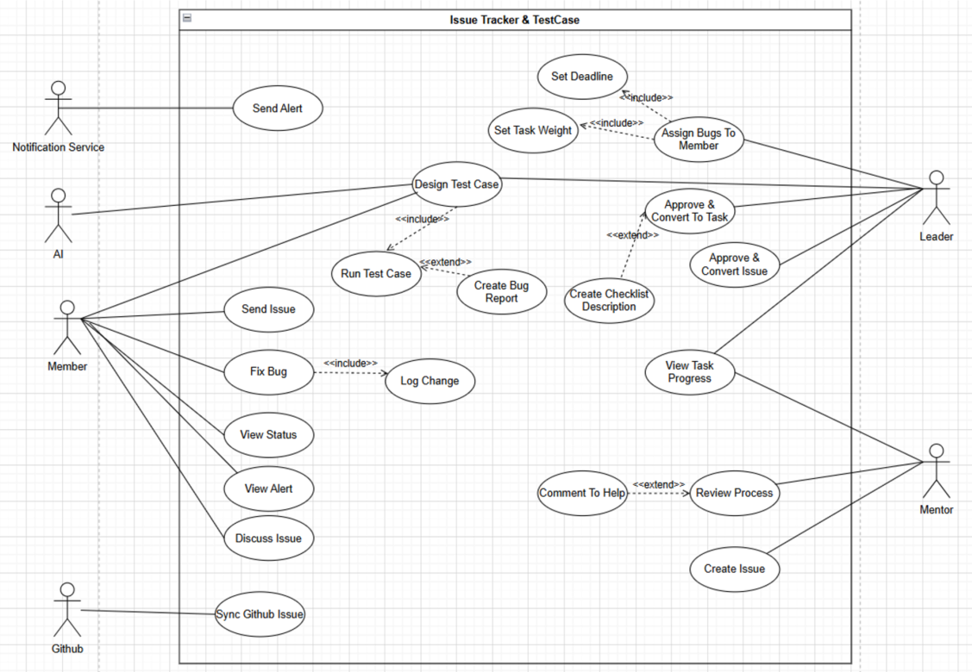
Figure 7: Use case diagram for Issue & Bug Tracker

2.2.2 Descriptions
The following table summarizes the main DevTrack AI use cases selected for the report. The descriptions are based on the use case plan and the UC diagram document, focusing on business-level behavior rather than implementation details.

ID | Use Case | Actors | Use Case Description
UC-01 | Register Account | Guest | Allows a guest to create a user account using valid registration information so they can access project workspace features.
UC-02 | Login | Guest | Allows a registered user to authenticate with valid credentials and enter the DevTrack AI system according to their role.
UC-03 | Logout | Team Member / Project Leader / Mentor | Allows an authenticated user to end the current session and prevent further access until the next login.
UC-04 | View Profile | Team Member / Project Leader / Mentor | Allows a user to view personal account information, role, and basic participation details in the system.
UC-05 | Create Project | Project Leader | Allows a project leader to create a new academic project workspace with basic project information, course context, and timeline.
UC-06 | View Project Dashboard | Project Leader / Team Member / Mentor | Allows project participants to view project status, recent activity, progress indicators, and key traceability summaries.
UC-07 | Invite Member | Project Leader | Allows the project leader to invite team members or mentors to join a project workspace through an invitation flow.
UC-08 | Accept Invitation | Team Member / Mentor | Allows an invited user to accept a project invitation and become part of the workspace with the assigned role.
UC-09 | Manage Member Role | Project Leader | Allows the project leader to review project members and update their roles or permissions when needed.
UC-10 | Create Requirement | Project Leader | Allows the project leader to create a formal requirement that becomes the starting point of the traceability chain.
UC-11 | Edit Requirement | Project Leader | Allows the project leader to update requirement information such as title, description, priority, or acceptance criteria.
UC-12 | View Requirement Detail | Project Leader / Team Member / Mentor | Allows authorized users to inspect requirement information and understand related use cases, tasks, tests, evidence, and RTM status.
UC-13 | Create Use Case | Project Leader | Allows the project leader to define a use case that describes how an actor interacts with the system to satisfy a requirement.
UC-14 | Edit Use Case | Project Leader | Allows the project leader to update use case information such as actor, goal, main flow, alternative flow, and postconditions.
UC-15 | Link Use Case to Requirement | Project Leader | Allows the project leader to connect a use case with one or more requirements to maintain traceability.
UC-16 | Create Task | Project Leader | Allows the project leader to create a task from project work, usually linked to a requirement or use case for tracking.
UC-17 | Assign Task | Project Leader | Allows the project leader to assign a task to a team member and define responsibility, deadline, and expected contribution.
UC-18 | Update Task Status | Team Member | Allows a team member to update task progress through workflow states such as To Do, In Progress, and Done.
UC-19 | View Kanban Board | Project Leader / Team Member | Allows project users to view tasks in a Kanban board layout and monitor the team's current workload and progress.
UC-20 | View My Tasks | Team Member | Allows a team member to view assigned tasks, deadlines, status, and required evidence in one personal task view.
UC-21 | Manage Sprint | Project Leader | Allows the project leader to organize tasks into sprint periods and manage sprint-level planning for the team.
UC-22 | Receive Deadline Reminder | Team Member | Allows the system to notify members about upcoming or missed deadlines so that work can be handled on time.
UC-23 | Apply Overdue Penalty | System | Allows the system to apply overdue rules when tasks pass their deadline without valid completion or accepted evidence.
UC-24 | Calculate Contribution by Task Weight | System / Project Leader | Allows the system to calculate member contribution using task weight, completion status, and related rules instead of only counting tasks.
UC-25 | Create Test Case | Team Member / Project Leader | Allows authorized users to create test cases for verifying whether requirements and related tasks are satisfied.
UC-26 | View Test Case | Team Member / Project Leader / Mentor | Allows project participants to view test case details, expected results, actual results, and related requirements.
UC-27 | Update Test Result | Team Member | Allows a team member to record the result of a test execution and mark it as passed, failed, or needing review.
UC-28 | Create Issue or Bug | Team Member / Mentor | Allows a user to report an issue or bug discovered during testing, review, or project work.
UC-29 | Convert Issue to Task | Project Leader | Allows the project leader to convert a valid issue or bug into an actionable task for assignment and tracking.
UC-30 | Upload Evidence | Team Member | Allows a team member to upload work evidence such as screenshots, files, links, or notes to prove task completion.
UC-31 | Link Evidence to Task or Requirement | Team Member / Project Leader | Allows evidence to be connected with a task or requirement so completion can be traced and verified.
UC-32 | Review Evidence | Project Leader | Allows the project leader to inspect submitted evidence and decide whether it is sufficient for progress confirmation.
UC-33 | Accept or Reject Evidence | Project Leader | Allows the project leader to approve valid evidence or reject insufficient evidence with feedback for correction.
UC-34 | View RTM | Project Leader / Team Member / Mentor | Allows users to view the Requirement Traceability Matrix showing relationships among requirements, use cases, tasks, tests, bugs, evidence, and status.
UC-35 | View RTM Risk Status | Project Leader / Mentor | Allows leaders and mentors to identify traceability risks such as missing tasks, missing test cases, unresolved issues, or missing evidence.
UC-36 | Save RTM Snapshot | Project Leader | Allows the project leader to save the current RTM state for comparison, reporting, or progress review at a later time.
UC-37 | AI Suggest Task or Test Case | AI Engine / Project Leader | Allows the AI engine to generate draft task or test case suggestions from requirements or use cases for human review.
UC-38 | Detect Missing Artifact | AI Engine / System | Allows the AI engine or system to detect missing artifacts in the traceability chain and warn users about incomplete work.
UC-39 | Generate Weekly Report | AI Engine / Project Leader | Allows the system to generate a weekly progress report summarizing project status, risks, completed work, and pending items.
UC-40 | Record AI Audit Log | Team Member / System | Allows the system to record AI-assisted actions, prompts, suggestions, or failures for transparency and later review.
UC-41 | Mentor View Project Progress | Mentor | Allows a mentor to monitor project progress in read-only mode through dashboards, RTM views, and contribution information.
UC-42 | Mentor Comment | Mentor | Allows a mentor to leave feedback or comments on project entities such as tasks, requirements, issues, or evidence.
UC-43 | Admin Manage Users | Admin | Allows an administrator to manage user accounts and support basic system governance when administrative control is required.
Table 3 - Use Case Description

3. Functional Requirements

3.1 System Functional Overview

3.1.1 Screens Flow

3.1.1.1 Screen Flow of Guest/User
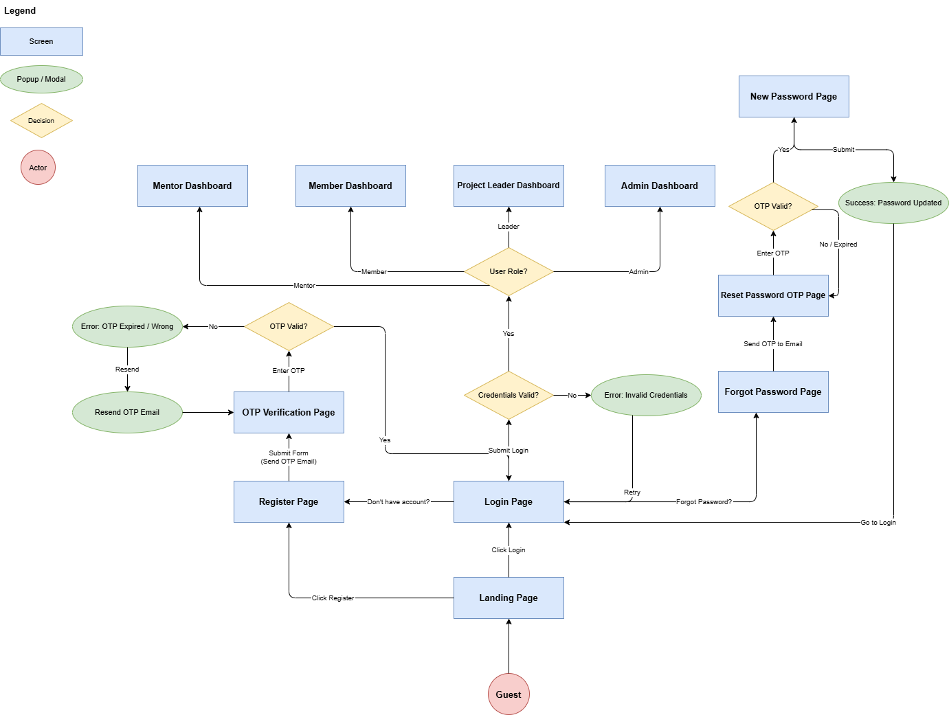
Figure 8: Screen Flow of Guest/User

3.1.1.2 Screen Flow of Project Leader
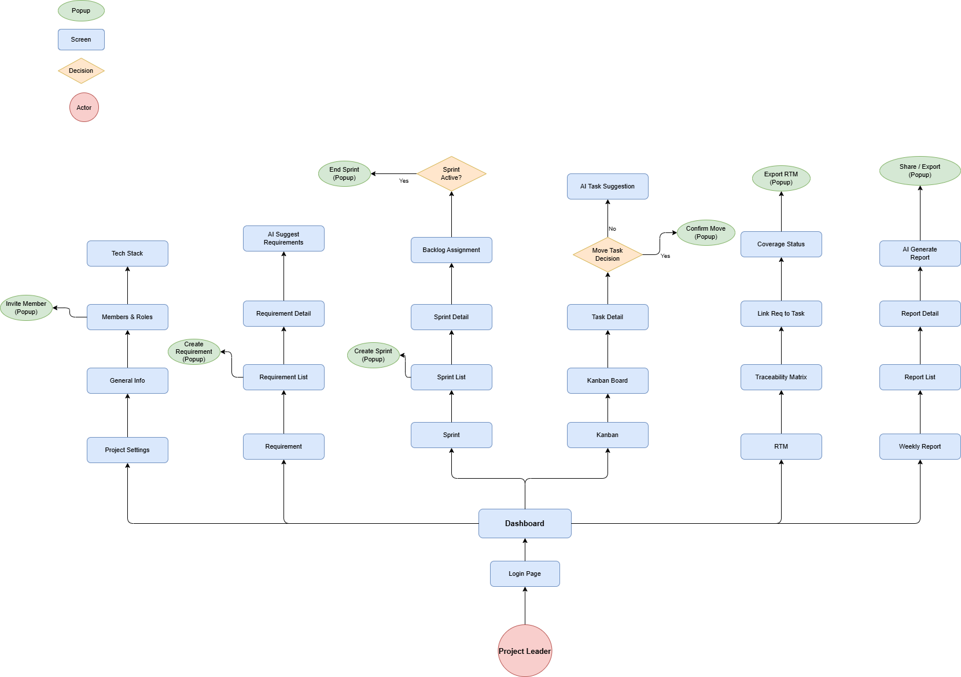
Figure 9: Screen Flow of Project Leader

3.1.1.3 Screen Flow of Team Member
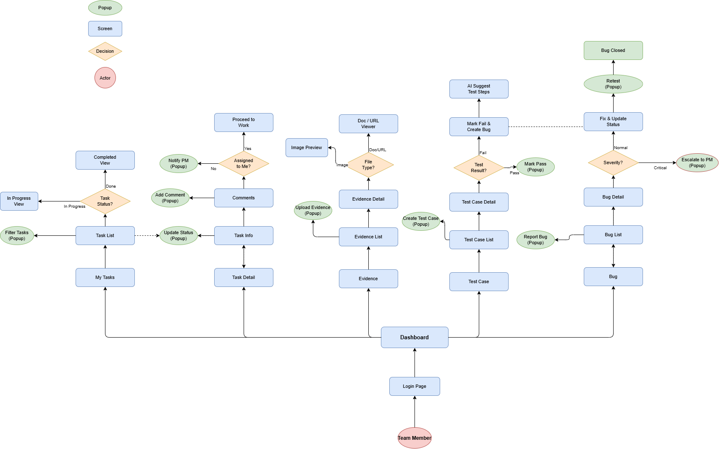
Figure 10: Screen Flow of Team Member

3.1.1.3 Screen Flow of Team Member
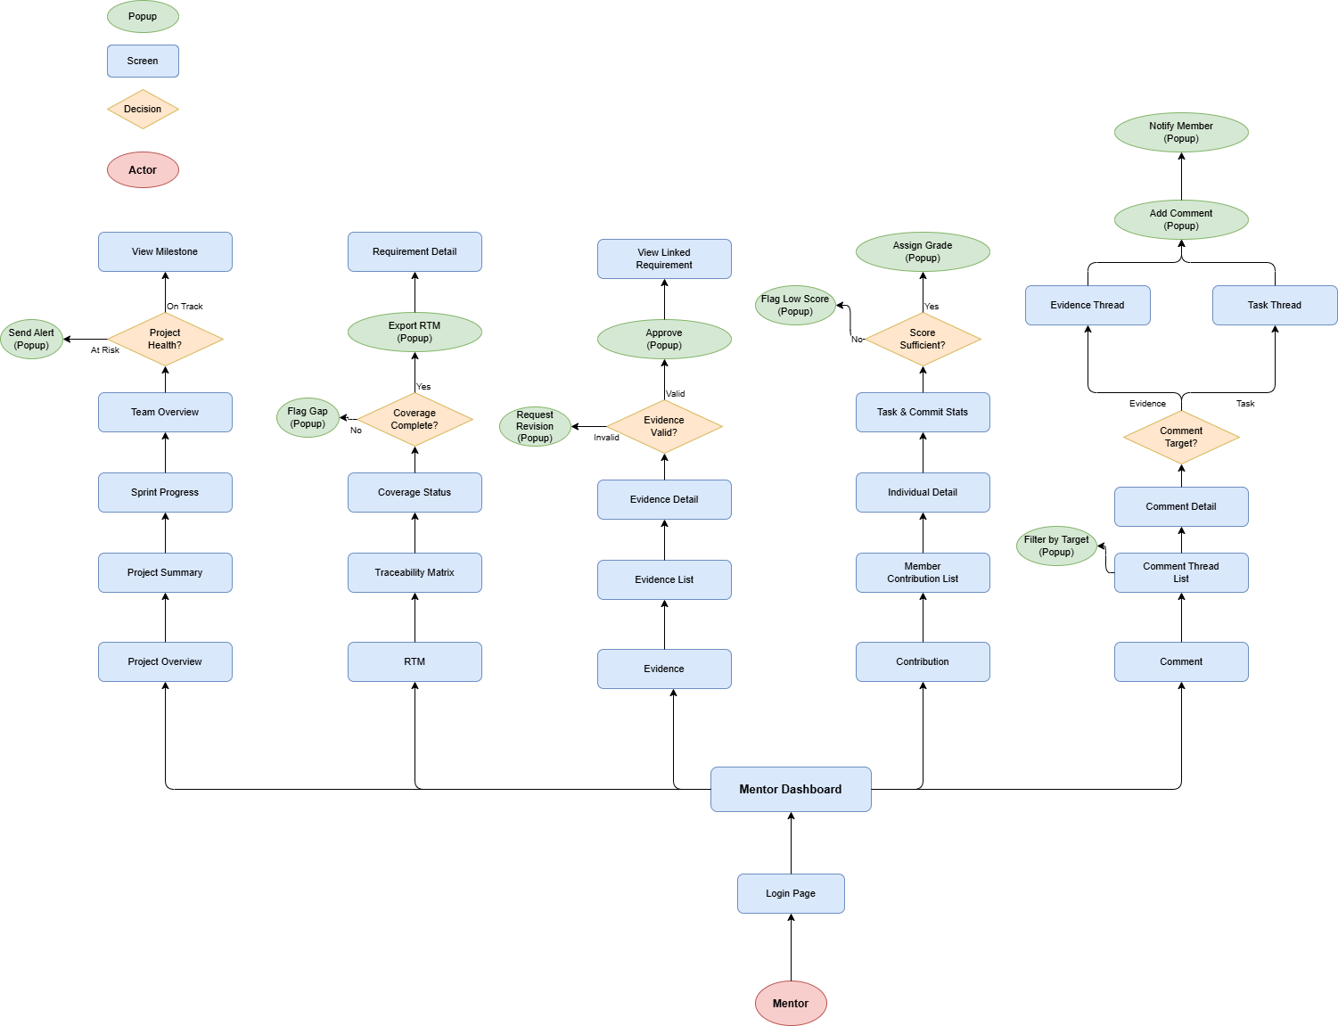
Figure 11: Screen Flow of Mentor

3.1.2 Screen Descriptions
# | Screen | Purpose | Status / Note
1 | Login/Register | Authenticate users and verify accounts. | Implemented in frontend auth module.
2 | Project Dashboard | Show project health, progress and recent activity. | Implemented in workspace module.
3 | Requirement Page | Manage project requirements and acceptance criteria. | Implemented in requirement module.
4 | Sprint Page | Plan sprint goals and task schedule. | Implemented in sprint module.
5 | Kanban Board | Track tasks by status. | Implemented in kanban module.
6 | My Tasks | Show personal daily/weekly work. | Implemented in my-task module.
7 | Test Case Page | Create and run test cases. | Implemented in testing module.
8 | Issue/Bug Tracker | Manage bugs and feature discussion. | Implemented in issue-tracker module.
9 | Evidence Vault | Upload, preview and review evidence. | Implemented in evidence module.
10 | RTM Page | Show requirement traceability matrix. | Implemented in rtm module.
11 | Code Insight | Configure GitHub and inspect code contribution. | Implemented in code-insight module.
12 | Sprint Report | Generate sprint report and export PDF. | Implemented in sprint-report module.
13 | Mentor Dashboard | Read-only mentor view. | Implemented in mentor module.
Table 4 - Screen Descriptions

3.1.3 Screen Authorization
# | Feature | Admin | Leader | Member | Mentor
1 | User Management | Full | No | No | No
2 | Project Workspace | View | Full | Project-scoped | Read-only
3 | Requirement/Use Case | View | Full | Create/Edit | Read-only + Comment
4 | Sprint/Task/Kanban | View | Full | Project-scoped | Read-only
5 | Test/Bug | View | Full | Create/Edit | Read-only
6 | Evidence | View | Review | Upload/Edit | Read-only
7 | RTM/Report | View | Generate/Edit | View | Read-only
Table 5 - Screen Authorization

3.1.4 Non-Screen Functions
# | Function | Description
1 | OTP/Email | Send verification and password recovery email.
2 | Redis Session | Store session, OTP and cache data.
3 | Kafka/Local Event Publisher | Publish notification/SLA/outbox events.
4 | Cloudinary Storage | Store evidence files.
5 | GitHub API | Fetch commit data and repository metadata.
6 | Playwright Service | Execute automated UI tests and return live test status.
7 | AI Engine | Generate task suggestions, test suggestions and weekly report draft.
8 | SLA State Engine | Detect overdue/risk tasks and create recovery plans.
Table 6 - Non-Screen Functions

3.1.5 Entity Relationship Diagram
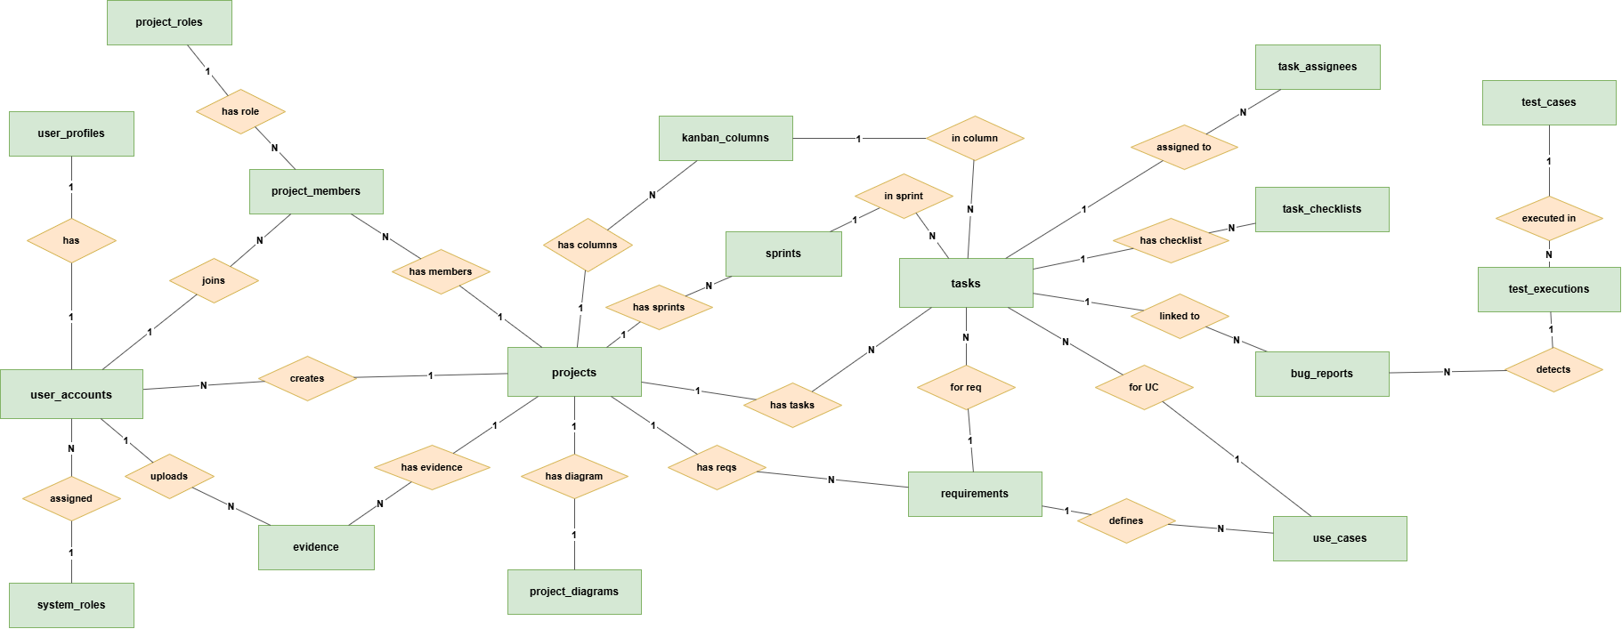
Figure 12: Entity Relationship Diagram
Entities Description

# | Entity | Description
1 | system_roles | Stores global system-level roles and permission groups used to control access across DevTrack.
2 | user_accounts | Stores user login accounts, credentials, account status, and basic authentication information.
3 | user_profiles | Stores personal profile details linked to each user account, such as name, avatar, and contact information.
4 | project_roles | Defines project-specific roles and permissions, such as owner, manager, developer, tester, or member.
5 | projects | Stores the main project workspaces in DevTrack, including project name, description, timeline, and status.
6 | project_members | Links users to projects and records their assigned project role within each project team.
7 | sprints | Stores sprint iterations for a project, including sprint goal, start date, end date, and progress status.
8 | requirements | Stores captured project requirements that describe the expected system features, rules, and constraints.
9 | use_cases | Stores use cases created from requirements to describe actor interactions and system behavior.
10 | tasks | Stores project work items that team members need to complete during development, testing, or documentation.
11 | task_assignees | Links tasks to the users responsible for completing or tracking those tasks.
12 | task_checklists | Stores smaller checklist items inside a task so progress can be tracked step by step.
13 | kanban_columns | Stores workflow columns on the Kanban board, such as To Do, In Progress, Review, and Done.
14 | test_cases | Stores test cases with steps, test data, and expected results used to verify requirements and use cases.
15 | test_executions | Stores records of test case runs, including actual results, execution status, tester, and execution time.
16 | bug_reports | Stores defects found during testing or system use, including priority, severity, status, and related task or test.
17 | evidence | Stores supporting proof such as screenshots, logs, files, or links attached to bugs, tests, or tasks.
18 | project_diagrams | Stores diagrams generated or uploaded for project analysis and design, such as use case or data diagrams.
Table 7 - Entities Description

3.2 Register
Function Description
Guest creates account and verifies email/OTP.
Actors/Roles: Guest
Input | Processing | Output
User/project data submitted from UI. | Backend validates request, checks project permission, updates database, and returns response. | Updated data is shown on the relevant screen and notification/report data may be generated.
Screen Layout
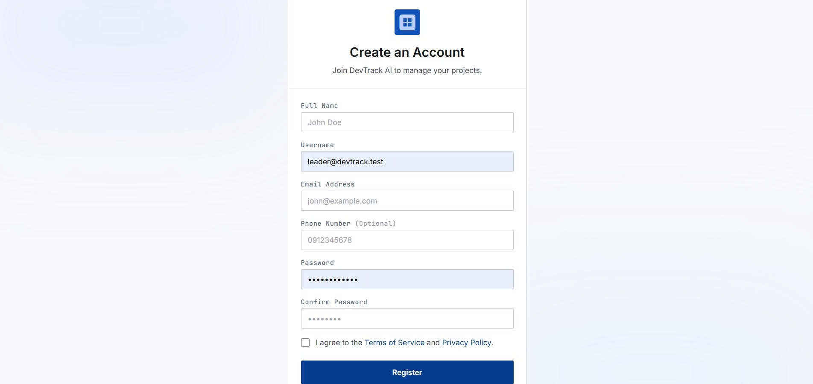
Figure 13: Register page
Validation
- Required fields must not be empty.
- User must have permission for the project.
- Invalid data returns an error message.
Business Rules
- Data must be project-isolated.
- Important AI-generated content must be reviewed by a human.
- Implemented. Need screenshot of Register and OTP screens.

3.3 Login
Function Description
User logs in and enters workspace.
Actors/Roles: Guest/User

Input | Processing | Output
User/project data submitted from UI. | Backend validates request, checks project permission, updates database, and returns response. | Updated data is shown on the relevant screen and notification/report data may be generated.
Screen Layout
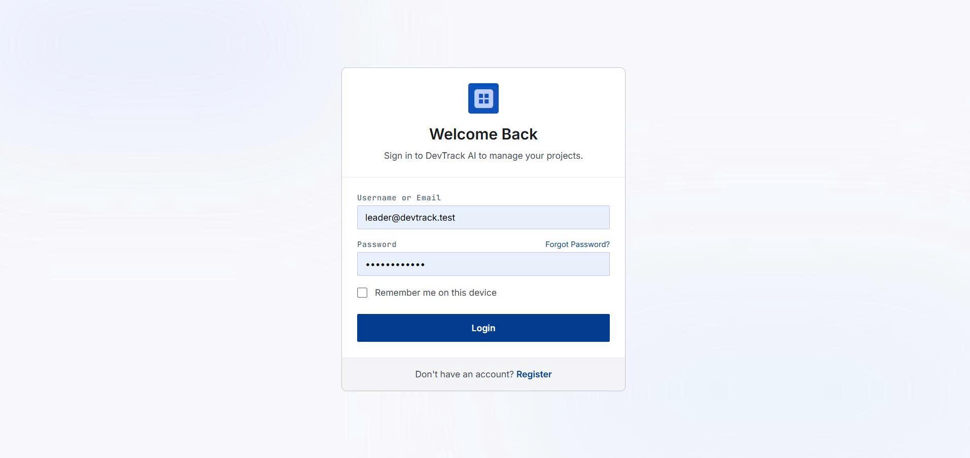
Figure 14: Login page
Validation
- Required fields must not be empty.
- User must have permission for the project.
- Invalid data returns an error message.
Business Rules
- Data must be project-isolated.
- Important AI-generated content must be reviewed by a human.
- Implemented. Need screenshot of Login screen.

3.4 Forgot Password
Function Description
User resets password through email verification.
Actors/Roles: Registered User
Input | Processing | Output
User/project data submitted from UI. | Backend validates request, checks project permission, updates database, and returns response. | Updated data is shown on the relevant screen and notification/report data may be generated.
Screen Layout

Figure 15: Forgot password page
Validation
- Required fields must not be empty.
- User must have permission for the project.
- Invalid data returns an error message.
Business Rules
- Data must be project-isolated.
- Important AI-generated content must be reviewed by a human.
- Implemented. Need screenshot if this flow is shown in demo.

3.5 Project Workspace Management
Function Description
Leader creates and manages project, members and dashboard.
Actors/Roles: Project Leader
Input | Processing | Output
User/project data submitted from UI. | Backend validates request, checks project permission, updates database, and returns response. | Updated data is shown on the relevant screen and notification/report data may be generated.
Screen Layout
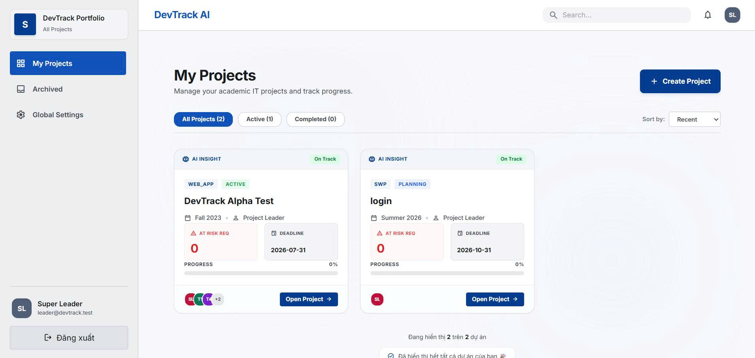
Figure 16: Project work space
Validation
- Required fields must not be empty.
- User must have permission for the project.
- Invalid data returns an error message.
Business Rules
- Data must be project-isolated.
- Important AI-generated content must be reviewed by a human.
- Implemented. Need screenshots: Project Dashboard, Project Settings/Invite Member.

3.6 Requirement Management
Function Description
Team creates requirements, acceptance criteria, status, priority and use cases.
Actors/Roles: Leader/Member
Input | Processing | Output
User/project data submitted from UI. | Backend validates request, checks project permission, updates database, and returns response. | Updated data is shown on the relevant screen and notification/report data may be generated.
Screen Layout
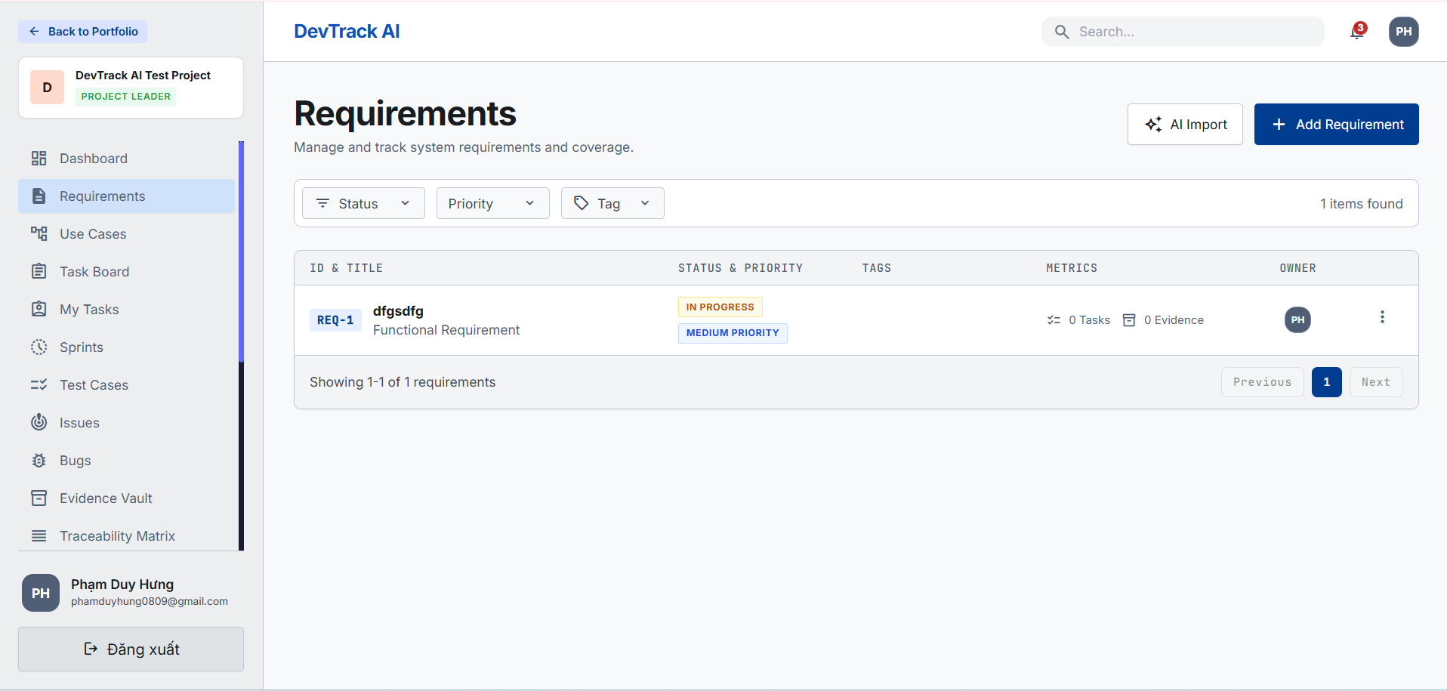
Figure 17: Requirement list page
Validation
- Required fields must not be empty.
- User must have permission for the project.
- Invalid data returns an error message.
Business Rules
- Data must be project-isolated.
- Important AI-generated content must be reviewed by a human.
- Implemented. Need screenshots: Requirement list/form and Use Case screen.

3.7 Task and Sprint Management
Function Description
Team plans sprints and tracks tasks on kanban/personal views.
Actors/Roles: Leader/Member
Input | Processing | Output
User/project data submitted from UI. | Backend validates request, checks project permission, updates database, and returns response. | Updated data is shown on the relevant screen and notification/report data may be generated.
Screen Layout
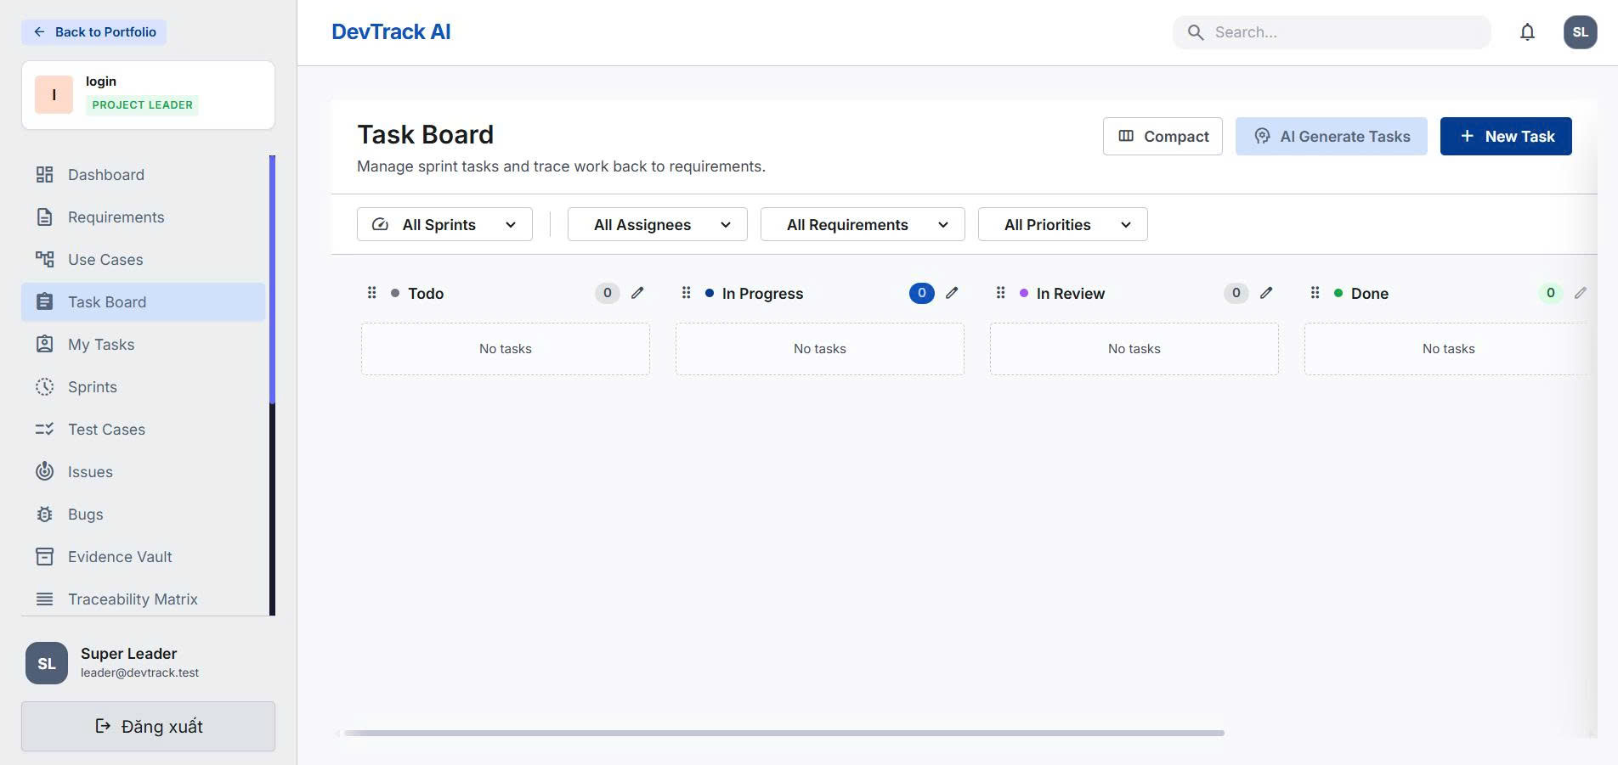
Figure 18: Task page
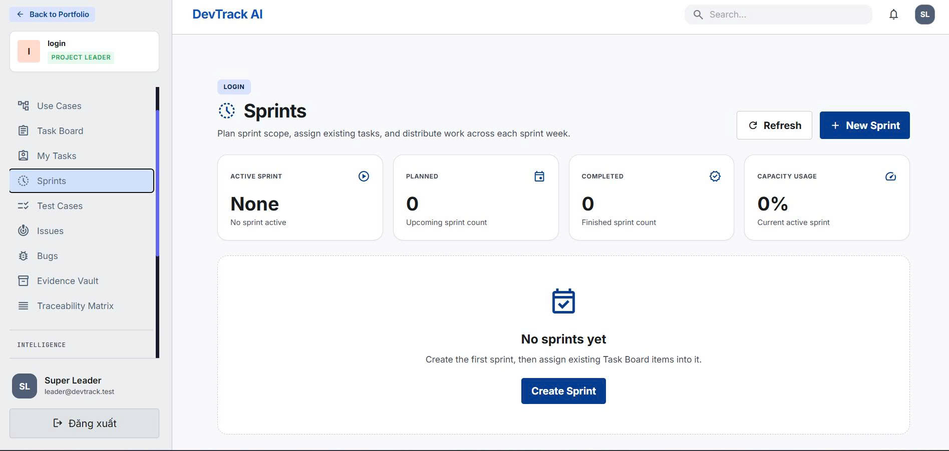
Figure 19: Sprint page
Validation
- Required fields must not be empty.
- User must have permission for the project.
- Invalid data returns an error message.
Business Rules
- Data must be project-isolated.
- Important AI-generated content must be reviewed by a human.
- Implemented. Need screenshots: Sprint page, Kanban board, My Tasks.

3.8 Test Case and Bug Tracking
Function Description
Team creates test cases, runs tests and reports bugs.
Actors/Roles: Tester/Member
Input | Processing | Output
User/project data submitted from UI. | Backend validates request, checks project permission, updates database, and returns response. | Updated data is shown on the relevant screen and notification/report data may be generated.

Validation
- Required fields must not be empty.
- User must have permission for the project.
- Invalid data returns an error message.
Business Rules
- Data must be project-isolated.
- Important AI-generated content must be reviewed by a human.
- Implemented. Need screenshots: Test Case page, Test Run panel, Bug detail.

3.9 Evidence Vault
Function Description
Members upload proof and link evidence to requirements/tasks/tests/bugs.
Actors/Roles: Member/Leader
Input | Processing | Output
User/project data submitted from UI. | Backend validates request, checks project permission, updates database, and returns response. | Updated data is shown on the relevant screen and notification/report data may be generated.
Screen Layout
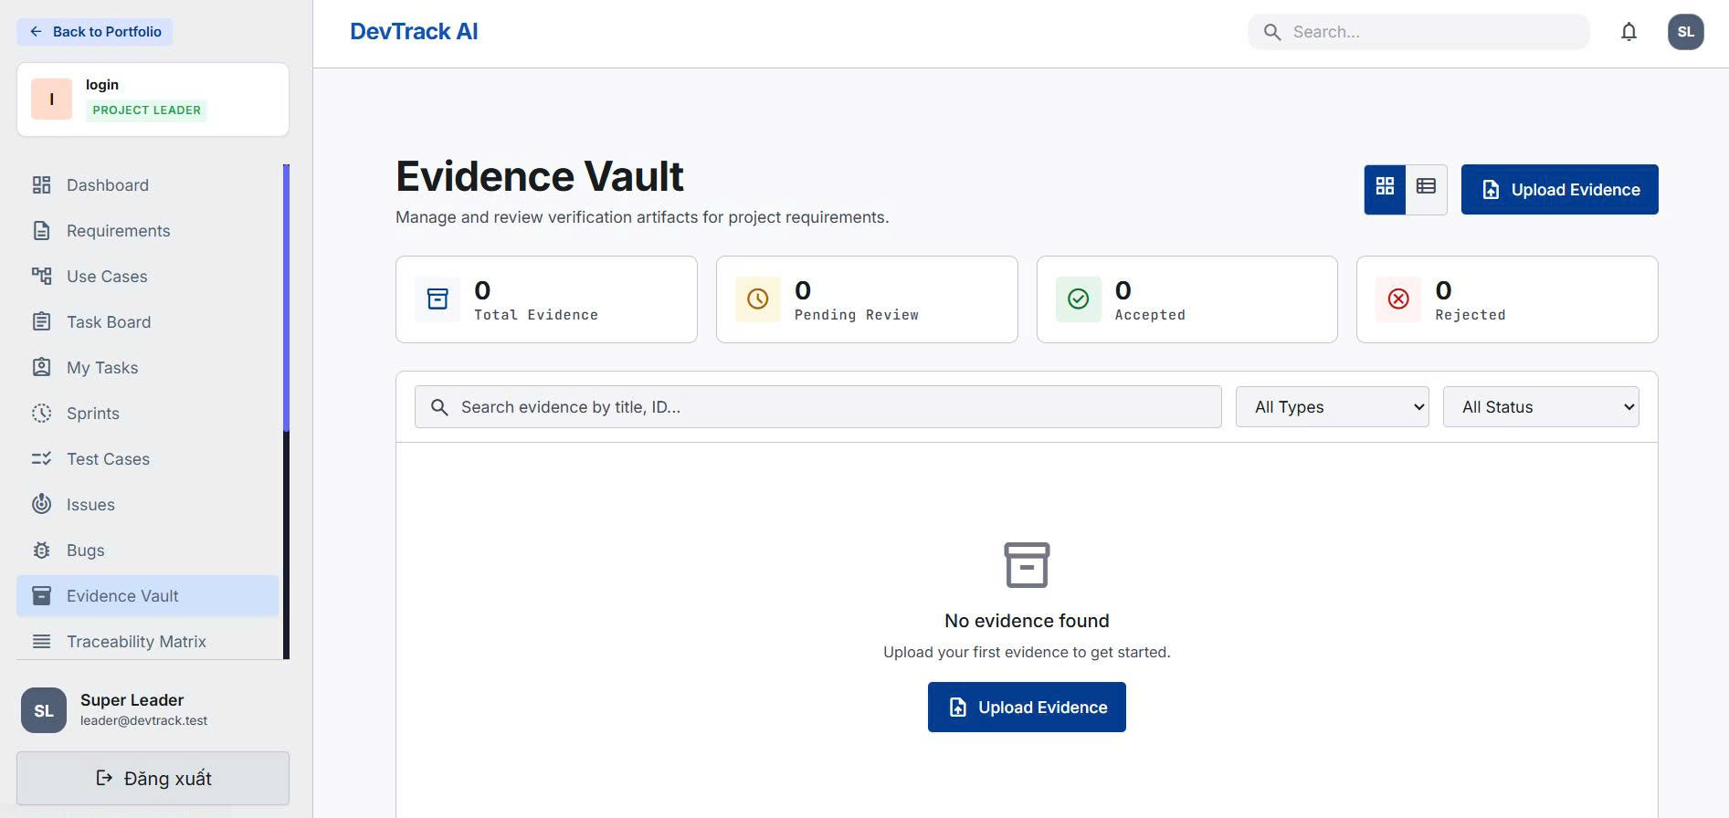
Figure 20: Evidence vault page
Validation
- Required fields must not be empty.
- User must have permission for the project.
- Invalid data returns an error message.
Business Rules
- Data must be project-isolated.
- Important AI-generated content must be reviewed by a human.
- Implemented. Need screenshots: Evidence list, Evidence detail, upload modal.

3.10 Requirement Traceability Matrix
Function Description
System aggregates requirement coverage and risk status.
Actors/Roles: Leader/Mentor
Input | Processing | Output
User/project data submitted from UI. | Backend validates request, checks project permission, updates database, and returns response. | Updated data is shown on the relevant screen and notification/report data may be generated.
Screen Layout
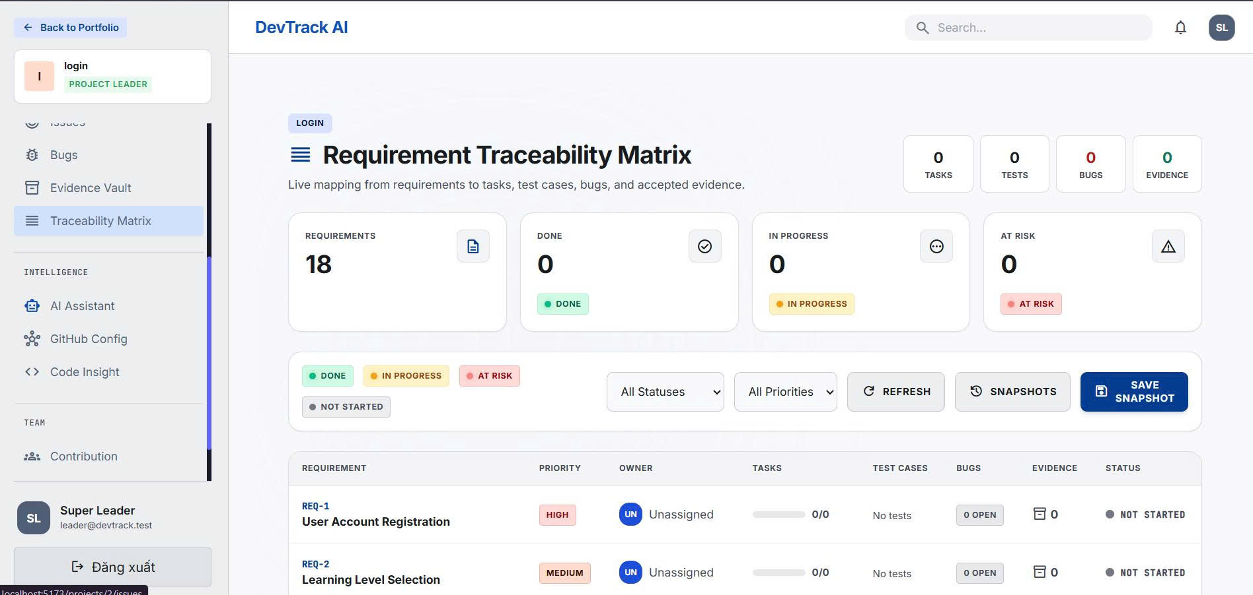
Figure 21: Traceability Matrix page
Validation
- Required fields must not be empty.
- User must have permission for the project.
- Invalid data returns an error message.
Business Rules
- Data must be project-isolated.
- Important AI-generated content must be reviewed by a human.
- Implemented. Need screenshot: RTM matrix and detail drawer.

3.11 Code Insight and GitHub Integration
Function Description
System connects GitHub and analyzes commit/contribution signals.
Actors/Roles: Leader/Member
Input | Processing | Output
User/project data submitted from UI. | Backend validates request, checks project permission, updates database, and returns response. | Updated data is shown on the relevant screen and notification/report data may be generated.
Screen Layout
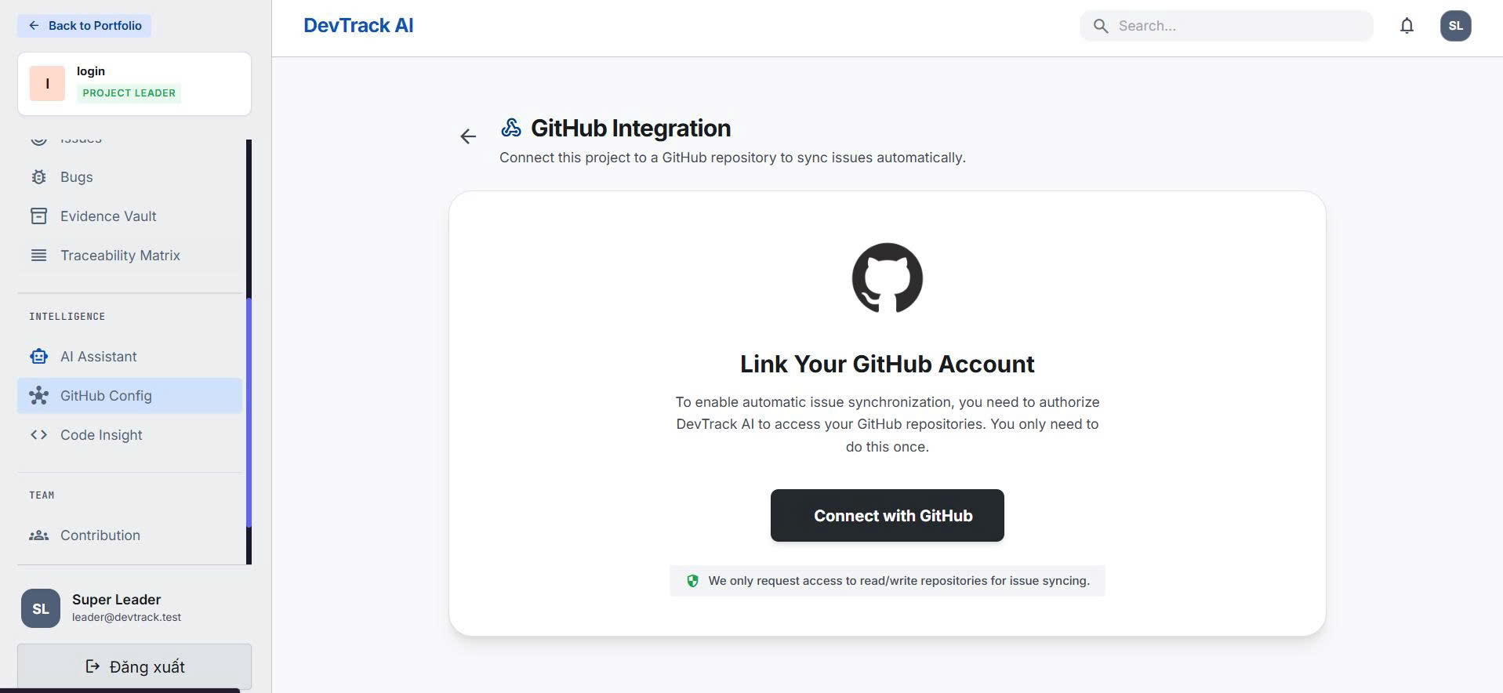
Figure 22: Github integration page
Validation
- Required fields must not be empty.
- User must have permission for the project.
- Invalid data returns an error message.
Business Rules
- Data must be project-isolated.
- Important AI-generated content must be reviewed by a human.
- Implemented in source. Need screenshot: Code Insight config/result page. If GitHub demo is not configured, mark as partial demo.

3.12 AI Engine and Weekly Report
Function Description
AI suggests tasks/tests and generates weekly sprint reports.
Actors/Roles: Leader/AI
Input | Processing | Output
User/project data submitted from UI. | Backend validates request, checks project permission, updates database, and returns response. | Updated data is shown on the relevant screen and notification/report data may be generated.
Screen Layout
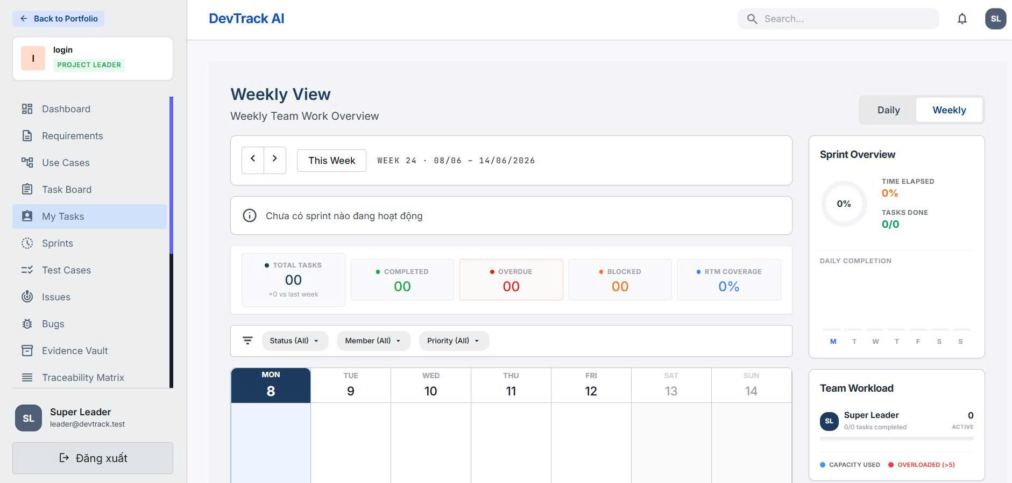
Figure 23: Weekly view page
Validation
- Required fields must not be empty.
- User must have permission for the project.
- Invalid data returns an error message.
Business Rules
- Data must be project-isolated.
- Important AI-generated content must be reviewed by a human.
- Implemented in source modules. Need screenshot: AI suggestion/report result. If API key is not available, mark as local/demo-limited.

3.13 Mentor Dashboard
Function Description
Mentor views project progress and comments read-only.
Actors/Roles: Mentor
Input | Processing | Output
User/project data submitted from UI. | Backend validates request, checks project permission, updates database, and returns response. | Updated data is shown on the relevant screen and notification/report data may be generated.

Validation
- Required fields must not be empty.
- User must have permission for the project.
- Invalid data returns an error message.
Business Rules
- Data must be project-isolated.
- Important AI-generated content must be reviewed by a human.
- Implemented in frontend module. Need screenshot: Mentor dashboard.

4. System Requirements

4.1 External Interfaces

4.1.1 User Interfaces
- Frontend: React 18, Vite, TailwindCSS, Axios, Zustand, React Router, Recharts, jsPDF/html2canvas.
- Main frontend features: auth, workspace, requirement, sprint, kanban, my-task, testing, issue-tracker, evidence, rtm, code-insight, analytics, mentor, sprint-report, ai-engine.

4.1.2 Software Interfaces
Layer | Technology
Backend | Java 21, Spring Boot 4, Spring Security, Spring Web MVC, Spring Data JPA, Validation, Mail, WebSocket.
Database | PostgreSQL with Flyway migrations; MongoDB for flexible support data.
Cache/Session | Redis and Spring Session Data Redis.
Event Bus | Kafka with local publisher fallback.
File Storage | Cloudinary.
Automation | Node.js Express Playwright service with WebSocket.
AI | Anthropic SDK in playwright-service; AI engine features in frontend/backend modules.
Repository | GitHub OAuth/API integration and encrypted user tokens.
Table 8 - Software Interfaces

4.2 Quality Attributes
Attribute | Requirement
Usability | UI must be simple for student teams and mentors.
Security | Passwords, sessions, project authorization and GitHub tokens must be protected.
Performance | Dashboard, kanban, RTM and report views should load quickly for demo-size projects.
Maintainability | Frontend and backend are separated by feature/layer.
Reliability | Outbox/event fallback should avoid blocking user actions when Kafka is not available.
Table 9 - Quality Attributes

5. Other Requirements

5.1 Business Rules
- Only project members can access project data.
- Project Leader manages project members and task assignment.
- Requirement should connect to use cases, tasks, tests and evidence.
- Evidence should be reviewed before being treated as valid proof.
- Failed test cases should be traceable to bug reports.
- Mentor can view and comment but cannot edit core project data.
- GitHub token and webhook secrets must not be exposed.

5.2 Application Messages List
Code | Message | Type
AUTH-001 | Login successful. | Success
AUTH-002 | Invalid email or password. | Error
PRJ-001 | Project created successfully. | Success
REQ-001 | Requirement saved successfully. | Success
TASK-001 | Task status updated. | Success
EVD-001 | Evidence uploaded successfully. | Success
TEST-001 | Test run completed. | Success
BUG-001 | Bug report created. | Success
RTM-001 | Traceability matrix refreshed. | Success
AI-001 | AI suggestion generated. Please review before applying. | Info
GIT-001 | GitHub repository connected. | Success
Table 10 - Application Messages List

Appendix A. Missing Images / Required Inserts
No. | Place in Report | Image Needed | Status
1 | Figure 1 | Context diagram overview | Need user-provided image
2 | Figure 2 | Project setup workflow | Need user-provided image
3 | Figure 3 | Requirement to delivery workflow | Need user-provided image
4 | Figure 4 | AI and Code Insight workflow | Need user-provided image
5-11 | Use Case section | Use case diagrams for each module | Need user-provided image
12-15 | Screen Flow section | Screen flow diagrams for Guest/Leader/Member/Mentor | Need user-provided image
16 | ERD section | Entity Relationship Diagram from database | Need user-provided image
17+ | Functional sections | Screenshots of real UI pages | Optional but recommended for final submission

Parts that may be marked as partial demo if not configured on the local machine: GitHub OAuth/webhook, AI provider API key, Kafka runtime, Cloudinary credentials, and automated Playwright execution service.

