

Requirement & Design Specification
Integrated HR and Project Management System (HRP)
Version: 1.0

– DaNang, May 2026 –

Record of Changes

Version | Date | A*  M, D | In charge | Change Description
V1.0 | 15/2 | A | KienNTHE11
*A - Added M - Modified D - Deleted

Contents
Contents 3
I. Introduction 5
1.1 Purpose 5
1.2 Document Conventions 5
1.3 Intended Audience and Reading Suggestions 5
1.4 Project Scope 6
1.5 Product Scope 6
II. Overall Description 7
2.1 Product Perspective 7
2.2 Current Systems 7
2.3 Product Functions 8
2.4 User Classes and Characteristics 8
2.5 Operating Environment 9
2.6 Assumptions and Dependencies 9
III. Overview 10
1. User Requirements 10
1.1 Actors 10
1.2 Use Cases 11
2. Overall Functionalities 19
2.1 Reset Password Screens Flow 19
2.2 Screen Descriptions 19
2.3 Screen Authorization 21
2.4 Non-UI Functions 22
3. System High Level Design 24
3.1 Database Design 24
3.2 Code Packages 26
IV. Requirement Specifications 28
1. Functional Description Contents 28
1.1. Authentication Feature 29
1.2. Employee Management Feature 32
1.3. Attendance Management Feature 33
1.4. Payroll Management Feature 36
1.5. Recruitment Management Feature 38
1.6. Project Management Feature 39
1.7. Task Management Feature 41
1.8. Agent Support Feature 42
2. Common Functions 44
2.1 UC-2_Login System 44
3. Patron Feature 45
3.1 UC-5_Order a Meal 45
3.2 UC-6_Register for Payroll Deduction 47
V. Design Specifications 48
1. <<Feature Name>> 48
1.1 <<SubFeature Name>> 48
1.2 System Access 49
VI. Appendix 53
1. Assumptions & Dependencies 53
2. Limitations & Exclusions 53
3. Business Rules 53

Table of Figures
Figure 1 Employee Management 11
Figure 2 Payroll Management 12
Figure 3 Authentication 12
Figure 4 Task Management 13
Figure 5 Agent Support 13
Figure 6 Recruit Management 14
Figure 7 Project Management 14
Figure 8 Attendance Management 15

I. Introduction

1.1 Purpose
This document is the Software Requirements Specification (SRS) for the Integrated HR and Project Management System (HRP). The document fully describes the functional requirements, non-functional requirements, high-level database design, and user permissions for the system.
The goal of the document is to provide a common platform for stakeholders – including the development team, HR Manager, General Manager, and testers – to ensure the system is built to meet the organization's business needs.

1.2 Document Conventions
The document follows the following symbology and identification conventions:

Ký hiệu | Định dạng | Ví dụ
Use Case ID | UC-XX (XX là số thứ tự) | UC-01, UC-22, UC-52
Business Rule ID | BR-[MODULE]-XX | BR-ATT-01, BR-PAY-01
Preconditions | PRE-X | PRE-1: User is authenticated
Postconditions | POST-X | POST-1: Record is stored
Exceptions | X.Y.EZ | 5.0.E1 (UC5, normal flow, exception 1)
Priority | Must Have / Should Have / Could Have | Must Have + High

1.3 Intended Audience and Reading Suggestions
This document is aimed at the following audiences with the corresponding recommended reading:

Đối tượng | Vai trò | Phần nên đọc
Nhóm phát triển (Developer) | Thiết kế và xây dựng hệ thống | Toàn bộ tài liệu, đặc biệt Phần II và III
HR Manager / Business Owner | Xác nhận yêu cầu nghiệp vụ | Phần I – Overview, Phần II – Requirement Specifications
Kiểm thử (QA/Tester) | Kiểm tra chức năng hệ thống | Phần II – Normal Flow, Alternative Flows, Exceptions
Quản trị hệ thống (Admin) | Vận hành và bảo mật hệ thống | Phần I mục 2.3 Screen Authorization, Phần III
General Manager | Phê duyệt và giám sát tổng thể | Phần I mục 1.1 Actors, mục 2.3 Screen Authorization

1.4 Project Scope
The project scope includes the entire functional modules of the HRP as described in detail in section 1.5 below. The project does not include integration with external ERP systems (SAP, Oracle), financial accounting systems, or any third-party platforms other than the Social Platform API for recruitment and hardware fingerprinting devices.

1.5 Product Scope
An HRP system is an integrated internal management platform, designed to digitize and automate HR operations and project management in an organization. The system consists of the following main modules:
• Authentication: Login, logout, password reset, session control, and login logging.
• Employee Management: Add, update, and disable employee records; Manage roles and decentralization.
• Attendance Management: Fingerprint attendance, shift management, application processing (leave, overtime, remote work, shift change, special mode).
• Payroll Management: Configure payroll components, create salary templates, automatically calculate scheduled payroll, approve and export payroll reports, view individual payslips.
• Recruitment Management: Posting job postings (with social media integration), managing candidate profiles, scheduling interviews, processing recruitment proposals.
• Project Management: Create and manage projects, assign members, and track progress.
• Task Management: Create, assign, update, and track tasks within a project.
• Agent AI (Agent Support): Allows agents to send orders in natural language; The agent authenticates the user's identity and executes the command within the scope of the assigned permissions.
Main business objectives:
• Minimize manual operations in HR processes, increase processing accuracy and speed.
• Ensure transparency and traceability in timekeeping, payroll, and project management.
• Create a unified data platform that supports real-time decision-making for management.
• Establish a strict role-based access control system (RBAC).

II. Overall Description

2.1 Product Perspective
HRP is a new, standalone software system built to replace HR and project management processes that are currently done discretely (via email, Excel spreadsheets, or non-integrated tools). The system interacts with several peripheral components:
• Fingerprint Scanner: Sends attendance data to the system via a background sync service (Fingerprint Sync Service) running in the background.
• Social Platforms (LinkedIn, etc.): Receive job postings posted from HRP via the built-in API configured by the Administrator.
• Email system: Send automatic notifications to employees (login information, application approval results, interview schedule confirmation, etc.).
• Cron Job – Auto Payroll Generation: An internal service that automatically triggers scheduled payroll configured by General Manager.

2.2 Current Systems
Before implementing HRP, the organization was using discrete manual tools and processes. The table below summarizes the current situation and limitations of each sector:

Đối tượng | Vai trò | Phần nên đọc
Nhóm phát triển (Developer) | Thiết kế và xây dựng hệ thống | Toàn bộ tài liệu, đặc biệt Phần II và III
HR Manager / Business Owner | Xác nhận yêu cầu nghiệp vụ | Phần I – Overview, Phần II – Requirement Specifications
Kiểm thử (QA/Tester) | Kiểm tra chức năng hệ thống | Phần II – Normal Flow, Alternative Flows, Exceptions
Quản trị hệ thống (Admin) | Vận hành và bảo mật hệ thống | Phần I mục 2.3 Screen Authorization, Phần III
General Manager | Phê duyệt và giám sát tổng thể | Phần I mục 1.1 Actors, mục 2.3 Screen Authorization
Core issues to be addressed:
• Data is scattered and heterogeneous across departments, making it difficult to synthesize and report.
• Lack of standardized approval flow leads to processing delays and loss of information in internal communication.
• There is no clear role-based decentralization (RBAC) system, resulting in the risk of accessing sensitive data.
• It is not possible to trace the history or audit trail of important HR operations such as salary editing and approving leave.
• Individual dependence on maintaining and updating data creates a single point of failure.
HRP is built to solve all of the above problems through a single, integrated platform with role-based decentralization control with 6 actors: Employee, Team Leader, HR Manager, General Manager, Administrator and Internal Agent.

2.3 Product Functions
The system provides a total of 54 use cases in 8 main feature groups, including non-UI functions such as fingerprint synchronization, cron jobs, social media API integration, suspicious activity detection, and Agent command processor. For details, see Part I – Section 1.2 Use Cases and Section 2.4 Non-UI Functions.

2.4 User Classes and Characteristics
The system serves 6 groups of users (actors) with different characteristics and scope of access:
• Employee: Basic End User. It is possible to view personal records, timekeeping, apply from, view payslips, participate in projects, and create tasks.
• Team Leader: Inherit all rights of the Employee. Added the ability to approve applications by affiliates, project managers, and team members.
• HR Manager: Manage employee profiles, configure timekeeping, process payroll, manage recruitment. No project management permissions.
• General Manager: Approve payroll, manage projects, and adjust payroll automation schedules. Have access to the full report.
• Administrator: Manages system security, decentralization, login monitoring, and anomaly detection.
• Internal Agent: The agent automatically handles natural language commands from the user after identity authentication and decentralization.

2.5 Operating Environment
• Platform: Web application accessed via modern browser (Chrome, Firefox, Edge).
• Database: Relational (RDBMS), designed according to 18 main tables (see section 3.1 Database Design).
• Package Architecture: According to the hrp.* structure (hrp.authentication, hrp.employee, hrp.attendance, etc.) – see section 3.2 Code Packages.
• Hardware integration: The fingerprint device connects via a background synchronization service.
• External Integration: Social Platform API (LinkedIn, etc.) with pre-configured Administrator credentials.

2.6 Assumptions and Dependencies
• AS-1: Each employee has a unique email address in the system, which serves as the primary identifier.
• AS-2: Each employee is always assigned at least one approver (Team Leader or HR Manager) to handle applications.
• AS-3: Social media API credentials are configured by the Administrator before the posting feature is used.
• AS-4: The Administrator account is always available to perform password resets for employees.
• DE-1: The system relies on an external email service to send automated notifications; If the email service is interrupted, the notification will be delayed but the system data will not be affected.
• DE-2: The hardware fingerprint device must support a sync protocol compatible with HRP's Fingerprint Sync Service.

III. Overview

1. User Requirements

1.1 Actors

# | Actor | Description
1 | Employee | A staff member of the organization. Can log in, view profile, submit attendance requests, view payroll slips, and use task/project features.
2 | HR Manager | Manages employee records, payroll, attendance configurations, and recruitment processes.
3 | Team Leader | Inherits Employee role. Additionally manages team members in projects, assigns tasks, and approves attendance-related requests for direct reports.
4 | General Manager | Oversees projects, approves/rejects payroll, and modifies payroll generation triggers.
5 | Administrator | Manages system security: creates/modifies/deletes roles, assigns/revokes permissions, views login activity, and monitors suspicious activity.
6 | Internal Agent | An automated internal agent that processes commands after authorization by user credentials.

1.2 Use Cases

a. Diagram(s)

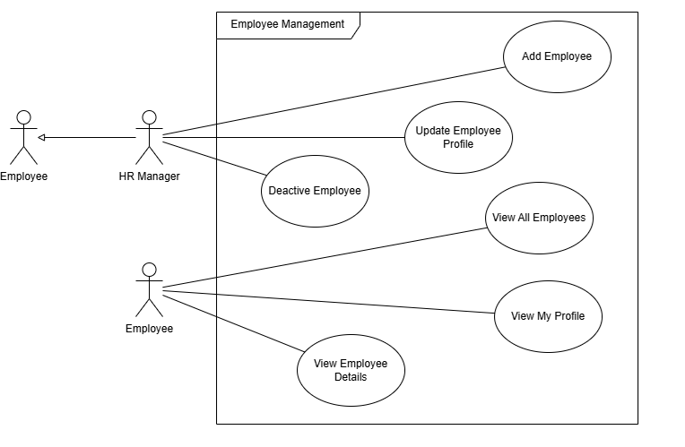
Figure 1 Employee Management
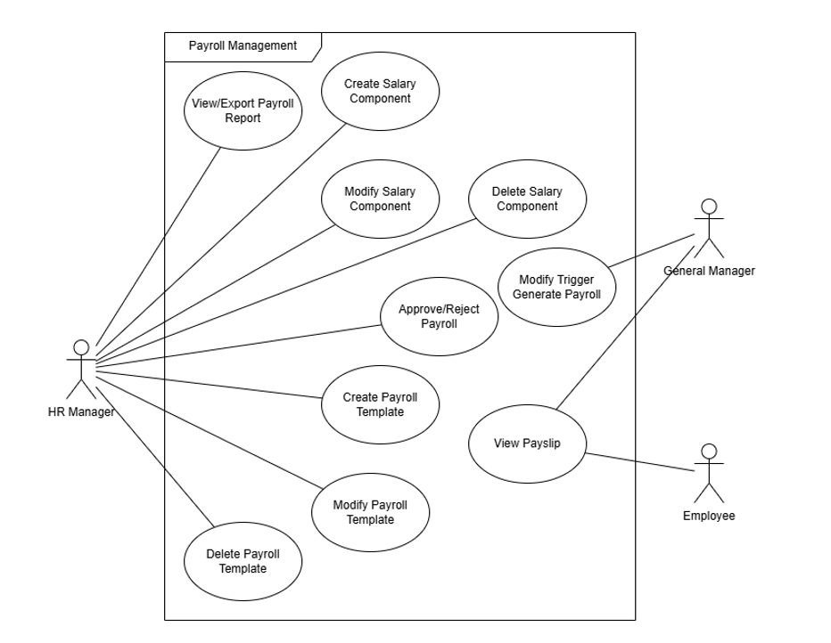
Figure 2 Payroll Management
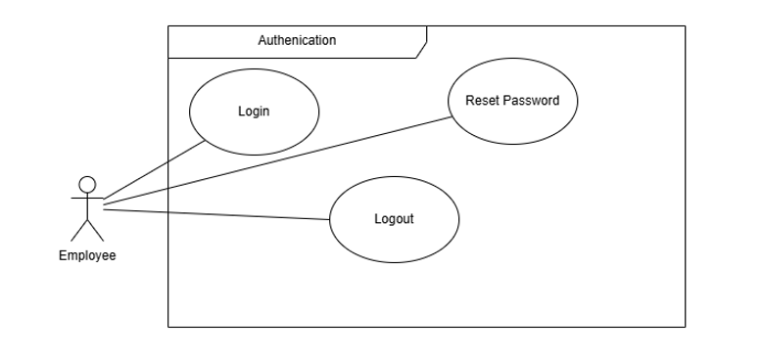
Figure 3 Authentication
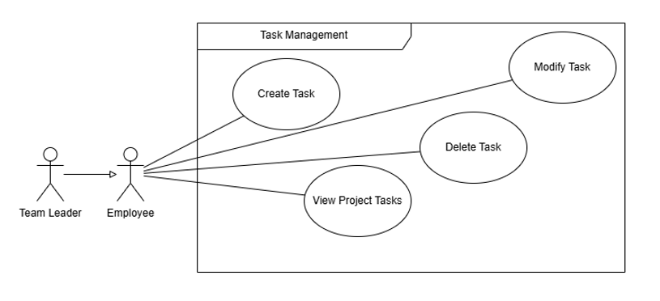
Figure 4 Task Management
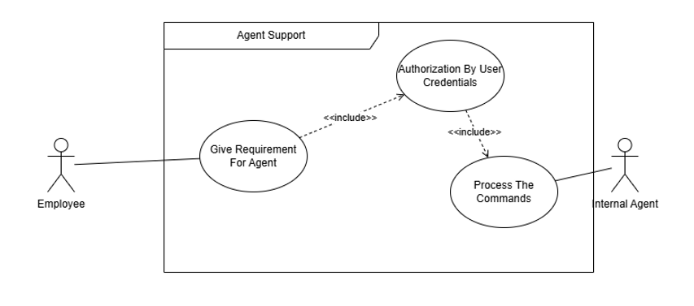
Figure 5 Agent Support
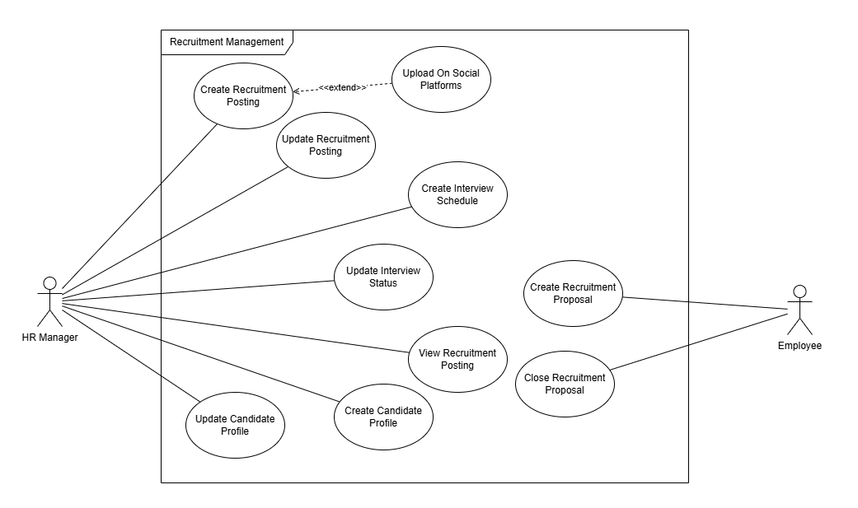
Figure 6 Recruit Management

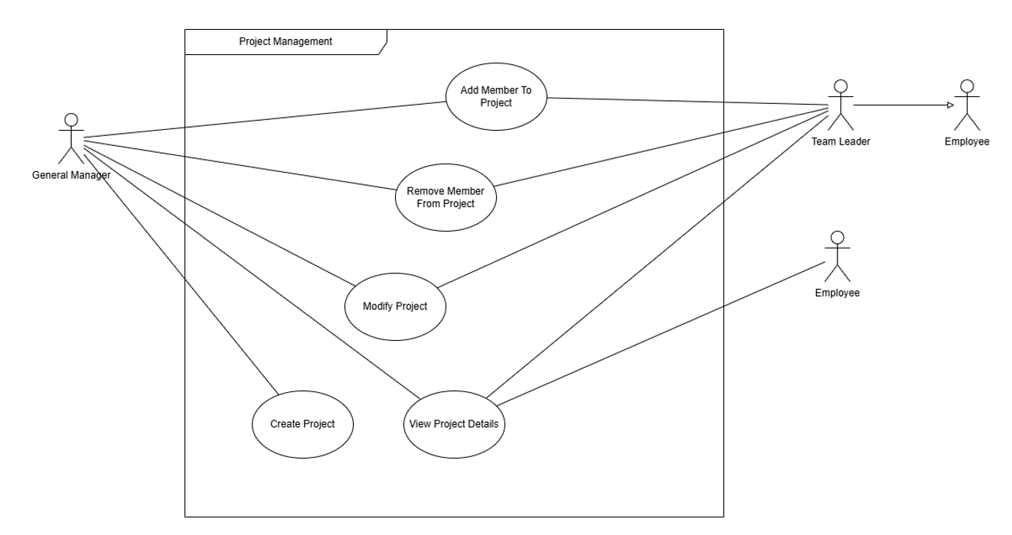
Figure 7 Project Management

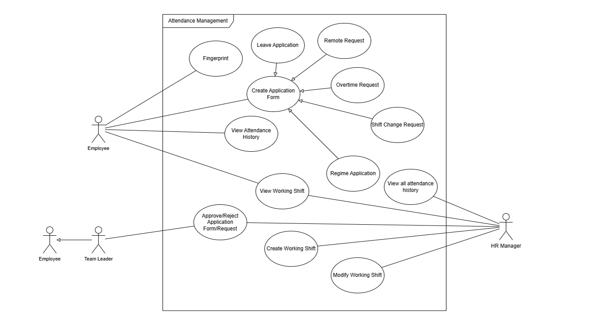
Figure 8 Attendance Management

b. Descriptions

ID | Feature | Use Case | Use Case Description
01 | Authentication | Login | Employee logs into the system with credentials.
02 | Authentication | Logout | Employee logs out and terminates the current session.
03 | Authentication | Reset Password | Employee resets their password by requesting Admin to reset it, then entering a new password and confirming it.
04 | Employee Management | Add Employee | HR Manager adds a new employee profile to the system.
05 | Employee Management | Update Employee Profile | HR Manager updates personal and professional details of an employee.
06 | Employee Management | Deactivate Employee | HR Manager deactivates an employee account (e.g., upon resignation).
07 | Employee Management | View All Employees | HR Manager views the list of all employees.
08 | Employee Management | View My Profile | Employee views their own profile information.
09 | Employee Management | View Employee Details | Employee views detailed information of a specific employee.
10 | Attendance Management | Fingerprint | Employee records attendance via fingerprint scanner.
11 | Attendance Management | View Attendance History | Employee views their own attendance records.
12 | Attendance Management | View All Attendance History | HR Manager views attendance records of all employees.
13 | Attendance Management | Create Application Form | Employee creates an application form (Leave, Overtime, Remote, Shift Change, or Regime).
14 | Attendance Management | Leave Application | Employee submits a leave request (extends Create Application Form).
15 | Attendance Management | Overtime Request | Employee submits an overtime request (extends Create Application Form).
16 | Attendance Management | Remote Request | Employee submits a remote work request  form stating the reason for working  outside the office. By default, employees  work on-site; a Remote Request is  required to be approved before working  remotely.
17 | Attendance Management | Shift Change Request | Employee requests a change to their working shift.
18 | Attendance Management | Regime Application | Employee applies for a special work regime.
19 | Attendance Management | View Working Shift | Employee views their assigned working shift schedule.
20 | Attendance Management | Create Working Shift | HR Manager creates a new working shift template.
21 | Attendance Management | Modify Working Shift | HR Manager modifies an existing working shift.
22 | Attendance Management | Approve/Reject Application Form | Team Leader or HR Manager approves or rejects submitted application forms.
23 | Payroll Management | View/Export Payroll Report | HR Manager views and exports payroll reports.
24 | Payroll Management | Create Salary Component | HR Manager creates a new salary component (e.g., bonus, allowance).
25 | Payroll Management | Modify Salary Component | HR Manager modifies an existing salary component.
26 | Payroll Management | Delete Salary Component | HR Manager removes a salary component.
27 | Payroll Management | Create Payroll Template | HR Manager creates a payroll calculation template.
28 | Payroll Management | Modify Payroll Template | HR Manager modifies an existing payroll template.
29 | Payroll Management | Delete Payroll Template | HR Manager deletes a payroll template.
30 | Payroll Management | Approve/Reject Payroll | HR Manager submits and General Manager approves or rejects payroll.
31 | Payroll Management | View Payslip | Employee views their monthly payslip
32 | Payroll Management | Modify Trigger Generate Payroll | General Manager modifies the schedule/trigger for automatic payroll generation.
33 | Recruitment Management | Create Recruitment Posting | HR Manager creates a job posting for a vacancy.
34 | Recruitment Management | Update Recruitment Posting | HR Manager edits an existing job posting.
35 | Recruitment Management | View Recruitment Posting | HR Manager views the list of open job postings.
36 | Recruitment Management | Upload On Social Platforms | System extends Create Recruitment Posting to publish on social platforms.
37 | Recruitment Management | Create Candidate Profile | HR Manager creates a profile for a job applicant.
38 | Recruitment Management | Update Candidate Profile | HR Manager updates candidate information.
39 | Recruitment Management | Create Interview Schedule | HR Manager schedules an interview for a candidate.
40 | Recruitment Management | Update Interview Status | HR Manager updates the result/status of an interview.
41 | Recruitment Management | Create Recruitment Proposal | Employee submits a recruitment proposal/request for new headcount.
42 | Recruitment Management | Close Recruitment Proposal | Employee closes a recruitment proposal once the position is filled.
43 | Project Management | Create Project | General Manager creates a new project.
44 | Project Management | Modify Project | General Manager or Team Leader modifies project details.
45 | Project Management | Add Member To Project | General Manager or Team Leader adds an employee to a project.
46 | Project Management | Remove Member From Project | General Manager or Team Leader removes a member from a project.
47 | Project Management | View Project Details | General Manager, Team Leader, or Employee views project information.
48 | Task Management | Create Task | Employee creates a new task within a project.
49 | Task Management | Modify Task | Employee modifies an existing task.
50 | Task Management | Delete Task | Employee deletes a task.
51 | Task Management | View Project Tasks | Employee views all tasks associated with a project.
52 | Agent Support | Give Requirement For Agent | Employee provides a natural language requirement/command to the internal agent.
53 | Agent Support | Authorization By User Credentials | The agent verifies the user's identity before executing commands (included in UC-52).
54 | Agent Support | Process The Commands | The agent processes and executes the authorized command (included in UC-53).

2. Overall Functionalities

2.1 Reset Password Screens Flow
[This part shows the system screens and the relationship among screens. You can draw the Screens Flow for the system in the form of diagram as below. Please note that beside the normal flat screen, we might have the oval notation for pop-up screen (Import Order) or a screen with multiple information tab (Order Details), etc. You may also use text or background format for different visuality purpose]
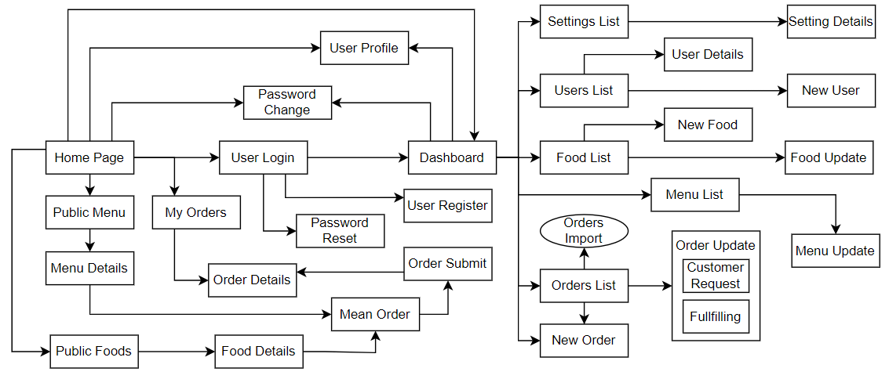

2.2 Screen Descriptions

# | Feature | Screen | Description
1 | Authentication | Login Screen | Screen for employees to enter credentials and log in.
2 | Authentication | Reset Password Screen | Screen for Admin to reset an employee's  password, or for employee to enter and  confirm a new password.
3 | Employee Management | Employee List | Displays all employee records with search and filter options.
4 | Employee Management | Employee Details | Displays full profile of an individual employee.
5 | Employee Management | Add/Edit Employee | Form screen for creating or updating an employee record.
6 | Attendance Management | Attendance Dashboard | Overview of attendance statistics and quick-access links.
7 | Attendance Management | Attendance History | List of check-in/check-out records for an employee
8 | Attendance Management | Application Form Screen | Form for submitting Leave, Overtime, Remote, Shift Change, or Regime requests.
9 | Attendance Management | Working Shift Management | Screen to create, view, and modify working shifts.
10 | Payroll Management | Payroll Dashboard | Summary of payroll status and navigation to sub-features.
11 | Payroll Management | Salary Component Management | CRUD screen for salary components.
12 | Payroll Management | Payroll Template Management | CRUD screen for payroll templates.
13 | Payroll Management | Payroll Report | View and export payroll reports by period.
14 | Payroll Management | Payslip View | Employee's personal payslip screen.
15 | Recruitment Management | Job Postings List | List of open and closed recruitment postings.
16 | Recruitment Management | Candidate Profile Screen | Screen for managing candidate information.
17 | Recruitment Management | Interview Schedule Screen | Calendar/list view of scheduled interviews.
18 | Project Management | Project List | List of all projects with status and key information.
19 | Project Management | Project Details | Detailed view of a project including members and tasks.
20 | Task Management | Task Board/List | Kanban or list view of tasks for a project.
21 | Agent Support | Agent Chat Interface | Chat-based interface for submitting commands to the internal agent.

2.3 Screen Authorization

Screen | Employee | Team Leader | HR Manager | General Manager
Login / Logout / Reset Password | X | X | X | X
View My Profile | X | X | X | X
View Employee Details | X | X | X
View All Employees |  |  | X | X
Add / Update / Deactivate Employee |  |  | X
View Attendance History (own) | X | X
View All Attendance History |  |  | X
Submit Application Forms | X | X
Approve/Reject Application Form |  | X | X
Create / Modify Working Shift |  |  | X
View Working Shift | X | X | X
View/Export Payroll Report |  |  | X | X
Manage Salary Components & Templates |  |  | X
Approve/Reject Payroll |  |  | X | X
Modify Trigger Generate Payroll |  |  |  | X
View Payslip | X | X
Manage Recruitment Postings & Candidates |  |  | X
Create / Close Recruitment Proposal | X | X
Create / Modify Project |  | X |  | X
Add / Remove Project Members |  | X |  | X
View Project Details | X | X |  | X
Create / Modify / Delete Task | X | X
View Project Tasks | X | X |  | X
Agent Support (Give Requirement) | X | X

2.4 Non-UI Functions

# | Feature | System Function | Description
1 | Attendance Management | Fingerprint Sync Service | Background service that synchronizes fingerprint data from hardware devices to the database.
2 | Payroll Management | Auto Payroll Generation (Cron Job) | Scheduled job that automatically generates payroll on a configured trigger date each month.
3 | Recruitment Management | Social Platform Upload API | API integration that publishes job postings to configured social platforms (LinkedIn, etc.).
4 | Authorization & Security | Suspicious Activity Detection | Background service that monitors login patterns and flags anomalies (e.g., multiple failed logins).
5 | Agent Support | Agent Command Processor | Internal service that parses, validates, and executes commands submitted by authorized users.

3. System High Level Design

3.1 Database Design

a. Database Schema
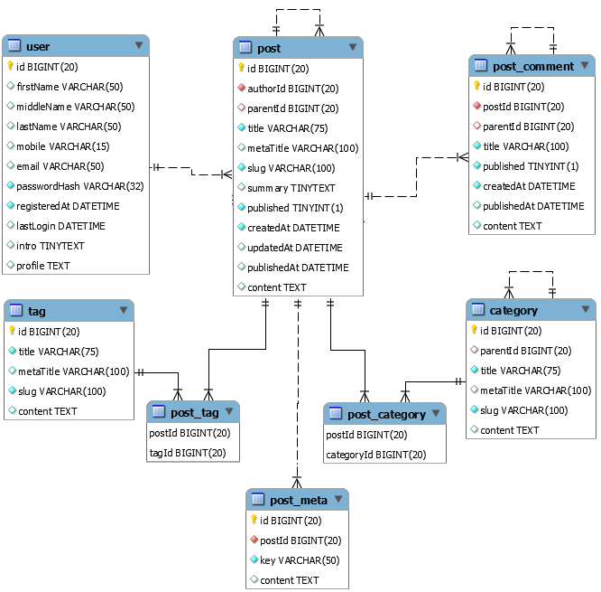

b. Table Descriptions

No | Table | Description
01 | Employee | Stores employee personal and employment information. - Primary keys: employee_id - Foreign keys: role_id (Role)
02 | Role | Defines system roles (Employee, Team Leader, HR Manager, General Manager, Administrator). - Primary keys: role_id
03 | Permission | Defines granular permissions assignable to roles. - Primary keys: permission_id
04 | RolePermission | Junction table mapping roles to permissions. - Primary keys: role_id, permission_id - Foreign keys: role_id, permission_id
05 | Attendance | Records employee check-in/check-out events from fingerprint device. - Primary keys: attendance_id - Foreign keys: employee_id
06 | WorkingShift | Defines working shift schedules. - Primary keys: shift_id
07 | ApplicationForm | Stores leave, overtime, remote, shift change, and regime application forms. - Primary keys: form_id - Foreign keys: employee_id, approver_id
08 | SalaryComponent | Stores salary components such as base pay, bonuses, allowances, deductions. - Primary keys: component_id
09 | PayrollTemplate | Defines payroll calculation templates. - Primary keys: template_id
10 | Payroll | Stores generated payroll records per period. - Primary keys: payroll_id - Foreign keys: template_id, approved_by
11 | Payslip | Individual employee payslip for each payroll period. - Primary keys: payslip_id - Foreign keys: payroll_id, employee_id
12 | RecruitmentPosting | Stores job postings for open positions. - Primary keys: posting_id - Foreign keys: created_by (HR Manager)
13 | Candidate | Stores applicant/candidate information. - Primary keys: candidate_id - Foreign keys: posting_id
14 | InterviewSchedule | Tracks scheduled interviews for candidates. - Primary keys: interview_id - Foreign keys: candidate_id, interviewer_id
15 | Project | Stores project information. - Primary keys: project_id - Foreign keys: created_by
16 | ProjectMember | Junction table mapping employees to projects. - Primary keys: project_id, employee_id - Foreign keys: project_id, employee_id
17 | Task | Stores tasks within projects. - Primary keys: task_id - Foreign keys: project_id, assignee_id, created_by
18 | LoginActivity | Logs all login events for audit and security monitoring. - Primary keys: log_id - Foreign keys: employee_id

3.2 Code Packages
[Provide the package diagram for each sub-system. The content of this section including the overall package diagram, the explanation, package and class naming conventions in each package. Please see the sample & description table format below]
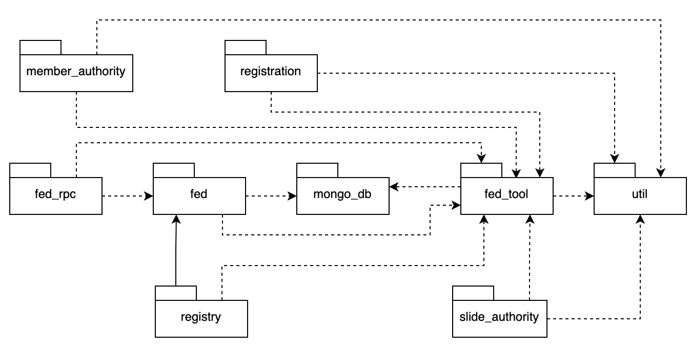
Package descriptions

No | Package | Description
01 | hrp.authentication | Handles login, logout, session management, and password reset functionality.
02 | hrp.employee | Contains controllers, services, and repositories for employee management.
03 | hrp.attendance | Handles attendance recording, working shifts, and application forms processing.
04 | hrp.payroll | Manages salary components, payroll templates, payroll generation, and payslips.
05 | hrp.recruitment | Handles job postings, candidate profiles, interview scheduling, and recruitment proposals.
06 | hrp.project | Manages projects, project members, and project details.
07 | hrp.task | Manages tasks within projects.
08 | hrp.agent | Processes natural language commands from users; handles authorization and execution pipeline.
09 | hrp.security | Manages roles, permissions, login activity log, and suspicious activity detection.
10 | hrp.common | Shared utilities, base classes, exception handlers, and common DTOs.

IV. Requirement Specifications

1. Functional Description Contents
Use Case ID and Name
Give each use case a unique integer sequence number identifier. State a concise name for the use case that indicates the value the use case would provide to some user. Begin with an action verb, followed by an object.
Author and Date Created
Enter the name of the person who initially wrote this use case and the date it was written.
Primary and Secondary Actors
An actor is a person or other entity external to the software system being specified who interacts with the system and performs use cases to accomplish tasks. Different actors often correspond to different user classes, or roles, identified from the customer community that will use the product. Name the primary actor that will be initiating this use case and any other secondary actors who will participate in completing execution of the use case.
Trigger
Identify the business event, system event, or user action that initiates the use case. This trigger alerts the system that it should begin testing the preconditions for the use case so it can judge whether to proceed with execution.
Description
Provide a brief description of the reason for and outcome of this use case, or a high-level description of the sequence of actions and the outcome of executing the use case.
Preconditions
List any activities that must take place, or any conditions that must be true, before the use case can be started. The system must be able to test each precondition. Number each precondition. Example: PRE-1: User’s identity has been authenticated.
Postconditions
Describe the state of the system at the successful conclusion of the use case execution. Label each postcondition in the form POST-X, where X is a sequence number. Example: POST-1: Price of item in the database has been updated with the new value.
Normal Flow
Provide a description of the user actions and corresponding system responses that will take place during execution of the use case under normal, expected conditions. This dialog sequence will ultimately lead to accomplishing the goal stated in the use case name and description. Show a numbered list of actions performed by the actor, alternating with responses provided by the system. The normal flow is numbered “X.0”, where “X” is the Use Case ID.
Alternative Flows
Document other successful usage scenarios that can take place within this use case. State the alternative flow, and describe any differences in the sequence of steps that take place. Number each alternative flow in the form “X.Y”, where “X” is the Use Case ID and Y is a sequence number for the alternative flow. For example, “5.3” would indicate the third alternative flow for use case number 5. Indicate where each alternative flow would branch off from the normal flow, and if pertinent, where it would rejoin the normal flow.
Exceptions
Describe any anticipated error conditions that could occur during execution of the use case and how the system is to respond to those conditions. Number each alternative flow in the form “X.Y.EZ”, where “X” is the Use Case ID, Y indicates the normal (0) or alternative (>0) flow during which this exception could take place, “E” indicates an exception, and “Z” is a sequence number for the exceptions. For example “5.0.E2” would indicate the second exception for the normal flow for use case number 5. Indicate where in the normal (or an alternative) flow each exception could occur.
Priority
Indicate the relative priority of implementing the functionality required to allow this use case to be executed. Use the same priority scheme as that used for the functional requirements.
Frequency of Use
Estimate the number of times this use case will be performed per some appropriate unit of time. This gives an early indicator of throughput, concurrent usage loads, and transaction capacity.
Business Rules
List any business rules that influence this use case. Don’t include the business rule text here, just its identifier so the reader can find it in another repository when needed.
Other Information
Identify any additional requirements, such as quality attributes, for the use case that may need to be addressed during design or implementation. Also list any associated functional requirements that aren’t a direct part of the use case flows but which a developer needs to know about. Describe what should happen if the use case execution fails for some unanticipated or systemic reason (e.g., loss of network connectivity, timeout). If the use case results in a durable state change in a database or the outside world, state whether the change is rolled back, completed correctly, partially completed with a known state, or left in an undetermined state as a result of the exception.
Assumptions
List any assumptions that were made regarding this use case or how it might execute.

1.1. Authentication Feature

1.1 UC-01_Login
a. Functionalities
Functional Description Template
UC ID and Name:
Created By: |  | Date Created:
Primary Actor: |  | Secondary Actors:
Trigger:
Description:
Preconditions:
Postconditions:
Normal Flow:
Alternative Flows:
Exceptions:
Priority: | High (Medium, Low), Must Have (Should Have, Could Have),..
Frequency of Use:
Business Rules:
Other Information:
Assumptions:

b. Business Rules
Provide the business rules those are applied only to the use case
ID | Business Rule | Business Rule Description
FR1 | Password Encoding | User’s password must be encoded with MD5 hashing

1.2 UC-03_Reset Password
a. Functional Description

UC ID and Name: | UC-03_Reset Password
Created By: | Team HRMS | Date Created: | 25/05/2026
Primary Actor: | Employee (all roles) | Secondary Actors: | Administrator / HR Manager (as password resetter)
Trigger: | Employee requests a password reset (contacts Admin), OR Admin initiates a reset on behalf of an employee.
Description: | An employee who has forgotten their password requests the Administrator (or HR Manager) to reset it. The Admin resets the password in the system. The employee then logs in and is prompted to enter a new password and confirm it.
Preconditions: | PRE-1: Employee account exists and is active. PRE-2: Admin is authenticated.
Postconditions: | POST-1: Employee's password is updated to the new password. POST-2: Employee can log in with the new password.
Normal Flow: | 3.0 Reset Password  1. Employee contacts Admin to request a password reset.  2. Admin navigates to the employee's account in the system.  3. Admin triggers the 'Reset Password' action for the employee.  4. System sets a temporary/default password for the employee.  5. Employee logs in using the temporary password. (see 3.0.E1)  6. System prompts employee to enter a new password and confirm it. 7. System validates the new password. (see 3.0.E2)  8. System updates the password.  9. Employee is redirected to the Home Dashboard.
Alternative Flows: | 3.1 Employee resets own password (if currently logged in):  1. Employee navigates to Account Settings.  2. Employee enters new password and confirms it.  3. System validates and updates the password.
Exceptions: | 3.0.E1 Employee enters wrong temporary password: System displays error; employee may retry or contact Admin again.  3.0.E2 New password does not meet policy requirements: System displays an error message and prompts employee to enter a valid password.
Priority: | Must Have
Frequency of Use: | Occasional.
Business Rules: | BR-AUTH-01
Other Information: | Only Administrator or HR Manager with sufficient permission can reset another employee's password.
Assumptions: | Admin accounts are always accessible to perform resets.

b. Business Rules

ID | Business Rule | Business Rule Description
BR-AUTH-01 | Password Policy | Same as login – new password must meet complexity requirements.

1.2. Employee Management Feature

2.1 UC-04_Add Employee
a. Functional Description

UC ID and Name: | UC-04_Add Employee
Created By: | Team HRMS | Date Created: | 25/05/2026
Primary Actor: | HR Manager | Secondary Actors: | None
Trigger: | HR Manager clicks 'Add Employee' on the Employee List screen.
Description: | HR Manager creates a new employee record in the system, including personal details, role assignment, and initial credentials.
Preconditions: | PRE-1: HR Manager is authenticated.
Postconditions: | POST-1: New employee record is stored in the Employee table. POST-2: System-generated credentials are sent to the new employee's email.
Normal Flow: | 1. HR Manager accesses the Add Employee form.  2. HR Manager fills in employee details (name, email, phone, department, role, start date).  3. HR Manager submits the form.  4. System validates the data. (see 4.0.E1)  5. System creates the employee record and assigns initial credentials.  6. System sends a welcome email with credentials to the new employee.
Alternative Flows: | None
Exceptions: | 4.0.E1 Duplicate email: System informs HR Manager that the email already exists.
Priority: | Must Have
Frequency of Use: | Occasional (when new staff joins).
Business Rules: | BR-EMP-01
Other Information:
Assumptions: | Email address is unique per employee.

b. Business Rules

ID | Business Rule | Business Rule Description
BR-EMP-01 | Unique Employee Email | Each employee must have a unique email address in the system.

1.3. Attendance Management Feature

3.1 UC-13_Create Application Form
a. Functional Description

UC ID and Name: | UC-13_Create Application Form
Created By: | Team HRMS | Date Created: | 25/05/2026
Primary Actor: | Employee | Secondary Actors: | Team Leader, HR Manager (as approvers)
Trigger: | Employee clicks 'New Application' on the Attendance dashboard.
Description: | Employee creates and submits an attendance-related application form. The form type can be: Leave Application, Overtime Request, Remote Request, Shift Change Request, or Regime Application. Each type extends this base use case.
Preconditions: | PRE-1: Employee is authenticated.  PRE-2: Employee has an assigned working shift.
Postconditions: | POST-1: Application form is stored with status 'Pending'.  POST-2: Approver (Team Leader or HR Manager) is notified.
Normal Flow: | 1. Employee selects the application type.  2. Employee fills in the form (dates, reason, etc.).  3. Employee submits the form.  4. System validates the form. (see 13.0.E1)  5. System saves the application with status 'Pending'.  6. System notifies the designated approver.
Alternative Flows: | 13.1 Leave Application: Employee selects leave type and date range. 13.2 Overtime Request: Employee specifies overtime date and hours. 13.3 Remote Request: Employee specifies the remote work date(s) and provides a reason/justification for working outside the office. The request must be approved before the employee is allowed to work remotely on that day.  13.4 Shift Change Request: Employee selects current shift and desired shift.  13.5 Regime Application: Employee specifies regime type and period.
Exceptions: | 13.0.E1 Overlapping request: System informs employee of an existing approved request for the same period.
Priority: | Must Have
Frequency of Use: | Daily – multiple submissions per employee per month.
Business Rules: | BR-ATT-01, BR-ATT-02
Other Information: | Applications can be cancelled before approval.
Assumptions: | An approver (Team Leader or HR Manager) is always assigned for each employee.

b. Business Rules

ID | Business Rule | Business Rule Description
BR-ATT-01 | Leave Balance | Employee cannot apply for leave exceeding their remaining leave balance for the year.
BR-ATT-02 | Approval Hierarchy | Application forms are first reviewed by Team Leader; if no Team Leader is assigned, they go directly to HR Manager.

3.2 UC-22_Approve/Reject Application Form
a. Functional Description

UC ID and Name: | UC-22_Approve/Reject Application Form
Created By: | Team HRMS | Date Created: | 25/05/2026
Primary Actor: | Team Leader / HR Manager | Secondary Actors: | Employee (notified)
Trigger: | Approver receives notification of a pending application form or accesses the pending list.
Description: | Team Leader or HR Manager reviews a submitted application form and either approves or rejects it with an optional comment.
Preconditions: | PRE-1: At least one application form has status 'Pending' and is assigned to the approver.
Postconditions: | POST-1: Application form status is updated to 'Approved' or 'Rejected'.  POST-2: Employee is notified of the decision.
Normal Flow: | 1. Approver opens the pending application form.  2. Approver reviews the details.  3. Approver enters optional comment.  4. Approver clicks 'Approve' or 'Reject'.  5. System updates the form status.  6. System notifies the submitting employee.
Alternative Flows: | None
Exceptions: | 22.0.E1 Form already processed: System informs that the form has already been approved or rejected.
Priority: | Must Have
Frequency of Use: | Daily.
Business Rules: | BR-ATT-02
Other Information:
Assumptions:

b. Business Rules

ID | Business Rule | Business Rule Description
BR-ATT-02 | Approval Hierarchy | Only the designated approver can approve/reject a form.

1.4. Payroll Management Feature

4.1 UC-23_View/Export Payroll Report
a. Functional Description

UC ID and Name: | UC-23_View/Export Payroll Report
Created By: | Team HRMS | Date Created: | 25/05/2026
Primary Actor: | HR Manager | Secondary Actors: | General Manager
Trigger: | HR Manager navigates to the Payroll Report screen.
Description: | HR Manager views payroll data for a selected period and optionally exports it to Excel or PDF format.
Preconditions: | PRE-1: HR Manager is authenticated.  PRE-2: At least one payroll has been generated for the selected period.
Postconditions: | POST-1: Payroll report is displayed.  POST-2 (if export): Report file is downloaded.
Normal Flow: | 1. HR Manager selects the payroll period (month/year).  2. System displays payroll summary and employee-level breakdown. 3. HR Manager optionally clicks 'Export'.  4. System generates and downloads the report file.
Alternative Flows: | None
Exceptions: | 23.0.E1 No payroll data: System informs HR Manager that no payroll has been generated for the selected period.
Priority: | Must Have
Frequency of Use: | Monthly.
Business Rules: | BR-PAY-01
Other Information: | Export formats supported: Excel (.xlsx) and PDF.
Assumptions:

b. Business Rules

ID | Business Rule | Business Rule Description
BR-PAY-01 | Payroll Period | Payroll is generated once per calendar month based on the configured trigger date.

4.2 UC-31_View Payslip
a. Functional Description

UC ID and Name: | UC-31_View Payslip
Created By: | Team HRMS | Date Created: | 25/05/2026
Primary Actor: | Employee | Secondary Actors: | None
Trigger: | Employee navigates to the Payslip screen.
Description: | Employee views their personal payslip for a selected month, showing earnings, deductions, and net pay.
Preconditions: | PRE-1: Employee is authenticated.  PRE-2: Payroll has been generated and approved for the selected period.
Postconditions: | POST-1: Payslip details are displayed to the employee.
Normal Flow: | 1. Employee selects the month/year.  2. System retrieves and displays the payslip.  3. Employee optionally downloads the payslip as PDF.
Alternative Flows: | None
Exceptions: | 31.0.E1 Payslip not available: System informs employee payroll for the period has not been finalized.
Priority: | Must Have
Frequency of Use: | Monthly per employee.
Business Rules: | BR-PAY-01
Other Information:
Assumptions:

b. Business Rules

ID | Business Rule | Business Rule Description
BR-PAY-01 | Payroll Period | Payslip becomes visible only after payroll is approved by General Manager.

1.5. Recruitment Management Feature

5.1 UC-33_Create Recruitment Posting
a. Functional Description

UC ID and Name: | UC-33_Create Recruitment Posting
Created By: | Team HRMS | Date Created: | 25/05/2026
Primary Actor: | HR Manager | Secondary Actors: | Social Platform API (optional)
Trigger: | HR Manager clicks 'New Job Posting' on the Recruitment screen.
Description: | HR Manager creates a new job posting for an open position. The system can optionally upload the posting to configured social platforms (<<extend>>).
Preconditions: | PRE-1: HR Manager is authenticated.
Postconditions: | POST-1: Job posting is stored with status 'Open'.  POST-2 (if upload): Posting is published on social platforms.
Normal Flow: | 1. HR Manager fills in job details (title, description, requirements, deadline).  2. HR Manager submits the form.  3. System validates and stores the posting.  4. System optionally uploads the posting to social platforms.
Alternative Flows: | 33.1 Upload On Social Platforms (<<extend>>): System integrates with social platform API to publish the posting.
Exceptions: | 33.0.E1 Upload failure: System saves the posting locally and notifies HR Manager of the upload failure.
Priority: | Must Have
Frequency of Use: | Occasional.
Business Rules: | BR-REC-01
Other Information:
Assumptions: | Social platform API credentials are pre-configured by Administrator.

b. Business Rules

ID | Business Rule | Business Rule Description
BR-REC-01 | Posting Deadline | Recruitment posting must have a valid deadline date in the future.

1.6. Project Management Feature

6.1 UC-43_Create Project
a. Functional Description

UC ID and Name: | UC-43_Create Project
Created By: | Team HRMS | Date Created: | 25/05/2026
Primary Actor: | General Manager | Secondary Actors: | None
Trigger: | General Manager clicks 'New Project' on the Project List screen.
Description: | General Manager creates a new project with basic information and assigns a Team Leader.
Preconditions: | PRE-1: General Manager is authenticated.
Postconditions: | POST-1: Project record is created.  POST-2: Assigned Team Leader is notified.
Normal Flow: | 1. General Manager fills in project details (name, description, start date, end date, Team Leader).  2. General Manager submits.  3. System validates and stores the project.  4. System notifies the assigned Team Leader.
Alternative Flows: | None
Exceptions: | 43.0.E1 Duplicate project name: System warns General Manager.
Priority: | Must Have
Frequency of Use: | Occasional.
Business Rules: | BR-PRJ-01
Other Information:
Assumptions:

b. Business Rules

ID | Business Rule | Business Rule Description
BR-PRJ-01 | Project Name Uniqueness | Project names must be unique within the organization.

1.7. Task Management Feature

7.1 UC-48_Create Task
a. Functional Description

UC ID and Name: | UC-48_Create Task
Created By: | Team HRMS | Date Created: | 25/05/2026
Primary Actor: | Employee | Secondary Actors: | None
Trigger: | Employee clicks 'New Task' within a project's task board.
Description: | Employee creates a new task within a project, specifying title, description, assignee, priority, and due date.
Preconditions: | PRE-1: Employee is a member of the project.
Postconditions: | POST-1: Task is stored and visible on the project task board. POST-2: Assignee is notified.
Normal Flow: | 1. Employee fills in task details.  2. Employee assigns the task to a project member.  3. Employee sets priority and due date.  4. Employee submits.  5. System stores the task and notifies the assignee.
Alternative Flows: | None
Exceptions: | 48.0.E1 Assignee not a project member: System prompts to select a valid project member.
Priority: | Must Have
Frequency of Use: | Frequently – multiple times per day during active projects.
Business Rules: | BR-TASK-01
Other Information:
Assumptions:

b. Business Rules

ID | Business Rule | Business Rule Description
BR-TASK-01 | Task Assignee | A task can only be assigned to an employee who is a member of the same project.

1.8. Agent Support Feature

8.1 UC-52_Give Requirement For Agent
a. Functional Description

UC ID and Name: | UC-52_Give Requirement For Agent
Created By: | Team HRMS | Date Created: | 25/05/2026
Primary Actor: | Employee | Secondary Actors: | Internal Agent
Trigger: | Employee types a command or requirement in the Agent Chat Interface.
Description: | Employee submits a natural language requirement to the internal AI agent. The agent authorizes the user via credentials (<<include>>) and then processes the command (<<include>>).
Preconditions: | PRE-1: Employee is authenticated.
Postconditions: | POST-1: Command is processed and result is returned to the employee.
Normal Flow: | 1. Employee types a natural language command.  2. System authorizes the request via user credentials (UC-53).  3. Agent processes the command (UC-54).  4. System returns the result to the employee.
Alternative Flows: | None
Exceptions: | 52.0.E1 Authorization failure: Agent refuses to process the command. 52.0.E2 Command not understood: Agent returns an error and asks user to clarify.
Priority: | Should Have
Frequency of Use: | Occasional.
Business Rules: | BR-AGENT-01
Other Information:
Assumptions: | The agent only performs actions within the scope of HRMS functionalities.

b. Business Rules

ID | Business Rule | Business Rule Description
BR-AGENT-01 | Agent Scope | The internal agent is only authorized to perform HRMS system functions on behalf of the authenticated user. It cannot access data beyond the user's role permissions.

2. Common Functions

2.1 UC-2_Login System

a. Functional Description
UC ID and Name: | UC-2_Login System
Created By: | MinhNNT | Date Created: | 16/Jun/2023
Primary Actor: | Customer | Secondary Actors: | None
Trigger: | User clicks Login button from the page header, or  User accesses an authenticated feature (from a link or type the page URL directly into the address bar)
Description: | As a user, I want to be able to log into the system so that I can use the system’s authenticated features and access my personalized account.
Preconditions: | User account has been created & authorized
Postconditions: | - User logs in the system successfully  - The system tracked successful login into the Activity Log
Normal Flow | 2.0 Login System  1. User accesses the User Login screen  2. User types in the login details or choo other login options (see 2.1 and 2.2)  3. User clicks the Login button  4. System validates the login details (see 2.0.E1)  5. System allows user to access  6. System tracks user’s success login to the Activity Log  7. System accesses the Home Page (or the previous calling page if any)
Alternative Flows: | 2.1 Google Login  1. User chooses to login system using Google account  2. System redirects the user to the Google’s Login screen  3. User types in the Google account details and chooses to login  4. Google validates user’s login information successfully and redirect him/her back to the system  5. Return to step 5 of normal flow.  2.2 Facebook Login  1. User chooses to login system using Facebook account  2. System redirects the user to the Facebook’s Login screen  3. User types in the Facebook account details and chooses to login  4. Facebook validates user’s login information successfully and redirect him/her back to the system  5. Return to step 5 of normal flow.
Exceptions: | 2.0.E1 System can’t authenticate the user  1. The Error Message screen is shown to the user  2. User cancels the logging in => UC stops, change to UC-1_View Home Page  3. User clicks “Forgot Password?” link => change to UC-3_Reset Password  4. User clicks “Register” link => change to UC-4_Register User Account
Priority: | Must Have
Frequency of Use:
Business Rules: | FR1, FR2, FR3
Other Information:
Assumptions:

b. Business Rules
ID | Business Rule | Business Rule Description
FR1 | Password Encoding | User’s password must be encoded with MD5 hashing
FR2 | Invalid Logging In | User can’t be authenticated to login the system if below cases  - His/her logging-in details are incorrect  - His/her account has not been verified  - His/her account has been locked or blocked
FR3 | Account Locking | If user inputs wrong logging-in details 6 times continuously, his/her account would be locked in 30 minutes

3. Patron Feature

3.1 UC-5_Order a Meal

a. Functional Description
ID and Name: | UC-5 Order a Meal
Created By: | Prithvi Raj | Date Created: | 10/4/13
Primary Actor: | Patron | Secondary Actors: | Cafeteria Inventory System
Description: | A Patron accesses the Cafeteria Ordering System from the corporate intranet or from home, views the menu for a specific date if desired, selects food items, and places an order for a meal to be delivered to a specified location within a specified 15-minute time window.
Trigger: | A Patron indicates that he wants to order a meal
Preconditions: | PRE-1. Patron is logged into COS.  PRE-2. Patron is registered for meal payments by payroll deduction.
Postconditions: | POST-1. Meal order is stored in COS with a status of “Accepted”.  POST-2. Inventory of available food items is updated to reflect items in this order.  POST-3. Remaining delivery capacity for the requested time window is updated.
Normal Flow: | 5.0 Order a Single Meal  - Patron asks to view menu for a specific date. (see 5.0.E1, 5.0.E2)  - COS displays menu of available food items and the daily special.  - Patron selects one or more food items from menu. (see 5.1)  - Patron indicates that meal order is complete. (see 5.2)  - COS displays ordered menu items, individual prices, and total price, including taxes and delivery charge.  - Patron either confirms meal order (continue normal flow) or requests to modify meal order (return to step 2).  - COS displays available delivery times for the delivery date.  - Patron selects a delivery time and specifies the delivery location.  - Patron specifies payment method.  - COS confirms acceptance of the order.  - COS sends Patron an email message confirming order details, price, and delivery instructions.  - COS stores order, sends food item information to Cafeteria Inventory System, and updates available delivery times.
Alternative Flows: | 5.1 Order multiple identical meals  - Patron requests a specified number of identical meals. (see 5.1.E1)  - Return to step 4 of normal flow.  5.2 Order multiple meals  - Patron asks to order another meal.  - Return to step 1 of normal flow.
Exceptions: | 5.0.E1 Requested date is today and current time is after today’s order cutoff time  1. COS informs Patron that it’s too late to place an order for today.  2a. If Patron cancels the meal ordering process, then COS terminates use case.  2b. Else if Patron requests another date, then COS restarts use case.  5.0.E2 No delivery times left  1. COS informs Patron that no delivery times are available for the meal date.  2a. If Patron cancels the meal ordering process, then COS terminates use case.  2b. Else if Patron requests to pick the order up at the cafeteria, then continue with normal flow, but skip steps 7 and 8.  5.1.E1 Insufficient inventory to fulfill multiple meal order  1. COS informs Patron of the maximum number of identical meals he can order, based on current available inventory.  2a. If Patron modifies number of meals ordered, then Return to step 4 of normal flow.  2b. Else if Patron cancels the meal ordering process, then COS terminates use case.
Priority: | High
Frequency of Use: | Approximately 300 users, average of one usage per day. Peak usage load for this use case is between 9:00 A.M. and 10:00 A.M. local time.
Business Rules: | BR-1, BR-2, BR-3, BR-4, BR-11, BR-12, BR-33
Other Information: | - Patron shall be able to cancel the meal ordering process at any time prior to confirming it.  - Patron shall be able to view all meals he ordered within the previous six months and repeat one of those meals as the new order, provided that all food items are available on the menu for the requested delivery date. (Priority = M)  - The default date is the current date if the Patron is using the system before today’s order cutoff time. Otherwise, the default date is the next day that the cafeteria is open.
Assumptions: | Assume that 15 percent of Patrons will order the daily special (source: previous 6 months of cafeteria data).

b. Business Rules

3.2 UC-6_Register for Payroll Deduction

a. Functional Description
ID and Name: | UC-6 Register for Payroll Deduction
Created By: | Nancy Anderson | Date Created: | 9/15/13
Primary Actor: | Patron | Secondary Actors: | Payroll System
Description: | Cafeteria patrons who use the COS and have meals delivered must be registered for payroll deduction. For noncash purchases made through the COS, the cafeteria will issue a payment request to the Payroll System, which will deduct the meal costs from the next scheduled employee payday direct deposit.
Trigger: | Patron requests to register for payroll deduction, or Patron says yes when COS asks if he wants to register
Preconditions: | PRE-1. Patron is logged into COS.
Postconditions: | POST-2. Patron is registered for payroll deduction.
Normal Flow: | 6.0 Register for Payroll Deduction  - COS asks Payroll System if Patron is eligible to register for payroll deduction.  - Payroll System confirms that Patron is eligible to register for payroll deduction.  - COS asks Patron to confirm his desire to register for payroll deduction.  - If so, COS asks Payroll System to establish payroll deduction for Patron.  - Payroll System confirms that payroll deduction is established.  - COS informs Patron that payroll deduction is established.
Alternative Flows: | None
Exceptions: | 6.0.E1 Patron is not eligible for payroll deduction  6.0.E2 Patron is already enrolled for payroll deduction
Priority: | High
Business Rules: | BR-86 and BR-88 govern an employee’s eligibility to enroll for payroll deduction.
Other Information: | Expect high frequency of executing this use case within first 2 weeks after system is released.

b. Business Rules

V. Design Specifications

1. <<Feature Name>>

1.1 <<SubFeature Name>>

a. <<Screen/Function Name>>
UI Design
[This is to describe the UI layout (Mockup prototype) & descriptions for screen fields/components]
<<Mockup prototype>>
Field Name | Field Type | Description
Field Group Name
<<Field-Name>> | <<Field type>> | <<Field description & data initializing design>>

Database Access
[Provide the design description for the screen/function to access the database here: what table the screen/function would access, which transactions does it make (C-Create, R-Read, U-Update, or D-Delete), and how/purpose of the access (by providing Description and SQL commands)]
Table | CRUD | Description
<<Table Name>> | <<transaction(s)>> | <<Table access description: purpose, how,…>>
..

SQL Commands
[Provide the detailed SQL (select, insert, update...) which are used in implementing the screen/function]

1.2 System Access

a. User Login
This screen allows user to be authenticated to the system screens/functionalities.
Related use cases: UC02_Login System
UI Design
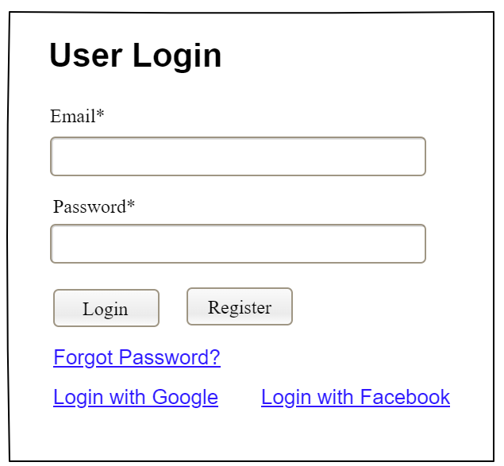

Field Name | Field Type | Description
Email* | Text Box | This is for user to input valid email address for logging in
Password* | Password Box | This is for user to input password for logging in
Login | Button | User clicks to authenticate him/herself into the system with provided email & password
Register | Button | User clicks to redirect to the User Register page for registering new user account to access the system
Forgot Password? | Hyperlink | User clicks to redirect to the Password Reset page for resetting his/her forgot password
Login with Google | Hyperlink | Allow user to login with his/her Google account
Login with Facebook | Hyperlink | Allow user to login with his/her Facebook account

Database Access
Table | CRUD | Description
User | R | Verify UserName & Password information
Setting, User | R | Specify the authorizations of the logged-in user

SQL Commands:
1/ Verify UserName & Password information
SELECT user_id, full_name, email, image_url, status
FROM user WHERE user_name = ? AND password = ?

2/ Specify the authorizations of the logged-in user
SELECT mapped_values FROM setting WHERE setting_id = ?
SELECT setting_name, mapped_values FROM setting WHERE setting_id IN (?)

b. Setting List
UI Design
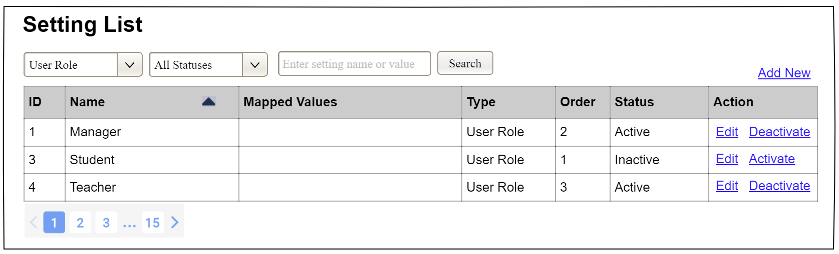

Field Name | Field Type | Description
Search Fields
Setting Type | Combo Box  Single-Choice | Filled with the list of current active setting types  Allow to filter the list by setting type;  Default value is “All Types”
Setting Status | Combo Box  Single-Choice | Values: All Statuses (default), Active, and Inactive  Allow to filter the list by status  Default value: “All Statuses”
Search Phase | Text Box  String (30) | Allow to search using the name or map values  Default value: blank
Search | Button | Click to refresh the list with the defined filter(s) and search phrase.
Add New | Hyperlink | Click to open the Setting Details page for adding new setting (master data)
Data Table
ID | Integer | Auto-increased identifier of the setting
Name | Text | Name of the setting
Mapped Values | Text | Supplementary information for the setting
Type | Text | Type of the setting
Order | Integer | Display order of the setting: the order of the setting type, displayed among the list of settings with the same type
Data Actions
Edit | icon | Click to open the Setting Details page for updating the relevant setting (master data)
Activate | icon | Shown when the data status is inactive. This is to activate the relevant setting (master data)
Deactivate | Ion | Shown when the data status is active. This is to deactivate the relevant setting (master data)

Database Access
Table | CRUD | Description
Setting | RU | Query the list of current settings from the database  Update status of a specific setting

SQL Commands:
1/ Query the list of current settings from the database
SELECT setting_id, setting_name, mapped_values, type_id, display_order, status
FROM setting WHERE (setting_type = ?) AND (status = ?) AND (setting_name LIKE ?)

2/ Update status of a specific setting
UPDATE setting SET status = ? WHERE setting_id = ?

c. Setting Details
UI Design
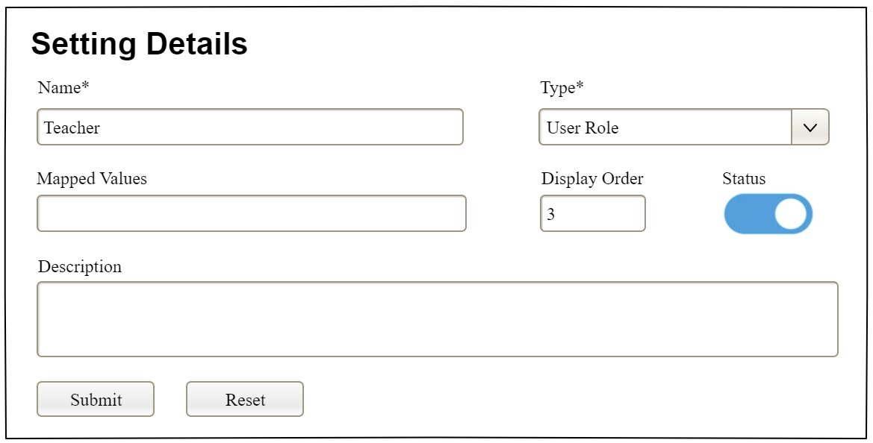

Field Name | Field Type | Description
Name* | Text Box  String (20) | Name of the setting
Type* | Combo Box  (Single Choice) | Type of the setting, filled with the list of setting types  Default value: the first type in the list
Mapped Values | Text Box  String (50) | Supplementary information for the setting (if any)
Order | Text Box  Integer (>=0) | Display order of the setting: the order of the setting type, displayed among the list of settings with the same type
Status | On/Off button | Status of the setting: Active or Inactive  Default value: Active
Description | Text Area  String (200) | Description of the setting
Submit | Button | Click to store new or updated setting details
Reset | Button | Click to reset the changes use has made on the screen fields back to the initial values when the screen is loaded

Database Access
…

VI. Appendix

1. Assumptions & Dependencies
[Record any assumptions that were made when conceiving the project and writing this vision and scope document. Note any major dependencies the project must rely upon for success, such as specific technologies, third-party vendors, development partners, or other business relationships.]
<<Sample:
AS-1: Systems with appropriate user interfaces will be available for cafeteria employees to process the expected volume of meals ordered.
AS-2: Cafeteria staff and vehicles will be available to deliver all meals for specified delivery time slots within 15 minutes of the requested delivery time.
DE-1: If a restaurant has its own on-line ordering system, the Cafeteria Ordering System must be able to communicate with it bi-directionally.
>>

2. Limitations & Exclusions
[Identify any product features or characteristics that a stakeholder might anticipate, but which are not planned to be included in the new product]

3. Business Rules
[Provide common business rules that you must follow. The information can be provided in the table format as the sample below]
<<Sample
ID | Category | Rule Definition
BR-01 | Constraints | Delivery time windows are 15 minutes, beginning on each quarter hour.
BR-02 | Constraints | Deliveries must be completed between 10:00 A.M. and 2:00 P.M. local time, inclusive.
BR-03 | Facts | All meals in a single order must be delivered to the same location.
BR-04 | Facts | All meals in a single order must be paid for by using the same payment method.
BR-11 | Constraints | If an order is to be delivered, the patron must pay by payroll deduction.
BR-12 | Computations | Order price is calculated as the sum of each food item price times the quantity of that food item ordered, plus applicable sales tax, plus a delivery charge if a meal is delivered outside the free delivery zone.
>>

