

Travel Attraction Ticket Booking Platform
Software Requirement Specification

– Danang, April 2026 –

Table of Contents
I. Record of Changes 6
II. Software Requirement Specification 7
1. Product Overview 7
2. User Requirements 8
2.1 Actors 8
2.2 Use Cases 9
2.2.1 Diagram(s) 10
2.2.2 Use Case Descriptions 14
2.2.3 Use Case Specifications 22
Module 1: Authentication & Profile Management 22
3. Functional Requirements 36
3.1 System Functional Overview 36
3.1.1. Screens Flow 36
3.1.2 Screen Descriptions 39
3.1.3 Screen Authorization 44
3.1.4 Non-Screen Functions 47
3.1.5 Entity Relationship Diagram 48
3.2 Authentication and User Management 57
3.2.1 - Sign In 57
3.2.2 - Forgot Password 60
3.2.3 - Reset Password 61
3.2.4 - View Profile 63
3.2.5 - Update Profile 66
3.2.6 - Change Password 69
3.2.7 - View List of Employees 70
3.2.8 - View Employee Detail Information 73
3.2.9 - Add Employee 76
3.2.10 - Edit Employee Information 79
3.2.11 - View List of Departments 82
3.2.12 - View Department Detail Information 85
3.2.13 - Add Department 88
3.2.14 - Edit Department’s Information 90
3.3 Product and Inventory Management 92
3.3.1 - View List of Products 92
3.3.2 - View Product Detail Information 95
3.3.3 - Add Product 99
3.3.4 - Update Product’s Information 102
3.3.5 - View List of Inventory lot 104
3.3.6 - View Inventory Lot Detail Information 106
3.3.7 - Add Inventory Lot 109
3.3.8 - Update Inventory Lot’s Information 112
3.4 Order and Sales Management 115
3.4.1 - Sales Orders List 115
3.4.2 - Sales Orders Detail 118
3.4.3 - Create new Sales Orders 121
3.4.4 - Edit Sales Orders 125
3.4.5 - View Return Orders 128
3.4.6 - Add Return Orders 132
3.4.7 - Edit Return Orders 135
3.4.8 - Customer List 139
3.4.9 - Customer Profile 142
3.4.10 Create new Customer Profile 146
3.4.11 - Update Customer Profile 148
3.5 Preparation and Delivery Management 152
3.5.1 - Delivery Runs List 152
3.5.2 - Delivery Runs Detail 157
3.5.3 - Assign Shipping Task 163
3.5.4 - Edit Delivery Runs 168
3.5.5 - Packing Task List 172
3.5.6 - Packing Task Detail 177
3.5.7 - Assign Packing Task 180
3.5.8 - Update Packing Task 186
3.6 Supplier and Warehouse Management 190
3.6.1 - View Supplier List 190
3.6.2 - View Supplier Detail 194
3.6.3 - Create Supplier 198
3.6.4 - Update Supplier Information 201
3.6.5 - Delete Supplier 203
3.6.6 - View List of Supplier Transactions 205
3.6.7 - View Supplier Transaction Detail Information 208
3.6.8 - Add Supplier Transaction 211
3.6.9 - Update Supplier Transaction’s Information 218
3.7 Accounting and Financial Tracking 222
3.7.1 - View list of Supplier Transaction Payment 222
3.7.2 - View Supplier Transaction Payment Detail Information 224
3.7.3 - Add Supplier Transaction Payment 227
3.7.4 - Update Supplier Transaction Payment’s Information 230
3.7.5 - Customer Payments List 233
3.7.6 - Customer Payment Detail 236
3.7.7 - Add new Customer Payment 239
3.7.8 - Edit Customer Payment 243
3.7.9 - View Sales Invoices 247
3.7.10 - Create new Sales Invoices 252
3.7.11 - Edit Sales Invoice 257
3.7.12 - COD Remittance Ticket List 262
3.7.13 - COD Remittance Ticket Detail 266
3.7.14 - Create a COD Remittance Ticket 272
3.7.15 - Edit COD Remittance Ticket 276
3.8 Reporting and Dashboard Visualization 280
3.8.1 - Dashboard 280
3.9 System Notifications & Monitoring 285
3.9.1 - 404 285
3.10 Manage Issue Ticket Feature 286
3.10.1 - View List of Issue Ticket 286
3.10.2 - View Issue Ticket Detail Information 291
3.10.3 - Create Issue Ticket 295
3.10.4 - Update Issue Ticket’s Information 299
4. Non-Functional Requirements 303
4.1. External Interfaces 303
4.1.1 User Interface 303
4.1.2 Software Interface 303
4.1.3 Hardware Interface 303
4.2. Quality Attributes 304
4.2.1 Availability 304
4.2.2 Usability 304
4.2.3 Reliability 304
4.2.4 Performance 304
4.2.5 Security 304
4.2.6 Maintainability and Extensibility 304
5. Requirement Appendix 304
5.1 Business Rules 304
5.2 Common Requirements 306
5.3 Application Messages List 307
List of Tables
Table 1. Record of Change 6
Table 2. All Actors in the System 9
Table 3. Use Case Description 22
Table 4. Screen Descriptions 44
Table 5. Screen Authorization 47
Table 6. Non-Screen Functions 48
Table 7. Entities Description 57
Table 8. Business Rule 306
Table 9. Common Requirements 306
Table 10. Application Messages List 313
List of Figures
Figure 1. Context Diagram 7
Figure 2. Authenticated Users Inheritance 9
Figure 3. Authentication Usecase 9
Figure 4. User and Department Management Usecase 10
Figure 5. User Interaction and Dashboard Usecase 10
Figure 6. Warehouse Management Usecase 11
Figure 7. Order and Sales Management Usecase 12
Figure 8. Accounting and Finance Management Usecase 13
Figure 9. Preparation and Delivery Management Usecase 14
Figure 10. Admin Screen Flow Diagram 24
Figure 11. Sell Staff Screen Flow Diagram 25
Figure 12. Packing Staff Screen Flow Diagram 25
Figure 13. Packing Supervisor Screen Flow Diagram 26
Figure 14. Delivery Staff Screen Flow Diagram 26
Figure 15. Delivery Supervisor Screen Flow Diagram 27
Figure 16. Warehouse Manager Screen Flow Diagram 27
Figure 17. Accountant Screen Flow Diagram 28
Figure 18. ERD Diagram 37

I. Record of Changes
*A - Added M - Modified D - Deleted
Date | A*  M, D | In charge | Change Description

Table 1. Record of Change

II. Software Requirement Specification

1. Product Overview
The Travel Attraction Ticket Booking Platform is an online system designed to help tourists search, compare, and book tickets for tourism attractions in a convenient and reliable way. The platform allows guests to browse attraction information, view reviews, and register an account. Registered customers can book attraction tickets, apply vouchers, make online payments, receive e-tickets, manage booking history, cancel bookings, request refunds, submit reviews after using the service, and register to become attraction partners. Attraction partners can create, update, and delete attraction listings, as well as create, update, and deactivate ticket products, view customer bookings, confirm bookings if required, view revenue reports, and respond to customer reviews. In addition, support staff handle customer inquiries, complaints, refund requests, payment tracking, and ticket reissues, while administrators manage users, partner registrations, attraction approvals, hiding violating attractions, vouchers, reports, commission rates, and system policies. The system also integrates external services such as payment gateways, notification services, Google authentication, and AI travel assistance to improve booking efficiency, user experience, and platform reliability.
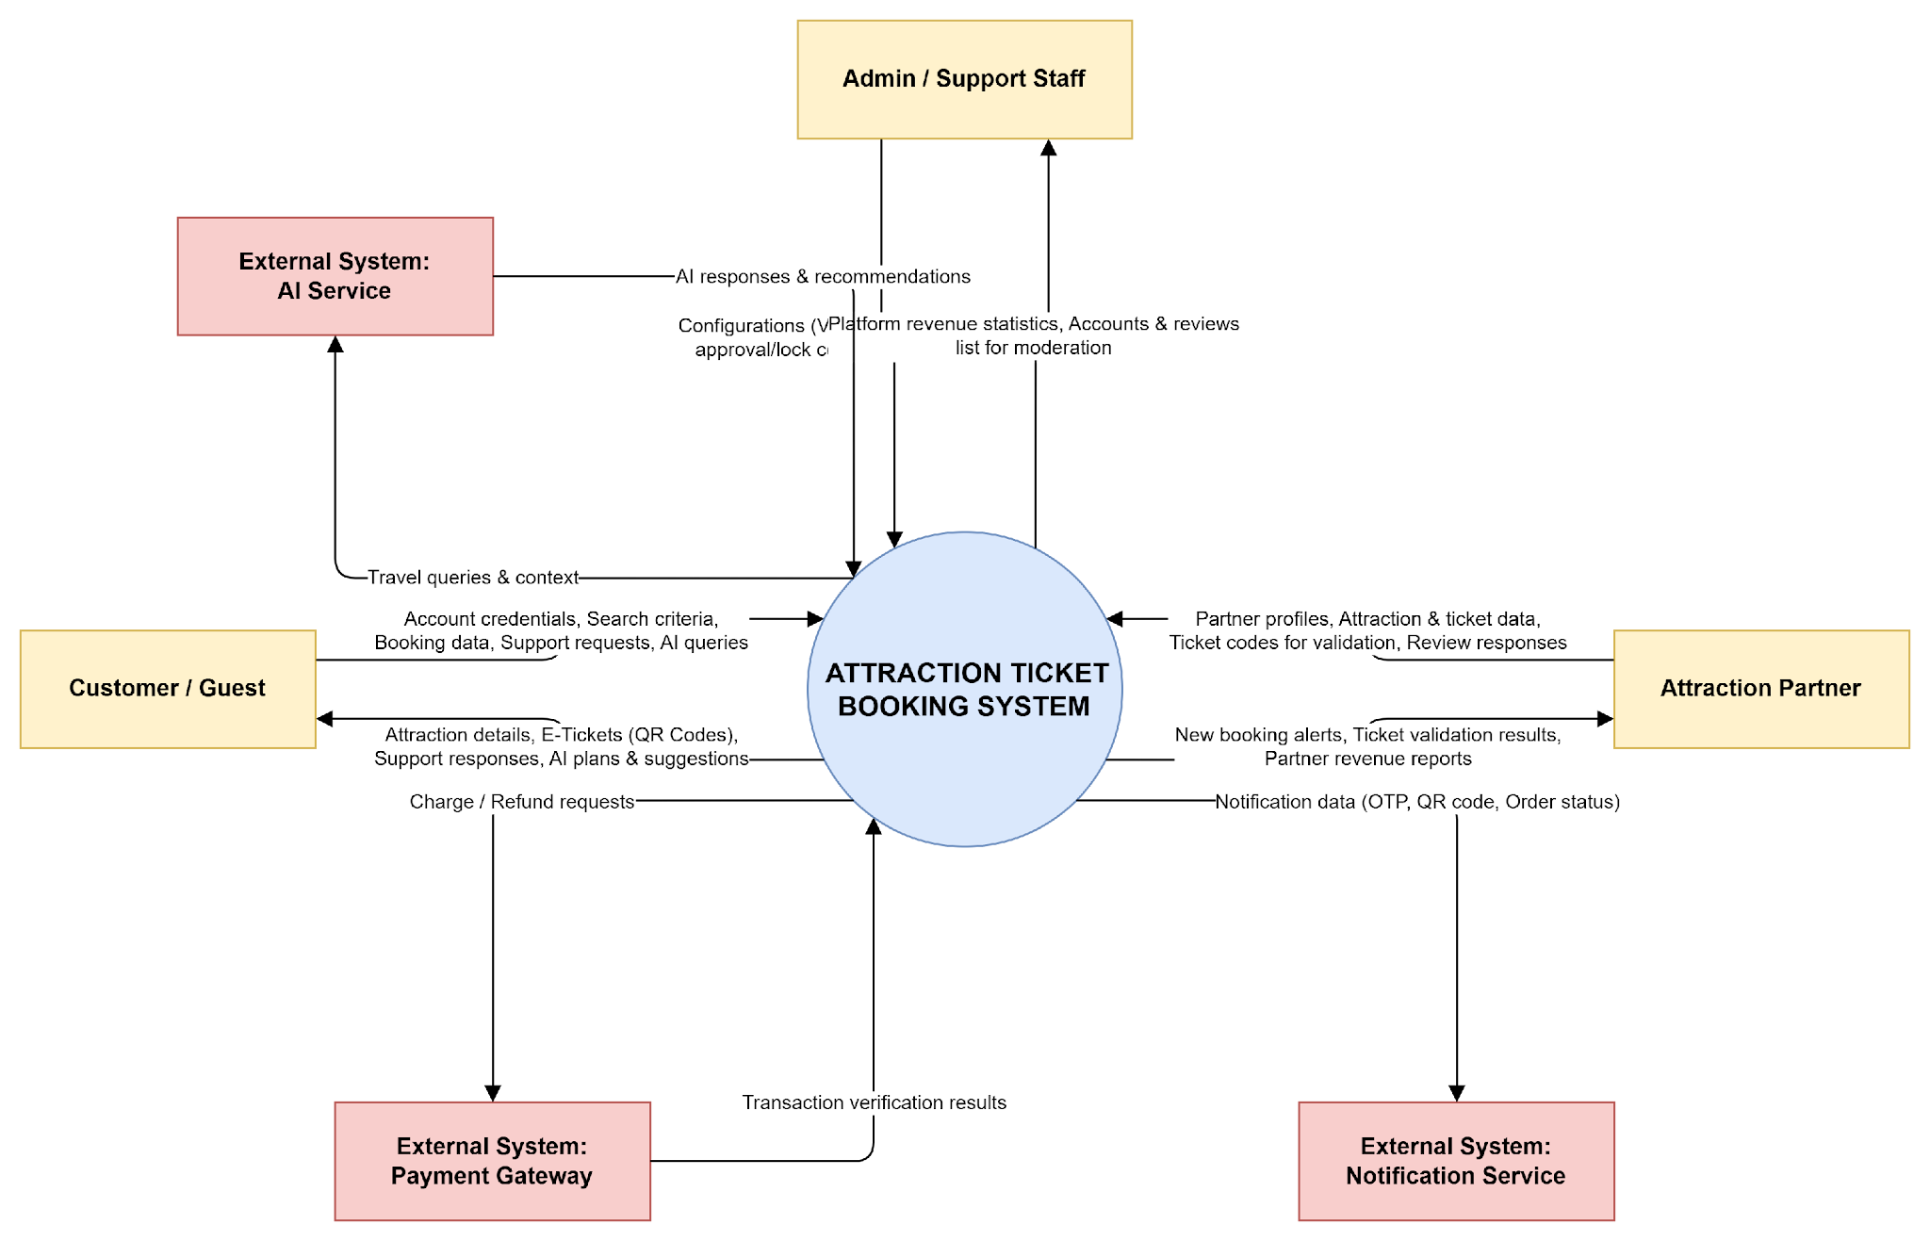

Figure 1. Context Diagram

2. User Requirements

2.1 Actors
# | Actor | Description
1 | Guest | The Guest is an unregistered user who can access the platform to search and view tourism attraction information. Main activities include searching and filtering attractions, viewing attraction details, reading reviews, registering a new account, and logging into the system. However, the Guest cannot book tickets, make payments, or submit reviews until becoming a registered Customer.
2 | Customer | The Customer is the main end user of the platform who uses the system to search, book, and manage attraction tickets. Key activities include updating profile information, saving favorite attractions, using the AI travel assistant, booking attraction tickets, applying vouchers, making online payments, receiving e-tickets, viewing booking history, cancelling bookings, requesting refunds, submitting reviews, registering to become an attraction partner, and contacting support staff when needed.
3 | Attraction Partner | The Attraction Partner represents tourism attraction providers such as museums, amusement parks, sightseeing areas, cultural sites, or entertainment venues. This actor is responsible for creating, updating, and deleting attraction listings, submitting attraction information for approval, creating, updating, and deactivating ticket products, setting ticket prices and availability, viewing customer bookings, confirming bookings if required, viewing revenue reports, and responding to customer reviews.
4 | Support Staff
  The Support Staff is responsible for assisting customers during and after the booking process. Main responsibilities include handling customer support requests, responding to customer inquiries, checking booking information when needed, resolving complaints, processing refund requests, reissuing e-tickets, and tracking payment status. This actor does not have full administrative permissions but supports daily customer service operations.
5 | Admin | The Admin is responsible for managing and controlling the overall platform. Main responsibilities include locking or unlocking user accounts, reviewing partner registration requests, locking or unlocking partner accounts, reviewing attraction submissions, hiding violating attractions, moderating customer reviews, configuring vouchers, viewing platform reports, monitoring booking and revenue statistics, and configuring the platform commission rate. The Admin ensures that the system operates correctly, securely, and according to platform policies.
6 | Payment Gateway | The Payment Gateway is an external system that processes online payment transactions between customers and the platform. Its main responsibilities include processing online payments, returning payment results, processing refunds, and returning refund results. This actor is integrated with the platform to ensure secure and reliable financial transactions.
7 | Notification Service | The Notification Service is an external service used to send system notifications to users and partners. It supports sending verification codes, account status notifications, booking confirmation messages, e-ticket notifications, refund notifications, and violation notifications. This actor helps keep users informed about important actions and booking status updates.
8 | AI Service | The AI Service is an external or internal intelligent service that provides travel assistance features for customers. Its main responsibilities include suggesting suitable attractions, answering travel-related questions, recommending ticket packages, and generating simple visit plans based on user preferences. This actor improves user experience but is not the core booking function of the platform.

Table 2. All Actors in the System

2.2 Use Cases

2.2.1 Diagram(s)

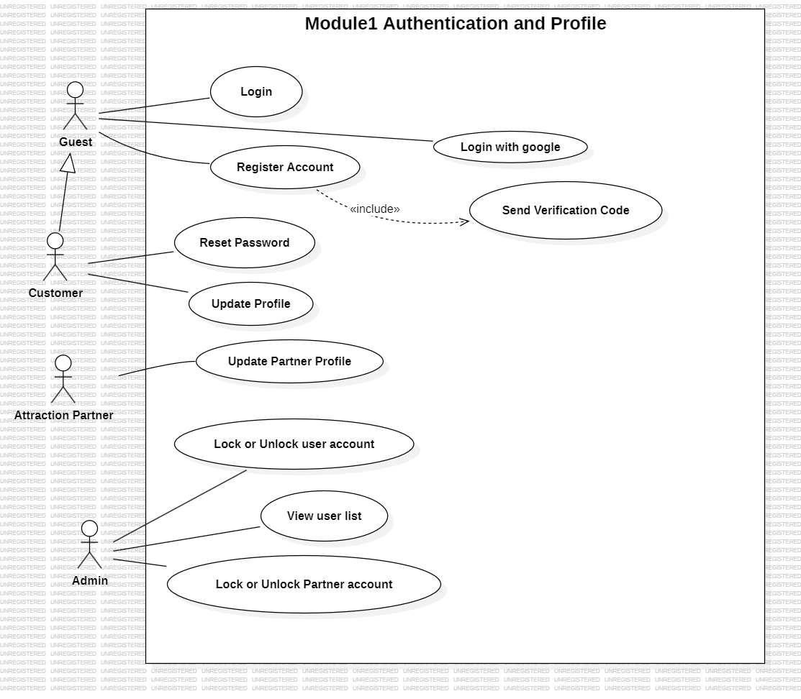Figure 1. Authentication and profile
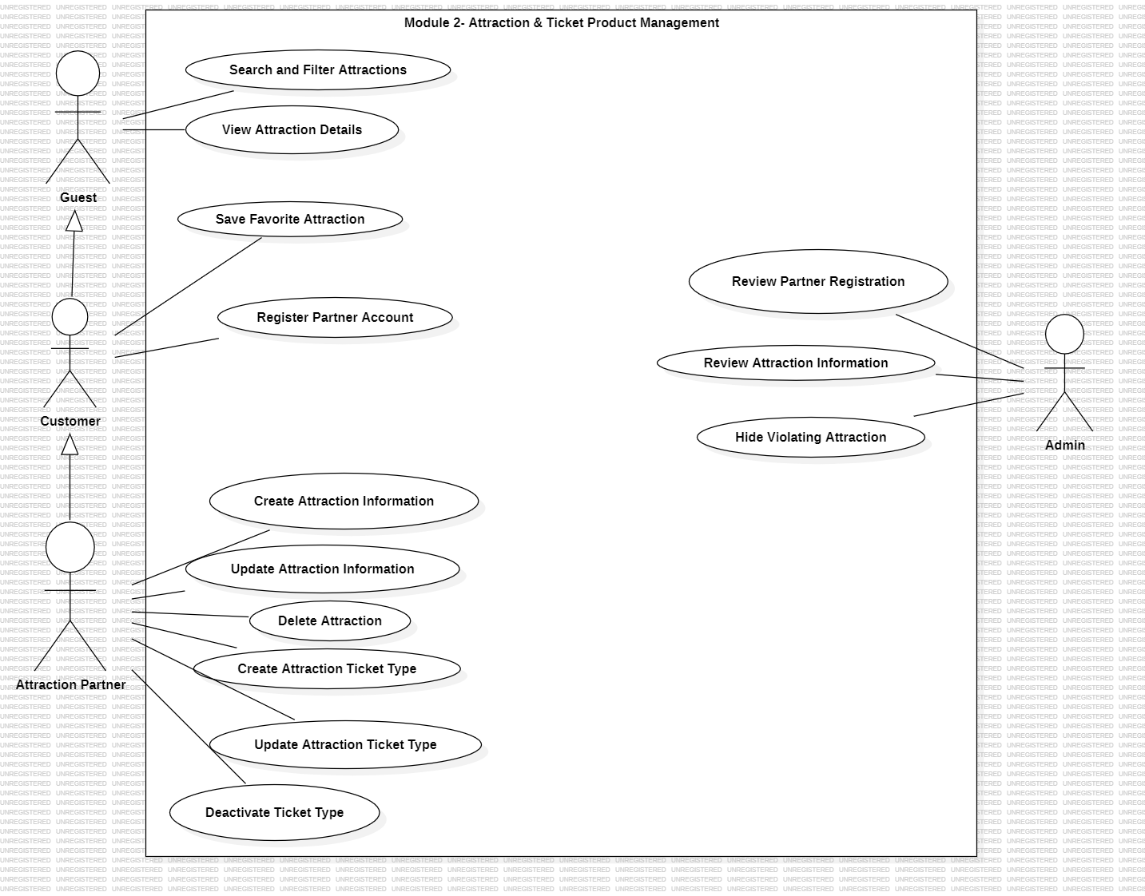

Figure 2. Attraction and Product Management
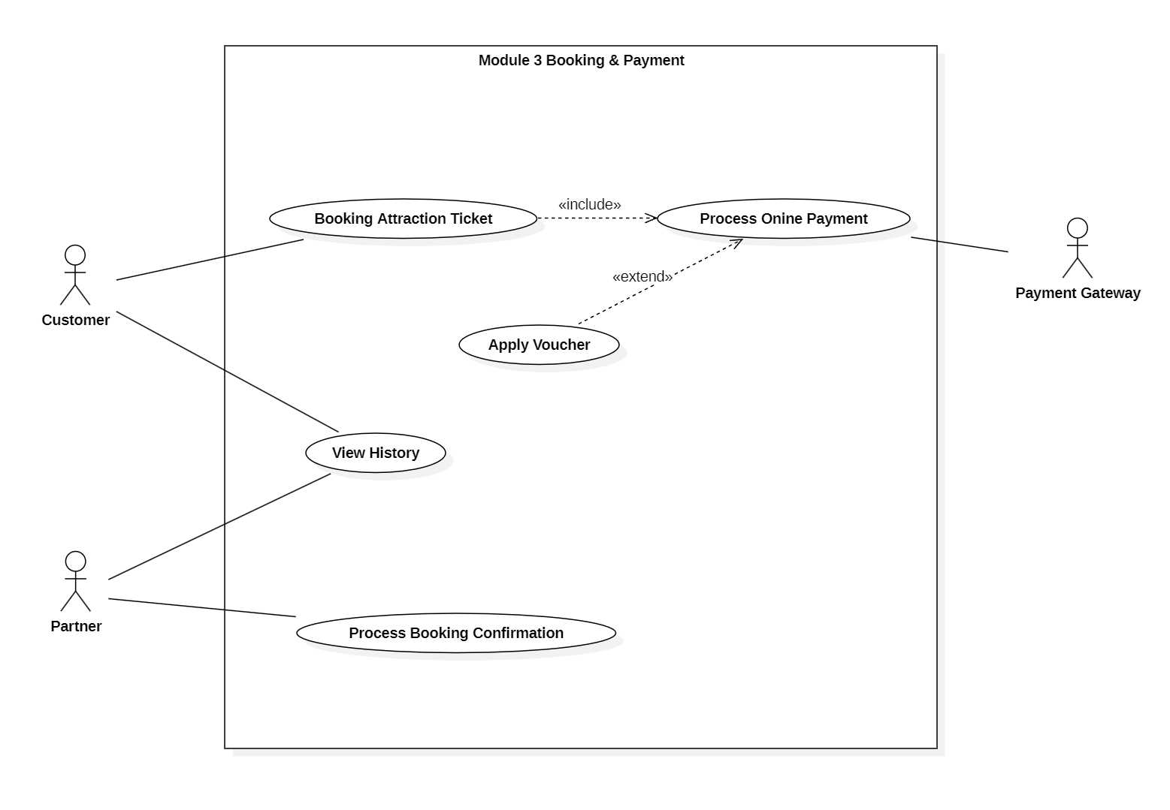

Figure 3. Booking And Payment
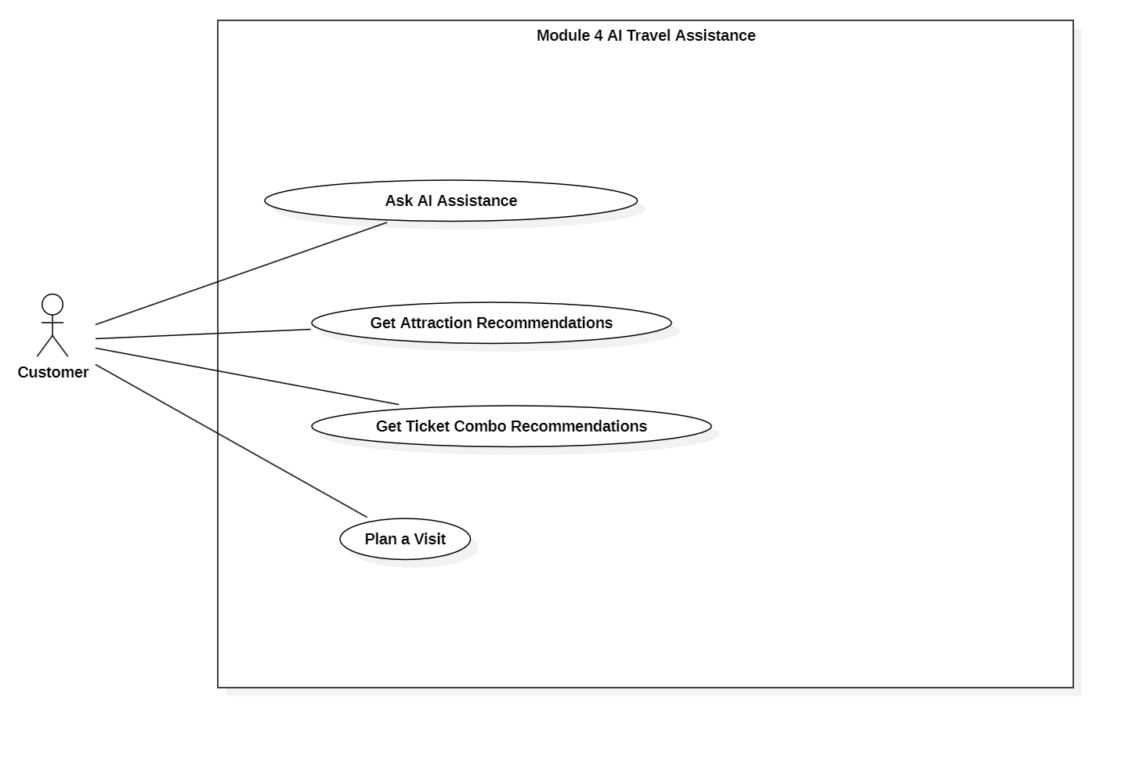

Figure 4. AI Assistant

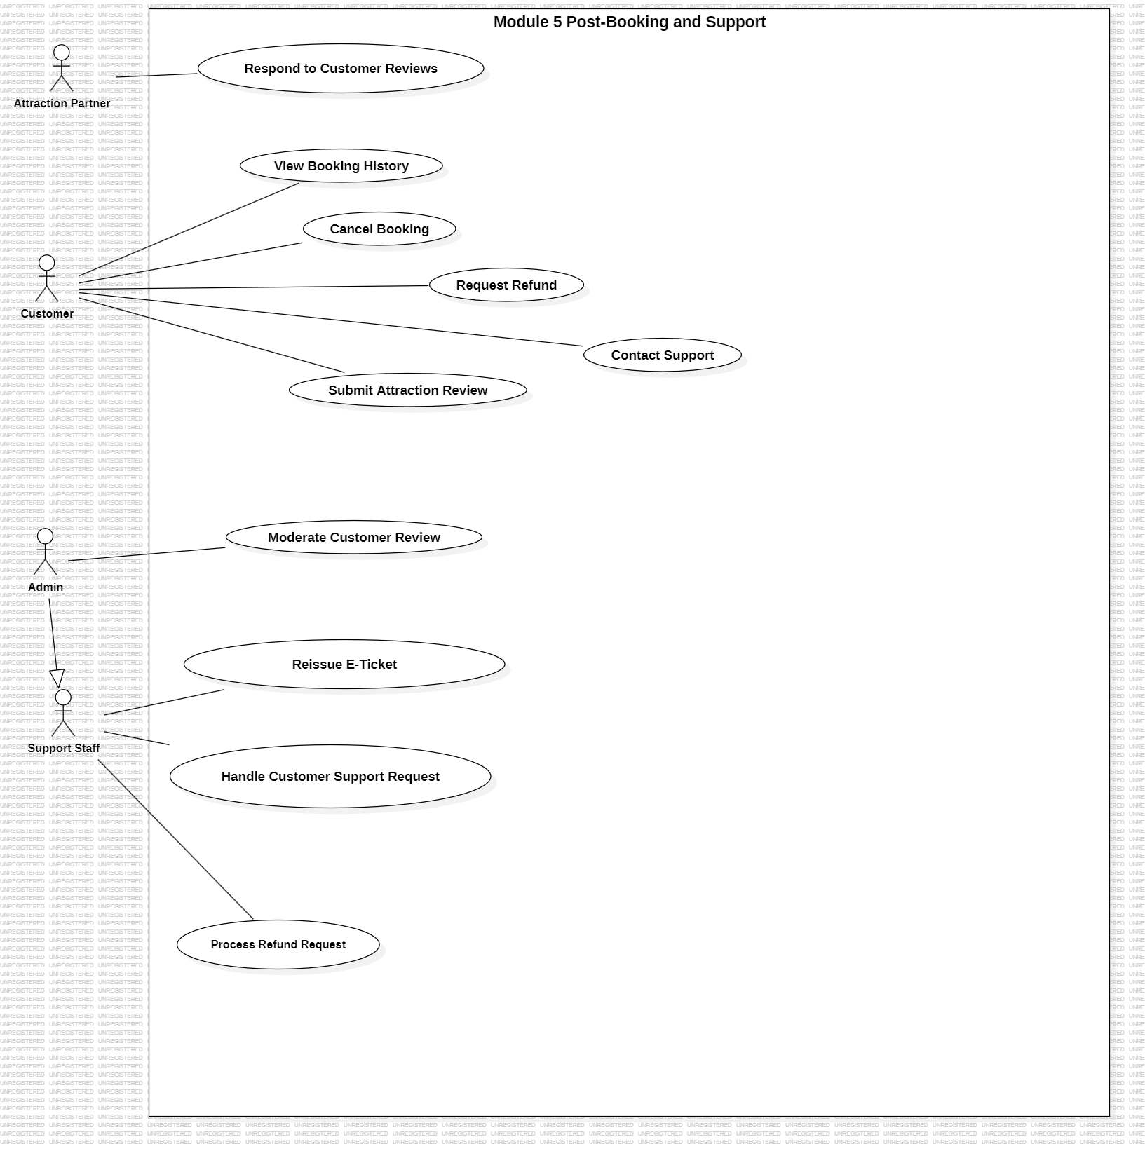

Figure 5. Post booking and support
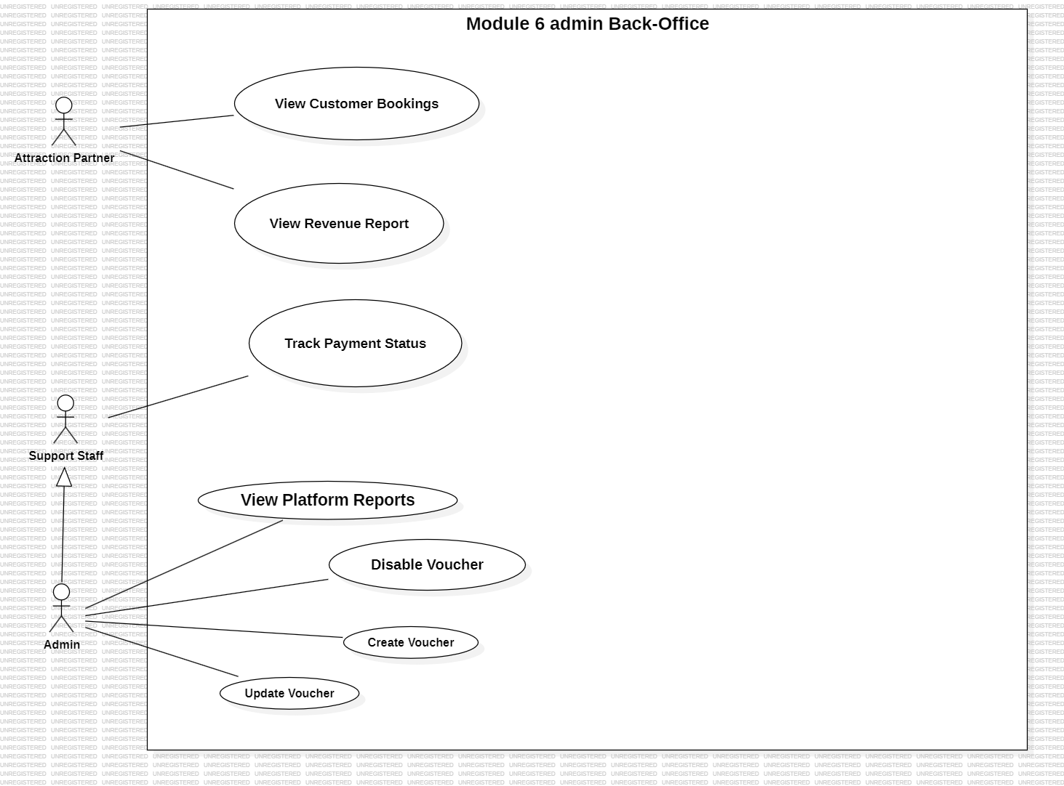

Figure 6. Admin back - office

2.2.2 Use Case Descriptions
ID | Use Case | Actors | Use Case Description
1 | Register Account | Guest, Notification Service | The Guest registers a new account to access the system. The system requires verification before the account can be activated. This use case includes Send Verification Code.
2 | Send Verification Code | Guest, Notification Service | The Notification Service sends a verification code to the Guest through email or SMS to confirm the registration process.
3 | Login | Guest, Customer, Attraction Partner, Admin | The user logs in to the system using valid credentials. This use case can be extended by Reset Password when the user forgets the password.
4 |  | Guest, Customer, Google Authentication Service | The Guest or Customer logs in to the system using a Google account instead of entering a system username and password. The system connects to the Google Authentication Service to verify the user’s identity. This use case extends Login.
  Login with Google
5 | Forgot Password | Guest, Customer, Attraction Partner, Admin, Notification Service | The user requests password recovery when they cannot remember their password. The system sends a password reset link or verification code through the Notification Service. This use case extends Login and includes Reset Password.
6 | Reset Password | Guest, Customer, Attraction Partner, Admin, Notification Service | The user resets the password by requesting a reset code or link from the system when they cannot log in. This use case extends Login.
7 | Update Profile | Customer | The Customer updates personal profile information such as name, phone number, email, or avatar.
8 | Update Partner Profile | Attraction Partner | The Attraction Partner updates partner profile information such as business name, contact information, address, and business documents.
9 | View User List | Admin | The Admin views the list of user accounts before performing account management actions.
10 | Lock or Unlock User Account | Admin | The Admin locks or unlocks a user account when necessary. This use case includes View User List.
11 | Lock or Unlock Partner Account | Admin, Notification Service | The Admin locks or unlocks an Attraction Partner account. After the account status changes, the system sends a notification to the partner. This use case includes Send Account Status Notification.
12 | Send Account Status Notification | Attraction Partner, Notification Service | The Notification Service sends an account status notification to the Attraction Partner when the account is locked or unlocked.
13 | Search and Filter Attractions | Guest, Customer | The Guest or Customer searches and filters attractions based on criteria such as name, location, category, price, or rating.
14 | View Attraction Details | Guest, Customer | The Guest or Customer views detailed information about an attraction, including description, images, price, location, opening time, and related ticket products.
15 | Save Favorite Attraction | Customer | The Customer saves an attraction to a favorite list for later viewing or booking.
16 | Register Partner Account | Customer | The Customer submits required information and documents to register a partner account, intending to provide attraction services and ticket products on the platform.
17 | Create Attraction Information | Attraction Partner | The Attraction Partner creates a new attraction listing by providing necessary details and submitting it to the system for Admin review and approval.
18 | Update Attraction Information | Attraction Partner | The Attraction Partner modifies and updates the information of an existing attraction listing.
19 | Delete Attraction | Attraction Partner | The Attraction Partner removes an existing attraction listing from the platform (typically managed as a soft-delete to maintain data integrity).
20 | Create Attraction Ticket Type | Attraction Partner | The Attraction Partner creates a new ticket product for an attraction, which involves setting up ticket details, pricing, available visit time slots, and ticket quantities.
21 | Update Attraction Ticket Type | Attraction Partner | The Attraction Partner updates the details, pricing, availability, or time slots of an existing ticket product.
22 | Deactivate Ticket Type | Attraction Partner | The Attraction Partner deactivates a ticket product, making it unavailable for customers to book while preserving its past transaction data.
24 | Review Partner Registration | Admin | The Admin reviews the partner registration information and decides whether to approve or reject the partner account.
25 | Review Attraction Information | Admin | The Admin reviews the newly created attraction information before allowing it to be officially displayed to users on the platform.
26 | Hide Violating Attraction | Admin | The Admin hides an attraction from the public view if it is found to violate platform policies or provides misleading information.
28 | Book Attraction Ticket | Customer, Notification Service | The Customer books an attraction ticket by selecting an attraction, ticket type, visit date, and quantity. This use case includes Process Online Payment and can be extended by Apply Voucher.
29 | Apply Voucher | Customer | The Customer applies a voucher during the ticket booking process to receive a discount. This use case extends Book Attraction Ticket.
30 | Process Online Payment | Customer, Payment Gateway | The system processes the online payment through the Payment Gateway. This use case is included in Book Attraction Ticket.
31 | Process Booking Confirmation | Attraction Partner, Notification Service | The Attraction Partner confirms the booking for ticket products that require manual approval. After confirmation, the Notification Service sends a booking confirmation to the Customer.
32 | Use AI Travel Assistant | Customer, AI Service | The Customer uses the AI Travel Assistant to receive travel-related support. This use case includes Provide AI Travel Assistance.
33 | Provide AI Travel Assistance | AI Service, Customer | The AI Service provides travel assistance to the Customer by supporting attraction suggestions, travel questions, ticket package recommendations, and visit planning.
34 | Suggest Attractions | AI Service, Customer | The AI Service suggests suitable attractions for the Customer based on travel needs or preferences. This use case is included in Provide AI Travel Assistance.
35 | Answer Travel Questions | AI Service, Customer | The AI Service answers travel-related questions from the Customer. This use case extends Provide AI Travel Assistance.
36 | Recommend Ticket Packages | AI Service, Customer | The AI Service recommends suitable ticket packages to the Customer. This use case extends Provide AI Travel Assistance.
37 | Generate Visit Plan | AI Service, Customer | The AI Service generates a suggested visit plan for the Customer. This use case extends Provide AI Travel Assistance.
38 | View Booking History | Customer | The Customer views the history of bookings made on the system. This use case can be extended by View Booking Detail.
39 | View Booking Detail | Customer | The Customer views detailed information of a selected booking. This use case extends View Booking History.
40 | Cancel Booking | Customer, Notification Service | The Customer cancels a booking according to the platform’s cancellation policy. This use case can be extended by Request Refund.
41 | Request Refund | Customer, Support Staff, Payment Gateway | The Customer requests a refund after cancelling a booking or when a refund condition is met. This use case extends Cancel Booking.
42 | Submit Attraction Review | Customer | The Customer submits a review after using the attraction service. This use case includes Rate Attraction and can be extended by Write Review Comment.
43 | Rate Attraction | Customer | The Customer gives a rating for the attraction. This use case is included in Submit Attraction Review.
44 | Write Review Comment | Customer | The Customer writes a review comment about the attraction experience. This use case extends Submit Attraction Review.
45 | Contact Support | Customer, Support Staff | The Customer contacts Support Staff for help related to booking, payment, refund, ticket, or account issues.
46 | View Customer Reviews |  | The Attraction Partner views reviews submitted by Customers for the partner’s attractions.
  Attraction Partner
47 | Respond to Customer Reviews | Attraction Partner | The Attraction Partner responds to Customer reviews. This use case includes View Customer Reviews.
48 | Handle Customer Support Request | Support Staff | The Support Staff handles support requests from Customers. This use case includes Respond to Customer Inquiry and can be extended by View Customer Booking and Resolve Complaint.
49 | Respond to Customer Inquiry | Support Staff | The Support Staff responds to Customer inquiries through the system. This use case is included in Handle Customer Support Request.
50 | View Customer Booking | Support Staff | The Support Staff views the Customer’s booking information when handling a support request. This use case extends Handle Customer Support Request.
51 | Resolve Complaint | Support Staff | The Support Staff resolves Customer complaints related to bookings, payments, refunds, or ticket usage. This use case extends Handle Customer Support Request.
52 | Process Refund Request | Support Staff, Payment Gateway, Notification Service | The Support Staff processes a refund request submitted by the Customer. This use case includes Review Refund Request and Send Refund Notification, and can be extended by Process Refund.
53 | Review Refund Request | Support Staff | The Support Staff reviews the refund request to check whether the Customer is eligible for a refund. This use case is included in Process Refund Request.
54 | Send Refund Notification | Notification Service | The Notification Service sends a refund result notification to the Customer. This use case is included in Process Refund Request.
55 | Process Refund | Support Staff, Payment Gateway | The Support Staff processes the refund through the Payment Gateway when the refund request is approved. This use case extends Process Refund Request.
56 | Reissue E-Ticket | Support Staff, Notification Service | The Support Staff reissues an e-ticket when the Customer does not receive the ticket or the ticket needs to be resent. This use case includes Send E-Ticket Notification.
57 | Send E-Ticket Notification | Customer, Notification Service | The Notification Service sends the reissued e-ticket or QR code to the Customer.
58 | Moderate Customer Review | Admin | The Admin moderates Customer reviews to ensure that review content follows platform policies. This use case can be extended by Hide Violating Review.
59 | Hide Violating Review | Admin | The Admin hides a review that violates platform rules. This use case extends Moderate Customer Review.
60 | View Customer Bookings | Attraction Partner | The Attraction Partner views Customer bookings related to the partner’s attractions or ticket products.
61 | View Revenue Report | Attraction Partner | The Attraction Partner views revenue reports for ticket sales.
62 | Track Payment Status | Support Staff | The Support Staff tracks payment status for bookings, such as paid, failed, pending, or refunded.
63 | Configure Voucher | Admin | The Admin manages vouchers in the system. This use case can be extended by Create Voucher, Update Voucher, and Disable Voucher.
64 | Create Voucher | Admin | The Admin creates a new voucher. This use case extends Configure Voucher.
65 | Update Voucher | Admin | The Admin updates voucher information. This use case extends Configure Voucher.
66 | Disable Voucher | Admin | The Admin disables a voucher when it is no longer available or should not be used. This use case extends Configure Voucher.
67 | Configure Commission Rate | Admin | The Admin configures the commission rate between the platform and Attraction Partners.
68 | View Platform Reports | Admin | The Admin views platform reports. This use case includes View Booking Statistics, View Revenue Dashboard, and View Transaction History.
69 |  | Admin | The Admin views booking statistics of the platform. This use case is included in View Platform Reports.
  View Booking Statistics
70 | View Revenue Dashboard | Admin | The Admin views the revenue dashboard of the platform. This use case is included in View Platform Reports.
71 | View Transaction History | Admin | The Admin views transaction history related to payments and refunds. This use case is included in View Platform Reports.

Table 3. Use Case Description

2.2.3 Use Case Specifications

Module 1: Authentication & Profile Management

1.1 UC01 – Đăng ký tài khoản (Register)
Field | Details
UC ID and Name: | UC01 - Register Account
Created By: | Team 5
Primary Actor: | Guest (unauthenticated visitor)
Trigger: | The user navigates to /register and clicks "Create Account"
Description: | Allows a guest to create a new account by providing their full name, email address, phone number, password, and accepting the terms of service.  Upon successful registration, the system sends a verification email and redirects the user to the email verification page.
Preconditions: | 1. The user is not logged in.  2. The email address has not been registered in the system.
Postconditions: | 1. A new account is created with isEmailVerified = false.  2. A UserProfile record is created with the provided phone number.  3. A verification email is sent to the registered email address. 4. The user is redirected to /verify-email.
Normal Flow: | 1. The user fills in the form: Full Name, Email, Phone Number, Password, Confirm Password.  2. The user ticks the "I agree to the terms and privacy policy" checkbox.  3. The user clicks "Create Account".  4. The frontend validates all fields (full name, email, phone, password strength, password confirmation, terms checkbox). 5. The system checks that the email does not already exist in the database.  6. The system hashes the password using bcrypt (10 salt rounds).  7. The system creates a User + UserProfile within a database transaction.  8. The system creates an EmailVerificationToken (expires in 30 minutes).  9. The system sends the verification email via Nodemailer.  10. Returns HTTP 201; the user is redirected to /verify-email.
Alternative Flows: | A1 - Register with Google: The user clicks the Google button -> Proceeds to UC05 (Google Login); the account is created automatically with isEmailVerified = true.
Exceptions: | E1 - Email already exists: Returns HTTP 409 "This email is already in use."  E2 - Invalid data: Returns HTTP 400 with a specific message (invalid email, invalid phone format, password not strong enough, etc.).  E3 - Passwords do not match: Frontend shows a field error; request is not sent.  E4 - Terms not accepted: Frontend blocks submission; request is not sent.
Priority: | High - Must Have
Frequency of Use: | Medium - Once per new user registration
Business Rules: | BR1: Email must be a valid format.  BR2: Password must be at least 8 characters and include both letters and numbers.  BR3: Vietnamese phone number format (10 digits, starting with 0).  BR4:Full name must be 2–50 characters and contain only letters and spaces.  BR5: Rate limit: maximum 5 requests per 15 minutes (per IP + path).
Other Information: | A PasswordStrengthMeter is displayed in real time. The email verification token expires after 30 minutes.
Assumptions: | The SMTP server (Nodemailer) is operational.

1.2 UC02 - Verify Email
Field | Details
UC ID and Name: | UC02 - Verify Email
Created By: | Team 5
Primary Actor: | Registered user whose email has not yet been verified
Trigger: | The user enters the verification token received by email on the /verify-email page and clicks "Verify"
Description: | Allows a user to activate their account by entering the verification token sent to their email after registration.
Preconditions: | 1. The user has successfully registered an account.  2. The account has isEmailVerified = false.  3. A valid, non-expired EmailVerificationToken exists in the database.
Postconditions: | 1. isEmailVerified is updated to true.  2. All EmailVerificationToken records for the user are deleted.  3. The user is able to log in.
Normal Flow: | 1. The user opens their email and retrieves the verification token. 2. The user enters the token into the form at /verify-email.  3. The system looks up the token in the EmailVerificationToken table.  4. The system checks that the token has not expired (expiresAt).  5. The system updates isEmailVerified = true in a transaction and deletes the token.  6. Returns HTTP 200 with a success message.
Alternative Flows: | A1 - Token expired: The system deletes the expired token and returns the message "Verification code has expired. Please request a new one." -> The user proceeds to UC03.
Exceptions: | E1 - Invalid or already-used token: HTTP 400 "Verification code is invalid or has already been used."  E2 - Token not provided: HTTP 400 "Please enter the email verification code."
Priority: | High - Must Have
Frequency of Use: | Once per account
Business Rules: | BR1: Token is valid for 30 minutes from the time of creation.  BR2: Each resend request deletes the old token and creates a new one.  BR3: Rate limit: 5 requests per 15 minutes.
Other Information: | The page displays the pending email address (retrieved from localStorage).
Assumptions: | The user has access to the email inbox of the registered address.

1.3 UC03 - Resend Email Verification
Field | Details
UC ID and Name: | UC03 - Resend Email Verification
Created By: | Team 5
Primary Actor: | User whose email has not yet been verified
Trigger: | The user clicks "Resend Verification Code" on the /verify-email page
Description: | Sends a new verification email when the previous token has expired or was lost, invalidating the old token and creating a new one.
Preconditions: | 1. The email exists in the system. 2. The account has not yet been verified (isEmailVerified = false).
Postconditions: | 1. The old token is deleted and a new token is created (expires in 30 minutes). 2. A new verification email is sent.
Normal Flow: | 1. The user enters their email in the resend form. 2. The system checks whether the email exists and is unverified. 3. The system deletes the old token and creates a new one in a transaction. 4. The system sends the new verification email. 5. Returns HTTP 200 "A new verification link has been sent. Please check your email."
Alternative Flows: | A1 - Email already verified: HTTP 400 "This email has already been verified."
Exceptions: | E1 - Email does not exist: The system still returns HTTP 200 (ambiguous message to prevent information disclosure). E2 - Rate limit exceeded: HTTP 429 "You are acting too fast. Please try again later."
Priority: | Medium - Should Have
Frequency of Use: | Infrequent
Business Rules: | BR1: Do not reveal whether an email exists in the system (security). BR2: Rate limit: 5 requests per 15 minutes.
Other Information: | -
Assumptions: | The SMTP server is operational.

1.4 UC04 - Login
Field | Details
UC ID and Name: | UC04 - Login
Created By: | Team 5
Primary Actor: | Registered user
Trigger: | The user enters their email and password and clicks "Login" at /login
Description: | Authenticates the user using their email and password. On success, the system issues a JWT stored in an HttpOnly cookie and persists the session in localStorage.
Preconditions: | 1. The user is not currently logged in.  2. A user account with provider = LOCAL exists.
Postconditions: | 1. A JWT is set in the HttpOnly cookie (token).  2. User data is saved to localStorage.  3. The user is redirected to the previous page or /.
Normal Flow: | 1. The user enters their email and password.  2. The frontend validates the email and password format.  3. Sends POST /api/auth/login.  4. The backend looks up the user by email and checks status = ACTIVE.  5. Compares the password against the bcrypt hash.  6. Checks isEmailVerified = true.  7. Issues a JWT (signed with JWT_SECRET) and sets the HttpOnly cookie.  8. Returns user data; the frontend persists the session and redirects.
Alternative Flows: | A1 - Login with Google: The user clicks the Google button -> UC05.  A2 - Forgot Password: The user clicks "Forgot Password?" -> UC07a.
Exceptions: | E1 - Incorrect email or password: HTTP 401 "Email or password is incorrect."  E2 - Email not verified: HTTP 403 with code: EMAIL_NOT_VERIFIED; a prompt to verify email is displayed.  E3 - Account locked: HTTP 403 "Your account has been locked." E4 - Rate limit exceeded: HTTP 429.
Priority: | High - Must Have
Frequency of Use: | Very high
Business Rules: | BR1: This flow is only for LOCAL provider accounts.  BR2: Rate limit: 5 requests per 15 minutes per IP.  BR3: The auth_token cookie is HttpOnly and Secure (in production).  BR4: "Remember me" is displayed on the UI (extended cookie logic may be added later).
Other Information: | On app load, /api/auth/me is called to hydrate the session and confirm token validity.
Assumptions: | JWT_SECRET is configured in the environment variables.

1.5 UC05 - Login / Register with Google
Field | Details
UC ID and Name: | UC05 - Login / Register with Google
Created By: | Team 5
Primary Actor: | Any user (with or without an existing account)
Trigger: | The user clicks "Continue with Google" on the login or register page
Description: | Allows fast login or registration via a Google account. If the email does not exist in the system, a new account is created automatically with isEmailVerified = true. If the account already exists, the avatar is updated from Google.
Preconditions: | GOOGLE_CLIENT_ID is correctly configured.
Postconditions: | 1. If new user: User + UserProfile + OAuthAccount are created.  2. If existing user: Avatar is updated; OAuthAccount is upserted.  3. A JWT is set in the cookie and the session is persisted.
Normal Flow: | 1. The user clicks the Google button (via @react-oauth/google).  2. Google returns a credential (ID Token).  3. The frontend sends the credential to POST /api/auth/google.  4. The backend verifies the ID Token with the Google API and extracts the payload (email, name, picture, sub).  5. Looks up the user by email in the database: If not found - Creates a new user (provider=GOOGLE, isEmailVerified=true, avatarUrl from Google). If found - Upserts OAuthAccount, updates avatar if provided.  6. Issues a JWT and sets the cookie.  7. Returns user data; the frontend redirects.
Alternative Flows: | A1 (development mode): If no credential is present, the backend uses email + fullName from the request body to bypass OAuth (development only).
Exceptions: | E1 - Invalid or expired credential: HTTP 401.  E2 - Unverified Google email: HTTP 401.  E3 - Account locked: HTTP 403.
Priority: | High - Must Have
Frequency of Use: | High
Business Rules: | BR1: The avatarUrl from Google must be a valid URL before being saved.  BR2: If the user already has provider = LOCAL, the provider is not changed.  BR3: GOOGLE_CLIENT_ID is mandatory in production.
Other Information: | OAuthAccount stores the providerAccountId (Google sub) for unique linkage.
Assumptions: | The user has a valid Google account.

1.6 UC06 - Logout
Field | Details
UC ID and Name: | UC06 - Logout
Created By: | Team 5
Primary Actor: | Authenticated user
Trigger: | The user clicks "Logout" (in the Header or on the Profile page)
Description: | Ends the user's session by clearing the JWT cookie and removing all session data from localStorage and sessionStorage.
Preconditions: | The user is currently logged in (isAuthenticated = true).
Postconditions: | 1. The token cookie is cleared (clearAuthCookie).  2. user, auth, and pendingEmail are removed from localStorage and sessionStorage.  3. The user is redirected to the home page /.
Normal Flow: | 1. The user clicks "Logout".  2. The frontend calls POST /api/auth/logout.  3. The backend calls clearAuthCookie to remove the cookie.  4. The frontend calls clearSession() to clear localStorage regardless of the API result.  5. The user is redirected to /.
Alternative Flows: | A1 - Network error: The API call fails, but the frontend still clears the local session (handled in a try-finally block).
Exceptions: | No critical exceptions.
Priority: | High - Must Have
Frequency of Use: | Frequent
Business Rules: | BR1: The local session must be cleared regardless of the API response outcome.
Other Information: | sessionStorage is also cleared (demo tokens).
Assumptions: | -

1.7 UC07 - Request Password Reset (Forgot Password)
Field | Details
UC ID and Name: | UC07 - Request Password Reset
Created By: | Team 5
Primary Actor: | LOCAL account user who has forgotten their password
Trigger: | The user clicks "Forgot Password?" on /login, navigates to /forgot-password, enters their email, and clicks "Send Reset Link"
Description: | Allows the user to request a password reset email containing a reset token. The backend creates a PasswordResetToken (expires in 30 minutes), sends the email, and always returns an ambiguous message for security.
Preconditions: | 1. The user is not logged in.  2. The user has an account with provider = LOCAL.
Postconditions: | 1. A new PasswordResetToken is created in the database (the old one is deleted).  2. A password reset email is sent to the address.  3. The page shows a success message; the form is NOT reset (intentional, to support UC07b).
Normal Flow: | 1. The user enters their email address at /forgot-password.  2. The frontend validates the email format.  3. Clicks "Send Reset Link" -> POST /api/auth/forgot-password.  4. The backend checks whether the user exists and has provider = LOCAL.  5. Deletes any existing token; creates a new PasswordResetToken (UUID, expires in 30 min) in a transaction.  6. Sends the reset email via Nodemailer.  7. Returns HTTP 200 with an ambiguous message (regardless of whether the email exists).  8. The frontend displays a green success message inside the form; the submit button remains active.
Alternative Flows: | A1 - Resend email: After a successful submission, the user can click "Send Reset Link" again with the same email -> UC07b.
Exceptions: | E1 - Invalid email format: Frontend blocks submission and shows a field error.  E2 - Google account (provider != LOCAL): Backend does not send an email but still returns HTTP 200 (ambiguous message).  E3 - Email not found in DB: Backend still returns HTTP 200 (no information disclosure).  E4 - Rate limit exceeded: HTTP 429 "You are acting too fast."
Priority: | High - Must Have
Frequency of Use: | Low - Emergency situations only
Business Rules: | BR1: Always return HTTP 200 regardless of email existence (prevent user enumeration).  BR2: Token expires 30 minutes after creation.  BR3: Rate limit: 5 requests per 15 minutes per IP.  BR4: Only applicable to provider = LOCAL accounts.
Other Information: | The form is not reset after a successful submission - this is intentional to enable UC07b (resend).
Assumptions: | The SMTP server is operational.

1.8 UC08 - Resend Password Reset Email
Field | Details
UC ID and Name: | UC08 - Resend Password Reset Email
Created By: | Team 5
Primary Actor: | User who requested a password reset but has not received or read the email
Trigger: | After UC07a completes, the user clicks "Send Reset Link" again on the same /forgot-password page (the form still holds the previously entered email, as it was not reset)
Description: | Allows the user to resend the password reset email when the original email was lost, went to spam, or the token has expired. The system invalidates the old token immediately and creates a new one with a fresh 30-minute expiry.  This uses the same endpoint as UC07a (POST /api/auth/forgot-password).
Preconditions: | 1. The user has already performed UC07a at least once.  2. The email address is still populated in the input field (form was not reset after UC07a).  3. The user has not yet completed a password reset (UC07c).
Postconditions: | 1. The old PasswordResetToken is immediately deleted; a new one is created (fresh 30-minute expiry).  2. A new password reset email is sent.  3. The page displays an updated success message.
Normal Flow: | 1. After UC07a, the form at /forgot-password still shows the previously entered email and the previous success message.  2. The user clicks "Send Reset Link" again (same submit button). 3. The frontend validates the email (unchanged).  4. Sends POST /api/auth/forgot-password again with the same email.  5. The backend deletes the old PasswordResetToken and creates a new one in a transaction.  6. A new reset email is sent via Nodemailer.  7. Returns HTTP 200; the frontend updates the success message.
Alternative Flows: | None.
Exceptions: | E1 - Rate limit reached: HTTP 429 "You are acting too fast. Please try again in 15 minutes."  E2 - SMTP error: The email is not delivered, but the new token has already been created in the database.
Priority: | Medium - Should Have
Frequency of Use: | Low - Only when the original email was not received
Business Rules: | BR1: Each resend immediately deletes the old token and creates a new one (old token is instantly invalidated).  BR2: Rate limit: 5 requests per 15 minutes per IP (shared rate limiter with UC07a).  BR3: The response message is always ambiguous (no information disclosure).
Other Information: | This is the natural behavior of a form that does not reset after submission. There is no separate "Resend" button on the UI, but this is a real, specifiable use case.
Assumptions: | The SMTP server is operational. The old token must be deleted to ensure only one valid token exists at a time.

1.9 UC09 - Reset Password
Field | Details
UC ID and Name: | UC09 - Reset Password
Created By: | Team 5
Primary Actor: | User who has received the password reset email
Trigger: | The user navigates to /reset-password?token=... (or manually enters the token), fills in a new password, and clicks "Reset Password"
Description: | Allows the user to set a new password by validating a token received from the reset email.  The token is auto-populated from the query string (?token=) or entered manually.  On success, the user is redirected to the login page.
Preconditions: | 1. A valid, non-expired PasswordResetToken exists in the database for the user.  2. The user is not logged in.
Postconditions: | 1. The new passwordHash is updated in the database (bcrypt, 10 salt rounds).  2. All PasswordResetToken records for the user are deleted.  3. The user is redirected to /login.
Normal Flow: | 1. The user clicks the link in the email -> browser opens /reset-password?token=UUID.  2. The token is auto-filled into the form (the token input field is hidden if the URL contains it); if no ?token is present, the input is shown for manual entry.  3. The user enters a new password and confirms it.  4. The frontend validates: token is not empty, password meets strength requirements, confirmation matches.  5. Clicks "Reset Password" -> POST /api/auth/reset-password with { token, newPassword }.  6. The backend looks up the token in PasswordResetToken.  7. Checks that the token has not expired (expiresAt).  8. Validates the new password strength.  9. Hashes the new password, updates the DB, and deletes the token in a transaction.  10. Returns HTTP 200 "Password reset successfully."  11. The frontend shows a success toast and redirects to /login.
Alternative Flows: | A1 - No token in URL: The token input field is displayed so the user can paste it manually from the email.
Exceptions: | E1 - Invalid or already-used token: HTTP 400 "Password reset code is invalid."  E2 - Expired token: HTTP 400 "Password reset code has expired." -> The user must restart the flow from UC07a/UC07b.  E3 - New password too weak: HTTP 400 with a specific reason. E4 - Passwords do not match: Frontend blocks the request and shows a field error.  E5 - Empty token: Frontend blocks the request and shows a field error.
Priority: | High - Must Have
Frequency of Use: | Low
Business Rules: | BR1: The token is single-use - it is deleted immediately after a successful reset.  BR2: Token expires 30 minutes after creation.  BR3: The new password must meet strength requirements (minimum 8 characters, uppercase, lowercase, numeric).  BR4: The user does not need to be logged in to perform this action.
Other Information: | The PasswordStrengthMeter is displayed in real time as the user types the new password.
Assumptions: | The user accesses the link within 30 minutes of receiving the email.

1.10 UC10 - View Profile
Field | Details
UC ID and Name: | UC10 - View Profile
Created By: | Team 5
Primary Actor: | Authenticated user (Customer)
Trigger: | The user navigates to /profile
Description: | Displays the user's account information (full name, email, phone, login provider), account badges (role, status, email verification), recent bookings, and saved attractions.
Preconditions: | The user is logged in (ProtectedRoute checks isAuthenticated).
Postconditions: | The latest user data is loaded from GET /api/users/profile.
Normal Flow: | 1. The user navigates to /profile (protected by ProtectedRoute).  2. On mount, getProfile() is called -> GET /api/users/profile.  3. The backend verifies the JWT from the cookie and retrieves the user from the database.  4. The frontend updates the state and localStorage with the latest data.  5. The page displays: basic info, status badges (role, account status, email verification), recent bookings (demo), saved attractions (demo).
Alternative Flows: | A1 - Not logged in: ProtectedRoute redirects to /login with state.from.
Exceptions: | E1 - Expired or invalid token: HTTP 401 -> clearSession() is called, user is redirected to /login.
Priority: | High - Must Have
Frequency of Use: | High
Business Rules: | BR1: Only the account owner can view their own profile.  BR2: The "Change Password" button is hidden if provider = GOOGLE.
Other Information: | "Recent Bookings" and "Saved Attractions" are currently static demo data; they will be integrated with real APIs in future sprints.
Assumptions: | The booking module has not yet been developed.

1.11 UC11 - Edit Profile & Upload Avatar
Field | Details
UC ID and Name: | UC11 - Edit Profile & Upload Avatar
Created By: | Team 5
Primary Actor: | Authenticated user
Trigger: | The user clicks "Edit Profile" from the Profile page, modifies their information, and clicks "Save Changes"
Description: | Allows the user to update their personal information (full name, phone, date of birth, gender, address) and change their profile picture (upload a JPEG/PNG file to the server).
Preconditions: | The user is logged in.
Postconditions: | 1. The UserProfile record is updated in the database (upsert).  2. The profile picture is stored at backend/public/uploads/ and the URL is updated.  3. The React state and localStorage are updated immediately.
Normal Flow: | Edit personal information:  1. The form is pre-populated with the current user's data.  2. The user modifies the fields (full name, phone, date of birth, gender, address). Email is read-only.  3. The frontend validates (full name required, phone optional, date of birth must not be in the future).  4. Clicks "Save Changes" -> PUT /api/users/profile.  5. The backend validates and updates User + UserProfile (upsert).  6. Returns the updated user; a success toast is shown and the user is redirected to /profile.  Upload profile picture:  1. The user clicks "Change Avatar" -> selects a JPEG/PNG file <= 2MB.  2. The frontend validates the file type and size.  3. Sends multipart/form-data to POST /api/users/upload-avatar.  4. The backend uses multer to save the file and generate a public URL.  5. Updates avatarUrl in UserProfile.  6. The avatar preview updates immediately on screen.
Alternative Flows: | A1 - Click "Cancel": Navigates back to /profile without saving.
Exceptions: | E1 - File is not JPEG or PNG: Frontend rejects the file and shows an error toast.  E2 - File exceeds 2MB: Frontend rejects the file and shows an error toast.  E3 - Full name is empty: Validated by both frontend and backend; returns HTTP 400.  E4 - Date of birth is in the future: Returns HTTP 400. E5 - Invalid phone format: Returns HTTP 400.
Priority: | High - Must Have
Frequency of Use: | Medium
Business Rules: | BR1: Email address cannot be changed (read-only field).  BR2: Uploaded image must be JPEG or PNG, maximum 2MB. BR3: Avatar upload is immediate (does not require clicking "Save Changes").  BR4: Allowed gender values: Male, Female, Other, or blank.
Other Information: | Images are stored on the server and served via the /uploads/ static route.
Assumptions: | The server has write permissions to the public/uploads/ directory.

1.12 UC12 - Change Password
Field | Details
UC ID and Name: | UC12 - Change Password
Created By: | Team 5
Primary Actor: | Authenticated user (LOCAL account)
Trigger: | The user navigates to /change-password, enters their current password and a new password, and clicks "Update Password"
Description: | Allows a LOCAL account user to change their password while knowing their current password.  Google-linked accounts cannot use this feature.
Preconditions: | 1. The user is logged in. 2. The account has provider = LOCAL and a passwordHash set.
Postconditions: | 1. The new password is hashed with bcrypt and updated in the database.  2. The old password is no longer valid.
Normal Flow: | 1. The user enters their current password and new password (+ confirmation on the frontend).  2. The frontend validates that the new password is strong enough. 3. Sends PUT /api/users/change-password.  4. The backend verifies the JWT and retrieves the user from the database.  5. Checks provider = LOCAL and the existence of passwordHash. 6. Compares the current password against the bcrypt hash.  7. Checks that the new password differs from the current one.  8. Hashes and saves the new password.  9. Returns HTTP 200 "Password updated successfully."
Alternative Flows: | None.
Exceptions: | E1 - Google account: HTTP 400 "Your account is linked to Google and does not require a password change here."  E2 - Incorrect current password: HTTP 400 "Current password is incorrect."  E3 - New password same as current: HTTP 400 "New password must be different from the current password."  E4 - New password too weak: HTTP 400 with a specific reason.
Priority: | Medium - Should Have
Frequency of Use: | Low
Business Rules: | BR1: Only LOCAL accounts can change their password.  BR2: The new password must meet strength requirements.  BR3: The new password must differ from the current password.  BR4: The "Change Password" button is hidden from the UI if provider = GOOGLE.
Other Information: | -
Assumptions: | The user remembers their current password. If not -> use UC07a.

3. Functional Requirements

3.1 System Functional Overview

3.1.1. Screens Flow
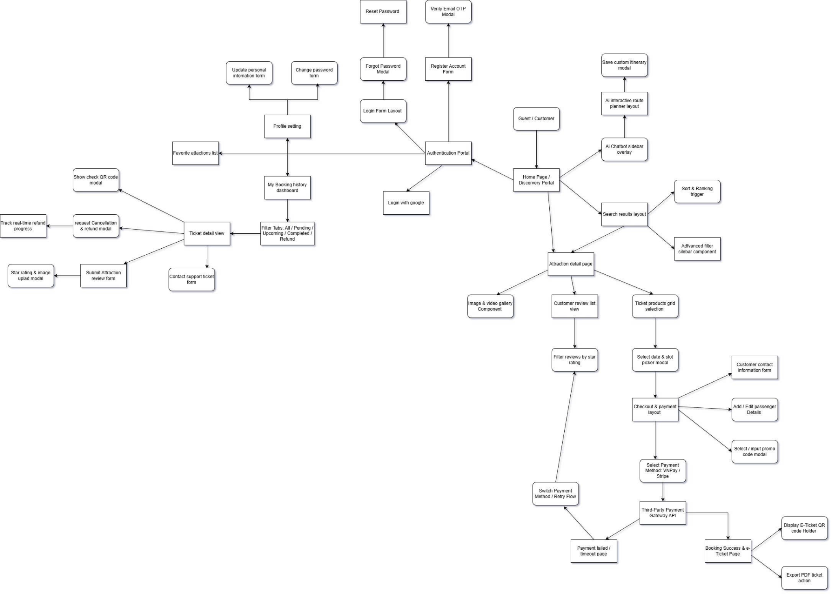

Figure 7. Guest and Customer Screen flow diagram
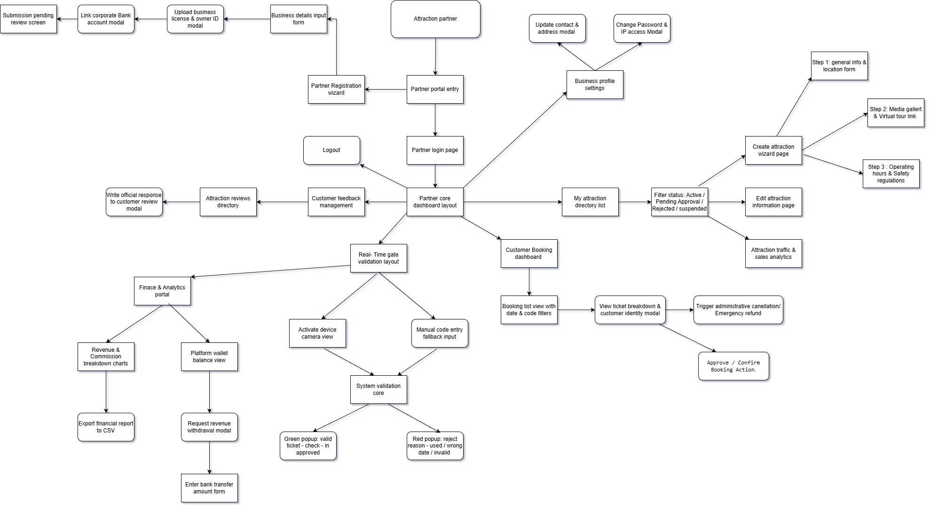

Figure 8. Attraction partner Screen Flow Diagram

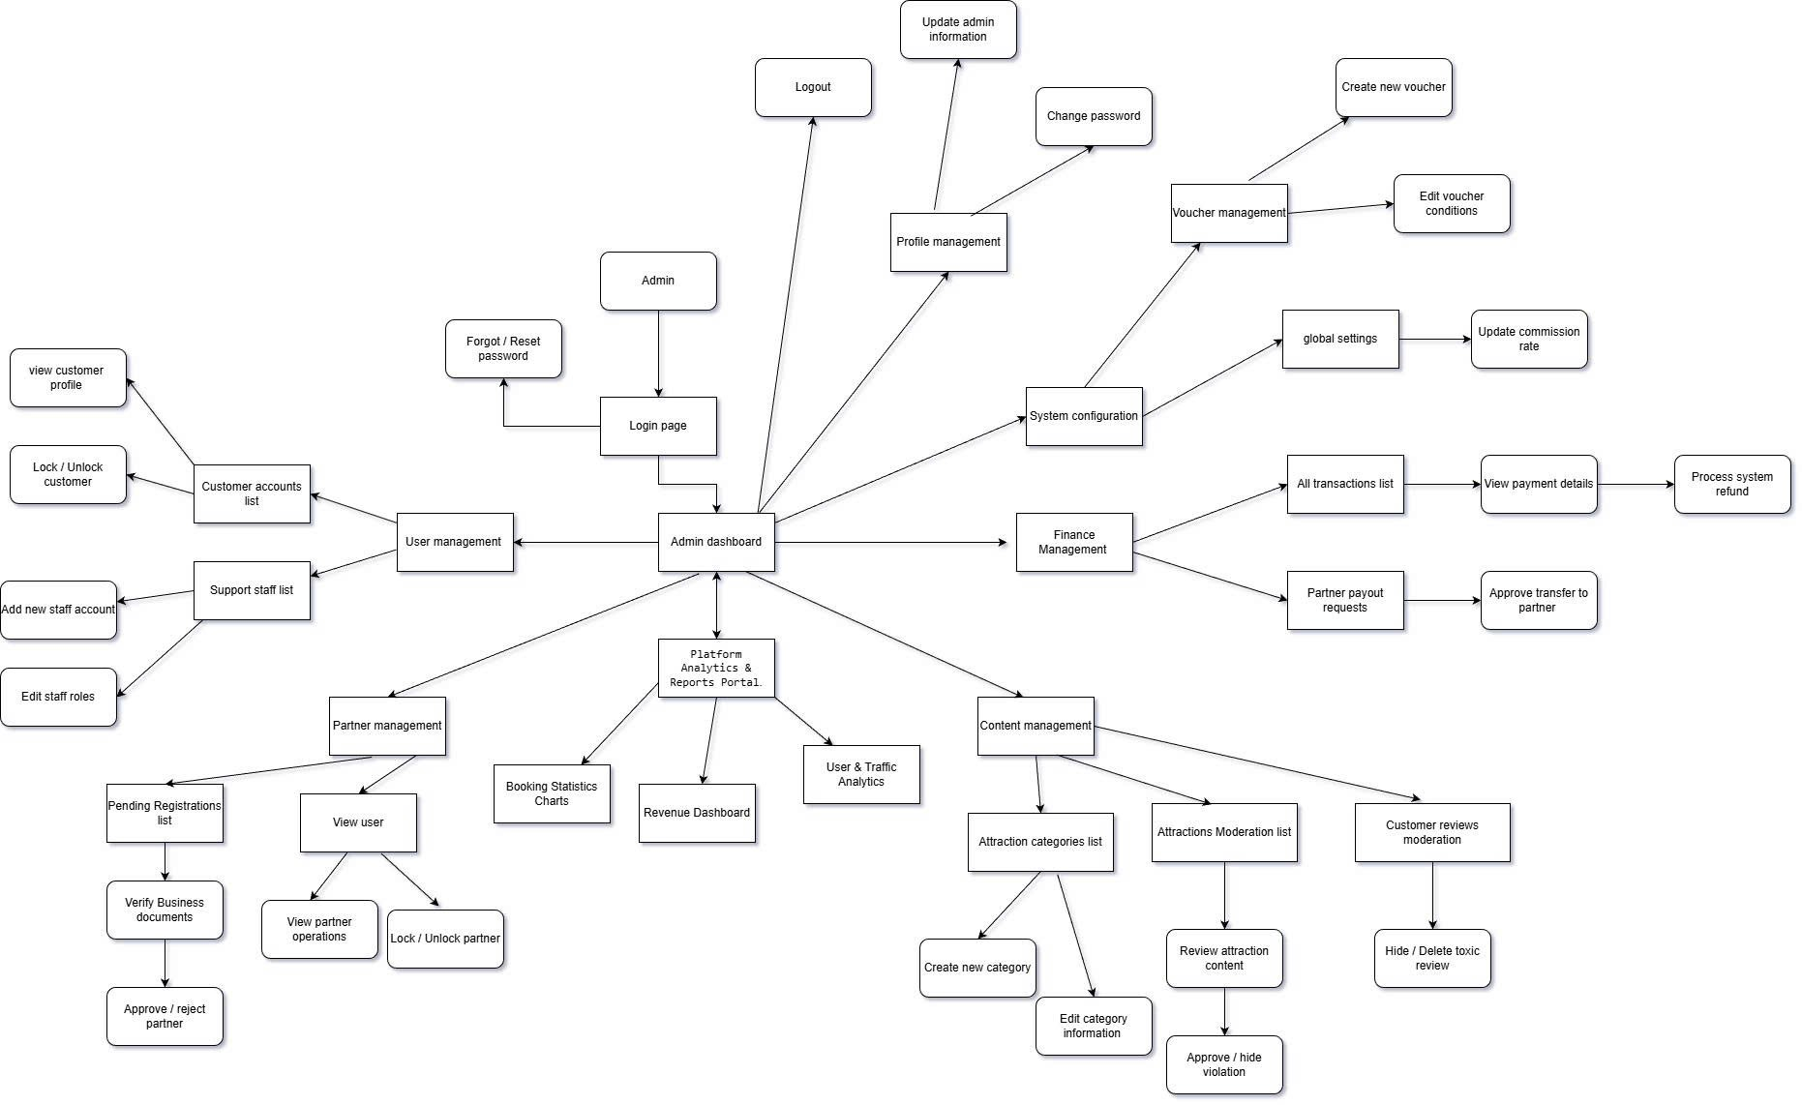

Figure 9. Admin Screen Flow Diagram
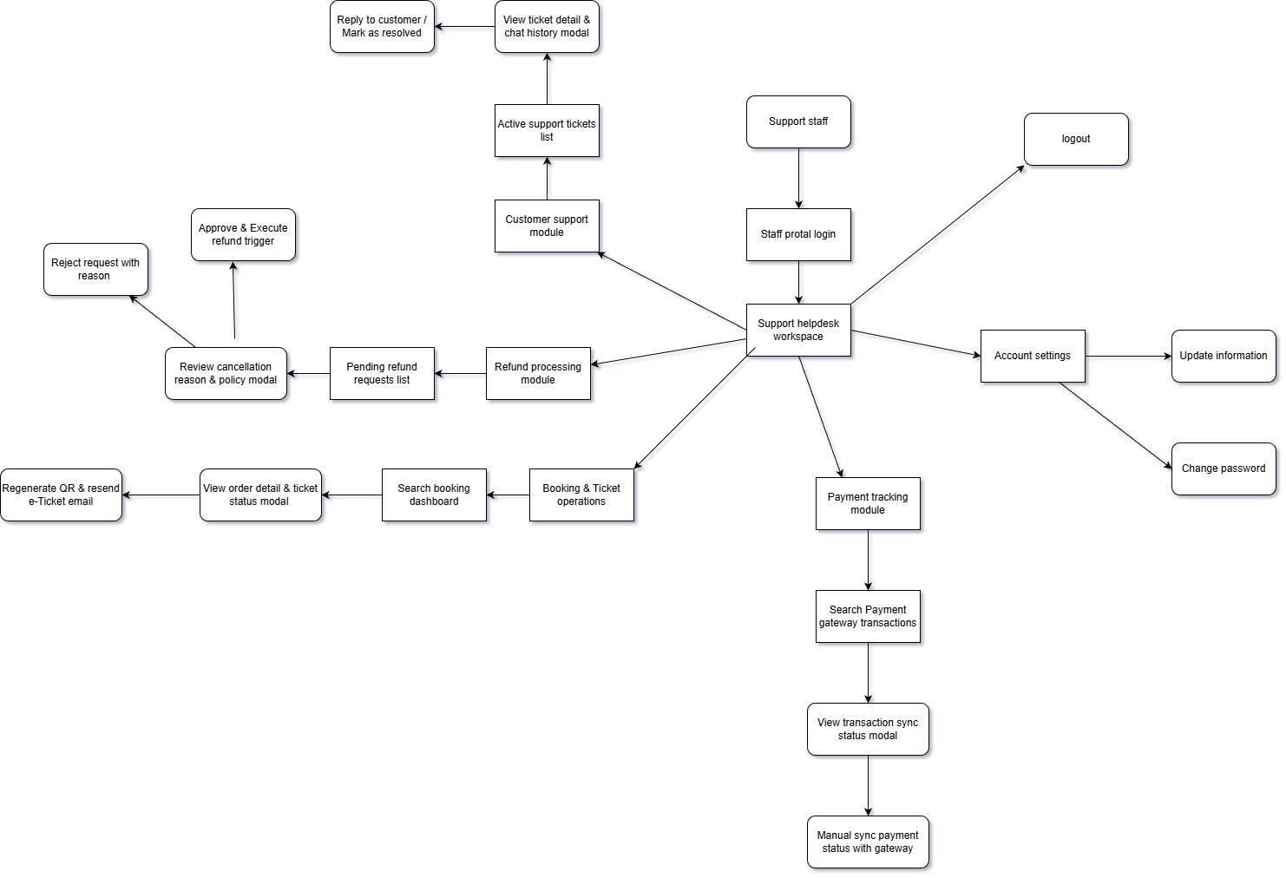

Figure 10. Support Staff Screen Flow Diagram

3.1.2 Screen Descriptions
# | Feature | Screen | Description
1 | Authentication and Profile Management | Register Screen | This screen allows Guests to register a new account by entering required information such as full name, email, phone number, and password. It supports the Register Account use case.
2 | Authentication and Profile Management | Email Verification Screen | This screen allows Guests to verify their account by entering the verification code sent by the Notification Service. It supports the Send Verification Code use case.
3 | Authentication and Profile Management | Sign in Screen | This screen allows Guests, Customers, Attraction Partners, and Admins to log in to the system using valid credentials. It supports the Login use case.
4 | Authentication and Profile Management | Google Sign in Screen | This screen allows Guests or Customers to sign in using a Google account through Google Authentication Service. It supports the Login with Google use case.
5 | Authentication and Profile Management | Forgot Password Screen | This screen allows users to request a password reset link or verification code when they cannot remember their password. It supports the Forgot Password use case.
6 | Authentication and Profile Management | Reset Password Screen | This screen allows users to create a new password after verifying the reset request. It supports the Reset Password use case.
7 | Authentication and Profile Management | Customer Profile Update Screen | This screen allows Customers to update personal profile information such as name, phone number, email, and avatar. It supports the Update Profile use case.
8 | Authentication and Profile Management | Partner Profile Update Screen | This screen allows Attraction Partners to update business profile information such as business name, contact information, address, and business documents. It supports the Update Partner Profile use case.
9 | Authentication and Profile Management | User Management Screen | This screen allows Admins to view the user list and lock or unlock user accounts when necessary. It supports View User List and Lock or Unlock User Account.
10 | Authentication and Profile Management | Partner Account Management Screen | This screen allows Admins to lock or unlock Attraction Partner accounts and send account status notifications. It supports Lock or Unlock Partner Account and Send Account Status Notification.
11 | Attraction and Ticket Product Management | Attraction Search Screen | This screen allows Guests and Customers to search and filter attractions by name, location, category, price, or rating. It supports the Search and Filter Attractions use case.
12 | Attraction and Ticket Product Management | Attraction Detail Screen | This screen allows Guests and Customers to view detailed information about an attraction, including description, images, price, location, opening time, and related ticket products. It supports View Attraction Details.
13 | Attraction and Ticket Product Management | Favorite Attractions Screen | This screen allows Customers to save and view favorite attractions for later booking. It supports the Save Favorite Attraction use case.
14 | Attraction and Ticket Product Management | Partner Registration Screen | This screen allows Customers to register as service providers and submit required partner information. It supports the Register Partner Account use case.
15 | Attraction and Ticket Product Management | Partner Approval Screen | This screen allows Admins to review partner registration information and approve or reject partner accounts. It supports the Review Partner Registration use case.
16 | Attraction and Ticket Product Management | Attraction Listing Management Screen | This screen allows Attraction Partners to manage their attraction listings, including creating new ones, updating details, or deleting them. It supports the Create Attraction Information, Update Attraction Information, and Delete Attraction use cases.
17 | Attraction and Ticket Product Management | Attraction Approval Screen | This screen allows Admins to review attraction submissions before allowing them to be displayed on the platform. It supports the Review Attraction Information use case.
18 | Attraction and Ticket Product Management | Ticket Product Management Screen | This screen allows Attraction Partners to manage their ticket products, including creating new ticket types, updating information, and deactivating them when needed. It supports the Create Attraction Ticket Type, Update Attraction Ticket Type, and Deactivate Ticket Type use cases.
19 | Attraction and Ticket Product Management | Attraction Moderation Screen | This screen allows Admins to hide attractions that violate platform policies. It supports the Hide Violating Attraction use case.
20 | Booking and Payment Management | Booking Checkout Screen | This screen allows Customers to book attraction tickets by selecting an attraction, ticket type, visit date, quantity, and booking information. It supports the Book Attraction Ticket use case.
21 | Booking and Payment Management | Voucher Application Screen | This screen allows Customers to apply a voucher during the booking process to receive a discount. It supports the Apply Voucher use case.
22 | Booking and Payment Management | Payment Screen | This screen allows Customers to complete online payment through the Payment Gateway. It supports the Process Online Payment use case.
23 | Booking and Payment Management | Booking Confirmation Screen | This screen allows Attraction Partners to confirm bookings that require manual approval. It supports the Process Booking Confirmation use case.
24 |  | AI Travel Assistant Screen | This screen allows Customers to use the AI Travel Assistant for travel-related support. It supports Use AI Travel Assistant and Provide AI Travel Assistance.
  AI Travel Assistant
25 |  | Attraction Suggestion Screen | This screen displays attraction suggestions generated by the AI Service based on Customer needs or preferences. It supports the Suggest Attractions use case.
26 |  | Travel Question Answering Screen | This screen allows Customers to ask travel-related questions and receive AI-generated answers. It supports the Answer Travel Questions use case.
27 |  | Ticket Package Recommendation Screen | This screen displays suitable ticket package recommendations such as combo tickets, family tickets, or group tickets. It supports the Recommend Ticket Packages use case.
28 |  | Visit Plan Generation Screen | This screen displays a suggested visit plan based on the Customer’s time, budget, and preferred attractions. It supports the Generate Visit Plan use case.
29 | Post-Booking and Customer Support | Booking History Screen | This screen allows Customers to view their booking history in the system. It supports the View Booking History use case.
30 | Post-Booking and Customer Support | Booking Detail Screen | This screen allows Customers to view detailed information about a selected booking, such as ticket code, QR code, visit date, payment status, and booking status. It supports the View Booking Detail use case.
31 | Post-Booking and Customer Support | Cancel Booking Screen | This screen allows Customers to cancel a booking according to the platform’s cancellation policy. It supports the Cancel Booking use case.
32 | Post-Booking and Customer Support | Refund Request Screen | This screen allows Customers to request a refund after cancelling a booking or when refund conditions are met. It supports the Request Refund use case.
33 | Post-Booking and Customer Support | Review Submission Screen | This screen allows Customers to submit attraction reviews after using the attraction service. It supports Submit Attraction Review, Rate Attraction, and Write Review Comment.
34 | Post-Booking and Customer Support | Support Contact Screen | This screen allows Customers to contact Support Staff for help related to booking, payment, refund, ticket, or account issues. It supports the Contact Support use case.
35 | Post-Booking and Customer Support |  | This screen allows Attraction Partners to view Customer reviews and respond to them. It supports View Customer Reviews and Respond to Customer Reviews.
  Partner Review Management Screen
36 | Post-Booking and Customer Support | Support Request Management Screen | This screen allows Support Staff to handle Customer support requests, respond to inquiries, view related booking information, and resolve complaints. It supports Handle Customer Support Request, Respond to Customer Inquiry, View Customer Booking, and Resolve Complaint.
37 | Post-Booking and Customer Support |  | This screen allows Support Staff to review refund requests, process approved refunds through the Payment Gateway, and send refund notifications. It supports Process Refund Request, Review Refund Request, Process Refund, and Send Refund Notification.
  Refund Management Screen
38 | Post-Booking and Customer Support | E-Ticket Reissue Screen | This screen allows Support Staff to reissue an e-ticket or QR code when the Customer does not receive the ticket or needs it resent. It supports Reissue E-Ticket and Send E-Ticket Notification.
39 | Post-Booking and Customer Support | Review Moderation Screen | This screen allows Admins to moderate Customer reviews and hide reviews that violate platform rules. It supports Moderate Customer Review and Hide Violating Review.
40 | Admin Back-Office and Reporting | Partner Booking List Screen | This screen allows Attraction Partners to view Customer bookings related to their attractions or ticket products. It supports the View Customer Bookings use case.
41 | Admin Back-Office and Reporting | Partner Revenue Report Screen | This screen allows Attraction Partners to view revenue reports for ticket sales. It supports the View Revenue Report use case.
42 | Admin Back-Office and Reporting | Payment Tracking Screen | This screen allows Support Staff to track payment status for bookings, such as paid, failed, pending, or refunded. It supports the Track Payment Status use case.
43 | Admin Back-Office and Reporting | Voucher Management Screen | This screen allows Admins to configure vouchers, create new vouchers, update voucher information, and disable vouchers. It supports Configure Voucher, Create Voucher, Update Voucher, and Disable Voucher.
44 | Admin Back-Office and Reporting | Commission Rate Setting Screen | This screen allows Admins to configure the commission rate between the platform and Attraction Partners. It supports the Configure Commission Rate use case.
45 | Admin Back-Office and Reporting | Platform Report Dashboard | This screen allows Admins to view platform reports, booking statistics, revenue dashboard, and transaction history. It supports View Platform Reports, View Booking Statistics, View Revenue Dashboard, and View Transaction History.

Table 4. Screen Descriptions

3.1.3 Screen Authorization
Screen | Guest | Customer | Attraction Partner | Support Staff | Admin
Register Screen | X
Email Verification Screen | X
Sign in Screen | X | X | X | X | X
Forgot Password Screen | X | X | X | X | X
Reset Password Screen | X | X | X | X | X
Customer Profile Update Screen |  | X
Partner Profile Update Screen |  |  | X
User Management Screen |  |  |  |  | X
Partner Account Management Screen |  |  |  |  | X
Attraction Search Screen | X | X | X
Attraction Detail Screen | X | X | X
Favorite Attractions Screen |  | X
Partner Registration Screen |  | X
Partner Approval Screen |  |  |  |  | X
Attraction Listing Management Screen |  |  | X
Attraction Approval Screen |  |  |  |  | X
Ticket Product Management Screen |  |  | X
Attraction Moderation Screen |  |  |  |  | X
Booking Checkout Screen |  | X
Voucher Application Screen |  | X
Payment Screen |  | X
Booking Confirmation Screen |  |  | X
AI Travel Assistant Screen |  | X
Attraction Suggestion Screen |  | X
Travel Question Answering Screen |  | X
Ticket Package Recommendation Screen |  | X
Visit Plan Generation Screen |  | X
Booking History Screen |  | X
Booking Detail Screen |  | X
Cancel Booking Screen |  | X
Refund Request Screen |  | X
Review Submission Screen |  | X
Support Contact Screen |  | X
Partner Review Management Screen |  |  | X
Support Request Management Screen |  |  |  | X
Refund Management Screen |  |  |  | X
E-Ticket Reissue Screen |  |  |  | X
Review Moderation Screen |  |  |  |  | X
Partner Booking List Screen |  |  | X
Partner Revenue Report Screen |  |  | X
Payment Tracking Screen |  |  |  | X
Voucher Management Screen |  |  |  |  | X
Commission Rate Setting Screen |  |  |  |  | X
Platform Report Dashboard |  |  |  |  | X

Table 5. Screen Authorization

3.1.4 Non-Screen Functions
# | Feature | System Function | Description
1 | Authentication and User Management | Send Verification Code | The system sends a verification code to the Guest through Notification Service after account registration.
1 | Authentication and User Management | Sign in with Google | The system verifies the user through Google Authentication Service when the user chooses to sign in with a Google account.
1 | Authentication and User Management | Forgot Password | The system sends a password reset link or verification code to the user through Notification Service when the user cannot log in.
1 | Authentication and User Management | Send Account Status Notification | The system sends an account status notification to the Attraction Partner when the Admin locks or unlocks the partner account.
2 | Attraction and Ticket Product Management | Send Attraction Approval Result | The system sends an approval or rejection notification to the Attraction Partner when the Admin reviews their newly submitted attraction listing.
2 | Attraction and Ticket Product Management | Send Violation Notification | The system sends a violation notification to the Attraction Partner when an attraction is hidden due to a policy violation.
3 | Booking and Payment Management | Process Online Payment | The system connects with Payment Gateway to process online payment when the Customer books an attraction ticket.
3 | Booking and Payment Management | Generate E-Ticket / QR Code | The system generates an electronic ticket or QR code after the booking and payment are completed successfully.
3 | Booking and Payment Management | Send Booking Confirmation Notification | The system sends booking confirmation to the Customer through Notification Service after the booking is confirmed.
4 | AI Travel Assistant | Provide AI Travel Assistance | The system connects with AI Service to suggest attractions, answer travel questions, recommend ticket packages, and generate visit plans.
5 | Post-Booking and Customer Support |  | The system connects with Payment Gateway to process refunds when a refund request is approved.
  Process Refund
5 | Post-Booking and Customer Support | Send Refund Notification | The system sends refund result notifications to the Customer through Notification Service.
6 | Admin Back-Office and Reporting | Generate Platform Reports | The system generates booking statistics, revenue dashboard, and transaction history for Admin reporting.

Table 6. Non-Screen Functions

3.1.5 Entity Relationship Diagram
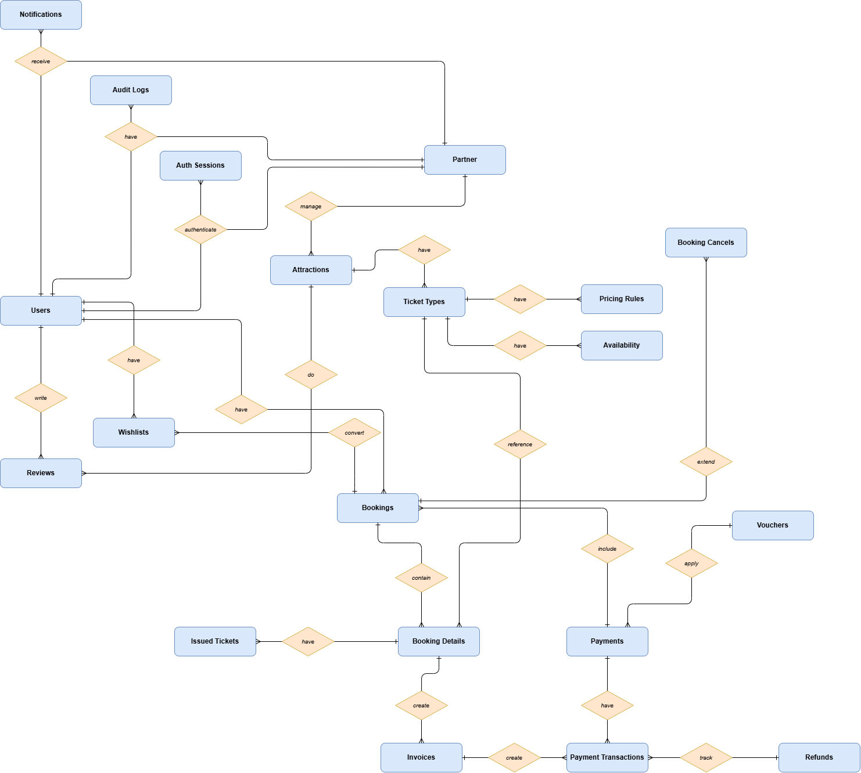

Figure 18. ERD Diagram
Entities Description
# | Entity | Description
1 | Users | The class represents storage of the user's account information in the system.  - Properties:  id (Primary Key)  email  password_hash  full_name  role  provider  is_email_verified  status  created_at  updated_at
2 | User profiles | The class represents detailed personal information of a user.  - Properties:  id (Primary Key)  user_id (Foreign Key to Users entity)  phone_number  avatar_url  date_of_birth  gender  address
3 | Email verification tokens | The class represents email verification tokens used to verify user accounts.  - Properties:  id (Primary Key)  user_id (Foreign Key to Users entity)  token  expires_at  created_at
4 | Password reset tokens | The class represents password reset tokens used when users forget their passwords.  - Properties:  id (Primary Key)  user_id (Foreign Key to Users entity)  token  expires_at  created_at
5 | OAuth accounts | The class represents external authentication accounts such as Google accounts linked to a user.  - Properties:  id (Primary Key)  user_id (Foreign Key to Users entity)  provider  provider_account_id  created_at
6 | Partner profiles | The class represents business information of attraction partners in the system.  - Properties:  id (Primary Key)  user_id (Foreign Key to Users entity)  business_name  business_email  business_phone  tax_code  address  description  logo_url  status  approved_by (Foreign Key to Users entity)  approved_at  created_at  updated_at
7 | Partner registration requests | The class represents registration requests submitted by users who want to become attraction partners.  - Properties:  id (Primary Key)  user_id (Foreign Key to Users entity)  business_name  business_email  business_phone  tax_code  address  description  status  rejection_reason  reviewed_by (Foreign Key to Users entity)  reviewed_at  created_at
8 | Attractions | The class represents tourist attractions listed on the platform.  - Properties:  id (Primary Key)  partner_id (Foreign Key to Partner profiles entity)  name  slug  description  address  city  province  country  latitude  longitude  opening_hours  rules  status  rejection_reason  hidden_reason  approved_by (Foreign Key to Users entity)  approved_at  created_at  updated_at
9 | Attraction images | The class represents images of attractions uploaded by partners.  - Properties:  id (Primary Key)  attraction_id (Foreign Key to Attractions entity)  image_url  caption  display_order  is_thumbnail  created_at
10 | Attraction categories | The class represents categories of attractions such as museums, theme parks, historical sites, or nature attractions.  - Properties:  id (Primary Key)  name  description  created_at
11 | Attraction category mappings | The class represents the many-to-many relationship between attractions and attraction categories.  - Properties:  attraction_id (Foreign Key to Attractions entity)  category_id (Foreign Key to Attraction categories entity)
12 | Favorite attractions | The class represents attractions saved by customers as their favorites.  - Properties:  id (Primary Key)  user_id (Foreign Key to Users entity)  attraction_id (Foreign Key to Attractions entity)  created_at
13 | Ticket products | The class represents ticket products created for each attraction.  - Properties:  id (Primary Key)  attraction_id (Foreign Key to Attractions entity)  name  description  ticket_type  base_price  currency  age_policy  status  created_at  updated_at
14 | Visit time slots | The class represents available visiting time slots of an attraction.  - Properties:  id (Primary Key)  attraction_id (Foreign Key to Attractions entity)  name  start_time  end_time  is_active  created_at
15 | Ticket availability | The class represents ticket quantity availability by ticket product, visit date, and time slot.  - Properties:  id (Primary Key)  ticket_product_id (Foreign Key to Ticket products entity)  visit_date  time_slot_id (Foreign Key to Visit time slots entity)  total_quantity  available_quantity  sold_quantity  status  created_at  updated_at
16 | Vouchers | The class represents discount vouchers configured by administrators.  - Properties:  id (Primary Key)  code  name  description  discount_type  discount_value  max_discount_amount  min_order_amount  usage_limit  used_count  start_date  end_date  status  created_by (Foreign Key to Users entity)  created_at  updated_at
17 | Voucher usages | The class represents voucher usage history by customers for bookings.  - Properties:  id (Primary Key)  voucher_id (Foreign Key to Vouchers entity)  user_id (Foreign Key to Users entity)  booking_id (Foreign Key to Bookings entity)  used_at
18 | Bookings | The class represents ticket booking orders created by customers.  - Properties:  id (Primary Key)  booking_code  customer_id (Foreign Key to Users entity)  attraction_id (Foreign Key to Attractions entity)  partner_id (Foreign Key to Partner profiles entity)  visit_datetime_slot_id (Foreign Key to Visit time slots entity)  total_amount  discount_amount  final_amount  status  payment_status  confirmation_status  voucher_id (Foreign Key to Vouchers entity)  created_at  updated_at
19 | Booking items | The class represents ticket items included in a booking.  - Properties:  id (Primary Key)  booking_id (Foreign Key to Bookings entity)  ticket_product_id (Foreign Key to Ticket products entity)  quantity  unit_price  subtotal
20 | Payment transactions | The class represents online payment transactions for bookings.  - Properties:  id (Primary Key)  booking_id (Foreign Key to Bookings entity)  payment_gateway  gateway_transaction_id  amount  currency  status  payment_method  paid_at  failed_reason  created_at
21 | E-tickets | The class represents electronic tickets or QR codes generated after successful payment.  - Properties:  id (Primary Key)  booking_item_id (Foreign Key to Booking items entity)  ticket_code  qr_code_url  status  issued_at  used_at  expired_at
22 | Ticket validation logs | The class represents ticket validation history when partners scan QR codes at the attraction gate.  - Properties:  id (Primary Key)  e_ticket_id (Foreign Key to E-tickets entity)  partner_id (Foreign Key to Partner profiles entity)  scanned_by (Foreign Key to Users entity)  validation_status  message  scanned_at
23 | Invalid ticket reports | The class represents reports created when a scanned ticket is invalid, expired, used, or suspicious.  - Properties:  id (Primary Key)  e_ticket_id (Foreign Key to E-tickets entity)  reported_by (Foreign Key to Users entity)  partner_id (Foreign Key to Partner profiles entity)  reason  description  status  created_at  resolved_at
24 | AI conversations | The class represents AI travel assistant conversations between customers and the AI service.  - Properties:  id (Primary Key)  user_id (Foreign Key to Users entity)  title  created_at  updated_at
25 | AI messages | The class represents messages inside an AI travel assistant conversation.  - Properties:  id (Primary Key)  conversation_id (Foreign Key to AI conversations entity)  sender_type  message  created_at
26 | AI recommendation logs | The class represents attractions or ticket products recommended by the AI service.  - Properties:  id (Primary Key)  user_id (Foreign Key to Users entity)  attraction_id (Foreign Key to Attractions entity)  ticket_product_id (Foreign Key to Ticket products entity)  reason  created_at
27 | AI visit plans | The class represents visit plans generated by the AI travel assistant for customers.  - Properties:  id (Primary Key)  user_id (Foreign Key to Users entity)  title  destination_city  start_date  end_date  plan_content  created_at
28 | Attraction reviews | The class represents customer reviews and ratings for attractions.  - Properties:  id (Primary Key)  user_id (Foreign Key to Users entity)  attraction_id (Foreign Key to Attractions entity)  booking_id (Foreign Key to Bookings entity)  rating  comment  partner_reply  replied_at  status  created_at  updated_at
29 | Review reports | The class represents reports of inappropriate or violating customer reviews.  - Properties:  id (Primary Key)  review_id (Foreign Key to Attraction reviews entity)  reported_by (Foreign Key to Users entity)  reason  status  resolved_by (Foreign Key to Users entity)  resolved_at  created_at
30 | Support requests | The class represents customer support requests related to bookings, payments, refunds, or complaints.  - Properties:  id (Primary Key)  user_id (Foreign Key to Users entity)  booking_id (Foreign Key to Bookings entity)  subject  description  type  status  assigned_staff_id (Foreign Key to Users entity)  created_at  updated_at
31 | Support messages | The class represents messages exchanged inside a support request.  - Properties:  id (Primary Key)  support_request_id (Foreign Key to Support requests entity)  sender_id (Foreign Key to Users entity)  message  created_at
32 | Refund requests | The class represents refund requests created by customers and processed by support staff.  - Properties:  id (Primary Key)  booking_id (Foreign Key to Bookings entity)  user_id (Foreign Key to Users entity)  reason  refund_amount  status  reviewed_by (Foreign Key to Users entity)  reviewed_at  rejection_reason  payment_transaction_id (Foreign Key to Payment transactions entity)  created_at  updated_at
33 | Notification logs | The class represents notifications sent to users through email, SMS, or in-app channels.  - Properties:  id (Primary Key)  user_id (Foreign Key to Users entity)  type  channel  title  content  status  sent_atcreated_at
34 | Commission rates | The class represents commission rate settings configured by administrators for partners or the whole platform.  - Properties:  id (Primary Key)  partner_id (Foreign Key to Partner profiles entity)  rate_percentage  effective_from  effective_to  status  created_by (Foreign Key to Users entity)  created_at
35 | Partner payouts | The class represents payout records calculated for attraction partners after platform commission deduction.  - Properties:  id (Primary Key)  partner_id (Foreign Key to Partner profiles entity)  total_revenue  commission_amount  payout_amount  status  period_start  period_end  paid_at  created_at

Table 7. Entities Description

3.2 Authentication and User Management

3.2.1 - Sign In
- Function trigger: The user may be automatically redirected to the sign-in page when trying to access pages that require authentication, but they are not signed in.
- Function description: Allows Admin, Packing Staff, Delivery Supervisor, Sell Staff, Warehouse Manager, Delivery Supervisor, Delivery Staff, Accountant to sign into their accounts using either their email or username and password or their Google account.
- Screen layout:
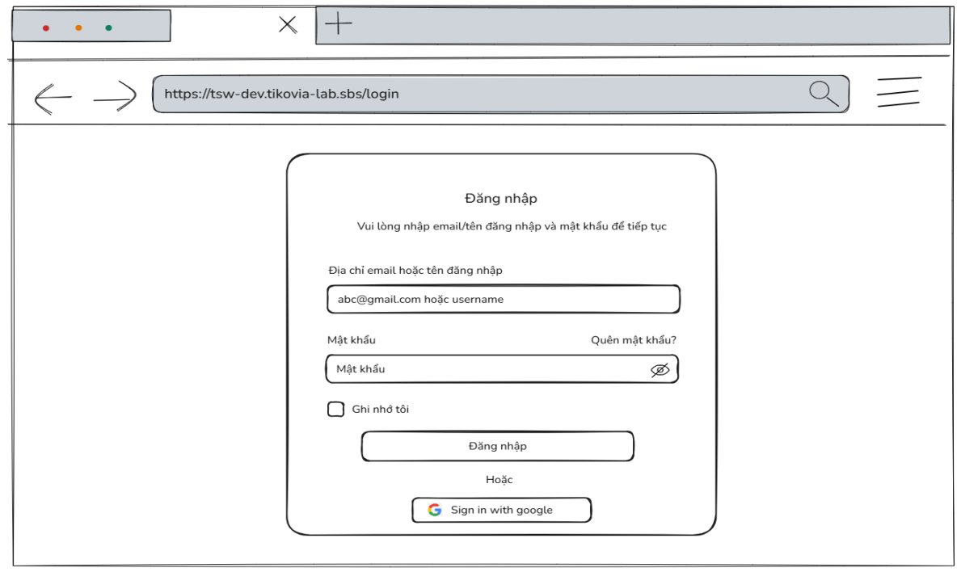
- Function detail (Traditional Sign in Flow):
  - Data Validation:
    - Password: Must match the password registered with the account.
  - Functionality:
    - In Normal Cases:
      - If the email or username and password are valid:
      - The system sends a sign in request to the server.
      - If successful, the user is signed in and redirected to the dashboard page.
    - In Abnormal Cases:
      - The email, username, or password is incorrect:
        - The system displays an error message like "Email or username not registered!."
      - If the server is unresponsive or there's a connection issue:
        - The system will notify the user of the issue and allow them to try again later.
      - Sign In with Google uses the OAuth2 process to authenticate the user through their Google account.
        - The system will display an error message such as "Account not registered. Please register before logging in with Google.".
  - Business rule: BR-02, BR-07, BR-14
# | Component | Comp. type | Editable | Mandatory | Default Value | Description
 | Header Section
1 | Page Title | Label (Text) | No | Yes | "Đăng nhập" | The main heading of the modal.
2 | Subtitle | Label (Text) | No | Yes | "Vui lòng nhập email/tên đăng nhập và mật khẩu để tiếp tục" | Instructional text guiding the user to enter credentials.
 | Credential Section
3 | User Label | Label (Text) | No | Yes | "Địa chỉ email hoặc tên đăng nhập" | Label for the username/email input field.
4 | User Input | Input (Text) | Yes | Yes | N/A | Accepts User ID or Email.
5 | Pass Label | Label (Text) | No | Yes | "Mật khẩu" | Label for the password input field.
6 | Forgot Pass Link | Link / Button | No | No | "Quên mật khẩu?" | Clickable text that redirects to the "Forgot Password" flow.
7 | Pass Input | Input (Password) | Yes | Yes | "Mật khẩu" | Input field for password. Characters should be masked (e.g., ******) by default.
8 | Visibility Icon | Icon Button | Yes | No | (Icon Eye-off) | Toggles the visibility of the password characters (Mask/Unmask).
9 | Remember Checkbox | Checkbox | Yes | No | "Ghi nhớ tôi" | Option to persist the user's login session (save token).
 | Action Section
10 | Login Button | Button (Primary) | No | Yes | "Đăng nhập" | Submits the credentials for authentication.
11 | Separator | Label (Text) | No | Yes | "Hoặc" | Visual divider between direct login and social login options.
12 | Google Login | Button (Social) | No | No | "Sign in with google" | Third-party authentication button via Google API.
 | Header Section
1 | Page Title | Label (Text) | No | Yes | "Đăng nhập" | The main heading of the modal.
––––––––––––––––––––––––––––––––––––––––––––––––––––––––––––––––––––––––––––––––––-

3.2.2 - Forgot Password
- Function trigger:
  - The Forgot Password function can be triggered via a "Forgot Password" link from the sign in page.
  - Additionally, it can be accessed from a direct link sent to the user’s email when they request password recovery.
- Function description:
  - Function description: Allow unauthenticated users who have forgotten their password or users who wish to reset their password to recover or reset their account password in case they forget it. After the user submits their email, the system verifies if the email exists in the database. If it does, the system sends a password reset link to the provided email.
- Screen layout:
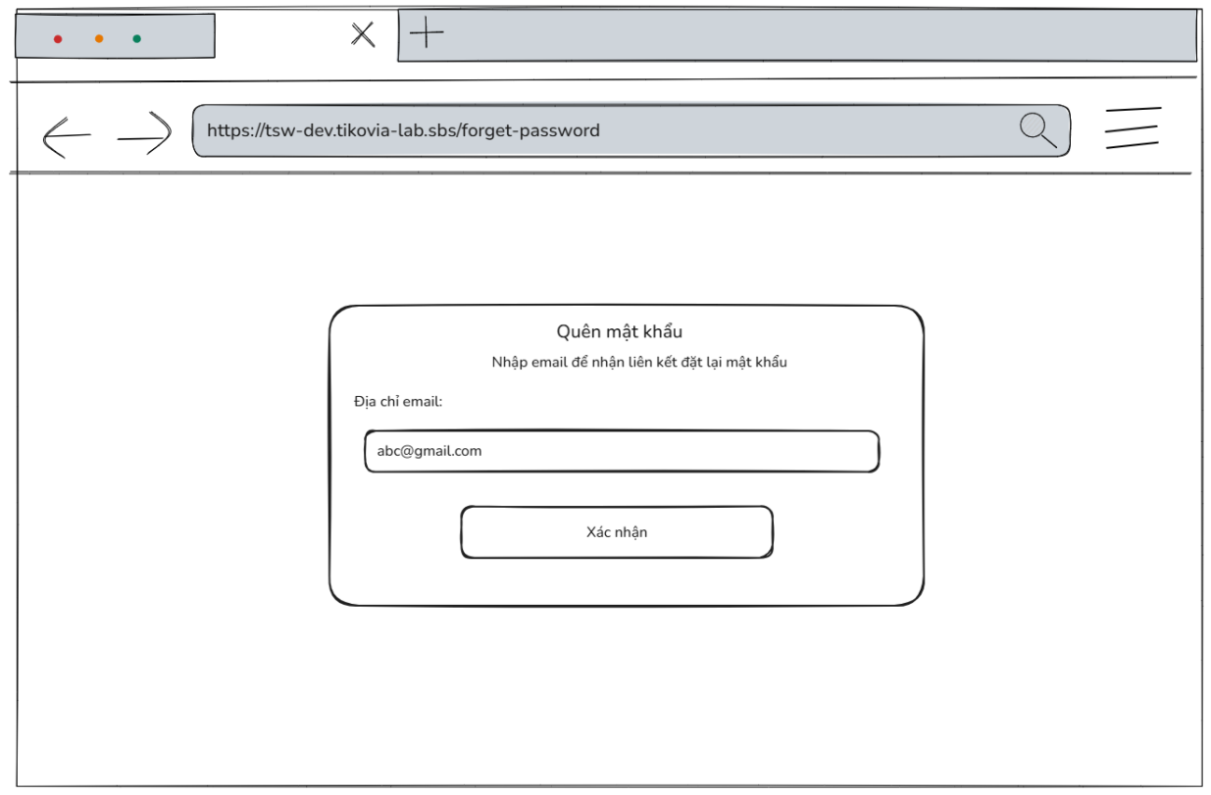
- Function detail:
  - Data validation:
    - Email: Required, must be a valid email format.
    - The email must exist in the database.
  - Functionality:
    - In normal cases:
      - If the provided email is valid and exists in the system, the system will send a password reset link to the user's email address.
      - The user will receive an email with a link to a page to enter a new password.
      - The new password must meet the system’s password strength requirements (at least 8 characters, at least 1 uppercase letter, 1 lowercase letter, 1 number).
    - In abnormal cases:
      - If the email does not exist in the system, the user will receive an error message like "Email does not exist in the system!"
      - If the system encounters a failure in sending the reset email (e.g., server issue or network error), an error message will be displayed, and the user will be advised to try again later.
  - Business rule: BR-02, BR-07, BR-14, BR-17.
# | Component | Comp. type | Editable | Mandatory | Default Value | Description
 | Header Section
1 | Modal Title | Label (Text) | No | Yes | "Quên mật khẩu" | Displays the main header of the modal.
2 | Instruction Text | Label (Text) | No | Yes | "Nhập email để nhận liên kết đặt lại mật khẩu" | Displays the helper text instructing the user.
 | Form Section
3 | Email Label | Label (Text) | No | Yes | "Địa chỉ email:" | The label for the email input field.
4 | Email Input | Input (Text/Email) | Yes | Yes | N/A | The input field for the user's email.
5 | Confirm Button | Button | No | Yes | "Xác nhận" | The primary button to submit the form.
––––––––––––––––––––––––––––––––––––––––––––––––––––––––––––––––––––––––––––––––––-

3.2.3 - Reset Password
- Function trigger: The Reset Password function can be triggered via a "Reset Password" link from the email.
- Function description: Allow Unauthenticated users who wish to reset their password to recover or reset their account password in case they forget it. After the user submits their new password, the system replaces the existing password with a new password.
- Screen layout:
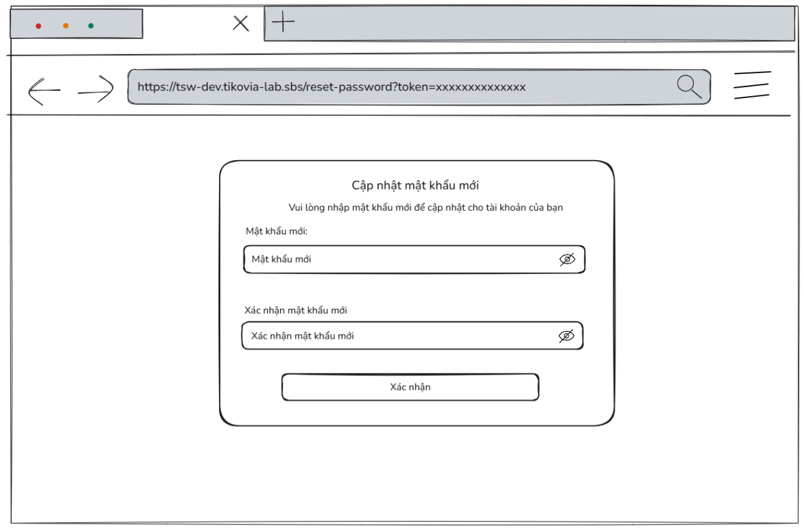
- Function detail:
  - Data validation:
    - New Password: Required, must be a valid password format (at least 8 characters, at least 1 uppercase letter, 1 lowercase letter, 1 number).
    - Confirm Password: Required, must match with new password.
  - Functionality:
    - In normal cases:
      - If the link has not expired, the system displays a form asking the user to enter the new password and confirm it again. Otherwise, the system displays notification expired links and does not allow resetting passwords.
      - The new password must meet the system’s password strength requirements (at least 8 characters, at least 1 uppercase letter, 1 lowercase letter, 1 number).
      - The user changes the password successfully and can sign in with a new password.
    - In abnormal cases:
      - If the system encounters a failure in sending the request reset password (e.g., server issue or network error), an error message will be displayed, and the user will be advised to try again later.
  - Business rule: BR01, BR-02, BR-03, BR-14.
# | Component | Comp. type | Editable | Mandatory | Default Value | Description
 | Header Section
1 | Modal Title | Label (Text) | No | Yes | "Cập nhật mật khẩu mới" | Displays the main header of the modal.
2 | Instruction Text | Label (Text) | No | Yes | "Vui lòng nhập mật khẩu mới để cập nhật cho tài khoản của bạn" | Displays the helper text instructing the user.
 | Form Section
3 | New Password Label | Label (Text) | No | Yes | "Mật khẩu mới:" | The label for the new password input field.
4 | New Password Input | Input (Password) | Yes | Yes | Placeholder: "Mật khẩu mới" | Input field for user's new password. Includes an eye icon to toggle visibility.
5 | Confirm Pwd Label | Label (Text) | No | Yes | "Xác nhận mật khẩu mới" | The label for the confirm password input field.
6 | Confirm Pwd Input | Input (Password) | Yes | Yes | Placeholder: "Xác nhận mật khẩu mới" | Input field to re-enter the password. Must match the value in component #4.
7 | Confirm Button | Button | No | Yes | "Xác nhận" | The primary button to submit the new password form.
––––––––––––––––––––––––––––––––––––––––––––––––––––––––––––––––––––––––––––––––––-

3.2.4 - View Profile
- Function Trigger: The user accesses their profile by selecting the "Profile" option from the dropdown menu linked to their account.
- Function Description: Allow any authenticated user (Admin, Packing Staff, Delivery Supervisor, Sell Staff, warehouse manager, Delivery Supervisor, Delivery Staff, Accountant) to view and manage their account information, including their avatar, phone. The system retrieves the user's profile information from the database and displays it in a clear, readable format.
- Screen Layout:
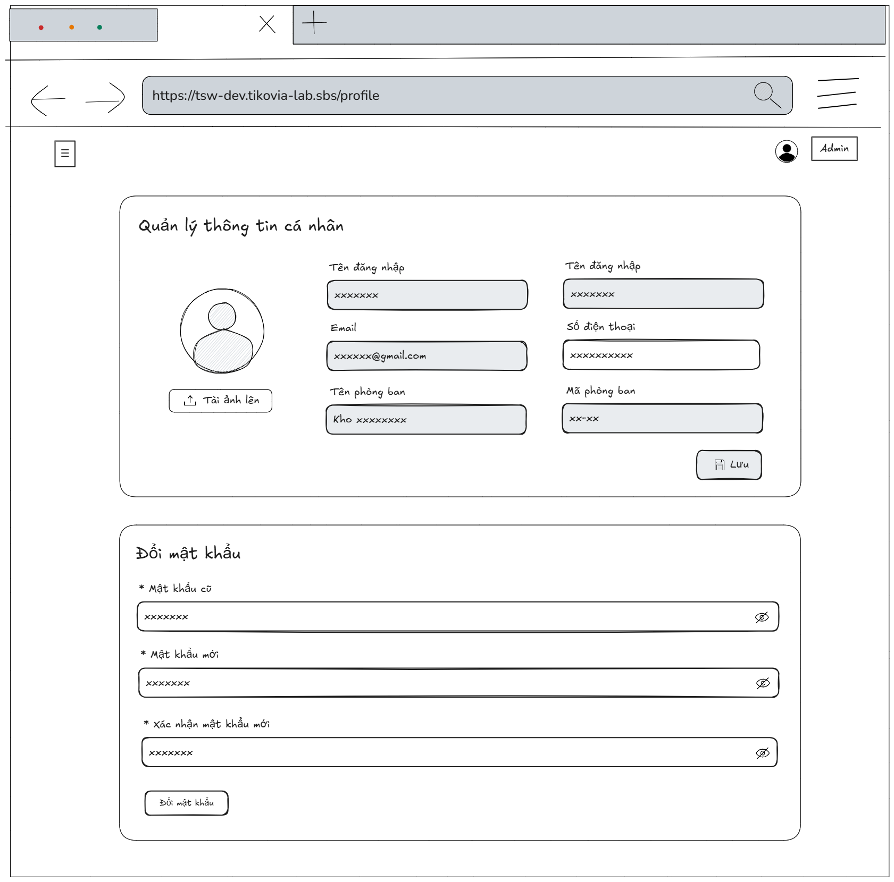
- Function Details:
  - Data validation:
    - The system must retrieve the necessary user data from the database (e.g., full name, username, email,…).
  - Functionality:
    - In normal cases:
      - The user profile information is retrieved and displayed correctly.
      - All profile details must be consistent with the data stored in the database.
    - In abnormal cases:
      - If the user’s session has expired or is invalid, the system will automatically redirect the user to the sign in page to re-authenticate.
  - Business rule: N/A.
# | Component | Comp. type | Editable | Mandatory | Default Value | Description
 | Section: Personal Info
1 | Screen Title | Label (Text) | No | Yes | "Quản lý thông tin cá nhân" | Displays the main title of the information management section.
2 | Avatar Image | Image | No | Yes | [User Avatar] | Displays the user's current profile picture.
3 | Upload Button | Button | No | No | "Tải ảnh lên" | Button to open the file picker for uploading a new avatar.
4 | Username Label | Label (Text) | No | Yes | "Tên đăng nhập" | Label for the username field.
5 | Username Input | Input (Text) | No | Yes | [User's username] | Displays the user's unique username. This field is read-only.
6 | Fullname Label | Label (Text) | No | Yes | "Họ và tên" | Label for the full name field.
7 | Fullname Input | Input (Text) | Yes | Yes | [User's fullname] | Input field allowing the user to edit their full name.
8 | Email Label | Label (Text) | No | Yes | "Email" | Label for the email address field.
9 | Email Input | Input (Email) | No | Yes | [User's email] | Displays the user's email address. This field is read-only.
10 | Phone Label | Label (Text) | No | Yes | "Số điện thoại" | Label for the phone number field.
11 | Phone Input | Input (Tel) | Yes | Yes | [User's phone] | Input field allowing the user to edit their phone number.
12 | Dept Name Label | Label (Text) | No | Yes | "Tên phòng ban" | Label for the department name field.
13 | Dept Name Input | Input (Text) | No | Yes | [User's dept name] | Displays the name of the department the user belongs to. This field is read-only.
14 | Dept Code Label | Label (Text) | No | Yes | "Mã phòng ban" | Label for the department code field.
15 | Dept Code Input | Input (Text) | No | Yes | [User's dept code] | Displays the unique code of the department. This field is read-only.
16 | Save Info Button | Button | No | Yes | "Lưu" | Button to submit and save changes made to the personal information fields.
 | Section: Change Password
17 | Section Title | Label (Text) | No | Yes | "Đổi mật khẩu" | Displays the title for the change password section.
18 | Old Pass Label | Label (Text) | No | Yes | "* Mật khẩu cũ" | Label for the old password field. Asterisk indicates a mandatory field.
19 | Old Pass Input | Input (Password) | Yes | Yes | N/A | Input field for entering the current password. Includes a toggle icon to show/hide text.
20 | New Pass Label | Label (Text) | No | Yes | "* Mật khẩu mới" | Label for the new password field. Asterisk indicates a mandatory field.
21 | New Pass Input | Input (Password) | Yes | Yes | N/A | Input field for entering the new password. Includes a toggle icon to show/hide text.
22 | Confirm Pass Label | Label (Text) | No | Yes | "* Xác nhận mật khẩu mới" | Label for the confirm password field. Asterisk indicates a mandatory field.
23 | Confirm Pass Input | Input (Password) | Yes | Yes | N/A | Input field to re-enter the new password for verification. Must match component #21. Includes a toggle icon.
24 | Change Pass Button | Button | No | Yes | "Đổi mật khẩu" | Button to submit the password change request.
––––––––––––––––––––––––––––––––––––––––––––––––––––––––––––––––––––––––––––––––––-

3.2.5 - Update Profile
- Function Trigger: Users access the phone number textbox, “upload photo” button from their profile page.
- Function Description: Allow any authenticated user (Admin, Packing Staff, Delivery Supervisor, Sell Staff, warehouse manager, Delivery Supervisor, Delivery Staff, Accountant) to update their personal information including: phone number, and avatar. When the user submits their changes, the system sends the updated data to the server, which validates and stores the new information in the database.
- Screen Layout:
- Function Details:
  - Data validation:
    - Phone number: must have length between 10 and 11 numbers.
  - Functionality:
    - In normal cases:
      - The system successfully updates and saves the profile information after validation.
      - Any changes made are immediately reflected in the user's profile view.
    - In abnormal cases:
      - Invalid input: If the user provides invalid data (incorrectly formatted phone or missing required fields), an error message will appear, prompting the user to correct the issue before resubmitting.
      - Failed update attempts: If the system fails to process the update (e.g., due to a server issue), the user will be informed of the failure and given the option to retry or cancel the changes.
  - Business rule: BR-04.
# | Component | Comp. type | Editable | Mandatory | Default Value | Description
 | Section: Personal Info
1 | Screen Title | Label (Text) | No | Yes | "Quản lý thông tin cá nhân" | Displays the main title of the information management section.
2 | Avatar Image | Image | No | Yes | [User Avatar] | Displays the user's current profile picture.
3 | Upload Button | Button | No | No | "Tải ảnh lên" | Button to open the file picker for uploading a new avatar.
4 | Username Label | Label (Text) | No | Yes | "Tên đăng nhập" | Label for the username field.
5 | Username Input | Input (Text) | No | Yes | [User's username] | Displays the user's unique username. This field is read-only.
6 | Fullname Label | Label (Text) | No | Yes | "Họ và tên" | Label for the full name field.
7 | Fullname Input | Input (Text) | Yes | Yes | [User's fullname] | Input field allowing the user to edit their full name.
8 | Email Label | Label (Text) | No | Yes | "Email" | Label for the email address field.
9 | Email Input | Input (Email) | No | Yes | [User's email] | Displays the user's email address. This field is read-only.
10 | Phone Label | Label (Text) | No | Yes | "Số điện thoại" | Label for the phone number field.
11 | Phone Input | Input (Tel) | Yes | Yes | [User's phone] | Input field allowing the user to edit their phone number.
12 | Dept Name Label | Label (Text) | No | Yes | "Tên phòng ban" | Label for the department name field.
13 | Dept Name Input | Input (Text) | No | Yes | [User's dept name] | Displays the name of the department the user belongs to. This field is read-only.
14 | Dept Code Label | Label (Text) | No | Yes | "Mã phòng ban" | Label for the department code field.
15 | Dept Code Input | Input (Text) | No | Yes | [User's dept code] | Displays the unique code of the department. This field is read-only.
16 | Save Info Button | Button | No | Yes | "Lưu" | Button to submit and save changes made to the personal information fields.
––––––––––––––––––––––––––––––––––––––––––––––––––––––––––––––––––––––––––––––––––-

3.2.6 - Change Password
- Function Trigger: Users can access the change password feature from their profile page .
- Function Description: Allow any authenticated user (Admin, Packing Staff, Delivery Supervisor, Sell Staff, warehouse manager, Delivery Supervisor, Delivery Staff, Accountant) to change passwords if they want. When the user submits their changes, the system sends the updated data to the server, which validates and stores the new password in the database.
- Screen Layout:
- Function Details:
  - Data Validation:
    - The old password must match with the current password in the database.
    - The new password must contain at least 8 characters, at least 1 uppercase letter, 1 lowercase letter, 1 number.
    - The system needs the updated password to be submitted by the user.
  - Functionality:
    - In normal cases:
      - The system successfully updates and saves the password after validation.
      - Any changes made are immediately reflected in the sign in process.
    - In abnormal cases:
      - Invalid input: If the user provides invalid data (incorrectly formatted password, invalid old password or missing required fields), an error message will appear, prompting the user to correct the issue before resubmitting.
      - Failed update attempts: If the system fails to process the update (e.g., due to a server issue), the user will be informed of the failure and given the option to retry or discard the changes.
  - Business rule: BR-02, BR-03, BR-14.
# | Component | Comp. type | Editable | Mandatory | Default Value | Description
 | Section: Change Password
1 | Section Title | Label (Text) | No | Yes | "Đổi mật khẩu" | Displays the title for the change password section.
2 | Old Pass Label | Label (Text) | No | Yes | "* Mật khẩu cũ" | Label for the old password field. Asterisk indicates a mandatory field.
3 | Old Pass Input | Input (Password) | Yes | Yes | N/A | Input field for entering the current password. Includes a toggle icon to show/hide text.
4 | New Pass Label | Label (Text) | No | Yes | "* Mật khẩu mới" | Label for the new password field. Asterisk indicates a mandatory field.
5 | New Pass Input | Input (Password) | Yes | Yes | N/A | Input field for entering the new password. Includes a toggle icon to show/hide text.
6 | Confirm Pass Label | Label (Text) | No | Yes | "* Xác nhận mật khẩu mới" | Label for the confirm password field. Asterisk indicates a mandatory field.
7 | Confirm Pass Input | Input (Password) | Yes | Yes | N/A | Input field to re-enter the new password for verification. Must match component #21. Includes a toggle icon.
8 | Change Pass Button | Button | No | Yes | "Đổi mật khẩu" | Button to submit the password change request.
––––––––––––––––––––––––––––––––––––––––––––––––––––––––––––––––––––––––––––––––––-

3.2.7 - View List of Employees
- Function trigger: The admin or accountant accesses the Employee manage page and navigates to the Employee page through the sidebar to view the list of employees in the system.
- Function description: To view a list of users with the information about an employee, such as the department name, full name, email, phone number, role, status.
- Screen layout:
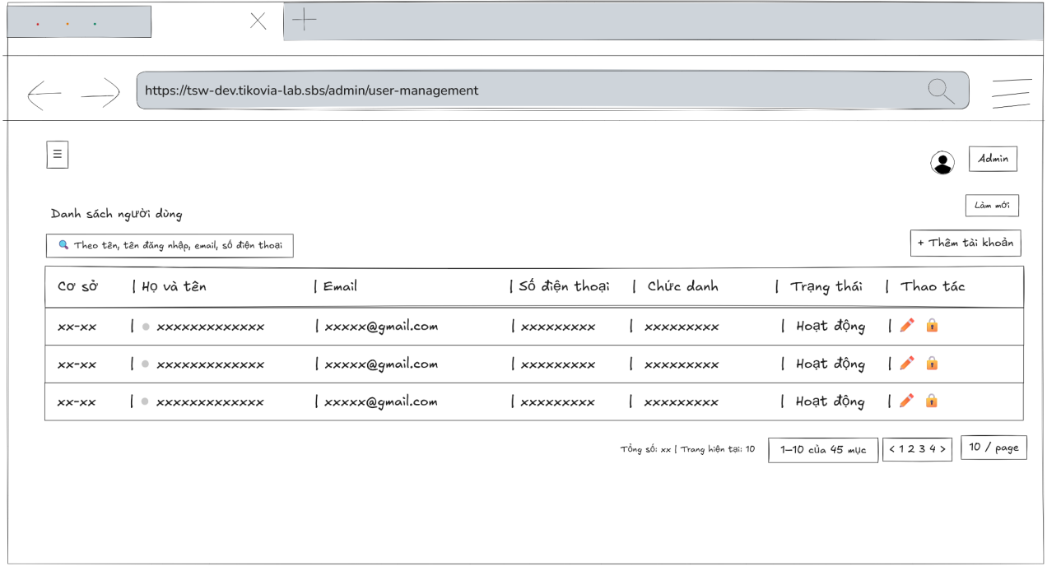
- Function Details:
  - Validation:
    - The admin or accountant must be logged in to view the employees list.
    - Each employee in the list must still exist in the system (valid user ID).
  - Functionality:
    - In Normal Cases:
      - The system displays the employees list with the information about the employees, such as the department name, full name, email, phone number, role, status.
    - In Abnormal Cases:
      - No User Data Found: If there is no data of employees listed in the system will display “No data”.
      - Connection Issues: If there's a server issue, the system will notify the admin: "Không thể tải dữ liệu. Đã xảy ra lỗi khi tải danh sách người dùng"
  - Business rule: N/A.
# | Component | Comp. type | Editable | Mandatory | Default Value | Description
 | Header & Toolbar
1 | Screen Title | Label (Text) | No | Yes | "Danh sách người dùng" | Displays the main title of the screen.
2 | Refresh Button | Button | No | No | "Làm mới" | Button to reload the data in the list from the server.
3 | Search Input | Input (Text) | Yes | No | Placeholder: "Theo tên, tên đăng nhập, email, số điện thoại" | Input field to filter the list by name, username, email, or phone number. Includes a search icon.
4 | Add Account Button | Button | No | Yes | "Thêm tài khoản" | Button to navigate to the "Create New Account" screen or open a modal.
 | Data Table Section
5 | Col Header: Facility | Label/Sort | No | Yes | "Cơ sở" | Column header for facility location. Clickable to sort data. Includes a tooltip icon.
6 | Col Header: Name | Label/Sort | No | Yes | "Họ và tên" | Column header for user's full name. Clickable to sort data. Includes a tooltip icon.
7 | Col Header: Email | Label/Sort | No | Yes | "Email" | Column header for email address. Clickable to sort data.
8 | Col Header: Phone | Label/Sort | No | Yes | "Số điện thoại" | Column header for phone number. Includes a tooltip icon.
9 | Col Header: Role | Label/Sort | No | Yes | "Chức danh" | Column header for user role/job title. Clickable to sort data.
10 | Col Header: Status | Label/Sort | No | Yes | "Trạng thái" | Column header for account status. Clickable to sort data.
11 | Col Header: Action | Label | No | Yes | "Thao tác" | Column header for action buttons.
12 | User Status Indicator | Icon | No | Yes | N/A | A small dot icon next to the name indicating online/offline status or user type.
13 | Role Badge | Label (Tag) | No | Yes | [Role Name] | Displays the user's role (e.g., Manager, Picker) inside a styled badge/tag.
14 | Status Badge | Label (Tag) | No | Yes | [Acc status] | Displays the account's active status inside a styled badge/tag.
15 | Edit Action | Button (Icon) | No | Yes | [Pencil Icon] | Icon button to edit the specific user's details.
16 | Lock Action | Button (Icon) | No | Yes | [Lock Icon] | Icon button to lock or deactivate the specific user account.
 | Footer & Pagination
17 | Total Count Label | Label (Text) | No | Yes | "Tổng số: [N] | Trang hiện tại: [N]"
18 | Quick Stats Label | Label (Text) | No | No | [Dynamic Stats] | Displays quick statistics of the list (e.g., number of Active users, Admins).
19 | Range Label | Label (Text) | No | Yes | "[X]-[Y] của [Z] mục" | Displays the range of items currently shown out of the total.
20 | Pagination Nav | Button Group | No | Yes | "1", "2", ">" | Navigation controls to switch between pages (Previous, Page Numbers, Next).
21 | Items Per Page | Dropdown | Yes | Yes | "10 / trang" | Dropdown to select how many items to display per page (e.g., 10, 20, 50).
––––––––––––––––––––––––––––––––––––––––––––––––––––––––––––––––––––––––––––––––––-

3.2.8 - View Employee Detail Information
- Function trigger: The admin or accountant accesses the Employee manage page and clicks on the selected employee to display a popup with employee’s information.
- Function description: Allow Admin to view employee’s information details
- Screen layout:
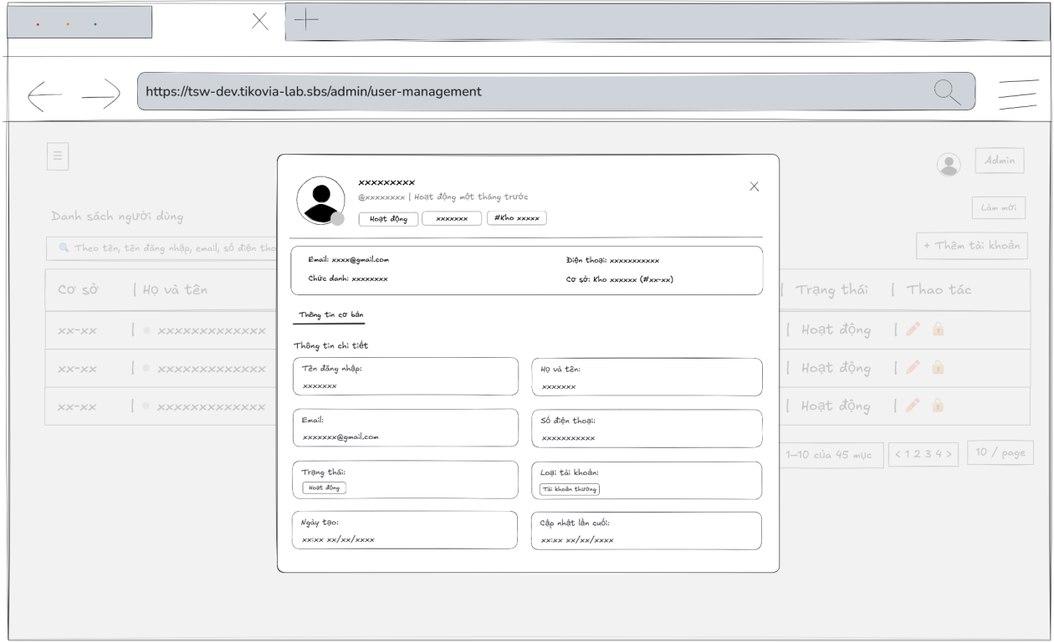
- Function Details:
  - Validation:
    - The selected employee ID must exist in the system database.
    - The Admin or accountant must have valid authorization to view employee details.
    - The employee data returned from the server must be complete and correspond to the selected employee.
  - Functionality:
    - In Normal Cases:
      - The system displays all the detailed information about employees correctly.
    - In Abnormal Cases:
      - Server Error: If there is an issue with the server when fetch data, the system display no data
  - Business rule: N/A.
# | Component | Comp. type | Editable | Mandatory | Default Value | Description
 | Header Profile Section
1 | Close Button | Button (Icon) | No | Yes | N/A | Icon button (X) to close the modal.
2 | User Avatar | Image | No | Yes | [User Avatar] | Displays the user's profile picture with a status indicator.
3 | Full Name (Header) | Label (Text) | No | Yes | [User's Name] | Displays the user's full name in the header.
4 | Username Handle | Label (Text) | No | Yes | "@[username]" | Displays the user's unique handle/username.
5 | Activity Text | Label (Text) | No | Yes | "Đang hoạt động" | Text indicating the user is currently online or active.
6 | Status Badge | Label (Tag) | No | Yes | "Hoạt động" | Badge indicating the account's active status.
7 | Role Badge | Label (Tag) | No | Yes | [Role Name] | Badge indicating the user's primary role.
8 | Facility Badge | Label (Tag) | No | Yes | "#[Facility Name]" | Badge indicating the user's assigned facility/location.
 | Quick Info Section
9 | Quick Email Label | Label (Text) | No | Yes | "Email:" | Label for the email field in the summary section.
10 | Quick Email Value | Label (Text) | No | Yes | [User's Email] | Displays the user's email address.
11 | Quick Phone Label | Label (Text) | No | Yes | "Điện thoại:" | Label for the phone field in the summary section.
12 | Quick Phone Value | Label (Text) | No | Yes | [User's Phone] | Displays the user's phone number.
13 | Quick Role Label | Label (Text) | No | Yes | "Chức danh:" | Label for the role field in the summary section.
14 | Quick Role Value | Label (Tag) | No | Yes | [Role Name] | Displays the user's role as a styled tag.
15 | Quick Facility Label | Label (Text) | No | Yes | "Cơ sở:" | Label for the facility field in the summary section.
16 | Quick Facility Value | Label (Text) | No | Yes | [Facility Name] | Displays the facility name and code.
 | Tabs & Detail Section
17 | Tab Navigation | Tab Control | No | Yes | "Thông tin cơ bản" | Active tab displaying basic information.
18 | Section Title | Label (Text) | No | Yes | "Thông tin chi tiết" | Header for the detailed information grid.
19 | Username Label | Label (Text) | No | Yes | "Tên đăng nhập" | Label inside the username detail card.
20 | Username Value | Label (Text) | No | Yes | [User name] | Read-only value of the username.
21 | Fullname Label | Label (Text) | No | Yes | "Họ và tên" | Label inside the full name detail card.
22 | Fullname Value | Label (Text) | No | Yes | [Full name] | Read-only value of the full name.
23 | Email Label | Label (Text) | No | Yes | "Email" | Label inside the email detail card.
24 | Email Value | Label (Text) | No | Yes | [Email] | Read-only value of the email.
25 | Phone Label | Label (Text) | No | Yes | "Số điện thoại" | Label inside the phone detail card.
26 | Phone Value | Label (Text) | No | Yes | [Phone number] | Read-only value of the phone number.
27 | Status Label | Label (Text) | No | Yes | "Trạng thái" | Label inside the status detail card.
28 | Status Value | Label (Tag) | No | Yes | [Status value] | Read-only badge indicating account status.
29 | Acc Type Label | Label (Text) | No | Yes | "Loại tài khoản" | Label inside the account type detail card.
30 | Acc Type Value | Label (Tag) | No | Yes | [Acc type] | Read-only badge indicating the type of account.
31 | Created Date Label | Label (Text) | No | Yes | "Ngày tạo" | Label inside the creation date detail card.
32 | Created Date Value | Label (Text) | No | Yes | [Date Time] | Displays the timestamp when the account was created.
33 | Updated Date Label | Label (Text) | No | Yes | "Cập nhật lần cuối" | Label inside the last updated detail card.
34 | Updated Date Value | Label (Text) | No | Yes | [Date Time] | Displays the timestamp of the last account update.
––––––––––––––––––––––––––––––––––––––––––––––––––––––––––––––––––––––––––––––––––-

3.2.9 - Add Employee
- Function trigger: The admin or accountant accesses the Employees manage page and clicks the button “Thêm tài khoản” to display a popup with input box.
- Function description: Allow admin and accountant to add a new employee’s account. But Accountants can not create new admin.
- Screen layout:
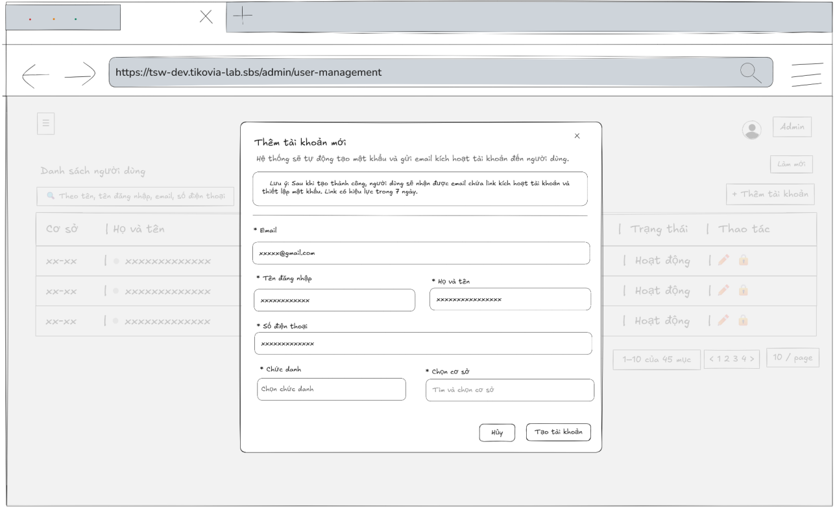
- Function Details:
  - Validation:
    - All required fields (Username, Email, Full name, Phone number, Role, Department) must be provided.
    - Only users with Admin roles are authorized to perform this action.
    - Password regulations: at least 8 characters, at least 1 uppercase letter, 1 lowercase letter, 1 number.
    - Passwords stored in the database must be hashed by the bcrypt algorithm.
    - Username format: no accent marks, no special characters (underscore _ is allowed), must not start with a digit, length between 3 and 50 characters
    - The email must follow email format.
    - Accountants can not create new admin.
  - Functionality:
    - In Normal Cases:
      - After the admin successfully submits the employee information and the system validates it, a message will be displayed: “Tạo tài khoản thành công. Tài khoản đã được tạo. Vui lòng kiểm tra email để kích hoạt.”.
    - In Abnormal Cases:
      - No input Provided: If the admin presses the submit button without any required field, the system will display an error message required field.
      - Server Error: If there is an issue with the server when submitting the new employee information and create account, the system will notify: "Có lỗi xảy ra khi tạo tài khoản"
  - Business rule: BR-02, BR-03, BR-09, BR-16.
# | Component | Comp. type | Editable | Mandatory | Default Value | Description
 | Header & Note Section
1 | Modal Title | Label (Text) | No | Yes | "Thêm tài khoản mới" | Displays the main title of the modal.
2 | Close Button | Button (Icon) | No | Yes | N/A | Icon button (X) to close the modal.
3 | Sub-instruction | Label (Text) | No | Yes | "Hệ thống sẽ tự động..." | Explains that the password is auto-generated and sent via email.
4 | Note Box | Container | No | Yes | "Lưu ý: Sau khi tạo..." | A highlighted alert box containing important information about email link expiration (7 days).
 | Form Section
5 | Email Label | Label (Text) | No | Yes | "* Email" | Label for the email field. Asterisk indicates a mandatory field.
6 | Email Input | Input (Email) | Yes | Yes | Placeholder: "example@tikovia.com" | Input field for the user's email address. Used for account activation.
7 | Username Label | Label (Text) | No | Yes | "* Tên đăng nhập" | Label for the username field. Asterisk indicates a mandatory field.
8 | Username Input | Input (Text) | Yes | Yes | Placeholder: "username123" | Input field for the unique username. Includes a user icon.
9 | Fullname Label | Label (Text) | No | Yes | "* Họ và tên" | Label for the full name field. Asterisk indicates a mandatory field.
10 | Fullname Input | Input (Text) | Yes | Yes | Placeholder: "Nguyễn Văn A" | Input field for the user's full name. Includes a user icon.
11 | Phone Label | Label (Text) | No | Yes | "* Số điện thoại" | Label for the phone number field. Asterisk indicates a mandatory field.
12 | Phone Input | Input (Tel) | Yes | Yes | Placeholder: "0987654321" | Input field for the phone number. Includes a phone icon.
13 | Role Label | Label (Text) | No | Yes | "* Chức danh" | Label for the role selection field. Asterisk indicates a mandatory field.
14 | Role Select | Dropdown | Yes | Yes | Placeholder: "Chọn chức danh" | Dropdown menu to select the user's role.
15 | Facility Label | Label (Text) | No | Yes | "* Chọn cơ sở" | Label for the facility selection field. Asterisk indicates a mandatory field.
16 | Facility Select | Dropdown (Search) | Yes | Yes | Placeholder: "Tìm và chọn cơ sở" | Searchable dropdown menu to find and select the facility/location.
 | Footer Section
17 | Cancel Button | Button | No | Yes | "Hủy" | Button to close the modal without creating the account.
18 | Submit Button | Button | No | Yes | "Tạo tài khoản" | Primary button to submit the form and create the new user account.
––––––––––––––––––––––––––––––––––––––––––––––––––––––––––––––––––––––––––––––––––-

3.2.10 - Edit Employee Information
- Function trigger: The admin or accountant accesses the Employee manage page to view the list of employees and press edit button to update/edit information for a specific employee.
- Function description: To allow the admin and accountant to update information of the employees. Accountants can not edit admin info and ban other employees.
- Screen layout:
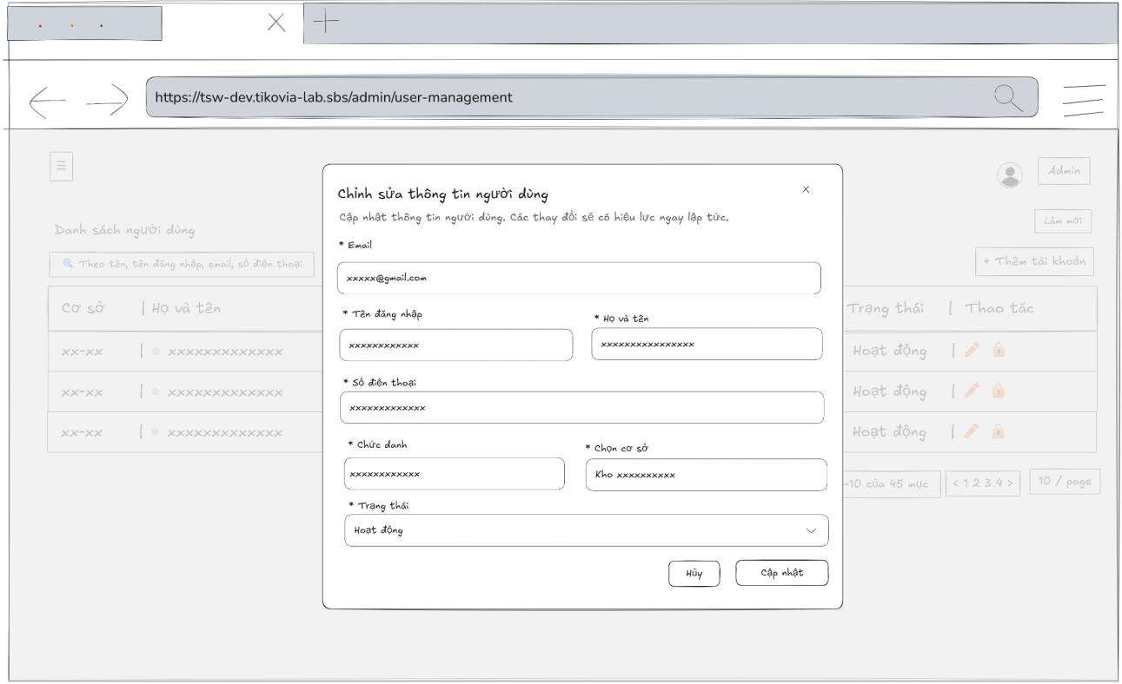
- Function Details:
  - Validation:
    - Only users with Admin and Accountant roles are authorized to perform this action.
    - All required fields (Username, Email, Full name, Phone number, Role, Department) must be provided.
    - Password regulations: at least 8 characters, at least 1 uppercase letter, 1 lowercase letter, 1 number.
    - Passwords stored in the database must be hashed by the bcrypt algorithm.
    - Username format: no accent marks, no special characters (underscore _ is allowed), must not start with a digit, length between 3 and 50 characters
    - The email must follow email format.
    - Accountants can not edit admin info and ban other employees.
  - Functionality:
    - In Normal Cases:
      - After pressing the button edit, the system displayed the employee’s information in the input box and it must match with the database.
      - The admin is able to edit employee’s information and can see a success message.
      - After pressing the “Cập nhật” button to send the update request, the system validates and a success message is displayed “Cập nhật thành công”
      - If admin edit email field and press “Cập nhật” button, the system should send a password reset link via new email address and display successful message “Chúng tôi đã gửi một email xác nhận đến địa chỉ email mới. Vui lòng kiểm tra email để xác nhận thay đổi.”
    - In Abnormal Cases:
      - Required fields blank: If required fields (e.g., Email, Username, Fullname, phone number, role, department) are left blank or contain invalid data (such as an incorrect email format or non-numeric phone number), the system will: Display an error message indicating which fields are missing or invalid and prevent saving until all required fields are correctly filled.
      - Server Error: If the server encounters an internal error (e.g., database timeout or server crash) during the update process, the system will show a message like “Server error occurred. Please try again later.”
  - Business rule: BR-02, BR-03, BR-09, BR-19, BR-14, BR-08, BR-15.
# | Component | Comp. type | Editable | Mandatory | Default Value | Description
 | Header Section
1 | Modal Title | Label (Text) | No | Yes | "Chỉnh sửa thông tin người dùng" | Displays the main title of the modal.
2 | Close Button | Button (Icon) | No | Yes | N/A | Icon button (X) to close the modal.
3 | Sub-instruction | Label (Text) | No | Yes | "Cập nhật thông tin người dùng..." | Explains that changes will take effect immediately after saving.
 | Form Section
4 | Email Label | Label (Text) | No | Yes | "* Email" | Label for the email field. Asterisk indicates a mandatory field.
5 | Email Input | Input (Email) | Yes | Yes | [Current Email] | Input field displaying the user's current email. Allows modification.
6 | Username Label | Label (Text) | No | Yes | "* Tên đăng nhập" | Label for the username field. Asterisk indicates a mandatory field.
7 | Username Input | Input (Text) | Yes | Yes | [Current Username] | Input field displaying the current username. Allows modification.
8 | Fullname Label | Label (Text) | No | Yes | "* Họ và tên" | Label for the full name field. Asterisk indicates a mandatory field.
9 | Fullname Input | Input (Text) | Yes | Yes | [Current Fullname] | Input field for the user's full name.
10 | Phone Label | Label (Text) | No | Yes | "* Số điện thoại" | Label for the phone number field. Asterisk indicates a mandatory field.
11 | Phone Input | Input (Tel) | Yes | Yes | [Current Phone] | Input field for the phone number.
12 | Role Label | Label (Text) | No | Yes | "* Chức danh" | Label for the role selection field. Asterisk indicates a mandatory field.
13 | Role Select | Dropdown | Yes | Yes | [Current Role] | Dropdown menu to change the user's role/job title.
14 | Facility Label | Label (Text) | No | Yes | "* Cơ sở" | Label for the facility selection field. Asterisk indicates a mandatory field.
15 | Facility Select | Dropdown | Yes | Yes | [Current Facility] | Dropdown menu to change the facility/location the user belongs to.
16 | Status Label | Label (Text) | No | Yes | "* Trạng thái" | Label for the account status field. Asterisk indicates a mandatory field.
17 | Status Select | Dropdown | Yes | Yes | [Current Status] | Dropdown to change account status (e.g., Active, Inactive). Includes a status indicator dot.
 | Footer Section
18 | Cancel Button | Button | No | Yes | "Hủy" | Button to discard changes and close the modal.
19 | Update Button | Button | No | Yes | "Cập nhật" | Primary button to save the modified user information.
––––––––––––––––––––––––––––––––––––––––––––––––––––––––––––––––––––––––––––––––––-

3.2.11 - View List of Departments
- Function trigger: The admin clicks on the “Department” button and navigates to the Department page through the sidebar to view the list of departments in the system.
- Function description: To view a list of departments with the information about a department, such as the department name, product code, status, address.
- Screen layout:
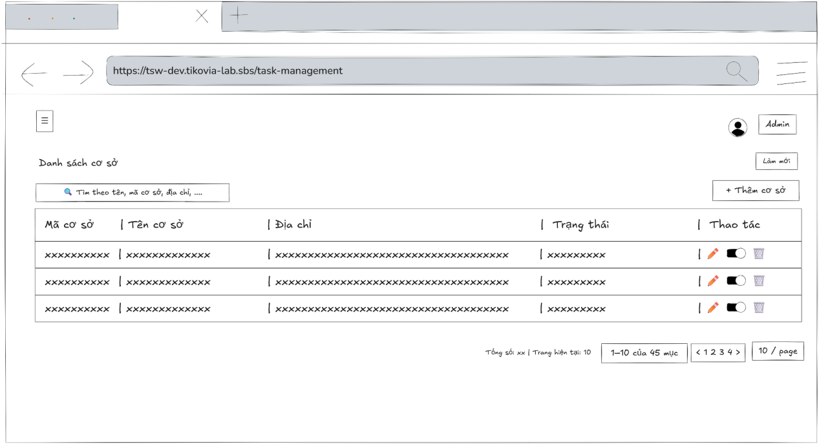
- Function Details:
  - Validation:
    - The user must be authenticated and authorized with the Admin role to access the Departments page.
    - The system shall successfully retrieve department data from the server before displaying the list.
    - The department information displayed (department code, department name, address, status) must match the data stored in the system.
  - Functionality:
    - In Normal Cases:
      - After clicking on "Departments", the system displays the departments list with the information about a department, such as the department name, product code, status, address.
    - In Abnormal Cases:
      - No User Data Found: If there is no data of department list in the system will display “No data”.
      - Connection Issues: If there's a server issue, the system will notify: "Không thể tải dữ liệu. Đã xảy ra lỗi khi tải danh sách cơ sở"
  - Business rule: N/A
# | Component | Comp. type | Editable | Mandatory | Default Value | Description
 | Header & Toolbar
1 | Screen Title | Label (Text) | No | Yes | "Danh sách cơ sở" | Displays the main title of the screen.
2 | Refresh Button | Button | No | No | "Làm mới" | Button to reload the data in the list from the server.
3 | Search Input | Input (Text) | Yes | No | Placeholder: "Theo tên, mã cơ sở, địa chỉ hoặc trạng thái" | Input field to filter the list by name, code, address, or status. Includes a search icon.
4 | Add Facility Button | Button | No | Yes | "Thêm cơ sở" | Button to navigate to the "Create New Facility" screen or modal.
 | Data Table Section
5 | Col Header: Code | Label/Sort | No | Yes | "Mã cơ sở" | Column header for the facility code. Clickable to sort data. Includes a tooltip icon.
6 | Col Header: Name | Label/Sort | No | Yes | "Tên cơ sở" | Column header for the facility name. Clickable to sort data. Includes a tooltip icon.
7 | Col Header: Address | Label/Sort | No | Yes | "Địa chỉ" | Column header for the physical address. Clickable to sort data. Includes a tooltip icon.
8 | Col Header: Status | Label/Sort | No | Yes | "Trạng thái" | Column header for the operating status. Clickable to sort data. Includes a tooltip icon.
9 | Col Header: Action | Label | No | Yes | "Thao tác" | Column header for action buttons.
10 | Facility Code Badge | Label (Tag) | No | Yes | [Code Value] | Displays the unique facility code inside a styled badge.
11 | Facility Name | Label (Text) | No | Yes | [Name Value] | Displays the full name of the facility.
12 | Address Text | Label (Text) | No | Yes | [Address Value] | Displays the facility's address.
13 | Status Badge | Label (Tag) | No | Yes | "Hoạt động" | Displays the current status as a text badge.
14 | Edit Action | Button (Icon) | No | Yes | [Pencil Icon] | Icon button to edit the specific facility's details.
15 | Toggle Status | Switch/Toggle | Yes | Yes | [On/Off] | A toggle switch to quickly enable or disable the facility directly from the list.
16 | Delete Action | Button (Icon) | No | Yes | [Trash Icon] | Icon button to delete the facility.
 | Footer & Pagination
17 | Total Count Label | Label (Text) | No | Yes | "Tổng số: [N] | Trang hiện tại: [N]"
18 | Quick Stats Label | Label (Text) | No | No | "Hoạt động [N]" | Displays quick statistics showing the number of active facilities.
19 | Range Label | Label (Text) | No | Yes | "[X]-[Y] của [Z] mục" | Displays the range of items currently shown out of the total.
20 | Pagination Nav | Button Group | No | Yes | "1", ">" | Navigation controls to switch between pages.
21 | Items Per Page | Dropdown | Yes | Yes | "10 / trang" | Dropdown to select how many items to display per page.
––––––––––––––––––––––––––––––––––––––––––––––––––––––––––––––––––––––––––––––––––-

3.2.12 - View Department Detail Information
- Function trigger: The admin accesses the Departments page and clicks on the selected department to display a popup with department’s information.
- Function description: To view department’s information details
- Screen layout:
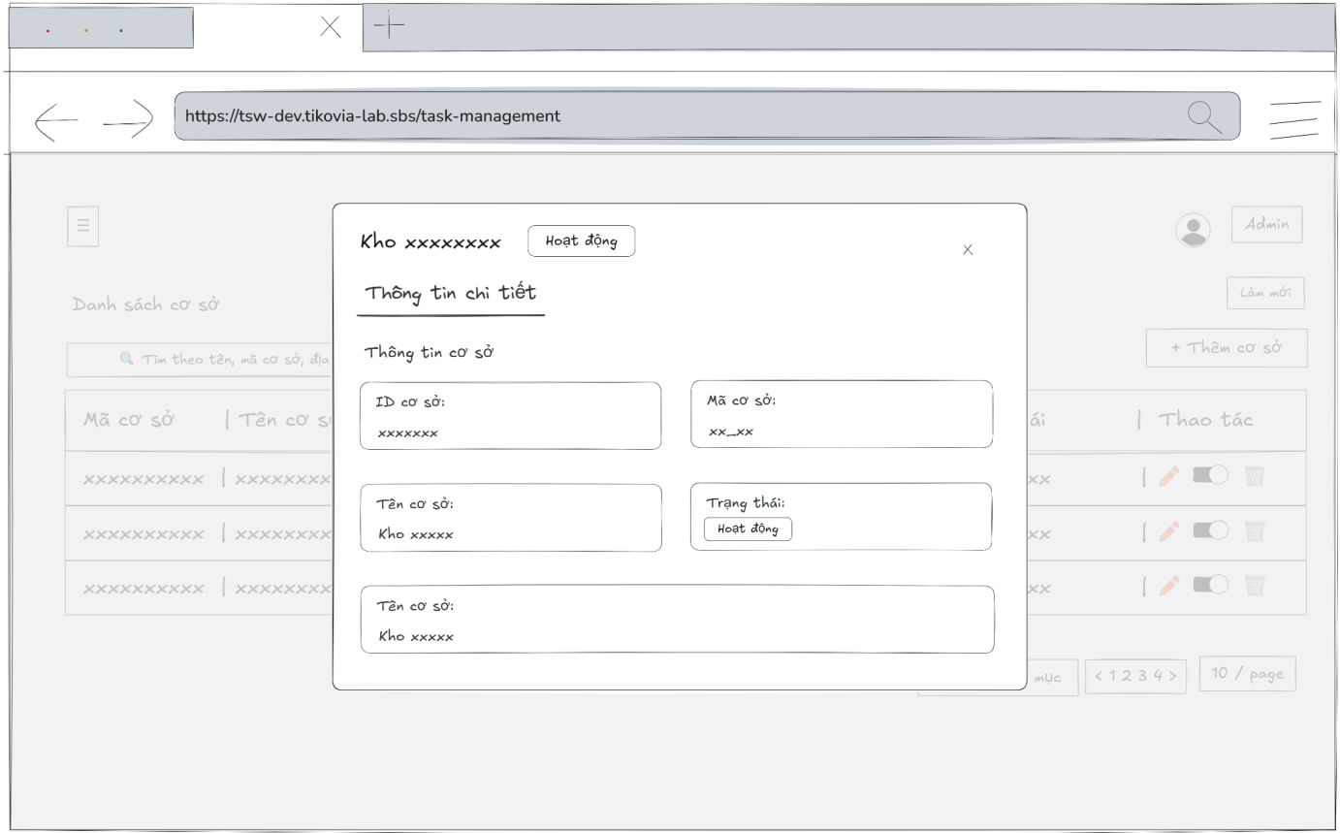
- Function Details:
  - Validation:
    - The user must be authenticated and authorized with the Admin role to view department details.
    - The selected department must exist in the system.
    - The system shall successfully retrieve department detail data from the server before displaying the popup.
    - The department information displayed must match the data stored in the system.
  - Functionality:
    - In Normal Cases:
      - The system displays all the detailed information about departments correctly.
    - In Abnormal Cases:
      - Server Error: If there is an issue with the server when fetch data, the system display no data
  - Business rule: N/A.
# | Component | Comp. type | Editable | Mandatory | Default Value | Description
 | Header Section
1 | Facility Icon | Icon | No | Yes | [Building Icon] | Decorative icon indicating the facility type.
2 | Modal Title | Label (Text) | No | Yes | [Facility Name] | Displays the name of the facility (e.g., "Kho Cần Thơ").
3 | Header Status | Label (Tag) | No | Yes | "Hoạt động" | Displays the current operating status next to the title.
4 | Close Button | Button (Icon) | No | Yes | N/A | Icon button (X) to close the modal.
5 | Tab Navigation | Tab Control | No | Yes | "Thông tin chi tiết" | Active tab displaying detailed information.
 | General Info Section
6 | Section Title | Label (Text) | No | Yes | "Thông tin cơ sở" | Header for the facility information block.
7 | ID Label | Label (Text) | No | Yes | "ID cơ sở" | Label for the Facility ID field.
8 | ID Value | Label (Text) | No | Yes | [UUID String] | Displays the unique system ID (e.g., e8b43...). Read-only.
9 | Copy ID Button | Button (Icon) | No | Yes | [Copy Icon] | Icon button allowing the user to copy the UUID to the clipboard.
10 | Code Label | Label (Text) | No | Yes | "Mã cơ sở" | Label for the Facility Code field.
11 | Code Value | Label (Tag) | No | Yes | [Code string | Displays the short code of the facility inside a styled badge.
12 | Name Label | Label (Text) | No | Yes | "Tên cơ sở" | Label for the Facility Name field.
13 | Name Value | Label (Text) | No | Yes | [Facility Name] | Displays the full name of the facility. Read-only.
14 | Status Label | Label (Text) | No | Yes | "Trạng thái" | Label for the Status field.
15 | Status Value | Label (Tag) | No | Yes | "Hoạt động" | Displays the active status in a styled badge. Read-only.
16 | Address Label | Label (Text) | No | Yes | "Địa chỉ" | Label for the Address field.
17 | Address Icon | Icon | No | Yes | [Map Pin] | Icon indicating a location/address.
18 | Address Value | Label (Text) | No | Yes | [Address String] | Displays the full physical address of the facility. Read-only.
––––––––––––––––––––––––––––––––––––––––––––––––––––––––––––––––––––––––––––––––––-

3.2.13 - Add Department
- Function trigger: The admin accesses the Departments page and clicks the button “Thêm cơ sở” to display a popup with input box.
- Function description: Allow admin to add a new department.
- Screen layout:
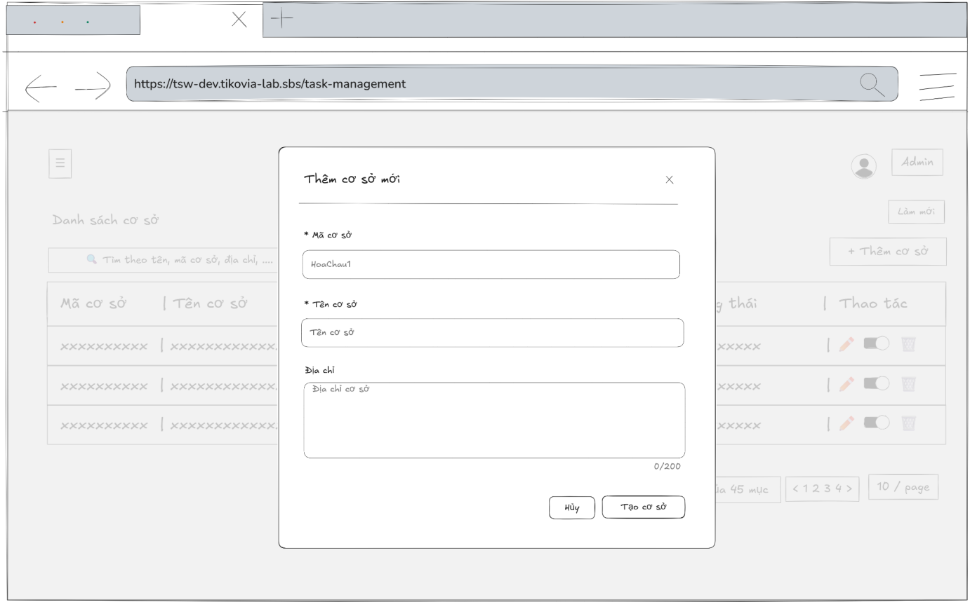
- Function Details:
  - Validation:
    - The user must be authenticated and authorized with Admin role.
    - All required fields (Department code, Department name) must be provided.
    - Department code must be unique in the system.
    - The address field, if provided, must not exceed the maximum allowed length.
    - The system shall validate all input data on the server side before creating a new department.
  - Functionality:
    - In Normal Cases:
      - After the admin has submitted the department’s information success and the system validates a message will be displayed: “Tạo cơ sở thành công. Cơ sở đã được tạo thành công.”.
    - In Abnormal Cases:
      - No input Provided:
If the admin presses the submit button without any required field, the system will display an error message required field.
      - Server Error:
If there is an issue with the server when submitting the new department’s information and add new department, the system will notify the admin:
"Có lỗi xảy ra. Có lỗi xảy ra khi tạo cơ sở."
  - Business rule: BR-11, BR-21.
# | Component | Comp. type | Editable | Mandatory | Default Value | Description
 | Header Section
1 | Modal Icon | Icon | No | Yes | [Building Icon] | Decorative icon indicating the facility type in the header.
2 | Modal Title | Label (Text) | No | Yes | "Thêm cơ sở mới" | Displays the main title of the modal.
3 | Close Button | Button (Icon) | No | Yes | N/A | Icon button (X) to close the modal.
 | Form Section
4 | Code Label | Label (Text) | No | Yes | "* Mã cơ sở" | Label for the facility code field. Asterisk indicates a mandatory field.
5 | Code Input | Input (Text) | Yes | Yes | Placeholder: "HoaChau1" | Input field for the facility unique code. Includes a barcode/building icon.
6 | Name Label | Label (Text) | No | Yes | "* Tên cơ sở" | Label for the facility name field. Asterisk indicates a mandatory field.
7 | Name Input | Input (Text) | Yes | Yes | Placeholder: "Tên cơ sở" | Input field for the facility full name. Includes a home icon.
8 | Address Label | Label (Text) | No | Yes | "Địa chỉ" | Label for the address field. (No asterisk, implies optional).
9 | Address Input | Textarea | Yes | No | Placeholder: "Địa chỉ cơ sở" | Multi-line text input for the facility's physical address.
10 | Char Counter | Label (Text) | No | Yes | "0 / 200" | Displays the current character count vs maximum limit for the address field.
11 | Resize Handle | Icon | No | Yes | N/A | Grip handle at the bottom-right of the textarea to resize the field.
 | Footer Section
12 | Cancel Button | Button | No | Yes | "Hủy" | Button to close the modal and discard entered data.
13 | Create Button | Button | No | Yes | "Tạo cơ sở" | Primary button to submit the form and create the new facility.
––––––––––––––––––––––––––––––––––––––––––––––––––––––––––––––––––––––––––––––––––-

3.2.14 - Edit Department’s Information
- Function trigger: The admin accesses the Departments page to view the list of departments and press edit button to update/edit information for a specific department.
- Function description: To allow the admin to update information of the departments.
- Screen layout:
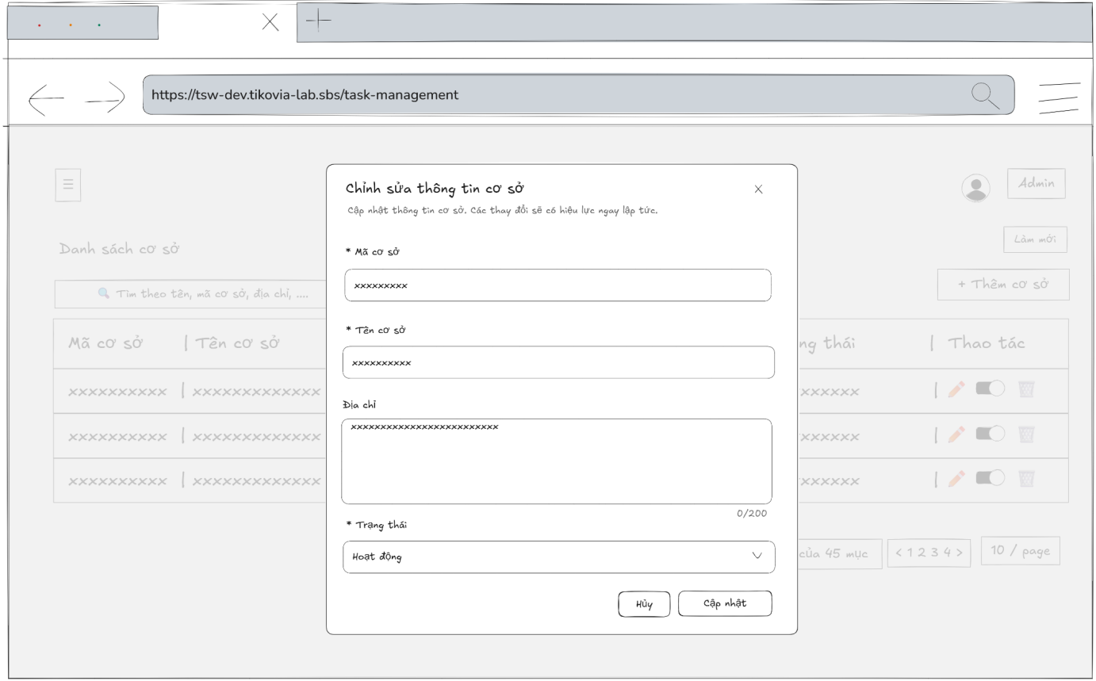
- Function Details:
  - Validation:
    - The user must be authenticated and authorized with the Admin role.
    - The selected department must exist in the system.
    - All required fields (Department code, Department name) must be provided and valid.
    - The address field, if provided, must not exceed the maximum allowed length.
  - Functionality:
    - In Normal Cases:
      - After pressing the button edit, the system displayed the department's information in the input box and it must match with the database.
      - The admin is able to edit department’s information and can see a success message.
      - After pressing the “Cập nhật” button to send the update request, the system validates and a success message is displayed “Cập nhật thành công”
    - In Abnormal Cases:
      - Required fields blank: If required fields (e.g., department code, department name) are left blank, the system will: Display an error message indicating which fields are missing and prevent saving until all required fields are correctly filled.
      - Server Error: If the server encounters an internal error (e.g., database timeout or server crash) during the update process, the system will show a message like “Server error occurred. Please try again later.”
  - Business rule: BR-11, BR-21.
# | Component | Comp. type | Editable | Mandatory | Default Value | Description
 | Header Section
1 | Modal Icon | Icon | No | Yes | [Building Icon] | Decorative icon indicating the facility type.
2 | Modal Title | Label (Text) | No | Yes | "Chỉnh sửa thông tin cơ sở" | Displays the main title of the modal.
3 | Close Button | Button (Icon) | No | Yes | N/A | Icon button (X) to close the modal.
4 | Sub-instruction | Label (Text) | No | Yes | "Cập nhật thông tin..." | Explains that changes will take effect immediately after saving.
 | Form Section
5 | Code Label | Label (Text) | No | Yes | "* Mã cơ sở" | Label for the facility code field. Asterisk indicates a mandatory field.
6 | Code Input | Input (Text) | Yes | Yes | [Current Code] | Input field displaying the current facility code. Includes a barcode icon.
7 | Name Label | Label (Text) | No | Yes | "* Tên cơ sở" | Label for the facility name field. Asterisk indicates a mandatory field.
8 | Name Input | Input (Text) | Yes | Yes | [Current Name] | Input field displaying the current facility name. Includes a home icon.
9 | Address Label | Label (Text) | No | Yes | "Địa chỉ" | Label for the address field.
10 | Address Input | Textarea | Yes | No | [Current Address] | Multi-line text input displaying the current address.
11 | Char Counter | Label (Text) | No | Yes | "[N] / 200" | Displays the current character count vs maximum limit for the address field.
12 | Status Label | Label (Text) | No | Yes | "* Trạng thái" | Label for the operating status field. Asterisk indicates a mandatory field.
13 | Status Select | Dropdown | Yes | Yes | [Current Status] | Dropdown menu to change the facility's operating status (e.g., Active).
 | Footer Section
14 | Cancel Button | Button | No | Yes | "Hủy" | Button to discard changes and close the modal.
15 | Update Button | Button | No | Yes | "Cập nhật" | Primary button to save the modified facility information.
––––––––––––––––––––––––––––––––––––––––––––––––––––––––––––––––––––––––––––––––––-

3.3 Product and Inventory Management

3.3.1 - View List of Products
- Function trigger: The Admin, Warehouse managers, Packing supervisor, Packing staff, Sell staff, Accountant accesses to the Products page through the sidebar to view the list of products in the system.
- Function description: To view a list of products with the information about a product, such as the sku code, product name, product’s category, status.
- Screen layout:
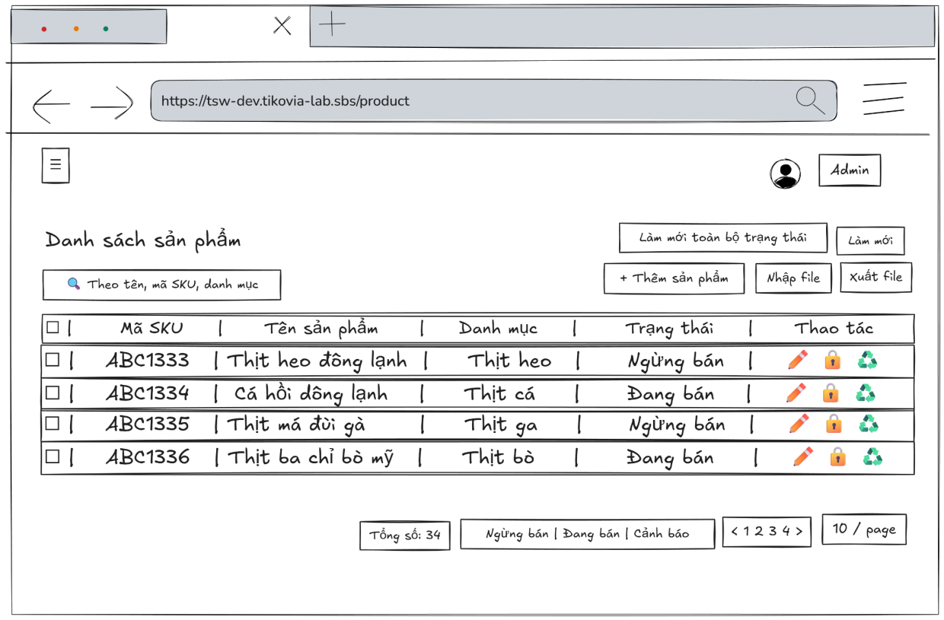
- Function Details:
  - Validation:
    - The user must be authenticated and authorized with one of the following roles to access the Products page: Admin, Warehouse Manager, Packing Supervisor, Packing Staff, Sell Staff, or Accountant.
    - The system shall validate the connection and successfully retrieve product data from the server before displaying the list.
    - The product data displayed must correctly match the data stored in the system (SKU code, product name, category, status).
  - Functionality:
    - In Normal Cases:
      - After clicking on "Products", the system displays the products list with the information about a product, such as the sku code, product name, product’s category, status.
    - In Abnormal Cases:
      - No User Data Found: If there is no data of products list in the system will display “No data”.
      - Connection Issues: If there's a server issue, the system will notify the users: "Không thể tải dữ liệu. Đã xảy ra lỗi khi tải danh sách sản phẩm"
  - Business rule: N/A.
# | Component | Comp. type | Editable | Mandatory | Default Value | Description
 | Header & Toolbar
1 | Screen Title | Label (Text) | No | Yes | "Danh sách sản phẩm" | Displays the main title of the screen.
2 | Refresh Status Btn | Button | No | No | "Làm mới toàn bộ trạng thái" | Button to trigger a system-wide update of product statuses (likely syncing with inventory).
3 | Refresh Data Btn | Button | No | No | "Làm mới" | Button to reload the list data from the server.
4 | Search Input | Input (Text) | Yes | No | Placeholder: "Theo tên, mã SKU, danh mục" | Input field to filter the list by Product Name, SKU, or Category.
5 | Add Product Btn | Button | No | Yes | "Thêm sản phẩm" | Primary button to navigate to the "Create New Product" screen.
6 | Import File Btn | Button | No | Yes | "Nhập file" | Button to open the file import modal (e.g., upload Excel/CSV).
7 | Export File Btn | Button | No | Yes | "Xuất file" | Button to export the current list to a file (Excel/CSV).
 | Data Table Section
8 | Select All Checkbox | Checkbox | Yes | No | Unchecked | Checkbox in the header to select/deselect all visible rows.
9 | Col Header: SKU | Label/Sort | No | Yes | "Mã SKU" | Column header for Stock Keeping Unit code. Clickable to sort. Includes tooltip.
10 | Col Header: Name | Label/Sort | No | Yes | "Tên sản phẩm" | Column header for product name. Clickable to sort. Includes tooltip.
11 | Col Header: Category | Label/Sort | No | Yes | "Danh mục" | Column header for product category. Clickable to sort. Includes tooltip.
12 | Col Header: Status | Label/Sort | No | Yes | "Trạng thái" | Column header for product status. Clickable to sort/filter.
13 | Col Header: Action | Label | No | Yes | "Thao tác" | Column header for action buttons.
14 | Row Checkbox | Checkbox | Yes | No | Unchecked | Checkbox to select a specific product row.
15 | SKU Badge | Label (Tag) | No | Yes | [SKU Code] | Displays the unique SKU code inside a styled badge. Clickable (link to detail).
16 | Product Name | Label (Text) | No | Yes | [Product Name] | Displays the full name of the product.
17 | Category Badge | Label (Tag) | No | Yes | [Category Name] | Displays the category name inside a styled badge.
18 | Status Badge | Label (Tag) | No | Yes | [Status Text] | Displays status (e.g., "Đang bán", "Ngừng bán", "Cảnh báo").
19 | Edit Action | Button (Icon) | No | Yes | [Pencil Icon] | Icon button to edit the product details.
20 | Stop/Lock Action | Button (Icon) | No | Yes | [Lock Icon] | Icon button to deactivate or stop selling the product.
21 | Sync Action | Button (Icon) | No | Yes | [Refresh Icon] | Icon button (circular arrow) to refresh or sync the status of a specific item.
 | Footer & Pagination
22 | Stats Label | Label (Text) | No | Yes | "Tổng số: [N] | Trang hiện tại: [N]"
23 | Status Filter/Stats | Button Group | No | No | "Đang bán [N]", "Ngừng bán [N]"... | clickable labels showing counts for each status. Can act as quick filters.
24 | Range Label | Label (Text) | No | Yes | "[X]-[Y] của [Z] mục" | Displays the range of items currently shown.
25 | Pagination Nav | Button Group | No | Yes | "1", "2", "3", "4", ">" | Navigation controls to switch pages.
26 | Items Per Page | Dropdown | Yes | Yes | "10 / trang" | Dropdown to select the number of items displayed per page.
––––––––––––––––––––––––––––––––––––––––––––––––––––––––––––––––––––––––––––––––––-

3.3.2 - View Product Detail Information
- Function trigger:
  - Primary Trigger: The Admin, Warehouse managers, Packing supervisor, Packing staff, Sell staff, Accountant accesses the Products page and clicks on the selected product to display a popup with product’s information.
- Function description: To view product’s information details
- Screen layout:
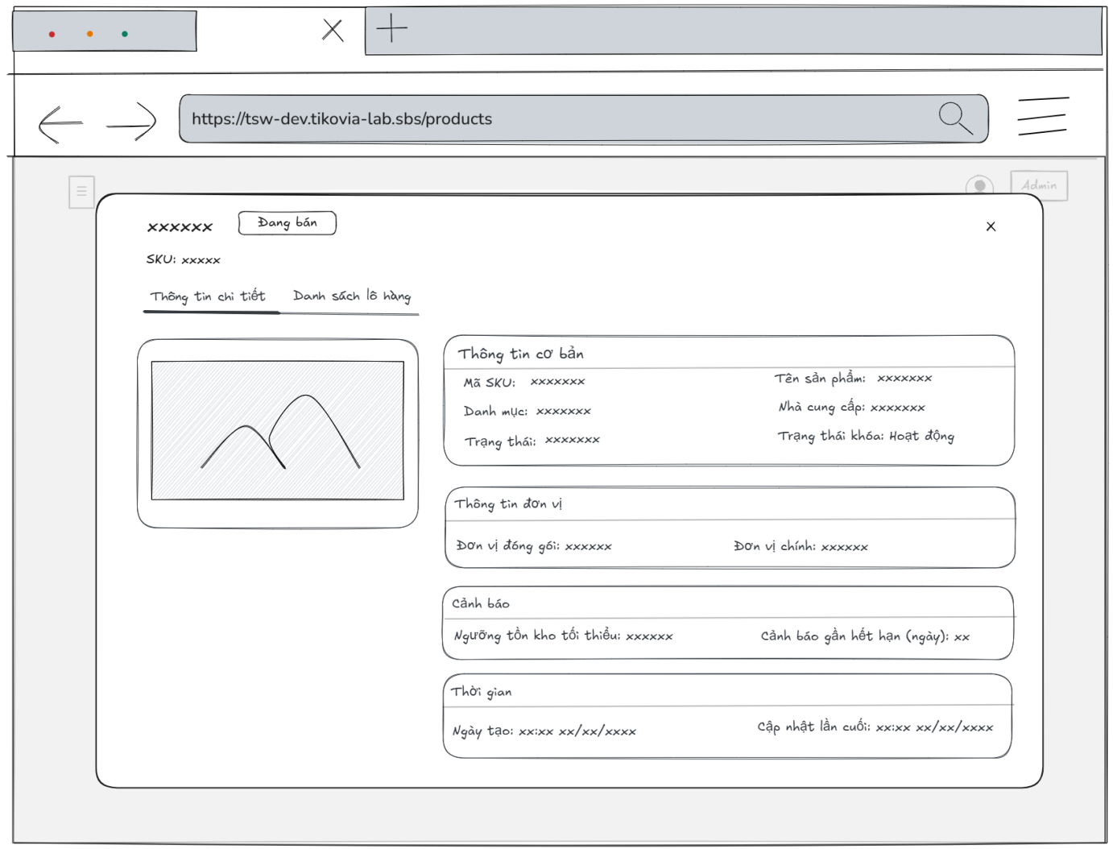
- Function Details:
  - Validation:
    - The user must be authenticated and authorized with one of the following roles to access the Products page: Admin, Warehouse Manager, Packing Supervisor, Packing Staff, Sell Staff, or Accountant.
    - The selected product must exist in the system.
    - The system shall successfully retrieve product detail data from the server before displaying the popup.
    - The product information displayed must match the data stored in the system.
  - Functionality:
    - In Normal Cases:
      - The system displays all the detailed information about products correctly.
    - In Abnormal Cases:
      - Server Error: If there is an issue with the server when fetch data, the system display no data
  - Business rule: N/A.
# | Component | Comp. type | Editable | Mandatory | Default Value | Description
 | Header Section
1 | Modal Icon | Icon | No | Yes | [Bag Icon] | Decorative icon indicating the product entity.
2 | Modal Title | Label (Text) | No | Yes | [Product Name] | Displays the full name of the product (e.g., "Thịt heo test").
3 | SKU Subtitle | Label (Text) | No | Yes | "SKU: [Code]" | Displays the SKU code below the title.
4 | Header Status | Label (Tag) | No | Yes | "Đang bán" | Displays the current selling status next to the title.
5 | Close Button | Button (Icon) | No | Yes | N/A | Icon button (X) to close the modal.
6 | Tab Navigation | Tab Control | No | Yes | "Thông tin chi tiết" | Navigation tabs to switch between "Detail Info" and "Batch List".
 | Image Section
7 | Product Image | Image | No | Yes | [Image URL] | Displays the primary image of the product.
 | Basic Info Section
8 | Section Title 1 | Label (Text) | No | Yes | "Thông tin cơ bản" | Header for the basic information block.
9 | SKU Label | Label (Text) | No | Yes | "Mã SKU:" | Label for the SKU field.
10 | SKU Value | Label (Tag) | No | Yes | [SKU Code] | Displays the SKU code inside a styled badge.
11 | Name Label | Label (Text) | No | Yes | "Tên sản phẩm:" | Label for the product name field.
12 | Name Value | Label (Text) | No | Yes | [Product Name] | Displays the product name.
13 | Category Label | Label (Text) | No | Yes | "Danh mục:" | Label for the category field.
14 | Category Value | Label (Tag) | No | Yes | [Category Name] | Displays the category name inside a styled badge.
15 | Supplier Label | Label (Text) | No | Yes | "Nhà cung cấp:" | Label for the supplier field.
16 | Supplier Value | Label (Text) | No | Yes | [Supplier Name] | Displays the name of the supplier.
17 | Status Label | Label (Text) | No | Yes | "Trạng thái:" | Label for the selling status field.
18 | Status Value | Label (Tag) | No | Yes | "Đang bán" | Displays the selling status badge.
19 | Lock Label | Label (Text) | No | Yes | "Trạng thái khóa:" | Label for the system lock status.
20 | Lock Value | Label (Tag) | No | Yes | "Hoạt động" | Displays the lock status badge (e.g., Active/Locked).
 | Unit Info Section
21 | Section Title 2 | Label (Text) | No | Yes | "Thông tin đơn vị" | Header for the unit information block.
22 | Pack Unit Label | Label (Text) | No | Yes | "Đơn vị đóng gói:" | Label for the packaging unit.
23 | Pack Unit Value | Label (Tag) | No | Yes | [Unit Name] | Displays the packaging unit (e.g., Box/Case).
24 | Base Unit Label | Label (Text) | No | Yes | "Đơn vị chính:" | Label for the base measurement unit.
25 | Base Unit Value | Label (Tag) | No | Yes | [Unit Name] | Displays the base unit (e.g., Kg, Gram).
 | Warning Section
26 | Section Title 3 | Label (Text) | No | Yes | "Cảnh báo" | Header for the warning configuration block.
27 | Min Stock Label | Label (Text) | No | Yes | "Ngưỡng tồn kho..." | Label for minimum inventory threshold.
28 | Min Stock Value | Label (Tag) | No | Yes | [Number] | Displays the minimum stock number configured for alerts.
29 | Expiry Label | Label (Text) | No | Yes | "Cảnh báo gần..." | Label for near-expiry alert days.
30 | Expiry Value | Label (Tag) | No | Yes | [Number] | Displays the number of days before expiry to trigger an alert.
 | Time Section
31 | Section Title 4 | Label (Text) | No | Yes | "Thời gian" | Header for the timestamps block.
32 | Created Label | Label (Text) | No | Yes | "Ngày tạo:" | Label for the creation timestamp.
33 | Created Value | Label (Text) | No | Yes | [Date Time] | Displays the date and time when the product was created.
34 | Updated Label | Label (Text) | No | Yes | "Cập nhật lần cuối:" | Label for the last update timestamp.
35 | Updated Value | Label (Text) | No | Yes | [Date Time] | Displays the date and time of the last modification.
––––––––––––––––––––––––––––––––––––––––––––––––––––––––––––––––––––––––––––––––––-

3.3.3 - Add Product
- Function trigger: The Admin, Warehouse manager accesses the Products page and clicks the button “Thêm sản phẩm” to display a popup with input box.
- Function description: Allow Admin, Warehouse manager to add a new product.
- Screen layout:
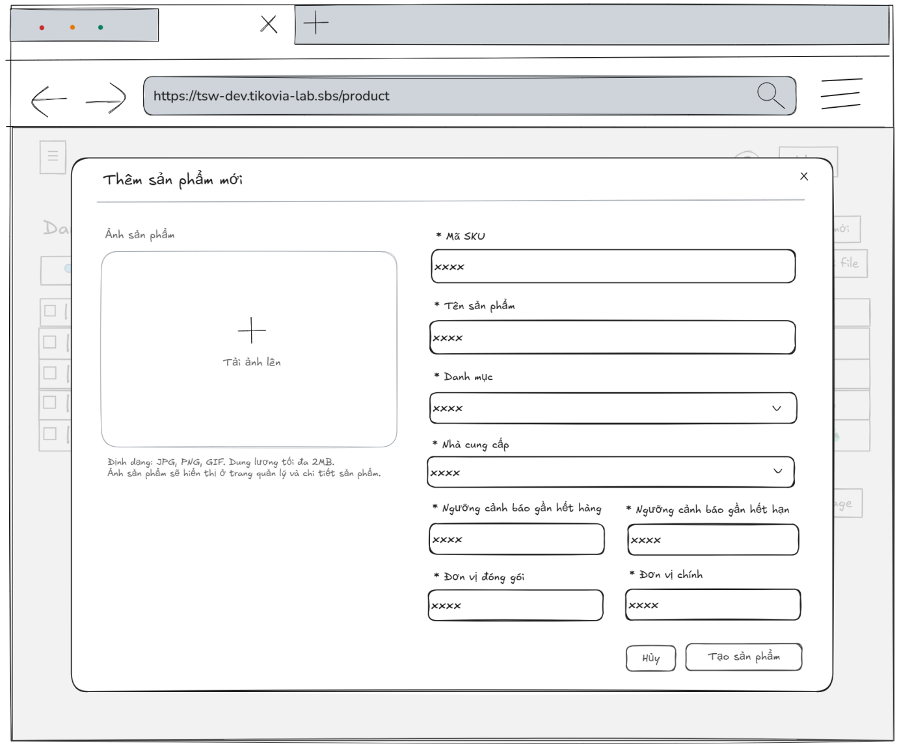
- Function Details:
  - Validation:
    - The user must be authenticated and authorized with the Admin or Warehouse Manager role to Add product.
    - The uploaded product image must be in JPG, PNG, or GIF format and must not exceed 2MB.
    - All required fields (SKU code, Product name, Product category, Supplier, Low stock threshold, Expiry warning threshold, Base unit, Pack unit) must be provided.
    - Numeric fields (Low stock threshold, Expiry warning threshold) must contain valid positive numbers.
  - Functionality:
    - In Normal Cases:
      - After the admin or warehouse manager has submitted the product’s information success and the system validates a message will be displayed: “Tạo sản phẩm thành công. Sản phẩm đã được thêm vào hệ thống.”.
    - In Abnormal Cases:
      - No input Provided: If the admin presses the submit button without any required field, the system will display an error message required field.
      - Server Error: If there is an issue with the server when submitting the new product’s information and add new product, the system will notify: "Có lỗi xảy ra. Không thể tạo sản phẩm".
  - Business rule: BR-18, BR-19.

# | Component | Comp. type | Editable | Mandatory | Default Value | Description
 | Header Section
1 | Modal Title | Label (Text) | No | Yes | "Thêm sản phẩm mới" | The main heading of the modal.
2 | Close Button | Icon Button | No | Yes | (Close icon) | Closes the modal without saving.
 | Image Upload Section
3 | Upload Area | File Uploader | Yes | No | "Tải ảnh lên" | Clickable area to upload product image. Includes a "+" icon.
4 | Upload Helper Text | Label (Text) | No | Yes | "Định dạng: JPG, PNG, GIF. Dung lượng tối đa 2MB. Ảnh sản phẩm sẽ hiển thị ở trang quản lý và chi tiết sản phẩm." | Instructional text regarding file format and size limits.
 | General Info Section
5 | SKU Label | Label (Text) | No | Yes | "* Mã SKU" | Label for the Stock Keeping Unit field.
6 | SKU Input | Input (Text) | Yes | Yes | N/A | Field to enter the unique product code.
7 | Product Name Label | Label (Text) | No | Yes | "* Tên sản phẩm" | Label for the product name.
8 | Product Name Input | Input (Text) | Yes | Yes | N/A | Field to enter the full name of the product.
9 | Category Label | Label (Text) | No | Yes | "* Danh mục" | Label for the product category.
10 | Category Select | Input (Dropdown) | Yes | Yes | N/A | User selects a category from a predefined list.
11 | Supplier Label | Label (Text) | No | Yes | "* Nhà cung cấp" | Label for the supplier field.
12 | Supplier Select | Input (Dropdown) | Yes | Yes | N/A | User selects a supplier from a predefined list.
 | Inventory Settings
13 | Low Stock Label | Label (Text) | No | Yes | "* Ngưỡng cảnh báo gần hết hàng" | Label for the minimum stock alert threshold.
14 | Low Stock Input | Input (Number) | Yes | Yes | N/A | Integer input. Triggers an alert when stock falls below this number.
15 | Expiry Label | Label (Text) | No | Yes | "* Ngưỡng cảnh báo gần hết hạn" | Label for the near-expiry alert threshold.
16 | Expiry Input | Input (Number) | Yes | Yes | N/A | Integer input (days/months). Triggers an alert before the product expires.
 | Unit Settings
17 | Pack Unit Label | Label (Text) | No | Yes | "* Đơn vị đóng gói" | Label for the packaging unit (e.g., Box, Carton).
18 | Pack Unit Input | Input (Text) | Yes | Yes | N/A | Field to define how the product is packed.
19 | Base Unit Label | Label (Text) | No | Yes | "* Đơn vị chính" | Label for the base unit (e.g., Piece, kg).
20 | Base Unit Input | Input (Text) | Yes | Yes | N/A | Field to define the smallest selling unit.
 | Action Section
21 | Cancel Button | Button (Secondary) | No | Yes | "Hủy" | Discards changes and closes the modal.
22 | Create Button | Button (Primary) | No | Yes | "Tạo sản phẩm" | Submits the form to create the new product record.
––––––––––––––––––––––––––––––––––––––––––––––––––––––––––––––––––––––––––––––––––-

3.3.4 - Update Product’s Information
- Function trigger: The admin, warehouse manager accesses the Products page to view the list of products and press edit button to update/edit information for a specific product.
- Function description: To allow the admin, warehouse manager to update information of the products.
- Screen layout:
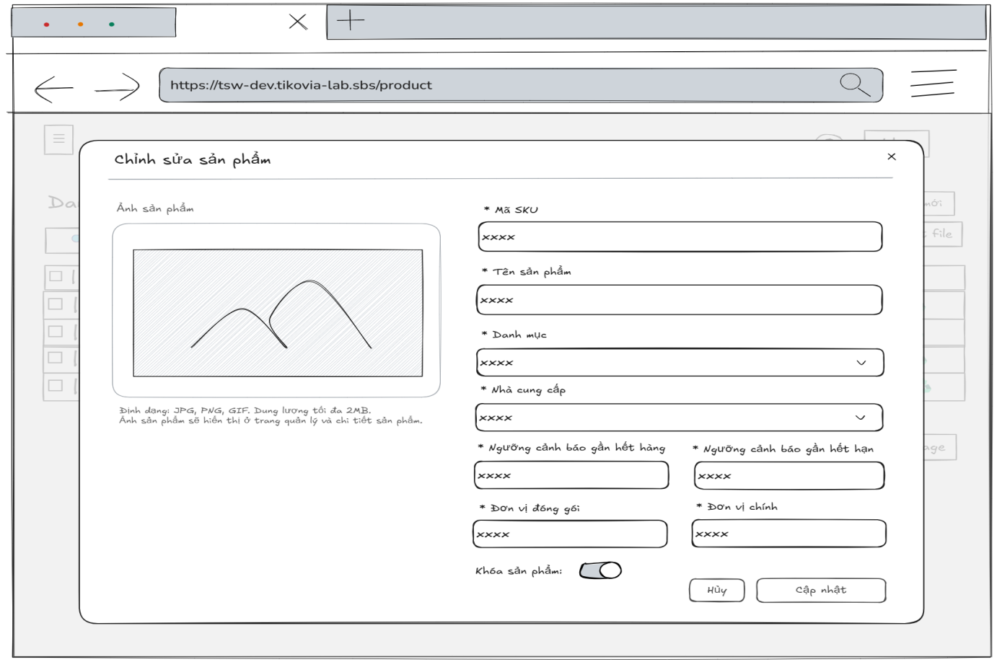
- Function Details:
  - Validation:
    - The user must be authenticated and authorized with the Admin or Warehouse Manager role to update product information.
    - The uploaded product image must be in JPG, PNG, or GIF format and must not exceed 2MB.
    - All required fields (SKU code, Product name, Product category, Supplier, Low stock threshold, Expiry warning threshold, Base unit, Pack unit) must be provided.
    - The selected product must exist in the system before editing.
    - Numeric fields (Low stock threshold, Expiry warning threshold) must contain valid positive numbers.
    - Updated product information must be saved consistently and correctly in the database.
  - Functionality:
    - In Normal Cases:
      - After pressing the button edit, the system displayed the product's information in the input box, upload box, and it must match with the database.
      - The admin, warehouse manager is able to edit product’s information and can see a success message.
      - The admin is able to lock the product.
      - After pressing the “Cập nhật” button to send the update request, the system validates and a success message is displayed “Cập nhật thành công”
    - In Abnormal Cases:
      - Required fields blank: If required fields (e.g., Sku code, product name, category, near-expiration warning threshold, Low stock warning threshold) are left blank, the system will: Display an error message indicating which fields are missing and prevent saving until all required fields are correctly filled.
      - Server Error: If the server encounters an internal error (e.g., database timeout or server crash) during the update process, the system will show a message like “Server error occurred. Please try again later.”
  - Business rule: BR-18, BR-19.

# | Component | Comp. type | Editable | Mandatory | Default Value | Description
 | Header Section
1 | Modal Title | Label (Text) | No | Yes | "Chỉnh sửa sản phẩm" | The main heading with an edit icon prefix.
2 | Close Button | Icon Button | No | Yes | "x" | Closes the modal.
 | Image Section
3 | Product Image | Image | Yes | No | [Image of product] | Displays the current product image.
4 | Upload Helper | Label (Text) | No | Yes | "Định dạng: JPG, PNG, GIF..." | Instructional text for file requirements.
 | General Info Section
5 | SKU Label | Label (Text) | No | Yes | "* Mã SKU"
6 | SKU Input | Input (Text) | Yes | Yes | [SKU code of product] | The unique product identifier.
7 | Name Label | Label (Text) | No | Yes | "* Tên sản phẩm"
8 | Name Input | Input (Text) | Yes | Yes | [Product name] | The display name of the product.
9 | Supplier Label | Label (Text) | No | Yes | "* Nhà cung cấp"
10 | Supplier Select | Input (Dropdown) | Yes | Yes | [Supplier name] | Selects the supplier source.
11 | Category Label | Label (Text) | No | Yes | "* Danh mục"
12 | Category Select | Input (Dropdown) | Yes | Yes | [Category of product] | Includes inline actions (Edit/Delete icons) inside the dropdown item if applicable.
 | Inventory Settings
13 | Low stock threshold Label | Label (Text) | No | Yes | "* Ngưỡng cảnh báo gần hết hàng"
14 | Low stock threshold Input | Input (Number) | Yes | Yes | [Low stock alert product] | Integer value for stock alert.
15 | Expiry Label | Label (Text) | No | Yes | "* Ngưỡng cảnh báo gần hết hạn"
16 | Expiry warning threshold Input | Input (Number) | Yes | Yes | [Expiry warning threshold] | Integer value (days/months).
 | Unit & Status Section
17 | Pack Unit Label | Label (Text) | No | Yes | "* Đơn vị đóng gói"
18 | Pack Unit Input | Input (Text) | Yes | Yes | "Thùng" | Sample Data.
19 | Base Unit Label | Label (Text) | No | Yes | "* Đơn vị chính"
20 | Base Unit Input | Input (Text) | Yes | Yes | "Kg" | Sample Data.
21 | Lock Toggle | Switch | Yes | No | "Khóa" (State: Off) | Toggles product status. Text "Khóa" is visible next to the switch.
 | Action Section
22 | Cancel Button | Button (Secondary) | No | Yes | "Hủy" | Button style: White background, gray border.
23 | Update Button | Button (Primary) | No | Yes | "Cập nhật" | Button style: Blue background, white text.

––––––––––––––––––––––––––––––––––––––––––––––––––––––––––––––––––––––––––––––––––-

3.3.5 - View List of Inventory lot
- Function trigger: Admin, Warehouse managers, Packing supervisor, Packing staff, Sell staff, Accountant clicks on the “Inventory Lot” button and navigates to the Inventory Lot page through the sidebar to view the list of Inventory Lot in the system.
- Function description: To view a list of inventory lots with the information about an inventory lot, such as the Lot No, product name, sku code, department code, quantity on hand, expiry date.
- Screen layout:
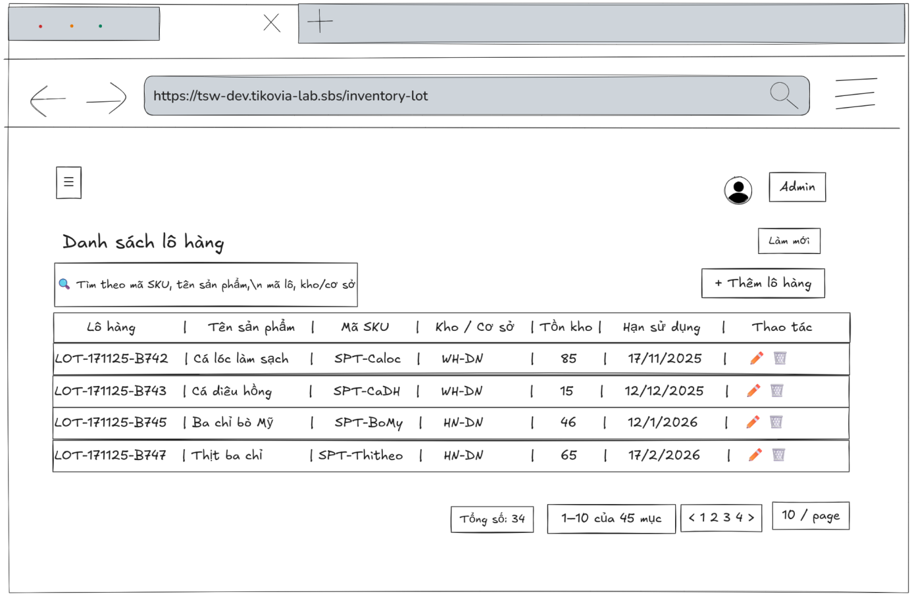
- Function Details:
  - Validation:
    - The user must be authenticated and authorized with one of the following roles: Admin, Packing Staff, Packing Supervisor, Warehouse Manager, Accountant.
    - The system shall successfully retrieve inventory lot data from the server before displaying the list.
    - The inventory lot information displayed (Lot No, product name, SKU code, department code, quantity on hand, expiry date) must match the data stored in the system.
  - Functionality:
    - In Normal Cases:
      - After clicking on "Inventory Lot", the system displays the inventory lots list with the information about an inventory lot, such as the Lot No, product name, sku code, department code, quantity on hand, expiry date.
    - In Abnormal Cases:
      - No User Data Found If there is no data of inventory lots list in the system will display “No data”.
      - Connection Issues: If there's a server issue, the system will notify the users: "Không thể tải dữ liệu. Đã xảy ra lỗi khi tải danh sách lô hàng"
  - Business rule: N/A.

# | Component | Comp. type | Editable | Mandatory | Default Value | Description
 | Toolbar (Filter & Actions)
4 | Search Input | Input (Search) | Yes | No | "Tìm theo mã SKU, tên sản phẩm, mã lô, kho/cơ sở" | Placeholder text. Allows full-text search across multiple fields (SKU, Name, Batch ID, Warehouse).
5 | Refresh Button | Button (Secondary) | No | Yes | "Làm mới" | Reloads the data table without refreshing the entire page.
6 | Add Button | Button (Primary) | No | Yes | "+ Thêm lô hàng" | Opens the "Add New Batch" modal/screen.
 | Data Table List
7 | Column Headers | Label (Text) | No | Yes | "Lô hàng | Tên sản phẩm
8 | Row Data (Sample) | Table Row | No | Yes | "LOT-171125-B742 | Cá lóc làm sạch
9 | Action: Edit | Icon Button | No | Yes | (Pencil Icon) | Opens the "Edit Batch" modal for the selected row.
10 | Action: Delete | Icon Button | No | Yes | (Trash Icon) | Triggers a confirmation dialog to delete the batch.
 | Pagination Footer
11 | Total Count | Label (Text) | No | Yes | "Tổng số: 34" | Displays the total number of records found.
12 | Range Display | Label (Text) | No | Yes | "1–10 của 45 mục" | Indicates which subset of records is currently visible.
13 | Page Navigation | Pagination Control | Yes | Yes | N/A | Navigation links to jump between pages.
14 | Page Size Selector | Dropdown | Yes | Yes | "10 / page" | Controls the number of rows displayed per page.

––––––––––––––––––––––––––––––––––––––––––––––––––––––––––––––––––––––––––––––––––-

3.3.6 - View Inventory Lot Detail Information
- Function trigger: The Admin, Warehouse managers, Packing supervisor, Packing staff, Sell staff, Accountant accesses the Inventory Lot page and clicks on the selected inventory lots to display a popup with lot’s information.
- Function description: To view lot’s information details
- Screen layout:
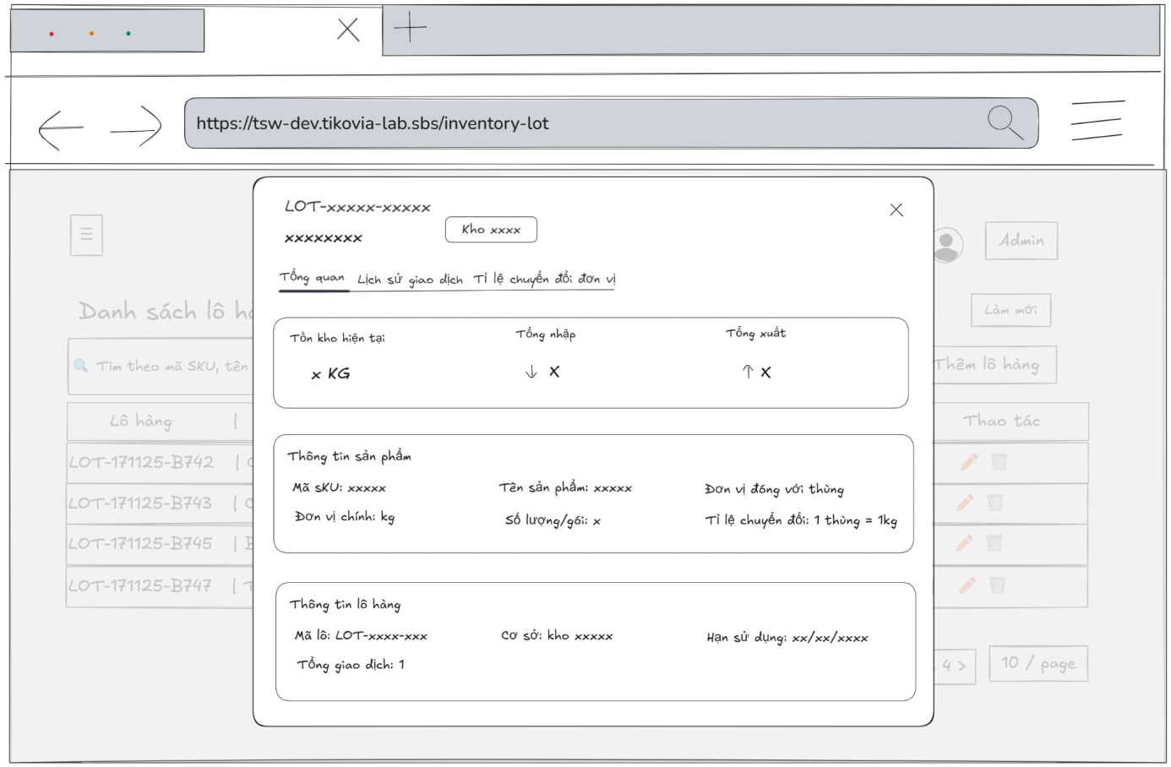
- Function Details:
  - Validation:
    - The user must be authenticated and authorized with one of the following roles: Admin, Packing Staff, Packing Supervisor, Warehouse Manager, Accountant.
    - The selected inventory lot must exist in the system.
    - The system shall successfully retrieve inventory lot detail data from the server before displaying the popup.
    - The inventory lot information displayed must match the data stored in the system.
  - Functionality:
    - In Normal Cases:
      - The system displays all the detailed information about inventory lots correctly.
    - In Abnormal Cases:
      - Server Error:
If there is an issue with the server when fetch data, the system display no data
  - Business rule: N/A.

# | Component | Comp. type | Editable | Mandatory | Default Value | Description
 | Header Section
1 | Modal Title | Label (Text) | No | Yes | LOT-[Batch Code] | Displays the full Batch ID.
2 | Subtitle | Label (Text) | No | Yes | [Product name] | Displays the descriptive name of the batch.
3 | Warehouse Badge | Tag / Badge | No | Yes | "Kho [Warehouse Name]" | Indicates which warehouse/facility holds this batch.
4 | Close Button | Icon Button | No | Yes | "x" | Closes the modal.
 | Navigation Tabs
5 | Tab List | Tab Control | Yes | Yes | "Tổng quan", "Lịch sử giao dịch", "Tỉ lệ chuyển đổi đơn vị" | Navigation tabs to switch views. "Tổng quan" is active by default.
 | Inventory Stats Card
6 | Current Stock Label | Label (Text) | No | Yes | "Tồn kho hiện tại"
7 | Current Stock Value | Label (Value) | No | Yes | [Current Stock] KG | Displays available quantity + Unit.
8 | Total Import Label | Label (Text) | No | Yes | "Tổng nhập"
9 | Total Import Value | Label (Value) | No | Yes | [Total Import] | Displays total quantity received (with down-arrow icon).
10 | Total Export Label | Label (Text) | No | Yes | "Tổng xuất"
11 | Total Export Value | Label (Value) | No | Yes | [Total Export] | Displays total quantity shipped (with up-arrow icon).
 | Product Info Group
12 | Group Title | Label (Text) | No | Yes | "Thông tin sản phẩm" | Section header.
13 | SKU Row | Label (Key-Val) | No | Yes | "Mã SKU: [SKU]"
14 | Product Name Row | Label (Key-Val) | No | Yes | "Tên sản phẩm: [Product Name]"
15 | Pack Unit Row | Label (Key-Val) | No | Yes | "Đơn vị đóng gói: [Pack Unit]"
16 | Base Unit Row | Label (Key-Val) | No | Yes | "Đơn vị chính: [Base Unit]"
17 | Qty Per Pack Row | Label (Key-Val) | No | Yes | "Số lượng/gói: [Quantity]"
18 | Conversion Row | Label (Key-Val) | No | Yes | "Tỉ lệ chuyển đổi: 1 [Pack Unit] = [Rate]kg" | Displays the conversion logic (e.g., 1 Thùng = 10kg).
 | Batch Info Group
19 | Group Title | Label (Text) | No | Yes | "Thông tin lô hàng" | Section header.
20 | Batch Code Row | Label (Key-Val) | No | Yes | "Mã lô: LOT-[Batch Code]"
21 | Facility Row | Label (Key-Val) | No | Yes | "Cơ sở: kho [Facility Name]"
22 | Expiry Row | Label (Key-Val) | No | Yes | "Hạn sử dụng: [Expiry Date]" | Format: DD/MM/YYYY.
23 | Transaction Row | Label (Key-Val) | No | Yes | "Tổng giao dịch: [Transaction Count]" | Total number of movements for this batch.
––––––––––––––––––––––––––––––––––––––––––––––––––––––––––––––––––––––––––––––––––-

3.3.7 - Add Inventory Lot
- Function trigger: Admin, warehouse manager accesses the Inventory lot page and clicks the button “Thêm lô hàng” to display a popup with input box.
- Function description: Allow Admin, Warehouse manager to add a new inventory lot.
- Screen layout:
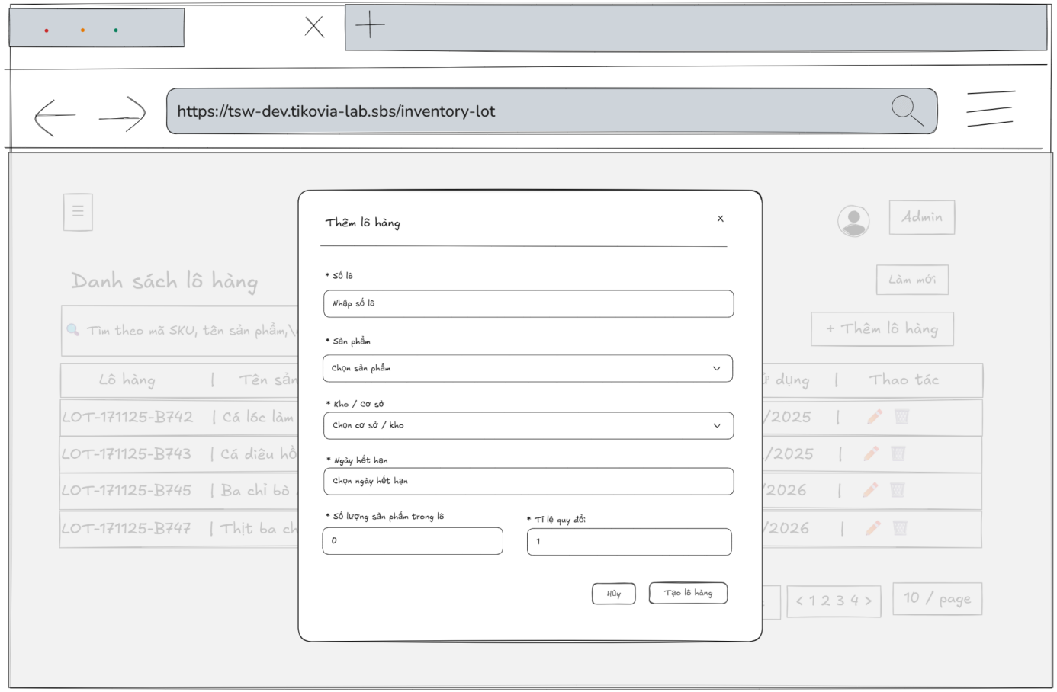
- Function Details:
  - Validation:
    - The user must be authenticated and authorized with the Admin or Warehouse Manager role.
    - All required fields (Lot No, Product, Warehouse/Department, Expiry Date, Quantity, Unit conversion rate) must be provided.
    - Lot No must be unique in the system.
    - Quantity and unit conversion rate must be valid positive numbers.
    - Expiry date must be a valid date and must not be earlier than the current date.
    - The system shall validate all input data on the server side before creating a new inventory lot.
  - Functionality:
    - In Normal Cases:
      - After the admin has submitted the inventory lot’s information success and the system validates a message will be displayed: “Tạo lô hàng thành công.”.
    - In Abnormal Cases:
      - No input Provided:
If the admin presses the submit button without any required field, the system will display an error message required field.
      - Server Error:
If there is an issue with the server when submitting the new department’s information and add new department, the system will notify: "Có lỗi xảy ra. Có lỗi xảy ra khi tạo lô hàng."
  - Business rule: BR-19, BR-20.

# | Component | Comp. type | Editable | Mandatory | Default Value | Description
 | Header Section
1 | Modal Title | Label (Text) | No | Yes | "Thêm lô hàng" | Displays the title of the modal dialog.
2 | Close Button | Button (Icon) | No | Yes | [X Icon] | Button to close the modal without saving data.
 | Form Section
3 | Lot No Label | Label (Text) | No | Yes | "* Số lô (Lot No)" | Label for the Lot Number field. Asterisk indicates a mandatory field.
4 | Lot No Input | Input (Text) | Yes | Yes | Placeholder: "Nhập số lô" | Input field for entering the unique identification number of the batch.
5 | Product Label | Label (Text) | No | Yes | "* Sản phẩm" | Label for the Product selection field. Asterisk indicates a mandatory field.
6 | Product Select | Dropdown | Yes | Yes | Placeholder: "Chọn sản phẩm" | Dropdown menu to select a product from the available list.
7 | Warehouse Label | Label (Text) | No | Yes | "* Kho / Cơ sở" | Label for the Warehouse/Facility field. Asterisk indicates a mandatory field.
8 | Warehouse Select | Dropdown | Yes | Yes | Placeholder: "Chọn cơ sở/kho" | Dropdown menu to select the specific warehouse or facility for storage.
9 | Exp Date Label | Label (Text) | No | Yes | "* Ngày hết hạn" | Label for the Expiry Date field. Asterisk indicates a mandatory field.
10 | Exp Date Picker | Date Picker | Yes | Yes | Placeholder: "Chọn ngày hết hạn" | Date picker widget allowing the user to select the expiration date. Includes a calendar icon.
11 | Quantity Label | Label (Text) | No | Yes | "* Số lượng sản phẩm trong lô" | Label for the Quantity field. Asterisk indicates a mandatory field.
12 | Quantity Input | Input (Number) | Yes | Yes | "0" | Numeric input field for defining the total quantity of items in the batch.
13 | Rate Label | Label (Text) | No | Yes | "* Tỉ lệ quy đổi" | Label for the Conversion Rate field. Asterisk indicates a mandatory field.
14 | Rate Input | Input (Number) | Yes | Yes | "1" | Numeric input field for the conversion rate.
 | Footer Section
15 | Cancel Button | Button | No | Yes | "Hủy" | Button to dismiss the modal and discard any entered information.
16 | Create Button | Button | No | Yes | "Tạo lô hàng" | Primary button to submit the form and create the new batch record.
––––––––––––––––––––––––––––––––––––––––––––––––––––––––––––––––––––––––––––––––––-

3.3.8 - Update Inventory Lot’s Information
- Function trigger: Admin, warehouse manager accesses the Inventory lot page to view the list of inventory lots and press edit button to update/edit information for a specific inventory lot.
- Function description: To allow the admin, warehouse manager to update information of the inventory lots.
- Screen layout:
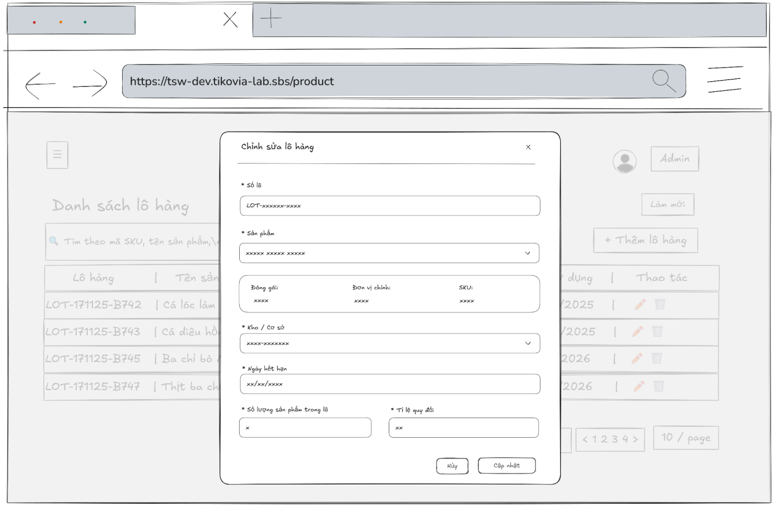
- Function Details:
  - Validation:
    - The user must be authenticated and authorized with the Admin or Warehouse Manager role.
    - All required fields (Lot No, Product, Warehouse/Department, Expiry Date, Quantity, Unit conversion rate) must be provided.
    - Lot No must be unique in the system.
    - Quantity and unit conversion rate must be valid positive numbers.
    - Expiry date must be a valid date and must not be earlier than the current date.
    - The system shall validate all input data on the server side before creating a new inventory lot.
  - Functionality:
    - In Normal Cases:
      - After pressing the button edit, the system displayed the inventory lot's information in the input box and it must match with the database.
      - The admin, warehouse manager is able to edit inventory lot’s information and can see a success message.
      - After pressing the “Cập nhật” button to send the update request, the system validates and a success message is displayed “Cập nhật thành công”
    - In Abnormal Cases:
      - Required fields blank: If required fields (e.g., Lot No, Product, Department, expiry date, quantity) are left blank, the system will: Display an error message indicating which fields are missing and prevent saving until all required fields are correctly filled.
      - Server Error: If the server encounters an internal error (e.g., database timeout or server crash) during the update process, the system will show a message like “Server error occurred. Please try again later.”
  - Business rule: BR-19, BR-20.

# | Component | Comp. type | Editable | Mandatory | Default Value | Description
 | Header Section
1 | Modal Title | Label (Text) | No | Yes | "Chỉnh sửa lô hàng" | Displays the title of the modal for the edit mode.
2 | Close Button | Button (Icon) | No | Yes | [X Icon] | Button to close the modal without saving changes.
 | Form Section
3 | Lot No Label | Label (Text) | No | Yes | "* Số lô (Lot No)" | Label for the Lot Number field.
4 | Lot No Input | Input (Text) | Yes | Yes | [Current Lot No] | Input field displaying the current batch number.
5 | Product Label | Label (Text) | No | Yes | "* Sản phẩm" | Label for the Product selection field.
6 | Product Select | Dropdown | Yes | Yes | [Current Product Name] | Dropdown to change the product. Includes search capability.
 | Product Info Panel | (Container) |  |  |  | Dynamic section displayed based on selected Product.
7 | Packing Unit Label | Label (Text) | No | Yes | "Đóng gói:" | Label indicating the packaging unit type.
8 | Packing Unit Value | Label (Text) | No | Yes | [e.g., "thùng"] | Read-only text displaying the packaging unit of the selected product.
9 | Main Unit Label | Label (Text) | No | Yes | "Đơn vị chính:" | Label indicating the base measurement unit.
10 | Main Unit Value | Label (Text) | No | Yes | [e.g., "kg"] | Read-only text displaying the base unit of the selected product.
11 | SKU Label | Label (Text) | No | Yes | "SKU:" | Label for the Stock Keeping Unit code.
12 | SKU Value | Label (Text) | No | Yes | [e.g., "SPT-CALOC"] | Read-only text displaying the unique SKU code.
 | Storage & Quantity
13 | Warehouse Label | Label (Text) | No | Yes | "* Kho / Cơ sở" | Label for the Warehouse field.
14 | Warehouse Select | Dropdown | Yes | Yes | [Current Warehouse] | Dropdown to change the storage location.
15 | Exp Date Label | Label (Text) | No | Yes | "* Ngày hết hạn" | Label for the Expiry Date field.
16 | Exp Date Picker | Date Picker | Yes | Yes | [Current Date] | Date picker widget displaying the set expiration date.
17 | Quantity Label | Label (Text) | No | Yes | "* Số lượng sản phẩm trong lô" | Label for the Quantity field.
18 | Quantity Input | Input (Number) | Yes | Yes | [Current Qty] | Numeric input for the quantity. Displays formatted number (e.g., 85.000).
19 | Rate Label | Label (Text) | No | Yes | "* Tỉ lệ quy đổi ([Unit A] = ? [Unit B])" | Label for conversion rate. It dynamically shows the relationship between Packaging Unit and Main Unit.
20 | Rate Input | Input (Number) | Yes | Yes | [Current Rate] | Numeric input for the conversion rate value.
 | Footer Section
21 | Cancel Button | Button | No | Yes | "Hủy" | Button to discard changes and close the modal.
22 | Update Button | Button | No | Yes | "Cập nhật" | Primary button to save the modified batch information.
––––––––––––––––––––––––––––––––––––––––––––––––––––––––––––––––––––––––––––––––––-

3.4 Order and Sales Management

3.4.1 - Sales Orders List
- Function trigger: The Admin, Warehouse manager, Sell staff, Accountant, Packing supervisors, Delivery supervisors access the Sales Orders page to view the list of sales orders.
- Function description: To allow the Admin, Warehouse manager, Sell staff, Accountant, Packing supervisors, Delivery supervisors to view the list of sales orders.
- Screen layout:
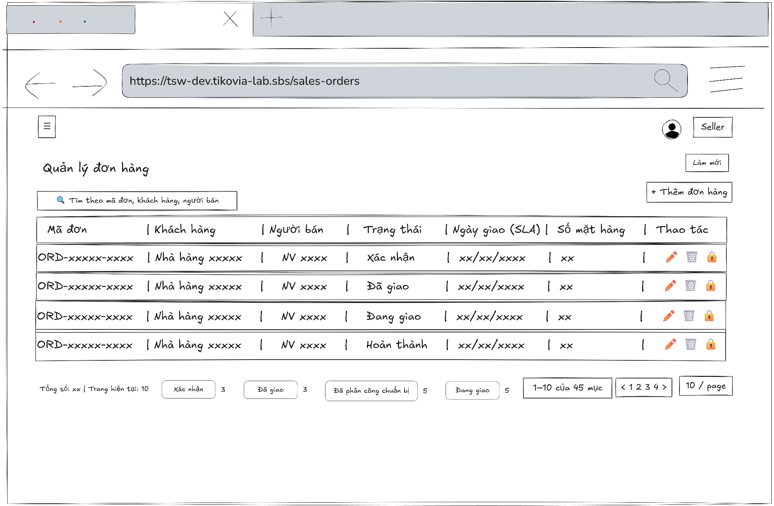
- Function Details:
  - Validation:
    - The user must be authenticated and logged in.
    - The user must have a valid role (Admin, Warehouse Manager, Sell Staff, Accountant, Packing Supervisor, Delivery Supervisor).
    - The system must validate access permission before displaying the Sales Orders page.
    - Sales orders data must be retrieved correctly from the database.
    - Displayed order information (order no, customer, seller, status, delivery date, number of products) must match the stored data.
    - If no data exists, the system must display “No data”.
  - Functionality:
    - In Normal Cases:
      - After clicking on "Sales Orders", the system displays the sales orders list with the information about a sales order, such as the OrderNo, customer name, seller name, status, delivery at, number of products.
    - In Abnormal Cases:
      - No Sales orders Data Found: If there is no data of sales orders list in the system will display “No data”.
      - Connection Issues: If there's a server issue, the system will notify the users: "Đã xảy ra lỗi khi tải danh sách đơn hàng"
  - Business rule: N/A.

# | Component | Comp. type | Editable | Mandatory | Default Value | Description
 | Header & Search
1 | Screen Title | Label (Text) | No | Yes | "Quản lý đơn hàng" | Displays the main title of the screen.
2 | Refresh Button | Button | No | No | "Làm mới" | Button to reload the order list data from the server.
3 | Search Input | Input (Text) | Yes | No | Placeholder: "Tìm theo mã đơn, khách hàng, người bán" | Input field to search for orders by Order ID, Customer Name, or Seller Name. Includes a search icon.
 | Data Table Headers
4 | Col Header: Order ID | Label/Sort | No | Yes | "Mã đơn" | Column header for Order ID. Clickable to sort data ascending/descending.
5 | Col Header: Customer | Label/Sort | No | Yes | "Khách hàng" | Column header for Customer Name. Clickable to sort data.
6 | Col Header: Seller | Label/Filter | No | Yes | "Người bán" | Column header for Seller Name. Includes a filter icon to filter by specific sellers.
7 | Col Header: Status | Label/Filter | No | Yes | "Trạng thái" | Column header for Order Status. Includes a filter icon to filter by specific statuses.
8 | Col Header: SLA Date | Label/Filter | No | Yes | "Ngày giao (SLA)" | Column header for Delivery Date. Includes a filter icon.
9 | Col Header: Item Count | Label/Sort | No | Yes | "Số mặt hàng" | Column header for the number of items in the order. Clickable to sort data.
10 | Col Header: Action | Label | No | Yes | "Thao tác" | Column header for action buttons.
 | Data Table Rows
11 | Order ID Link | Link/Button | No | Yes | [Dynamic Order ID] | Displays the unique Order ID (e.g., ORD-181125...). Clickable to navigate to the Order Detail screen.
12 | Customer Name | Label (Text) | No | Yes | [Dynamic Name] | Displays the name of the customer who placed the order.
13 | Seller Name | Label (Text) | No | Yes | [Dynamic Name] | Displays the name of the salesperson or seller associated with the order.
14 | Status Badge | Label (Tag) | No | Yes | [Dynamic Status] | Displays the current status of the order (e.g., "Đã giao", "Chờ chuẩn bị") in a styled badge.
15 | SLA Date Time | Label (Text) | No | Yes | [Dynamic Date] | Displays the scheduled delivery time and date.
16 | Item Count Value | Label (Text) | No | Yes | [Dynamic Number] | Displays the count of line items in the order.
17 | Lock Action | Button (Icon) | No | Yes | [Lock Icon] | Icon button to lock the specific order to prevent further changes.
 | Footer & Pagination
18 | Total Info Label | Label (Text) | No | Yes | "Tổng số: [N] | Trang hiện tại: [M]" | Displays total record count and current page index.
19 | Status Summary | Group (Tags) | No | No | [Dynamic Counts] | A horizontal list showing counts for each order status (e.g., "Xác nhận 1", "Đã giao 5").
20 | Range Label | Label (Text) | No | Yes | "[X]-[Y] của [Z] mục" | Displays the range of items currently visible out of the total.
21 | Pagination Nav | Button Group | No | Yes | "<", "1", "2", "3", ">" | Navigation controls to switch pages. Includes Previous/Next buttons and page numbers.
22 | Items Per Page | Dropdown | Yes | Yes | "10 / trang" | Dropdown to select the number of rows displayed per page.
––––––––––––––––––––––––––––––––––––––––––––––––––––––––––––––––––––––––––––––––––-

3.4.2 - Sales Orders Detail
- Function trigger: Admin, Warehouse manager, Sell staff, Accountant, Packing supervisors, Delivery supervisors accesses the Sales Orders page and clicks on the selected order to display a popup with sales order information.
- Function description: Allow Admin, Warehouse manager, Sell staff, Accountant, Packing supervisors, Delivery supervisors to view sales order information details.
- Screen layout
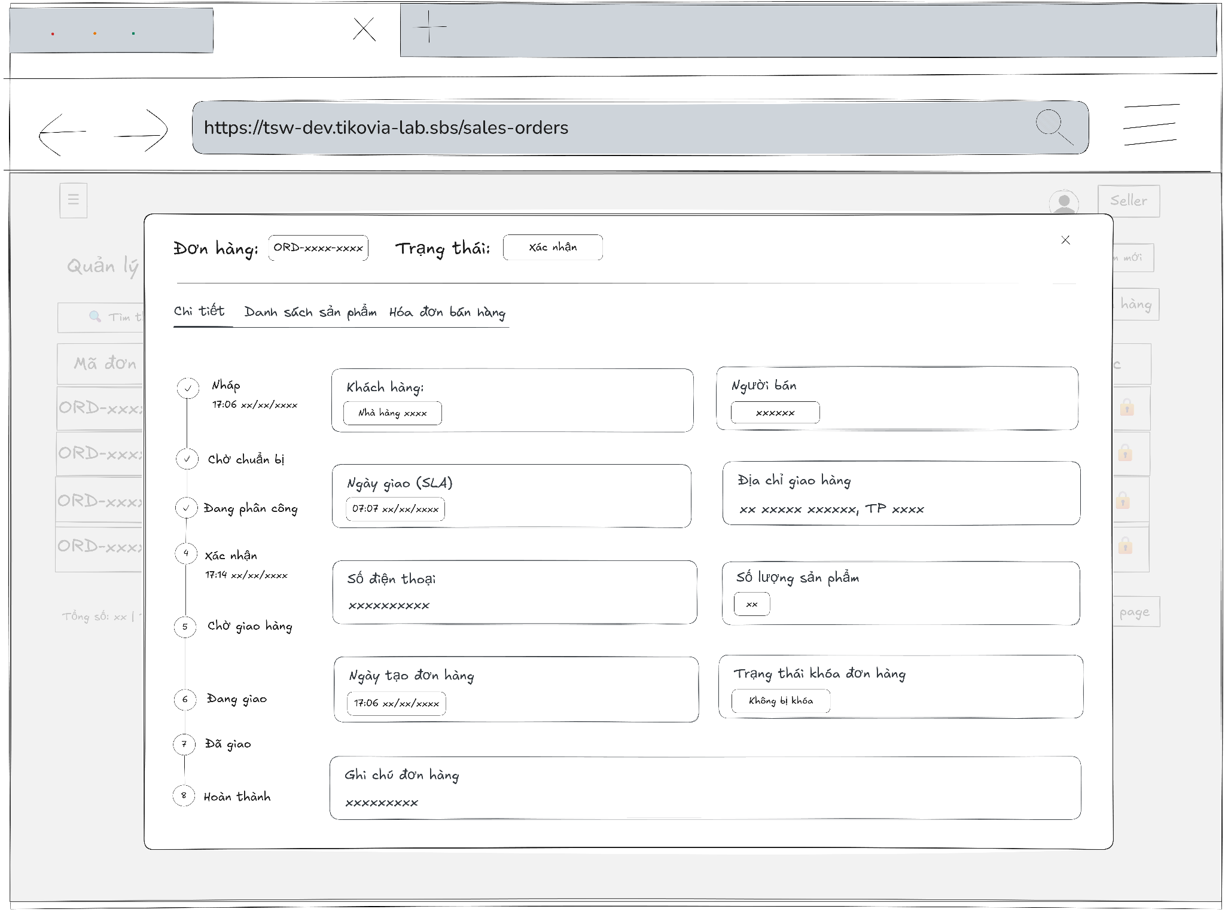
- Function Details:
  - Validation:
    - The user must be authenticated and logged in.
    - The user must have a valid role (Admin, Warehouse Manager, Sell Staff, Accountant, Packing Supervisor, Delivery Supervisor).
    - The selected sales order must exist in the system.
    - The system must validate access permission before showing order details.
    - Sales order detail data must be retrieved correctly from the database.
    - Displayed information (customer, seller, status, dates, delivery info, product quantity) must match stored data.
  - Functionality:
    - In Normal Cases:
      - The system displays all the detailed information about sales order correctly.
    - In Abnormal Cases:
      - Server Error: If there is an issue with the server when fetch data, the system display no data
  - Business rule: N/A.

# | Component | Comp. type | Editable | Mandatory | Default Value | Description
 | Header & Navigation
1 | Modal Title | Label (Text) | No | Yes | "Đơn hàng: [Order ID]" | Displays the static text "Đơn hàng" followed by the dynamic Order ID.
2 | Current Status Badge | Label (Tag) | No | Yes | "Trạng thái: [Status]" | Displays the current status of the order (e.g., "Xác nhận") next to the title.
3 | Close Button | Button (Icon) | No | Yes | [X Icon] | Button to close the modal dialog.
4 | Tab Navigation | Tab Group | Yes | Yes | "Chi tiết" | Navigation tabs to switch views: "Chi tiết" (Details), "Danh sách sản phẩm" (Product List), "Hóa đơn bán hàng" (Invoice).
 | Left Sidebar: Timeline
5 | Order Stepper | Vertical Stepper | No | Yes | [Dynamic Steps] | A vertical timeline showing the order progress steps (Draft, Prepared, Assigned, Confirmed, etc.).
6 | Step Time | Label (Text) | No | No | [Date Time] | Displays the timestamp when a specific step is completed.
 | Main Content: General Info
7 | Customer Label | Label (Text) | No | Yes | "Khách hàng" | Label for the customer information field.
8 | Customer Value | Label (Tag) | No | Yes | [Customer Name] | Displays the name of the customer inside a styled container.
9 | Seller Label | Label (Text) | No | Yes | "Người bán" | Label for the seller information field.
10 | Seller Value | Label (Tag) | No | Yes | [Seller Name] | Displays the name of the seller inside a styled container.
11 | SLA Date Label | Label (Text) | No | Yes | "Ngày giao (SLA)" | Label for the Service Level Agreement (delivery) date.
12 | SLA Date Value | Label (Tag) | No | Yes | [Date Time] | Displays the expected delivery date and time.
13 | Address Label | Label (Text) | No | Yes | "Địa chỉ giao hàng" | Label for the delivery address field.
14 | Address Value | Label (Text) | No | Yes | [Address String] | Displays the full delivery address.
15 | Phone Label | Label (Text) | No | Yes | "Số điện thoại" | Label for the contact phone number field.
16 | Phone Value | Label (Text) | No | Yes | [Phone Number] | Displays the customer's contact phone number.
17 | Item Count Label | Label (Text) | No | Yes | "Số lượng sản phẩm" | Label for the total quantity of items field.
18 | Item Count Value | Label (Tag) | No | Yes | [Number] | Displays the total count of products in the order inside a small badge.
19 | Created Date Label | Label (Text) | No | Yes | "Ngày tạo đơn hàng" | Label for the order creation date field.
20 | Created Date Value | Label (Tag) | No | Yes | [Date Time] | Displays the timestamp when the order was created.
21 | Lock Status Label | Label (Text) | No | Yes | "Trạng thái khóa đơn hàng" | Label indicating if the order is locked for editing.
22 | Lock Status Value | Label (Tag) | No | Yes | [Status Text] | Displays the lock status (e.g., "Không bị khóa") inside a styled badge.
23 | Note Label | Label (Text) | No | Yes | "Ghi chú đơn hàng" | Label for the order notes section.
24 | Note Value | Label (Text) | No | No | [Note] | Displays any additional notes attached to the order.
––––––––––––––––––––––––––––––––––––––––––––––––––––––––––––––––––––––––––––––––––-

3.4.3 - Create new Sales Orders
- Function trigger: The sell staff accesses the Sales Orders page and clicks the button “Thêm đơn hàng” to display a popup with input box.
- Function description: Allow sell staff to add a new sales order.
- Screen layout:
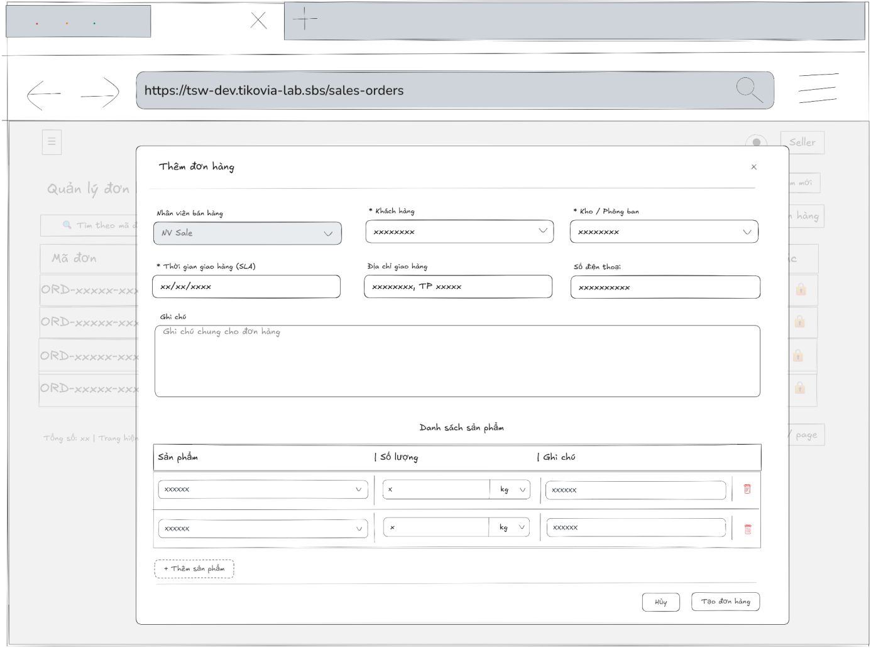
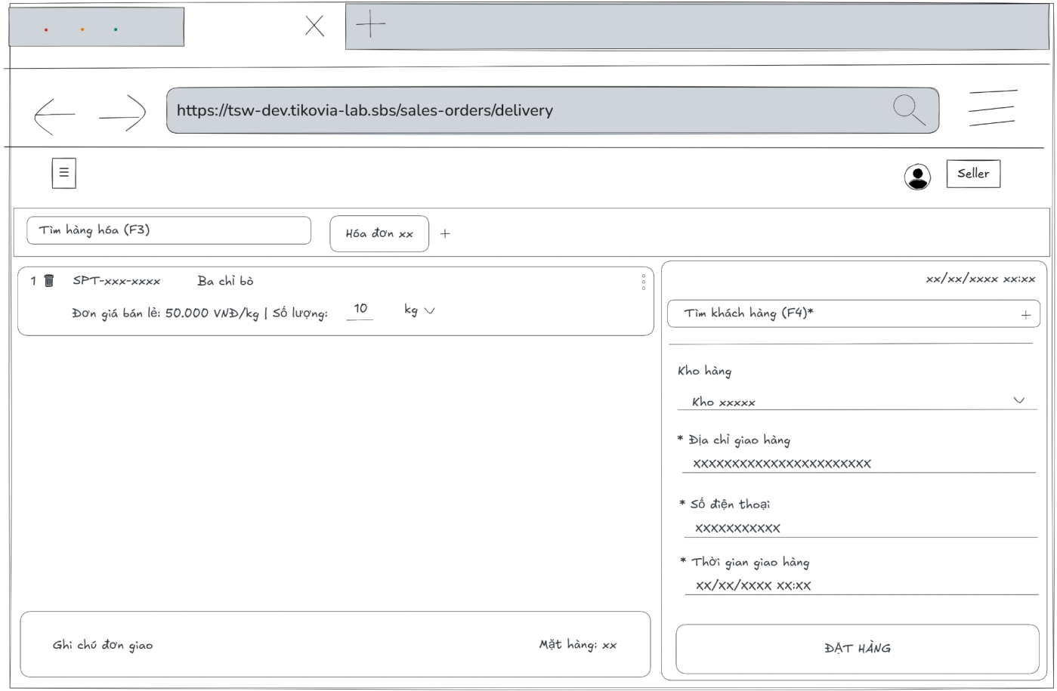
- Function Details:
  - Validation:
    - The user must be authenticated and logged into the system.
    - The user must have a valid role: Sell staff.
    - All required fields must be filled in (customer, department/warehouse, delivery time, product, quantity).
    - Product quantity must be valid and greater than zero.
    - Delivery time must be in the future.
    - The sales order data must be validated before submission.
  - Functionality:
    - In Normal Cases:
      - After submitting the sales order information success and the system validates a message will be displayed: “Tạo đơn hàng thành công. Đơn hàng đã được tạo thành công.”.
    - In Abnormal Cases:
      - No input Provided: If presses the submit button without any required field, the system will display an error message required field.
      - Server Error: If there is an issue with the server when submitting the new sales order information, the system will notify:
“Đã có lỗi xảy ra khi tạo đơn hàng."
  - Business rule: BR-19, BR-23.

# | Component | Comp. type | Editable | Mandatory | Default Value | Description
 | Header Section
1 | Modal Title | Label (Text) | No | Yes | "Thêm đơn hàng" | Displays the title of the modal dialog.
2 | Close Button | Button (Icon) | No | Yes | [X Icon] | Button to close the modal without creating an order.
 | General Information Form
3 | Seller Label | Label (Text) | No | Yes | "Nhân viên bán hàng" | Label for the salesperson field. Includes a tooltip icon (help) for help text.
4 | Seller Select | Dropdown | Yes | No | [Name of the sell staff currently logged into the system] | Dropdown to select the salesperson. Defaults to current user or generic sale account.
5 | Customer Label | Label (Text) | No | Yes | "* Khách hàng" | Label for the customer field. Asterisk indicates a mandatory field.
6 | Customer Select | Dropdown | Yes | Yes | Placeholder: "Tìm hoặc chọn khách hàng" | Searchable dropdown to find and select a customer.
7 | Warehouse Label | Label (Text) | No | Yes | "* Kho / Phòng ban" | Label for the warehouse/department field. Asterisk indicates a mandatory field.
8 | Warehouse Select | Dropdown | Yes | Yes | "Kho [warehouse name]" | Dropdown to select the source warehouse. Pre-selected with a default value.
9 | SLA Date Label | Label (Text) | No | Yes | "* Thời gian giao hàng (SLA)" | Label for the delivery deadline field. Asterisk indicates a mandatory field.
10 | SLA Date Picker | Date Picker | Yes | Yes | Placeholder: "Chọn thời điểm" | Widget to select the specific date and time for delivery.
11 | Address Label | Label (Text) | No | Yes | "Địa chỉ giao hàng" | Label for the delivery address field.
12 | Address Input | Input (Text) | Yes | No | Placeholder: "Địa chỉ giao" | Input field for manual address entry.
13 | Phone Label | Label (Text) | No | Yes | "Số điện thoại" | Label for the contact phone number field.
14 | Phone Input | Input (Text) | Yes | No | Placeholder: "Số điện thoại" | Input field for contact number.
15 | Note Label | Label (Text) | No | Yes | "Ghi chú" | Label for the general order note.
16 | Note Textarea | Input (Textarea) | Yes | No | Placeholder: "Ghi chú" | Multi-line text input for adding extra information about the order.
 | Product List Section
17 | List Header | Label (Text) | No | Yes | "Danh sách sản phẩm" | Section header for the line items.
18 | Product Col Header | Label (Text) | No | Yes | "Sản phẩm" | Header for the product selection column.
19 | Product Select | Dropdown | Yes | Yes | Placeholder: "Chọn sản phẩm" | Dropdown to select a specific product item for the row.
20 | Qty Col Header | Label (Text) | No | Yes | "Số lượng" | Header for the quantity column.
21 | Qty Input Group | Input Group | Yes | Yes | Placeholder: "0.00" | A composite field containing a number input and a unit dropdown (e.g., Box/Kg).
22 | Item Note Header | Label (Text) | No | Yes | "Ghi chú" | Header for the item-specific note column.
23 | Item Note Input | Input (Text) | Yes | No | Placeholder: "Ghi chú sản phẩm" | Text input for notes specific to that line item.
24 | Delete Row Button | Button (Icon) | No | Yes | [Trash Icon] | Button to remove the specific product row from the list.
25 | Add Product Button | Button | No | Yes | "+ Thêm sản phẩm" | Button to add a new empty row to the product list.
 | Footer Section
26 | Cancel Button | Button | No | Yes | "Hủy" | Button to dismiss the modal.
27 | Create Button | Button | No | Yes | "Tạo đơn hàng" | Primary button to submit the form and create the order.
––––––––––––––––––––––––––––––––––––––––––––––––––––––––––––––––––––––––––––––––––-

3.4.4 - Edit Sales Orders
- Function trigger: The sell staff accesses the Sales Orders page to view the list of sales orders if the order has status is draft,or pending preparation, sell staff can press edit button to edit information for a specific sales order .
- Function description: To allow the sell staff to edit information about the sales order.
- Screen layout:
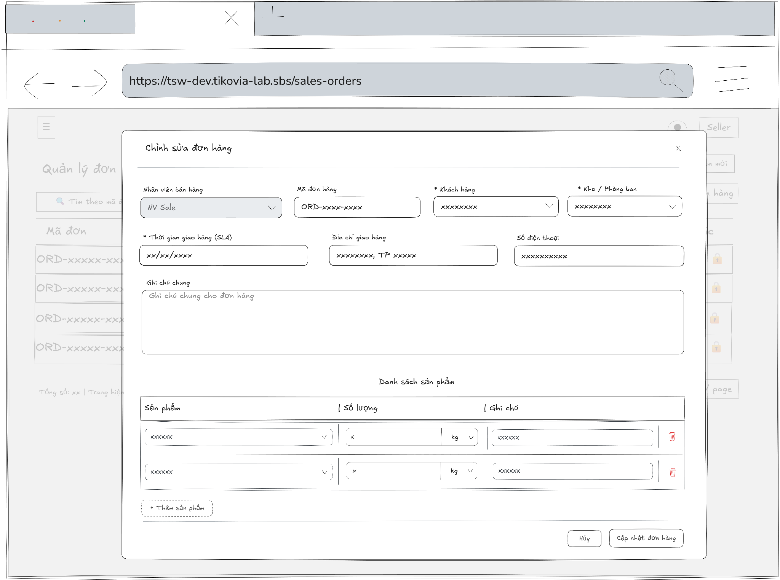
- Function Details:
  - Validation:
    - The user must be authenticated and logged into the system.
    - The user must have the Sell staff role.
    - The selected sales order must exist in the system.
    - Required fields (customer, delivery date, product list, quantities) must not be empty.
    - Delivery time must be in the future.
    - Product quantity must be greater than zero.
    - Updated order data must be validated before saving.
  - Functionality:
    - In Normal Cases:
      - After pressing the button edit, the system displayed the sales order information in the input box and it must match with the database.
      - The sales staff is able to edit sales order information and can see a success message.
      - After pressing the “Cập nhật đơn hàng” button to send the update request, the system validates and a success message is displayed “Cập nhật đơn hàng thành công"
    - In Abnormal Cases:
      - Required fields blank: If required fields are left blank or contain invalid data , the system will: Display an error message indicating which fields are missing or invalid and prevent saving until all required fields are correctly filled.
      - Server Error: If the server encounters an internal error (e.g., database timeout or server crash) during the update process, the system will show a message like “Server error occurred. Please try again later.”
  - Business rule: BR-19, BR-23.

# | Component | Comp. type | Editable | Mandatory | Default Value | Description
 | Header Section
1 | Modal Title | Label (Text) | No | Yes | "Chỉnh sửa đơn hàng" | Displays the title of the modal for editing an existing order.
2 | Close Button | Button (Icon) | No | Yes | [X Icon] | Button to close the modal without saving changes.
 | General Information Form
3 | Seller Label | Label (Text) | No | Yes | "Nhân viên bán hàng" | Label for the salesperson field. Includes a tooltip icon (help icon).
4 | Seller Select | Dropdown | Yes | No | [Current Seller Name] | Dropdown to change the salesperson. Pre-filled with the current value (e.g., "NV Sale").
5 | Order No Label | Label (Text) | No | Yes | "Mã đơn hàng" | Label for the Order ID field.
6 | Order No Input | Input (Text) | No | Yes | [Current Order No] | Displays the unique Order No (e.g., "ORD-181125-526470"). This field is Read-only.
7 | Customer Label | Label (Text) | No | Yes | "* Khách hàng" | Label for the customer field. Asterisk indicates a mandatory field.
8 | Customer Select | Dropdown | Yes | Yes | [Current Customer] | Searchable dropdown to change the customer. Pre-filled with the current customer (e.g., "Siêu thị GoMart").
9 | Warehouse Label | Label (Text) | No | Yes | "* Kho / Phòng ban" | Label for the warehouse field. Asterisk indicates a mandatory field.
10 | Warehouse Select | Dropdown | Yes | Yes | [Current Warehouse] | Dropdown to change the source warehouse. Pre-filled (e.g., "Kho Đà Nẵng").
11 | SLA Date Label | Label (Text) | No | Yes | "* Thời gian giao hàng (SLA)" | Label for the delivery deadline. Asterisk indicates a mandatory field.
12 | SLA Date Picker | Date Picker | Yes | Yes | [Current Date Time] | Widget to select date and time. Pre-filled with the saved SLA (e.g., "20/11/2025 17:00").
13 | Address Label | Label (Text) | No | Yes | "Địa chỉ giao hàng" | Label for the delivery address field.
14 | Address Input | Input (Text) | Yes | No | [Current customer’s Address] | Input field for address. Pre-filled (e.g., "56 Quang Trung...").
15 | Phone Label | Label (Text) | No | Yes | "Số điện thoại" | Label for the phone number field.
16 | Phone Input | Input (Text) | Yes | No | [Current customer’s Phone] | Input field for contact number. Pre-filled (e.g., "062637493").
17 | Note Label | Label (Text) | No | Yes | "Ghi chú" | Label for the order note.
18 | Note Textarea | Input (Textarea) | Yes | No | [Current Note] | Multi-line text input for order notes. Pre-filled if data exists.
 | Product List Section
19 | List Header | Label (Text) | No | Yes | "Danh sách sản phẩm" | Section header for the product line items.
20 | Product Select | Dropdown | Yes | Yes | [Selected Product] | Dropdown to select/change the product in a row (e.g., "Ba rọi heo Nga").
21 | Qty Input Group | Input Group | Yes | Yes | [Qty] [Unit] | Composite field with a Number Input (e.g., "200.00") and a Unit Dropdown (e.g., "kg").
22 | Item Note Input | Input (Text) | Yes | No | [Item Note] | Text input for specific item notes (e.g., "giao gấp").
23 | Delete Row Button | Button (Icon) | No | Yes | [Trash Icon] | Button to remove the specific product row.
24 | Add Product Button | Button | No | Yes | "+ Thêm sản phẩm" | Button to append a new empty row to the product list.
 | Footer Section
25 | Cancel Button | Button | No | Yes | "Hủy" | Button to discard changes and close the modal.
26 | Update Button | Button | No | Yes | "Cập nhật đơn hàng" | Primary button to submit the form and save changes to the order.
––––––––––––––––––––––––––––––––––––––––––––––––––––––––––––––––––––––––––––––––––-

3.4.5 - View Return Orders
- Function trigger: Sell staff, Accountant, Admin, Warehouse manager, Delivery supervisor accesses the Sales Orders page and clicks on the selected order to display a popup with sales order information then click on tab “Trả hàng” to display all information of sales invoice.
- Function description: Allow Sell staff, Accountant, Admin, Warehouse manager, Delivery supervisor to view return order information details.
- Screen layout
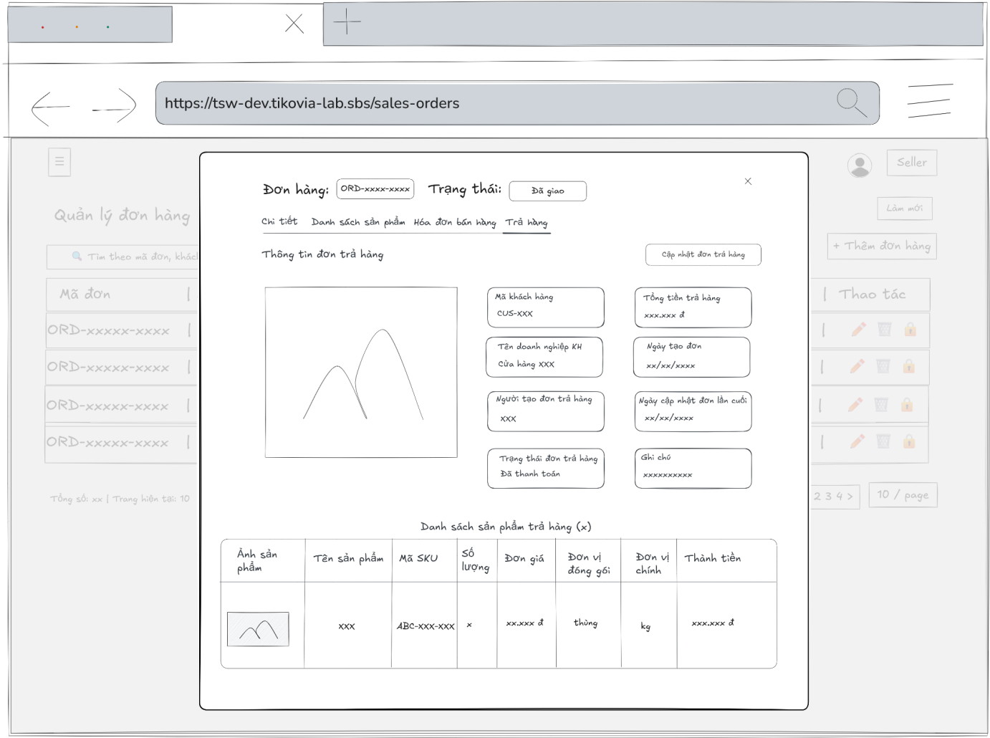
- Function Details:
  - Validation:
    - The user must be authenticated and logged into the system.
    - The user must have a valid role: Sell staff, Accountant, Admin, Warehouse manager, or Delivery supervisor.
    - The selected sales order must exist in the system.
    - The system must verify access permission before displaying return order information.
    - Return order data (general information and returned product list) must be retrieved correctly from the database.
  - Functionality:
    - In Normal Cases:
      - When accessing the Order Returns tab, the system displays all relevant details and the list of returned products.
    - In Abnormal Cases:
      - No Order Return Found: A message is displayed: "No order return found for this order."
      - Server Error: If there is an issue with the server when fetch data, the system display no data
  - Business rule: N/A.

# | Component | Comp. type | Editable | Mandatory | Default Value | Description
 | Header & Navigation
1 | Modal Title | Label (Text) | No | Yes | "Đơn hàng: [Order ID]" | Displays the static text "Đơn hàng" followed by the dynamic Order ID.
2 | Order Status Badge | Label (Tag) | No | Yes | "Trạng thái: [Status]" | Displays the current status of the main order (e.g., "Đã giao").
3 | Close Button | Button (Icon) | No | Yes | [X Icon] | Button to close the modal dialog.
4 | Tab Navigation | Tab Group | Yes | Yes | "Trả hàng" | Navigation tabs. The "Trả hàng" (Return Order) tab is currently active.
 | Return Order Information
5 | Section Title | Label (Text) | No | Yes | "Thông tin đơn trả hàng" | Title for the return order information section.
6 | Update Button | Button | No | Yes | "Cập nhật đơn trả hàng" | Button to open the edit form or update status for the return order.
7 | Proof Image | Image | No | No | [Image Source] | Displays the image uploaded as proof or reference for the return.
8 | Customer Code Label | Label (Text) | No | Yes | "Mã khách hàng:" | Label for the customer ID.
9 | Customer Code Value | Label (Tag) | No | Yes | [Customer code] | Displays the unique customer code (e.g., "CUS-COOP...").
10 | Total Amount Label | Label (Text) | No | Yes | "Tổng tiền trả hàng:" | Label for the total monetary value of the return.
11 | Total Amount Value | Label (Text) | No | Yes | [Amount] | Displays the total return amount formatted as currency (e.g., "130.000 đ").
12 | Business Name Label | Label (Text) | No | Yes | "Tên doanh nghiệp khách hàng:" | Label for the customer's business name.
13 | Business Name Value | Label (Tag) | No | Yes | [Business Name] | Displays the customer's business name.
14 | Created Date Label | Label (Text) | No | Yes | "Ngày tạo đơn:" | Label for the creation timestamp.
15 | Created Date Value | Label (Text) | No | Yes | [Date Time] | Displays the date and time when the return order was created.
16 | Creator Label | Label (Text) | No | Yes | "Người tạo đơn trả hàng:" | Label for the user who created the return request.
17 | Creator Value | Label (Tag) | No | Yes | [User Name] | Displays the name/role of the creator (e.g., "NV Sale").
18 | Updated Date Label | Label (Text) | No | Yes | "Ngày cập nhật đơn lần cuối:" | Label for the last modification timestamp.
19 | Updated Date Value | Label (Text) | No | Yes | [Date Time] | Displays the date and time of the last update.
20 | Return Status Label | Label (Text) | No | Yes | "Trạng thái đơn trả hàng:" | Label for the specific status of the return request.
21 | Return Status Value | Label (Tag) | No | Yes | [Status] | Displays the return status (e.g., "Đã hủy") inside a styled badge.
22 | Note Label | Label (Text) | No | Yes | "Ghi chú:" | Label for any additional notes.
23 | Note Value | Label (Text) | No | No | [Note Text] | Displays the content of the note.
 | Return Product List
24 | List Title | Label (Text) | No | Yes | "Danh sách sản phẩm trả hàng ([N])" | Header for the product list, including the total count of items.
25 | Col Header: Image | Label | No | Yes | "Ảnh sản phẩm" | Column header for product thumbnail.
26 | Col Header: Name | Label | No | Yes | "Tên sản phẩm" | Column header for product name.
27 | Col Header: SKU | Label | No | Yes | "Mã SKU" | Column header for SKU code.
28 | Col Header: Qty | Label | No | Yes | "Số lượng" | Column header for return quantity.
29 | Col Header: Price | Label | No | Yes | "Đơn giá" | Column header for unit price.
30 | Col Header: Unit 1 | Label | No | Yes | "Đơn vị đóng gói" | Column header for packaging unit.
31 | Col Header: Unit 2 | Label | No | Yes | "Đơn vị chính" | Column header for main unit.
32 | Col Header: Total | Label | No | Yes | "Thành tiền" | Column header for total line item value.
33 | Product Row | Row Group | No | Yes | [Dynamic Data] | Read-only rows displaying product details (Image, Name, SKU Tag, Qty, Price, Units, Total).
––––––––––––––––––––––––––––––––––––––––––––––––––––––––––––––––––––––––––––––––––-

3.4.6 - Add Return Orders
- Function trigger: Admin, Accountant, Sell staff accesses the Sales Orders page and clicks on the selected order to display a popup with sales order information then click on tab “Trả hàng” and click on “Thêm hóa đơn trả hàng” button to display a popup with input fields.
- Function description: Allow Admin, Sell staff, Accountant to add a return order for an existing sales order.
- Screen layout:
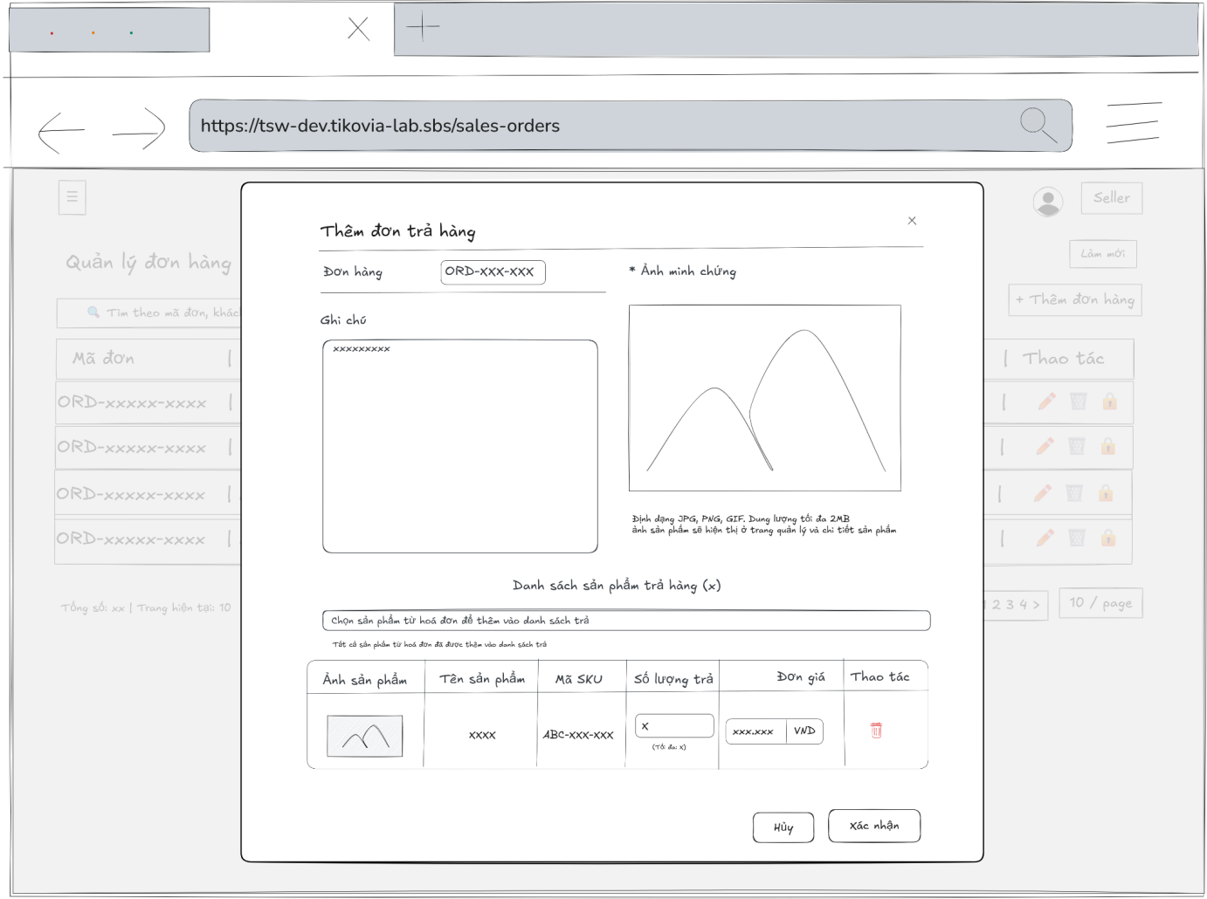
- Function Details:
  - Validation:
    - The user must be authenticated and logged into the system.
    - The user must have a valid role: Admin, Accountant, or Sell staff.
    - The selected sales order must exist and be eligible for return.
    - At least one returned product must be selected.
    - Return quantity for each product must be greater than 0 and must not exceed the purchased quantity.
    - Required fields (return products, quantities) must be provided before submission.
  - Functionality:
    - In Normal Cases:
      - After the user submits the return order and the system validates successfully, a message is displayed: “Return order created successfully.”
    - In Abnormal Cases:
      - Missing or Invalid Fields: If the submit button is pressed without filling all required fields, the system displays an error message indicating the missing or invalid fields.
      - Return Quantity Exceeds Purchased Quantity: If the return quantity for any product exceeds the purchased quantity, the system displays an error message.
      - Connection Issues / Server Error: If there is an issue with the server when submitting the new return order, the system notifies the user: “An error occurred while creating the return order. Please try again.”
  - Business rule: BR-19.

# | Component | Comp. type | Editable | Mandatory | Default Value | Description
 | Header & General Info
1 | Modal Title | Label (Text) | No | Yes | "Thêm đơn trả hàng" | Displays the title of the modal.
2 | Close Button | Button (Icon) | No | Yes | [X Icon] | Button to close the modal.
3 | Order No Label | Label (Text) | No | Yes | "Đơn hàng:" | Label for the Order No reference.
4 | Order No Value | Label (Tag) | No | Yes | [Current Order No] | Displays the No of the order being processed (e.g., ORD-171125...). This is read-only.
5 | Note Label | Label (Text) | No | Yes | "Ghi chú" | Label for the notes section.
6 | Note Textarea | Input (Textarea) | Yes | No | Placeholder: "Nhập ghi chú (nếu có)" | Multi-line text input for user comments regarding the return.
7 | Proof Label | Label (Text) | No | Yes | "* Ảnh minh chứng" | Label for the image upload section. Asterisk indicates a mandatory field.
8 | Upload Area | File Upload | Yes | Yes | "+ Tải ảnh lên" | Clickable area to upload files. Includes instruction text about format (JPG, PNG, GIF) and size limit (Max 2MB).
 | Product List Section
9 | List Header | Label (Text) | No | Yes | "Danh sách sản phẩm trả hàng" | Section header for the items to be returned.
10 | Product Selector | Dropdown | Yes | No | Placeholder: "Chọn sản phẩm từ hóa đơn..." | Dropdown to search and add products from the original order to the return list.
11 | Col Header: Image | Label | No | Yes | "Ảnh sản phẩm" | Column header for product thumbnail.
12 | Col Header: Name | Label | No | Yes | "Tên sản phẩm" | Column header for product name.
13 | Col Header: SKU | Label | No | Yes | "Mã SKU" | Column header for SKU code.
14 | Col Header: Qty | Label | No | Yes | "Số lượng trả" | Column header for the quantity to return.
15 | Col Header: Price | Label | No | Yes | "Đơn giá" | Column header for the refund unit price.
16 | Col Header: Action | Label | No | Yes | "Thao tác" | Column header for remove actions.
 | Product Row (Dynamic)
17 | Product Image | Image | No | Yes | [Product Thumb] | Displays the product image.
18 | Product Name | Label (Text) | No | Yes | [Product Name] | Displays the name of the product (e.g., "Ba chỉ bò Úc").
19 | SKU Code | Label (Text) | No | Yes | [SKU] | Displays the product SKU (e.g., "SPT-Bachibo2").
20 | Return Qty Input | Input (Number) | Yes | Yes | "1" | Input field for quantity. Must display helper text "(Tối đa: [N])" indicating max returnable items.
21 | Refund Price Input | Input (Number) | Yes | Yes | [Price] | Input field for unit price (e.g., "120.000"). Includes a unit label suffix (e.g., "VND").
22 | Remove Button | Button (Icon) | No | Yes | [Trash Icon] | Button to remove the item row from the return list.
 | Footer Section
23 | Cancel Button | Button | No | Yes | "Hủy" | Button to close the modal without saving.
24 | Confirm Button | Button | No | Yes | "Xác nhận" | Primary button to submit the return order request.
––––––––––––––––––––––––––––––––––––––––––––––––––––––––––––––––––––––––––––––––––-

3.4.7 - Edit Return Orders
- Function trigger: Admin, accountant, sell staff accesses the Sales Orders page and clicks on the selected order to display a popup with sales order information then click on tab “Trả hàng” and click on “Cập nhật hóa đơn trả hàng” button to display a popup with input fields.
- Function description: Allow admin, accountant, sell staff to edit a return order for an existing sales invoice.
- Screen layout:
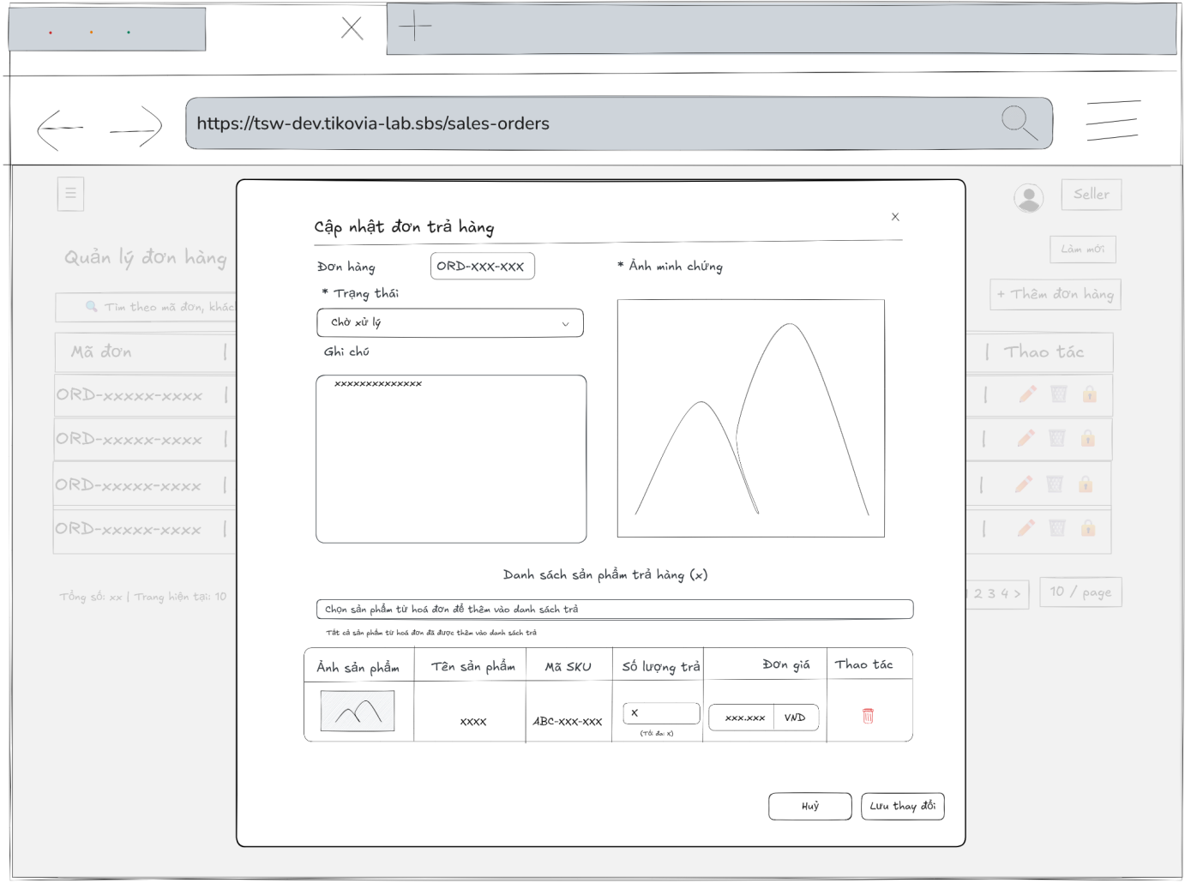
- Function Details:
  - Validation:
    - The user must be authenticated and logged into the system.
    - The user must have a valid role: Admin, Accountant, or Sell staff.
    - The selected return order must exist in the system.
    - The related sales order and invoice must be valid.
    - At least one returned product must be included.
    - Return quantity for each product must be greater than 0 and must not exceed the purchased quantity.
    - Required fields (status, return products, quantities) must be filled before saving.
    - The system must validate data consistency before updating the return order.
  - Functionality:
    - In Normal Cases:
      - After the user saves changes and the system validates successfully, a message is displayed: "Return order updated successfully."
    - In Abnormal Cases:
      - Missing or Invalid Fields: If the save button is pressed without filling all required fields, the system displays an error message indicating the missing or invalid fields.
      - Return Quantity Exceeds Purchased Quantity: If the return quantity for any product exceeds the quantity purchased in the sales invoice, the system displays an error message.
      - Connection Issues / Server Error: If there is an issue with the server when saving the updated return order, the system notifies the user: "An error occurred while updating the return order. Please try again."
  - Business rule: BR-19.

# | Component | Comp. type | Editable | Mandatory | Default Value | Description
 | Header & General Info
1 | Modal Title | Label (Text) | No | Yes | "Cập nhật đơn trả hàng" | Displays the title of the modal.
2 | Close Button | Button (Icon) | No | Yes | [X Icon] | Button to close the modal.
3 | Order No Label | Label (Text) | No | Yes | "Đơn hàng:" | Label for the associated order reference.
4 | Order No Value | Label (Tag) | No | Yes | [Current Order No] | Displays the No of the order (e.g., "ORD-181125-ACF152"). This is read-only.
5 | Status Label | Label (Text) | No | Yes | "* Trạng thái" | Label for the return status field. Asterisk indicates a mandatory field.
6 | Status Select | Dropdown | Yes | Yes | [Current Status] | Dropdown to update the status of the return request (e.g., "Nháp").
7 | Note Label | Label (Text) | No | Yes | "Ghi chú" | Label for the notes section.
8 | Note Textarea | Input (Textarea) | Yes | No | [Current Note] | Multi-line text input for editing user comments.
9 | Proof Label | Label (Text) | No | Yes | "Ảnh minh chứng" | Label for the proof image section.
10 | Proof Image | Image | Yes | No | [Uploaded Image] | Displays the previously uploaded proof image. Clicking it might open a full viewer or allow replacement.
 | Product List Section
11 | List Header | Label (Text) | No | Yes | "Danh sách sản phẩm trả hàng" | Section header for the items to be returned.
12 | Product Selector | Dropdown | No | No | "Tất cả sản phẩm..." | Dropdown to add more products. In this specific state (all items added), it is disabled/read-only with an explanatory message.
13 | Col Header: Image | Label | No | Yes | "Ảnh sản phẩm" | Column header for product thumbnail.
14 | Col Header: Name | Label | No | Yes | "Tên sản phẩm" | Column header for product name.
15 | Col Header: SKU | Label | No | Yes | "Mã SKU" | Column header for SKU code.
16 | Col Header: Qty | Label | No | Yes | "Số lượng trả" | Column header for the quantity to return.
17 | Col Header: Price | Label | No | Yes | "Đơn giá" | Column header for the refund unit price.
18 | Col Header: Action | Label | No | Yes | "Thao tác" | Column header for remove actions.
 | Product Row (Dynamic)
19 | Product Image | Image | No | Yes | [Product image] | Displays the product image.
20 | Product Name | Label (Text) | No | Yes | [Product Name] | Displays the name of the product (e.g., "Đùi tỏi gà").
21 | SKU Code | Label (Text) | No | Yes | [SKU] | Displays the product SKU (e.g., "SPG-Duitoi1").
22 | Return Qty Input | Input (Number) | Yes | Yes | [Current Qty] | Input field for quantity. Displays helper text "(Tối đa: [N])" indicating the max limit based on the original order.
23 | Refund Price Input | Input (Number) | Yes | Yes | [Current Price] | Input field for unit price (e.g., "50.000"). Includes a unit label suffix "VND".
24 | Remove Button | Button (Icon) | No | Yes | [Trash Icon] | Button to remove the item row from the return list.
 | Footer Section
25 | Cancel Button | Button | No | Yes | "Hủy" | Button to close the modal and discard unsaved changes.
26 | Save Button | Button | No | Yes | "Lưu thay đổi" | Primary button to submit and save the updates to the return order.
––––––––––––––––––––––––––––––––––––––––––––––––––––––––––––––––––––––––––––––––––-

3.4.8 - Customer List
- Function trigger: Admin, Accountant, Sell staff with the roles admin, accountant, or sell staff access the Customers page to view the list of customers.
- Function description: Allows users to view, search, filter, and manage the list of customers.
- Screen layout:
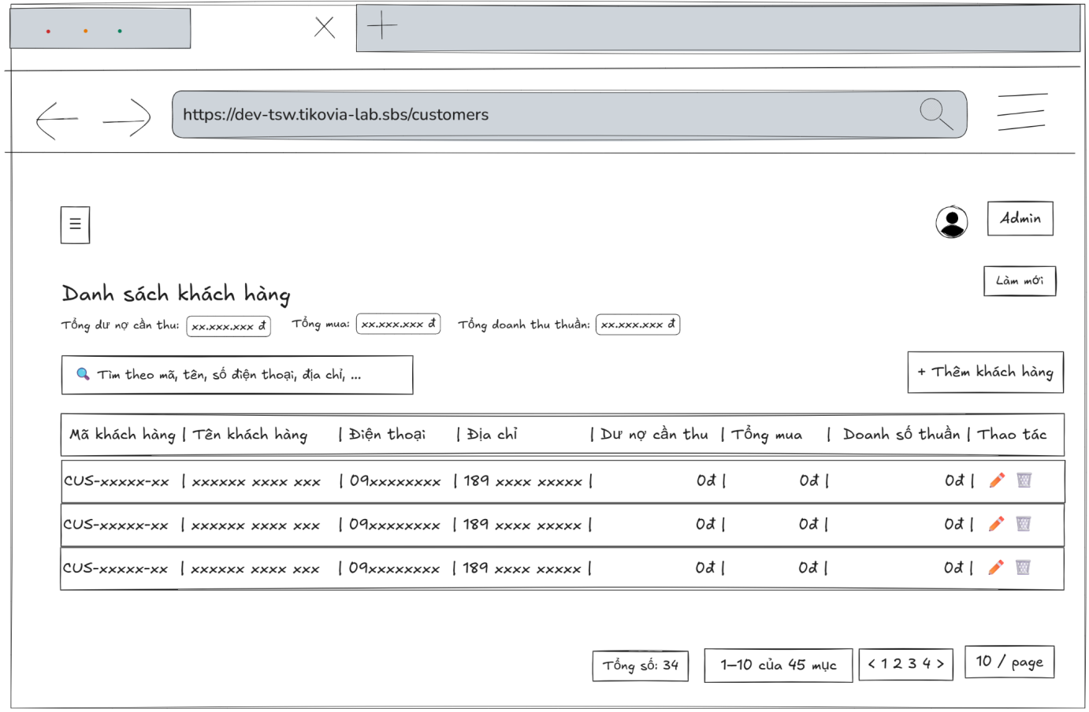
- Function Details:
  - Validation:
    - The user must be authenticated and logged into the system.
    - The user must have a valid role: Admin, Accountant, or Sell staff.
    - The Customers page must be accessible based on the user’s permissions.
    - Customer data must be retrieved correctly from the database.
  - Functionality:
    - In Normal Cases:
      - The system displays the customer list with all relevant information.
      - Users can search, filter, and view customer details.
      - Users with permission can add, edit, or delete customers.
    - In Abnormal Cases:
      - No Data Found: A message is displayed: "No customers found."
      - Connection Issues: An error message and retry button are shown: "An error occurred while loading customers. Please try again."
  - Business rule: N/A.

# | Component | Comp. type | Editable | Mandatory | Default Value | Description
 | Header & Statistics
1 | Screen Title | Label (Text) | No | Yes | "Danh sách khách hàng" | Displays the main title of the screen.
2 | Refresh Button | Button | No | No | "Làm mới" | Button to reload the data in the list from the server.
3 | Total Debt Label | Label | No | Yes | "Tổng dư nợ cần thu" | Displays the total receivables amount across all customers. Highlighted with a colored background.
4 | Total Buy Label | Label | No | Yes | "Tổng mua" | Displays the total purchase value across all customers. Highlighted with a colored background.
5 | Net Revenue Label | Label | No | Yes | "Tổng doanh thu thuần" | Displays the total net revenue generated. Highlighted with a colored background.
 | Toolbar Section
6 | Search Input | Input (Text) | Yes | No | Placeholder: "Theo mã, tên, số điện thoại, địa chỉ..." | Input field to search for customers by code, name, phone, or address.
7 | Add Customer Button | Button | No | Yes | "+ Thêm khách hàng" | Button to open the form to create a new customer.
 | Data Table Section
8 | Col Header: Code | Label/Sort | No | Yes | "Mã khách hàng" | Column header for Customer Code. Clickable to sort.
9 | Col Header: Name | Label/Sort | No | Yes | "Tên khách hàng" | Column header for Customer Name. Clickable to sort.
10 | Col Header: Phone | Label/Sort | No | Yes | "Điện thoại" | Column header for Phone Number. Clickable to sort.
11 | Col Header: Address | Label | No | Yes | "Địa chỉ" | Column header for Address.
12 | Col Header: Debt | Label/Sort | No | Yes | "Dư nợ cần thu" | Column header for Receivables. Includes a tooltip icon (?).
13 | Col Header: Total Buy | Label/Sort | No | Yes | "Tổng mua" | Column header for Total Purchase amount. Includes a tooltip icon (?).
14 | Col Header: Revenue | Label/Sort | No | Yes | "Doanh số thuần" | Column header for Net Sales. Includes a tooltip icon (?).
15 | Col Header: Action | Label | No | Yes | "Thao tác" | Column header for action buttons.
 | Data Table Rows
16 | Customer Code | Link/Button | No | Yes | [Dynamic Code] | Displays the unique customer code (e.g., "CUS-HAIQCA...") as a clickable link.
17 | Customer Name | Link/Button | No | Yes | [Dynamic Name] | Displays the full name of the customer. Clickable link.
18 | Phone Value | Label (Text) | No | Yes | [Phone Number] | Displays the contact number.
19 | Address Value | Label (Text) | No | Yes | [Address String] | Displays the full address.
20 | Debt Value | Label (Text) | No | Yes | [Currency] | Displays the debt amount (e.g., "19.484 đ"). Text color may indicate status (e.g., orange for debt).
21 | Total Buy Value | Label (Text) | No | Yes | [Currency] | Displays the total purchase amount formatted as currency.
22 | Revenue Value | Label (Text) | No | Yes | [Currency] | Displays the net revenue amount formatted as currency. Text color is green.
23 | Edit Action | Button (Icon) | No | Yes | [Pencil Icon] | Icon button to edit the customer's information.
24 | Delete Action | Button (Icon) | No | Yes | [Trash Icon] | Icon button to delete the customer record.
 | Footer & Pagination
25 | Total Info Label | Label (Text) | No | Yes | "Tổng số: [N] | Trang hiện tại: [M]" | Displays total record count and current page index.
26 | Range Label | Label (Text) | No | Yes | "[X]-[Y] của [Z] mục" | Displays the range of items currently shown.
27 | Pagination Nav | Button Group | No | Yes | "<", "1", ">" | Navigation controls to switch pages.
28 | Items Per Page | Dropdown | Yes | Yes | "20 / trang" | Dropdown to select the number of rows displayed per page.
––––––––––––––––––––––––––––––––––––––––––––––––––––––––––––––––––––––––––––––––––-

3.4.9 - Customer Profile
- Function trigger: Users with the roles admin, accountant, or sell staff access the Customers page and click on a customer row to view the customer profile in a modal.
- Function description: Allows Admin, Accountant, Sell staff to view detailed information about a specific customer, including contact info, financial summary, transaction history, and outstanding balance.
- Screen layout
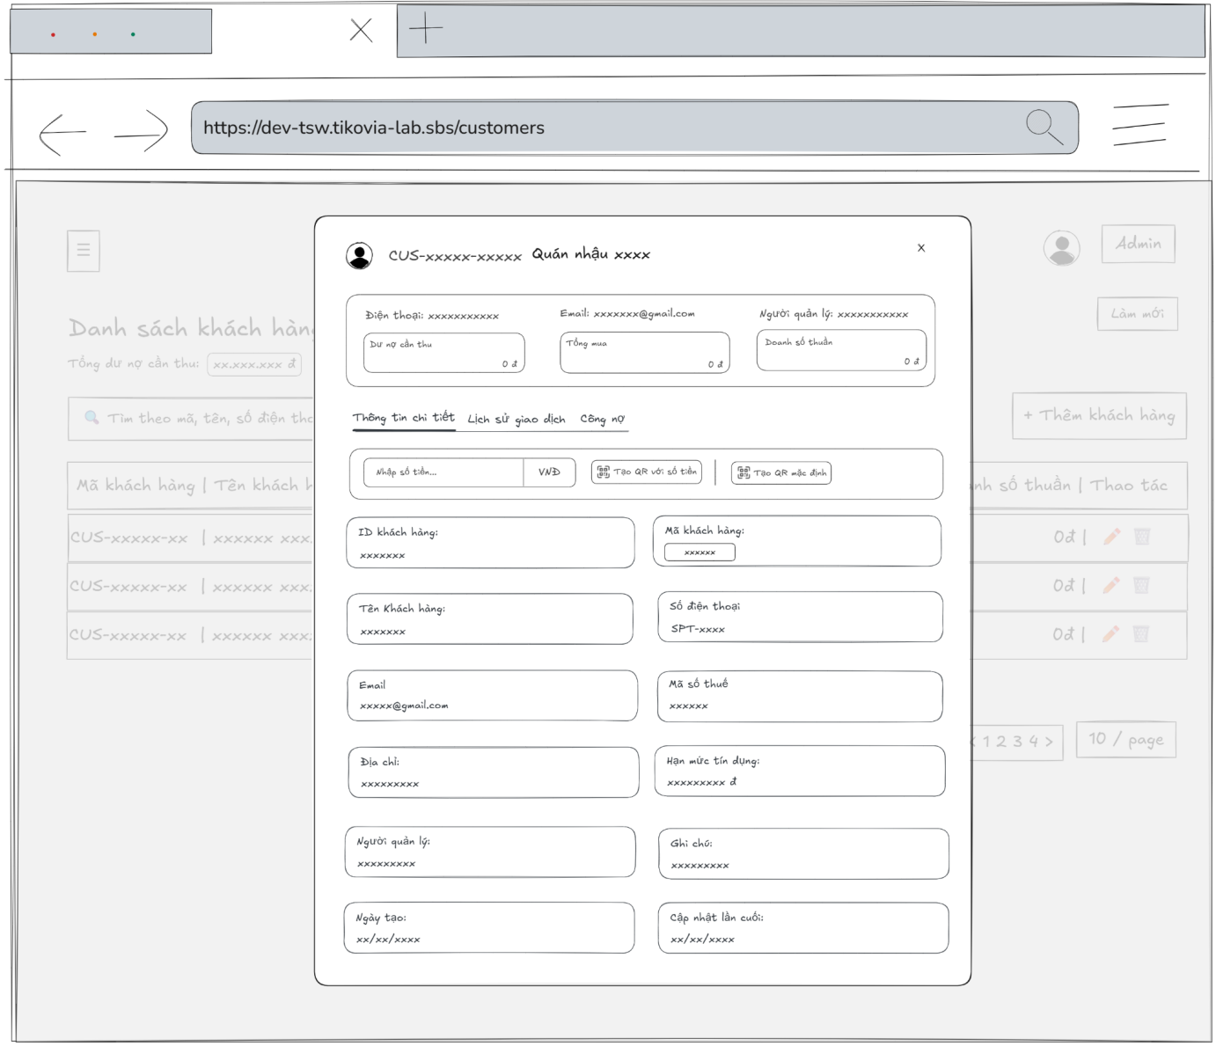
- Function Details:
  - Validation:
    - The user must be authenticated and logged into the system.
    - The user must have a valid role: Admin, Accountant, or Sell staff.
    - The selected customer must exist in the system.
    - The system shall validate access permission before displaying the customer profile.
    - Customer profile data (contact information, financial summary, transaction history) must be retrieved correctly from the database.
    - Displayed balances and transaction data must match the stored records.
  - Functionality:
    - In Normal Cases:
      - The system displays all customer profile information, financial summary, and transaction history.
      - Users can view all details and perform actions such as creating payment receipts or generating QR codes.
    - In Abnormal Cases:
      - No Data Found: A message is displayed: "No data found for this customer."
      - Connection Issues or server Error: An error message and close button are shown: "An error occurred while loading the customer profile. Please try again."
  - Business rule: BR-19.

# | Component | Comp. type | Editable | Mandatory | Default Value | Description
 | Header & Summary
1 | Modal Title | Label (Text) | No | Yes | [Cust. Code] - [Cust. Name] | Displays the unique customer ID and business name.
2 | Close Button | Button (Icon) | No | Yes | [X Icon] | Button to close the customer details modal.
3 | Contact Info Bar | Label (Text) | No | Yes | [Phone, Email, Manager] | Displays quick contact and management info at the top.
4 | Summary Cards | Container | No | Yes | 0 đ | Displays key financial metrics: Current Balance, Total Purchase, and Net Revenue.
 | Navigation Tabs
5 | Detail Tab | Tab Item | No | Yes | "Thông tin chi tiết" | Switch to view general customer profile information (Active by default).
6 | History Tab | Tab Item | No | Yes | "Lịch sử giao dịch" | Switch to view the list of past transactions for this customer.
7 | Debt Tab | Tab Item | No | Yes | "Công nợ" | Switch to view detailed debt records and payment status.
 | Transaction Action Bar
8 | Amount Input | Input (Number) | Yes | No | Placeholder: "Nhập số tiền..." | Field to enter a specific monetary amount for QR generation.
9 | Currency Label | Label (Text) | No | Yes | "VNĐ" | Displays the currency unit for the amount input.
10 | Create QR w/ Amount | Button | No | No | "Tạo QR với số tiền" | Generates a payment QR code based on the value entered in component.
11 | Default QR Button | Button | No | No | "Tạo QR mặc định" | Generates a standard payment QR code without a pre-defined amount.
 | Detailed Information Section
12 | Customer ID | Input (Text) | No | Yes | [ID Khách hàng] | Displays the internal system ID. Read-only.
13 | Customer Code | Input (Text) | No | Yes | [Mã khách hàng] | Displays the business-defined customer code. Read-only.
14 | Customer Name | Input (Text) | No | Yes | [Tên Khách hàng] | Displays the full name or legal name of the customer. Read-only.
15 | Phone Number | Input (Text) | No | Yes | [Số điện thoại] | Displays the primary contact phone number. Read-only.
16 | Email | Input (Email) | No | Yes | [Email] | Displays the contact email address. Read-only.
17 | Tax Code | Input (Text) | No | No | [Mã số thuế] | Displays the customer's registered tax identification number. Read-only.
18 | Address | Input (Text) | No | Yes | [Địa chỉ] | Displays the registered business or shipping address. Read-only.
19 | Credit Limit | Input (Number) | No | No | [Hạn mức tín dụng] | Displays the maximum allowed debt for this customer. Read-only.
20 | Manager | Input (Text) | No | Yes | [Người quản lý] | Displays the staff member responsible for this account. Read-only.
21 | Notes | Textarea | No | No | Textarea | Displays additional notes or remarks about the customer. Read-only.
22 | Created Date | Input (Date) | No | Yes | Input (Date) | Displays the date when the account was first created. Read-only.
23 | Last Updated | Input (Date) | No | Yes | [Cập nhật lần cuối] | Displays the timestamp of the most recent modification. Read-only.

––––––––––––––––––––––––––––––––––––––––––––––––––––––––––––––––––––––––––––––––––-

3.4.10 Create new Customer Profile
- Function trigger: Users with the roles Admin, Accountant or Sell staff access the Customers page and click the “Thêm khách hàng” button to open a modal for input.
- Function description: Allows Admin, Sell staff, Accountant to create a new customer profile with all necessary information for business transactions.
- Screen layout:
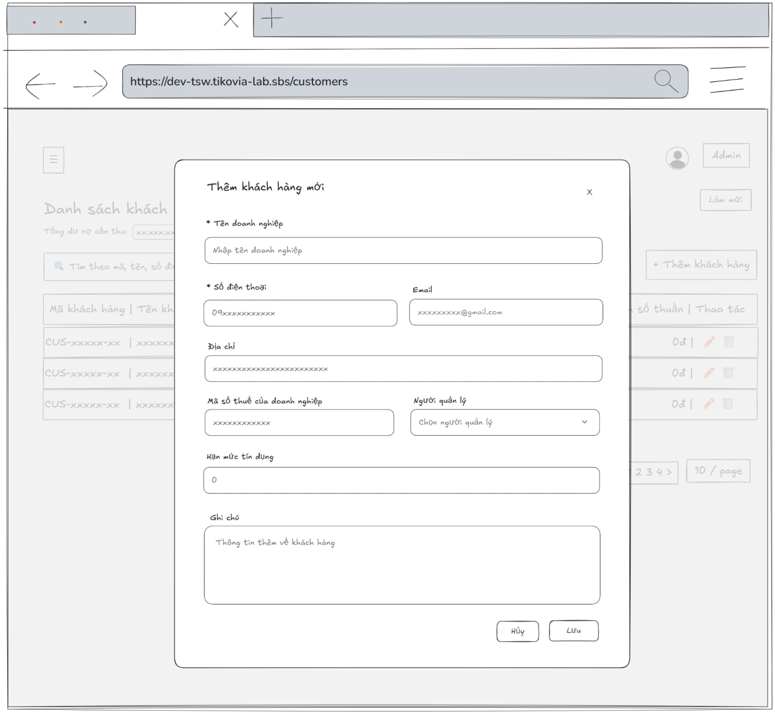
- Function Details:
  - Validation:
    - The user must be authenticated and logged into the system.
    - The user must have a valid role: Admin, Accountant, or Sell staff.
    - Required fields (company name, phone number, address) must not be empty.
    - Phone number, email must be in a valid format.
    - Phone number, email, and tax code must be unique in the system.
    - The system must validate all input data before creating the customer profile.
  - Functionality:
    - In Normal Cases:
      - After the user submits the profile and the system validates successfully, a message is displayed: "Customer profile created successfully."
    - In Abnormal Cases:
      - Missing or Invalid Fields: If the submit button is pressed without filling all required fields, the system displays an error message indicating the missing or invalid fields.
      - Duplicate Data: If the phone number, email, or tax code already exists, the system displays an error message.
      - Connection Issues / Server Error: If there is an issue with the server when submitting the new profile, the system notifies the user: "An error occurred while creating the customer profile. Please try again.”
  - Business rule: BR-10, BR-15, BR-19.

# | Component | Comp. type | Editable | Mandatory | Default Value | Description
 | Header Section
1 | Modal Title | Label (Text) | No | Yes | "Thêm khách hàng mới" | Displays the title of the modal.
2 | Close Icon | Button (Icon) | No | Yes | "x" | Closes the modal without saving any data.
 | Form Section
3 | Business Name Input | Input (Text) | Yes | Yes | Placeholder: "Nhập tên doanh nghiệp" | Field to enter the official name of the business/customer.
4 | Phone Number Input | Input (Tel) | Yes | Yes | Placeholder: "09xxxxxxxxxx" | Field to enter the primary contact phone number.
5 | Email Input | Input (Email) | Yes | No | Placeholder: "xxxxxxxx@gmail.com" | Optional field for the customer's email address.
6 | Address Input | Input (Text) | Yes | No | Placeholder: "xxxxxxxx..." | Optional field for the business or shipping address.
7 | Tax Code Input | Input (Text) | Yes | No | Placeholder: "xxxxxxxxxxxx" | Optional field for the business tax identification number.
8 | Manager Select | Dropdown | Yes | No | Placeholder: "Chọn người quản lý" | A selectable list to assign a specific staff member to manage this customer.
9 | Credit Limit Input | Input (Number) | Yes | No | "0" | Field to define the maximum debt limit allowed for this customer.
10 | Note Textarea | Textarea | Yes | No | Placeholder: "Thông tin thêm..." | Multi-line input for additional notes or remarks about the customer.
 | Footer Actions
11 | Cancel Button | Button | No | Yes | "Hủy" | Dismisses the modal and discards all unsaved input.
12 | Save Button | Button | No | Yes | "Lưu" | Validates the form and submits the data to create a new customer record.

––––––––––––––––––––––––––––––––––––––––––––––––––––––––––––––––––––––––––––––––––-

3.4.11 - Update Customer Profile
- Function trigger: Users with the roles Admin, Accountant or sell staff access the Customers page, select a customer, and click the “Edit” button to open a modal for editing.
- Function description: Allows Admin, Sell staff, Accountant to update details of an existing customer profile.
- Screen layout:
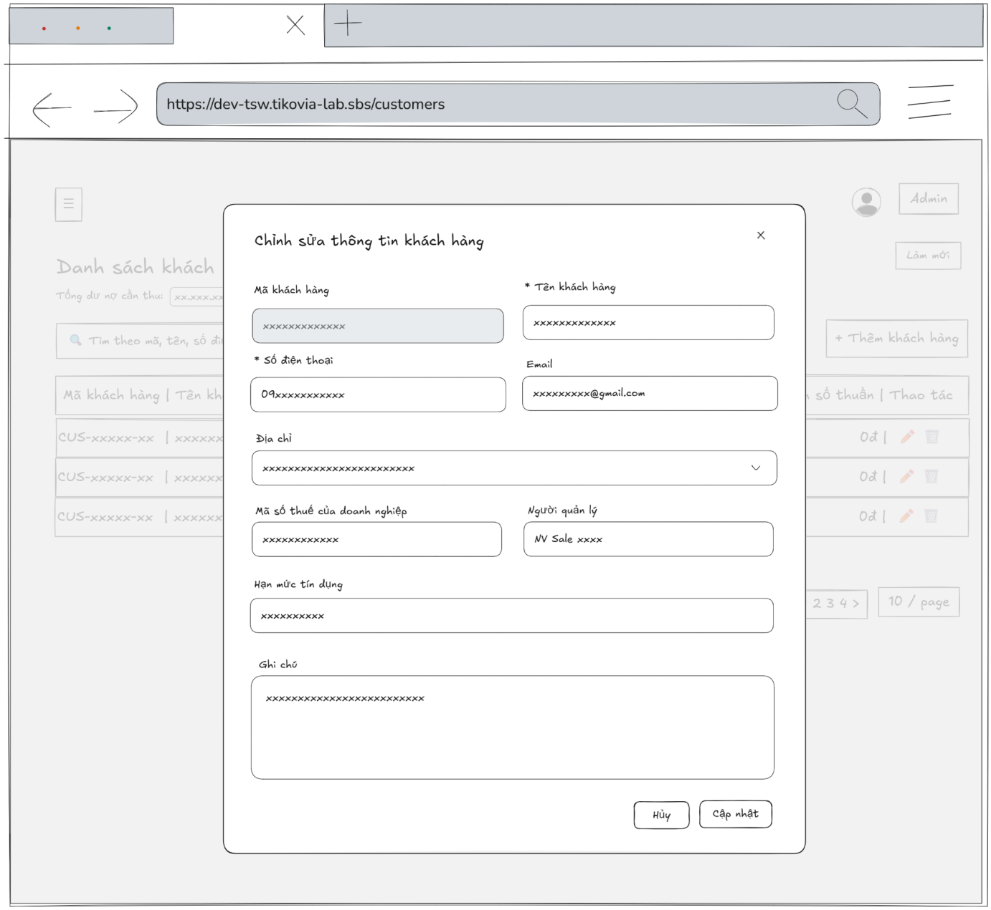
- Function Details:
  - Validation:
    - The user must be authenticated and logged into the system.
    - The user must have a valid role: Admin, Accountant, or Sell staff.
    - The selected customer must exist in the system.
    - Required fields (customer name, phone number, address) must not be empty.
    - Phone number, email must be in a valid format.
    - Phone number, email, and tax code must be unique (except for the current customer).
    - The system must validate all input data before saving changes.
  - Functionality:
    - In Normal Cases:
      - After the user saves changes and the system validates successfully, a message is displayed: "Customer profile updated successfully.”
    - In Abnormal Cases:
      - Missing or Invalid Fields: If the save button is pressed without filling all required fields, the system displays an error message indicating the missing or invalid fields.
      - Duplicate Data: If the phone number, email, or tax code already exists, the system displays an error message.
      - Connection Issues / Server Error: If there is an issue with the server when saving the profile, the system notifies the user: "An error occurred while updating the customer profile. Please try again.”
  - Business rule: BR-10, BR-15, BR-19.

# | Component | Comp. type | Editable | Mandatory | Default Value | Description
 | Header Section
1 | Modal Title | Label (Text) | No | Yes | "Chỉnh sửa thông tin khách hàng" | Displays the title of the edit modal.
2 | Close Icon | Button (Icon) | No | Yes | "x" | Closes the modal without saving any changes.
 | Form Section
3 | Customer Code | Input (Text) | No | Yes | [customer_code] | Displays the unique customer ID. This field is read-only and cannot be modified.
4 | Customer Name | Input (Text) | Yes | Yes | [customer_name] | Field to edit the customer's name. Asterisk indicates it is a required field.
5 | Phone Number | Input (Tel) | Yes | Yes | [phone_number] | Field to edit the contact phone number. Asterisk indicates it is a required field.
6 | Email | Input (Email) | Yes | No | [email_address] | Field to edit the customer's email address.
7 | Address | Input (Text) | Yes | No | [address] | Field to edit the customer's address. Includes a dropdown icon for selection or history.
8 | Tax Code | Input (Text) | Yes | No | [tax_code] | Field to edit the business tax identification number.
9 | Manager | Input (Text) | Yes | No | [manager_name] | Field to view or change the assigned manager/staff for this customer.
10 | Credit Limit | Input (Number) | Yes | No | [credit_limit] | Field to edit the maximum debt allowed for this customer.
11 | Note | Textarea | Yes | No | [note_content] | Multi-line input field for editing additional remarks or notes.
 | Footer Actions
12 | Cancel Button | Button | No | Yes | "Hủy" | Discards all changes and closes the modal.
13 | Update Button | Button | No | Yes | "Cập nhật" | Validates the form and saves the updated information to the system.

––––––––––––––––––––––––––––––––––––––––––––––––––––––––––––––––––––––––––––––––––-

3.5 Preparation and Delivery Management

3.5.1 - Delivery Runs List
- Function trigger: Users with the roles Admin, Delivery staff, or Delivery supervisor access the Delivery Runs page to view the list of delivery runs.
- Function description: Allows Admin, Delivery staff, or Delivery supervisor to view, search, and filter the list of delivery runs.
- Screen layout:
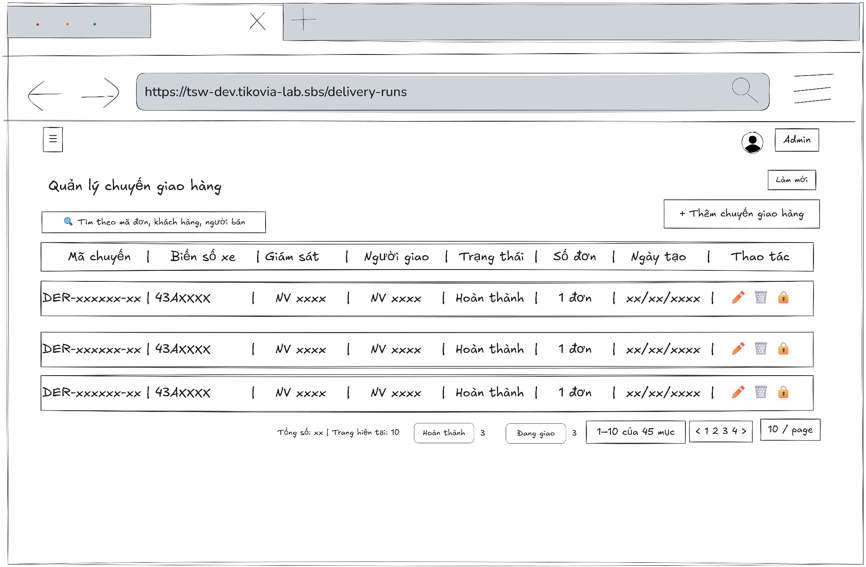
- Function Details:
  - Validation:
    - The user must be authenticated and logged into the system.
    - The user must have a valid role: Admin, Delivery staff, or Delivery supervisor.
    - The system must validate user access rights before displaying delivery runs.
    - Delivery run data must be retrieved correctly from the database.
  - Functionality:
    - In Normal Cases:
      - The system displays the delivery run list with all relevant information.
      - Clicking a delivery run opens the detail modal.
      - Admin and shipper supervisor can edit delivery runs unless they are completed or cancelled.
    - In Abnormal Cases:
      - No Sales orders Data Found: If there is no data of delivery run in the system will display “No data”.
      - Connection Issues: An error message and retry button are shown: “An error occurred while loading delivery runs. Please try again.”
  - Business rule: N/A.

# | Component | Comp. type | Editable | Mandatory | Default Value | Description
 | Header & Search Section
1 | Screen Title | Label (Text) | No | Yes | "Quản lý chuyến giao hàng" | Displays the main header of the screen.
2 | Search Input | Input (Text) | Yes | No | Placeholder: "Tìm theo mã đơn, khách hàng, người bán" | Search field to filter deliveries. Includes a search icon.
3 | Refresh Button | Button | No | No | "Làm mới" | Button to reload the delivery run list data.
4 | Add Delivery Button | Button | No | Yes | "+ Thêm chuyến giao hàng" | Navigates to the creation screen for a new delivery run.
 | Data Table Headers
5 | Col Header: Delivery ID | Label/Sort | No | Yes | "Mã chuyến" | Column header for Delivery Run ID. Supports sorting.
6 | Col Header: License Plate | Label/Sort | No | Yes | "Biển số xe" | Column header for Vehicle License Plate. Supports sorting.
7 | Col Header: Supervisor | Label/Sort | No | Yes | "Giám sát" | Column header for the assigned supervisor. Supports sorting.
8 | Col Header: Staff | Label/Sort | No | Yes | "Người giao" | Column header for the delivery personnel. Supports sorting.
9 | Col Header: Status | Label/Sort | No | Yes | "Trạng thái" | Column header for delivery status. Supports sorting.
10 | Col Header: Order Count | Label/Sort | No | Yes | "Số đơn" | Column header for the number of orders. Supports sorting.
11 | Col Header: Created Date | Label/Sort | No | Yes | "Ngày tạo" | Column header for the record creation date. Supports sorting.
12 | Col Header: Action | Label | No | Yes | "Thao tác" | Column header for action buttons.
 | Data Table Rows (Dynamic)
13 | Delivery ID Display | Link/Button | No | Yes | [Dynamic Delivery ID] | Displays the unique Delivery ID. Clickable to view details.
14 | License Plate Display | Label (Text) | No | Yes | [Dynamic License Plate] | Displays the vehicle's license plate number.
15 | Supervisor Name | Label (Text) | No | Yes | [Dynamic Supervisor] | Displays the name of the assigned supervisor.
16 | Staff Name | Label (Text) | No | Yes | [Dynamic Staff Name] | Displays the name of the delivery person.
17 | Status Badge | Label (Tag) | No | Yes | [Dynamic Status] | Displays the current status (e.g., "Hoàn thành") in a styled badge.
18 | Order Count Value | Label (Text) | No | Yes | [Dynamic Count] | Displays the total number of orders in the run.
19 | Created Date Display | Label (Text) | No | Yes | [Dynamic Date] | Displays the timestamp of when the run was created.
20 | Edit Action | Button (Icon) | No | Yes | [Edit Icon] | Icon button to modify the specific delivery run.
21 | Delete Action | Button (Icon) | No | Yes | [Trash Icon] | Icon button to remove the delivery run from the system.
22 | Lock Action | Button (Icon) | No | Yes | [Lock Icon] | Icon button to lock/unlock the run to prevent further changes.
 | Footer & Pagination
23 | Stats Summary | Label (Text) | No | Yes | "Tổng số: [N] | Trang hiện tại: [M]" | Displays total record count and current page index.
24 | Filter Badges | Group (Tags) | No | No | [Dynamic Status Counts] | Horizontal list showing counts per status (e.g., "Đang giao [N]").
25 | Range Info Label | Label (Text) | No | Yes | "[X]-[Y] của [Z] mục" | Displays the range of items currently visible.
26 | Pagination Nav | Button Group | No | Yes | "< 1 2 3 4 >" | Navigation controls to switch between pages.
27 | Page Size Select | Dropdown | Yes | Yes | "10 / page" | Dropdown to select the number of records shown per page.

––––––––––––––––––––––––––––––––––––––––––––––––––––––––––––––––––––––––––––––––––-

3.5.2 - Delivery Runs Detail
- Function trigger: The Admin, Delivery staff, or Delivery supervisor accesses the Delivery runs page and clicks on the selected delivery run to display a popup with delivery run information.
- Function description: Allow Admin, Delivery staff, or Delivery supervisor to view delivery run information details
- Screen layout
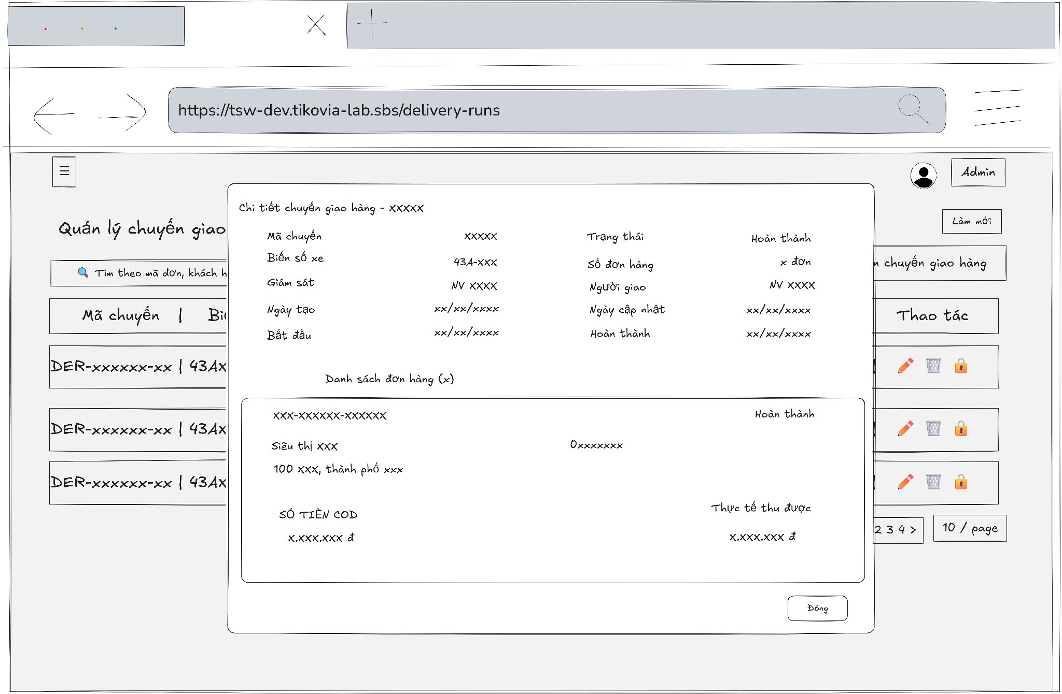
- Function Details:
  - Validation:
    - The user must be authenticated and logged into the system.
    - The user must have a valid role: Admin, Delivery staff, or Delivery supervisor.
    - The selected delivery run must exist in the system.
    - The system must validate user permissions before allowing actions on orders.
    - Delivery run details and associated orders must be loaded correctly from the database.
    - Available actions (start, cancel) must be enabled based on user role and current order status.
  - Functionality:
    - In Normal Cases:
      - The system displays all delivery run metadata and associated orders.
      - Users can click on an order card to view more details or update it (if they have permission).
      - Delivery staff can start, complete, or cancel orders based on their current status.
      - Admin and Delivery supervisors can reopen cancelled orders.
      - Delivery Supervisors and Staff initiate the fulfillment process via the 'Bắt đầu' button. To complete an order, users must access the order details, enter the necessary data, and submit the proof of delivery. The system restricts the submission of delivery proof to the user who initiated or was assigned the specific order.
    - In Abnormal Cases:
      - No Orders in Delivery Run: A message is displayed: "No orders found in this delivery run."
      - Server Error: An error message and close button are shown: "An error occurred while loading delivery run details. Please try again.”
  - Business rule: N/A.

# | Component | Comp. type | Editable | Mandatory | Default Value | Description
 | Header Section
1 | Modal Title | Label (Text) | No | Yes | "Chi tiết chuyến giao hàng - " [Dynamic ID] | Displays the title of the modal including the delivery run ID.
 | General Information Section
2 | Delivery ID Label | Label (Text) | No | Yes | "Mã chuyến" | Label for the delivery run ID field.
3 | Delivery ID Data | Label (Text) | No | Yes | [Dynamic ID] | Displays the unique identification code of the delivery run.
4 | License Plate Label | Label (Text) | No | Yes | "Biển số xe" | Label for the vehicle's license plate field.
5 | License Plate Data | Label (Text) | No | Yes | [Dynamic Plate] | Displays the license plate number of the delivery vehicle.
6 | Supervisor Label | Label (Text) | No | Yes | "Giám sát" | Label for the supervisor in charge of the run.
7 | Supervisor Data | Label (Text) | No | Yes | [Dynamic Name] | Displays the name of the assigned supervisor.
8 | Created Date Label | Label (Text) | No | Yes | "Ngày tạo" | Label for the run creation timestamp.
9 | Created Date Data | Label (Text) | No | Yes | [Dynamic Date] | Displays the date and time when the delivery run was created.
10 | Start Time Label | Label (Text) | No | Yes | "Bắt đầu" | Label for the actual start time of the delivery.
11 | Start Time Data | Label (Text) | No | Yes | [Dynamic Time] | Displays the timestamp when the delivery run officially started.
12 | Status Label | Label (Text) | No | Yes | "Trạng thái" | Label for the current delivery run status.
13 | Status Data | Label (Tag) | No | Yes | [Dynamic Status] | Displays the current status in a styled badge.
14 | Order Count Label | Label (Text) | No | Yes | "Số đơn hàng" | Label for the total number of orders in the run.
15 | Order Count Data | Label (Text) | No | Yes | [Dynamic Count] | Displays the total quantity of orders assigned to this run.
16 | Delivery Staff Label | Label (Text) | No | Yes | "Người giao" | Label for the assigned delivery personnel.
17 | Delivery Staff Data | Label (Text) | No | Yes | [Dynamic Name] | Displays the name of the person performing the delivery.
18 | Updated Date Label | Label (Text) | No | Yes | "Ngày cập nhật" | Label for the most recent data update timestamp.
19 | Updated Date Data | Label (Text) | No | Yes | [Dynamic Date] | Displays the timestamp of the last information update.
20 | Completion Label | Label (Text) | No | Yes | "Hoàn thành" | Label for the run completion timestamp.
21 | Completion Data | Label (Text) | No | Yes | [Dynamic Time] | Displays the date and time when the delivery run was finished.
 | Order List Section (Dynamic Rows)
22 | List Header | Label (Text) | No | Yes | "Danh sách đơn hàng ()" [Dynamic Count] | Section header showing the total number of orders.
23 | Order ID Display | Label (Text) | No | Yes | [Dynamic Order ID] | Displays the specific Order ID for the list item.
24 | Order Status Tag | Label (Tag) | No | Yes | [Dynamic Status] | Displays the delivery status for the specific order.
25 | Store Name | Label (Text) | No | Yes | [Dynamic Store Name] | Displays the name of the destination store/market.
26 | Store Phone | Label (Text) | No | Yes | [Dynamic Phone] | Displays the contact phone number of the store.
27 | Store Address | Label (Text) | No | Yes | [Dynamic Address] | Displays the full delivery address for the order.
28 | COD Amount Label | Label (Text) | No | Yes | "SỐ TIỀN COD" | Label for the expected Cash on Delivery amount.
29 | COD Amount Data | Label (Text) | No | Yes | [Dynamic Amount] | Displays the money amount to be collected for the order.
30 | Actual Collected Label | Label (Text) | No | Yes | "Thực tế thu được" | Label for the amount actually received by the staff.
31 | Actual Collected Data | Label (Text) | No | Yes | [Dynamic Amount] | Displays the final amount collected after delivery.
 | Footer Section
32 | Close Button | Button | No | Yes | "Đóng" | Button to close the delivery run detail modal.

––––––––––––––––––––––––––––––––––––––––––––––––––––––––––––––––––––––––––––––––––-

3.5.3 - Assign Shipping Task
- Function trigger: Users with the roles Admin or Delivery supervisor access the Delivery Runs page and click the "Thêm chuyến giao hàng" button to display a modal for creating a new run.
- Function description: Allows Admin or Delivery supervisor to create a new delivery run by assigning a supervisor, a shipper, and a vehicle, and then populating the run with a list of sales orders.
- Screen layout:
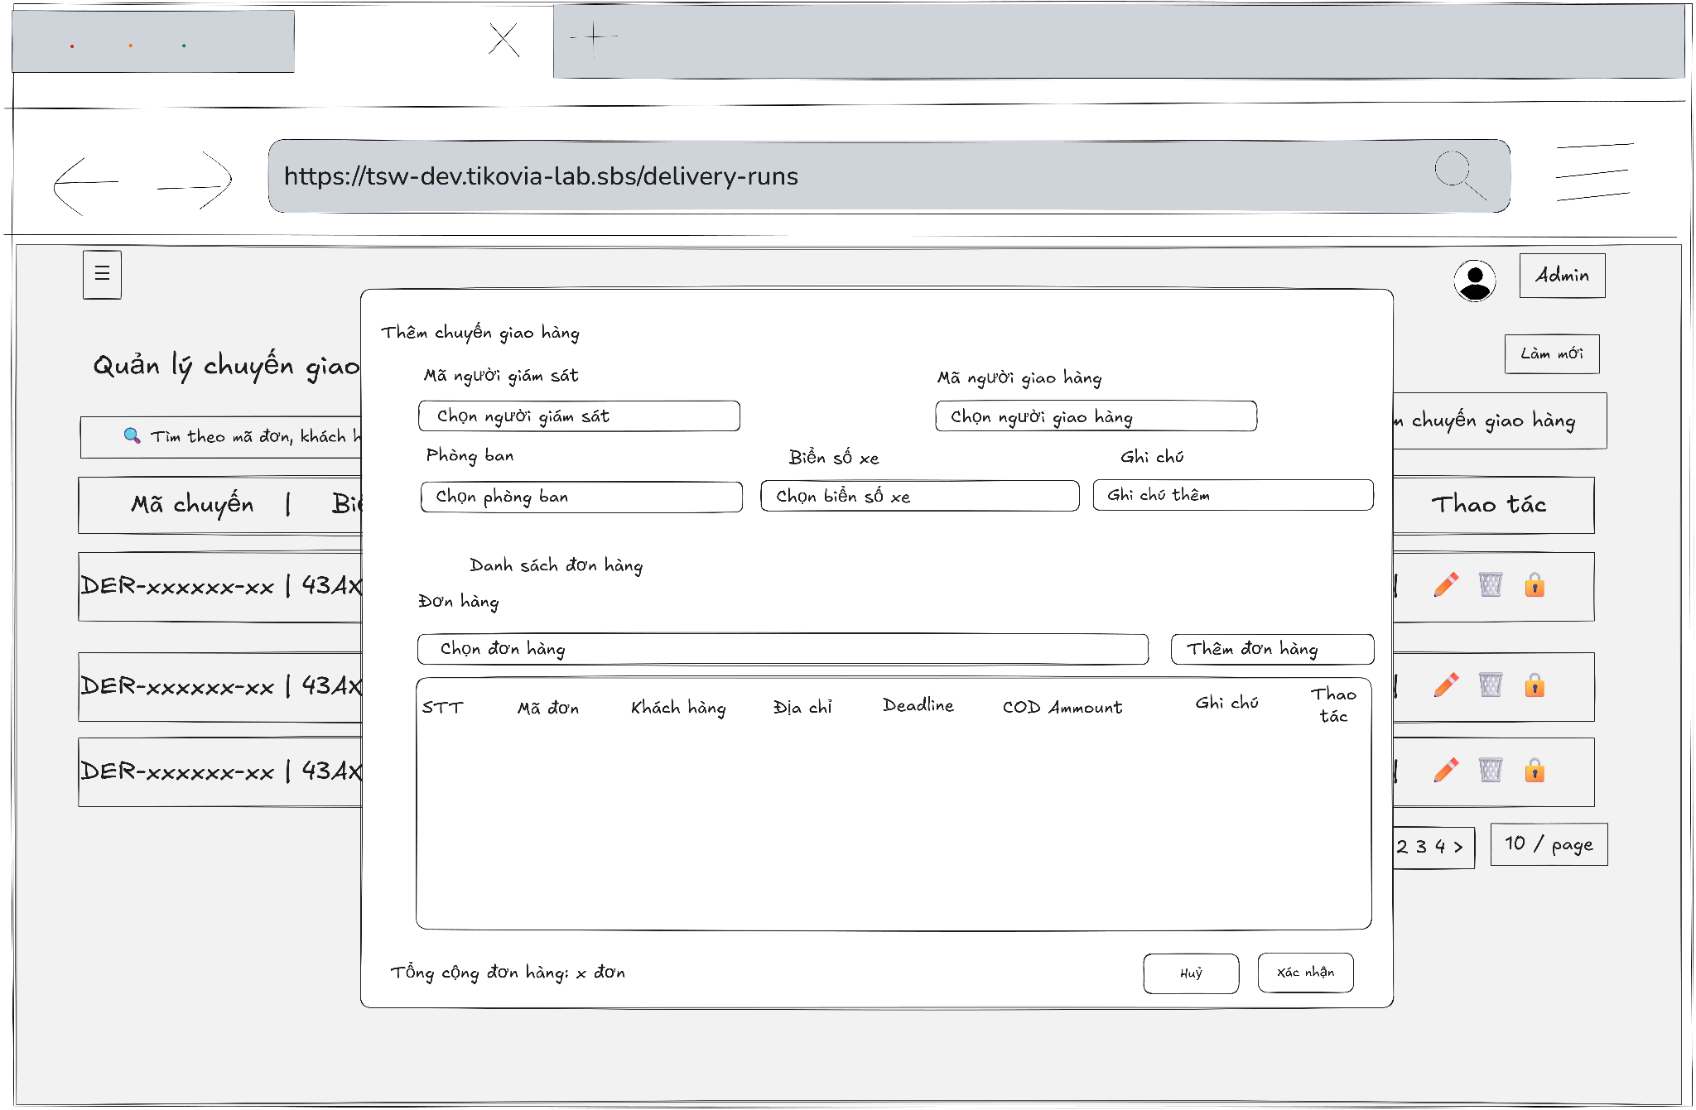
- Function Details:
  - Validation:
    - The user must be authenticated and logged into the system.
    - The user must have a valid role: Admin or Delivery Supervisor.
    - Required fields (supervisor, delivery staff, vehicle) must be selected before submission.
    - At least one valid sales order must be added to the delivery run.
    - Selected orders must be eligible for delivery and not assigned to another active run.
    - The system must validate data consistency before creating the delivery run.
  - Functionality:
    - In Normal Cases:
      - After the user submits the delivery run and the system validates successfully, a message is displayed: "Delivery run created successfully."
    - In Abnormal Cases:
      - If the submit button is pressed without filling all required fields, the system displays an error message indicating the missing or invalid fields.
      - No Orders Added: If no orders are added to the delivery run, the system displays a warning message.
      - Connection Issues / Server Error: If there is an issue with the server when submitting the new delivery run, the system notifies the user: "An error occurred while creating the delivery run. Please try again.”
  - Business rule: N/A.

# | Component | Comp. type | Editable | Mandatory | Default Value | Description
 | Header Section
1 | Modal Title | Label (Text) | No | Yes | "Thêm chuyến giao hàng" | Displays the title of the modal.
2 | Close Icon | Button (Icon) | No | Yes | "x" | Closes the modal without saving data.
 | General Assignment Section
3 | Supervisor Select | Dropdown | Yes | Yes | "Chọn người giám sát" | Field to select the supervisor in charge of the run.
4 | Delivery Staff Select | Dropdown | Yes | Yes | "Chọn người giao hàng" | Field to assign the delivery personnel.
5 | Department Select | Dropdown | Yes | Yes | "Chọn phòng ban" | Field to select the relevant department.
6 | License Plate Select | Dropdown | Yes | Yes | "Chọn biển số xe" | Field to select the vehicle assigned for this run.
7 | General Note Input | Input (Text) | Yes | No | "Ghi chú thêm" | Field for adding overall remarks for the delivery run.
 | Order Selection Section
8 | Order List Header | Label (Text) | No | Yes | "Danh sách đơn hàng" | Header for the dynamic order list section.
9 | Order Dropdown | Dropdown | Yes | No | "Chọn đơn hàng" | Search and select an order to add to the run.
10 | Add Order Button | Button | No | No | "Thêm đơn hàng" | Adds the selected order (from #9) into the data table below.
 | Data Table Headers
11 | Col Header: No. | Label | No | Yes | "STT" | Column header for the serial number.
12 | Col Header: Order ID | Label | No | Yes | "Mã đơn" | Column header for the unique Order ID.
13 | Col Header: Customer | Label | No | Yes | "Khách hàng" | Column header for the customer's name.
14 | Col Header: Address | Label | No | Yes | "Địa chỉ" | Column header for the delivery destination.
15 | Col Header: Deadline | Label | No | Yes | "Deadline" | Column header for the delivery time limit.
16 | Col Header: COD | Label | No | Yes | "COD Amount" | Column header for the cash on delivery amount.
17 | Col Header: Note | Label | No | Yes | "Ghi chú" | Column header for order-specific notes.
18 | Col Header: Action | Label | No | Yes | "Thao tác" | Column header for row-level actions.
 | Data Table Rows (Dynamic)
19 | Row Index | Label (Text) | No | Yes | [Dynamic No.] | Displays the sequence number of the added order.
20 | Order ID Data | Label (Text) | No | Yes | [Dynamic Order ID] | Displays the ID of the added order.
21 | Customer Name Data | Label (Text) | No | Yes | [Dynamic Name] | Displays the name of the customer for the order.
22 | Address Data | Label (Text) | No | Yes | [Dynamic Address] | Displays the delivery address.
23 | Deadline Data | Label (Text) | No | Yes | [Dynamic Date] | Displays the deadline for that specific order.
24 | COD Amount Data | Label (Text) | No | Yes | [Dynamic Amount] | Displays the money to be collected upon delivery.
25 | Row Note Input | Input (Text) | Yes | No | [Dynamic Note] | Allows entering a specific note for this individual order.
26 | Remove Action | Button (Icon) | No | Yes | [Trash Icon] | Removes the specific order row from the list.
 | Footer Section
27 | Total Count Label | Label (Text) | No | Yes | "Tổng cộng đơn hàng: " [Dynamic Count] " đơn" | Displays the total number of orders added to the table.
28 | Cancel Button | Button | No | Yes | "Huỷ" | Closes the modal and discards all entries.
29 | Confirm Button | Button | No | Yes | "Xác nhận" | Validates assignments and creates the delivery run.

––––––––––––––––––––––––––––––––––––––––––––––––––––––––––––––––––––––––––––––––––-

3.5.4 - Edit Delivery Runs
- Function trigger: Users with the Admin or Delivery supervisor role click the "Edit" icon on a specific row in the Delivery Runs list page.
- Function description: Allows Admin or Delivery supervisor to update the primary details of an existing delivery run (such as the assigned personnel and vehicle) and to edit notes for the individual orders within that run.
- Screen layout:
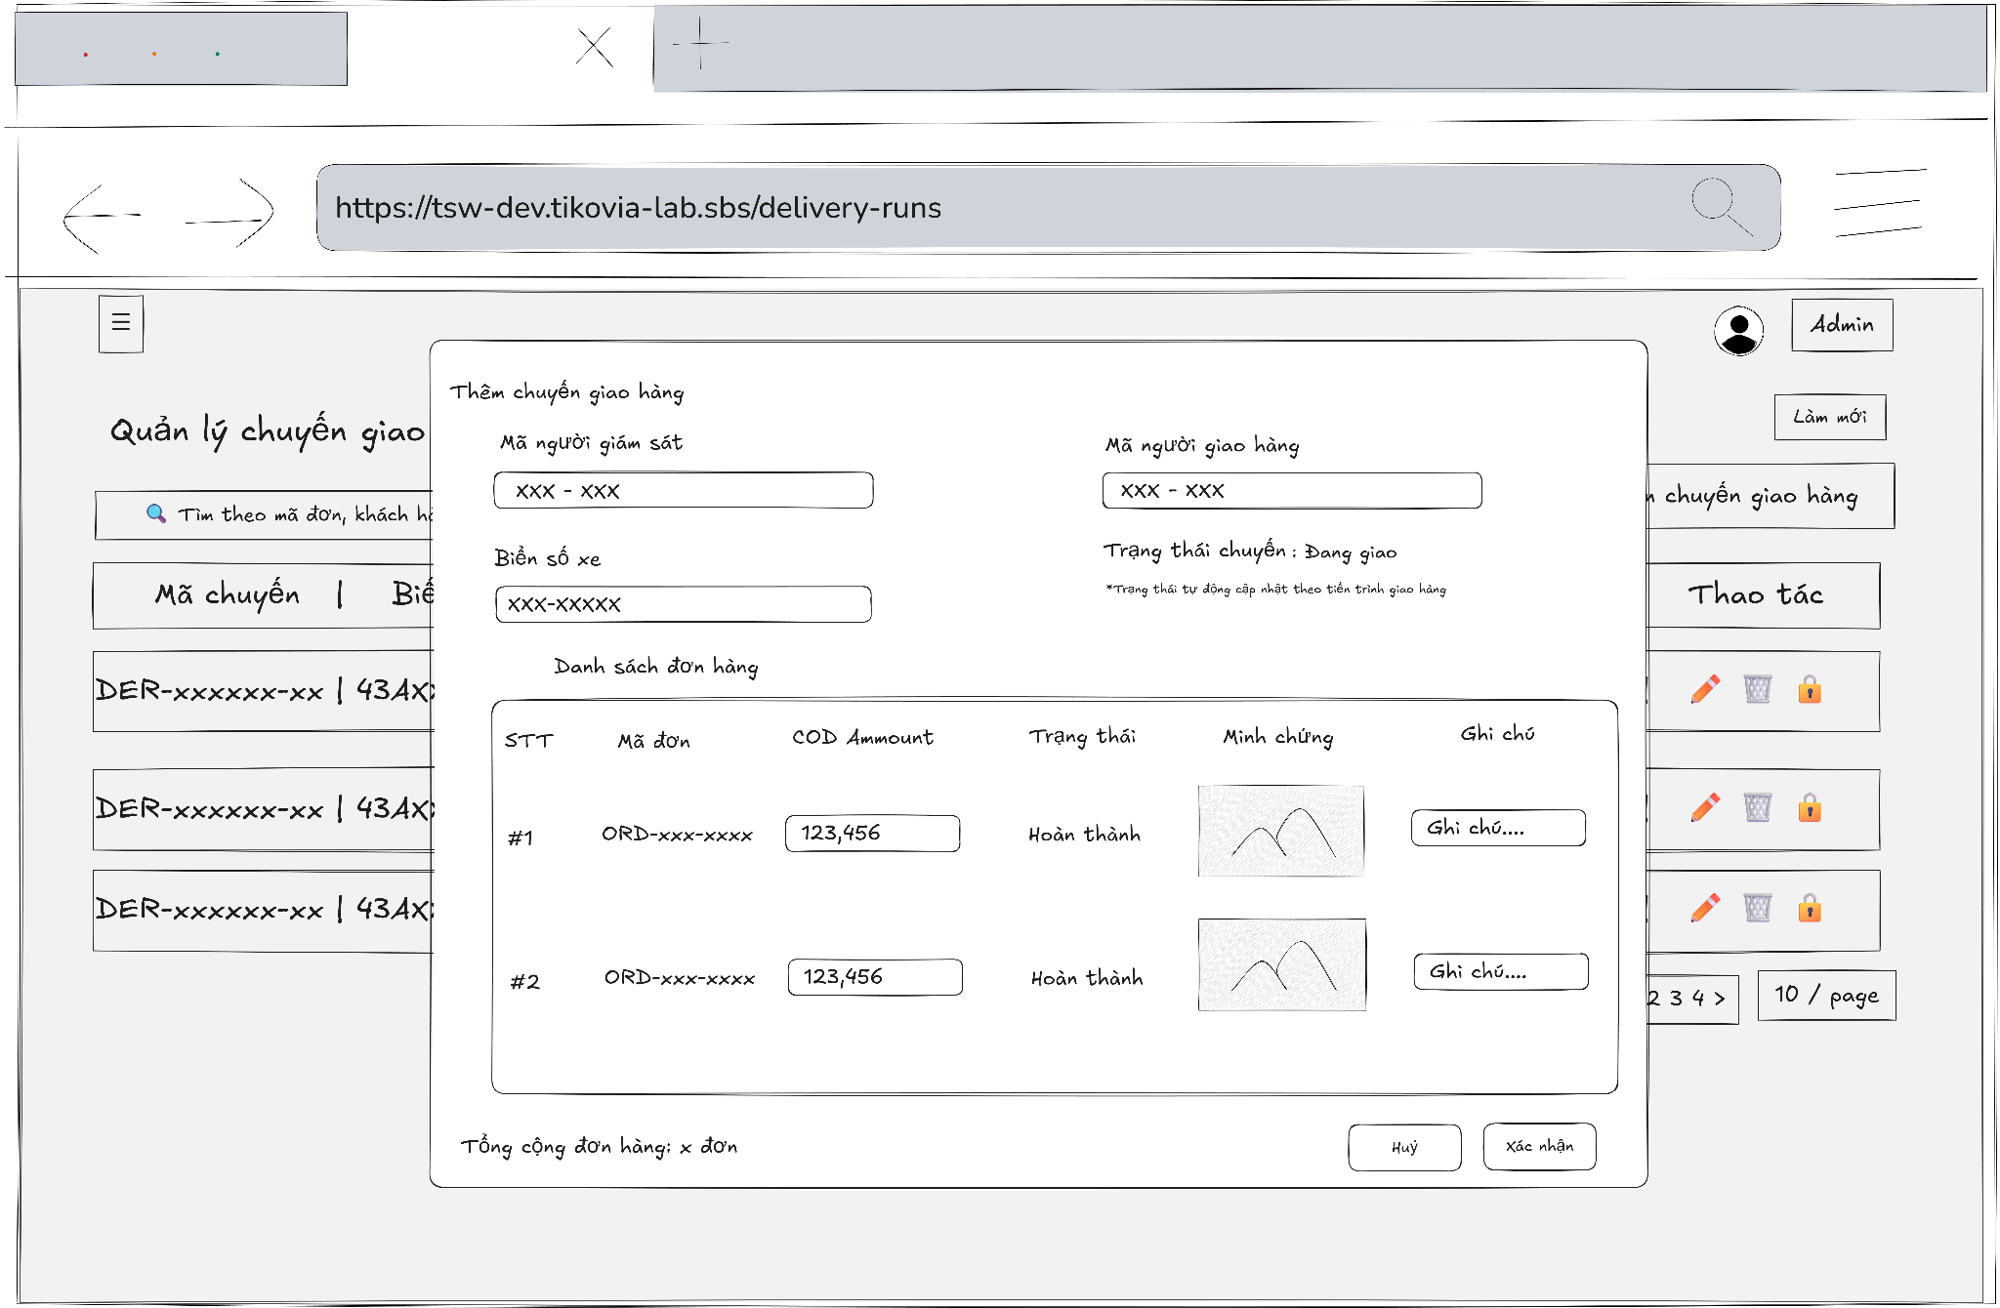
- Function Details:
  - Validation:
    - The user must be authenticated and logged into the system.
    - The user must have a valid role: Admin or Delivery Supervisor.
    - The selected delivery run must exist and be accessible to the user.
    - Required fields (e.g. Vehicle Number, assigned personnel) must not be empty.
    - Updated information must follow correct format and data constraints.
    - Only editable fields are allowed to be modified based on delivery run status.
  - Functionality:
    - In Normal Cases:
      - After the user modifies an editable field (e.g., Vehicle Number or an order's Note) and clicks "Save Changes", the system dispatches the update request.
      - On success, a notification is displayed: "Update delivery run successful".
      - The modal closes, and the main delivery run list is refreshed to reflect the changes.
    - In Abnormal Cases:
      - Missing or Invalid Fields: If the user clears a required field (e.g., Vehicle Number) and clicks "Save Changes", the form will display an error message under that field (e.g., "Please enter vehicle number!").
      - Connection or Server Error: If the update fails during submission, an error notification is displayed: "An error occurred" (or a more specific message from the server).
  - Business rule: N/A.

# | Component | Comp. type | Editable | Mandatory | Default Value | Description
 | Header Section
1 | Modal Title | Label (Text) | No | Yes | "Thêm chuyến giao hàng" | Displays the title of the modal.
 | General Assignment Info
2 | Supervisor ID Label | Label (Text) | No | Yes | "Mã người giám sát" | Label for the assigned supervisor ID.
3 | Supervisor ID Data | Input/Label | No | Yes | [Dynamic ID] | Displays the ID of the supervisor in charge.
4 | Delivery Staff Label | Label (Text) | No | Yes | "Mã người giao hàng" | Label for the assigned delivery personnel ID.
5 | Delivery Staff Data | Input/Label | No | Yes | [Dynamic ID] | Displays the ID of the person performing the delivery.
6 | License Plate Label | Label (Text) | No | Yes | "Biển số xe" | Label for the vehicle's license plate.
7 | License Plate Data | Input/Label | No | Yes | [Dynamic Plate] | Displays the assigned vehicle's license plate number.
8 | Run Status Label | Label (Text) | No | Yes | "Trạng thái chuyến: " [Dynamic Status] | Displays the overall current status of the delivery run (e.g., "Đang giao").
9 | Status Helper Note | Label (Text) | No | No | "*Trạng thái tự động cập nhật theo tiến trình giao hàng" | Informational text explaining that the status updates automatically.
 | Order List Section (Table Header)
10 | Col Header: No. | Label | No | Yes | "STT" | Column header for the serial number.
11 | Col Header: Order ID | Label | No | Yes | "Mã đơn" | Column header for the unique Order ID.
12 | Col Header: COD Amm. | Label | No | Yes | "COD Amount" | Column header for the Cash on Delivery amount.
13 | Col Header: Status | Label | No | Yes | "Trạng thái" | Column header for the delivery status of each order.
14 | Col Header: Proof | Label | No | Yes | "Minh chứng" | Column header for the delivery evidence/image.
15 | Col Header: Note | Label | No | Yes | "Ghi chú" | Column header for order-level remarks.
 | Data Table Rows (Dynamic)
16 | Row Index | Label (Text) | No | Yes | [Dynamic No.] | Displays the sequence number (e.g., #1, #2).
17 | Order ID Data | Label (Text) | No | Yes | [Dynamic Order ID] | Displays the specific ID for the order in the row.
18 | COD Amount Input | Input (Number) | Yes | Yes | [Dynamic Amount] | Editable field to update or confirm the collected COD amount.
19 | Order Status Data | Label (Tag) | No | Yes | [Dynamic Status] | Displays the individual order status (e.g., "Hoàn thành").
20 | Proof Thumbnail | Image | No | No | [Dynamic Image] | Displays a thumbnail of the uploaded delivery proof image.
21 | Row Note Input | Input (Text) | Yes | No | "Ghi chú...." [Dynamic Note] | Input field for adding/editing remarks for the specific order.
 | Footer Section
22 | Total Order Summary | Label (Text) | No | Yes | "Tổng cộng đơn hàng: " [Dynamic Count] " đơn" | Displays the total count of orders within this delivery run.
23 | Cancel Button | Button | No | Yes | "Huỷ" | Closes the modal and discards any unsaved changes.
24 | Confirm Button | Button | No | Yes | "Xác nhận" | Validates the updated information and saves it to the system.

––––––––––––––––––––––––––––––––––––––––––––––––––––––––––––––––––––––––––––––––––-

3.5.5 - Packing Task List
- Function trigger: Users with the roles Admin, Packing Supervisor, Packing staff, Warehouse manager access the Packing Tasks page to view the list of Packing tasks.
- Function description: Allows Admin, Accountant, Packing Supervisor, Packing staff, Warehouse manager to view, search, and filter the list of COD payment tickets.
- Screen layout:
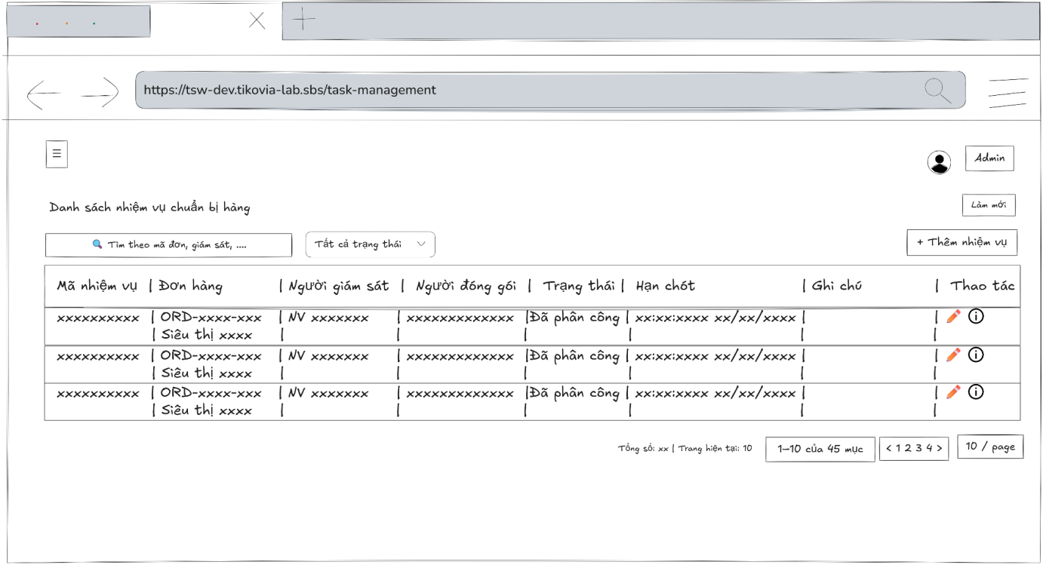
- Function Details:
  - Validation:
    - The user must be authenticated and logged into the system.
    - The user must have one of the following roles: Admin, Packing Supervisor, Packing staff, Warehouse manager.
    - The system must load task data correctly from the server.
    - If no data is available, the system displays “No preparation tasks found.”
  - Functionality:
    - In Normal Cases:
      - The system displays the task list with all relevant information.
      - Users can search, filter, and view task details.
    - In Abnormal Cases:
      - No Data Found: A message is displayed: "No preparation tasks found."
      - Connection Issues: An error message and retry button are shown: "An error occurred while loading packing tasks. Please try again."
  - Business rule: N/A.

# | Component | Comp. type | Editable | Mandatory | Default Value | Description
 | Header & Search Section
1 | Screen Title | Label (Text) | No | Yes | "Danh sách nhiệm vụ chuẩn bị hàng" | Displays the main header of the screen.
2 | Refresh Button | Button | No | No | "Làm mới" | Button to reload the task list data from the server.
3 | Search Input | Input (Text) | Yes | No | "Tìm theo mã đơn, giám sát, ...." | Input field to search for tasks. Includes a search icon.
4 | Status Filter | Dropdown | Yes | No | "Tất cả trạng thái" | Dropdown to filter the task list by its current progress status.
5 | Add Task Button | Button | No | Yes | "+ Thêm nhiệm vụ" | Navigates to the screen or modal to create a new picking task.
 | Data Table Headers
6 | Col Header: Task & Order | Label/Sort | No | Yes | "Mã nhiệm vụ | Đơn hàng" | Column header for Task ID and associated Order/Store info.
7 | Col Header: Supervisor | Label/Sort | No | Yes | "Người giám sát" | Column header for the supervisor assigned to the task.
8 | Col Header: Packer | Label/Sort | No | Yes | "Người đóng gói" | Column header for the staff member packing the order.
9 | Col Header: Status | Label/Filter | No | Yes | "Trạng thái" | Column header for task status. Includes a filter icon.
10 | Col Header: Deadline | Label/Sort | No | Yes | "Hạn chót" | Column header for the task completion deadline.
11 | Col Header: Note | Label | No | Yes | "Ghi chú" | Column header for additional task remarks.
12 | Col Header: Action | Label | No | Yes | "Thao tác" | Column header for row-level action buttons.
 | Data Table Rows (Dynamic)
13 | Task ID Display | Label (Text) | No | Yes | [Dynamic Task ID] | Displays the unique identification code of the picking task.
14 | Order & Store Info | Label/Link | No | Yes | [Dynamic Order ID] [Dynamic Store] | Displays the Order ID and Store name. May link to order details.
15 | Supervisor Name | Label (Text) | No | Yes | [Dynamic Name] | Displays the name of the assigned supervisor.
16 | Packer Name | Label (Text) | No | Yes | [Dynamic Name] | Displays the name of the assigned packing staff.
17 | Status Badge | Label (Tag) | No | Yes | [Dynamic Status] | Displays the current task status (e.g., "Đã phân công") in a tag.
18 | Deadline Display | Label (Text) | No | Yes | [Dynamic Time] [Dynamic Date] | Displays the specific time and date for the task deadline.
19 | Row Note Display | Label (Text) | No | No | [Dynamic Note] | Displays specific remarks or instructions for the task row.
20 | Edit Action | Button (Icon) | No | Yes | [Pencil Icon] | Icon button to modify the task details.
21 | Info Action | Button (Icon) | No | Yes | [Info Icon] | Icon button to view the full details of the picking task.
 | Footer & Pagination
22 | Total Stats Label | Label (Text) | No | Yes | "Tổng số: " [Dynamic Count] " | Trang hiện tại: " [Dynamic Index] | Displays total records and current page number.
23 | Range Info Label | Label (Text) | No | Yes | [Dynamic Range] " của " [Dynamic Total] " mục" | Displays the range of items visible (e.g., 1-10 of 45).
24 | Pagination Nav | Button Group | No | Yes | "< 1 2 3 4 >" | Navigation controls to switch between different pages of the list.
25 | Items Per Page | Dropdown | Yes | Yes | "10 / page" | Dropdown to select the number of tasks displayed per page.

––––––––––––––––––––––––––––––––––––––––––––––––––––––––––––––––––––––––––––––––––-

3.5.6 - Packing Task Detail
- Function trigger: Users with the roles Admin, Packing Supervisor, Packing staff, Warehouse manager access the Packing Tasks page and click on a task row to view its details in a modal.
- Function description: Allows Admin, Packing Supervisor, Packing staff, Warehouse manager to view detailed information about a specific packing task, including task metadata, product list, related sales order, and review history.
- Screen layout
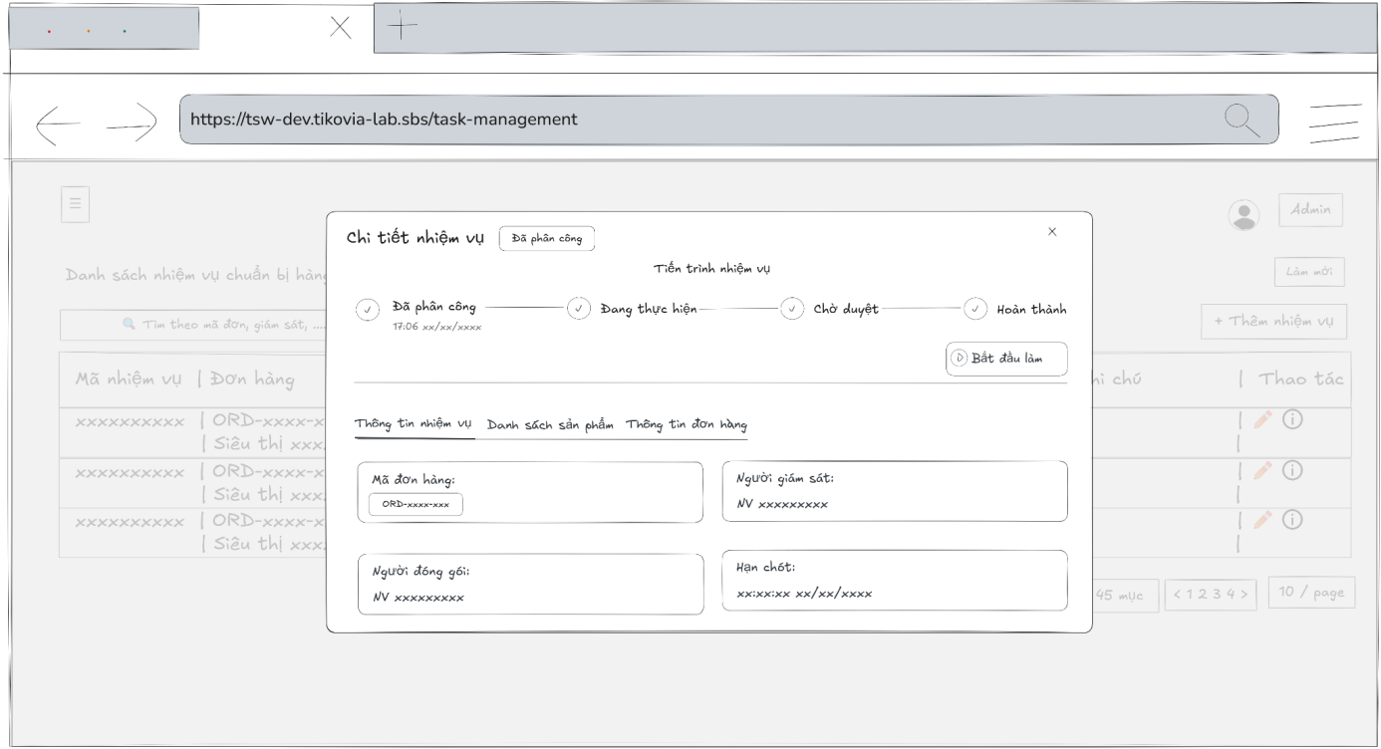
- Function Details:
  - Validation:
    - The user must be authenticated and logged into the system.
    - The user must have one of the following roles: Admin, Packing Supervisor, Packing staff, Warehouse manager.
    - The selected preparation task must exist in the system.
    - The system must validate access permission before displaying task details.
    - Task information (task metadata, product list, related sales order, review history) must be retrieved correctly from the database.
    - Displayed task status and details must match the stored data.
  - Functionality:
    - In Normal Cases:
      - The system displays all task metadata, product list, related sales order information, and review history.
      - Users can perform actions based on their role and the current status of the task.
      - Users with the Packing Supervisor or Packing Staff role can start a packing task via the 'Bắt đầu làm' button. Completion proof is submitted using the 'Cập nhật' button in the product list tab. The 'Cập nhật' action is restricted to the user who originally started the task.
    - In Abnormal Cases:
      - No Orders in Ticket: A message is displayed: "No data found for this task."
      - Connection Issues or server Error: An error message and close button are shown: An error message and close button are shown: "An error occurred while loading task details. Please try again.”
  - Business rule: N/A.

# | Component | Comp. type | Editable | Mandatory | Default Value | Description
 | Header Section
1 | Modal Title | Label (Text) | No | Yes | "Chi tiết nhiệm vụ" | Displays the main title of the modal.
2 | Status Tag | Label (Tag) | No | Yes | [Dynamic Status] | Displays the current progress status of the task next to the title.
3 | Close Icon | Button (Icon) | No | Yes | "x" | Button to close the task details modal.
 | Progress Stepper Section
4 | Stepper Header | Label (Text) | No | Yes | "Tiến trình nhiệm vụ" | Header for the task lifecycle visualization section.
5 | Progress Stepper | Stepper | No | Yes | "Đã phân công, Đang thực hiện, Chờ duyệt, Hoàn thành" [Dynamic Time] | Displays the 4 stages of the task and the specific time each stage was reached.
 | Navigation Tabs
6 | Detail Tabs | Tab Group | No | Yes | "Thông tin nhiệm vụ, Danh sách sản phẩm, Thông tin đơn hàng" | Navigation menu to switch between task info, product list, and order details.
 | Task Info Content (Active Tab)
7 | Order ID Label | Label (Text) | No | Yes | "Mã đơn hàng:" | Label for the associated order identification field.
8 | Order ID Data | Label (Text) | No | Yes | [Dynamic Order ID] | Displays the unique ID of the order related to this task.
9 | Supervisor Label | Label (Text) | No | Yes | "Người giám sát:" | Label for the assigned supervisor field.
10 | Supervisor Data | Label (Text) | No | Yes | [Dynamic Name] | Displays the full name of the staff member supervising the task.
11 | Packer Label | Label (Text) | No | Yes | "Người đóng gói:" | Label for the assigned packing staff field.
12 | Packer Data | Label (Text) | No | Yes | [Dynamic Name] | Displays the full name of the staff member responsible for packing.
13 | Deadline Label | Label (Text) | No | Yes | "Hạn chót:" | Label for the task completion time limit field.
14 | Deadline Data | Label (Text) | No | Yes | [Dynamic Date Time] | Displays the specific date and time by which the task must be completed.

––––––––––––––––––––––––––––––––––––––––––––––––––––––––––––––––––––––––––––––––––-

3.5.7 - Assign Packing Task
- Function trigger: Users with the roles admin or packing supervisor access the Preparation Tasks page and click the “Thêm nhiệm vụ” button to open a modal for input.
- Function description: Allows Admin, Packing supervisor, Warehouse manager to create a new preparation task for a sales order and assign it to a picker.
- Screen layout:
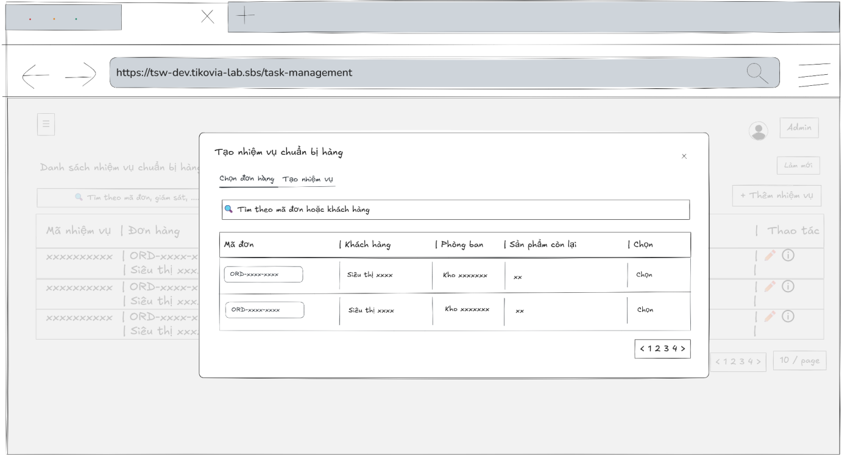
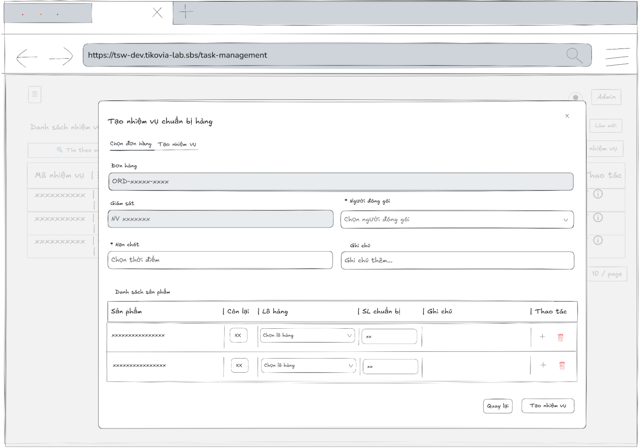
- Function Details:
  - Validation:
    - The user must be authenticated and logged into the system.
    - The user must have a valid role: Admin or Packing Supervisor.
    - A valid sales order must be selected.
    - Required fields (assignee, deadline, products, preparation quantities) must be provided.
    - Preparation quantity for each product must not exceed the remaining quantity.
    - At least one product must be added to the task.
  - Functionality:
    - In Normal Cases:
      - After the user submits the task and the system validates successfully, a message is displayed: "Preparation task created successfully."
    - In Abnormal Cases:
      - Missing or Invalid Fields: If the submit button is pressed without filling all required fields, the system displays an error message indicating the missing or invalid fields.
      - Preparation Quantity Exceeds Remaining Quantity: If the total preparation quantity for any product exceeds the remaining quantity, the system displays an error message.
      - No Products Added: If no products are added to the task, the system displays a warning message.
      - Connection Issues / Server Error: If there is an issue with the server when submitting the new task, the system notifies the user: "An error occurred while creating the preparation task. Please try again.”
  - Business rule: BR-19.

# | Component | Comp. type | Editable | Mandatory | Default Value | Description
 | Header & Navigation
1 | Modal Title | Label (Text) | No | Yes | "Tạo nhiệm vụ chuẩn bị hàng" | Displays the main title of the modal.
2 | Close Icon | Button (Icon) | No | Yes | "x" | Closes the modal and cancels the process.
3 | Step Tabs | Tab Group | No | Yes | "Chọn đơn hàng, Tạo nhiệm vụ" | Navigation tabs to switch between the two steps of the process.
 | Step 1: Chọn đơn hàng (Order Selection)
4 | Search Order Input | Input (Text) | Yes | No | "Tìm theo mã đơn hoặc khách hàng" | Search bar to filter the list of available orders.
5 | Col Header: Order ID | Label | No | Yes | "Mã đơn" | Table header for the Order ID column.
6 | Col Header: Customer | Label | No | Yes | "Khách hàng" | Table header for the Customer Name column.
7 | Col Header: Dept. | Label | No | Yes | "Phòng ban" | Table header for the department column.
8 | Col Header: Remaining | Label | No | Yes | "Sản phẩm còn lại" | Table header for the count of unpicked items.
9 | Col Header: Select | Label | No | Yes | "Chọn" | Table header for the action column.
10 | Order ID Row | Label (Text) | No | Yes | [Dynamic Order ID] | Displays the unique code of the order.
11 | Customer Row | Label (Text) | No | Yes | [Dynamic Store Name] | Displays the name of the customer/store.
12 | Dept. Row | Label (Text) | No | Yes | [Dynamic Dept.] | Displays the assigned department for the order.
13 | Remaining Row | Label (Text) | No | Yes | [Dynamic Qty] | Displays the quantity of items still needing preparation.
14 | Select Action | Button | No | Yes | "Chọn" | Button to select a specific order and proceed to Step 2.
15 | Pagination Nav | Button Group | No | Yes | "< 1 2 3 4 >" | Controls to navigate through pages of orders.
 | Step 2: Tạo nhiệm vụ (Task Creation)
16 | Order ID Display | Input (Text) | No | Yes | [Dynamic Order ID] | Displays the selected order code. This field is read-only.
17 | Supervisor Display | Input (Text) | No | Yes | [Dynamic Name] | Displays the assigned supervisor. This field is read-only.
18 | Packer Select | Dropdown | Yes | Yes | "Chọn người đóng gói" | Field to assign a staff member for packing. Asterisk indicates mandatory.
19 | Deadline Select | Date Picker | Yes | Yes | "Chọn thời điểm" | Field to set the task completion time limit. Asterisk indicates mandatory.
20 | Task Note Input | Input (Text) | Yes | No | "Ghi chú thêm..." | Field for entering general instructions or remarks.
21 | Product Table Header | Label Group | No | Yes | "Sản phẩm, Còn lại, Lô hàng, SL chuẩn bị, Ghi chú, Thao tác" | Headers for the product details table.
22 | Product Name | Label (Text) | No | Yes | [Dynamic Product Name] | Displays the name of the item to be picked.
23 | Stock Remaining | Label (Text) | No | Yes | [Dynamic Qty] | Displays the available stock quantity in the warehouse.
24 | Batch Select | Dropdown | Yes | Yes | "Chọn lô hàng" | Dropdown to select a specific product batch or lot.
25 | Picking Qty Input | Input (Number) | Yes | Yes | [Dynamic Qty] | Input field to specify the amount of product to be picked.
26 | Row Note Input | Input (Text) | Yes | No | "Ghi chú..." [Dynamic Note] | Input field for remarks specific to a product line item.
27 | Add/Remove Action | Button Group | No | Yes | "+, [Trash Icon]" | Buttons to add a new batch line or remove an existing one.
 | Footer Actions (Step 2)
28 | Back Button | Button | No | Yes | "Quay lại" | Navigates back to the "Chọn đơn hàng" step.
29 | Submit Task Button | Button | No | Yes | "Tạo nhiệm vụ" | Validates all inputs and creates the picking task.

––––––––––––––––––––––––––––––––––––––––––––––––––––––––––––––––––––––––––––––––––-

3.5.8 - Update Packing Task
- Function trigger: Users with the roles Admin, Packing supervisor access the Preparation Tasks page, select a task in "Assigned" status, and click the “Edit” button to open a modal for editing.
- Function description: Allows users to update details of an existing preparation task, including assigned picker, deadline, notes, and product list.
- Screen layout:
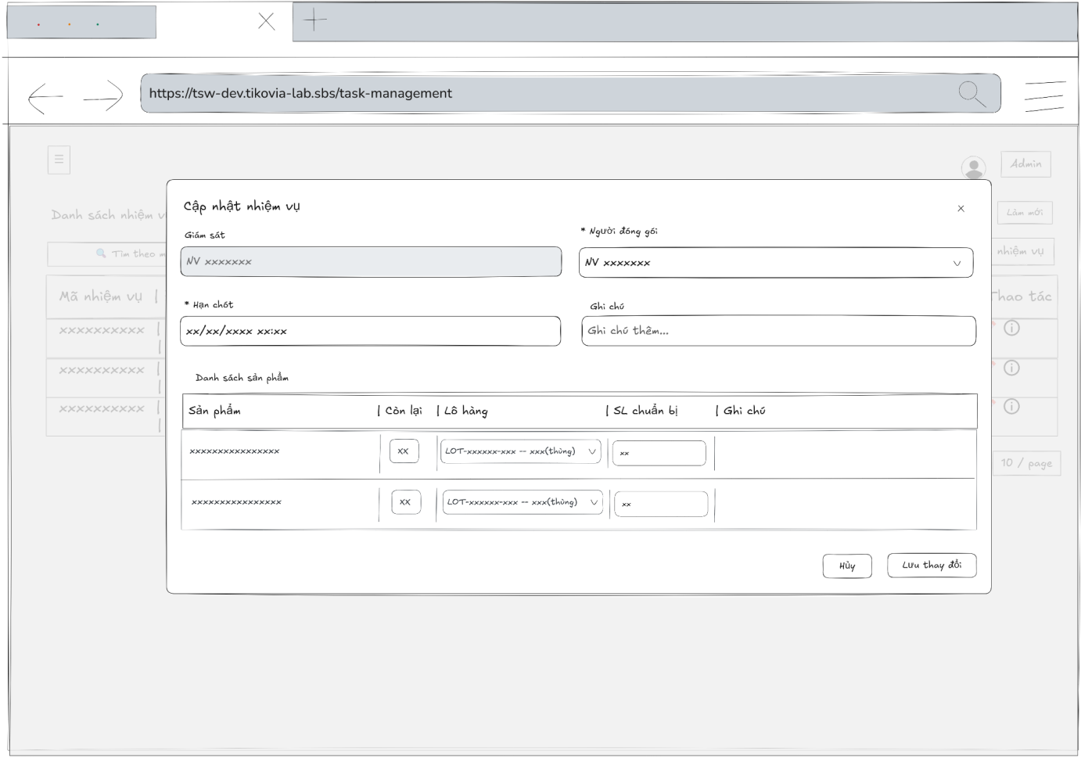
- Function Details:
  - Validation:
    - The user must be authenticated and logged into the system.
    - The user must have a valid role: Admin or Packing Supervisor.
    - The selected packing task must exist and be in Assigned status.
    - Required fields (assignee, deadline, products, preparation quantities) must be provided.
    - Preparation quantity must not exceed the remaining quantity or available lot quantity.
    - At least one product must be included in the task.
  - Functionality:
    - In Normal Cases:
      - After the user saves changes and the system validates successfully, a message is displayed: "Preparation task updated successfully."
    - In Abnormal Cases:
      - Missing or Invalid Fields: If the save button is pressed without filling all required fields, the system displays an error message indicating the missing or invalid fields.
      - Preparation Quantity Exceeds Remaining Quantity or Lot Quantity: If the total preparation quantity for any product exceeds the remaining quantity or available lot quantity, the system displays an error message.
      - No Products Added:If no products are added to the task, the system displays a warning message.
      - Connection Issues / Server Error: If there is an issue with the server when saving the task, the system notifies the user: "An error occurred while updating the preparation task. Please try again."
  - Business rule: BR-19.

# | Component | Comp. type | Editable | Mandatory | Default Value | Description
 | Header Section
1 | Modal Title | Label (Text) | No | Yes | "Cập nhật nhiệm vụ" | Displays the title of the update modal.
2 | Close Icon | Button (Icon) | No | Yes | "x" | Closes the modal without saving changes.
 | Task Configuration Section
3 | Supervisor Label | Label (Text) | No | Yes | "Giám sát" | Label for the assigned supervisor field.
4 | Supervisor Data | Input (Text) | No | Yes | [Dynamic Name] | Displays the name of the supervisor. This field is read-only.
5 | Packer Label | Label (Text) | No | Yes | "* Người đóng gói" | Label for the packer assignment. Asterisk indicates mandatory.
6 | Packer Select | Dropdown | Yes | Yes | [Dynamic Name] | Selectable list to reassign or confirm the packing staff.
7 | Deadline Label | Label (Text) | No | Yes | "* Hạn chót" | Label for the task completion deadline. Asterisk indicates mandatory.
8 | Deadline Input | Date Picker | Yes | Yes | "xx/xx/xxxx xx:xx" [Dynamic Date Time] | Field to update the task deadline. Supports date and time selection.
9 | Task Note Label | Label (Text) | No | Yes | "Ghi chú" | Label for the general task remarks field.
10 | Task Note Input | Input (Text) | Yes | No | "Ghi chú thêm..." [Dynamic Note] | Input field for modifying general task instructions.
 | Product List Section
11 | Section Header | Label (Text) | No | Yes | "Danh sách sản phẩm" | Header for the dynamic product allocation table.
12 | Table Column Headers | Label Group | No | Yes | "Sản phẩm, Còn lại, Lô hàng, SL chuẩn bị, Ghi chú" | Static headers for the product data columns.
13 | Product Name Data | Label (Text) | No | Yes | [Dynamic Product Name] | Displays the name of the item being picked.
14 | Stock Remaining | Label (Text) | No | Yes | [Dynamic Qty] | Displays the current available stock for the item.
15 | Batch Select | Dropdown | Yes | Yes | "Chọn lô hàng" [Dynamic Batch ID] | Dropdown to select or change the product lot/batch.
16 | Prep Qty Input | Input (Number) | Yes | Yes | [Dynamic Qty] | Input field to update the quantity of products to be prepared.
17 | Row Note Input | Input (Text) | Yes | No | [Dynamic Note] | Input field for editing remarks specific to the product line item.
 | Footer Section
18 | Cancel Button | Button | No | Yes | "Hủy" | Discards all changes and closes the modal.
19 | Save Changes Button | Button | No | Yes | "Lưu thay đổi" | Validates inputs and saves the updated task information.

––––––––––––––––––––––––––––––––––––––––––––––––––––––––––––––––––––––––––––––––––-

3.6 Supplier and Warehouse Management

3.6.1 - View Supplier List
- Function trigger: The Admin, Accountant, Warehouse manager accesses the Suppliers page view list suppliers.
- Function description: Allow Admin, Accountant, Warehouse manager to view list suppliers.
- Screen layout:
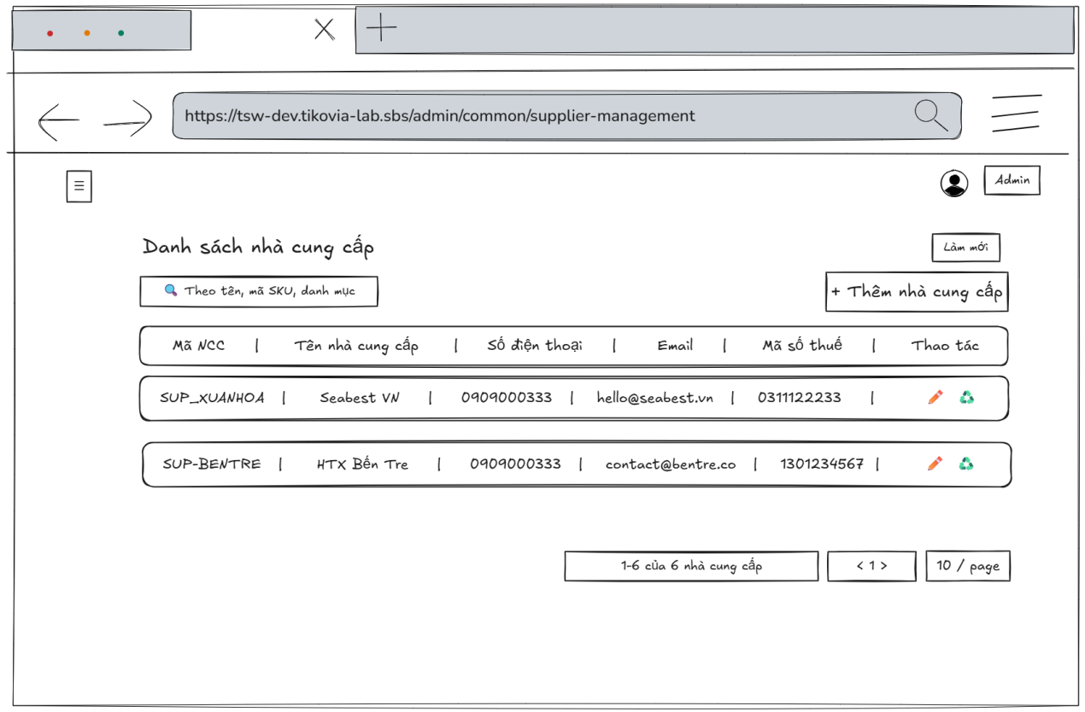
- Function Details:
  - Validation:
    - The user must be authenticated and authorized with one of the following roles: Admin, Accountant, Warehouse Manager.
    - The system shall successfully retrieve supplier data from the server before displaying the list.
    - The supplier information displayed (Supplier code, Supplier name, Phone number, Email, Tax code) must match the data stored in the system.
  - Functionality:
    - In Normal Cases:
      - After the admin, warehouse manager, and accountant had logged in the system, they could view the suppliers list.
      - The system must display the list of suppliers correctly according to the data from the database.
    - In Abnormal Cases:
      - Connection Issues: If there's a server issue, the system will notify the user: "Unable to fetch data. Please try again later."
  - Business rule: N/A.

# | Component | Comp. type | Editable | Mandatory | Default Value | Description
 | Header & Search Section
1 | Screen Title | Label (Text) | No | Yes | "Danh sách nhà cung cấp" | Displays the main header of the screen.
2 | Refresh Button | Button | No | No | "Làm mới" | Button to reload the supplier list data from the server.
3 | Search Input | Input (Text) | Yes | No | "Theo tên, mã SKU, danh mục" | Input field to search for suppliers. Includes a search icon.
4 | Add Supplier Button | Button | No | Yes | "+ Thêm nhà cung cấp" | Navigates to the screen or modal to add a new supplier record.
 | Data Table Headers
5 | Col Header: Supplier ID | Label | No | Yes | "Mã NCC" | Column header for the unique Supplier ID.
6 | Col Header: Supplier Name | Label | No | Yes | "Tên nhà cung cấp" | Column header for the name of the supplier.
7 | Col Header: Phone | Label | No | Yes | "Số điện thoại" | Column header for the contact phone number.
8 | Col Header: Email | Label | No | Yes | "Email" | Column header for the contact email address.
9 | Col Header: Tax Code | Label | No | Yes | "Mã số thuế" | Column header for the supplier's tax identification number.
10 | Col Header: Action | Label | No | Yes | "Thao tác" | Column header for row-level action buttons.
 | Data Table Rows (Dynamic)
11 | Supplier ID Data | Label (Text) | No | Yes | [Dynamic Supplier ID] | Displays the identification code of the supplier (e.g., SUP_XUANHOA).
12 | Supplier Name Data | Label (Text) | No | Yes | [Dynamic Name] | Displays the full name of the supplier.
13 | Phone Data | Label (Text) | No | Yes | [Dynamic Phone] | Displays the registered phone number of the supplier.
14 | Email Data | Label (Text) | No | Yes | [Dynamic Email] | Displays the contact email address for the supplier.
15 | Tax Code Data | Label (Text) | No | Yes | [Dynamic Tax Code] | Displays the supplier's tax identification number.
16 | Edit Action | Button (Icon) | No | Yes | [Pencil Icon] | Icon button to open the edit interface for the specific supplier.
17 | Status Toggle Action | Button (Icon) | No | Yes | [Recycle Icon] | Icon button to change or toggle the active status of the supplier.
 | Footer & Pagination
18 | Range Info Label | Label (Text) | No | Yes | [Dynamic Range] " của " [Dynamic Total] " nhà cung cấp" | Displays the range of items currently visible (e.g., 1-6 of 6).
19 | Pagination Nav | Button Group | No | Yes | "< 1 >" | Navigation controls to switch between list pages.
20 | Items Per Page | Dropdown | Yes | Yes | "10 / page" | Dropdown to select how many records to display per page.

––––––––––––––––––––––––––––––––––––––––––––––––––––––––––––––––––––––––––––––––––-

3.6.2 - View Supplier Detail
- Function trigger: Admin, Accountant, Warehouse manager accesses the Suppliers page and clicks on the selected supplier to display a popup with information.
- Function description: Allow Admin, Accountant, Warehouse manager to view supplier details
- Screen layout:
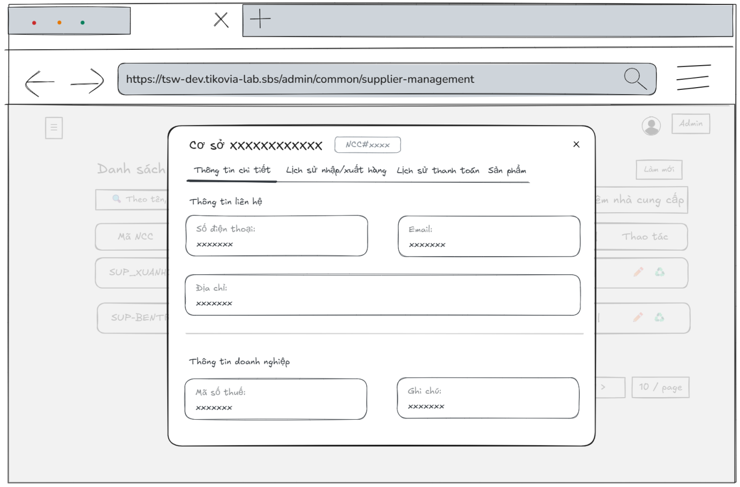
- Function Details:
  - Validation:
    - The user must be authenticated and authorized with one of the following roles: Admin, Accountant, Warehouse Manager.
    - The selected supplier must exist in the system.
    - The system shall successfully retrieve supplier detail data from the server before displaying the popup.
    - The supplier information displayed must match the data stored in the system.
  - Functionality:
    - In Normal Cases:
      - The system displays all the detailed information about suppliers correctly.
    - In Abnormal Cases:
      - Server Error: If there is an issue with the server when fetch data, the system display no data
  - Business rule: N/A.

# | Component | Comp. type | Editable | Mandatory | Default Value | Description
 | Header Section
1 | Modal Title | Label (Text) | No | Yes | "Cơ sở " [Dynamic Name] | Displays the name of the supplier facility.
2 | Supplier ID Tag | Label (Tag) | No | Yes | [Dynamic ID] | Displays the unique Supplier ID (e.g., NCC#xxxx) in a tag format.
3 | Close Icon | Button (Icon) | No | Yes | "x" | Closes the supplier detail modal.
 | Navigation Tabs
4 | Details Tab | Tab Item | No | Yes | "Thông tin chi tiết" | Navigation tab for general information (Active by default).
5 | Inventory Logs Tab | Tab Item | No | Yes | "Lịch sử nhập/xuất hàng" | Navigation tab to view stock movement history.
6 | Payment Logs Tab | Tab Item | No | Yes | "Lịch sử thanh toán" | Navigation tab to view financial transaction history.
7 | Product List Tab | Tab Item | No | Yes | "Sản phẩm" | Navigation tab to view the list of products supplied.
 | Contact Information Section
8 | Section Header 1 | Label (Text) | No | Yes | "Thông tin liên hệ" | Header for the contact details group.
9 | Phone Label | Label (Text) | No | Yes | "Số điện thoại:" | Label for the supplier's contact number.
10 | Phone Data | Input (Text) | No | Yes | [Dynamic Phone] | Displays the contact phone number. Field is read-only.
11 | Email Label | Label (Text) | No | Yes | "Email:" | Label for the supplier's contact email.
12 | Email Data | Input (Text) | No | Yes | [Dynamic Email] | Displays the contact email address. Field is read-only.
13 | Address Label | Label (Text) | No | Yes | "Địa chỉ:" | Label for the supplier's physical address.
14 | Address Data | Input (Text) | No | Yes | [Dynamic Address] | Displays the full registered address. Field is read-only.
 | Business Information Section
15 | Section Header 2 | Label (Text) | No | Yes | "Thông tin doanh nghiệp" | Header for the official business details group.
16 | Tax Code Label | Label (Text) | No | Yes | "Mã số thuế:" | Label for the business tax identification number.
17 | Tax Code Data | Input (Text) | No | Yes | [Dynamic Tax Code] | Displays the supplier's tax code. Field is read-only.
18 | Note Label | Label (Text) | No | Yes | "Ghi chú:" | Label for additional remarks about the supplier.
19 | Note Data | Input (Text) | No | No | [Dynamic Note] | Displays any existing notes or comments. Field is read-only.

––––––––––––––––––––––––––––––––––––––––––––––––––––––––––––––––––––––––––––––––––-

3.6.3 - Create Supplier
- Function trigger: The Admin, Accountant, Warehouse manager accesses the Suppliers page and clicks the button “Thêm nhà cung cấp” to display a popup with input box.
- Function description: Allow Admin, Accountant, Warehouse manager to add a new supplier.
- Screen layout:
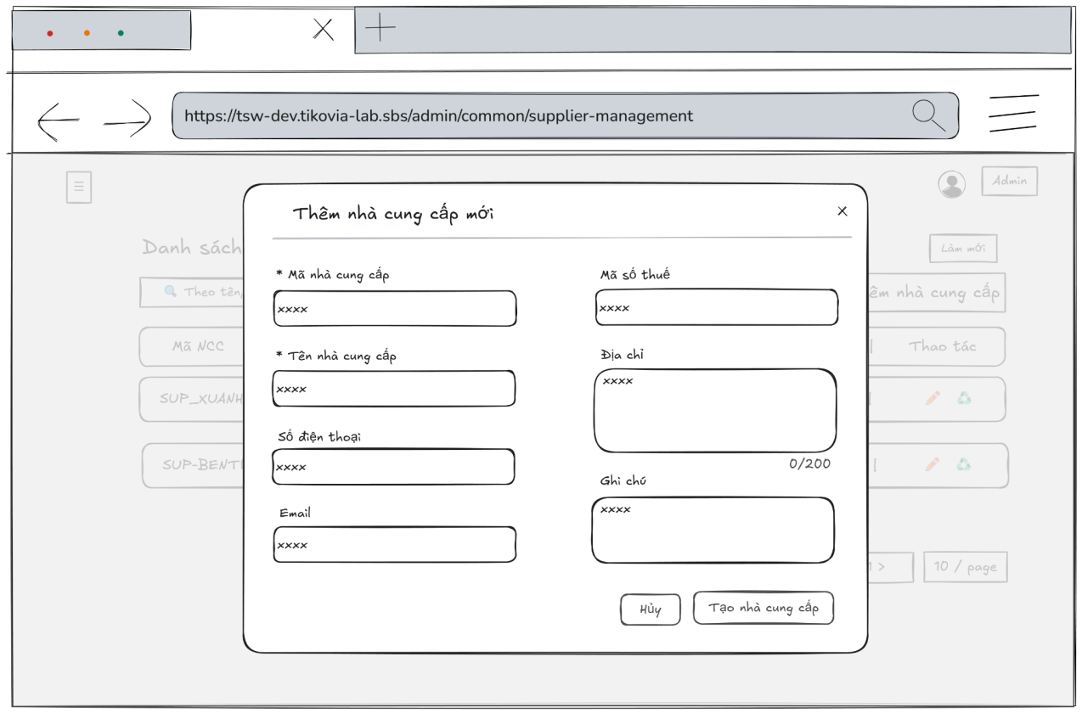
- Function Details:
  - Validation:
    - The user must be authenticated and authorized with one of the following roles: Admin, Accountant, Warehouse Manager.
    - All required fields (Supplier code, Supplier name, Phone number, Email) must be provided.
    - Supplier code must be unique in the system.
    - Phone number must follow a valid phone number format.
    - Email must follow a valid email format.
    - The address and note fields, if provided, must not exceed the maximum allowed length.
    - The system shall validate all input data on the server side before creating a new supplier.
  - Functionality:
    - In Normal Cases:
      - After the admin has submitted the supplier information and the system validates a message will be displayed: “Thêm nhà cung cấp thành công”.
    - In Abnormal Cases:
      - Missing or Invalid Fields: If the admin presses the submit button without any required field, the system will display an error message required field.
      - Connection Issues: If there is an issue with the server when submitting the new supplier information, the system will notify: "Có lỗi xảy ra trong quá trình thêm mới. Vui lòng thử lại!"
  - Business rule: BR-10, BR-15, BR-21.

# | Component | Comp. type | Editable | Mandatory | Default Value | Description
 | Header Section
1 | Modal Title | Label (Text) | No | Yes | "Thêm nhà cung cấp mới" | Displays the title of the modal.
2 | Close Icon | Button (Icon) | No | Yes | "x" | Closes the modal without saving any data.
 | Form Section
3 | Supplier Code Input | Input (Text) | Yes | Yes | Placeholder: "xxxx" | Field to enter the unique identification code for the supplier. Asterisk indicates mandatory.
4 | Supplier Name Input | Input (Text) | Yes | Yes | Placeholder: "xxxx" | Field to enter the official name of the supplier. Asterisk indicates mandatory.
5 | Phone Number Input | Input (Tel) | Yes | No | Placeholder: "09xxxxxxxxxx" | Field to enter the supplier's contact phone number.
6 | Email Input | Input (Email) | Yes | No | Placeholder: "xxxxxxxx@gmail.com" | Field to enter the supplier's contact email address.
7 | Tax Code Input | Input (Text) | Yes | No | Placeholder: "xxxx" | Field to enter the business tax identification number of the supplier.
8 | Address Textarea | Textarea | Yes | No | Placeholder: "xxxx" | Multi-line input for the physical address. Includes a character counter (0/200).
9 | Note Textarea | Textarea | Yes | No | Placeholder: "xxxx" | Multi-line input for additional remarks or instructions regarding the supplier.
 | Footer Section
10 | Cancel Button | Button | No | Yes | "Hủy" | Dismisses the modal and discards all unsaved input.
11 | Create Supplier Button | Button | No | Yes | "Tạo nhà cung cấp" | Validates the form and submits data to create a new supplier record.

––––––––––––––––––––––––––––––––––––––––––––––––––––––––––––––––––––––––––––––––––-

3.6.4 - Update Supplier Information
- Function trigger: The Admin, Accountant, Warehouse manager accesses the Suppliers page to view the list of suppliers and press edit button to update/edit information for a specific supplier.
- Function description: To allow the Admin, Accountant, Warehouse manager to update information of the suppliers.
- Screen layout:
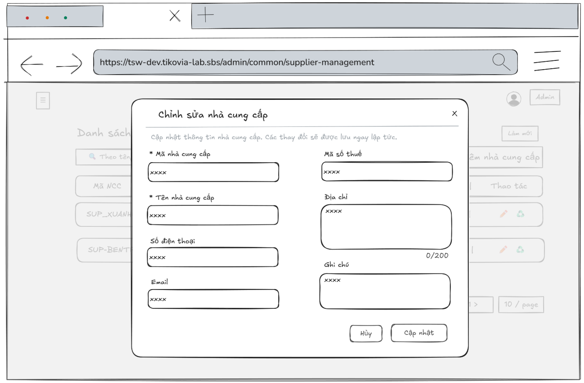
- Function Details:
  - Validation:
    - The user must be authenticated and authorized with one of the following roles: Admin, Accountant, Warehouse Manager.
    - The selected supplier must exist in the system.
    - All required fields (Supplier code, Supplier name, Phone number, Email) must be provided and valid.
    - Supplier code must remain unique in the system (excluding the current supplier).
    - Phone number must follow a valid phone number format.
    - Email must follow a valid email format.
    - The address and note fields, if provided, must not exceed the maximum allowed length.
    - The system shall validate all input data on the server side before saving changes.
  - Functionality:
    - In Normal Cases:
      - After press button edit, the system displayed supplier information in the input box and it must match the database.
      - The admin, accountant is able to edit supplier’s information and can see a success message.
    - In Abnormal Cases:
      - Missing fields or Data: If required fields (e.g., Supplier code, Supplier name, Tax code, Phone number, Email) are left blank or contain invalid data (such as an incorrect email format or non-numeric phone number), the system will: Display an error message indicating which fields are missing or invalid and prevent saving until all required fields are correctly filled.
      - Connection Issues: If the server encounters an internal error (e.g., database timeout or server crash) during the update process, the system will show a message like “Server error occurred. Please try again later.”
  - Business rule: BR-10, BR-15, BR-21.
# | Component | Comp. type | Editable | Mandatory | Default Value | Description
 | Header Section
1 | Title | Label (Text) | No | N/A | “Chỉnh sửa nhà cung cấp” | Title of the modal.
2 | Close Button | Button | No | No | N/A | The "x" icon in the top-right corner. Closes the popup without saving.
3 | Sub-instruction | Label (Text) | No | N/A | “Cập nhật thông tin...” | Explains the purpose of the form ("Cập nhật thông tin nhà cung cấp...").
 | Form Section
4 | Supplier Code | Input (Text) | Yes | Yes | Dữ liệu hiện tại | Input for supplier ID. Marked with a red * (mandatory).
5 | Tax Code | Input (Text) | Yes | No | Dữ liệu hiện tại | Input for tax identification number.
6 | Supplier Name | Input (Text) | Yes | Yes | Dữ liệu hiện tại | Input for the full name of the supplier. Marked with a red * (mandatory)..
7 | Address | Input (Text) | Yes | No | Dữ liệu hiện tại | Input for detailed address.
8 | Phone Number | Input (Text) | Yes | No | Dữ liệu hiện tại | Input for contact phone number. Numeric input only.
9 | Note | Input (Text) | Yes | No | Dữ liệu hiện tại | Input for additional remarks/notes.
10 | Email | Input (Email) | Yes | No | Dữ liệu hiện tại | Input for email address. Requires standard email format validation.
 | Footer Section
11 | Cancel Button | Button | No | No | “Huỷ” | Closes the popup and discards any changes.
12 | Update Button | Button | No | No | “Cập nhật” | Submits and saves the changes to the system.
––––––––––––––––––––––––––––––––––––––––––––––––––––––––––––––––––––––––––––––––––-

3.6.5 - Delete Supplier
- Function trigger: The admin clicks on the Delete button to remove selected suppliers from the system.
- Function description: To allow the admin to delete a supplier.
- Screen layout:
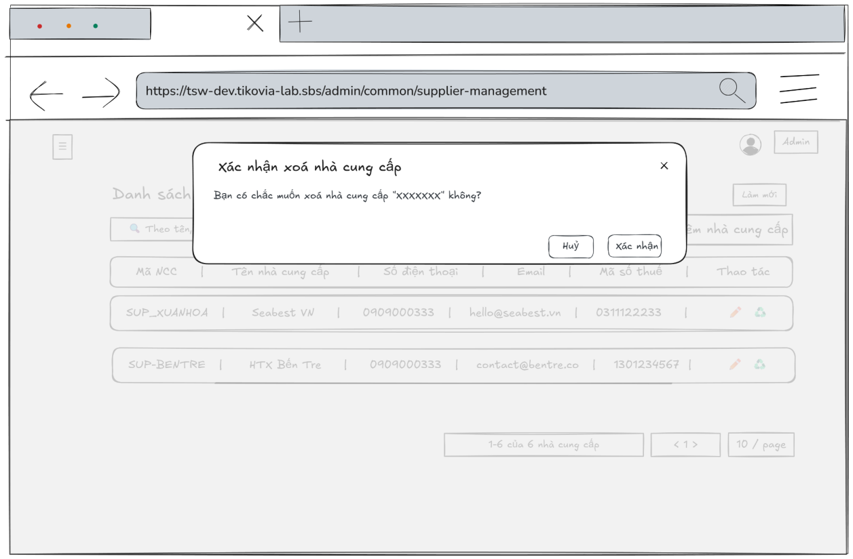
- Function Details:
  - Validation:
    - The user must be authenticated and authorized with the Admin role.
    - The selected supplier must exist in the system.
    - The system shall require user confirmation before executing the delete action.
  - Functionality:
    - In Normal Cases:
      - After the admin confirms the deletion, the system will remove the supplier out of the system and display a success message:
"Xóa nhà cung cấp thành công."
    - In Abnormal Cases:
      - Server Error: If there is a failure when deleting the supplier due to a server issue, the system will display:
"Lỗi xóa nhà cung cấp"
      - Confirmation Failure: If the admin cancels the deletion process at the confirmation step, the system will stop the deleting process and go back to the list.
  - Business rule: BR-05.
# | Component | Comp. type | Editable | Mandatory | Default Value | Description
 | Header Section
1 | Title | Label (Text) | No | N/A | “Xác nhận xóa nhà cung cấp” | Displays the title of the confirmation modal.
2 | Close Button | Button | No | No | N/A | Icon button (X) to close the modal without performing the delete action.
 | Body Section
3 | Confirmation Message | Input (Text) | No | N/A | “Bạn có chắc muốn xóa nhà cung cấp “{Supplier Name}“ không?” | Displays the warning message. {Supplier Name} is dynamic data based on the selected item.
 | Footer Section
4 | Cancel Button | Button | No | No | “Huỷ” | Closes the modal and cancels the delete action.
5 | Update Button | Button | No | No | “Cập nhật” | Executes the delete command for the selected supplier and refreshes the list.
––––––––––––––––––––––––––––––––––––––––––––––––––––––––––––––––––––––––––––––––––-

3.6.6 - View List of Supplier Transactions
- Function trigger: The Admin, Warehouse manager, Accountant clicks on the “Supplier Transaction” button and navigates to the Supplier Transaction page through the sidebar to view the list of supplier transactions in the system.
- Function description: To view a list of supplier transactions with the information about a supplier transaction, such as the document no, transaction type, status, transaction date, due date, total amount (VND), paid amount
- Screen layout:
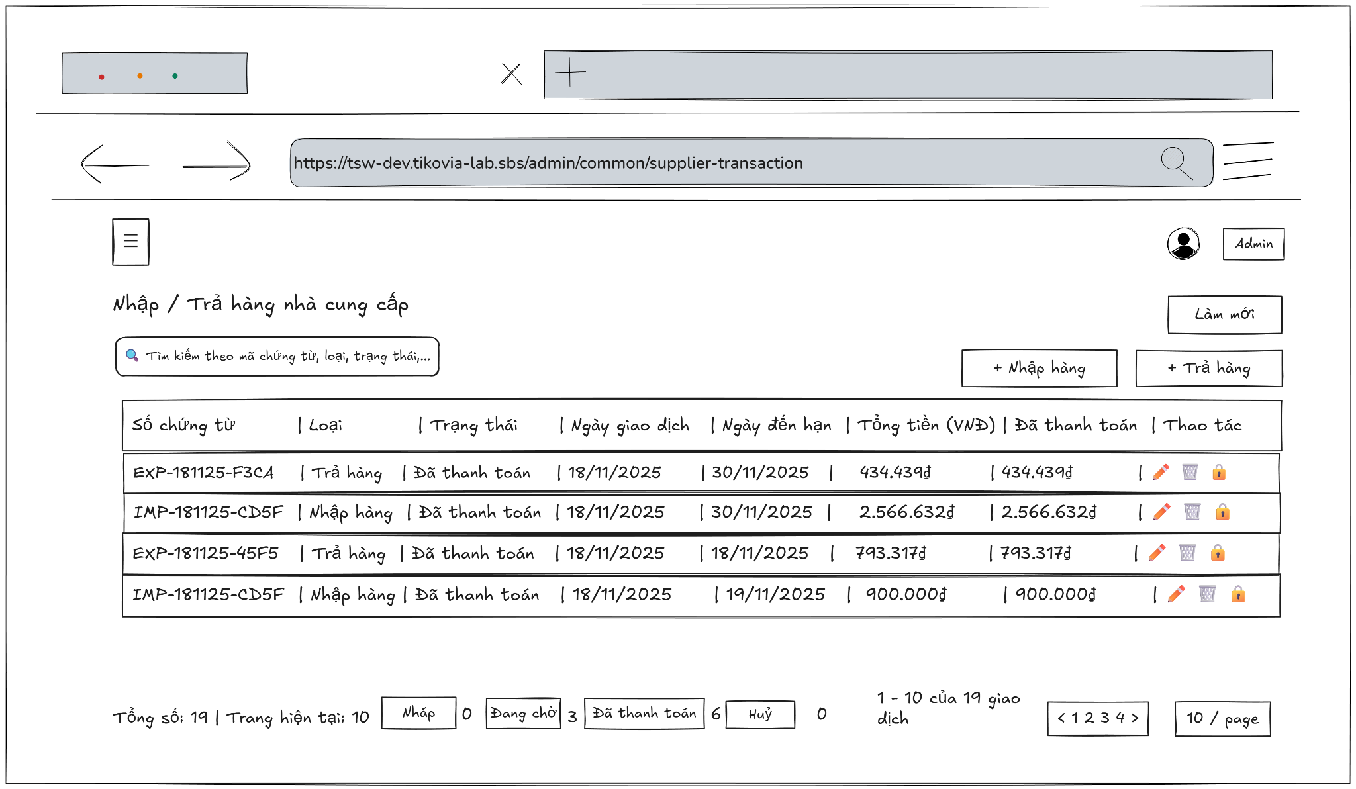
- Function Details:
  - Validation:
    - The user must be authenticated and logged into the system.
    - The user must have a valid role: Admin, Warehouse manager, Accountant.
    - The system shall validate access permission before displaying the Supplier Transaction page.
    - The supplier transaction data retrieved must be consistent with the data stored in the database.
    - Pagination and filtering (if applied) must load valid data corresponding to the selected criteria.
  - Functionality:
    - In Normal Cases:
      - After clicking on "Supplier Transaction", the system displays the supplier transaction list with the information about a supplier transaction, such as the document no, transaction type, status, transaction date, due date, total amount (VND), paid amount
    - In Abnormal Cases:
      - No Supplier Transaction Data Found: If there is no data of supplier transaction list in the system will display “No data”.
      - Connection Issues: If there's a server issue, the system will notify the admin: "Không thể tải dữ liệu. Đã xảy ra lỗi khi tải danh sách giao dịch nhà cung cấp"
  - Business rule: BR-22.

# | Component | Comp. type | Editable | Mandatory | Default Value | Description
 | Header Section
1 | Title | Label (Text) | No | N/A | “Nhập / Trả hàng nhà cung cấp” | Displays the main title of the page.
2 | Search Bar | Input (Search) | Yes | No | "Tìm kiếm theo mã chứng từ, loại, trạng thái..." | Placeholder text. Allows full-text search across transaction code, type, or status.
3 | Refresh Button | Button | No | Yes | “Làm mới” | Reloads the data table list.
4 | Import Button | Button | No | Yes | “+ Nhập hàng” | Open the "Create Import Transaction" screen/modal.
5 | Return Button | Button | No | Yes | "+ Trả hàng" | Opens the "Create Return Transaction" screen/modal.
 | Data Table List
6 | Column Headers | Label (Text) | No | Yes | "Số chứng từ | Loại | Trạng thái | Ngày giao dịch..." | Headers defining the data columns: Transaction Code, Type, Status, Date, Due Date, Total, Paid, Actions.
7 | Row Data (Sample) | Table Row | No | Yes | Dữ liệu hiện tại | Displays the content of each transaction record.
8 | Action: Edit | Icon Button | No | Yes | (Pencil Icon) | Opens the edit screen/modal for the selected transaction.
9 | Action: Delete | Icon Button | No | Yes | (Trash Icon) | Opens the edit screen/modal for the selected transaction.
10 | Action: Lock | Icon Button | No | Yes | (Padlock Icon) | Indicator or toggle for locked transactions (cannot be edited).
 | Footer Section
11 | Summary Info | Label (Text) | No | Yes | "Tổng số: n | Trang hiện tại: n" | Displays overview statistics of the records.
12 | Status Filters | Button Group | No | Yes | "Nhập | Đang chờ | Đã thanh toán | Huỷ" | Quick filter tabs with count badges (e.g., "Đang chờ 3") to filter the list by status.
13 | Range Display | Label (Text) | No | Yes | "x - y của z giao dịch" | Indicates which subset of records is currently visible.
14 | Page Navigation | Pagination Control | No | Yes | "< 1 2 3 4 >" | Navigation controls to jump between pages.
15 | Page Size Selector | Dropdown | No | Yes | "x / page" | Controls the number of rows displayed per page.
––––––––––––––––––––––––––––––––––––––––––––––––––––––––––––––––––––––––––––––––––-

3.6.7 - View Supplier Transaction Detail Information
- Function trigger: The Admin, Warehouse manager, Accountant accesses the Supplier Transaction page and clicks on the selected user to display a popup with supplier transaction’s information.
- Function description: Allow Admin, Warehouse manager, Accountant to view supplier transaction’s information details
- Screen layout
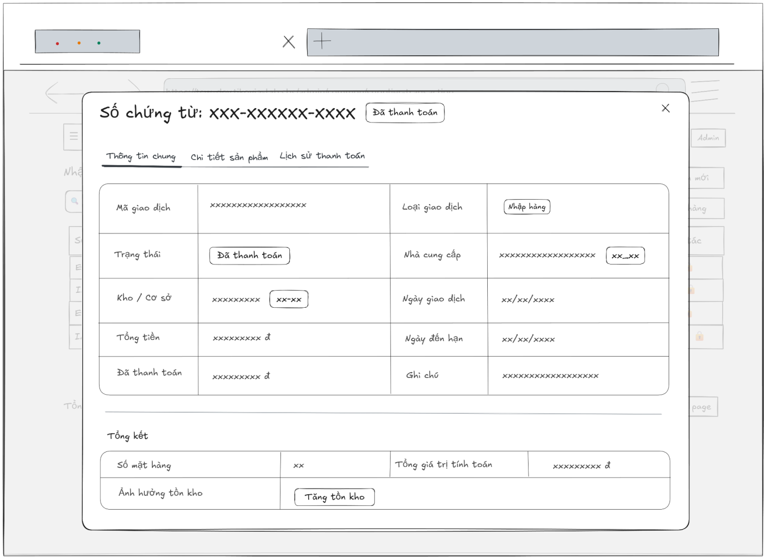
- Function Details:
  - Validation:
    - The user must be authenticated and logged into the system.
    - The user must have a valid role: Admin, Warehouse manager, Accountant.
    - The selected supplier transaction must exist in the system.
    - The system shall validate access permission before displaying supplier transaction details.
    - The transaction detail data (general information, product details, payment history) must be retrieved correctly and consistently from the database.
    - The transaction status, amounts, and dates displayed must match the stored transaction record.
  - Functionality:
    - In Normal Cases:
      - The system displays all the detailed information about supplier transactions correctly.
    - In Abnormal Cases:
      - Server Error: If there is an issue with the server when fetch data, the system display no data
  - Business rule: BR-22.

# | Component | Comp. type | Editable | Mandatory | Default Value | Description
 | Header Section
1 | Title | Label (Text) | No | N/A | "Số chứng từ" | Displays the Transaction ID dynamically.
2 | Badge | Badge (Tag) | No | N/A | Dữ liệu hiện tại | Shows the current status of the transaction next to the title.
3 | Close Button | Button | No | No | N/A | Icon button (x) to close the detail modal.
 | Navigation Section
4 | Tab Navigation | Tabs | Yes | Yes | "Thông tin chung" | Navigation tabs: Thông tin chung (Active), Chi tiết sản phẩm, Lịch sử thanh toán.
 | Content Section
5 | Transaction Code | Label (Text) | No | N/A | Dữ liệu hiện tại | Displays the unique transaction code.
6 | Transaction Type | Badge (Tag) | No | N/A | Dữ liệu hiện tại | Visual tag indicating the type (e.g., Import, Return).
7 | Status | Badge (Tag) | No | N/A | Dữ liệu hiện tại | Visual tag indicating the payment/process status.
8 | Supplier Info | Label (Text) | No | N/A | Dữ liệu hiện tại | Displays Supplier Name and Supplier Code.
9 | Warehouse / Facility | Label (Text) | No | N/A | Dữ liệu hiện tại | Displays the name and code of the warehouse/facility.
10 | Transaction Date | Label (Date) | No | N/A | Dữ liệu hiện tại | The date the transaction occurred.
11 | Total Amount | Label (Currency) | No | N/A | Dữ liệu hiện tại | Total monetary value of the transaction.
12 | Due Date | Label (Date) | No | N/A | Dữ liệu hiện tại | The deadline for payment or completion.
13 | Paid Ammount | Label (Currency) | No | N/A | Dữ liệu hiện tại | Amount already paid.
14 | Note | Label (Text) | No | N/A | Dữ liệu hiện tại | Additional notes or remarks found in the record.
 | Footer Section
15 | Summary Header | Label (Title) | No | N/A | "Tổng kết" | Section header for summary statistics.
16 | Total Items | Label (Number) | No | N/A | Dữ liệu hiện tại | Total count of unique items/products in the transaction.
17 | Calculated Total | Label (Currency) | No | N/A | Dữ liệu hiện tại | Total calculated value (likely sum of line items).
18 | Inventory Impact | Badge (Tag) | No | N/A | Dữ liệu hiện tại | Indicates how this transaction affects inventory levels (Increase/Decrease).
––––––––––––––––––––––––––––––––––––––––––––––––––––––––––––––––––––––––––––––––––-

3.6.8 - Add Supplier Transaction
- Function trigger:
  - Primary Trigger: The Admin, Warehouse manager accesses the Supplier Transactions page and clicks the button “Nhập hàng” or “Trả hàng” to display a popup with input box.
- Function description: Allow Admin, Warehouse manager to add a new supplier transaction
- Screen layout:
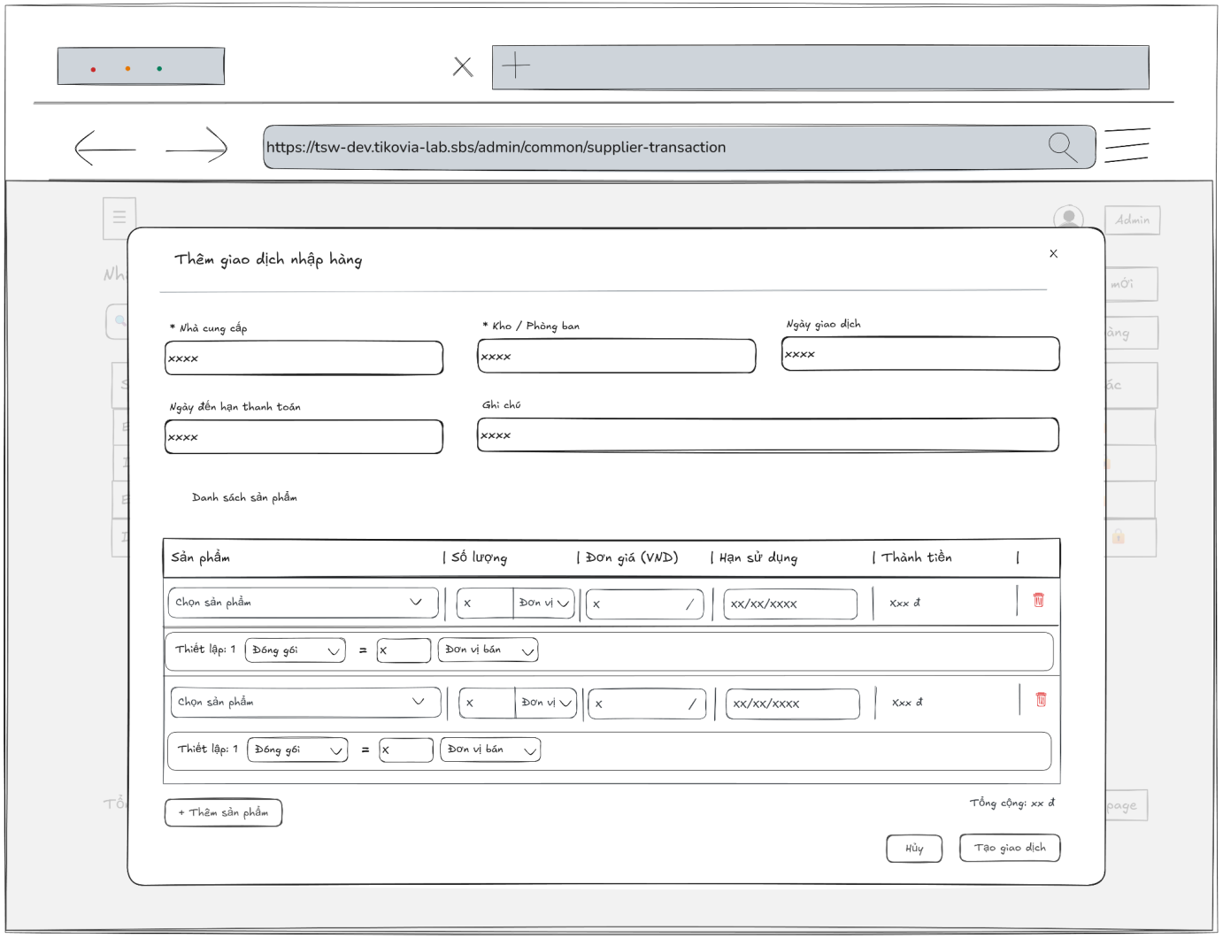
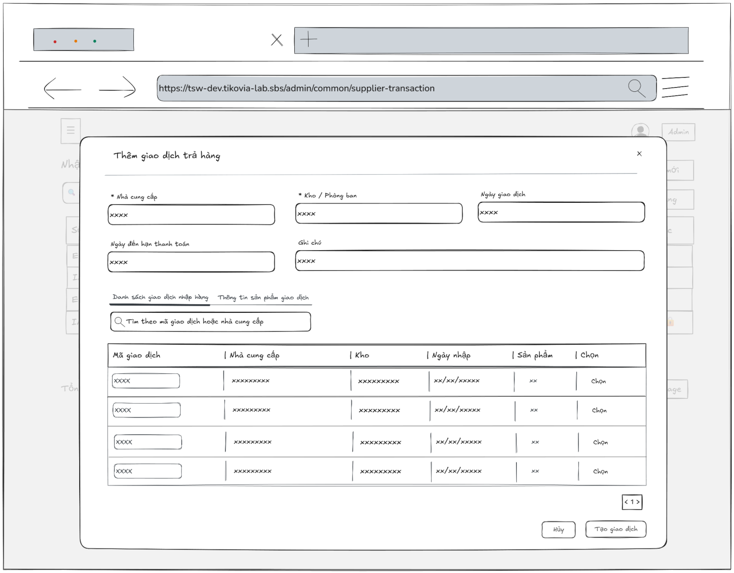
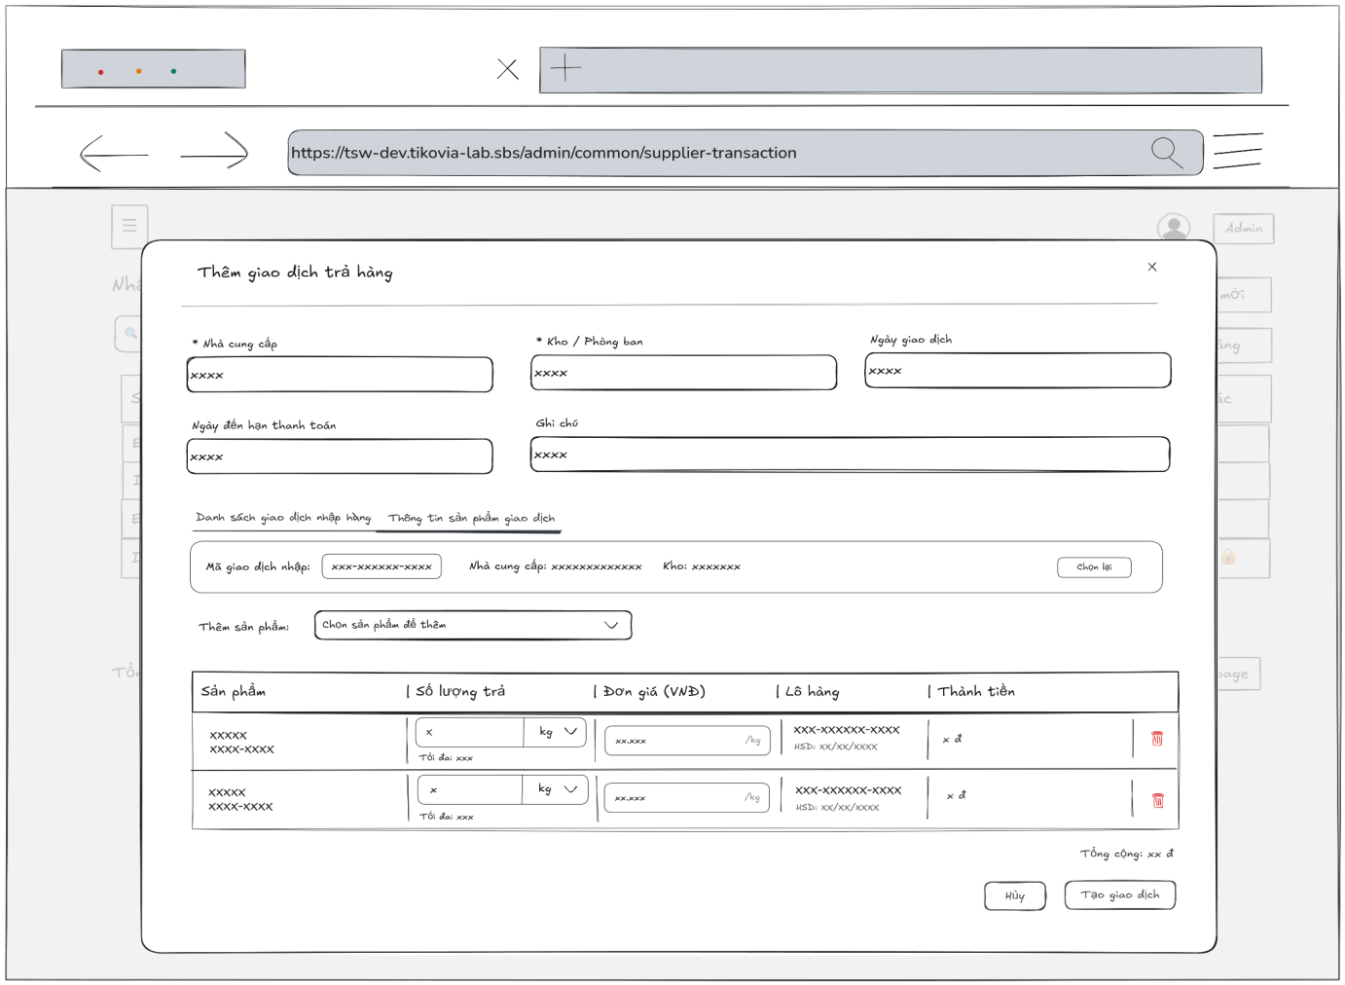
- Function Details:
  - Validation:
    - The user must be authenticated and have a valid role authorized to create supplier transactions.
    - The transaction date must follow the correct format (dd/mm/yyyy) and cannot be in the future.
    - The payment due date, if entered, must be greater than or equal to the transaction date.
    - The transaction must contain at least one valid product line item before submission.
    - The quantity and unit price for each product must be valid positive numbers.
    - For return transactions, the selected original import transaction must exist in the system.
    - For return transactions, the return quantity must not exceed the available quantity from the original import transaction.
    - The system shall validate that the conversion rate is a positive number if a packing unit is configured.
    - The system shall prevent the creation of the transaction if any mandatory field is left empty.
  - Functionality:
    - In Normal Cases:
      - After submitted the supplier transaction’s information success and the system validates a message will be displayed: “Thêm giao dịch thành công – Giao dịch nhập / xuất đã được tạo.”.
    - In Abnormal Cases:
      - No input Provided:
If the admin presses the submit button without any required field, the system will display an error message required field.
      - Server Error:
If there is an issue with the server when submitting the new supplier transaction’s information and create transaction, the system will notify: “Lỗi khi tạo giao dịch – Không thể tạo giao dịch."
  - Business rule: BR-19, BR-20, BR-22.

# | Component | Comp. type | Editable | Mandatory | Default Value | Description
 | Header Section (Shared)
1 | Title | Label (Text) | No | N/A | "Thêm giao dịch..." | Dynamic title based on context ("Nhập hàng" or "Trả hàng").
2 | Close Button | Button | No | No | N/A | Icon button (x) to close the modal.
 | General Information Section (Shared)
3 | Supplier Select | Dropdown (Search) | Yes | Yes | Placeholder: "Chọn nhà cung cấp" | Searchable dropdown to select the supplier. Marked with *.
4 | Warehouse Select | Dropdown (Search) | Yes | Yes | Placeholder: "Chọn kho / phòng ban" | Searchable dropdown to select the receiving warehouse. Marked with *.
5 | Transaction Date | Input (Date) | Yes | No | Placeholder: "dd/mm/yyyy" | Date picker for the transaction date.
6 | Due Date | Input (Date) | Yes | No | Placeholder: "dd/mm/yyyy" | Date picker for the payment due date.
7 | Note | Input (Text Area) | Yes | No | Placeholder: "Nhập ghi chú..." | Text input for additional remarks.
Content Section A: Import Transaction (Specific)

(Only visible when Mode = Import)
8 | Section Header | Label (Text) | No | N/A | "Danh sách sản phẩm" | Header for the product input table.
9 | Product Select | Dropdown (Select) | Yes | Yes | Placeholder: "Chọn sản phẩm" | Dropdown to select a product to add.
10 | Quantity Input | Input (Number) | Yes | Yes | Placeholder: "x" | Input for product quantity.
11 | Unit Select | Dropdown | Yes | Yes | Placeholder: "Đơn vị" | Select unit of measure for the quantity.
12 | Unit Price | Input (Currency) | Yes | No | Placeholder: "x" | Input for price per unit.
13 | Expiry Date | Input (Date) | Yes | No | Placeholder: "xx/xx/xxxx" | Date picker for product expiry (Hạn sử dụng).
14 | Line Total | Label (Currency) | No | N/A | "xxx đ" | Auto-calculated total (Quantity * Unit Price).
15 | Remove Item | Button (Icon) | No | No | N/A | Trash icon to remove the product row.
16 | Packaging Setup | Toggle/Group | Yes | No | Default: "Thiết lập: Đóng gói" | Optional row to define conversion rate (e.g., 1 Box = x Units).
17 | Add Product Button | Button | No | No | "+ Thêm sản phẩm" | Adds a new empty row to the product list.
Content Section B: Return Transaction (Specific)

(Only visible when Mode = Return)
18 | Tab Menu | Tabs | Yes | Yes | "Danh sách giao dịch nhập hàng" | Switch between "Select Import Transaction" (Tab 1) and "Transaction Product Details" (Tab 2).
 | Tab 1: Import List (Select Source)
19 | Search Import | Input (Search) | Yes | No | Placeholder: "Tìm theo mã giao dịch..." | Search for the original import transaction to return.
20 | Import List Table | Data Table | No | N/A | N/A | Columns: Mã giao dịch, Nhà cung cấp, Kho, Ngày nhập, Sản phẩm.
21 | Action: Select | Button (Text) | No | Yes | "Chọn" | Button to select an import transaction. Clicking this auto-switches to Tab 2.
 | Tab 2: Product Details (Return Items)
22 | Selected Import Info | Panel / Card | No | Yes | "Mã giao dịch nhập: {Code}..." | Displays summary of the selected import transaction (Read-only).
23 | Re-select Button | Button | No | No | "Chọn lại" | Allows re-opening Tab 1 to choose a different transaction.
24 | Add Product | Dropdown | Yes | No | Placeholder: "Chọn sản phẩm để thêm" | Adds items from the original invoice to the return list.
25 | Product Name/Code | Label (Text) | No | N/A | "{Name} - {Code}" | Product identifier.
26 | Return Quantity | Input (Number) | Yes | Yes | Placeholder: "x" | Quantity to return. Note: Must validate against "Tối đa: {n}" (Max qty).
27 | Unit Select | Dropdown | Yes | Yes | “kg” | Unit of measure.
28 | Return Price | Input (Currency) | Yes | No | Placeholder: "xx.xxx" | Price per unit for return (usually defaults to import price).
29 | Batch Info | Label (Text) | No | N/A | "{Batch Code} - HSD: {Date}" | Displays batch and expiry date of the product.
30 | Line Total | Label (Currency) | No | N/A | "xxx đ" | Auto-calculated total (Quantity * Unit Price).
31 | Remove Item | Button | No | No | N/A | Trash icon to remove item from return list.
 | Footer Section
32 | Total Label | Label (Text) | No | N/A | "Tổng cộng: xx đ" | Displays the sum of all line totals.
33 | Cancel Button | Button | No | No | "Hủy" | Closes modal.
34 | Create Button | Button | No | No | "Tạo giao dịch" | Submits the return transaction.

––––––––––––––––––––––––––––––––––––––––––––––––––––––––––––––––––––––––––––––––––-

3.6.9 - Update Supplier Transaction’s Information
- Function trigger: The Admin, Warehouse manager, Accountant accesses the Supplier Transaction page to view the list of supplier transactions and press edit button to update/edit information for a specific supplier transaction.
- Function description: To allow the Admin, Warehouse manager, Accountant to update information of the supplier transactions. The warehouse manager can not update unit prices.
- Screen layout:
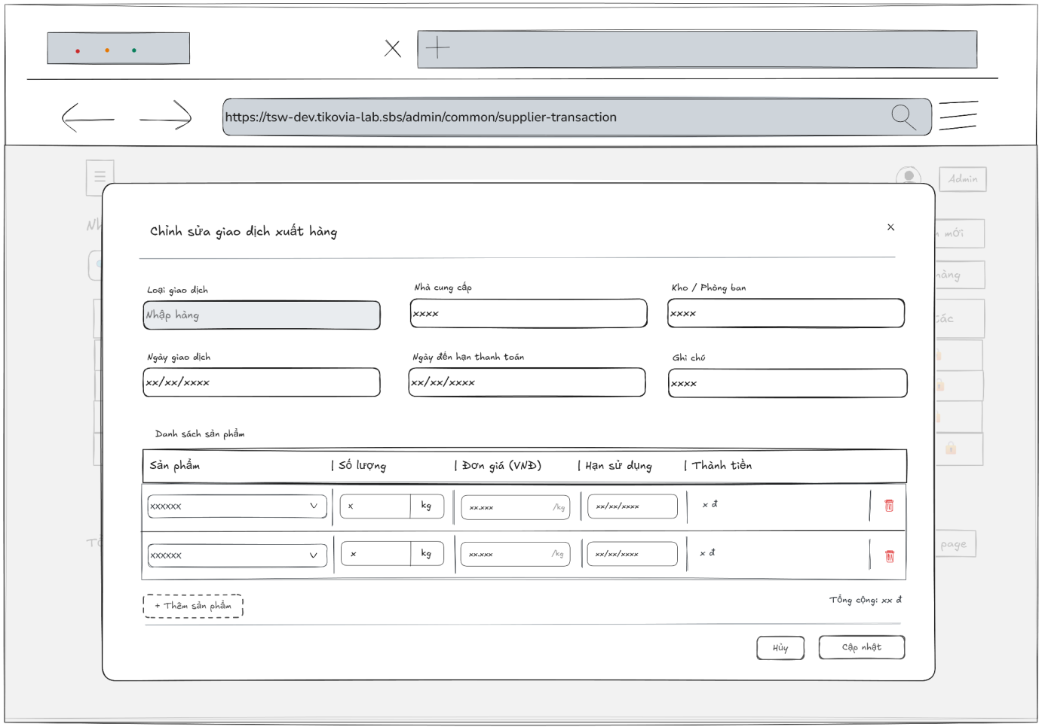

- Function Details:
  - Validation:
    - The user must be authenticated and hold a valid role (Admin, Warehouse manager, Accountant) to access the update function.
    - The system shall validate that the selected transaction exists and is currently in an editable status.
    - The system must enforce role-based restrictions, specifically preventing the "Warehouse manager" from modifying the "Unit Price" field.
    - The "Payment Due Date" must be greater than or equal to the "Transaction Date".
    - The "Quantity" and "Unit Price" must be valid positive numbers greater than zero.
    - The system shall prevent the update if any mandatory field (Supplier, Warehouse, Date) is left empty or contains invalid data formats.
  - Functionality:
    - In Normal Cases:
      - After pressing the button edit, the system displayed the supplier transaction’s information in the input box and it must match with the database.
      - The admin is able to edit supplier transaction’s information and can see a success message.
      - After pressing the “Cập nhật giao dịch” button to send the update request, the system validates and a success message is displayed “Cập nhật thành công – Giao dịch nhập / xuất đã được cập nhật.”
    - In Abnormal Cases:
      - Required fields blank: If required fields (e.g., Email, Username, Fullname, phone number, role, department) are left blank or contain invalid data (such as an incorrect email format or non-numeric phone number), the system will: Display an error message indicating which fields are missing or invalid and prevent saving until all required fields are correctly filled.
      - Server Error: If the server encounters an internal error (e.g., database timeout or server crash) during the update process, the system will show a message like “Server error occurred. Please try again later.”
  - Business rule: BR-19, BR-20, BR-22.

# | Component | Comp. type | Editable | Mandatory | Default Value | Description
 | Header Section
1 | Title | Label (Text) | No | N/A | "Chỉnh sửa giao dịch xuất hàng" | Title of the modal.
2 | Close Button | Button | No | No | N/A | Icon button (x) to close the modal without saving.
 | General Information Section
3 | Transaction Type | Input (Text) | No | Yes | Dữ liệu hiện tại | Displays the type (e.g., "Nhập hàng"). Disabled/Read-only state (gray background).
4 | Supplier Select | Dropdown (Search) | Yes | Yes | Dữ liệu hiện tại | Selected supplier. Can be changed.
5 | Warehouse Select | Dropdown (Search) | Yes | Yes | Dữ liệu hiện tại | Selected warehouse/facility. Can be changed.
6 | Transaction Date | Input (Date) | Yes | No | Dữ liệu hiện tại | Date the transaction occurred.
7 | Due Date | Input (Date) | Yes | No | Dữ liệu hiện tại | Payment due date.
8 | Note | Input (Text Area) | Yes | No | Dữ liệu hiện tại | Additional remarks.
 | Product List Section
9 | Section Header | Label (Text) | No | N/A | "Danh sách sản phẩm" | Header for the product table.
10 | Product Select | Dropdown (Search) | Yes | Yes | Dữ liệu hiện tại | Dropdown to change the product if needed.
11 | Quantity Input | Input (Number) | Yes | Yes | Dữ liệu hiện tại | Input for product quantity.
12 | Unit Select | Dropdown | Yes | Yes | Dữ liệu hiện tại | Unit of measure (e.g., kg, box).
13 | Unit Price | Input (Currency) | Yes | No | Dữ liệu hiện tại | Price per unit.
14 | Expiry Date | Input (Date) | Yes | No | Dữ liệu hiện tại | Expiry date of the product batch.
15 | Line Total | Label (Currency) | No | N/A | Dữ liệu hiện tại | Auto-calculated total (Quantity * Unit Price).
16 | Remove Item | Button (Icon) | No | No | N/A | Trash icon to remove the product row.
17 | Add Product Button | Button (Dashed) | No | No | "+ Thêm sản phẩm" | Adds a new empty row to the product list.
 | Footer Section
18 | Total Label | Label (Text) | No | N/A | "Tổng cộng: xx đ" | Displays the sum of all line totals.
19 | Cancel Button | Button | No | No | "Hủy" | Closes the modal and discards changes.
20 | Update Button | Button | No | No | "Cập nhật" | Submits the form to update the transaction.
––––––––––––––––––––––––––––––––––––––––––––––––––––––––––––––––––––––––––––––––––-

3.7 Accounting and Financial Tracking

3.7.1 - View list of Supplier Transaction Payment
- Function trigger: The Admin, Accountant clicks on the “Supplier Transaction Payment” button and navigates to the Supplier Transaction Payment page through the sidebar to view the list of supplier transaction payments in the system.
- Function description: To view a list of supplier transaction payments with the information about a supplier transaction payment.
- Screen layout:
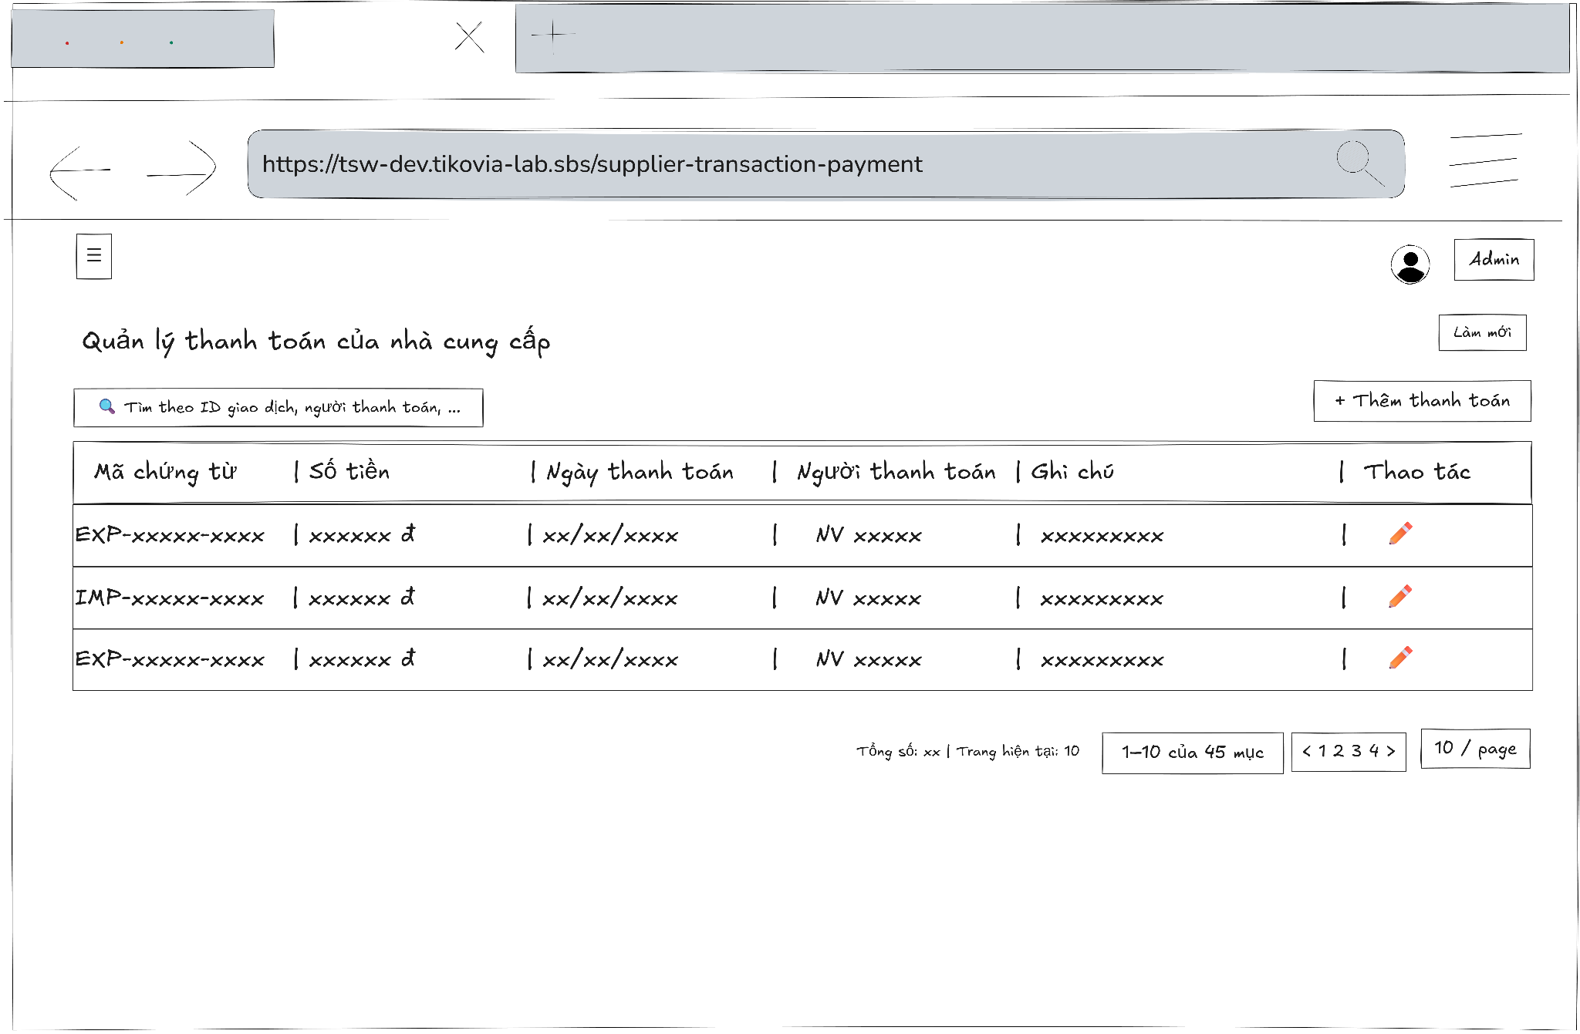
- Function Details:
  - Validation:
    - The user must be authenticated and logged into the system.
    - The user must have a valid role: Admin, Accountant.
    - The Supplier Transaction Payment page must be accessible only to authorized users.
    - The supplier transaction payment data must exist in the system.
    - The system shall validate user access permissions before displaying the supplier transaction payment list.
    - The payment data (Document No, total amount, payment date, payer, notes) must be retrieved correctly and consistently from the database.
    - The displayed payment information must match the stored payment records.
    - If no supplier transaction payment data exists, the system must display “No data”.
  - Functionality:
    - In Normal Cases:
      - After clicking on "Supplier transaction payment", the system displays the supplier transaction payment list with the information about a supplier transaction payment, such as the Document No, total amount, payment date, payer, notes.
    - In Abnormal Cases:
      - No Supplier Transaction Payment Data Found: If there is no data of supplier transaction payment list in the system will display “No data”.
      - Connection Issues: If there's a server issue, the system will notify the users: "Không thể tải dữ liệu. Đã xảy ra lỗi khi tải danh sách thanh toán của nhà cung cấp"
  - Business rule: BR-22.

# | Component | Comp. type | Editable | Mandatory | Default Value | Description
 | Header Section
1 | Title | Label (Text) | No | Yes | "Quản lý thanh toán của nhà cung cấp" | Displays the main title of the page.
2 | Search Input | Input (Search) | Yes | No | "Tìm theo ID giao dịch, người thanh toán,..." | Placeholder text. Allows searching by Transaction ID or Payer name.
3 | Refresh Button | Button | No | Yes | “Làm mới” | Reloads the data table list.
4 | Import Button | Button | No | Yes | “+ Nhập hàng” | Open the "Create Import Transaction" screen/modal.
5 | Return Button | Button | No | Yes | "+ Trả hàng" | Opens the "Create Return Transaction" screen/modal.
 | Data Table List
6 | Column Headers | Label (Text) | No | Yes | "Số chứng từ | Loại | Trạng thái | Ngày giao dịch..." | Headers defining the data columns: Transaction Code, Type, Status, Date, Due Date, Total, Paid, Actions.
7 | Row Data (Sample) | Table Row | No | Yes | Dữ liệu hiện tại | Displays the content of each transaction record.
8 | Action: Edit | Icon Button | No | Yes | (Pencil Icon) | Opens the edit screen/modal for the selected transaction.
9 | Action: Delete | Icon Button | No | Yes | (Trash Icon) | Opens the edit screen/modal for the selected transaction.
10 | Action: Lock | Icon Button | No | Yes | (Padlock Icon) | Indicator or toggle for locked transactions (cannot be edited).
 | Footer Section
11 | Summary Info | Label (Text) | No | Yes | "Tổng số: n | Trang hiện tại: n" | Displays overview statistics of the records.
12 | Status Filters | Button Group | No | Yes | "Nhập | Đang chờ | Đã thanh toán | Huỷ" | Quick filter tabs with count badges (e.g., "Đang chờ 3") to filter the list by status.
13 | Range Display | Label (Text) | No | Yes | "x - y của z giao dịch" | Indicates which subset of records is currently visible.
14 | Page Navigation | Pagination Control | No | Yes | "< 1 2 3 4 >" | Navigation controls to jump between pages.
15 | Page Size Selector | Dropdown | No | Yes | "x / page" | Controls the number of rows displayed per page.

––––––––––––––––––––––––––––––––––––––––––––––––––––––––––––––––––––––––––––––––––-

3.7.2 - View Supplier Transaction Payment Detail Information
- Function trigger: The Admin, Accountant accesses the Supplier Transaction Payment page and clicks on the selected user to display a popup with supplier transaction payment’s information.
- Function description: Allow Admin, Accountant to view supplier transaction payments information details.
- Screen layout
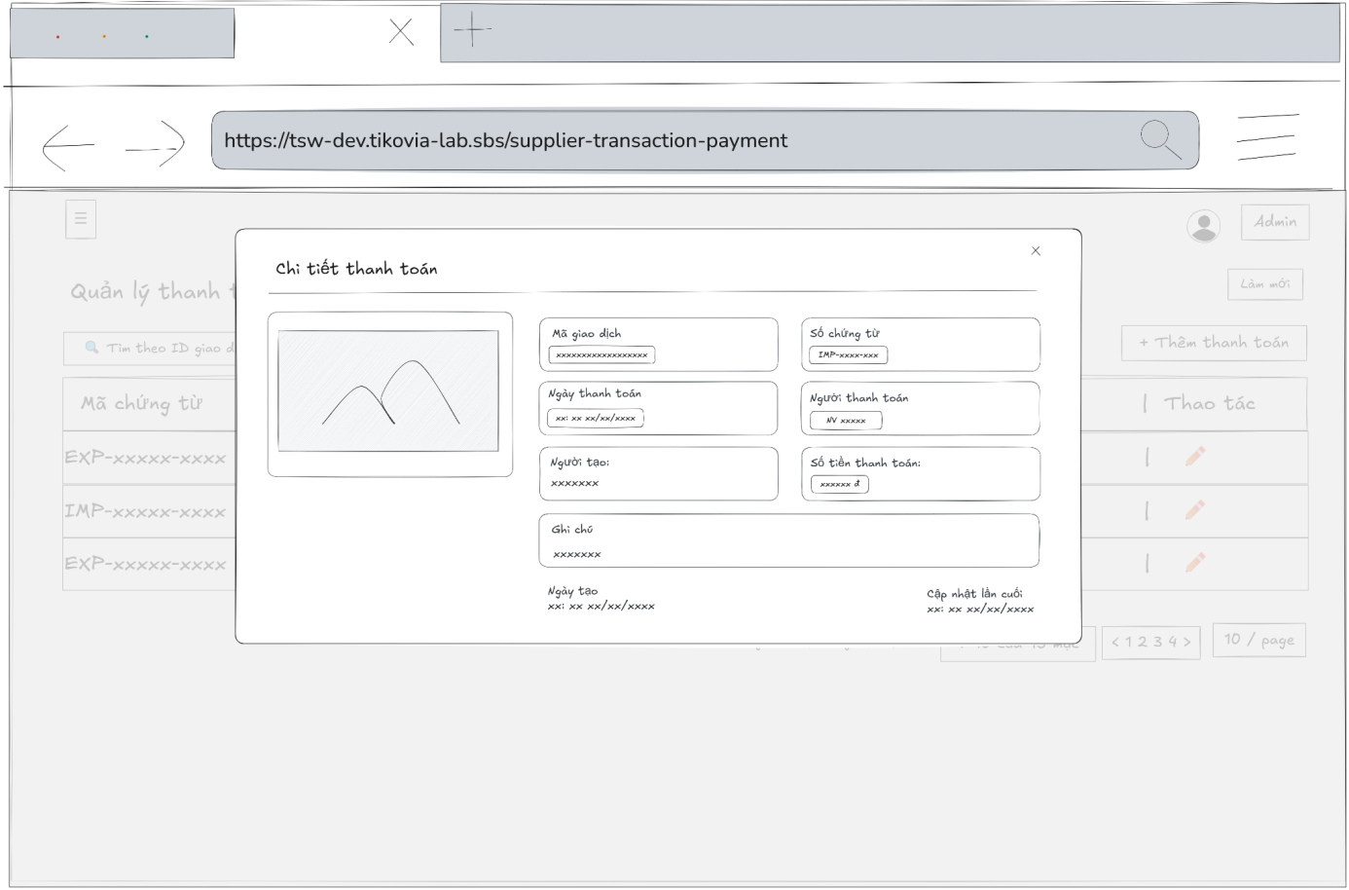
- Function Details:
  - Validation:
    - The user must be authenticated and logged into the system.
    - The user must have a valid role: Admin, Accountant.
    - The selected supplier transaction payment must exist in the system.
    - The system shall validate user access permissions before displaying supplier transaction payment details.
    - The supplier transaction payment detail data (Document No, transaction ID, payment date, payer, notes, created/updated information) must be retrieved correctly and consistently from the database.
    - All displayed fields must match the stored supplier transaction payment record.
  - Functionality:
    - In Normal Cases:
      - The system displays all the detailed information about supplier transaction payments correctly.
    - In Abnormal Cases:
      - Server Error: If there is an issue with the server when fetch data, the system display no data
  - Business rule: BR-22.

# | Component | Comp. type | Editable | Mandatory | Default Value | Description
 | Header Section
1 | Modal Title | Label (Text) | No | N/A | "Chi tiết thanh toán" | Title of the modal.
2 | Close Button | Button (Icon) | No | No | N/A | Icon button (x) to close the modal.
 | Content Section (Left Column)
3 | Proof Image | Image / Preview | No | N/A | Dữ liệu hiện tại | Displays the attached image of the receipt or proof of payment.
 | Content Section (Right Column)
4 | Transaction Code | Label (Text) | No | N/A | Dữ liệu hiện tại | Displays the unique transaction ID ("Mã giao dịch").
5 | Document Number | Label (Text) | No | N/A | Dữ liệu hiện tại | Displays the related document code (e.g., IMP-xxxx).
6 | Payment Date | Label (Date) | No | N/A | Dữ liệu hiện tại | The date the payment was made.
7 | Payer | Label (Text) | No | N/A | Dữ liệu hiện tại | Name or ID of the person who performed the payment ("Người thanh toán").
8 | Creator | Label (Text) | No | N/A | Dữ liệu hiện tại | Name or ID of the user who created this record ("Người tạo").
9 | Payment Amount | Label (Currency) | No | N/A | Dữ liệu hiện tại | The total amount paid ("Số tiền thanh toán").
10 | Note | Label (Text Area) | No | N/A | Dữ liệu hiện tại | Additional remarks or notes ("Ghi chú").
 | Footer Section
11 | Created Date | Label (Date) | No | N/A | Dữ liệu hiện tại | Timestamp showing when the record was created ("Ngày tạo").
12 | Last Updated | Label (Date) | No | N/A | Dữ liệu hiện tại | Timestamp showing the last modification ("Cập nhật lần cuối").

––––––––––––––––––––––––––––––––––––––––––––––––––––––––––––––––––––––––––––––––––-

3.7.3 - Add Supplier Transaction Payment
- Function trigger: The Admin, Accountant accesses the Supplier Transaction Payments page and clicks the button “Thêm thanh toán” to display a popup with input box.
- Function description: Allow Admin, Accountant to add a new supplier transaction payment
- Screen layout:
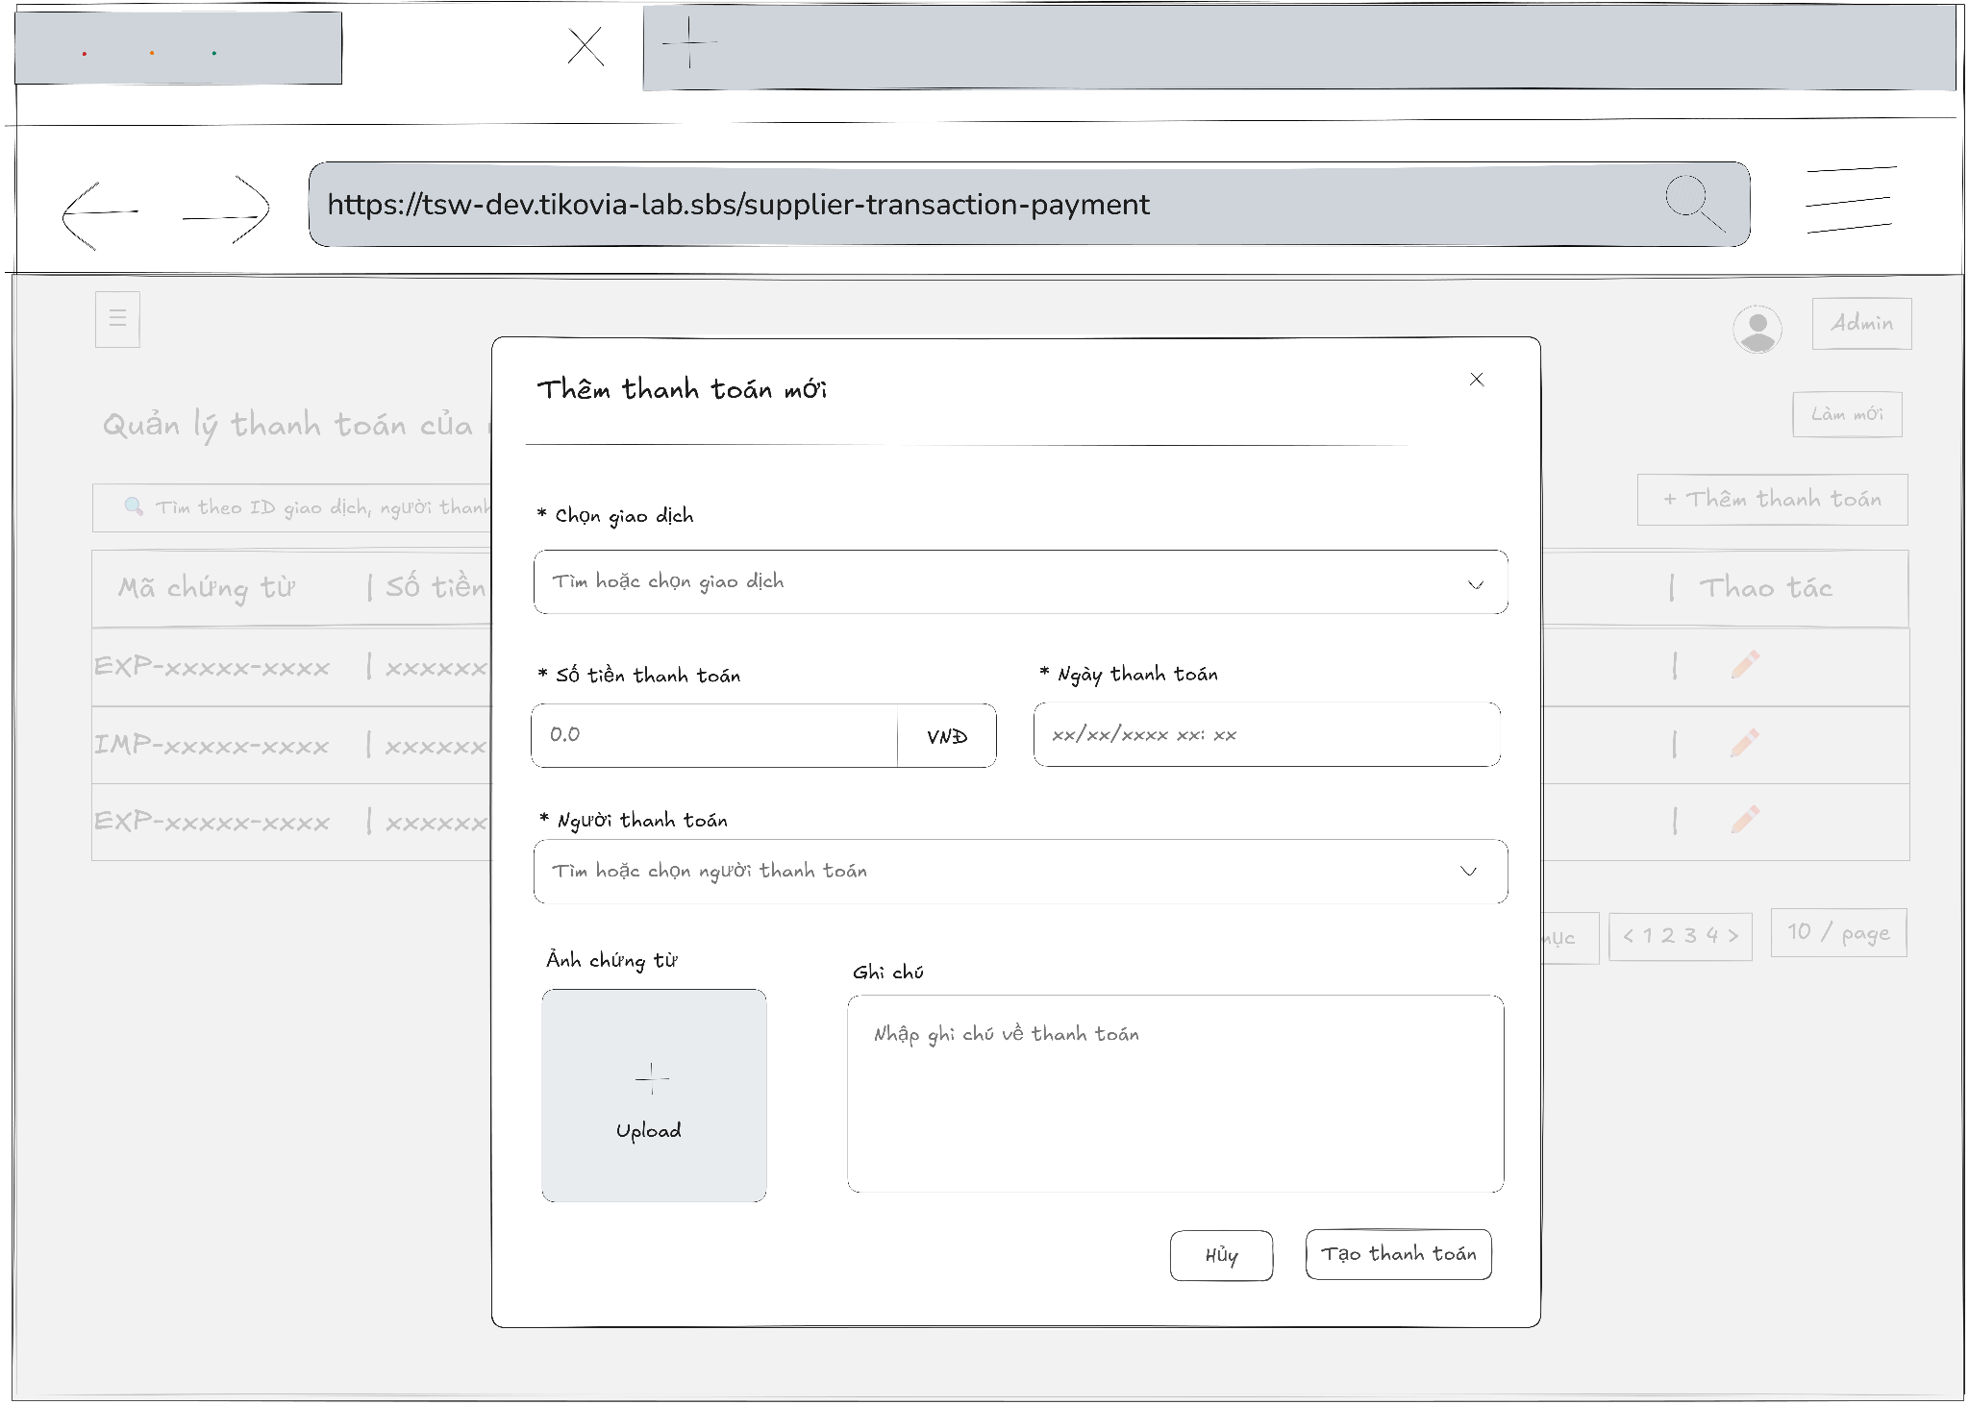
- Function Details:
  - Validation:
    - The user must be authenticated and logged into the system.
    - The user must have a valid role: Admin or Accountant.
    - The system shall validate access permission before allowing the user to add a supplier transaction payment.
    - Required fields must be provided, including: Supplier transaction, Payment amount, Payment date, Payer.
    - The payment amount must be a valid numeric value greater than zero.
    - The payment date must be a valid date and must not be later than the current system date.
    - The selected payer must exist in the system.
    - All payment data must be validated and stored consistently in the database.
  - Functionality:
    - In Normal Cases:
      - After submitting the supplier transaction’s information success and the system validates a message will be displayed: “Thêm thanh toán thành công”.
    - In Abnormal Cases:
      - No input Provided:
If the Admin, Accountant presses the submit button without any required field, the system will display an error message required field.
      - Server Error:
If there is an issue with the server when submitting the new supplier transaction’s information and create transaction, the system will notify: “Lỗi khi tạo thanh toán"
  - Business rule: BR-19.

# | Component | Comp. type | Editable | Mandatory | Default Value | Description
 | Header Section
1 | Modal Title | Label (Text) | No | N/A | "Thêm thanh toán mới" | Title of the modal.
2 | Close Button | Button (Icon) | No | No | N/A | Icon button (x) to close the modal.
 | Form Section
3 | Transaction Select | Dropdown (Search) | Yes | Yes | Placeholder: "Tìm hoặc chọn giao dịch" | Searchable dropdown to link the payment to a specific transaction ID. Marked with *.
4 | Payment Amount | Input (Currency) | Yes | Yes | Placeholder: "0.0" | Input for the payment amount. Includes the "VNĐ" suffix unit. Marked with *.
5 | Payment Date | Input (DateTime) | Yes | Yes | Placeholder: "xx/xx/xxxx xx:xx" | Date and time picker for when the payment occurred. Marked with *.
6 | Payer Select | Dropdown (Search) | Yes | Yes | Placeholder: "Tìm hoặc chọn người thanh toán" | Select the person/staff who performed the payment. Marked with *.
7 | Proof Upload | Upload (Image) | Yes | No | Label: "+ Upload" | Drag & drop or click area to upload an image of the receipt/proof.
8 | Note | Input (Text Area) | Yes | No | Placeholder: "Nhập ghi chú về thanh toán" | Multi-line text input for additional remarks.
 | Footer Section
9 | Cancel Button | Button | No | No | "Hủy" | Closes the modal without creating the payment.
10 | Create Button | Button (Primary) | No | No | "Tạo thanh toán" | Submits the form to record the new payment.

––––––––––––––––––––––––––––––––––––––––––––––––––––––––––––––––––––––––––––––––––-

3.7.4 - Update Supplier Transaction Payment’s Information
- Function trigger: The Admin, Accountant accesses the Supplier Transaction Payments page to view the list of supplier transaction payments and press edit button to update/edit information for a specific supplier transaction payments.
- Function description: To allow the Admin, Accountant to update information of the supplier transaction payments.
- Screen layout:
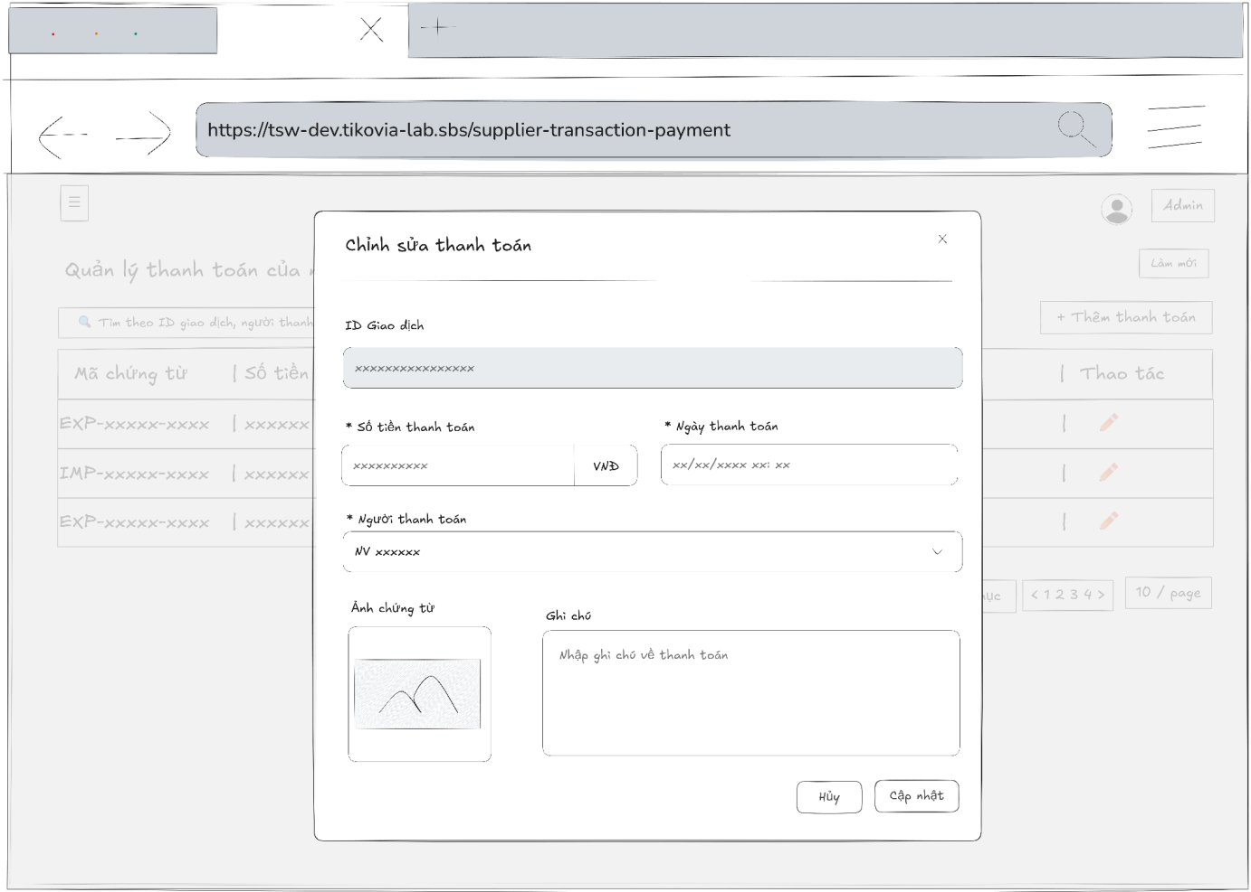
- Function Details:
  - Validation:
    - The user must be authenticated and logged into the system.
    - The user must have a valid role: Admin or Accountant.
    - The selected supplier transaction payment must exist in the system.
    - Required fields must be provided, including: Payment amount, Payment date, Payer
    - The payment amount must be a valid numeric value greater than zero.
    - The payment date must be a valid date and must not be later than the current system date.
  - Functionality:
    - In Normal Cases:
      - After pressing the button edit, the system displayed the supplier transaction payment’s information in the input box and it must match with the database.
      - The admin is able to edit supplier transaction payment’s information and can see a success message.
      - After pressing the “Cập nhật” button to send the update request, the system validates and a success message is displayed “Cập nhật thành công"
    - In Abnormal Cases:
      - Required fields blank: If required fields are left blank or contain invalid data , the system will: Display an error message indicating which fields are missing or invalid and prevent saving until all required fields are correctly filled.
      - Server Error: If the server encounters an internal error (e.g., database timeout or server crash) during the update process, the system will show a message like “Server error occurred. Please try again later.”
  - Business rule: BR-19.

# | Component | Comp. type | Editable | Mandatory | Default Value | Description
 | Header Section
1 | Modal Title | Label (Text) | No | N/A | "Chỉnh sửa thanh toán" | Title of the modal.
2 | Close Button | Button (Icon) | No | No | N/A | Icon button (x) to close the modal.
 | Form Section
3 | Transaction ID | Input (Text) | No | Yes | Dữ liệu hiện tại | Displays the linked transaction ID. Disabled/Read-only state (gray background).
4 | Payment Amount | Input (Currency) | Yes | Yes | Dữ liệu hiện tại | Input for the payment amount. Includes "VNĐ" suffix. Marked with *.
5 | Payment Date | Input (DateTime) | Yes | Yes | Dữ liệu hiện tại | Date and time picker (xx/xx/xxxx xx:xx). Marked with *.
6 | Payer Select | Dropdown (Search) | Yes | Yes | Dữ liệu hiện tại | Select the person who performed the payment. Marked with *.
7 | Proof Image | Upload (Preview) | Yes | No | Dữ liệu hiện tại | Displays current proof image. Clicking allows viewing or uploading a replacement.
8 | Note | Input (Text Area) | Yes | No | Dữ liệu hiện tại | Multi-line text input for editing remarks.
 | Footer Section
9 | Cancel Button | Button | No | No | "Hủy" | Closes the modal and discards changes.
10 | Update Button | Button (Primary) | No | No | "Cập nhật" | Submits the form to update the payment record.

––––––––––––––––––––––––––––––––––––––––––––––––––––––––––––––––––––––––––––––––––-

3.7.5 - Customer Payments List
- Function trigger: A user with the role of Admin, Sell Staff, or Accountant navigates to the "Customer Payment Management" page.
- Function description: Allows Admin, Sell Staff, or Accountant to view, search, and manage a list of all customer payments.
- Screen layout:
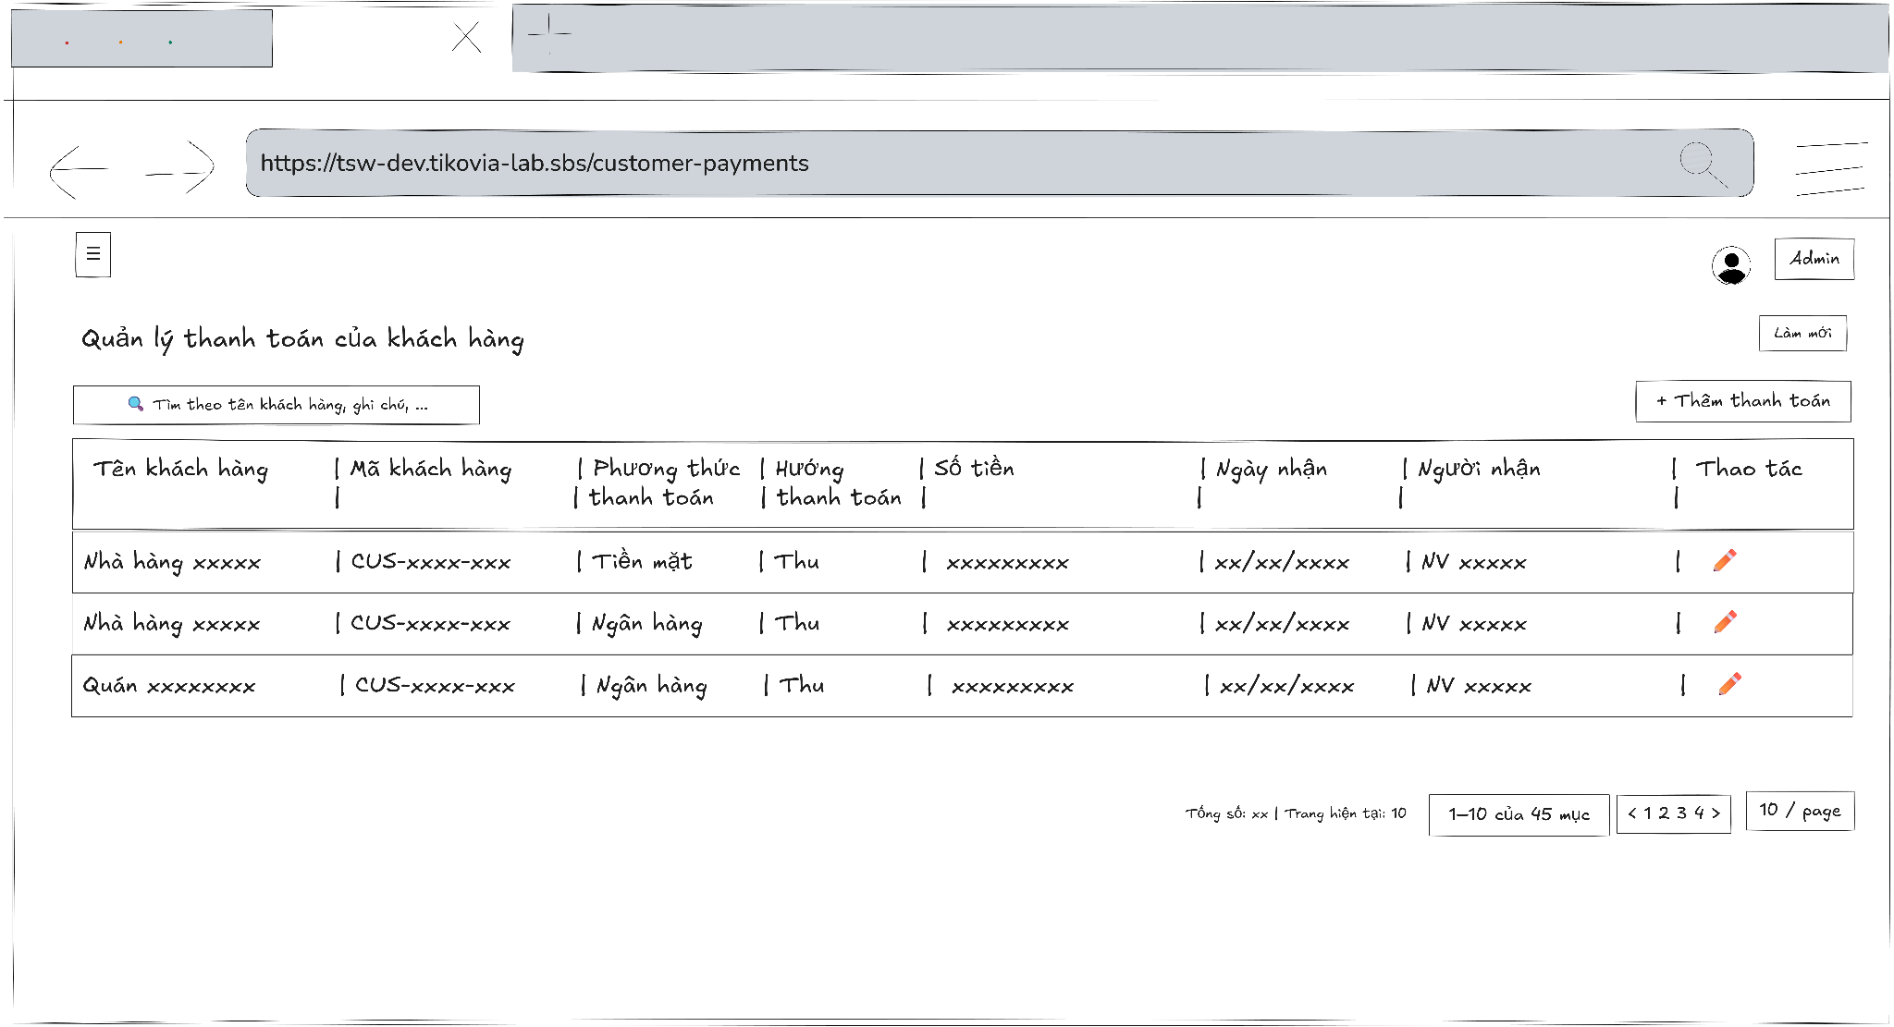
- Function Details:
  - Validation:
    - The user must be authenticated and logged into the system.
    - The user must have a valid role: Admin, Sell Staff, or Accountant.
    - The system must verify access permission before displaying customer payment data.
    - Customer payment data must be retrieved correctly from the database.
    - Displayed payment information (customer, method, amount, date, receiver) must be accurate and consistent.
  - Functionality:
    - In Normal Cases:
      - The page displays the table populated with the list of customer payments.
    - In Abnormal Cases:
      - No customer payment Data Found: If there is no data of customer payment in the system will display “No data”.
      - Connection Issues: An error message and retry button are shown: “An error occurred while loading customer payment. Please try again.”
  - Business rule: N/A.

# | Component | Comp. type | Editable | Mandatory | Default Value | Description
 | Header & Toolbar (Filter & Actions)
1 | Screen Title | Label (Text) | No | Yes | "Quản lý thanh toán của khách hàng" | Displays the main title of the page.
2 | Search Input | Input (Search) | Yes | No | "Tìm theo tên khách hàng, ghi chú, ..." | Placeholder text. Allows searching by Customer Name or Notes.
3 | Refresh Button | Button (Secondary) | No | Yes | "Làm mới" | Reloads the data table list.
4 | Add Payment Button | Button (Primary) | No | Yes | "+ Thêm thanh toán" | Opens the "Add New Customer Payment" modal/screen.
 | Data Table List
5 | Column Headers | Label (Text) | No | Yes | "Tên khách hàng | Mã khách hàng | Phương thức..." | Headers: Customer Name, Customer Code, Payment Method, Payment Direction, Amount, Received Date, Receiver, Actions.
6 | Row Data (Sample) | Table Row | No | Yes | "Nhà hàng xxxxx | CUS-xxxx-xxx | Tiền mặt..." | Displays the content of each payment record. Note: "Hướng thanh toán" shows "Thu" (Collection/Inbound).
7 | Action: Edit | Icon Button | No | Yes | (Pencil Icon) | Opens the edit screen/modal for the selected payment record.
 | Footer Section (Summary & Pagination)
8 | Summary Info | Label (Text) | No | Yes | "Tổng số: xx | Trang hiện tại: 10" | Displays overview statistics of the records.
9 | Range Display | Label (Text) | No | Yes | "1–10 của 45 mục" | Indicates which subset of records is currently visible.
10 | Page Navigation | Pagination Control | Yes | Yes | "< 1 2 3 4 >" | Navigation controls to jump between pages.
11 | Page Size Selector | Dropdown | Yes | Yes | "10 / page" | Controls the number of rows displayed per page.

––––––––––––––––––––––––––––––––––––––––––––––––––––––––––––––––––––––––––––––––––-

3.7.6 - Customer Payment Detail
- Function trigger: Admin, Accountant, Sell staff access the Customer Payments page and click on a payment row to view its details in a modal.
- Function description: Allows Admin, Accountant, Sell staff to view detailed information about a specific customer payment, including metadata and invoice allocations.
- Screen layout
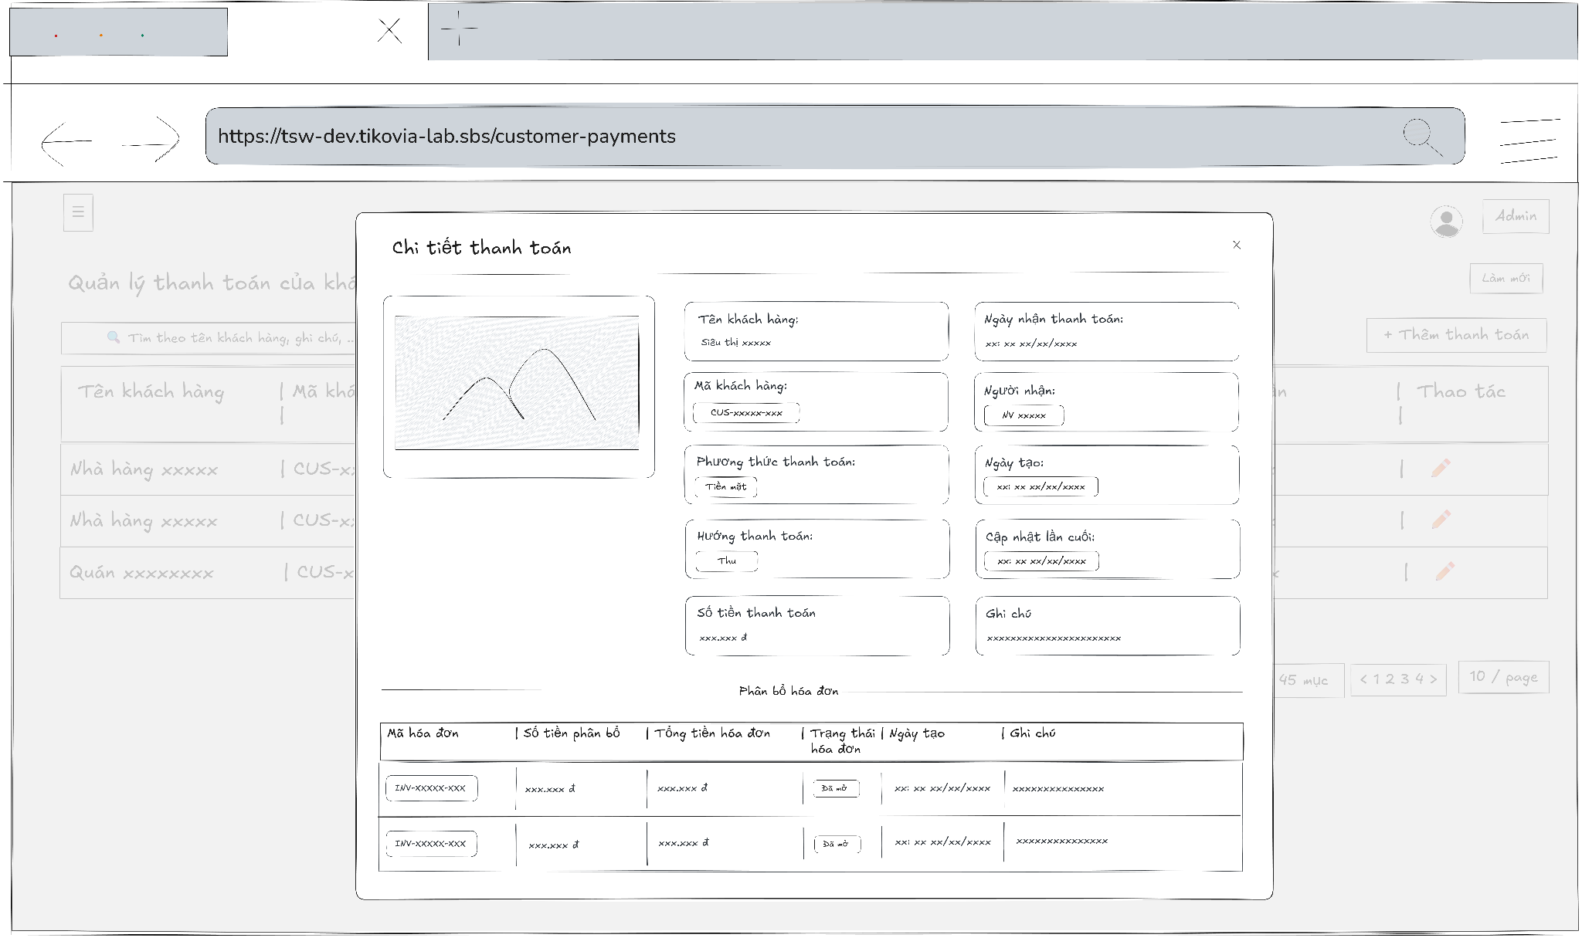
- Function Details:
  - Validation:
    - The user must be authenticated and logged into the system.
    - The user must have a valid role: Admin, Accountant, or Sell staff.
    - The selected customer payment must exist in the system.
    - The system must verify access permission before displaying payment details.
    - Payment metadata and invoice allocation data must be loaded correctly from the database.
  - Functionality:
    - In Normal Cases:
      - The system displays all customer payment metadata and associated invoice allocations.
    - In Abnormal Cases:
      - No Invoice Allocations: A message is displayed: "No invoices allocated to this payment."
      - Connection Issues or server Error: An error message and close button are shown: "An error occurred while loading payment details. Please try again.”
  - Business rule: N/A.

# | Component | Comp. type | Editable | Mandatory | Default Value | Description
 | Header Section
1 | Modal Title | Label (Text) | No | N/A | "Chi tiết thanh toán" | Title of the modal.
2 | Close Button | Button (Icon) | No | No | N/A | Icon button (x) to close the modal.
 | General Information Section
3 | Proof Image | Image / Preview | No | N/A | Dữ liệu hiện tại | Displays the attached image of the receipt/proof (Left side).
4 | Customer Name | Label (Text) | No | N/A | Dữ liệu hiện tại | Displays the customer's name ("Tên khách hàng").
5 | Customer Code | Label (Text) | No | N/A | Dữ liệu hiện tại | Displays the customer's unique ID ("Mã khách hàng").
6 | Payment Method | Label (Text) | No | N/A | Dữ liệu hiện tại | e.g., "Tiền mặt", "Chuyển khoản" ("Phương thức thanh toán").
7 | Payment Direction | Label (Text) | No | N/A | "Thu" | Indicates money in ("Hướng thanh toán").
8 | Payment Amount | Label (Currency) | No | N/A | Dữ liệu hiện tại | Total amount paid ("Số tiền thanh toán").
9 | Received Date | Label (DateTime) | No | N/A | Dữ liệu hiện tại | Date and time payment was received ("Ngày nhận thanh toán").
10 | Receiver | Label (Text) | No | N/A | Dữ liệu hiện tại | Staff who received the payment ("Người nhận").
11 | Created Date | Label (DateTime) | No | N/A | Dữ liệu hiện tại | Record creation timestamp ("Ngày tạo").
12 | Last Updated | Label (DateTime) | No | N/A | Dữ liệu hiện tại | Last modification timestamp ("Cập nhật lần cuối").
13 | Note | Label (Text) | No | N/A | Dữ liệu hiện tại | Additional remarks ("Ghi chú").
 | Invoice Allocation Section
14 | Section Header | Label (Title) | No | N/A | "Phân bổ hóa đơn" | Header for the table below ("Allocation Section").
15 | Allocation Table | Data Table | No | N/A | N/A | List of invoices paid by this transaction. Columns: Mã hóa đơn, Số tiền phân bổ, Tổng tiền hóa đơn, Trạng thái, Ngày tạo, Ghi chú.

––––––––––––––––––––––––––––––––––––––––––––––––––––––––––––––––––––––––––––––––––-

3.7.7 - Add new Customer Payment
- Function trigger: Users with the roles admin or accountant access the Customer Payments page and click the “Thêm thanh toán” button to open a modal for input.
- Function description: Allows Admin, Accountant to create a new customer payment and allocate it to one or more sales invoices.
- Screen layout:
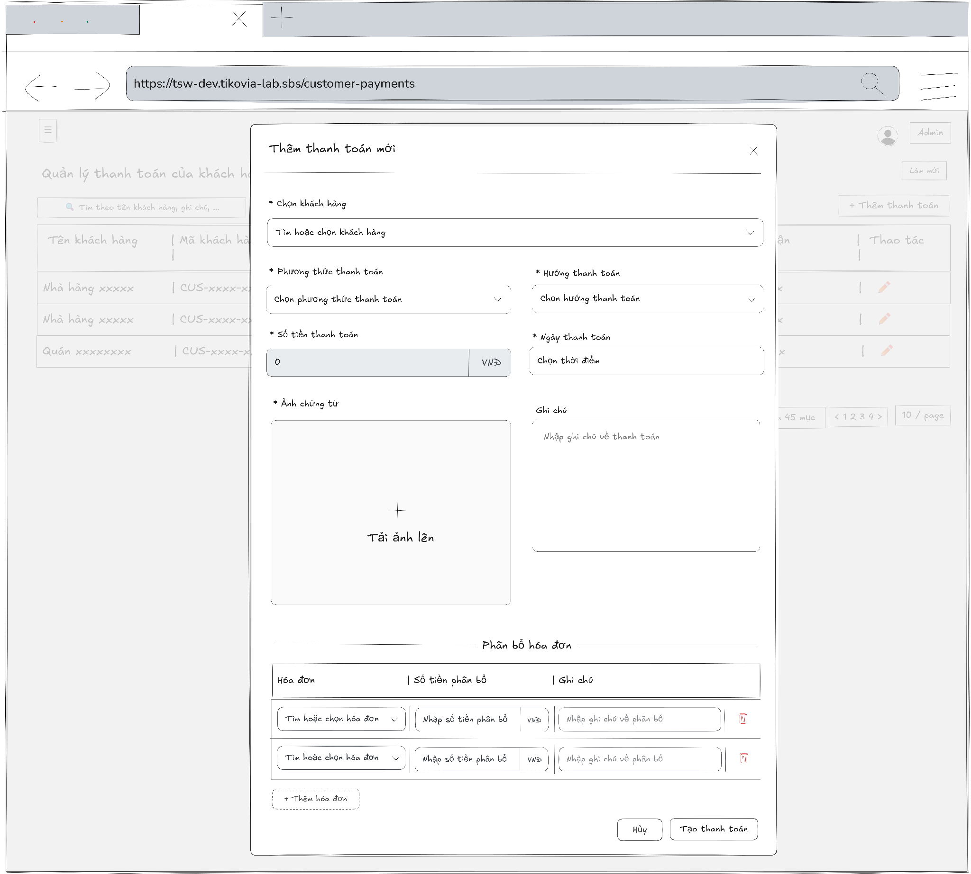
- Function Details:
  - Validation:
    - The user must be authenticated and logged into the system.
    - The user must have a valid role: Admin or Accountant.
    - Required fields (Customer, Payment Method, Payment Direction, Amount, Payment Date) must not be empty.
    - The payment amount must be greater than zero.
    - At least one sales invoice must be selected and allocated.
    - The total allocated amount must not exceed the payment amount.
  - Functionality:
    - In Normal Cases:
      - After the user submits the payment and the system validates successfully, a message is displayed: "Payment created successfully."
    - In Abnormal Cases:
      - Missing or Invalid Fields: If the submit button is pressed without filling all required fields, the system displays an error message indicating the missing or invalid fields.
      - No Invoice Allocations: If no invoices are allocated to the payment, the system displays a warning message.
      - Connection Issues / Server Error: If there is an issue with the server when submitting the new payment, the system notifies the user: "An error occurred while creating the payment. Please try again."
  - Business rule: BR-19, BR-24.

# | Component | Comp. type | Editable | Mandatory | Default Value | Description
 | Header Section
1 | Modal Title | Label (Text) | No | N/A | "Thêm thanh toán mới" | Title of the modal.
2 | Close Button | Button (Icon) | No | No | N/A | Icon button (x) to close the modal.
 | General Info Section
3 | Customer Select | Dropdown (Search) | Yes | Yes | Placeholder: "Tìm hoặc chọn khách hàng" | Searchable dropdown to select the customer. Marked with *.
4 | Payment Method | Dropdown | Yes | Yes | Placeholder: "Chọn phương thức..." | Select method (Cash, Bank Transfer...). Marked with *.
5 | Payment Direction | Dropdown | Yes | Yes | Placeholder: "Chọn hướng thanh toán" | Select direction (Thu/Chi). Usually defaults to "Thu" (Inbound). Marked with *.
6 | Payment Amount | Input (Currency) | Yes | Yes | Placeholder: "0" | Total payment amount received. Unit: "VNĐ". Marked with *.
7 | Payment Date | Input (DateTime) | Yes | Yes | Placeholder: "Chọn thời điểm" | Date and time picker. Marked with *.
8 | Proof Upload | Upload (Zone) | Yes | Yes | Label: "+ Tải ảnh lên" | Large area to upload proof image. Marked with *.
9 | Note | Input (Text Area) | Yes | No | Placeholder: "Nhập ghi chú về thanh toán" | Multi-line input for general remarks.
 | Allocation Section
10 | Section Header | Label (Text) | No | N/A | "Phân bổ hóa đơn" | Divider and title for the allocation list.
11 | Invoice Select | Dropdown (Search) | Yes | Yes | Placeholder: "Tìm hoặc chọn hóa đơn" | Select unpaid invoices related to this customer.
12 | Allocated Amount | Input (Currency) | Yes | Yes | Placeholder: "Nhập số tiền phân bổ" | Amount to apply to the selected invoice.
13 | Allocation Note | Input (Text) | Yes | No | Placeholder: "Nhập ghi chú về phân bổ" | Specific note for this allocation line.
14 | Remove Row | Button (Icon) | No | No | N/A | Red trash icon to remove the allocation row.
15 | Add Invoice Button | Button (Dashed) | No | No | "+ Thêm hóa đơn" | Adds a new empty row to allocate funds to another invoice.
 | Footer Section
16 | Cancel Button | Button | No | No | "Hủy" | Closes the modal without saving.
17 | Create Button | Button (Primary) | No | No | "Tạo thanh toán" | Submits the form to create the payment and its allocations.

––––––––––––––––––––––––––––––––––––––––––––––––––––––––––––––––––––––––––––––––––-

3.7.8 - Edit Customer Payment
- Function trigger: Users with the roles admin or accountant access the Customer Payments page, select a payment, and click the “Edit” button to open a modal for editing.
- Function description: Allows admin or accountant to update details of an existing customer payment and adjust invoice allocations.
- Screen layout:
- Function Details:
  - Validation:
    - The user must be authenticated and logged into the system.
    - The user must have a valid role: Admin or Accountant.
    - The selected customer payment must exist in the system.
    - Required fields (Customer, Payment Method, Payment Direction, Amount, Payment Date) must not be empty.
    - The payment amount must be greater than zero.
    - At least one sales invoice must be allocated to the payment.
    - The total allocated amount must not exceed the payment amount.
    - The system must validate permissions and data consistency before saving changes.
  - Functionality:
    - In Normal Cases:
      - After the user saves changes and the system validates successfully, a message is displayed: "Payment updated successfully."
    - In Abnormal Cases:
      - Missing or Invalid Fields: If the save button is pressed without filling all required fields, the system displays an error message indicating the missing or invalid fields.
      - No Invoice Allocations: If no invoices are allocated to the payment, the system displays a warning message.
      - Connection Issues / Server Error: If there is an issue with the server when saving the payment, the system notifies the user: "An error occurred while updating the payment. Please try again."
  - Business rule: BR-19, BR-24.

# | Component | Comp. type | Editable | Mandatory | Default Value | Description
 | Header Section
1 | Modal Title | Label (Text) | No | N/A | "Chỉnh sửa thanh toán" | Title of the modal.
2 | Close Button | Button (Icon) | No | No | N/A | Icon button (x) to close the modal.
 | General Info Section
3 | Customer Name | Input (Text) | No | Yes | Dữ liệu hiện tại | Customer name. Disabled/Read-only (Cannot change customer to preserve invoice mapping).
4 | Payment Method | Dropdown | Yes | Yes | Dữ liệu hiện tại | Select method (Cash, Bank Transfer...).
5 | Payment Direction | Dropdown | Yes | Yes | Dữ liệu hiện tại | Select direction (Thu/Chi).
6 | Payment Amount | Input (Currency) | Yes | Yes | Dữ liệu hiện tại | Total payment amount. Unit: "VNĐ".
7 | Payment Date | Input (DateTime) | Yes | Yes | Dữ liệu hiện tại | Date and time picker.
8 | Proof Image | Upload (Preview) | Yes | No | Dữ liệu hiện tại | Displays current proof thumbnail. Click to view or upload new image to replace.
9 | Note | Input (Text Area) | Yes | No | Dữ liệu hiện tại | Multi-line input for editing remarks.
 | Allocation Section
10 | Section Header | Label (Text) | No | N/A | "Phân bổ hóa đơn" | Divider and title.
11 | Invoice Select | Dropdown (Search) | Yes | Yes | Dữ liệu hiện tại | Dropdown to select additional invoices (if adding more).
12 | Allocated Amount | Input (Currency) | Yes | Yes | Dữ liệu hiện tại | Amount applied to the specific invoice.
13 | Allocation Note | Input (Text) | Yes | No | Dữ liệu hiện tại | Note for the allocation line.
14 | Remove Row | Button (Icon) | No | No | N/A | Red trash icon to remove the allocation.
15 | Add Invoice Button | Button (Dashed) | No | No | "+ Thêm hóa đơn" | Adds a new row to allocate funds to another invoice.
 | Footer Section
16 | Cancel Button | Button | No | No | "Hủy" | Closes the modal and discards changes.
17 | Update Button | Button (Primary) | No | No | "Cập nhật" | Submits the form to update the payment record.

––––––––––––––––––––––––––––––––––––––––––––––––––––––––––––––––––––––––––––––––––-

3.7.9 - View Sales Invoices
- Function trigger: Admin, Sell staff, Accountant accesses the Sales Orders page and clicks on the selected order to display a popup with sales order information then click on tab “Hóa đơn bán hàng” to display all information of sales invoice.
- Function description: Allow Admin, Sell staff, Accountant to view sales invoice information details.
- Screen layout
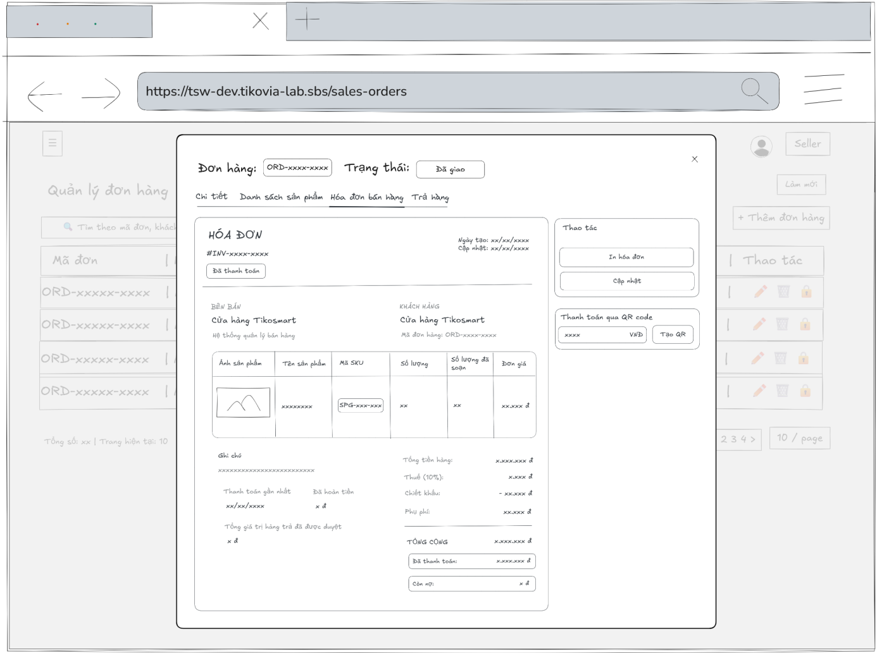
- Function Details:
  - Validation:
    - The user must be authenticated and logged into the system.
    - The user must have a valid role: Admin, Sell staff, or Accountant.
    - The selected sales order must exist in the system.
    - The sales order must have an associated sales invoice.
    - The system must validate access permission before displaying invoice details.
    - Invoice data (amounts, dates, customer, products, totals) must be retrieved accurately from the database.
  - Functionality:
    - In Normal Cases:
      - The system displays all the detailed information about sales invoice correctly.
    - In Abnormal Cases:
      - Server Error: If there is an issue with the server when fetch data, the system display no data
  - Business rule: BR-19.
# | Component | Comp. type | Editable | Mandatory | Default Value | Description
 | Navigation & Actions
1 | Tab Navigation | Tab Control | No | Yes | "Hóa đơn bán hàng" | Navigation tabs to switch between Details, Product List, Sales Invoice (Active), and Returns.
2 | Screen Title | Label (Text) | No | Yes | "Hóa đơn bán hàng" | Displays the title of the current screen.
3 | Update Button | Button | No | Yes | "Cập nhật" | Button to save changes or update the invoice status.
4 | Print Button | Button | No | Yes | "In hóa đơn" | Button to trigger the print function for the invoice.
 | QR Payment Section
5 | Section Title | Label (Text) | No | Yes | "Thanh toán qua QR Code" | Title for the QR payment generation area.
6 | Payment Amount Input | Input (Number) | Yes | Yes | [Invoice Amount] | Input field to enter the amount for QR generation. Defaults to the total remaining debt.
7 | Generate QR Button | Button | No | Yes | "Tạo QR" | Button to generate a QR code based on the value in component #6.
 | General Information
8 | Invoice Code Label | Label (Text) | No | Yes | "Mã hóa đơn" | Label for the invoice identifier.
9 | Invoice Code Value | Label (Link) | No | Yes | [INV-Code] | Displays the unique invoice ID.
10 | Status Badge | Label (Tag) | No | Yes | "Đang mở" | Displays the current status of the invoice (e.g., Open, Paid, Cancelled).
11 | Total Invoice Card | Label (Number) | No | Yes | [Amount] | Displays the total monetary value of the invoice.
12 | Remaining Debt Card | Label (Number) | No | Yes | [Amount] | Displays the remaining amount the customer needs to pay.
13 | Paid Amount Card | Label (Number) | No | Yes | [Amount] | Displays the total amount already paid by the customer.
 | Invoice Details Section
14 | Section Header | Label (Text) | No | Yes | "Chi tiết hóa đơn" | Header for the detailed breakdown section.
15 | Order Code Link | Link/Button | No | Yes | [ORD-Code] | Clickable link redirecting to the original Order details.
16 | Customer Tag | Label (Tag) | No | Yes | [Customer Name] | Displays the customer's name.
17 | Sub-total Labels | Label (Text) | No | Yes | [Various] | Displays financial breakdown: Total goods, Tax (10%), Discount, Surcharge.
 | Additional Info Section
18 | Section Header | Label (Text) | No | Yes | "Thông tin bổ sung" | Header for the additional information section.
19 | Return Value | Label (Number) | No | Yes | [Amount] | Displays the value of approved returned goods.
20 | Refunded Value | Label (Number) | No | Yes | [Amount] | Displays the amount already refunded to the customer.
21 | Last Payment | Label (Text) | No | Yes | [Date/Status] | Displays the date of the last payment or "Chưa có" if none.
 | Product List Section
22 | List Header | Label (Text) | No | Yes | "Danh sách sản phẩm" | Header for the product list table.
23 | Product Image | Image | No | Yes | [Thumbnail] | Thumbnail image of the product.
24 | Product Name | Label (Text) | No | Yes | [Name] | Name of the product (e.g., Bắp bò, Bò viên).
25 | SKU Code | Link/Tag | No | Yes | [SKU Code] | Clickable SKU code (e.g., SPT-Bapbo1) linking to product details.
26 | Quantity | Label (Number) | No | Yes | [Qty] | The ordered quantity.
27 | Picked Quantity | Label (Number) | No | Yes | [Qty] | The quantity actually prepared/picked.
28 | Unit Price | Label (Number) | No | Yes | [Price] | The price per unit of the product.

––––––––––––––––––––––––––––––––––––––––––––––––––––––––––––––––––––––––––––––––––-

3.7.10 - Create new Sales Invoices
- Function trigger: The admin, accountant accesses the Sales Orders page and clicks on the selected order to display a popup with sales order information then click on tab “Hóa đơn bán hàng” and click on “Thêm hóa đơn” button to display a popup with input fields.
- Function description: Allow admin, accountant to to create a new sales invoice for an existing sales order.
- Screen layout:
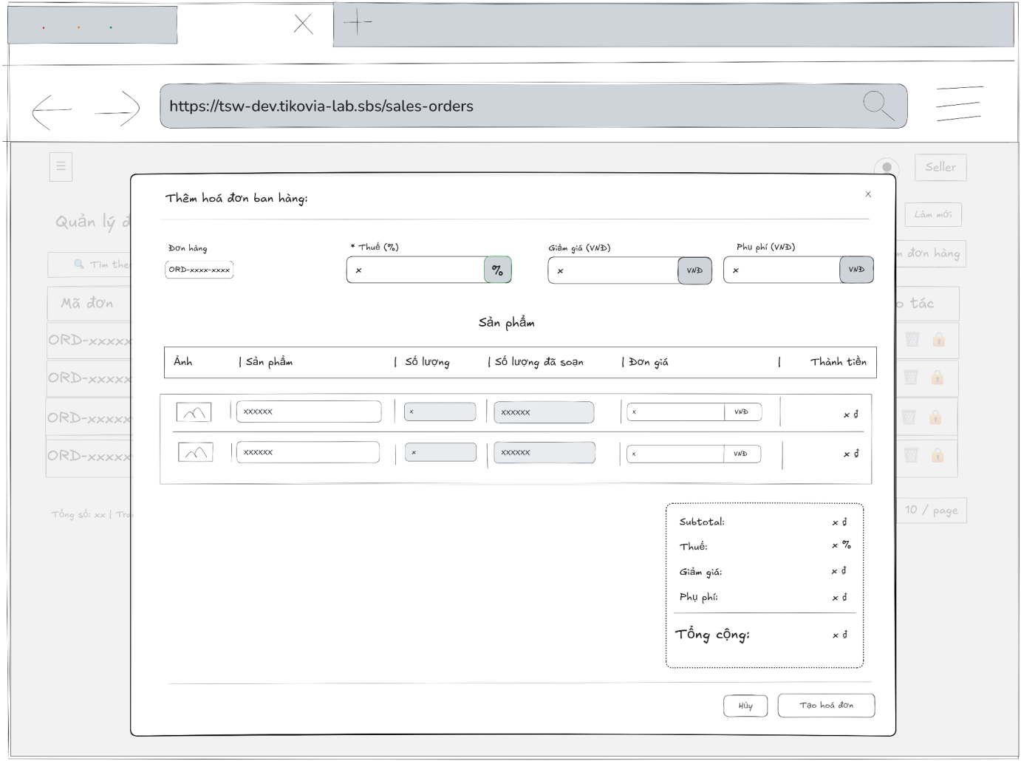
- Function Details:
  - Validation:
    - The user must be authenticated and logged into the system.
    - The user must have a valid role: Admin or Accountant.
    - The selected sales order must exist and be valid.
    - The sales order must not already have a finalized sales invoice.
    - All required invoice fields (tax, discount, surcharge, products, quantities, prices) must be provided and valid.
    - Invoice product quantities must not exceed the ordered quantities.
    - Invoice totals (subtotal, tax, discount, surcharge, total amount) must be calculated correctly by the system.
  - Functionality:
    - In Normal Cases:
      - After the admin or accountant submits the sales invoice information and the system validates successfully, a message will be displayed: “Tạo hóa đơn thành công. Hóa đơn đã được tạo thành công.”
    - In Abnormal Cases:
      - Missing or Invalid Fields: If the submit button is pressed without filling all required fields, the system will display an error message indicating the missing or invalid fields.
      - Connection Issues / Server Error: If there is an issue with the server when submitting the new sales invoice information, the system will notify the admin, accountant: “Đã có lỗi xảy ra khi tạo hóa đơn.”
  - Business rule: BR-19.

# | Component | Comp. type | Editable | Mandatory | Default Value | Description
 | Header Section
1 | Modal Title | Label (Text) | No | Yes | "Thêm hóa đơn bán hàng" | Displays the title of the modal window.
2 | Close Button | Button (Icon) | No | Yes | [X Icon] | Button to close the modal without saving.
 | General Information
3 | Order Label | Label (Text) | No | Yes | "Đơn hàng:" | Label for the associated order field.
4 | Order ID Link | Link / Tag | No | Yes | [ORD-Code] | Clickable tag displaying the source Order ID. Links to order details.
5 | Tax Label | Label (Text) | No | Yes | "* Thuế (%)" | Label for tax percentage input. Asterisk indicates mandatory.
6 | Tax Input | Input (Number) | Yes | Yes | "0" | Input field for tax percentage.
7 | Discount Label | Label (Text) | No | Yes | "Giảm giá (VNĐ)" | Label for discount amount input.
8 | Discount Input | Input (Number) | Yes | No | "0" | Input field for discount value in currency.
9 | Surcharge Label | Label (Text) | No | Yes | "Phụ phí (VNĐ)" | Label for surcharge amount input.
10 | Surcharge Input | Input (Number) | Yes | No | "0" | Input field for surcharge value in currency.
 | Product List Table
11 | Col Header: Image | Label | No | Yes | "Ảnh" | Header for product thumbnail column.
12 | Col Header: Product | Label | No | Yes | "Sản phẩm" | Header for product name and SKU column.
13 | Col Header: Qty | Label | No | Yes | "Số lượng" | Header for ordered quantity column.
14 | Col Header: Picked | Label | No | Yes | "Số lượng đã soạn" | Header for the quantity actually picked/prepared.
15 | Col Header: Price | Label | No | Yes | "Đơn giá (VNĐ)" | Header for unit price input column.
16 | Col Header: Total | Label | No | Yes | "Thành tiền" | Header for the row total column.
17 | Product Image | Image | No | Yes | [Thumbnail] | Displays the product image.
18 | Product Name | Label (Text) | No | Yes | [Name] | Displays the product name.
19 | SKU Tag | Link / Tag | No | Yes | [SKU Code] | Clickable tag displaying the product SKU.
20 | Quantity Input | Input (Number) | No | Yes | [Value] | Displays ordered quantity. Read-only in this view.
21 | Picked Qty Input | Input (Number) | No | Yes | [Value] | Displays picked quantity. Read-only in this view.
22 | Unit Price Input | Input (Number) | Yes | Yes | "0" | Input field for the user to set the price per unit for this invoice.
23 | Row Total | Label (Number) | No | Yes | "0 đ" | Calculated field: (Picked Qty * Unit Price). Updates automatically.
 | Summary & Footer
24 | Subtotal Label | Label (Text) | No | Yes | "Subtotal: [Value]" | Displays sum of all Row Totals.
25 | Tax Summary | Label (Text) | No | Yes | "Thuế: [Value]" | Calculated tax value based on Subtotal and Tax Input (#6).
26 | Discount Summary | Label (Text) | No | Yes | "Giảm giá: [Value]" | Displays value from Discount Input (#8).
27 | Surcharge Summary | Label (Text) | No | Yes | "Phụ phí: [Value]" | Displays value from Surcharge Input (#10).
28 | Final Total Label | Label (Text) | No | Yes | "Tổng cộng: [Value]" | Final calculation: Subtotal + Tax - Discount + Surcharge.
29 | Cancel Button | Button | No | Yes | "Hủy" | Button to close the modal and discard changes.
30 | Create Button | Button | No | Yes | "Tạo hóa đơn" | Primary button to submit data and create the sales invoice.

––––––––––––––––––––––––––––––––––––––––––––––––––––––––––––––––––––––––––––––––––-

3.7.11 - Edit Sales Invoice
- Function trigger: Admin, Accountant accesses the Sales Orders page and clicks on the selected order to display a popup with sales order information then click on tab “Hóa đơn bán hàng” and click on “Cập nhật hóa đơn” button to display a popup with input fields.
- Function description: Allow admin, accountant to to edit sales invoice for an existing sales invoice.
- Screen layout:
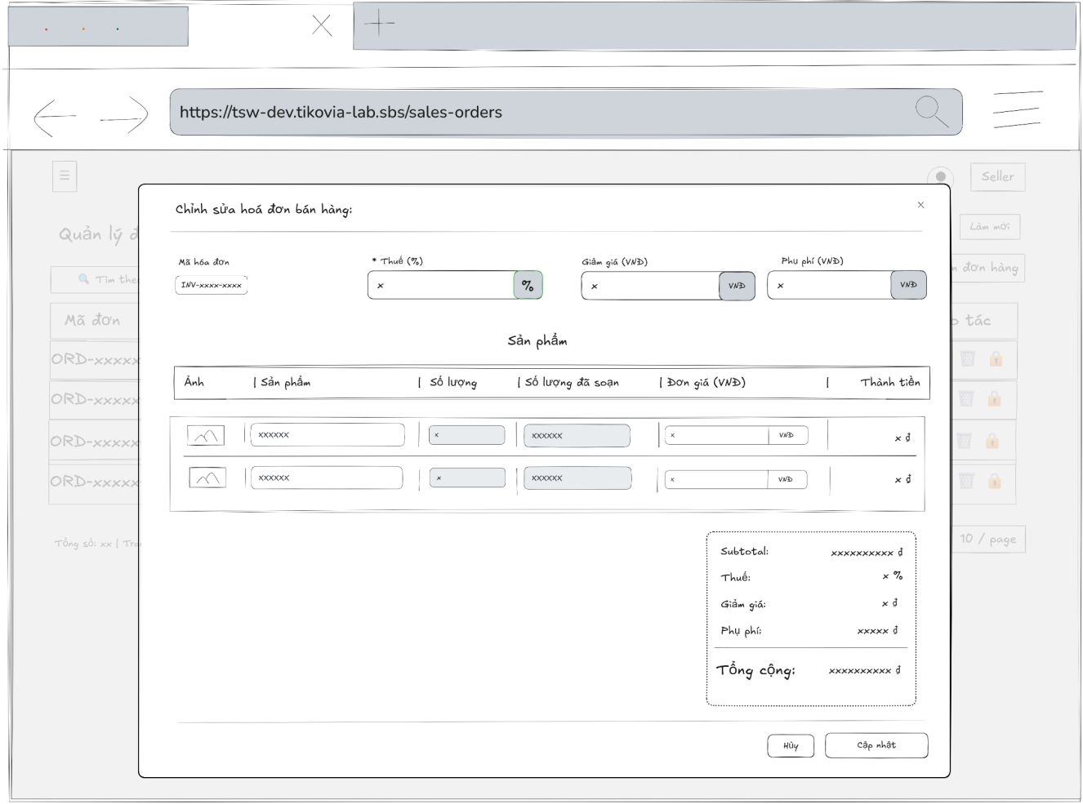
- Function Details:
  - Validation:
    - The user must be authenticated and have a valid role: Admin or Accountant.
    - The selected sales invoice must exist and be editable.
    - The related sales order must be valid and not canceled.
    - All required invoice fields (tax, discount, surcharge, product list, quantities, unit prices) must be provided and valid.
    - Product quantities in the invoice must not exceed the remaining quantities of the sales order.
    - Numeric values (tax, discount, surcharge, prices, quantities) must be non-negative and in valid formats.
    - The system must recalculate and validate invoice totals before saving.
  - Functionality:
    - In Normal Cases:
      - After submitting the information (clicks "Update") and the system validates it successfully, a notification will be displayed: "Cập nhật hóa đơn thành công.".
    - In Abnormal Cases:
      - Missing or Invalid Fields: If the submit button is pressed without filling all required fields, the system will display an error message indicating the missing or invalid fields.
      - Connection Issues / Server Error: If there is an issue with the server when submitting the new sales invoice information, the system will notify the admin: “Đã có lỗi xảy ra khi tạo hóa đơn.”
  - Business rule: BR-19.
# | Component | Comp. type | Editable | Mandatory | Default Value | Description
 | Header Section
1 | Modal Title | Label (Text) | No | Yes | "Chỉnh sửa hóa đơn bán hàng" | Displays the title of the modal window.
2 | Close Button | Button (Icon) | No | Yes | [X Icon] | Button to close the modal without saving changes.
 | General Information
3 | Invoice ID Label | Label (Text) | No | Yes | "Mã hóa đơn:" | Label for the invoice identifier field.
4 | Invoice ID Tag | Link / Tag | No | Yes | [INV-Code] | Displays the unique code of the invoice being edited (e.g., INV-181125...). Read-only.
5 | Tax Label | Label (Text) | No | Yes | "* Thuế (%)" | Label for the tax percentage input. Asterisk indicates a mandatory field.
6 | Tax Input | Input (Number) | Yes | Yes | [Current Tax] | Input field to edit the tax percentage.
7 | Discount Label | Label (Text) | No | Yes | "Giảm giá (VNĐ)" | Label for the discount amount input.
8 | Discount Input | Input (Number) | Yes | No | [Current Discount] | Input field to edit the discount amount in currency.
9 | Surcharge Label | Label (Text) | No | Yes | "Phụ phí (VNĐ)" | Label for the surcharge amount input.
10 | Surcharge Input | Input (Number) | Yes | No | [Current Surcharge] | Input field to edit the surcharge amount in currency.
 | Product List Table
11 | Col Header: Image | Label | No | Yes | "Ảnh" | Header for the product thumbnail column.
12 | Col Header: Product | Label | No | Yes | "Sản phẩm" | Header for the product name and SKU column.
13 | Col Header: Qty | Label | No | Yes | "Số lượng" | Header for the ordered quantity column.
14 | Col Header: Picked | Label | No | Yes | "Số lượng đã soạn" | Header for the quantity actually prepared/picked.
15 | Col Header: Price | Label | No | Yes | "Đơn giá (VNĐ)" | Header for the unit price input column.
16 | Col Header: Total | Label | No | Yes | "Thành tiền" | Header for the row total column.
17 | Product Image | Image | No | Yes | [Thumbnail] | Displays the product image.
18 | Product Name | Label (Text) | No | Yes | [Name] | Displays the product name.
19 | SKU Tag | Link / Tag | No | Yes | [SKU Code] | Clickable tag displaying the product SKU.
20 | Quantity Input | Input (Number) | No | Yes | [Value] | Displays ordered quantity. Read-only (disabled background).
21 | Picked Qty Input | Input (Number) | No | Yes | [Value] | Displays picked quantity. Read-only (disabled background).
22 | Unit Price Input | Input (Number) | Yes | Yes | [Current Price] | Input field allowing the user to adjust the unit price for this specific invoice.
23 | Row Total | Label (Number) | No | Yes | [Calculated Value] | Automatically calculated: (Picked Qty * Unit Price).
 | Summary & Footer
24 | Subtotal Label | Label (Text) | No | Yes | "Subtotal: [Value]" | Sum of all Row Totals before tax/fees.
25 | Tax Summary | Label (Text) | No | Yes | "Thuế: [Value]" | Calculated tax amount based on Subtotal and Tax Input (#6).
26 | Discount Summary | Label (Text) | No | Yes | "Giảm giá: [Value]" | Displays value from Discount Input (#8).
27 | Surcharge Summary | Label (Text) | No | Yes | "Phụ phí: [Value]" | Displays value from Surcharge Input (#10).
28 | Final Total Label | Label (Text) | No | Yes | "Tổng cộng: [Value]" | Final calculation: Subtotal + Tax - Discount + Surcharge.
29 | Cancel Button | Button | No | Yes | "Hủy" | Button to discard changes and close the modal.
30 | Update Button | Button | No | Yes | "Cập nhật" | Primary button to save the changes to the invoice.

––––––––––––––––––––––––––––––––––––––––––––––––––––––––––––––––––––––––––––––––––-

3.7.12 - COD Remittance Ticket List
- Function trigger: Users with the roles Admin, Accountant, or Delivery supervisor access the COD Remittance Tickets page to view the list of COD remittance tickets.
- Function description: Allows Admin, Accountant, Delivery Supervisor to view, search, and filter the list of COD payment tickets.
- Screen layout:
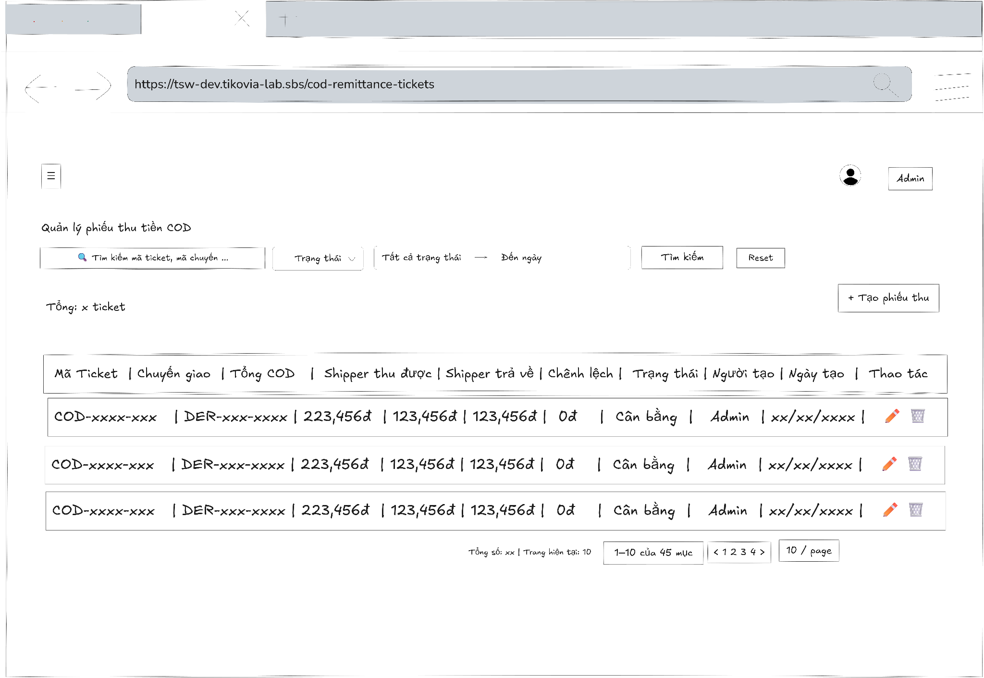
- Function Details:
  - Validation:
    - The user must be authenticated.
    - The user must have one of the following roles: Admin, Accountant, or Delivery Supervisor.
    - The system validates access permission before loading data.
    - The system must handle empty results and server errors correctly.
  - Functionality:
    - In Normal Cases:
      - The system displays the ticket list with all relevant information.
      - Users can search, filter, and view ticket details.
    - In Abnormal Cases:
      - No Data Found: A message is displayed: "No COD payment tickets found."
      - Connection Issues: An error message and retry button are shown: "An error occurred while loading COD payment tickets. Please try again."
  - Business rule: N/A.

# | Component | Comp. type | Editable | Mandatory | Default Value | Description
 | Filter & Search Section
1 | Screen Title | Label (Text) | No | Yes | "Quản lý phiếu thu tiền COD" | Displays the main title of the screen.
2 | Search Input | Input (Text) | Yes | No | Placeholder: "Tìm kiếm mã ticket, mã chuyển..." | Input field to search by Ticket ID or Transfer/Shipment Code.
3 | Status Filter | Dropdown | Yes | No | Placeholder: "Trạng thái" | Dropdown to filter the list by ticket status (e.g., Balanced, Discrepancy).
4 | Date Range Picker | Date Input | Yes | No | Placeholder: "Từ ngày -> Đến ngày" | Date picker to filter records by creation date range.
5 | Search Button | Button | No | Yes | "Tìm kiếm" | Button to execute the search query based on selected filters.
6 | Reset Button | Button | No | Yes | "Reset" | Button to clear all filters and reload the default list.
 | Action & Summary Bar
7 | Total Count Label | Label (Text) | No | Yes | "Tổng: [N] ticket" | Displays the total count of tickets found.
8 | Create Button | Button | No | Yes | "+ Tạo phiếu thu" | Button to navigate to the "Create New COD Ticket" screen.
 | Data Table Section
9 | Col Header: Ticket ID | Label | No | Yes | "Mã Ticket" | Column header for the unique ticket identifier.
10 | Col Header: Transfer | Label | No | Yes | "Chuyển giao" | Column header for the shipment/transfer reference code.
11 | Col Header: Total COD | Label | No | Yes | "Tổng COD" | Column header for the total Cash On Delivery amount.
12 | Col Header: Collected | Label | No | Yes | "Shipper thu được" | Column header for the amount collected by the shipper.
13 | Col Header: Returned | Label | No | Yes | "Shipper trả về" | Column header for the amount returned by the shipper.
14 | Col Header: Diff | Label | No | Yes | "Chênh lệch" | Column header for the difference between collected and returned amounts.
15 | Col Header: Status | Label | No | Yes | "Trạng thái" | Column header for the reconciliation status.
16 | Col Header: Creator | Label | No | Yes | "Người tạo" | Column header for the user who created the ticket.
17 | Col Header: Created Date | Label | No | Yes | "Ngày tạo" | Column header for the creation timestamp.
18 | Col Header: Action | Label | No | Yes | "Thao tác" | Column header for action buttons.
19 | Ticket ID Link | Link | No | Yes | [COD-Code] | Clickable link to view full details of the specific ticket.
20 | Transfer Info | Label (Text) | No | Yes | [Code] + [Role] | Displays the Transfer Code (e.g., DER-...) and the role (e.g., NV Shipper).
21 | Money Values | Label (Currency) | No | Yes | [Amount] | Displays currency values for Total COD, Collected, Returned, and Difference columns.
22 | Status Badge | Label (Tag) | No | Yes | [Status Name] | Displays status (e.g., "Cân bằng" for Balanced, "Chênh lệch" for Discrepancy) inside a styled badge.
23 | Edit Action | Button (Icon) | No | Yes | [Pencil Icon] | Button to edit the ticket details.
24 | Delete Action | Button (Icon) | No | Yes | [Trash Icon] | Button to delete the ticket. Requires confirmation.
 | Pagination
25 | Range Label | Label (Text) | No | Yes | "[X]-[Y] của [Z] ticket" | Displays current view range vs total records.
26 | Pagination Nav | Button Group | No | Yes | [Page Numbers] | Controls to navigate between pages.
27 | Page Size Dropdown | Dropdown | Yes | Yes | "20 / trang" | Dropdown to select number of items displayed per page.

––––––––––––––––––––––––––––––––––––––––––––––––––––––––––––––––––––––––––––––––––-

3.7.13 - COD Remittance Ticket Detail
- Function trigger: Users with the roles Admin, Accountant, or Delivery supervisor access the COD Remittance Tickets page and click on a ticket row to view its details in a modal.
- Function description: Allows Admin, Accountant, Delivery Supervisor to view detailed information about a specific COD Remittance ticket, including summary, delivery run info, orders, and audit trail.
- Screen layout
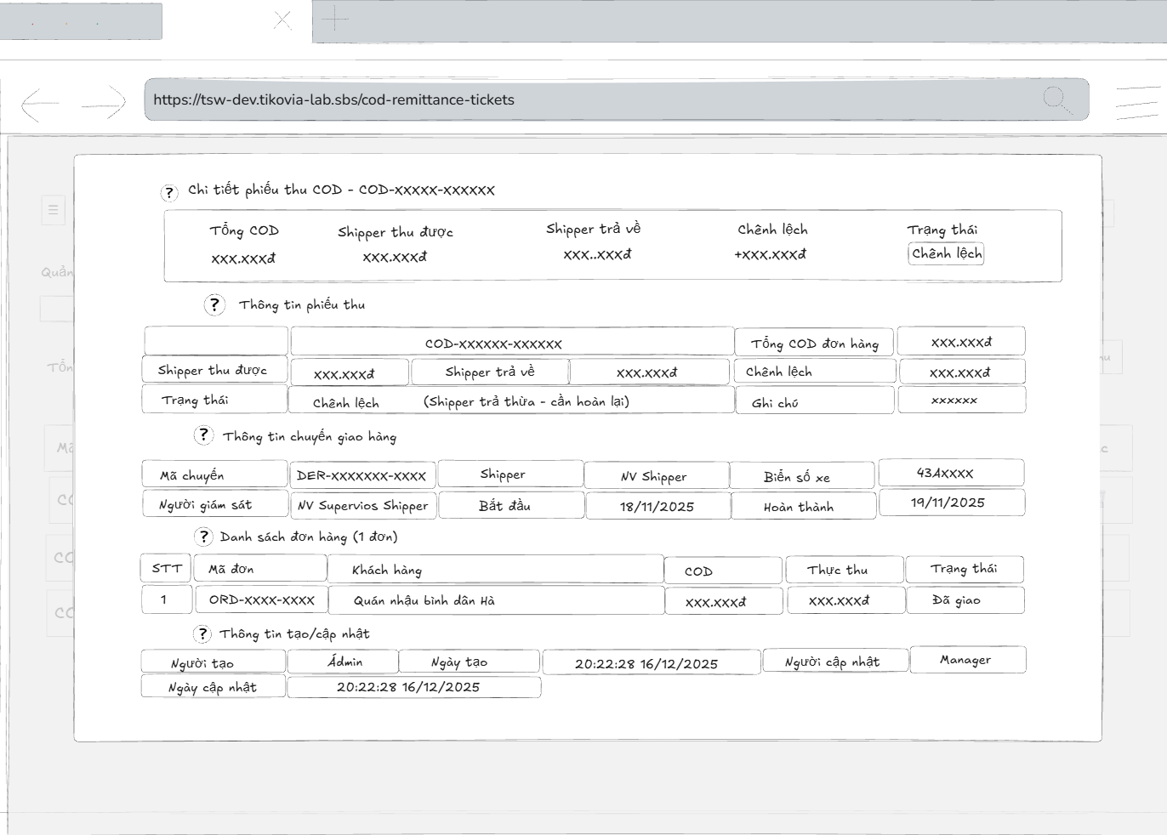
- Function Details:
  - Validation:
    - The user must be authenticated and logged into the system.
    - The user must have a valid role: Admin, Accountant, or Delivery Supervisor.
    - The selected COD Remittance ticket must exist in the system.
    - The system must validate user access permission before displaying ticket details.
    - Ticket information (summary, delivery run info, order list, audit data) must be retrieved correctly from the database.
    - Displayed COD amounts, differences, and status must match stored records.
  - Functionality:
    - In Normal Cases:
      - The system displays all ticket metadata, delivery run info, and associated orders.
      - Users can view all details and close the modal when done.
    - In Abnormal Cases:
      - No Orders in Ticket: A message is displayed: "No orders found in this ticket."
      - Connection Issues or server Error: An error message and close button are shown: "An error occurred while loading ticket details. Please try again."
  - Business rule: N/A.
# | Component | Comp. type | Editable | Mandatory | Default Value | Description
 | Header & Summary Cards
1 | Modal Title | Label (Text) | No | Yes | "Chi tiết phiếu thu COD - [Ticket-ID]" | Displays the screen title including the Ticket ID.
2 | Close Button | Button (Icon) | No | Yes | [X Icon] | Button to close the detail view.
3 | Card: Total COD | Label (Metric) | No | Yes | [Amount] | Summary card showing total COD amount to be collected.
4 | Card: Collected | Label (Metric) | No | Yes | [Amount] | Summary card showing amount actually collected by Shipper.
5 | Card: Returned | Label (Metric) | No | Yes | [Amount] | Summary card showing amount returned by Shipper to company.
6 | Card: Difference | Label (Metric) | No | Yes | [Amount] (+/-) | Summary card showing the discrepancy. Displays with + or - sign.
7 | Card: Status | Label (Tag) | No | Yes | [Status Name] | Summary card showing the overall ticket status (e.g., Discrepancy).
 | Section 1: Ticket Information
8 | Section Title | Label (Text) | No | Yes | "Thông tin phiếu thu" | Section header.
9 | Ticket Code | Link / Label | No | Yes | [COD-Code] | Unique identifier for the ticket.
10 | Order Total COD | Label (Number) | No | Yes | [Amount] | Total COD value from all orders in this ticket.
11 | Shipper Collected | Label (Number) | No | Yes | [Amount] | Total value collected by the shipper.
12 | Shipper Returned | Label (Number) | No | Yes | [Amount] | Total value returned by the shipper.
13 | Ticket Status | Label (Tag) | No | Yes | [Status] | Current status tag (e.g., Discrepancy).
14 | Status Note | Label (Text) | No | No | "(Shipper trả thừa...)" | Explanatory text detailing the status reason (e.g., Refund needed).
15 | Diff Amount | Label (Number) | No | Yes | [Amount] | The calculated difference amount.
16 | Note | Label (Text) | No | No | [User Note] | Any remarks or notes added during creation (e.g., "test").
 | Section 2: Shipment Info
17 | Section Title | Label (Text) | No | Yes | "Thông tin chuyển giao hàng" | Section header.
18 | Transfer Code | Link | No | Yes | [DER-Code] | Clickable link to the Shipment/Transfer detail screen.
19 | Shipper Name | Label (Text) | No | Yes | [Name] | Name of the assigned shipper.
20 | Supervisor Name | Label (Text) | No | Yes | [Name] | Name of the supervisor managing this shipment.
21 | Start Date | Label (Date) | No | Yes | [Date/Time] | Timestamp when the shipment started.
22 | License Plate | Label (Text) | No | Yes | [Plate Number] | Vehicle license plate number.
23 | Completion Date | Label (Date) | No | Yes | [Date/Time] | Timestamp when the shipment was completed.
 | Section 3: Order List
24 | List Header | Label (Text) | No | Yes | "Danh sách đơn hàng ([N] đơn)" | Header showing the count of orders included.
25 | Col: Index (STT) | Label | No | Yes | "1", "2"... | Row number.
26 | Col: Order Code | Link | No | Yes | [ORD-Code] | Clickable link to the specific Order detail.
27 | Col: Customer | Label (Text) | No | Yes | [Name] + [CUS-ID] | Customer name and unique ID.
28 | Col: COD | Label (Number) | No | Yes | [Amount] | Expected COD amount for the specific order.
29 | Col: Actual Collect | Label (Number) | No | Yes | [Amount] | Actual amount collected for the specific order.
30 | Col: Status | Label (Tag) | No | Yes | [Status] | Delivery status of the order (e.g., Delivered).
31 | Footer Total | Label (Number) | No | Yes | "Tổng cộng: [Values]" | Sum of COD and Actual Collected columns at the bottom.
 | Section 4: Audit Log
32 | Section Title | Label (Text) | No | Yes | "Thông tin tạo/cập nhật" | Section header.
33 | Creator Info | Label (Text) | No | Yes | [Name] | Name of the user who created the ticket.
34 | Created Date | Label (Date) | No | Yes | [Date/Time] | Timestamp of creation.
35 | Updator Info | Label (Text) | No | No | [Name] | Name of the user who last updated the ticket.
36 | Updated Date | Label (Date) | No | No | [Date/Time] | Timestamp of last update.

––––––––––––––––––––––––––––––––––––––––––––––––––––––––––––––––––––––––––––––––––-

3.7.14 - Create a COD Remittance Ticket
- Function trigger: Users with the roles Admin, Accountant access the COD Remittance Tickets page and click the “Tạo phiếu thu” button to open a modal for input.
- Function description: Allows Admin, Accountant to create a new COD Remittance ticket for a completed delivery run.
- Screen layout:
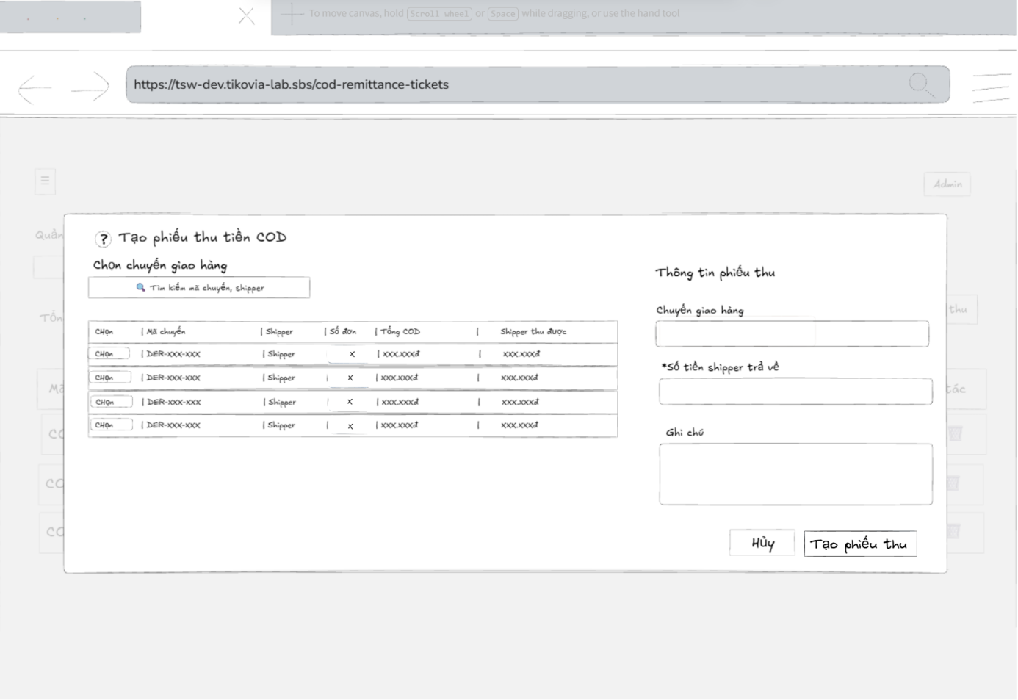
- Function Details:
  - Validation:
    - The user must be authenticated and logged into the system.
    - The user must have a valid role: Admin or Accountant.
    - At least one completed delivery run must be selected.
    - Required fields (delivery run, shipper return amount, etc.) must be filled with valid data.
    - The selected delivery run(s) must exist and be eligible for COD remittance.
    - COD amounts (total COD, shipper collected, shipper returned) must be calculated and validated correctly.
    - The system must validate data before creating the ticket.
  - Functionality:
    - In Normal Cases:
      - After the user submits the ticket and the system validates successfully, a message is displayed: "COD payment ticket created successfully."
    - In Abnormal Cases:
      - Missing or Invalid Fields: If the submit button is pressed without filling all required fields, the system displays an error message indicating the missing or invalid fields.
      - No Delivery Run Selected: If no delivery run is selected, the system displays a warning message.
      - Connection Issues / Server Error: If there is an issue with the server when submitting the new ticket, the system notifies the user: "An error occurred while creating the COD payment ticket. Please try again.”
  - Business rule: BR-19.
# | Component | Comp. type | Editable | Mandatory | Default Value | Description
 | Header
1 | Modal Title | Label (Text) | No | Yes | "Tạo phiếu thu tiền COD" | Displays the title of the modal.
2 | Close Button | Button (Icon) | No | Yes | [X Icon] | Button to close the modal.
 | Left Column: Select Shipment
3 | Section Title | Label (Text) | No | Yes | "Chọn chuyển giao hàng" | Header for the selection area.
4 | Search Input | Input (Text) | Yes | No | Placeholder: "Tìm kiếm mã chuyển, shipper..." | Search bar to filter the list of shipments by code or shipper name.
5 | Table Header: Select | Label | No | Yes | "Chọn" | Header for the selection action column.
6 | Table Header: Transfer | Label | No | Yes | "Mã chuyển" | Header for shipment transfer code.
7 | Table Header: Shipper | Label | No | Yes | "Shipper" | Header for shipper name.
8 | Table Header: Orders | Label | No | Yes | "Số đơn" | Header for total order count.
9 | Table Header: Total COD | Label | No | Yes | "Tổng COD" | Header for total COD amount to be collected.
10 | Table Header: Collected | Label | No | Yes | "Shipper thu được" | Header for amount actually collected by shipper (system calculated).
11 | Select Button | Button | No | Yes | "Chọn" | Action button to select a specific shipment row. Populates field #13.
 | Right Column: Ticket Info
12 | Section Title | Label (Text) | No | Yes | "Thông tin phiếu thu" | Header for the input form area.
13 | Selected Transfer Label | Label (Text) | No | Yes | "Chuyển giao hàng" | Label for the selected transfer field.
14 | Selected Transfer Input | Input (Text) | No | Yes | Placeholder: "Chọn chuyển giao hàng từ bảng bên trái" | Displays the code of the selected shipment. Read-only. Populated by clicking component #11.
15 | Returned Amount Label | Label (Text) | No | Yes | "* Số tiền shipper trả về" | Label for the returned amount input. Asterisk indicates mandatory.
16 | Returned Amount Input | Input (Number) | Yes | Yes | Placeholder: "Nhập số tiền thực nhận từ shipper" | Input field for the actual amount the shipper turns in to the cashier/accountant.
17 | Note Label | Label (Text) | No | Yes | "Ghi chú" | Label for the note field.
18 | Note Input | TextArea | Yes | No | Placeholder: "Nhập ghi chú (nếu có)" | Text area for additional comments or explanations.
 | Footer Actions
19 | Cancel Button | Button | No | Yes | "Hủy" | Button to close the modal without creating a ticket.
20 | Create Button | Button | No | Yes | "Tạo phiếu thu" | Primary button to submit the form and create the ticket.

––––––––––––––––––––––––––––––––––––––––––––––––––––––––––––––––––––––––––––––––––-

3.7.15 - Edit COD Remittance Ticket
- Function trigger: Users with the roles Admin, Accountant access the COD Remittance Tickets page, select a ticket, and click the “Edit” button to open a modal for editing.
- Function description: Allows Admin, Accountant to update details of an existing COD Remittance ticket, including the received amount and notes.
- Screen layout:
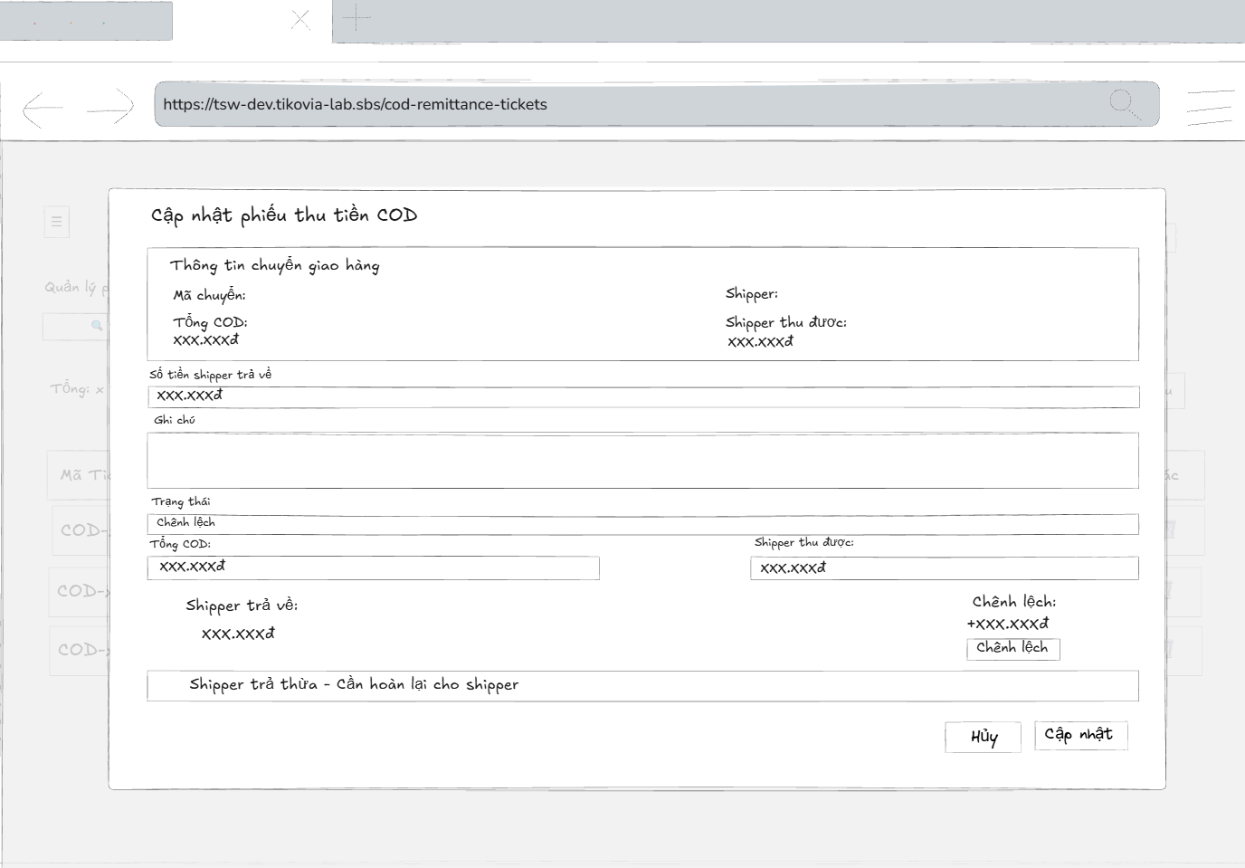
- Function Details:
  - Validation:
    - The user must be authenticated and logged into the system.
    - The user must have a valid role: Admin or Accountant.
    - The selected COD Remittance ticket must exist in the system.
    - Editable required fields (e.g. shipper returned amount, notes) must be filled with valid data.
    - COD amounts and differences must be recalculated and validated correctly.
    - The system must validate data before saving changes.
  - Functionality:
    - In Normal Cases:
      - After the user saves changes and the system validates successfully, a message is displayed: "COD Remittance ticket updated successfully."
    - In Abnormal Cases:
      - Missing or Invalid Fields: If the save button is pressed without filling all required fields, the system displays an error message indicating the missing or invalid fields.
      - Connection Issues / Server Error: If there is an issue with the server when saving the ticket, the system notifies the user: "An error occurred while updating the COD Remittance ticket. Please try again."
  - Business rule: BR-19.
# | Component | Comp. type | Editable | Mandatory | Default Value | Description
 | Header
1 | Modal Title | Label (Text) | No | Yes | "Cập nhật phiếu thu tiền COD" | Displays the title of the modal.
2 | Close Button | Button (Icon) | No | Yes | [X Icon] | Button to close the modal without saving.
 | Shipment Info Section (Blue Box)
3 | Section Header | Label (Text) | No | Yes | "Thông tin chuyển giao hàng" | Header for the read-only shipment details area.
4 | Transfer Code | Label (Text) | No | Yes | [Value] | Displays the shipment transfer code. Read-only.
5 | Shipper Name | Label (Text) | No | Yes | [Value] | Displays the shipper's name. Read-only.
6 | Total COD | Label (Text) | No | Yes | [Value] | Displays the total COD amount to be collected. Read-only.
7 | Collected | Label (Text) | No | Yes | [Value] | Displays the amount actually collected by the shipper (system data). Read-only.
 | Edit Form Section
8 | Returned Label | Label (Text) | No | Yes | "* Số tiền shipper trả về" | Label for the returned amount input. Asterisk indicates mandatory.
9 | Returned Input | Input (Number) | Yes | Yes | [Current Value] | Input field to edit the actual cash amount received from the shipper.
10 | Note Label | Label (Text) | No | Yes | "Ghi chú" | Label for the remarks field.
11 | Note Input | TextArea | Yes | No | [Current Text] | Text area to edit notes regarding this ticket.
12 | Status Label | Label (Text) | No | Yes | "* Trạng thái" | Label for the ticket status dropdown.
13 | Status Dropdown | Dropdown | Yes | Yes | [Current Status] | Dropdown to select the ticket status (e.g., Balanced, Discrepancy).
 | Calculation Summary (Bottom Box)
14 | Summary Box | Container | No | Yes | N/A | A panel displaying the real-time calculation of the difference.
15 | Calc: Total COD | Label (Text) | No | Yes | [Value] | Repeats the Total COD value.
16 | Calc: Collected | Label (Text) | No | Yes | [Value] | Repeats the Shipper Collected value.
17 | Calc: Returned | Label (Text) | No | Yes | [Value] | Displays the value currently entered in Component #9.
18 | Calc: Diff Label | Label (Text) | No | Yes | "Chênh lệch:" | Label for the difference value.
19 | Calc: Diff Value | Label (Number) | No | Yes | [+/- Value] | Calculated field: (Collected - Returned). Updates dynamically when #9 changes.
20 | Warning Tag | Label (Tag) | No | Yes | "Chênh lệch" | Status tag appearing if difference is not 0.
21 | Warning Msg | Label (Text) | No | No | "Shipper trả thừa..." | Contextual message explaining the difference (e.g., Refund needed or Shortage).
 | Footer Actions
22 | Cancel Button | Button | No | Yes | "Hủy" | Button to close the modal and discard changes.
23 | Update Button | Button | No | Yes | "Cập nhật" | Primary button to save the changes to the ticket.

––––––––––––––––––––––––––––––––––––––––––––––––––––––––––––––––––––––––––––––––––-

3.8 Reporting and Dashboard Visualization

3.8.1 - Dashboard
- Function trigger: The authenticated users access the Dashboard page and view statistical charts and reports.
- Function description: Allow all authenticated users to view statistical charts and reports.
- Screen layout:
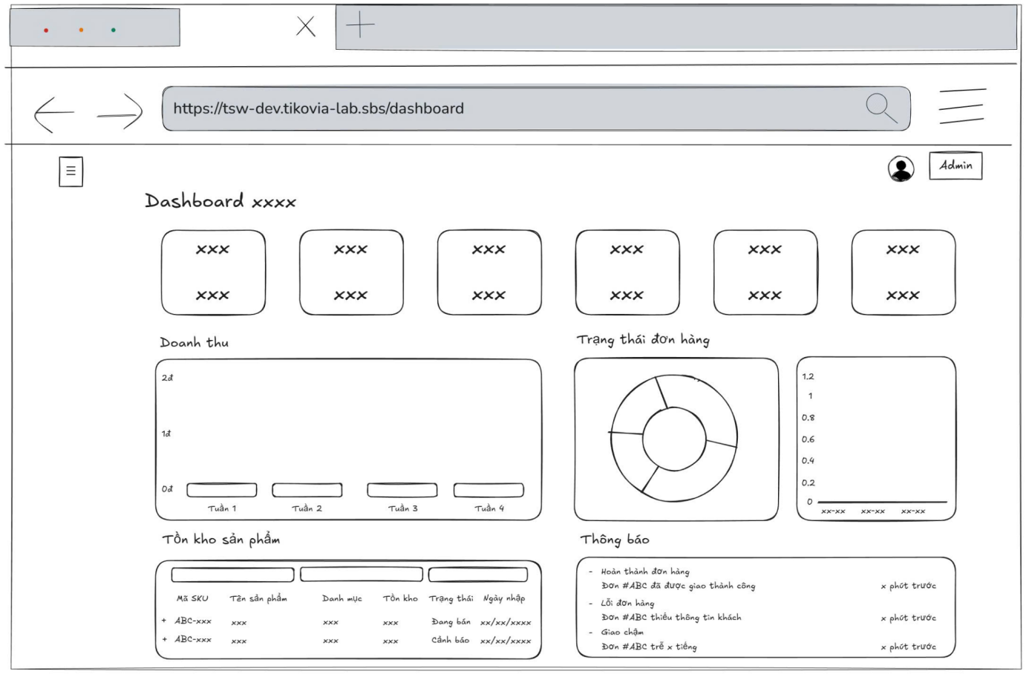
- Function Details:
  - Validation:
    - All data on the dashboard must match the data in the database.
  - Functionality:
    - In Normal Cases:
      - After users had logged in the system, they could view the dashboard with statistical charts.
      - The system must display the summary reports correctly according to the data from the database.
    - In Abnormal Cases:
      - Connection Issues: If there's a server issue, the system will notify the user: "Unable to fetch data. Please try again later."
  - Business rule: N/A.

# | Component | Comp. type | Editable | Mandatory | Default Value | Description
 | Screen Header
1 | Screen Title | Label (Text) | No | Yes | "Dashboard Quản Trị" | Displays the main title of the dashboard screen.
 | Overview Cards (KPIs)
2 | Total Users Card | Card/Container | No | Yes | Label: "Tổng người dùng" | Displays the total number of registered users (e.g., 18).
3 | Total Orders Card | Card/Container | No | Yes | Label: "Tổng đơn hàng" | Displays the total number of orders placed (e.g., 21).
4 | Total Products Card | Card/Container | No | Yes | Label: "Tổng sản phẩm" | Displays the total number of products in the inventory (e.g., 35).
5 | Total Customers Card | Card/Container | No | Yes | Label: "Tổng khách hàng" | Displays the total number of customers (e.g., 15).
6 | Supplier Trans. Card | Card/Container | No | Yes | Label: "Giao dịch nhà cung cấp" | Displays summary of supplier transactions: "Nhập" (Import) and "Trả" (Return) counts.
 | Chart Section: Revenue
7 | Revenue Title | Label (Text) | No | Yes | "Doanh thu bán hàng" | Title for the revenue chart section.
8 | Time Filter | Button Group | Yes | Yes | "Tháng" | Filter options to view revenue by Week (Tuần), Month (Tháng), or Year (Năm).
9 | Period Dropdown | Dropdown | Yes | Yes | "Tháng 1" | Dropdown to select the specific time period (e.g., specific month).
10 | Revenue Chart | Chart (Bar) | No | Yes | N/A | Bar chart visualizing sales revenue over the selected period.
 | Chart Section: Order Status
11 | Status Title | Label (Text) | No | Yes | "Trạng thái đơn hàng" | Title for the order status distribution chart.
12 | Status Chart | Chart (Donut) | No | Yes | N/A | Donut chart showing the proportion of orders by status (e.g., Pending, Shipping, Completed).
13 | Legend | Label (List) | No | Yes | "Chờ xác nhận", "Đang giao"... | Legend explaining the colors used in the donut chart.
 | Chart Section: Weekly Orders
14 | Weekly Orders Title | Label (Text) | No | Yes | "Đơn hàng trong tuần này" | Title for the weekly order volume chart.
15 | Weekly Chart | Chart (Line) | No | Yes | N/A | Line chart tracking the number of orders per day for the current week.
 | Bottom Section: Lists & Stats
16 | Best Sellers Title | Label (Text) | No | Yes | "Sản phẩm bán chạy" | Title for the best-selling products list.
17 | View All Link (1) | Link/Button | No | Yes | "Xem tất cả" | Link to navigate to the full report of best-selling products.
18 | Product List Item | List Item | No | Yes | [SKU] + [Sold Count] | Displays product SKU link and total sold quantity (e.g., "Đã bán: 242").
19 | Recent Orders Title | Label (Text) | No | Yes | "Đơn hàng gần đây" | Title for the recent orders list.
20 | View All Link (2) | Link/Button | No | Yes | "Xem tất cả" | Link to navigate to the full order management list.
21 | Empty State Icon | Image/Icon | No | No | "Trống" | Placeholder icon/text displayed when there are no recent orders.
22 | Profit Title | Label (Text) | No | Yes | "Lợi nhuận so với tháng trước" | Title for the profit comparison widget.
23 | Profit Value | Label (Number) | No | Yes | [Currency Value] | Displays the profit difference (e.g., -452,000 đ) with a trend indicator (arrow up/down).
24 | Profit Percentage | Label (Number) | No | Yes | [Percentage] | Displays the percentage change (e.g., -100.0%).
25 | Comparison Values | Label (Text) | No | Yes | "Tháng trước: [Val]", "Tháng này: [Val]" | Displays the absolute values for the current and previous month for context.
 | Floating Actions
26 | Chat Support | Button (Fab) | No | Yes | [Icon] | Floating action button (bottom-right) to open chat/support window.

––––––––––––––––––––––––––––––––––––––––––––––––––––––––––––––––––––––––––––––––––-

3.9 System Notifications & Monitoring

3.9.1 - 404
- Function trigger: The user's access to the unauthorised page or unknown page.
- Function description: Prevent users from access to the unauthorised page.
- Screen layout:
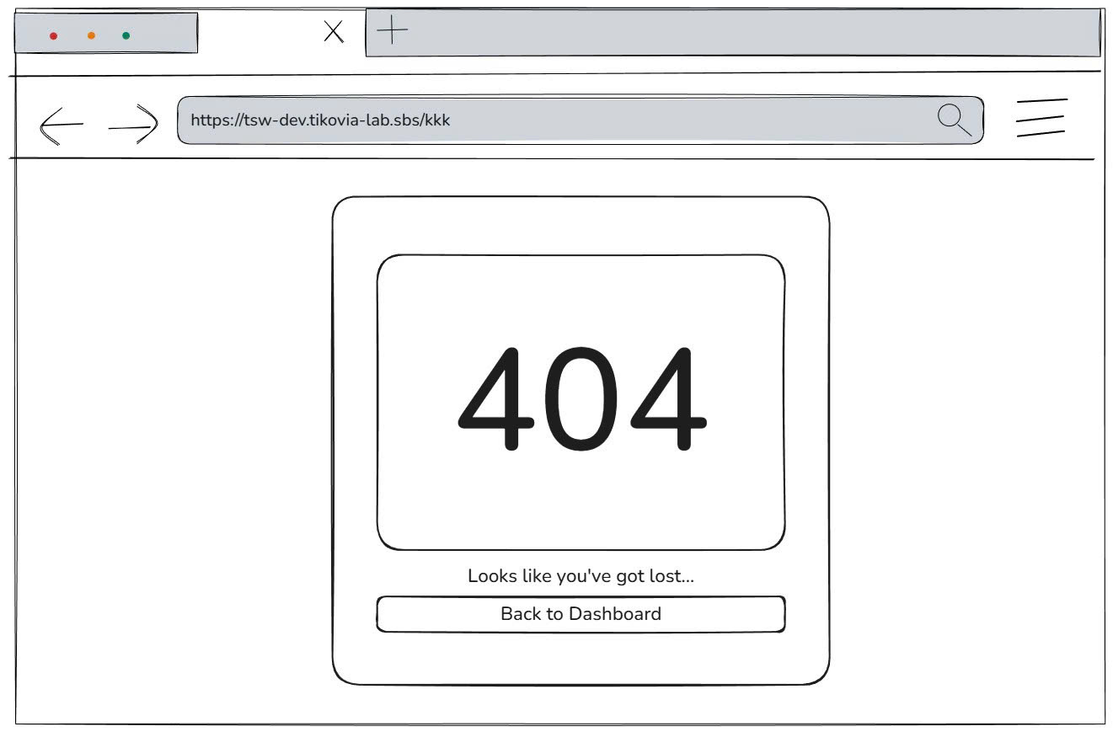
- Function Details:
  - Functionality:
    - In Normal Cases:
      - The system displays 404 images and a “Back to Dashboard” button.
    - In Abnormal Cases: N/A
  - Business rule: N/A.

# | Component | Comp. type | Editable | Mandatory | Default Value | Description
1 | Page Background | Container | No | Yes | N/A | The main background container for the error page layout.
2 | Center Card | Container | No | Yes | N/A | A centered container that holds the error content and actions.
3 | Error Illustration | Image | No | Yes | [404 Graphic] | A graphical illustration depicting a "404" browser error state.
4 | Error Message | Label (Text) | No | Yes | "Looks like you’ve got lost...." | Friendly text message informing the user that the page cannot be found.
5 | Back Button | Button | No | Yes | "Back to Dashboard" | Primary action button to redirect the user back to the main dashboard screen.
6 | Chat Widget | Button (Icon) | No | Yes | [Chat Icon] | Floating action button (bottom-right) to open the support chat window.

––––––––––––––––––––––––––––––––––––––––––––––––––––––––––––––––––––––––––––––––––-

3.10 Manage Issue Ticket Feature

3.10.1 - View List of Issue Ticket
- Function trigger: Any authenticated users (Admin, Packing Staff, Delivery Supervisor, Sell Staff, warehouse manager, Delivery Supervisor, Delivery Staff, Accountant) clicks on the “Issue” button and navigates to the Issue page through the sidebar to view the list of issues in the system.
- Function description: To view a list of issues with the information about an issue, such as the Ticket No, Title, Created by, Status, Type, Severity, Created at.
- Screen layout:
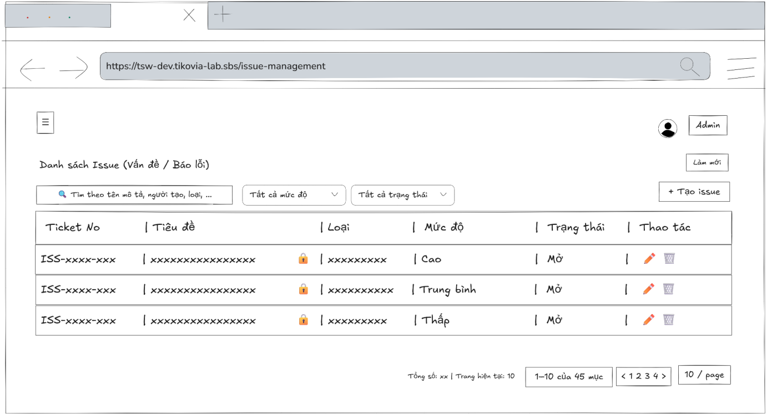
- Function Details:
  - Validation:
    - The user must be authenticated and logged into the system.
    - The user must have a valid role (Admin, Packing Staff, Delivery Supervisor, Sell Staff, Warehouse Manager, Delivery Staff, Accountant).
    - The system must verify user permissions before allowing access to the Issue page.
    - Issue ticket data must be loaded correctly from the database.
    - Displayed information (Ticket No, Title, Created By, Type, Severity, Status, Created At) must match stored records.
  - Functionality:
    - In Normal Cases:
      - When the user navigates to the Issue List screen, the system successfully loads and displays the list of issues. Each issue entry includes key information such as Ticket No, Title, Create by, Type, Severity, Status, Create at, Available actions
    - In Abnormal Cases:
      - No Issue Ticket Data Found: If there is no data of issue ticket list in the system will display “No data”.
      - Connection Issues: If there's a server issue, the system will notify the users: "Không thể tải dữ liệu. Đã xảy ra lỗi khi tải danh sách issue"
  - Business rule: N/A
––––––––––––––––––––
# | Component | Comp. type | Editable | Mandatory | Default Value | Description
 | Header & Filters
1 | Screen Title | Label (Text) | No | Yes | "Danh sách Issue (Vấn đề / Báo lỗi)" | Displays the main title of the screen.
2 | Refresh Button | Button | No | No | "Làm mới" | Button to reload the issue list data.
3 | Search Input | Input (Text) | Yes | No | Placeholder: "Tìm kiếm theo mô tả, người tạo, loại ..." | Input field to filter issues by description, creator name, or type.
4 | Severity Filter | Dropdown | Yes | No | "Tất cả mức độ" | Dropdown to filter the list by severity level (e.g., High, Medium, Low).
5 | Status Filter | Dropdown | Yes | No | "Tất cả trạng thái" | Dropdown to filter the list by status (e.g., Open, Closed).
6 | Create Button | Button | No | Yes | "+ Tạo Issue" | Button to navigate to the "Create New Issue" screen or modal.
 | Data Table Section
7 | Col Header: Ticket No | Label | No | Yes | "Ticket No" | Column header for the unique issue identifier.
8 | Col Header: Title | Label | No | Yes | "Tiêu đề" | Column header for the issue title/summary.
9 | Col Header: Creator | Label | No | Yes | "Người tạo" | Column header for the user who reported the issue.
10 | Col Header: Type | Label | No | Yes | "Loại" | Column header for the category of the issue.
11 | Col Header: Severity | Label | No | Yes | "Mức độ" | Column header for the priority/severity level.
12 | Col Header: Status | Label | No | Yes | "Trạng thái" | Column header for the current processing status.
13 | Col Header: Date | Label | No | Yes | "Ngày tạo" | Column header for the creation timestamp.
14 | Col Header: Action | Label | No | Yes | "Thao tác" | Column header for action buttons.
15 | Ticket ID Link | Link / Button | No | Yes | [ISS-Code] | Clickable link (e.g., ISS-251117...) to view full issue details.
16 | Issue Title Text | Label (Text) | No | Yes | [Title] | Displays the short description of the issue. May include a lock icon indicating privacy.
17 | Creator Info | Label (Text) | No | Yes | [User Icon] + [Name] | Displays the name of the creator with a user icon.
18 | Type Badge | Label (Tag) | No | Yes | [Type Name] | Displays the issue category (e.g., "Không thu được tiền", "Thiếu hàng") in a styled badge.
19 | Severity Badge | Label (Tag) | No | Yes | [Level] | Displays severity (e.g., "Cao", "Trung bình") in a styled badge to indicate urgency.
20 | Status Badge | Label (Tag) | No | Yes | "Mở" | Displays the current status (e.g., Open) in a styled badge.
21 | Created Date | Label (Text) | No | Yes | [Time] [Date] | Displays the exact time and date of creation.
22 | Edit Action | Button (Icon) | No | Yes | [Pencil Icon] | Button to edit the issue details.
23 | Delete Action | Button (Icon) | No | Yes | [Trash Icon] | Button to delete the issue record.
 | Pagination
24 | Pagination Stats | Label (Text) | No | Yes | "Tổng số: [N] | Trang hiện tại: [N]"
25 | Range Label | Label (Text) | No | Yes | "[X]-[Y] của [Z] issue" | Displays the current range of items being shown.
26 | Page Nav | Button Group | No | Yes | "<", "1", ">" | Navigation controls for switching pages.
27 | Items Per Page | Dropdown | Yes | Yes | "10 / trang" | Dropdown to select the number of items displayed per page.
––––––––––––––––––––––––––––––––––––––––––––––––––––––––––––––-

3.10.2 - View Issue Ticket Detail Information
- Function trigger: Any authenticated users (Admin, Packing Staff, Delivery Supervisor, Sell Staff, warehouse manager, Delivery Supervisor, Delivery Staff, Accountant) access the Issue List page and click on a specific Issue Ticket to open a popup displaying detailed information about that issue.
- Function description: Allow authenticated users to view complete details of a selected issue ticket, including metadata, comments, tags, and status information.
- Screen layout
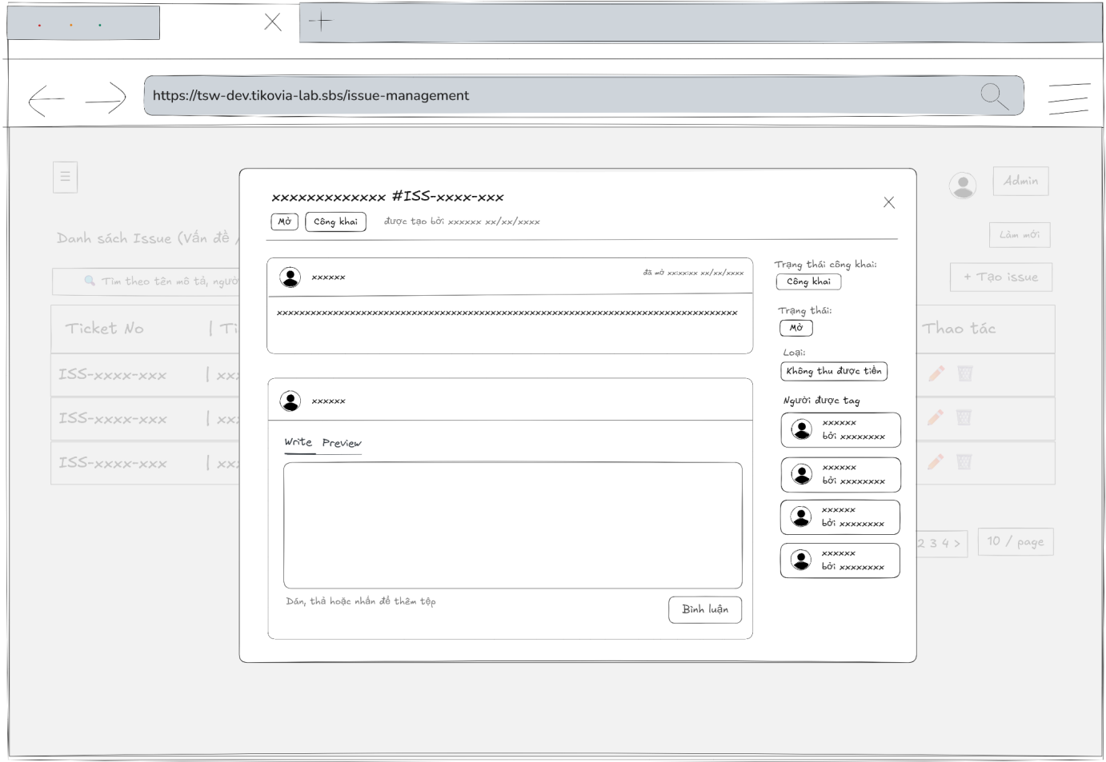
- Function Details:
  - Validation:
    - The user must be authenticated and logged into the system.
    - The user must have a valid authorized role (Admin, Packing Staff, Delivery Supervisor, Sell Staff, Warehouse Manager, Delivery Staff, Accountant).
    - The selected Issue Ticket ID must exist and be valid in the system.
    - The system must verify access permission before displaying issue details.
    - All issue-related data (Ticket No, Title, Created by, Type, Severity, Status, Created at, comments, tags, assignees) must be retrieved correctly from the database.
    - Comments and activity history must be displayed in the correct order and associated with the correct users.
    - Status, visibility (public/private), and assignment information must reflect the current state of the issue ticket.
  - Functionality:
    - In Normal Cases:
      - The system successfully retrieves and displays all information related to the selected issue ticket.
    - In Abnormal Cases:
      - Server Error: If there is an issue with the server when fetch data, the system display no data
  - Business rule: N/A

# | Component | Comp. type | Editable | Mandatory | Default Value | Description
 | Header Section
1 | Issue Title | Label (Text) | No | Yes | [Issue Subject] | Displays the main subject of the issue (e.g., "Khách không chịu trả tiền").
2 | Issue ID | Label (Text) | No | Yes | #ISS-[Code] | Unique identifier for the issue (e.g., #ISS-251117-7JHM).
3 | Close Button | Button (Icon) | No | Yes | [X Icon] | Button to close the modal.
4 | Action Button | Button | No | Yes | "Bắt đầu xử lý" | Primary action button to change status (e.g., from Open to In Progress).
5 | Meta Status | Label (Tag) | No | Yes | "Mở" | Quick status indicator next to the title.
6 | Meta Visibility | Label (Tag) | No | Yes | "Công khai" | Visibility indicator (Public/Private).
7 | Meta Creator | Label (Text) | No | Yes | "được tạo bởi [Name] [Date]" | Displays who created the issue and when.
 | Main Discussion Area (Left)
8 | Post Container | Container | No | Yes | N/A | Container for the original issue description.
9 | User Avatar | Image | No | Yes | [Avatar] | Avatar of the user who posted the comment/issue.
10 | User Name | Label (Link) | No | Yes | [Name] | Clickable name of the poster.
11 | Timestamp | Label (Text) | No | Yes | "opened [Time] [Date]" | Timestamp of the post.
12 | Content Body | Label (Rich Text) | No | Yes | [Description Text] | The detailed description of the issue. Supports rich text.
13 | Comment Header | Label (Text) | No | Yes | "Thêm bình luận mới" | Header for the comment input section.
14 | Editor Tabs | Tab Control | Yes | Yes | "Write" | Toggle between "Write" (editing) and "Preview" modes.
15 | Formatting Toolbar | Toolbar | Yes | No | [B, I, Link, List...] | Rich text formatting tools for the comment.
16 | Comment Input | TextArea | Yes | No | Placeholder: N/A | Input area for typing new comments.
17 | File Upload | Dropzone | Yes | No | "Dán, thả hoặc nhấp để thêm tệp" | Area to attach files by dragging or clicking.
18 | Submit Button | Button | No | Yes | "Bình luận" | Button to post the comment.
 | Sidebar Info (Right)
19 | Sidebar Label 1 | Label (Text) | No | Yes | "Trạng thái công khai:" | Label for visibility setting.
20 | Visibility Tag | Label (Tag) | No | Yes | "Công khai" | Tag indicating visibility. May function as a dropdown to change setting.
21 | Sidebar Label 2 | Label (Text) | No | Yes | "Trạng thái:" | Label for processing status.
22 | Status Tag | Label (Tag) | No | Yes | "Mở" | Tag indicating current workflow status.
23 | Sidebar Label 3 | Label (Text) | No | Yes | "Loại:" | Label for issue category.
24 | Type Tag | Label (Tag) | No | Yes | "Không thu được tiền" | Tag displaying the issue type.
25 | Sidebar Label 4 | Label (Text) | No | Yes | "Mức độ nghiêm trọng:" | Label for severity level.
26 | Severity Tag | Label (Tag) | No | Yes | "Cao" | Tag displaying severity level (e.g., High, Medium).
27 | Sidebar Label 5 | Label (Text) | No | Yes | "Người được tag" | Header for the list of involved users.
28 | Tagged User List | List | No | Yes | [List of Users] | List of users tagged/assigned to this issue. Shows Avatar, Name, and "by [Assigner]".

––––––––––––––––––––––––––––––––––––––––––––––––––––––––––––––––––––––––––––––––––-

3.10.3 - Create Issue Ticket
- Function trigger: Any authenticated users (Admin, Packing Staff, Delivery Supervisor, Sell Staff, warehouse manager, Delivery Supervisor, Delivery Staff, Accountant) accesses the Issue List page and clicks the “Tạo Issue” button to open a popup containing input fields for creating a new issue ticket.
- Function description: Allow authenticated users to create a new issue ticket by providing necessary information such as title, description, issue type, severity, privacy setting, and tagged users.
- Screen layout:
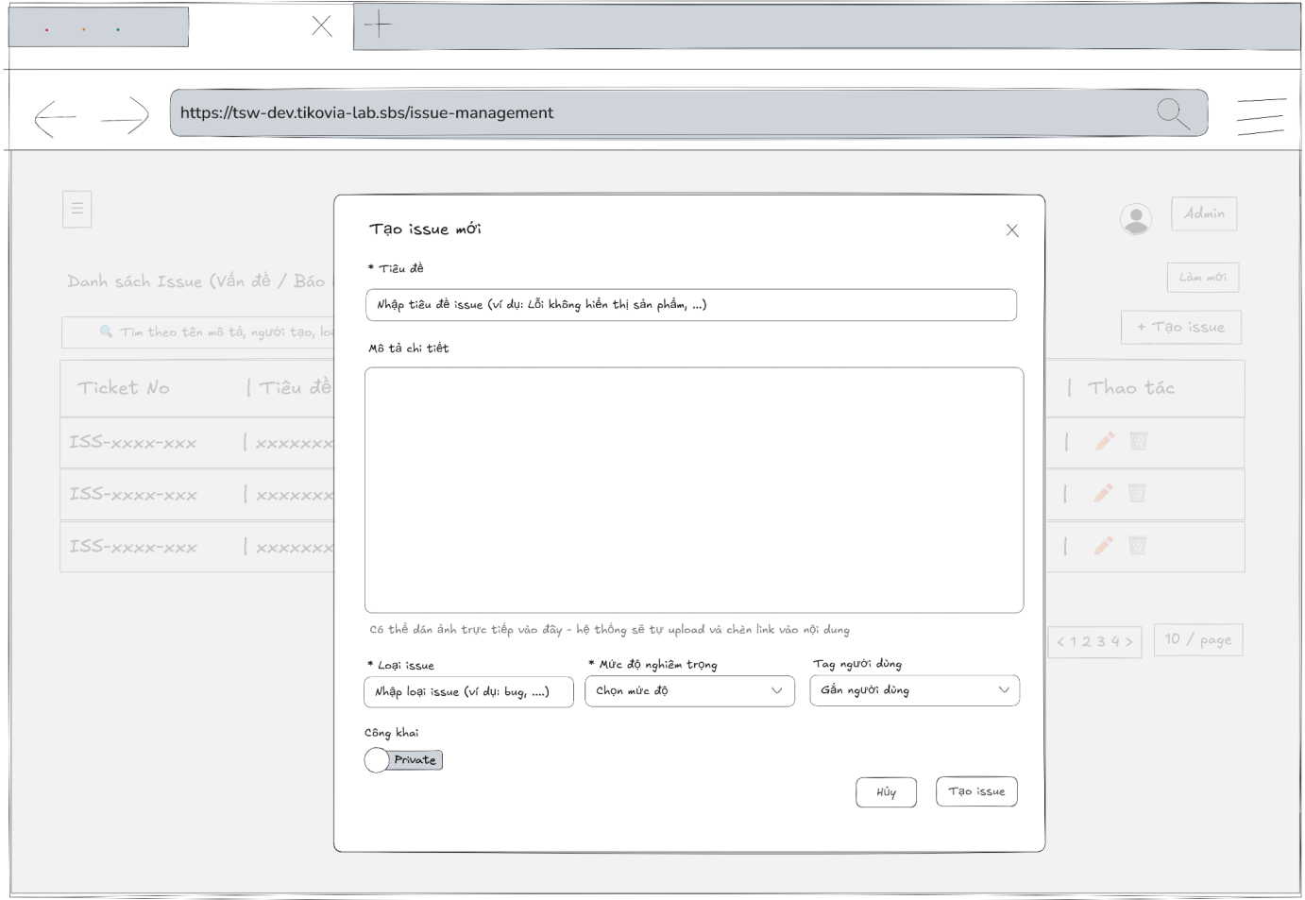
- Function Details:
  - Validation:
    - Users must be authenticated and have an authorized role (Admin, Manager, or permitted staff).
    - Required fields (Title, Description, Issue Type, Severity) must not be empty.
    - Input data must follow valid formats and allowed values.
    - Privacy settings (Public/Private) must be selected correctly.
    - Tagged users (if any) must exist in the system.
    - The system must successfully connect to the server to create the issue.
  - Functionality:
    - In Normal Cases:
      - When the user fills in all required fields and clicks “Tạo Issue”, the system validates the information.
      - If validation passes and the server creates the issue successfully, the system displays a success message: “Tạo issue thành công”
    - In Abnormal Cases:
      - No input Provided: If the admin presses the submit button without any required field, the system will display an error message required field.
      - Server Error: If there is an issue with the server when submitting the new issue ticket: “Lỗi khi tạo issue”
  - Business rule: N/A

# | Component | Comp. type | Editable | Mandatory | Default Value | Description
 | Header
1 | Modal Title | Label (Text) | No | Yes | "Tạo Issue mới" | Displays the title of the modal window.
2 | Close Button | Button (Icon) | No | Yes | [X Icon] | Button to close the modal without saving.
 | Issue Content Form
3 | Subject Label | Label (Text) | No | Yes | "* Tiêu đề" | Label for the issue title. Asterisk indicates mandatory.
4 | Subject Input | Input (Text) | Yes | Yes | Placeholder: "Nhập tiêu đề issue (ví dụ: Lỗi không hiển thị...)" | Input field for the main subject of the issue.
5 | Desc Label | Label (Text) | No | Yes | "Mô tả chi tiết (Markdown supported)" | Label for the description area, indicating Markdown support.
6 | Formatting Toolbar | Toolbar | Yes | No | [Bold, Italic, Link, List...] | Toolbar containing rich text formatting options for the description.
7 | Description Input | TextArea | Yes | No | N/A | Large text area for entering detailed information. Supports drag-and-drop image upload.
8 | Upload Hint | Label (Text) | No | Yes | "Có thể dán ảnh trực tiếp vào đây..." | Helper text instructing users that they can paste images directly.
 | Attributes & Classification
9 | Type Label | Label (Text) | No | Yes | "* Loại issue" | Label for the issue category input.
10 | Type Input | Input / Combobox | Yes | Yes | Placeholder: "Nhập loại issue (ví dụ: bug, feature...)" | Field to define the issue type. Likely a text input with autocomplete suggestions.
11 | Severity Label | Label (Text) | No | Yes | "* Mức độ nghiêm trọng" | Label for the severity dropdown.
12 | Severity Dropdown | Dropdown | Yes | Yes | Placeholder: "Chọn mức độ" | Dropdown to select the priority level of the issue.
13 | Tag User Label | Label (Text) | No | Yes | "Tag người dùng" | Label for the user tagging field.
14 | Tag User Input | Dropdown (Multi) | Yes | No | Placeholder: "Gắn người dùng" | Multi-select field to search and tag relevant users.
 | Settings & Footer
15 | Visibility Label | Label (Text) | No | Yes | "Công khai" | Label for the visibility setting section.
16 | Visibility Toggle | Toggle Switch | Yes | Yes | "Private" (Off) | Switch to toggle between Public and Private visibility modes.
17 | Cancel Button | Button | No | Yes | "Hủy" | Button to close the modal and discard the draft.
18 | Create Button | Button | No | Yes | "Tạo Issue" | Primary button to submit the form and create the new issue record.

––––––––––––––––––––––––––––––––––––––––––––––––––––––––––––––––––––––––––––––––––-

3.10.4 - Update Issue Ticket’s Information
- Function trigger: Any authenticated users (Admin, Packing Staff, Delivery Supervisor, Sell Staff, warehouse manager, Delivery Supervisor, Delivery Staff, Accountant) accesses the Issue List page and clicks the Edit button corresponding to a specific issue ticket to open a popup containing editable fields.
- Function description: Allow authorized users to update the information of an existing issue ticket.
- Screen layout:
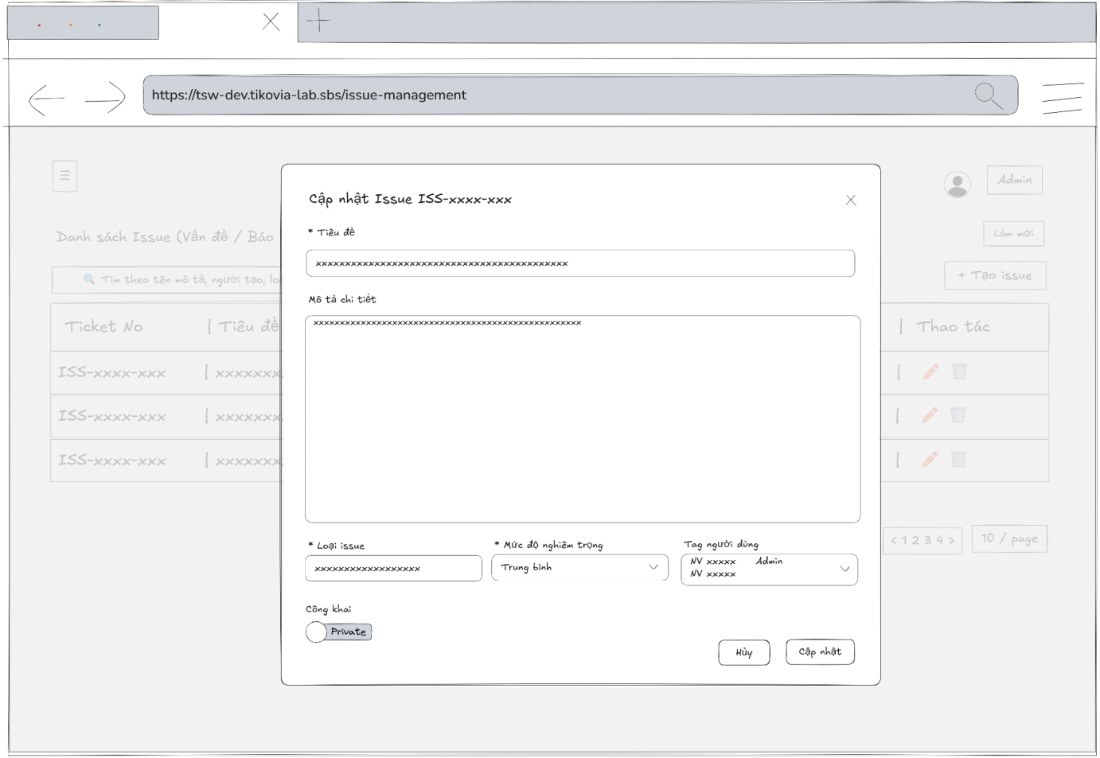
- Function Details:
  - Validation:
    - Required fields (Title, Description, Type, Severity) must not be empty.
    - Private issues are editable only by permitted users.
  - Functionality:
    - In Normal Cases:
      - After clicking the Edit button, the system retrieves and displays the issue ticket’s information correctly in the input fields.
      - All displayed information must match the existing data stored in the database.
      - After the user edits the issue ticket and presses the “Cập nhật” button: The system validates all required fields. If validation succeeds, the update request is submitted to the server. The system then displays the success message: “Cập nhật thành công”
    - In Abnormal Cases:
      - Required fields blank: If required fields are left blank or contain invalid data , the system will: Display an error message indicating which fields are missing or invalid and prevent saving until all required fields are correctly filled.
      - Server Error: If the server encounters an internal error (e.g., database timeout or server crash) during the update process, the system will show a message like “Server error occurred. Please try again later.”
  - Business rule: N/A

# | Component | Comp. type | Editable | Mandatory | Default Value | Description
 | Header
1 | Modal Title | Label (Text) | No | Yes | "Cập nhật Issue [ISS-ID]" | Displays the title including the unique Issue ID (e.g., ISS-251117-7JHM).
2 | Close Button | Button (Icon) | No | Yes | [X Icon] | Button to close the modal without saving changes.
 | Content Editing Form
3 | Subject Label | Label (Text) | No | Yes | "* Tiêu đề" | Label for the issue title. Asterisk indicates mandatory.
4 | Subject Input | Input (Text) | Yes | Yes | [Current Subject] | Input field pre-filled with the current title (e.g., "Khách không chịu trả tiền").
5 | Desc Label | Label (Text) | No | Yes | "Mô tả chi tiết (Markdown supported)" | Label for the description area.
6 | Formatting Toolbar | Toolbar | Yes | No | [Bold, Italic, Link...] | Standard rich text toolbar.
7 | Description Input | TextArea | Yes | No | [Current Description] | Editor area pre-filled with the existing description content.
 | Attributes & Classification
8 | Type Label | Label (Text) | No | Yes | "* Loại issue" | Label for the issue category.
9 | Type Input | Input / Combobox | Yes | Yes | [Current Type] | Field displaying the current issue type (e.g., "Không thu được tiền").
10 | Severity Label | Label (Text) | No | Yes | "* Mức độ nghiêm trọng" | Label for severity level.
11 | Severity Dropdown | Dropdown | Yes | Yes | [Current Severity] | Dropdown showing current severity (e.g., "Cao"). User can change it here.
12 | Tag User Label | Label (Text) | No | Yes | "Tag người dùng" | Label for the tagged users section.
13 | Tag User Input | Dropdown (Multi) | Yes | No | [List of Tagged Users] | Multi-select field displaying currently tagged users as chips (e.g., thangadmin, namadmin). Allows adding/removing tags.
 | Settings & Footer
14 | Visibility Label | Label (Text) | No | Yes | "Công khai" | Label for visibility status.
15 | Visibility Toggle | Toggle Switch | Yes | Yes | [Current State] | Toggle switch showing current state (e.g., "Public" - Blue). Can be switched to Private.
16 | Cancel Button | Button | No | Yes | "Hủy" | Button to discard changes and close the modal.
17 | Update Button | Button | No | Yes | "Cập nhật" | Primary button to save the modified information to the database.

––––––––––––––––––––––––––––––––––––––––––––––––––––––––––––––––––––––––––––––––––-

4. Non-Functional Requirements

4.1. External Interfaces

4.1.1 User Interface
- UI-01: When users complete any actions such as save, delete, create, etc… the system has to display a Success toast Message when completing an action.
- UI-02: Whenever a user wants to delete something, a popup Message will display and confirm (Yes/Cancel).

4.1.2 Software Interface
- SI-01: Users can use Google services to log in, which will help them authenticate their account.
- SI-02: The API should perform efficiently, handling requests quickly and without excessive resource consumption.
- SI-03: The API must include jwt in the header when accessing private or secure resources.
- SI-04: The API for each server must be independent and have little dependence on each other
- SI-05: The API should have a clear versioning strategy to manage changes and maintain compatibility with existing applications.

4.1.3 Hardware Interface
- HI-01: The server can increase the amount of RAM when it has to process many requests.

4.2. Quality Attributes

4.2.1 Availability
- The TikoSmart system must be operational and accessible to users for at least 99.5% of the time (uptime).
- The average time to repair critical system failures should be within 4 business hours.
- A strategy must be in place to recover from a major system failure or disaster (Disaster Recovery Plan).

4.2.2 Usability
- The system should be intuitive and simple for new employees to learn and operate effectively.
- Users should be able to remember how to use the system's features even after a long period of non-use.
- As new features become available, users can quickly adapt to working with them.

4.2.3 Reliability
- The system must ensure data integrity and consistency across all transactions (e.g., inventory updates, order creation).
- Confidential business information, customer data, and employee details must be kept secure and protected from unauthorized access.

4.2.4 Performance
- Response time should be under 2 seconds for standard queries and under 5 seconds for complex reports.
- System data must be backed up automatically on a daily basis.

4.2.5 Security
- The system must be protected against common web vulnerabilities like SQL injection by using parameterized queries instead of string concatenation.
- Implement Role-Based Access Control (RBAC) to ensure employees can only access data relevant to their job functions.

4.2.6 Maintainability and Extensibility
- The project's technical documentation should be stored in a concise and organized manner so that it can be easily retrieved when needed.
- The codebase must adhere to clean coding principles and conventions to ensure the application is easy to maintain, modify, and extend.

5. Requirement Appendix

5.1 Business Rules
# | Rule Definition
BR-01 | The email password reset link will expire after 10 minutes.
BR-02 | Password regulations: at least 8 characters, at least 1 uppercase letter, 1 lowercase letter, 1 number.
BR-03 | Passwords stored in the database must be hashed by the bcrypt algorithm.
BR-04 | Users only can edit phone numbers and avatar in profile.
BR-05 | All deleting actions must have a confirmation popup before deleting.
BR-07 | The TikoSmart system must maintain the privacy and security of user data and not use it for any other purpose.
BR-08 | Full name format: does not start with a number, minimum 2 characters.
BR-09 | Username format: no accent marks, no special characters (underscore _ is allowed), must not start with a digit, length between 3 and 50 characters
BR-10 | Phone numbers must have length between 10 and 11 numbers.
BR-11 | Department code must no accent marks, no special characters (underscore _ is allowed), must not start with a digit, at least 3 characters
BR-12 | All active/disable must have popup confirmation before implementation.
BR-13 | Files imported into the system must follow the format provided by the system.
BR-14 | The account must exist on the TikoSmart system.
BR-15 | The email must follow email format.
BR-16 | The username, email must be unique.
BR-17 | Users must wait 25 seconds before sending the request reset password again.
BR-18 | The uploaded product image must be in JPG, PNG, or GIF format and must not exceed 2MB.
BR-19 | Numeric fields must contain valid positive numbers.
BR-20 | Expiry date must be a valid date and must not be earlier than the current date.
BR-21 | The address field must not exceed 200 characters.
BR-22 | Warehouse manager can not view any field that related to money.
BR-23 | Delivery time must be in the future.
BR-24 | Payment date can not be in the future.

Table 8. Business Rule

5.2 Common Requirements
# | Requirement | Description
1 | Functionality | The TikoSmart system is a centralized management platform that enables the business to: Inventory Management: Track inbound and outbound goods, and monitor inventory levels in real-time. Order Management: Create and process orders based on customer requests and track their status. Department Management: Assign permissions and manage the activities of different departments within the company. Transaction Management: Record and manage all transactions with suppliers and partners.
2 | Security | The web platform must ensure the complete security and confidentiality of all business data, including customer information, sales data, and internal information.
3 | Performance | The system must be optimized for fast page load times and smooth processing of transactions (such as order creation and inventory updates), ensuring immediate responses without interruption.
4 | Scalability | Designed with a microservices architecture, the TikoSmart system can easily scale each service independently to handle high volumes of orders, products, and users as the business grows.
5 | Compatibility | The website must function stably and display correctly across all modern and popular web browsers (e.g., Chrome, Firefox, Safari, Edge).
6 | Maintainability | The system must have a well-structured architecture, allowing the technical team to easily maintain, debug, and upgrade features during operation.
7 | Quality | The platform must undergo rigorous functional, load, and security testing to ensure high standards of performance, stability, and reliability for business operations.
8 | Usability | The user interface must be intuitive and user-friendly, helping employees manage their tasks easily and efficiently. The system must also be compatible with mobile and tablet devices.
9 | Availability | The system must operate stably 24/7 to ensure that business operations are never interrupted.

Table 9. Common Requirements

5.3 Application Messages List
# | Message code | Message Type | Context | Content
01 | MSG01 | Toast message | Sign in success (check box remember me checked) | Đăng nhập thành công. Bạn đã đăng nhập và sẽ được ghi nhớ.
02 | MSG02 | Toast message | Sign in success (check box remember me unchecked) | Đăng nhập thành công. Bạn đã đăng nhập cho phiên hiện tại.
03 | MSG03 | Toast message | Sign in failure. The account does not exist in the system | Đăng nhập thất bại. Email hoặc username chưa được đăng ký!
04 | MSG04 | Toast message | Sign in failure. Wrong password | Đăng nhập thất bại. Mật khẩu không đúng!
05 | MSG05 | Toast message | Sign in with google success | Đăng nhập thành công. Đăng nhập Google thành công!
06 | MSG06 | Toast message | Sign in with google failure. The account does not exist in the system | Đăng nhập thất bại. Tài khoản chưa được đăng ký. Vui lòng đăng ký trước khi đăng nhập bằng Google.
07 | MSG07 | Inline message | Password input field does not meet the requirement | Mật khẩu phải có ít nhất 8 ký tự, bao gồm chữ hoa, chữ thường và số!
08 | MSG08 | Toast message | In forget password, user input email that does not exist in the system | Email không tồn tại trong hệ thống!
09 | MSG09 | Toast message | Send request to reset password success | Thành công. Yêu cầu đặt lại mật khẩu đã được gửi. Vui lòng kiểm tra email của bạn!
10 | MSG10 | Inline message | {field name} input field is empty | Vui lòng nhập {field name}!
11 | MSG11 | Inline message | Input email address not follow email format | Địa chỉ email không hợp lệ!
12 | MSG12 | Inline message | In reset password, input confirm password does not same with new password | Mật khẩu xác nhận không khớp!
13 | MSG13 | Toast message | After send request reset password success | Mật khẩu của bạn đã được cập nhật thành công!
14 | MSG14 | Toast message | After send request reset password failure | Có lỗi xảy ra khi đặt lại mật khẩu. Vui lòng thử lại.
15 | MSG15 | Inline message | If the reset password link is out of time | Liên kết đặt lại không hợp lệ hoặc đã hết hạn. Vui lòng yêu cầu đặt lại mật khẩu mới.
16 | MSG16 | Inline message | If the list is empty | No data
17 | MSG17 | Inline message | Error during fetch user data | Không thể tải dữ liệu. Đã xảy ra lỗi khi tải danh sách người dùng
18 | MSG18 | Popup message | When admin want to active/disable user's account | Bạn có chắc chắn muốn {kích hoạt/vô hiệu hóa} tài khoản {username}.
19 | MSG19 | Toast message | After send request to active/disable user's account success | Cập nhật trạng thái thành công. Tài khoản {username} đã được {kích hoạt/vô hiệu hóa}.
20 | MSG20 | Toast message | After send request to active/disable user's account failure | Cập nhật trạng thái thất bại. Có lỗi xảy ra khi cập nhật trạng thái người dùng.
21 | MSG21 | Toast message | After admin send request to create new account success | Tạo tài khoản thành công. Tài khoản đã được tạo. Vui lòng kiểm tra email để kích hoạt.
22 | MSG22 | Toast message | After admin send request to create new account failure | Có lỗi xảy ra. Có lỗi xảy ra khi tạo tài khoản
23 | MSG23 | Inline message | Note for admin when create a new account | Lưu ý: Sau khi tạo thành công, người dùng sẽ nhận được email chứa link kích hoạt tài khoản và thiết lập mật khẩu. Link có hiệu lực trong 7 ngày.
24 | MSG24 | Inline message | Input username does not meet the requirement | Tên đăng nhập phải có ít nhất 3 ký tự!  Tên đăng nhập không được quá 50 ký tự!  Tên đăng nhập phải bắt đầu bằng chữ cái, có 3-50 ký tự và chỉ chứa chữ cái, số, dấu gạch dưới!
25 | MSG25 | Inline message | Input full name does not meet the requirement | Họ và tên phải có ít nhất 2 ký tự!  Họ và tên không được bắt đầu bằng số!
26 | MSG26 | Inline message | Input phone number does not meet the requirement | Số điện thoại phải có 10-11 chữ số!
27 | MSG27 | Toast message | When admin edit email of an user's account | Cập nhật thành công. Chúng tôi đã gửi một email xác nhận đến địa chỉ mới {email}. Vui lòng kiểm tra email để xác nhận thay đổi.
28 | MSG28 | Toast message | When admin update information of an user's account success | Cập nhật thành công. Thông tin người dùng đã được cập nhật.
29 | MSG29 | Toast message | When admin update information of an user's account failure | Có lỗi xảy ra. Có lỗi xảy ra khi cập nhật thông tin người dùng
30 | MSG30 | Toast message | When admin, manager create new product success | Tạo sản phẩm thành công. Sản phẩm đã được thêm vào hệ thống.
31 | MSG31 | Toast message | When admin, manager create new product failure | Có lỗi xảy ra. Không thể tạo sản phẩm
32 | MSG32 | Popup message | When admin press button to lock or unlock product, an confirm popup appear | Bạn có chắc chắn muốn {khóa/mở khóa} sản phẩm này?  Thao tác này sẽ ảnh hưởng trực tiếp đến việc kinh doanh sản phẩm!
33 | MSG33 | Toast message | After send request to lock / unlock product success | Khóa sản phẩm thành công / Mở khóa sản phẩm thành công  Sản phẩm đã được {khóa / mở khóa}.
34 | MSG34 | Toast message | After send request to lock / unlock product failure | Có lỗi xảy ra. Không thể {khóa / mở khóa} sản phẩm.
35 | MSG35 | Popup message | After admin press on reload all product status | Làm mới trạng thái tất cả sản phẩm? Thao tác này sẽ cập nhật lại trạng thái cho toàn bộ sản phẩm. Bạn có chắc chắn?
36 | MSG36 | Toast message | When the admin press reload status of a product success | Làm mới trạng thái thành công. Trạng thái sản phẩm đã được cập nhật.
37 | MSG37 | Toast message | When the admin press reload status of a product failure | Lỗi. Không thể làm mới trạng thái sản phẩm.
38 | MSG38 | Toast message | When the admin press reload status of all product success | Làm mới trạng thái tất cả sản phẩm thành công.
39 | MSG39 | Toast message | When the admin press reload status of all product failure | Không thể làm mới trạng thái tất cả sản phẩm.
40 | MSG40 | Toast message | After send request to update product info success | Cập nhật thành công. Thông tin sản phẩm đã được cập nhật.
41 | MSG41 | Toast message | After send request to update product info success | Có lỗi xảy ra. Không thể cập nhật sản phẩm.
42 | MSG42 | Inline message | When there is no inventory lot for selected product | Không có lô hàng nào cho sản phẩm này.
43 | MSG43 | Popup message | When admin want to active/disable a department | Xác nhận {vô hiệu hóa / kích hoạt} cơ sở  Bạn có chắc chắn muốn {vô hiệu hóa / kích hoạt} cơ sở {department name} không?
44 | MSG44 | Toast message | After admin send request to active/disable department success | {Kích hoạt / Vô hiệu hóa} thành công  Cơ sở {department name} đã được {vô hiệu hóa / kích hoạt}.
45 | MSG45 | Toast message | After admin send request to active/disable department failure | Cập nhật trạng thái thất bại. Không thể {vô hiệu hóa / kích hoạt} cơ sở {department name}.
46 | MSG46 | Popup message | When admin press button to delete an department | Xác nhận xóa cơ sở. Bạn có chắc chắn muốn xóa cơ sở {department name} không? Hành động này không thể hoàn tác.
47 | MSG47 | Toast message | After admin send request to delete a department success | Xóa cơ sở thành công. Cơ sở {department name} đã được xóa.
48 | MSG48 | Toast message | After admin send request to delete a department failure | Xóa cơ sở thất bại. Không thể xóa cơ sở {department name}.
49 | MSG49 | Toast message | After admin send request to create new department success | Tạo cơ sở thành công. Cơ sở đã được tạo thành công.
50 | MSG50 | Toast message | After admin send request to create new department failure | Có lỗi xảy ra. Có lỗi xảy ra khi tạo cơ sở.
51 | MSG51 | Inline message | Input department code does not meet the requirement | Mã cơ sở phải có ít nhất 3 ký tự!"  Mã cơ sở không được chứa dấu, không bắt đầu bằng số và không có ký tự đặc biệt (ngoại trừ dấu gạch dưới)!
52 | MSG52 | Toast message | After admin send request to update department success | Cập nhật thành công. Thông tin cơ sở {department name} đã được cập nhật.
53 | MSG53 | Toast message | After admin send request to update department failure | Có lỗi xảy ra. Có lỗi xảy ra khi cập nhật thông tin cơ sở
54 | MSG54 | Popup message | When admin press on delete inventory lot button | Bạn có chắc chắn muốn xóa lô hàng {lotNo} không?
55 | MSG55 | Toast message | After send request to delete inventory lot success | Xóa lô hàng thành công. Lô hàng {lotNo} đã được xóa.
56 | MSG56 | Toast message | After send request to delete inventory lot failure | Đã xảy ra lỗi khi xóa lô hàng. Xóa lô hàng thất bại
57 | MSG57 | Toast message | After send request to add new inventory lot success | Tạo lô hàng thành công. Lô {lotNo} đã được tạo.
58 | MSG58 | Toast message | After send request to add new inventory lot failure | Tạo lô hàng thất bại. Có lỗi xảy ra khi tạo lô hàng.
59 | MSG59 | Toast message | After send request to update inventory lot success | Cập nhật thành công. Thông tin lô hàng {lotNo} đã được cập nhật.
60 | MSG60 | Toast message | After send request to update inventory lot failure | Có lỗi xảy ra. Không thể cập nhật thông tin lô hàng
61 | MSG61 | Inline message | If list of unit conversion belong to a inventory lot is empty | Không có dữ liệu quy đổi đơn vị.
62 | MSG62 | Toast message | After accountant, admin update supplier transaction payment success | Cập nhật thành công. Thông tin thanh toán đã được cập nhật.
63 | MSG63 | Toast message | After accountant, admin update supplier transaction payment success | Có lỗi xảy ra. Không thể cập nhật thanh toán.
64 | MSG64 | Toast message | After accountant, admin add a supplier transaction payment success | Tạo thanh toán thành công. Thanh toán đã được thêm vào hệ thống..
65 | MSG65 | Toast message | After accountant, admin add a supplier transaction payment success | Có lỗi xảy ra. Không thể tạo thanh toán.
66 | MSG66 | Toast message | After successfully deleting a supplier | Xóa thành công – Nhà cung cấp "..." đã bị xóa.
67 | MSG67 | Toast message | When deleting a supplier fails | Lỗi xóa nhà cung cấp
68 | MSG68 | Popup message | When user clicks delete supplier → confirmation dialog | Xác nhận xóa nhà cung cấp?
69 | MSG69 | Inline message | When data fetching fails | When data fetching fails
70 | MSG70 | Toast message | When supplier creation succeeds | Tạo nhà cung cấp thành công – Nhà cung cấp “...” đã được thêm mới.
71 | MSG71 | Toast message | When supplier creation fails | Lỗi khi tạo nhà cung cấp – Hiển thị lỗi chi tiết nếu không thể tạo nhà cung cấp.
72 | MSG72 | Inline message | Required supplier code | Vui lòng nhập mã nhà cung cấp!
73 | MSG73 | Inline message | Supplier code too short (<3 characters) | Mã phải có ít nhất 3 ký tự!
74 | MSG74 | Inline message | Supplier code invalid pattern | Không chứa dấu, không bắt đầu bằng số và không có ký tự đặc biệt (trừ gạch dưới)!
75 | MSG75 | Inline message | Missing supplier name | Vui lòng nhập tên nhà cung cấp!
76 | MSG76 | Inline message | Invalid email format | Email không hợp lệ!
77 | MSG77 | Inline message | Invalid phone format | Số điện thoại không hợp lệ!
78 | MSG78 | Toast message | After supplier is successfully updated | Cập nhật thành công – Nhà cung cấp “...” đã được cập nhật.
79 | MSG79 | Toast message | When supplier update fails | Cập nhật thất bại – Hiển thị lỗi chi tiết nếu không thể cập nhật nhà cung cấp.
80 | MSG80 | Popup message | Confirm dialog when deleting transaction | Xác nhận xóa giao dịch?
81 | MSG81 | Popup message | Confirm dialog content | Bạn có chắc muốn xóa chứng từ "{record.doc_no}" không?
82 | MSG82 | Toast message | When transaction deleted successfully | Xóa thành công – Giao dịch “...” đã bị xóa.
83 | MSG83 | Toast message | When transaction deletion fails | Lỗi xóa giao dịch – Không thể xóa giao dịch.
84 | MSG84 | Toast message | When no items in transaction | Vui lòng thêm ít nhất 1 sản phẩm
85 | MSG85 | Toast message | When all product rows are empty | Không có sản phẩm hợp lệ – "Vui lòng nhập ít nhất một sản phẩm có thông tin đầy đủ."
86 | MSG86 | Toast message | When some products missing fields | Thiếu thông tin sản phẩm – "Một số sản phẩm chưa điền đủ thông tin (tên, số lượng, đơn giá hoặc hạn sử dụng / lô hàng)."
87 | MSG87 | Toast message | When transaction creation succeeds | Thêm giao dịch thành công – "Giao dịch nhập / xuất đã được tạo."
88 | MSG88 | Toast message | When transaction creation fails | Lỗi khi tạo giao dịch – "Không thể tạo giao dịch."
89 | MSG89 | Toast message | When transaction details fail to load | Lỗi khi tải dữ liệu giao dịch – "Không thể tải thông tin chi tiết giao dịch."
90 | MSG90 | Toast message | When transaction update succeeds | Cập nhật thành công – "Giao dịch nhập / xuất đã được cập nhật."
91 | MSG91 | Toast message | When transaction update fails | Cập nhật thất bại
92 | MSG92 | Toast message | When payment history fail to load | Không thể tải lịch sử thanh toán

Table 10. Application Messages List

