

CAPSTONE PROJECT REPORT
Report 3 – Software Requirement Specification

Table of Contents
I. Record of Changes 3
II. Software Requirement Specification 5
1. Product Overview 5
Figure 1. Context diagram 5
2. User Requirements 6
2.1 Actors 6
2.2 Use Cases 7
3. Functional Requirements 18
3.1 System Functional Overview 18
3.2 Authentication feature 36
3.3. Manage common User’s feature 42
3.4 Manage Car & Booking 50
3.5 Vehicle Management feature 82
3.7 Manage Admin feature 92
4. Non-functional Requirements 112
5. Requirement Appendix 114
5.1 Business Rules 114
5.2 Common Requirements 123
5.3 Application Messages List 124

Table of Tables
Table 1. All actors in the system 7
Table 2. Use case Description 18
Table 3. Screen Descriptions 25
Table 4. Screen Authorization 28
Table 5. Non-Screen Functions 30
Table 6. Entities Description 37
Table 7. Business Rule 124
Table 8. Common Requirements 125
Table 9. Application Message List 128

Table of Figures
Figure 1. Context Diagram 6
Figure 2. ViVuCar System Use Case Diagram 8
Figure 3. Use Case for Authentication 9
Figure 4. Use Case for Guest 10
Figure 5. Use Case for Renter 11
Figure 6. Use Case for Vehicle Owner 12
Figure 7. Use Case for Admin 13
Figure 8. Use Case for Support Staff 14
Figure 9. Use Case for AI 15
Figure 10. Screen flow diagram 19
Figure 11. ERD digram 28
Figure 12. Sign in 35
Figure 13. Sign out 37
Figure 14. Register Account 38
Figure 15. Forgot password 40
Figure 16. View / Update Profile & Link Bank Account Screen Layout 42
Figure 17. Upgrade Account to Car Owner Screen Layout 44
Figure 18. View Wallet & Manage Transactions Screen Layout 46
Figure 19. View Notifications Screen Layout 48
Figure 20. Create car listing 49
Figure 21. Search & Book Car 51
Figure 22. Confirm Booking & Deposit 52
Figure 23. Complete Trip & Review 54
Figure 24. View Car Details 56
Figure 25. Filter & Search Cars 57
Figure 26. Create Vehicle Booking 59
Figure 27. View Booking History & Details 61
Figure 28. Cancel Vehicle Booking 63
Figure 29. View Owned Vehicle List 64
Figure 30. Register / Manage New Vehicle 66
Figure 31. Confirm Rental Request(Approve/Reject) 67
Figure 32. Contact Customer Service / AI Chatbot Screen Layout 69
Figure 33. Report Incident Screen Layout 71
Figure 34. Submit & Handle Complaint Screen Layout 73
Figure 35. View Admin Dashboard 75
Figure 36. View List Users 77
Figure 37. View List Reports 78

I. Record of Changes
Date | A*  M, D | In charge | Change Description
11/8/2024 | A | TamMV | Update ERD diagram
*A - Added M - Modified D - Deleted

II. Software Requirement Specification

1. Product Overview
The Self-drive Car Rental Platform (SCRP) is a comprehensive software platform that digitizes the peer-to-peer car rental process, connecting Renters and Car Owners while providing Admin and Customer Service with the tools needed to operate the platform safely. It simplifies vehicle discovery, booking, KYC identity verification, secure deposit payment via VietQR, digital vehicle handover, and dispute resolution. The system also integrates AI-assisted KYC document extraction (OCR) and an AI support chatbot to reduce manual workload for Customer Service. The context diagram below illustrates the external entities and system interfaces for release 1.0, including the payment gateway, Google OAuth, email notification service, and the AI OCR/chatbot services. Over time, the system will evolve with additional features such as GPS-based vehicle tracking and dynamic pricing.
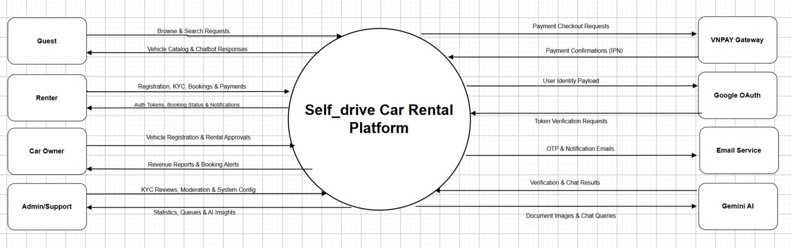
Figure 1. Context Diagram

2. User Requirements

2.1 Actors

# | Actor | Description
1 | Guest | An unauthenticated user who can browse available vehicles, read reviews, and view platform policies without logging in.
2 | Renter | A registered and KYC-verified user who can search, book, and pay for vehicle rentals, manage bookings, submit incident reports, and use the wallet.
3 | Car Owner | A registered user who has upgraded to the Car Owner role. Can register vehicles, manage listings, confirm/reject rental requests, and view revenue.
4 | Admin | The system manager with full administrative control: manages users, approves vehicles, monitors transactions, configures system settings, and generates reports.
5 | Support Staff (CSKH) | Operational staff who review KYC documents, moderate reviews, handle support tickets, manage incident and complaint cases, and compile statistics.
Table 1. All actors in the system

2.2 Use Cases

2.2.1 Diagram(s)

2.2.1.1 Use Case Overview
Below is an overview of the use cases for the ViVuCar system.
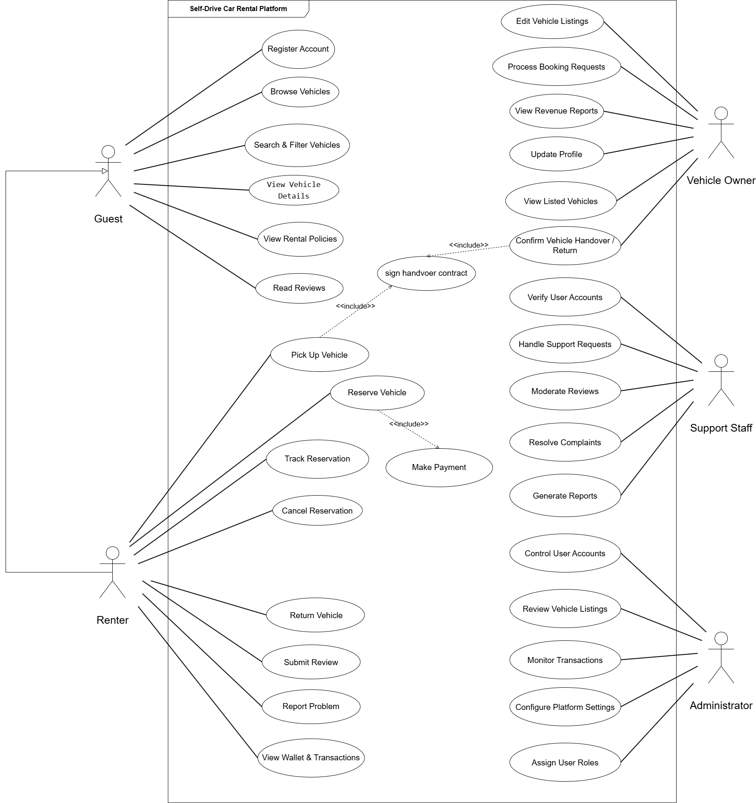
Figure 2. ViVuCar System Use Case Diagram

2.2.1.2 Use Case for Authentication
In the ViVuCar system, all users are required to undergo an authentication process when they enter the platform. This process verifies the user's identity and ensures that only authorized individuals are granted access. The system can safeguard sensitive information and prevent unauthorized entry by implementing authentication.
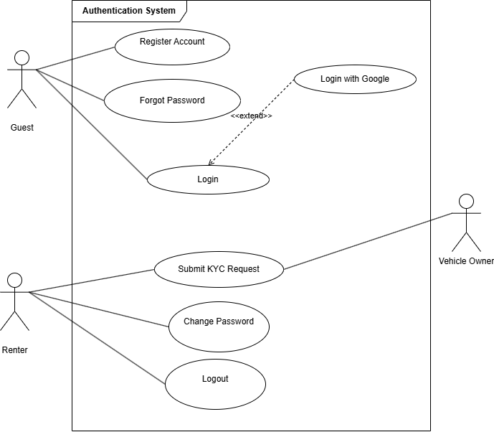
Figure 3. Use Case for Authentication

2.2.1.3 Use Case for Guest
Below is a subsystem use case for the Guest actor.
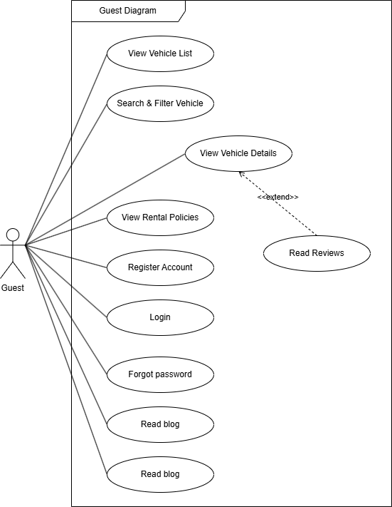
Figure 4. Use Case for Guest

2.2.1.4 Use Case for Renter
Below is a subsystem use case for the Renter actor.
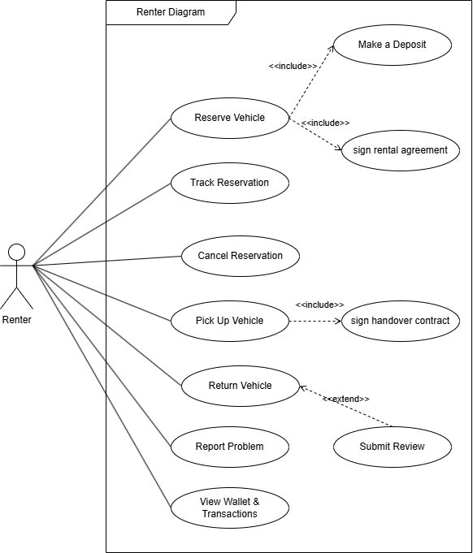
Figure 5. Use Case for Renter

2.2.1.5 Use Case for Vehicle Owner

Below is a subsystem use case for the Vehicle Owner actor.
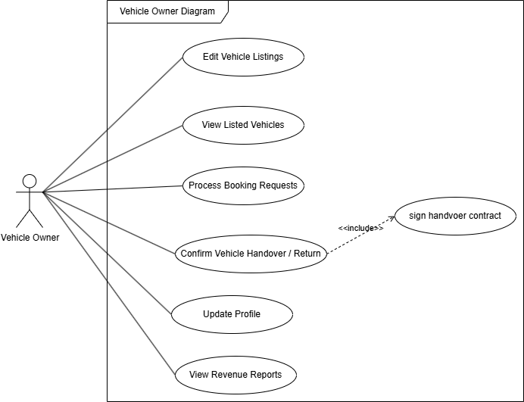
Figure 6. Use Case for Vehicle Owner

2.2.1.6 Use Case for Admin
Below is a subsystem use case for the Admin actor.
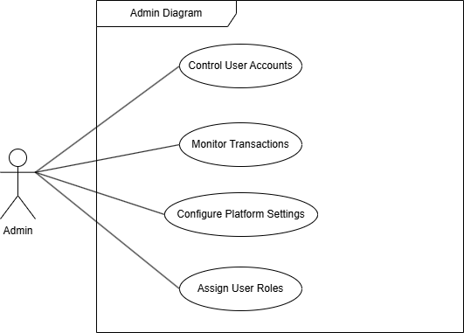
Figure 7. Use Case for Admin

2.2.1.7 Use Case for Support Staff
Below is a subsystem use case for the Support Staff actor.

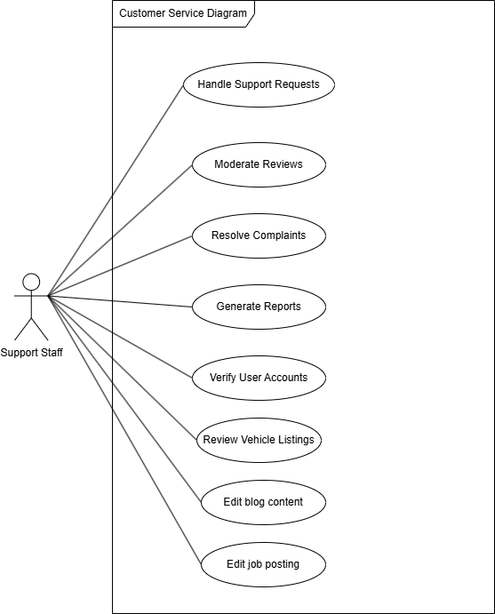
Figure 8. Use Case for Support Staff

2.2.1.8 Use Case for AI
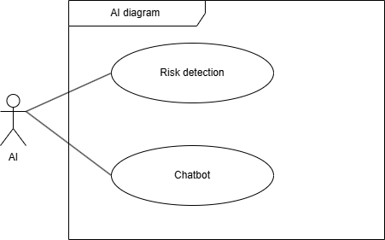
Figure 9. Use Case for AI

2.2.2 Descriptions
Below is a summary of the use cases present in the ViVuCar system:
ID | Use Case | Actors
UC01 | Register Account | Guest
UC02 | Verify Email | Guest
UC03 | Login | Guest, Renter, Car Owner, Admin, Support Staff
UC04 | Login with Google | Guest
UC05 | Logout | Renter, Car Owner, Admin, Support Staff
UC06 | Forgot Password | Guest, Renter, Car Owner, Admin, Support Staff
UC07 | Reset Password | Guest, Renter, Car Owner, Admin, Support Staff
UC08 | Change Password | Renter, Car Owner, Admin, Support Staff
UC09 | View & Edit Profile | Renter, Car Owner, Admin, Support Staff
UC10 | Upload KYC Documents | Renter, Car Owner
UC11 | Link Bank Account | Renter, Car Owner
UC12 | Register as Car Owner | Renter
UC13 | View Vehicle List | Guest, Renter
UC14 | Search & Filter Vehicles | Guest, Renter
UC15 | View Vehicle Details & Reviews | Guest, Renter
UC16 | View Policies & FAQ | Guest, Renter
UC17 | Book Vehicle | Renter
UC18 | Payment & Deposit via VNPAY | Renter
UC19 | Track Booking | Renter, Car Owner
UC20 | Cancel Booking & Refund | Renter
UC21 | Vehicle Handover | Renter, Car Owner
UC22 | Rate & Review Service | Renter
UC23 | Report Incident | Renter
UC24 | Submit Complaint | Renter, Car Owner
UC25 | View Wallet & Transactions | Renter, Car Owner
UC26 | Register New Vehicle | Car Owner
UC27 | Update Vehicle Listings | Car Owner
UC28 | Confirm Rental Request | Car Owner
UC29 | View Revenue Statistics | Car Owner
UC30 | Monitor User Accounts | Admin
UC31 | Assign User Roles | Admin
UC32 | Approve Vehicles | Admin, Support Staff
UC33 | Monitor & Resolve Transactions | Admin
UC34 | Configure System Settings | Admin
UC35 | Verify KYC Documents | Support Staff
UC36 | Approve New Vehicles (Support) | Support Staff
UC37 | Handle Support Tickets | Support Staff
UC38 | Handle Complaints | Support Staff
UC39 | Handle Incidents | Support Staff
UC40 | Moderate Reviews | Support Staff
UC41 | Statistics & Reports | Support Staff
UC42 | AI KYC OCR | System
UC43 | AI Support Chatbot | Guest, Renter, Car Owner
Table 2. Use case Description

3. Functional Requirements

3.1 System Functional Overview

3.1.1 Screens Flow
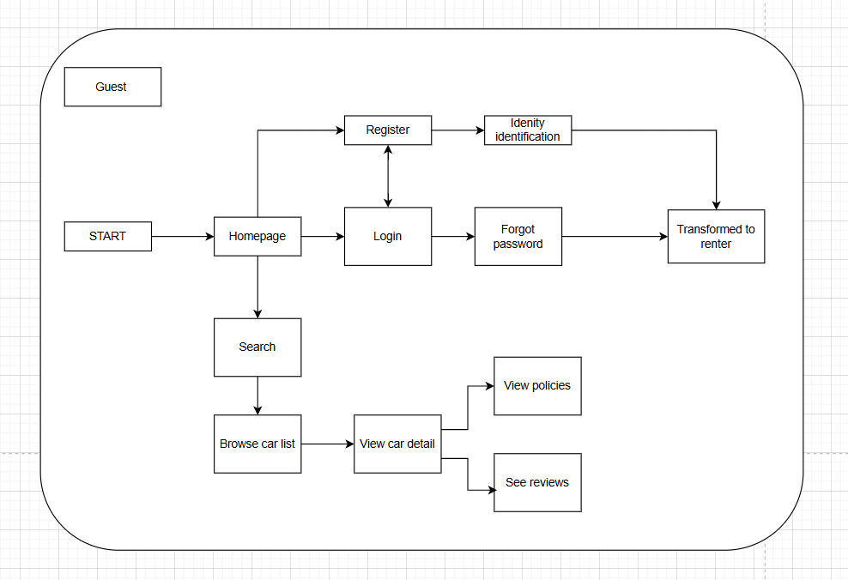
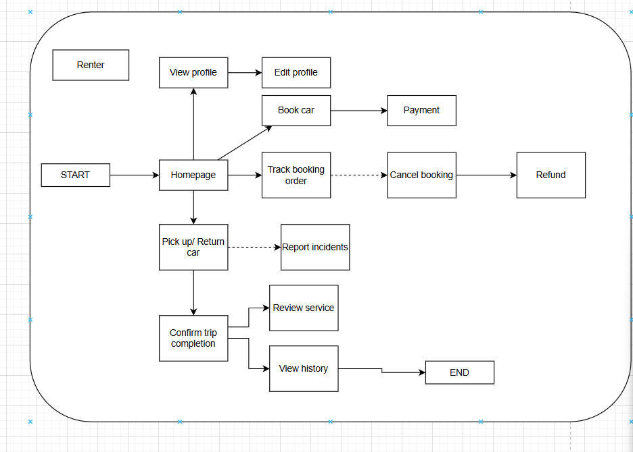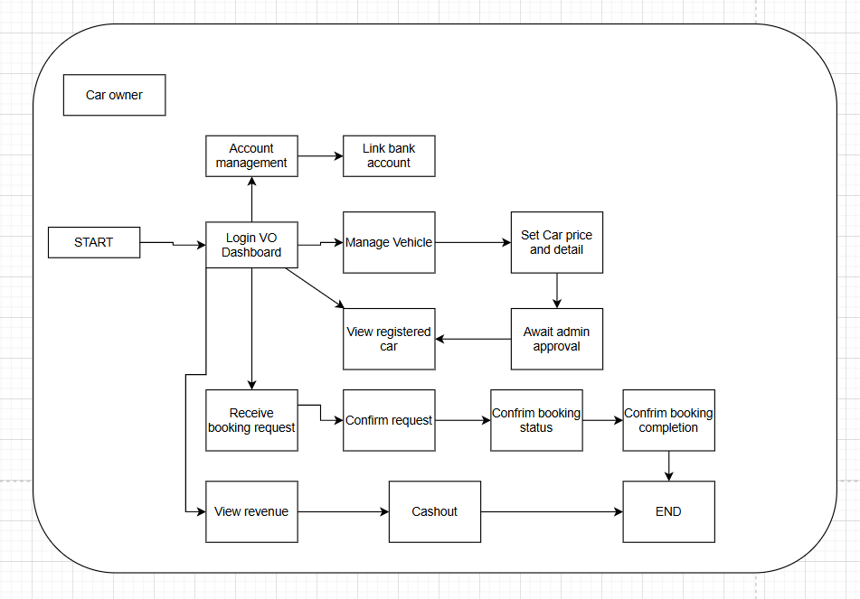
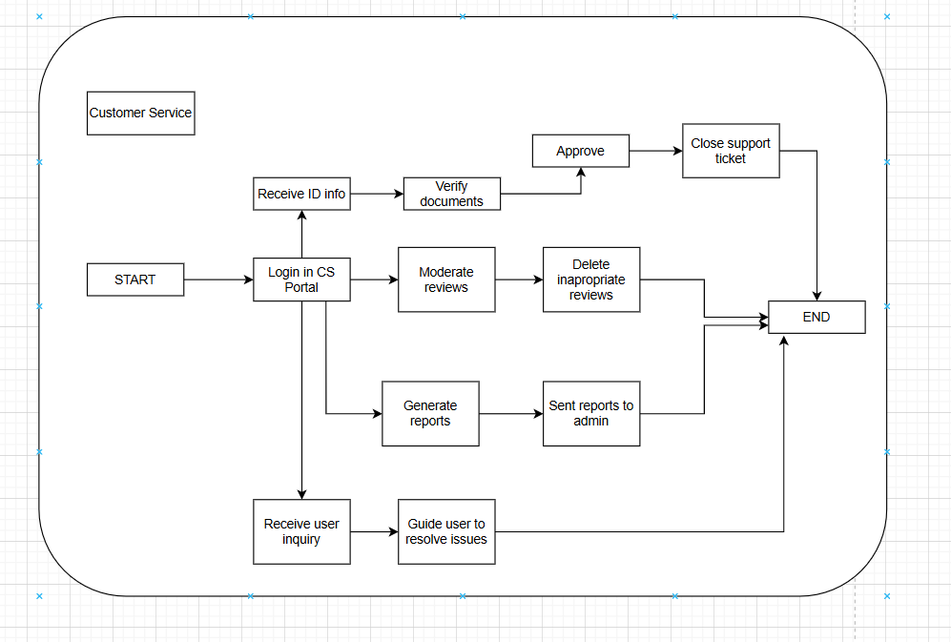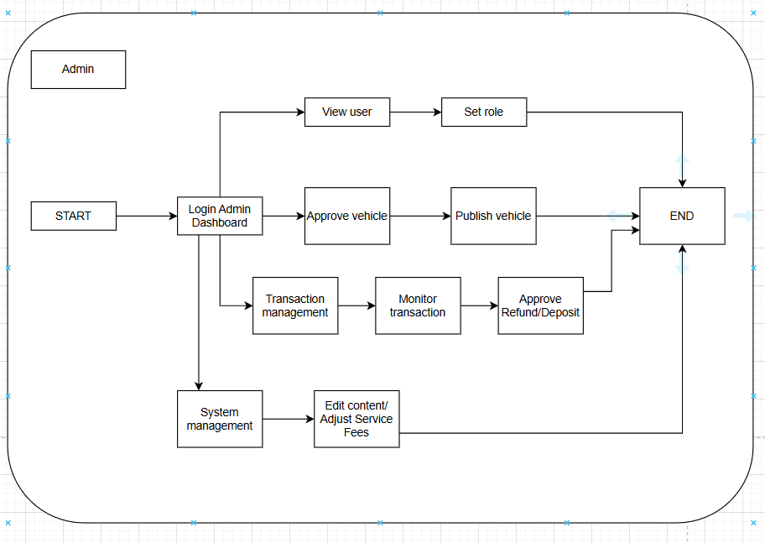
Figure 10. Screen flow diagram

3.1.2 Screen Descriptions
No | Screen | Feature | Description
1 | Home / Landing Page | Home / Landing Page Overview | Acts as the primary entry marketplace for all actors to discover available vehicles, featuring quick routing navigation tools, recommended car clusters, and active promotional campaigns.
2 | Home / Landing Page | Location Input Filter | A text field and dynamic dropdown synchronized with the system location database, allowing users to select the target city/district for car pickup.
3 | Home / Landing Page | Pick-up Date & Time Picker | A calendar and time selection widget. Constraint: Must be greater than or equal to the current system date and time. It sets the starting timeline for the hire.
4 | Home / Landing Page | Return Date & Time Picker | A calendar and time selection widget. Constraint: Must be strictly greater than the selected Pick-up Date & Time. It establishes the vehicle return deadline.
5 | Home / Landing Page | "Tìm xe ngay" Action Button | A primary interactive button that validates the input parameters and routes the user's query payloads directly to the Search Dashboard.
6 | Home / Landing Page | Vehicle Grid Display | A composite catalog layout showing car cards (images, model names, daily rental prices, and location strings) matching specific dynamic system asset IDs.
7 | Search & Filter Dashboard | Search & Filter Dashboard Overview | Displays real-time dynamic search results and catalog items based on user criteria, featuring a left-aligned multi-criteria filter panel.
8 | Search & Filter Dashboard | Transmission Type Filter | A checkbox group with options [Số sàn, Số tự động], triggering a real-time reactive UI filter to sort vehicles based on transmission mechanics.
9 | Search & Filter Dashboard | Fuel Type Filter | A checkbox group with options [Xăng, Dầu, Điện], narrowing down the displayed vehicle grid records based on engine power sources.
10 | Search & Filter Dashboard | Seat Capacity Filter | A checkbox group with options [4 chỗ, 5 chỗ, 7 chỗ] used to refine marketplace search boundaries according to the vehicle cabin size.
11 | Search & Filter Dashboard | Sort Selection Menu | A dropdown list with options [Giá thấp đến cao, Giá cao đến thấp, Đánh giá tốt] to instantly re-order the active UI grid array client-side without page reloads.
12 | Search & Filter Dashboard | Car Card Redirection Link | An interactive hyperlink overlay on each product card mapped to a unique Car ID. Clicking redirects the user to the Vehicle Details Profile screen.
13 | Vehicle Details Profile | Vehicle Details Profile Overview | Shows a comprehensive profile for an individual vehicle, presenting verified technical specifications, past ratings, owner credentials, and booking configurations.
14 | Vehicle Details Profile | High-Res Image Gallery | A media carousel layout showcasing internal, external, and registration state photos uploaded and verified directly by the Car Owner.
15 | Vehicle Details Profile | Technical Specification Matrix | An icon-driven status display showing boolean presence badges for hardware features like GPS/Maps, Bluetooth, Backup Camera, and Dashcam.
16 | Vehicle Details Profile | Timeline Duration Adjuster | An inline calendar picker synchronized with the owner's availability schedule, letting renters recalculate rental days directly on the details view.
17 | Vehicle Details Profile | Itemized Price Output | A dynamic numeric text label formatting currency strings ($VND$), displaying the calculated total rental cost based on day spans and active surcharges.
18 | Vehicle Details Profile | "ĐẶT XE" Booking Trigger | A primary action button. Constraint: Active only when the User Session is alive and KYC Status = Verified. Redirects the renter payload to the Checkout screen.
19 | Booking Summary & Checkout | Booking Summary & Checkout Overview | Provides the secure transactional checkout interface where renters review legal contract data, verify documentation, and process escrow payments.
20 | Booking Summary & Checkout | Verified Renter Metadata Card | A read-only summary container extracting user parameters (Full Name, Phone Number, and Driver's License verification status) from the database.
21 | Booking Summary & Checkout | Financial Pricing Ledger | An itemized financial statement data grid that breaks down base rental fees, required platform escrow security deposit amounts (Tiền cọc), and service fees.
22 | Booking Summary & Checkout | Payment Gateway Radio Selector | A radio button group with options [VNPAY Sandbox Gateway, Internal Digital Wallet Balance] to route and validate payment transaction sequences.
23 | Booking Summary & Checkout | Promo Code Coupon Input | A text input field checked against active promotional database entities to calculate dynamic discount deductions from the total base rental cost.
24 | Booking Summary & Checkout | "Thanh toán cọc" Action Button | A primary transactional button. Constraint: Executable only upon checking the "Terms & Conditions" box. Fires secure APIs to lock escrow funds.
25 | User Booking History Dashboard | User Booking History Dashboard Overview | A unified tracking panel mapping operational lifecycle milestones for Renters and Car Owners to manage active and historical rental trips.
26 | User Booking History Dashboard | Status Tab Navigation Bar | A navigation tab control containing options [Tất cả, Chờ duyệt, Đã duyệt, Đang thuê, Hoàn thành, Đã hủy] to sort historical log data views.
27 | User Booking History Dashboard | Dynamic Status Color Badge | A color-coded structural label mapping core status model states (Yellow: Pending Approval, Green: Active Rental, Gray: Completed) for immediate visual feedback.
28 | User Booking History Dashboard | "Hủy chuyến" Control Button | An action trigger. Constraint: Visible only when current state = Chờ duyệt or time is $\ge 24h$ before pickup. Cancels the booking and triggers deposit returns.
29 | User Booking History Dashboard | "Nhận xe / Trả xe" Form Trigger | An action trigger. Constraint: Visible during the official scheduled pickup or return timeline windows. Launches the digital electronic handover checklist interface.
30 | User Booking History Dashboard | "Đánh giá" Modal Button | An action button. Constraint: Visible only when booking status = Hoàn thành and review is unsubmitted. Opens a modal box for star ratings and feedback.
Table 3. Screen Descriptions

3.1.3 Screen Authorization

No | Screen | Guest | Renter | Vehicle  Owner | Admin | Customer Service
1 | Home / Landing Page | X | X | X | X | X
2 | Vehicle Search & Filter Dashboard | X | X | X | X | X
3 | Vehicle Details Profile | X | X | X | X | X
4 | Sign In / Sign Up Portal | X | X | X | X | X
5 | Forgot Password & Recovery Screen | X | X | X | X | X
6 | User Profile Management Dashboard |  | X | X | X | X
7 | Identity Verification Upload Portal (KYC) |  | X | X
8 | Booking Summary & Checkout (Deposit) |  | X
9 | User Booking History Dashboard (Tracking) |  | X | X
10 | Internal Chat & Communication Interface |  | X | X
11 | Vehicle Onboarding & Registration Wizard |  |  | X
12 | Vehicle Asset Management Dashboard |  |  | X
13 | Car Owner Financial & Revenue Dashboard |  |  | X
14 | System Digital Wallet Dashboard |  | X | X
15 | Digital Handover Checklist Form (Pick-up/Return) |  | X | X
16 | Admin User Directory & Account Control Portal |  |  |  | X
17 | Admin Vehicle Listing Moderation Dashboard |  |  |  | X
18 | Admin Escrow & Transaction Logs Management |  |  |  | X
19 | Admin System Settings & Pricing Configurations |  |  |  | X
20 | CS Staff KYC Document Approval Dashboard |  |  |  |  | X
21 | CS Staff Helpdesk & Support Ticket Center |  |  |  |  | X
22 | CS Staff Content & Review Moderation Panel |  |  |  |  | X
23 | CS Staff Incident & Dispute Claims Resolver |  |  |  |  | X
Table 4. Screen Authorization

3.1.4 Non-Screen Functions

# | Feature | System Function | Description
1 | User Authentication | Sign in with Google OAuth2 | Allows users to authenticate and log into the system instantly using their registered Google account credentials via a secure background handshake.
2 | Email Token & Alert Service | Forgot Password Recovery | When a user requests a password recovery, the background token subsystem generates a secure OTP/reset link and dispatches an automated notification email within a strict 20-minute validity boundary.
3 | Email Token & Alert Service | Automated Booking Status Alerts | Runs in the background to instantly deliver confirmation or rejection emails to Renters as soon as a Car Owner approves or rejects a dynamic booking contract state.
4 | Image Processing Service | Cloud Asset & KYC Data Upload | Automatically triggered whenever a Renter uploads identity records (CCCD, driving permit) or a Car Owner registers vehicle asset photos. It runs in the background to compress, sanitize, and store files safely (supporting .png, .jpg, .jpeg, .svg formats).
5 | Payment Gateway System | Real-time Payment & Escrow Initialization | When a renter clicks the checkout button, a background API worker handles secure handshake signatures with external services (like the VNPAY Sandbox), calculates the platform service cut, and places the dynamic security deposit (Tiền cọc) into secure escrow hold states.
6 | Payment Gateway System | Automated Escrow Refund System | Upon successful, conflict-free trip termination or early qualified cancellation requests, an background routing process evaluates data rules and prompts automatic refund pipelines for the renter's deposit asset.
7 | Ledger Tracking System | Live Financial Surcharge & Fee Calculation | Executes underlying mathematical balance algorithms to dynamically audit overall car usage counts, calculate total trip overhead margins based on exact days, and accurately log final revenue splits onto the Car Owner's balance history table.
8 | Database Scheduler System | Vehicle Availability State Automation | A background cron-job routinely loops through reservation date parameters to flip vehicle calendar availability state markers from active marketplace displays to hidden indicators while a trip is underway.
Table 5. Non-Screen Functions

3.1.5 Entity Relationship Diagram

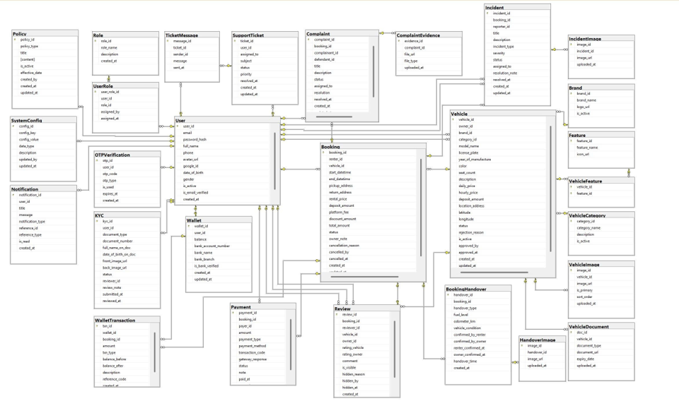
Figure 11. ERD digram

Entities Description
# | Entity | Description
1 | User | The class represents storage of the user's information for identity in the system.  - Properties:  - User_id (Primary Key)  - Email  - Password_hash  - Fullname  - Phone  - Avatar_url  - Google_id  - Date_of_birth  - Gender  - Is_active  - Is_email_verified  - CreateAt
2 | Booking | The class represents a storage for booking appointments  - Properties:  - Booking_id (Primary Key)  - Renter_id  - Vehicle_id  - Start_datetime  - End_datetime  - Pickup_address  - Return_address  - Rental_price  - Deposit_amount  - Platform_fee  - Discount_amount  - Total_amount  - Status  - Owner_note  - Cancellation_reason  - Cancelled_by  - Cancelled_at  - Created_at  - Updated_at
3 | Vehicle | Vehicle represents cars that car owners uploaded.  - Properties:  - vehicle_id  - owner_id  - brand_id  - category_id  - model_name  - license_plate  - year_of_manufacture  - color  - seat_count  - description  - daily_price  - hourly_price  - deposit_amount  - location_address  - latitude  - longitude  - status  - rejection_reason  - is_active  - approved_by  - approved_at  - created_at  - updated_at
4 | Wallet | - Properties:  - wallet_id  - user_id  - balance  - bank_account_number  - bank_name  - bank_branch  - is_bank_verified  - created_at  - updated_at
5 | Payment | Report represents a comment or rating given by a user.  - Properties:  - payment_id  - booking_id  - payer_id  - amount  - payment_type  - payment_method  - transaction_code  - gateway_response  - status  - note  - paid_at
6 | WalletTransaction | - Properties:  - txn_id  - wallet_id  - booking_id  - amount  - txn_type  - balance_before  - balance_after  - description  - reference_code  - created_at
7 | KYC | - Properties:  - kyc_id  - user_id  - document_type  - document_number  - full_name_on_doc  - date_of_birth_on_doc  - front_image_url  - back_image_url  - status  - reviewer_id  - review_note  - submitted_at  - reviewed_at
8 | Review | - Properties:  - review_id  - booking_id  - reviewer_id  - vehicle_id  - owner_id  - rating_vehicle  - rating_owner  - comment  - is_visible  - hidden_reason  - hidden_by  - hidden_at  - created_at
9 | Role | - Properties:  - role_id  - role_name  - description  - created_at
10 | UserRole | - Properties:  - user_role_id  - user_id  - role_id  - assigned_by  - assigned_at
11 | OTPVerification | - Properties:  - otp_id  - user_id  - otp_code  - otp_type  - is_used  - expires_at  - created_at
12 | HandoverImage | - Properties:  - image_id  - handover_id  - image_url  - uploaded_at
13 | Brand | - Properties:  - brand_id  - brand_name  - logo_url  - is_active
14 | Feature | - Properties:  - feature_id  - feature_name  - icon_url
15 | VehicleFeature | - Properties:  - vehicle_id  - feature_id
16 | VehicleCategory | Role of Teacher, that can allow users access resources  - Properties:  - category_id  - category_name  - description  - is_active
17 | VehicleImage | - Properties:  - image_id  - vehicle_id  - image_ur  - is_primary  - sort_order  - created_at
18 | VehicleDocument | - Properties:  - doc_id  - vehicle_id  - document_type  - document_url  - expiry_date  - created_at
19 | SupportTicket | - Properties:  - ticket_id  - user_id  - assigned_to  - subject  - status  - priority  - resolved_at  - created_at  - updated_at
20 | TicketMessage | - Properties:  - message_id  - ticket_id  - sender_id  - message  - sent_atresolved_at  - created_at  + updated_at
21 | Complaint | - Properties:  - complaint_id  - booking_id  - complainant_id  - defendant_id  - title  - description  - status  - assigned_t  - resolution  - resolved_at  - created_at  - updated_at
22 | ComplaintEvidence | Properties:  - evidence_id  - complaint_i  - file_url  - file_type  - uploaded_at
23 | Incident | Properties:  - incident_id  - booking_id  - reporter_id  - title  - description  - incident_type  - severity  - status  - assigned_to  - resolution_note  - resolved_at  - created_at  - updated_at
24 | IncidentImage | Properties:  - image_id  - incident_id  - image_url  - uploaded_at
25 | Policy | Properties:  - policy_id  - policy_type  - title  - content  - is_active  - effective_date  - created_by  - created_at  - updated_at
26 | SystemConfig | Properties:  - config_id  - config_key  - config_value  - data_type  - description  - updated_by  - updated_at
27 | Notification | Properties:  - notification_id  - user_id  - title  - message  - notification_type  - reference_id  - reference_typ  - is_read  - created_at
Table 6. Entities Description

3.2 Authentication feature

3.2.1 Sign in
- Function trigger:
- Primary Trigger: The user clicks the "Đăng nhập" button on the Home page, the navigation bar, or when they attempt to access features that require authentication.
- Secondary Trigger: The user is automatically redirected to the Login page when trying to access a protected page without being logged in.
- Function description:
- Role: Guest (becomes Renter / Car Owner / Admin / CSKH after successful login)
- Purpose: Allows registered and verified users to authenticate and access the ViVuCar system using their email and password, or via Google OAuth2.
- Interface: The Sign In interface includes the following fields and elements:
  - Login Mode Toggle: Two tabs — "Người dùng" (Renter/Owner) and "Ban Quản Trị" (Admin/CSKH) — to select the appropriate login portal.
  - Email: Input field where users enter their registered email address (placeholder: name@example.com).
  - Password: Input field where users enter their account password, with a show/hide toggle (Eye icon).
  - "Đăng Nhập" Button: Submits the email and password to the server for authentication.
  - "Sign in with Google" Button: Rendered by Google Identity Services SDK — triggers Google OAuth2 authentication flow.
  - "Quên mật khẩu?" Link: Navigates to the Forgot Password screen.
  - "Đăng ký" Link: Navigates to the Register screen.
- Data Processing: The system validates the email format, looks up the user by email, compares the password against the stored bcrypt hash (bcryptjs), generates a JWT token (expires in 24h) upon success, and stores it in localStorage. If the account is unverified, the system auto-resends an OTP email and returns a 403 status. Rate limiting is applied: max 100 requests per IP per 15 minutes.

- - Screen layout:
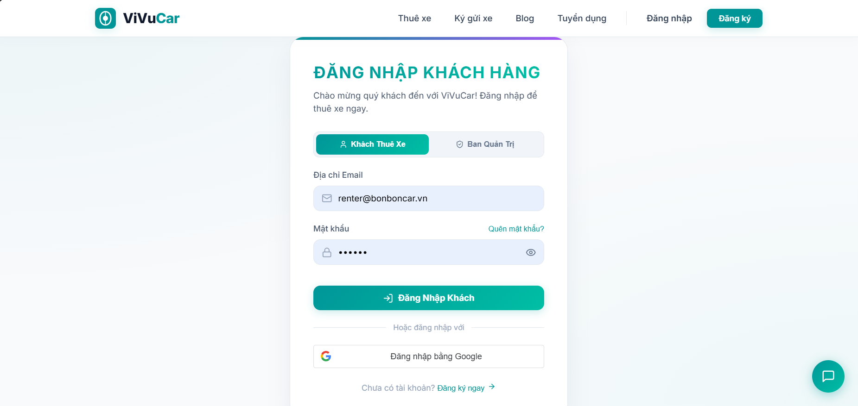
Figure 12. Sign in

- Function detail:
- Data:
  - Email: Required. Must be a valid email format.
  - Password: Required. Compared against the stored bcrypt hash.
- Validation and Business Rules:
  - In normal cases:
- If the email and password are valid and the account is verified (isEmailVerified = true), the system generates a JWT token, returns it to the client, stores it in localStorage, and redirects the user to the Home page. The toast "Đăng nhập thành công!" is shown.
- Portal access control is enforced: Renter/Owner accounts cannot log in through the Admin portal and vice versa. The system shows "Tài khoản Quản trị/CSKH vui lòng đăng nhập tại cổng Ban Quản Trị." if a mismatch is detected.
  - In abnormal cases:
- If the email field or password field is empty: The system displays "Vui lòng điền đầy đủ email và mật khẩu."
- If the email is not found or the password is incorrect: The system displays "Email hoặc Mật khẩu không đúng." (generic message to prevent email enumeration).
- If the account has not been email-verified: The system auto-resends the OTP email and displays "Tài khoản của bạn chưa được xác thực email. Mã xác thực OTP mới đã được gửi vào email của bạn." A "Verify Now" option is shown on the client.
- If the rate limit is exceeded: The system returns "Quá nhiều yêu cầu đăng nhập từ IP này, vui lòng thử lại sau 15 phút."
- If the server is unresponsive or a network error occurs: The system displays an error toast and allows the user to retry.

3.2.2 Sign out
- Function trigger:
- Primary Trigger: The user clicks the "Đăng Xuất" button in the navigation bar dropdown menu.
- Automatic Trigger: The JWT token expires after 24 hours, effectively ending the session on the next protected request.
- -Function description:
- Role: Renter, Car Owner, Admin, CSKH (any authenticated user)
- Purpose: Allows logged-in users to safely and securely log out of their account, ending their session on the ViVuCar platform.
- Interface:
- "Đăng Xuất" Button/Link: Located in the navigation bar user dropdown menu.
- Data Processing: Since the system uses stateless JWT authentication, logout is handled entirely on the client side — the JWT token is removed from localStorage and the global user state is cleared. No server-side session invalidation call is made.
-Screen layout:
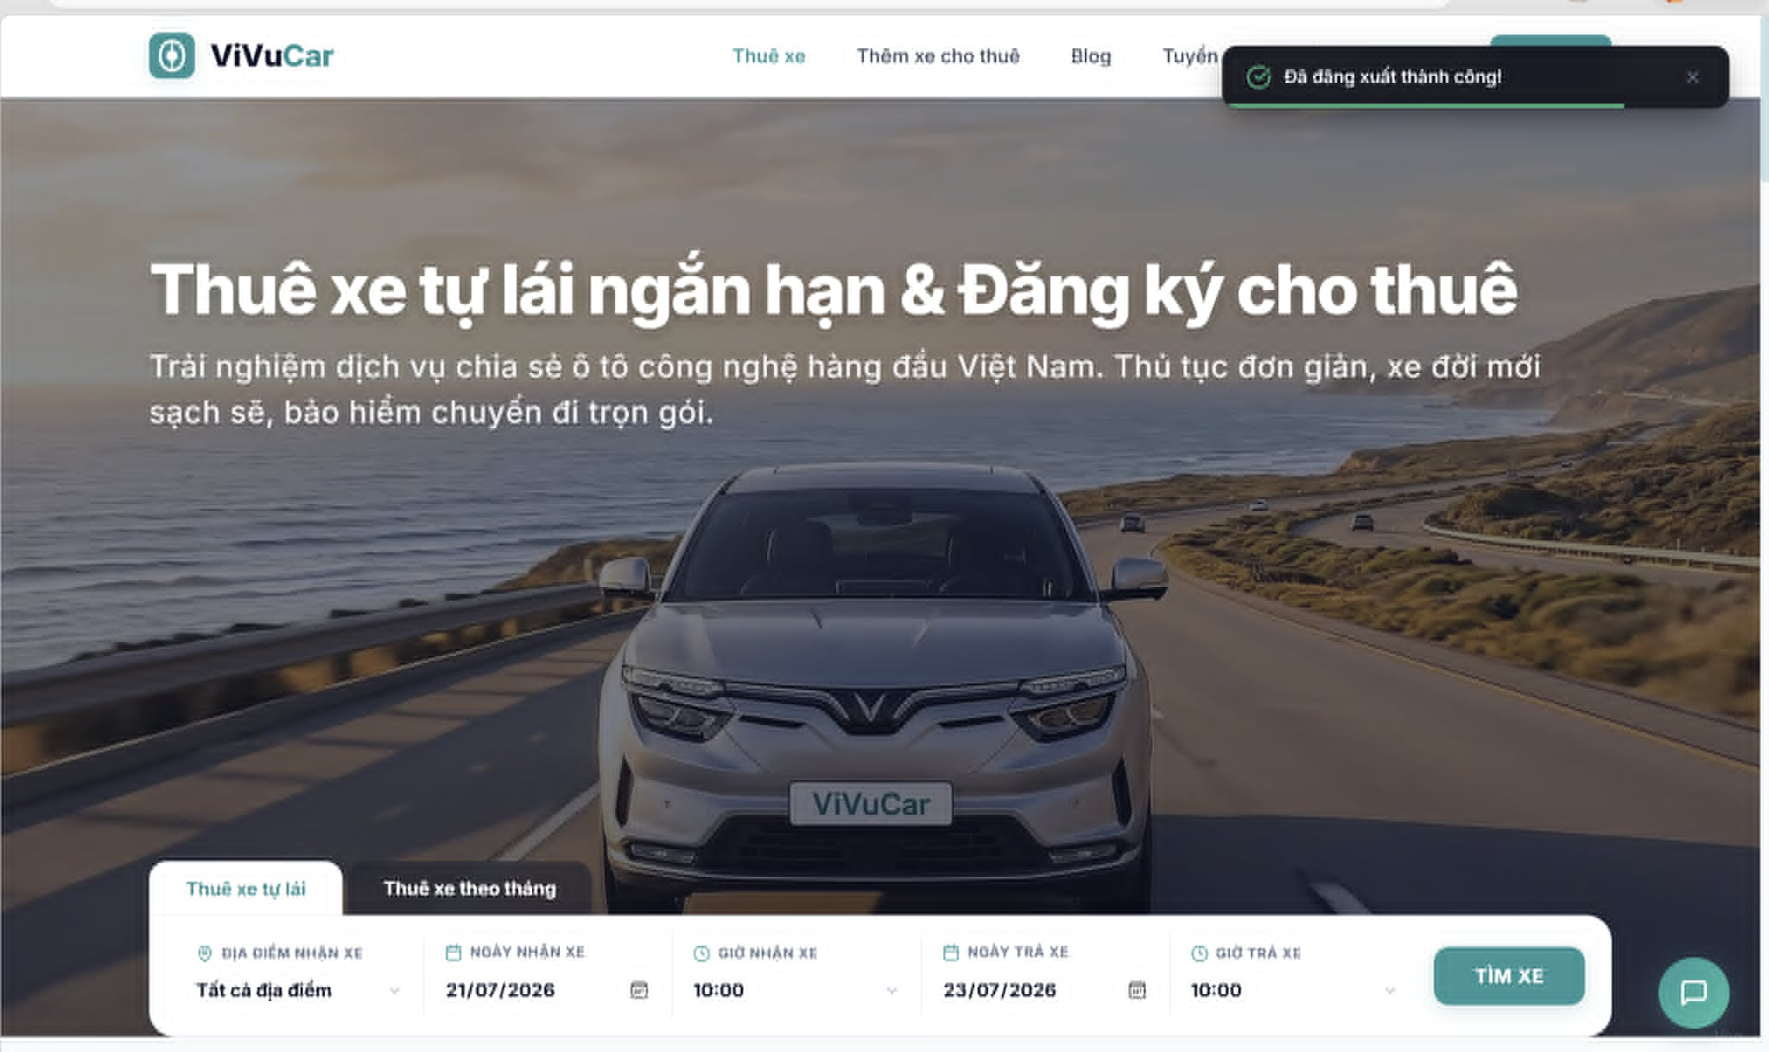
Figure 13. Sign out
- Function Details:
- Validation and Business Rules:
- In normal cases:
- The JWT token is removed from localStorage: localStorage.removeItem("token").
- The global user state is cleared: setUser(null).
- The user is redirected to the Home / Landing Page.
- A success toast is shown: "Đã đăng xuất thành công!"
- In abnormal cases:
- If the JWT token is already absent from localStorage: The system still clears the user state and redirects to the Home page without error.
- If browser storage is unavailable or blocked: The system clears in-memory user state and redirects to the Home page.

3.2.3 Register Account
- Function trigger:
- Primary Trigger: The user clicks the "Đăng Ký" tab or button on the Login/Home page to open the Register form.
- Secondary Trigger: The user is navigated to the Register screen via the "Đăng ký" link at the bottom of the Sign In form.
- Function description:
- Role: Guest
- Purpose: Allows a new user to create a ViVuCar account by providing their full name, email address, and password. After registration, the account is created with status unverified (isEmailVerified = false) and a 6-digit OTP is sent to the user's email.
- Interface: The Register form includes the following fields:
- Họ và Tên (Full Name): Text input field. Placeholder: "Nguyễn Văn A".
- Địa chỉ Email (Email): Email input field. Placeholder: "name@example.com".
- Mật khẩu (Password): Password input field with show/hide toggle. Placeholder: "Ít nhất 6 ký tự".
- Nhập lại Mật khẩu (Confirm Password): Password confirmation field with show/hide toggle. Placeholder: "Trùng khớp mật khẩu trên".
- "Tạo Tài Khoản" Button: Submits the registration form.
- "Quay lại Đăng nhập" Link: Returns to the Login screen without creating an account.
- Data Processing: The system trims and lowercases the email, checks for uniqueness in the database, hashes the password using bcrypt (10 salt rounds), creates the user record with role = "renter" and isEmailVerified = false, generates a 6-digit OTP (100000–999999), and sends a verification email with subject "Mã OTP xác thực tài khoản ViVuCar ". The OTP is valid for 10 minutes.
- Screen layout:
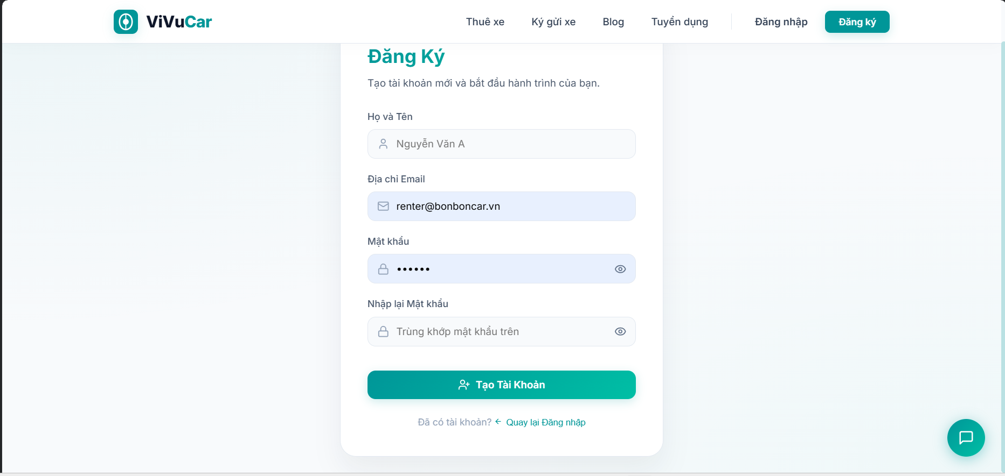
Figure 14. Register Account

- Function detail:
- Data:
- Họ và Tên: Required. Must not be blank.
- Email: Required. Must be a valid email format. Must not already be registered.
- Mật khẩu: Required. Must be at least 6 characters.
- Nhập lại Mật khẩu: Required. Must match Mật khẩu exactly

- Validation and business rules:
- In normal cases:
- If all inputs are valid and the email is not already registered, the system creates the user account, generates a 6-digit OTP, and sends it to the user's email. The system displays the success toast: "Đăng ký tài khoản thành công! Mã xác thực OTP đã được gửi vào email của bạn." The user is switched to the Login tab (setCurrentTab("login")).
  - In abnormal cases:
    - If the email does not exist in the system, the user will receive an error message like "Email not found in our records."
    - If the system encounters a failure in sending the reset email (e.g., server issue or network error), an error message will be displayed, and the user will be advised to try again later.
    - If the user tries to reset their password multiple times within a short period, the system may lock the reset function temporarily as a security measure to prevent abuse.

3.2.3 Forgot Password
- Function trigger:
  - The Forgot Password function can be triggered via a "Forgot Password" link from the login page.
  - Additionally, it can be accessed from a direct link sent to the user’s email when they request password recovery.
- Function description:
  - Actors/Roles: Unauthenticated users who have forgotten their password or users who wish to reset their password.
  - Purpose: To allow users to recover or reset their account password in case they forget it.
  - Interface: The system displays a form asking the user to enter the email associated with their account.
  - Data processing: After the user submits their email, the system verifies if the email exists in the database. If it does, the system sends a password reset link to the provided email.
- Screen layout:
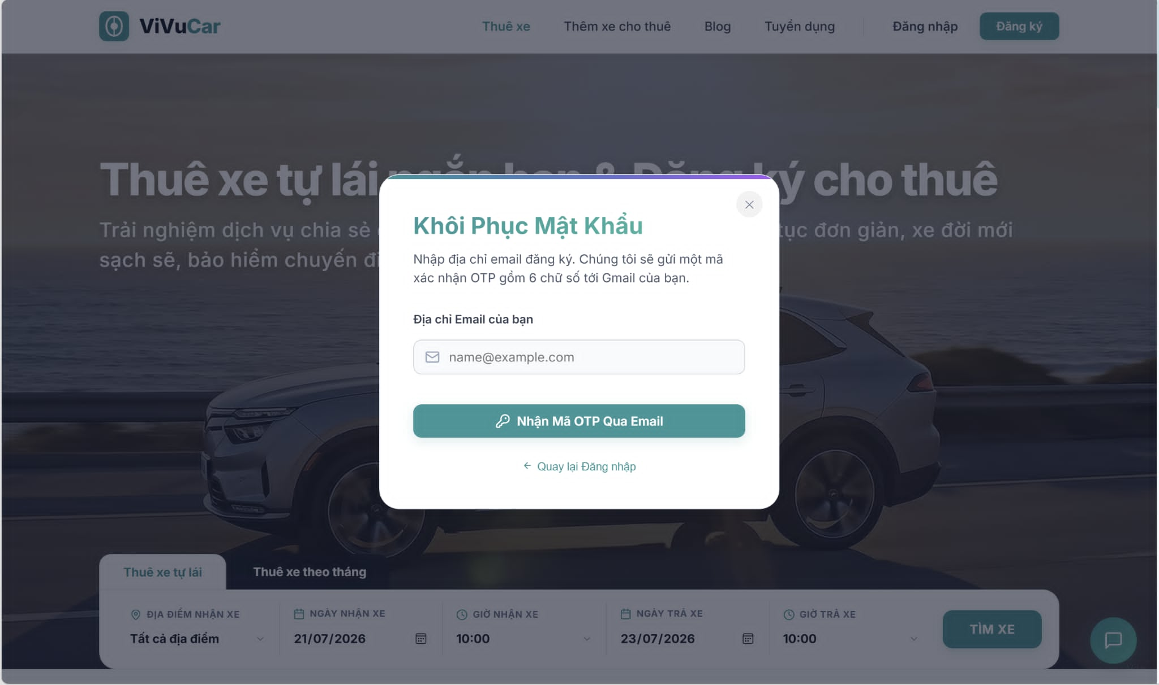
Figure 15. Forgot password

- Function detail:
  - Data:
    - Email: Required, must be a valid email format.
  - Validation and business rules:
    - In normal cases:
      - If the provided email is valid and exists in the system, the system will send a password reset link to the user's email address.
      - The user will receive an email with a link to a page to enter a new password.
      - The new password must meet the system’s password strength requirements (e.g.,at least 8 characters, must include at least 1 uppercase letter, 1 lowercase letter, 1 number and 1 special character).
  - In abnormal cases:
    - If the email does not exist in the system, the user will receive an error message like "Email not found in our records."
    - If the system encounters a failure in sending the reset email (e.g., server issue or network error), an error message will be displayed, and the user will be advised to try again later.
    - If the user tries to reset their password multiple times within a short period, the system may lock the reset function temporarily as a security measure to prevent abuse.

3.3. Manage common User’s feature

3.3.1. View / Update Profile & Link Bank Account
- Function Trigger:
- User-initiated: The user accesses their profile by selecting the "Profile" option from the navigation bar dropdown menu.
- System-initiated: After registration or login, the system may automatically redirect users to the profile page to encourage updating incomplete profile information.
- Function Description:
- Actors/Roles: Any authenticated user (Renter, Car Owner, CSKH, Admin).
- Purpose: To allow users to view and manage their account information, including their name, email, role, bio, and linked bank account details.
- Interface:
- Displays essential user details such as:
- Full Name
- Email Address
- User Avatar
- Bio / Short Description
- KYC Status (Approved / Pending / Rejected)
- Bank Account Details (Bank Name, Account Number, Account Holder)
- Data Processing:
- The system retrieves the user's profile information from the database ([User] table) and displays it in a clear, readable format.
- Upon user submission, the system updates the database with the new profile details or bank account information.
- Screen Layout:
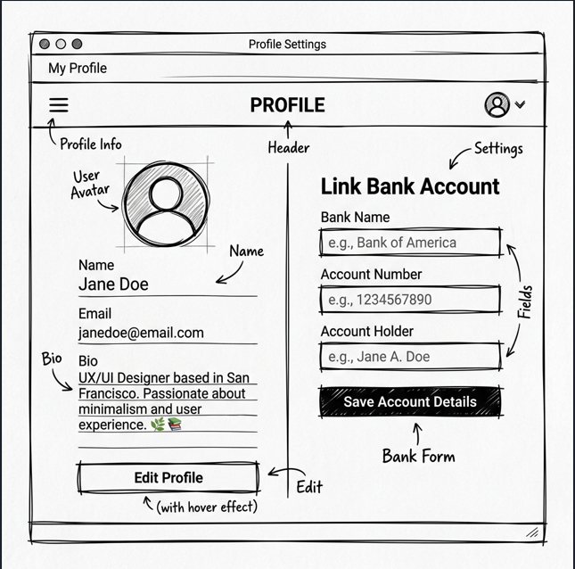
Figure 16. View / Update Profile & Link Bank Account Screen Layout

- Function Details:
- Data Requirements: The system must retrieve the necessary user data from the database (e.g., user_id, full_name, email, avatar_url, bio, bankAccount JSON, licenseStatus).
- Actions:
- View personal information: Users can review their stored details on the profile page.
- Update Profile: Users can modify their full name, bio, and upload a new avatar.
- Link Bank Account: Users can input and save their bank details (Bank Name, Account Number, Account Holder Name).
- Change Password: Users can update their security password by providing the current password and the new password.
- Validation and Business Rules:
- In normal cases:
- The user profile information is retrieved and displayed correctly.
- All profile details must be consistent with the data stored in the database.
- Updating bank account details requires all three fields (Bank Name, Account Number, Account Holder) to be filled out.
- In abnormal cases:
- If the system fails to retrieve the profile data (e.g., due to a server issue), an error message will be displayed along with a "Retry" option.
- If the user's session has expired or is invalid, the system will automatically redirect the user to the login page to re-authenticate.
- If the user inputs an incorrect current password during a password change, the system displays a validation error and blocks the update.

3.3.2. Upgrade Account to Car Owner
- Function Trigger:
- User-initiated: The user clicks the "Register as Car Owner" button on the profile page or navigation bar.
- System-initiated: None.
- Function Description:
- Actors/Roles: Renter.
- Purpose: To allow a registered renter to upgrade their account role to a Car Owner, enabling them to list and manage vehicles on the platform.
- Interface:
- Displays essential details such as:
- Terms and Conditions Agreement Text
- "I agree to the terms" Checkbox
- "Upgrade Account" Button
- Data Processing:
- The system updates the user's role in the UserRole table to owner and refreshes the user's session permissions.
- Screen Layout:
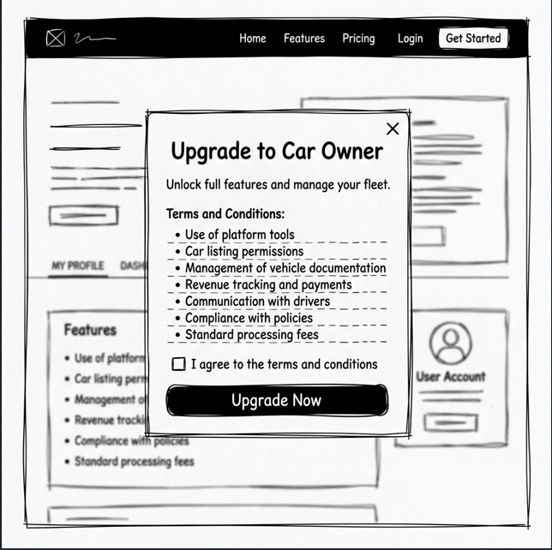
Figure 17. Upgrade Account to Car Owner Screen Layout

- Function Details:
- Data Requirements: The system must retrieve and update the user's role data from the database (user_id, role_id).
- Actions:
- Read Terms & Conditions: Users can review the owner agreement.
- Agree and Upgrade: Users check the agreement box and click the upgrade button to change their role.
- Validation and Business Rules:
- In normal cases:
- The user's role is successfully updated to owner in the database.
- The user's dashboard is updated immediately to display the "List Car" tab.
- In abnormal cases:
- If the user does not check the agreement box, the "Upgrade Account" button remains disabled.
- If the system fails to update the database, an error message is shown, and the user remains a Renter.

3.3.3. View Wallet & Manage Transactions (Deposit / Withdraw)
- Function Trigger:
- User-initiated: The user selects the "My Wallet" option from the navigation bar or profile dropdown menu.
- System-initiated: The system redirects the user to the wallet page after a payment gateway (VNPAY) transaction completes.
- Function Description:
- Actors/Roles: Renter, Car Owner.
- Purpose: To allow users to view their current wallet balance, check their transaction history, and perform deposit (via VNPAY) or withdrawal operations.
- Interface:
Displays essential details such as:
- Wallet Balance (VND)
- Deposit Button
- Withdraw Button
- Transaction History Table (Date, Transaction Type, Amount, Balance Before/After, Description, Status)
- Data Processing:
- The system retrieves the wallet balance and transaction records from the Wallet and WalletTransaction tables.
- Deposits are processed by generating a secure VNPAY URL. Withdrawals are processed by verifying the balance and executing the usp_ProcessWalletTransaction stored procedure in a database transaction.
- Screen Layout:
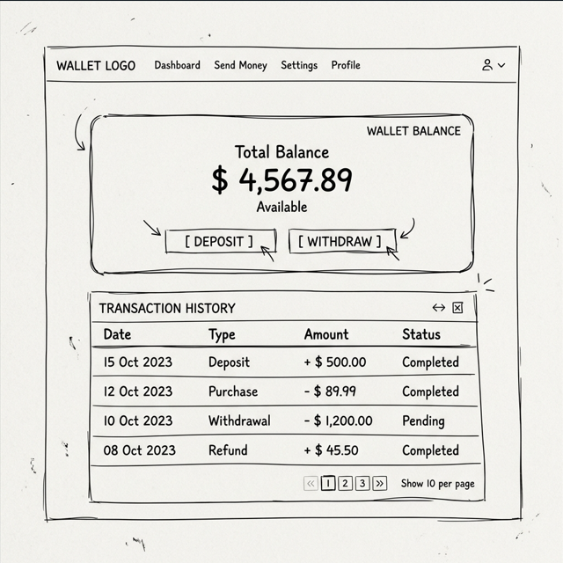
Figure 18. View Wallet & Manage Transactions Screen Layout

- Function Details:
- Data Requirements: The system must retrieve the necessary wallet and transaction data from the database (e.g., wallet_id, balance, bank_name, bank_account_number, transaction list).
- Actions:
- View Balance: Users can review their current funds.
- Deposit Funds: Users enter an amount and are redirected to the VNPAY portal to complete the transaction.
- Withdraw Funds: Users enter an amount to transfer from their wallet to their linked bank account.
- Validation and Business Rules:
- In normal cases:
- The wallet balance and transaction history are retrieved and displayed accurately.
- Deposits are credited immediately upon receiving a successful payment confirmation from VNPAY.
- Withdrawals are debited immediately and logged in the transaction history.
- In abnormal cases:
- If the user attempts to withdraw without a linked bank account, the system displays an error: "Please link a bank account first."
- If the withdrawal amount exceeds the current wallet balance, the system displays an error: "Insufficient wallet balance."
- If the VNPAY transaction fails or is cancelled, the wallet balance remains unchanged, and a failure message is shown.

3.3.4. View Notifications
- Function Trigger:
- User-initiated: The user clicks on the notification bell icon on the navigation bar.
- System-initiated: The system displays a red badge count over the bell icon when a new notification is received in real-time.
- Function Description:
- Actors/Roles: Any authenticated user (Renter, Car Owner, CSKH, Admin).
- Purpose: To allow users to view system-generated notifications regarding bookings, KYC status updates, car approvals, and wallet transactions.
- Interface:
- Displays essential details such as:
- List of Notifications (Title, Message, Timestamp, Read/Unread Status)
- "Mark All as Read" Button
- Data Processing:
- The system retrieves notifications matching the user's ID from the Notification table.
- Updates the status of notifications to is_read = 1 in the database when they are clicked or when "Mark All as Read" is selected.
- Screen Layout:
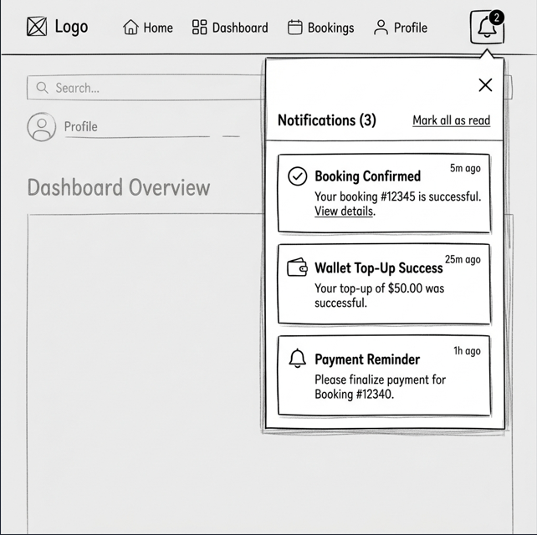
Figure 19. View Notifications Screen Layout
- Function Details:
- Data Requirements: The system must retrieve notification data from the database (notification_id, user_id, title, message, is_read, created_at).
- Actions:
- View Notifications: Users click the bell icon to view the notification dropdown list.
- Mark Notification as Read: Users click an individual notification to mark it as read.
- Mark All as Read: Users click the "Mark All as Read" button to clear all unread notification badges.
- Validation and Business Rules:
- In normal cases:
  - Notifications are retrieved and displayed in reverse chronological order (newest first).
  - The unread count badge updates dynamically as notifications are read.
  - In abnormal cases:
  - If there are no notifications, the dropdown displays: "You have no notifications."

3.4 Manage Car & Booking

3.4.1 Create Car Listing
- Function trigger:
  - Primary Trigger: The Car Owner accesses the Manage My Cars page and clicks on the "Register New Car" button. They fill in all required specifications, upload vehicle documents, and click the submit button to send the registration request to the Admin..
- Function description:
  - Role : Car Owner
  - Purpose: Allow car owners to register their idle electric vehicles on the platform for rent by providing detailed car specifications, pricing, and images.
  - Interface:
    - Car Specification Fields: Input fields for Car Name, Manufacturer, License
    - Pricing & Location Fields: Input fields for Daily Rental Price and Pick-up/Drop-off Location.
    - Media & Document Upload: Upload zones for real vehicle images and required legal documents (Registration, Insurance).
    - Submit Button: A button to submit the car listing for Admin approval

- Screen layout:
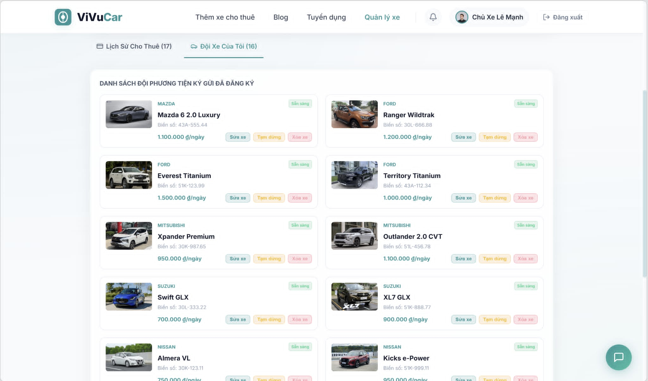
Figure 20. Create car listing

- In Normal Cases:
  - After the car owner has filled in all required vehicle specifications and uploaded documents, they click the Submit button.
  - The system validates the inputs and confirms successful registration with a message: "Your car listing registration has been successfully submitted and is pending Admin approval."

- In Abnormal Cases:
  - Missing or Invalid Fields:
    - The system will display an error message if any required field is missing or contains invalid input (e.g., "Please enter a valid rental price per day," or "License plate format is invalid").
  - Connection Issues:

    - If there's a server issue, the system will notify the car owner: "Unable to submit car registration due to a technical issue. Please try again later."

3.4.2 Search & Book Car
- Function trigger:
  - Primary Trigger: The customer accesses the Homepage or Booking page and enters their desired rental location, start date/time, and end date/time. They select an available car from the filtered results and click the button to submit their booking request.
- Function description:
  - Role : Customer (Renter)
  - Purpose: Allow customers to search for available electric cars by location and rental duration, view vehicle details, and submit a booking request.
  - Interface:
    - Search Bar: Fields for Location, Start Date/Time, and End Date/Time.
    - Filter Options: Checkboxes/Sliders for Price range, Car brand, and Battery capacity.
    - Car Catalog: A grid view displaying available cars with their images, daily rental rates, and ratings.
    - Book Now Button: A button on the Car Detail page to proceed to the checkout/summary page.
    - Confirm Booking Button: A final button to submit the booking request.
- Screen layout:
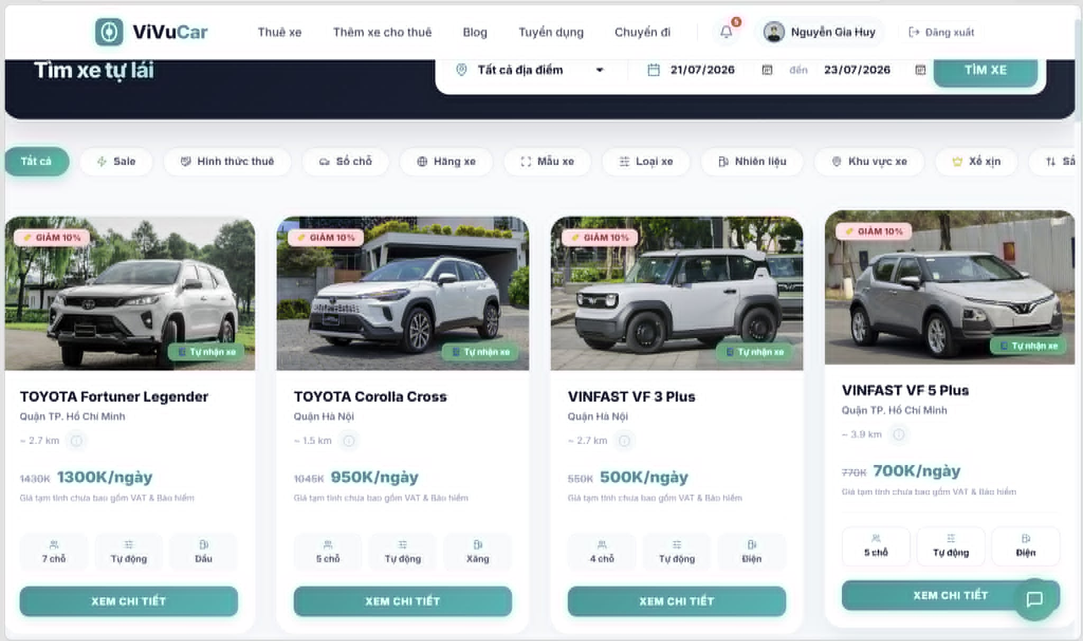
Figure 21. Search & Book Car

- In Normal Cases:
  - After the customer has selected an available car and reviewed the booking summary, they click the Confirm Booking button.
  - The system executes the calendar overlap check algorithm, reserves the car, and confirms the successful submission with the message: "Your booking request has been successfully submitted."
"Your answers have been successfully updated and submitted."
  - The customer is redirected to the booking overview page or they see a confirmation page with their booking details and booking status updated to PENDING_CONFIRMATION.
- In Abnormal Cases:
  - Missing or Invalid Fields:
    - No Location or Time Provided: If the customer leaves any required search criteria (Location, Start Date, or End Date) blank before searching, the system will display: "Please fill in all search criteria before proceeding.""Please answer all the questions before submitting."
    - Invalid Date/Time Range: If the customer enters a pickup date that is in the past, or an end date that occurs before the start date, the system will show: "Please enter a valid rental duration (Start date must be before End date and in the future)."
  - Connection Issues:
    - Server Error:
    - If there is an issue with the server when submitting the booking request, the system will notify the customer: "There was an issue submitting your booking request. Please try again later."
    - Timeout:
    - If the session times out or if the customer tries to confirm the booking after the vehicle availability window has expired, the system will show: "Time's up! The selected vehicle is no longer held for you. Please restart your search."

3.4.3 Confirm Booking & Deposit
- Function trigger:
  - Primary Trigger: The Car Owner accesses the Booking Requests page to approve a pending request, and subsequently, the Customer accesses the Payment Checkout page to pay the required deposit.
- Function description:
  - Role :, Car Owner, Customer
  - Purpose: To allow the car owner to accept rental requests and enable the customer to complete the deposit payment via the payment gateway to lock the car's calendar.
  - Interface:
    - ▪ Booking Request Details: A breakdown of the pending rental request showing customer profile, vehicle chosen, and rental dates.
    - Payment Gateways: An area where the customer can select their preferred payment method (e.g., VNPAY, MoMo) to execute the deposit.
- Screen layout:
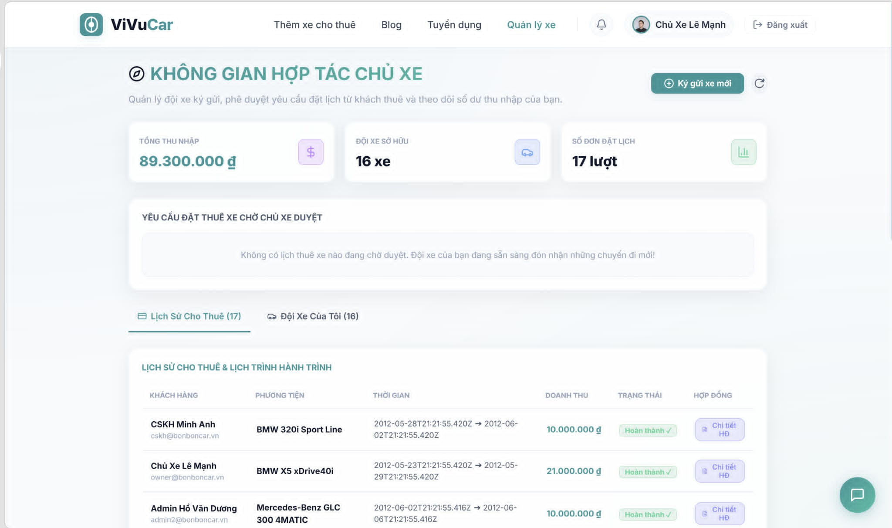
Figure 22. Confirm Booking & Deposit

- In Normal Cases:
  - Successful Viewing:
    - After the car owner clicks "Accept", the system will display the booking status updated to PENDING_DEPOSIT.
    - The customer is able to review the total breakdown and can see a confirmation message: "Your booking request has been accepted. Please proceed to deposit payment."
    - Data Retrieval Error: If there is an issue retrieving the transaction status from the payment gateway server, the system will display: "Unable to load your payment status at this moment. Please try again later."
- In Abnormal Cases:
  - Missing Answers or Data:
    - Booking Cancelled by Owner: If the car owner rejects the request or no confirmation is made, the system will show: "This booking request has been declined or is no longer available. Please choose another vehicle."
    - Data Retrieval Error:
If there is an issue retrieving the answers from the server, the system will display:
"Unable to load your answers at this moment. Please try again later."
  - Connection Issues:
    - Server Error:
    - If there is an issue with the server when trying to process the checkout, the system will notify the user:
    - "There was an issue retrieving your transaction. Please try again later."
    - Timeout or Session Expiry: If the customer's payment window (30-minute limit) has expired or there is a timeout, the system will display:
    - "Your payment session has expired. The booking has been canceled automatically."

3.4.4 Complete Trip & Review
- Function trigger:
  - Primary Trigger:
  - The Car Owner clicks on the Confirm Return button within the Order Detail page to end the trip, inspect the car conditions, or input any extra fees, then both parties submit their mutual ratings.
- Function description:
  - Role : Car Owner, Customer
  - Purpose: To allow the car owner to terminate the rental trip, calculate additional surcharges if any, and enable both users to post feedback reviews.
  - Interface:
    - Trip Summary & Fees: A list of final rental costs, including base rates and input fields for surcharges (e.g., low battery, cleaning fee)..
    - Rating Stars & Comment Box: An active input layout where users can select 1-5 stars and write a text review for their experience.
    - Submit Review Button: A button next to each review block, which allows the user to submit their feedback to the system.
- Screen layout:
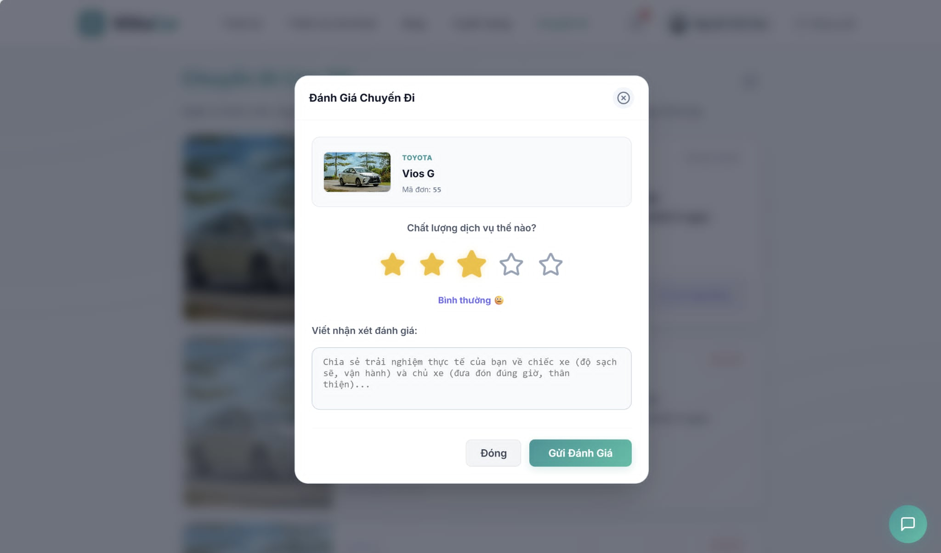
Figure 23. Complete Trip & Review

- In Normal Cases:
  - Successful Deletion:
    - After the car owner confirms the vehicle return conditions, the system will remove the car from active rental status and display a success message: "The trip has been successfully completed."
    - The system will update the interface to show that the car's calendar is now empty, allowing other renters to book this vehicle if desired.
  - No Answer to Delete:
    - If the user exits the page without entering feedback or if the review field is left empty, the system will display: "No review submitted. You can still rate the trip from your history page."
- In Abnormal Cases:
  - Missing or Invalid Data:
      - Trip Records Not Found:
      - If the user tries to complete or review a trip that is not present (e.g., the trip record has been archived or corrupted), the system will show: "No trip record found for this transaction."
      - Connection Issues:
    - Server Error:
      - If there is a failure when completing the trip or saving the review due to a server issue, the system will display: "There was an issue processing your request. Please try again later."
  - Timeout or Session Expiry:
      - If the user's session has expired or the connection times out, the system will display:
      - "Your session has expired. Please log in again to complete your trip or submit your review."
  - Confirmation Failure:
    - Cancellation:
      - If the car owner cancels the trip completion process or the user cancels the review submission at the confirmation step, the system will display:
"The process has been canceled."

3.4.5 View Car Details
- Function trigger:
  - Primary Trigger: The customer clicks on a specific car card from the search results or navigates to the Car Details page to view comprehensive technical, pricing, and owner information of that specific vehicle.
- Function description:
  - Role : Customer, Car Owner
  - Purpose: To allow users to view essential information about an electric car, such as battery status, pricing, guidelines, and previous renter reviews, via a structured car overview page.
  - Interface:
      - Vehicle Information: Displays key details about the car, including:
      - Car Name & Model: The exact brand and version of the electric car.
      - Technical Specs: The battery capacity, remaining percentage, and maximum range per charge.
      - Pricing Details: The daily rental rate and breakdown of security deposit requirements.
      - Car Description: A short description or custom usage rules provided by the car owner.
      - Location & Range: The specific pickup location area and distance from the renter.

      - Navigation Elements & History: An action area or sidebar that allows the user to navigate to different related modules such as:
      - ● Renter Reviews
      - ● Owner Profile
      - ● Booking Summary Checkout

- Screen layout:
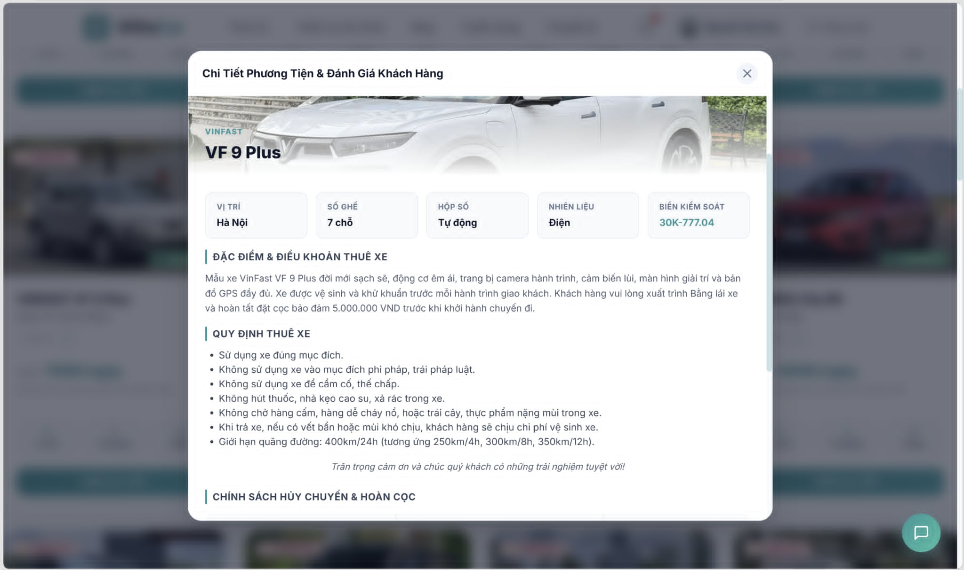
Figure 24. View Car Details

- In Normal Cases:
  - Successful Viewing:
    - After clicking on "View Car Details", the system displays all the detailed vehicle information, such as the Car Name, Technical Specs, Pricing, Description, and Location.
    - The user is able to easily navigate to other sections of the platform using the action buttons or the side menu.

- In Abnormal Cases:
  - Missing or Invalid Fields:
    - No Class Data Found
      - ● If any required vehicle field is missing or invalid (e.g., the car details cannot be pulled or the listing was archived), the system will display an error message (e.g., "Car details are currently unavailable.").
  - Connection Issues:
    - If there's a server issue, the system will notify the user: "Unable to load vehicle details due to a technical issue. Please try again later."

3.4.6 Filter & Search Cars
- Function trigger:
  - Primary Trigger:
The renter navigates to the homepage or the "Browse Cars" section and inputs search criteria (location, dates) or adjusts the filter sidebar.
- Function description:
  - Role :, Renter, Admin
  - Purpose:
  - To allow renters to find available self-driving electric vehicles based on specific locations, rental dates, and advanced EV criteria (battery range, charger type, brand) while preventing double-booking via a real-time calendar overlap check algorithm.
  - Interface:
- Search Bar: Input fields for Location, Start Date/Time, and End Date/Time.
- Filter Sidebar: Checkboxes and sliders for Price Range, EV Brand (Tesla, VinFast, Hyundai, etc.), Battery Capacity/Range, and Connector Type (CCS2, CHAdeMO).
- Car Grid: Displays search results including vehicle photos, hourly/daily price, remaining battery percentage, and rating.
- Pagination Control: Controls to navigate between multiple pages of car result.
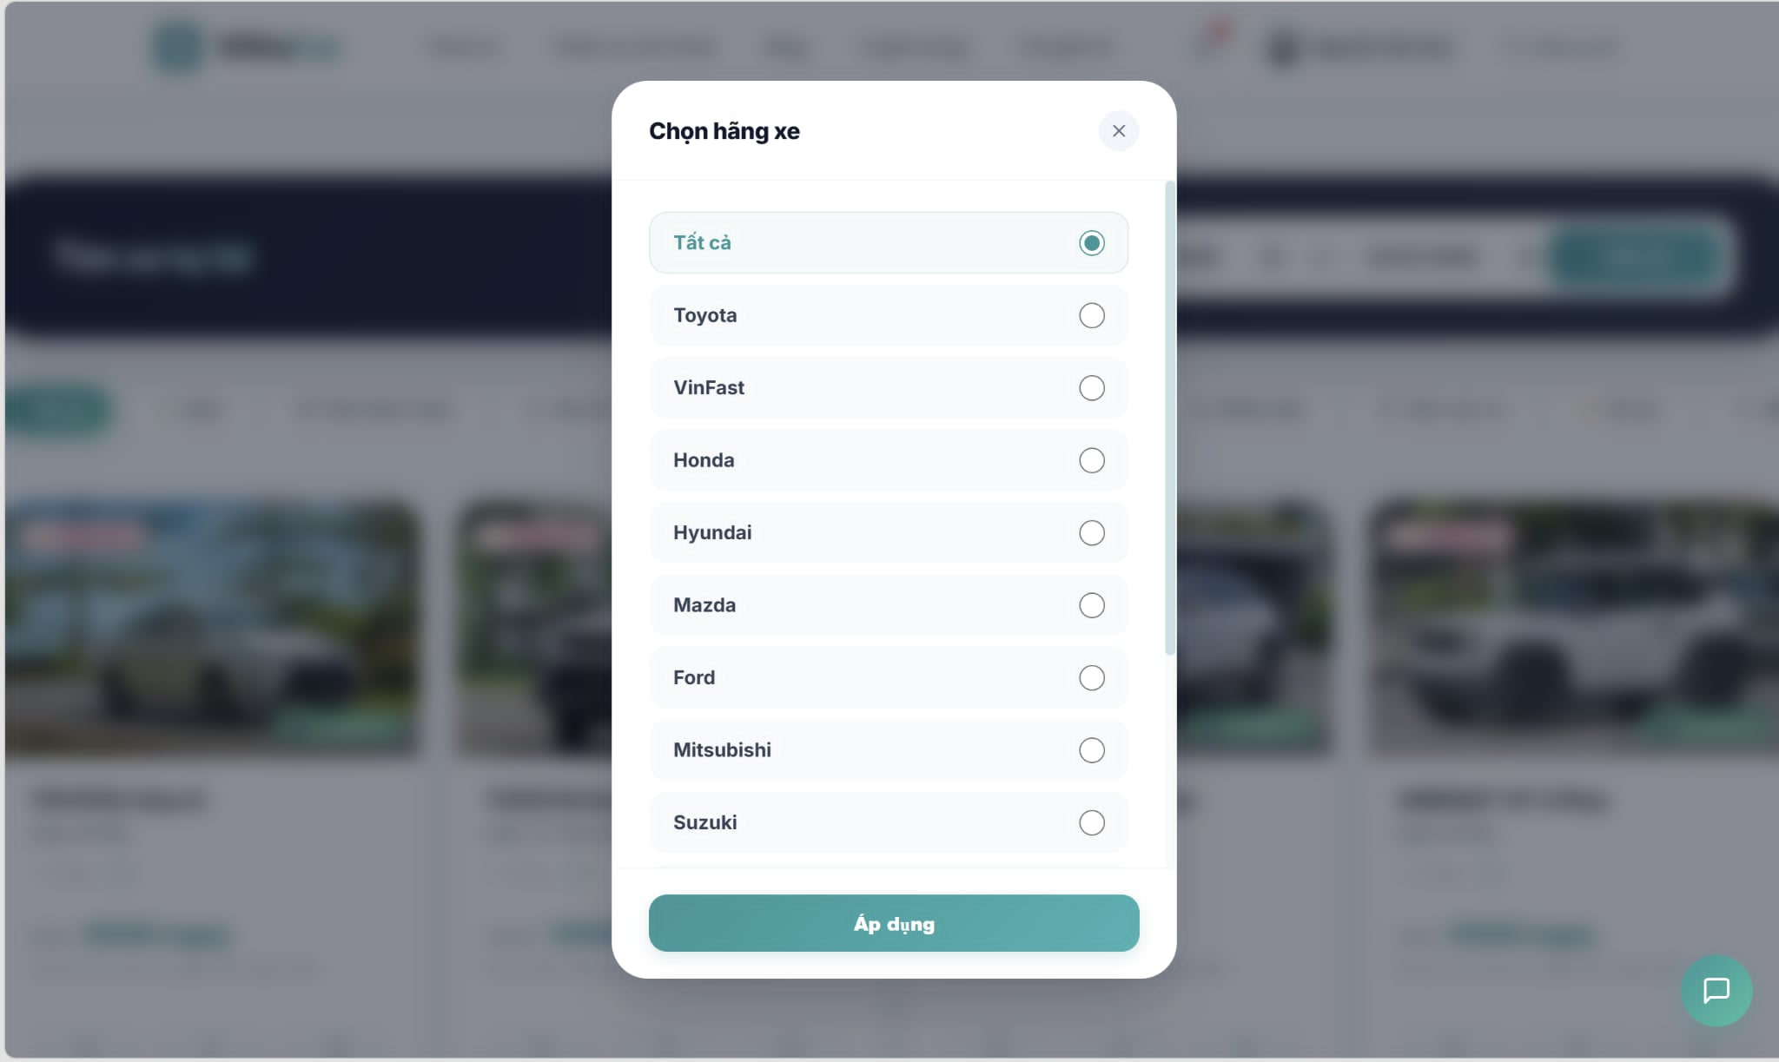
Figure 25. Filter & Search Cars

- In Normal Cases:Successful Search & Filtering:
- ● Executing Search:
  - The renter enters the destination location and selects the desired rental time frame, then clicks the "Search" button.
  - The system runs a backend SQL query incorporating a calendar overlap check to filter out any vehicles that already have approved bookings during that exact interval.
  - The system displays a list of active, unbooked electric cars matching the specified location and time slot.
● Applying Filters:
- The renter refines the results by adjusting the filter sidebar (e.g., selecting "VinFast" and "Battery Range > 400km").
- The grid updates instantly via asynchronous requests to display only the vehicles matching all criteria.

    - No Results Found:
- ● Zero Matching Cars:
  - If no electric cars match the requested location, dates, or filter combinations, the system will display: "No available electric vehicles found matching your criteria. Try adjusting your dates or widening your search filters."
    - Invalid Inputs:
- Chronological Error:
  - if the renter sets the End Date/Time prior to the Start Date/Time, the system blocks the search action and displays: "Invalid date range. Return date must be after the pickup date."
- Past Date Input:
  - If the renter selects a pickup date in the past, the system resets the field to the current date and time, displaying: "Cannot book a vehicle for a past date. Please select a future time slot."
    - Connection Issues:
- Database Timeout:
  - If the complex calendar verification query takes too long or fails to respond due to a server issue, the system will display: "Unable to fetch available vehicles due to a technical issue. Please try again later."

3.4.7 Create Vehicle Booking
- Function trigger:
  - Primary Trigger:
  - The renter clicks on the "Book Now" button from the vehicle details page after selecting their desired rental period.
- Function description:
  - Role :, Renter
  - Purpose:
  - To allow renters to reserve a self-driving electric car for a specific time window, executing a critical real-time check to guarantee the car is fully available.
  - Interface:
- ■ Booking Summary Panel: Displays chosen car details (model, license plate), pickup/return location, and selected date/time window.
- ■ Price Breakdown: Itemizes the daily rental rate, platform service fee, insurance package costs, and total calculated amount.
- ■ Renter Information Form: Fields for updating driving license details and uploading necessary identity verifications.
- ■ Confirm Booking Button: A button to finalize the reservation request and initiate the calendar lock.
- ■ Cancel Button: A button to abort the booking process and return to the car browsing screen.

- Screen layout:
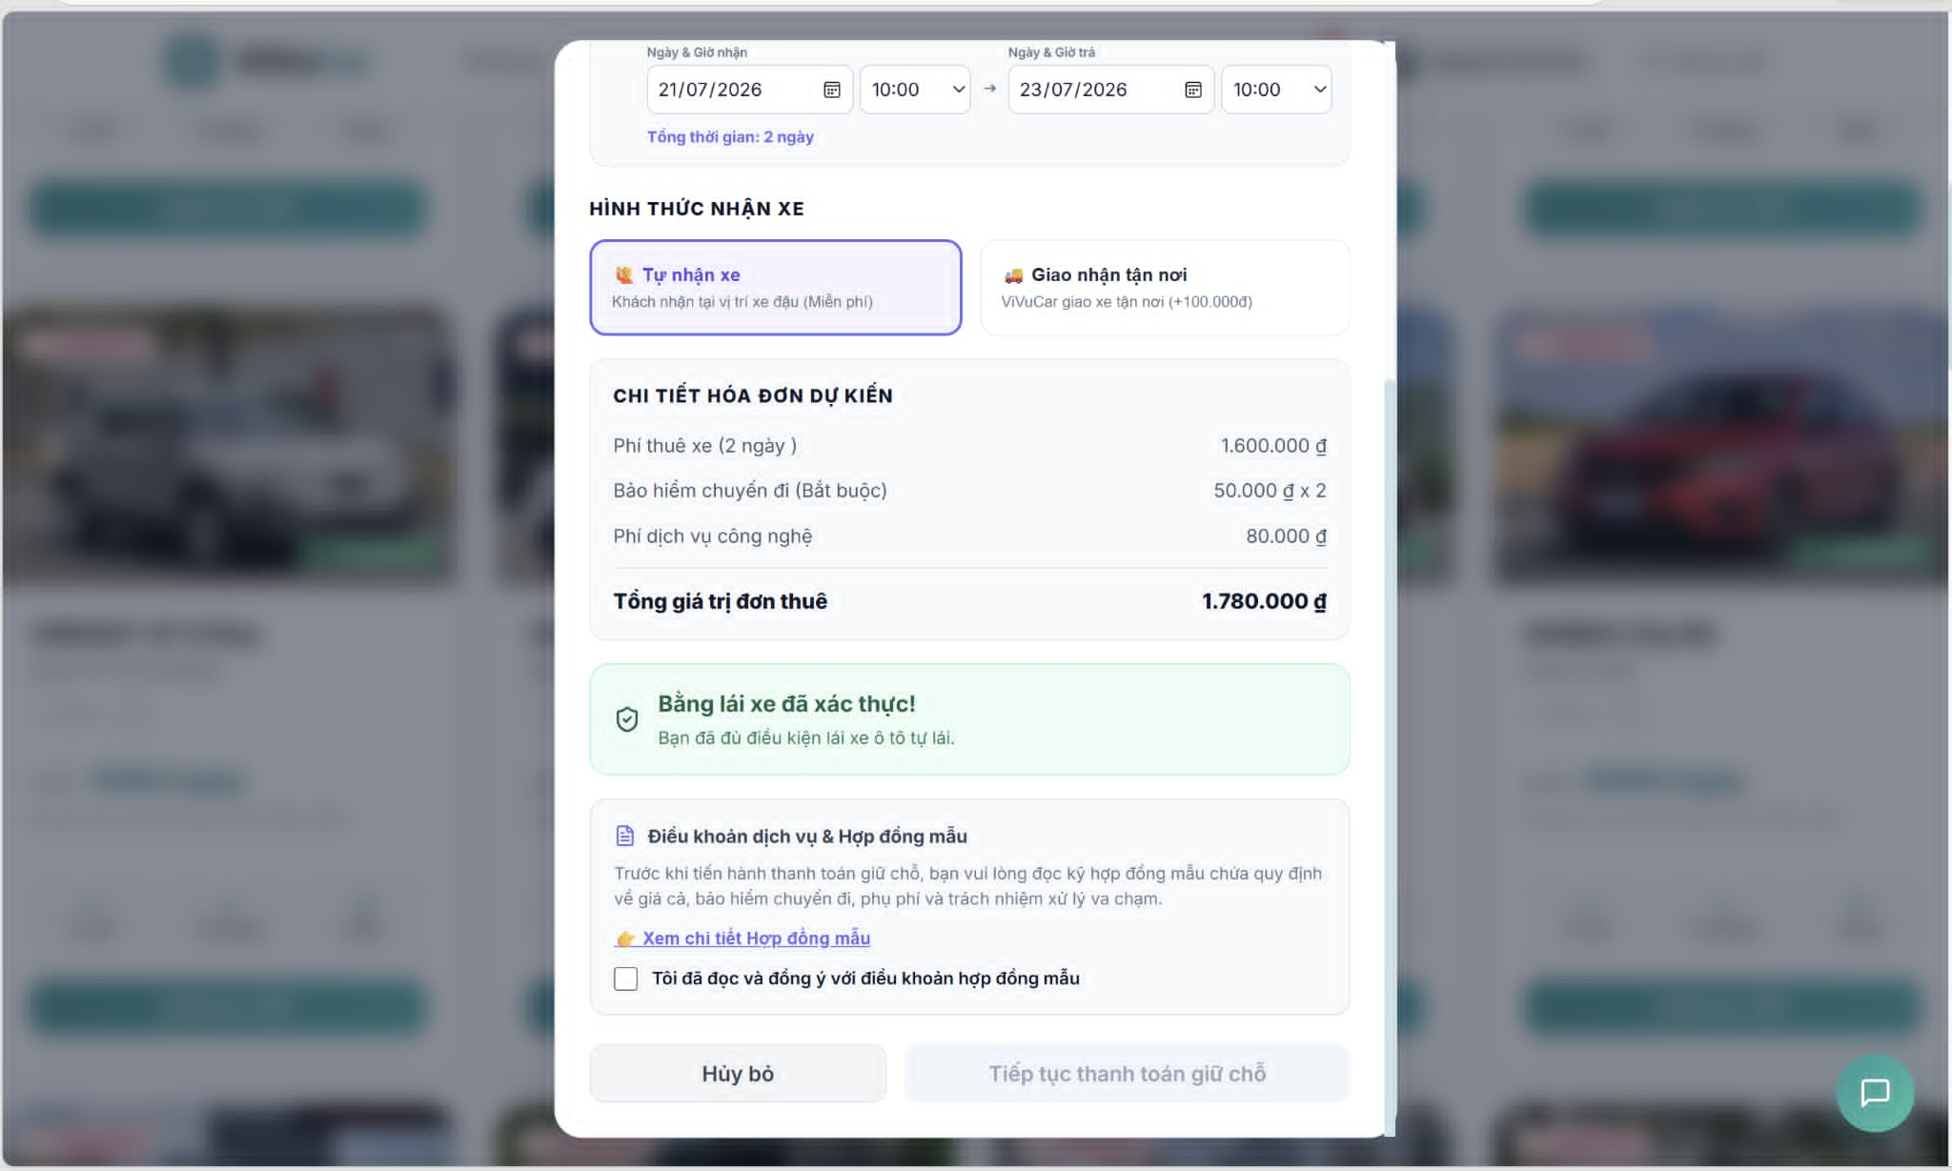
Figure 26. Create Vehicle Booking

Successful Booking Creation:
- ● Initiating Reservation:
  - The renter reviews the cost breakdown, completes any missing identity fields, and clicks the Confirm Booking button.
  - The backend system immediately triggers an Interceptor to verify role permissions and runs the SQL-based calendar overlap check.
  - Finding no booking overlaps, the system locks the vehicle for that time frame, sets the booking status to "Pending Payment", and routes the user to the invoice page.
  - The system displays a confirmation banner: "Booking initiated successfully! Please complete your payment to lock your reservation."
  - Double-Booking Conflict:
- ● Calendar Overlap Detected:
  - o If another renter successfully completes a booking for the same vehicle and overlapping hours while this user was on the checkout screen, the SQL verification will fail.
  - o The system blocks the transaction, releases any temporary holds, and displays: "This electric vehicle has just been reserved by another user for the selected time slot. Please choose different dates or select another vehicle."
  - Invalid Renter Credentials:
- ● Missing Verification Documents:
  - o If the renter has not uploaded a valid driving license or if the background Interceptor flags an unverified account status, the system halts the booking and displays: "Booking failed. A verified driver's license is required to rent a self-driving vehicle. Please update your profile."
  - Connection Issues:
- ● Transaction Timeout:
  - o If the database encounters a deadlock or connection drop during the calendar verification query, the system rolls back any partial changes and notifies the renter: "Unable to process your booking reservation due to a technical server issue. Please try again shortly."

3.4.8 View Booking History & Details
- Function trigger:
  - Primary Trigger: The user (Car Owner or Renter) clicks on the "My Bookings" or "Booking History" tab in their dashboard layout..
- Function description:
  - Role :, Car Owner, Renter, Admin
  - Purpose:
  - To provide users with a complete chronological list of their past and active vehicle rentals, including detailed breakdowns of pricing, rental periods, and current fulfillment statuses.
- Interface:
- ■ Booking List Grid: A paginated table showing Booking ID, Vehicle Model, Total Price, Date Range, and Status Tags (e.g., Pending, Confirmed, Active, Completed, Cancelled).
- ■ Status Filters: Tabs or dropdowns to filter rows by active rentals, completed trips, or cancelled requests.
- ■ Detail Modal / Page: A detailed view triggered by clicking a specific booking entry, exposing the license plate, pickup instructions, battery status at handover, and linked rental documents.
- Screen layout:
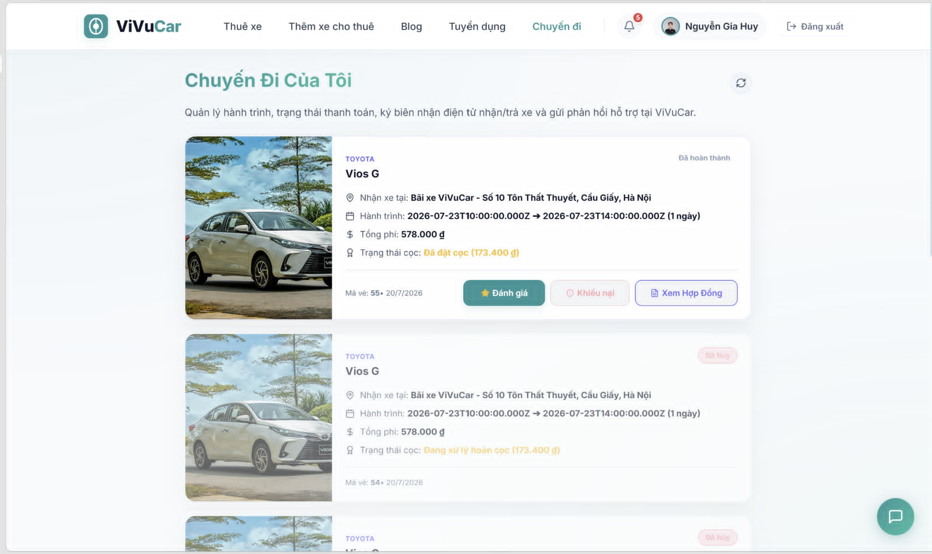
Figure 27. View Booking History & Details

- In Normal Cases:
  - User Experience (Renter & Owner):
- ● Browsing History:
  - o The user navigates to the booking dashboard. The system utilizes background Interceptors to verify the user's active session and security token.
  - o The system fetches and renders all matching booking rows from the database, sorted with the newest transactions appearing first.
- ● Viewing Detailed Breakdown:
  - o The user clicks on a single booking item. The UI displays the full technical asset details (EV model, battery capacity specifications) alongside the financial receipt and digital signatures of both parties.
- In Abnormal Cases:
  - No Bookings Recorded:
- ● Empty State:
  - o If a newly registered user accesses the page and has zero previous transactions, the system will clear the grid and display: "You haven't made any vehicle reservations yet. Start browsing available electric cars now!"
  - Permission Overlap / Security Violations:
- ● Unauthorized Record Access:
  - o If a user attempts to manually alter the request parameters in the browser to view a Booking ID that belongs to another customer, the security Interceptor blocks the query and displays: "Access Denied. You do not have permission to view the details of this booking transaction."
  - Connection Issues:
- ● Fetch Timeout:
  - o If the database fails to respond due to a network interruption or heavy load, the system will display: "Unable to retrieve your booking history due to a server connection issue. Please refresh the page or try again later."

3.4.9 Cancel Vehicle Booking
- Function trigger:
  - Primary Trigger: The renter or car owner clicks on the "Cancel Booking" button within the booking details page.
- Function description:
  - Role :, Renter, Car Owner, Admin
  - Purpose: To allow users to cancel a pending or confirmed reservation, automatically releasing the locked time slot in the vehicle's availability calendar and recalculating any applicable refund fees based on platform policy.
  - Interface:
- ■ Cancellation Reason Dropdown: A required selection menu for the user to state why they are cancelling (e.g., Change of plans, Found another car, Emergency).
- ■ Refund Policy Summary: A dynamic text area explaining the cancellation fees and the estimated refund amount (if applicable).
- ■ Confirm Cancellation Button: A button to permanently execute the cancellation.
- ■ Back Button: A button to close the modal and retain the active booking.

Figure 37. View list member of class
- In Normal Cases:
- Successful Cancellation:
- ● Executing Cancellation:
  - The user selects a reason from the dropdown and clicks the Confirm Cancellation button.
  - The backend system invokes the security Interceptor to check user roles and updates the status of the booking record to "Cancelled" in the database.
  - The system instantly updates the vehicle's availability calendar, making the previously blocked time frame open for other renters to search and book.
  - The system displays a confirmation message: "Your booking has been cancelled successfully. A confirmation email has been sent to your inbox."
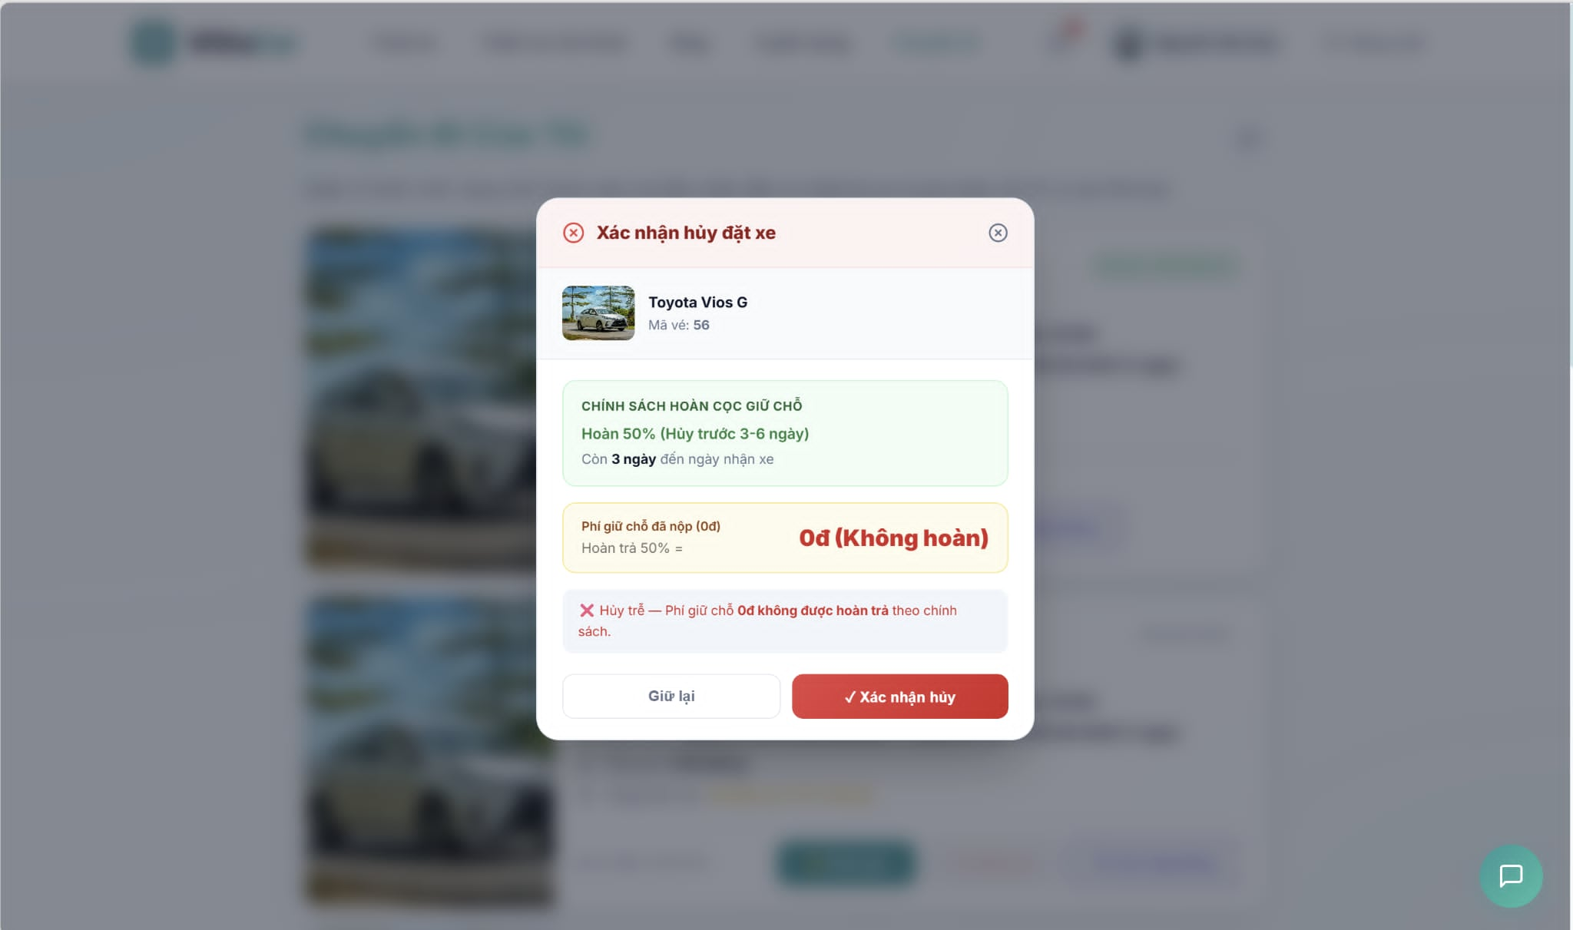
Figure 28. Cancel Vehicle Booking
- In Abnormal Cases:
    - Policy Violations (Late Cancellation):
- ● Invalid Cancellation Window:
  - o If a renter tries to cancel a booking that has already started (Active status) or is within the non-refundable window (e.g., less than 1 hour before pickup), the system blocks the action.
  - o The system displays an error message: "Cannot cancel this booking. The cancellation window has closed as the rental period is about to start or is already active. Please contact support for assistance."
    - Already Processed:
- ● Status Conflict:
  - o If the booking was already cancelled or modified in another session, the system prevents a duplicate request and displays: "This booking has already been cancelled or updated. Please refresh your dashboard."
    - Connection Issues:
- ● Database Error:
  - o If a server timeout occurs while releasing the calendar slots, the system rolls back the transaction and displays: "Unable to process your cancellation request due to a technical issue. Please try again later."

3.5 Vehicle Management feature

3.5.1 View Owned Vehicle List
- Function trigger: This function is accessed through the “My Vehicles” or "Vehicle Management" section, where car owners can view all their registered vehicles.
- Function description:
  - Role : Car Owner can view the list of their registered vehicles.
  - Purpose: This feature allows authorized car owners to monitor all their vehicles on the platform, check their current status (Pending, Available, Rented, etc.), and quickly navigate to edit or delete them.
  - Interface: The interface provides a data grid or a list of vehicle cards displaying primary images, model names, license plates, daily prices, and status tags. It includes a "Register New Vehicle" button and action menus (Edit, Delete) for each item.
- Data Processing: The system fetches vehicle data (joined with Brand and Category) from the database filtered by the logged-in user's owner_id.

- Screen layout:


Figure 29. View Owned Vehicle List

- Function detail:
  - Data:
    - Owner ID: Automatically retrieved from the active session.
    - Search/Filter parameters: Optional (e.g., filter by Status or License Plate).
  - Validation and Business Rules:
    - In normal cases:
      - The system accurately retrieves and paginates only the vehicles belonging to the currently authenticated Car Owner.
      - If the owner has no vehicles, the system displays a user-friendly empty state with a call-to-action button to register a new vehicle.
    - In abnormal cases:
      - In case of server or network errors, the user will receive a notification like "Unable to load vehicle list", and the system will display a retry button.

3.5.2 Register / Manage New Vehicle
- Function trigger: This function is accessed by clicking the "Add Vehicle" button or selecting "Edit" on an existing vehicle card in the vehicle list.
- Function description:
  - Role : Car Owner can create, update, or delete vehicle listings.
  - Purpose: This feature allows owners to list a new vehicle for rent by providing specifications, pricing, legal documents, and images. It also enables them to update existing vehicle details.
  - Interface: A comprehensive form containing sections for General Info, Specifications, Pricing, Images, and Documents. It includes "Save/Submit" and "Cancel" buttons.
  - Data Processing: Once submitted, the system saves data into Vehicle, VehicleImage, VehicleDocument, and VehicleFeature tables. New vehicles are defaulted to 'Pending' status awaiting Admin approval.

- Screen layout:
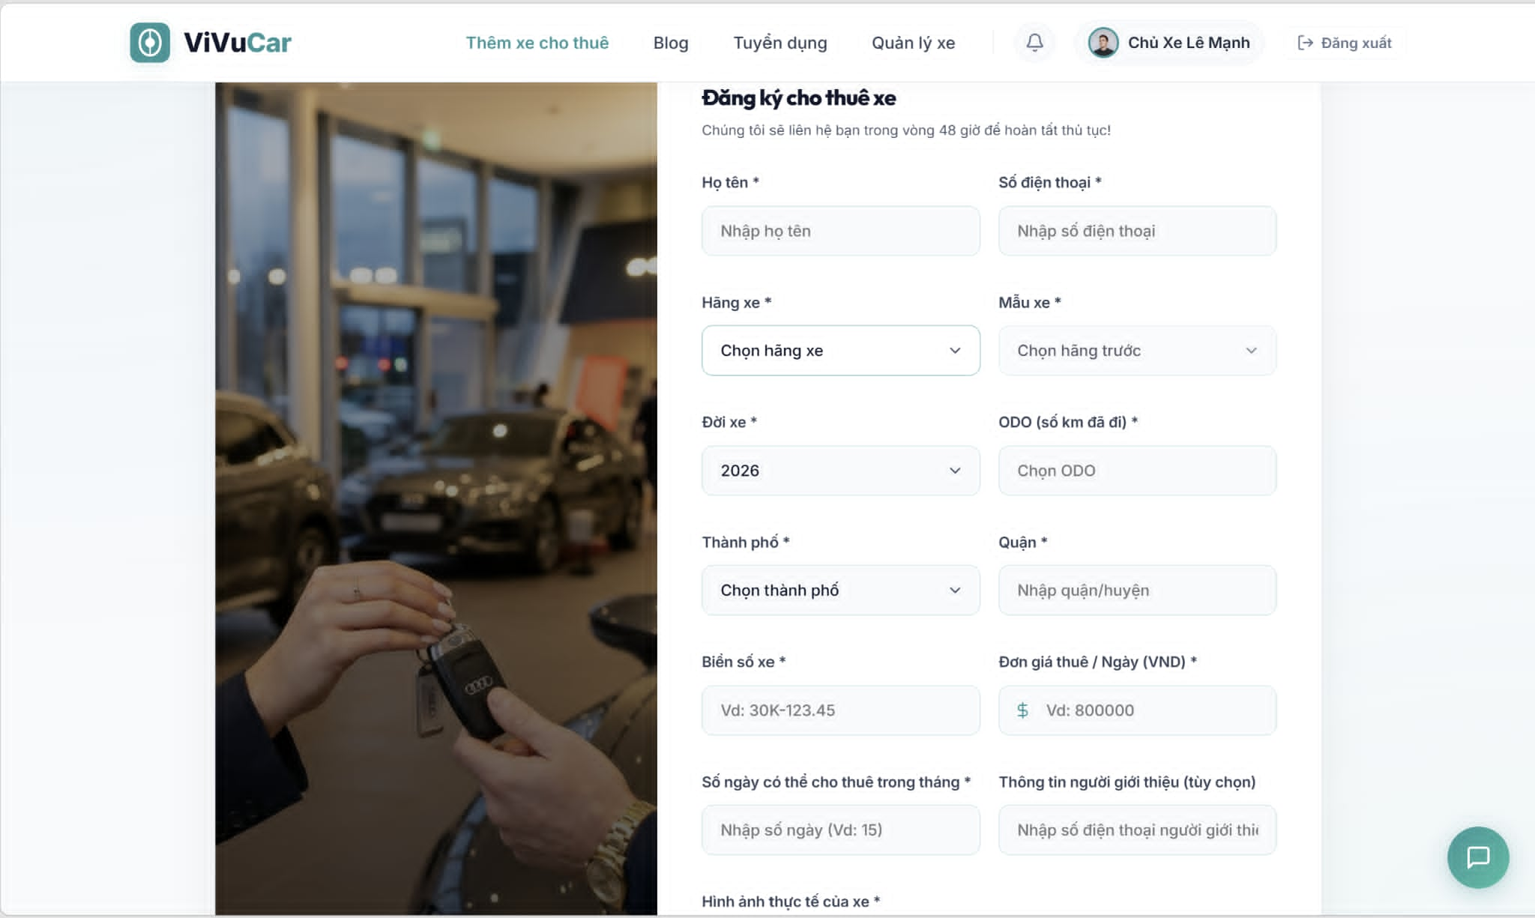
Figure 30. Register / Manage New Vehicle

- Function detail:
  - Data:
    - Brand & Category: Required, must be selected from a predefined list.
    - Model Name: Required, must be a non-empty string.
    - License Plate: Required, must be a unique string.
    - Daily Price & Deposit Amount: Required, must be a valid number greater than 0.
    - Seat Count: Required, must be a positive integer.
    - Images & Documents: Required, at least one primary image and valid registration document must be uploaded.
  - Validation and Business Rules:
    - In normal cases:
      - When creating a vehicle, the system validates all inputs. If valid, the vehicle is saved with a Pending status.

      - If the quiz is marked as "Published," it becomes available to students; otherwise, it remains as a draft.
      - The system ensures that the quiz data is properly saved to the database and updates are reflected in real-time.
    - In abnormal cases:
      - If required fields (like title or time limit) are missing or invalid, the system displays an error message and prevents the quiz from being saved.
      - If an attempt is made to delete a quiz that is linked to active assessments, the system will block the deletion and show an appropriate error.

3.5.3 Confirm Rental Request(Approve/Reject)
- Function trigger:This function is accessed through the “Manage Quiz” section, where users can create, update, delete, and view quizzes.
- Function description:
  - Role :Teacher can create, edit, delete, or view quizzes.
  - Purpose: This feature allows authorized users to manage quizzes, ensuring that they can create, update, and delete quizzes efficiently within the system.
  - Interface: The interface provides a list of all quizzes, along with buttons for creating, editing, or deleting quizzes. Each quiz can be viewed in detail or modified through dedicated forms.
  - Data Processing: Once a quiz is created or modified, the system saves or updates the quiz data in the database. Deleting a quiz removes its related data.
- Screen layout:
Figure 31. Confirm Rental Request(Approve/Reject)

- Function detail:
  - Data:
    - Quiz Title: Required, must be a non-empty string.
    - Chapter: Optional, but recommended for clarity.
    - Time Limit: Required, must be a valid number in minutes.
    - Time start: Required, must be a valid number in minutes.
    - Time finish: Required, must be a valid number in minutes.
    - Number of question: Required, must be a valid number

  - Validation and Business Rules:
    - In normal cases:
      - When creating or updating a quiz, the system validates that the title is not empty and the time limit is a positive number.
      - If the quiz is marked as "Published," it becomes available to students; otherwise, it remains as a draft.
      - The system ensures that the quiz data is properly saved to the database and updates are reflected in real-time.
    - In abnormal cases:
      - If required fields (like title or time limit) are missing or invalid, the system displays an error message and prevents the quiz from being saved.
      - If an attempt is made to delete a quiz that is linked to active assessments, the system will block the deletion and show an appropriate error.
      - In case of server or network errors during quiz creation or modification, the user will receive a notification, and the system will advise trying again later.

3.6. Support & Dispute feature (CSKH & User)
3.6.1. Contact Customer Service / AI Chatbot
- Function Trigger:
  - User-initiated:
- For Ticket: The user navigates to the "Support" section and fills out the support ticket form.
- For Chatbot: The user clicks the floating chatbot widget icon in the bottom right corner of the screen.
- System-initiated: None.
- Function Description:
- Actors/Roles: Renter, Car Owner, CSKH (for resolving tickets).
- Purpose: To provide users with automated support via an AI Chatbot and a portal to submit formal support tickets to human customer service agents.
- Interface:
Displays essential details such as:
- Ticket Form: Subject Input, Message Textarea, Submit Button.
- AI Chatbot: Conversation Window, Floating Chat Widget, Message Input Box, Send Button.
- Data Processing:
- Tickets are stored in the SupportTicket table.
- Chatbot messages are sent to the backend (POST /api/chatbot/message), which calls the Gemini API. The backend retrieves the user's profile, active bookings, and wallet balance to provide personalized answers.
- Screen Layout:
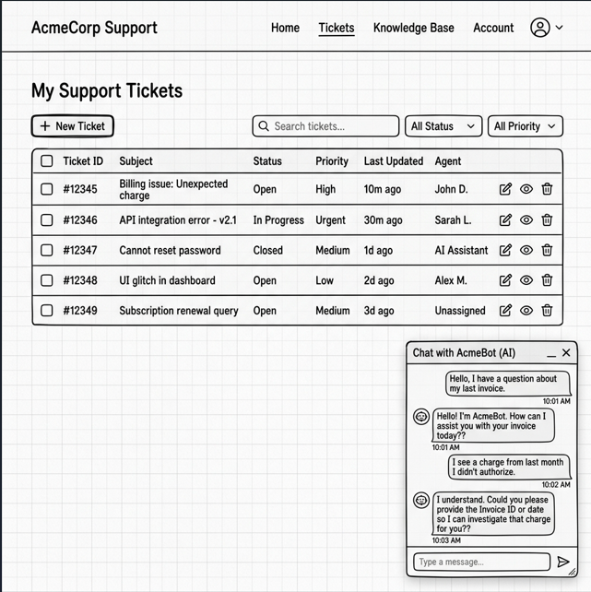
Figure 32. Contact Customer Service / AI Chatbot Screen Layout
- Function Details:
- Data Requirements: The system must retrieve user profile, wallet balance, active bookings, and support ticket records.
- Actions:
- Submit Support Ticket: Users write a subject and message to submit to human CSKH.
- Chat with AI: Users type a question in the widget and receive an instant reply.
- Validation and Business Rules:
- In normal cases:
- Tickets are successfully saved in the database with status open and CSKH is notified.
- AI Chatbot responds within 2 seconds with personalized, context-aware answers.
- In abnormal cases:
- If the AI service is unavailable, the chatbot displays a fallback message: "AI Chatbot is currently offline. Please submit a support ticket above."
- If the ticket form fields are empty, submission is blocked.
3.6.2. Report Incident
- Function Trigger:
- User-initiated: The renter clicks the "Report Emergency Incident" button in their active booking details view.
- System-initiated: None.
- Function Description:
- Actors/Roles: Renter, Car Owner (notified), CSKH/Admin (notified).
- Purpose: To allow renters to report accidents, mechanical breakdowns, or vehicle damage during an active trip, uploading photos and location details.
- Interface:
Displays essential details such as:
- Incident Type Dropdown (Accident, Mechanical Failure, Flat Tire, Other)
- Description Textarea
- Location Input Field
- Photo Upload Area
- "Submit Incident Report" Button
- Data Processing:
- The system updates the issue_report JSON column of the corresponding Booking record with the incident details.
- Sends high-priority notifications to both the Car Owner and the CSKH team.
Screen Layout:
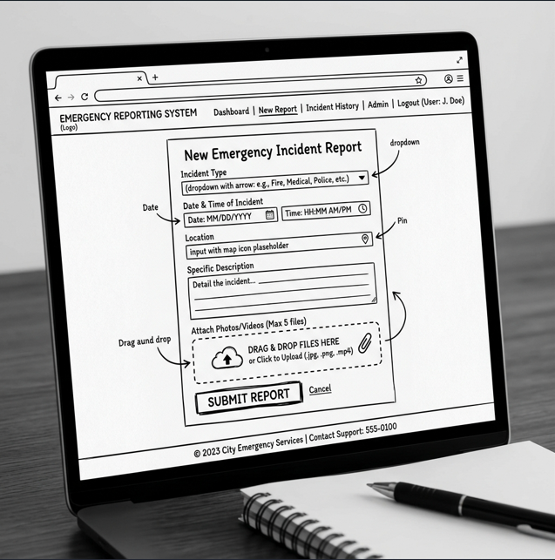
Figure 33. Report Incident Screen Layout
- Function Details:
- Data Requirements: The system must retrieve and update booking data (booking_id, issue_report JSON).
- Actions:
- Fill Incident Details: User selects the type, describes the event, and inputs the location.
- Upload Photos: User attaches pictures of the vehicle damage or breakdown scene.
- Submit Report: User sends the report, triggering emergency alerts.
- Validation and Business Rules:
- In normal cases:
- The incident report is successfully saved, and the booking record is updated.
- Emergency notifications are dispatched instantly to the Car Owner and CSKH.
- In abnormal cases:
  - If the booking status is not Active, the "Report Incident" button is hidden or disabled.
  - If the description is empty or no photo is uploaded, the system displays an error: "Description and at least one photo are required."
3.6.3. Submit & Handle Complaint
- Function Trigger:
- User-initiated:
- Renter: Clicks the "Submit Dispute" button on a completed booking details page.
- Admin/CSKH: Navigates to the "Disputes" section in the Admin Dashboard.
- System-initiated: None.
- Function Description:
- Actors/Roles: Renter, Car Owner, CSKH, Admin.
- Purpose: To manage, track, and resolve disputes between renters and owners regarding deposits, extra fees, or vehicle conditions.
- Interface:
- Displays essential details such as:
- Renter: Dispute Description Textarea, Submit Dispute Button.
- Admin/CSKH: List of Active Disputes, Dispute Detail View (Renter Claim, Owner Response), Resolution Actions Card (Refund Renter, Pay Owner, Split Refund buttons).
- Data Processing:
- When a dispute is submitted, a record is created in the Dispute table and the Booking status is changed to Disputed.
- Upon resolution, the system executes the wallet transactions via the usp_ProcessWalletTransaction stored procedure to distribute the funds and updates the dispute status to resolved.
- Screen Layout:
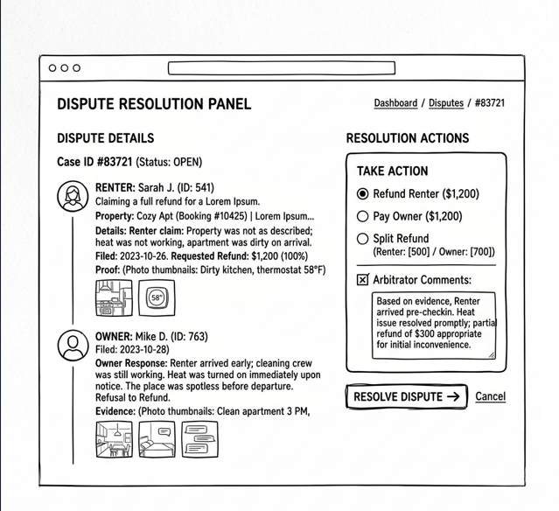
Figure 34. Submit & Handle Complaint Screen Layout
- Function Details:
  - Data Requirements: The system must retrieve and update dispute and booking records (dispute_id, booking_id, renter_id, owner_id, description, status, resolution).
- Actions:
  - File Dispute (Renter): Request platform arbitration on a booking.
  - Review Dispute (CSKH/Admin): Access the dispute dashboard and review claims.
  - Resolve Dispute (CSKH/Admin): Click a resolution button to distribute funds and close the dispute.
- Validation and Business Rules:
  - In normal cases:
    - Filing a dispute successfully freezes the booking funds by changing the status to Disputed.
    - Resolving a dispute automatically distributes the funds to the respective wallets and closes the dispute.
  - In abnormal cases:
    - If the booking is already settled and closed, the system blocks automatic dispute filing and directs the user to contact CSKH manually.
    - If the admin attempts to resolve a dispute without selecting a payout resolution, the system displays a validation error.

3.7 Manage Admin feature

3.7.1 View Dashboard
- Function Trigger:
  - User-initiated: The dashboard can be accessed by Admin after logging in by clicking the "Dashboard" link from the navigation bar.
  - System-initiated: After a successful login, Admin users may be automatically redirected to the dashboard as the default landing page.
- Function Description:
  - Actors/Roles: ADMIN: The Admin uses the dashboard interface to monitor system activities and manage key features.
  - Purpose: The dashboard provides Admin users with an overview of system performance, user activity, and access to administrative tools.
  - Interface: The dashboard typically displays the following sections:
    - System analytics (e.g., number of active users, system performance)
    - Administrative notifications (pending teacher approvals, reports)
    - Access to management tools (e.g., user management, content moderation)
  - Data Processing: Upon accessing the dashboard, the system retrieves relevant data from the server, displaying system-wide statistics, logs, and other administrative information.
- Screen Layout:
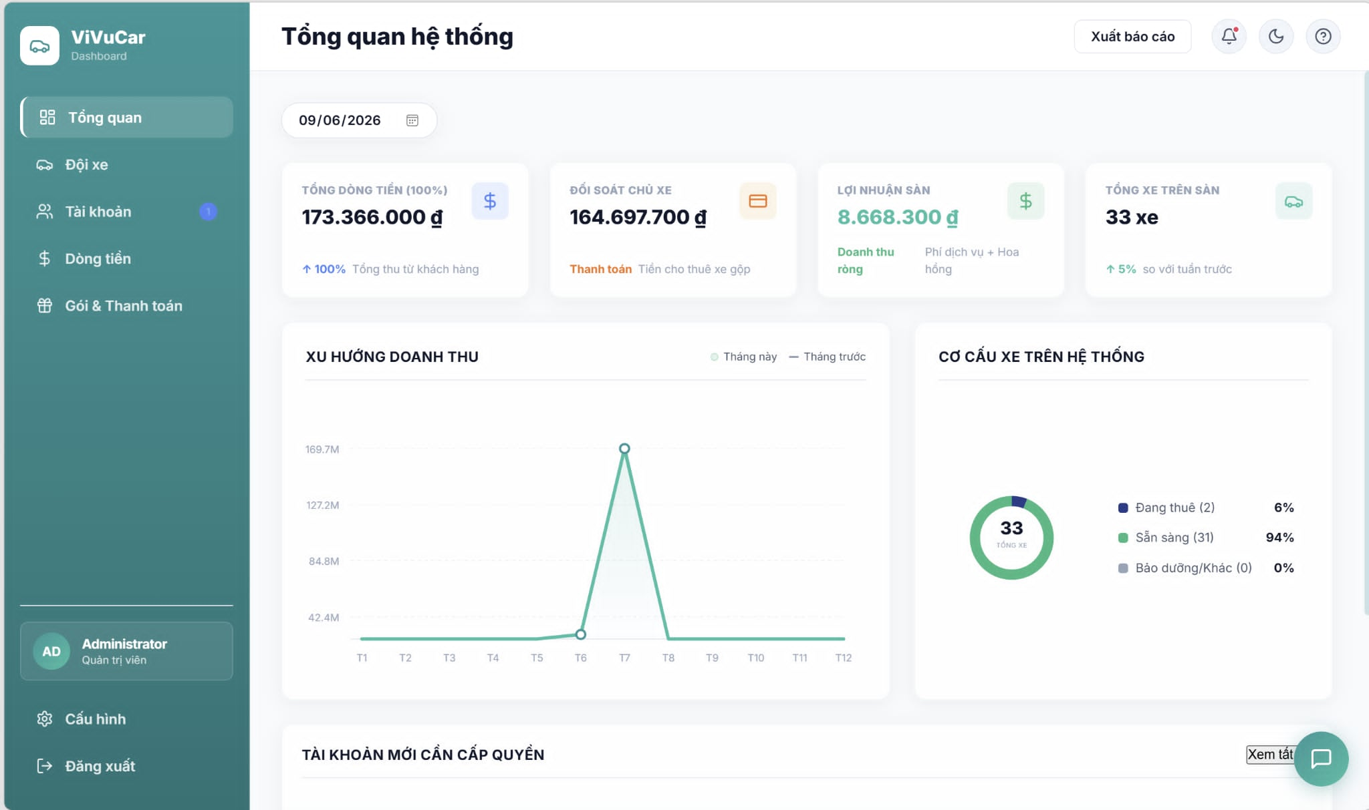
Figure 35. View Admin Dashboard

- Function Details:
  - Data Requirements:
    - System Information: Overview of key system metrics:
      - Number of active users
    - User Management: List of recent user activities, including:
      - New registrations
      - User reports
      - Pending actions (e.g., account approvals, content flags)
    - Notifications:
      - Admin-specific notifications, such as:
      - Security alerts
      - Pending administrative actions (e.g., content moderation, user bans)
    - Quick Access Links:
      - Reports management
      - User management
      - Teacher account approvals
      - System settings
  - Validation and Business Rules:
    - Normal cases:
      - After logging in, the system retrieves and displays admin-relevant data and system performance metrics.
      - Admins can access tools for managing users and content directly from the dashboard.
    - Abnormal cases:
      - If system data cannot be retrieved, an error message will be displayed, and the Admin will be prompted to refresh the page or try again later.
      - If the admin’s session is invalid, they will be redirected to the login page.
      - In the case of server or connection issues, the system will notify the Admin and allow retries once the connection is restored.

3.7.2 View List Users
- Function Trigger:
  - User-initiated: Admin can access the "List Users" page by selecting the "User Management" option from the navigation bar or the dashboard.
  - System-initiated: In certain cases, such as when there are flagged or pending user-related actions, the system may redirect the admin to the user list after login.
- Function Description:
  - Actors/Roles: ADMIN: This function is used by Admins to view, manage, and take actions on the registered users in the system.
  - Purpose: Allows Admin to view the list of all users and manage their accounts through various administrative actions.
  - Interface:
    - The page displays a list of users, showing details such as:
      - User ID
      - Full name or username
      - Email address
      - Registration date
      - Account status (e.g., Active, Suspended)
      - User role (Student, Teacher)
  - Data Processing: When the page is accessed, the system retrieves user data from the server, presenting it in a searchable, sortable, and filterable table format.
Screen Layout:
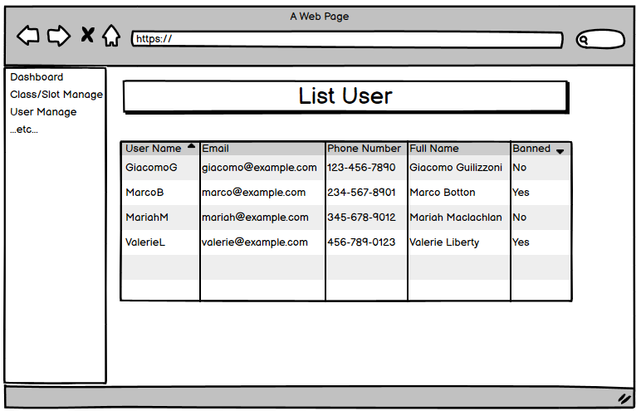
Figure 36. View List Users

- Function Details:
  - Data Requirements:
    - User Information
    - Actions: Admins can perform the following actions on each user:
      - View user details: Display a detailed view of the user's account and history.
      - Edit user: Modify user roles, statuses, or other account settings.
      - Delete/Ban/Activate user: Temporarily suspend or reactivate user accounts.
- Validation and Business Rules:
  - Normal cases:
    - The system successfully retrieves and displays all user data in a paginated format.
    - The Admin can search for users by name, email, or ID, and filter by role (e.g., Student, Teacher) or account status.
    - Any administrative actions taken, such as suspensions or deletions, will be processed immediately and reflected in the UI.
  - Abnormal cases:
    - If the system fails to retrieve user data, an error message will be displayed with an option to retry.
    - If a session expires or is invalid, the admin will be redirected to the login page.
    - In the case of a failed action (e.g., trying to suspend an already suspended account), the system will notify the Admin and provide an appropriate error message.

3.7.3 View List Reports
- Function Trigger:
  - User-initiated: The Admin can access the "List Reports" page by selecting the "System Reports" option.
  - System-initiated: If users report urgent system issues, the system may prompt the Admin to review the list of reports after login.
- Function Description:
  - Actors/Roles: ADMIN: The admin uses this function to view system-related reports submitted by users, such as bugs, performance issues, or feature requests.
  - Purpose: Allows the Admin to manage and review system-related reports, helping to identify and resolve technical issues or system malfunctions.
  - Interface:
    - The Reports list displays relevant information about each system-related report:
      - Report ID
      - Reporting user (who submitted the report)
      - Report category (e.g., Bug report, Performance issue, Feature request)
      - Date of the report submission
      - Report status (e.g., Pending, Reviewed, Resolved)
  - Data Processing: The system retrieves all system-related reports from the server and presents them in a searchable, filterable, and sortable table format.
- Screen Layout: 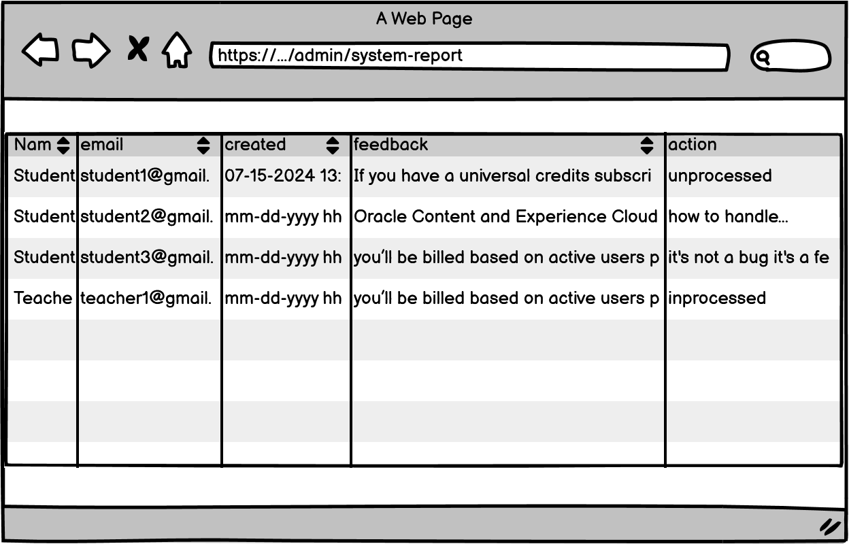
Figure 37. View List Reports

- Function Details:
  - Data Requirements:
    - Report Information:
      - Report ID
      - Reporting user (Full name or username of the user who submitted the report)
      - Report category (e.g., Bug report, Performance issue, Feature request)
      - Date of the report submission
      - Report description (if provided)
      - Current report status (Pending, Reviewed, Resolved)
  - Actions:
    - View report details: Access a more detailed view of the system issue or suggestion reported, including any steps to reproduce or additional comments.
    - Mark as reviewed: Change the report status from "Pending" to "Reviewed" once the issue or suggestion has been examined.
    - Resolve report: Mark the report as resolved after the issue has been addressed or the feature request has been acknowledged.
  - Validation and Business Rules:
    - Normal cases:
      - The system retrieves and displays all system-related reports in a paginated list.
      - The Admin can filter reports by status (Pending, Reviewed, Resolved) or by category (e.g., Bug report, Feature request).
      - When a report is marked as "Reviewed" or "Resolved," the system updates the server and reflects the change in the user interface in real time.
    - Abnormal cases:
      - If the system fails to retrieve reports, it will display an error message with an option to retry.
      - If there is a server issue preventing actions (e.g., marking a report as resolved), the system will notify the admin and allow them to try again later.
      - In case of a session timeout, the admin will be redirected to the login page.

4. Non-functional Requirements
4.1. External Interfaces
- The system must ensure smooth, reliable, and secure communication with external services:
- User Interface & Design Consistency:
  - Must maintain strict visual consistency regarding brand colors (BonBonCar's primary palette), typography (Arial/system default), and font sizes across all layouts (Landing Page, admin dashboards, checkout screens).
  - The UI must be fully adaptive and responsive, ensuring flawless layouts on all standard web browsers, mobile viewports, and tablet devices.
  - System must immediately trigger a Success Toast Message upon operational actions (saving profile, onboarding a vehicle, booking requests, deleting data).
  - High-risk or destructive actions (deleting records, cancelling active bookings) must explicitly display a modal confirmation popup (Yes/Cancel) before processing.
  - Every view assigned to any target actor (Guest, Renter, Car Owner, Admin, Customer Service) must incorporate a fixed global Header or floating Navigation menu.
- Authentication Providers (Google OAuth, JWT):
  - Must support Google OAuth2 services for instant, safe authentication using external credentials.
  - Every internal backend API handling protected actions, balance adjustments, or ledger tracking must strictly mandate a JSON Web Token (JWT) injected into the request header.
- Payment Gateway Integration:
  - Must smoothly communicate with the VNPAY Sandbox Gateway interface to handle transactional handshake signatures, real-time escrow deposit initializations, and dynamic payment validations.
  - Sensitive operations tied to digital wallet balance shifts, escrow payouts, and refunds must be isolated and backed up with checksum validations.
- Cloud File Storage Service:
  - Must integrate with cloud assets hosting infrastructure to securely upload, compress, and archive verified KYC documents (CCCD, driving permit) and asset photos.
  - File extension uploads must be strictly restricted to .png, .jpg, .jpeg, and .svg formats.
- System Architecture & API Strategy:
  - Backend infrastructure must be designed using independent microservice workers (Authentication, Booking Engine, Digital Wallet, Image Processing) to isolate resource overhead.
  - All backend routing patterns must apply an explicit API versioning mechanism (e.g., /api/v1/...) to maintain backward compatibility.
- Hardware & Infrastructure Interface:
  - Direct administrative connections to production servers must strictly require validated cryptographic SSH-key handshakes; standard IP-and-password exposures are forbidden.
  - Backend servers must run within a containerized auto-scaling policy, automatically adding RAM and worker nodes during high concurrent search or peak operational hours.
4.2. Quality Attributes

4.2.1 Usability
- The interface must remain exceptionally simple, allowing a first-time marketplace consumer to browse vehicle grids, manipulate transmission/fuel checkboxes, and commit escrow deposits without advanced guidance.
- Transactional interfaces must be logically organized so returning consumers can intuitively recall how to configure dynamic car prices or coordinate active digital handover checklists after long intervals of inactivity.

4.2.2 Reliability
- System availability: $\ge 95\%$ uptime over a monthly cycle, remaining online and accessible to end-users.
- Mean Time to Recovery (MTTR): $\le 24$ hours (1 day) on average to address infrastructure failure states or database unresponsiveness.
- The underlying servers must run without critical system errors for at least 28 days a month to ensure critical business operations (real-time electronic handovers, vehicle condition checks, claim filings) remain functional.
- A comprehensive backup restoration and system-wide disaster recovery protocol must be enforced to securely restore data rules, wallet transaction logs, and rental contract states during unforeseen failures.

4.2.3 Performance
- Page/layout response latency: $\le 2$ seconds for standard user inputs, filter updates, or page switching controls.
- Internal messaging latency: Real-time chat channel messages between Renters and Car Owners must be delivered in $< 1$ second to encourage rapid trip alignment.
- File processing performance: Background tasks handling vehicle specifications or electronic handover records uploads up to 25 MB must successfully finalize sanitization, compression, and permanent storage within 3 seconds.
- Automated backup schedulers: Background database backup processes must automatically record full system-wide snapshots every 2 weeks to preserve tracking integrity.

4.2.4 Security & Privacy
- All sensitive data configurations must strictly isolate renter drivers' records and financial metadata models to protect private parameter vectors from identity spoofing or third-party exploits.
- All search input pipelines, filtering dashboards, and criteria evaluation queries must pass parameters through parameterized queries or integrated ORM methods instead of string concatenation to mitigate SQL injection vectors.
- User password records must be protected using the highly secure Argon2 adaptive hashing algorithm before saving credentials onto the database.

4.2.5 Maintainability and Extensibility
- Engineering blueprints, schema specifications, and API payload definitions must be systematically maintained and archived in an easily retrievable, consolidated structural knowledge base.
- All technical code must enforce clean architecture, explicit object encapsulation, and recognized programming design patterns to easily inject new regional surcharges, alter global platform percentage parameters, or add future physical GPS device trackers.

5. Requirement Appendix

5.1 Business Rules
BR-01 | Unique Email | Each email address can only be used to register one account.
BR-02 | Password Policy | Password ≥ 8 characters, containing at least one letter and one number. Stored using bcrypt.
BR-03 | Email Verification | Account must be verified via email link before login. Token expires after 24 hours.
BR-04 | Login Restriction | Unverified accounts are not allowed to log in.
BR-05 | OTP Format | OTP code must consist of 6 random digits.
BR-06 | OTP Expiration | OTP code expires after 10 minutes.
BR-07 | Link Expiration | Email verification link expires after 24 hours.
BR-08 | One-time Use | A verification token or OTP can only be used once.
BR-09 | Email Verification | Account must be verified via email link before login. Token expires after 24 hours.
BR-10 | Authentication Security | Passwords must be matched against the hashed version (bcrypt) stored in the database. No plain-text passwords should be logged or transmitted in plain text.
BR-11 | Secure Google Authentication | Users must authenticate through a secure SSL connection when using Google OAuth.
BR-12 | Server-side Token Verification | The system must verify the Google ID Token on the server side before logging in the user.
BR-13 | Auto Email Verification | Notify with MSG18 if CV information is incomplete when trying to save.
BR-14 | Account Linking | If an account with the same email already exists, the system links the Google ID instead of creating a duplicate account.
BR-15 | Default Role | If no account exists, the system creates a new account with default role Renter.
BR-16 | Logged-in User Only | Only logged-in users can perform logout.
BR-17 | Remove Token | JWT token must be removed from client-side storage after logout.
BR-18 | Clear User State | The application must clear current user state after logout.
BR-19 | Protected Page Restriction | After logout, user must not access protected pages without logging in again.
BR-20 | Email validation rule | The email address inputted for password recovery must exist in the database; otherwise, the system will reject the request.
BR-21 | OTP generation rule | The password recovery OTP code must be a randomly generated 6-digit numeric string (between 100000 and 900000).
BR-22 | OTP expiry rule | The password recovery OTP code is only valid for 10 minutes (600000 ms) from the time it was generated and sent.
BR-23 | Password length rule | New passwords must be encrypted using bcrypt (10 salt rounds) before saving to the database.
BR-24 | Password encryption rule | New passwords must be encrypted/hashed using the bcrypt algorithm with a work factor of 10 salt rounds before being stored in the database.
BR-25 | Authentication Required | User must be logged in to change or set a password.
BR-26 | Password Hashing | Passwords must be hashed using bcrypt before database insertion.
BR-27 | Current Password Required | Users with an existing password must provide the correct current password.
BR-28 | Google Account Exception | Accounts with no existing password do not require current password when setting one for the first time.
BR-29 | Password Confirmation | New Password and Confirm New Password must match.
BR-30 | Login Required | The User must be logged in to view or edit profile information.
BR-31 | Active Account Required | The User account must be active and accessible before profile information can be viewed or updated.
BR-32 | Own Profile Only | The User can only view and edit their own profile unless they have admin permission.
BR-33 | Mandatory Full Name | Full Name is mandatory and cannot be blank.
BR-34 | Editable Profile Fields | The User may update Full Name, Phone Number, Date of Birth, Bio/Description, and Avatar. Email Address is displayed as account information and is not edited in this use case.
BR-35 | Phone Number Format | Phone Number must follow the accepted phone number format before being saved.
BR-36 | Optional Bio and Avatar | Bio/Description and Avatar are optional fields.
BR-37 | Image Format | Avatar upload supports PNG, JPG, and JPEG formats only.
BR-38 | File Size Limit | Avatar image size must not exceed 10MB.
BR-39 | Base64 Avatar Storage | Avatar image is converted to base64 and stored in the avatar_url field, unless the initial avatar is loaded from a Google account URL.
BR-40 | Activity Logging | The system must record the profile update activity after a successful update.
BR-41 | KYC Role Permission | Only Renters and Owners can submit KYC documents.
BR-42 | Required Documents | Renters must upload CCCD Front, CCCD Back, and Driver’s License.
BR43 | Driver License Requirement | Renters must have a verified Driver’s License before booking a car.
BR44 | File Format | Uploaded documents must be PNG, JPG, or JPEG.
BR45 | File Size Limit | Each uploaded document must not exceed 10MB.
BR46 | Name Matching | The full name from CCCD QR code must match the registered full name, case-insensitive and without accents.
BR47 | Login Required | User must be logged in to link a bank account.
BR48 | Bank Required for Withdrawal | A linked bank account is required before requesting withdrawal.
BR49 | Name Matching | Account Holder Name must match the user’s verified Full Name.
BR50 | Required Fields | Bank Name, Bank Account Number, and Account Holder Name are mandatory.
BR51 | Mask Sensitive Data | Bank account number should be masked when displayed on the client interface.
BR52 | Bank account linking rule | To successfully upgrade to a Car Owner, users must provide a valid bank name, account number, and account holder name.
BR53 | KYC owner validation rule | A renter must have their driver's license status marked as verified in the database before listing a vehicle or becoming a Car Owner.
BR54 | Auto-escalation rule | If a user with the renter role successfully submits a new vehicle for listing, the system automatically escalates their database role to owner.
BR55 | Display Eligibility Status | Only vehicles that have been approved by the Admin/Customer Service and are actively set to "Active" or "Available" status by the Car Owner can be displayed in the listing.
BR56 | Active Vehicle Only | Only vehicles with is_active = 1 can be displayed.
BR57 | Available Vehicle Only | Only vehicles with status Available can be displayed.
BR58 | Date Validation | Return Date must be at least 1 day after Pick-up Date.
BR59 | Filter Matching | Search results must match all selected filter criteria.
BR60 | Premium Filter | Premium filter displays vehicles with base daily price greater than 1,500,000 VND.
BR61 | Review Eligibility | Only Registered Users who have successfully completed a rental order for that specific car are allowed to submit a rating and review.
BR-62 | Rating Calculation | The average star rating of a car must be automatically re-calculated and updated in real-time whenever a new approved review is submitted.
BR63 | Published Policy Only | Only published policies and FAQ articles are visible to users. Draft or archived content must not be displayed.
BR64 | FAQ Search | The system searches FAQ articles by title and content keywords and displays matching results.
BR65 | Overlap Prevention | A car cannot be booked for overlapping periods. Availability is validated before confirming.
BR66 | Renter Only | Only authenticated Renters can process booking payments.
BR67 | Pending Status Required | Booking must be in Pending/Temporary status before payment.
BR68 | Total Payment Split | Payments include the rental fee and security deposit. The gateway supports either full payment or a 30% initial deposit configuration.
BR69 | Fixed Security Deposit | Standard security deposit is fixed at 5,000,000 VND unless configured otherwise.
BR70 | Gateway Verification | External payment results must be verified via secure hash signature before updating the database.
BR71 | Wallet Balance Check | Wallet payments require the user's balance to be $\ge$ the total required checkout amount.
BR72 | Session Expiration | Gatewưay links and dynamic VietQR codes strictly expire after 10 minutes.
BR73 | Booking Status Workflow | Only valid booking statuses (Pending, Approved, Ongoing, Completed, Cancelled) may be displayed in the Track Booking screen.
BR74 | Booking Ownership | Users may only view and track bookings associated with their own account
BR75 | Cancellation Refund Policy | Cancel > 48 h before trip: 100% refund. Cancel 24–48 h: 50% refund. Cancel < 24 h: no refund.
BR76 | Cancellation Deadline | Cancellation is only allowed before the rental start time. Once the trip has started, cancellation is locked.
BR77 | Handover Integrity | The handover form cannot be submitted unless all required vehicle condition photos (Front, Rear, Left, Right) have been uploaded successfully.
BR78 | Electronic Confirmation | Both the Car Owner and the Renter must electronically confirm the handover before the booking status changes to Ongoing or Completed.
BR79 | One Review Per Booking | Each completed booking can receive only one review from the renter. Once submitted, the review cannot be submitted again.
BR80 | Calculation | The system recalculates the vehicle's and car owner's average rating using: Average Rating = Total Stars ÷ Total Reviews, rounded to one decimal place.
BR81 | Active Trip Requirement | Emergency reports can only be submitted while booking status is "In Progress".
BR82 | Severity Escalation | Incidents of type "Accident" are automatically escalated to Admin in addition to CSKH and Car Owner.
BR 83 | Dispute Timeline | A formal complaint regarding a trip must be submitted within a maximum of 72 hours (3 days) after the electronic handover form is signed at vehicle return. Late submissions will be rejected automatically.
BR84 | Evidence Integrity | Dispute complaints must contain at least 1 image attachment verifying the physical condition, receipt, or transaction error. General complaints without clear visual proof may be dismissed during initial CSKH screening.
BR85 | Minimum Thresholds | Outbound wallet withdrawals must adhere to platform limits (e.g., Minimum 50,000 VND per transaction request).
BR-86 | Mandatory vehicle fields | The system must reject a vehicle registration request if any of the following fields are missing: Brand, Model, Seats, Price Per Day, Location, and Plate Number.
BR-87 | Moderation dependency | All newly registered vehicles must be placed in a pending_moderation status and cannot be searched or rented by guests until verified and approved by the CSKH/Admin.
BR-88 | Ownership verification | The system must verify that the logged-in user's ID matches the ownerId of the vehicle associated with the booking before allowing approval or rejection of a rental request.
BR89 | Revenue Calculation | Net revenue = total rental fee × (1 − 15% platform fee). Both gross and net amounts are displayed.
BR90 | Data Scope | Only bookings with status "Completed" are included in revenue statistics. Cancelled or in-progress bookings are excluded.
BR-91 | Self-deletion restriction | The system must block any logged-in administrator from deleting their own active account.
BR-92 | Role type enforcement | The user role can only be assigned to one of the following predefined string literals: 'renter', 'owner', 'cskh', or 'admin'.
BR-93 | Rejection justification | The system must verify that the logged-in user's ID matches the ownerId of the vehicle associated with the booking before allowing approval or rejection of a rental request.
BR94 | Decision Authority | Only users with Admin role can approve or forfeit deposits. CSKH may flag cases but cannot make the final decision.
BR95 | Policy Compliance | Refund decisions must align with the platform's cancellation policy (BR07). Deviations require a documented reason.
BR96 | Audit Log | Every deposit decision (Admin ID, timestamp, decision type, reason) is permanently logged and cannot be deleted
BR97 | Staff Authorization | Only Admin or CSKH can access KYC approval function.
BR98 | Pending Only | Only KYC records with Pending status can be approved or rejected.
BR99 | Rejection Reason | KYC rejection must include a rejection reason.
BR100 | Service Restriction | Rejected KYC prevents user from renting cars or listing personal vehicles.
BR101 | Audit Log | Each KYC review must record reviewer ID and review timestamp.
BR102 | Vehicle Approval Authority | Only Customer Service staff are authorized to approve or reject newly submitted vehicle listings
BR103 | Vehicle Document Requirement | Vehicle listings must include valid registration and insurance documents before approval
BR104 | Support Ticket Audit Trail | All ticket responses, status changes, and actions performed by Customer Service must be recorded in the system.
BR105 | Support Ticket Status Management | Support tickets must maintain one of the following statuses: Open, In Progress, Resolved, or Closed.
BR106 | Complaint Access Control | Guests and registered users can access AI Support Chatbot.
BR107 | Complaint Status Management | AI responses must stay within ViVuCar business operations.
BR108 | Complaint Evidence Retention | Backend must not expose GEMINI_API_KEY to the client.
BR109 | Empty Message Block | Empty messages must not be submitted to the chatbot API.
BR110 | Rate Limit | The system should limit message frequency to reduce spam and API abuse.
BR111 | Incident Status Management | Every incident report must maintain one of the following statuses: Reported, Investigating, Resolved, Closed.
BR112 | Incident Evidence Requirement | Every incident report must include at least one supporting image or document before Customer Service begins processing.
BR113 | Incident Notification | The system must notify Customer Service immediately when a new incident report is submitted.
BR114 | Incident Audit Trail | All incident handling activities, status updates, and resolution notes must be recorded in the system audit log.
BR115 | Review Moderation Policy | Customer Service may hide or remove reviews containing offensive, misleading, or inappropriate content.
BR116 | Review Status Management | Every review must maintain one of the following statuses: Visible, Hidden, or Removed.
BR117 | Review Audit Trail | Every review moderation action must be recorded with moderator, date, and reason.
BR118 | Report Generation | Reports must be generated based on real-time system data.
BR119 | Report Export | Reports can be exported in PDF or Excel format.
BR120 | Report History | All generated reports must be stored for future reference.
BR121 | OCR Data Extraction | The AI OCR service automatically extracts identity information from uploaded documents.
BR122 | Manual Verification | Customer Service must review and verify all extracted information before approving KYC.
DBR123 | KYC Data Security | All uploaded identity documents and extracted information must be securely stored and protected.
BR124 | Public Access | Guests and registered users can access AI Support Chatbot.
BR125 | Business Scope | AI responses must stay within ViVuCar business operations.
BR126 | API Key Security | Backend must not expose GEMINI_API_KEY to the client.
BR127 | Empty Message Block | Empty messages must not be submitted to the chatbot API.
BR128 | Rate Limit | The system should limit message frequency to reduce spam and API abuse.
Table 7. Business Rule

5.2 Common Requirements
# | Requirement | Description
1 | Functionality | The ViVuCar platform provides a complete peer-to-peer self-drive car rental ecosystem. Guests can browse available vehicles and view platform policies without logging in. Renters can search, filter, book, and pay for vehicle rentals, manage their trips, submit incident reports, and use the in-app digital wallet. Car Owners can register vehicles, manage listings, confirm or reject rental requests, and track revenue. Admin can manage all users, approve vehicles, monitor transactions, configure system pricing, and oversee platform operations. Support Staff (CSKH) can review KYC identity documents, moderate user reviews, handle support tickets, manage incident and dispute cases. The system also integrates an AI support chatbot (powered by Google Gemini) for public users and an AI operational assistant for Admin/CSKH staff.
2 | Security | The platform enforces multi-layered security: all user passwords are hashed using bcrypt (10 salt rounds) before database storage; API authentication uses signed JWT tokens (HS256, 24-hour expiry); all sensitive endpoints are protected by role-based middleware checks (Renter, Car Owner, Admin, CSKH); all SQL queries are executed via parameterized inputs (mssql library) to prevent SQL injection; Google OAuth2 login tokens are server-side verified via google-auth-library before account creation; CORS is restricted to the registered client origin; the VNPAY payment gateway integration uses HMAC-SHA512 signature validation on every transaction callback; uploaded files (KYC documents, vehicle images, avatars) are validated for file type and size before processing.
3 | Performance | The system is designed to deliver responsive user experiences: all standard page load and API response times must not exceed 2 seconds under normal traffic conditions; real-time internal notifications between Renters and Car Owners must be delivered within 1 second; background payment callbacks (VNPAY IPN) are handled server-side without blocking the user interface; large file uploads (vehicle images, KYC documents up to 50MB as set in the Express json and urlencoded body limit) are processed asynchronously in the background to avoid UI blocking; monthly revenue statistics are aggregated using optimized SQL GROUP BY queries on the database layer for fast chart rendering.
4 | Scalability | The server-side architecture (Node.js + Express) is stateless and modular, with each feature area organized into independent route modules (authRoutes, bookingRoutes, carRoutes, paymentRoutes, supportRoutes, adminRoutes, contractRoutes, notificationRoutes, voucherRoutes). The Microsoft SQL Server database backend (mssql) supports connection pooling to handle concurrent user requests. The system configuration (platform service fee, insurance multiplier, bank account, maintenance mode) is fully dynamic and adjustable at runtime via the Admin panel without requiring code redeployment.
5 | Compatibility | The web-based front-end (React + Vite) is designed to be compatible with all modern browsers (Chrome, Firefox, Edge, Safari). The responsive CSS layout adapts to desktop, tablet, and mobile screen sizes, enabling users to access the platform from any device. The VNPAY payment gateway is compatible with domestic Vietnamese bank cards (ATM) and international cards.
6 | Maintainability | The codebase follows a clean, modular architecture with clear separation of concerns: the client (/client) and server (/server) are independently structured; server-side models, routes, middleware, services, and utilities are organized in dedicated directories; all database interactions use a centralized pool (getPool()) and a consistent data mapping layer (mapUserRow, mapBookingRow); the system configuration is stored in a SystemConfig database table, allowing non-technical administrators to modify platform parameters without code changes.
7 | Quality | The platform undergoes functional testing across all major user flows (registration, KYC upload, booking, payment, handover, review, dispute). The VNPAY integration includes both a return redirect handler and a server-to-server IPN handler with HMAC-SHA512 signature verification to ensure payment integrity. Rate limiting (express-rate-limit, 100 requests/15 minutes) is applied on authentication endpoints to prevent brute-force attacks. Input validation is enforced at both the client and server layers before any database operation.
8 | Usability | The user interface is built with React and features a modern dark-theme design with clear visual feedback using a 4-type toast notification system (success , error , warning , info ) for every user action. Key user workflows such as booking, KYC upload, and vehicle registration are implemented as multi-step modal flows with inline validation and progress indicators. The platform is fully available in Vietnamese to ensure accessibility for the primary target market.
9 | Availability | The ViVuCar backend server is designed to run continuously as a persistent Node.js process. A global error handler middleware (app.use(err, req, res, next)) catches all unhandled exceptions and returns structured JSON error responses to prevent server crashes. The database connection uses a connection pool managed by mssql to recover from transient connectivity issues.
Table 8. Common Requirements

5.3 Application Messages List
# | Message code | Message Type | Context | Content
01 | MSG01 | Toast – Warning | Registration: Required field(s) left empty | "Vui lòng điền đầy đủ tất cả các trường."
02 | MSG02 | Toast – Warning | Registration: Password too short | "Mật khẩu phải chứa ít nhất 6 ký tự."
03 | MSG03 | Toast – Warning | Registration: Confirm password does not match | "Mật khẩu nhập lại không khớp."
04 | MSG04 | Toast – Success | Registration: Account created successfully | "Đăng ký tài khoản thành công! Mã OTP đã được gửi vào email."
05 | MSG05 | Toast – Success | Email OTP verification: Account activated | "Tài khoản đã kích hoạt thành công!"
06 | MSG06 | Toast – Warning | Login: Email or password field is empty | "Vui lòng điền đầy đủ email và mật khẩu."
7 | MSG7 | Toast – Success | Login: Login successful | "Đăng nhập thành công!"
8 | MSG8 | Toast – Warning | OTP verification: Invalid OTP format entered | "Vui lòng nhập đúng mã OTP 6 số."
9 | MSG9 | Toast – Success | Forgot password: OTP sent to email | "Mã xác thực OTP đã được gửi thành công vào email của bạn!"
10 | MSG10 | Toast – Warning | Reset password: New password too short | "Mật khẩu mới phải chứa ít nhất 6 ký tự."
11 | MSG11 | Toast – Warning | Reset password: Confirm password does not match | "Mật khẩu xác nhận không khớp."
12 | MSG12 | Toast – Success | Reset password: Password changed successfully | "Đặt lại mật khẩu thành công! Hãy đăng nhập lại."
13 | MSG13 | Toast – Success | Logout: User logs out | "Đã đăng xuất thành công!"
14 | MSG14 | Toast – Warning | Profile: Full name field is empty | "Họ tên không được để trống."
15 | MSG15 | Toast – Success | Profile: Profile information updated successfully | "Cập nhật thông tin hồ sơ thành công!"
16 | MSG16 | Toast – Success | Profile: Avatar photo updated | "Cập nhật ảnh đại diện thành công!"
17 | MSG17 | Toast-Info | KYC: AI is scanning the uploaded identity document | "AI đang quét và đối chiếu dữ liệu hình ảnh giấy tờ..."
18 | MSG18 | Toast – Success | KYC: Identity document uploaded and verified | "Tải ảnh KYC thành công!"
19 | MSG19 | Toast – Warning | KYC: Bank account fields are incomplete | "Vui lòng nhập đầy đủ thông tin tài khoản ngân hàng."
20 | MSG20 | Toast – Success | KYC: Bank account linked successfully | "Liên kết tài khoản ngân hàng thành công!"
21 | MSG21 | Toast-Info | KYC: Face scan is being uploaded | "Đang tải ảnh khuôn mặt lên hệ thống KYC..."
22 | MSG22 | Toast – Success | KYC: Face image uploaded and verified | "Tải ảnh và xác minh khuôn mặt KYC thành công!"
23 | MSG23 | Toast – Warning | Booking: User not logged in attempts to book | "Vui lòng đăng nhập tài khoản để tiến hành đặt xe."
24 | MSG24 | Toast – Warning | Booking: Terms & Conditions checkbox not checked | "Vui lòng tích chọn đồng ý tất cả điều khoản hợp đồng."
25 | MSG25 | Toast – Warning | Booking: Digital signature field is blank | "Vui lòng ký tên vào khung vẽ chữ ký."
26 | MSG26 | Toast – Warning | Booking: Wallet balance is insufficient for reservation fee | "Số dư ví không đủ. Cần tối thiểu [amount] để thanh toán phí giữ chỗ."
27 | MSG27 | Toast – Warning | Booking: Reservation fee paid via wallet | "Thanh toán phí giữ chỗ [amount] thành công!"
28 | MSG28 | Toast-Error | Booking: VNPAY payment failed or cancelled | "Thanh toán thất bại. Vui lòng thử lại."
29 | MSG29 | Toast – Success | Booking: Booking confirmed and payment completed | "Xác nhận thanh toán và đặt xe thành công!"
30 | MSG30 | Toast – Success | Booking: Face biometric authentication matched | "Xác thực khuôn mặt sinh trắc học khớp 99.8%!"
31 | MSG31 | Toast-Error | Booking: Face does not match KYC profile | "Khuôn mặt không khớp với hồ sơ KYC. Vui lòng quét lại."
32 | MSG32 | Toast – Success | Trip: Booking cancelled successfully | "Hủy đơn đặt xe thành công!"
33 | MSG33 | Toast – Warning | Trip: Incident description field is empty | "Vui lòng nhập mô tả chi tiết sự cố phát sinh."
34 | MSG34 | Toast – Success | Trip: Incident report submitted | "Báo cáo sự cố thành công!"
35 | MSG35 | Toast – Warning | Trip: Review comment field is empty | "Vui lòng nhập nhận xét chi tiết."
36 | MSG36 | Toast – Success | Trip: Review/Rating submitted successfully | "Đánh giá xe thành công!"
37 | MSG37 | Toast – Warning | Trip: Complaint/Dispute description is empty | "Vui lòng điền nội dung khiếu nại tranh chấp."
38 | MSG38 | Toast – Success | Trip: Complaint/Dispute submitted | "Gửi khiếu nại thành công!"
39 | MSG39 | Toast – Success | Trip: Support ticket submitted | "Gửi yêu cầu hỗ trợ thành công!"
40 | MSG40 | Toast – Success | Contract: Digital handover contract signed | "Ký hợp đồng điện tử thành công!"
41 | MSG41 | Toast – Warning | Owner: Required vehicle field(s) are missing | "Vui lòng nhập đầy đủ các thông tin xe."
42 | MSG42 | Toast – Success | Owner: Vehicle information updated | "Cập nhật thông tin xe thành công!"
43 | MSG43 | Toast – Success | Owner: Vehicle image uploaded | "Tải ảnh mới của xe lên thành công!"
44 | MSG44 | Toast – Success | Owner: Vehicle deleted from listings | "Xóa phương tiện thành công!"
45 | MSG45 | Toast – Success | Owner: Rental request approved or rejected | "[Action] đơn đặt xe thành công!"
46 | MSG46 | Toast – Success | Admin/CSKH: KYC document approved or rejected | "Đã phê duyệt trạng thái KYC thành công sang: Đã xác minh / Từ chối"
47 | MSG47 | Toast – Success | Admin/CSKH: Vehicle listing approved or rejected | "Duyệt phương tiện đăng ký cho thuê lên sàn thành công! / Đã từ chối phương tiện."
48 | MSG48 | Toast – Success | Admin/CSKH: Support ticket replied | "Đã gửi câu trả lời phản hồi cho khách hàng!"
49 | MSG49 | Toast – Success | Admin/CSKH: Support ticket closed | "Đã đóng ticket hỗ trợ thành công!"
50 | MSG50 | Toast – Success | Admin/CSKH: Dispute/Complaint resolved | "Đã giải quyết tranh chấp khiếu nại thành công!"
51 | MSG51 | Toast – Success | Admin/CSKH: Deposit refunded to renter | "Đã duyệt hoàn trả phí giữ chỗ thành công! Tiền đã được cộng vào ví."
52 | MSG52 | Toast – Success | Admin/CSKH: Incident report resolved | "Đã đánh dấu giải quyết sự cố thành công!"
53 | MSG53 | Toast – Success | Admin/CSKH: Review visibility updated | "Đã cập nhật trạng thái hiển thị đánh giá thành công!"
54 | MSG54 | Toast – Success | Admin: User role reassigned | "Phân quyền thành viên thành công thành vai trò: [ROLE]"
55 | MSG55 | Toast – Success | Admin: User account deleted | "Đã xóa tài khoản thành viên [name] thành công!"
56 | MSG56 | Toast – Success | Admin: System configuration updated | "Cập nhật cấu hình dịch vụ hệ thống thành công!"
57 | MSG57 | Toast – Success | Admin: Voucher/Promo code created | "Tạo mã giảm giá thành công!"
58 | MSG58 | Toast – Success | Admin: Voucher/Promo code deleted | "Xóa mã giảm giá thành công!"
59 | MSG59 | Toast – Success | Notification: All notifications marked as read | "Đã đánh dấu tất cả thông báo là đã đọc."
60 | MSG60 | Toast – Error | General: Date validation – return date before pickup | "Ngày trả xe phải sau ngày nhận xe ít nhất 1 ngày."
61 | MSG61 | Toast – Error | General: File type is not an image | "Vui lòng chỉ tải lên file hình ảnh."
62 | MSG62 | Toast – Warning | General: Uploaded image exceeds size limit | "Kích thước ảnh phải nhỏ hơn 5MB."
63 | MSG63 | Toast – Error | System: Cannot load data due to server/network error | "Lỗi tải dữ liệu. Vui lòng thử lại."
64 | MSG64 | Toast – Warning | System: Amount entered is not a valid number | "Vui lòng nhập số tiền giao dịch hợp lệ."
Table 9. Application Message List

