Results for publication on AE and US from CS

1. Experimental Setup
Objective:
To estimate lubrication conditions in a ball bearing (kappa) from acoustic emission and ultrasound signals.
Experimental Setup:
Experiment 1:
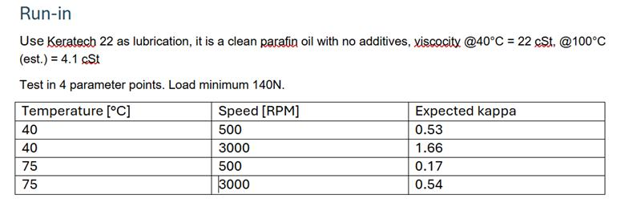
Comments from Morten:
There are still things that needs fixing, some of these are:
- Switching noise from VFD (i’we ordered a new+filter), right now switching occurs a 5KHz
- Scope data formats, resolution vs samples that can be acquired
- Start/Control everything from the .js dashboard
- Assemble the hardware nicer
- Etc...
Experiment 2

Experiment log
Date : Feb 5, 2026 / moj
Oil : Keratech 22
 |  |  |  | Scope voltage
Start time | RPM | Hz | Temp | Ch 1 - AE | Ch 2 - UL
11:30 | 500 | 8.33 | 49 | 500mV | 50mV
11:39 | 1000 | 16.5 | 50 | 500mV | 50mV
11:50 | 1500 | 25 | 48 | 1V | 50mV
11:58 | 2000 | 33.32 | 48 | 1V | 50mV
12:06 | 2500 | 41.65 | 45 | 1V | 50mV
12:15 | stop | 49.98
Start time | RPM | Hz | Temp | Ch 1 - AE | Ch 2 - UL
12:34 | 500 | 8.33 | 76 | 1V | 50mV
12:43 | 1000 | 16.5 | - | 1V | 50mV
12:52 | 1500 | 25 | - | 1V | 50mV
13:02 | 2000 | 33.32 | - | 1V | 50mV
13:11 | 2500 | 41.65 | - | 1V | 50mV
13:20 | stop | 49.98 | - | 1V | 50mV
Comments from Morten:
A few things to note:
- Ultrasound readings are only usefull upto maybe 10kHz as the signal is heterodyned (frequency shifted) down into the hearable domain. I migh purchase another probe that can capture the raw signal
- Both Ultrasound and AE show some harmonic frequency content in the 100' s of kHz range (see waterfall plot below), i think this come from electrical noise as they are unaffedted by RPM change and temperaure

2. Preliminary Feature Analysis
Derived metrics from Morten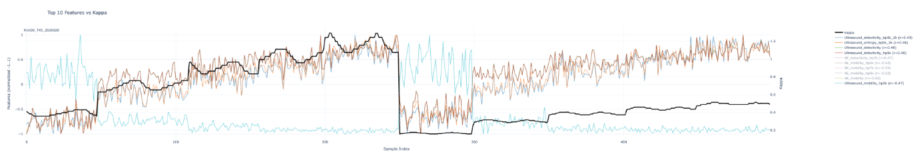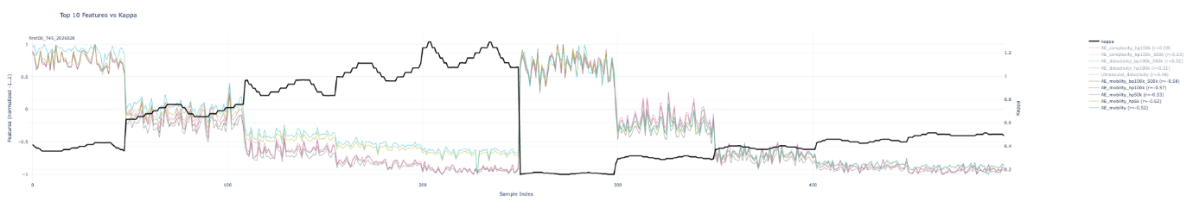
Hjorths mobility correlates well with kappa. The plots show that mobility is useful in a relative sense but different rpm make the absolute mobility difficult to interpret.

3. Data Processing Pipeline
Preprocessing Steps:
The pipeline runs five sequential steps on each sweep/sensor pair:
- Validation — sweeps shorter than 64 samples, all-zero, or all-NaN signals are rejected outright.
- NaN/Inf interpolation — any non-finite samples are replaced using linear interpolation (with nearest-neighbour extrapolation at the edges).
- Clipping detection — if more than 1% of samples sit at the estimated DAQ voltage rails (defined by the 99.9th/0.1st percentile), the signal is flagged as clipped. By default this is logged but does not reject the sweep.
- Saturation detection — contiguous flat runs (consecutive differences < 1e-10) longer than 50 samples are flagged as saturated. Again, flagged but not rejected by default.
- Spike removal — samples more than 6 standard deviations from the mean are treated as outliers and replaced with the local median within a ±5-sample window.

Feature Extraction / Selection:
26 features are computed from the (cleaned, optionally filtered) voltage signal for each sweep × sensor pair:
- 12 time-domain features: peak, RMS, std, variance, skewness, kurtosis, crest factor, shape factor, impulse factor, margin factor, and Hjorth mobility and complexity.
- 14 frequency-domain features (from the one-sided FFT): dominant frequency, spectral mean/std/skewness/kurtosis, center frequency, RMS frequency, spectral flatness, frequency-weighted std, peak frequency, normalized frequency std, frequency skewness/kurtosis, and normalized bandwidth.
Feature cleaning
Applied to the assembled feature DataFrame:
- Operational filtering — sweeps with RPM above 10,000 are discarded.
- NaN/Inf handling — rows containing any NaN or Inf feature values are dropped (default strategy).
- Constant feature removal — any feature column with zero variance is dropped.
- Outlier removal — optionally, rows where any feature exceeds a threshold (IQR or z-score based) are removed.

4. Exploratory Data Analysis
Visualizations:
Operating conditions
There is a large gap in the sweeped operating conditions.
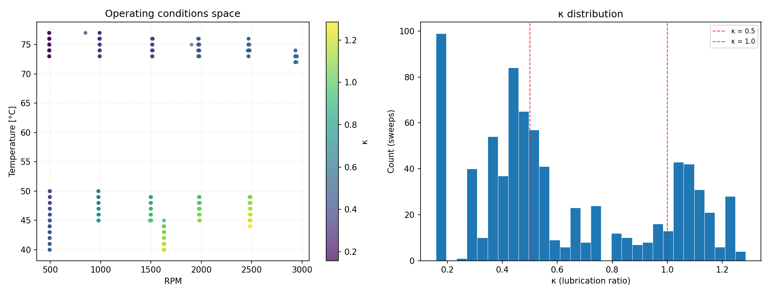
Waveform plots
- AE would like higher sampling rate than US
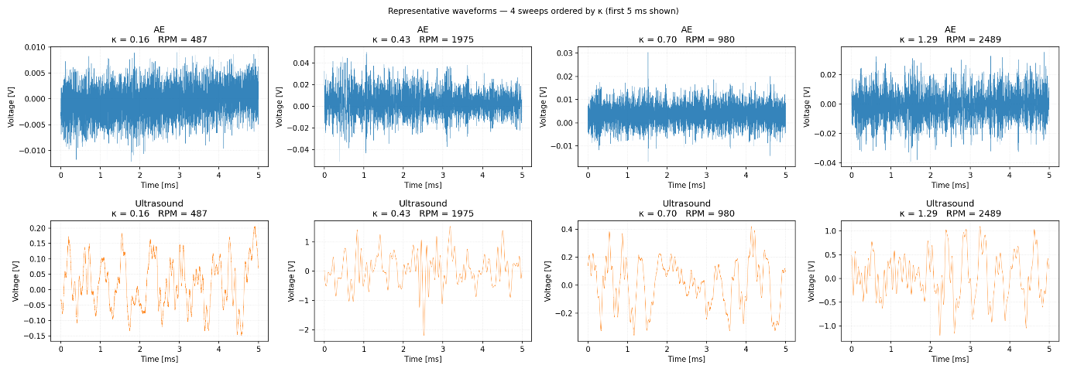
Features against kappa and rpm
- Rms clearly correlates with rpm.
- Mobility correlates well with kappa but also confounds rpm and kappa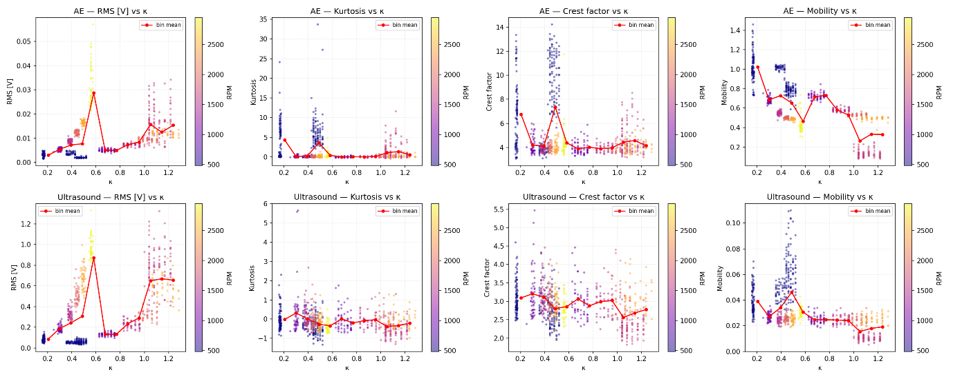
Averaged PSD
- AE has significantly more activity in higher frequencies than US.
- It is difficult to discern a consistent change dependent on kappa.
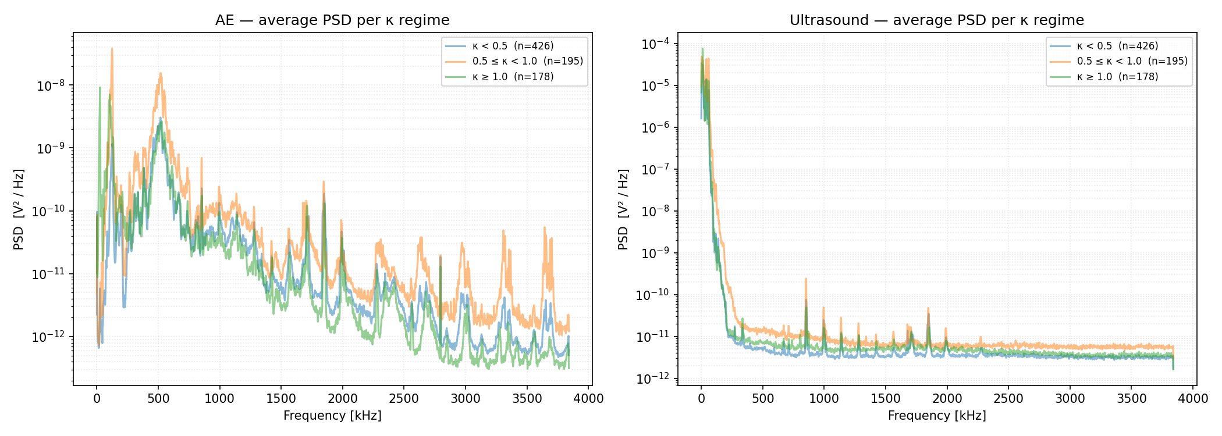
Envelope analysis
- The energy of envelopes changes very clearly with rpm. Not a clear correlation with kappa.
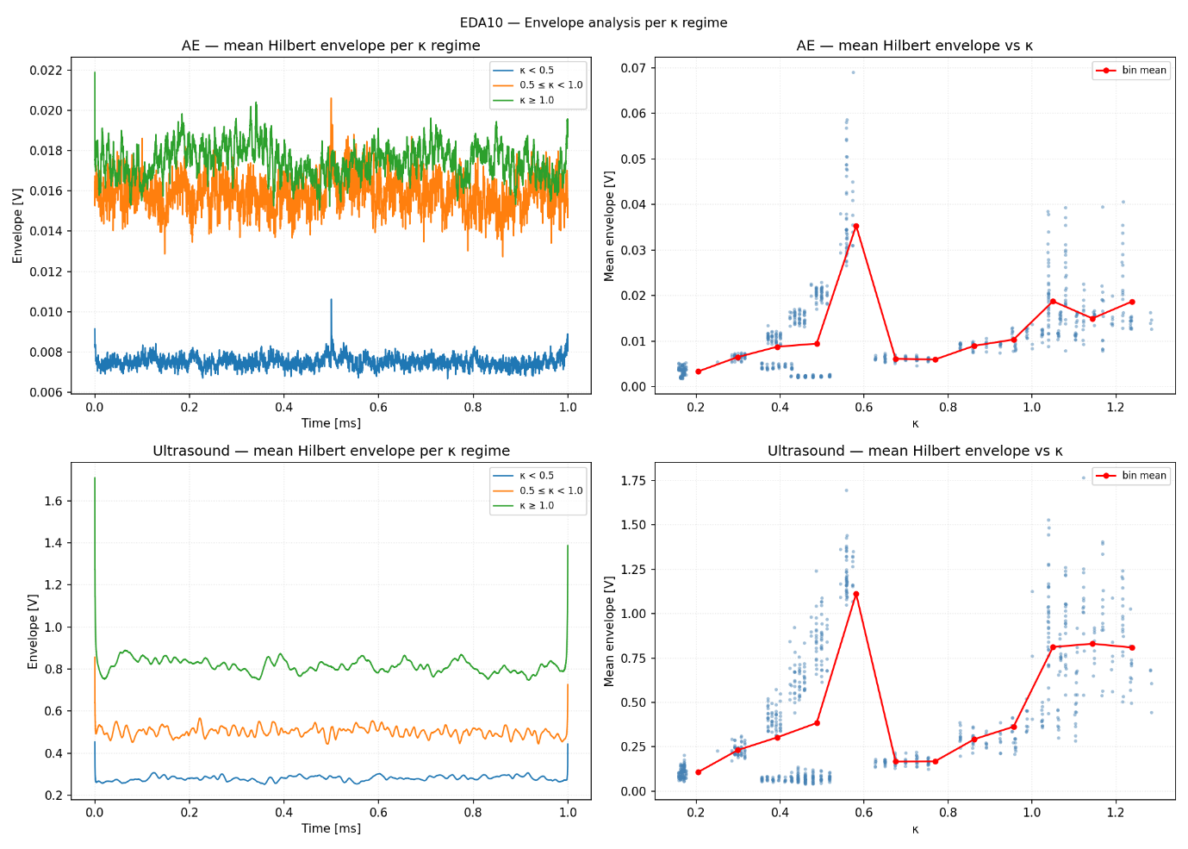
PSD of envelope
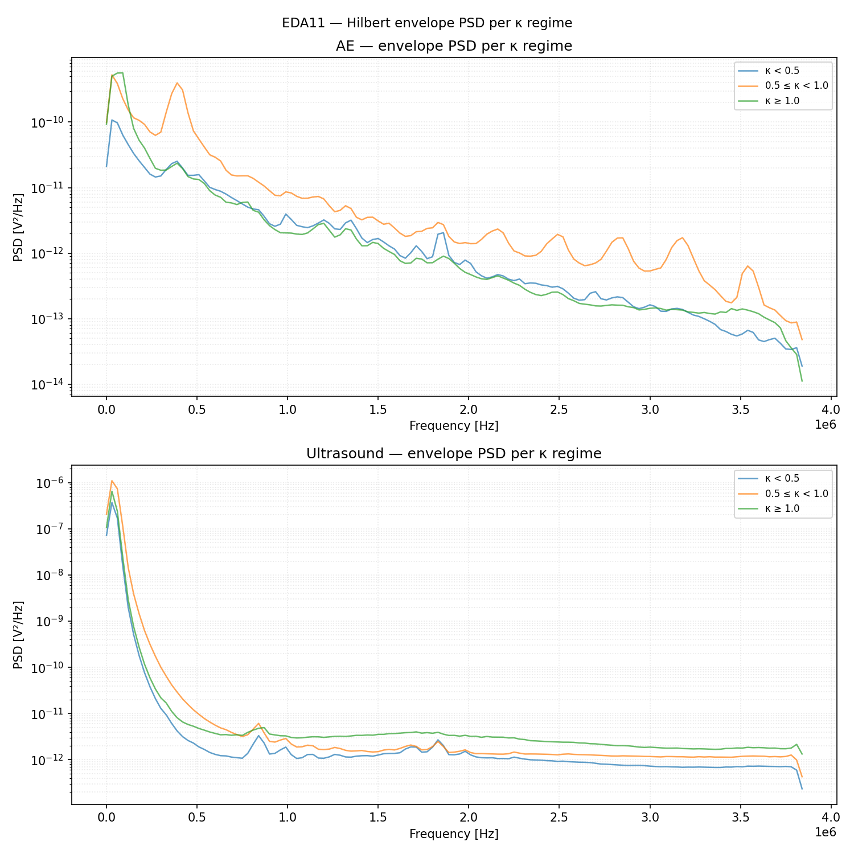
Spectral flatness of PSD of envelope against kappa
- Spectral envelope tells something about kappa.
- Still correlates with rpm.
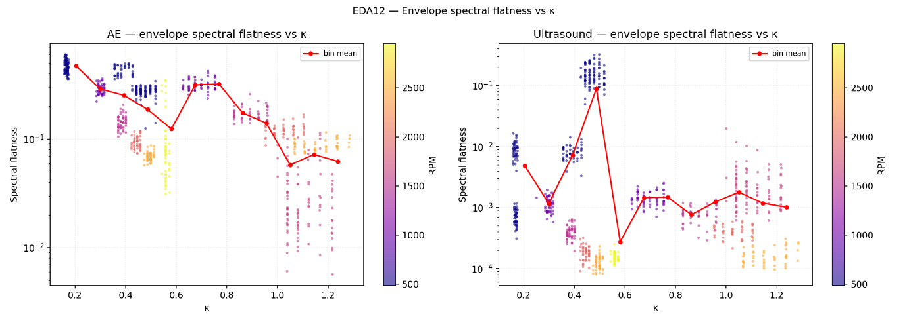

Key Observations from EDA:
- Rms/energy correlate very well with rpm. This makes it unsuitable for detecting changes in lubrication conditions unless rpm is kept constant.
- No clear correlation between psd or psd of the envelope with kappa is apparent.
- The waveforms and spectral contents of AE and US are very different but it is difficult to discern whether they provide complementary information.

5. Key Hypotheses
The following hypotheses are derived from the EDA figures. They identify which features are most physically motivated as kappa predictors and highlight the key modelling challenges.
H1 — Hjorth mobility captures asperity contact intensity
AE and US mobility both show a consistent negative correlation with kappa (AE r ≈ −0.52 to −0.58; US r ≈ −0.47). Under boundary lubrication (low κ), metal-to-metal asperity contacts produce high-frequency transient impulses that drive mobility up. As κ increases and a full oil film forms, these impulses are suppressed and the signal becomes smoother. Hjorth mobility computed over bandpass-filtered AE (10–500 kHz) and raw US should be a core feature in any model.
H2 — US detectivity is the strongest single kappa indicator
ultrasound_detectivity_fple achieves r = −0.92 with kappa. The hypothesis is that the oil film dampens acoustic coupling between bearing and sensor: at low κ, metal contact transmits energy efficiently; at high κ, the film acts as a mechanical decoupler. This feature must be validated after RPM normalisation to confirm it is not simply an amplitude proxy.
H3 — Amplitude features are RPM proxies; spectral ratios are more robust
AE RMS scales strongly with RPM regardless of kappa. Because low kappa tends to co-occur with low RPM in this dataset, raw amplitude is entangled with operating condition. Spectral shape features (energy band ratios, crest factor, spectral flatness) should be more robust kappa predictors. Normalisation of features by RMS or RPM should be evaluated as a preprocessing step.
H4 — Envelope spectral flatness marks the boundary-to-mixed lubrication transition
Both AE and US envelope spectral flatness show a non-monotonic shape with an inflection near κ ≈ 0.5. In boundary lubrication, many random asperity contacts produce a broadband noise-like envelope (high flatness). As the mixed regime begins, contacts become more sporadic and structured (lower flatness). Spectral flatness may therefore work better as a lubrication regime classifier than as a direct regression target for kappa.
H5 — AE and US carry complementary, non-redundant information
AE is broadband to ~4000 kHz and primarily sensitive to asperity contact stress waves. US is concentrated below ~100 kHz and reflects bulk acoustic properties of the lubricant film. These mechanisms are physically distinct, so a fused feature set from both sensors should outperform either sensor alone. This should be verified by comparing AE-only, US-only, and combined models.
H6 — Hilbert envelope amplitude is non-monotonic with kappa
AE mean envelope amplitude peaks around κ ≈ 0.4–0.5 before declining, suggesting that the mixed lubrication regime produces more impulsive contact events than full boundary lubrication. Envelope amplitude is therefore not a monotonic kappa predictor. Features such as the variance or kurtosis of the Hilbert envelope may capture this non-linearity better than the mean.
H7 — The data gap at κ = 0.6–0.9 is the model’s weakest region
Very few samples exist in the mixed lubrication regime (κ ≈ 0.6–0.9), which is where physical transitions are most complex and where accurate prediction matters most in practice. Model performance must be specifically evaluated in this range, and additional experiments at intermediate temperature/RPM combinations should be prioritised to fill this gap.

6. Modeling
Models Tried:
- Linear regression, ElasticNet, Bayesian Ridge, Random Forest, etc.
Hyperparameters / Tuning:
- Methods (grid search, cross-validation).
- Final hyperparameters used per model.
Validation / Cross-Validation Strategy:
- Hold-out split, K-fold, nested CV.
- Number of folds, random seed, stratification.
Model Performance Metrics:
- RMSE, MAE, R², MAPE, etc.
- Out-of-sample vs. in-sample performance.
Feature Importance / Coefficients:
To be completed when model results are available.
Modeling Notes:
- To be documented during model training.

7. Discussion & Interpretation
Insights from Data and Models:
- RPM and kappa are confounded in the current dataset: most amplitude features reliably detect speed changes but not lubrication state independently. Feature engineering must explicitly decouple these effects.
- Hjorth mobility (AE, bandpass 10–500 kHz) and US detectivity emerge as the most promising kappa-sensitive features. AE mobility captures asperity contact intensity; US detectivity reflects acoustic coupling through the oil film. Both are grounded in distinct physical mechanisms and should be included in any baseline feature set.
- AE and US appear to capture complementary information: AE is sensitive to high-frequency stress waves from micro-impacts (broadband to 4000 kHz), while US reflects bulk acoustic properties of the lubricant film (concentrated below ~100 kHz). A fused feature set from both sensors is expected to outperform either sensor alone.
Experimental Limitations:
- Four key limitations have been identified: (1) A large data gap exists between κ ≈ 0.6–0.9 (the mixed lubrication regime), which will degrade model performance precisely where it matters most. (2) VFD switching noise at 5 kHz contaminates low-frequency features; a new filter has been ordered. (3) Ultrasound signals are currently heterodyned (frequency-shifted), limiting usable bandwidth; a raw-signal probe is under consideration. (4) All experiments use a single lubricant (Keratech 22) and bearing type, so generalisability to other configurations is unknown.

8. Supplementary Information
- References to literature, datasets, or formulas.
- Software, libraries, or tools used.
- Any additional notes or raw calculations.

