Design and Experimental Validation of an IoT-Based Water Quality Monitoring System for Remote Aquaculture
Efraín Villalvazo Laureano
University of Colima (México)

Jesús Horacio Villa Díaz
University of Colima (México)
Jesús Osvaldo López Hernandez
University of Colima (México)
Fernando Miguel Vázquez Covarrubias
University of Colima (México)

Recibido:
Aceptado:
Publicado:

Abstract
In recent years, several sectors have required modernization, including aquaculture. Despite its importance, this sector continues to rely largely on conventional practices, creating significant opportunities to improve productivity and profitability by adopting contemporary technologies. This paper presents an IoT (Internet of Things)-based system for monitoring key water quality parameters essential to the vitality, development, and growth of aquatic species in controlled environments. The proposed prototype measures pH, dissolved oxygen (DO), and turbidity. These parameters are acquired in situ by a transmitter module, which processes the sensor data and forwards it to a receiver module, which then uploads the data to a cloud database.
Initially, the transmitter module collects the sensor readings and encapsulates them into a single data packet. This packet, containing the three monitored variables, is then transmitted to the receiver module through a LoRa wireless communication link. The receiver-side LoRa module receives the packet and forwards it for further processing.

Finally, the receiver module uses an ESP32 microcontroller with integrated Wi-Fi connectivity to upload the received data to a cloud database. This enables users to remotely access the measurements through a web-based platform, visualize water quality parameters in real time, and download monitoring reports.
Keywords: IoT (Internet of Things), ESP32, LoRa, Water Quality, pH, Dissolved Oxygen, Turbidity.
Introduction
Water is indispensable for all forms of life. Aquatic organisms are among the most affected by water pollution because contamination directly degrades their habitats, compromising their growth and development and, consequently, affecting the aquaculture and fisheries sectors. According to [1], the application of IoT-based water quality monitoring systems in aquaculture has grown considerably, improving resource management efficiency and optimizing organism growth. Key sensors, including pH, temperature, and dissolved oxygen, have been integrated into a variety of technological solutions to enhance aquaculture production.
Traditional methods for assessing water quality rely on manual sampling and data collection, increasing the time and effort required to obtain reliable measurements. In this context, the development of Internet of Things (IoT)-based technologies has created new opportunities to modernize and improve the efficiency of water quality monitoring processes [2].
Currently, aquaculture monitoring systems still offer significant opportunities for technological improvement. As the global population continues to grow, conventional terrestrial livestock production including cattle, pigs, sheep, and goats is expected to face increasing challenges in meeting future food demand. Consequently, aquaculture has emerged as a promising alternative to help satisfy the growing demand for animal protein.

Despite these advances, most aquaculture farms still have critical areas for improvement, particularly in water quality monitoring. Parameters such as dissolved oxygen, pH, and turbidity provide direct indicators of water quality, enabling producers to identify the environmental conditions required to promote healthy fish growth and maximize production efficiency [3].
In many aquaculture facilities, water quality measurements are still collected manually, requiring personnel to travel to the monitoring site at predetermined sampling intervals. To address this limitation, the monitoring system presented in this work was designed to automate data acquisition and transmission by integrating radio-frequency communication with IoT technologies.

Aquaculture farms are commonly located in remote areas where cellular coverage and reliable Internet connectivity are limited or unavailable. In 2022, Chiung-Hsing Chen et al. [4] developed a monitoring system based on the LoRa SX1278 communication module, capable of transmitting sensor data packets over long distances using radio frequency communication. This technology enables reliable wireless data transmission without requiring Internet access or cellular network coverage.
In 2021, Jen-Yung Lin [5] proposed a monitoring system based on an ESP32 microcontroller that transmitted sensor data via Wi-Fi to the ThingSpeak cloud platform. Although this solution is practical and effective, it is unsuitable for many aquaculture farms because stable Internet connectivity is rarely available in remote production sites.
Most aquaculture farms are established in remote locations lacking telecommunications infrastructure and, in many cases, even reliable access to electricity and potable water. These conditions significantly limit the deployment of intelligent monitoring systems based on wireless communication or IoT technologies, thereby reducing the range of feasible technological solutions for production environments.
In 2024, Mohd Jais [6] developed a water quality monitoring system capable of measuring pH, dissolved oxygen, electrical conductivity, salinity, and ammonia concentration. The acquired data were processed using an Arduino Uno and transmitted through an ESP8266 Wi-Fi module for visualization on the ThingSpeak platform and the Virtuino mobile application.
In 2023, Yin Xu [7] proposed a custom-designed control system rather than employing conventional development boards such as Arduino, thereby making the monitoring unit more compact, portable, and easier to deploy. The proposed system uses the MQTT protocol to transmit sensor data to a local interface and enable remote visualization on mobile devices and personal computers.
Also in 2023, King Mongkut's University of Technology North Bangkok [8] presented an autonomous water quality monitoring system housed on a floating platform powered by a solar panel. The system measures dissolved oxygen, pH, electrical conductivity, temperature, and turbidity and employs a Narrowband IoT (NB-IoT) communication module for remote monitoring via a Grafana-based visualization platform.
According to [9], integrating IoT sensors into water quality monitoring networks reduces human intervention during data acquisition and minimizes errors associated with manual sampling. As a result, IoT-based monitoring enables a more proactive and reliable assessment of water quality amid the increasing pressures of urbanization, industrialization, and climate change.

Related Work
Agricultural activities near aquatic ecosystems often lead to the discharge of chemicals and fertilizers into groundwater and river systems, thereby negatively affecting aquatic flora and fauna. To address this problem, [10] proposed a LoRa-based wireless sensor network (WSN) for water quality monitoring in coastal and riverine environments, focusing on critical parameters such as turbidity and temperature. Similarly, [11] presented a real-time water quality monitoring system based on low-cost hardware, including affordable sensors and a microcontroller, with data transmitted via a LoRa communication network.
According to [12], the adoption of IoT-based water quality monitoring systems in aquaculture has increased significantly, improving resource management efficiency and optimizing organism growth. Key parameters, including pH, temperature, and dissolved oxygen, are monitored using various technological approaches to enhance aquaculture production. Furthermore, the study reported in [13] demonstrated that real-time monitoring combined with automated interventions improved feed conversion efficiency, reduced mortality by up to 40%, and increased production yields by 15% to 50%. Likewise, [14] developed a monitoring system based on an NB-IoT communication network that employs sensors to measure key water quality parameters, including temperature, pH, and dissolved oxygen.

The study presented in [15] analyzed the application of IoT technologies in aquaculture, highlighting their potential to improve resource management and water quality monitoring while also identifying challenges related to rural connectivity, energy consumption, and data quality.

Although numerous water quality monitoring systems for aquaculture have been developed in recent years, most rely on telecommunications infrastructure, such as Wi-Fi networks, NB-IoT, or cellular networks, which limits their deployment on aquaculture farms in rural or remote areas. In addition, many existing studies focus primarily on monitoring physicochemical parameters while overlooking important aspects such as continuous operation during power outages, experimental validation with commercial reference instruments, and the development of remote monitoring platforms tailored to these environments.

To overcome these limitations, this work proposes an IoT-based water quality monitoring system that integrates pH, dissolved oxygen, and turbidity sensors with LoRa communication for long-range data transmission without relying on telecommunications infrastructure. The proposed system also incorporates an automatic backup power supply and a web-based platform for data storage, real-time visualization, and alert generation. Furthermore, custom-designed PCB modules were developed for data acquisition and wireless transmission, facilitating system deployment on aquaculture farms in remote and difficult-to-access areas. Finally, the proposed system was experimentally validated by comparing its measurements with those of commercial reference instruments using the Mean Absolute Error (MAE) and Root Mean Square Error (RMSE). In addition, the performance of the LoRa communication link was evaluated using metrics such as Packet Delivery Ratio (PDR), Received Signal Strength Indicator (RSSI), Signal-to-Noise Ratio (SNR), and communication latency.

Contributions of This Work
Based on the system development and its experimental validation, the main contributions of this work are summarized as follows:
- An IoT-based system for real-time water quality monitoring was developed by integrating pH, dissolved oxygen, and turbidity sensors, providing continuous information to support the monitoring and management of aquaculture farms.
- A communication architecture based on LoRa and ESP32 technologies was implemented, enabling reliable wireless data transmission from remote monitoring sites without relying on telecommunications infrastructure.
- Custom-designed PCB modules for data acquisition and reception were designed and integrated. The proposed hardware also incorporates an automatic backup power system that ensures continuous operation during power supply interruptions.
- A web-based monitoring platform was developed to enable real-time visualization of the measured variables, historical data storage, report generation, and alert notifications, thereby facilitating system supervision and supporting decision-making.
- The proposed system was experimentally validated by comparing its measurements with those obtained from commercial reference instruments and by evaluating the performance of the LoRa communication link. Accuracy and reliability metrics, including the Mean Absolute Error (MAE), Root Mean Square Error (RMSE), Packet Delivery Ratio (PDR), Received Signal Strength Indicator (RSSI), Signal-to-Noise Ratio (SNR), and communication latency, demonstrated the effectiveness of the proposed architecture for aquaculture monitoring applications in remote environments.

Materials and Methods
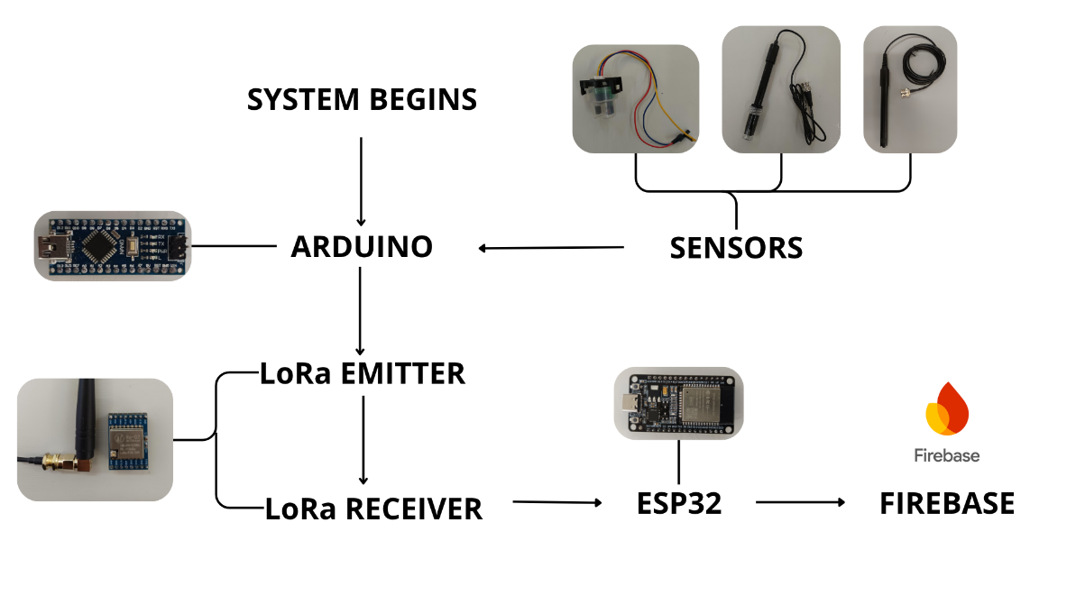
Prototype Development
Figure 1. Block Diagram

Overall System Architecture and Data Acquisition

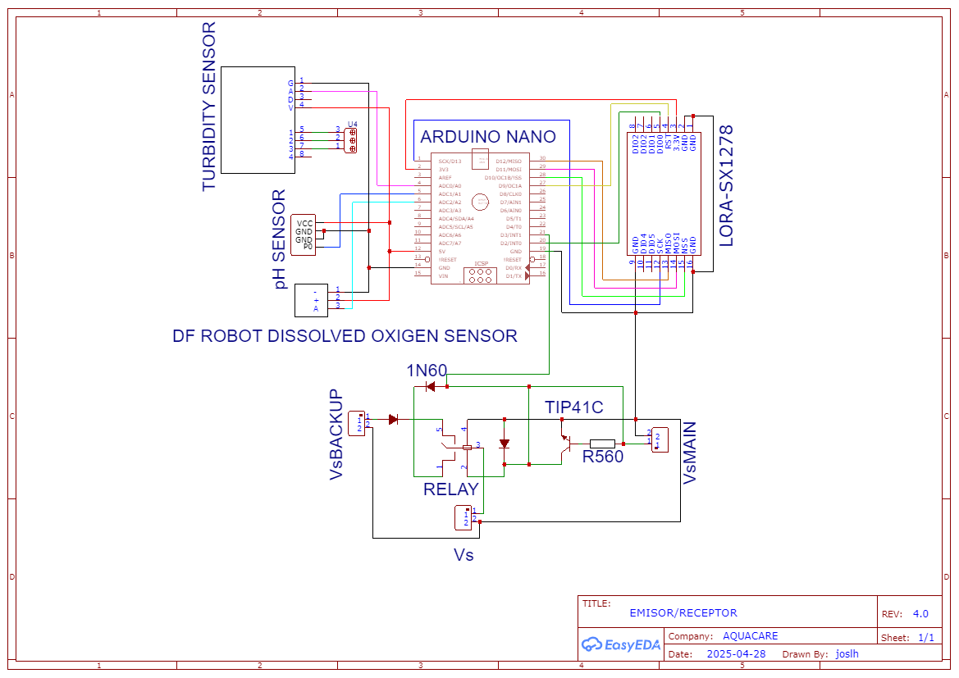
The proposed system architecture consists of two main modules: a transmitter module based on an Arduino Nano and a receiver module based on an ESP32. Both modules were implemented on custom-designed PCBs, enclosed in protective housings, and powered by a primary power supply with an automatic backup provided by a portable battery. This configuration ensures continuous system operation during power supply interruptions.
Figure 2. Electrical Schematic of the Emitter Module
Figure 2 illustrates the transmitter module responsible for data acquisition, along with its main components: the three sensors (pH, dissolved oxygen, and turbidity), the LoRa radio-frequency communication module (upper right), and the automatic power-source switching circuit (bottom).

To measure physicochemical parameters in the aquatic environment, the proposed system employs an Arduino Nano microcontroller as the central data acquisition unit [16]. The Arduino Nano was selected for its compatibility with analog sensors, its 10-bit analog-to-digital converter (ADC), its low cost, and its ease of integration into compact embedded systems. These characteristics enable reliable acquisition of signals from the pH, dissolved oxygen, and turbidity sensors while maintaining a simple architecture suitable for low-cost aquaculture monitoring applications.

In addition, the Arduino Nano provides a regulated 5 V output that is fully compatible with the power requirements of the pH, dissolved oxygen, and turbidity sensors. This allows the sensors to be powered directly from the transmitter module, simplifying the electronic design and eliminating the need for additional voltage adaptation circuitry. The acquired signals are subsequently processed by the microcontroller before being transmitted through the LoRa communication module.

Component | Model | Measurement Range | Resolution | Accuracy (±) | Installation/Calibration Notes
pH Sensor | PH-4502C | 0 – 14 pH | ~0.02 pH | ±0.1 pH | Calibration using pH 4, 7, and 10 buffer solutions; temperature compensation, if applicable.
Dissolved Oxygen Sensor | SEN0237-A DFRobot | 0 – 20 mg/L | ~0.05 mg/L | ±0.2mg/L a ±0.5mg/L | Zero-point and air-saturated calibration; verify the membrane and electrolyte, if applicable.
Turbidity Sensor | TSW-20M | 0-3000NTU | 0-200NTU | ±5% FS depending on the software calibration. | Calibration using a formazin turbidity standard; do not fully immerse the upper PCB; clean periodically to prevent biofouling.
Transmitter Microcontroller | Arduino Nano (ATmega328P) | 5V | 10-bit ADC | 10-bit ADC | ADC data acquisition; basic digital filtering.
LoRa Communication Module | Semtech / SX1278 (433 MHz) | 3.3 V (operating range: 1.8–3.7 V) | - | - | Configure SF/BW/CR, transmission power, antenna placement, and mounting height to minimize physical obstructions.
Receiver Microcontroller | Espressif / ESP32 (Tensilica Xtensa LX6) | 2.3–3.6 V (typically operated at 3.3 V) | 12-bit ADC | - | Wi-Fi cloud communication (Firebase), timestamp generation, and automatic reconnection after communication loss. A power supply capable of delivering 500 mA peak current is recommended.

An ESP32 [17] was selected for the receiver module because its integrated Wi-Fi connectivity enables the transmission of data received via LoRa to a cloud database, where it can be accessed via the web-based monitoring platform. This integration simplifies the overall system design and facilitates communication with remote services. Figure 3 shows the receiver module components and their interconnections, including the automatic power-source switching circuit, which ensures continuous system operation during power supply interruptions.
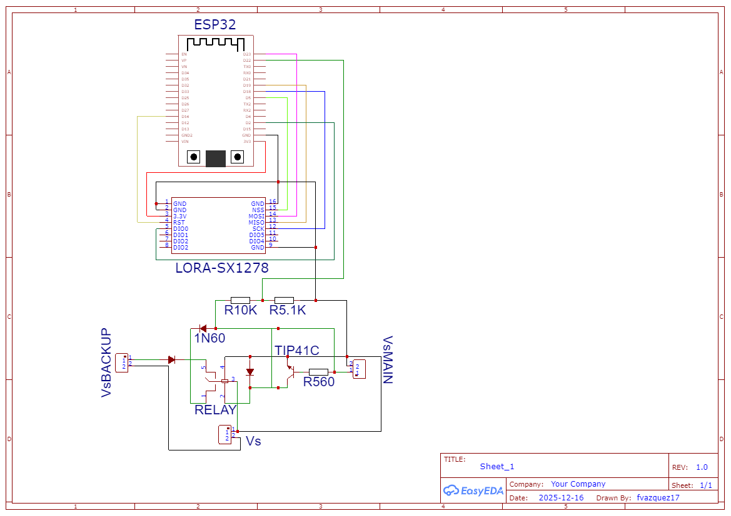
Figure 3. Electrical Diagram of the Receiver Module.

Signal Conditioning and Data Packaging Algorithm

To mitigate high-frequency noise and fluctuations induced by fluid dynamics in the aquaculture tank, the raw data acquired from the analog input channels of the 10-bit analog-to-digital converter (ADC) in the transmitter microcontroller were processed using digital filtering and mathematical calibration algorithms implemented in the system software.

For pH sensor measurements, a nonlinear filtering algorithm based on bubble sort combined with a trimmed mean was developed. The system acquires a burst of 10 samples at an inter-sampling interval of 10 ms. The resulting vector, BufpH, is sorted in ascending order, after which the two lowest and two highest values are discarded to reduce the effects of impulsive noise (spikes). The average electrical potential, VpH, expressed in millivolts, is then computed from the remaining six samples according to the following equation:
$$V_{pH}= \left(\frac{\sum_{i=2}^{7}{Buf_{pH}[i]}}{6}\right) × \left(\frac{V_{REF}}{1023}\right) ×1000$$

where $V_{REF}=5V$. The pH value is then calculated using a two-point linear interpolation model:
$$pH=m × V_{pH}+b$$

In this model, the slope (m) and intercept (b) are dynamically calculated from calibration constants previously obtained using reference buffer solutions:

$${pH}_{1}=4.0 \left(V_{i}=1200mV\right)$$
$${pH}_{2}=7.0 (V_{2}=2100mV)$$

Signal Conditioning and Data Packaging Algorithm

The turbidity sensor is highly sensitive to suspended particles undergoing continuous motion. To stabilize its response, a moving average filter with a large averaging window was implemented via an oversampling loop comprising 800 consecutive readings. The resulting average voltage is calculated using a 4.2 V reference and rounded to two decimal places. To characterize the nonlinear response of the infrared transducer, a second-order polynomial model obtained through empirical regression was incorporated. The model is defined according to a critical voltage threshold:

$$NTU=\left\{\begin{aligned}3000.0, si V_{turb}<2.1V \\ \frac{-1120.4 × V_{turb}^{2}+5742.3 × V_{turb}-4353.8}{1000}, & si V_{turb}≥2.1V\end{aligned}\right.$$

Dissolved Oxygen Processing and Temperature Compensation

Dissolved oxygen quantification requires intrinsic temperature compensation. The galvanic sensor voltage is obtained by converting the ADC output using a hardware reference voltage of $V_{REF_DO}=4200mV$. The algorithm performs a two-point calibration based on the operating temperature (T), estimating the theoretical saturation voltage (Vsat) according to the linear relationship described by the following equation:

$$V_{SAT}=\left(T-CAL2_{T}\right)× \frac{CAL1_V-CAL2_V}{CAL1_T-CAL2_T}+CAL2_V$$

The calibration constants correspond to $CAL1_V = 1600mV$ at $CAL1_T = 25°C$ and CAL2_ $CAL2_V = 1300mV$ at $CAL2_T = 15°C$. Finally, the dissolved oxygen (DO) concentration, expressed in milligrams per liter (mg/L), is calculated by interpolating the measured instantaneous voltage using an indexed empirical solubility table (Figure 4) and dividing the result by the calculated saturation voltage.

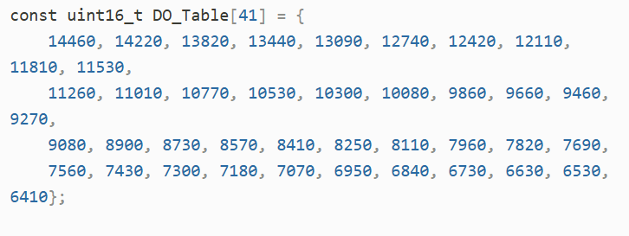
Figure 4. Empirical Solubility Table for the Gravity Dissolved Oxygen Sensor.

Data Packaging and Transmission Algorithm

Once the numerical conditioning stage is completed, the firmware executes a preventive diagnostic routine using the isnan() macro. If any of the measured physical variables contains an invalid reading or an overflow condition, the data packet is discarded to prevent corrupted data from being transmitted to the cloud.

Under normal operating conditions, the measured variables are converted into character strings with a fixed precision of two decimal places, forming an optimized data packet in CSV format (e.g., "pH,NTU,DO"). Before transmitting the environmental telemetry, the system reads the digital input PIN_ESTADO (Pin 3), which is connected to the power-source switching circuit, and appends a binary header indicating the status of the electrical power infrastructure ("Main" or "Backup"). The complete data packet is then transmitted sequentially through the wireless transceiver at a transmission interval determined by the system control loop.

LoRa Wireless Communication Link Configuration

To ensure robust and continuous data transmission from the aquaculture tank to the receiver, a long-range, low-power point-to-point wireless communication link using Chirp Spread Spectrum (CSS) modulation was implemented. The radio frequency (RF) network infrastructure was built using two commercial Semtech SX1278 transceivers interfaced with the transmitter (Arduino Nano) and receiver (ESP32) processing units through the Serial Peripheral Interface (SPI) bus.

To maximize immunity to multipath fading and ensure reliable signal propagation in outdoor environments with physical obstacles, the transceiver firmware was configured by optimizing key RF parameters. The corresponding operating parameters are summarized below:

- Operating Frequency: The operating frequency was set to 433 MHz (sub-GHz ISM band). This frequency provides lower free-space path loss and better diffraction capability than the conventional 2.4 GHz band, making it more suitable for long-range wireless communication.
- Spreading Factor (SF): The spreading factor was configured to SF = 12. Selecting the maximum available spreading factor increases the number of chirps used to encode each data bit. Although this reduces the effective bit rate, it significantly improves receiver sensitivity to a theoretical value of −148 dBm, thereby enabling reliable packet decoding even under extremely low signal-to-noise conditions.
- Bandwidth (BW): The bandwidth was set to 125 kHz. This value provides an appropriate balance between the transmission rate required for environmental monitoring data and the receiver's selectivity, thereby reducing interference from adjacent channels.
- Coding Rate (CR): The coding rate was configured to CR = 4/8. This Forward Error Correction (FEC) scheme appends four parity bits to every four information bits, enabling the receiver to recover corrupted packets caused by transient electromagnetic interference in the aquaculture environment without requiring retransmission.
- Transmission Power (Tx Power): The RF power amplifier was configured to its maximum output power of +20 dBm (100 mW), ensuring reliable communication over long transmission distances.

Furthermore, to ensure data integrity and network selectivity, two hardware-level control mechanisms were enabled: a 16-bit Cyclic Redundancy Check (CRC) verification (enableCrc), which automatically discards corrupted frames during transmission, and a synchronization word (SyncWord) configured to the hexadecimal value 0xC8 (setSyncWord). This digital signature acts as a logical isolation filter, ensuring that the ESP32 receiver processes only the frames transmitted by the aquaculture monitoring node while ignoring any other remote transmissions operating in the same frequency band.

To evaluate the reliability and robustness of the proposed wireless link under real aquaculture operating conditions, an experimental testing protocol was conducted at transmitter-to-receiver separation distances of 50, 100, 150, and 200 m. The primary performance metric used to assess the communication link was the Packet Delivery Ratio (PDR), which was formally calculated using the following equation:

$PDR= \left(\frac{N_{rec}}{N_{env}}\right) ×$100%

where $N_{rec}$ represents the number of messages successfully decoded by the receiver, and $N_{env}$ denotes the total number of messages transmitted by the transmitting node. During a 200 m test in an urban environment, the proposed system maintained reliable communication, achieving a Packet Delivery Ratio (PDR) of 81.35% and a packet loss rate of 18.65%.

Under the same test conditions, quantitative channel measurements yielded an average Received Signal Strength Indicator (RSSI) of −99.97 dBm and an average Signal-to-Noise Ratio (SNR) of −14.19 dB. Although signal quality was degraded by interference at the 200 m separation distance, these results confirm that the robustness of the LoRa modulation scheme enables reliable data recovery even under adverse channel conditions.

Finally, the end-to-end communication delay, measured from sensor data acquisition to Wi-Fi transmission, averaged 5 s. This temporal performance is well suited for continuous real-time monitoring in aquaculture applications, where the physicochemical properties of water typically change gradually rather than undergo rapid transient variations.

Cloud-Based Data Transmission Architecture
The information flow extends to a cloud-based storage and visualization architecture designed to enable remote access. This system layer processes the acquired data from their local wireless reception to their organization within a web-based graphical interface accessible to end users.

Receiver Module and Data Gateway

The receiver serves as the system gateway. It is based on an ESP32 microcontroller, strategically selected for its dual-core architecture and integrated networking capabilities. Once the local SX1278 LoRa module decodes the data transmitted from the aquaculture pond, the received data string is transferred to the ESP32 through the SPI bus.

The receiver firmware immediately performs a data parsing process to extract the measured variables, including pH, turbidity, and dissolved oxygen. Subsequently, the device activates the TCP/IP protocol stack to establish a secure Wi-Fi connection to the aquaculture farm's local access point using the WPA2 security protocol. After the network connection is established, the microcontroller issues secure HTTP requests to the cloud platform's REST API, ensuring that the communication latency between the local gateway and the cloud server remains minimal.

Cloud Infrastructure and Web Platform
Google Firebase Realtime Database was adopted as the cloud database solution. This platform was selected over traditional relational database systems for its JSON-based data model, which enables automatic, low-latency bidirectional synchronization via WebSocket.

The database structure was optimized to minimize bandwidth consumption. Each data packet received by the gateway is stored chronologically under a root node, where a unique server-generated timestamp is automatically assigned. Each record contains four key fields: the measured pH value, turbidity (NTU), dissolved oxygen concentration (mg/L), and the power supply status ("Primary" or "Backup"). This flexible data organization enhances system scalability, allowing additional monitoring nodes to be incorporated in the future without affecting the integrity of the existing database.

Visualization Platform and User Interface

To facilitate end-user interaction, an intuitive and user-friendly web application was developed, providing an optimized visualization experience on both desktop computers and mobile devices. This design enables use across diverse aquaculture settings, from small-scale operations to industrial production systems. The web platform was developed in Spanish because the prototype was initially deployed for aquaculture applications in Mexico; however, its interface can be adapted to other languages without modifying the system architecture.
The user interface connects directly to Firebase via the official JavaScript Software Development Kit (SDK), enabling the graphical interface to update automatically whenever data changes occur in the cloud. This event-driven synchronization eliminates the need for manual page refreshes, thereby providing continuous access to the most up-to-date monitoring information.

The web platform provides four key functionalities:

- Real-Time Numerical and Graphical Monitoring: Displays the instantaneous values of the monitored water quality parameters together with their corresponding timestamps, allowing users to identify precisely when each measurement was acquired.
- Historical Data Filtering: The interface incorporates a filtering module that enables users to select specific time intervals, including hourly, daily, or custom date ranges. This functionality facilitates the analysis of both transient and cyclic variations in water quality parameters, such as dissolved oxygen throughout the day–night cycle.
- Multi-Format Report Export: To facilitate external processing and analysis of water quality data, the system incorporates client-side functions that organize the filtered records into downloadable reports. The platform supports data export in three widely used formats: CSV, JSON, and XLSX.

- Early Warning and Power Supply Monitoring: The system continuously evaluates whether the monitored variables fall below predefined biological safety thresholds, triggering immediate visual alerts when necessary. Simultaneously, it displays the real-time operating status of the transmitter power supply. When a received data packet indicates that the system is operating from the backup power source, the interface activates a visual warning indicator (a blinking red LED), enabling timely intervention before the battery is depleted.

Energy Management and Backup System

To ensure continuous operation during commercial power outages, the proposed system incorporates a dual-power-supply architecture consisting of a regulated 5 V DC primary power source derived from an AC/DC adapter and an integrated (Li-ion) backup battery.

Figure 5 illustrates the design of the automatic power source switching circuit, which is based on an electromechanical relay controlled by a TIP41C power transistor. While the primary power supply is available, the applied voltage keeps the transistor operating in the saturation region, energizing the relay coil and closing the contact connected to the 5 V DC supply line. In the event of a power outage, the voltage drop immediately interrupts transistor conduction, causing the relay to switch mechanically to the normally closed (NC) contact connected to the backup battery.

To provide real-time diagnostics of the power supply system, the primary power supply output is connected in parallel to the PIN_ESTADO (Pin 3) digital input of the transmitter microcontroller via a pull-down resistor. When this input detects a logic HIGH level, the firmware sets the operating status to "Primary". Conversely, when the voltage falls to a logic LOW level, the operating status is automatically updated to "Backup". This configuration enables the power source status to be embedded within each LoRa data packet, allowing the web interface to generate maintenance alerts before the backup battery is fully depleted.
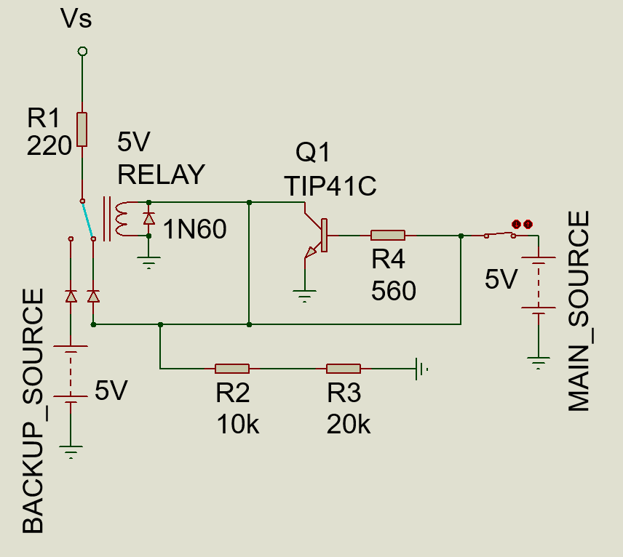
Figure 5. Electrical schematic of the primary and backup power source switching circuit.

Experimental Validation Protocol

To evaluate the accuracy and robustness of the proposed system under real-world operating conditions, an experimental validation protocol was established based on three complementary aspects: analytical accuracy, network performance, and energy feasibility.

Sensor accuracy was assessed by simultaneously comparing measurements from the transmitter node with those from professional reference instruments. For pH validation, potable water was measured under controlled laboratory conditions using an ORION 410A pH meter as the reference instrument. Turbidity measurements were performed using distilled water and validated against a HANNA HI88703 turbidimeter. Likewise, dissolved oxygen measurements were evaluated using water samples under controlled aeration conditions with a YSI PRO2030 dissolved oxygen meter as the reference instrument. Measurement accuracy was quantified by calculating the Mean Absolute Error (MAE) and the Root Mean Square Error (RMSE), as defined by the following equations:

$$MAE=\frac{1}{n}\sum_{i=1}^{n}{\left|x_{ref}-x_{i}\right|}$$

$$RMSE=\sqrt{\frac{1}{n}\sum_{i=1}^{n}{{(x_{ref}-x_{i})}^{2}} }$$

where x_{i} represents the measurement obtained from the proposed prototype, $x_{ref}$ is the corresponding value measured by the reference instrument, and n denotes the total number of samples. In addition, the performance of the LoRa communication link was evaluated through field stress tests conducted at separation distances of 50, 100, 150, and 200 m in an environment containing physical obstacles. At the ESP32 receiver, the RSSI, SNR, end-to-end latency, and Packet Delivery Ratio (PDR) were measured, with the latter defined by Equation (5).

Finally, the energy feasibility of the proposed system was validated by simulating unexpected interruptions in the 110 Vac. commercial power supply. The operating autonomy of the Li-ion battery pack under continuous load, together with the switching time of the hardware-based power source selector, was evaluated to verify that the relay switching time prevented critical voltage drops, firmware resets, and interruptions to the Wi-Fi connection. The minimum acceptance criteria established for system validation are summarized in Table 2.

System Dimension | Variable / Metric | Acceptance Criterion | Measured Result | Validation Status
Instrumentation | pH Accuracy (MAE / RMSE) | $$≤ 0.2 pH units$$ | 0.048 MAE / 0.052915 RMSE | Passed
 | Dissolved Oxygen Accuracy (MAE / RMSE) | $$≤ 0.5 mg/L$$ | 0.114 MAE / 0.132514 RMSE | Passed
 | Turbidity Accuracy (MAE / RMSE) | $$≤ 1.0 NTU$$ | 0.049 MAE / 0.0499 RMSE | Passed
LoRa Communication | Packet Delivery Ratio (PDR) | $$≥ 80\% at 200 m$$ | 81.35% | Passed
 | Channel Quality (Average RSSI) | $$≥ -110 dBm$$ | -99.97 dBm | Excellent
 | Signal-to-Noise Ratio (Average SNR) | $$≥ -15 dB$$ | -14.19 dB | Within Threshold
System Performance | End-to-End Latency | $$≤10s$$ | 5.00 s | Optimal
 | Transmitter Current Consumption | $$≤350 mA$$ | 323 mA | Passed
 | Receiver Current Consumption | $$≤120 mA$$ | 84.3 mA | Passed
 | Backup Switching Time | $$≤20 ms$$ | 17 ms | Successful Switching

Radio Frequency Communication (LoRa SX1278)
The proposed system employs LoRa SX1278 modules for wireless data transmission between the sensing node and the receiving station. This technology uses Chirp Spread Spectrum (CSS) modulation, which provides high receiver sensitivity, low power consumption, and improved immunity to interference, making it well suited for long-range Internet of Things (IoT) applications [4].

In this work, the LoRa module operates in the 433 MHz ISM band, providing a receiver sensitivity of up to −148 dBm and a maximum transmission power of +20 dBm. Under favorable operating conditions, these characteristics enable communication over several kilometers, making the technology suitable for distributed environmental monitoring applications.
Reference [18] presents an IoT-based system designed to optimize communication between the microcontroller, sensors, and the server, providing a dashboard with both historical and real-time information, as well as alert mechanisms to maintain water quality parameters within acceptable ranges. However, data transmission relies on a 2G cellular network through a SIM card, which limits system deployment in rural or remote locations where cellular coverage is limited or unavailable.
Similarly, [19] reports that aquaculture currently supplies nearly half of the aquatic food products consumed worldwide and highlights the adoption of Internet of Things technologies to improve production efficiency. Nevertheless, the study identifies the availability of electrical power, Internet connectivity, and telecommunications infrastructure as major challenges for implementing IoT solutions in remote aquaculture facilities.
Based on these considerations, the proposed system incorporates LoRa SX1278 modules to establish a dedicated wireless communication link between the data acquisition unit and the receiving station. This architecture eliminates dependence on existing telecommunications infrastructure, facilitating deployment in remote areas while improving communication coverage and availability for continuous water quality monitoring.

Monitoring Variables
Dissolved oxygen (DO) is one of the most important water quality parameters in aquaculture, as it directly influences the growth, metabolism, and survival of aquatic organisms. Insufficient dissolved oxygen concentrations reduce the growth rate of cultured species and, when levels fall below the species-specific threshold, can cause physiological stress, reduced feeding activity, and even mortality. Furthermore, dissolved oxygen concentrations can change rapidly over short periods due to biological processes and environmental conditions, making continuous monitoring essential for effective aquaculture management [20].
Similarly, turbidity is a key water quality parameter because of its influence on the physical, chemical, and biological processes occurring in aquatic ecosystems. Increased concentrations of suspended solids act as environmental stressors that affect a wide range of aquatic organisms across different developmental stages. High turbidity levels increase the absorption of solar radiation, thereby raising water temperature and reducing the solubility of dissolved oxygen, which limits its availability to aquatic life. In addition, suspended particles may protect microorganisms from pesticides and other chemical agents, enhancing their survival and promoting bacterial growth, ultimately contributing to water quality deterioration and ecosystem imbalance [21].

Data Processing and Visualization
The proposed system transmits the acquired measurements from the sensing node to a web platform, where they can be remotely accessed and visualized through an Internet connection. Initially, the three sensors measure the water quality parameters under the control of the Arduino microcontroller. The acquired data are then transmitted wirelessly to the receiving station through the LoRa SX1278 communication modules.
Upon receipt, the ESP32 forwards the data to the Firebase cloud database, where they are securely stored for subsequent retrieval and analysis. The stored information is then presented through the web platform developed for the proposed system, enabling real-time visualization of the monitored water quality parameters.
The main interface displays the most recent values of the three monitored variables. Each parameter is presented numerically, along with a button that provides the recommended operating range for that variable and the date and time of the latest measurement, as shown in Figure 6.
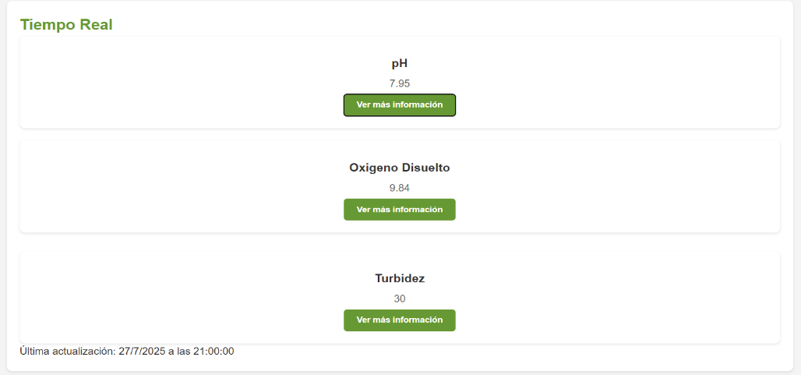
Figure 6. Water quality variables displayed on the web platform.

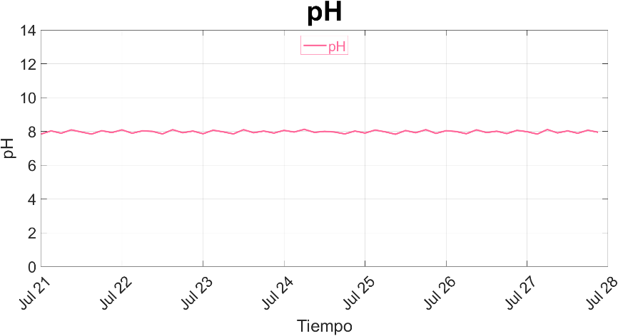
The Graphs section presents the historical trends of the monitored water quality parameters. The x-axis represents the measurement dates (day and month), whereas the y-axis displays the corresponding values of each parameter. Representative examples of these plots are shown in Figures 7–9.
Figure 7. Historical trend of pH.

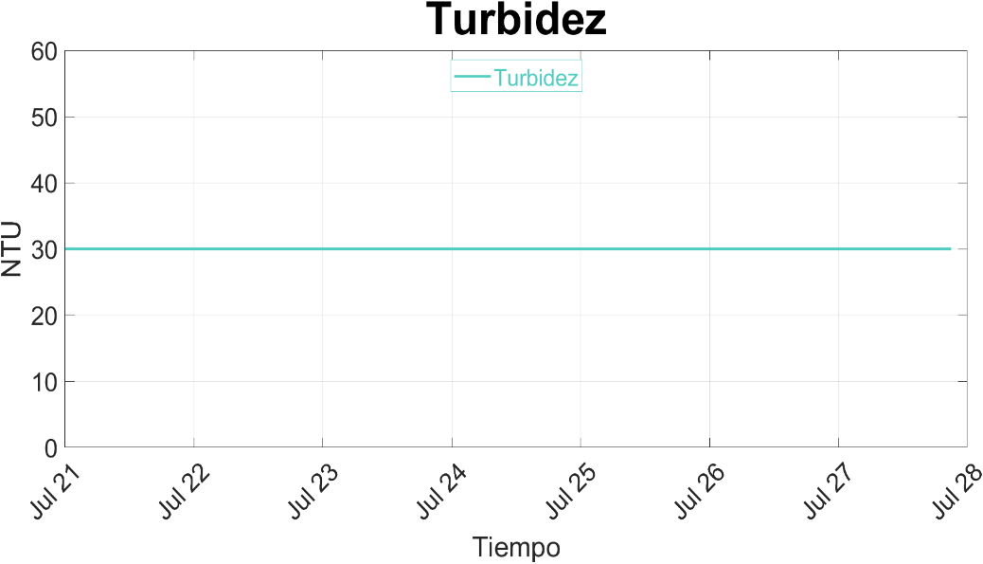
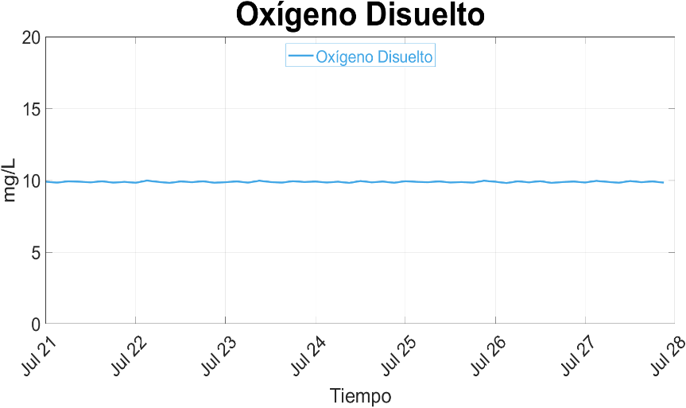
Figure 9. Historical trend of turbidity.
Figure 8. Historical trend of dissolved oxygen.

Alert System

The proposed system incorporates an alert mechanism that automatically activates whenever a monitored water quality parameter falls outside its recommended operating range. This functionality is integrated into a dedicated section of the web platform, where users are promptly notified whenever abnormal water quality conditions are detected, as shown in Figure 10.

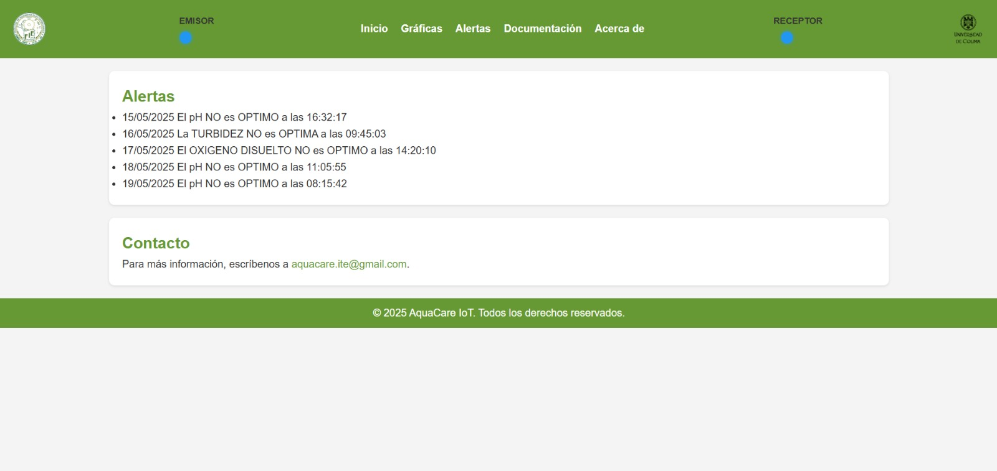
Figure 10. Web platform interface displaying water quality alerts.
Power Supply Status
The upper section of the web platform includes four status indicators: two blue LEDs and two red LEDs, as shown in Figure 11. These indicators provide real-time information about the power source currently supplying the system. The blinking LED indicates whether the circuit is powered by the primary or backup power supply, allowing users to quickly verify the system's power status.

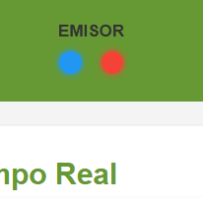
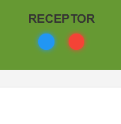
Figure 11. Power supply status indicators.
Conclusions
This work presented a low-cost water-quality monitoring system for aquaculture applications, capable of continuously measuring pH, dissolved oxygen, and turbidity. The integration of environmental sensors, LoRa wireless communication, and a web-based monitoring platform enables remote access to real-time data, while the backup power subsystem ensures continuous operation during main power supply interruptions.
The experimental results demonstrated good agreement between the proposed system and the commercial reference instruments, yielding low measurement errors for all monitored variables. In addition, the communication tests confirmed that LoRa provides a reliable solution for long-range data transmission in areas where conventional telecommunications infrastructure is unavailable, a common limitation in many aquaculture facilities.
Overall, the proposed system provides a practical and cost-effective solution for continuous water quality monitoring in aquaculture environments. Its modular architecture facilitates future expansion by integrating additional sensors and advanced capabilities, enabling more comprehensive environmental monitoring and supporting decision-making in aquaculture management.

References
[1] | M. Flores-Iwasaki, G. A. Guadalupe, M. Pachas-Caycho, S. Chapa-Gonza, R. C. Mori-Zabarburú and J. C. Guerrero-Abad, "Internet of Things (IoT) Sensors for Water Quality Monitoring in Aquaculture Systems: A Systematic Review and Bibliometric Analysis," AgriEngineering, vol. 7, no. 3, p. 78, 2025, https://doi.org/10.3390/agriengineering7030078.
[2] | M. Mohan, D. Venkatesan, M. Arif, E.-R. Bulai, P. Bulai and O. Geman, "State of the Art Techniques for Water Quality Monitoring Systems for Fish Ponds Using IoT and Underwater Sensors: A Review.," Sensors - An MDPI Journal, pp. 9-11, 2022, doi:10.3390/s22062088.
[3] | C. Z. Zulkifli, S. A. Garfan, M. Talal, A. Alamoodi, A. Alamleh, I. Y. Ahmaro, S. Sulaiman, A. B. Ibrahim, B. Zaidan, A. R. Ismail, O. Albahri, A. S. Albahri, F. S. Chin , N. H. Harun and H. C. Ho, "IoT-Based Water Monitoring Systems: A Systematic Review.," Water - An MDPI Journal, p. 2, 2022, doi:10.3390/w14223621.
[4] | C.-H. Chen, Y.-C. Wu, J.-X. Zhang and Y.-H. Chen, "IoT-Based Fish Farm Water Quality Monitoring System.," Sensors - An MDPI Journal, pp. 7-8, 2022, doi:10.3390/s22176700.
[5] | J.-Y. Lin, H.-L. Tsai and W.-H. Lyu, "An Integrated Wireless Multi-Sensor System for Monitoring the Water Quality of Aquaculture.," Sensors - An MDPI Journal., pp. 2-3, 2021, doi:10.3390/s21248179.
[6] | N. A. Mohd Jais, A. F. Abdullah, M. S. Mohd Kassim, M. M. Abd Karim, A. M and N. '. Muhadi , "Improved accuracy in IoT-Based water quality monitoring for aquaculture tanks using low-cost sensors: Asian seabass fish farming," Heliyon, p. 8, 2024, doi:10.1016/j.heliyon.2024.e29022.
[7] | Y. Xu, J. Jin, S. Zeng, Y. Zhang and Q. Xiao, "DEVELOPMENT AND EVALUATION OF AN IoT-BASED PORTABLE WATER QUALITY MONITORING SYSTEM FOR AQUACULTURE," INMATEH - Agricultural Engineering, pp. 360-361, 2023, doi:10.35633/inmateh-70-35.
[8] | C. Jamroen, N. Yonsiri, T. Odthon, N. Wisitthiwong and S. Janreung , "A standalone photovoltaic/battery energy-powered water quality monitoring system based on narrowband internet of things for aquaculture: Design and implementation,," Smart Agricultural Technology, pp. 4-5, 2023, https://doi.org/10.1016/j.atech.2022.100072.
[9] | R. M. P. N. S. Bandara, A. B. Jayasignhe and G. Retscher, "The Integration of IoT (Internet of Things) Sensors and Location-Based Services for Water Quality Monitoring: A Systematic Literature Review," Sensors, vol. 25, no. 6, p. 1918, 18 Mar 2025, https://doi.org/10.3390/s25061918.
[10] | S. Sedra, L. Parra, J. M. Jiménez, L. Garcia and J. Lloret, "LoRa-based Network for Water Quality Monitoring in Coastal Areas," Mobile Networks and Applications, vol. 28, no. 1, pp. 65-81, 2023, https://doi.org/10.1007/s11036-022-01994-8.
[11] | I. Georgantas, S. Mitropoulos, S. Katsoulis, I. Chronis and I. Christakis, "Integrated Low-Cost Water Quality Monitoring System Based on LoRa Network," Electronics, vol. 14, no. 5, p. 857, 2025, https://doi.org/10.3390/electronics14050857.
[12] | M. Flores-Iwasaki, G. A. Guadalupe, M. Pachas-Caycho, S. Chapa-Gonza, R. C. Mori-Zabarburú and J. C. Guerrero-Abad, "Internet of Things (IoT) Sensors for Water Quality Monitoring in Aquaculture Systems: A Systematic Review and Bibliometric Analysis," AgriEngineering, vol. 7, no. 3, p. 78, 2025, https://doi.org/10.3390/agriengineering7030078.
[13] | L. Liu, W. Cheng and H.-W. Kuo, "A Narrative Review on Smart Sensors and IoT Solutions for Sustainable Agriculture and Aquaculture Practices," Sustainability, vol. 17, no. 12, p. 17, 2025, https://doi.org/10.3390/su17125256.
[14] | J. Huan, H. Li, F. Wu and W. Cao, "Design of water quality monitoring system for aquaculture ponds based on NB-IoT," Aquacultural Engineering, vol. 90, no. 1, p. 102088, 2020, https://doi.org/10.1016/j.aquaeng.2020.102088.
[15] | M. C. Bonfante Rodríguez, C. E. Marriaga González, E. D. Coneo Almanza, C. González Rodríguez, J. Á. Regino-Vergara and A. López-Padilla, "Benefits and challenges of the internet of things in aquaculture production: a literature review," Frontiers in Sustainable Food Systems, vol. 9, no. 1, p. 1590153, 2025, https://doi.org/10.3389/fsufs.2025.1590153.
[16] | ARDUINO, "Arduino.cl," 02 04 2025. [Online]. Available: https://arduino.cl/arduino-nano/#:~:text=Arduino%20Nano%20es%20una%20placa,basada%20en%20el%20microcontrolador%20ATmega328P..
[17] | ESPRESSIF, "ESPRESSIF," 20 May 2025. [Online]. Available: https://www.espressif.com/en/products/socs/esp32.
[18] | R. P. Shete, A. M. Bongale and D. Dharrao, "IoT-enabled effective real-time water quality monitoring method for aquaculture," MethodsX, vol. 13, no. 1, p. 10, 2024, https://doi.org/10.1016/j.mex.2024.102906.
[19] | H. Rastegari, F. Nadi, S. S. Lam, M. Ikhwanuddin, N. A. Kasan and R. F. Rahmat, "Internet of Things in aquaculture: A review of the challenges and potential solutions based on current and future trends," Smart Agricultural Technology, vol. 4, no. 1, p. 100187, 2023, https://doi.org/10.1016/j.atech.2023.100187.
[20] | N. Shaghaghi, F. Fazlollahi, T. Shrivastav, A. Graham, J. Mayer, B. Liu, G. Jiang, N. Govindaraju, S. Garg and K. Dunigan, "DOxy: A Dissolved Oxygen Monitoring System.," Sensors, p. 24, 2024, https://doi.org/10.3390/s24103253.
[21] | S. Y. Park, J. Lee, Y. Byeon and J. S. Khim, "Systematic review of suspended sediment effects on aquatic organisms across taxa, developmental stages, and endpoints," Marine Pollution Bulletin, vol. 221, p. 10, 2025, https://doi.org/10.1016/j.marpolbul.2025.118568.

