Exercise 1

Q1



The DES IP address of gaia.cs.umass.edu is 128.119.245.12 use port number is 80. The source IP was 192.168.1.102 and use port 1161.

Q2



The seq number is 232129013.

Q3

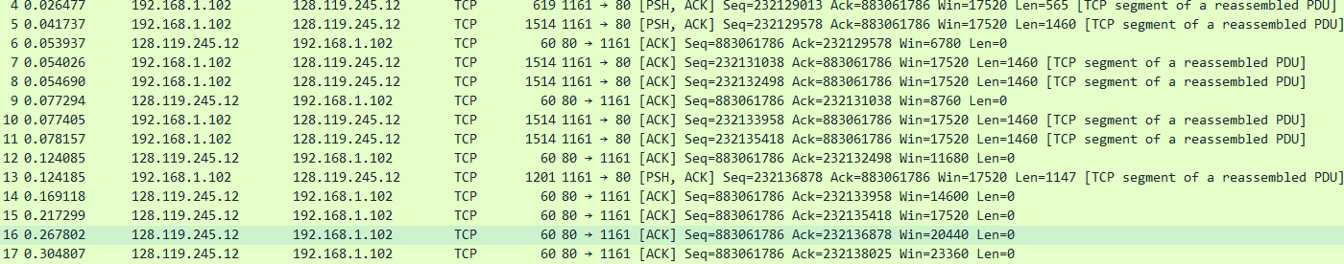

|  |  |  |  |  |  |
| --- | --- | --- | --- | --- | --- |
| Segment | Sequence | Time-send(sec) | Received(sec) | RTT-diff  (sec) | Est-RTT (sec) |
| 4 | 232129013 | 0.026477 | 0.053937 | 0.02746 | 0.02746 |
| 5 | 232129578 | 0.041737 | 0.077294 | 0.035557 | 0.028472125 |
| 7 | 232131038 | 0.054026 | 0.124085 | 0.070059 | 0.032784875 |
| 8 | 232132498 | 0.054690 | 0.169118 | 0.114428 | 0.038331 |
| 10 | 232133958 | 0.077405 | 0.217299 | 0.139894 | 0.04151425 |
| 11 | 232135418 | 0.078157 | 0.267802 | 0.189645 | 0.047733125 |

Q4

The first length of TCP segment was 565 bytes and the rest of five segments length are 1460 bytes.

Q5

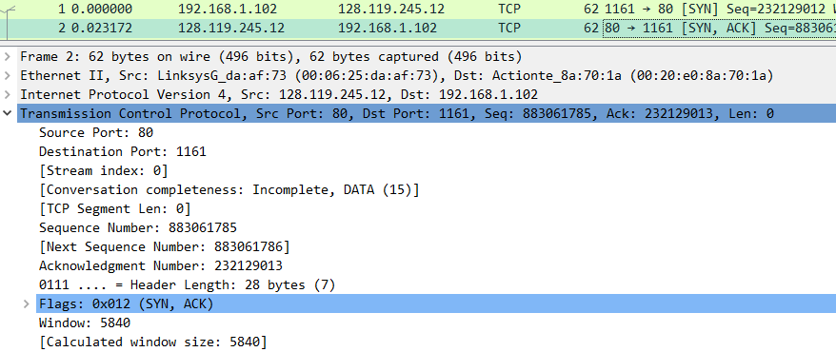

The window size was 5840 bytes and the lack of receiver buffer space does not will throttle the sender.

Q6

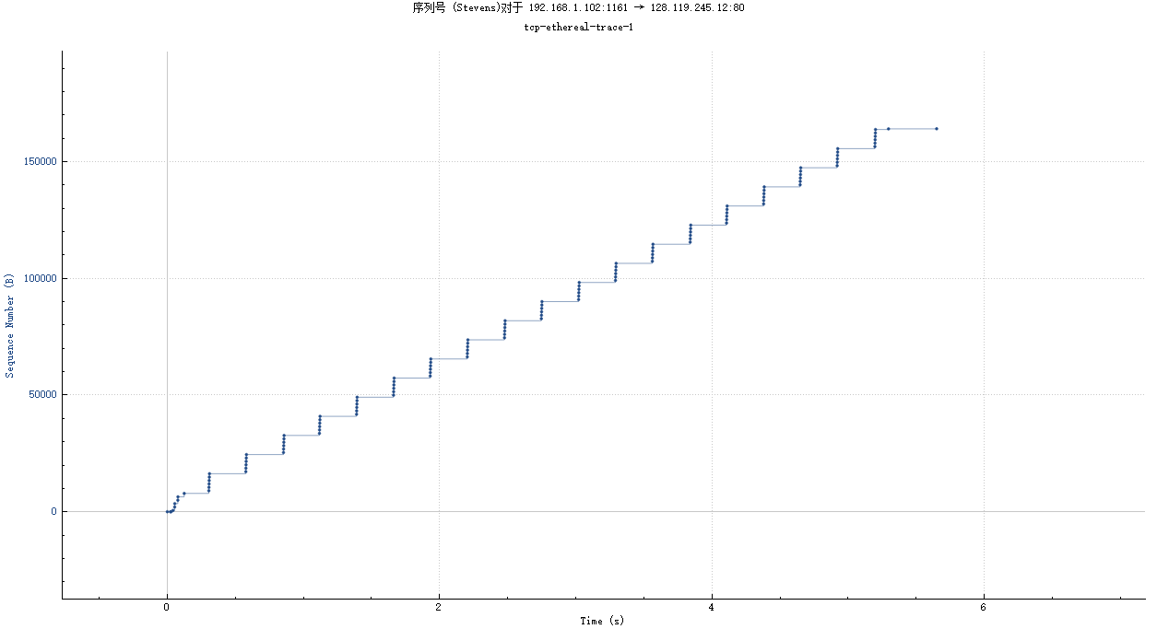

From this sequence graph we can see there are no sequence number decrease, if there exist a retransmitted segment, then we sequence number will decrease on some point.

Q7

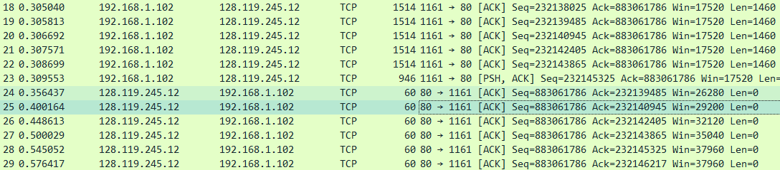

 The receiver typically acknowledges 1460 bytes data in an ACK.

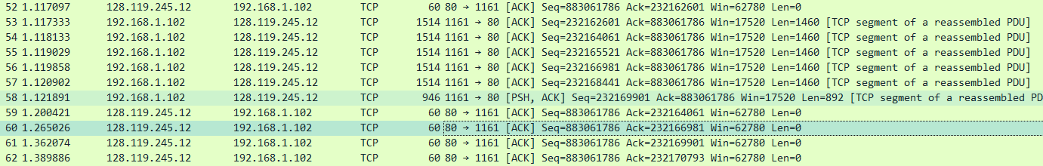

From above picture we notice there have 4 ACKs(segments 59 to 62) for 6 packets(segments 53 to 58). This is because TCP use delayed ACK to send cumulative ACKs.

Q8





To get this TCP throughput we can use the first TCP segment and last TCP segment.

The TCP throughput = Total amount data $/$ Total transmission time

= (232293103 $-$ 232129013 $-1$) $/$ (5.455830 $-$ 0.026477)

=30222.5697979 bytes/sec

Exercise 2

Q1

The sequence number of the TCP SYN segment that is used to initiate the TCP connection is 2818463618.

Q2

The sequence number 1247095790 is the SYNACK segment sent by the server to the client computer in reply to the SYN and the value 2818463619 is the Acknowledgement field in the SYNACK segment which is the sequence number of SYN segment plus 1.

Q3

The sequence number 2818463619 is the ACK segment sent by the client computer in response to the SYNACK and the value 1247095791 is the Acknowledgment field in this ACK segment and this segment does not contain data.

Q4

The client and server both done the active close because they active close (sent FIN flag) without receive ACK flag from each other. The type if closure is simultaneous close.

Q4

The data bytes have been transferred from the client to server is

281846353 $-$ 2818463618 $=$ 35 bytes

And we need minus 2 bytes SYN and FIN segment which is 35 $-2=33$ bytes.

and from the server to the client is

1247095831 $-$ 1247095790 $-$ 2 $=$ 39 bytes.

The final ACK number indicate the Initial Sequence Number plus the whole data size of this TCP transmission from other side. If we have these two number we can easily calculate how many data are transferred from this connection.