# COMP3331 Lab05

Exercise 1

Q1

-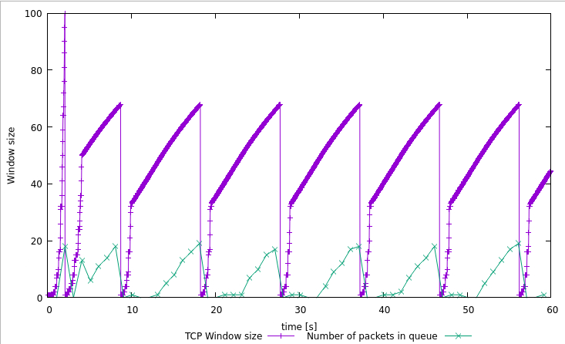  
a) The maximum size of the congestion window that the TCP flow reaches is 100

b) when the congestion window reaches this value then the congestion window size will decrease to 1 because there have packet time out which the receiver knows the congestion happened (we use Tahoe mechanisms).

c) Then it will do slow start(ssthresh) until to window size is 50, since the max window size is 100 then it will set the congestion window size be half the 100(which is 50).

Q2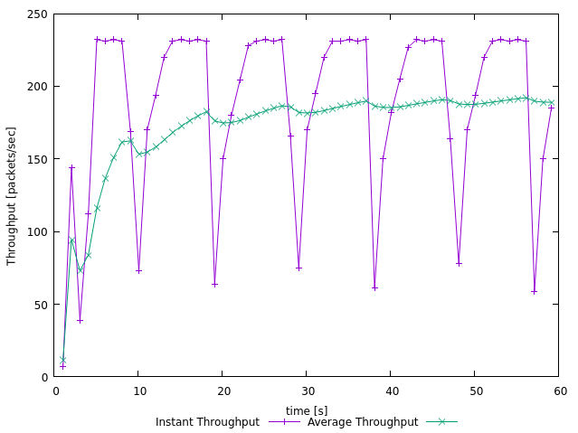

From the plot we can see the average throughput roughly is 190/(packets/sec) then the average throughput of TCP 190 $×\left(500+40\left(TCP header+IP header\right)\right)=102600 bps$.

Q3

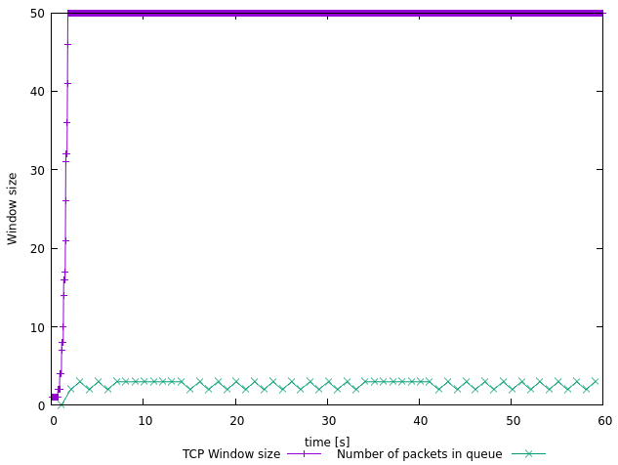

I notice when I decrease the congestion window size the TCP respond more and more stable and when the CWND size reach to 50, the TCP no more oscillating and now the average throughput is roughly is 227 packets/sec which is 122580 bps. The 1 Mbps link capacity is 12500 bps and the actual average throughout is slightly lager than 12500 bps.

Q4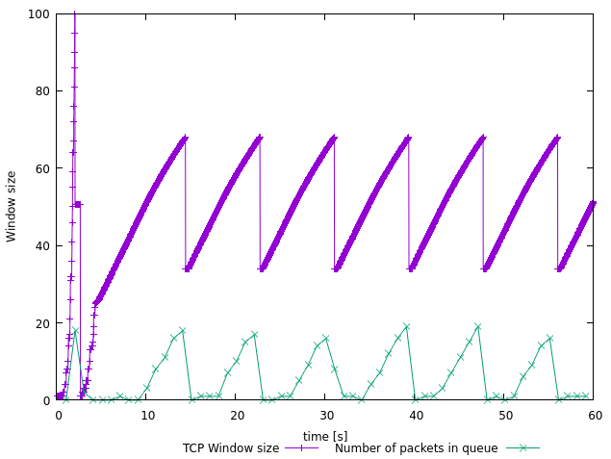

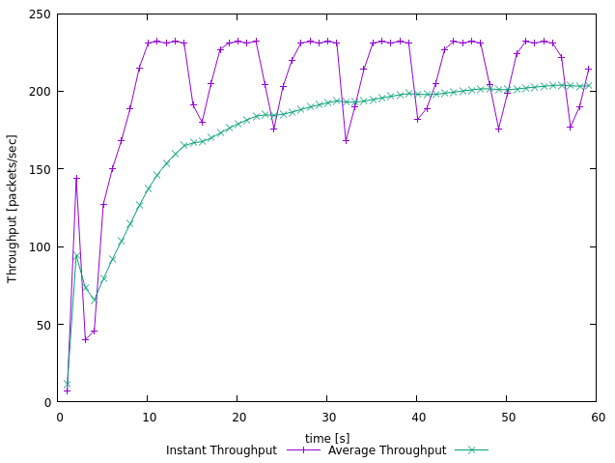

We can see in TCP Reno don’t set the congestion window size to 1 after it occur congestion also when it happens a congestion it won’t have a slow start step to increases the congestion window size, but it will be in a liner increase. Reno has greater average throughout which roughly be 202 packets/sec.

Exercise 2

Q1

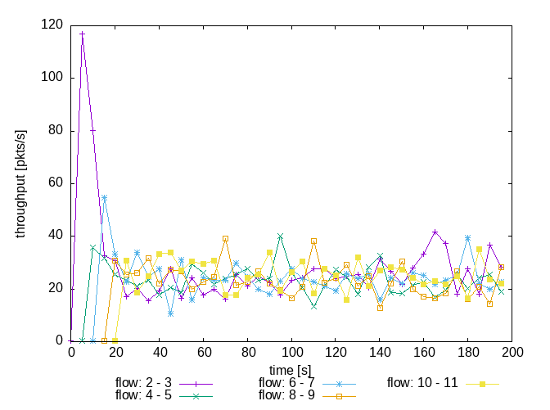

Yes, each flow get equal capacity because we can see after these flow be stable through time, every flow capacity within 20 to 40 packets/sec and the max throughout was about 120 packets/sec, these flows equally share the link capacity.

Q2

The throughput of the pre-existing TCP flows will decrease when a new flow is created. The mechanisms of TCP is when a new flow be created the flow’s throughout will increase very quick and it will cause congestion but after the TCP use its mechanisms to solve the congestion then every flow will equal assign relatively fair throughput. After these five flows share the same throughout it will be fairly share the capacity of the throughout, so I think this behavior is a fair.

Exercise 3

Q1

I guess the UDP flow will very quick to occupy the most of the throughout and TCP flow’s throughout will change based on if the UDP flow need more or less throughout.

Q2

I think this is because TCP have avoided congestion control mechanisms, but UPD don’t, which UDP don’t have transmission limit. At start the UDP want as much as possible throughout to use but TCP at start was slow then TCP can’t get much throughout (very small throughout can be used to TCP). After when UDP don’t need much throughout, TCP will increase the CWND size and use more throughout, however if UDP take back that part of throughout then TCP will decrease the CWND size and TCP may occur time out or duplicate ACKS then it will send the packets again which also occupy some throughout. In other words, the capacity of throughout occupied by UDP will affect TCP’s throughout.

Q3

The advantages when we use UDP in flow competition are

1. Can use more throughout and high bandwidth usage,
2. Higher average file transfer rate.

The disadvantage when flow congestion happened the UDP will lost a lot of packets and the sender doesn’t know.

If everyone uses UDP then the if the congestion happened, the network will crash, because everyone still keep sending their file in same rate and network link can’t handle these error also sender don’t care if congestion happened in network then no one can get they want.