**Pre-requisite to Run FX Flow**

There are four pieces of required software for CorDapp development:

* Java 8 JDK
* IntelliJ IDEA
* Git
* Gradle

Use below commands to install required software’s in VM :

1. sudo apt-get update

2.sudo apt-get install openjdk-8-jdk

3.export JAVA_HOME=/usr/lib/jvm/java-8-openjdk-amd64

4.docker pull corda/corda-zulu-java1.8-4.6:latest

5.sudo apt-get  install gradle 8.1.1

6.sudo snap install docker

7.sudo apt-get  install docker-compose

8. sudo apt-get install openssh-server

* sudo service ssh status---to check status
* sudo service ssh restart ---to restart ssh

**Steps to Run FX Flow**

1. **Clone the repository**:

* Git clone the Code from <https://github.com/FXInstaForex/forex.git>
* Command:

Git clone <https://github.com/FXInstaForex/forex.git>

* Branch Name: PreAndPostTrade

gradle clean deployNodes(intellij) or gradlew.bat clean deployNodes(terminal)

1. Download **“corda-tools-network-bootstrapper-4.10-RC05.jar”** from <https://software.r3.com/ui/native/corda-releases/net/corda/corda-tools-network-bootstrapper/4.10-RC05/>
2. Create folder “VMConnection”(any name of your choice) and copy **“corda-tools-network-bootstrapper-4.10-RC05.jar”**  to this folder.
3. Copy **contracts-0.1.jar** and **workflows-0.1.jar** from any node folder and paste in “VMConnection”

* Ex: <Inside project folder >/build/nodes/PartyA/cordapps
* Copy PartyB_node.conf, PartyB_node.conf,Notary_conf from <Project Folder >/cordapp- example/build/nodes and paste in “VMConnection”.

Open each *_node.conf file and update p2pAddress, rpcSettings:adminAdress and admin

Ex:

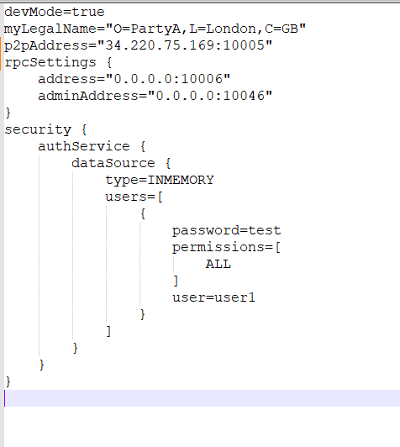

* P2pAddress is the ip of vm where you will be starting that node

1. Open terminal and navigate to VMConnection folder

* Execute below command:(update the jar name to the version you have downloaded)



1. Copy **“drivers”** folder from node folder and paste in  VMConnection/PartyA

* Ex: samples-java/Basic/cordapp-example/build/nodes/PartyA
* Repeat step for every nodes to copy the drivers folder.

**Copy files from local to VM**

1. scp -r ./PartyA cloud_user@34.220.75.169:/home/cloud_user/samples-java/Basic/cordapp-example

* <mention ip where you want to start the node: ip in *_node_conf and in above path should be same>
* Similarly Copy other nodes on the vm.

**VM Steps**

1. Open cmd and connect to vm

2.ssh [cloud_user@35.87.136.13](mailto:cloud_user@35.87.136.13) and provide password

3.Navigate to node folder where the folder from local in copied

* Ex: ~/samples-java/Basic/cordapp-example/PartyA
* Execute below command:



**Deploy and Run Nodes In Corda**

* 1. Run below commands to run deploy corda nodes and execute transactions(Flow commands):

Go to the project folder where you have colined the project and run below command on terminal.

**gradlew.bat clean deployNodes**

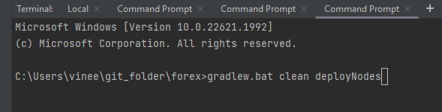

**call build\nodes\runnodes.bat**



* 1. Nodes are started using above command and popped up as below :

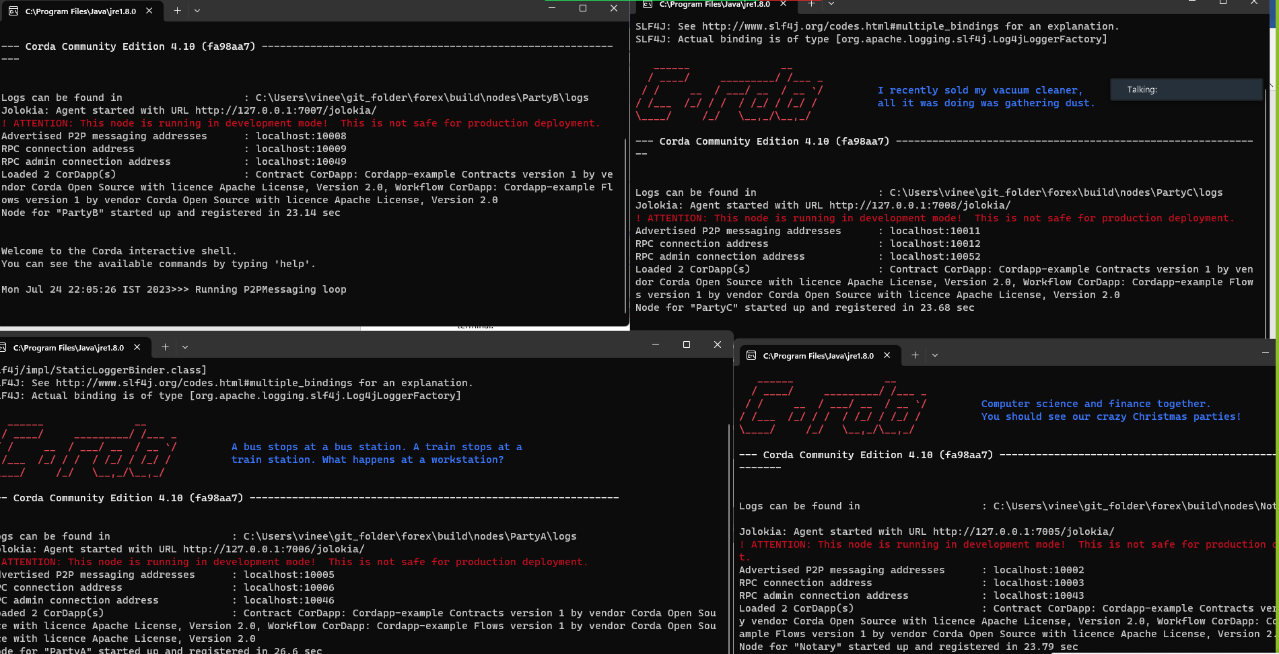

3.Upate balances using below commands on Nodes opened in step 2 :

**flow start PartyAUpdateBalanceFlow amount: 100000, issuer: "O=PartyA, L=London, C=GB", status: "UNCONSUMED"**

**flow start PartyAUpdateNostroBalanceFlow amount: 50,issuer: "O=PartyA, L=London, C=GB", status: "UNCONSUMED"**

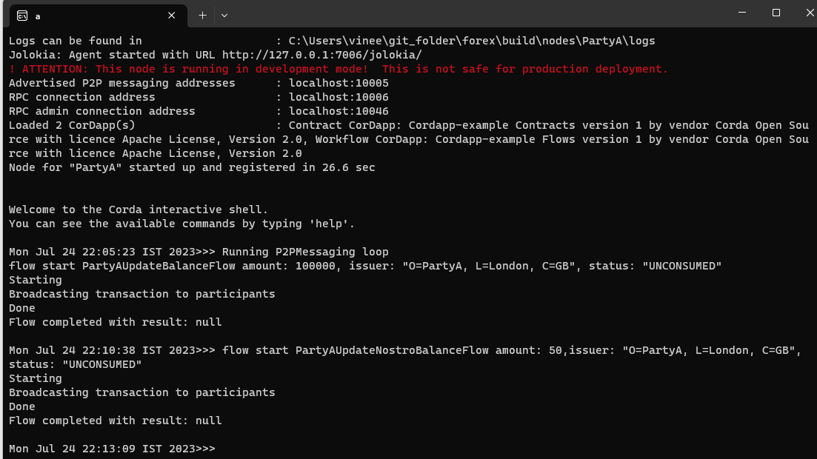

**flow start PartyBUpdateBalanceFlow amount: 1000, issuer: "O=PartyB, L=New York, C=US", status: "UNCONSUMED"**

**flow start PartyBUpdateNostroBalanceFlow amount: 50,issuer: "O=PartyB, L=New York, C=US", status: "UNCONSUMED"**

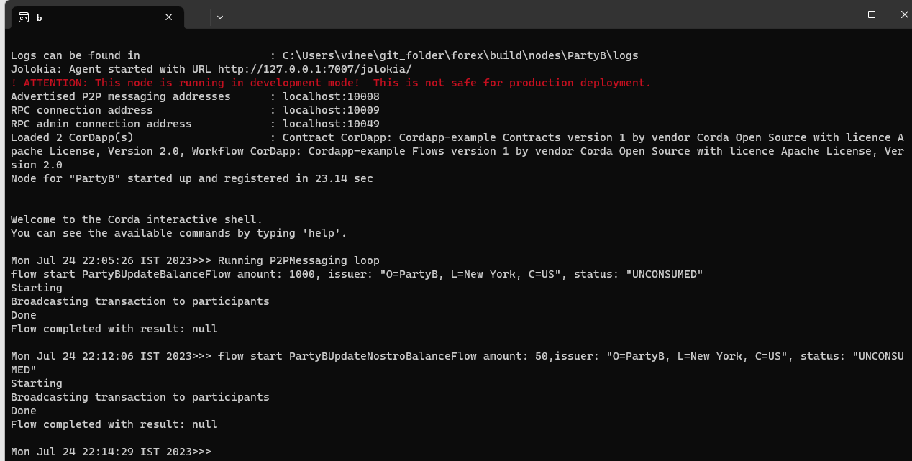

**4.**Run below queries to see balances in VALUT :E.g for 1 command run.

**run vaultQuery contractStateType: net.corda.samples.example.states.PartyABalanceState**

**run vaultQuery contractStateType: net.corda.samples.example.states.PartyANostroState**

**run vaultQuery contractStateType: net.corda.samples.example.states.NostroState**

**run vaultQuery contractStateType: net.corda.samples.example.states.PartyBalanceStateB**

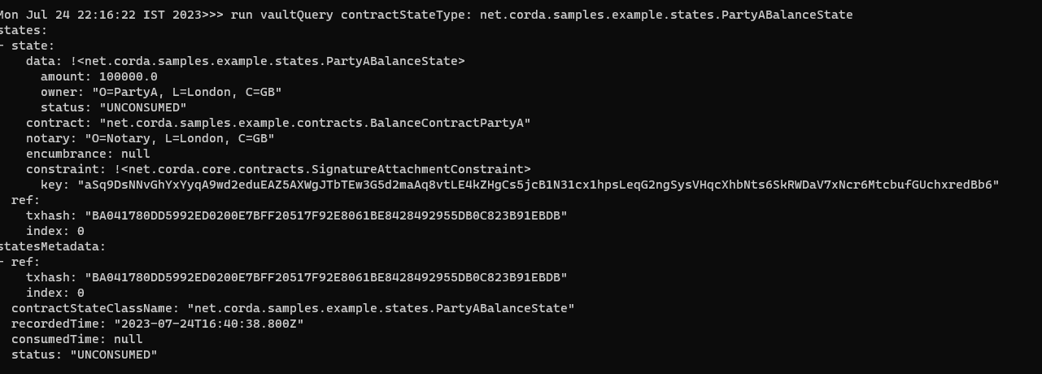

**Settlement Flow**

1.run below commands to start settlement flow :

**flow start SettleBalancesForB buyAmount: 100, lender: "O=PartyB, L=New York, C=US",sellAmount: 100, borrower: "O=PartyA, L=London, C=GB"**

**flow start SettleBalancesForA buyAmount: 100, lender: "O=PartyB, L=New York, C=US",sellAmount: 200, borrower: "O=PartyA, L=London, C=GB"**

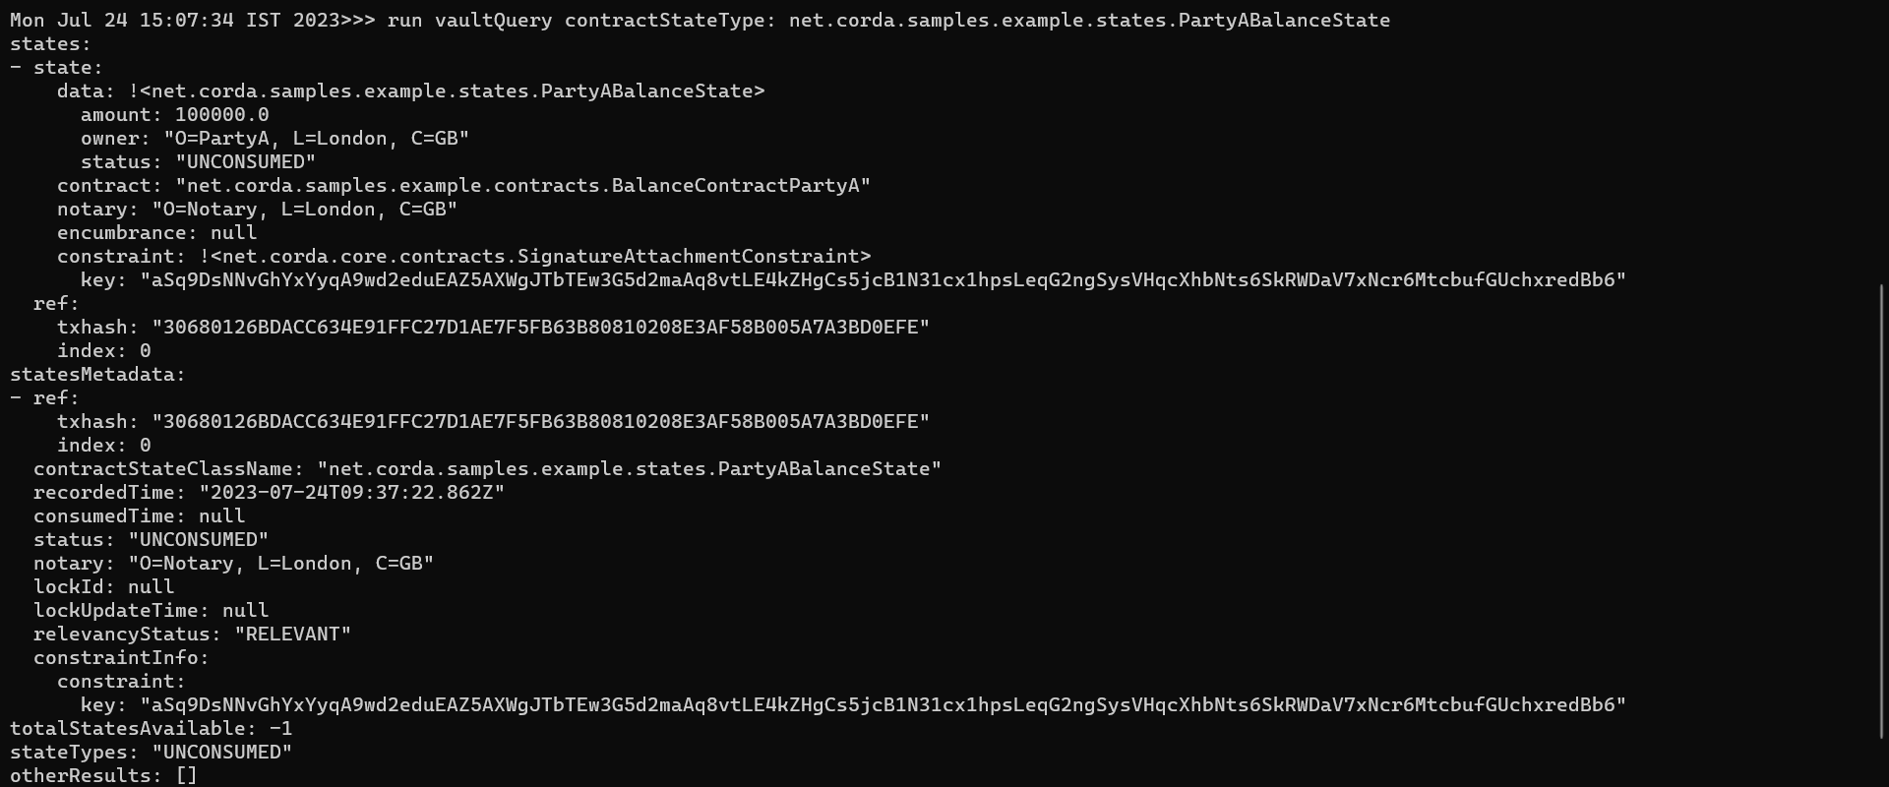

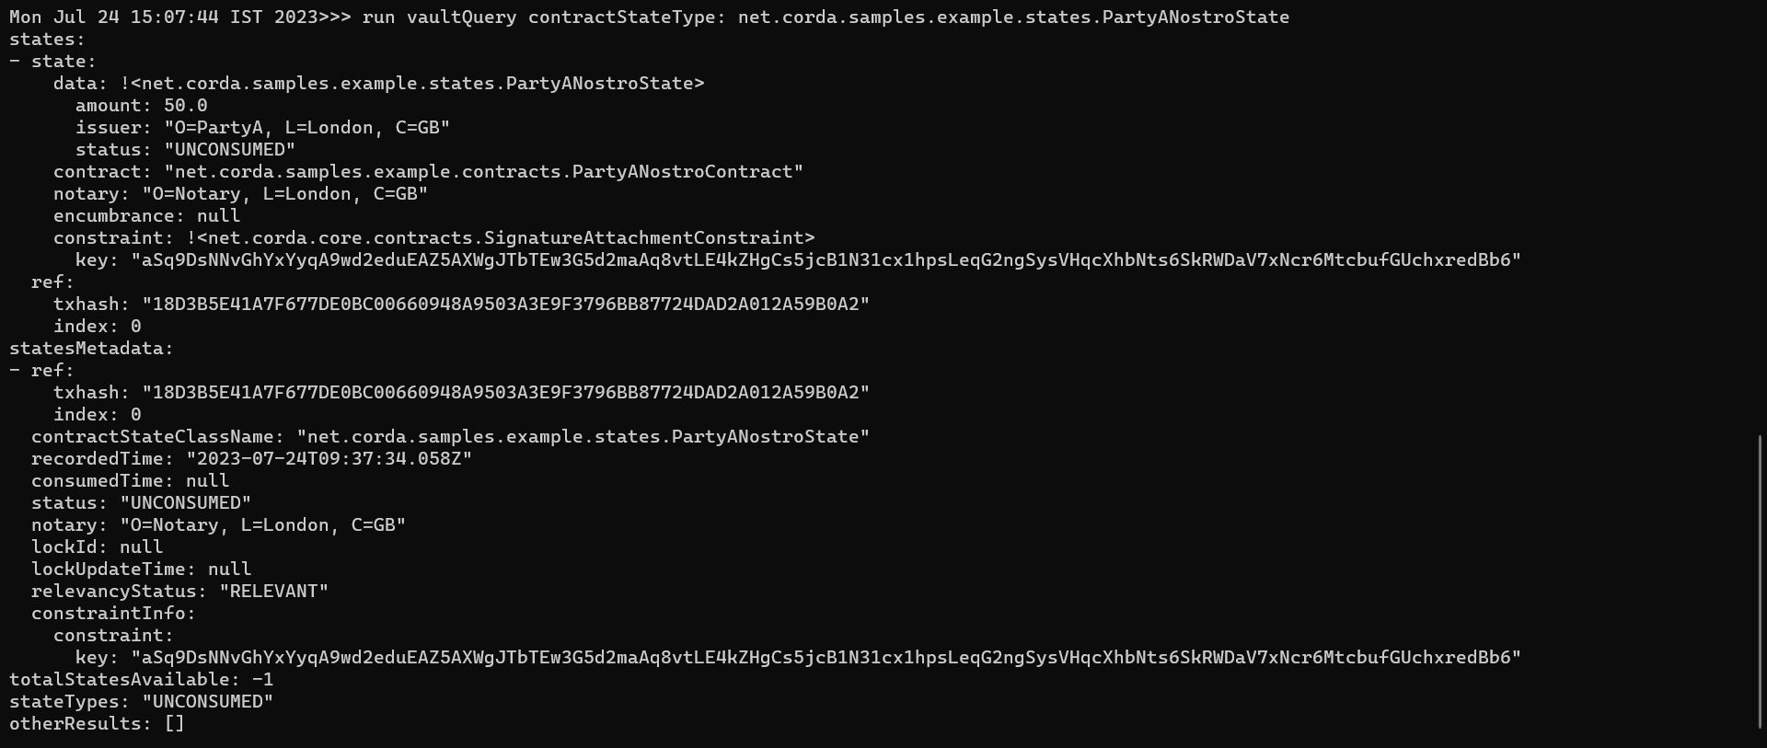

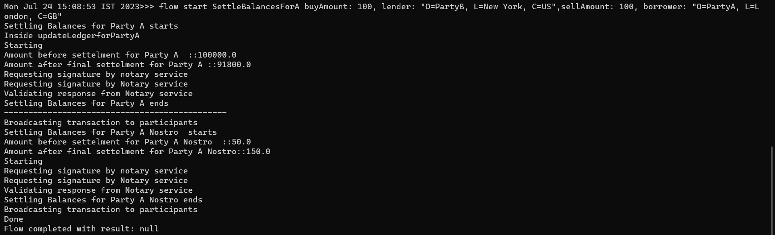

**Netting Flow**

* Run below commands to start Netting Flow

**flow start NettingFlowA borrower: "O=PartyA, L=London, C=GB" , lender: "O=PartyB, L=New York, C=US"**

**flow start NettingFlowB borrower: "O=PartyA, L=London, C=GB" , lender: "O=PartyB, L=New York, C=US"**

