

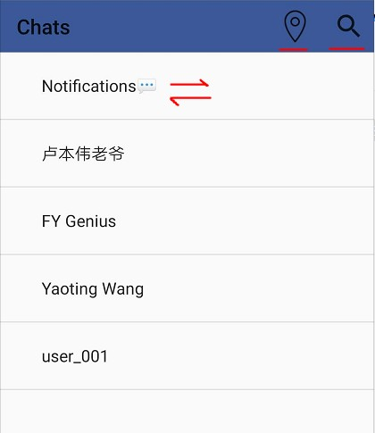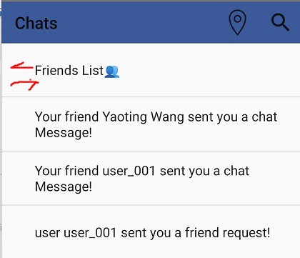

User Guide for Suplink app

**Sign in:**

New users will be redirected to the initial page once they finished their registrations.

- You could regist your own account and here we also prepare the test account with plenty of test data:

Account: [test@suplink.com](mailto:test@suplink.com)

Password: 123456

**Chats:**

- Friends List:

-- See all your friends and click on their username to chat with them.

-- Click the “notification” or “friends” button, to switch between friends list/notification page. You can see notifications such as other’s friend requests or messages.

-- Search users: by email, or by device location (see in map), or by phone (based on the first 5 digits of your phone number. You can modify your phone number in setting page (Me), and set it with “35308” start, then you can find us).

-- To return to the friends list from search page, just click the blank space under

the search section.

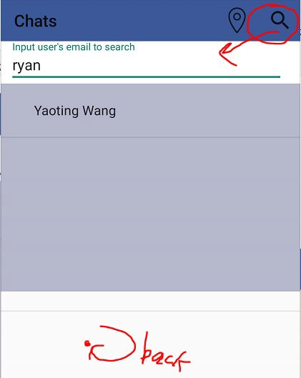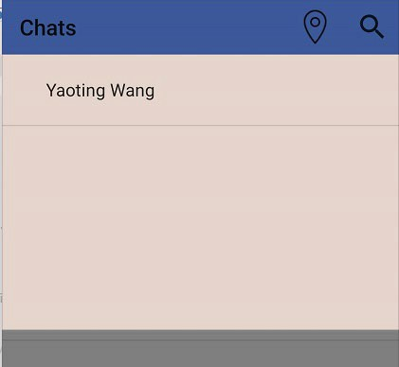

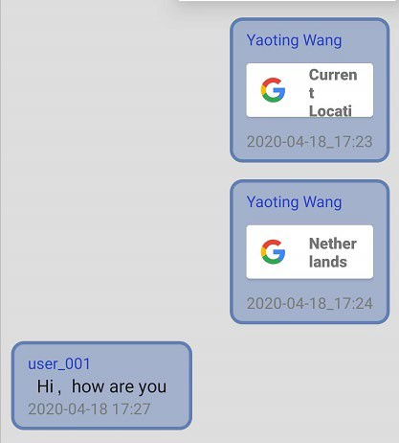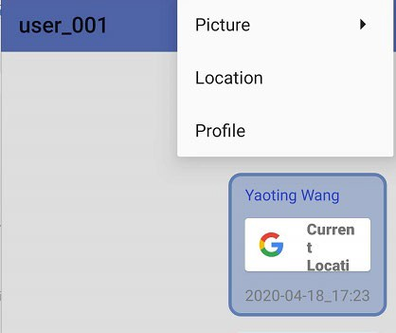

- Chat (see below):

-- Chat with your friends, send and receive messages in real time (by Firebase realtime).

-- Click “Picture” to choose pictures from ablum or take now by camera.

-- Click “Location” to send location (as well you can search specific places but they may not exist. And if you click send directly without seach, is will be showen as current location).

-- Message sent by you will be displayed on the right side of the screen while message sent by your friends will be displayed on the left side.

-- Click location messages, map page will show in which you have been located to

the corresponding location (see details in the “Map” part).

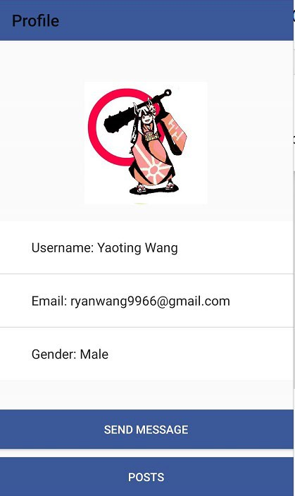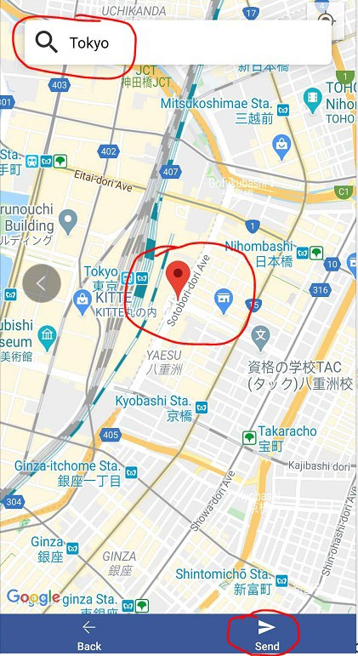

- Profile (see above):

-- You can see other’s information.

-- chat with them (if they are your friends).

-- send them a friend request (if they are not your friends).

-- See all the posts they have posted (Long press to “favorite” the posts).

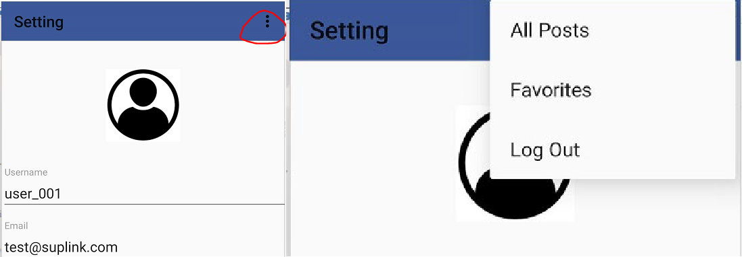

When you select to create a new post:

Users could write the title, content and a picture of the post, they could also choose to send their own location, and then select the Submit button to send the post. Note: click map button then your post will be stored into a local-based channel (will be mentioned later).

**Setting:**

When you select a post:

Users could see the post title, author, sending time, and content. There is also a Like button at the bottom, they could choose to click or cancel Like.

**Discover**

Users could select different Channels in the discover page, and they could view posts

posted by nearby people in the last channel (the “Local” channel).

When you select a channel:

Users could browse all the post titles of this channel, and they could also click to view detail content. Users can also create their own posts through the lower right corner (shows like “+” in a circle). If you long press a post, you can add it to the “favorites”.

“Me” page will display personal information:

- Click “menu” in the upper right corner:

-- Click “all posts”: View all your posts (click to view details, long press to delete).

-- Click “favourites”: View favorite posts (click to view details, long press to delete).

-- Click “log out”: return to the previous page of sign in.

- Click edit to enter edit info:

-- Click the text box: personal information can be modified, whether to display for gender.

-- Click on the avatar: You can upload the user's avatar (it will be showed after returning to the Me page, you may need to wait seconds or click other pages temporary).

-- * length for username is limited within 15 chars, password should be 6 digits more and

letter(s) should be involved.

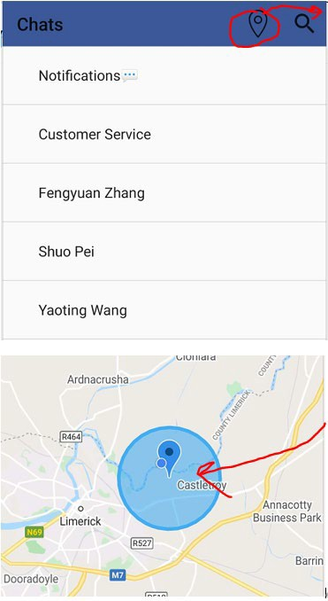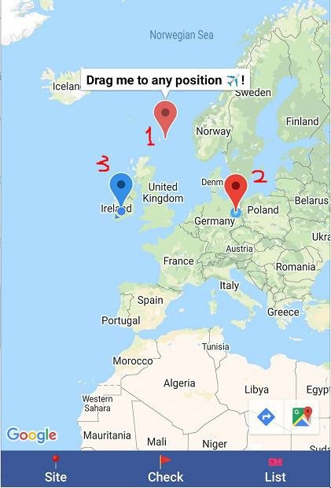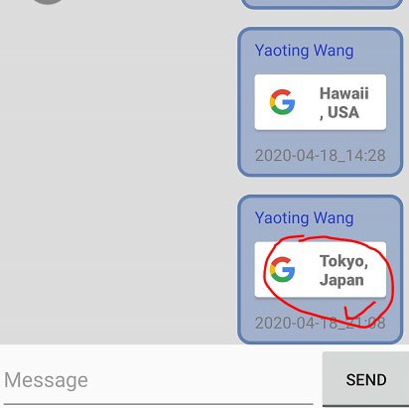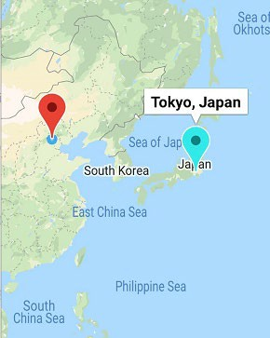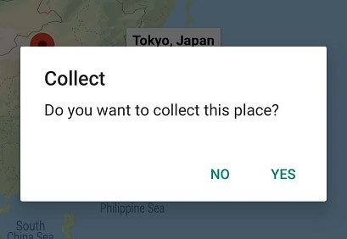

**Map**

Click the map icon (circled above) then you will be in the map page:

* There are 3 functions: “Site” to get current device location. “Check” to check points, “List” to see what you have checked and collected.
* the 1st marker is draggable and you could drag it to any position and once you click it, you will find the Google route navigation at the right bottom.
* the 2nd marker is red which means a check point could be checked (as blue, the 3rd marker, means it has been checked), now there are several points could be checked.
* checkable makers are set with specific bounds and you could check it only you are in the circle(bound) radius.
* Cyan marker: you can send/receive location from chat box and click it you will jump to Map page and then you will see a cyan marker, and now click it you can chose to

collect it (which will then be saw in the “List”).



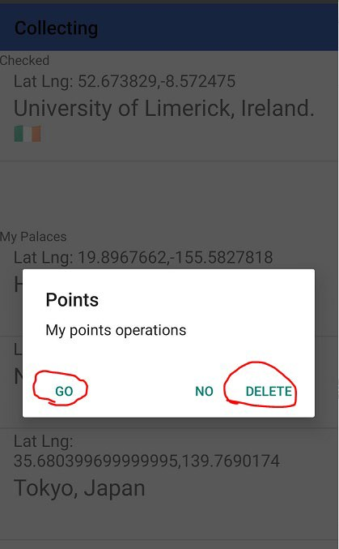

- in the “List” page, press the item (keep clicking in a long time), and you could have

more options i.e. delete it or go to there as a destination.

- Search Nearby & Local Posts

- You can search nearby users by device location (users should keep online).

- Click Post button you can see local posts (To check this function you can submit

a new post in any channel (which is mentioned above in “Discover”), remember to click the “map/location” icon).

