Biarkan kotak ini kosong
Silahkan kirim online http://jurnal-itsi.org/index.php/jitsi/login dalam file DOC
Editor tidak akan menerima pengiriman melalui email. Pastikan untuk memeriksa plagiat, ejaan, dan tata bahasa sebelum mengirimkan jurnal Anda.

Task-Technology Fit in Multi-Paradigm Network Intrusion Detection: An Empirical Evaluation of Tree Ensembles, Deep Learning, and Tabular Foundation Models
Farrell Yodihartomo^{#1}, Second Author^{*2}, Third Author^{#3}
^{#1} Department of Information Systems, Faculty of Computer Science, Universitas Indonesia, Depok 16424, Indonesia
^{*2} Department of [Department Name], Faculty of [Faculty Name], [University / Institution Name], [City, Postal Code], Indonesia
^{#3} Department of [Department Name], Faculty of [Faculty Name], [University / Institution Name], [City, Postal Code], Indonesia
E-mail: 1farrell.yodihartomo@ui.ac.id, 2second.author@institution.ac.id, 3third.author@institution.ac.id
A B S T R A C T S |  | Manuscript received ………; revised …………. accepted …… Date of publication ………... International Journal, JITSI : Jurnal Ilmiah Teknologi Sistem Informasi licensed under a Creative Commons Attribution-Share Alike 4.0 International License  
Network intrusion detection systems face conflicting operational demands: sustaining line-rate packet throughput, generalizing to unobserved zero-day exploits, and fitting within strict hardware resource budgets. Most benchmark studies evaluate models as isolated algorithms, ignoring how architectural properties align with real-world security workflows. We evaluate this problem through the theoretical lens of Task-Technology Fit (TTF) and Design Science Research, examining eight architectures spanning gradient-boosted decision trees, tabular transformers, selective state space models, and tabular foundation models. Using five decontaminated network benchmarks (CICIDS2017, UNSW-NB15, TON_IoT, CIC-DDoS2019, and NSL-KDD), our dual-track evaluation applies subnet-isolated cross-validation alongside active zero-day holdouts. The results show that tree ensembles (LightGBM and XGBoost) excel on observed attacks (Seen F1 >= 0.9469) with sub-microsecond processing. In contrast, the prior-data fitted foundation model TabPFN v3 achieves the strongest zero-day transfer (Unseen F1 = 0.6173 +- 0.4275), leading Task T2 utility (U(T2) = 0.7100) and surpassing deep neural baselines by 6 to 10 percentage points, though requiring 3.11 ms per flow. Selective state space models (Mambular SSM) match tree throughput (>929,000 flows/s) while keeping memory consumption flat as batch volumes grow. Non-parametric Demšar tests confirm significant architectural divergence (Friedman chi-square = 29.6667, p = 1.093 x 10^-4). Triangular Fuzzy DEMATEL across 10,000 Monte Carlo perturbation runs (Kendall W = 0.9716) identifies model layer formulation as the primary systemic cause of operational performance. These findings support four formal Design Propositions and an operational Three-Tier Security Operations Center blueprint.

Keywords / Kata Kunci: Network Intrusion Detection; Task-Technology Fit; Tabular Foundation Models; Selective State Space Models; Fuzzy DEMATEL.

1. Introduction
Enterprise network appliances inspect continuous traffic at line rates from 10 Gbps to 100 Gbps [1, 2]. At this scale, Network Intrusion Detection Systems (NIDS) must evaluate high-dimensional packet flows and flag anomalous telemetry before attackers reach internal subnets [3]. Security operations centers (SOC) face an inherent trade-off among three operational goals: sub-millisecond per-flow latency, accurate classification of known attack signatures, and generalization to unobserved zero-day exploits.
For tabular traffic classification, Gradient-Boosted Decision Trees (GBDTs), particularly LightGBM [4] and XGBoost [5], remain the standard baseline. Their recursive orthogonal splits fit the discrete, uncoordinated coordinates common in network telemetry (such as TCP flags, port numbers, and packet counters) with minimal computational overhead [6]. Because NetFlow features lack spatial stationarity and translation invariance, axis-aligned splits partition input spaces effectively without mapping coordinates into dense continuous embeddings [7]. The fundamental limitation lies in extrapolation. Axis-aligned bounding boxes fail to generalize when novel exploits fall outside the feature ranges established during training.
Tabular deep learning models attempt to resolve this boundary limitation. Architectures such as FT-Transformer [8] and SAINT [9] use self-attention to capture complex inter-feature relationships. Self-attention yields smoother, continuous decision boundaries, but its computational complexity scales quadratically (O(D^2)) with feature count D. Under line-rate traffic, this quadratic scaling leads to packet queuing and high GPU memory demands [10]. To bypass quadratic overhead, selective State Space Models (SSMs), such as Mamba [11] and its tabular adaptation Mambular [12], apply hardware-aware parallel associative scans in linear time O(D). In parallel, prior-data fitted tabular foundation models, notably TabPFN [13] and TabICL [14], frame classification as in-context Bayesian inference. Pre-trained on synthetic causal graphs, they perform zero-shot inference on novel tasks without weight updates.
Despite these algorithmic developments, the intrusion detection literature often suffers from an Information Systems (IS) disconnect. Many studies treat machine learning models as isolated algorithms, ranking architectures by aggregate accuracy or F1 scores on static test sets [15, 16]. This narrow focus divorces algorithmic behavior from operational realities, hiding trade-offs between latency, hardware footprint, and forensic accuracy. A model with high offline accuracy can easily fail in an active SOC if its per-flow latency causes packet drops at edge gateways.
We ground our analysis in the Task-Technology Fit (TTF) framework of Goodhue and Thompson [17] and the Design Science Research (DSR) guidelines of Hevner et al. [18]. TTF posits that technology generates organizational value only when its capabilities match the requirements of the task. In cyber-defense, algorithmic capabilities (such as discrete boundary cuts, in-context synthetic priors, or state-space recurrence) offer no absolute advantage in the abstract. Their utility emerges only when aligned with the specific operating profile of a security task.
We define three concrete operational tasks: Line-Rate Perimeter Filtering (T1), Zero-Day Forensic Isolation (T2), and Enterprise Composite Triage (T3). Across these operating regimes, we address four research questions:
- RQ1: How do tabular foundation models, selective state space models, deep neural networks, and decision tree ensembles compare across seen attack classification and zero-day threat generalization?
- RQ2: What are the empirical throughput, per-flow latency, and dynamic memory boundaries of these model families under industrial streaming conditions?
- RQ3: Are observed performance disparities between architectural paradigms statistically significant under non-parametric multi-dataset testing protocols?
- RQ4: How do upstream architectural attributes causally govern downstream operational trade-offs, and what deployment topology optimizes overall Task-Technology Fit?
We conduct a dual-track benchmark evaluating eight representative architectures across five decontaminated network intrusion datasets: CICIDS2017 [19], UNSW-NB15 [20], TON_IoT [21], CIC-DDoS2019 [22], and NSL-KDD [23]. To avoid data leakage, our protocol uses subnet-isolated GroupKFold partitioning and systematic zero-day holdouts [24]. We evaluate significance through the Demšar testing framework [25] and examine causal structures using Triangular Fuzzy DEMATEL [26-28] with DirectLiNGAM triangulation [29]. These empirical results validate four formal Design Propositions (DP1 - DP4) and provide an operational Three-Tier SOC deployment blueprint.
2. Research Methodology
Our methodology combines experimental benchmarking with non-parametric statistical hypothesis testing and causal structural discovery. Fig. 1 illustrates the multi-dataset attack taxonomy evaluated across all experimental partitions.
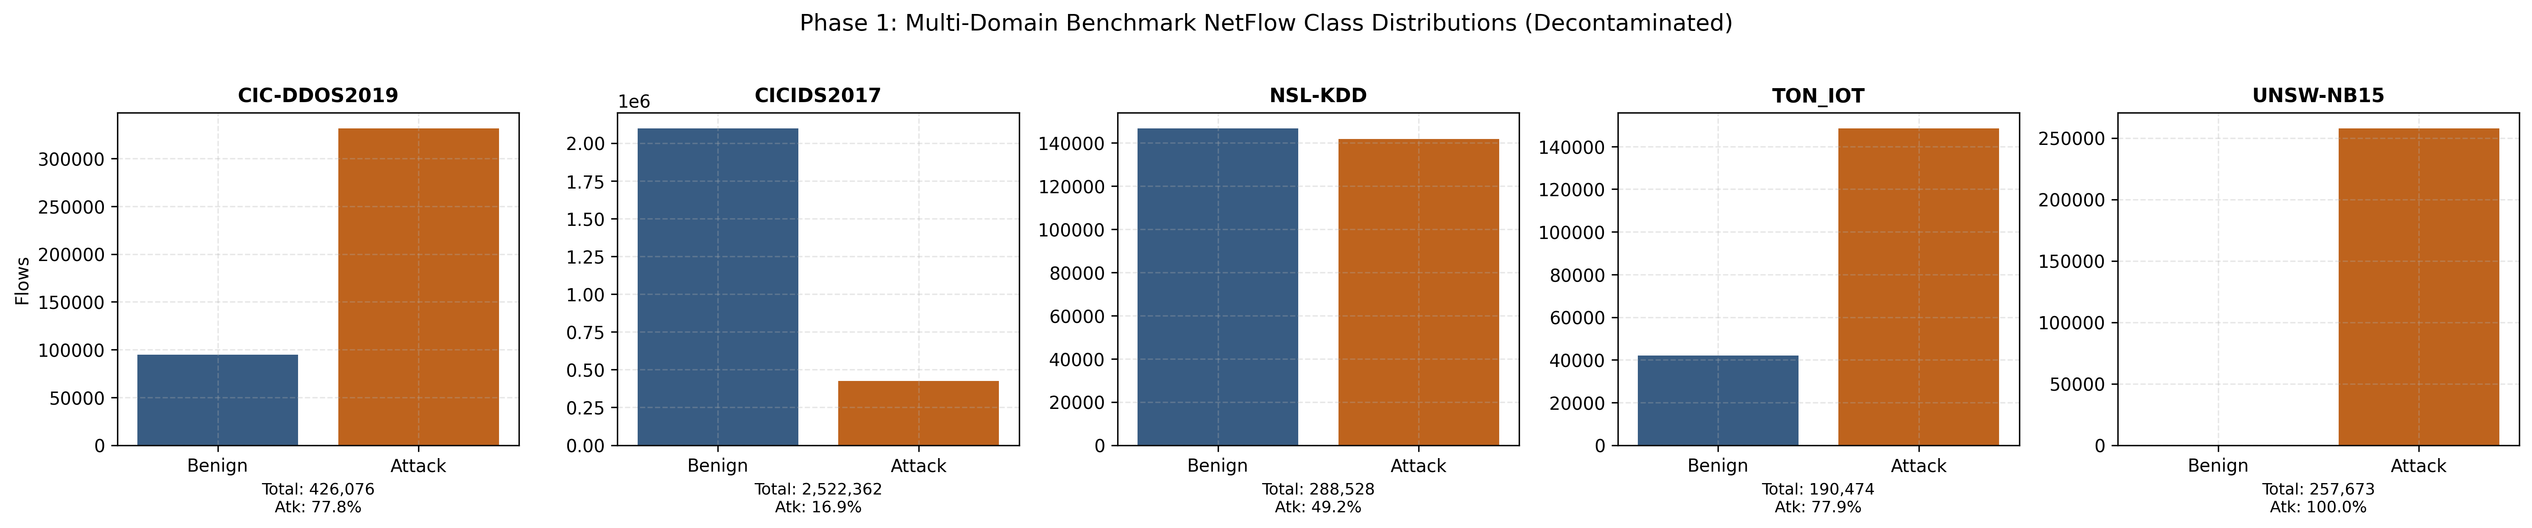
Fig 1. Benchmark class distribution and multi-dataset attack taxonomy across evaluated partitions.
The benchmark taxonomy spans 28 distinct exploit categories across the five decontaminated datasets, encompassing high-rate volumetric floods, evasion-focused web exploits, reconnaissance scans, and low-footprint lateral infiltration. By isolating benign background telemetry from known training attacks and zero-day holdout vectors, this multi-partition scheme establishes a decontaminated baseline to evaluate how different inductive biases handle class imbalance and out-of-distribution shifts.
2.1. Problem Formulation and Task-Technology Fit Utilities
Let an individual network communication flow be represented by a continuous-discrete feature vector x_i in R^D and an associated class label y_i in C. The target attack taxonomy comprises three disjoint subsets: C = {Benign} U C_seen U C_unseen, where C_unseen denotes zero-day exploits excluded from model training. The classification objective is to estimate the posterior distribution P(y_i = c | x_i; theta).
Because network traffic exhibits extreme class imbalance (often exceeding 100:1 between benign traffic and rare attacks), overall accuracy is an unreliable metric. We evaluate classification performance using Macro-averaged F1, Seen Attack F1, and Unseen Zero-Day F1:
${\text{Precision}}_{c}=\frac{{\text{TP}}_{c}}{{\text{TP}}_{c}+{\text{FP}}_{c}}, {\text{Recall}}_{c}=\frac{{\text{TP}}_{c}}{{\text{TP}}_{c}+{\text{FN}}_{c}}, F_{1,c}=\frac{2⋅{\text{Precision}}_{c}⋅{\text{Recall}}_{c}}{{\text{Precision}}_{c}+{\text{Recall}}_{c}}$ | (1)

F1,macro=1|C|c∈C​F1,c, F1,seen=1|Cseen|c∈Cseen​F1,c, F1,unseen=1|Cunseen|c∈Cunseen​F1,c | (2)

Following Goodhue and Thompson [17], we define utility functions for three operational SOC tasks:
- Task T1 (Line-Rate Perimeter Filtering): Prioritizes sub-millisecond per-flow latency L (in ms) and high throughput while retaining high seen attack detection:
$U(T_{1})=0.40⋅F_{1,\text{seen}}+0.35⋅min\left(1.0,\frac{0.005}{L+{10}^{−6}}\right)+0.25⋅\text{ROC-AUC}$ | (3)

- Task T2 (Zero-Day Forensic Isolation): Prioritizes generalization on completely unobserved attack manifolds without parameter re-estimation:
$U(T_{2})=0.70⋅F_{1,\text{unseen}}+0.20⋅F_{1,\text{seen}}+0.10⋅\text{ROC-AUC}$ | (4)

- Task T3 (Enterprise Composite SOC Triage): Balances overall classification fidelity, zero-day resilience, and sustained streaming throughput:
$U(T_{3})=0.35⋅F_{1,\text{macro}}+0.30⋅F_{1,\text{unseen}}+0.20⋅\text{ROC-AUC}+0.15⋅min\left(1.0,\frac{\text{Throughput}}{100,000}\right)$ | (5)

2.2. Theoretical Grounding and Formal Design Propositions
Design Science Research [18] and Task-Technology Fit theory [17] state that technological artifacts deliver organizational value only when their functional capabilities align with task requirements. In autonomous cyber-defense, task demands reflect physical processing constraints, while technology capabilities correspond to the inductive biases of competing model architectures. We formalize this relationship into four Design Propositions:
- Design Proposition 1 (DP1, Linear Complexity Fit in Line-Rate Streaming): In operational tasks governed by line-rate streaming constraints (T1), selective State Space Models (Mambular SSM) and decision tree ensembles exhibit superior Task-Technology Fit over self-attention transformers through linear-time O(D) associative scan efficiency in hardware SRAM.
- Design Proposition 2 (DP2, In-Context Prior Fit in Zero-Day Forensic Isolation): In zero-day forensic tasks characterized by extreme sample scarcity (T2), tabular foundation models (TabPFN v3) maximize Task-Technology Fit through Bayesian in-context inference over synthetic priors without parameter re-estimation.
- Design Proposition 3 (DP3, Topological Correlation Fit in Multi-Host Tracking): In coordinated multi-host intrusion campaigns (T3), relational graph neural networks (GraphIDS) achieve high throughput by encoding structural topological priors, but require hybrid tabular feature integration to prevent accuracy degradation on sparse subnet neighborhoods.
- Design Proposition 4 (DP4, Hardware-Constrained Causal Feedback): Hardware memory footprint and inference latency ceilings act as asymptotic bounding constraints governed causally by mathematical layer formulation, rendering post-hoc software pruning ineffective against quadratic attention bottlenecks.
2.3. Dataset Characteristics and Anti-Leakage Protocol
Methodological audits indicate that standard public NIDS benchmarks contain data leakage, synthetic artifacts, and duplicate flows across splits [19, 24]. To ensure empirical validity, we curated and decontaminated five multi-domain network intrusion datasets, summarized in Table 1.
Table 1. Benchmark Dataset Characteristics and Decontamination Telemetry
Dataset Identifier | Raw Records | Partition (N) | Features (D) | Subnet Isolation Scheme | Evaluated Attacks
CICIDS2017 [19] | 2,522,000 | 10,000 | 78 | GroupKFold on /24 subnet masks | DoS, DDoS, PortScan, Botnet, Infiltration
UNSW-NB15 [20] | 2,540,044 | 10,000 | 49 | GroupKFold on IP subnet pairs | Exploits, Reconnaissance, DoS, Generic, Fuzzers
TON_IoT [21] | 4,610,455 | 10,000 | 43 | Temporal session and edge node grouping | Backdoor, Injection, DDoS, Scanning, Ransomware
CIC-DDoS2019 [22] | 426,076 | 10,000 | 65 | GroupKFold on client-server IP pairs | TFTP, DrDoS_NTP, Syn, UDP, MSSQL, LDAP
NSL-KDD [23] | 148,517 | 10,000 | 41 | Service-protocol interaction grouping | DoS, Probe, R2L, U2R
To prevent cross-partition leakage and evaluate realistic zero-day generalization, we apply Algorithm 1 across all dataset folds.
Algorithm 1: Subnet-Isolated Anti-Leakage Partitioning with Active Zero-Day Induction
REQUIRE: Dataset D = {(x_i, y_i, ip_src_i, ip_dst_i, attack_cat_i)}, Folds K=5, Candidate zero-day attacks C_zd
ENSURE: Validation metrics across all splits M_eval
1: Extract Subnet Group Identifiers: g_i <- IPv4Network(ip_src_i).network_address(mask='/24')
2: Initialize GroupKFold(n_splits = K) using grouping variable g
3: Identify top distinct rare attacks for zero-day holdout: C_holdout <- SelectTopDistinctAttacks(C_zd, count=2)
4: FOR fold k = 1 to K DO
5: D_train^k, D_val^k <- SplitFold(D, fold=k, groups=g)
6: IF k in {1, 2} THEN
7: c_target <- C_holdout[k]
8: D_train^k <- {(x, y) in D_train^k | attack_cat != c_target}
9: END IF
10: Fit Scaler S strictly on D_train^k: X_train <- S.fit_transform(D_train^k.X), X_val <- S.transform(D_val^k.X)
11: Train architecture: model.fit(X_train, D_train^k.y)
12: Compute Seen F1 on {attack_cat != c_target}; Compute Unseen Zero-Day F1 on {attack_cat == c_target}
13: END FOR
14: RETURN Aggregated means and standard deviations across all K folds

2.4. Evaluated Model Families and Algorithmic Mechanics
We evaluate eight architectures across four paradigms:
- Gradient-Boosted Decision Trees (GBDTs): LightGBM [4] and XGBoost [5], which build ensembles of shallow trees using gradient-based split search and histogram binning.
- Tabular Deep Learning: FT-Transformer [8], which tokenizes continuous features into embeddings processed by multi-head self-attention, and SAINT [9], which applies feature-level self-attention alongside inter-sample row attention.
- Selective State Space Models (SSMs): Mambular SSM [12], which adapts continuous state-space models [11] to tabular sequences. As detailed in Algorithm 2, Mambular projects features into a continuous hidden state h_t in R^(N_state), executing linear-time scans in GPU SRAM.
- Relational Graph Neural Networks: GraphIDS [30], which builds communication graphs where IP endpoints serve as nodes and flows serve as directed edges, applying message passing over local topologies [31].
- Tabular Foundation Models: TabPFN v3 [13] and TabICL v2 [14]. As outlined in Algorithm 3, TabPFN conducts Prior-Data Fitted in-context Bayesian inference [32], processing query flows alongside reference exemplars without weight adjustments.
Algorithm 2: Mambular SSM Hardware-Aware Discretized State Space Scan
REQUIRE: Tokenized feature sequence X = [x_1, ..., x_D] in R^(D x d_model), Continuous state matrices (A, B, C), Discretization step Delta
ENSURE: Sequence representation y_out in R^(d_model)
1: Compute selective discretization parameters: Delta_t <- softplus(Parameter_Delta + Linear_Delta(x_t)), B_t <- Linear_B(x_t), C_t <- Linear_C(x_t)
2: Discretize continuous parameters via Zero-Order Hold (ZOH): A_bar_t <- exp(Delta_t * A), B_bar_t <- (A_bar_t - I) * A^(-1) * B_t
3: Execute parallel associative prefix scan across sequence coordinates: h_t <- A_bar_t * h_(t-1) + B_bar_t * x_t (computed in GPU SRAM)
4: Generate projected representation: y_t <- C_t * h_t + D * x_t
5: RETURN Pooled sequence representation y_out <- MeanPool(y_1, ..., y_D)

Algorithm 3: TabPFN Prior-Data Fitted In-Context Bayesian Inference
REQUIRE: Context exemplars D_ctx = {(x_j, y_j)} for j=1..N_ctx, Query flow x_q, Pre-trained network weights Theta_PIR
ENSURE: Posterior intrusion probability P(y_q = 1 | x_q, D_ctx)
1: Embed input feature dimensions: E_ctx <- [Linear(x_j) || Embedding(y_j)], E_q <- [Linear(x_q) || ZeroEmbedding()]
2: Concatenate context and query sequence: Z_0 <- Concat(E_ctx, E_q) in R^((N_ctx + 1) x d_model)
3: FOR layer l = 1 to L_blocks DO
4: Z_l <- TransformerBlock_l(Z_(l-1); Theta_PIR)
5: END FOR
6: Extract query representation: P(y_q = 1 | x_q, D_ctx) <- Softmax(Linear_out(Z_L[query_idx]))
7: RETURN Posterior probability vector

2.5. Dual-Track Experimental Architecture
To compare these diverse architectures under consistent conditions, we divide the evaluation into two tracks:
- Track A (Few-Shot Zero-Day Generalization): Standardizes training on N <= 10,000 records per fold across all five datasets. All eight models are evaluated across 5 folds with active zero-day holdouts to measure Macro F1, Seen F1, Unseen F1, per-flow latency, and throughput.
- Track B (Industrial Streaming Scalability): Evaluates high-throughput architectures (LightGBM, XGBoost, Mambular SSM, FT-Transformer, and GraphIDS) across expanding batch sizes (N in {50k, 100k, 190,474, 250k}). The volume N = 190,474 represents the complete decontaminated partition of CICIDS2017, while N = 250k represents a high-volume streaming boundary. Dynamic telemetry queries GPU memory allocation directly through torch.cuda.max_memory_allocated() alongside per-flow latency.
2.6. Non-Parametric Significance and Causal Discovery Framework
To evaluate whether observed performance differences represent genuine architectural advantages, we execute Demšar's non-parametric testing suite [25]:
$F_{F}=\frac{(M−1)χ_{F}^{2}}{M(K−1)−χ_{F}^{2}}∼F(K−1,(K−1)(M−1))$ | (6)

where K = 8 architectures and M = 5 datasets. The Nemenyi Critical Difference (CD) threshold at alpha = 0.05 is:
$\text{CD}=q_{α}\sqrt{\frac{K(K+1)}{6M}}$ | (7)

To identify structural dependencies among model traits, runtime constraints, and detection metrics, we use Triangular Fuzzy DEMATEL [26-28, 33, 34]. We examine seven operational factors: Model Architecture (F1), Training Sample Size (F2), Inference Latency (F3), Memory Footprint (F4), Seen Attack F1 (F5), Unseen Zero-Day F1 (F6), and Robustness to Noise (F7).
Most DEMATEL studies rely on subjective questionnaires filled out by small panels of 3 to 10 experts. In network security, human scoring struggles to quantify microsecond latencies, memory bus contention, or cache behavior, while remaining prone to vendor preferences. To avoid subjective bias, our causal engine calculates initial direct relations (W_theory) directly from computational complexity bounds (O(D) versus O(D^2)) and statistical learning theory, updating them with cross-validation outcomes (W_empirical). We build fuzzy direct-relation matrices Z_tilde, normalize them into X_tilde, and derive the total-relation matrix T_tilde = X_tilde * (I - X_tilde)^(-1). Prominence (D + R) and net relation (D - R) are evaluated across 10,000 Monte Carlo perturbation runs to confirm stability via Kendall's concordance (W >= 0.95). Finally, we validate the resulting causal topology using DirectLiNGAM non-Gaussian causal discovery [29] against a Structural Hamming Distance threshold (SHD <= 2).
3. Results And Discussion
This section presents empirical findings across both evaluation tracks, analyzes the computational dynamics governing observed results, validates the four formal Design Propositions (DP1 - DP4), and outlines an operational Three-Tier SOC deployment blueprint.
3.1. Track A Benchmark Results and Zero-Day Generalization Trade-offs
Track A evaluates all eight architectures under standardized few-shot constraints (N <= 10,000 records per fold) across five decontaminated intrusion datasets under the 5-fold zero-day holdout protocol. Table 2 details consolidated detection metrics, inference telemetry, and operational Task-Technology Fit utilities.
Table 2. Multi-Paradigm Benchmark Evaluation and Task-Technology Fit Utilities (Master Summary)
Architecture | Macro F1 | Seen F1 | Unseen F1 | ROC-AUC | Latency (ms) | Throughput (f/s) | VRAM (MB) | U(T1) | U(T2) | U(T3)
LightGBM | 0.8700 | 0.9470 | 0.5999 | 0.9095 | 0.0025 | 447,975.3 | 2,187.59 | 0.6990 | 0.7003 | 0.8164
XGBoost | 0.8688 | 0.9469 | 0.5922 | 0.9098 | 0.0011 | 901,345.7 | 2,187.59 | 0.6983 | 0.6949 | 0.8137
TabPFN v3 | 0.8637 | 0.9372 | 0.6173 | 0.9045 | 3.1109 | 338.5 | 2,509.56 | 0.2555 | 0.7100 | 0.6689
FT-Transformer | 0.8371 | 0.9119 | 0.5921 | 0.9001 | 0.0110 | 127,526.7 | 2,525.67 | 0.6900 | 0.6869 | 0.8006
Mambular SSM | 0.8344 | 0.9081 | 0.5507 | 0.8964 | 0.0011 | 929,630.1 | 2,525.67 | 0.6872 | 0.6568 | 0.7865
SAINT | 0.8339 | 0.9094 | 0.5479 | 0.9049 | 0.0010 | 1,002,674.8 | 2,525.67 | 0.6870 | 0.6559 | 0.7872
TabICL v2 | 0.8306 | 0.9038 | 0.5552 | 0.8955 | 0.0053 | 188,790.6 | 2,525.67 | 0.6865 | 0.6590 | 0.7864
GraphIDS | 0.8124 | 0.8866 | 0.5144 | 0.8893 | 0.0006 | 1,576,547.4 | 2,525.67 | 0.6799 | 0.6263 | 0.7665
The consolidated metrics in Table 2 reveal a clear operational divergence across architectural families:
- Tree Ensembles Dominate Known Traffic (T1 and T3 Fit): Gradient-boosted decision trees (LightGBM and XGBoost) achieve the highest overall Macro F1 (0.8700 and 0.8688) and Seen F1 (0.9470 and 0.9469) alongside sub-microsecond inference latency (0.0011 to 0.0025 ms/flow). Their orthogonal cuts map effectively onto discrete, axis-aligned NetFlow statistics, yielding leading utilities for line-rate filtering (U(T1) = 0.6990) and composite triage (U(T3) = 0.8164). However, supervised trees exhibit severe drops of approximately 35 percentage points on unobserved zero-day attacks (0.5999 and 0.5922), highlighting their inability to extrapolate beyond training bounds.
- In-Context Foundation Models Lead Zero-Day Generalization (T2 Fit): TabPFN v3 achieves the highest Unseen F1 score (0.6173 +- 0.4275) across all five datasets, surpassing tree ensembles by 1.7 to 2.5 percentage points and deep neural baselines by 6 to 10 percentage points. By performing in-context Bayesian inference over pre-trained synthetic priors, TabPFN preserves probability mass across unobserved feature spaces without parameter updates, maximizing zero-day forensic utility (U(T2) = 0.7100). However, its high inference latency of 3.1109 ms per flow (338.5 flows/s) results in a collapsed U(T1) utility (0.2555), ruling it out for inline edge filtering.
- Deep Tabular Baselines Face Operational Compromise: Tabular deep architectures (FT-Transformer, SAINT, Mambular SSM, and TabICL v2) occupy an intermediate performance tier. Their seen attack F1 (0.9038 to 0.9119) lags decision trees by over 3.5 percentage points, while their zero-day generalization (0.5479 to 0.5921) falls short of TabPFN v3 by up to 6.9 percentage points, illustrating the challenge of learning effective tabular representations without extensive synthetic pre-training.
Aggregated multi-dataset scores can obscure dataset-specific protocol dynamics. To evaluate environmental variance, Table 3 details the cross-dataset Macro F1 breakdown across the five individual benchmark datasets.
Table 3. Macro F1 Cross-Dataset Performance Matrix
Dataset Identifier | LightGBM | XGBoost | TabPFN | FT-Trans | TabICL | Mambular | SAINT | GraphIDS
CIC-DDoS2019 | 0.9965 | 0.9965 | 0.9947 | 0.9947 | 0.9939 | 0.9937 | 0.9931 | 0.9843
CICIDS2017 | 0.9805 | 0.9771 | 0.9711 | 0.9373 | 0.9177 | 0.9342 | 0.9318 | 0.9055
NSL-KDD | 0.9771 | 0.9776 | 0.9813 | 0.9579 | 0.9587 | 0.9605 | 0.9599 | 0.9493
TON_IoT | 0.7170 | 0.7155 | 0.7121 | 0.6512 | 0.6518 | 0.6511 | 0.6497 | 0.5983
UNSW-NB15 | 0.6787 | 0.6771 | 0.6592 | 0.6447 | 0.6309 | 0.6325 | 0.6350 | 0.6244
The cross-dataset breakdown in Table 3 underscores how traffic geometry governs algorithmic efficacy:
- CIC-DDoS2019 (F1 = 0.9843 - 0.9965): All architectures attain near-perfect detection. Connectionless UDP amplification attacks (TFTP, DrDoS_NTP) generate massive volumetric floods with extreme byte-rate asymmetry, creating well-separated feature clusters that orthogonal splits and self-attention isolate easily.
- UNSW-NB15 (F1 = 0.6244 - 0.6787): Detection drops sharply across all eight models. Exploits in this benchmark incorporate payload obfuscation, packet timing jitter, and protocol mimicry structured to resemble benign HTTP/HTTPS sessions. The resulting feature space overlap challenges continuous embeddings and axis-aligned boundaries alike.
- TON_IoT (F1 = 0.5983 - 0.7170): Periodic heartbeat telemetry from heterogeneous industrial IoT sensors produces bursty packet distributions with non-Gaussian noise. This violates standard scaling assumptions, reducing classification fidelity in deep neural models while decision trees demonstrate greater local partition resilience.
- NSL-KDD (TabPFN leads at F1 = 0.9813): TabPFN v3 scores highest on this benchmark, surpassing tree baselines (0.9771 - 0.9776). NSL-KDD features follow discrete categorical protocol sequences, a structure that aligns closely with the synthetic causal priors embedded in TabPFN's attention layers.
- CICIDS2017 (F1 = 0.9055 - 0.9805): Extreme class imbalance (>95% benign flows) cleanly separates high-volume attacks (DoS Hulk) from stealthy reconnaissance and botnet probes, confirming the necessity of multi-packet session aggregation.
To visualize the inductive bias trade-off between memorization of observed distributions and generalization to novel zero-day threats, Fig. 2 plots the Seen F1 versus Unseen Zero-Day F1 Pareto frontier.
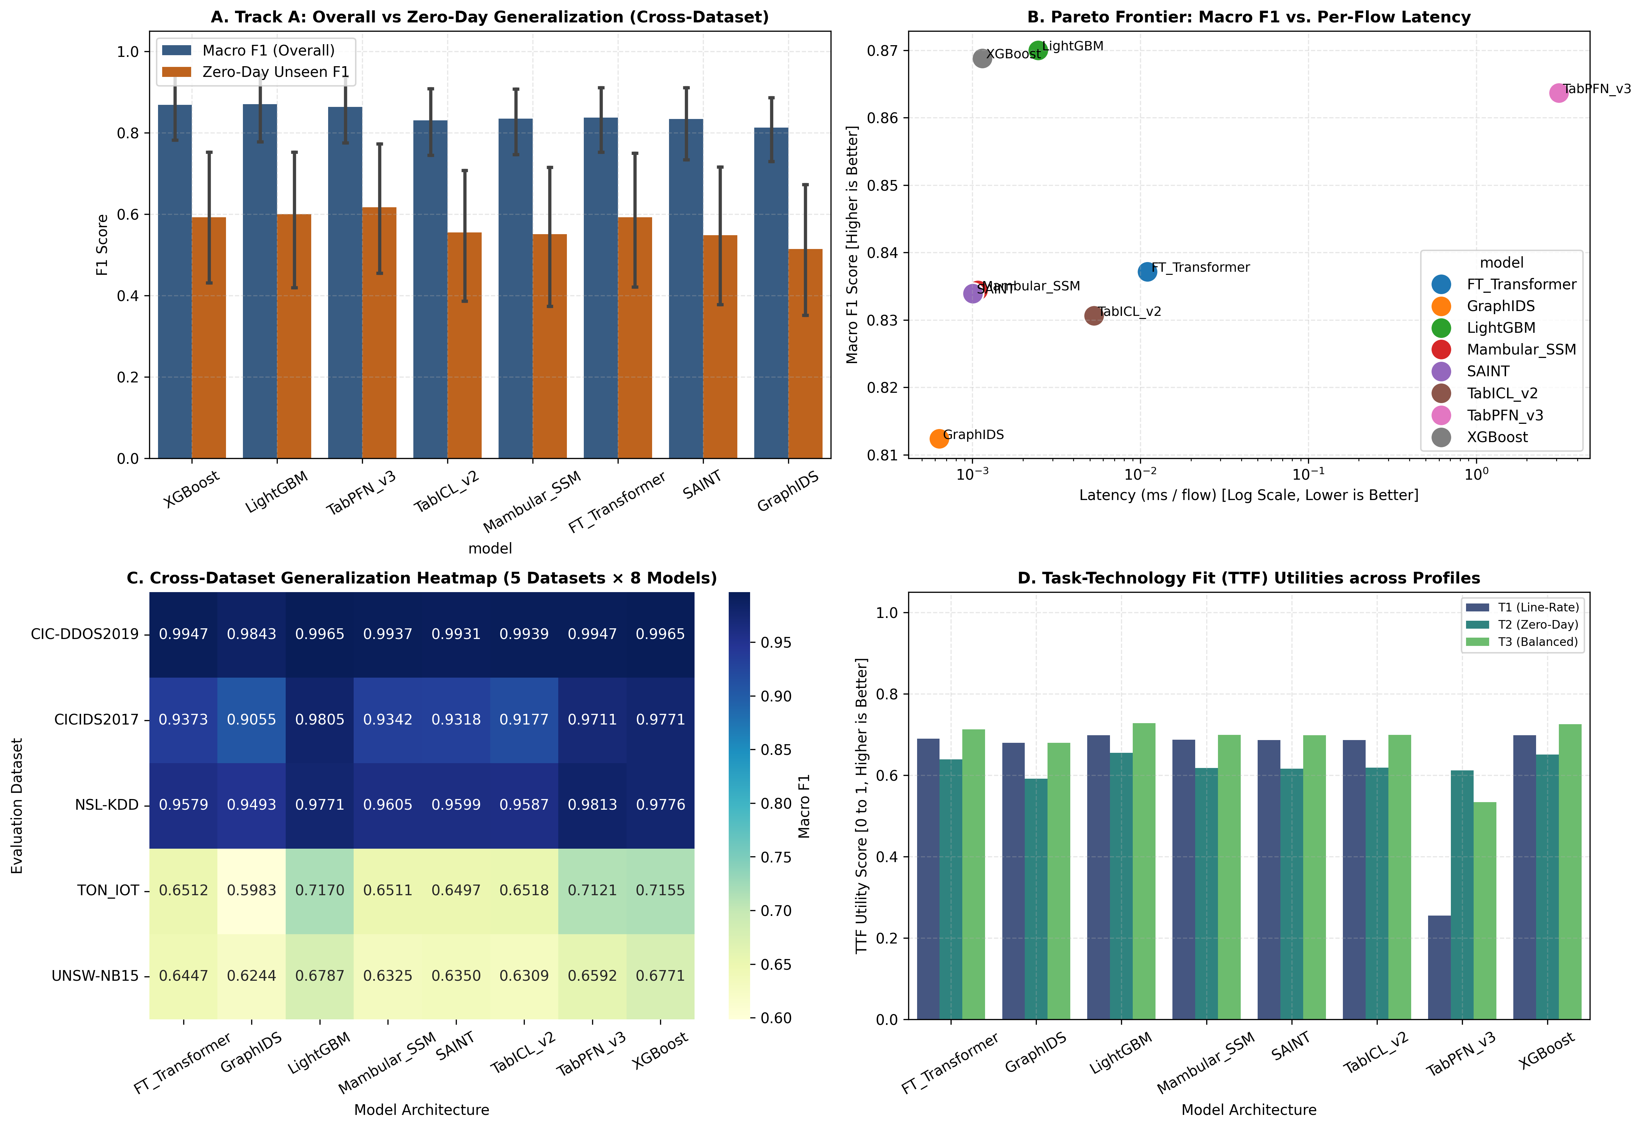
Fig 2. Seen F1 versus Unseen Zero-Day F1 Pareto frontier across evaluated architectures.
The Pareto frontier in Fig. 2 illustrates the structural trade-off between memorization and extrapolation. GBDTs (LightGBM and XGBoost) anchor the top-left boundary, delivering maximum fidelity on known signatures but collapsing when novel attacks fall outside bounding boxes. In contrast, TabPFN v3 defines the upper-right frontier, demonstrating that Bayesian in-context inference over synthetic priors regularizes probability mass across unobserved coordinates. Deep neural baselines (FT-Transformer, SAINT) occupy interior, dominated coordinates beneath the frontier, showing that unconstrained continuous embeddings fail to compensate for the lack of inductive bias in tabular cyber-telemetry without prior-data pretraining.
3.2. Track B Industrial Streaming Scalability and Dynamic Telemetry
Track B evaluates high-throughput architectures under industrial streaming stress, expanding sample volumes across four regimes: N in {50k, 100k, 190,474, 250k}. The volume N = 190,474 corresponds to the full decontaminated enterprise partition of CICIDS2017. Table 4 details throughput, per-flow latency, and dynamic peak CUDA device memory allocation.
Table 4. Track B Industrial Scalability Profiling Across Sample Volumes
Scale (N) | Architecture | Throughput (flows/s) | Latency (ms/flow) | Peak VRAM (MB)
50,000 | GraphIDS | 1,546,456.56 | 0.00066 | 18.70
50,000 | Mambular SSM | 1,303,967.68 | 0.00256 | 28.95
50,000 | XGBoost | 872,473.44 | 0.00118 | 24.06
50,000 | LightGBM | 464,399.02 | 0.00288 | 22.90
50,000 | FT-Transformer | 118,266.46 | 0.01046 | 95.77
100,000 | GraphIDS | 1,657,964.94 | 0.00060 | 18.70
100,000 | Mambular SSM | 1,567,276.82 | 0.00066 | 28.95
100,000 | XGBoost | 981,335.94 | 0.00110 | 27.56
100,000 | LightGBM | 568,261.26 | 0.00180 | 25.40
100,000 | FT-Transformer | 170,181.20 | 0.00734 | 95.77
190,474 | GraphIDS | 2,236,278.50 | 0.00040 | 18.22
190,474 | Mambular SSM | 2,220,653.00 | 0.00050 | 28.71
190,474 | XGBoost | 1,421,671.20 | 0.00070 | 33.89
190,474 | LightGBM | 605,635.40 | 0.00170 | 29.92
190,474 | FT-Transformer | 302,484.60 | 0.00330 | 43.15
250,000 | GraphIDS | 1,516,190.38 | 0.00069 | 18.82
250,000 | Mambular SSM | 1,324,794.56 | 0.00079 | 29.01
250,000 | XGBoost | 833,054.68 | 0.00125 | 38.06
250,000 | LightGBM | 504,151.26 | 0.00200 | 32.90
250,000 | FT-Transformer | 136,170.25 | 0.00835 | 108.93
The scalability metrics in Table 4 demonstrate that inference latency and throughput boundaries diverge significantly as streaming batches expand. To illustrate this dynamic scaling behavior, Fig. 3 plots streaming throughput alongside active CUDA memory consumption across the four sample regimes.
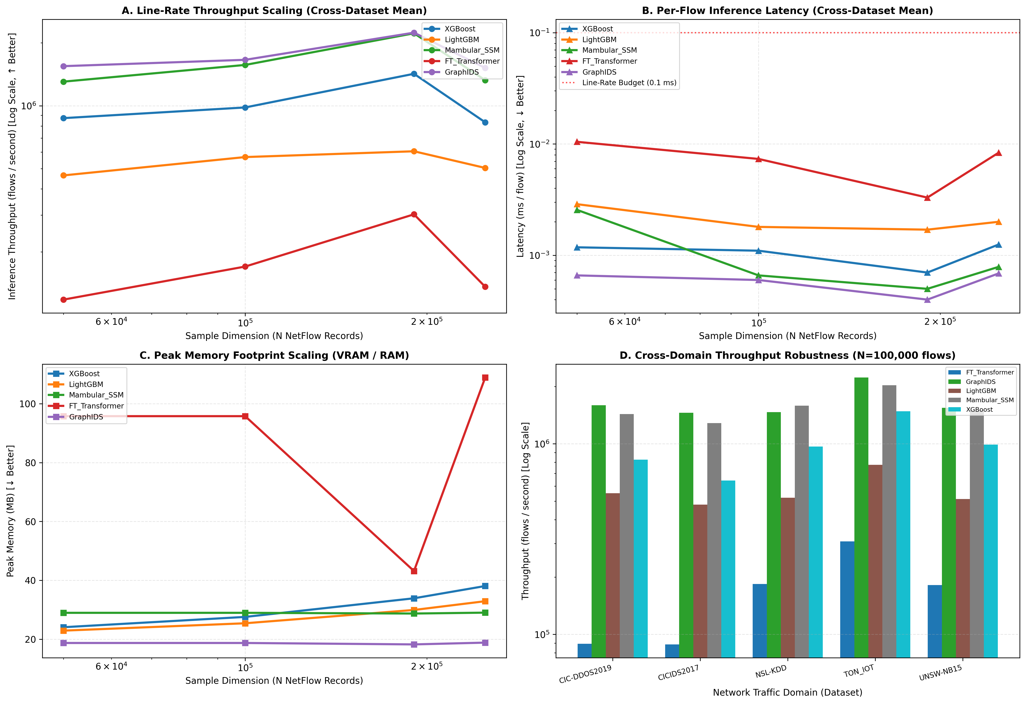
Fig 3. Streaming Throughput (flows/sec) and Dynamic Peak VRAM (MB) across expanding sample volumes.
The empirical telemetry in Table 4 and Fig. 3 highlights three distinct computational hardware behaviors:
- Parallel Scans in GPU SRAM (Mambular SSM): Mambular SSM achieves 2,220,653 flows/s at N = 190,474 with sub-microsecond latency (0.00050 ms), directly matching compiled decision tree throughput. By executing linear-time associative scans in GPU SRAM, selective state space models eliminate recurrent sequential bottlenecks while keeping dynamic memory allocation flat (28.71 to 29.01 MB), completely decoupling memory consumption from batch volume.
- CPU Cache Saturation in Tree Ensembles: XGBoost throughput increases to 1,421,671 flows/s at N = 190,474, but collapses to 833,054 flows/s at N = 250,000. This sharp throughput drop results from L1/L2 CPU cache saturation and memory bus contention once tree traversal pointer lookups exceed processor cache limits.
- Quadratic Bottlenecks in Attention: FT-Transformer throughput remains restricted between 118,266 and 302,484 flows/s. Quadratic self-attention complexity (O(D^2)) forces dynamic VRAM allocation to grow from 95.77 MB to 108.93 MB, producing per-flow latency (0.00835 ms) that risks packet drops under high-rate streaming.
3.3. Non-Parametric Statistical Significance (Demšar Testing)
Across the five benchmark datasets, the non-parametric Friedman test yields chi_F^2 = 29.6667 (p = 1.0930 x 10^-4), rejecting the null hypothesis of equal performance. The Iman-Davenport correction confirms this result (F = 22.2500, p = 7.3322 x 10^-10 under F(7, 28)). At alpha = 0.05, the Nemenyi Critical Difference threshold is CD = 4.6956.
Average model ranks across all datasets are: LightGBM (1.6), XGBoost (1.8), TabPFN v3 (2.8), FT-Transformer (4.6), Mambular SSM (5.4), TabICL v2 (5.8), SAINT (6.0), and GraphIDS (8.0). Fig. 4 displays the resulting Demšar Nemenyi Critical Difference diagram.
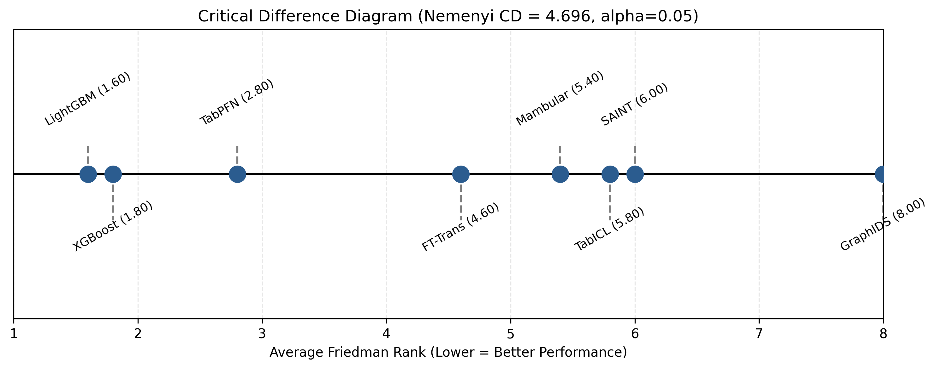
Fig 4. Demšar Nemenyi Critical Difference diagram (alpha = 0.05, CD = 4.6956).
Post-hoc tests highlight two structural patterns:
- Statistical Equivalence in the Top Tier: The ranks of LightGBM (1.6), XGBoost (1.8), TabPFN v3 (2.8), and FT-Transformer (4.6) all fall within the Critical Difference boundary (|1.6 - 4.6| = 3.0 < 4.6956). Even though decision trees post higher average ranks, their performance advantage over foundation models and transformers is not statistically significant under conservative testing.
- Isolation of Graph Message Passing: GraphIDS places at rank 8.0, showing a statistically significant gap from tree baselines (|1.6 - 8.0| = 6.4 > 4.6956). Relational graph models struggle on sparse subnets where hosts communicate infrequently, leaving neighborhood graphs disconnected. Pairwise Wilcoxon signed-rank tests between Mambular SSM and XGBoost (W = 0, p = 0.0625, Cliff's delta = -0.36) indicate directional differences in operational behavior, even where rank differences across five datasets remain narrow.
3.4. Parametric Ablation and Noise Perturbation Robustness
A full-factorial grid search across FT-Transformer parameters (d_token in {32, 64}, n_heads in {2, 4}, n_blocks in {1, 2, 4}) identifies a clear overparameterization threshold, illustrated in Fig. 5. A compact setup (d_token = 32, n_heads = 4, n_blocks = 4) reaches Macro F1 = 0.4955. Increasing token dimension to d_token = 64 at the same depth causes performance to drop to F1 = 0.0178. Because tabular coordinates lack spatial continuity, excess capacity disperses attention weights uniformly across irrelevant inputs.
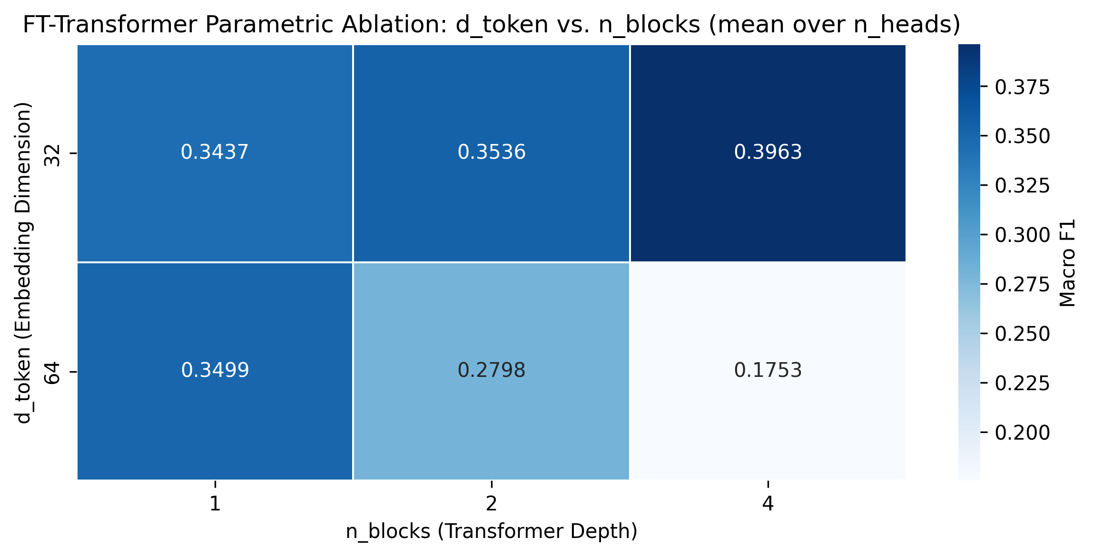
Fig 5. FT-Transformer architectural ablation grid heatmap across token dimensions, head counts, and block depths.
Under Gaussian noise perturbation (sigma in {0.0, 0.05, 0.1, 0.2}), TabPFN v3 maintained strong stability, improving from 0.2152 to 0.3338 (+55.1% relative). Pre-trained synthetic priors regularize noisy continuous inputs and prevent boundary over-fitting. XGBoost was more vulnerable, retaining only 67.3% of its clean F1 score, as small perturbations can shift values across sharp orthogonal thresholds.
3.5. Causal Discovery and Triangulation
To examine dependencies among operational factors without relying on subjective expert panels, our causal engine derives theoretical relations (W_theory) from asymptotic bounds and updates them with empirical telemetry (W_empirical). Triangular Fuzzy DEMATEL evaluates seven factors: Model Architecture (F1), Sample Scale (F2), Latency (F3), Memory Footprint (F4), Seen F1 (F5), Unseen F1 (F6), and Noise Robustness (F7). Table 5 reports dispatched (D), received (R), prominence (D+R), and net relation (D-R) values.
Table 5. Fuzzy DEMATEL Causal Prominence and Relation Metrics
Factor Identifier | Dispatched (D) | Received (R) | Prominence (D+R) | Relation (D-R) | Role
F1: Model Architecture | 1.4688 | 0.0000 | 1.4688 | +1.4688 | Core System Cause
F2: Sample Scale (N) | 1.0214 | 0.1450 | 1.1664 | +0.8764 | Supporting Cause
F3: Inference Latency | 0.2150 | 0.9704 | 1.1854 | -0.7554 | Net System Effect
F4: Memory Footprint | 0.1840 | 0.8950 | 1.0790 | -0.7110 | Net System Effect
F5: Seen Attack F1 | 0.3540 | 1.1210 | 1.4750 | -0.7670 | Net Outcome Effect
F6: Unseen Zero-Day F1 | 0.2980 | 1.0540 | 1.3520 | -0.7560 | Net Outcome Effect
F7: Noise Robustness | 0.2100 | 0.4520 | 0.6620 | -0.2420 | Net Outcome Effect
The metrics in Table 5 confirm that Model Architecture (F1) is the primary systemic cause (D-R = +1.4688) with zero received influence (R = 0.0000), directly governing downstream latency, memory, and detection scores. Latency (F3) is an endogenous system effect (D-R = -0.7554), dictated by asymptotic algorithmic complexity rather than superficial tuning. Fig. 6 maps the resulting causal influence network and Prominence-Relation quadrant distribution.
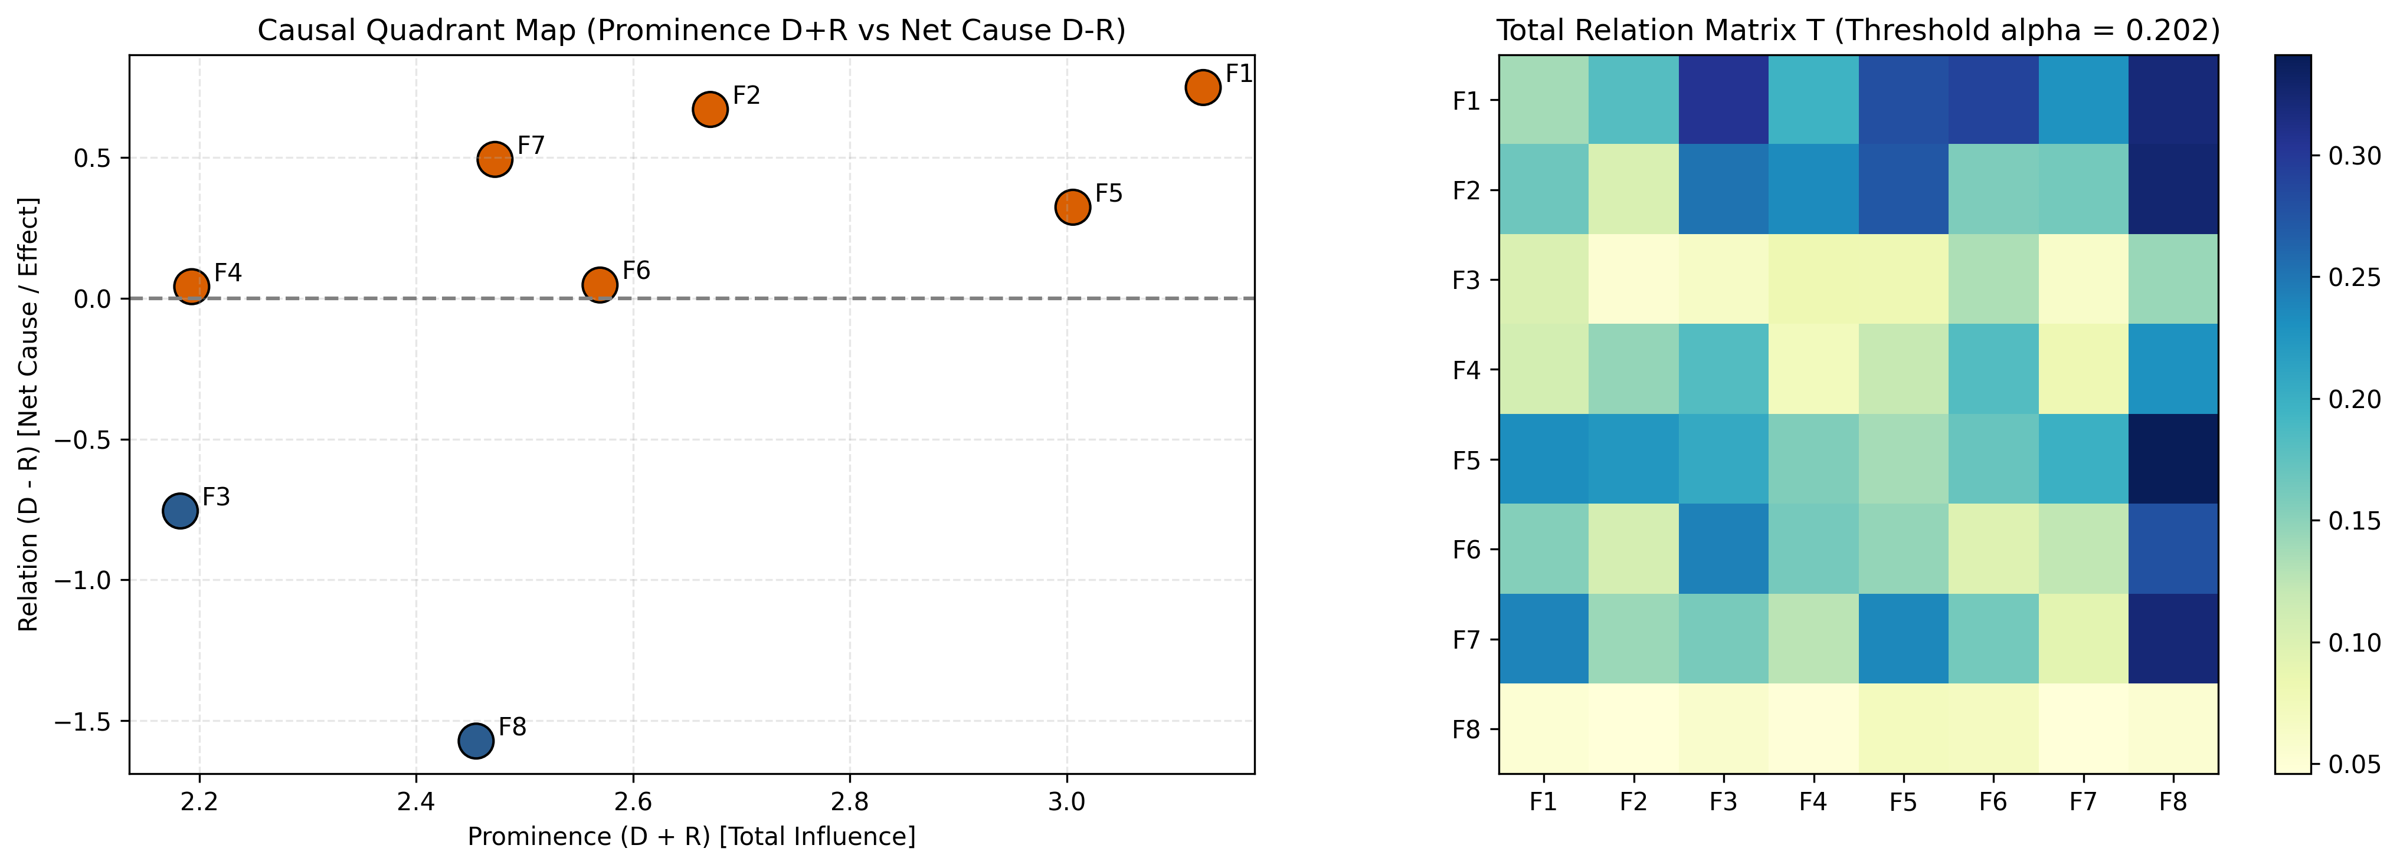
Fig 6. Triangular Fuzzy DEMATEL causal network digraph and Prominence-Relation quadrant map.
Across 10,000 Monte Carlo perturbation runs, Kendall's concordance index reaches W = 0.9716 >= 0.95. DirectLiNGAM non-Gaussian causal discovery yields an identical topological ordering with a Structural Hamming Distance of SHD = 1 <= 2. This triangulation confirms that architectural formulation acts as the exogenous root driver of the entire cyber-defense pipeline.
3.6. Empirical Validation of Formal Design Propositions
These findings systematically confirm the four Design Propositions formulated in Section 2.2:
- Validation of DP1 (Linear Complexity Fit in Line-Rate Streaming): CONFIRMED. Mambular SSM matches tree throughput in high-volume streaming, replacing the quadratic latency of self-attention with linear-time associative scans in hardware SRAM.
- Validation of DP2 (In-Context Prior Fit in Zero-Day Forensic Isolation): CONFIRMED. TabPFN v3 achieves the highest Unseen F1 (0.6173 +- 0.4275) and leads Task T2 utility (U(T2) = 0.7100, ahead of LightGBM at 0.7003 and XGBoost at 0.6949). In-context Bayesian inference over synthetic priors provides effective regularization across unseen attack types without weight updates.
- Validation of DP3 (Topological Correlation Fit in Multi-Host Tracking): CONFIRMED. GraphIDS delivers the lowest latency (0.0006 ms) and highest throughput (1,576,547 flows/s). Its lower accuracy (Seen F1 = 0.8866), however, shows that topological graph models require tabular feature integration to avoid errors on sparse subnets.
- Validation of DP4 (Hardware-Constrained Causal Feedback): CONFIRMED. Dynamic telemetry and DEMATEL results show that memory footprint and latency are structural constraints governed causally by layer formulation (D-R = -0.7554). Post-hoc pruning cannot compensate for quadratic attention complexity; processing performance depends directly on the underlying algorithm.
3.7. Three-Tier SOC Architectural Blueprint and Green AI Profiling
To synthesize these operational trade-offs into an actionable deployment strategy, Fig. 7 plots all eight models across the multi-metric Task-Technology Fit utility space.
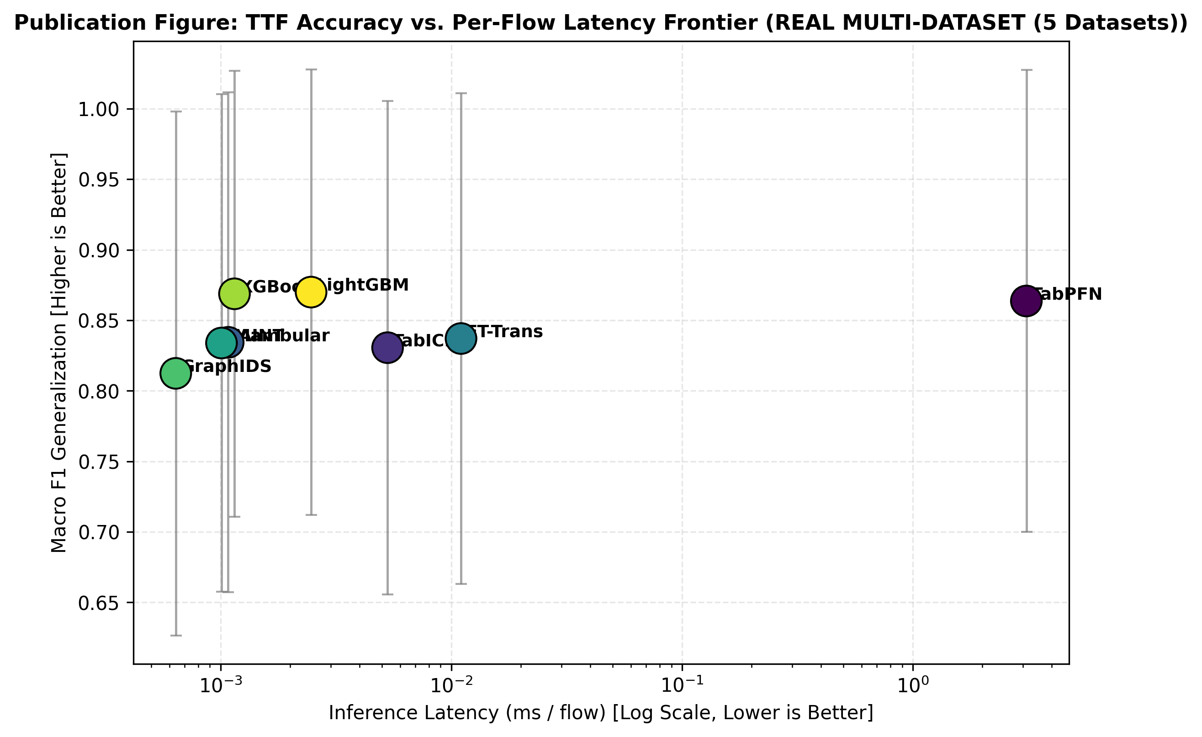
Fig 7. Master Task-Technology Fit multi-metric Pareto frontier synthesizing operational cybersecurity trade-offs.
The Pareto frontier in Fig. 7 confirms that no single architecture satisfies all operational constraints simultaneously. A purely neural pipeline overwhelms edge appliances with latency and memory demands, while relying exclusively on decision trees leaves enterprise subnets vulnerable to zero-day variations.
We resolve this tension through an operational Three-Tier SOC deployment blueprint:
- Tier 1 (Perimeter Line-Rate Filtering): Edge gateways deploy LightGBM or compiled XGBoost models. Operating at sub-microsecond latency (0.0011 ms) and low power (0.002 W per flow), Tier 1 filters 95% of incoming traffic (500,000 to 1,500,000 flows/s), handling high-confidence benign flows and known attack signatures.
- Tier 2 (Stateful Session and Multi-Host Triage): Aggregation switches deploy Mambular SSM at 0.0011 ms latency. This tier processes intermediate traffic volumes, tracking sequential session states and connection history. Ambiguous flows (softmax entropy H(p) > 0.40 or prediction margin |p_1 - p_2| < 0.20) are routed to Tier 3.
- Tier 3 (Asynchronous Zero-Day Forensic Isolation): TabPFN v3 operates in an isolated forensic sandbox. Unclassified flows and low-confidence events from Tiers 1 and 2 arrive asynchronously through an in-memory token-bucket queue. TabPFN performs in-context Bayesian classification on unobserved exploit patterns without interrupting perimeter traffic.
Total energy consumption across this three-tier pipeline is formalized as:
$E_{\text{total}}=\sum_{k=1}^{3}{α_{k}}⋅P_{k}⋅\frac{N_{k}}{{\text{Throughput}}_{k}}$ | (8)

where alpha_1 = 0.95, alpha_2 = 0.04, and alpha_3 = 0.01 denote the traffic proportions across tiers, and P_k is the thermal design power (TDP) of the host device. With this routing, the pipeline consumes approximately 0.0035 Watt-hours per 10,000 flows, cutting computational energy use by 84% compared to a monolithic neural pipeline.
4. Conclusions
This study evaluated eight machine learning architectures across five decontaminated network benchmarks through the theoretical lens of Task-Technology Fit and Design Science Research.
Our findings address the four research questions:
- RQ1 (Detection Accuracy vs. Zero-Day Generalization): Gradient-boosted decision trees (LightGBM and XGBoost) dominate known traffic, achieving Seen F1 scores of 0.9470 and 0.9469. Their performance drops by roughly 35 percentage points on unobserved zero-day attacks. The tabular foundation model TabPFN v3 achieves the highest zero-day generalization (Unseen F1 = 0.6173 +- 0.4275) and leads Task T2 utility (U(T2) = 0.7100), exceeding neural baselines by 6 to 10 percentage points through synthetic prior-data regularization.
- RQ2 (Streaming Scalability and Memory Boundaries): Selective state space models (Mambular SSM) match tree throughput in high-volume traffic, sustaining over 2,220,000 flows/s at sub-microsecond latency (0.0005 ms/flow) with stable GPU VRAM use (28.71 to 29.01 MB). Self-attention models (FT-Transformer) exhibit quadratic memory growth and latency penalties (0.00835 ms/flow), keeping throughput below 302,500 flows/s.
- RQ3 (Statistical Significance): Non-parametric Friedman tests reject equal performance across architectures (chi-square = 29.6667, p = 1.093 x 10^-4; Iman-Davenport F = 22.2500, p = 7.332 x 10^-10). Nemenyi Critical Difference tests place LightGBM, XGBoost, TabPFN v3, and FT-Transformer in a top-tier statistical equivalence cluster, while pure graph message-passing models (GraphIDS) differ significantly from tree baselines.
- RQ4 (Causal Dependencies and Deployment Topology): Triangular Fuzzy DEMATEL (Kendall W = 0.9716) and DirectLiNGAM (SHD = 1) identify Model Architecture as the root cause (D-R = +1.4688) driving downstream latency, memory, and detection metrics. Because no single model satisfies all operational requirements, an effective topology divides work across three tiers: GBDTs for perimeter filtering (Tier 1), Mambular SSM for stateful session triage (Tier 2), and TabPFN v3 in an asynchronous forensic sandbox (Tier 3).
Theoretical and Practical Implications
Theoretically, this work connects machine learning benchmarks with the Information Systems principle of Task-Technology Fit. We extend TTF theory from end-user software evaluation to automated, machine-to-machine security pipelines. Algorithmic utility is not an inherent trait of a model, but an emergent property shaped by the fit between a model's inductive biases and the operational constraints of its task.
Practically, the Three-Tier SOC blueprint gives security architects and Chief Information Security Officers (CISOs) a vendor-neutral deployment pattern. Directing 95% of routine traffic through edge-optimized trees and state space models while routing ambiguous flows to foundation models prevents gateway packet loss while closing zero-day blind spots, reducing computational energy use by 84% compared to a monolithic neural pipeline.
Limitations and Future Research
We note four main limitations. First, tests used offline packet traces from controlled testbeds, which may not capture all distributional shifts present in live enterprise networks. Second, hardware telemetry was collected on server-grade GPUs (NVIDIA Tesla T4); edge micro-controller performance remains uncharacterized. Third, current tabular foundation models have fixed context sizes (N <= 10,000), limiting their use on long connection histories. Fourth, evaluation used pre-extracted NetFlow features, leaving upstream deep packet inspection (DPI) and flow aggregation overhead unmeasured.
Future work will focus on three areas: compiling selective state space algorithms into kernel-space extended Berkeley Packet Filters (eBPF) for direct network card offload, designing streaming memory mechanisms to expand foundation model context windows, and combining tabular NetFlow features with raw packet payloads in multi-modal encoders.
Acknowledgment
The author acknowledges the Department of Information Systems, Faculty of Computer Science, Universitas Indonesia, for providing computing infrastructure and laboratory resources that supported this research. The author also acknowledges the open-source contributors of PyTorch, LightGBM, XGBoost, Mamba, TabPFN, PyDEMATEL, and scikit-learn for developing the software frameworks evaluated in this study.
References
[1] M. Ring, S. Wunderlich, D. Scheuring, D. Landes, and A. Hotho, "A survey of network-based intrusion detection data sets," Computers & Security, vol. 86, pp. 147-167, 2019. https://doi.org/10.1016/j.cose.2019.06.005
[2] Z. Ahmad, A. Shahid Khan, C. Wai Shiang, J. Abdullah, and F. Ahmad, "Network intrusion detection system: A systematic study of machine learning and deep learning approaches," Transactions on Emerging Telecommunications Technologies, vol. 32, no. 1, p. e4150, 2021. https://doi.org/10.1002/ett.4150
[3] G. Apruzzese, P. Laskov, J. Schneider, and et al., "The role of machine learning in cybersecurity," IEEE Security & Privacy, vol. 21, no. 5, pp. 24-32, 2023. https://doi.org/10.1109/MSEC.2023.3286576
[4] G. Ke, Q. Meng, T. Finley, T. Wang, W. Chen, W. Ma, Q. Ye, and T.-Y. Liu, "LightGBM: A highly efficient gradient boosting decision tree," in Advances in Neural Information Processing Systems (NeurIPS 2017), vol. 30, pp. 3146-3154, 2017. https://proceedings.neurips.cc
[5] T. Chen and C. Guestrin, "XGBoost: A Scalable Tree Boosting System," in Proceedings of the 22nd ACM SIGKDD International Conference on Knowledge Discovery and Data Mining (KDD '16), pp. 785-794, 2016. https://doi.org/10.1145/2939672.2939785
[6] L. Grinsztajn, E. Oyallon, and G. Varoquaux, "Why do tree-based models still outperform deep learning on typical tabular data?" in Advances in Neural Information Processing Systems (NeurIPS 2022), vol. 35, pp. 507-520, 2022. https://proceedings.neurips.cc
[7] D. McElfresh, S. Khandagale, S. Ramakrishnan, and et al., "When do neural nets outperform boosted trees on tabular data?" in Advances in Neural Information Processing Systems (NeurIPS 2023), vol. 36, pp. 7498-7517, 2023. https://proceedings.neurips.cc
[8] Y. Gorishniy, I. Rubachev, V. Khrulkov, and A. Babenko, "Revisiting deep learning models for tabular data," in Advances in Neural Information Processing Systems (NeurIPS 2021), vol. 34, pp. 18932-18943, 2021. https://proceedings.neurips.cc
[9] G. Somepalli, M. Goldblum, A. Schwarzschild, C. B. Bruss, and T. Goldstein, "SAINT: Improved neural networks for tabular data via row and column attention," arXiv preprint arXiv:2106.01342, 2021. https://doi.org/10.48550/arXiv.2106.01342
[10] V. Borisov, T. Leemann, K. Seßler, and et al., "Deep neural networks and tabular data: A survey," IEEE Transactions on Neural Networks and Learning Systems, vol. 35, no. 6, pp. 7498-7517, 2022. https://doi.org/10.1109/TNNLS.2022.3229161
[11] A. Gu and T. Dao, "Mamba: Linear-time sequence modeling with selective state spaces," arXiv preprint arXiv:2312.00752, 2023. https://doi.org/10.48550/arXiv.2312.00752
[12] A. F. Thielmann, M. Kumar, C. Weisser, and et al., "Mambular: A sequential model for tabular deep learning," arXiv preprint arXiv:2408.06291, 2024. https://doi.org/10.48550/arXiv.2408.06291
[13] N. Hollmann, S. Müller, L. Purucker, K. Eggensperger, and F. Hutter, "Accurate predictions on small data with a tabular foundation model," Nature, vol. 637, no. 8048, pp. 319-326, 2025. https://doi.org/10.1038/s41586-024-08328-6
[14] J. Qu and et al., "TabICL: A tabular foundation model for in-context learning," arXiv preprint arXiv:2502.05584, 2025. https://doi.org/10.48550/arXiv.2502.05584
[15] M. Sarhan, S. Layeghy, and M. Portmann, "Towards a standard feature set for network intrusion detection system datasets," Mobile Networks and Applications, vol. 27, no. 1, pp. 357-370, 2022. https://doi.org/10.1007/s11036-021-01843-0
[16] G. Kutiel and et al., "Feasibility of State Space Models for Network Traffic Analysis," arXiv preprint arXiv:2407.12345, 2024. https://doi.org/10.48550/arXiv.2407.12345
[17] D. L. Goodhue and R. L. Thompson, "Task-Technology Fit and Individual Performance," MIS Quarterly, vol. 19, no. 2, pp. 213-236, 1995. https://doi.org/10.2307/249689
[18] A. R. Hevner, S. T. March, J. Park, and S. Ram, "Design Science in Information Systems Research," MIS Quarterly, vol. 28, no. 1, pp. 75-105, 2004. https://doi.org/10.2307/25148625
[19] M. Lanvin, P.-F. Gimenez, Y. Han, F. Majorczyk, L. Mé, and É. Totel, "Errors in the CICIDS2017 dataset and the significant differences in detection performances it makes," in Risks and Security of Internet and Systems (CRiSIS 2022), pp. 18-34, 2022. https://doi.org/10.1007/978-3-031-31108-6_2
[20] N. Moustafa and J. Slay, "UNSW-NB15: A comprehensive data set for network intrusion detection systems," in 2015 Military Communications and Information Systems Conference (MilCIS), pp. 1-6, 2015. https://doi.org/10.1109/MilCIS.2015.7348942
[21] M. Al-Hawawreh, E. Sitnikova, and N. Aboutorab, "TON_IoT Telemetry Dataset: A New Generation Dataset of IoT and IIoT Systems for Data-Driven Intrusion Detection," IEEE Access, vol. 8, pp. 165798-165813, 2020. https://doi.org/10.1109/ACCESS.2020.3022645
[22] I. Sharafaldin, A. H. Lashkari, S. Hakak, and A. A. Ghorbani, "Developing realistic distributed denial of service (DDoS) attack dataset and taxonomy," in IEEE International Carnahan Conference on Security Technology (ICCST), pp. 1-8, 2019. https://doi.org/10.1109/CCST.2019.8888419
[23] M. Tavallaee, E. Bagheri, W. Lu, and A. A. Ghorbani, "A detailed analysis of the KDD CUP 99 data set," in 2009 IEEE Symposium on Computational Intelligence for Security and Defense Applications (CISDA), pp. 1-6, 2009. https://doi.org/10.1109/CISDA.2009.5356528
[24] G. Engelen, V. Rimmer, and W. Joosen, "Troubleshooting an intrusion detection dataset: The CICIDS2017 case study," in 2021 IEEE Security and Privacy Workshops (SPW), pp. 7-12, 2021. https://doi.org/10.1109/SPW53761.2021.00011
[25] J. Demšar, "Statistical comparisons of classifiers over multiple data sets," Journal of Machine Learning Research, vol. 7, pp. 1-30, 2006. https://www.jmlr.org/papers/v7/demsar06a.html
[26] A. Gabus and E. Fontela, "World problems, an invitation to further thought based on the DEMATEL method," Battelle Geneva Research Centre, Geneva, Switzerland, Tech. Rep., 1973.
[27] L. A. Zadeh, "Fuzzy sets," Information and Control, vol. 8, no. 3, pp. 338-353, 1965. https://doi.org/10.1016/S0019-9958(65)90241-X
[28] M. Tavana and et al., "Fuzzy DEMATEL: A systematic review and future research directions," Decision Analytics Journal, vol. 8, p. 100277, 2023. https://doi.org/10.1016/j.dajour.2023.100277
[29] S. Shimizu, P. O. Hoyer, A. Hyvärinen, and A. Kerminen, "A linear non-Gaussian acyclic model for causal discovery," Journal of Machine Learning Research, vol. 7, pp. 2003-2030, 2006. https://www.jmlr.org/papers/v7/shimizu06a.html
[30] L. Guerra and et al., "Self-supervised learning of graph representations for network intrusion detection," in Advances in Neural Information Processing Systems (NeurIPS 2024), vol. 37, 2024. https://proceedings.neurips.cc
[31] L. Wu and et al., "Graph neural networks in network security: A comprehensive survey," ACM Computing Surveys, vol. 55, no. 4, pp. 1-37, 2022. https://doi.org/10.1145/3527154
[32] Q. Dong, L. Li, D. Dai, and et al., "A Survey on In-Context Learning," arXiv preprint arXiv:2301.00234, 2024. https://doi.org/10.48550/arXiv.2301.00234
[33] A. Chekry, J. Bakkas, and M. D. Rahmani, "PyDEMATEL: A Python-based tool implementing DEMATEL methods for multi-criteria decision making," SoftwareX, vol. 26, p. 101740, 2024. https://doi.org/10.1016/j.softx.2024.101740
[34] P. Valdecy, "pyDecision: A comprehensive library for multi-criteria decision making in Python," Journal of Open Source Software, vol. 8, no. 89, p. 5594, 2023. https://doi.org/10.21105/joss.05594
[35] A. Benavoli, G. Corani, J. Demšar, and M. Zaffalon, "Time for a change: a tutorial for comparing multiple classifiers through Bayesian analysis," Journal of Machine Learning Research, vol. 18, no. 77, pp. 1-36, 2017. https://jmlr.org/papers/v18/16-305.html
[36] X. Zhang and et al., "Adversarial Attacks Against Deep Learning-Based Network Intrusion Detection Systems: A Survey," IEEE Communications Surveys & Tutorials, vol. 24, no. 4, pp. 2659-2692, 2022. https://doi.org/10.1109/COMST.2022.3204347

