7 VARIABLES FOR CETA:

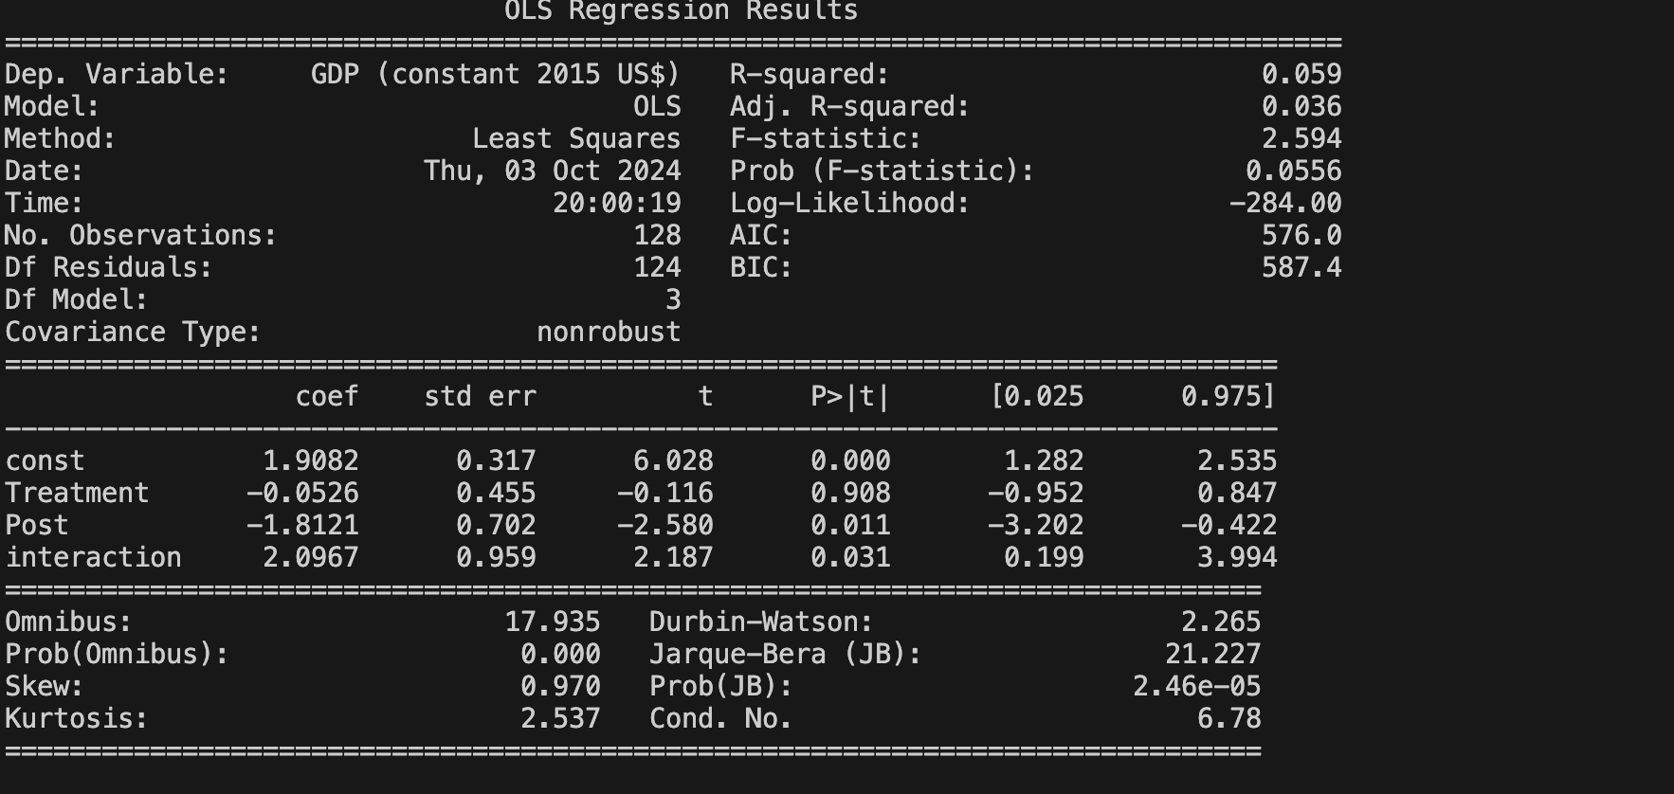

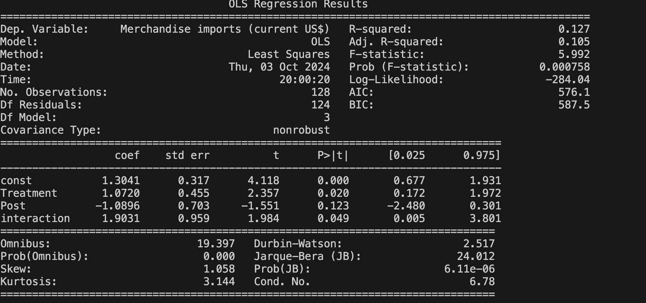

14 FOR CPTPP

