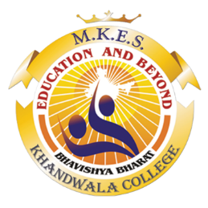

**MALAD KANDIVALI EDUCATION SOCIETY’S**

**NAGINDAS KHANDWALA COLLEGE OF COMMERCE, ARTS & MANAGEMENT STUDIES & SHANTABEN NAGINDAS KHANDWALA COLLEGE OF SCIENCE**

**MALAD [W], MUMBAI – 64**

AUTONOMOUS INSTITUTION

(Affiliated To University Of Mumbai)

Reaccredited ‘A’ Grade by NAAC | ISO 9001:2015 Certified

**CERTIFICATE**

Name: Palak Dave

Roll No: 132 Programme: BSc IT Semester: II

This is certified to be a bonafide record of practical work done by the above student in the college laboratory for the course **IT PLATFORM, TOOLS AND PRACTICES** for the partial fulfilment of Second Semester of BSc IT/CS during the academic year 2021-22.

The journal work is the original study work that has been duly approved in the year 2021-22 by the undersigned.

|  |  |  |
| --- | --- | --- |
| ____________________  External Examiner |  | ____________________  Mrs. Sweety Garg  (Subject-In-Charge) |
| Date of Examination: | (College Stamp) |  |