**1.PYTHON PROGRAM TO PRINT CALENDAR**

CODE:

# Program to display calendar of the given month and year

# importing calendar module

import calendar

yy = 2022 # year

mm = 1 # month

# To take month and year input from the user

# yy = int(input("Enter year: "))

# mm = int(input("Enter month: "))

# display the calendar

print(calendar.month(yy, mm))

**OUTPUT:**

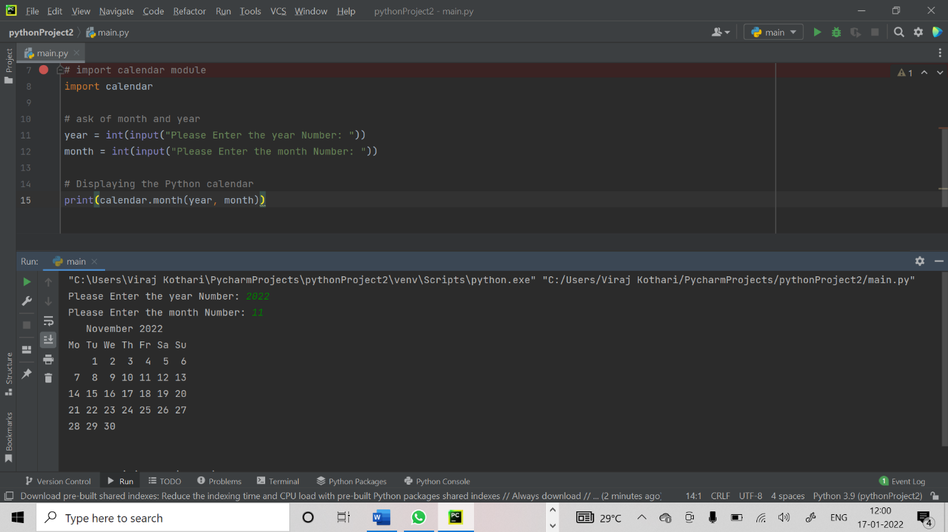

**2.PYTHON PROGRAM TO FIND CUBE OF OF A NUMBER**

# Python program to find the largest number among the three input numbers

# change the values of num1, num2 and num3

# for a different result

num1 = 10

num2 = 14

num3 = 120

# uncomment following lines to take three numbers from user

#num1 = float(input("Enter first number: "))

#num2 = float(input("Enter second number: "))

#num3 = float(input("Enter third number: "))

if (num1 >= num2) and (num1 >= num3):

largest = num1

elif (num2 >= num1) and (num2 >= num3):

largest = num2

else:

largest = num3

print("The largest number is", largest)

**OUTPUT:**

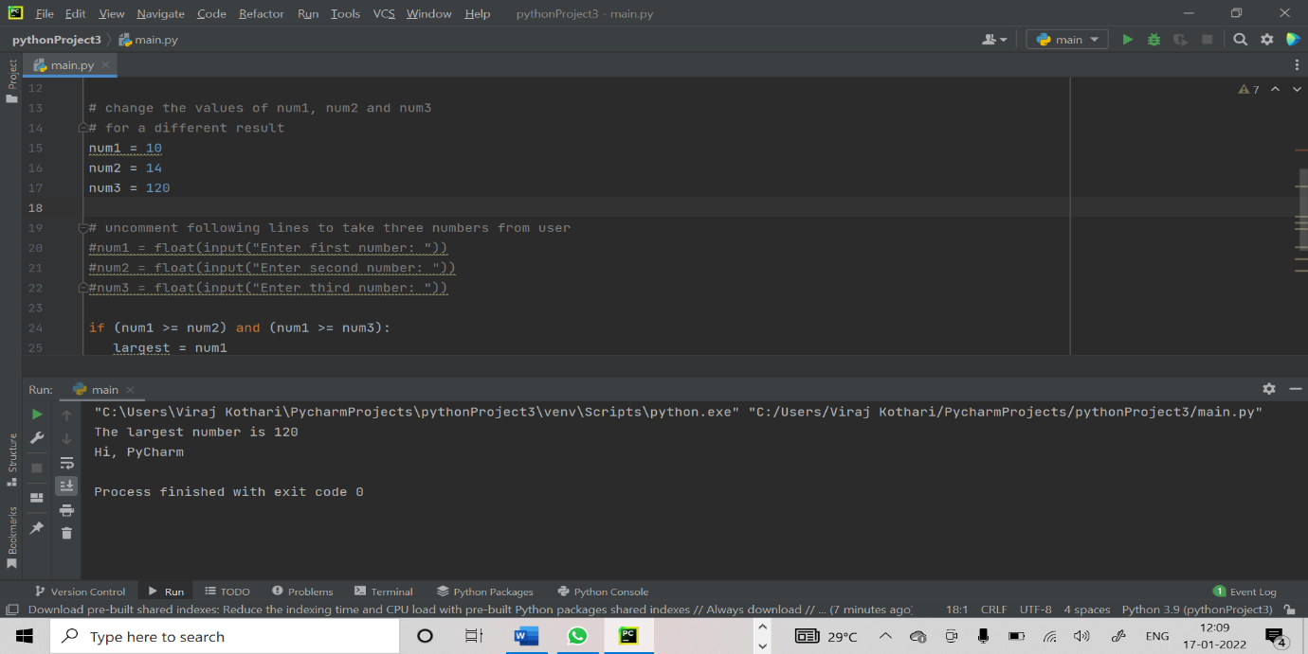

**3.PYTHON PROGRAM TO FIND LARGEST OF 3 NUMBERS**

**CODE:**

# Python program to find the largest number among the three input numbers

# change the values of num1, num2 and num3

# for a different result

num1 = 10

num2 = 14

num3 = 120

# uncomment following lines to take three numbers from user

#num1 = float(input("Enter first number: "))

#num2 = float(input("Enter second number: "))

#num3 = float(input("Enter third number: "))

if (num1 >= num2) and (num1 >= num3):

largest = num1

elif (num2 >= num1) and (num2 >= num3):

largest = num2

else:

largest = num3

print("The largest number is", largest)

**OUTPUT:**

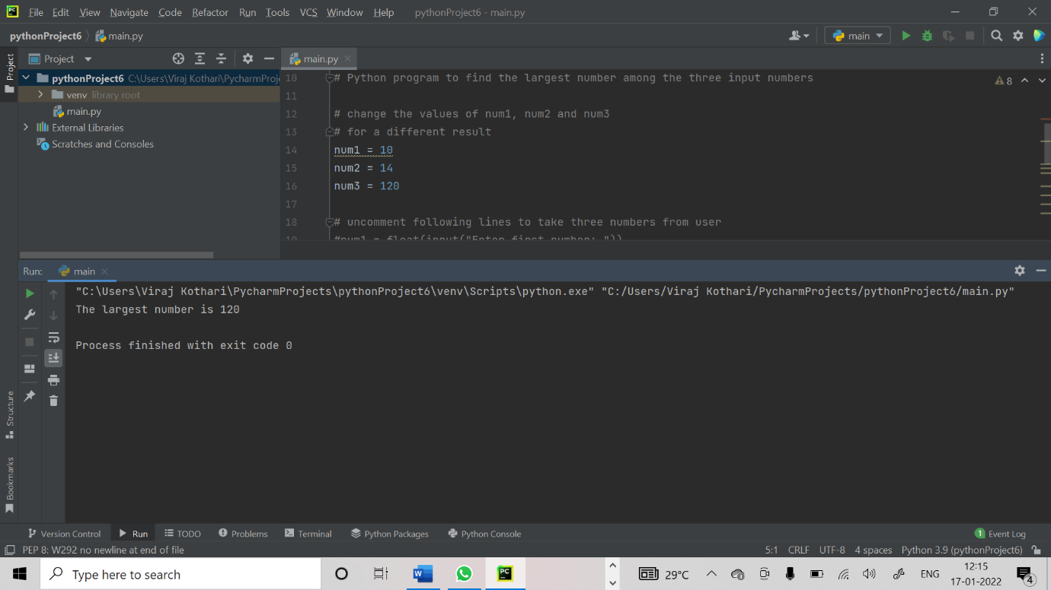

**4.PYTHON PROGRAM TO PRINT NATURAL NUMBER 1 TO N**

# Python program to print numbers from 1 to n

n = int(input("Please Enter any Number: "))

print("The List of Natural Numbers from 1", "to", n)

for i in range(1, n + 1):

print (i, end = ' ')

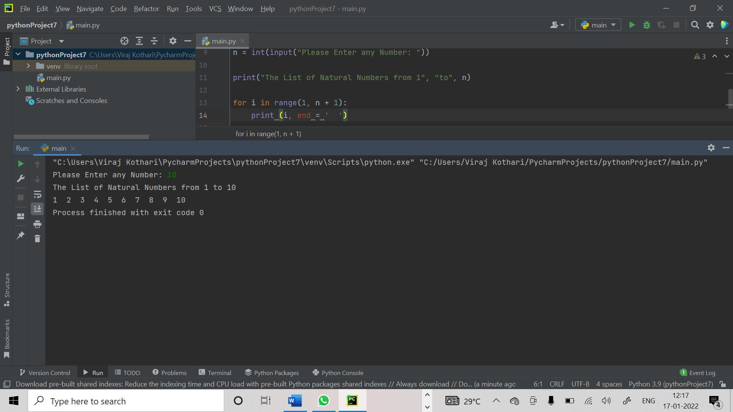

**5. PYTHON PROGRAM FOR LEAP YEAR**

**CODE:**

# Python program to print numbers from 1 to n

n = int(input("Please Enter any Number: "))

print("The List of Natural Numbers from 1", "to", n)

for i in range(1, n + 1):

print (i, end = ' ')

**OUTPUT:**

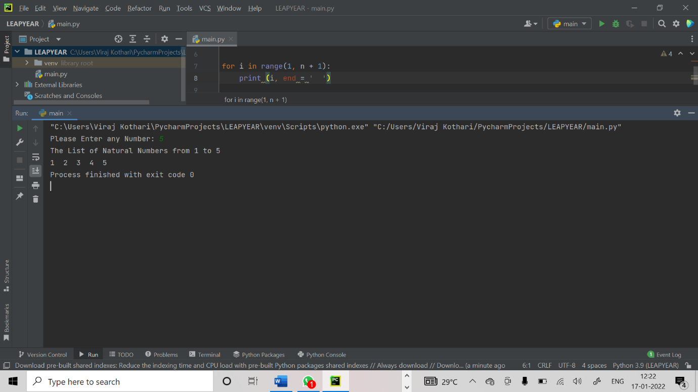

6.PYTHON PROGRAM TO FIND ODD OR EVEN

num = int(input("Enter a number: "))

if (num % 2) == 0:

print("{0} is Even number".format(num))

else:

print("{0} is Odd number".format(num))

OUTPUT:

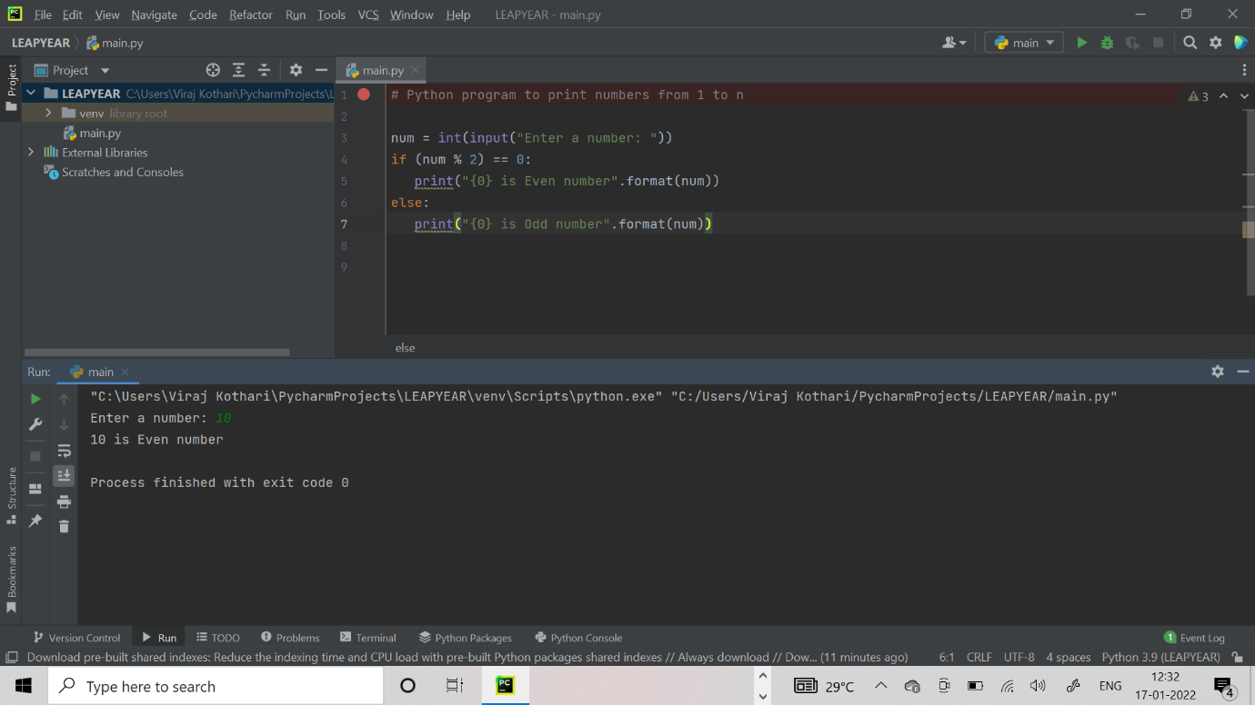

7.PYTHON PROGRAM TO PRINT EVEN NUMBER FROM 1 TO 100

**CODE:**

# Python program to print Even Numbers in given range

start, end = 1, 100

# iterating each number in list

for num in range(start, end + 1):

# checking condition

if num % 2 == 0:

print(num, end = " ")

**OUTPUT:**

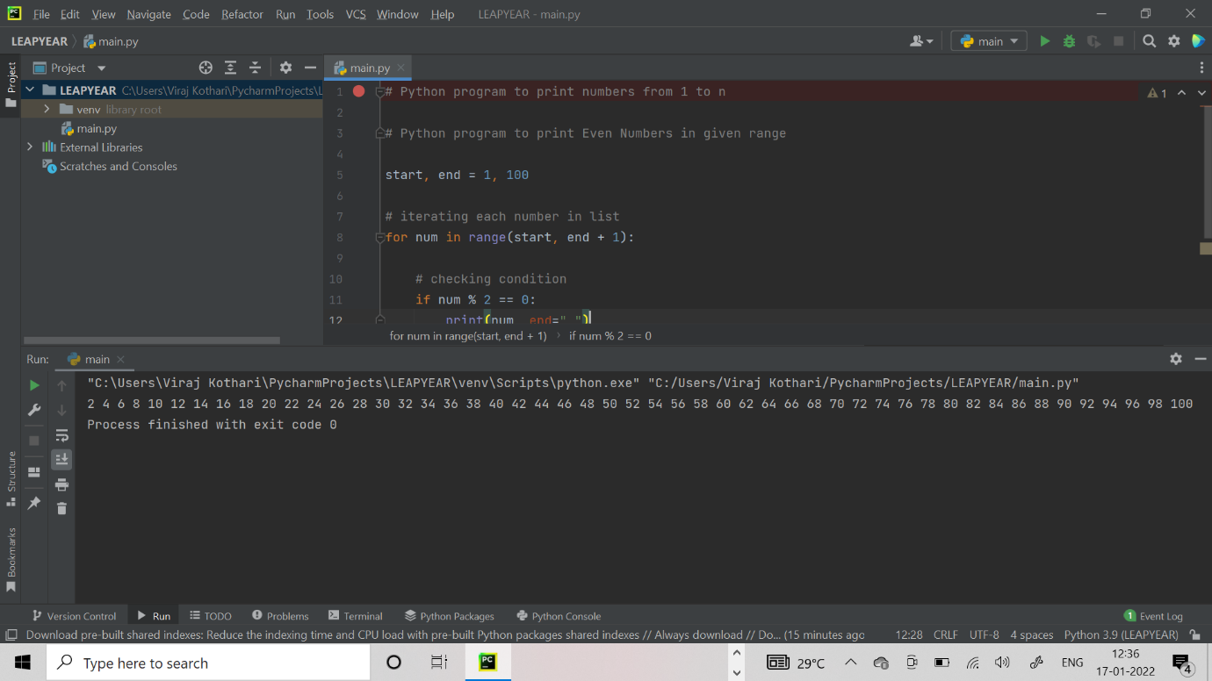

**8. PYTHON PROGRAM TO PRINT ODD NUMBERS FROM 1 TO 100**

**CODE:**

**# Python program to print Even Numbers in given range**

**start, end = 1, 100**

**# iterating each number in list**

**for num in range(start, end + 1):**

**# checking condition**

**if num % 2 != 0:**

**print(num, end = " ")**

**OUTPUT:**

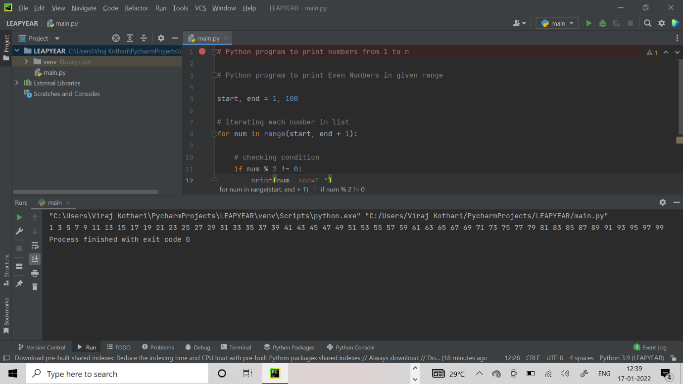

**9. PYTHON PROGRAM TO PRINT NEGATIVE NUMBERS IN RANGE**

**CODE:**

# Python program to print negative Numbers in given range

start, end = -10, 100

# iterating each number in list

for num in range(start, end + 1):

# checking condition

if num < 0:

print(num, end = " ")

**OUTPUT:**

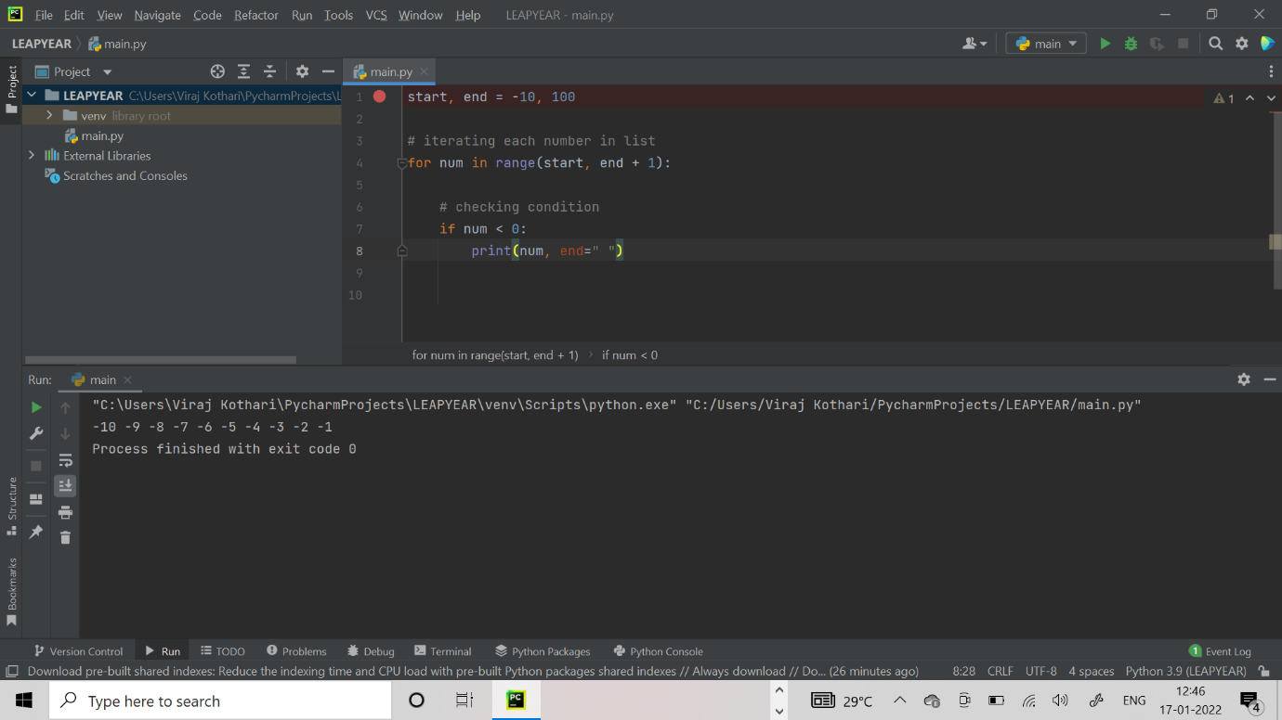

**10. PYTHON PROGRAM TO PRINT POSITIVE NUMBER IN A RANGE**

**CODE:**

**# Python program to print positive Numbers in given range**

**start, end = -20, 19**

**# iterating each number in list**

**for num in range(start, end + 1):**

**# checking condition**

**if num >= 0:**

**print(num, end = " ")**

**OUTPUT:**

