PRACTICAL-NO:1

AIM: Creating account, repository on GitHub and Cloning repository in GitHub Page.

**GITHUB**:

1. GitHub is a code hosting platform for collaboration and version control.

2. GitHub lets you (and others) work together on projects. ADVANTAGES:

**1. It makes it easy to contribute to your open source projects**

To be honest, nearly every open-source project uses GitHub to manage their project. Using GitHub is free if your project is open source and includes a wiki and issue tracker that makes it easy to include more in-depth documentation and get feedback about your project.

**2. Documentation**

By using GitHub, you make it easier to get excellent documentation. Their help section and guides have articles for nearly any topic related to git that you can think of.

**3.** **Track changes in your code across versions**

When multiple people collaborate on a project, it’s hard to keep track revisions—who changed what, when, and where those files are stored. GitHub takes care of this problem by keeping track of all the changes that have been pushed to the repository. Much like using Microsoft Word or Google Drive, you can have a version history of your code so that previous versions are not lost with every iteration.

**CREATING A REPOSITORY:**

Create a repository

In the upper-right corner of any page, use the drop-down menu, and select New repository. Type a short, memorable name for your repository. ...

Optionally, add a description of your repository. ...

Choose a repository visibility. ...

Select Initialize this repository with a README. Click Create repository.

**CLONING REPOSITORY:**

Clone a repository using the command line

You can use Sourcetree, Git from the command line, or any client you like to clone your Git repository. These instructions show you how to clone your repository using Git from the terminal.

From the repository, click + in the global sidebar and select Clone this repository under Get to work. Copy the clone command (either the SSH format or the HTTPS).

If you are using the SSH protocol, ensure your public key is in Bitbucket and loaded on the local system to which you are cloning.

From a terminal window, change to the local directory where you want to clone your repository. Paste the command you copied from Bitbucket.

REPOSITORY CREATED:

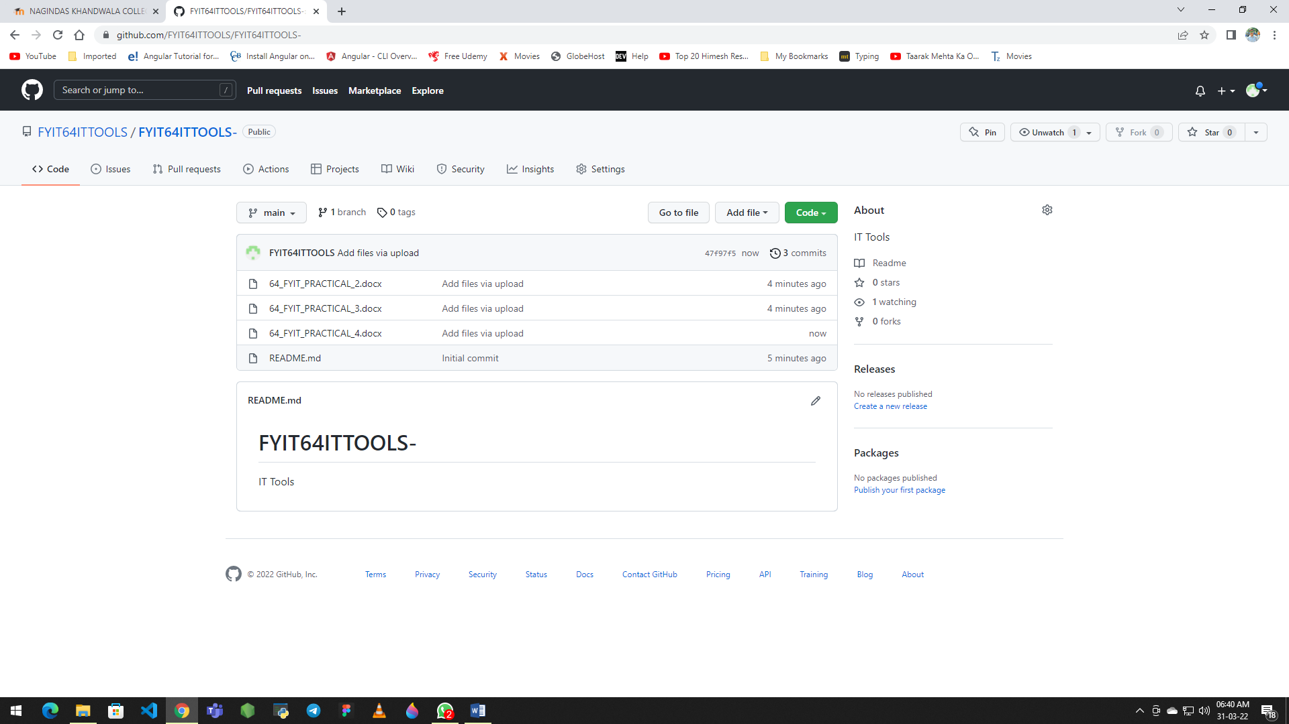

**REPOSITORY LINK:**

<https://github.com/FYIT64ITTOOLS/FYIT64ITTOOLS.git>