PRACTICAL-NO:4

**AIM**: INTRODUCTION and CONTRIBUTING TO WIKIPEDIA.

1. What is Wikipedia?

Wikipedia audio speaker is a free content, multilingual online encyclopedia written and maintained by a community of volunteers through a model of open collaboration, using a wiki-based editing system. Individual contributors, also called editors, are known as Wikipedians. Wikipedia is the largest and most-read reference work in history. It is consistently one of the 15 most popular websites ranked by Alexa; as of 2021, Wikipedia was ranked the 13th most popular site. It is hosted by the Wikimedia Foundation, an American non-profit organization funded mainly through donations.

**b) Steps to Create Account on Wikipedia**

**STEP1: Click the "Sign in/create account" link in the upper right corner on the Wikipedia website.**

**STEP2: Click the link "Create One" above the boxes. This will take you to**[**the account creation page**](https://en.wikipedia.org/w/index.php?title=Special:UserLogin&type=signup)**(of course, if you are reading this on line, you could use this link directly instead of following step one and two).**

**STEP3: Type the captcha. Wikipedia now presents people with a simple captcha to solve to prevent against computer activated programs signing up. Type it in the box below (refresh the image if you must) and move on to the next step.**

**STEP4**:  **Enter your desired user name in the "Username:"** box. This will be the name of your account. For suggestions for usernames, see below.

* Scramble your real name. No one will know. Make it an anagram, meaning that they are words that can be rearranged to form, in this case, your real name.
* Look to social media. If you have a social media account, you can use the same username as your social media username (if it is not taken), but you may not want to do so if you are a famous user.
* Think creatively. Have any passions, including computers, languages, companies, etc.? Choose a username suitable for your interests.
* Don't choose a username that promotes another business, flags you as a vandal, impersonates an admin, or is just plain annoying. Those get blocked quickly.

**STEP5**: Enter a password in the "Password:" box. Make sure that you can remember your password, but for it to be hard for anyone else to guess.

**STEP6**: Re-enter the same password as above in the "Confirm Password:" box.

**STEP7**: Enter your e-mail address in the "E-mail" box if you want to. For more information about this, see below in the "Tips" section.

**STEP8**: **Click the big "Create account" button.**

**STEP9**: **Congratulations!** You are now a registered user in Wikipedia!

**c) Creating Page on Wikipedia**

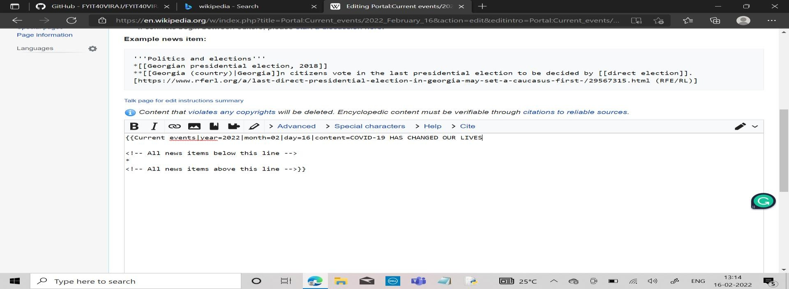

d) Edit your page

