



**Module Code & Module Title**

CS6P05NI-Project

**Assessment Weightage & Type**

5% Final Year Project Proposal

**Semester**

2023 Autumn

**PROJECT TITLE:** MitraNepalAdventurousTrekkingApp

**Student Name:** Prekshya Subedi

**London Met ID:** 21049562

**College ID:** np01cp4a210218

**Submitted to:** (External Supervisor- Shekhar Timsina Sir)

(Internal Supervisor- Bisal G.C Sir)

**Assignment** **Submission Date:** 29th November 2023

**Word Count :**

*I confirm that I understand my coursework needs to be submitted online via MST under the relevant module page before the deadline in order for my assignment to be accepted and marked. I am fully aware that late submissions will be treated as non-submission and a mark of zero will be awarded.*

Table of Content

**1.** **Introduction** 4

1.1 Problem scenario 4

1.2 The project as a solution 4

**2.** **Aims and Objectives** 5

a. Aims 5

**3.** **Expected Outcomes and Deliverables** 6

**4.** **Project risks, threats and contingency plans** 7

**5. Methodology:** 8

**6. Resource Requirements:** 9

6.1 Software Requirements 9

6.2 Hardware Requirements 9

**7. Work breakdown structure:** 10

**8. Milestones:** 11

**9. Project Gantt chart** 12

**10. Conclusion** 13

**11. Bibliography & References** 14

Table of Figures

Figure 1: Work Breakdown Structure 10

Figure 2: Milestones of the project 11

Figure 3: Gantt Chart 12

**Mitra Nepal Adventurous Trekking App**

# **Introduction**

Tourism is the largest source of income globally, with a $500 billion valuation in 2007. Traveling has become an increasingly common recreational activity around the world. Through generating revenue, creating jobs, and promoting cross-cultural understanding, the tourism sector plays a vital role in the global economy.

Travelers from all over the world are attracted to Nepal because of its distinctive combination of natural beauty, cultural legacy, and adventure opportunities. Trekking tour offices play a crucial role in facilitating trekking adventures in Nepal by offering services such as guides, permits, transportation, and accommodations.

Mitra Nepal is a leading Trekking and Tour Company in Nepal which provides package based tour as well as customized tour to its customers. Customer can book the packages online of tour or trekking of their choice through this app. The App contains different packages which include the details about the tour like duration, difficulty levels, Map showing trekking routes, pricing details with images and videos with description about the trip.

## Problem scenario

Tourism has great Importance in Nepal, but due to limited Connectivity it is not able to sufficiently develop in this sector. Many trekking areas have limited connectivity or no internet connectivity. Similarly, we could find incorrect or outdated information about trekking, tour routes, accommodations which could lead to dangerous situation. Customer’s safety and privacy is also a concern. Language and cultural differences could also be a problem.

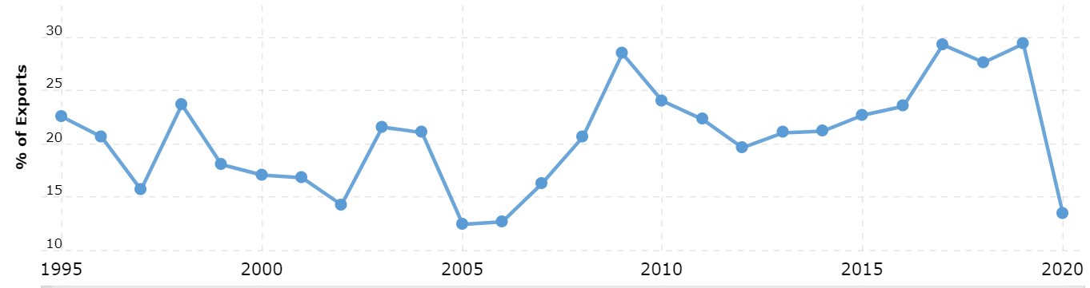

Figure : Nepal Tourism Statistics 1995-2023

Above figure shows the statistics from 1995 to 2023. The years 2016 to 2020 were a remarkable rollercoaster for Nepal's tourism industry. There was a significant uptick in 2017, with a 42.97% growth, meaning that tourism earnings reached 712,000,000.00. With rises of 3.93% and 8.24% in 2018 and 2019, respectively, this positive momentum continued, resulting in a revenue of 801,000,000.00 in 2019. However, the business suffered a great lot when the global COVID-19 pandemic struck in 2020, resulting in a startling 70.29% fall in tourism income, which fell to 238,000,000.00. This sudden decline in 2020 highlights how susceptible Nepal's tourism business is to outside shocks, highlighting the necessity for adaptability and resilience in the sector to deal with unforeseen obstacles and promote recovery in the post-pandemic environment. (MacroTrends, 2023)

## The project as a solution

An Attractive, user-friendly app with a responsive design. Providing offline services, regularly updating and verifying data with easy payment methods. Ensuring that any personal data collected is secured. Allowing customers to choose the package of their choice and customize any tours of their interest. Assigning travel or tour guides according to their language preference.

# **Aims and Objectives**

The aims and objective of the project are as follows:

## Aims

* + - * To create attractive user-friendly app with a responsive design.
      * To provide easy Booking and Online Reservations system.
      * To Expand Market reach.
  1. **Objectives**
* Creating clear and engaging content describing about the tour details like routes, difficulty level, duration, map showing trekking routes and pricing.
* Creating secure and efficient booking system with various payment methods along with confirmation emails and booking receipts.
* Providing gear rental services for customers who may not have their own equipment.
* Allowing customer to take part in photo contest by sharing most beautiful photo that they capture during the journey.
* Allowing customers to customize their own tour such as choosing locations, routes, selecting dates and adding extra activities.
* Ensuring that the Web app and Mobile app are accessible to international travelers, adventure enthusiasts and potential trekkers around the world.

# **Expected Outcomes and Deliverables**

After the completion of the project a web app as well as mobile app is expected. It will be able to perform the following task.

* To show different packages related to tours and travels and allow customer to book the package of their choice.
* To provide personalized services, customer can request for customized tour facility according to their preferences and interests.
* To provides the facility of car renting service where customer can rent cars with reliable drivers.
* To request the trekking gears.
* To choose the guide according to their language preference.
* To recommend different packages to customer.
* To view breath taking views of different location.
* Customer can review about the journey.
* Admin can send notification to their customer about competitions with attractive offers like photo contest where customer can take part in contest by capturing the beauty of the trek and tour and uploading it.

# **Project risks, threats and contingency plans**

Risk is the anticipation of loss, a prospective issue that could or might not arise in the future. Usually, it results from a lack of knowledge, authority, or time. Software risks are instances where there is a chance that a loss will occur throughout the software development process. Any loss could result from a rise in manufacturing costs, the creation of subpar software, or failing to finish the project on schedule (International Software test institute, 2023).

Various risks and threats are expected during the development of this system. Some of them are mentioned below:

* Difficulties on developing UI.
* OS system could crash.
* Could be difficult to implement all the features on time.
* Slow internet speed.
* Difficulties in code bugging.
* Incompatible hardware and Technology

The risks above could be minimized by following consistency plans:

* Researching and learning Designing.
* Backing up the data.
* Trying to complete the project fast.
* Connecting fast internet speed.
* Identifying the bug and researching.
* Testing app compatibility before starting the project.

# **5. Methodology:**

For this project, I have planned to implement Kanban Methodology. Agile is a project technique that encourages breaking down large projects into smaller parts. It places a premium on ongoing cooperation, continual improvement, and high levels of consumer involvement. There are several frameworks that teams can use to implement Agile, with Kanban being one of them. Kanban is about more than just using cards to help manage just-in-time deliveries. The Kanban framework is intended to assist teams in reducing bottlenecks, increasing efficiency, increasing quality, and increasing productivity. Kanban is founded on four fundamental concepts and six core practices.

**The four principles of the Kanban methodology are:**

* **Begin right now. Concentrate on what you're doing right now. Understand the existing procedures, including what works and what doesn't.**
* **Take a step-by-step strategy. Consider ways to gradually alter your operations over time. Avoid making drastic adjustments.**
* Keep roles. Unlike other frameworks that promote their own unique roles (such as [Scrum master](https://www.wrike.com/project-management-guide/faq/what-is-an-agile-scrum-master/)), Kanban emphasizes working with the roles your team already has.
* Encourage leadership. Innovation and ideas for improvement should be promoted at all levels. Encourage every employee to act as a leader, regardless of role or title.

# **6. Resource Requirements:**

The basic requirements to complete this projects are as follows:

## 6.1 Software Requirements

|  |  |
| --- | --- |
| Technology Version | Purpose |
| .net 6.0 | BackEnd |
| MySQL 8.0 | Database |
| Flutter | FrontEnd |
| Proto.io | Wireframes and Prototype |
| InstaGantt | Gantt Chart |
| Microsoft Word | Documentation |
| Draw.io | UML Diagram |

## 6.2 Hardware Requirements

1. PC with windows 10
2. Android Phone

# **7. Work breakdown structure:**

Project management techniques like work breakdown structures provide a visual manner to list the deliverables for a project. This is achieved by outlining significant turning points inside a hierarchical structure that divides complicated undertakings into more manageable chunks. Work breakdown structures are therefore appropriate for complicated projects with plenty of processes and stakeholders (Planview, 2023).

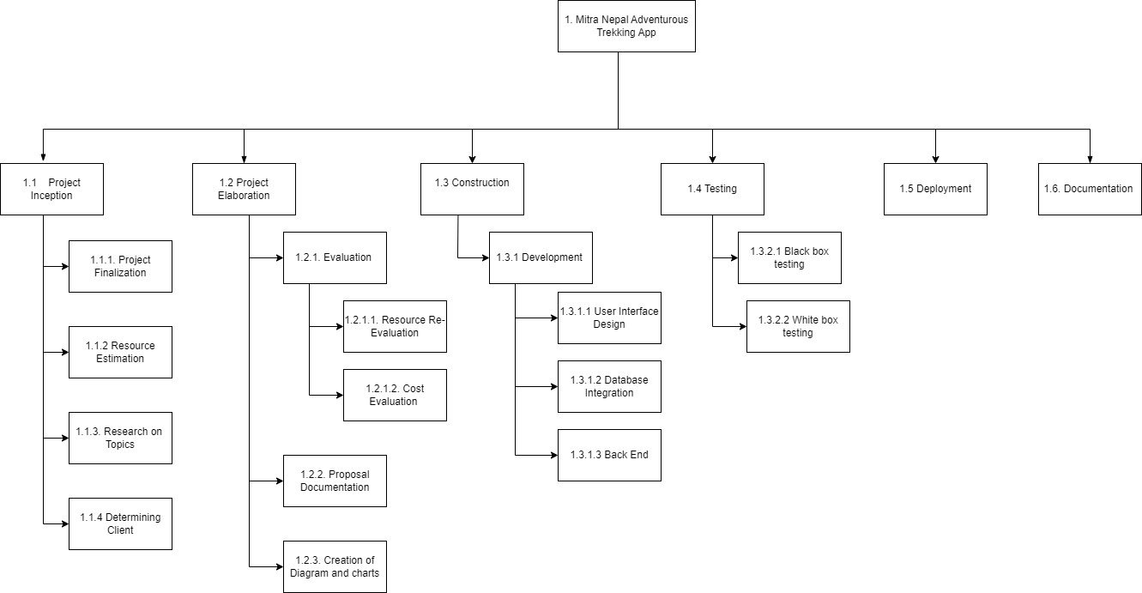

Figure 3: Work Breakdown Structure

Work breakdown structure for the project is shown in the figure below. To complete the project smoothly without any complications, the work to be done throughout the project is divided through this work breakdown structure. The first step to start the project is project Inception where the finalization of project then resources estimation is done followed by research on topics and final step is to determine the client. Then in project Elaboration phase the re-evaluation of project is done along with cost evaluation to complete the project. Then the proposal of project is prepared and diagrams and charts are created. Then the construction of the project is started through development where the first step is to create user interface design then the database is integrated and finally the backend development is done. After the completion of development part the program is tested by white box testing and black box testing methods. The project is deployed and then the documentation of the project is done.

# **8. Milestones:**

A project milestone is a tool for project planning that is used to identify a certain point in a project timeline. Project milestones can signify the beginning and end of a project, the conclusion of a significant work phase, or anything else that's important to emphasize in a project, including the creation of project deliverables. By assisting everyone in understanding the goals of the project and the activities that must be done to attain them, milestones aid project teams in coordinating their efforts (Tristancho, 2023).

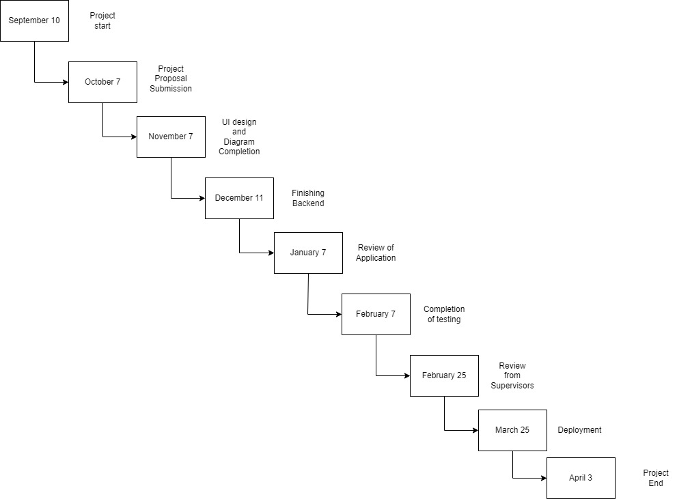

Figure 4: Milestones of the project

The given figures shows the timeline for the project to finish. Pitching idea and topic finalization was first milestone that was achieved. Then submitting the project proposal, which gives the idea about the entire project. The third milestone will be creating UI design and completing diagrams. Finishing backend would be the next milestone. After backend submission the application would be reviewed and then the testing is done. Then the project is reviewed from supervisor. The project is deployed and the documentation is completed which is most important part of the project. The project ends which is reviewed for the final time and submitted to the RTE.

# **9. Project Gantt chart**

A Gantt chart is a project management tool that helps with the planning and scheduling of projects of all sizes. They are especially effective for project visualization. Project managers can track progress using Gantt charts, which are graphical representations of activities against time (APM, 2023).

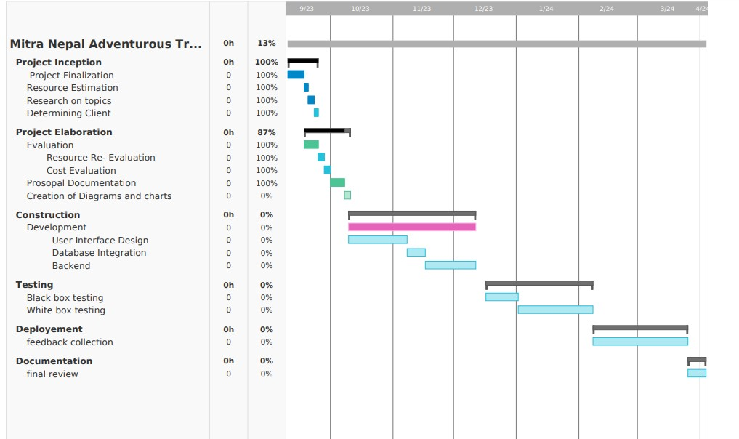

Figure 5: Gantt Chart

The figure shows the Gantt chart of the project.

# **10. Conclusion**

The creation and deployment of an app could greatly improve the business's online presence and provide a strong platform for reaching out to prospective clients around the world. Having a strong online presence is essential for increasing brand recognition and expanding the company's customer base.

Platform for direct interaction is also provided by the interactive elements built within the app, like review sections, comments, and direct client inquiries. Genuine evaluations and good interactions can work as powerful testimonies, influencing other potential customers and establishing a reliable online reputation.

A systematic and thorough approach will be used to assure the project's success. Every part of app development and internet visibility improvement will be properly planned and carried out. By breaking the job down into smaller, manageable pieces, you may create a more focused and effective workflow. This comprehensive and detail-oriented strategy not only ensures the project's successful completion, but also lays the groundwork for future growth and expansion in the competitive trekking and adventure tourism market.

# **11. Bibliography & References**

APM, 2023. *What is Gantt Chart?.* [Online]   
Available at: https://www.apm.org.uk/  
[Accessed 06 10 2023].

Guthrie, G., 2021. *Lean Management.* [Online]   
Available at: https://nulab.com/learn/project-management/lean-management-pros-cons-everything/  
[Accessed 6 10 2023].

International Software test institute, 2023. *What is software risk management?.* [Online]   
Available at: https://www.test-institute.org/  
[Accessed 05 10 2023].

Planview, 2023. *what is Work Break Down Structure.* [Online]   
Available at: https://www.planview.com/resources/articles/work  
[Accessed 5 10 2023].

Tristancho, C., 2023. *What are milestones in Project Management.* [Online]   
Available at: https://www.projectmanager.com/blog/milestones-project-management  
[Accessed 05 07 2023].