DIGITAL TWIN ASSISTED DYNAMIC NETWORK SLICING USING SSL, TGNN AND MARL FOR AI-NATIVE 6G NETWORKS

Project Record: Work Completed up to October 2026
Submitted in partial fulfilment for the Degree of
BACHELOR OF TECHNOLOGY
in
COMPUTER SCIENCE AND ENGINEERING (ARTIFICIAL INTELLIGENCE)

by
KEERTHIVASAN S V
KRISH S
SRIRANJANA C
THRISHALA S N

Under the guidance of Dr. Sundaresan

DEPARTMENT OF ARTIFICIAL INTELLIGENCE
AMRITA VISHWA VIDYAPEETHAM
COIMBATORE CAMPUS (INDIA)
October 2026

Abstract
Network slicing lets a 6G network carry very different services, namely enhanced mobile broadband (eMBB), ultra-reliable low-latency communication (URLLC) and massive machine-type communication (mMTC), on shared infrastructure. Most slicing schemes in the literature react to demand after it has changed. This project studies whether predicting traffic before allocating bandwidth helps, using a pipeline of self-supervised representation learning (SSL), a temporal graph neural network (TGNN) for forecasting and multi-agent reinforcement learning (MARL) for allocation, tested inside a Digital Twin of the network.
This record documents the work completed between the July 2026 kickoff and 20 October 2026. We reviewed the literature across the four pillars, collected ten public datasets and implemented every module. Following the review of 12 October, we found that no public dataset joins topology, per-slice traffic, quality of service and allocation actions, so we built a unified slicing environment on real Telecom Italia Milan traffic with latency calibrated on a public 6G RAN telemetry dataset. In this environment a parameter-shared MARL controller held a reward of about 0.76 from 9 to 100 cells, while a tuned centralised agent fell from 0.41 to 0.27. A TGNN forecast improved an expert allocation policy by about 0.05 reward at every network size, and a city-wide forecaster trained with per-cell scaling beat persistence on all 10,000 Milan cells. We also generated a Digital Twin dataset of 393.6 million rows and 122 columns with six what-if scenarios, and built an interactive monitoring prototype.
Several results are negative and are reported as such: SSL embeddings gave no gain over raw features, the forecast did not help the learned MARL agent, and the learned agent did not outperform the forecast-informed expert policy. The record closes with the limitations of the current evidence and a publication plan for the guide's approval.

Contents
Abstract
Contents
Abbreviations
Chapter 1 Introduction
1.1 Background
1.2 Problem statement
1.3 Proposed approach
1.4 Objectives
1.5 Organisation of this record
Chapter 2 Timeline and Team
2.1 Timeline of work
2.2 Team and responsibilities
2.3 Alignment with the School assessment policy
Chapter 3 Literature Survey
3.1 Scope and coverage
3.2 Datasets used in the reviewed papers
3.3 Research gap
Chapter 4 Datasets
4.1 Datasets collected
4.2 Is there a unified public dataset?
Chapter 5 Module Implementation up to the First Review
5.1 Results of each module
5.2 Errors found and corrected
Chapter 6 Review of 12 October and the Unified Environment
6.1 Comments from the review
6.2 Design of the unified environment
6.3 Policies compared
Chapter 7 Experiments and Results
7.1 Experimental set-up
7.2 MARL compared with a single centralised agent
7.3 Value of the forecast
7.4 Forecast as an input to MARL
7.5 Forecasting the whole city
7.6 Controllers across the whole city
Chapter 8 The Digital Twin Dataset
8.1 Overview
8.2 Scenarios
8.3 Energy saving across the city
8.4 Checks on the generated data
Chapter 9 Prototype: the Slice Twin Monitor
9.1 Purpose
9.2 Views
Chapter 10 Limitations of the Current Evidence
10.1 Statistical strength
10.2 Fairness of the single-agent baseline
10.3 Model fidelity
10.4 Negative results
10.5 The Digital Twin claim
Chapter 11 Publication Plan and Pending Work
11.1 Review paper
11.2 Original paper
11.3 Questions for the guide
11.4 Pending work
References
Appendix A: Literature Review Notes
Appendix B: Columns of the Digital Twin Dataset

(If page numbers do not appear, right-click the table and choose Update Field.)

Abbreviations
5G-NIDD 5G Network Intrusion Detection Dataset
APC Article processing charge
CQI Channel quality indicator
DDPG Deep deterministic policy gradient
DT Digital Twin
eMBB Enhanced mobile broadband
GNN Graph neural network
GRU Gated recurrent unit
MADDPG Multi-agent deep deterministic policy gradient
MARL Multi-agent reinforcement learning
mMTC Massive machine-type communication
PRB Physical resource block
QoS Quality of service
RAN Radio access network
SINR Signal-to-interference-plus-noise ratio
SLA Service level agreement
SSL Self-supervised learning
TGNN Temporal graph neural network
URLLC Ultra-reliable low-latency communication

Chapter 1
Introduction

1.1 Background
Sixth-generation networks are expected to host services with conflicting requirements on the same physical network. Video streaming and extended reality need high throughput, industrial control and vehicle coordination need latencies of a few milliseconds with very high reliability, and sensor networks need to connect very large numbers of low-rate devices. Network slicing addresses this by giving each service class its own logical share of the radio and core resources, with its own service level agreement (SLA).
Deciding how large each slice should be is difficult because demand changes continuously and differs from cell to cell. Static splits waste capacity when a slice is idle and break SLAs when it surges. Learning-based controllers adapt better, but in most published work they respond to the state the network is already in, so any reallocation lags behind the change in demand.

1.2 Problem statement
The project asks whether a slicing controller that is told what demand will look like in the next interval allocates bandwidth better than one that only sees current demand, and whether a decentralised multi-agent controller is a better fit for this task than a single centralised one. A secondary aim is to test these controllers safely in a Digital Twin before they would be applied to a real network.

1.3 Proposed approach
The proposed pipeline has four stages. An SSL encoder learns compact representations of network telemetry from unlabelled data. A TGNN, which combines GraphSAGE aggregation over the cell graph with a recurrent update over time, forecasts the next interval's demand for each slice. A MARL controller, with one agent per cell, splits each cell's capacity between eMBB, URLLC, mMTC and an idle share. The Digital Twin is a virtual copy of the network in which these allocations are trained, evaluated and, ideally, approved before deployment.
Table 1.1: Stages of the proposed pipeline
Stage | Role | Output
Self-supervised learning | Learns representations of telemetry by masking features and reconstructing them | 64-dimensional embedding per node and time step
Temporal GNN | Forecasts next-interval demand per cell and slice from the cell graph and recent history | Predicted demand
Multi-agent RL | Each cell agent decides how to split its bandwidth between slices | Slice shares per cell
Digital Twin | Virtual network used to train, test and check allocations; supports what-if scenarios | Evaluation, scenario data

1.4 Objectives
- Survey the literature on Digital Twins, SSL, graph-based forecasting and MARL for network slicing, and identify the gap.
- Collect and prepare public datasets suitable for each stage of the pipeline.
- Implement and evaluate each module on real data against simple baselines.
- Build an environment in which prediction and allocation can be tested together on real traffic.
- Deliver a working prototype and prepare research papers from the results.

1.5 Organisation of this record
Chapter 2 gives the timeline and team roles. Chapter 3 summarises the literature survey and Chapter 4 the datasets. Chapter 5 covers the module implementations up to the first review. Chapter 6 describes the response to the review of 12 October and the unified environment, and Chapter 7 the experiments run in it. Chapter 8 describes the Digital Twin dataset and Chapter 9 the prototype. Chapter 10 discusses limitations, and Chapter 11 the publication plan and pending work. The full literature review notes are in Appendix A.

Chapter 2
Timeline and Team

2.1 Timeline of work
Table 2.1 lists the main milestones. Dates are taken from the meeting minutes and the history of the project repository (github.com/FYP-A09/6G).
Table 2.1: Project milestones in 2026
Date | Milestone | Outcome
11 July | Kickoff meeting with the guide | Problem, novelty position and publication roadmap agreed; each member to review five to six papers
July to September | Literature survey | Papers reviewed across the four pillars; candidate datasets studied
16 September | Repository and datasets | Repository created; eight datasets downloaded; download scripts written for the two large datasets
17 September | First review deliverables | Requirements, design and task documents per member; interface contracts and architecture diagram; prototypes of each module; end-to-end orchestrator
17 and 18 September | Module implementations merged | SSL pipeline, TGNN graph construction and training, MARL slicing environment; nine bugs fixed in a code review
18 September | Simulator and training | Simu5G, OMNeT++ and INET built under WSL2; reference NR run completed; first MADDPG training
30 September | Forecasting on real traffic | TGNN trained on real Milan traffic; data loader and evaluation split corrected
7 October | Correction of the MARL environment | Slice attribution bug fixed and all affected results re-run
12 October | Review with the guide | TGNN shown to beat persistence over a full day; SSL ablation presented; four review comments received
12 to 16 October | Response to the review | Dataset audit, unified environment, MARL versus single-agent study, forecast value, dataset generator
15 and 16 October | Large-scale data generation | 393.6 million-row Digital Twin dataset; city-wide forecaster; 25 automated tests passing
19 and 20 October | Prototype and planning | Monitoring prototype with block and city views; new data samples; literature search for publications

2.2 Team and responsibilities
The work was divided by pillar so that each member's literature review, datasets and implementation formed one coherent part of the system (Table 2.2). Shared items, such as the novelty statement and the work plan, were prepared together.
Table 2.2: Division of work
Member | Pillar | Main contributions
Keerthivasan S V | Digital Twin and integration | Repository and data pipeline, interface contracts, orchestrator, simulator set-up, unified environment, MARL versus single-agent study, city-wide forecaster, Digital Twin dataset, monitoring prototype
Krish S | MARL and slicing | Problem formulation as a decentralised POMDP, B5G slicing environment, MADDPG training and tuning, reward design
Sriranjana C | Self-supervised learning | 5G-NIDD preprocessing, masked-reconstruction encoder, embeddings for NIDD, Milan and NeversNet5G, embedding evaluation
Thrishala S N | Temporal GNN | Graph construction for NeversNet5G, Milan and B5G, the TGNN model, forecasting on Milan traffic

2.3 Alignment with the School assessment policy
The School of AI policy for final year projects (AY 2026-27) requires B.Tech projects to be product-oriented and allots 10 marks for a working product or prototype and 5 marks for a paper, industry collaboration, patent or startup. The working prototype for this project is the Slice Twin monitor described in Chapter 9, supported by the code, environment and dataset in the repository. The paper component is addressed by the plan in Chapter 11. The policy also returns final reports with more than 15% plagiarism or more than 20% AI-generated content, which the team will check before submitting the thesis.

Chapter 3
Literature Survey

3.1 Scope and coverage
Each member reviewed papers from their own pillar, published mainly between 2022 and 2026 in IEEE journals and conferences, with some arXiv and TechRxiv preprints. For every paper we recorded the problem, the method, the dataset or simulation tool, the results, the research gap and the relevance to this project. The complete notes are reproduced in Appendix A, and Table 3.1 summarises the coverage.
Table 3.1: Coverage of the literature survey
Pillar | Representative papers | Recurring gap
Digital Twin | Native network Digital Twin architecture for 6G (2025); AI-driven Digital Twins for slicing with non-terrestrial networks (2025); slicing-aware Digital Twins with graph attention (2025); GNN-based Digital Twin for slicing (2022); self-optimising 6G networks through Digital Twin intelligence on Milan data (2026) | Twins mostly react to the current state; validation on private or self-built data
Self-supervised learning | Survey of SSL for wireless networks (2024); Net2Net position prediction (2025); SSL for encrypted traffic classification in SDN (2022) | Rarely applied to slicing telemetry; evaluated on non-telecom or self-generated data
Graph-based forecasting | GraphSAGE-based Digital Twin for latency prediction (2022); self-supervised spatio-temporal GNN for traffic (2023) | Static graphs; road-traffic rather than cellular benchmarks
RL and MARL for slicing | Multi-agent RAN slicing for 6G (2026); GAN-enhanced DRL (2026); MARL for vehicular slicing (2023); DRL for end-to-end slicing (2023); slice mobility (2022); slicing for AI services (2025) | Reactive decisions; small cell clusters; own simulators

3.2 Datasets used in the reviewed papers
At the review of 12 October the guide asked which datasets the papers use. Table 3.2 answers this for the sixteen papers in the repository's survey notes.
Table 3.2: Data used by the reviewed papers
No. | Paper | Data used | Kind
1 | Ali and Arslan (2025), AI-driven Digital Twins for slicing | Python 5G simulator, 50 UEs, 20 MHz | Own simulator
2 | Li et al. (2026), multi-agent RAN slicing | NS-3 RAN slicing simulator | Own simulator
3 | Chowdhury et al. (2025), semantic slicing | None (conceptual) | None
4 | John (2026), GAN-enhanced DRL | Custom 6G simulator with GAN traffic | Own simulator
5 | MARL for vehicular slicing (2023) | Mininet with Ryu SDN controller | Own emulator
6 | Native network Digital Twin (2025) | Operator-inspired scenario | Private
7 | Slicing-aware Digital Twins (2025) | Docker UPF and extended OMNeT++ | Own testbed
8 | GNN-based Digital Twin (2022) | NSFNET, GEANT2, synthetic topologies | Public topologies
9 | SSL for wireless networks (2024) | None (survey) | None
10 | Net2Net (2025) | Cora, Citeseer, DBLP, PubMed and others | Non-telecom graphs
11 | SSL for encrypted traffic (2022) | Mininet and D-ITG traffic | Own generated
12 | Slice mobility for 6G (2022) | Discrete-time simulation | Own simulator
13 | Slicing for AI services (2025) | Mobile-health dataset | Non-telecom
14 | Self-supervised spatio-temporal GNN (2023) | METR-LA, PEMS-BAY, PEMS03/04/07/08 | Road traffic
15 | DRL for end-to-end slicing (2023) | OpenAirInterface and FlexRAN testbed | Own testbed
16 | Self-optimising 6G via Digital Twin (2026) | Telecom Italia Milan | Public cellular

Eight of the sixteen papers generate their own data with a simulator, emulator or testbed, and only one uses public cellular traffic (the Milan dataset, which we also use). None uses a public dataset that combines topology, per-slice traffic, QoS and allocation decisions. Generating data is therefore the usual practice in this area, which supports the approach taken in Chapter 6.

3.3 Research gap
Across the reviewed work, the components of our pipeline appear separately: Digital Twins combined with reinforcement learning, MARL for slicing, and GNN-based traffic prediction. We did not find a paper that combines SSL, temporal graph forecasting, a Digital Twin and MARL for slicing, and most controllers are reactive. The guide advised at the kickoff that novelty claims must be backed by evidence from the literature; Chapter 11 revisits this claim in the light of a wider search.

Chapter 4
Datasets

4.1 Datasets collected
Table 4.1: Datasets used in the project
Dataset | Size | Contents | Use in this project
Telecom Italia Milan | 62 days, 10,000 cells, 10-minute intervals | SMS, call and internet activity on a 100 x 100 grid of 235 m cells | Real traffic for SSL, TGNN, the unified environment and the Digital Twin dataset
5G-NIDD | 1,215,890 flows | Labelled benign and attack flows from a 5G network | Training and evaluation of the SSL encoder
NeversNet5G | 716 UE files, about 27 GB, 19 gNodeBs | Vehicular 5G NR telemetry produced with Simu5G and SUMO | UE to gNodeB topology (695 nodes) and telemetry replay
B5G network slicing | 7,984 samples | Transport topologies with eMBB, URLLC and mMTC flows | First MARL environment
6G RAN telemetry | 30,000 windows | PRB load, latency percentiles, SLA flag and reward | Calibration of latency against load
DeepSlice, Secure5G, Kaggle slicing sets, Botez 6G slicing | Small | Slice labels and QoS budgets | Slice-type benchmarks

4.2 Is there a unified public dataset?
A dataset that connects every stage of the pipeline would need, in one record, the network topology, per-cell traffic over time, per-slice demand, QoS measurements, the SLA outcome and the allocation action with its reward. We checked each dataset we hold and searched the web in October 2026. None contains all of these. The closest are the B5G slicing dataset, which covers only the transport network and has no record of allocation actions, and published O-RAN slicing traces, which come from single-cell testbeds and whose release we could not confirm. Following the guide's advice, we therefore built a unified dataset synthetically, grounded in real data wherever real data exists (Chapters 6 and 8).

Chapter 5
Module Implementation up to the First Review

5.1 Results of each module
Table 5.1 summarises what was built for each module and how it performed on held-out real data. Each result is compared with a simple baseline, because a model that cannot beat a baseline has not yet shown value.
Table 5.1: Module results on real data
Module | Implementation | Result
SSL on 5G-NIDD | Masked-reconstruction encoder producing 64-dimensional embeddings, trained on all 1.2 million flows | Stratified held-out accuracy 0.766 and macro-F1 0.708, equal to raw features (0.766 and 0.707) and better than random embeddings (0.607 and 0.378); recall on benign flows is low (0.41)
SSL on Milan | Masked-reconstruction encoder on the full Milan release | Trains; embeddings used as TGNN input
TGNN | GraphSAGE with GRU, next-step forecast on 400 real Milan cells over a full day | Validation MSE 0.000616 against 0.000720 for repeating the last value (about 14% better, 28 windows); with raw features instead of SSL embeddings, 0.000612
MARL on B5G | B5G environment, MADDPG, train, validation and test split with tuning | Held-out reward 0.447 against 0.372 for a heuristic and 0.312 for equal split; the reward is close to trivial because B5G has no latency or loss data
Digital Twin loop | B5G sample, TGNN, MARL action and an approve or reject gate | Runs end to end; approves no actions because B5G lacks the telemetry needed for the SLA check
Simulator | OMNeT++ 6.4.0, INET 4.7.0 and Simu5G 1.7.0 under WSL2 | Reference NR voice run: 28,092 events, 93 of 93 packets delivered, MOS 4.41; the project's own 19-gNodeB scenario is not yet connected
Topology check | Nearest-gNodeB association on NeversNet5G, 118 UEs | Correlation between distance and SINR of -0.355; every UE within its cell's range

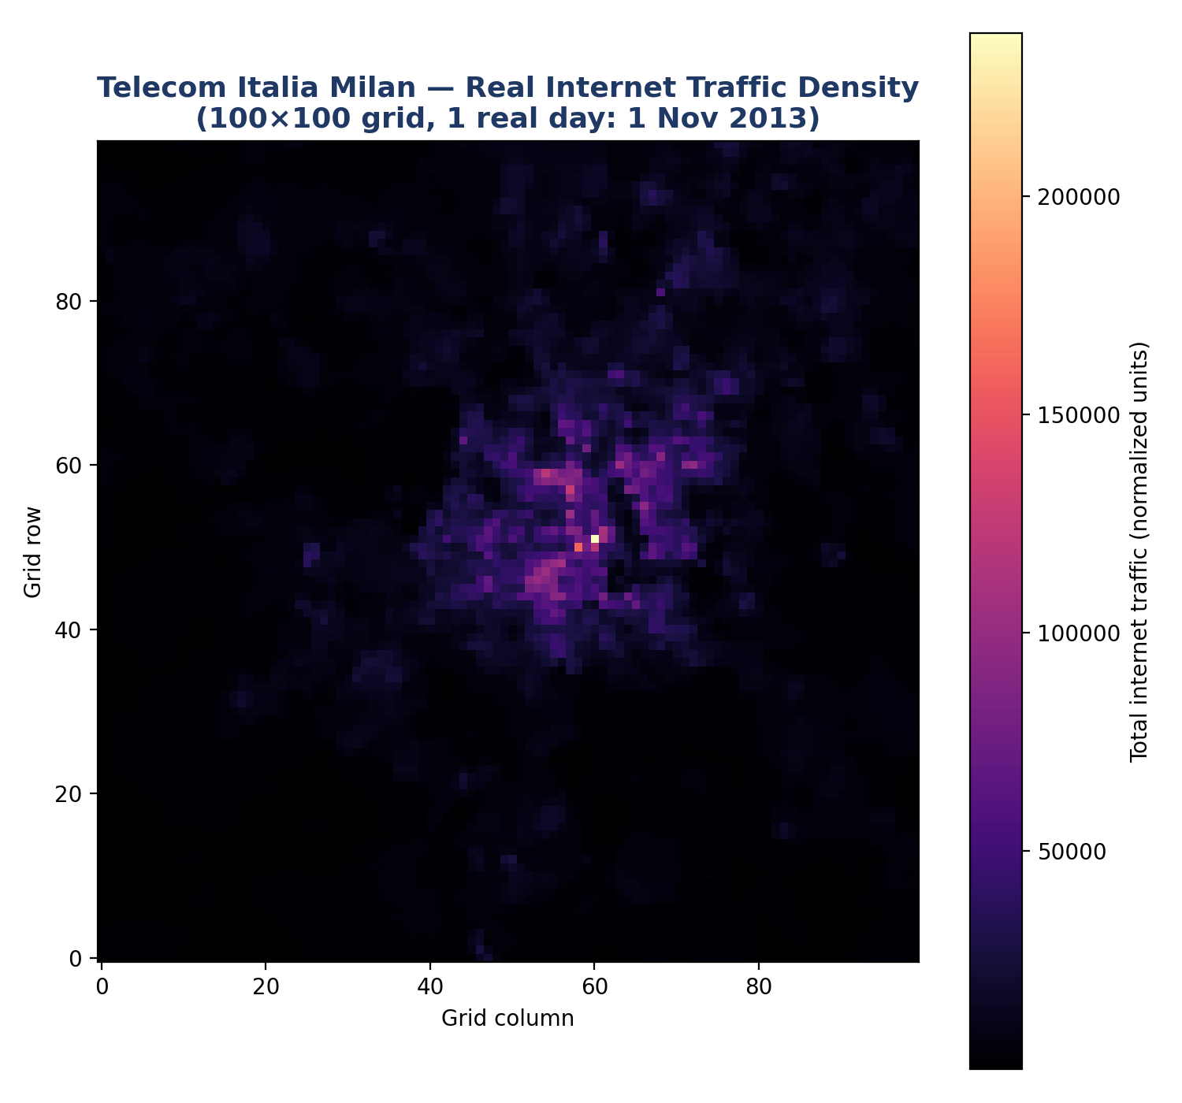
Figure 5.1: Real traffic on the Milan grid
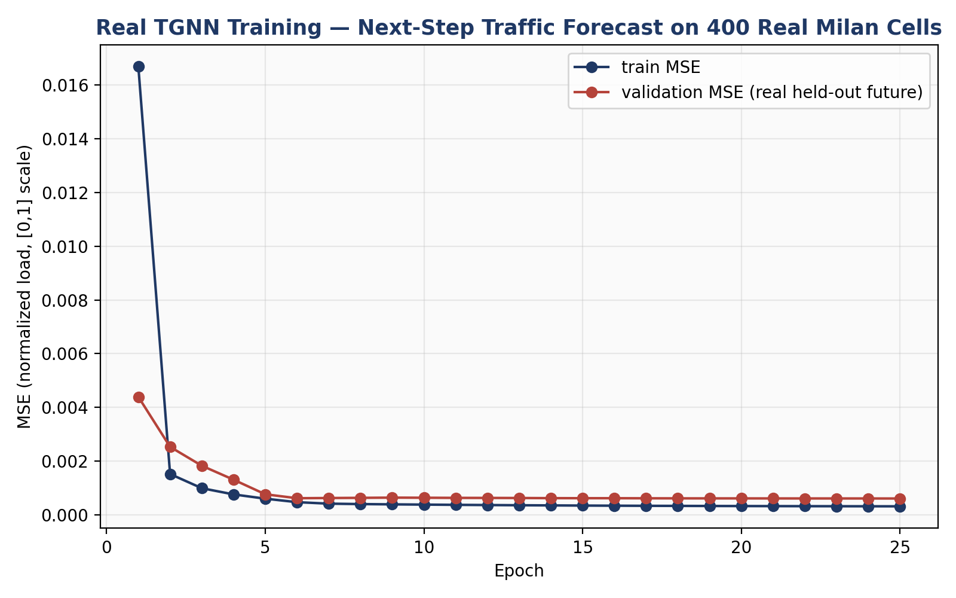
Figure 5.2: TGNN training and validation error on real Milan traffic
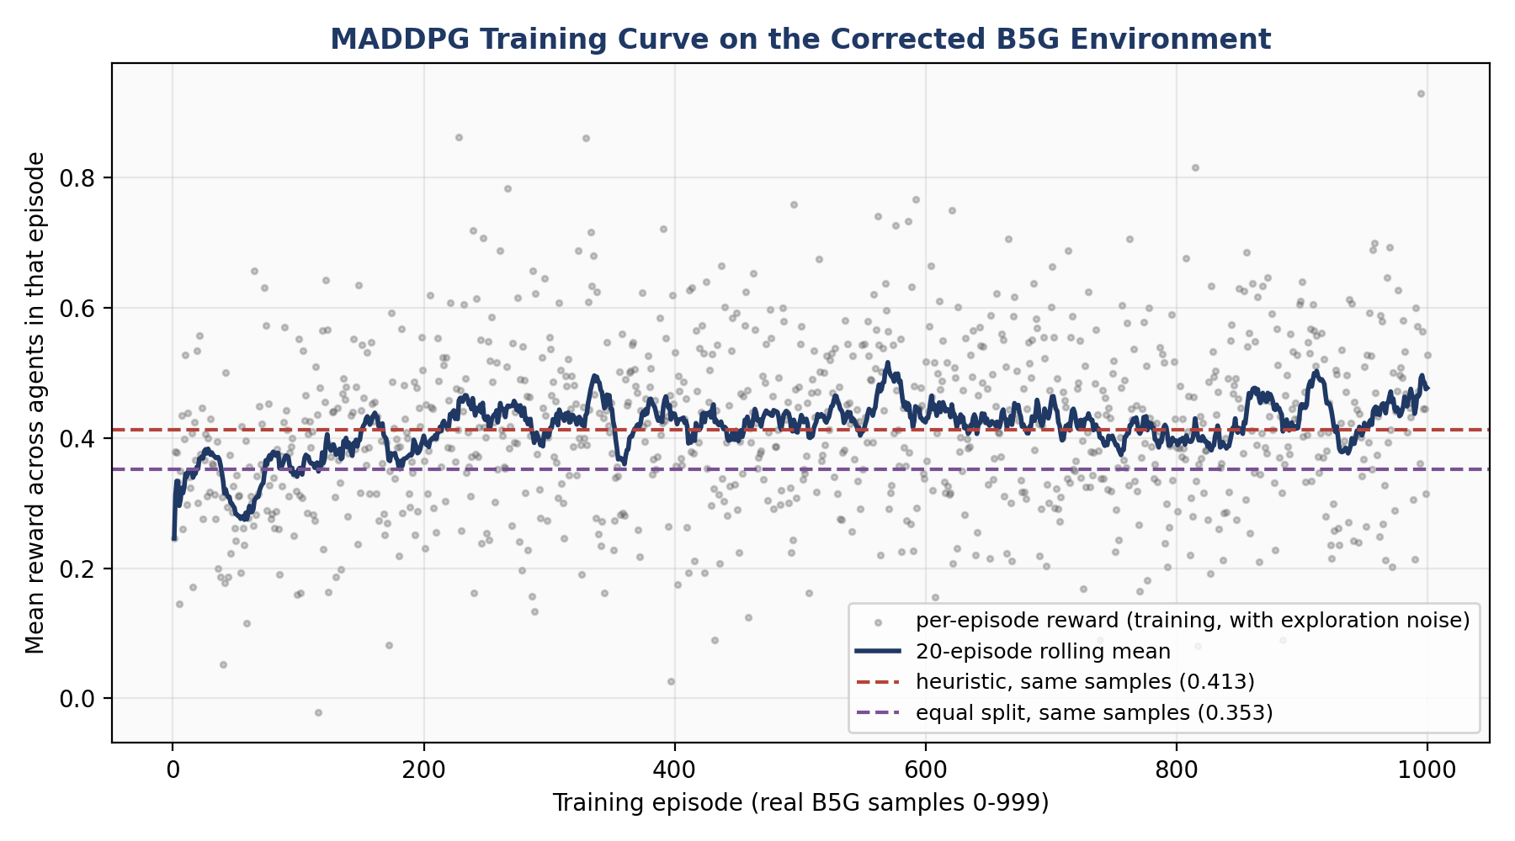
Figure 5.3: MADDPG training reward on the B5G slicing environment
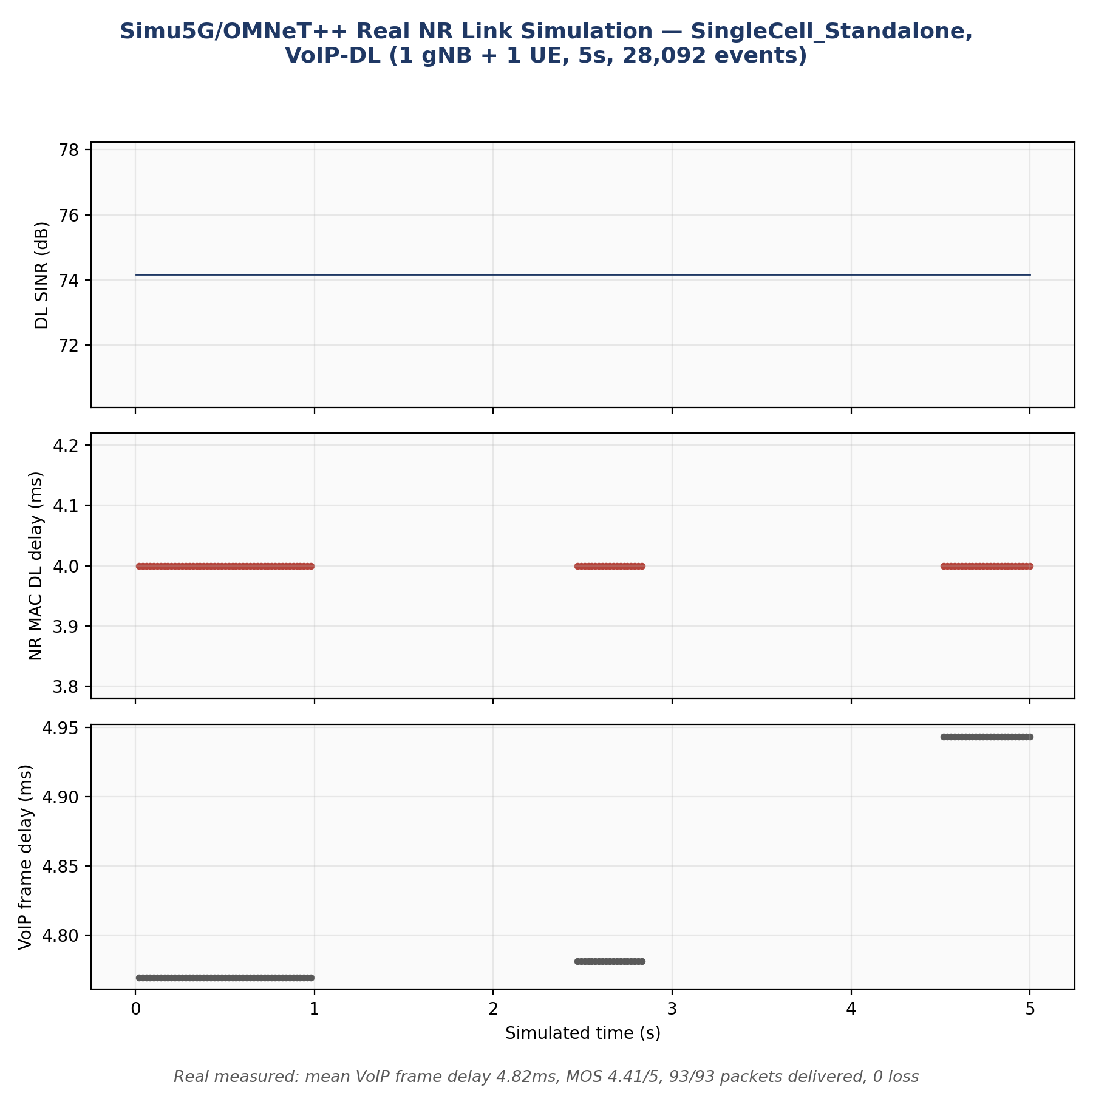
Figure 5.4: Reference Simu5G NR run

5.2 Errors found and corrected
Two errors invalidated early results and were corrected before the first review. The 5G-NIDD file is stored in blocks of identical labels, so a sequential train-test split placed 99.88% of one class in the test set and produced an accuracy near 1%; we replaced it with a stratified split. In the B5G environment, agents were keyed by their position in the slice list rather than by slice, so most rewards were computed against the wrong slice. We fixed the indexing, added a regression test and re-ran all MARL experiments. A code review of the merged module branches on 18 September also found and fixed nine smaller correctness and efficiency problems, including a mismatch between mMTC and mIoT labels.

Chapter 6
Review of 12 October and the Unified Environment

6.1 Comments from the review
At the review of 12 October the guide made four comments: look for unified data that connects every stage; justify the use of MARL instead of a single agent; if unified data is not available, create it synthetically; and report which datasets the reviewed papers use. Table 6.1 lists how each was addressed.
Table 6.1: Response to the review comments
Comment | Response | Where
Datasets used in papers | Audited the sixteen papers in the survey notes | Section 3.2
Unified data | Checked every dataset held and searched the web; none is unified | Section 4.2
Create it synthetically | Built the unified environment below and a large dataset from it | Section 6.2 and Chapter 8
Why MARL | Controlled comparison of MARL and a tuned centralised agent | Section 7.2

6.2 Design of the unified environment
The environment joins, for each cell and each 10-minute interval, real traffic on a real spatial layout, per-slice demand, an allocation action and the resulting QoS, SLA outcome and reward. It is implemented in the src/unified directory of the repository. Table 6.2 states which parts are real, which are calibrated and which are modelling assumptions.
Table 6.2: Components of the unified environment
Component | Status | Source or rule
Traffic per cell and interval | Real | Telecom Italia Milan
Topology | Real | Milan grid layout with 4-connected neighbours
Slice demand | Modelled | Internet activity mapped to eMBB, calls to URLLC and SMS to mMTC, scaled so that each slice's 95th percentile is 80%, 10% and 5% of a 100 Mbps cell
Latency and jitter against load | Calibrated | Curves fitted to the 6G RAN telemetry dataset (30,000 windows)
Inter-cell interference | Modelled | Usable capacity = 100 Mbps / (1 + 0.3 x mean neighbour load)
Loss and SLA | Rules | Targets for eMBB 50 ms latency, 20 ms jitter, 0.99 reliability; URLLC 5 ms, 1 ms, 0.99999; mMTC 100 ms, 50 ms, 0.99
Action | Agent output | Shares of each cell's capacity for eMBB, URLLC, mMTC and idle, applied to the next interval
Reward | Design choice | 0.7 x weighted SLA score + 0.3 x fraction of demand served - 0.1 x reconfiguration churn

To check realism, we compared the eMBB SLA rate against load with the SLA label in the reference telemetry. A deterministic latency model matched poorly, with a mean gap of 0.086 across fifteen load bins. Adding lognormal variation in latency with a single parameter (sigma = 0.21) fitted to that curve reduced the gap to 0.021. Since the parameter was fitted on the same curve, this is a goodness-of-fit measure rather than an independent validation.

6.3 Policies compared
Besides the learned agents, we evaluated an equal split, an allocation proportional to demand, and an expert policy that gives URLLC and mMTC enough capacity to stay below their SLA-safe utilisation and assigns the remainder to eMBB. The expert policy was run with three inputs: current demand, the TGNN forecast, and the true next-interval demand, which serves as an upper bound.

Chapter 7
Experiments and Results

7.1 Experimental set-up
The experiments use seven real days of Milan traffic on the central block of the grid. Learned models are trained on the first five days and tested on the last two, which are not seen during training. Every learned method uses the same reward and the same training budget of 300 episodes of six hours (10,300 updates), and each is run with three random seeds. Values in brackets are the sample standard deviation over seeds.

7.2 MARL compared with a single centralised agent
The single agent observes every cell and outputs the slice shares of every cell, so its input and output grow with the network. The MARL controller uses one actor shared by all cells, each acting on its own seventeen local features, with a critic that also sees the mean of its neighbours' observations and actions and a reward that mixes each cell's reward with its neighbours'. The learning rate of the single agent was tuned first over five settings on a validation day, and the best value (1e-4) was used.
Table 7.1: Held-out reward by network size
Cells | MARL | Single agent | Equal split | Expert, current demand | Expert, TGNN forecast | Expert, true demand
9 | 0.767 (0.023) | 0.411 (0.046) | 0.761 | 0.783 | 0.842 | 0.929
25 | 0.765 (0.051) | 0.300 (0.033) | 0.731 | 0.755 | 0.802 | 0.898
49 | 0.758 (0.061) | 0.275 (0.018) | 0.712 | 0.734 | 0.782 | 0.876
100 | 0.769 (0.037) | 0.273 (0.003) | 0.713 | 0.739 | 0.790 | 0.880

Table 7.2: Size of the actor network
Cells | MARL actor parameters | Single-agent actor parameters | Single-agent input and output size
9 | 19,332 | 1,14,468 | 153 and 36
25 | 19,332 | 2,00,548 | 425 and 100
49 | 19,332 | 3,29,668 | 833 and 196
100 | 19,332 | 6,04,048 | 1700 and 400

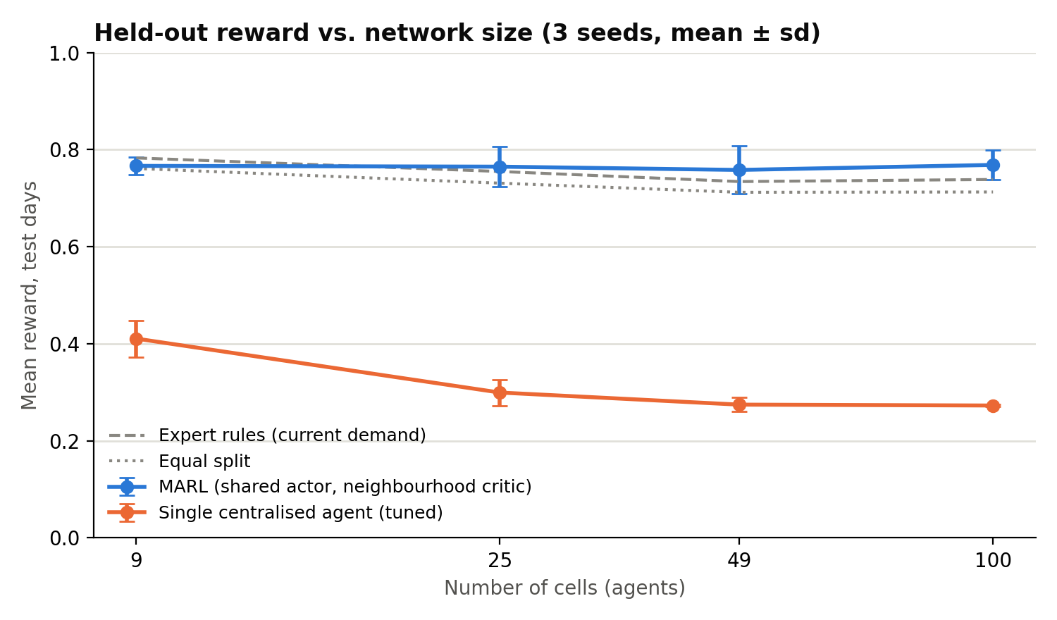
Figure 7.1: Held-out reward against the number of cells (three seeds)
The single agent's reward falls from 0.411 at 9 cells to 0.273 at 100 cells, below the equal split at every size, and in practice it learns to leave much of the capacity idle. The MARL controller keeps the same 19,332-parameter actor at every size and its reward stays between 0.758 and 0.769, because every cell's experience trains the same actor. This decentralised structure also matches how a radio access network is operated, since each cell decides from its own and its neighbours' measurements without a central controller.
These results support MARL over a single centralised agent for this problem, but they do not show that MARL beats simpler policies. Its reward is within one standard deviation of the expert policy on current demand and of the equal split, and it stays below the expert policy given the TGNN forecast. Chapter 10 discusses why the single-agent baseline also needs strengthening.

7.3 Value of the forecast
On the test days the TGNN forecast has 12%, 29%, 27% lower mean squared error than repeating the last value for eMBB, URLLC and mMTC respectively. When the same expert policy is given this forecast instead of current demand, its reward improves at every network size (for example from 0.739 to 0.790 at 100 cells). This recovers roughly one third of the gap between using current demand and knowing the true next demand.
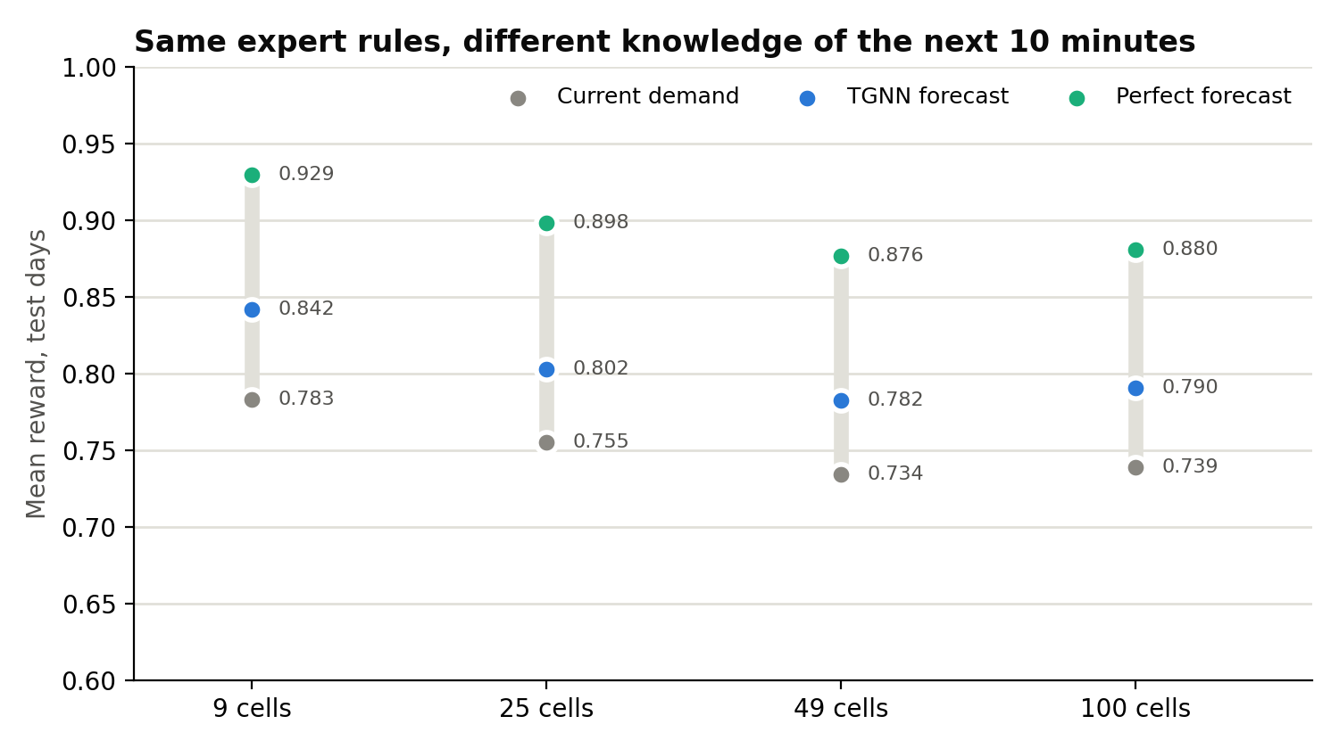
Figure 7.2: Reward of the expert policy with different knowledge of the next ten minutes

7.4 Forecast as an input to MARL
We also gave the forecast to the MARL controller as additional input. As Table 7.3 shows, this did not help at the current training budget, and even the true next-interval demand did not help. The forecast therefore improves allocation through the expert policy but not yet through the learned agent.
Table 7.3: MARL with and without the forecast (25 cells, three seeds)
Input to the MARL controller | Held-out reward
No forecast | 0.778 (0.048)
TGNN forecast | 0.765 (0.051)
True next-interval demand | 0.762 (0.057)

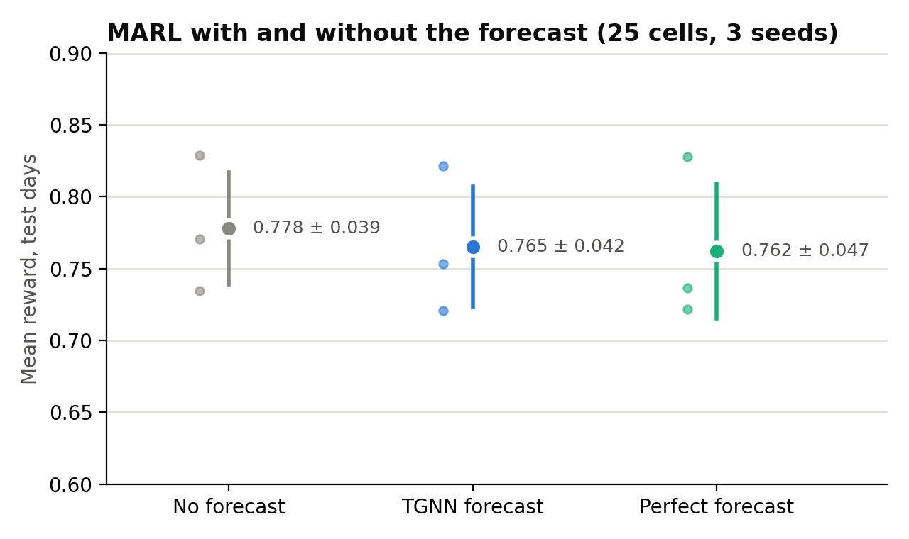
Figure 7.3: MARL reward with and without the forecast

7.5 Forecasting the whole city
The forecaster above was trained on the 100 central cells. Applied to all 10,000 Milan cells on the same held-out days, its error on the quiet outer cells was 10.8 times that of repeating the last value, because it had learned the traffic level of the dense centre and over-predicted the suburbs by about 6 Mbps. We addressed the cause with two changes: each cell's traffic is divided by its own 95th percentile over the training days, and every training step uses a randomly placed 32 x 32 patch of the grid so that the model sees quiet and busy areas alike. Table 7.4 compares the two forecasters.
Table 7.4: Improvement over repeating the last value, by region (eMBB / URLLC / mMTC)
Cells | Block-trained forecaster | City-trained forecaster
100 block cells | +12% / +30% / +27% | +24% / +36% / +27%
300 cells around the block | -8% / -30% / -34% | +19% / +30% / +19%
9,600 outer cells | -985% / -101% / -100% | +19% / +27% / +11%
All 10,000 cells | -635% / -74% / -75% | +19% / +29% / +14%

The city-trained forecaster beats persistence in every region, including the 100 block cells on which the first forecaster was trained, and its average bias on the outer cells falls from +6.2 Mbps to +0.16 Mbps.

7.6 Controllers across the whole city
Finally we ran the three controllers used in the prototype (static equal split, the expert policy on current demand, and the expert policy with the city-wide forecast) on all 10,000 cells for one held-out day with scripted incidents (Table 7.5).
Table 7.5: Controllers on all 10,000 cells, Wednesday 6 November 2013
Controller | SLA met (eMBB / URLLC / mMTC) | Reward, whole city | Reward, dense block | Reward, outer city
Static | 0.919 / 0.997 / 1.000 | 0.974 | 0.709 | 0.977
Reactive | 0.975 / 0.711 / 0.568 | 0.839 | 0.735 | 0.840
Predictive | 0.975 / 0.794 / 0.665 | 0.879 | 0.784 | 0.880

In the dense block the predictive controller does best, but across the city as a whole the static split does best. Most of the city is lightly loaded, and the expert rules give URLLC and mMTC almost no capacity when their traffic is near zero, so these slices miss their SLA when traffic returns. An earlier version of this run, which used the block-trained forecaster, showed the predictive controller at 0.935; that gain came from over-allocation caused by the biased forecast and has been replaced by the figures above.

Chapter 8
The Digital Twin Dataset

8.1 Overview
Using the unified environment we generated a long dataset in which every row describes one cell in one 10-minute interval. It is produced by src/unified/twin_dataset.py; the full data is stored as Parquet files on the project drive, and summaries and samples are kept in the repository under reports/unified_twin.
Table 8.1: Size of the Digital Twin dataset
Build | Cells | Days | Scenarios | Rows | Size
Core year | 400 (central 20 x 20 block) | 364 | 6 | 12,57,96,000 | 30.8 GB
Full city | 10,000 (whole grid) | 62 | 3 | 26,78,10,000 | 40.5 GB
Total |  |  |  | 39,36,06,000

The traffic for the 62 recorded days is real. The remaining days of the core year are built from real days of the same weekday, with a growth trend of 20% per year and small random variation, and every row records whether it is real or bootstrapped. Latency and jitter follow the calibrated curves, radio fields use the 3GPP TS 38.214 CQI table, and power uses the EARTH base-station model. The slice mapping, the industrial zone, per-user rates and packet sizes are assumptions. Each row has 122 columns covering calendar, control, events, radio and capacity, neighbourhood, energy, per-slice demand and QoS, reward and noisy telemetry; the full list is in Appendix B.

8.2 Scenarios
All scenarios use the same days, behaviour policies and random noise, so that any difference between two scenarios is caused only by the scenario itself. Table 8.2 gives the results for the core year.
Table 8.2: Scenarios of the core year
Scenario | What changes | SLA met (eMBB / URLLC / mMTC) | Reward | Energy (MWh)
baseline | Recorded traffic without incidents | 0.704 / 0.731 / 0.651 | 0.763 | 3,473
events | Adds flash crowds, outages, interference, URLLC bursts, mMTC storms and capacity degradation | 0.703 / 0.730 / 0.651 | 0.763 | 3,473
growth_6g | eMBB x1.3, URLLC x2 and mMTC x3 | 0.553 / 0.696 / 0.610 | 0.688 | 3,648
energy_saving | Lightly loaded cells sleep from 01:00 to 05:00 and hand their traffic to neighbours | 0.703 / 0.737 / 0.659 | 0.766 | 3,435
industrial_urllc | Industrial cells see URLLC x4 during weekday shifts | 0.693 / 0.723 / 0.646 | 0.756 | 3,481
massive_iot | mMTC x10, with a further x3 at the start of every hour | 0.554 / 0.710 / 0.524 | 0.660 | 3,628

Table 8.3: Effect of each injected event (core year, events scenario)
Event | Rows | SLA met (eMBB / URLLC / mMTC) | Reward
none | 2,09,32,659 | 0.704 / 0.730 / 0.651 | 0.763
flash crowd | 19,740 | 0.217 / 0.683 / 0.598 | 0.532
cell outage | 985 | 0.000 / 0.095 / 0.019 | 0.019
interference spike | 8,883 | 0.577 / 0.697 / 0.629 | 0.704
urllc burst | 814 | 0.608 / 0.510 / 0.575 | 0.631
mmtc storm | 1,966 | 0.658 / 0.730 / 0.344 | 0.679
capacity degradation | 953 | 0.323 / 0.710 / 0.647 | 0.578

Each type of event affects the slices it should: flash crowds and capacity degradation reduce eMBB compliance, URLLC bursts reduce URLLC compliance, mMTC storms reduce mMTC compliance, and outages affect every slice.

8.3 Energy saving across the city
Table 8.4: Night-time sleep across the city (01:00 to 05:00, 62 days)
Measure | Baseline | Energy saving
Night-time energy (MWh) | 1983 | 1593 (19.6% lower)
Night cell-intervals asleep | 0% | 47.6%
SLA met on awake cells (eMBB / URLLC / mMTC) | 0.983 / 0.761 / 0.724 | 0.976 / 0.720 / 0.693
Mean load of awake cells | 0.045 | 0.066

Putting quiet cells to sleep at night saves about a fifth of night-time energy, or 3.2% over the whole 62 days. The cost falls on the cells that stay awake and absorb the extra traffic, where URLLC compliance drops by about four percentage points. Sleeping cells carry no traffic and so meet their SLA trivially, which is why the comparison above is restricted to awake cells.

8.4 Checks on the generated data
A three-day test build of all six scenarios was checked before the full run. The scenarios contain identical rows of interval and cell; traffic is conserved under energy saving (the traffic handed over equals the traffic received); the industrial and massive-IoT multipliers are applied exactly; 1.0% of telemetry is missing, as designed; and the forecasting targets for 10 and 60 minutes ahead equal the cell's demand one and six rows later. These checks are also covered by automated tests in the repository.

Chapter 9
Prototype: the Slice Twin Monitor

9.1 Purpose
The School policy requires each B.Tech project to end in a working product or prototype. Ours is Slice Twin, a browser-based monitor for watching how different controllers divide each cell's bandwidth between slices during one held-out day of real Milan traffic with scripted incidents. Its interaction model is borrowed from Cisco Packet Tracer, with a real-time mode, a simulation mode that stops at each new event, an event list and step-by-step playback. The source is in app/slice_twin of the repository.

9.2 Views
Block view. The 100 central cells are drawn as rings whose segments show each cell's split between slices, with moving packets indicating served traffic. Selecting a cell shows its demand, allocation, latency against target and SLA status for each slice.
City view. All 10,000 grid cells are drawn as a map coloured by real traffic, cell load or SLA misses, with landmarks (Duomo, Milano Centrale, San Siro, Linate airport, Navigli and Citta Studi) and the active incidents. Selecting a cell compares the three controllers on that cell over the day, and a cell inside the central block can be opened in the block view.
Controllers. Static (equal thirds), Reactive (the expert policy on current demand) and Predictive (the same policy with the TGNN forecast).
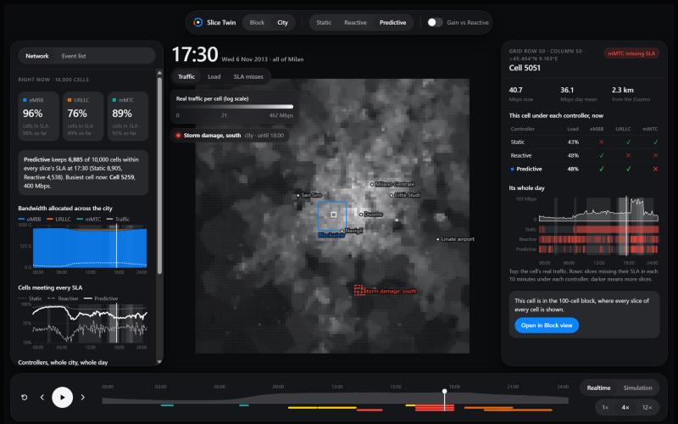
Figure 9.1: City view coloured by real traffic (dark theme)
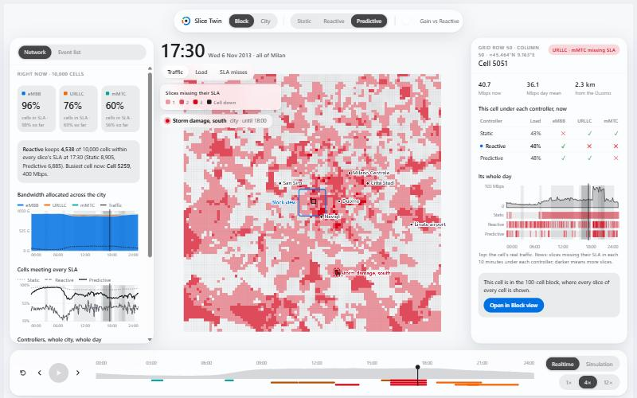
Figure 9.2: City view coloured by SLA misses under the reactive controller (light theme)

Chapter 10
Limitations of the Current Evidence
Before planning publications we checked every claim against the stored result files. The results that hold up best are the city-wide forecaster and the value of the forecast to the expert policy. The following limitations need to be addressed or stated openly.

10.1 Statistical strength
All learned results use three seeds and a test window of two weekdays, and only seven of the 62 available real days are used. With three seeds, the difference between MARL and the expert policy or the equal split is not statistically significant at any network size. The standard practice in recent reinforcement learning work is at least ten seeds with confidence intervals, and the remaining 55 days allow a much longer test period.

10.2 Fairness of the single-agent baseline
The single agent's reward decreases during training, which suggests a training failure rather than a pure scaling limit. It also receives far fewer samples per update than the shared MARL actor. A fair comparison needs further baselines: independent agents sharing one network without the neighbourhood critic, IPPO or MAPPO, and a centralised agent with a factorised output, each tuned with the same budget.

10.3 Model fidelity
QoS comes from a calibrated surrogate model rather than a packet-level simulator, and the reference telemetry used for calibration is itself simulated. The reinforcement learning experiments used the deterministic version of the latency model. A load sweep in Simu5G would provide an independent check of the latency curve.

10.4 Negative results
SSL embeddings matched but did not improve on raw features, both for 5G-NIDD classification and for the Milan forecast; the raw-feature baseline on 5G-NIDD is itself weak compared with tree-based classifiers reported for that dataset. Giving the forecast to the MARL controller did not improve its reward. The learned controller did not outperform the forecast-informed expert policy, and the static split outperformed the predictive controller on quiet cells.

10.5 The Digital Twin claim
The approve or reject gate exists only in the early B5G orchestrator, where it approves no actions, and the unified environment has no gate. Describing the controllers as validated inside a Digital Twin is therefore not yet justified. A one-step look-ahead gate in the unified environment, which rejects actions whose predicted SLA falls below a threshold and measures the effect on reward, would make this claim testable at modest cost.

Chapter 11
Publication Plan and Pending Work
The plan below is based on a search of existing surveys and closely related original work from 2021 to 2026, a review of suitable venues, and the limitations in Chapter 10. It is proposed for the guide's approval before drafting begins.

11.1 Review paper
Proposed title. Predict-then-Allocate for AI-Native 6G Network Slicing: A Systematic Review of Forecasting, Digital Twins and Multi-Agent Reinforcement Learning, with a Dataset and Reproducibility Audit.
Recent surveys cover each building block separately, including Digital Twin networks, graph-based traffic forecasting, reinforcement learning for slicing and foundation models for wireless networks. We did not find a survey that examines how forecasts are connected to the allocation decision, the different roles a Digital Twin can play in that loop, or which datasets and simulators support each stage of the slicing pipeline. The closest competitors are a 2026 review of MARL for slicing in PeerJ Computer Science and several survey preprints from mid-2026, which must be read in full before the paper claims novelty.
The review would follow the PRISMA 2020 method over IEEE Xplore, Scopus, the ACM Digital Library and arXiv for 2021 to 2026, with two reviewers screening each paper. The proposed taxonomy has five layers (representation, prediction, Digital Twin, allocation, and the coupling between prediction and control) and two cross-cutting dimensions (data provenance and reproducibility). A narrower fallback is a review of datasets, simulators and reproducibility for AI-native slicing. The suggested target is IEEE Access, whose article processing charge is US$2,160, or Elsevier Computer Networks on its subscription route if the charge cannot be funded; a realistic submission date is the end of February 2027.

11.2 Original paper
Proposed title. How Much Is Traffic Prediction Worth for Multi-Cell Network Slicing? A Real-Traffic, City-Scale Benchmark.
The contributions would be the open multi-cell slicing benchmark on real Milan traffic, the city-scale forecasting study (the failure of the block-trained model on the periphery and its correction), the value of the forecast measured as a fraction of the gap to perfect knowledge, and the parameter-shared MARL controller as a secondary result with its negative findings reported. The terms Digital Twin, SSL and MARL outperforms should be kept out of the paper title, while the project title remains appropriate for the thesis.
Before submission the team needs to recompute all tables with sample standard deviations and confidence intervals, add seasonal-naive, historical-average and graph-free forecasting baselines, test over the unused real days, run ten seeds, and add independent-agent and IPPO or MAPPO baselines; this is about one to two weeks of work. Suitable first venues are an IEEE ICC 2027 workshop, whose deadline is expected in January 2027, or IEEE CONECCT 2027, with a paper deadline of 15 February 2027. A journal extension with a Simu5G check and a public release of the dataset could follow. Two arXiv preprints (2306.09290 and 2605.03345) may already use the Milan data for slicing and must be checked first.

11.3 Questions for the guide
- Does the guide approve the proposed review topic and the framing of the original paper?
- Do the 5 marks for a paper apply to this semester, and is a draft ready for submission sufficient?
- Should the Digital Twin gate and the Simu5G validation be completed before the final review, or reported as future work?

11.4 Pending work
Table 11.1: Pending work
Item | Responsible | Target
Final review presentation | All members | Before the final review
Thesis in the department template; signed soft-bound copy with silver title page | All members | At the final presentation
Message to the guide with this record and the publication plan | Keerthivasan | 20 to 22 October 2026
Ten seeds, confidence intervals and longer test period | Keerthivasan and Krish | November 2026
Forecasting baselines and ablation of the city forecaster | Thrishala and Keerthivasan | November 2026
MARL baselines (independent agents, IPPO or MAPPO) | Krish | November to December 2026
Tree-based baselines for SSL, or report as a limitation | Sriranjana | November 2026
Literature search, screening and coding for the review | All members | November 2026 to January 2027
First drafts of both papers | All members | After approval, December 2026 to February 2027
Digital Twin gate and Simu5G load sweep | Keerthivasan | Optional, December 2026

References
[1] G. Barlacchi et al., "A multi-source dataset of urban life in the city of Milan and the Province of Trentino," Scientific Data, vol. 2, 150055, 2015.
[2] H. Samarakoon et al., "5G-NIDD: A comprehensive network intrusion detection dataset generated over 5G wireless network," arXiv:2212.01298, 2022.
[3] D. Bega, M. Gramaglia, M. Fiore, A. Banchs and X. Costa-Perez, "DeepCog: Optimizing resource provisioning in network slicing with AI-based capacity forecasting," IEEE Journal on Selected Areas in Communications, vol. 38, no. 2, pp. 361-376, 2020.
[4] W. Hamilton, Z. Ying and J. Leskovec, "Inductive representation learning on large graphs," in Advances in Neural Information Processing Systems, 2017.
[5] R. Lowe et al., "Multi-agent actor-critic for mixed cooperative-competitive environments," in Advances in Neural Information Processing Systems, 2017.
[6] Y. Yang et al., "Mean field multi-agent reinforcement learning," in Proc. International Conference on Machine Learning, 2018.
[7] T. Kim et al., "Reversible instance normalization for accurate time-series forecasting against distribution shift," in Proc. International Conference on Learning Representations, 2022.
[8] G. Auer et al., "How much energy is needed to run a wireless network?," IEEE Wireless Communications, vol. 18, no. 5, pp. 40-49, 2011.
[9] 3GPP, "NR; Physical layer procedures for data," TS 38.214.
[10] G. Nardini, D. Sabella, G. Stea, P. Thakkar and A. Virdis, "Simu5G: An OMNeT++ library for end-to-end performance evaluation of 5G networks," IEEE Access, vol. 8, pp. 181176-181191, 2020.
[11] R. Agarwal, M. Schwarzer, P. S. Castro, A. Courville and M. G. Bellemare, "Deep reinforcement learning at the edge of the statistical precipice," in Advances in Neural Information Processing Systems, 2021.
[12] M. J. Page et al., "The PRISMA 2020 statement: An updated guideline for reporting systematic reviews," BMJ, vol. 372, n71, 2021.

Appendix A: Literature Review Notes
These notes are reproduced from the team's literature review document with light formatting changes.
Paper 1: AI-Driven Digital Twins: Optimizing 5G/6G Network Slicing with NTNs
Ali & Arslan (2025) — IEEE Wireless Communications Letters
Problem Statement | Static Digital Twin updates can't keep pace with the rapid topology changes caused by UAV-mounted flying base stations during disaster recovery or urban blockage events, leading to latency spikes for NTN-integrated eMBB slices.
Methodology / Algorithm | A real-time DT synchronization scheme continuously tracks the spatial distance between mobile users and the flying base station, feeding a continuous-action DDPG agent that allocates bandwidth. The state space folds in path loss, Rayleigh fading and satellite interference.
Dataset / Simulation Tool | Custom Python-based 5G simulator with 50 UEs over 20 MHz bandwidth.
Results | ~25% latency reduction vs static allocation (avg. 33 ms), jitter down to 2.1 ms, ~92% resource utilization.
Research Gap | Assumes clean, noise-free telemetry and has no predictive topology mapping — it reacts to raw signals rather than filtering anomalies through learned representations.
How it relates to our project | Confirms DDPG works well inside a Digital Twin loop, but its lack of representation learning is exactly the gap our SSL module is meant to close, and its purely reactive design motivates adding TGNN-based prediction.

Paper 2: A Flexible and Scalable Multi-Agent Learning Framework for Dynamic RAN Slicing in 6G Native-AI Networks
Li, Wang, et al. (2026) — IEEE Transactions on Mobile Computing
Problem Statement | Changing slice configurations forces costly model retraining, and frequent radio-resource reconfiguration creates heavy signalling and computational overhead.
Methodology / Algorithm | Proposes a Statistic-Field Deep Truncated Monte Carlo (SF-DTMC) algorithm operating in a RAN Partially Observable Stochastic Game (RAN-POSG), paired with an Adaptive Retention Framework (ARF) that penalizes unnecessary state transitions to balance responsiveness against reconfiguration stability.
Dataset / Simulation Tool | NS-3-based high-fidelity RAN slicing simulator.
Results | Large drop in reconfiguration time and SLA violations compared with LLM-based agents and standard RL baselines.
Research Gap | Scalability is limited once you move past tightly localized cell clusters, and control decisions still rely purely on local/reactive state observations.
How it relates to our project | Backs our decentralized multi-agent design, but our framework goes further by adding SSL and TGNN to enrich state representation and add predictive foresight, which this paper doesn't attempt.

Paper 3: A Framework for AI-Native Semantic-Based Dynamic Slicing for 6G Networks
Chowdhury et al. (2025) — TechRxiv
Problem Statement | Traditional architectures treat data content and network resource orchestration as separate concerns — insufficient for 6G's semantic-aware ambitions.
Methodology / Algorithm | Introduces a semantic slicing framework built around a horizontal "Reasoning Plane" that sits between the data and control planes, using symbolic AI, GFlowNets, and signaling games to build shared semantic languages.
Dataset / Simulation Tool | Python / TensorFlow.
Results | Faster semantic task execution and improved convergence as the system settles on a shared semantic vocabulary.
Research Gap | Highly theoretical — it doesn't quantify the computational latency the Reasoning Plane would add on real edge hardware.
How it relates to our project | Supplies the conceptual blueprint for the Reasoning Plane and data slicing, which we position as future work once the core SSL+TGNN+MARL pipeline is validated.

Paper 4: GAN-Enhanced Deep Reinforcement Learning for Semantic-Aware Resource Allocation in 6G Network Slicing
Daniel Benniah John (2026) — arXiv (cs.NI)
Problem Statement | Discrete action quantization plus "semantic blindness" in classical resource allocation wastes an estimated 35% of bandwidth on redundant data.
Methodology / Algorithm | GAN-DDPG framework: conditional GANs generate synthetic semantic traffic while a continuous-action DDPG agent optimizes allocation against a semantic-aware reward instead of raw bit-rate maximization.
Dataset / Simulation Tool | Python / custom 6G slicing simulator.
Results | +22% URLLC spectral efficiency, +20% eMBB spectral efficiency, -31% packet loss, -18% latency versus baseline.
Research Gap | Semantic state definitions are domain-specific and don't generalize; semantic extraction itself adds computational delay at the edge.
How it relates to our project | Gives concrete empirical proof that reward-level semantic awareness beats classical MARL objectives — direct evidence for why we flag semantic communication as a strong future-work extension.

Paper 5: Multi-Agent Reinforcement Learning for Slicing Resource Allocation in Vehicular Networks
(vehicular networks MARL study) (2023) — IEEE Transactions on Intelligent Transportation Systems
Problem Statement | High-speed vehicular mobility forces frequent RAN slicing changes, generating heavy reconfiguration overhead.
Methodology / Algorithm | Formulates the problem as a POMDP and solves it with Multi-Agent DDPG (MADDPG) to minimize long-term system cost.
Dataset / Simulation Tool | Python with a Mininet emulator and Ryu SDN controller.
Results | Lower system cost overall, with an average QoS satisfaction rate of 96.5%.
Research Gap | Validation stays confined to simulation (true of ~86% of surveyed studies), and coordination delays of 120–180 ms exceed URLLC latency budgets.
How it relates to our project | Validates multi-agent handling of mobility, but has no Digital Twin safety net for policy exploration — the gap our NDT sandbox is designed to fill.

Paper 1: Native Network Digital Twin Architecture for 6G: From Design to Practice (2025)
1. Problem Statement
- Existing Network Digital Twins (NDTs) lack standardized architecture, real-time synchronization, and efficient data collection for large-scale 6G networks.
- Traditional KPI-based monitoring cannot support service validation, prediction, or safe testing of network changes.
- The paper proposes a native Network Digital Twin architecture for real-time monitoring, simulation, verification, and optimization.
2. Methodology / Algorithm
- Introduces a three-layer architecture: Network Element Layer, NDT Layer, and Application Layer.
- Defines the complete NDT lifecycle: Preparation, Creation, Runtime, and Feedback.
- Proposes native high-speed data collection using kernel pass, sidecar agents, Kafka/RDMA/QUIC.
- Uses a gray-box modelling approach combining protocol knowledge with learned behaviour.
3. Dataset / Simulation Tool
- No public dataset is used.
- Validated using a real operator-inspired signalling storm scenario during disaster recovery.
- Digital Twin is built using real topology, signalling statistics, historical traffic patterns, and network behaviour models.
4. Results
Achieved ≈3% MAPE for registration arrival rate prediction.
Achieved ≈25% MAPE for successful registration count.
- Successfully replicated signalling storm behaviour and validated safe traffic control strategies.
- Demonstrated the effectiveness of the proposed architecture and gray-box modelling.
5. Research Gap
- Evaluation is limited to a signalling storm use case.
- No Graph Neural Networks (GNN), Temporal GNN (TGNN), Self-Supervised Learning (SSL), or Reinforcement Learning (RL) are incorporated.
- Focuses on simulation and verification rather than autonomous optimization.
6. How it Relates to Our Project
- Provides the architectural foundation for our Digital Twin framework.
- Supports real-time synchronization, modular Digital Twin lifecycle, and gray-box modelling.
- Our work extends this architecture using SSL, TGNN, and MARL for intelligent network slicing.

Paper 2: Attention to Virtualization: Making Network Digital Twins Aware of Network Slicing (2025)
1. Problem Statement
- Existing Digital Twins ignore virtualization effects such as resource contention between virtual network functions.
- Conventional GNNs suffer from over-smoothing and poor long-term dependency modelling.
- The paper proposes a virtualization-aware Digital Twin using Graph Attention Networks for improved KPI prediction.
2. Methodology / Algorithm
- Measures virtualization overhead using Docker-based UPF deployments.
- Represents physical and virtual resources as a graph.
- Combines GraphSAGE + Graph Attention Network (GAT) to learn virtualization-aware node embeddings.
- Performs "what-if" analysis before slice deployment using the Digital Twin.
3. Dataset / Simulation Tool
- Experimental measurements collected from Docker-based UPFs.
Digital Twin evaluated using an extended OMNeT++ simulator.
- Simulation includes 30 CNFs, 5 physical nodes, and GraphSAGE + GAT trained using a 70/30 split.
4. Results
- Virtualization significantly increases delay and packet loss.
- GraphSAGE + GAT outperforms conventional GNNs in KPI prediction.
- Achieves lower MAE and MSE than RouteNet-Fermi.
- Improves delay prediction across eMBB, URLLC, and mMTC slices.
5. Research Gap
- Uses a static graph and cannot model temporal traffic evolution.
- Depends on supervised learning with labelled data.
- No Reinforcement Learning for autonomous optimization.
6. How it Relates to Our Project
- Introduces virtualization-aware Digital Twins for network slicing.
- Provides the graph abstraction used in our framework

Paper 3: A Graph Neural Network-Based Digital Twin for Network Slicing Management (2022)
1. Problem Statement
- Existing analytical models and conventional deep learning methods cannot effectively model graph-structured communication networks.
- Shared physical resources create complex interactions between network slices, making E2E latency prediction difficult.
- The paper proposes a GraphSAGE-based Digital Twin for accurate End-to-End latency prediction.
2. Methodology / Algorithm
- Represents physical infrastructure and network slices as graphs.
- Uses GraphSAGE with neighbour sampling and mean aggregation to generate node embeddings.
- Aggregates node embeddings into slice embeddings and predicts End-to-End latency.
Trains using the Log-Cosh loss and Adam optimizer.
3. Dataset / Simulation Tool
- Uses three network topologies: NSFNET (14 nodes), GEANT2 (24 nodes), and Synthetic (50 nodes).
Trains on 70% of graph nodes and evaluates on unseen nodes.
- Uses traffic matrices, VNF resource utilization, and E2E latency as input features.
4. Results
- Achieved less than 5% prediction error for End-to-End latency.
- Successfully generalized to unseen network topologies.
- Demonstrated transfer learning for jitter prediction.
- Supported SLA monitoring, link failure recovery, and deployment optimization.
5. Research Gap
- Models the network as a static graph, ignoring temporal changes.
- Requires labelled datasets due to supervised learning.
- Does not perform Reinforcement Learning-based optimization.
- Does not explicitly model virtualization effects.
6. How it Relates to Our Project
- Provides the graph-based modelling foundation for our Digital Twin.
- Our work extends GraphSAGE using Temporal Graph Neural Networks (TGNNs).

Paper 4: Revolutionizing Wireless Networks with Self-Supervised Learning: A Pathway to Intelligent Communications (2024)
1. Problem Statement
- Supervised learning requires large labelled datasets, which are difficult to obtain in dynamic wireless communication networks.
- Massive amounts of unlabelled traffic, channel, and mobility data remain underutilized.
- The paper investigates Self-Supervised Learning (SSL) as an alternative learning paradigm for AI-native 6G networks.
2. Methodology / Algorithm
- Reviews three SSL paradigms: Generative, Contrastive, and Predictive learning.
- Describes the SSL workflow consisting of pretext task generation, representation learning, and downstream task fine-tuning.
- Surveys SSL applications in traffic prediction, channel estimation, anomaly detection, semantic communication, and network optimization.
3. Dataset / Simulation Tool
- Survey paper; no single dataset is used.
- Reviews multiple wireless communication datasets and existing SSL-based communication systems.
- Covers applications in wireless networking, semantic communications, and edge intelligence.
4. Results
- Demonstrates that SSL effectively learns meaningful representations from unlabelled wireless data.
- Reduces dependence on labelled datasets while improving model generalization.
- Successfully supports various communication tasks, including channel estimation, anomaly detection, and intelligent network management.
5. Research Gap
- Designing efficient pretext tasks for wireless communication remains challenging.
- Existing SSL methods have high computational complexity and limited robustness in dynamic environments.
- Integration with Digital Twins, TGNNs, and Reinforcement Learning remains largely unexplored.
6. How it Relates to Our Project
- Provides the motivation for using Self-Supervised Learning in AI-native 6G networks.
- Supports learning from unlabelled Digital Twin data before TGNN-based modelling.
- Our framework integrates SSL with TGNN and MARL for intelligent dynamic network slicing.

Paper 5: Network-to-Network: Self-Supervised Network Representation Learning via Position Prediction (2025)
1. Problem Statement
- Existing Graph Neural Networks (GNNs) rely heavily on labelled data, making training expensive and limiting scalability.
- Most network representation learning methods capture structural information but fail to preserve node positional information and rich node content simultaneously.
- The paper proposes a Self-Supervised Network Representation Learning framework (Net2Net) that learns meaningful node embeddings without requiring large labelled datasets.
2. Methodology / Algorithm
- Introduces Net2Net, a self-supervised encoder-decoder framework based on Node Position Prediction (PosPredict).
- Constructs ego networks for each node and learns embeddings by combining node content and graph topology.
- Uses a hierarchical GNN encoder and cross-modal decoder to predict each node's position (PosID), followed by semi-supervised fine-tuning for downstream tasks.
3. Dataset / Simulation Tool
- Evaluated on eight real-world graph datasets, including Cora, Citeseer, DBLP, PubMed, GitHub, Facebook, LastFM Asia, and Twitch.
- Compared against multiple graph embedding and GNN baselines such as DeepWalk, Node2Vec, GraphSAGE, GAT, DGI, and MVGRL.
- Performance was evaluated using node classification with Micro-F1 score.
4. Results
- Net2Net consistently achieved higher node classification accuracy than existing supervised and unsupervised methods.
- The proposed Position Prediction task produced more discriminative node embeddings by preserving structural, positional, and content information.
- Demonstrated strong generalization with minimal labelled data across diverse graph datasets.
5. Research Gap
- The framework learns static graph representations and does not capture temporal network evolution.
- Does not address Digital Twin modelling, dynamic network slicing, or reinforcement learning-based decision making.
- Primarily designed for node representation learning rather than autonomous network optimization.
6. How it Relates to Our Project
- Provides the Self-Supervised Learning foundation for learning graph representations from unlabelled network data.
- The learned embeddings can serve as inputs to our Temporal Graph Neural Network (TGNN) for modelling dynamic network states.
- Our project extends this work by integrating Digital Twins, TGNN, and MARL for intelligent dynamic network slicing in AI-native 6G networks.

Paper 6: Encrypted Network Traffic Classification in SDN using Self-Supervised Learning (2022)
1. Problem Statement
- Encrypted network traffic is difficult to classify using conventional supervised learning due to the need for large labelled datasets.
- Preparing labelled network traffic data is costly and prone to errors.
- The paper investigates Self-Supervised Learning (SSL) for accurate traffic classification in Software Defined Networks (SDNs).
2. Methodology / Algorithm
- Builds an SDN testbed using Mininet, Open vSwitch, and the RYU Controller to generate and collect network traffic.
- Uses a two-stage SSL framework with pre-training on unlabelled traffic followed by fine-tuning on a small labelled dataset.
- Extracts protocol-independent traffic features from flow statistics for real-time encrypted traffic classification.
3. Dataset / Simulation Tool
- Generated a custom SDN dataset containing five encrypted traffic classes: Counter Strike (Active/Idle), Quake III, DNS, and VoIP.
- Traffic was created using Mininet and the D-ITG traffic generator, while features were collected using the RYU SDN Controller.
- Both offline evaluation and real-time traffic classification experiments were conducted.
4. Results
- SSL achieved 97.64% classification accuracy, outperforming the supervised model by approximately 2%.
- Real-time traffic classification achieved up to 99% accuracy with an average inference time of approximately 0.002 seconds.
- Demonstrated that SSL effectively reduces label dependency while maintaining high classification performance.
5. Research Gap
- Focuses only on encrypted traffic classification in SDN environments.
- Does not perform network representation learning, Digital Twin modelling, or dynamic network slicing.
- The SSL framework is task-specific and not designed for graph-based network optimization.
6. How it Relates to Our Project
- Demonstrates that Self-Supervised Learning can effectively learn from large amounts of unlabelled network data.
- Provides evidence that SSL reduces dependence on manually labelled datasets, supporting the motivation for our SSL module.
- Our framework extends SSL beyond traffic classification by combining it with Digital Twins, TGNN, and MARLfor autonomous network slicing in AI-native 6G networks.
KRISH S

Paper 1: Toward Enabling Network Slice Mobility to Support 6G System (2022)
Problem Statement
- Future 6G networks will support diverse applications with different latency, bandwidth, and resource requirements.
- When users move, the VNFs providing their services may need to be migrated, scaled, created, or relocated to maintain the required QoS.
- Relocating VNFs closer to users can reduce end-to-end latency, but frequent relocation can cause service interruption.
- Therefore, the main problem is finding a balance between low end-to-end delay and minimum service relocation while maintaining the slice SLA
.
2. Methodology
The authors propose three Network Service Management solutions:
- DELAY-NSM: Minimizes end-to-end delay by placing VNFs closer to users through VNF instantiation, migration and resource reconfiguration.
- R-NSM: Minimizes VNF/service relocation to reduce service interruption while satisfying delay, bandwidth and jitter requirements.
- FT-NSM: Uses the Kalai-Smorodinsky bargaining game to obtain a Pareto-fair trade-off between minimizing delay and minimizing service relocation.
The framework can dynamically perform VNF scaling up/down, VNF creation/deletion, VNF migration, and UE reassignment
3. Dataset
- Uses a discrete-time network simulation, not a public dataset.
- Simulates UEs, eNB/gNBs, Edge Clouds, VNFs, and network slices.
UE mobility is modeled using random walk with pymobility.
Tests different numbers of UEs and Edge Clouds.
Maximum end-to-end delay is set to 30 ms.
Each simulation is repeated 80 times for reliable results.
4. Results
DELAY-NSM: Lowest latency of 16–17.5 ms.
R-NSM: Lowest relocation time of 5–7.5 ms.
- FT-NSM: Good balance — around 18 ms latency and 8–10 ms relocation time.
- FT-NSM provides the best overall trade-off, but has higher computational cost.
5. Research Gap
Relies mainly on optimization and game theory.
Does not use SSL for learning network representations.
Does not use TGNN for future traffic prediction.
- Does not use MARL for intelligent cooperative resource allocation.
- Does not use a Digital Twin for network simulation and learning.
6. How it relates to our Project
Directly supports our dynamic 6G network slicing concept.
- Shows the importance of dynamically scaling, migrating and relocating VNFs.
- Demonstrates the need to balance latency, QoS and resource management.
- Our project extends this using SSL + TGNN + Digital Twin + MARL for predictive and intelligent network slicing.

Paper 2: Slicing for AI: An Online Learning Framework for Network Slicing Supporting AI Services (2025)
1.Problem Statement
- 6G will support many AI-based services with different resource and QoS requirements.
- Static/offline slicing struggles with dynamic and time-varying network conditions.
- The goal is to dynamically allocate resources while improving AI model accuracy, latency, and cost
2.Methodology
- Proposes an Online Learning for Slicing (OLS) framework.
- Uses the EXP3 online learning algorithm to adapt resource allocation over time.
- Introduces OLS-SA and OLS-RSA to reduce the decision space and improve learning speed.
- Jointly allocates computing + communication resources and tunes AI model parameters.
3.Dataset
- Uses a mobile-health Deep Learning dataset with 245,921 samples.
Dataset contains 13 physical-activity classes.
- Tests different training-data sizes and numbers of epochs.
Results are averaged over 10 experiments
4.Results
- Proposed methods converge toward optimal resource allocation.
- OLS-SA and OLS-RSA reduce the decision space and computational complexity.
- Performs better under dynamic network conditions and varying resource availability
5.Research Gap
Focuses mainly on slicing resources for AI services.
Does not use TGNN for future network-traffic prediction.
Does not use MARL for cooperative slicing decisions.
- Does not integrate a Digital Twin or SSL-based network representation learning.
6.How It Relates to Our Project
Strongly supports our dynamic 6G network slicing component.
- Shows how learning can adapt resource allocation to changing network conditions.
- Our project extends this with SSL + TGNN + Digital Twin + MARL for predictive and autonomous network slicing.

Paper 3: Self-Supervised Spatiotemporal Graph Neural Networks With Self-Distillation for Traffic Prediction (2023)
1.Problem Statement
- Existing spatiotemporal GNNs struggle to capture wider spatial-temporal dependencies.
- Deeper GNNs can suffer from overfitting and poor generalization.
- The paper aims to improve traffic prediction accuracy and robustness.
2. Methodology
- Proposes SSGNN, combining Self-Supervised Learning + Spatiotemporal GNN + Self-Distillation.
- SSL reconstructs masked traffic signals to learn better features.
- GCN captures spatial relationships, while temporal convolutions capture time dependencies.
- Self-distillation improves model generalization and stability.
3.Dataset
Uses 6 real-world traffic datasets.
METR-LA, PEMS-BAY – traffic speed.
PEMS03, PEMS04, PEMS07, PEMS08 – traffic flow.
Uses 1 hour of historical data to predict the next 1 hour.
4.Results
- SSGNN achieved better or competitive performance against strong GNN baselines.
- Maximum improvements were 3.0% MAE, 5.2% RMSE and 3.8% MAPE.
- Shows that SSL and self-distillation improve traffic forecasting.
5.Research Gap
- Predicts road traffic, rather than 6G network traffic/slice demand.
- Prediction is the final objective; it does not use predictions for dynamic resource allocation.
- No closed-loop mechanism to convert predicted traffic into network slicing decisions.
- Therefore, it does not address proactive 6G slice orchestration.
6.How It Relates to Our Project
Very relevant to our SSL + TGNN prediction stage.
- Its idea of learning spatial-temporal patterns from traffic data can conceptually be adapted to 6G network nodes and traffic.
- In our project, these learned patterns help predict future network/slice demand.
- We then go further: TGNN prediction → MARL decision-making → dynamic network slicing inside the Digital Twin.

Paper 4: Deep Reinforcement Learning for End-to-End Network Slicing: Challenges and Solutions (2023)
1. Problem Statement
- End-to-end network slicing involves many configuration parameters across RAN, transport, core, edge, and cloud.
- Traditional model-based methods struggle with such complex and dynamic resource allocation.
- The paper investigates DRL for intelligent end-to-end slice orchestration.
2. Methodology
- Models resource orchestration as a Markov Decision Process (MDP).
- DRL observes network state and traffic load and decides resource allocation for each slice.
- Explores Safety DRL, Distributed/Multi-Agent DRL, and Imitation Learning.
- Proposes a three-layer architecture: Network → Orchestration → Intelligence (DRL).
3. Dataset
- Uses a real network slicing testbed, rather than a public dataset.
- Uses OpenAirInterface/FlexRAN, OpenDayLight, OpenFlow, Docker and USRP B210.
- DRL agents are implemented using PyTorch with 3-layer neural networks.
4. Results
- Safety DRL reduces SLA violations from up to 15% to about 1%.
- Distributed DRL improves scalability using multiple agents.
- Imitation Learning gives DRL a better starting policy and helps accelerate online learning.
- The paper shows that DRL is promising for automating end-to-end resource orchestration, while practical deployment still faces scalability and convergence challenges.
5. Research Gap
- DRL mainly reacts to observed network states; our project adds TGNN-based future traffic prediction before slicing decisions.
- The paper identifies difficulty in handling huge heterogeneous network data; our SSL stage conceptually addresses this by learning useful representations from unlabeled network data.
- DRL learning through real-network interaction can be slow and potentially unsafe; our Digital Twin provides a virtual environment for training/testing decisions.
6. How It Relates to Our Project
- Very closely related to our MARL + Dynamic Network Slicing stage.
- Its distributed DRL concept uses multiple agents that coordinate resource allocation, directly supporting our choice of MARL.
- Our project adds a predictive pipeline before these agents: SSL → TGNN → predicted network demand → MARL → dynamic slicing.
- Thus, this paper provides a strong foundation for the decision-making/resource-allocation part of our proposed 6G architecture.
Additional Papers

Paper 3: Toward Self-Optimizing 6G Networks Through Network Digital Twin Intelligence: A Real Network Traffic Evaluation (2026)
1. Problem Statement
- Existing Digital Twins mainly support monitoring and simulation rather than autonomous optimization.
- Manual network management cannot efficiently handle dynamic 6G traffic.
- The paper proposes an AI-native Digital Twin for prediction, anomaly detection, load balancing, and energy optimization.
2. Methodology / Algorithm
- Uses KPIs such as traffic, latency, load, energy efficiency, and reliability.
- Predicts traffic using a rolling average over previous observations.
- Employs Isolation Forest for anomaly detection and MLP for latency prediction.
- Performs adaptive load balancing and energy optimization in a closed-loop framework.
3. Dataset / Simulation Tool
Uses the Telecom Italia Milan Grid Dataset.
- Contains approximately 10,000 cells and 1.85 million traffic records.
- Evaluates Internet traffic and Voice/SMS traffic separately.
- Models trained using a 60/20/20 train-validation-test split.
4. Results
- Achieved 96.7% Internet traffic prediction accuracy and 98.3% Voice/SMS prediction accuracy.
- Reduced network load by 25.5% and achieved 30.4% energy savings.
- Obtained high anomaly detection and prevention accuracy.
- Outperformed conventional rule-based optimization methods.
5. Research Gap
- Uses traditional ML models (Isolation Forest and MLP) instead of graph learning.
- Traffic prediction relies on a simple rolling average.
- Evaluation is limited to one dataset and a few KPIs.
6. How it Relates to Our Project
- Demonstrates AI-driven Digital Twin intelligence for autonomous network management.
- Our framework replaces conventional ML with SSL and TGNN for richer network representations.
- MARL enables collaborative and adaptive network slicing beyond rule-based optimization.
Datasets
Dataset / Tool | Purpose
Telecom Italia Milan | Real cellular traffic forecasting
NeversNet5G | 5G wireless state + mobility + QoS
B5G Network Slicing Dataset | eMBB/URLLC/mIoT slicing + QoS

1. Telecom Italia Milan Mobile Traffic Dataset
Telecom Italia dataset on Harvard Dataverse
Milan Grid dataset on Harvard Dataverse
Scientific Data paper describing the dataset
What it contains
This is one of the most important datasets for your project.
It contains anonymized mobile-network activity from Milan, aggregated into spatial grid cells and 10-minute intervals.
The telecom activity includes:
- SMS-in
- SMS-out
- Call-in
- Call-out
- Internet activity
- Grid ID
- Timestamp
- Country code
The original dataset covers November 1, 2013 to January 1, 2014, with the city represented spatially by a grid. Nature
The Milan grid is approximately 100 × 100 spatial cells, with cells around 235 m × 235 m. PLOS

Why it is extremely useful for you
This is almost tailor-made for the TGNN part.
Critical limitation
It does not contain actual 5G slice allocation, PRB allocation, latency constraints or MARL actions.
So don't pretend that Milan alone represents a 6G network.
Instead, use it as your real-world traffic-demand layer.
2. NeversNet5G
This is one of the most interesting datasets I found for your project because it is very recent.
NeversNet5G project page
NeversNet5G dataset on Hugging Face
Zenodo DOI for NeversNet5G
What it contains
NeversNet5G is a city-scale 5G NR vehicular network dataset generated using:
SUMO: + Simu5G / OMNeT++
It contains approximately:
390 vehicle trajectories
19 real-world base-station locations
4 network-load scenarios
242+ million records
- SINR
- CQI
- throughput
- latency
- vehicle position
- speed
- road segment
- UE identity
- network measurements
The released data contains 242,304,261 rows across 716 per-UE CSV files. 6G-TWIN

Why this is extremely interesting for your Digital Twin
You essentially get:
Mobility
+
5G network state
+
Base stations
+
SINR
+
CQI
+
Throughput
+
Latency
That gives you a much richer state representation than Milan.
You can construct:
Graph:
gNB ───── gNB
│: │
│: │
UE ─────── UE
and feed temporal network states into your TGNN.
Big limitation
It is generated through simulation, rather than being raw operational 5G measurements.
3. B5G Network Slicing Dataset (Farreras et al., 2024)
Link: https://zenodo.org/records/10610616 (paper: https://doi.org/10.1016/j.dib.2024.110738)
- Generated through a packet-level simulator, it captures network slicing considering the three main 3GPP slice types: eMBB, URLLC, and mIoT, across a wide range of scenarios with varying topologies, slice instances, and traffic flows. Each sample pairs a network configuration (topology, traffic characteristics, routing) with performance metrics (delay, jitter, loss) per flow, and includes deliberately over- and under-provisioned scenarios. Zenodonih
- Why it fits: it's already labeled by your exact three slice types (eMBB/URLLC/mMTC), gives you real topologies to build your TGNN's graph structure on, and the over/under-provisioning cases are perfect negative examples for training your MARL reward function to avoid QoS violations.
What it contains
This dataset was specifically generated for 5G/B5G network slicing.
It contains:
- network topology
- traffic characteristics
- routing configurations
- eMBB
- URLLC
- mIoT
- delay
- jitter
- packet loss
- flow-level performance
The dataset was generated using packet-level network simulation and includes scenarios with different levels of over/under-provisioning. ScienceDirect

Why it fits your project
This is almost exactly the environment you need for:
MARL state
↓
Agent action
↓
Resource allocation
↓
Network
↓
Delay / jitter / loss
↓
Reward
You can formulate:
Agent state
Traffic demand
Available bandwidth
Current utilization
Slice type
Latency
Packet loss
Previous allocation
Action
Allocate bandwidth
Allocate resources
Change slice allocation
Reward
Something like:
Reward =
QoS satisfaction
+ resource utilization
- latency penalty
- packet-loss penalty
- SLA violation penalty
Major limitation
The dataset models the transport network, not the complete RAN.
The paper explicitly states that the scenarios exclude the RAN infrastructure. ScienceDirect
So this should be your slicing/control benchmark, not your entire 6G dataset.
Datasets
Dataset: Purpose
Telecom Italia: Model spatial-temporal traffic demand
OAI-KPM / TRACTOR: 5G/O-RAN network-state KPIs
ns-3/OAI simulation: MARL actually perform slice allocation.
1.Dataset: Telecom Italia – Telecommunications (SMS, Call, Internet) – Milan
Main dataset — Harvard Dataverse
Telecom Italia Milan Dataset
Milan spatial grid — Harvard Dataverse
Milan Grid Dataset
Scientific Data paper
Dataset Description Paper
The dataset provides historical mobile-network activity aggregated over geographical grid cells at 10-minute intervals.
It includes:
- SMS-in activity
- SMS-out activity
- Call-in activity
- Call-out activity
- Internet activity
- Spatial grid/cell identifier
- Time interval
- Country code
The original dataset covers November 1, 2013 to January 1, 2014. Milan is represented using a regular spatial grid with cells of approximately 235 m × 235 m.
Why we selected it
This dataset provides a real-world representation of spatial and temporal variations in cellular traffic demand.
For our project, it can be used to:
- Identify traffic patterns across different geographical locations
- Model changing network demand over time
- Construct spatial relationships between network regions
Provide input for TGNN-based traffic prediction
- Generate future traffic-demand states for the Digital Twin
The spatial grid is particularly useful because neighbouring geographical cells can be represented as nodes/relationships in a graph.
How it fits our Digital Twin
Telecom Italia
↓
Historical traffic demand
↓
Spatial-temporal representation
↓
Digital Twin traffic state
↓
TGNN
↓
Future traffic prediction
Important limitation
The dataset does not provide actual 5G/6G network-control information, such as:
- PRB allocation
- RAN resource utilization
- Slice configuration
- Network latency
- MARL actions
- QoS/SLA decisions
Therefore, we use Telecom Italia primarily as the real-world traffic-demand layer, rather than claiming that it represents a complete 6G network.
2.OAI-KPM / TRACTOR 5G-O-RAN Telemetry
For the second layer, we use 5G/O-RAN network telemetry to complement the traffic-demand information.: OAI-KPM:
- Official GitHub repository + dataset: OAI-KPM Dataset
- Direct dataset file: OAI-KPM Excel Dataset
Dataset documentation/README: OAI-KPM Documentation
OAI-KPM provides RAN metrics such as latency, PRB usage, PDCP volume, RLC delay and UE throughput from an OAI experimental 5G setup.
TRACTOR:
- Official GitHub repository: TRACTOR O-RAN Repository
Dataset/logs: available under the repository's logs/ and raw/ directories.
- TRACTOR project/research page: TRACTOR Project Page
There are two closely related options here:
OAI-KPM
The OAI-KPM dataset was collected using a bare-metal OpenAirInterface experimental setup consisting of OAI 5G Core, OAI gNB, FlexRIC and a KPM xApp. It provides approximately 5 weeks of RAN time-series measurements.
It contains network-state variables such as:
- UE identifier/registration
- Network latency
- Downlink PRB usage
- Uplink PRB usage
- PDCP data volume
- RLC delay
- UE throughput
- Uplink/downlink measurements
It contains network-state variables such as:
- UE identifier/registration
- Network latency
- Downlink PRB usage
- Uplink PRB usage
- PDCP data volume
- RLC delay
- UE throughput
- Uplink/downlink measurements
Latency
PRB utilization
Throughput
RLC delay
↓
Network state
TRACTOR
TRACTOR provides another useful O-RAN telemetry source. It collected 447 minutes of real 5G traffic from a Google Pixel 6 Pro, covering different applications, locations and mobility conditions. Those traffic traces were then replayed in a full-stack srsRAN-based O-RAN environment on the Colosseum RF emulator to generate O-RAN KPI data.
Its released KPI dataset contains 17 selected O-RAN KPIs, including:
- Downlink MCS
- Downlink buffer size
- Downlink throughput
- CQI
- Uplink MCS
- Uplink buffer size
- Uplink throughput
- Uplink SINR
- Requested PRBs
- Granted PRBs
- UE power headroom
The KPIs are collected at 250 ms intervals through the O-RAN E2 interface.

Why we need this layer
Telecom Italia tells us:
"How much traffic demand exists and where/when it occurs?"
OAI-KPM / TRACTOR tells us:
"What is happening inside the 5G network while handling that traffic?"
Therefore, this layer allows the Digital Twin to represent network conditions such as:
Traffic demand
+
PRB utilization
+
Throughput
+
Latency
+
Channel quality
+
Buffer status
↓
Digital Twin network state
3.ns-3 / OpenAirInterface Controlled Network Environment

ns-3 / OAI Simulation Environment
For the third component, this isn't really a dataset like Telecom Italia or OAI-KPM. It's your controllable simulation/emulation environment.
- Official ns-3 website: ns-3 Network Simulator
- Official ns-3 App Store: ns-3 App Store
- OpenAirInterface: OpenAirInterface 5G/6G Software Alliance
ns-3 is an open-source discrete-event network simulator intended for research and education.
The first two sources provide observational data, but our MARL agent requires something different: an environment that can respond to the agent's actions.
This is where ns-3/OAI comes in.
What it provides
We can construct a controlled 5G/B5G network environment containing:
- Base stations/gNBs
- UEs
- Network traffic
- Radio resources
- Bandwidth
- Network links
- QoS requirements
- Different traffic/service classes
- Network congestion conditions
ns-3 also has 5G/mmWave capabilities and supports cellular-network simulation features such as channel models, MAC/PHY components, RLC and cellular mobility.

Why simulation is necessary
MARL works through an interaction loop:
Current Network State
↓
MARL Agent
↓
Action
↓
Resource/Slice Allocation
↓
Network Environment
↓
New Network State
↓
Reward
↓
Agent learns
A static historical dataset cannot naturally perform this state → action → new state → reward interaction.
Therefore, simulation gives us the controllable environment required to train and evaluate the MARL-based dynamic slicing policy.

How the Three Work Together:
This is the most important part of your methodology.
REAL / EXPERIMENTAL DATA
│
┌────────┴─────────┐
↓: ↓
Telecom Italia: OAI-KPM / TRACTOR
Traffic Demand: Network Telemetry
│: │
└────────┬─────────┘
↓
DIGITAL TWIN
↓
Self-Supervised Learning
↓
TGNN
↓
Future Traffic/Network State
↓
MARL
↓
ns-3 / OAI Environment
↓
Dynamic Slice Allocation
↓
QoS + Resource State
↓
DIGITAL TWIN
↺
Telecom Italia provides the real-world spatial-temporal traffic demand, OAI-KPM/TRACTOR provides experimental 5G/O-RAN network-state telemetry, and ns-3/OAI provides the controllable environment in which the MARL agent can learn and evaluate dynamic network-slicing decisions.

Appendix B: Columns of the Digital Twin Dataset
Identity and calendar (20)
scenario, interval, day_index, date, interval_of_day, hour, minute, weekday, month, day_of_year, iso_week, season, is_weekend, is_holiday, is_business_hours, is_night, source, source_date, cell_id, zone
Control (3)
policy, idle_share, reconfiguration_churn
Events and state (8)
event_type_code, event_type, event_id, anomaly, cell_asleep, capacity_factor, interference_factor, anomaly_score
Cell radio and capacity (11)
capacity_mbps, spare_capacity_mbps, total_demand_mbps, total_served_mbps, prbs_used, load, sinr_db, cqi, modulation, spectral_efficiency_bps_hz, all_slices_sla_ok
Neighbourhood (6)
neighbour_load, neighbour_mean_demand_mbps, neighbour_all_sla_ok, rehomed_in_mbps, rehomed_out_mbps, handover_users_est
Energy (3)
power_w, energy_wh, energy_efficiency_mbit_per_j
Per slice, 21 fields for each of eMBB, URLLC and mMTC (63)
share, prbs, demand_mbps, demand_next_10min_mbps, demand_next_30min_mbps, demand_next_60min_mbps, demand_1h_mean_mbps, demand_delta_mbps, users_est, allocated_mbps, utilisation, served_mbps, throughput_per_user_mbps, packets, queue_kbit, latency_p50_ms, latency_p95_ms, jitter_ms, loss, sla_margin_ms, sla_ok
Reward (2)
reward, team_reward
Telemetry as observed (6)
obs_total_demand_mbps, obs_embb_latency_p95_ms, obs_load, obs_sinr_db, obs_cqi, telemetry_missing

