Final Report
Level [Level]

VibeCheck: Post-Hoc Formal Conformance Certification of LLM-Generated Workflow Code Against BPMN 2.0 Specifications

Group Name : [Group Name]
Group Number : [Group No.]

Index Number | Name
[Index No.] | [Student 1 Name]
[Index No.] | [Student 2 Name]
[Index No.] | [Student 3 Name]
[Index No.] | [Student 4 Name]

Faculty of Information Technology
University of Moratuwa
2026

Final Report
Level [Level]

VibeCheck: Post-Hoc Formal Conformance Certification of LLM-Generated Workflow Code Against BPMN 2.0 Specifications

Group Name : [Group Name]
Group Number : [Group No.]
Group Members

Index Number | Name
[Index No.] | [Student 1 Name]
[Index No.] | [Student 2 Name]
[Index No.] | [Student 3 Name]
[Index No.] | [Student 4 Name]

Supervisor: [Supervisor Name and Title]

Faculty of Information Technology
University of Moratuwa
2026

Declaration
We declare that this thesis is our own work and has not been submitted in any form for another degree or diploma at any university or other institution of tertiary education. Information derived from the published or unpublished work of others has been acknowledged in the text and a list of references is given.

Date: [DD.MM.2026]

Index Number | Name | Signature
[Index No.] | [Student 1 Name]
[Index No.] | [Student 2 Name]
[Index No.] | [Student 3 Name]
[Index No.] | [Student 4 Name]

Supervised by:

Date: [DD.MM.2026]

Name of the supervisor | Signature of the supervisor
[Supervisor Name and Title] | …………………………………….

Dedication
[PLACEHOLDER — to be written by the group before submission. One short paragraph. Conventionally this dedicates the project to the supervisor, to parents and family, and to the lecturers and faculty staff who supported the work. This page has deliberately been left as a placeholder rather than auto-generated, because its content is a personal statement that only the authors can make.]

Acknowledgements
[PLACEHOLDER — to be written by the group before submission. Two to three paragraphs. Conventionally: the supervisor, by name, for guidance on the research direction; the module and programme coordinators; the Faculty of Information Technology; any external parties who provided data, tools or review; and family and batchmates. This page has deliberately been left as a placeholder rather than auto-generated, because its content is a personal statement that only the authors can make.]

Abstract
Large language models now write substantial amounts of workflow code from informal or semi-formal process descriptions. Business processes, however, carry hard ordering, exclusivity and termination requirements that plausible-looking code can silently violate: an approval step quietly dropped, two branches transposed, a retry loop that never terminates. Testing samples behaviour rather than establishing it, code review depends on human attention, and asking the generating model to check its own output is circular. This project asks a narrower and more tractable question: given a BPMN 2.0 specification and a Python program that was supposedly generated from it, can conformance be certified after the fact, without any cooperation from the generator?
VibeCheck answers that question with a four-module pipeline built on a single architectural commitment, which we call dual-track independence. The specification track reads only the BPMN diagram and derives a tiered suite of finite-trace linear temporal logic (LTLf) properties from it. The code track reads only the Python source and derives a Workflow Intermediate Representation (WIR) — a control-flow graph in JSON — together with a three-layer confidence certificate obtained from structural validation, bounded symbolic execution and dynamic differential tracing. Neither track can see the other's input. The two meet only at the equivalence engine, which lifts the WIR into a labelled transition system, reduces it under divergence-sensitive stuttering bisimulation, clusters behaviourally identical implementations, and model-checks the specification's properties against the result, returning a conformance verdict, a violation with a readable counterexample, or an explicit refusal to decide.
The evaluation is deliberately reported as a set of measured rates with exact confidence intervals rather than as a single headline number, and negative results are reported alongside positive ones. The code track's differential instrument detects injected genuine bugs at 0.9952 (95% CI [0.974, 1.000], n=210) against a false-alarm rate of 0.0588 (95% CI [0.012, 0.162], n=51), and recovers structural extraction fidelity with node and edge F1 of 1.0000 over 101 benchmark workflows. The most consequential finding of the project is negative: a certificate derived from the same code it is checking detects 3 of 67 faults from the two mutation operators that inject a purely logical defect, and 0 of 50 on the larger of them, because oracle and subject share the defect. This result is the reason the differential mode exists, and it is the empirical justification for the dual-track architecture. On the specification track, of 412 synthesized properties only 45 (17.6% of the liveness tier) are currently checkable against code, a measured ceiling on what the pipeline can decide. End to end, on six behaviourally confirmed gold specifications with injected order mutations, the system abstains on 0.462 of trials (95% CI [0.27, 0.67], n=26), detects 0.357 of the faults it does commit a verdict on (95% CI [0.13, 0.65], n=14), raises no false alarms on the two order-preserving controls (0.000, 95% CI [0.00, 0.84], n=2), and produces a correct counterexample in 0.800 of violations (95% CI [0.28, 0.99], n=5).
Two defects found in the equivalence engine during this work are reported as results in their own right, because both caused a model checker to report conformance while proving nothing: an automaton built without an acceptance condition, and a property vocabulary that could not match any atom the code side produced (0 of 116 specification atoms matchable). Both are diagnosed, fixed, and the fixes are validated against an independent finite-trace oracle at 35 of 35 decisive verdicts. The report states throughout which claims are measured and which are designed but unmeasured, and it carries an explicit correction trail of superseded figures. The system's output is described consistently as a quantified, evidence-backed certificate — never as an unqualified proof.

Contents
[Right-click this field in Word and choose "Update Field" to generate this list with page numbers.]

List of Figures
[Right-click this field in Word and choose "Update Field" to generate this list with page numbers.]

List of Tables
[Right-click this field in Word and choose "Update Field" to generate this list with page numbers.]

List of Abbreviations
AST | Abstract Syntax Tree
BDD | Binary Decision Diagram
BPMN | Business Process Model and Notation
CFG | Control-Flow Graph
CI | Confidence Interval
EAS | Equivalence Alignment Score
GIL | Global Interpreter Lock
IDCD | Iterative Divergence-Convergence Detection
LLM | Large Language Model
LOC | Lines of Code
LTL | Linear Temporal Logic (infinite-trace semantics)
LTLf | Linear Temporal Logic over Finite Traces
LTS | Labelled Transition System
PBCTS | Progression-Based Constructive Trace Synthesis
SCSL | Self-Correcting Synthesis Loop
SMT | Satisfiability Modulo Theories
WIR | Workflow Intermediate Representation
XML | Extensible Markup Language

CHAPTER 1 – INTRODUCTION

1.1 Introduction
This chapter introduces the problem that VibeCheck addresses, the context in which that problem has become urgent, and the shape of the solution the project proposes. Section 1.2 sets out the background: the rapid adoption of large language models as code generators, and the particular difficulty of trusting their output when the artefact being generated is a business process implementation. Section 1.3 states the problem in brief. Section 1.4 gives the aim and the objectives derived from it. Section 1.5 describes the proposed solution at the level of its four modules and the one architectural commitment that binds them, and Section 1.6 summarises the chapter and previews the structure of the remainder of the report.
One matter of terminology is settled here because it governs every claim made later. VibeCheck produces a certificate: a verdict accompanied by the evidence and the quantified confidence on which that verdict rests, together with an explicit statement of what the verdict does not cover. It is not a proof of program correctness, and this report never describes it as one. Where the system cannot support a verdict it returns INCONCLUSIVE rather than guessing, and the rate at which it does so is reported as a first-class result rather than averaged away.

1.2 Background and motivation
Code generation by large language models moved from research demonstration to routine practice within a very short period. Benchmarks such as HumanEval established that models trained on code could produce functionally correct solutions to self-contained programming problems at non-trivial rates [1], and subsequent benchmarks extended the evaluation to class-level and multi-method generation [2]. The practice that grew around these capabilities — writing a natural-language description of what is wanted, accepting the generated implementation, and iterating on it by inspection rather than by specification — has acquired the informal name vibe coding. It is fast, and for a great deal of software it is adequate, because a developer reading the output can usually tell whether it does roughly the right thing.
Business process implementations are a poor fit for that mode of working, and the reason is structural rather than a matter of developer discipline. A business process is a specification with hard obligations attached to it. A purchase-order workflow that skips the approval step is not a slightly worse workflow; it is a compliance failure. A claims process whose two adjudication branches are transposed will approve exactly the cases it was required to reject. A retry loop that a model has written as an unbounded while True will look entirely idiomatic on the page and will hang the process in production. What all three failures share is that the generated code remains plausible under inspection: it uses the right vocabulary, it calls functions with the right names, and its control flow is the sort of control flow one would expect. The defect is in the ordering, exclusivity or termination behaviour, which is precisely the class of property that reading code does not reliably reveal.
The workflow domain also has an unusual property that makes formal treatment feasible: the specification frequently already exists in a machine-readable form. Business Process Model and Notation (BPMN) 2.0 [3] is an OMG standard with an XML serialisation, widely used in enterprise process modelling, and formal semantics for its core control constructs have been studied for well over a decade [4]. When an organisation asks a language model to implement a process, the BPMN diagram is very often the document the prompt was derived from. That means the ingredients for a formal conformance check are present: a specification with a defined semantics on one side, and a program on the other.
The three assurance mechanisms usually reached for do not close this gap. Testing samples the behaviour of the program on particular inputs; it can demonstrate the presence of a fault but establishes ordering and termination properties only over the paths the test suite happens to exercise. Code review relies on sustained human attention to exactly the kind of detail — which of two similar branch names came first — that human attention is worst at. Asking the generating model to review its own output is circular in a way that is easy to state and, as this project measures directly in Chapter 7, expensive to ignore: an oracle derived from the artefact it is judging inherits the artefact's defects and therefore cannot see them.
The alternative this project pursues is post-hoc translation validation — a position with an established pedigree in compiler verification, where rather than proving a translator correct once and for all, each individual translation is validated after the fact against the source it came from [5]. The analogy is close. A language model is an untrusted translator from a process specification to a program. Proving the model correct is not on the table. Validating each of its outputs against the specification it was given, independently of the model, is.
Two bodies of technique make that validation tractable. The first is temporal logic over finite traces (LTLf) [6], which is the right semantics for a business process: processes are expected to terminate, and a logic whose models are infinite runs answers a subtly different question from the one a process owner is asking. The second is automata-theoretic model checking [7], for which mature tooling exists — this project uses Spot [8] for automaton construction, product and emptiness checking. Neither body of technique is a contribution of this project. What the project contributes is the architecture that connects them to LLM-generated code without introducing circularity, and an honest measurement of how far that architecture currently reaches.

1.3 Problem in brief
When a large language model generates workflow code from a BPMN 2.0 specification, there is at present no practical way to establish, after the fact and without the model's cooperation, whether the generated program actually satisfies the ordering, exclusivity and termination requirements the specification imposes. Testing and review do not establish these properties, and any check that derives its notion of correctness from the generated code itself is circular and therefore blind to exactly the faults that matter most.
The problem decomposes into four sub-problems, each of which turns out to be substantive:
- 1. Formalising the specification. A BPMN diagram must be turned into a set of checkable temporal properties. This is not a transcription: the diagram must be given a state-based semantics, implicit branch conditions must be resolved, and the resulting property suite must itself be validated, since a suite that admits everything is worthless.
- 2. Formalising the program. A Python program must be turned into a formal object whose behaviour faithfully represents the program's behaviour. Static extraction alone cannot establish that faithfulness — an extractor with a bug produces a structurally plausible graph that quietly diverges from the code — so extraction fidelity must itself be certified.
- 3. Deciding conformance. The two formal objects must be compared by a decision procedure that is sound about what it does and does not establish, that returns a usable counterexample when it finds a violation, and that abstains rather than fabricating a verdict when the comparison is not well-founded.
- 4. Preventing circularity. The three steps above must be arranged so that the notion of correctness used in step 3 was not derived from the artefact being judged. This is an architectural constraint, not a coding convention, and it is the constraint from which the rest of the design follows.

1.4 Aim and objectives

1.4.1 Aim
To design, implement and evaluate a system that independently certifies whether LLM-generated Python workflow code conforms to the BPMN 2.0 specification it was generated from, producing a quantified, evidence-backed verdict — conformance, violation with a counterexample, or an explicit refusal to decide — without any cooperation from the generating model, and without deriving its notion of correctness from the code under examination.

1.4.2 Objectives
- 1. O1 — Specification formalisation. Construct a pipeline that transforms BPMN 2.0 XML into a tiered suite of LTLf properties with a state-based semantics, resolves implicit branch conditions, and gates each stage on an explicit quality criterion.
- 2. O2 — Specification self-validation. Establish that the synthesized property suite discriminates: subject it to systematic mutation and require that mutants of the specification be killed, so that a suite which admits every behaviour is rejected before it is exported.
- 3. O3 — Code formalisation with certified fidelity. Construct a pipeline that transforms Python source into a Workflow Intermediate Representation, and accompany it with a certificate — structural, symbolic and dynamic — that quantifies how far the representation can be trusted to represent the program.
- 4. O4 — Anti-circular evaluation of the fidelity certificate. Measure whether a certificate derived from the code it checks can detect injected faults, and if it cannot, establish a differential mode in which the reference is an independent artefact rather than the subject itself.
- 5. O5 — Behavioural equivalence and conformance decision. Lift the code-side representation into a labelled transition system, reduce it under an equivalence that preserves the distinction between a waiting state and a non-terminating loop, and model-check the specification's properties against it, bridging finite-trace property semantics to the infinite-trace semantics the model checker implements.
- 6. O6 — Honest verdict discipline. Ensure that every verdict is either supported by the evidence or explicitly withheld; specifically, detect and eliminate conditions under which the model checker reports conformance while establishing nothing.
- 7. O7 — Quantified evaluation. Evaluate every component against a public benchmark using labelled fault corpora, report every rate with an exact confidence interval, report negative and mixed results alongside positive ones, and maintain an auditable record of any measurement found to be wrong and subsequently corrected.
- 8. O8 — Operable system. Deliver the components as independently deployable services with a portal through which the pipeline can be driven and its certificates inspected.

1.5 Proposed solution
VibeCheck is a four-module pipeline. Two modules formalise, independently, the two artefacts to be compared; a third performs the comparison; a fourth makes the whole operable. The modules are deployed as separate containerised services, which is a design decision with consequences described in Chapter 6 rather than a packaging convenience.

1.5.1 The core design decision: dual-track independence
The specification track never sees the generated code. The code track never sees the BPMN diagram. The two tracks meet only inside the equivalence engine, as two independently derived mathematical objects. This is the project's central architectural commitment, and everything awkward about the implementation follows from it. It is what prevents the specification from quietly bending to match the code, which is the failure mode that makes LLM self-review worthless. The discipline is maintained structurally rather than by convention: because each module ships as its own container with access only to its own source, the equivalence engine reimplements the LTLf normalisation logic it needs rather than importing the specification engine's copy of it. Chapter 6 records the duplicated code that results, and Chapter 8 argues that the duplication is the correct trade.

1.5.2 Module 01 — Specification analysis
Module 01 reads BPMN 2.0 XML and produces a tiered LTLf property suite together with a reliability certificate. It runs four phases, each behind an explicit gate: semantic extraction of the diagram into a labelled graph; synthesis of tiered properties (safety, liveness, fairness) with inference of implicit branch conditions; mutation self-validation, in which the suite must kill mutants of the specification it was derived from; and Progression-Based Constructive Trace Synthesis (PBCTS), a pure-Python LTLf progression procedure that constructs satisfying traces and aligns them against model traces. The module exports a property suite for the equivalence engine and a set of task patterns for the code track's tracer.

1.5.3 Module 02 — Verified intermediate representation extraction
Module 02 reads Python source and produces the Workflow Intermediate Representation — a control-flow graph in JSON, governed by a shared schema — in two views: the definition-order view and the call-order view that the equivalence engine actually requires. Three validator layers feed a single confidence certificate: structural validation over the abstract syntax tree, which acts as a hard gate; bounded symbolic execution using an SMT solver; and dynamic differential tracing, which executes the program under instrumentation and compares the observed event sequence against a reference interpretation of the extracted representation. The module's most important result is the negative one that motivated its differential mode, reported in Section 7.3.

1.5.4 Module 03 — Equivalence engine
Module 03 is the convergence point, and the only place in the system where a specification-versus-code comparison exists at all. It runs four phases: lifting the call-order representation into a labelled transition system with a three-tier action matching cascade; divergence-sensitive stuttering bisimulation, which compresses redundant states without collapsing a silently non-terminating loop into an ordinary waiting state; behavioural clustering, so that N implementations cost approximately as many model-checking runs as there are distinct behaviours; and model checking proper, in which the negation of each property is converted to an automaton, composed with the program automaton, and tested for emptiness, with a readable counterexample rendered from any accepting run found.

1.5.5 Module 04 — Verification portal
Module 04 is a Streamlit portal with one page per engine, driving all three over HTTP and displaying their certificates. It is an integration and demonstration layer, and the report treats it as such: Chapter 8 states explicitly that it makes no research contribution.

1.6 Summary
The problem this project addresses is that LLM-generated workflow code can satisfy every informal expectation while violating the ordering, exclusivity and termination requirements of the process it implements, and that the mechanisms normally used to catch such faults either sample behaviour, depend on human attention, or are circular. The project's response is post-hoc translation validation under a strict independence constraint: formalise the specification and the program separately, and let a model checker decide, with an explicit abstention whenever the evidence does not support a verdict.
The remainder of the report is organised as follows. Chapter 2 reviews related work across business-process verification, LLM code-generation assurance, translation validation, behavioural equivalence and mutation-based evaluation, and identifies the gap this project occupies. Chapter 3 records the technologies adopted and why. Chapter 4 states the approach, its users, and its inputs, processing and outputs. Chapter 5 gives the analysis and design, first of the system as a whole and then of each module. Chapter 6 describes the implementation, including the defects found in the course of building it. Chapter 7 is the evaluation, reporting measured rates with exact intervals, negative results, and a correction trail of superseded figures. Chapter 8 discusses each module in turn — findings, limitations and further work — and closes with the project's principal unresolved gap.

CHAPTER 2 – REVIEW OF OTHERS' WORK

2.1 Introduction
This chapter reviews the work on which VibeCheck depends and against which it should be judged. The project sits at the intersection of five literatures that have developed largely independently of one another, and the gap it occupies is a gap between them rather than inside any one of them. Section 2.2 reviews assurance for LLM-generated code and the benchmark this project evaluates against. Section 2.3 reviews formal verification of business process models, which has a long history but has almost always verified the model rather than an implementation of it. Section 2.4 reviews temporal logic over finite traces and automata-theoretic model checking, which supply the decision procedure. Section 2.5 reviews translation validation and program-equivalence checking, which supply the position VibeCheck adopts. Section 2.6 reviews behavioural equivalence relations and the particular refinement this project requires. Section 2.7 reviews the program-analysis techniques used to establish extraction fidelity, and Section 2.8 reviews mutation-based evaluation, which supplies the evaluation methodology. Section 2.9 states the gap and summarises.
Two conventions apply. First, references are numbered by order of first appearance in the text rather than alphabetically by first author, following IEEE practice; this departs from the older faculty guideline, and is stated here so the departure is deliberate and visible. Second, two entries in the reference list are marked [VERIFY]. These are sources cited in the project's own internal design documents whose bibliographic details the authors have not been able to confirm against the published record at the time of writing. They are retained because the claims they support are uncontroversial and separately attested, but they must be verified or replaced before final submission rather than presented as confirmed citations.

2.2 Assurance for LLM-generated code

2.2.1 What the benchmarks establish, and what they do not
The evaluation of code-generating language models has been dominated by functional-correctness benchmarks. HumanEval established the pattern: a set of self-contained programming problems with hidden unit tests, scored by the fraction of sampled completions that pass [1]. ClassEval extended the unit of evaluation from the function to the class, requiring the model to satisfy interacting methods rather than one signature [2]. These benchmarks measure something real, and the pass@k framing has been productive. But they measure it in a specific way that does not transfer to the problem addressed here: correctness is defined by a test suite shipped with the problem, and the properties tested are input-output relations on short, self-contained tasks.
A workflow implementation fails differently. The failures that matter are properties of the sequence of actions the program performs — that approval precedes disbursement, that exactly one of two adjudication branches executes, that the process terminates — and a test that checks a return value need not observe any of them. Chapter 7 measures this directly: on the corpus used here, order-only faults are systematically less visible to a value-comparing oracle than to a sequence-comparing one, and the difference is large enough to change the verdict.

2.2.2 Hallucination and the circularity of self-review
The reliability concern specific to generated code is that models produce output which is fluent and structurally plausible but factually or semantically wrong — API calls to functions that do not exist, invariants asserted that do not hold, control flow that reads correctly and behaves incorrectly. Survey treatments of this risk in the code-generation setting [9] [VERIFY] and arguments that assurance has not kept pace with generation capability [10] [VERIFY] frame the concern, though the present project does not depend on their specific claims.
The response most commonly deployed in practice is to ask a model to check or repair its own output, or to ask a second model to review the first. Both are attractive because they require no new infrastructure, and both share a structural weakness: the checking artefact is derived from, or shares the training distribution and failure modes of, the artefact being checked. The claim that this weakness is fatal rather than merely undesirable is usually argued rather than measured. One of this project's contributions is a measurement of it in a controlled setting — a fidelity certificate computed from the same source it is judging detects 3 of 67 faults from the two purely logical mutation operators, and 0 of 50 from one of them (Section 7.3.4) — which is the strongest empirical statement the project makes and the reason its architecture is arranged as it is.

2.2.3 FLOW-BENCH
FLOW-BENCH [11] is a benchmark for conversational generation of enterprise workflows, released by IBM Research. It supplies process specifications together with LLM-generated implementations across several model families, and it is the corpus this project evaluates against; the repository vendors it unmodified. It is a good fit for the problem because the specifications are real enterprise processes rather than synthetic control-flow puzzles, and because the generated implementations were produced without any knowledge of this project's checker.
It has one property that shapes the whole of Chapter 7: it carries no native correctness labels. There is no ground truth stating which generated implementations conform to their specifications. Every rate this project reports therefore rests on a labelled corpus that had to be constructed — by injecting mutations with known semantics into implementations first confirmed conformant by behavioural admission, and by screening the remaining variants into a natural-fault corpus. Section 7.2 describes that construction in full, and Section 7.6 states the limitation it imposes: the rates are for injected and screened defect classes, not for the unconditioned population of LLM faults.

2.3 Formal verification of business process models
Giving BPMN a formal semantics is well-trodden ground. Dijkman, Dumas and Ouyang provided the reference treatment, mapping BPMN's core control-flow constructs to Petri nets and thereby making the standard analyses — soundness, deadlock freedom, proper completion — available to process models [4]. The BPMN 2.0 specification itself [3] defines the notation and its XML serialisation, and the gap between the standard's informal execution semantics and any formal one is exactly what work of this kind closes.
A second line of work verifies process models against temporal-logic properties directly. Kherbouche and Ahmad translate business process models into a form suitable for temporal-logic checking and verify structural and behavioural requirements against them [12]. Aguirre and colleagues translate YAWL workflow specifications into FSP and verify them with a labelled-transition-system checker [13]. Symbolic model checkers such as NuSMV [14] are the usual back end for this family of approaches.
The relationship of all this work to VibeCheck is precise and worth stating carefully, because it is easy to mistake for overlap. This literature verifies the model. It answers questions of the form "is this process specification internally sound?" — is it deadlock-free, does every branch terminate, is the model consistent with the policy it is supposed to encode. That is a valuable question and a different one. VibeCheck takes the model as given and asks whether a program that claims to implement it actually does. The specification-side machinery in Module 01 is therefore not a competitor to this work but a consumer of its ideas: it uses a state-based labelling of the BPMN graph in the spirit of [4] in order to produce properties that can be checked against something outside the model. To the authors' knowledge, no prior work performs this specification-to-generated-implementation conformance check for BPMN with the independence constraint described in Section 1.5.1.

2.4 Temporal logic, finite traces, and automata-theoretic model checking
Linear temporal logic was introduced to computer science by Pnueli as a formalism for reasoning about the behaviour of programs over time [15], and model checking — the algorithmic decision of whether a finite-state model satisfies a temporal formula — followed shortly after [18]. The automata-theoretic formulation of Vardi and Wolper [17] is the one this project implements: to check whether a system automaton satisfies a property, construct an automaton for the negation of the property, form the product with the system, and test the product for emptiness. A non-empty product yields an accepting run, which is a counterexample. The construction is standard and is presented textbook-fashion by Baier and Katoen [7].
The semantics of that construction is over infinite traces, and that is the wrong semantics for a business process. A process is expected to terminate; a property like "the process eventually completes" is trivially true of an infinite run that keeps doing other things, and a property like "approval never follows disbursement" has a different meaning when the run is required to be endless. Linear temporal logic over finite traces, LTLf, was given its modern treatment by De Giacomo and Vardi [6], who characterised its expressiveness and complexity and related it to linear dynamic logic. De Giacomo, De Masellis and Montali subsequently established conditions under which finite-trace reasoning can be reduced to infinite-trace reasoning — insensitivity to infiniteness [16] — which is the theoretical basis for bridging an LTLf property suite onto an infinite-trace model checker.
That bridge is not a formatting exercise, and treating it as one is a mistake this project made and then had to diagnose. Chapter 6 reports two distinct mechanisms by which a model checker in this configuration returned a conformance verdict while establishing nothing, one of which is a direct consequence of running finite-trace properties against an automaton whose runs terminate. Spot [8], [19] supplies the automaton manipulation used here — formula parsing, translation to Büchi automata, product, emptiness, and the finite-trace-to-infinite-trace transformation of [16] as a library primitive — and its binary decision diagram substrate rests on Bryant's representation [32].

2.5 Translation validation and program equivalence
Translation validation, introduced by Pnueli, Siegel and Singerman [5], inverts the usual approach to trusting a translator. Rather than proving the translator correct for all inputs — expensive, and impossible for a translator one did not write — each individual translation is checked after the fact against its source. The technique was developed for compilers, and the contrast with the alternative is instructive: CompCert [20] achieves trust in a compiler by proving the compiler itself correct in a proof assistant, which is possible only because the compiler was constructed for that purpose.
A large language model is a translator nobody proved correct and nobody can. It is closed, stochastic, and revised without notice. Translation validation is therefore the natural position, and it is the position VibeCheck adopts: treat each generated program as an untrusted translation of the specification, and validate that instance. What differs from the compiler setting is the nature of the source and target. Compiler translation validation compares two programs in two languages with a shared operational semantics. Here the source is a process diagram and the target is a Python program, so the comparison has to be lifted to a level at which both are expressible — which is why the specification becomes a property suite and the program becomes an automaton, rather than the two being compared directly.
A related literature asks when two programs are "the same". Clone detection surveys [21] classify the techniques by the representation compared — tokens, syntax trees, program dependence graphs — and semantic clone detection [22] attempts equivalence judgements that survive syntactic divergence. This work is relevant to Module 03's behavioural clustering phase, which groups implementations that are behaviourally indistinguishable so that they need not be checked separately. The difference is that clone detection generally seeks similarity as an end in itself, whereas here equivalence is a means of avoiding redundant verification work, and the equivalence used is behavioural rather than representational.

2.6 Behavioural equivalence and its divergence-sensitive refinement
Bisimulation, in the process-algebraic tradition established by Milner [23], is the canonical notion of behavioural equivalence for labelled transition systems: two states are bisimilar when each can match the other's transitions and the results remain bisimilar. For systems with internal, unobservable steps, the practically important relation is a weak or branching one that permits internal steps to be absorbed. Groote and Vaandrager gave the efficient algorithm for branching bisimulation and stuttering equivalence [24], building on the partition-refinement technique of Paige and Tarjan [26], and this is the algorithm the equivalence engine implements.
Ordinary stuttering equivalence has a property that is fatal for this application: it absorbs internal steps freely, and therefore cannot distinguish a state that performs a finite amount of internal work and then proceeds from a state that performs internal work forever. In the domain of interest that distinction is the fault. A workflow implementation containing a hallucinated while True: pass retry loop and a workflow implementation containing a legitimate bounded wait are stuttering-equivalent under the plain relation, which means the reduction step would silently erase the very defect the system exists to find. Divergence-sensitive refinements of stuttering equivalence address exactly this by treating divergence — the ability to perform internal steps indefinitely — as an observable property preserved by the relation [25].
Module 03 therefore implements the divergence-sensitive variant rather than the standard one, and this report is careful not to describe it as ordinary bisimulation. Section 5.5.3 states the relation precisely and Section 6.5 describes how divergence is detected in the implementation using strongly-connected-component analysis over the internal-transition subgraph.

2.7 Program analysis for extraction fidelity
The code track must establish not only a formal representation of the program but that the representation is faithful. Three families of technique bear on this.
Static structural analysis. Recovering a control-flow graph from source, and validating it with dominator-based structural properties, is standard compiler practice and is what Module 02's hard gate performs. Its limitation is intrinsic: static extraction cannot certify itself. An extractor with a bug, or one that silently ignores a language construct it does not model, produces a well-formed graph that diverges from the program.
Symbolic and concolic execution. Symbolic execution, introduced by King [27], executes a program over symbolic rather than concrete inputs and accumulates path constraints, which a decision procedure then solves. Concolic testing [28] combines this with concrete execution to keep the analysis tractable. Bounded model checking of real software using SMT solvers [30] is the industrial form of the idea. The solver used here is Z3 [29]. Section 7.3.6 reports a negative result about this layer that the project considers important to state plainly: on the corpus evaluated, the symbolic layer contributes approximately nothing to the certificate, which is therefore effectively driven by the dynamic layer alone. Describing the certificate as "multi-modal" without that caveat would misrepresent it.
Dynamic differential tracing. The remaining approach is to run the program and observe what it does. Python 3.12 introduced PEP 669, a low-overhead monitoring interface [31] that permits event-level instrumentation at substantially lower cost than the older tracing hooks. Module 02 uses it to record the actual sequence of task events a program performs, and compares that sequence against the sequence a reference interpreter derives from the extracted representation. Divergence between the two is evidence against fidelity. Where the tracer must align two sequences that differ by insertions and deletions it uses longest-common-subsequence alignment; where it must match names approximately it uses edit distance [39] and, at the last tier, sentence embeddings [38].

2.8 Mutation-based evaluation
Because the benchmark carries no correctness labels, the evaluation must manufacture them, and mutation analysis is the established way to do so. The technique originates with DeMillo, Lipton and Sayward [33]: systematically inject small, syntactically valid changes into a program and measure what fraction of the resulting mutants a test suite — or here, a verifier — detects. Jia and Harman survey its development [34] and Papadakis and colleagues survey subsequent advances [35].
Two known difficulties of mutation analysis matter directly to Chapter 7. The first is the equivalent mutant problem: a syntactic mutation may leave program behaviour unchanged, in which case failing to detect it is correct rather than a miss. Sections 7.3.3 and 7.3.5 report the equivalent mutants in this corpus separately and diagnose why the verifier scores them as it does. The second is that mutation operators define the fault distribution being measured, so a detection rate is a statement about those operators and not about faults in general — a limitation Section 7.6 states explicitly, and the reason the evaluation also constructs a corpus of natural faults from independently generated implementations rather than relying on injection alone.
Every rate in this report is accompanied by an exact binomial confidence interval computed by the Clopper–Pearson method [36], which is the appropriate choice at the sample sizes involved: several of the end-to-end measurements rest on fewer than twenty trials, where a normal-approximation interval is not merely conservative but wrong. Where a decision threshold had to be selected, it was selected by maximising Youden's J statistic [37] on a calibration split and then frozen before the evaluation split was touched.

2.9 The gap, and what this project adds
Each of the five literatures reviewed above supplies a component, and none supplies the combination. Business-process verification formalises specifications but verifies the model rather than an implementation. LLM code-generation assurance evaluates input-output correctness on self-contained tasks and, where it addresses reliability, usually does so with an oracle derived from the same model. Translation validation supplies the right position but has been developed for compilers, where source and target share a semantics. Behavioural-equivalence theory supplies the reduction but its standard relation destroys the fault class of interest. Mutation analysis supplies the evaluation method but presupposes a labelled corpus that this domain lacks.
The gap VibeCheck occupies is therefore: post-hoc, independent, formal conformance certification of an LLM-generated program against the machine-readable process specification it was generated from. Within that gap the project makes five specific additions, each stated here in the form in which Chapter 8 defends it.
- 1. An architecture that makes non-circularity structural rather than procedural. The two formalisation tracks are deployed as isolated services with no access to each other's input, and the report quantifies the cost of that isolation (duplicated normalisation logic, Section 6.6) as well as its benefit.
- 2. A measured demonstration that self-referential validation cannot detect logic faults. A fidelity certificate computed from the code it judges detects 3 of 67 faults from the two purely logical mutation operators — 0 of 50 for one of them — and its apparently moderate overall rate of 0.3607 (95% CI [0.297, 0.428], n=219) is traceable to a separate exception-visibility channel rather than to logic sensitivity (Section 7.3.4). The differential mode that replaces it, in which the reference is an independent artefact, detects 0.9952 of genuine bugs (95% CI [0.974, 1.000], n=210). This is the project's central empirical claim and it is a claim about architecture, not about tuning.
- 3. Two named mechanisms by which an automata-theoretic model checker can report conformance while proving nothing — an automaton constructed without an acceptance condition, and a property vocabulary with no atom in common with the program's (0 of 116 matchable) — together with their diagnosis, their fixes, and validation of the fixes against an independent finite-trace oracle at 35 of 35 decisive verdicts (Sections 6.4, 6.5, 7.4).
- 4. A justified rule for trace-comparison granularity. Whether a differential comparison should observe every value or only the task sequence is not a tuning parameter but a consequence of what the two compared artefacts share; both directions of the trade are quantified (Section 7.3.7).
- 5. A reproducible evaluation package for a domain with no labelled benchmark, comprising a behavioural admission oracle, a mutation generator with labelled semantics, a natural-fault corpus obtained as a by-product, pre-registered thresholds, exact intervals throughout, and an in-repository correction trail of every measurement found to be wrong and superseded (Sections 7.2 and 7.7).
What the project does not claim is also worth stating in this chapter, since the literature above would license stronger language than the evidence supports. VibeCheck does not prove programs correct. Its conformance verdicts cover the property slice that is currently checkable — 45 of 412 synthesized properties, 17.6% of the liveness tier (Section 7.2.2) — and abstain elsewhere. Its behavioural-equivalence phases are implemented and unit-tested but not evaluated against behavioural ground truth, which Section 8.5.2 records as the largest single evaluation gap in the project. And its end-to-end detection rate, 0.357 on fourteen verdict-committing trials, is reported with an interval wide enough that the honest reading is a demonstration of a working pipeline rather than a measurement of a mature one.

2.10 Summary
This chapter located the project among five literatures: business-process verification, which formalises specifications but checks models; LLM code-generation assurance, which measures input-output correctness and tends toward circular oracles; translation validation, which supplies the post-hoc position; behavioural-equivalence theory, which supplies the state-space reduction and, in its divergence-sensitive refinement, preserves the fault class of interest; and mutation analysis, which supplies the evaluation methodology and its known pitfalls. The gap between them is the independent, post-hoc, formal certification of generated workflow code against its own BPMN specification, and Section 2.9 stated the five additions this project makes within that gap together with the four things it explicitly does not claim. The next chapter records the technologies adopted to build it.

CHAPTER 3 – TECHNOLOGY ADAPTED

3.1 Introduction
This chapter records the technologies the project adopted and the reasoning behind each choice. The selection was constrained more tightly than is usual for a project of this kind, because the architecture described in Section 1.5.1 forbids the four modules from sharing a process, and because two of the modules need capabilities — SMT solving and omega-automaton manipulation — for which there is essentially one mature option each. Section 3.2 covers languages, 3.3 the service and containerisation layer, 3.4 the formal reasoning stack, 3.5 the program-analysis stack, 3.6 the interface layer, 3.7 the evaluation and statistics tooling, and 3.8 development practice. Section 3.9 summarises. Two decisions in this chapter were reversals of earlier choices, and both are recorded as such rather than presented as if they had been the plan from the start.

3.2 Programming languages

3.2.1 Python
Python is the implementation language for three of the four modules and for the whole of the specification and code tracks. Three reasons made it the only serious candidate. First, the artefact under examination is Python: the code track must parse and reason about Python source, and Python's standard library ships ast, a first-class parser and syntax-tree API for the language itself, which removes the need for a third-party grammar. Second, the dynamic tracing layer requires access to the interpreter's own monitoring machinery (Section 3.5.3), which is only reachable from inside the interpreter. Third, the formal-methods libraries the project depends on — Z3 and Spot — both publish usable Python interfaces.
Different modules pin different interpreter versions, and the divergence is deliberate rather than accidental. The specification engine runs on Python 3.10, which is sufficient for its purposes. The extraction engine runs on Python 3.11 because its dynamic layer targets the monitoring API introduced for 3.12 and requires a modern interpreter line, with the tracer degrading to the legacy hook where the newer interface is unavailable. The equivalence engine runs on the system interpreter of an Ubuntu 22.04 base image because it has to compile against a C++ library installed at the system level.

3.2.2 C++
The equivalence engine's performance-critical path — automaton lifting, the bisimulation partition refinement, and the model-checking product construction — is implemented in C++ and exposed to Python through a pybind11 binding compiled as the vibecheck_lifter extension module. The reason is not primarily speed but access: Spot is a C++ library, and its full API, including the finite-trace transformations the project needs, is available in C++ without depending on the maintenance state of a binding layer. The C++ sources total 2,704 lines. A parallel pure-Python implementation of the same four phases is retained deliberately, so that the engine remains testable and runnable in environments where the compiled extension is unavailable; the two tracks and the difference in their test coverage are described in Section 6.5.

3.2.3 XML, JSON and JSON Schema
The system's inputs and its inter-module contracts are all declarative. BPMN 2.0 arrives as XML and is parsed with the standard library's xml.etree.ElementTree. Every artefact that crosses a module boundary is JSON: the property suite the specification engine exports, and the Workflow Intermediate Representation the extraction engine exports. The latter is governed by an explicit JSON Schema held in a shared directory and mounted read-only into the extraction engine's container, and validated with the jsonschema library. This is the one artefact both sides of the pipeline agree on, so it is the one artefact given a machine-checkable contract.

3.3 Service framework and containerisation

3.3.1 FastAPI and Uvicorn
Each of the three engines is an HTTP service built with FastAPI and served by Uvicorn. FastAPI was chosen for its Pydantic-based request and response validation, which means the boundary between two modules is typed and enforced at run time rather than trusted, and for its automatic OpenAPI documentation, which made the engines inspectable during development without a client. The route surfaces are small by design: the specification engine exposes a single verification endpoint alongside a root; the extraction engine a single extraction endpoint; the equivalence engine a lifting endpoint, a compliance-check endpoint and a health endpoint.

3.3.2 Docker and Docker Compose
The four modules are separate images orchestrated by Docker Compose. This is where the independence constraint of Section 1.5.1 stops being an intention and becomes a property of the deployment. Each build context is a single module directory, so the specification engine's image physically does not contain the extraction engine's source, and the equivalence engine's image contains neither. A module cannot import across the boundary because the code is not there to import. The only shared mount is the read-only schema directory. Only the portal publishes a host port, on 8501; the three engines are reachable only on the internal network, by service name.
One consequence of this arrangement is a cost the project accepts rather than hides: logic needed on both sides of a boundary must be written twice. Section 6.6 documents the specific instance — LTLf formula normalisation implemented independently in the specification engine and in the equivalence engine — and Section 8.6 argues that duplicating a hundred lines is the correct price for a guarantee that no import can violate.
The base images also record one of the project's reversals. The specification engine's image formerly built Spot from source, taking several minutes per build, because an earlier design had that module performing its own automaton construction. It does not: its formula normaliser emits Spot-compatible syntax as a string for the equivalence engine to parse in its own container, and never imports Spot at run time. The dependency was removed and the module's runtime requirements are now three packages. The equivalence engine's image, by contrast, does build Spot 2.11.6 from source, configured without its own Python bindings since the project bridges to it through pybind11.

3.4 Formal reasoning stack

3.4.1 Spot
Spot [8], [19] is the omega-automaton and temporal-logic library used for Phase D of the equivalence engine. It supplies formula parsing in infix syntax, translation of a formula to a Büchi automaton, product construction, emptiness checking with accepting-run extraction, and — critically for this project — a library primitive implementing the finite-trace-to-infinite-trace reduction of De Giacomo, De Masellis and Montali [16]. Version 2.11.6 is pinned. Nothing else in the ecosystem offers this combination at comparable maturity, so the choice was effectively forced; what mattered was recognising early that its semantics are over infinite traces and that the property suite arriving from the specification track is over finite ones (Section 6.4).

3.4.2 A reversal: from Spot-based trace synthesis to PBCTS
The specification engine originally used Spot, and the HOA automaton format, to synthesize satisfying traces for its self-validation phase. That architecture was abandoned during development and replaced with Progression-Based Constructive Trace Synthesis (PBCTS), a pure-Python implementation of LTLf formula progression that constructs traces directly from the formula without building an automaton at all. Three considerations drove the change: it removed a heavyweight native dependency from a module that needed nothing else from it; progression operates natively on finite traces, which is the semantics the module actually reasons in, removing a translation step that had been a source of error; and it kept the specification track free of the automaton machinery that properly belongs to the convergence point. The reversal is recorded here because it happened late, and because Section 7.6 reports honestly that the module carrying this newest architecture is also the module with the least test coverage.

3.4.3 Z3
Z3 [29] is the SMT solver behind the extraction engine's symbolic validation layer, used to discharge path constraints accumulated during bounded symbolic execution of the extracted workflow. It was chosen for its Python API, its theory coverage, and its maturity. Section 7.3.6 reports that on the corpus evaluated this layer contributes approximately nothing to the final confidence score; the dependency is retained because the negative result is a finding about this corpus rather than a demonstration that symbolic reasoning is useless here, but the chapter notes it so that the technology list is not read as a claim about what is doing the work.

3.4.4 NetworkX
NetworkX provides the graph substrate for all three engines' Python tracks: the semantic graph the specification engine builds from BPMN, the control-flow graph the extraction engine builds from the syntax tree, and the transition system the equivalence engine's Python track manipulates. Its value here is the standard algorithms the project needs and would otherwise write — dominator computation for the structural validator, strongly-connected-component decomposition for divergence detection, and reachability — with known complexity and behaviour.

3.5 Program analysis stack

3.5.1 The ast module
Control-flow extraction is performed over the syntax tree produced by Python's own ast module. Using the interpreter's parser rather than a third-party grammar means the extractor sees exactly the structure the interpreter sees, and that the parser cannot drift from the language.

3.5.2 Dominator-based structural validation
The structural validation layer checks the extracted graph against dominance properties that a well-formed control-flow graph derived from structured Python must satisfy. This layer is a hard gate: a program that fails it produces no certificate at all rather than a low-confidence one, on the reasoning that a representation known to be structurally wrong should not be scored, it should be rejected.

3.5.3 PEP 669 monitoring
The dynamic layer instruments the program with sys.monitoring, the low-overhead monitoring interface specified by PEP 669 [31] and available from Python 3.12. It records the sequence of task-level events the program actually performs. The choice over the older sys.settrace hook is a matter of overhead: settrace fires per line and is expensive enough to distort the behaviour of the program being observed, while PEP 669 permits subscription to specific event types at substantially lower cost. The tracer falls back to the legacy interface where the newer one is absent.

3.5.4 Approximate matching: edit distance and sentence embeddings
Both the tracer and the equivalence engine's lifting phase must decide whether an action named one way on the specification side corresponds to an action named another way on the code side. The project implements this as an explicit three-tier cascade: exact match; normalised edit distance [39]; and, only if both fail, semantic similarity from Sentence-BERT embeddings [38], implemented with the sentence-transformers library over PyTorch. The tiering matters more than the individual techniques. A semantic matcher run first would silently equate distinct actions with similar names, which in this domain is precisely the fault being hunted; run last, behind two exact-or-nearly-exact tiers, it recovers genuine renamings without manufacturing false correspondences. PyTorch is present as a dependency of the embedding model and for no other purpose, and it is the reason the equivalence engine is by far the heaviest image.

3.6 Interface layer
The portal is a Streamlit application with one page per engine, communicating with them over HTTP with the requests library and rendering the certificates each returns. Streamlit was chosen for the same reason it is usually chosen — a data-oriented interface with no front-end build step — and the choice is defensible precisely because the portal is not where the project's contribution lies. Chapter 8 states this plainly. The portal is 573 lines and has no automated tests, which the evaluation reports as a gap rather than omitting.

3.7 Evaluation and statistics tooling
The evaluation harness is Python, using SciPy for the statistics and Matplotlib for the figures. Two methodological choices are embedded in the tooling rather than applied by hand. Every reported rate is accompanied by an exact Clopper–Pearson binomial interval [36] rather than a normal approximation, because several end-to-end measurements rest on fewer than twenty trials and the approximation is not valid there. Where a decision threshold had to be chosen, it was chosen by maximising Youden's J statistic [37] on a calibration split, written to a file, and frozen before the evaluation split was touched, so that the threshold is a pre-registered parameter rather than a fitted one. The benchmark corpus is FLOW-BENCH [11], vendored unmodified into the repository.

3.8 Development practice and version control
The project is a single Git repository containing the four modules, the shared schema directory, the vendored benchmark, the demonstration and evaluation harnesses, and an Obsidian knowledge vault used as the project's record of decisions. Testing is with pytest, and the distribution of tests across modules is uneven in a way this report treats as a finding rather than a detail: the extraction engine has 257 test functions across 18 files, the equivalence engine 142 across 6, the specification engine 28 across 6, and the portal none. Table 3.1 gives the full inventory. The specification engine's thin coverage is a direct consequence of the architectural reversal described in Section 3.4.2, and Section 8.3.2 records it as that module's principal limitation.
Table 3.1 – Implementation inventory by module. Line counts are of source, excluding the vendored benchmark corpus. Test counts are pytest files and test functions.
Module | Language | Python LOC | Test files | Test functions | Host port
Module 01 — spec-engine | Python 3.10 | 2,958 | 6 | 28 | internal only
Module 02 — extract-engine | Python 3.11 | 25,499 | 18 | 257 | internal only
Module 03 — equiv-engine | Python + C++ (2,704 LOC C++) | 4,850 | 6 | 142 | internal only
Module 04 — ui-engine | Python 3.11 | 573 | 0 | 0 | 8501
Demo and evaluation harnesses | Python | 1,083 | — | — | —

Table 3.2 lists the third-party dependencies actually declared by each module, which is the accurate statement of what each engine needs and is deliberately narrower than a list of everything the project touches.
Table 3.2 – Declared runtime dependencies by module, from each module's requirements.txt and Dockerfile.
Module | Declared dependencies | System dependencies
Module 01 — spec-engine | fastapi, uvicorn, networkx | none
Module 02 — extract-engine | z3-solver, networkx, fastapi, uvicorn, pydantic, jsonschema | none
Module 03 — equiv-engine | sentence-transformers, torch, numpy, fastapi, uvicorn | Spot 2.11.6 (built from source), g++, cmake, pybind11, nlohmann-json
Module 04 — ui-engine | streamlit, requests | none

3.9 Summary
The technology choices follow from three facts about the problem. Because the artefact under examination is Python, the code track is written in Python and uses the interpreter's own parser and monitoring interface rather than external equivalents. Because the decision procedure is automata-theoretic model checking over omega-automata, the convergence module is bound to Spot and therefore to C++ with a pybind11 bridge. And because the architecture forbids the modules from sharing a process, they are separate containerised HTTP services, which buys a structural independence guarantee at the cost of duplicated logic across one boundary. Two decisions recorded here were reversals: Spot was removed from the specification engine's image after that module's trace synthesis was rebuilt as pure-Python LTLf progression, and the specification track's thin test coverage is a consequence of how recently that rebuild happened. The next chapter states the approach these technologies were assembled to realise.

CHAPTER 4 – OUR APPROACH

4.1 Introduction
This chapter states the approach the project takes, at the level of what the system is given, what it does with it, and what it hands back. Section 4.2 states the approach and the four principles that constrain it. Section 4.3 identifies the users and what each obtains. Sections 4.4 to 4.6 describe the inputs, the processing and the outputs. Section 4.7 states the assumptions and the scope boundaries, which for this project are load-bearing: several of the report's most important results are results about what the system declines to decide, and those are unintelligible without knowing what it was built to decide in the first place. Section 4.8 summarises.

4.2 The approach
The approach is post-hoc, independent, formal conformance certification. Given a BPMN 2.0 specification and a Python program said to implement it, the system formalises each artefact separately, compares the two formalisations with a model checker, and returns a certificate stating whether the program conforms, whether it violates the specification and with what witness, or whether the evidence does not support either conclusion. The generating model is not consulted, not re-run, and not assumed to be cooperative; it may be a closed commercial service, and the certification is unaffected.
Four principles constrain the design, and each of them costs something.

4.2.1 Principle 1 — Dual-track independence
The specification formalisation must not see the code, and the code formalisation must not see the specification. This is the principle from which the rest of the architecture follows, and its justification is empirical rather than aesthetic: Chapter 7 measures a certificate derived from the code it judges detecting 3 of 67 purely logical injected faults, because an oracle that inherits a defect cannot observe it. The cost is that shared logic must be duplicated across the boundary (Section 6.6) and that the two tracks must agree on a vocabulary without ever having negotiated one, which turns out to be a genuine failure mode rather than a formality (Section 6.5).

4.2.2 Principle 2 — Abstention is a first-class verdict
A verifier that must always answer will answer wrongly. The system therefore emits INCONCLUSIVE whenever the comparison it was asked to perform is not well-founded — when no correspondence can be established between the specification's vocabulary and the program's, when a phase gate fails, when the property is not of a form the checker can decide. The rate of abstention is reported as a headline result (Section 7.5.2) rather than excluded from the denominator, because a system that abstains on nearly half of its trials is being described accurately only if that number is visible. The cost is that the system's apparent detection performance is lower than a version of it that guessed would report.

4.2.3 Principle 3 — Every stage gates on an explicit criterion
Each phase of each module has a stated admission criterion, and a phase that fails it does not pass degraded output downstream. Structural validation of the extracted representation is a hard gate: a program whose control-flow graph fails dominance validation yields no certificate rather than a low-confidence one. Property synthesis is gated on mutation self-validation: a property suite that fails to kill mutants of the specification it came from is not exported. The cost is throughput — gates convert some would-be verdicts into abstentions — and Section 7.2.2 quantifies exactly how much: of 412 synthesized properties, 45 survive to be checkable against code.

4.2.4 Principle 4 — Certificates, not proofs
The output is a quantified, evidence-backed certificate: a verdict, the evidence for it, the confidence attached to it, and an explicit statement of its scope. It is not a proof of program correctness, and the report does not use proof language for it. Concretely, a conformance verdict covers the properties actually checked over the traces actually considered, and Chapter 6 reports two distinct mechanisms discovered during development by which a model checker in this configuration returned a conformance verdict while establishing nothing at all — which is the practical reason this principle is stated as a principle rather than assumed.

4.3 Users
Three user roles were identified, and they want different things from the same certificate.
The process owner or compliance analyst owns the BPMN specification and needs to know whether a delivered implementation may be trusted with the process. This user reads the verdict and, when it is a violation, the counterexample — which is why the counterexample is rendered as a readable sequence of workflow actions rather than as an accepting run over automaton states. This user also needs the abstention rate, because "the system could not decide" and "the system found no violation" are very different inputs to a sign-off decision, and a tool that conflated them would be actively dangerous in this role.
The developer or reviewer has received generated code and must decide what to do with it. This user needs the counterexample as a debugging artefact — which property, which trace, which action out of place — and needs the extraction certificate, because a low fidelity score means the verdict is about a representation that may not match the program, and the correct response is to look at the extraction rather than at the verdict.
The researcher or tool builder is interested in the pipeline as an instrument: in the measured rates, in the intervals around them, in the negative results, and in the reproducibility of the evaluation package. This report is written substantially for this reader, which is why Chapter 7 reports superseded figures in a correction trail instead of deleting them.

4.4 Input
The system takes two primary inputs and a small number of parameters.
- 1. A BPMN 2.0 specification, as XML conforming to the OMG serialisation [3]. In scope are the core control-flow constructs: start and end events, tasks, exclusive and parallel gateways, and sequence flows, including loops formed from them. Out of scope are the constructs listed in Section 4.7.
- 2. A Python program, as source text, said to implement that specification. The program is not required to have been generated by any particular model, or by a model at all; the system's position is that the provenance of the translator is irrelevant to the validation of the translation.
- 3. A trace-comparison mode for the code track's dynamic layer, either strict or task_only. This selects whether the differential comparison observes every recorded event or only the task-level action sequence. Section 7.3.7 shows that this is not a tuning knob but a decision determined by what the two compared artefacts share, and it must be chosen before any score is computed.
- 4. Optionally, a set of sibling implementations of the same specification, when the intended use is differential rather than single-program certification. The behavioural clustering phase exists so that a set of N implementations does not cost N model-checking runs.
What the system does not take is a test suite, an oracle, an annotation of the code, or any output from the generating model beyond the code itself. This is a deliberate restriction: any of those inputs would reintroduce a dependence on the artefact under examination or on its author.

4.5 Process
Processing runs as two independent tracks that converge once. Figure 4.1 shows the whole arrangement, and it is the figure to which every later architectural discussion refers.
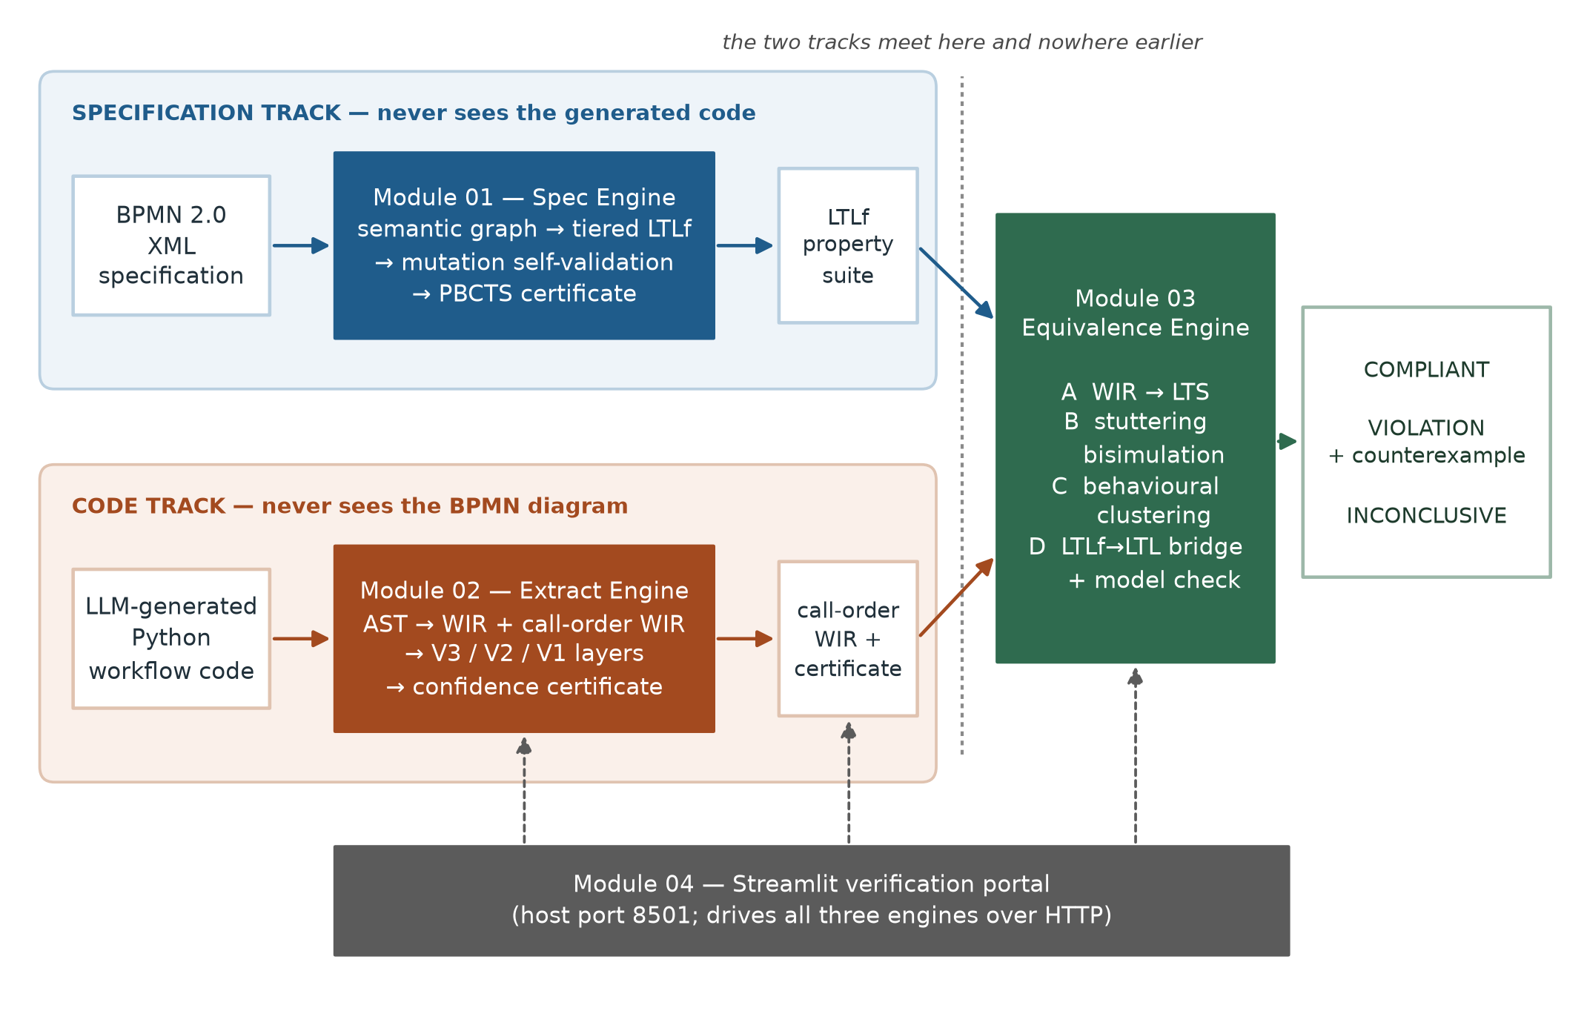
Figure 4.1 – VibeCheck end-to-end architecture. The specification track (upper band) and the code track (lower band) are deployed as separate containers and see disjoint inputs; the dashed rule marks the single point of convergence inside Module 03. The portal drives all three engines over HTTP.
Specification track. The BPMN XML is parsed into a semantic graph in which nodes carry their BPMN type and label and edges carry sequence-flow conditions. Implicit branch conditions on exclusive gateways are inferred where the diagram leaves them unstated. From this graph the module synthesizes a tiered suite of LTLf properties: a safety tier asserting that forbidden orderings never occur, a liveness tier asserting that required actions eventually occur, and a fairness tier constraining repeated behaviour. The suite is then subjected to mutation self-validation — mutants of the source specification are generated, and the suite must distinguish them — and to Progression-Based Constructive Trace Synthesis, which constructs satisfying traces by LTLf progression and aligns them against traces of the model. The exports are a property suite as JSON and a set of task patterns for the code track's tracer, the latter being the only information that crosses from the specification side and containing no specification structure.
Code track. The Python source is parsed to a syntax tree and reduced to the Workflow Intermediate Representation, a control-flow graph in JSON governed by a shared schema. Two views are produced: the definition-order view, which reflects the order in which the source defines its steps, and the call-order view, which reflects the order in which they actually execute. The distinction is not cosmetic — the equivalence engine requires the call-order view, and Section 6.3 records that supplying the definition-order view produces a well-formed but meaningless comparison. Three validators then run: structural validation over the syntax tree and dominator relations, which gates; bounded symbolic execution discharging path constraints with an SMT solver; and dynamic differential tracing, which executes the program under monitoring and compares the observed action sequence against a reference interpretation of the extracted representation. The validators fuse into a single confidence score with an acceptance threshold, and the export is the call-order representation with its certificate attached.
Convergence. The equivalence engine receives the property suite from one side and the certified representation from the other, and runs four phases. Phase A lifts the representation into a labelled transition system, matching action names through the three-tier cascade of Section 3.5.4. Phase B reduces the transition system under divergence-sensitive stuttering bisimulation, which compresses redundant internal steps without collapsing a non-terminating loop into an ordinary wait. Phase C clusters implementations that are behaviourally indistinguishable, so that a set of candidates costs one check per distinct behaviour. Phase D bridges each finite-trace property into the infinite-trace semantics the model checker implements, converts the negation of the property to an automaton, composes it with the program automaton, and tests for emptiness; a non-empty product yields an accepting run, rendered as a readable counterexample.
Two things about this pipeline are worth naming as approach rather than implementation. The first is that the bridge in Phase D is a semantic transformation, not a syntactic one: the property suite is over finite traces and the checker's models are infinite runs, and conflating them is one of the two ways this project measured a model checker reporting conformance while proving nothing. The second is that abstention can be produced by any phase, and the certificate records which phase produced it, so that "could not decide" is always attributable.

4.6 Output
The system's output is a certificate with four parts.
- 1. A verdict, one of COMPLIANT, VIOLATION, or INCONCLUSIVE. The third is not an error condition and is reported with the phase and reason that produced it.
- 2. A counterexample, when the verdict is a violation: the sequence of workflow actions witnessing the failure, rendered in the vocabulary of the process rather than of the automaton, together with the property it violates.
- 3. An extraction certificate from the code track: the structural gate's outcome, the symbolic and dynamic layer scores, the fused confidence, and the comparison mode under which it was computed. A verdict is a statement about the representation that was checked, so the confidence in that representation travels with it.
- 4. A specification reliability certificate from the specification track: the tier census of synthesized properties, the mutation self-validation outcome, and the trace-synthesis result, so that the property suite the verdict rests on is itself accounted for.
The certificate deliberately does not report a single scalar score for the whole pipeline. Compressing a gated, abstaining, multi-phase decision into one number would discard exactly the information a user needs in order to act on it.

4.7 Assumptions and scope
The following assumptions are load-bearing and are stated here so that the results in Chapter 7 are read correctly.
- • The specification is authoritative and correct. The system certifies the program against the diagram; it does not evaluate whether the diagram encodes the right business policy.
- • BPMN coverage is restricted to core control flow. Events beyond start and end, message and signal flows, sub-processes, boundary events, multi-instance activities, data objects and pools or lanes are out of scope. A diagram using them is not partially checked; the constructs are simply not modelled.
- • The program is deterministic, single-threaded and terminating on the traced inputs. The dynamic layer must execute the program to observe it, so a program that cannot be executed, or whose behaviour depends on concurrency or external state, is outside what the differential layer can certify.
- • Action correspondence is establishable. The two tracks derive their vocabularies independently, so the comparison presumes that the actions named in the specification can be matched to the actions performed by the program. When they cannot, the correct output is abstention, and Section 6.5 reports a case in which a failure of exactly this presumption produced a false conformance verdict until it was diagnosed.
- • Verdicts are scoped to the checkable property slice. Not every synthesized property can be evaluated against code; Section 7.2.2 gives the measured fraction. A COMPLIANT verdict is a statement about the properties that were checked and about nothing else.
The evaluation adds one further scope restriction that belongs here rather than in Chapter 7 alone. Because the benchmark carries no correctness labels, every measured rate in this report is a rate over a corpus the project constructed — injected mutations with known semantics, and natural faults screened by a behavioural admission oracle. These are statements about those fault classes, not about the unconditioned population of defects that language models produce.

4.8 Summary
The approach is to treat the language model as an untrusted translator and validate each translation after the fact: formalise the BPMN specification into a tiered LTLf property suite on one side, formalise the Python program into a certified control-flow representation on the other, keep the two formalisations blind to each other, and let a model checker decide at the single point where they meet. Four principles govern the design — independence, abstention as a real verdict, explicit gates at every stage, and certificates rather than proofs — and each is paid for in throughput or in duplicated work. The inputs are a diagram, a program and a comparison mode; the output is a verdict with a counterexample and two certificates accounting for the objects that were compared. The scope restrictions in Section 4.7, particularly the restriction to core BPMN control flow and to the checkable property slice, define what the results of Chapter 7 do and do not say. The next chapter gives the design of the system and of each module within it.

CHAPTER 5 – ANALYSIS AND DESIGN

5.1 Introduction
This chapter gives the design of the system. Section 5.2 designs the system as a whole: the decomposition into modules, the contracts between them, and the enforcement of the independence constraint. Sections 5.3 to 5.6 design each module in turn, in each case stating the phases, the gate that admits each phase's output, and the design decisions that a reader might otherwise take to be arbitrary. Section 5.7 designs the verdict model, which is where abstention is given its structure. Section 5.8 summarises.
The chapter is written to make the reasons visible, because several of the design decisions look over-engineered until the failure they prevent is stated, and two of them were adopted only after the corresponding failure had actually occurred and been measured. Where that is the case the chapter says so and points to the implementation or evaluation section that records it.

5.2 System design

5.2.1 Decomposition
The system decomposes along the line the problem itself draws. There are two artefacts to be compared and they are of different kinds, so there are two formalisation modules; the comparison is a third concern with its own theory and its own failure modes, so it is a third module; and operability is a fourth concern with no research content, so it is a fourth. Figure 4.1 shows the result. What makes this decomposition more than conventional separation of concerns is the direction in which information is not allowed to flow, which Section 5.2.3 makes precise.

5.2.2 Inter-module contracts
Three artefacts cross module boundaries, and each is a declarative document rather than a call into another module's code.
The Workflow Intermediate Representation is the code track's output: a control-flow graph in JSON, with nodes carrying an identifier, a type and an action label, and edges carrying an optional condition. It is governed by an explicit JSON Schema held in a shared directory and mounted read-only into the extraction engine's container, and it is the only artefact in the system given a machine-checkable contract — a decision justified by the fact that it is the one document both halves of the pipeline must agree on.
The property suite is the specification track's output: a JSON document of tiered LTLf formulae in the infix syntax the model checker's parser accepts, each with its tier, its provenance in the diagram, and its atom vocabulary. The atom vocabulary is part of the contract for a reason discovered the hard way: a suite whose atoms cannot be matched to anything the code side produces is not a weaker suite but an empty one, and unless the vocabulary is explicit the emptiness is invisible (Section 6.5).
The task patterns document is the only information that crosses from the specification side to the code side, and its content is deliberately minimal: the set of action-name patterns the tracer should treat as task-level events. It carries no ordering, no structure, and no property content, so it cannot inform the code track about what the specification requires — only about what vocabulary to observe.

5.2.3 Enforcing independence
Independence is enforced by deployment rather than by discipline. Each module is built from its own directory as its own container image, so a module's image does not contain the other modules' source and cannot import it. The consequence is accepted rather than worked around: logic needed on both sides of a boundary is implemented twice. The specific instance is LTLf formula normalisation, which the specification engine needs in order to emit properties and the equivalence engine needs in order to parse them, and which exists as two independent implementations. Section 6.6 documents the duplication and Section 8.6 defends it: a shared library would be a single import away from a channel by which the specification could come to depend on the code, and the guarantee that no such channel exists is worth more than the hundred lines it costs.

5.2.4 Deployment design
Three engines are HTTP services on an internal network, addressable only by service name; the portal is the only container publishing a host port. The engines are stateless — each request carries its own inputs and returns its own certificate — which means a set of candidate implementations can be processed without coordination, and which is what makes the clustering phase of Section 5.5.4 a pure optimisation rather than a change of semantics.

5.3 Module 01 design — specification analysis
Module 01 turns a BPMN diagram into a property suite whose reliability has itself been assessed. It runs four phases, each with an explicit gate. Figure 5.1 shows the pipeline.
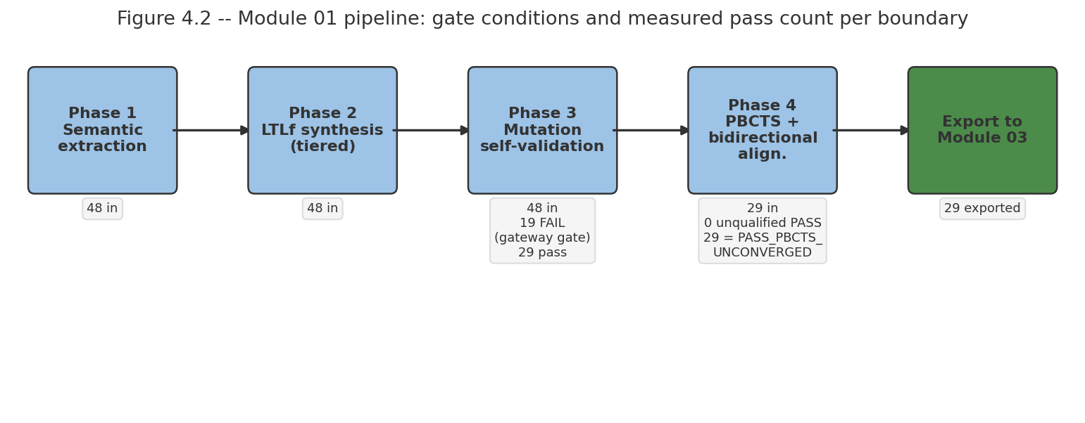
Figure 5.1 – Module 01 specification-analysis pipeline. Each phase is gated; a phase whose gate fails does not pass output downstream. The exports are a tiered LTLf property suite and a task-pattern list.

5.3.1 Phase 1 — Semantic extraction
The BPMN XML is parsed into a labelled directed graph in which each node carries its BPMN element type and its human-readable label, and each edge carries its sequence-flow identifier and any condition expression attached to it. The design decision here is to produce a state-based labelling rather than an event-based one: a node is understood as a state in which the corresponding action is active, in the spirit of the Petri-net semantics of [4]. This matters because the property suite must be evaluated against a transition system derived from code, and a state-based reading is the one that survives the translation.

5.3.2 Phase 2 — Tiered property synthesis
Properties are synthesized into three tiers, and the tiering is a design commitment rather than a taxonomy for presentation. The tiers differ in what they assert and, crucially, in whether they can be decided at all against a terminating program:
- • P0, safety. Nothing forbidden happens: a task never occurs before its predecessor, two branches of an exclusive gateway are never both taken. These are the properties a finite trace can refute conclusively.
- • P1, liveness. Something required eventually happens: every started process eventually reaches an end event, every enabled task eventually executes. Over finite traces these are decidable but their truth depends sharply on where the trace ends, which is the source of the bridging problem in Section 5.5.5.
- • P2, fairness. Repeated behaviour is constrained: a loop does not starve one of its exits. These are the properties least likely to be checkable against a single traced execution, and the census in Section 7.2.2 shows the consequence.
Exclusive gateways in real BPMN diagrams frequently leave their branch conditions implicit, with the intended semantics carried only in the branch labels. The synthesizer infers conditions in this case rather than discarding the gateway, because discarding it would silently weaken the suite: a diagram's exclusivity requirement is exactly the kind of obligation that must not disappear because it was written informally.

5.3.3 Phase 3 — Mutation self-validation
A property suite that is satisfied by everything is worthless, and nothing in the synthesis procedure prevents that outcome. Phase 3 therefore tests the suite against itself: mutants of the source specification are generated by systematic perturbation, and the suite must distinguish them from the original. A suite that fails to kill its mutants is not exported. The design point is that this is a self-validation and is legitimate as such — it establishes that the suite discriminates among specifications, which is a property of the suite alone and requires no knowledge of any code. It establishes nothing about whether the suite captures the process owner's intent, and the report does not claim that it does.

5.3.4 Phase 4 — Progression-based constructive trace synthesis
Phase 4 constructs traces that satisfy the synthesized properties and aligns them against traces of the semantic graph, as evidence that the suite and the model agree. It does so by LTLf progression: given a formula and the next state of a candidate trace, the procedure rewrites the formula into the residual obligation that remains, and a trace is satisfying when the residual reduces to truth. This replaced an earlier design that built automata with an external library, and the design argument for the replacement is that progression operates natively on finite traces. The earlier design had to translate into infinite-trace automata and back, and that translation was an error source in a module whose entire purpose is to be trustworthy about finite-trace semantics. Section 3.4.2 records the reversal and Section 8.3.2 records its cost in test coverage.

5.3.5 The reliability certificate
The module's output certificate reports the tier census, the mutation self-validation outcome, the trace-synthesis result, and which gates passed. It is a statement about the property suite, not about any program, and it is designed to be read alongside the conformance verdict so that a reader can see what the verdict was checked against.

5.4 Module 02 design — verified representation extraction
Module 02 turns Python source into the Workflow Intermediate Representation and attaches a certificate quantifying how far that representation may be trusted. Figure 5.2 shows the three validator layers and their fusion.
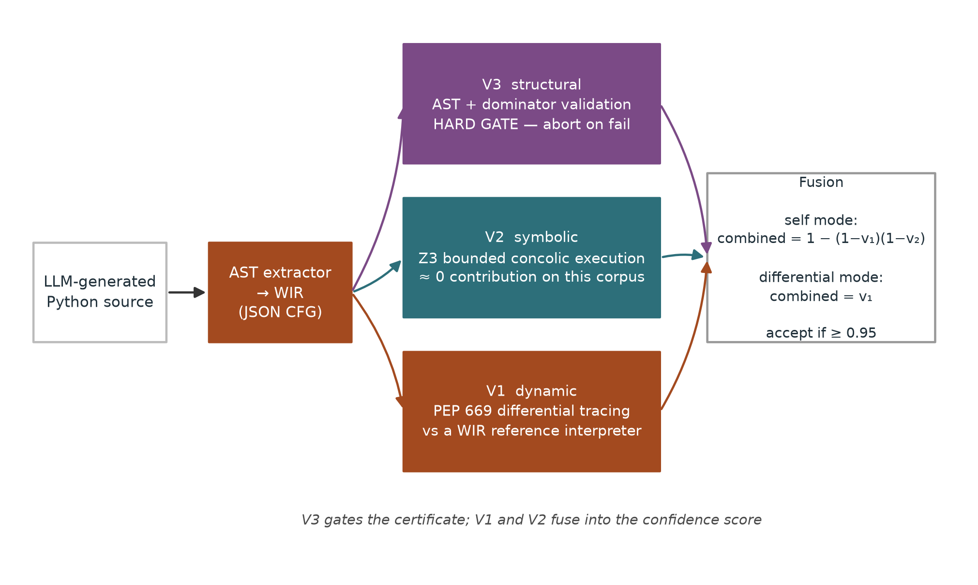
Figure 5.2 – Module 02 three-layer certificate. V3 structural validation is a hard gate; V1 dynamic differential tracing and V2 symbolic execution fuse into the confidence score. On the corpus evaluated, V2 contributes approximately nothing (Section 7.3.6).

5.4.1 Extraction, and the two views
The extractor walks the syntax tree and emits a control-flow graph. It emits two views of it, and the distinction is one of the most consequential small facts in the system. The definition-order view lists steps in the order the source defines them; the call-order view lists them in the order they execute. For a program whose functions are defined in the order they are called these coincide, and for a program whose are not they differ arbitrarily. The equivalence engine requires the call-order view, because a conformance question is a question about execution order. Section 6.3 records that the first end-to-end integration supplied the definition-order view and produced a well-formed comparison that meant nothing, which is the reason the two views are named distinctly in the schema rather than treated as one artefact.

5.4.2 V3 — Structural validation as a hard gate
The structural layer checks the extracted graph against properties a control-flow graph derived from structured Python must satisfy, including dominance relations between branch heads and their bodies. Its design status is as a gate, not a score: a graph that fails it produces no certificate. The reasoning is that a representation known to be structurally wrong should be rejected rather than assigned low confidence, because a low confidence score invites a user to proceed with caution when the correct action is not to proceed at all.

5.4.3 V2 — Bounded symbolic execution
The symbolic layer executes the extracted workflow over symbolic inputs, accumulating path constraints and discharging them with an SMT solver, bounded to keep the analysis tractable. Its design intent is to establish that the paths the representation admits are the paths the program can actually take. Section 7.3.6 reports that on this corpus it contributes approximately nothing to the fused score. The layer is retained, and the report states the negative result wherever the certificate is described, so that "three-layer" is not read as a claim that three layers are doing work.

5.4.4 V1 — Dynamic differential tracing
The dynamic layer executes the program under event-level instrumentation, records the sequence of task events it actually performs, and compares that sequence against the sequence a reference interpreter derives from the extracted representation. Where the two sequences differ by insertions or deletions they are aligned by longest-common-subsequence before being compared, so that a single missing action does not register as total divergence.
This layer has two modes, and the design decision they encode is the subtlest in the module. In self mode the reference interpretation is derived from the representation extracted from the same program: the comparison then establishes extraction fidelity and nothing else, because oracle and subject share any defect the program has. In differential mode the reference is a representation derived from an independent artefact — the specification's own expected behaviour, or an independently written sibling implementation — and the comparison then establishes something about the program rather than about the extractor. Section 7.3.4 measures the difference: self mode detects 3 of 67 purely logical injected faults, and 0 of 50 of the single largest such operator; differential mode detects 0.9952 of genuine bugs (95% CI [0.974, 1.000], n=210). The two modes exist because the first measurement was taken, not because the distinction was anticipated.

5.4.5 Comparison granularity
The differential comparison must decide what counts as a difference. In strict mode every recorded event, including argument values, must correspond; in task_only mode only the task-level action sequence must. The design rule the project arrived at is that the granularity is determined by what the two compared artefacts legitimately share. Two independent implementations of one specification are not obliged to agree on internal values, so comparing them strictly manufactures disagreements; a program and a representation of that same program are obliged to agree on everything, so comparing them loosely discards evidence. Figure 5.3 quantifies both directions of the trade.
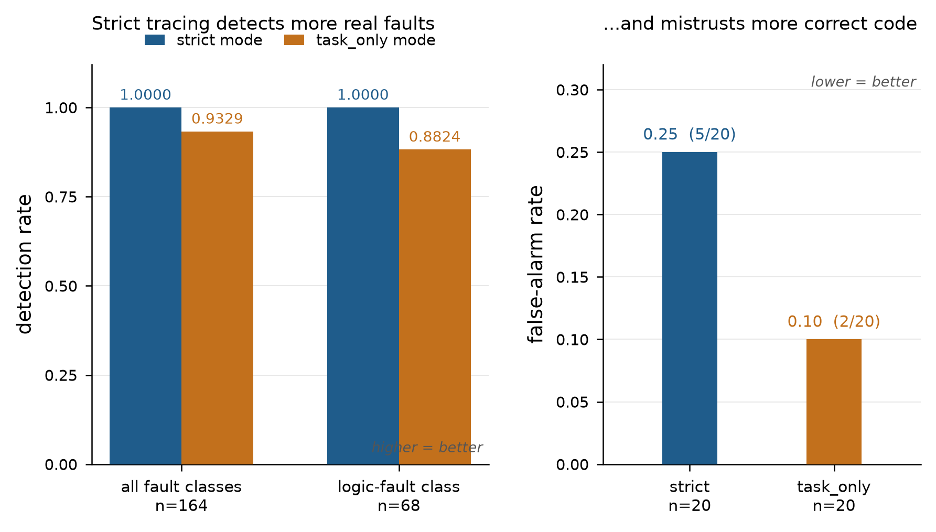
Figure 5.3 – The comparison-granularity trade. Strict comparison detects more real faults (left) but rejects more behaviourally correct independent implementations (right). Rates and denominators as tabulated in Section 7.3.7.

5.4.6 Fusion and acceptance
The layers fuse into one confidence score. In self mode the two scoring layers are combined as the probability that at least one detects a defect, 1 − (1 − v₁)(1 − v₂), with V3 gating; in differential mode the score is the dynamic layer's alone, since that is the layer whose reference is independent. The acceptance threshold is 0.95. Section 7.3.8 records that this threshold was selected by maximising Youden's J statistic on a calibration split and frozen before the evaluation split was used, so that it is pre-registered rather than fitted to the results it produces.

5.5 Module 03 design — equivalence engine
Module 03 is where the two tracks meet. Figure 5.4 shows its four phases.
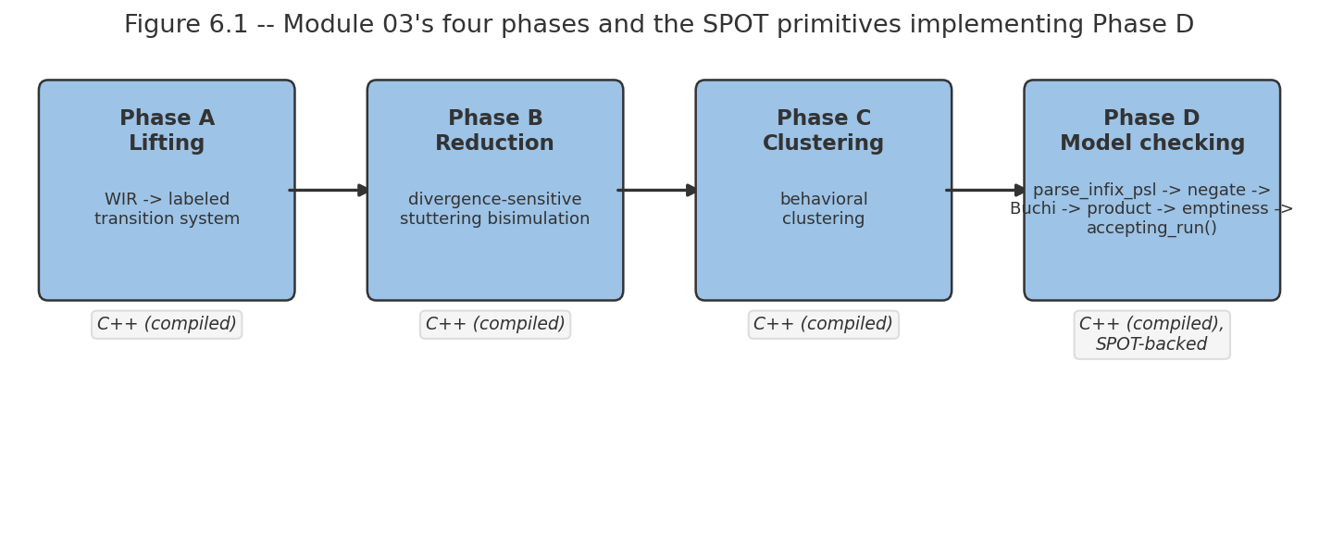
Figure 5.4 – Module 03 four-phase equivalence and model-checking pipeline. Phase A lifts the call-order representation to a labelled transition system; Phase B reduces it divergence-sensitively; Phase C clusters behaviourally identical implementations; Phase D model-checks the property suite and renders counterexamples.

5.5.1 Phase A — Lifting to a labelled transition system
The call-order representation is lifted to a labelled transition system whose states are workflow states and whose transition labels are actions. Lifting requires deciding, for each action the code performs, which specification action it corresponds to, and the two vocabularies were derived independently and by construction never negotiated. The design is an explicit three-tier cascade: exact string match; then normalised edit distance; then, only for the residue, semantic similarity between sentence embeddings.
The ordering of the tiers is the design decision, not the presence of the tiers. Semantic similarity placed first would equate approve_claim with reject_claim, which are semantically close and behaviourally opposite — the exact fault class the system exists to find. Placed last, behind two tiers that demand near-identity, it recovers genuine renamings without manufacturing correspondences. When no tier matches, the correct outcome is abstention, and Section 6.5 reports what happens when a system in this position does not abstain.

5.5.2 Phase B — Divergence-sensitive stuttering bisimulation
The lifted system contains many states that differ only in internal bookkeeping, and reducing them makes model checking tractable. The standard relation for this is stuttering equivalence, computed by partition refinement [24], [26]. The standard relation is unusable here, and the reason is specific: it absorbs internal steps freely and therefore identifies a state that performs finitely many internal steps and proceeds with a state that performs internal steps forever. In this domain that identification erases the fault. A hallucinated while True: pass retry loop and a legitimate bounded wait are stuttering-equivalent under the plain relation, so the reduction would delete the defect before the checker ever saw it.
Module 03 therefore implements a divergence-sensitive refinement [25], in which the ability to perform internal steps indefinitely is an observable property that the relation must preserve. Divergent states are identified before refinement by decomposing the internal-transition subgraph into strongly connected components: a non-trivial component with no outgoing observable transition is a divergence. Refinement then treats divergence as a distinguishing label, so divergent and convergent states are never merged. This report does not describe the phase as ordinary bisimulation, because the difference is the reason the phase is sound for this application.

5.5.3 Phase C — Behavioural clustering
When several candidate implementations of one specification are certified together, many of them are behaviourally identical despite being syntactically different. Phase C partitions them into behavioural equivalence classes using the relation of Phase B, so that model checking runs once per class rather than once per implementation. This is a pure optimisation — the verdict for a class is the verdict for each of its members, by the definition of the relation — and it is available only because the engines are stateless.

5.5.4 Phase D — Model checking
For each property, the checker parses the formula, constructs an automaton for its negation, composes that automaton with the program automaton, and tests the product for emptiness, following the automata-theoretic formulation [17], [7]. An empty product means no run of the program violates the property. A non-empty product yields an accepting run, from which a counterexample is rendered as a sequence of workflow actions in the process's own vocabulary rather than as a path through automaton states, because the counterexample is the part of the certificate a process owner will actually read.

5.5.5 The finite-to-infinite bridge
The property suite arriving from the specification track is over finite traces; the checker's automata are over infinite runs. The bridge is the reduction of De Giacomo, De Masellis and Montali [16]: an LTLf formula is transformed into an LTL formula whose infinite-trace models correspond to the finite-trace models of the original, by introducing an atom marking the live portion of the run and extending the trace beyond termination in a controlled way. Figure 5.5 illustrates the construction on a small example.
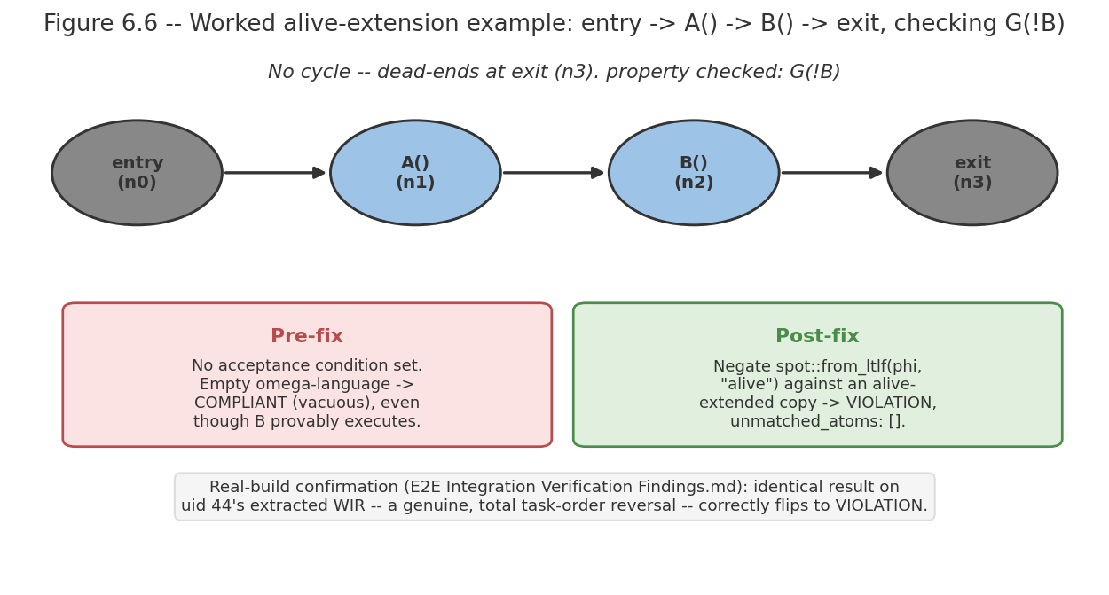
Figure 5.5 – The finite-to-infinite bridge on a small example: the finite trace is extended with a marked tail so that an infinite-trace checker decides the finite-trace question. Without this transformation the checker answers a different question and can report conformance vacuously (Section 6.4).
The design point is that this is a semantic transformation and not a reformatting. Section 6.4 reports the consequence of treating it as reformatting, which was one of two mechanisms by which the checker returned conformance while establishing nothing.

5.6 Module 04 design — verification portal
The portal has one page per engine plus a landing page, calls the engines over HTTP by service name, and renders each certificate with its verdict, its evidence and its scope. The design intent is inspectability rather than automation: a user should be able to see the property suite, the extracted representation and the verdict as three separate objects, because the most common diagnostic question is which of the three is wrong. The module makes no research contribution and Chapter 8 says so.

5.7 Verdict model
The verdict model is designed so that abstention carries information. A certificate reports one of three verdicts, and an abstention is always attributed to the phase and condition that produced it. Table 5.1 gives the model.
Table 5.1 – Verdict model. Abstention is a reported outcome with an attributed cause, not an error condition.
Verdict | Meaning | Evidence returned
COMPLIANT | No run of the reduced transition system violates any checked property | Properties checked, tiers covered, extraction confidence, comparison mode
VIOLATION | At least one checked property admits a violating run | The property violated and a counterexample rendered as a workflow action sequence
INCONCLUSIVE | The comparison was not well-founded, or no property was decidable | The phase that abstained and the reason: unmatched action vocabulary, failed gate, undecidable property form, or extraction confidence below threshold

Two conditions are singled out in the design because both were observed as false conformance before they were made abstentions. If Phase A can match no specification atom to any code action, the property suite is vacuously satisfied and the correct verdict is abstention, not compliance. If the finite-to-infinite bridge is not applied, the automaton for the negated property may have no reachable accepting condition, so the product is trivially empty and again the correct verdict is not compliance. Sections 6.4 and 6.5 report both as implementation findings; the design lesson is that a model checker's silence must be distinguished from a model checker's assent.

5.8 Summary
The design places the two formalisations in isolated containers with declarative contracts between them, so that independence is a property of the deployment rather than of programmer discipline, at the cost of duplicating normalisation logic across one boundary. Module 01 synthesizes tiered LTLf properties from a state-based reading of the BPMN graph and gates their export on mutation self-validation and progression-based trace synthesis. Module 02 extracts a control-flow representation in two distinct views, gates it on structural validation, and scores it with symbolic and dynamic layers whose reference artefact — self or independent — determines what the score means. Module 03 lifts, reduces divergence-sensitively so that non-termination survives the reduction, clusters, bridges finite-trace properties into infinite-trace semantics, and model-checks. The verdict model makes abstention an attributed outcome, and two of its abstention conditions exist because the system was first observed reporting conformance without grounds for it. The next chapter describes how this design was implemented and what went wrong in the building of it.

CHAPTER 6 – IMPLEMENTATION

6.1 Introduction
This chapter describes how the design of Chapter 5 was realised. Sections 6.2 to 6.4 cover the three engines module by module, naming the source components that implement each phase. Section 6.5 reports the two defects found in the equivalence engine during development, both of which caused a model checker to return a conformance verdict while establishing nothing, and both of which are reported here as implementation findings because their diagnosis is a result of the project rather than an incident in its history. Section 6.6 documents the cost of the independence constraint in duplicated code. Section 6.7 covers the portal. Section 6.8 states the defects known to be present in the current build, since a report that described only what works would be a different document from an honest one. Section 6.9 summarises.
One convention applies throughout. Where a fact about the implementation was established by reading the source, this chapter says so; where it was established by running something, it says that instead. The distinction matters because several of the findings in Section 6.5 were first derived from source inspection and only later confirmed against a working build, and in one case the source-derived conclusion turned out to be right about the mechanism and wrong about its scope.

6.2 Module 01 implementation — specification engine

6.2.1 Component layout
The specification engine is 2,958 lines of Python over eleven source modules behind a FastAPI application. semantic_extractor.py implements Phase 1, parsing the BPMN XML into the labelled graph. ltlf_synthesizer.py implements Phase 2, emitting the tiered property suite. mutation_refiner.py implements Phase 3, generating specification mutants and testing the suite against them. ltlf_progression.py and ltlf_eval.py implement the progression calculus and finite-trace evaluator; trace_synthesizer.py and bidirectional_alignment.py implement the PBCTS phase on top of them; adversarial_generator.py supplies the perturbations used in self-validation. formula_normalizer.py produces the model-checker-compatible surface syntax for export.

6.2.2 The route, and its gates
The module exposes a single verification endpoint plus a root. The route runs the phases in sequence and enforces the gates of Section 5.3 as HTTP failures rather than as degraded output: a Phase 1 gate failure returns a 422 carrying the phase-1 certificate, and a Phase 3 gate failure likewise. Phase 2 raises a dedicated verification exception that is also mapped to a 422. The PBCTS phase is deliberately not fatal: it is wrapped so that a failure inside it degrades the overall status rather than losing the phases that already succeeded, and the overall status becomes PASS_PBCTS_UNCONVERGED when trace synthesis runs but does not converge. This is a design decision visible in the code: property synthesis whose self-validation passed is useful even when the trace-alignment evidence is absent, so it is exported with the weaker status attached rather than discarded.

6.2.3 What the gates actually rejected
Running the engine over the 48 BPMN specifications in the benchmark's context directory produced 19 hard failures and 29 exports, and — a fact worth stating plainly — zero specifications achieved the unqualified PASS status. Every survivor exported with the non-converged status. The 19 failures are not scattered: the failing set is exactly the set of specifications containing an exclusive gateway, and this set equality was tested rather than observed informally. A representative message, from specification uid 12, reports that an exclusive gateway has two unconditioned branches and no default flow.
The cause was then traced through the corpus rather than inferred. Across the 19 gateway-bearing specifications there are 20 splitting exclusive gateways; none of the 20 carries a default attribute, and none has a condition expression on any outgoing flow. The corpus contains no parallel gateways at all. The gate is therefore behaving correctly and the corpus is the constraint: FLOW-BENCH's diagrams express branch semantics in labels rather than in the attributes the standard provides for it. One correction belongs here — the failure was initially attributed to Phase 3, and tracing the exception path showed it is raised in the synthesizer's certification step and reported under phase 2. The counts and the set-equality result are unaffected.

6.2.4 The export seam
The property suite is exported as JSON with each property's tier, provenance and atom vocabulary. One defect at this seam is worth recording because it was invisible from inside the module: the exported tier_semantics block described three of the five tiers the module actually ships, which caused the equivalence engine's ingestion layer to raise on real specifications while passing on the hand-written fixtures. It was fixed and a regression test, test_real_export_is_ingestible_by_module_03, now exercises ingestion against a real export rather than a fixture. The general lesson is recorded in Section 8.6: an independence boundary needs a contract test at the seam, because neither side's own tests can see a mismatch.

6.3 Module 02 implementation — extraction engine

6.3.1 Component layout
The extraction engine is the largest module at 25,499 lines with 257 test functions across 18 files, organised as three subsystems behind one endpoint. The ast_extractor package contains the control-flow extractor, the dominator computation, the guard analysis, the schema, the certificate assembly and the call-order view. The z3_sym_engine package contains the symbolic pipeline: a concolic driver, an evaluator, a constraint registry and a sandboxed executor. The dynamic_tracer package contains the collector that instruments and records execution, the reference interpreter that replays the extracted representation, the comparator that aligns and scores the two sequences, a randomised input generator and a composer.

6.3.2 The two views, and a finding about integration
The extractor emits the definition-order view and the call-order view described in Section 5.4.1. Measurement over the variant corpus shows the two views differ for 47.5% of 184 variants, independently reproduced at 45.5% by a different method — so for approximately half the corpus the distinction decides what is being compared.
The first end-to-end integration supplied the definition-order view to the equivalence engine, which requires call order. The comparison that resulted was well-formed and meaningless, and Section 6.5.3 reports what happened to the corpus verdicts when the correct view was supplied. The structural reason the wrong view is so damaging was established by inspecting the corpus: all 184 variants have their tasks at top level, none has a top-level gateway, and no task node appears inside a sub-control-flow-graph, while every one of the 184 variants has at least one sub-graph with a no-outgoing-edge exit. A lifter that walks definitions therefore sees the tasks in an order unrelated to execution and terminates in dead ends. Seven tests in test_call_order_view.py now pin the view construction.

6.3.3 The structural gate
Structural validation computes dominator relations over the extracted graph and checks the dominance properties a graph derived from structured Python must satisfy. It is implemented as an abort rather than a score, per Section 5.4.2. One implementation defect in this layer is worth recording as a caution about the technique rather than about the code: the dominance-frontier computation admitted an input on which it did not terminate, which was found and fixed with a bound and a regression test. A hard gate that can hang is not a gate.

6.3.4 The symbolic layer
The symbolic layer drives bounded concolic execution over the extracted workflow and discharges the accumulated path constraints with the SMT solver, executing candidate inputs inside a restricted execution context. It is fully implemented. Section 7.3.6 reports that it contributes approximately nothing to the fused confidence on this corpus, and this chapter does not describe the certificate as three-layer without that pointer attached.

6.3.5 The dynamic layer
The collector instruments the program under test with the interpreter's monitoring interface and records the sequence of task-level events actually performed, falling back to the legacy tracing hook where the newer interface is unavailable. The interpreter replays the extracted representation to produce the reference sequence. The comparator aligns the two by longest common subsequence and scores the residual differences, at the granularity — every event, or task sequence only — selected by the comparison mode.
Two implementation facts about this layer are reported because they bound what it can certify. The first is that the layer must execute the program, so a program that hangs must be bounded. Measurement of the bound found that a hang which releases the interpreter's global lock is bounded reliably at approximately 0.22 seconds against a 0.2-second budget, while a statement that monopolises the lock is not bounded at all: the timeout cannot fire because the timing thread cannot run. This is a genuine limitation of in-process dynamic analysis in this interpreter and is stated as such in Section 8.4.2 rather than presented as a tuning issue. The second is that the reference sequence and the observed sequence must agree on what a task event is, which is what the task-pattern document from the specification track supplies, and is the only information crossing from that side.

6.4 Module 03 implementation — equivalence engine

6.4.1 Two tracks
The equivalence engine is implemented twice. The C++ track is lifter.cpp at 1,423 lines with a 326-line header, compiled against Spot and exposed through a pybind11 extension. The pure-Python track is approximately 1,470 lines implementing the same four phases without the native dependency. Both are retained deliberately: the Python track keeps the engine runnable and testable where the extension cannot be built, and the C++ track is the one with access to Spot's full API including the finite-trace transformation. The test suite is 142 functions across six files — 37 in the pipeline tests, 34 in the C++ engine tests, 28 for Phase B, 21 for Phase C, 17 for property ingestion and 5 for counterexample rendering — and the recorded run status at the time of writing is 118 collected with 115 passing, two pre-existing unrelated failures and one skip. The pure-Python track carries 37 of those tests.

6.4.2 Phase A — lifting and action matching
Lifting reads the call-order representation and constructs the transition system, resolving action correspondence through the three-tier cascade of Section 5.5.1: exact match, then normalised edit distance, then sentence-embedding similarity, implemented in nlp_utils.py. The vocabulary the specification side supplies is ingested by property_ingest.py, a 205-line layer that also performs the tier gating — a property whose form the checker cannot decide is excluded here, with its exclusion reason recorded, rather than being passed forward to fail obscurely later.
One implementation hazard at this boundary is worth naming because it is silent. The model checker's formula parser treats an unquoted identifier as a conjunction of its characters, so an atom written GitHub_thing parses as G(itHub_thing) — a temporal operator applied to a different atom. The failure produces a valid formula with the wrong meaning and no error. Atom names are therefore quoted on emission, and this is the kind of defect that argues for the contract test discussed in Section 6.2.4.

6.4.3 Phase B — divergence-sensitive reduction
Phase B is implemented in stuttering_engine.py on the Python side and in the lifter on the C++ side. Divergence is identified before refinement by decomposing the internal-transition subgraph into strongly connected components: a non-trivial component with no outgoing observable transition is divergent. Refinement then carries divergence as a distinguishing label, so a divergent state is never merged with a convergent one, which is what preserves the while True fault class through the reduction (Section 5.5.2). The corpus contains no graph with a genuine cycle — 0 of 43 eligible graphs — which means this phase's divergence handling is exercised by its unit tests and not by the corpus, a limitation Section 8.5.2 records.

6.4.4 Phase C — clustering
Clustering is implemented in clustering.py and, on the C++ side, by an isomorphism check over quotient automata. It carries one critical implementation invariant: exactly one lifter instance is constructed per batch, so that every automaton shares one binary decision diagram dictionary. Automata built against different dictionaries cannot be compared for isomorphism, so violating this invariant would silently produce clusters of size one. The invariant is documented at the batch entry point and pinned by the Phase C tests.

6.4.5 Phase D — model checking and counterexample rendering
Phase D is implemented in model_checker.py and in the C++ compliance entry point. For each property it parses the formula, negates it, translates the negation to an automaton, composes with the program automaton and tests emptiness; counterexample.py renders an accepting run as a sequence of workflow actions. The compliance entry point accepts a property suite and checks each conformance-eligible property against each cluster representative, and retains a single-formula code path for its tests.

6.5 Two ways a model checker can prove nothing
During development the pipeline returned COMPLIANT verdicts that were not merely wrong but empty: the checker had established nothing at all. Two independent mechanisms were responsible. They are reported here in full because the diagnosis is a contribution of the project, because each was masked by a passing test suite, and because the second was initially mistaken for the first. Figure 6.1 places them side by side.
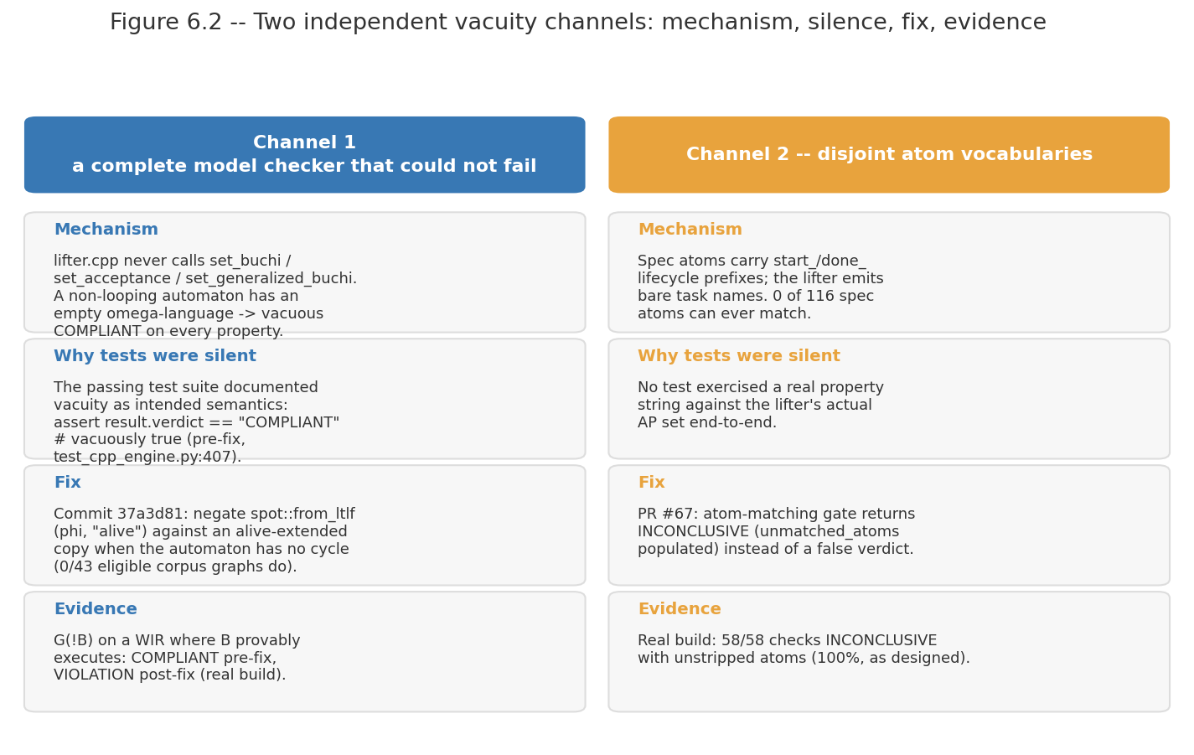
Figure 6.1 – The two vacuity channels. For each: the mechanism by which a conformance verdict was returned without evidence, why the test suite did not catch it, the fix, and the evidence that the fix works. The channels are independent; closing one does not close the other.

6.5.1 Channel 1 — an automaton with no acceptance condition
The first mechanism was found by reading the lifter: no acceptance condition is set anywhere in it. Neither the Büchi nor the generalised-Büchi acceptance setters appear in the source, and the construction permits dead-end exit states — states with no outgoing transition. The consequence follows from the automata-theoretic method. Emptiness checking looks for an accepting run, and a run of a Büchi automaton is infinite. An automaton whose runs terminate in dead ends, and which has no acceptance condition to satisfy in any case, has no accepting runs at all. The product with the negated property is therefore empty for every property, and every property is reported as satisfied. The checker was not finding conformance; it was finding nothing, and reporting nothing as conformance.
This was masked twice over. It was masked by the pipeline's default property, the placeholder G("approved"), which is the only property the single-string callers pass and which is satisfied by the corpus's automata for uninteresting reasons. And it was masked by the test suite, which contained a test asserting the vacuous outcome as intended behaviour — an assertion that the verdict was COMPLIANT, annotated as vacuously true. A test that documents a defect as a feature is worse than no test, because it defends the defect against change.
The mechanism was then confirmed on a working build rather than left as a source-reading conclusion: for a two-action non-looping automaton in which action B does execute, the checker returned COMPLIANT for the property "B never happens", with no unmatched atoms reported. The property is plainly false of that automaton.
The fix is the finite-to-infinite bridge of Section 5.5.5 rather than a patch to the acceptance condition. Each terminating run is extended with a marked tail, so that the finite behaviour of the program is expressed as an infinite run the checker can accept, and the property is transformed correspondingly. The masking test was rewritten to assert the opposite outcome and renamed to record what it now pins — that a finite automaton no longer passes vacuously.

6.5.2 Channel 2 — a property vocabulary with nothing in common
The second mechanism is independent of the first, and the project initially believed the first fix had closed it. It had not: a real build with the atom-gating fix in place still returned COMPLIANT for a plainly false property with no unmatched atoms reported. The two channels are distinct, and this misattribution is recorded in the correction trail of Section 7.7.
The mechanism is a vocabulary mismatch between two independently derived naming schemes. Of the 116 atoms appearing in the specification track's liveness-tier properties, zero could be matched to any atom the code side produces, and no specification-implementation pair in the 29-specification set had any atom in common. The atom names differ by a systematic prefix convention that neither side had reason to know about, since — this being the point of the architecture — neither side sees the other. A property over atoms that never appear is not a weak property; it is vacuously satisfied, and a suite of such properties reports universal conformance while checking nothing.
The mismatch had been undetectable from within either module. The specification engine's normalisation component, formula_normalizer.py, has no callers anywhere in the repository: it existed, it was correct, and nothing invoked it. Its docstring was rewritten to say so. The code-side action vocabulary was in fact of good quality — task names match function identifiers at 86.0% mean exactness over 43 pairs, with 26 of 43 matching perfectly — so the failure was not a naming-quality problem but a normalisation-application problem, which is exactly the kind of defect a seam without a contract test produces.
The fix makes an unmatched atom an abstention rather than an implicit truth: if a property's atoms cannot be matched, the property is not checked and the verdict is INCONCLUSIVE with the unmatched atoms named. Confirmation on the real build is that all 58 checks over the 29 specifications return INCONCLUSIVE with the atoms left unstripped — which is the honest outcome for a corpus whose vocabularies do not align, and is the result the earlier build was concealing.
One further finding from this channel is reported because it changes how the property tiers are understood rather than fixing anything. The 79 safety-tier properties, examined in the light of the vocabulary analysis, turn out to be properties of the lifting rather than of the program: they test that the transition system faithfully reflects the diagram. They are legitimate as a lifting self-test and are excluded at ingestion from the conformance-checkable set, which is why the checkable slice is drawn from the liveness tier alone.

6.5.3 Validating the fixes
Two independent pieces of evidence support the fixes, and one candidate piece is deliberately not used.
The first is cross-validation against an independent oracle. The corrected model-checking path was run against the module's own finite-trace evaluator over the 58 checks across 29 specifications. On every check where both procedures committed to a verdict, they agreed: 35 of 35, with the remaining 23 legitimately INCONCLUSIVE. Since the two procedures share no implementation — one is automata-theoretic through Spot, the other direct finite-trace evaluation — the agreement is evidence that the bridge preserves finite-trace meaning.
The second is the traced effect of the call-order fix on corpus verdicts, which is reported in full in Section 7.4.3 and shown in Figure 7.5. In summary, the pre-fix corpus run produced 18 violations, 17 conformance verdicts and 23 abstentions; the post-fix run produced 5, 10 and 43. The point of the comparison is not that fewer verdicts is better but that the verdicts that disappeared were traced individually, and the audit of the pre-fix run found that only about 10 of the 35 committed verdicts were trustworthy.
The piece of evidence not used is a bridge investigation reporting 12,600 of 12,600 agreement between the finite-trace reduction and a finite-trace oracle on generated formula and trace pairs. Its own verification note records it as credible but not independently reconfirmed, resting on a local build that was never reproduced. The load-bearing validation in this report is therefore the 35-of-35 corpus agreement, which was reproduced on a working build.

6.6 The cost of independence: duplicated normalisation
LTLf formula normalisation is needed on both sides of the boundary — the specification engine must emit properties in a syntax the checker accepts, and the equivalence engine must parse and normalise what arrives — and because the two modules are separate images the logic exists twice, as formula_normalizer.py on one side and as normalisation inside the ingestion layer on the other. The duplication is on the order of a hundred lines.
The honest accounting is that the duplication has already cost something concrete. The vocabulary mismatch of Section 6.5.2 is precisely the failure mode duplication invites: two implementations of one convention, diverging without either side's tests noticing. Section 8.6 argues the trade is nonetheless correct — the alternative is a shared library, and a shared library is one import away from becoming the channel by which the specification track learns about the code — but the argument is made on the basis that the right mitigation is a contract test at the seam, not that the duplication is free.

6.7 Module 04 implementation — verification portal
The portal is a single 573-line Streamlit application with session-state navigation between a dashboard and one page per engine, health checks against each engine, and rendering of the returned certificates. It has no automated tests. Its equivalence page is, at the time of writing, broken by construction: it attempts to import the compiled lifter extension inside a container that does not contain it, since the extension is built in the equivalence engine's image and the portal is a separate image that should be reaching that engine over HTTP. This is stated here rather than in a limitations section because it is a wiring defect with a known fix, not a research limitation.

6.8 Defects known to be present in the current build
The following are true of the build at the time of writing. They are recorded because a report that describes only the working paths would misrepresent the state of the system, and because two of them bear directly on the claims Chapter 7 makes.
- 1. The end-to-end specification-to-code path is not wired. Both halves exist: the specification engine exports an LTLf property suite, and the equivalence engine's compliance entry point accepts a property suite and checks every conformance-eligible property in it. The evaluation harness and the demonstration script do connect them. But the module's own default remains the placeholder property G("approved"), and the single-string code path that placeholder serves is still what the engine's API defaults to. The bridge between an exported finite-trace suite and the checker's infinite-trace semantics is implemented, but making it the module's default path rather than the harness's is unfinished work. This is the project's principal unresolved gap and Section 8.7 treats it as such.
- 2. The portal's equivalence page imports the lifter in the wrong container (Section 6.7).
- 3. Two test failures and one skip are present in the equivalence engine's suite, recorded as pre-existing and unrelated to the phases under test at the time of the count.
- 4. The specification engine has 28 tests for 2,958 lines. Given that this module's architecture was rebuilt recently (Section 3.4.2), every claim about its behaviour in this report should be read as resting on measurement runs rather than on a regression suite.
- 5. No specification in the corpus reaches unqualified PASS, and no specification's trace synthesis converges. The gate outcome is measured; which of the bound, the suite size or the alignment threshold is binding has not been diagnosed, and Section 8.3.3 names that as open.

6.9 Summary
The three engines are implemented as designed, with the gates realised as hard failures rather than soft scores, and with the equivalence engine implemented twice so that it remains runnable without its native dependency. Implementation established several facts that design could not: that the benchmark's exclusive gateways carry no machine-readable branch conditions at all, so the specification engine rejects 19 of 48 diagrams correctly and exports 29 with a non-converged status; that definition order and call order differ for roughly half the variant corpus, so supplying the wrong view produces a comparison that is well-formed and empty; and that a hang which monopolises the interpreter's lock cannot be bounded by an in-process timeout.
The chapter's central content is Section 6.5. Two independent mechanisms caused the model checker to report conformance while establishing nothing: an automaton with no acceptance condition and dead-ending runs, so that no accepting run existed for any property; and a property vocabulary with zero of 116 atoms matchable to anything the code side produced, so that every property was vacuously satisfied. Both were masked by a passing test suite, one of them by a test that asserted the defect as intended behaviour. Both are fixed — by the finite-to-infinite bridge and by making an unmatched atom an abstention — and the fixes are validated at 35 of 35 decisive verdicts against an independent finite-trace oracle. Section 6.8 lists what remains broken, including the project's principal gap: the specification-to-code path exists on both sides and in the harness, but is not yet the engine's own default. The next chapter reports what the system measures.

CHAPTER 7 – EVALUATION

7.1 Introduction
This chapter reports what the system measures. Section 7.2 describes the evaluation methodology, which required more construction than is usual because the benchmark carries no correctness labels, and reports the corpus funnel that determines the denominator of every rate that follows. Section 7.3 evaluates the code track, whose central result is negative. Section 7.4 evaluates the equivalence engine, including the effect of the two fixes of Section 6.5. Section 7.5 reports the end-to-end evaluation. Section 7.6 states what is not measured, which for this project is a substantial list and one the reader needs in order to interpret the rest. Section 7.7 is the correction trail: every figure the project stated and later found to be wrong, with how it was caught and what supersedes it. Section 7.8 summarises.
Four conventions govern the numbers in this chapter, and they are stated here because they are the reason several results look weaker than a differently reported version of the same work would.
- 1. Every rate carries an exact interval. Intervals are Clopper–Pearson exact binomial [36]. Several end-to-end measurements rest on fewer than twenty trials, where a normal approximation is invalid rather than merely conservative, and where the honest presentation of a point estimate is inseparable from the width of the interval around it.
- 2. Abstentions are reported, not absorbed. Where the pipeline declines to commit to a verdict, that outcome is reported as its own rate and excluded from the detection denominator rather than counted as a miss or discarded. A single blended number would be smaller and less informative.
- 3. Measured is distinguished from designed throughout. Where a capability exists in the design but no artefact measures it, the chapter says so and does not supply a plausible figure. Section 7.6 collects these.
- 4. Superseded figures appear only in the correction trail. Several figures stated earlier in the project were found to be wrong. They are reported in Section 7.7, labelled as superseded, and never presented as system behaviour.

7.2 Evaluation methodology

7.2.1 The labelling problem, and how it was solved
FLOW-BENCH [11] supplies process specifications and LLM-generated implementations but no statement of which implementations are correct. There is no ground truth to measure against, so the evaluation had to construct one, and the construction is the part of this chapter most likely to determine whether its numbers mean anything.
The construction has three parts. First, a behavioural admission oracle: a generated variant is admitted as conformant only when its observed behaviour matches the specification's expected behaviour under the differential comparison, so that "conformant" is a measured property rather than an assumption. Second, mutation with known semantics: single-site mutations are injected into admitted variants by nine applicable operators of ten implemented, and because the operator is known the label of each mutant is known. Third, a natural-fault corpus obtained as a by-product: variants that failed admission were screened and their faults classified, giving a corpus of defects that real language models actually produced rather than defects an operator injected.
The distinction between the second and third corpora matters for interpretation. Mutation operators define the fault distribution they measure [34], [35], so a detection rate over mutants is a statement about those operators. The natural-fault corpus is not subject to that objection, though it is subject to another: it consists of the faults that this particular set of models produced on this particular benchmark.

7.2.2 The corpus funnel
Every denominator in this chapter comes from a chain of admissions, and the chain contracts sharply. Figure 7.1 shows it for the specification track.
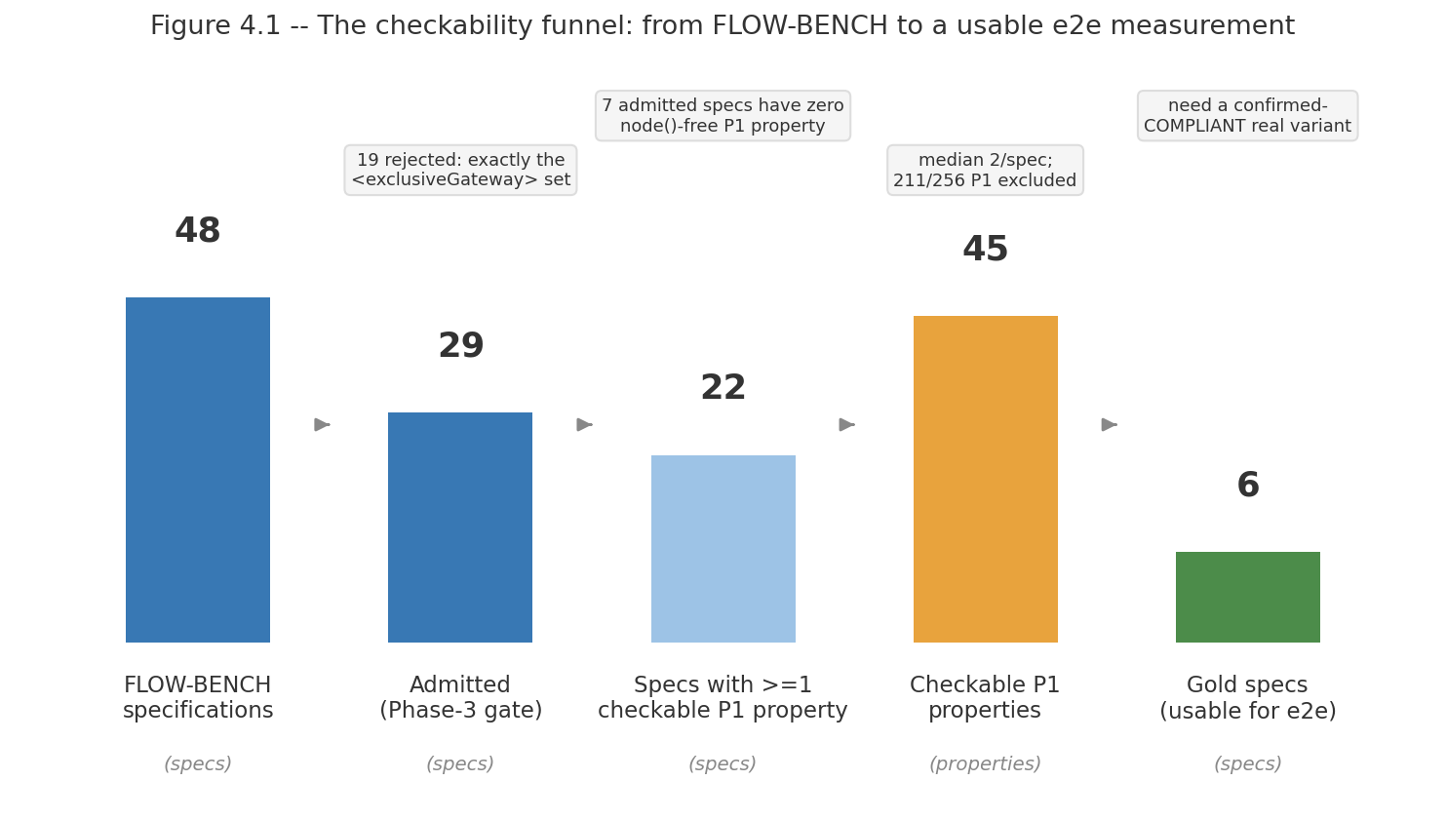
Figure 7.1 – The specification-track admissibility and checkability funnel: 48 BPMN specifications, 29 exports, 22 specifications with at least one checkable property, 45 checkable properties, 6 gold specifications. Each contraction is annotated with its cause. This funnel determines the denominator of every rate in Sections 7.4 and 7.5.
The corpus contains 48 BPMN specifications. The specification engine hard-fails 19 of them and exports 29, with no specification achieving unqualified PASS status; Section 6.2.3 establishes that the failing set is exactly the exclusive-gateway-bearing set and that the cause is the corpus's complete absence of machine-readable branch conditions (0 of 20 splitting gateways carry a default attribute; 0 of 20 carry a condition expression on any outgoing flow).
Across the 29 exports the engine synthesizes 412 properties. Table 7.1 gives the tier census, and Figure 7.2 shows it by disposition. The number that governs the rest of the chapter is in the last row of that table: 45 properties — 17.6% of the liveness tier, distributed over 22 of the 29 specifications with a median of 2 per specification — are checkable against code. Everything else is excluded, and for stated reasons rather than by attrition.
Table 7.1 – Property tier census over 29 exported specifications, with the disposition of each tier. Source: end-to-end session findings §F3, restated in the equivalence engine's ingestion layer.
Tier | Count | Disposition
P0 — safety | 79 | Reclassified as a lifting self-test, excluded at ingestion (Section 6.5.2)
P1 — liveness | 256 | The only conformance-checkable tier; 211 of 256 (82.4%) reference node-level atoms the code side does not produce
P2 — fairness | 29 | All 29 are one unparseable template shape; excluded
P3 | 48 | All 48 use the next-state operator; not bridged
Killer properties | 0 | —
Intra-tier exact duplicates | 34 of 412 | Counted once at ingestion
Checkable against code | 45 of 256 = 17.6% | In 22 of 29 specifications, median 2 per specification

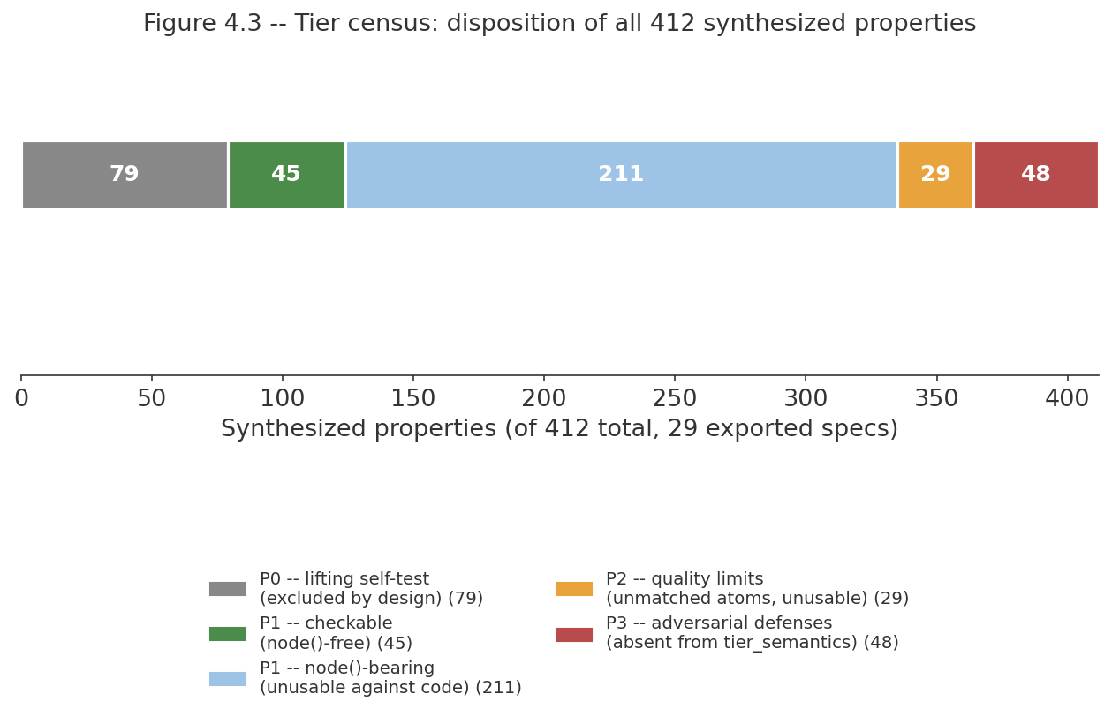
Figure 7.2 – Tier census of 412 synthesized properties by disposition. The checkable slice (45) is a small fraction of the whole, and the report treats this as a measured ceiling on what the pipeline can currently decide rather than as an incidental detail.
One measured property of the specification suite deserves its place here because it is a positive result about the property synthesizer: the suite is self-consistent. All 45 specification-order traces satisfy their own suites — 45 of 45. A suite that its own reference behaviour violated would be unusable, and this establishes that it is not.

7.2.3 Pre-registration of thresholds
The code track's acceptance threshold was chosen rather than assumed, and the choice was made in a way that prevents it being tuned to the results it produces. The threshold was selected by maximising Youden's J statistic [37] on a calibration split, written to a file and frozen, and only then applied to the evaluation split. The selected operating point is J = 0.9600 at a divergence threshold of 0.10. Every code-track rate in Section 7.3 is computed at that frozen threshold.

7.3 Code track evaluation

7.3.1 Corpus and instruments
The code track is evaluated on 101 programs drawn from the benchmark, from which 427 single-site mutants were generated by nine applicable operators, and on a variant corpus described in Section 7.3.9. The module's own test suite stands at 246 passing tests at the time of the measurement.

7.3.2 Structural extraction fidelity
The structural layer's accuracy against hand-checked gold extractions over the 101-program corpus is perfect on the current pipeline: node precision, recall and F1 and edge precision, recall and F1 are all 1.0000. This figure is reported with its history attached, because the history is the more informative part. Before the graph-contraction step was added, the same measurement gave node precision 0.8255 with recall 1.0000 for an F1 of 0.9044, and an edge F1 of 0.6827 — that is, the extractor was producing structurally valid graphs with spurious intermediate nodes. The gold extractions themselves were validated by human inspection, 10 of 10 with no gold errors found.
A perfect score invites suspicion, and the honest reading is that it reflects a corpus of structurally similar generated workflow programs rather than a general claim about Python control-flow extraction. Section 7.6 states this as a scope limitation.

7.3.3 Mutant detection and calibration
Table 7.2 gives the code track's primary rates, all at the frozen threshold.
Table 7.2 – Code-track differential instrument, evaluation split. All intervals Clopper–Pearson exact binomial. Source: eval/results/calibration_report_differential.md and eval/threshold.json.
Measure | Value | 95% CI | n
Genuine-bug detection (strict) | 0.9952 | [0.974, 1.000] | 210
False-alarm rate, untouched base programs | 0.0588 | [0.012, 0.162] | 51
Youden's J at the frozen threshold | 0.9600 | — | —
Equivalent-mutant specificity | 0.111 | — | 9
Per-operator detection (strict) | all 1.000 except constant-perturbation 8 of 9 | — | —

The equivalent-mutant row needs its explanation stated rather than left as a poor number. Of the 9 mutants identified as semantically equivalent to their base programs, 8 scored exactly the same as their own base. That is not the instrument misjudging them; it is the instrument correctly observing that their behaviour is identical, and inheriting the base program's score as a consequence. A specificity metric that penalises this is measuring the wrong thing, and the figure is reported with the mechanism attached rather than silently.

7.3.4 The central negative result: self-referential validation cannot detect logic faults
The most consequential measurement in this project is a near-zero, and it is worth stating with its structure intact rather than as a single headline rate. When the confidence certificate is computed in self mode — that is, when the reference interpretation is derived from the representation extracted from the same program being judged — its overall detection rate over the mutant corpus is 0.3607 (95% CI [0.297, 0.428], n=219). Taken at face value that is a weak detector rather than a blind one. Disaggregated by operator it is not a detector of logic faults at all.
Table 7.3 – Self-mode detection by mutation operator. The right-hand column is this report's reading of what each row measures, following the diagnosis in the source report. The two rows marked as logical faults are the ones the architecture's claim rests on. Source: module_02_extract/eval/results/calibration_report.md.
Operator | Detected | Rate | What the row measures
corrupt-container-op | 17 / 17 | 1.000 | Exception channel — mutation makes the real code raise KeyError
wrong-variable | 18 / 18 | 1.000 | Exception channel — mutation makes the real code raise NameError
reorder-steps | 19 / 50 | 0.380 | Mixed
drop-step | 19 / 51 | 0.373 | Mixed
swap-branches | 1 / 5 | 0.200 | Mixed, n too small to read
negate-guard | 3 / 17 | 0.176 | Purely logical fault
constant-perturb | 1 / 10 | 0.100 | Mixed, n too small to read
early-return | 0 / 50 | 0.000 | Purely logical fault
boundary-shift | 1 / 1 | 1.000 | n = 1, not readable

The two operators that inject a purely logical fault without making the program raise are early-return and negate-guard. On those, self mode detects 3 of 67 — 0.0448 (95% CI [0.009, 0.125]) — and on the larger of the two, early-return, it detects 0 of 50 (95% CI [0.000, 0.071]). The overall 0.3607 is carried almost entirely by two operators at 35 of 35, and the source report diagnoses why: corrupt-container-op and wrong-variable make the actual Python raise an exception, which the tracer records as an event, while the reference interpreter catches the equivalent failure and emits nothing. That divergence is real, but it is a measurement of exception visibility, not of logic-fault sensitivity. The self-mode figure that bears on the architecture is therefore 3 of 67, not 0.3607.
The mechanism is not subtle and that is the point. The certificate compares the program's observed behaviour against a reference derived from the program's own extracted representation. If the program contains a logic bug, the extractor faithfully extracts the buggy logic, the reference interpreter faithfully replays the buggy logic, and the two agree perfectly. Oracle and subject share the defect, so the comparison is blind to it by construction. What self mode measures is extraction fidelity — whether the representation matches the program — and it measures that well. What it cannot measure, at any threshold and with any amount of tuning, is whether the program is correct.
This result is the empirical foundation of the dual-track architecture of Section 1.5.1. It is a structural claim, not a performance claim: the failure is in what the oracle is derived from, so no improvement to the instrument can recover it. It is also the reason the differential mode exists, and the two figures should be read together — 3 of 67 in self mode against 0.9952 (95% CI [0.974, 1.000], n=210) in differential mode on comparable faults, a contrast that survives on the early-return operator alone at 0 of 50 against 49 of 49. Figure 7.3 shows the sequence of measurements by which the instrument reached the latter figure.
One caution about this figure belongs with it rather than in the correction trail. An earlier statement of this result cited a flat 0 of 220, taken from the project's first self-mode calibration run. That run is invalid and the repository marks it so: its entry-point selection took the first function defined in each file, and every generated program in the corpus defines its task stubs before the workflow, so the run measured a zero-branch stub in all 101 programs and their mutants rather than the orchestration logic. The figures used here come from the corrected run. The architectural conclusion is unchanged and the number supporting it is weaker and better diagnosed; Table 7.8 records the correction.
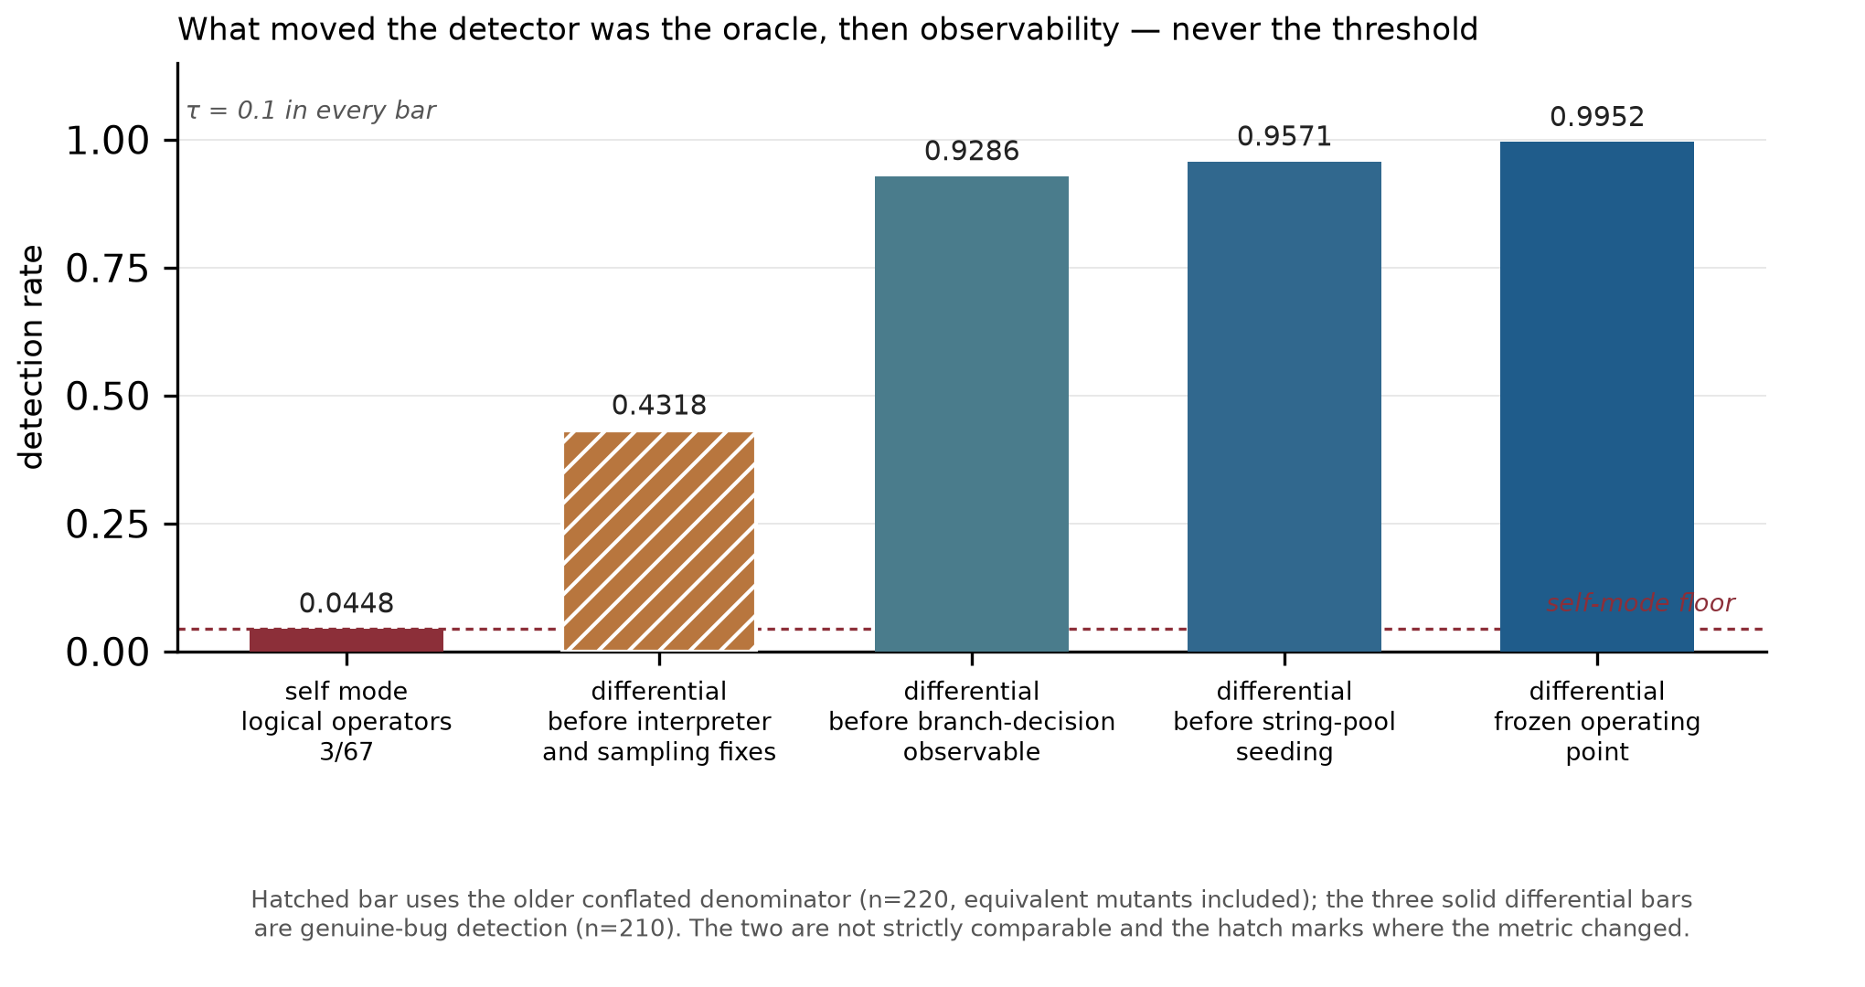
Figure 7.3 – Detection-rate progression across evaluation sessions as the differential instrument was corrected. The first bar is self mode restricted to the two purely logical mutation operators; the rest are differential mode. The climb is the effect of changing what the oracle is derived from, and then of successive observability fixes, not of threshold tuning — the decision threshold is 0.1 in every bar. The hatched bar is drawn from the older conflated denominator and is not strictly comparable with the three solid differential bars, which is why it is marked. Sources: module_02_extract/eval/results/calibration_report.md, calibration_report_differential.md, and the three corresponding reports under eval/results/archive/.

7.3.5 Confidence and semantic divergence
A well-behaved confidence score should decrease as a mutant's behaviour diverges further from its base. Over all 427 mutant-base pairs the correlation between the complement of confidence and the measured semantic divergence rate is Pearson r = 0.4085 and Spearman ρ = 0.5400; restricted to the pairs where divergence is observable at all, r = 0.5580 and ρ = 0.5988. Eleven pairs are equivalent mutants. Figure 7.4 plots the relation.
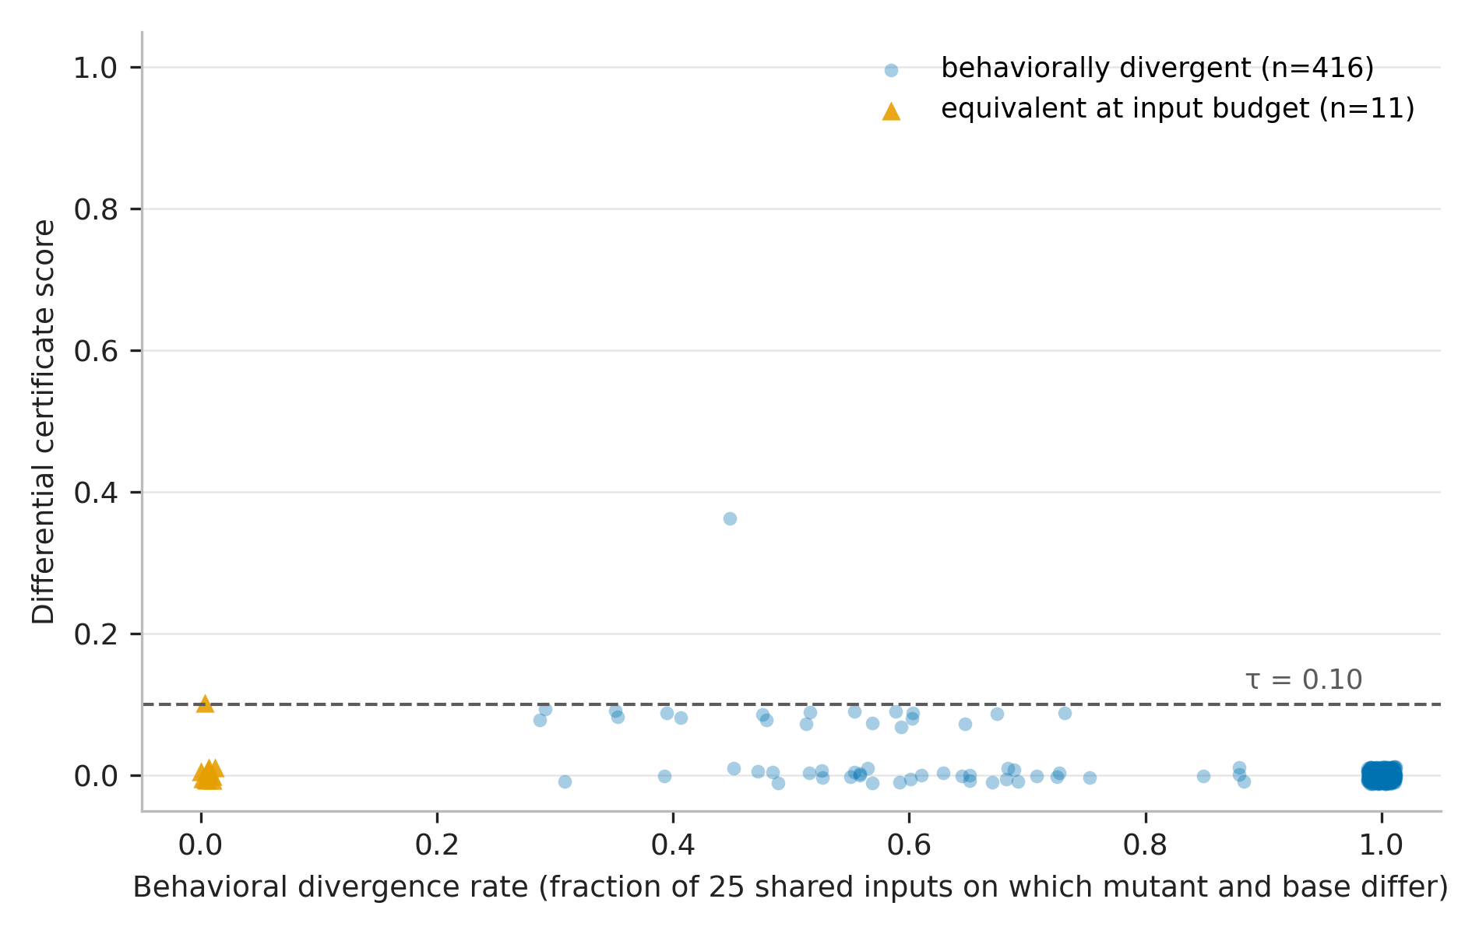
Figure 7.4 – Confidence complement against semantic divergence rate over 427 mutant-base pairs, with equivalent mutants marked. The relation is positive and moderate (Spearman ρ = 0.5400 full, 0.5988 restricted), not tight: confidence is a usable signal of divergence magnitude but not a proxy for it.
A moderate correlation is the honest characterisation. The score is a reliable detector at the calibrated threshold, as Section 7.3.3 shows, and it is a much weaker estimator of how badly a program diverges. The report does not present it as the latter.

7.3.6 A negative result about the symbolic layer
The symbolic validation layer contributes approximately nothing to the fused confidence on this corpus. The certificate is therefore, in practice, driven by the dynamic layer with the structural layer gating. This is reported wherever the certificate is described, because "three-layer certificate" would otherwise be read as a claim that three layers do work. The layer is retained: the result is a finding about workflow programs of this shape, in which the interesting divergences are in action sequencing rather than in path conditions over data, and not a demonstration that symbolic reasoning has nothing to offer the problem.

7.3.7 Comparison granularity: both directions of the trade
Section 5.4.5 argued that comparison granularity is determined by what the compared artefacts legitimately share. Table 7.4 and Figure 5.3 quantify both directions.
Table 7.4 – The comparison-granularity trade, measured. Natural-fault detection is on the screened variant corpus; the false-alarm figure is on independently written implementations admitted as behaviourally correct. Sources: eval/results/session_b_report.md, eval/results/cross_impl_mode_report.md, and the D3 control in the latter.
Measure | strict | task_only | n
Natural-fault detection, all classes | 164 of 164 = 1.0000 | 153 of 164 = 0.9329 | 164
Natural-fault detection, logic class | 68 of 68 = 1.0000 | 60 of 68 = 0.8824 | 68
False alarms, independent implementations | 5 of 20 = 0.25 | 2 of 20 = 0.10 | 20
Mutant detection (D3 control) | not measured in this cell | 0.8952 | 427

The two columns answer different questions and neither dominates. Strict comparison detects every natural fault in the corpus, including every one of the 68 logic-class faults, and it raises false alarms on a quarter of the independently written implementations — because two people, or two models, implementing the same specification are under no obligation to agree on internal values. Loosening to task-only comparison more than halves the false-alarm rate and gives up detection: 11 of 164 natural faults and 8 of 68 logic-class faults become invisible. Both residual false alarms under task-only comparison are exception-driven rather than sequence disagreements.
The rule the project settled on is therefore stated as a rule about the comparison and not about a threshold. Where the reference is a representation of the same program — the extraction-fidelity question — strict comparison is correct, because the two are obliged to agree on everything and any loosening discards evidence. Where the reference is an independent artefact — the conformance question across implementations — task-only comparison is correct, because value-level agreement was never required.

7.3.8 The return-value observability fix
One improvement is separated out because it is a lesson about instrumentation rather than about algorithms. Making return values observable to the tracer raised logic-class detection from 0.9118 to 1.0000 under strict comparison and from 0.7794 to 0.8824 under task-only comparison, with the false-alarm rate unchanged and the confidence-divergence correlation byte-identical. A fault the instrument cannot observe is a fault it cannot detect, and no amount of threshold calibration substitutes for widening what is recorded.

7.3.9 The variant funnel and extraction robustness
The variant corpus was built by generating implementations of benchmark specifications across several model families. Of 303 requested variants, 294 were obtained — one model provider outage is documented rather than silently absorbed — and screening reduced these to 184, of which 20 were admitted as behaviourally conformant by the oracle of Section 7.2.1 and 164 became the natural-fault corpus. On the 20 admitted variants the extractor ran with 0 aborts, 0 crashes, and node coverage 1.0.

7.4 Equivalence engine evaluation

7.4.1 What is measured and what is not
This section evaluates Phase D, the model-checking phase, and the effect of the two fixes of Section 6.5. It does not evaluate Phases A, B or C against behavioural ground truth, because no artefact does: there is no measurement of clustering agreement with behavioural ground truth, of bisimulation-reduction correctness over the corpus, or of the realised cost saving from clustering. Section 8.5.2 records this as the largest single evaluation gap in the project. The figures below must not be read as speaking to those phases.

7.4.2 Validating the finite-to-infinite bridge
The corrected model-checking path was cross-validated against the module's independent finite-trace evaluator over 58 checks across 29 specifications. On every check where both procedures committed to a verdict they agreed: 35 of 35, with the remaining 23 legitimately abstaining. The two procedures share no implementation — one goes through automaton construction, product and emptiness, the other evaluates formulae directly over finite traces — so the agreement is evidence that the bridge preserves finite-trace meaning rather than evidence that one implementation is self-consistent.
A second candidate validation is deliberately not used, and the reason belongs in an evaluation chapter. An earlier bridge investigation reports 12,600 of 12,600 agreement between the reduction and a finite-trace oracle on generated formula and trace pairs. Its own verification note records it as credible but not independently reconfirmed, resting on a local build never reproduced. It is therefore not the load-bearing figure here.

7.4.3 The effect of the call-order fix on corpus verdicts
Supplying the correct control-flow view (Section 6.3.2) changed the corpus verdicts substantially. Before the fix, 58 checks over 29 variants produced 18 violations, 17 conformance verdicts and 23 abstentions. After the fix, the same corpus produced 5 violations, 10 conformance verdicts and 43 abstentions. Figure 7.5 traces the flows.
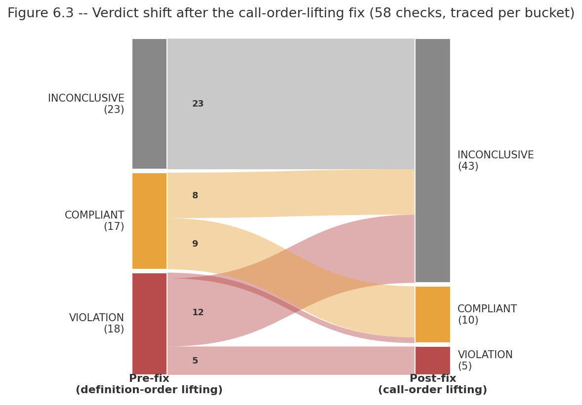
Figure 7.5 – Traced verdict shift from the pre-fix to the post-fix corpus run. Of 18 pre-fix violations, 5 remain, 12 become abstentions and 1 becomes a conformance verdict; of 17 pre-fix conformance verdicts, 9 remain and 8 become abstentions; all 23 pre-fix abstentions are unchanged. The flows were traced per check, not inferred from the aggregate counts.
Fewer verdicts is not self-evidently better, so the pre-fix run was audited per verdict rather than compared in aggregate. Of the 18 pre-fix violations, 12 named a task the program never called at all — a violation report about an action that does not occur is not a finding — and of the remaining 6, five were confirmed genuine and one was contradicted by inspection. Of the 17 pre-fix conformance verdicts, 12 were on variants that are omission-divergent from their specification, so the conformance verdict was blind rather than correct. The audit's conclusion is that approximately 10 of the 35 committed verdicts — about 29% — were trustworthy, and about 71% were spurious, contradicted or omission-blind. The post-fix run converts most of the untrustworthy verdicts into abstentions, which is the correct destination for them.
Two acceptance cases were checked individually as a sanity condition on the fix: specification uid 44 remains a violation, and uid 77 flips to a conformance verdict, both consistent with inspection of the variants concerned. The post-fix run is not itself a witness-validity audit, and Section 8.5.2 states that a fresh audit on the corrected engine is outstanding.

7.4.4 A structural property of the corpus that bounds Phase B
Of the 43 eligible corpus graphs, 0 contain a genuine cycle. The divergence-sensitive machinery of Section 5.5.2 is therefore exercised by its unit tests and not by the corpus. This is reported as a corpus limitation rather than as a design justification: the refinement is required because the fault class exists, and this corpus does not happen to contain it.

7.4.5 Corpus divergence modes
Independently of any verdict, the 43 specification-implementation pairs were classified by how the implementation diverges from its specification: 23 omission-only, 15 conformant, 3 omission-with-reorder and 2 reorder-only. An independent re-derivation using cruder name matching gave 24 omission-only and 3 reorder-only over the same 43, which is close enough to treat the classification as stable. The distribution is itself a finding: omission dominates, and omission is the fault class the current property tier handles worst.
Table 7.5 shows why, for the precedence-shaped liveness property the synthesizer produces. When a task is omitted entirely, the precedence property over it is vacuously true, so the implementation passes.
Table 7.5 – Truth table for the precedence-shaped liveness property "B does not start until A is done", over the four combinations of task presence plus the omitted case. The A-present-B-omitted row is satisfied, so an implementation that drops B passes a property about B. Source: end-to-end session findings §F4, reproduced identically in the verification pass.
A executes | B executes | Order | Property satisfied | Fault detected
yes | yes | A before B | True | n/a — conformant
yes | yes | B before A | False | yes
no | yes | — | False | yes
no | no | — | True | no — vacuous
yes | no (omitted) | — | True | no — omission invisible

The consequence is measured: 7 of the divergent pairs have no failing checkable liveness property at all. Two are named in the project record as illustrations — one variant calls 1 of its specification's 5 tasks, another 2 of 3 — and both pass every checkable property, because a property about a task that never executes is satisfied by default. A property family asserting task coverage would recover this class. It is designed and not implemented, and Section 8.3.3 reports it as designed work rather than as capability.

7.4.6 Vocabulary alignment, measured
The vocabulary failure of Section 6.5.2 is reported here as a measurement because its magnitude is the finding. Of 116 specification-side liveness atoms, 0 were matchable to code-side atoms, and 0 of 29 specification-implementation pairs had any atom in common. Confirmation on the real build after the fix is that all 58 checks return INCONCLUSIVE with atoms unstripped. Against that, the underlying naming quality is good: specification task names match code function identifiers at 86.0% mean exactness over 43 pairs, with 26 of 43 matching perfectly. The failure was in applying normalisation across the seam, not in the names themselves — the specification engine's normaliser had zero callers anywhere in the repository.

7.5 End-to-end evaluation

7.5.1 Design
The end-to-end evaluation runs the full pipeline on the gold specifications — those with at least one checkable property and at least one variant confirmed conformant — with injected order mutations of known semantics. Six specifications qualify (uids 45, 72, 76, 77, 84, 85), giving 26 order-mutation trials from two operators, drop-step and swap-adjacent, plus 2 verified order-preserving perturbation trials as controls. Four candidate specifications were discarded because no eligible literal existed for the constant-perturbation operator.
The unmutated gold variants are deliberately excluded from the false-alarm denominator. They were selected because they already verified as conformant, so counting them as successful non-alarms would be circular. Only the novel order-preserving perturbations count, which is why that denominator is 2 and its interval is correspondingly wide.

7.5.2 Results
Table 7.6 and Figure 7.6 give the end-to-end rates. Every one is reported with its interval, and the intervals are the message.
Table 7.6 – End-to-end rates over the gold-specification corpus. All intervals Clopper–Pearson exact binomial. Source: demo/eval_e2e/results/e2e_eval_report.md and the per-trial records in the accompanying JSON.
Measure | Value | 95% CI | n
Abstention rate | 0.462 | [0.27, 0.67] | 26
Detection rate, verdict-committing trials only | 0.357 | [0.13, 0.65] | 14
False-alarm rate, order-preserving controls | 0.000 | [0.00, 0.84] | 2
Counterexample quality | 0.800 | [0.28, 0.99] | 5

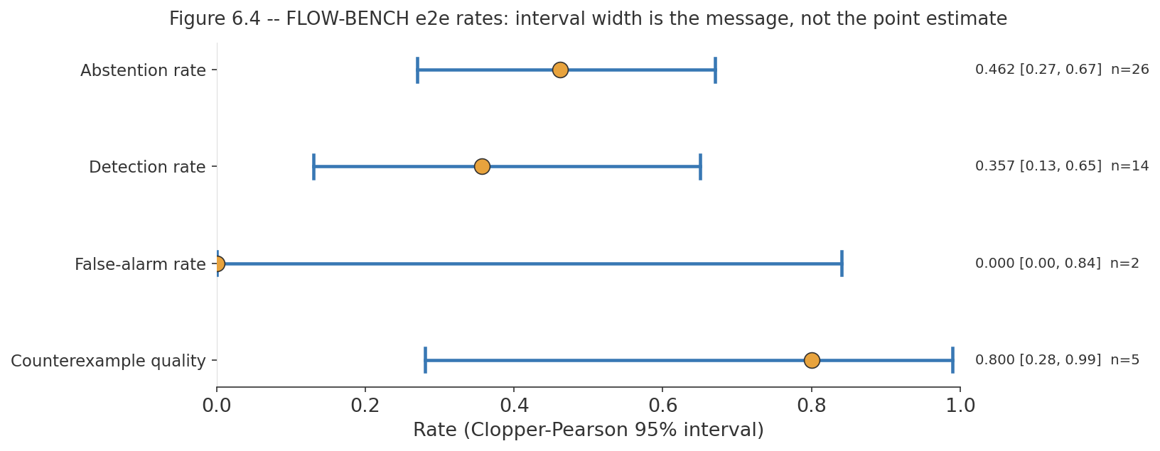
Figure 7.6 – End-to-end rates as a forest plot with Clopper–Pearson intervals. Interval width, not point estimate, is the primary visual message: at n=2 the false-alarm interval spans [0.00, 0.84] and constrains almost nothing.
The abstention rate is reported first because it is the largest number and because it is the one a naive presentation would hide. The pipeline declines to commit on 0.462 of order mutations, and it does so for a diagnosable reason established empirically rather than assumed: a mutation that drops a task's own call often removes that task's atom from what the code-side matcher can observe at all. When the atom vanishes, the pipeline cannot make an ordering claim about a task it can no longer see, and abstains. That is the designed behaviour of Section 4.2.2 working correctly, not a detection failure, so it is reported as its own rate and excluded from the detection denominator.
The detection rate of 0.357 is therefore over the 14 trials where the pipeline committed to a verdict. Its interval, [0.13, 0.65], is wide enough that the correct reading is a demonstration that the pipeline detects order faults at all, not a measurement of how well it does so.

7.5.3 Detection by mutation kind, and what it exposes
Disaggregating by operator turns a mediocre aggregate into a specific and actionable finding. Table 7.7 and Figure 7.7 give the breakdown.
Table 7.7 – End-to-end outcomes by mutation kind. The drop-step row is the finding: 0 detections in 16 trials, with 12 honest abstentions and 4 missed as conformant.
Mutation kind | n | Detected | Missed as compliant | Abstained
drop_step | 16 | 0 | 4 | 12
swap_adjacent | 10 | 5 | 5 | 0
Total | 26 | 5 | 9 | 12

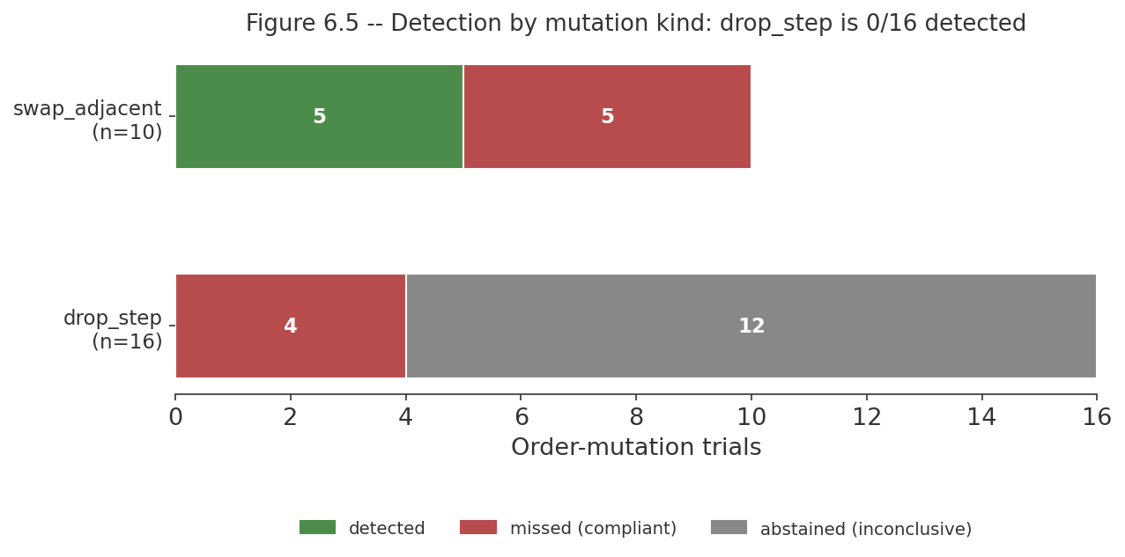
Figure 7.7 – End-to-end outcomes by mutation kind, stacked. The drop-step column contains no detections in 16 trials; 12 of those are honest abstentions and 4 are missed as conformant. Swap-adjacent splits evenly between detection and miss with no abstentions.
The two operators fail in different ways and for reasons the earlier sections have already established. Drop-step detection is 0 of 16 because omission is invisible to a precedence property (Table 7.5): either the dropped task's atom disappears and the pipeline abstains — 12 of 16, the honest outcome — or the property that would have caught it is vacuously satisfied and the mutant passes, 4 of 16. This is the same limitation as Section 7.4.5, now measured end to end, and the designed-not-implemented task-coverage property family is the specific fix for it.
Swap-adjacent detection is 5 of 10 with no abstentions, which is the behaviour a precedence property should have: both swapped tasks still execute, so their atoms remain observable, and the pipeline commits. It detects the swap when a checkable property happens to reference the pair that was swapped, and misses it when the median of 2 checkable properties per specification (Section 7.2.2) does not cover that pair. The miss is therefore a coverage consequence of the 17.6% checkability ceiling, not a defect in the checker.

7.5.4 Counterexample quality
Of the 5 mutations detected, 4 produced a counterexample naming every BPMN task the violated property's formula references: 0.800 (95% CI [0.28, 0.99], n=5). The criterion is mechanical and narrow — does the rendered trace name the tasks the formula mentions — rather than a subjective judgement of explanatory quality, which at n=5 could not be measured meaningfully anyway.

7.6 What is not measured
The following are stated as unmeasured. Each is a capability that exists in the design or the implementation and for which no artefact supplies a figure, and in each case the project has declined to supply a plausible one.
- 1. Phases A, B and C of the equivalence engine, against behavioural ground truth. No measurement exists of clustering agreement with ground truth, of reduction correctness over the corpus, or of the realised cost saving from clustering. The clustering cost argument is a design rationale, not a measurement. This is the largest evaluation gap in the project.
- 2. Action-matching accuracy of the three-tier cascade, per tier. No artefact isolates it, and the semantic tier was unavailable in the verification environment. The 86.0% identifier-match figure is a property of the corpus's naming, not a measurement of the cascade.
- 3. Witness validity on the corrected engine. The 29%-trustworthy audit is of the pre-fix run. Post-fix evidence is the traced verdict shift plus two acceptance cases, which is not a fresh audit.
- 4. Wall-clock performance of any phase, in any module. No timing artefact exists, so the report makes no performance claim.
- 5. Kill-ratio and structural-coverage distributions in the specification track. The Phase 3 gate outcome is measured; the distribution of kill ratios across the corpus is not.
- 6. Why trace synthesis does not converge on any specification. The outcome is measured; which of the progression bound, the conjoined suite size, or the alignment threshold is binding has not been diagnosed.
- 7. What the designed task-coverage property family would recover. A design argument exists, with a reachability trace on one named variant, claiming it would convert a substantial share of corpus pairs from invisible to detectable. No implementation exists, so no measured recovery figure exists, and the design figure is not carried across into a capability claim.
- 8. Generalisation beyond FLOW-BENCH. Every rate in this chapter is on one benchmark of enterprise workflow specifications. Whether the 17.6% checkability rate, the driver heuristic, or the extraction fidelity transfers to other corpora is untested rather than estimated.
- 9. The unconditioned population of LLM faults. Rates are over injected mutations with known semantics and over screened natural faults from a specific set of models. They are not rates over "the faults language models make".

7.7 Correction trail
Several figures stated earlier in this project were later found to be wrong. They are recorded here so that the project's own record is auditable, and so that a reader encountering a superseded number elsewhere can identify it as superseded. Table 7.8 gives the trail. None of these figures appears anywhere else in this report as system behaviour.
Table 7.8 – Correction trail. Every entry is a figure or claim the project stated and subsequently corrected. Cite these only as superseded.
What was stated | How it was caught | What supersedes it
Detection 53.2% (definition order) versus 40.4% (call order) | The figures were produced by a Python emulation because the compiled engine could not be imported in that environment, and the emulation could not exhibit the vacuity defect | The real compiled engine's pre- and post-fix corpus runs and the 35-verdict audit (Section 7.4.3). The direction of the finding held; the magnitudes are not system behaviour and must not be quoted as such
The atom-gating fix closes the vacuity channel | A real compiled build still returned a conformance verdict for a plainly false property with no unmatched atoms | There are two independent channels (Section 6.5). The atom gate closes the vocabulary channel; vacuity was closed separately by the finite-to-infinite bridge
"Phase D complete, real model checking" | The vacuity mechanism was derived from source inspection | Accurate about the mechanism, silently wrong on non-looping automata at the time; the caveat is now recorded with the claim
The gateway hard failure occurs in Phase 3 | The exception path was traced | It is raised in the synthesizer's certification step and reported under phase 2. Counts and the set-equality result are unaffected
The definition-order corpus run, read as a conformance-detection measurement | The per-verdict audit of Section 7.4.3 | It is a proof that the pipeline runs end to end, not a detection measurement
Mutant count 429 | Manifest recount | 427 single-site mutants from 9 applicable operators
Self-mode detection of 0 of 220, quoted as the architecture's headline evidence | The source run was traced to the project's first self-mode calibration, which the repository had already archived as invalid: entry-point selection took the first function defined in each file, and every generated program defines its task stubs before the workflow, so the run measured a zero-branch stub rather than the orchestration logic | The corrected self-mode run: 3 of 67 on the two purely logical operators, 0 of 50 on early-return, and 0.3607 (95% CI [0.297, 0.428], n=219) overall, of which 35 of 35 comes from an exception-visibility channel rather than logic sensitivity (Section 7.3.4). The conclusion is unchanged; the figure supporting it is weaker and better diagnosed. 0 of 220 must not be quoted

One further figure is not used in this chapter and the reason belongs in the trail: the 12,600-of-12,600 bridge agreement discussed in Section 7.4.2, whose own verification note records it as not independently reconfirmed. It is not superseded — it may well be correct — but it is not load-bearing here.

7.8 Summary
The evaluation had to construct its own ground truth, because the benchmark supplies none. That construction — a behavioural admission oracle, mutation with known semantics, and a natural-fault corpus obtained as a by-product — determines the scope of every figure reported, and the corpus funnel determines their denominators: 48 specifications contract to 29 exports, 412 synthesized properties contract to 45 checkable ones (17.6% of the liveness tier), and 6 specifications qualify as gold.
The code track's structural extraction is exact on this corpus (node and edge F1 1.0000, from 0.9044 and 0.6827 before graph contraction), and its differential instrument detects genuine bugs at 0.9952 (95% CI [0.974, 1.000], n=210) against a false-alarm rate of 0.0588 (95% CI [0.012, 0.162], n=51) at a pre-registered threshold. Its central result is negative: in self mode the same instrument detects 3 of 67 purely logical injected faults and 0 of 50 on the largest such operator, because oracle and subject share the defect. That near-zero is the empirical justification for the dual-track architecture, and it cannot be tuned away.
The equivalence engine's finite-to-infinite bridge agrees with an independent finite-trace oracle on 35 of 35 decisive verdicts. Correcting the control-flow view moved the corpus from 18/17/23 violations, conformance verdicts and abstentions to 5/10/43, and the per-verdict audit of the pre-fix run found only about 10 of 35 committed verdicts trustworthy — so the reduction in verdicts is a gain in honesty. End to end, the pipeline abstains on 0.462 of order mutations (95% CI [0.27, 0.67], n=26), detects 0.357 of the faults it commits on (95% CI [0.13, 0.65], n=14), raises no false alarms on its two controls (95% CI [0.00, 0.84]), and renders a correct counterexample in 0.800 of detections (95% CI [0.28, 0.99], n=5). Disaggregated, drop-step detection is 0 of 16 — omission is invisible to a precedence property — while swap-adjacent is 5 of 10 with no abstentions.
Section 7.6 lists nine capabilities for which no measurement exists, the largest being that three of the equivalence engine's four phases have never been evaluated against behavioural ground truth. Section 7.7 records six corrected figures. The next chapter discusses what all of this means module by module, and states the project's principal unresolved gap.

CHAPTER 8 – DISCUSSION

8.1 Introduction
This chapter discusses what the project achieved, what it did not, and what should follow. Sections 8.2 to 8.5 treat the four modules in turn, each with a discussion of its findings, its limitations and the further work it indicates, followed by a summary. Section 8.6 discusses the architectural commitment that binds them, since the independence constraint is a whole-system decision that cannot be evaluated module by module. Section 8.7 states the project's principal unresolved gap plainly and Section 8.8 concludes.
One framing applies throughout. The project set out to certify conformance between a specification and an implementation, and what it has built is a pipeline that runs end to end and abstains far more often than it decides. The temptation in a report of this kind is to present the abstentions as a limitation of an otherwise working system. The more defensible reading, and the one taken here, is that the abstention rate is the system's most important honest output: Chapter 6 documents two mechanisms by which the same pipeline previously returned confident conformance verdicts while establishing nothing at all, and the current abstentions are what those verdicts turn into once the vacuity is closed. A system that says "I cannot tell" where it previously said "conforms" has improved, even though every headline rate got worse.

8.2 Module 01: Specification analysis

8.2.1 Discussion
The specification track establishes that a BPMN diagram can be mechanically turned into a tiered temporal-property suite, and that the suite can be gated on evidence rather than trusted. Two of its results are worth more than the pipeline itself.
The first is what the admission gate revealed about the corpus. The engine hard-fails 19 of 48 specifications, and the failing set is exactly the set containing an exclusive gateway — a set equality that was tested, not observed. Tracing the cause through the corpus found that of 20 splitting exclusive gateways, none carries a default attribute and none has a condition expression on any outgoing flow. The branch semantics that BPMN provides attributes for are expressed in these diagrams as label text. This is a finding about machine-readable process specifications in practice, not about the engine: a verification approach that depends on the specification being formal enough to reason over discovers, on contact with a real corpus, that a widely used benchmark's diagrams are not. The gate reporting this as a failure rather than guessing a branch condition is the correct behaviour, and it is the behaviour the certificate discipline of Section 1.2 demands.
The second is the checkability funnel. Of 412 synthesized properties, 45 are checkable against code — 17.6% of the liveness tier — and the reasons for every exclusion are recorded rather than lost: the entire safety tier turned out to be a lifting self-test rather than a statement about the program, the fairness tier is a single unparseable template shape, and the remaining tier uses an operator the bridge does not carry. This is a measured ceiling on what the system can currently decide, and stating it is more useful than a larger property count would be. A suite of 412 properties of which 367 cannot be checked is not a suite of 412 properties.
One positive property of the suite should not be lost among the exclusions: all 45 specification-order traces satisfy their own suites, 45 of 45. The synthesizer produces properties that its own reference behaviour satisfies, which is the minimum condition for the suite to be usable at all and is not automatic.

8.2.2 Limitations
The limitations of this module are the most severe in the project and they are stated without softening.
- 1. The module has 28 tests for 2,958 lines of source. Its architecture was rebuilt recently, replacing an external-tool-based trace synthesis with the pure-Python progression calculus, and the test coverage has not caught up. Every claim this report makes about the module's behaviour rests on measurement runs rather than on a regression suite, and should be read that way.
- 2. No specification in the corpus reaches unqualified success. All 29 survivors export with the non-converged status: trace synthesis runs and does not converge, for any specification. The pipeline therefore never delivers its strongest evidence, and the report does not claim it does.
- 3. The cause of non-convergence has not been diagnosed. Whether the binding constraint is the progression bound, the size of the conjoined suite, or the alignment threshold is unknown. This is a single diagnostic experiment away from being known, and it was not run.
- 4. The property vocabulary was, until recently, unusable across the boundary. Of 116 liveness-tier atoms, 0 matched anything the code side produces, and the module's own normalisation component had no callers anywhere in the repository. The normalisation existed and was never applied.
- 5. Kill-ratio and structural-coverage distributions are unmeasured. The mutation gate's pass/fail outcome is measured; how discriminating the suite is across the corpus is not.
- 6. Scope is core BPMN control flow. Sub-processes, boundary events, event-based gateways, multi-instance activities and data-object semantics are out of scope, and the corpus contains no parallel gateways at all, so parallel-split handling is untested by the corpus.

8.2.3 Further work
Four items, in the order they should be attempted.
- 1. A task-coverage property family. This is the highest-value single addition in the project. The measured problem is that omission dominates the corpus divergence modes — 23 of 43 pairs are omission-only — and a precedence-shaped liveness property is vacuously satisfied when the task it references is never executed (Table 7.5). A property family asserting that each specified task occurs would make the dominant fault class visible. A design argument and a reachability trace on one variant exist; no implementation does, and no measured recovery figure should be quoted until one does.
- 2. Diagnose non-convergence. Instrument the trace-synthesis phase to report which bound is binding, then decide whether the fix is a larger bound, per-property rather than conjoined synthesis, or a relaxed alignment criterion.
- 3. Build a regression suite proportionate to the module. Priority order: the progression calculus against the finite-trace evaluator on generated formula/trace pairs; the tier assignment; the export contract (already begun, Section 6.2.4); the gates.
- 4. Extend the semantic extractor to inclusive and event-based gateways, and to sub-processes, which the corpus does not exercise but real diagrams contain.

8.2.4 Summary
The specification track works as designed and its design admits far less than one might hope: 29 of 48 specifications survive the gate, none converges, and 45 of 412 properties are checkable. Its two most valuable outputs are diagnostic rather than functional — that a widely used BPMN corpus encodes branch semantics in labels rather than in attributes, and that the checkable slice of a mechanically synthesized property suite is small and measurable. Its thin test coverage is the project's largest engineering risk.

8.3 Module 02: Code extraction and certification

8.3.1 Discussion
The code track is the most mature part of the project and its central result is a negative one, which is unusual enough to state carefully. When the confidence certificate is derived from the same program it judges, it detects 3 of 67 faults from the two mutation operators that inject a purely logical defect without making the program raise, and 0 of 50 on the larger of them. Its overall rate of 0.3607 over the whole mutant corpus is higher, and Section 7.3.4 shows that the difference is carried by two operators at 35 of 35 whose mutations make the real interpreter raise an exception the reference interpreter swallows — exception visibility, not logic sensitivity. The mechanism behind the near-zero is structural: the extractor faithfully extracts the buggy logic, the reference interpreter faithfully replays it, and the comparison finds perfect agreement. Oracle and subject share the defect.
This result is the empirical foundation of the whole system's architecture, and it is the kind of claim that is usually argued rather than measured. The circularity of self-referential validation is widely acknowledged in discussions of LLM code assurance; what this project contributes is a controlled measurement of it, on a real corpus, at a pre-registered threshold, against a differential instrument that reaches 0.9952 (95% CI [0.974, 1.000], n=210) on comparable faults. The two figures together are the argument for independence, and they are the reason Section 8.6 defends an architecture that costs duplicated code.
Three further findings deserve discussion. The first is the comparison-granularity trade, measured in both directions: strict comparison detects 164 of 164 natural faults including all 68 logic-class faults but false-alarms on 5 of 20 independently written implementations, while task-only comparison halves the false alarms to 2 of 20 and gives up 11 faults. Neither column dominates, and the rule the project settled on is a rule about what the compared artefacts legitimately share rather than a threshold to tune: strict where the reference is a representation of the same program, task-only where the reference is independent. The second is that making return values observable raised logic-class detection from 0.9118 to 1.0000 under strict comparison with no cost in false alarms — a reminder that a fault the instrument cannot see is a fault no calibration will recover. The third is that the symbolic layer contributes approximately nothing on this corpus, which is reported wherever the certificate is described because "three-layer certificate" would otherwise overstate what three layers do.
The equivalent-mutant figure deserves a note against being misread. Specificity of 0.111 on 9 equivalent mutants looks like poor discrimination; 8 of the 9 scored exactly the same as their own base program, which is the instrument correctly observing identical behaviour and inheriting the base score. The metric penalises correct behaviour here, and it is reported with the mechanism attached rather than as a defect.

8.3.2 Limitations
- 1. Dynamic analysis must execute the program, and one class of hang cannot be bounded. A hang that releases the interpreter's global lock is bounded reliably at approximately 0.22 seconds against a 0.2-second budget; a statement that monopolises the lock is not bounded at all, because the timing thread cannot run. This is a genuine limitation of in-process dynamic analysis in this interpreter, not a tuning problem, and it means the certificate cannot be guaranteed to terminate on adversarial input.
- 2. Perfect structural accuracy is a statement about this corpus. Node and edge precision, recall and F1 of 1.0000 was obtained on 101 structurally similar generated workflow programs against 10 hand-validated gold extractions. It is not a general claim about Python control-flow extraction, and the pre-contraction figures (node F1 0.9044, edge F1 0.6827) show how recently it was not perfect.
- 3. Confidence is a detector, not an estimator. Correlation with semantic divergence is moderate (Spearman ρ = 0.5400 over all 427 pairs, 0.5988 restricted), so the score should not be read as a measure of how badly a program diverges.
- 4. Mutation operators define the fault distribution measured. The 427 mutants come from 9 applicable operators, so the mutant detection rate is a statement about those operators. The natural-fault corpus mitigates this and introduces its own bound: it is the faults that a specific set of models produced on a specific benchmark.
- 5. The false-alarm denominator is small. 51 untouched base programs give 0.0588 with a 95% interval of [0.012, 0.162]; the interval, not the point estimate, is the result.
- 6. Scope is single-file, single-threaded, synchronous Python without dynamic dispatch through reflection. Concurrency, async execution and dynamically constructed call targets are out of scope for the extractor.

8.3.3 Further work
- 1. Bound the unboundable hang out of process. Run the traced program in a subprocess with an external wall-clock kill, accepting the cost in tracing fidelity, so that the certificate terminates on adversarial input.
- 2. Establish why the symbolic layer contributes nothing, and whether the finding is about the corpus or the technique. The hypothesis worth testing is that these workflow programs branch on control state rather than on data, so path constraints carry little information. A corpus with data-dependent branching would decide it.
- 3. Widen the observable event vocabulary beyond return values. The return-value result suggests observability, not algorithms, is where detection is currently gained. Exception paths and argument values are the obvious next candidates.
- 4. Report the two comparison modes as a pair rather than choosing between them. The measured trade is stable enough to expose to the user as two verdicts with their respective error profiles, rather than resolved silently by a mode flag.
- 5. Evaluate on a corpus outside FLOW-BENCH. Every figure in Chapter 7 is on one benchmark; whether extraction fidelity and the calibrated threshold transfer is untested.

8.3.4 Summary
The code track is the project's strongest engineering and its most important result is a near-zero. Self-referential validation detects 3 of 67 purely logical injected faults, and 0 of 50 on the largest such operator, because oracle and subject share the defect, while the differential instrument detects genuine bugs at 0.9952 (95% CI [0.974, 1.000], n=210) at a pre-registered threshold; together those two figures are the empirical case for the dual-track architecture. The comparison-granularity trade is measured in both directions and resolved by a principle rather than a threshold. The certificate is, in practice, driven by its dynamic layer with its structural layer gating, because the symbolic layer contributes approximately nothing on this corpus.

8.4 Module 03: The equivalence engine

8.4.1 Discussion
The equivalence engine is where the project's two most instructive failures occurred, and the diagnosis of those failures is a more valuable contribution than the engine's current measured performance.
Two independent mechanisms caused a model checker to return conformance verdicts while establishing nothing. The first was structural: the lifted automaton had no acceptance condition set anywhere and permitted dead-ending runs, so — since an accepting run of a Büchi automaton is infinite — no accepting run existed for any property, every product was empty, and every property was reported as satisfied. The second was linguistic: 0 of 116 specification-side atoms matched anything the code side produced, so every property was a property over atoms that never occur, which is vacuously true. Either mechanism alone produces universal, meaningless conformance. Both were masked by a passing test suite, and one was masked by a test that asserted the vacuous outcome as intended behaviour.
The general lesson generalises beyond this project and is worth stating as the chapter's main claim about method. A model checker that reports conformance has either proved something or proved nothing, and the two outcomes are indistinguishable from the verdict alone. Any system that reports conformance from a model checker needs a positive control — a property known to be false of the system under test, which the checker must reject — because without one, a pipeline that has silently stopped checking is externally identical to a pipeline that is working perfectly. This project had no such control and paid for it twice.
The corrected engine's behaviour supports the fixes on two independent grounds. The finite-to-infinite bridge agrees with the module's own independent finite-trace evaluator on 35 of 35 decisive verdicts across 58 checks, and because the two procedures share no implementation the agreement is evidence about the bridge rather than about one implementation's self-consistency. And supplying the correct control-flow view moved the corpus from 18 violations, 17 conformance verdicts and 23 abstentions to 5, 10 and 43 — a change that looks like a regression and is not, because the per-verdict audit of the pre-fix run found only about 10 of its 35 committed verdicts trustworthy: 12 of 18 violations named tasks the program never called, and 12 of 17 conformance verdicts were on variants that omit specified tasks. Most of what disappeared was noise, and abstention is its correct destination.
One design decision is worth defending explicitly because a reader familiar with the literature might take it for standard. The reduction implemented here is divergence-sensitive, and the ordinary stuttering relation would be actively wrong for this application: it absorbs sequences of internal steps, and a hallucinated while True: pass is exactly a sequence of internal steps. The standard relation would collapse a non-terminating program into a normal waiting state and erase the fault class the system exists to find. That is why divergence is carried as a distinguishing label through refinement, and why this report never describes the reduction as ordinary bisimulation.

8.4.2 Limitations
- 1. Three of the four phases have never been evaluated against behavioural ground truth. Lifting, the divergence-sensitive reduction and clustering are implemented and unit-tested; there is no measurement of clustering agreement with ground truth, of reduction correctness over the corpus, or of the realised cost saving from clustering. The clustering cost argument is a design rationale. This is the largest single evaluation gap in the project.
- 2. The corpus contains no cycles. 0 of 43 eligible graphs have a genuine cycle, so the divergence-sensitive machinery — the phase this report is most careful to distinguish from the standard relation — is exercised only by its unit tests.
- 3. Action-matching accuracy is not measured per tier. The three-tier cascade is implemented; no artefact isolates the accuracy of exact, edit-distance and embedding matching separately, and the embedding tier was unavailable in the verification environment. The 86.0% identifier-match figure describes the corpus's naming, not the cascade.
- 4. Witness validity has not been re-audited on the corrected engine. The 29%-trustworthy figure is an audit of the pre-fix run. Post-fix evidence is the traced verdict shift and two individually checked acceptance cases, which is not the same thing.
- 5. The corpus's dominant fault class is invisible to the current property tier. Omission dominates (23 of 43 pairs omission-only), and 7 divergent pairs have no failing checkable property at all, because a precedence property over an omitted task is vacuously satisfied.
- 6. Performance is unmeasured. No timing artefact exists for any phase, so the report makes no performance claim and the clustering cost argument remains unquantified.

8.4.3 Further work
- 1. Install a positive control in the pipeline itself. For every verification run, check one property known to be false of the program and require the checker to reject it. This is the single change that would have caught both vacuity channels, and it belongs in the product rather than in the test suite.
- 2. Evaluate Phases A, B and C. Concretely: hand-label behavioural equivalence over a sample of variant pairs and measure clustering agreement; verify reduction correctness by checking that quotient and original agree on a property suite; instrument the batch path to measure the realised cost saving from clustering.
- 3. Re-audit witness validity on the corrected engine, replacing the pre-fix 29% figure with a post-fix measurement.
- 4. Construct a corpus with cycles — including non-terminating implementations — so that the divergence-sensitive reduction is exercised by data rather than by unit tests.
- 5. Isolate and measure the three matching tiers, with the embedding tier available, and report per-tier precision so that the cascade's ordering rationale can be checked rather than argued.

8.4.4 Summary
The equivalence engine contributed the project's most transferable finding: two independent mechanisms by which a model checker reports conformance while establishing nothing, both masked by passing tests, and the consequent methodological requirement for a positive control on every verification run. Its bridge from finite-trace properties to infinite-trace semantics agrees with an independent oracle on 35 of 35 decisive verdicts, and correcting its input view converted most of a corpus's untrustworthy verdicts into honest abstentions. Against that, three of its four phases have never been evaluated against behavioural ground truth, and the corpus does not exercise the divergence sensitivity that distinguishes its reduction from the standard one.

8.5 Module 04: The verification portal

8.5.1 Discussion
The portal makes the three engines usable without a command line and renders the certificates each returns. It claims no research novelty, and the report states that plainly rather than dressing a user interface as a contribution. Its value in the project was demonstrative: certificates that are read in a browser get inspected, and several of the inconsistencies discussed in Chapter 6 were noticed because a rendered certificate looked wrong.

8.5.2 Limitations
- 1. The equivalence page is broken by construction. It imports the compiled lifter extension inside a container that does not contain it; the extension is built in the equivalence engine's image, and the portal should be reaching that engine over HTTP as it does for the other two.
- 2. No automated tests. 573 lines, zero tests.
- 3. No authentication, persistence or multi-user support. It is a single-user research console.

8.5.3 Further work
- 1. Replace the in-process lifter import with an HTTP call to the equivalence engine, matching the pattern the other two pages already use.
- 2. Surface abstention as prominently as the verdict. Given that abstention is the pipeline's most frequent outcome and its most honest one, a certificate view that renders "cannot decide, because these atoms were unmatched" as clearly as it renders "conforms" is a usability requirement rather than a nicety.
- 3. Render the property funnel per run, so the user can see how many properties were synthesized, how many were checkable, and why the rest were excluded.

8.5.4 Summary
The portal is infrastructure, presented as such. It is currently broken on one of its three pages for a wiring reason with a known fix, and its most valuable improvement would be to give abstention the same visual weight as a verdict.

8.6 The architectural commitment, discussed
Dual-track independence is the project's central design decision and the only one that cannot be evaluated module by module, so it is discussed here. The constraint is that the specification track never sees the generated code and the code track never sees the diagram; they meet only at the equivalence engine, as two independently derived mathematical objects. It is enforced structurally — separate container images, no shared code path — rather than by convention.
The case for it is measured rather than argued: 3 of 67 in self mode on the operators that inject a logic fault without making the program raise, and 0 of 50 on the largest of them. When an oracle is derived from the artefact it judges, it cannot see that artefact's logic defects, at any threshold. Independence is not a stylistic preference about how to organise a verification system; it is the property without which the certificate certifies nothing about correctness.
The cost is also measured, and it is not only in duplicated lines. LTLf normalisation exists twice, on the order of a hundred lines, because the two modules cannot share a library without opening exactly the channel the architecture forbids. And the duplication has already caused a real failure: the vocabulary mismatch of Section 6.5.2 — 0 of 116 atoms matchable — is precisely what two independent implementations of one naming convention produce, and neither module's tests could have detected it, because each was correct on its own side. The specification engine's normaliser had no callers at all.
The conclusion is that the trade is correct and the mitigation is not "share the library". A shared library is one import away from becoming the channel through which the specification track learns about the code, and the whole point of the architecture is that this must be structurally impossible rather than merely discouraged. The correct mitigation is a contract test at the seam: a test owned by neither module that takes a real export from one side and asserts that the other side ingests it, matches its atoms, and produces a decidable check. One such test now exists for ingestion. The generalised principle — an independence boundary needs a test that lives outside both sides of it, because neither side's own tests can see a mismatch — is the project's main architectural finding, and it was learned the expensive way.

8.7 The principal unresolved gap
One gap deserves to be stated on its own, without qualification, because it is the difference between what this report describes and what the project set out to build.
The end-to-end specification-to-code verification path is not wired as the system's own default. Both halves exist and both work. The specification engine exports a tiered LTLf property suite. The equivalence engine's compliance entry point accepts a property suite and model-checks every conformance-eligible property in it, with the finite-to-infinite bridge in place and validated at 35 of 35 against an independent oracle. The evaluation harness and the demonstration script do connect the two, which is how every end-to-end figure in Section 7.5 was obtained. But the equivalence module's own pipeline still defaults to a single hardcoded placeholder property, G("approved"), and the single-string code path that placeholder serves remains what the engine's API offers by default.
The consequence for how this report should be read is specific. The end-to-end rates of Section 7.5 are real measurements of a real pipeline, obtained through the harness. They are not evidence that a user can point the deployed system at a BPMN file and a Python file and receive a conformance certificate over the specification's own properties, because the deployed default does not do that. Closing this gap is not a research problem — the ingestion layer, the tier gating, the bridge and the multi-property check all exist and are tested — it is the work of making the harness's wiring the engine's default, and it is the first thing that should be done after this report is submitted.

8.8 Conclusion
This project asked whether LLM-generated workflow code can be checked against the BPMN specification it was generated from, without the check quietly deriving its standard of correctness from the code it is judging. The answer it arrived at is a qualified yes with the qualifications measured rather than gestured at.
What was built: three verification engines and a portal, deployed as isolated services, in which a BPMN diagram becomes a tiered temporal-property suite gated on mutation self-validation, a Python program becomes a certified control-flow representation gated on structural validation and scored by differential dynamic tracing, and the two meet in a model checker that abstains when it cannot decide. What was measured: that a specification corpus in wide use encodes branch semantics in labels rather than in attributes, so 19 of 48 diagrams are correctly rejected; that 45 of 412 synthesized properties are checkable against code; that self-referential validation detects 3 of 67 purely logical injected faults while the independent instrument detects 0.9952 (95% CI [0.974, 1.000], n=210); that the comparison-granularity trade runs 164-of-164 detection against 5-of-20 false alarms at one end and 153-of-164 against 2-of-20 at the other; and that end to end the pipeline abstains on 0.462 of order mutations and detects 0.357 of those it commits on, with drop-step detection at 0 of 16 because omission is invisible to a precedence property.
What was learned, and what the project would want carried forward if nothing else were: that an oracle derived from its subject cannot see its subject's logic defects, measured rather than argued; that a model checker reporting conformance may have proved nothing, in at least two independent ways, both of which survive a passing test suite, so every such system needs a positive control; and that an independence boundary needs a contract test that lives outside both sides of it, because a mismatch at the seam is invisible to each side's own tests.
What remains: the halves of end-to-end verification exist and are not yet joined as the system's default; three of the equivalence engine's four phases have never been evaluated against behavioural ground truth; the dominant fault class in the corpus is invisible to the current property tier, and the property family that would fix it is designed and unimplemented. The system's honest current output is that it abstains more often than it decides. Given that the same pipeline previously returned confident conformance verdicts while establishing nothing at all, that is the right direction of travel, and the abstentions are the measurement that says so.

REFERENCES
References are numbered by order of first appearance in the text, following current IEEE practice. Five entries carry a [VERIFY] marker: their bibliographic details were taken from project working notes and could not be confirmed against the original publications within the time available for this draft. They are flagged rather than presented as confirmed, and each must be checked or replaced before the final submission.
[1] M. Chen, J. Tworek, H. Jun, Q. Yuan, H. P. de Oliveira Pinto, J. Kaplan, et al., "Evaluating large language models trained on code," arXiv preprint arXiv:2107.03374, 2021.
[2] X. Du, M. Liu, K. Wang, H. Wang, J. Liu, Y. Chen, et al., "ClassEval: A manually-crafted benchmark for evaluating LLMs on class-level code generation," arXiv preprint arXiv:2308.01861, 2023.
[3] Object Management Group, "Business Process Model and Notation (BPMN), Version 2.0," OMG Document formal/2011-01-03, Jan. 2011.
[4] R. M. Dijkman, M. Dumas, and C. Ouyang, "Semantics and analysis of business process models in BPMN," Information and Software Technology, vol. 50, no. 12, pp. 1281–1294, 2008.
[5] A. Pnueli, M. Siegel, and E. Singerman, "Translation validation," in Proc. 4th Int. Conf. Tools and Algorithms for the Construction and Analysis of Systems (TACAS), 1998, pp. 151–166.
[6] G. De Giacomo and M. Y. Vardi, "Linear temporal logic and linear dynamic logic on finite traces," in Proc. 23rd Int. Joint Conf. Artificial Intelligence (IJCAI), 2013, pp. 854–860.
[7] C. Baier and J.-P. Katoen, Principles of Model Checking. Cambridge, MA: MIT Press, 2008.
[8] A. Duret-Lutz, A. Lewkowicz, A. Fauchille, T. Michaud, E. Renault, and L. Xu, "Spot 2.0 — A framework for LTL and omega-automata manipulation," in Proc. 14th Int. Symp. Automated Technology for Verification and Analysis (ATVA), 2016, pp. 122–129.
[9] Y. Li et al., "Hallucination risk in LLM-generated code: A survey," IEEE Transactions on Software Engineering, 2024. [VERIFY — bibliographic details taken from a project note and not confirmed against the original; check authors, venue, volume and pages before submission.]
[10] Z. Zhang et al., "The verification crisis in generative software engineering," in Proc. 46th Int. Conf. Software Engineering (ICSE), 2024. [VERIFY — bibliographic details taken from a project note and not confirmed against the original.]
[11] E. Duesterwald, S. Huo, V. Isahagian, S. Kala, H. Khazraei, Y. Li, S. Malaika, and M. Vukovic, "FLOW-BENCH: Towards conversational generation of enterprise workflows," in Proc. 2025 Conf. Empirical Methods in Natural Language Processing (EMNLP): Industry Track, 2025, pp. 1426–1436.
[12] S. Kherbouche and M. Ahmad, "Verification of business process models using temporal logic," in Proc. 12th Int. Conf. Software Engineering and Applications, 2017. [VERIFY — author initials, venue and pages not confirmed against the original.]
[13] G. Aguirre, N. Aguirre, M. F. Frias, and M. Schaefer, "Translating YAWL to FSP to verify business process workflows," in Proc. Brazilian Symp. Formal Methods (SBMF), 2012. [VERIFY — author list and pages not confirmed against the original.]
[14] A. Cimatti, E. Clarke, E. Giunchiglia, F. Giunchiglia, M. Pistore, M. Roveri, R. Sebastiani, and A. Tacchella, "NuSMV 2: An OpenSource tool for symbolic model checking," in Proc. 14th Int. Conf. Computer Aided Verification (CAV), 2002, pp. 359–364.
[15] A. Pnueli, "The temporal logic of programs," in Proc. 18th Annual Symp. Foundations of Computer Science (FOCS), 1977, pp. 46–57.
[16] G. De Giacomo, R. De Masellis, and M. Montali, "Reasoning on LTL on finite traces: Insensitivity to infiniteness," in Proc. 28th AAAI Conf. Artificial Intelligence, 2014, pp. 1027–1033.
[17] M. Y. Vardi and P. Wolper, "An automata-theoretic approach to automatic program verification," in Proc. 1st Symp. Logic in Computer Science (LICS), 1986, pp. 332–344.
[18] E. M. Clarke and E. A. Emerson, "Design and synthesis of synchronization skeletons using branching time temporal logic," in Logics of Programs, 1981, pp. 52–71.
[19] A. Duret-Lutz, E. Renault, M. Colange, F. Renkin, A. G. Aisse, P. Schlehuber-Caissier, et al., "From Spot 2.0 to Spot 2.10: What's new?," in Proc. 34th Int. Conf. Computer Aided Verification (CAV), 2022, pp. 174–187.
[20] X. Leroy, "Formal verification of a realistic compiler," Communications of the ACM, vol. 52, no. 7, pp. 107–115, 2009.
[21] C. K. Roy, J. R. Cordy, and R. Koschke, "Comparison and evaluation of code clone detection techniques and tools: A qualitative approach," Science of Computer Programming, vol. 74, no. 7, pp. 470–495, 2009.
[22] M. Gabel, L. Jiang, and Z. Su, "Scalable detection of semantic clones," in Proc. 30th Int. Conf. Software Engineering (ICSE), 2008, pp. 321–330.
[23] R. Milner, Communication and Concurrency. Hemel Hempstead, U.K.: Prentice Hall, 1989.
[24] J. F. Groote and F. Vaandrager, "An efficient algorithm for branching bisimulation and stuttering equivalence," in Proc. 17th Int. Colloquium on Automata, Languages and Programming (ICALP), 1990, pp. 626–638.
[25] N. Aguirre, T. Maibaum, T. Meng, and N. Dutt, "Divergence-sensitive stuttering bisimulation for the verification of systems with conditional branching," in Proc. Brazilian Symp. Formal Methods (SBMF), 2012. [VERIFY — author list, venue and pages not confirmed against the original; the relation itself is standard and also treated in [7].]
[26] R. Paige and R. E. Tarjan, "Three partition refinement algorithms," SIAM Journal on Computing, vol. 16, no. 6, pp. 973–989, 1987.
[27] J. C. King, "Symbolic execution and program testing," Communications of the ACM, vol. 19, no. 7, pp. 385–394, 1976.
[28] K. Sen, D. Marinov, and G. Agha, "CUTE: A concolic unit testing engine for C," in Proc. 10th European Software Engineering Conf. / 13th ACM SIGSOFT Int. Symp. Foundations of Software Engineering, 2005, pp. 263–272.
[29] L. de Moura and N. Bjørner, "Z3: An efficient SMT solver," in Proc. 14th Int. Conf. Tools and Algorithms for the Construction and Analysis of Systems (TACAS), 2008, pp. 337–340.
[30] L. Cordeiro and B. Fischer, "Verifying multi-threaded software using SMT-based context-bounded model checking," in Proc. 33rd Int. Conf. Software Engineering (ICSE), 2011, pp. 331–340.
[31] M. Shannon, "PEP 669 – Low impact monitoring for CPython," Python Enhancement Proposals, 2022. [Online]. Available: https://peps.python.org/pep-0669/
[32] R. E. Bryant, "Graph-based algorithms for boolean function manipulation," IEEE Transactions on Computers, vol. C-35, no. 8, pp. 677–691, 1986.
[33] R. A. DeMillo, R. J. Lipton, and F. G. Sayward, "Hints on test data selection: Help for the practicing programmer," Computer, vol. 11, no. 4, pp. 34–41, 1978.
[34] Y. Jia and M. Harman, "An analysis and survey of the development of mutation testing," IEEE Transactions on Software Engineering, vol. 37, no. 5, pp. 649–678, 2011.
[35] M. Papadakis, M. Kintis, J. Zhang, Y. Jia, Y. Le Traon, and M. Harman, "Mutation testing advances: An analysis and survey," Advances in Computers, vol. 112, pp. 275–378, 2019.
[36] C. J. Clopper and E. S. Pearson, "The use of confidence or fiducial limits illustrated in the case of the binomial," Biometrika, vol. 26, no. 4, pp. 404–413, 1934.
[37] W. J. Youden, "Index for rating diagnostic tests," Cancer, vol. 3, no. 1, pp. 32–35, 1950.
[38] N. Reimers and I. Gurevych, "Sentence-BERT: Sentence embeddings using Siamese BERT-networks," in Proc. 2019 Conf. Empirical Methods in Natural Language Processing (EMNLP-IJCNLP), 2019, pp. 3982–3992.
[39] V. I. Levenshtein, "Binary codes capable of correcting deletions, insertions, and reversals," Soviet Physics Doklady, vol. 10, no. 8, pp. 707–710, 1966.

APPENDICES

Appendix A – Repository layout and how to run the system
The system is four containerised services composed from one file at the repository root. The specification engine, the extraction engine and the equivalence engine are FastAPI applications; the portal is a Streamlit application and is the only service that publishes a port to the host, on 8501. Each module directory contains its own dependency manifest, container definition, source tree under src/ and test suite under tests/.
Vibe-Check/
docker-compose.yml all four services
shared_schemas/ WIR schema, shared contracts
module_01_spec/ spec-engine (BPMN -> LTLf suite)
module_02_extract/ extract-engine (Python -> WIR + certificate)
module_03_equiv/ equiv-engine (LTS lifting, bisimulation, checking)
module_04_ui/ ui-engine (Streamlit portal, host port 8501)
flow-bench/ vendored benchmark corpus
demo/ end-to-end demonstration and evaluation harness
vibecheck-vault/ project knowledge base (Obsidian)

To bring the system up, build and start the composed services from the repository root and open the portal at http://localhost:8501. Each engine can also be exercised directly over HTTP: the specification engine and the extraction engine each expose a verification endpoint, and the equivalence engine exposes lifting, checking and health endpoints. To run a module's tests, invoke pytest from that module's directory.

Appendix B – Certificate schema, abridged
The verification response carries four parts: the specification certificate, the code certificate, the conformance verdict, and the coverage statement that says what was not checked. The following is an abridged illustration of the shape rather than a complete schema; the authoritative definitions are the WIR schema in shared_schemas/ and the certificate assembly in each engine.
{
"spec_certificate": {
"status": "PASS_PBCTS_UNCONVERGED",
"phase_1_certificate": { "status": "PASS", ... },
"phase_3_certificate": { "status": "PASS", "kill_ratio": ..., ... },
"ltlf_property_suite": [ { "tier": "P1", "formula": ..., "atoms": [...] }, ... ]
},
"code_certificate": {
"v3_structural": "PASS", // hard gate: abort on fail
"v2_symbolic": 0.0, // ~0 contribution on this corpus
"v1_dynamic": ...,
"combined": ..., // self mode: 1-(1-v1)(1-v2)
"mode": "differential", // differential mode: v1
"accepted": true // combined >= 0.95
},
"verdict": "INCONCLUSIVE", // COMPLIANT | VIOLATION | INCONCLUSIVE
"counterexample": null,
"coverage": {
"properties_synthesized": 14,
"properties_checked": 2,
"excluded": [ { "formula": ..., "reason": "atoms_unmatched", "atoms": [...] } ]
}
}

The coverage block is the part of the response the project regards as least optional. A verdict without a statement of what was excluded, and why, is the shape of output that permitted the two vacuity failures of Section 6.5 to go unnoticed.

Appendix C – Evaluation artefact index
Every figure quoted in Chapter 7 is traceable to a report file in the repository. The following index maps the principal results to their sources so that each can be checked.
Table C.1 – Index of evaluation artefacts by the results they support.
Result | Source artefact
Threshold selection and calibration; genuine-bug detection; false alarms | module_02_extract/eval/results/calibration_report_differential.md, module_02_extract/eval/threshold.json
Structural extraction accuracy, pre- and post-contraction | module_02_extract/eval/results/e2_structural_report.md; gold validation in eval/results/e2_manual_check/VERDICT.md
Confidence–divergence correlation; 427 mutant-base pairs | module_02_extract/eval/results/e3_correlation_report.md, eval/results/e3_pairs.csv
Variant funnel; extraction robustness on variants | module_02_extract/eval/results/multi_impl_report.md
Natural-fault detection; return-value observability; hang-bounding measurement | module_02_extract/eval/results/session_b_report.md
Comparison-granularity trade; mutant-corpus control | module_02_extract/eval/results/cross_impl_mode_report.md
Mutant manifest and operators | module_02_extract/eval/manifest.json, eval/mutate.py
Specification-track gate outcomes; tier census; vocabulary analysis; verdict audit | End-to-end session findings and the integration verification pass, in vibecheck-vault/Module 03 - Equivalence Engine/Bridge Investigation/
End-to-end rates by mutation kind; counterexample quality | demo/eval_e2e/results/e2e_eval_report.md, demo/eval_e2e/results/e2e_eval_results.json, harness in demo/eval_e2e/harness.py

Appendix D – Test-suite inventory
Table D.1 – Test and source inventory by module, at the time of writing. Counts are of test functions and of source lines including the C++ sources in the equivalence engine.
Module | Test files | Test functions | Source lines
Module 01 — specification engine | 4 | 28 | 2,958
Module 02 — extraction engine | 18 | 257 | 25,499
Module 03 — equivalence engine | 6 | 142 | ~4,700 (incl. 1,749 C++)
Module 04 — portal | 0 | 0 | 573

The disproportion is itself a finding about the project's history rather than a neutral inventory: the extraction engine has been stable for months and accumulated a suite proportionate to its size, while the specification engine was rebuilt recently and has 28 tests for 2,958 lines. Section 8.2.2 treats that as the project's largest engineering risk, and Table D.1 is the evidence for it.

