Air University Multan Campus

Department of Computer Science

NGO Operation and Volunteer Management System

(HRAS — Hamesha Rahein Apke Saath)

FYP-02 Report: Chapters 3–6

Submitted by: Muhammad Maauz Mansoor
Registration No: 233599
Session: 2023–2027 | Semester: 7th
Supervised by: Miss Fatima Yousuf

Chapter 3: Planning and Methodology
This chapter describes the project planning, deliverables, scheduling, and the development methodology adopted for the HRAS NGO Volunteer Management System.

3.1 Project Deliverables
The list of project deliverables is:
• Project Management Plan
• Software Requirements Specification (SRS)
• Software Design Description (SDD)
• Software Quality Assurance Plan
• Working System with Firestore Database
• Cross-Platform Mobile Application (Android, iOS, Web)
• Public Website (Next.js)
• Final Thesis Document

3.2 Work Breakdown Structure
The project is divided into seven major work packages spanning three FYP semesters.
Table 3.1: Work Breakdown Structure
WP# | Work Package | FYP Phase | Duration
WP1 | Requirements & Literature Review | FYP-01 | 4 weeks
WP2 | Core System Development (Flutter + Firebase) | FYP-01 | 8 weeks
WP3 | Website Development (Next.js) | FYP-01 | 3 weeks
WP4 | Advanced Features (Matching, QR, FCM) | FYP-02 | 6 weeks
WP5 | System Design & Documentation | FYP-02 | 4 weeks
WP6 | Testing & User Study | FYP-03 | 4 weeks
WP7 | Deployment & Final Thesis | FYP-03 | 4 weeks

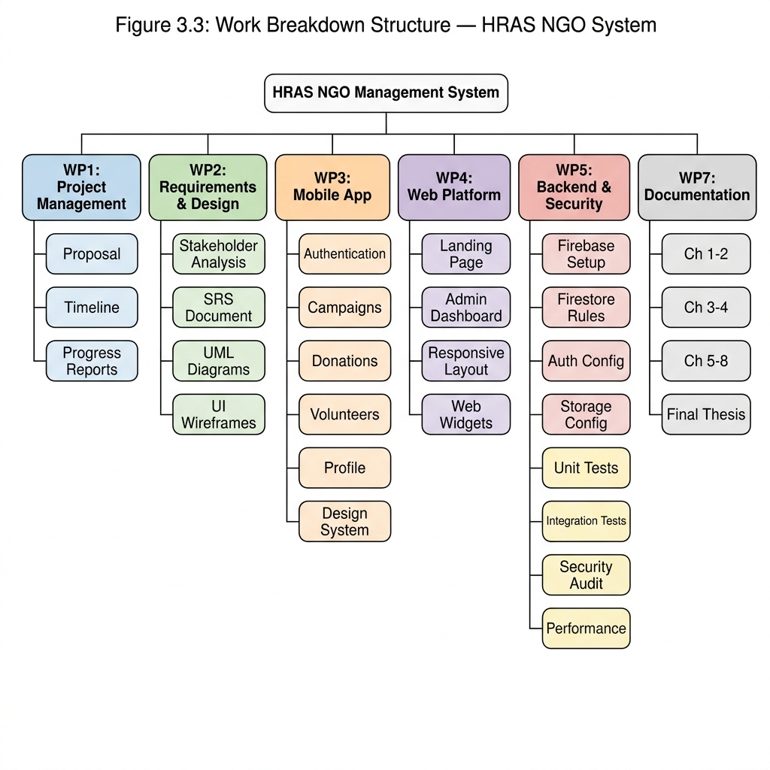
Figure 3.1: Work Breakdown Structure

3.3 Project Timeline (Gantt Chart)
The project follows a phased timeline across 1.5 years (3 semesters).
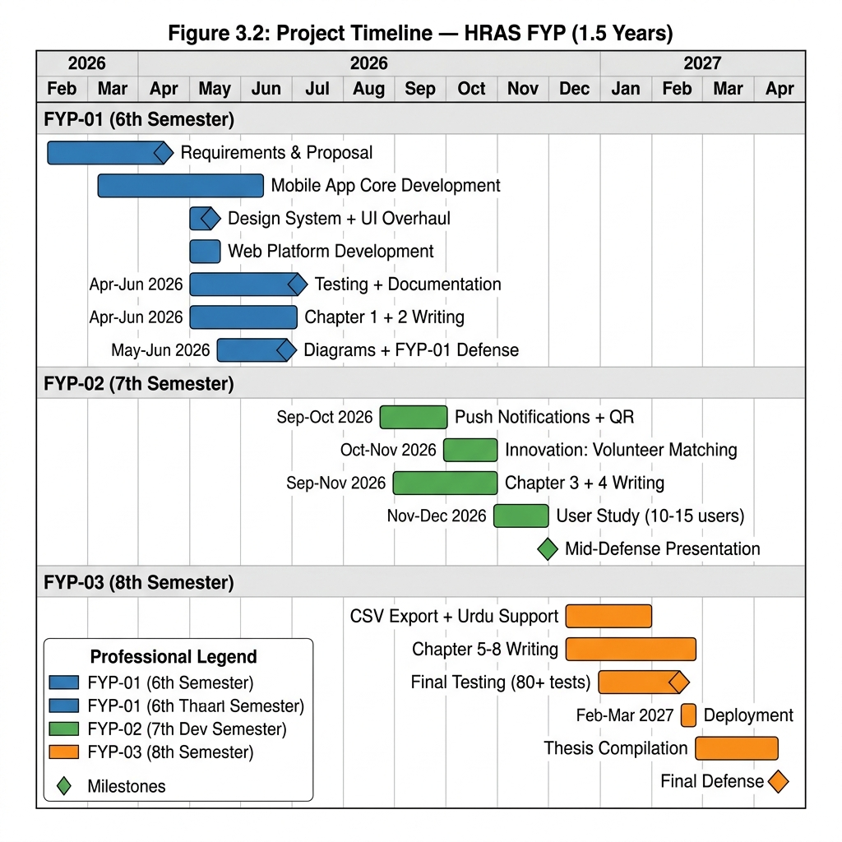
Figure 3.2: Project Timeline — Gantt Chart

3.4 Process Model
The HRAS system is developed using the Agile Iterative Model. This model was selected because:
• Requirements evolved incrementally across FYP phases
• Each iteration produces a working prototype for supervisor review
• Feature flags enable parallel development without breaking stable releases
• Continuous integration ensures regression-free development
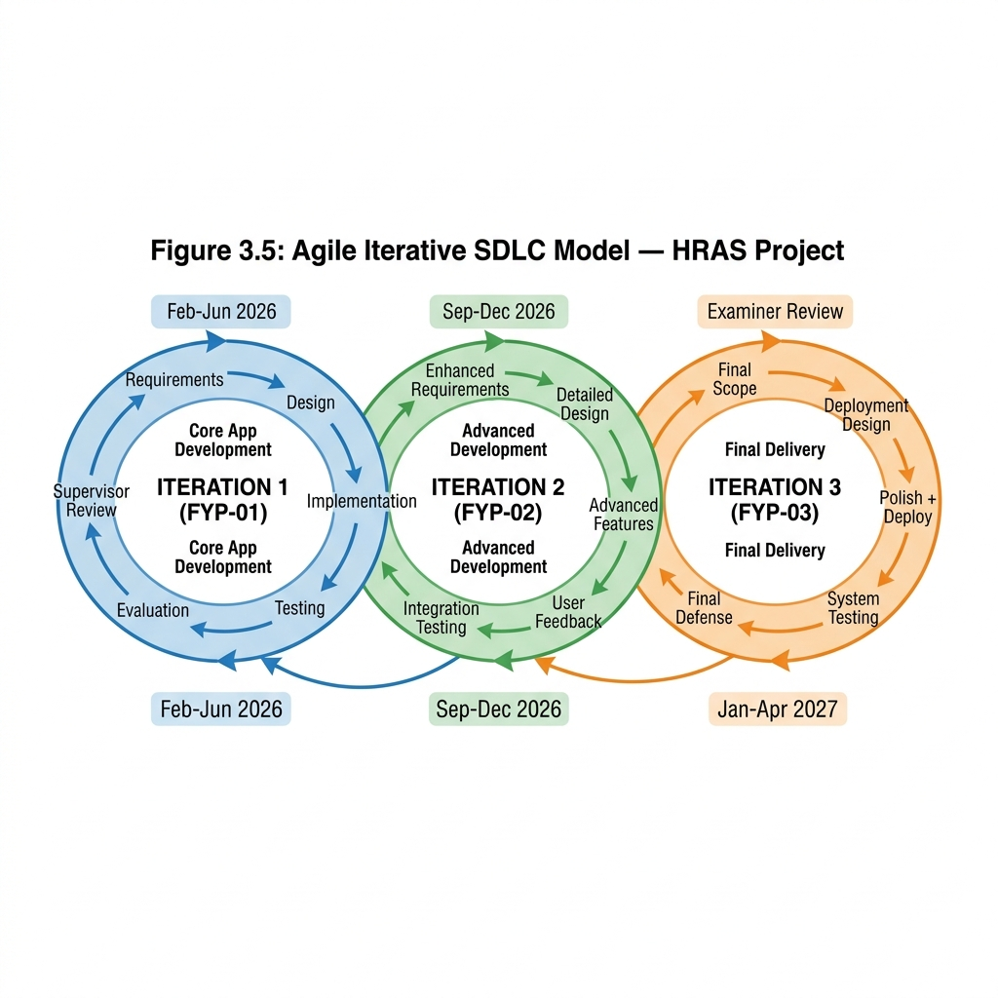
Figure 3.3: Agile Iterative SDLC Model

3.5 FYP Phase Structure
Table 3.2: FYP Phase Structure
Phase | Semester | Focus | Deliverables
FYP-01 | 6th | Core Development | Mobile App, Website, Firebase Backend
FYP-02 | 7th | Advanced Features | Smart Matching, QR Attendance, FCM, Documentation
FYP-03 | 8th | Testing & Deployment | UAT, Performance Testing, Final Thesis

3.6 Feature Flag Architecture
A compile-time feature gating system ensures backward compatibility across FYP phases:
• FYP-01 Mode (Default): flutter run — Only basic features visible
• FYP-02 Mode: flutter run --dart-define=APP_PHASE=FYP2 — Advanced features enabled
• Full Mode: flutter run --dart-define=APP_PHASE=FULL — Everything enabled
This architecture allows simultaneous development of FYP-02 features without breaking the stable FYP-01 codebase that was already defended.

3.7 Summary
This chapter established the Agile Iterative methodology, described the Work Breakdown Structure spanning three FYP semesters, and presented the feature flag architecture ensuring backward compatibility. The phased approach ensures each FYP defense demonstrates only the features relevant to that phase.

Chapter 4: System Specification
This chapter specifies the software requirements including business requirements, functional and non-functional requirements, use cases, and the traceability matrix.

4.1 Business Requirements
The HRAS NGO requires a digital platform that:
• Centralizes campaign management across multiple campaign types (Ration, Medical, Education, Winter Drive, etc.)
• Tracks monetary and in-kind donations with verifiable records
• Coordinates volunteer recruitment, registration, and attendance
• Provides real-time analytics and PDF reports for transparency
• Operates on mobile (Android/iOS) and web from a single codebase

4.2 User Requirements

4.2.1 Admin Requirements
• Login with email/password authentication
• Create, edit, and delete campaigns with full lifecycle management
• Record donations (cash, online, in-kind) with receipt generation
• Manage volunteers and track attendance
• View analytics dashboard with real-time statistics
• Generate QR codes for campaign attendance (FYP-02)
• Manage all users (activate/deactivate accounts)

4.2.2 Volunteer Requirements
• Register and login with email verification
• Browse available campaigns and join/leave campaigns
• View personal contribution history
• Receive campaign recommendations based on skills (FYP-02)
• Scan QR codes for attendance verification (FYP-02)
• Update profile with skills, address, and bio

4.3 Process Flow
The system follows a three-tier process flow: User Interface (Flutter) → Business Logic (Dart Services) → Backend (Firebase Firestore).
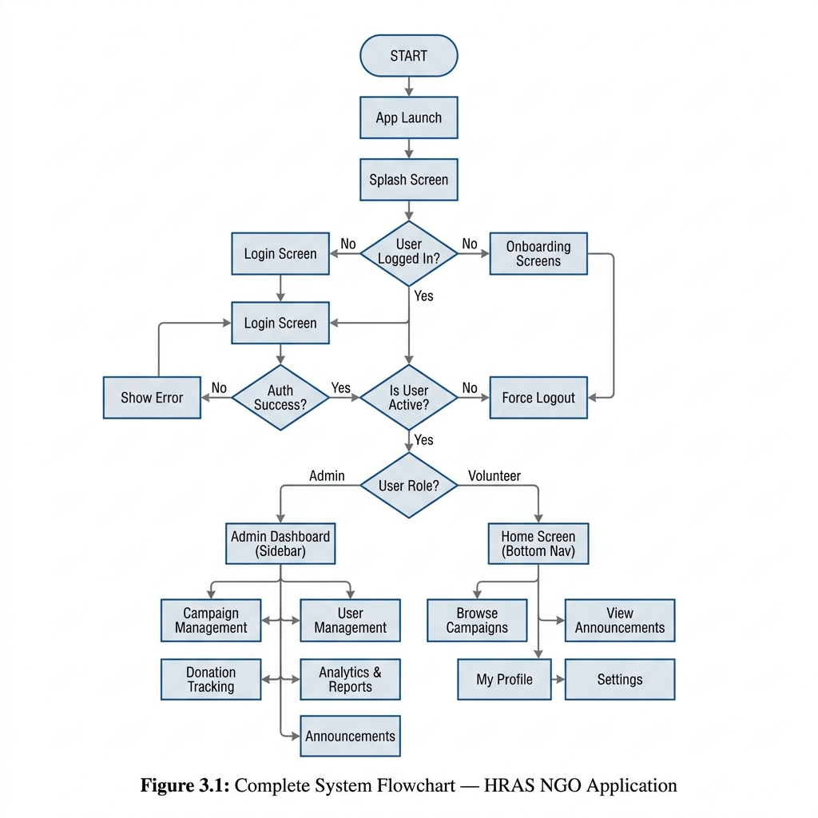
Figure 4.1: Complete System Process Flow

4.4 Functional Requirements
Table 4.1: Functional Requirements
ID | Requirement | Priority | FYP Phase
FR01 | User Login with email/password authentication | High | FYP-01
FR02 | User Registration with email verification | High | FYP-01
FR03 | Campaign CRUD (Create, Read, Update, Delete) | High | FYP-01
FR04 | Campaign status lifecycle (Upcoming → Active → Completed) | High | FYP-01
FR05 | Donation recording (Cash, Online, In-kind categories) | High | FYP-01
FR06 | PDF donation receipt generation | Medium | FYP-01
FR07 | Volunteer self-registration for campaigns | High | FYP-01
FR08 | Volunteer attendance tracking | Medium | FYP-01
FR09 | Expense recording per campaign | High | FYP-01
FR10 | Admin dashboard with real-time analytics | Medium | FYP-01
FR11 | Role-based access control (Admin/Volunteer) | High | FYP-01
FR12 | Smart volunteer-campaign matching algorithm | Medium | FYP-02
FR13 | QR code generation for campaign attendance | Medium | FYP-02
FR14 | QR code scanning for volunteer check-in | Medium | FYP-02
FR15 | Push notifications via FCM | Low | FYP-02

4.5 Non-Functional Requirements
Table 4.2: Non-Functional Requirements
ID | Requirement | Description
NFR01 | Performance | System must respond within 2 seconds for CRUD operations
NFR02 | Usability | Interface must be intuitive for users with basic smartphone literacy
NFR03 | Availability | System must be available 99% uptime via Firebase infrastructure
NFR04 | Scalability | Must handle 500+ concurrent users without performance degradation
NFR05 | Security | RBAC enforced via Firestore security rules; passwords hashed by Firebase Auth
NFR06 | Maintainability | Modular architecture with feature flags for phase-based development

4.6 Assumptions and Constraints

4.6.1 Development Languages and Tools
Table 4.3: Development Tools and Technologies
Tool/Technology | Version | Purpose
Flutter | 3.x | Cross-platform UI framework (Android, iOS, Web)
Dart | 3.x | Programming language
Firebase Core | 4.7.0 | Backend-as-a-Service
Cloud Firestore | 6.3.0 | NoSQL database
Firebase Auth | 5.5.1 | Authentication
Firebase Storage | 12.4.4 | File/image storage
Firebase Messaging | 16.2.0 | Push notifications (FCM)
Next.js | 16.x | Public website framework
qr_flutter | 4.1.0 | QR code generation
mobile_scanner | 6.0.x | QR code scanning (camera)
VS Code | Latest | Primary IDE

4.6.2 Operating Environment
The system runs on: Android 5.0+, iOS 12+, and modern web browsers (Chrome, Safari, Firefox). The backend runs on Google Cloud infrastructure via Firebase.

4.7 Actors
Table 4.4: System Actors
Actor | Description | Key Actions
Admin | NGO administrator with full system access | Campaign CRUD, Donation recording, User management, QR generation, Analytics
Volunteer | Registered user who participates in campaigns | Browse campaigns, Join/Leave, Scan QR, View recommendations, Update profile
Public User | Unregistered visitor on the website | View public campaigns, Read about HRAS, Contact NGO

4.8 Use Cases
The following use case diagram shows the interactions between actors and the system.
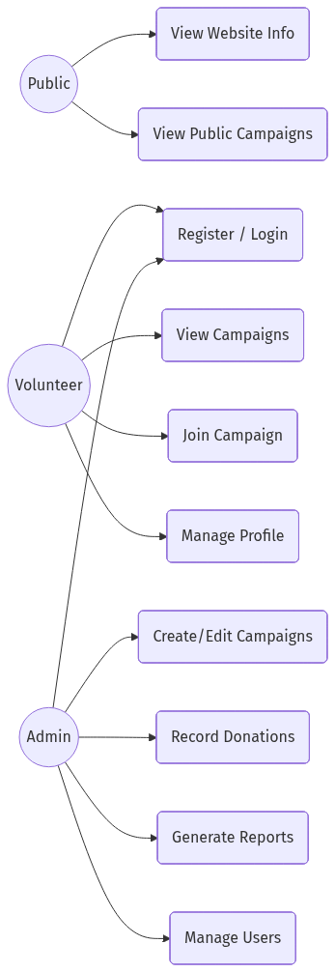
Figure 4.2: Use Case Diagram

4.8.1 Use Case: User Login
Table 4.5: Login Use Case
Field | Description
Use Case ID | UC01
Actor | Admin / Volunteer
Precondition | User has a registered account
Main Flow | 1. User enters email and password  2. System validates credentials via Firebase Auth  3. System loads user profile from Firestore  4. System redirects to Dashboard (Volunteer) or Admin Panel (Admin)
Postcondition | User is authenticated and dashboard is displayed
Exception | Invalid credentials → error message shown

4.8.2 Use Case: Campaign Management
Table 4.6: Campaign Management Use Case
Field | Description
Use Case ID | UC02
Actor | Admin
Precondition | Admin is logged in
Main Flow | 1. Admin clicks 'Create Campaign'  2. Fills title, description, type, location, dates  3. System creates campaign in Firestore  4. Campaign appears in campaign list
Postcondition | New campaign is created and visible to all users
Exception | Validation errors → form shows inline errors

4.9 Traceability Matrix
Table 4.7: Requirements Traceability Matrix
FR ID | Use Case | Test Case | Module
FR01 | UC01 | TC01 | Authentication
FR02 | UC01 | TC02 | Registration
FR03 | UC02 | TC03 | Campaign Management
FR05 | UC03 | TC04 | Donation Recording
FR07 | UC04 | TC05 | Volunteer Management
FR12 | UC05 | TC06 | Smart Matching (FYP-02)
FR13 | UC06 | TC07 | QR Attendance (FYP-02)

4.10 Summary
This chapter specified 15 functional requirements and 6 non-functional requirements across FYP-01 and FYP-02 phases. Use cases were defined for core system interactions, and a traceability matrix links requirements to test cases for verification in Chapter 7.

Chapter 5: System Design
This chapter presents the architectural design of the HRAS system including system architecture, data models, flow diagrams, and the design of advanced FYP-02 features.

5.1 System Architecture
The HRAS system follows a four-layer architecture: Presentation Layer (Flutter UI), Business Logic Layer (Dart Services), Data Access Layer (Firebase SDK), and Infrastructure Layer (Google Cloud).
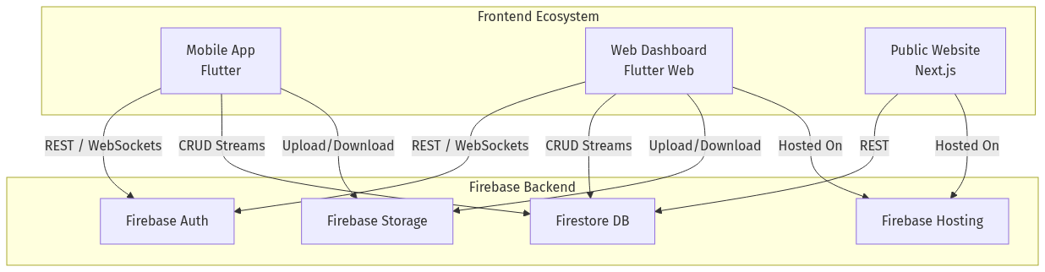
Figure 5.1: Unified System Architecture

5.2 Entity Relationship Diagram
The Firestore database uses a NoSQL document model with the following collections:
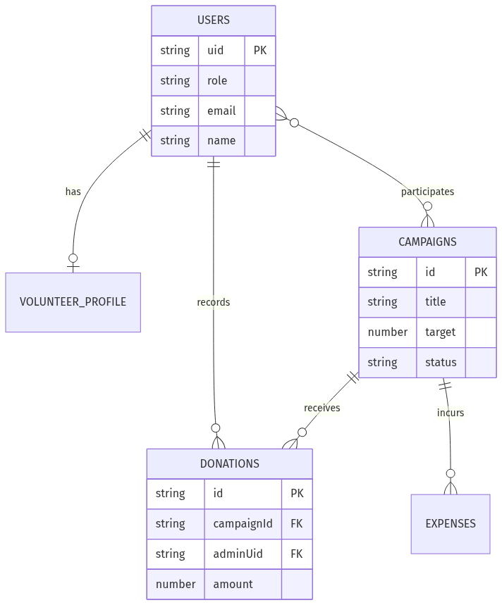
Figure 5.2: Entity Relationship Diagram

5.3 Data Flow Diagrams

5.3.1 Context Level (Level 0)
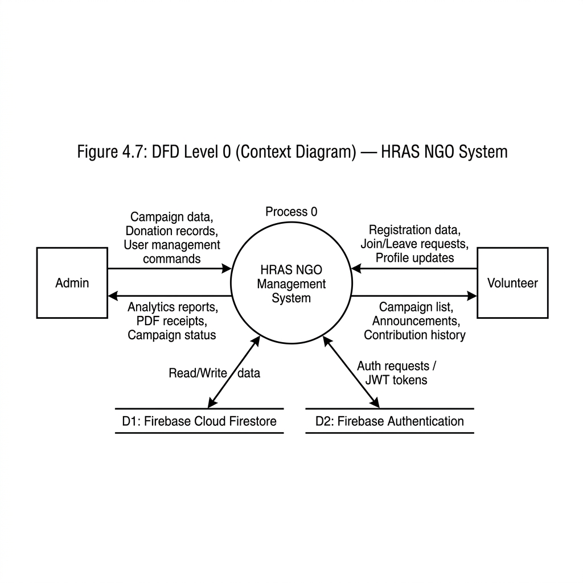
Figure 5.3: DFD Level 0 — System Context

5.3.2 Level 1 DFD
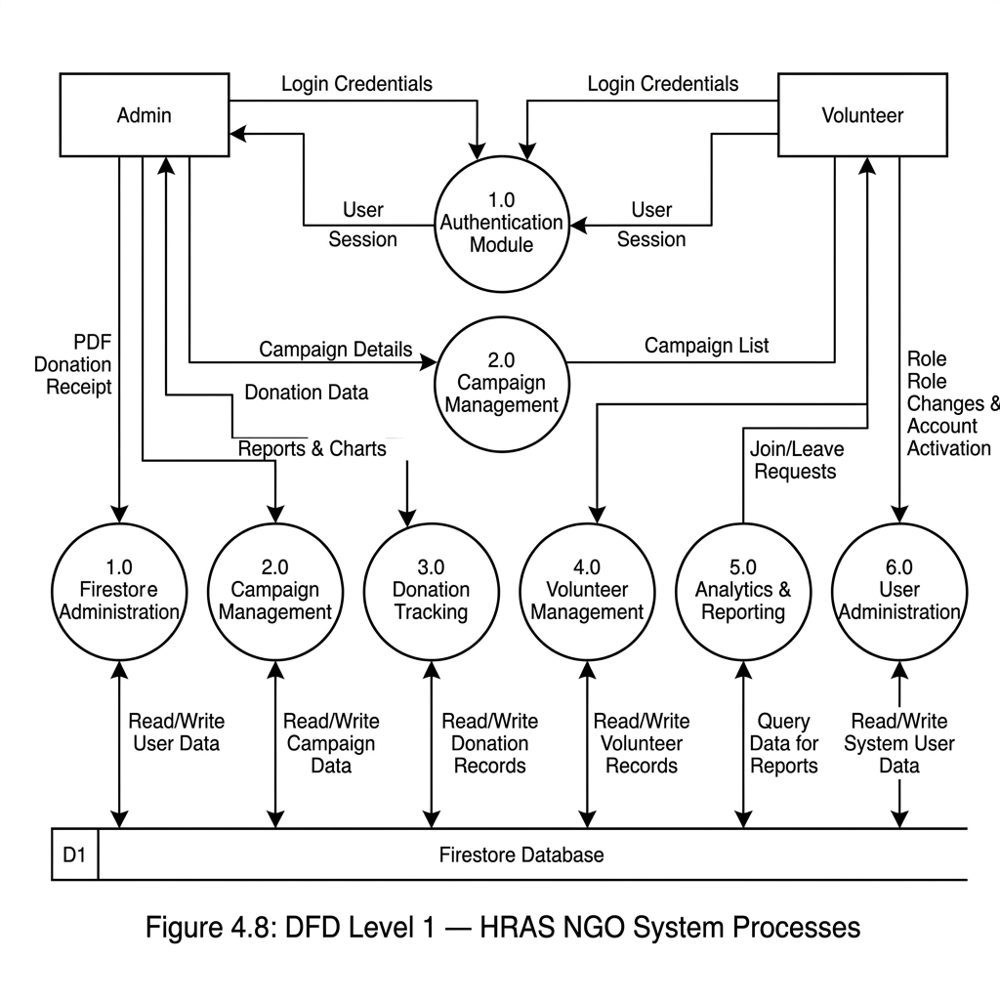
Figure 5.4: DFD Level 1 — Process Decomposition

5.3.3 Level 2 DFD
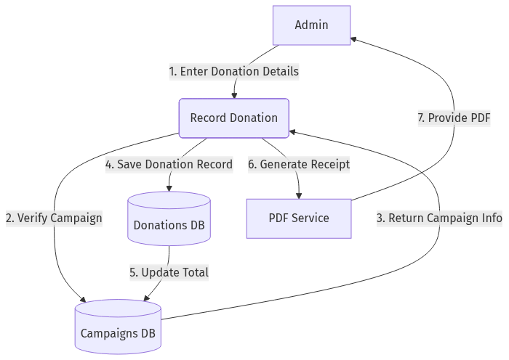
Figure 5.5: DFD Level 2 — Donation & Volunteer Flow

5.4 Sequence Diagrams

5.4.1 Donation Transaction Flow
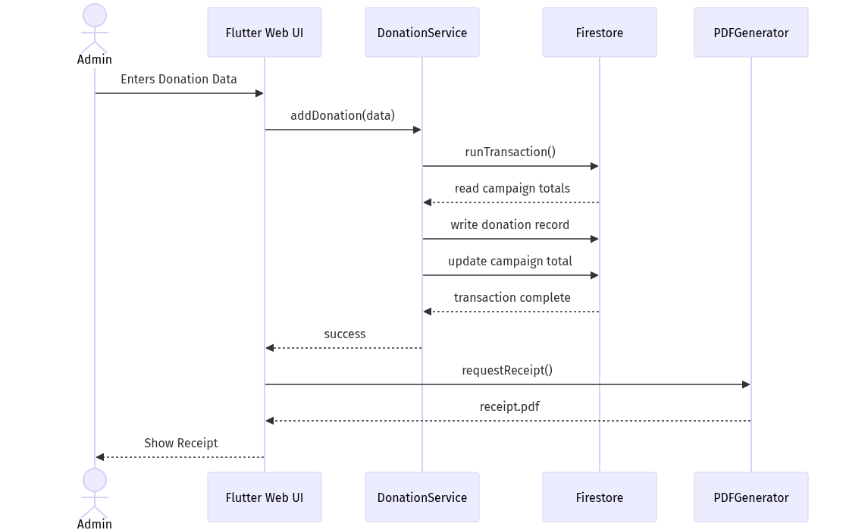
Figure 5.6: Sequence Diagram — Donation Flow

5.4.2 Volunteer Registration Flow
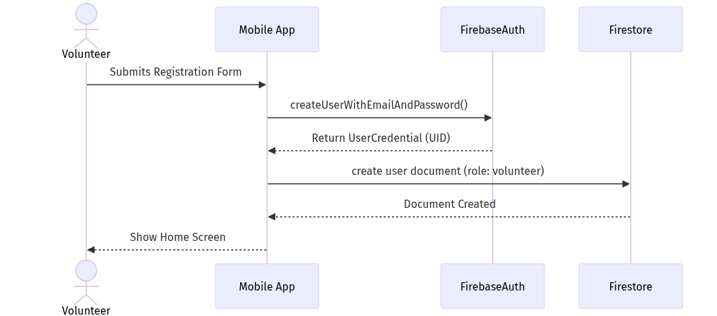
Figure 5.7: Sequence Diagram — Volunteer Registration

5.5 Class Diagram
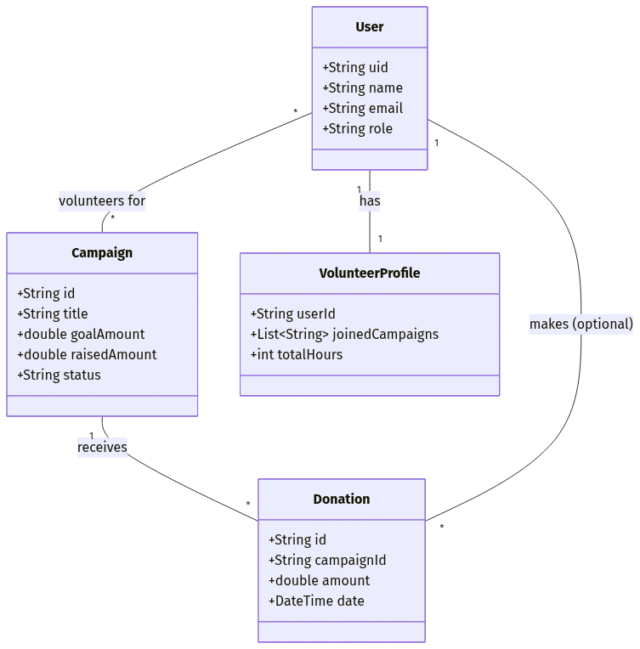
Figure 5.8: Class Diagram — Core Entities

5.6 Component Diagram
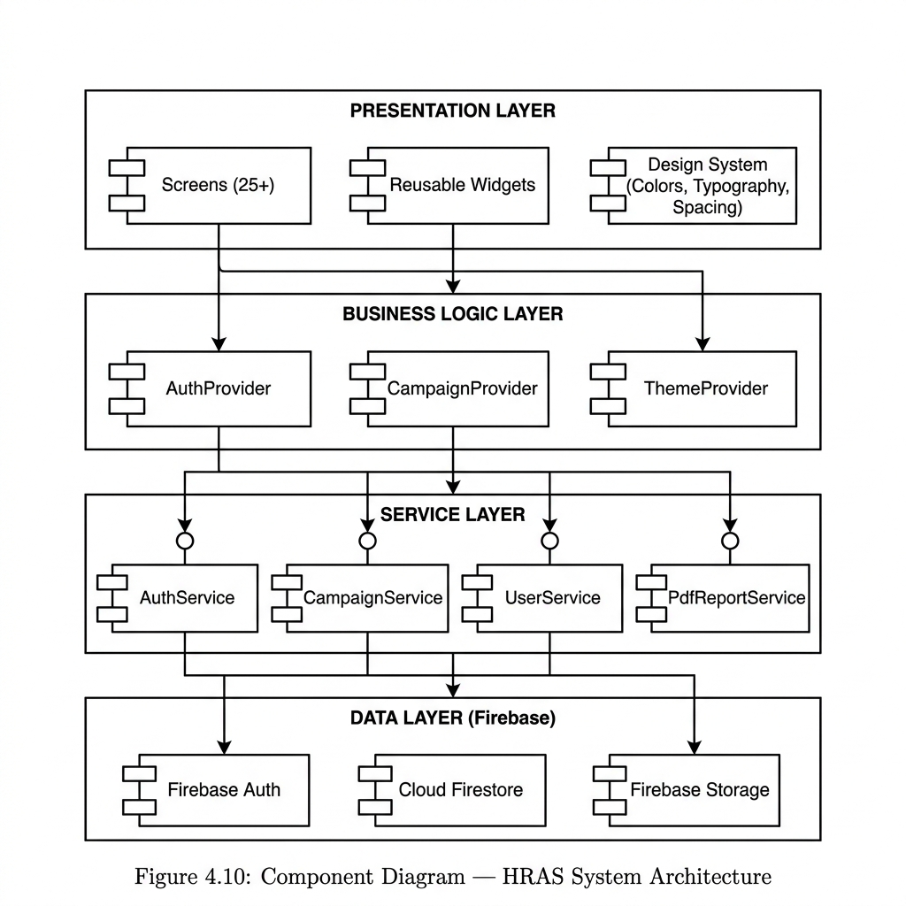
Figure 5.9: Component Diagram — Four-Layer Architecture

5.7 Deployment Diagram
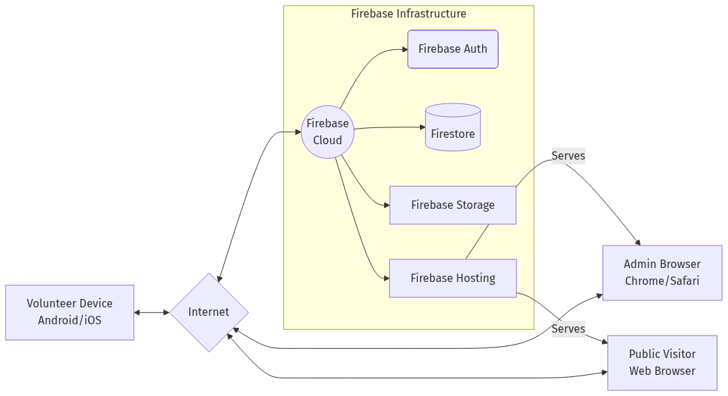
Figure 5.10: Deployment Diagram

5.8 Data Dictionary
Table 5.1: Users Collection
Field | Type | Description
uid | String | Unique user identifier (Firebase Auth UID)
name | String | Full name of the user
email | String | Email address (unique)
phone | String | Phone number
role | String | User role: 'admin' or 'volunteer'
skills | Array<String> | List of user skills (for matching)
address | String | User address (for location matching)
isActive | Boolean | Account active status
campaignsJoined | Integer | Count of campaigns joined
fcmToken | String | FCM push notification token (FYP-02)

Table 5.2: Campaigns Collection
Field | Type | Description
id | String | Unique campaign identifier
title | String | Campaign title
type | Enum | Campaign type (ration, medical, education, etc.)
status | Enum | Status: upcoming, active, completed
location | String | Campaign location
startDate | Timestamp | Campaign start date
totalVolunteers | Integer | Count of registered volunteers
totalDonationsAmount | Double | Total donation amount (PKR)
totalExpenses | Double | Total expenses recorded
progressPercent | Integer | Campaign completion percentage

Table 5.3: Volunteers Collection
Field | Type | Description
id | String | Unique volunteer record ID
campaignId | String | Reference to campaign
userId | String | Reference to user
status | Enum | Status: registered, confirmed, attended, absent
registeredAt | Timestamp | Registration timestamp
attendedAt | Timestamp | Attendance timestamp (set by QR scan)

5.9 Smart Matching Algorithm Design (FYP-02)
The Smart Matching Algorithm uses a weighted scoring model to recommend campaigns to volunteers:
Score = (Skill Match × 0.50) + (Location Match × 0.30) + (Availability × 0.20)
Table 5.4: Matching Algorithm Weights
Factor | Weight | Score Range | Logic
Skills Match | 50% | 0.0–1.0 | Maps user skill keywords to campaign type compatibility
Location Match | 30% | 0.0–1.0 | String-based city comparison (15 Pakistani cities)
Availability | 20% | 0.0–1.0 | 1.0 if not registered, 0.0 if already registered
Quality Labels: Excellent (≥80%), Good (≥60%), Fair (≥40%), Low (<40%)

5.10 QR Attendance System Design (FYP-02)
The QR Attendance system follows a generate-scan-verify flow:
1. Admin opens a campaign and selects 'Generate QR Code'
2. System encodes campaign ID and title into a JSON payload
3. QR code is displayed using the qr_flutter package
4. Volunteer opens the app and taps 'Scan QR Attendance'
5. Camera scans the QR code using mobile_scanner package
6. System parses the JSON, verifies registration, and marks attendance in Firestore

5.11 Summary
This chapter presented the four-layer system architecture, data models (ER diagram and data dictionary), behavioral models (sequence and activity diagrams), and the design of FYP-02 innovation features. All diagrams follow UML 2.0 notation standards.

Chapter 6: Coding
This chapter contains code of the major functionalities of the project. Full code is available in the GitHub repository.

6.1 Flutter Mobile Development

6.1.1 Feature Flags System
The feature flag system controls which features are visible in each FYP phase:
class FeatureFlags {
static const String phase = String.fromEnvironment(
'APP_PHASE', defaultValue: 'FYP1');
static bool get isFyp1 => phase == 'FYP1';
static bool get isFyp2 => phase == 'FYP2';
static bool get isFull => phase == 'FULL';
// Feature gates
static bool get isSmartMatchingEnabled => isFyp2 || isFull;
static bool get isQrAttendanceEnabled => isFyp2 || isFull;
static bool get isPushNotificationsEnabled => isFyp2 || isFull;
}

6.1.2 Campaign Service (Core CRUD)
The CampaignService handles all Firestore CRUD operations for campaigns:
class CampaignService {
final FirebaseFirestore _db = FirebaseFirestore.instance;
Future<CampaignModel> createCampaign(CampaignModel campaign) async {
final docRef = _db.collection('campaigns').doc();
final newCampaign = campaign.copyWith(id: docRef.id);
await docRef.set(newCampaign.toMap());
return newCampaign;
}
Stream<List<CampaignModel>> getCampaignsStream() {
return _db.collection('campaigns')
.orderBy('createdAt', descending: true)
.snapshots()
.map((s) => s.docs.map((d) => CampaignModel.fromMap(d.data())).toList());
}
}

6.2 Smart Matching Algorithm (FYP-02)
The matching algorithm uses weighted scoring to recommend campaigns:
static List<MatchResult> getRecommendations({
required UserModel user,
required List<CampaignModel> campaigns,
List<VolunteerModel> existingRegistrations = const [],
}) {
for (final campaign in campaigns) {
final skillScore = _calculateSkillScore(user.skills, campaign.type);
final locationScore = _calculateLocationScore(user.address, campaign.location);
final availabilityScore = registeredIds.contains(campaign.id) ? 0.0 : 1.0;
final totalScore = (skillScore * 0.50) + (locationScore * 0.30)
+ (availabilityScore * 0.20);
results.add(MatchResult(campaign: campaign, score: totalScore, ...));
}
results.sort((a, b) => b.score.compareTo(a.score));
return results;
}

6.3 QR Attendance System (FYP-02)
QR code generation and scanning for volunteer attendance:
// Generate QR payload
static String generateQrPayload({required String campaignId, required String campaignTitle}) {
return jsonEncode({'type': 'hras_attendance', 'campaignId': campaignId,
'campaignTitle': campaignTitle, 'generatedAt': DateTime.now().toIso8601String()});
}
// Mark attendance from scanned QR
static Future<QrScanResult> markAttendance({required String qrRawData, required String userId}) {
final payload = parseQrPayload(qrRawData);
if (payload == null) return QrScanResult(success: false, message: 'Invalid QR');
// Verify registration, check duplicate, mark as attended in Firestore
}

6.4 Firebase Security Rules
Firestore security rules enforce role-based access control:
rules_version = '2';
service cloud.firestore {
match /databases/{database}/documents {
match /campaigns/{campaignId} {
allow read: if request.auth != null;
allow write: if request.auth != null
&& get(/databases/$(database)/documents/users/$(request.auth.uid)).data.role == 'admin';
}
match /users/{userId} {
allow read: if request.auth != null;
allow write: if request.auth.uid == userId
|| get(/databases/$(database)/documents/users/$(request.auth.uid)).data.role == 'admin';
}
}
}

6.5 Summary
This chapter presented code for the major system functionalities including the feature flag system, campaign management, smart matching algorithm, QR attendance system, and Firebase security rules. The complete source code with 80+ Dart files and 14,000+ lines is available in the GitHub repository.

