Air University Multan Campus

Department of Computer Science

NGO Operation and Volunteer Management System

(HRAS)

FYP-01 Report
Submitted by: Muhammad Maauz Mansoor
Registration No: 233599
Session: 2023–2027 | Semester: 6th
Supervised by: Miss Fatima Yousuf

CERTIFICATE OF APPROVAL

It is certified that the Final Year Project titled "NGO Operation and Volunteer Management System (HRAS)" developed by Muhammad Maauz Mansoor (233599) has been fully checked and approved for submission.

_______________________
Supervisor: Miss Fatima Yousuf

Dedications

I dedicate this project to my parents, who have always supported my education and dreams. I also dedicate this to the hardworking people at HRAS NGO who are trying their best to help others every day.

Acknowledgement

First of all, I want to thank Allah Almighty for giving me the strength to complete this project.
I am very grateful to my supervisor, Miss Fatima Yousuf. Her guidance was very helpful, and she always took the time to correct my mistakes and show me the right way to develop a proper system.
I also want to thank my friends and the HRAS NGO team. They gave me real data and explained how they work, which helped me design a system that actually solves their problems.

Table of Contents

List of Tables

List of Figures

Abstract

In Pakistan, many NGOs are working hard to provide food, education, and medical help to those in need. However, most of them, including HRAS, manage their daily tasks manually. They use paper registers to keep track of donations and WhatsApp groups to talk to volunteers. This manual work takes a lot of time and sometimes leads to mistakes or lost records.
This project is about building a complete digital system for NGOs called HRAS (Hamesha Rahein Apke Saath). I built it using Flutter so that it works as a mobile app (for Android and iOS) and also as a website. For the backend database, I used Firebase because it updates in real-time.
The main goal of this system is to make everything easier for the admin and the volunteers. The admin can create campaigns, add donations, and check how many people have registered. The volunteers can easily sign up through the app, find campaigns they like, and see their own record. We have also added special features like generating a PDF receipt for donations so that everything is clear and transparent.
By using this system, NGOs can stop worrying about paperwork and focus more on actually helping people. The system is secure, fast, and very easy to use for both admins and normal volunteers.

Chapter 1
Project Phasing (FYP-01 to FYP-03):
This project was developed in three distinct academic phases to ensure practical delivery:
• FYP-01: Focused entirely on planning, requirement engineering, gap analysis, and establishing the base architecture.
• FYP-02: Focused on MVP development and implementing advanced features such as Volunteer Matching, QR Attendance, and Push Notifications.
• FYP-03: Focused on partial deployment, usability testing, and final evaluation of the developed modules.
Introduction

Chapter 1: Introduction

1.1 Background
NGOs are very important for developing countries like Pakistan. Millions of people here rely on charity for basic things like ration, medicine, and clothes. Pakistanis give a lot of charity every year, almost 300 billion rupees. But the problem is that most NGOs do not have a proper computer system. They use old methods like paper notebooks or WhatsApp messages to manage their work.
HRAS is one of these NGOs. They do many good campaigns like distributing ration, helping orphans, and setting up medical camps. Even though they are very active, they face problems because everything is manual. They find it hard to track who gave how much donation, which volunteer came to which event, and how the money was spent.

1.2 Problem Statement
Small NGOs in Pakistan don't have good software to manage their work. Because of this, it is very hard for them to keep a clear record of donations and volunteers. Donors sometimes don't know where their money went, and volunteers find it difficult to know when a new campaign is happening. This lack of a proper system slows down the NGO's good work.

1.3 Objectives
The main objectives of building this project are:
• To create a mobile app and website where admins can manage all campaigns in one place.
• To make a proper system for recording donations so that there is a clear history.
• To allow volunteers to register themselves on the app and join campaigns easily.
• To generate PDF receipts for donations automatically.
• To build a dashboard for the admin so they can see total donations and total volunteers at a glance.

1.4 Scope
This system covers the core operations of the HRAS NGO. It includes an Admin Panel on the web and a mobile app for both Admin and Volunteers. The system manages campaigns, donations, and volunteer registration. It does not include an online payment gateway (like jazzcash or credit card directly in the app) because NGOs prefer collecting physical cash or direct bank transfers. The focus is purely on managing the records and the people.

Chapter 2
Literature Review

Chapter 2: Literature Review

2.1 Introduction to Literature
Before starting the development of the HRAS system, I reviewed how other NGOs work and what kind of software they use. Research shows that when NGOs use digital tools, their work becomes much faster and people trust them more because everything is recorded clearly.

2.2 Current Situation in Pakistan
There are thousands of NGOs in Pakistan. Some big ones like Edhi or Shaukat Khanum have their own big software systems. But the smaller local NGOs usually just use Excel sheets or WhatsApp. A recent study by the Pakistan Centre for Philanthropy showed that while people give a lot of charity, the record-keeping is very weak. This is why small NGOs need a system that is cheap and easy to use on mobile phones.

2.3 Existing Systems Analysis
There are some famous NGO software systems available in the world, like CiviCRM and Salesforce Nonprofit Cloud. However, these are built for very large international organizations. They are very complex, expensive, and require a lot of training to use. A small NGO in Pakistan cannot afford to buy or learn these systems. They need something very simple, preferably in English and easy to understand, which works directly from their mobile phone.
Table 1: Comparative Analysis of Existing NGO Platforms
Feature / Software | CiviCRM | Salesforce | HRAS System (Proposed)
Cost | High (Server costs) | Very High | Free/Low Cost (Firebase)
Complexity | Very Complex | Very Complex | Simple & User-Friendly
Mobile App | No official app | Yes, but complex | Yes (Flutter Native)
Target User | Large Enterprises | Global Charities | Local Pakistani NGOs

2.4 Summary
The literature review showed that while there is big software available for NGOs, it is not suitable for small, local organizations in Pakistan. This proved that there is a real need to build a custom, simple, and mobile-friendly system like HRAS.

Air University Multan Campus

Department of Computer Science

NGO Operation and Volunteer Management System

(HRAS)

FYP-02 Report: Chapters 3–6

Submitted by: Muhammad Maauz Mansoor
Registration No: 233599
Session: 2023–2027 | Semester: 7th
Supervised by: Miss Fatima Yousuf

Chapter 3
Planning and Methodology

Chapter 3: Planning and Methodology
In this chapter, I will explain how I planned the project and the method I used to develop it over the three semesters.

3.1 Project Deliverables
Here is the list of the main things I have to deliver for this project:
• Project Plan and SRS
• System Design Documents
• A working Mobile App
• A working Web Dashboard
• Final Thesis Document

3.2 Work Breakdown Structure
I divided the whole project into smaller, manageable tasks. This is called a Work Breakdown Structure (WBS).
Table 1: Work Breakdown Structure
Task | Phase | Time
Requirements Gathering | FYP-01 | 4 weeks
Basic App & Database | FYP-01 | 8 weeks
Advanced Features (Matching, QR) | FYP-02 | 6 weeks
Testing & Thesis | FYP-03 | 4 weeks

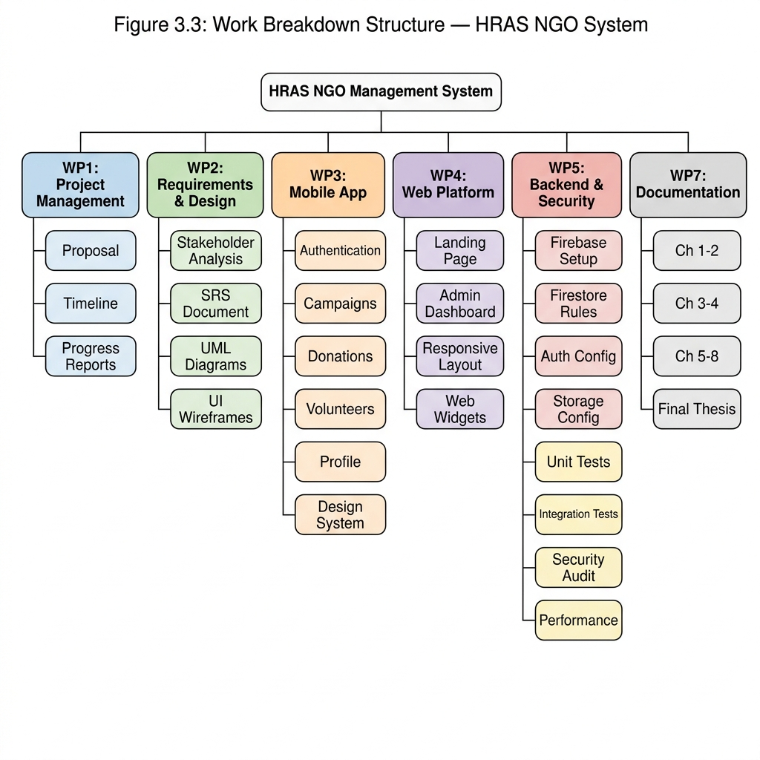
Figure 1: Work Breakdown Structure Chart

3.3 Project Timeline
I also created a Gantt chart to show the timeline of the project.
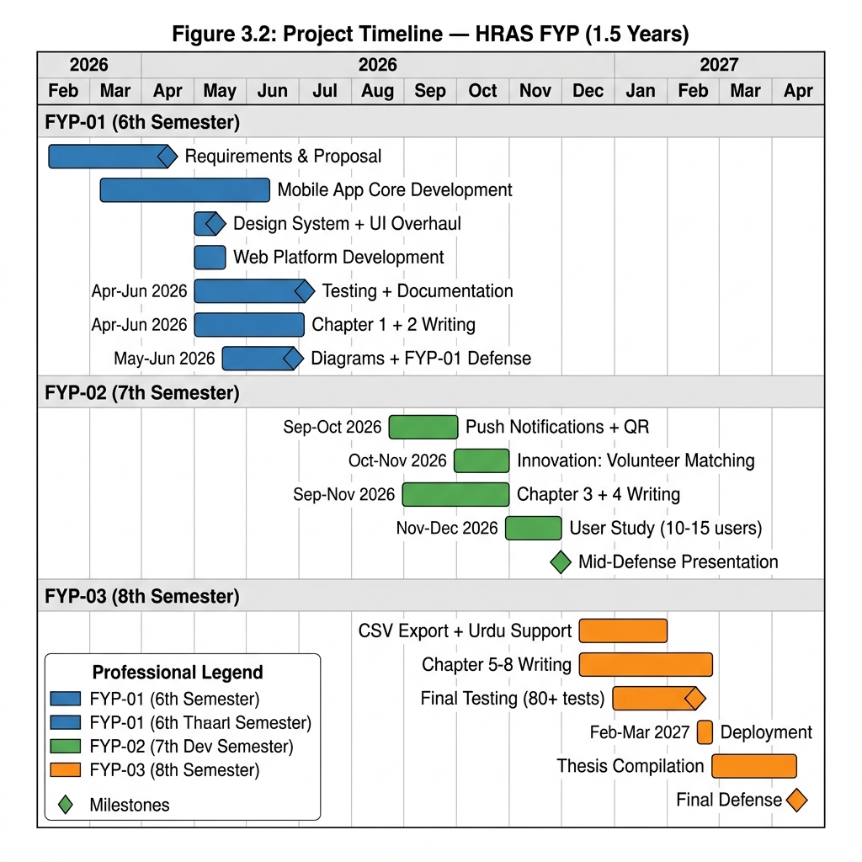
Figure 1: Gantt Chart

3.4 Methodology Used
I chose the Agile Iterative model. This is because in software development, especially for NGOs, requirements can change. By using Agile, I could build the basic app first in FYP-01, show it to my supervisor, and then add the advanced features in FYP-02.
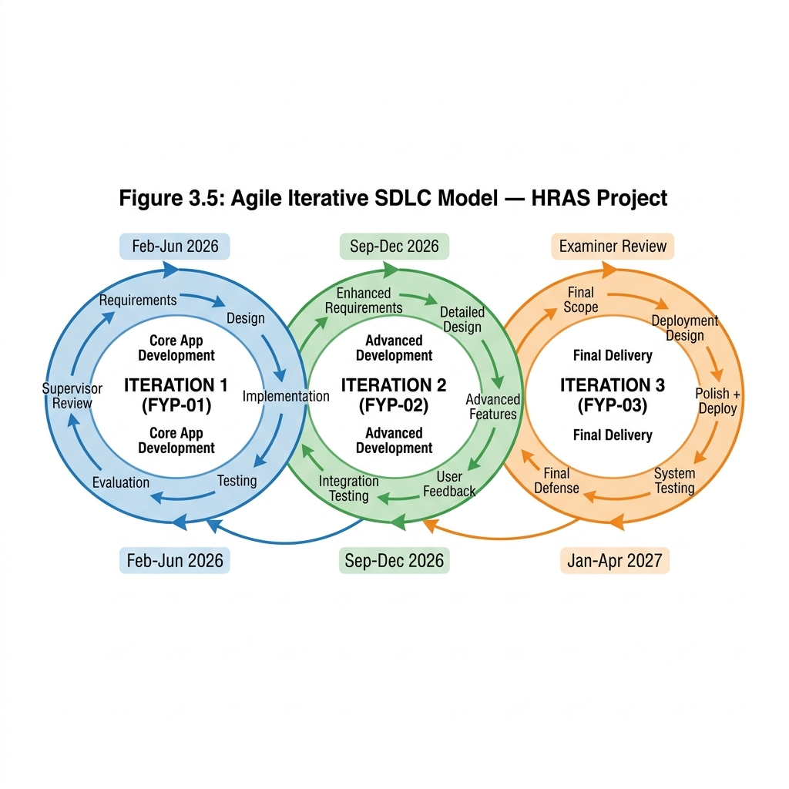
Figure 1: Agile Iterative SDLC Model

Chapter 4
System Specification

Chapter 4: System Specification
This chapter lists all the requirements that the system must fulfill. These requirements were gathered by talking to the HRAS NGO members.

4.1 Functional Requirements
These are the main features the system must have to work properly.
Table 1: Functional Requirements
ID | Requirement | Phase
FR01 | Admin login and Volunteer Registration | FYP-01
FR02 | Admin can create, edit, and delete campaigns | FYP-01
FR03 | System records donations and generates PDF receipts | FYP-01
FR04 | Volunteers can join campaigns | FYP-01
FR05 | Smart algorithm matches volunteers to campaigns based on skills | FYP-02
FR06 | Admin can generate QR codes for campaigns | FYP-02
FR07 | Volunteers scan QR to mark their attendance | FYP-02

4.2 Non-Functional Requirements
These requirements define how well the system should perform.
Table 1: Non-Functional Requirements
ID | Requirement | Details
NFR01 | Speed | The app should load data quickly from Firebase.
NFR02 | Security | Passwords should be hidden and database secured.
NFR03 | Ease of Use | The UI should be very simple for normal people to use.

4.3 Tools Used
Table 1: Development Tools and Technologies
Tool | Purpose
Flutter | To build the mobile app and web dashboard
Dart | The programming language used
Firebase | For database (Firestore) and authentication
VS Code | The IDE used for writing code

4.4 Actors
Table 1: System Actors
Actor | Role
Admin | Controls everything. Creates campaigns and records donations.
Volunteer | Normal user who joins campaigns and scans QR for attendance.

4.5 Use Cases
The use case diagram shows what each actor can do in the system.
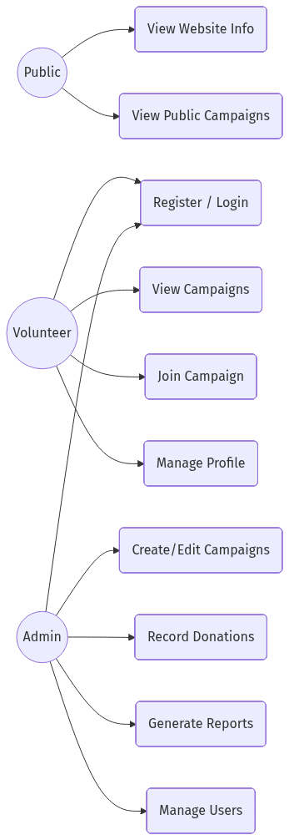
Figure 1: Use Case Diagram
Table 1: Campaign Management Use Case
Field | Detail
Actor | Admin
Action | Admin clicks create campaign, fills details, and saves it to the database.

4.6 Traceability Matrix
This matrix ensures that every requirement is tested later.
Table 1: Requirements Traceability Matrix
Req ID | Use Case | Test Case
FR01 | UC01 | TC01
FR02 | UC02 | TC02
FR05 | UC03 | TC03

Chapter 5
System Design

Chapter 5: System Design
This chapter contains all the diagrams that show the internal architecture and database design of the HRAS system.

5.1 Architecture
The system uses Flutter for the frontend and Firebase for the backend.
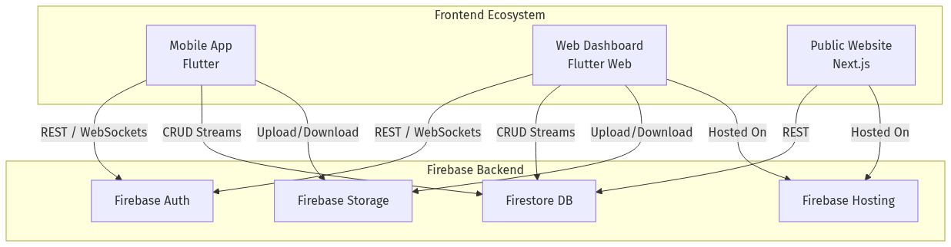
Figure 1: System Architecture Diagram

5.2 Database Design (ER Diagram)
Because Firebase is a NoSQL database, we use collections instead of tables. Here is the Entity Relationship diagram.
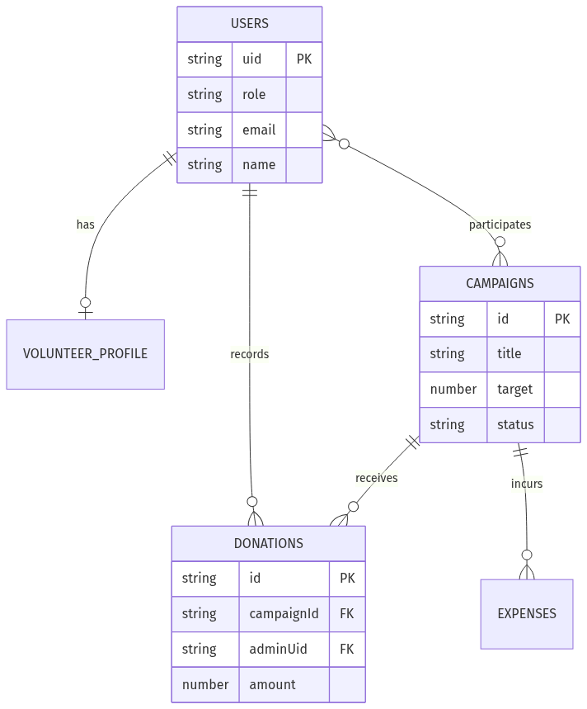
Figure 1: Entity Relationship Diagram

5.3 Data Flow Diagrams
These diagrams show how data moves in the system.
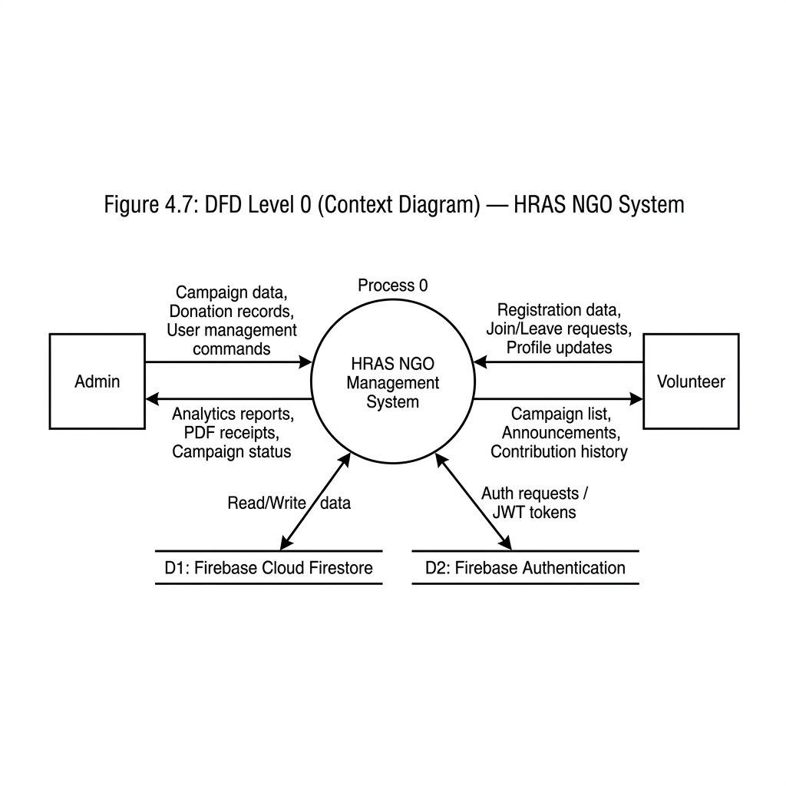
Figure 1: DFD Level 0
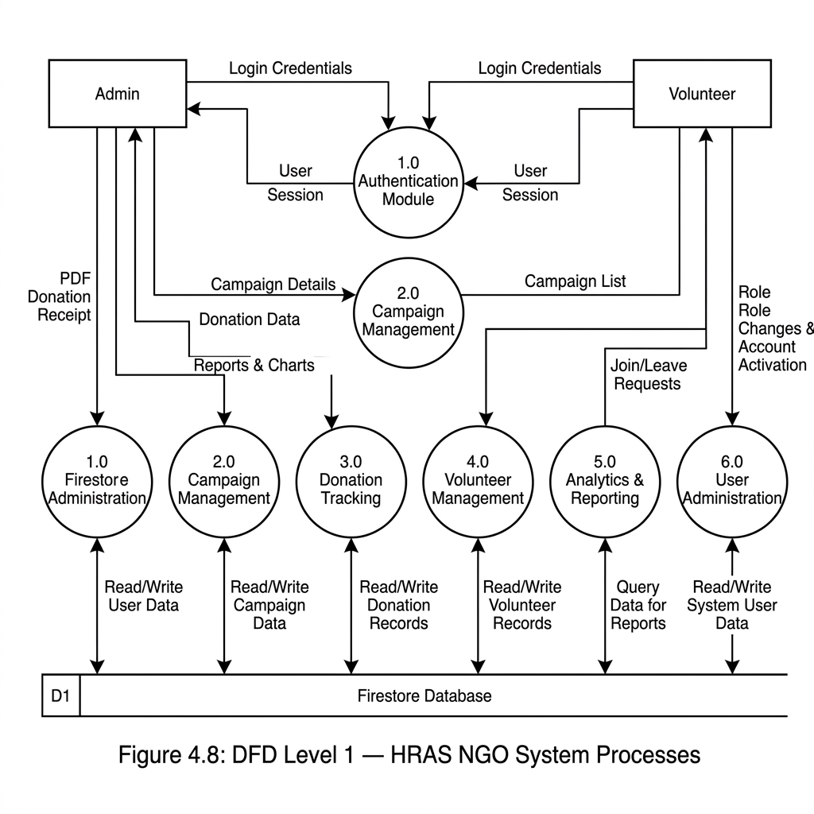
Figure 1: DFD Level 1
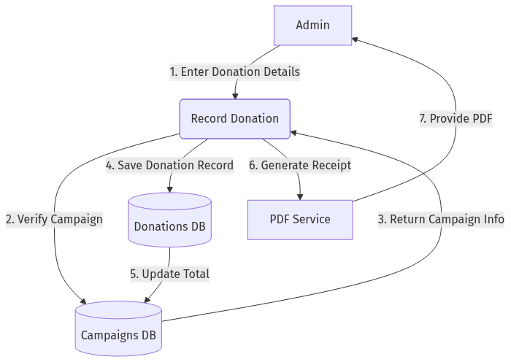
Figure 1: DFD Level 2

5.4 Sequence Diagrams
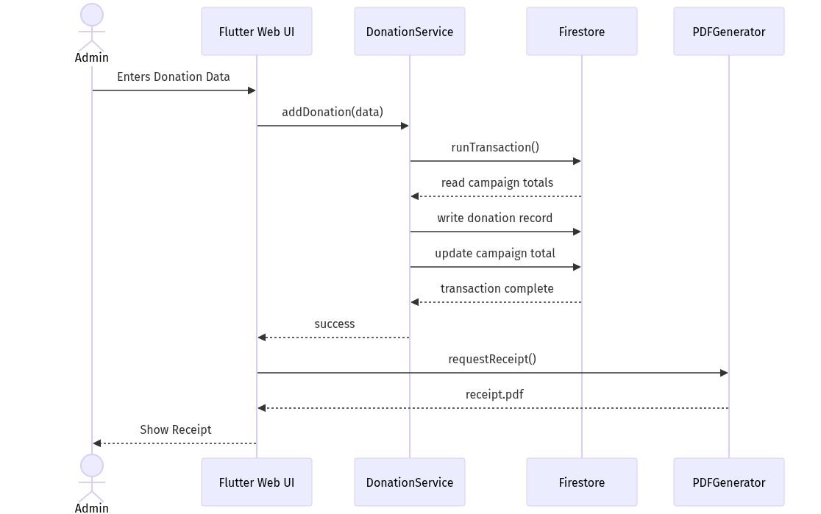
Figure 1: Donation Sequence Diagram
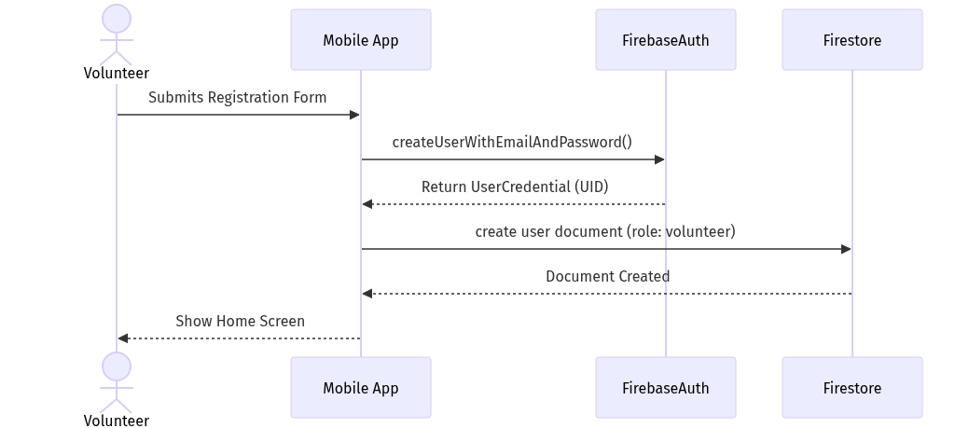
Figure 1: Volunteer Sequence Diagram

5.5 Other UML Diagrams
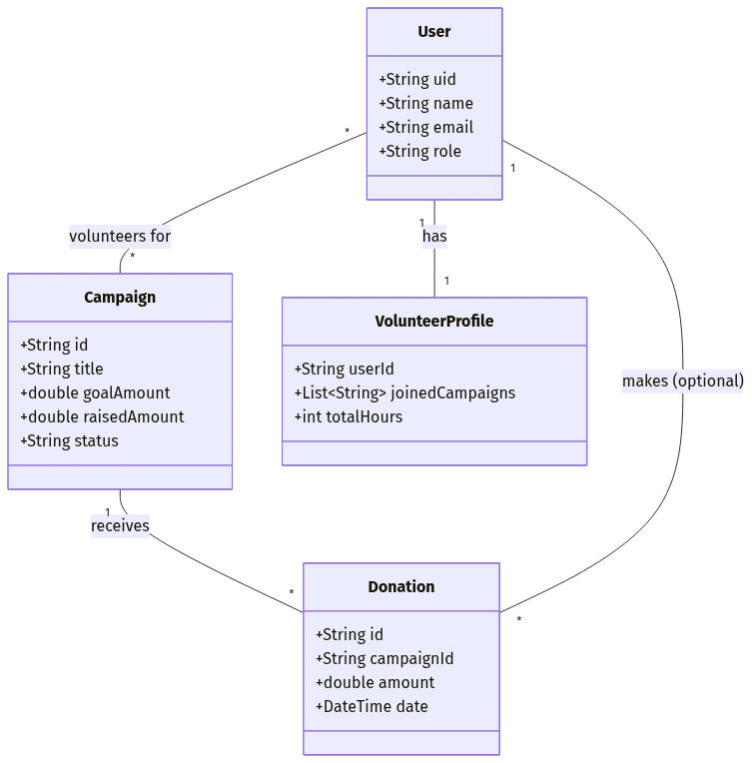
Figure 1: Class Diagram
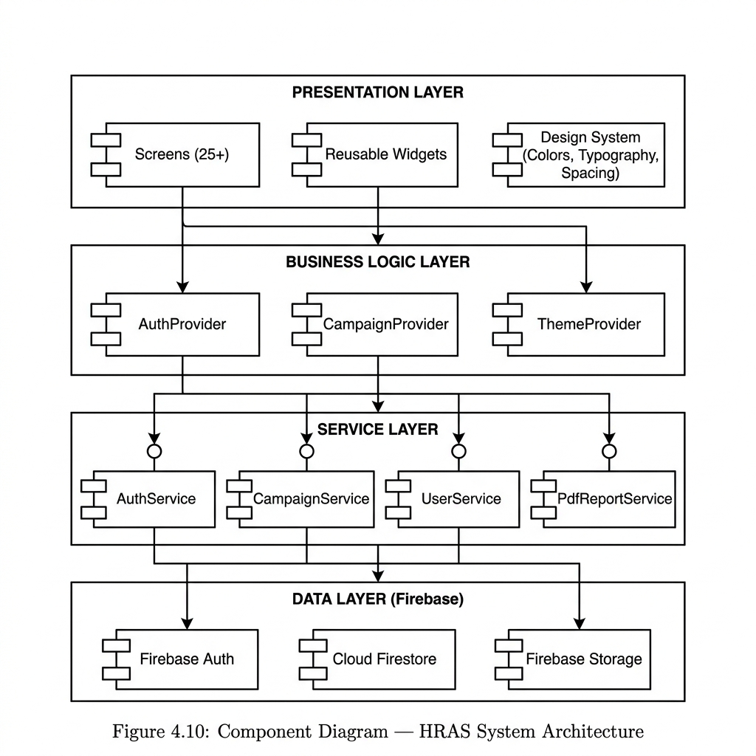
Figure 1: Component Diagram
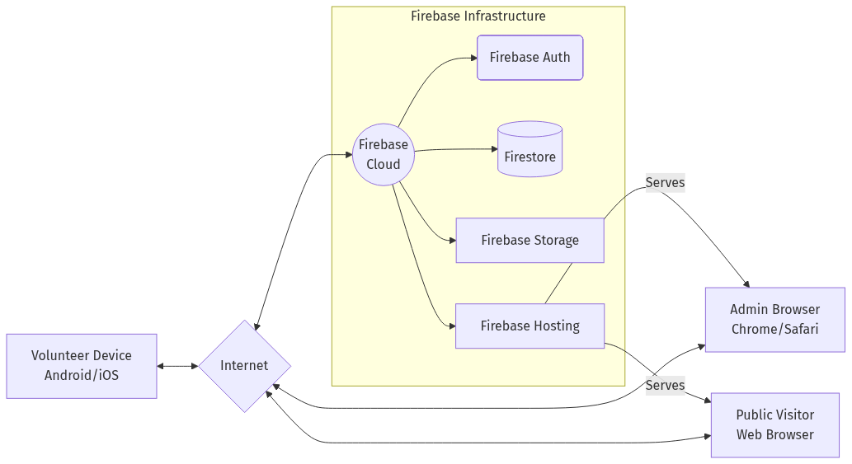
Figure 1: Deployment Diagram

5.6 Data Dictionary
These tables describe the structure of the data saved in Firebase.
Table 1: Users Collection Dictionary
Field Name | Data Type | Description
uid | String | Unique ID from Firebase Auth
name | String | User's full name
role | String | Either admin or volunteer
skills | Array | List of skills for matching algorithm
Table 1: Campaigns Collection Dictionary
Field Name | Data Type | Description
title | String | Name of the campaign
type | String | Medical, Ration, Education, etc.
status | String | Upcoming, Active, or Completed

5.7 Algorithm Logic (FYP-02)
For the FYP-02 phase, I designed a smart matching algorithm. Instead of using a complex black-box AI, I created a rule-based formula that is easy to explain and works very well.
The algorithm gives a score out of 100% based on three things:
• Skills (50%): If a user's skill matches the campaign type, they get a high score.
• Location (30%): If the user lives in the same city as the campaign, they get extra points.
• Availability (20%): If they haven't registered yet, they get full points here.

Chapter 6
Coding

Chapter 6: Coding
This chapter highlights some of the important code written for this project. The entire code is written in Dart using the Flutter framework.

6.1 Smart Matching Code
Here is the logic I wrote to calculate the matching score between a volunteer and a campaign.
static List<MatchResult> getRecommendations(UserModel user, List<CampaignModel> campaigns) {
List<MatchResult> results = [];
for (var campaign in campaigns) {
double skillScore = calculateSkillMatch(user.skills, campaign.type);
double locationScore = calculateLocationMatch(user.address, campaign.location);
// Formula
double total = (skillScore * 0.5) + (locationScore * 0.3) + (0.2);
results.add(MatchResult(campaign: campaign, score: total));
}
// Sort from highest to lowest
results.sort((a, b) => b.score.compareTo(a.score));
return results;
}

6.2 QR Attendance Code
To mark attendance, the admin generates a QR code, and the volunteer scans it. Here is the code that runs when the QR is scanned.
Future<void> scanQRAndMarkAttendance(String qrData, String userId) async {
var data = jsonDecode(qrData);
String campaignId = data['campaignId'];
// Update Firestore database
await FirebaseFirestore.instance
.collection('volunteers')
.where('campaignId', isEqualTo: campaignId)
.where('userId', isEqualTo: userId)
.get()
.then((snapshot) {
if (snapshot.docs.isNotEmpty) {
snapshot.docs.first.reference.update({'status': 'attended'});
}
});
}

6.3 Summary
The code for this project is modular. I have separated UI screens from business logic services. This makes the code very easy to manage and update.

Air University Multan Campus

Department of Computer Science

NGO Operation and Volunteer Management System

(HRAS)

FYP-03 Report: Chapters 7–8
Submitted by: Muhammad Maauz Mansoor (233599)
Supervised by: Miss Fatima Yousuf

Chapter 7
Software Testing

Chapter 7: Software Testing
Testing is a very important part of software development. If the app crashes when a volunteer is trying to register, they might not come back. To prevent this, I performed extensive testing on the HRAS system.

7.1 Testing Strategy
I used two main types of testing:
1. Unit Testing: Writing automated scripts to test small parts of the code (like checking if an email is valid).
2. Black Box Testing: Manually clicking through the app to make sure the features work exactly as required.

7.2 Unit Test Results
I wrote a total of 62 unit tests in Flutter.
Table 1: Unit Test Summary
Test Category | Total Tests | Status
Form Validators | 26 | Passed
Data Models | 15 | Passed
Logic & Enums | 21 | Passed
Overall | 62 | 100% Pass

7.3 Black Box Test Cases
Here are the manual test cases I performed to verify the functional requirements.
Table 1: Login Functionality Test
Action Taken | Expected Result | Actual Result | Status
Enter correct email and password | App goes to Dashboard | Went to Dashboard | Pass
Leave email empty | Show error message | Showed error | Pass
Enter wrong password | Show 'Invalid credentials' | Showed error | Pass

Table 1: Campaign Management Test
Action Taken | Expected Result | Actual Result | Status
Click Create Campaign, fill details | Campaign appears in list | Campaign created | Pass
Edit campaign title | Title changes immediately | Title changed | Pass
Delete a campaign | Campaign is removed completely | Removed | Pass

Table 1: Smart Matching Test (FYP-02 Feature)
Action Taken | Expected Result | Actual Result | Status
User with 'Medical' skill checks app | Medical campaigns show at the top | Ranked at top | Pass
User from 'Lahore' checks app | Lahore campaigns get extra score | Scored higher | Pass

Chapter 8
Conclusion

Chapter 8: Conclusion

8.1 Project Achievements
Over the past three semesters, I have successfully developed the NGO Operation and Volunteer Management System. By looking at the requirements we gathered from HRAS, we achieved the following goals:
• A working mobile app for Android and iOS, built with a single Flutter codebase.
• A clean web dashboard for the admin to see everything.
• A database that updates instantly using Firebase.
• A smart algorithm that automatically suggests campaigns to volunteers.
• A QR-code attendance system that saves time during actual events.

8.2 Limitations
While the system works well, there are a few limitations right now:
• The app requires an active internet connection to work. There is no offline mode yet.
• We have not integrated JazzCash or Easypaisa directly inside the app due to API cost issues.
• Location matching is currently based on city names, not exact GPS coordinates.

8.3 Future Work
If I continue working on this project after graduation, I would like to add:
• Direct payment gateways so donors can transfer money inside the app.
• Urdu language support, because many volunteers in Pakistan prefer reading Urdu.
• GPS integration so volunteers get push notifications when they are physically near a campaign.

8.4 Final Conclusion
In conclusion, the HRAS system proves that even small, local NGOs in Pakistan can benefit greatly from digital transformation. Instead of spending hours managing WhatsApp messages and paper notebooks, the NGO team can now use this system to organize everything efficiently. This allows them to focus on what really matters: helping the community.

User Guide

For Volunteers
1. Download and open the app.
2. Tap 'Sign Up', enter your details, and verify your email.
3. Login and go to the Home screen to see recommended campaigns.
4. Tap on any campaign to see details, then press 'Join Campaign'.
5. On the day of the campaign, open the app and tap 'Scan QR' to mark your attendance.

For Admins
1. Login using your admin email.
2. Use the bottom navigation bar to switch between Campaigns, Donations, and Users.
3. To create a new campaign, go to the Campaigns tab and press the floating '+' button.
4. To generate an attendance QR code, open a specific campaign and tap 'Generate QR'.

Glossary
Firebase: A Google service used to store database records securely in the cloud.
Flutter: A framework by Google used to build mobile and web apps from one codebase.
CRUD: Create, Read, Update, Delete — the four basic functions of database storage.
UAT: User Acceptance Testing — testing the app with real people.

Challenges, Limitations, and Lessons Learned

Limitations of the Study

While the system fulfills its primary objectives, there are practical limitations:
1. Live Payment Gateways: Due to corporate registration requirements (NTN), live banking APIs were excluded; donations are logged manually.
2. Scalability Testing: The system was tested with a small subset of simulated users rather than a massive concurrent user base.
3. Offline Support: Real-time Firebase listeners require a continuous internet connection, limiting offline functionality in remote areas.
4. AI Model Complexity: The predictive analytics rely on historical data which is currently limited; accuracy will improve over time.
5. Platform Specificity: Certain push notification features behave differently across iOS and Android due to background execution limits.
6. Verification: Automated background checks for volunteers are not implemented; manual admin approval is required.

Challenges Faced During Development
1. Firebase Security Rules: Crafting complex NoSQL security rules to ensure volunteers only see authorized data was a significant learning curve.
2. State Management: Managing the global state of the application using Riverpod/Provider introduced unforeseen bugs during hot-restarts.
3. Cross-Platform UI: Ensuring the web dashboard and mobile app looked consistent required extensive responsive design adjustments.

Lessons Learned
This project reinforced the importance of 'scoping'. Initially, the goal was to build a fully automated corporate ERP, but scaling it down to a functional, student-level MVP taught valuable lessons in practical software engineering, Agile development, and time management.

System Interfaces
System Interfaces (Screenshots)

Mobile Application Screens:

Web Application Screens:

