SMS SCHEDULER PRO

Text Type*: Times New Roman*

Text Size: *26*



Width: 1.72

Height: 1.72

By

Toheed Abbas

Zark Iqbal

Just student names (NO ROLL NO)

Text Type: *Time New Roman*

*Text Size: 18*

Just student names (NO ROLL NO)

Text Type: *Time New Roman*

*Text Size: 18*

Recent Month and Year

Department of Information Technology

University of Haripur

July, 2021

SMS SCHEDULER PRO

Text Type*: Times New Roman*

Text Size: *26*



Text Type*: Times New Roman*

Text Size: *18*

By

Toheed Abbas, Zark Iqbal

F17-0116, F17-0125

Supervised by

Dr. X

Department of Information Technology

University of Haripur

July, 2021

SMS SCHEDULER PRO



Text Type*: Times New Roman*

Text Size: *26*

Text Type*: Times New Roman*

Text Size: *18*

By

Toheed Abbas, Zark Iqbal

Text Type*: Times New Roman*

Text Size: *14*

A Dissertation Submitted in Partial Fulfilment for the Degree of

BACHELORS OF SCIENCE

IN

SOFTWARE ENGINEERING

Text Type*: Times New Roman*

Text Size: *18*

Department of Information Technology

University of Haripur

July, 2021

SMS SCHEDULER PRO

Text Type*: Times New Roman*

Text Size: *26*

Text Type*: Times New Roman*

Text Size: *18*

By

Toheed Abbas, Zark Iqbal

Text Type*: Times New Roman*

Text Size: *12*

CERTIFICATE

A THESIS SUBMITTED IN THE PARTIAL FULFILMENT OF THE

REQUIRMENTS FOR THE DEGREE OF BACHELORS

IN SOFTWARE ENGINEERING

We accept this dissertation as conforming to the required standards

Supervisor Name

Project Supervisor

Examiner Name

External Examiner

Adeel Ahmed

Final Year Project

Coordinator

Dr. Mukhtaj Khan

Chairman

Text Type*: Times New Roman*

Text Size: *18*

Department of Information Technology

University of Haripur

July, 2021

*Line1*

Spaces: 3 lines with font size 25

*Line2*

*Line3*

Text Type*: Times New Roman*

Text Size: *26*

Declaration

*Line1*

Spaces: 2 lines with font size 25

*Line2*

I hereby declare that this dissertation is neither as a whole or part thereof has been copied out from any source. If any part of this thesis is proved to be copied or found to be a report of some other, we shall bear the consequences. No portion of this work presented in the thesis has been submitted in support of any application from any other degree of qualification or any other university or any other institute of learning.

I further declare that this research and all the associated documents with this, reports and all records are submitted as a partial requirement of the degree of Bachelor in Software Engineering. We understand and transfer copyrights for these materials to University of Haripur and we will not sale this research and documents for getting any financial gains. It is further declared that I developed this and also this thesis is entirely on the basis of our personal efforts made under the sincere guidance of the project supervisor Dr. Y. Saeed, Department of Information Technology, University of Haripur, Haripur.

Date: July 15th, 2021 *Toheed Abbas Zark Iqbal*

*Line1*

Spaces: 3 lines with font size 25

*Line2*

*Line3*

Text Type*: Times New Roman*

Text Size: *26*

Plagiarism Certificate

*Line1*

Spaces: 2 lines with font size 25

*Line2*

This thesis has been checked for Plagiarism. Turnitin report endorsed by Supervisor is attached at the end of thesis.

Date: July 15th, 2021 Toheed Abbas, Zark Iqbal

Student Name(s)

Student Signature

Supervisor Signature

Text Type: Times New Roman

Text Size: 16

Dedicated to

*any one the student intends to dedicate*

*Line1*

Spaces: 3 lines with font size 25

*Line2*

*Line3*

Text Type*: Times New Roman*

Text Size: *26*

Acknowledgements

*Line1*

Spaces: 2 lines with font size 25

*Line2*

Acknowledgement text start here. It should contain acknowledging people who facilitated the student in carrying out the project.

Abstract

SMS Scheduler Pro is an android application. This app is for those who don’t want to miss important SMS from family, friends, and office. This app provides their dedicated users to schedule their SMS to time in the future so that, even if they are busy somewhere, this app will send that specified SMS to the exact time as per schedule. This app is a helping hand for busy people who want to wish birthdays to their loved ones, send official text messages, and auto-reply to incoming calls and messages. SMS Scheduler Pro uses the default messaging app of mobile phones to send text messages. It just schedules the time and text to be sent and sends automatically without user engagement. This application allows sending text messages to multiple contacts at a time. It provides a simple and user-friendly interface for improved interaction.

*Line1*

Spaces: 3 lines with font size 25

*Line2*

*Line3*

Text Type*: Times New Roman*

Text Size: *26*

Table of Contents

*Line1*

Spaces: 2 lines with font size 25

*Line2*

|  |  |  |  |  |  |  |  |  |
| --- | --- | --- | --- | --- | --- | --- | --- | --- |
| Declaration | | | | . . . . . . . . . . . . . . . . . . . . . . . . . . . . . . . . . . . . . . . | | | | I |
| Dedication | | | | . . . . . . . . . . . . . . . . . . . . . . . . . . . . . . . . . . . . . . . | | | | ii |
| Acknowledgements | | | | | | | . . . . . . . . . . . . . . . . . . . . . . . . . . . . . . . . . . . | iii |
| Abstract | | | . . . . . . . . . . . . . . . . . . . . . . . . . . . . . . . . . . . . . . . . . | | | | | iv |
| List of Figures | | | | | | . . . . . . . . . . . . . . . . . . . . . . . . . . . . . . . . . . . . . . | | V |
| List of Tables | | | | | | . . . . . . . . . . . . . . . . . . . . . . . . . . . . . . . . . . . . . . | | vi |
| **Chapter 1** | | | | | | **Introduction**. . . . . . . . . . . . . . . . . . . . . . . . . . . . . . | | 1 |
| 1.1 | | This is the heading of the chapter . . . . . . . . . . . . . . . . . . . . . . . . . . | | | | | | 1 |
|  | | 1.1.1 | | | This is the sub-heading . . . . . . . . . . . . . . . . . . .   . . . . . . . . | | | 1 |
| **Chapter 2** | | | | | | **Related Work** . . . . . . . . . . . . . . . . . . . . . . . . . . . . . . | | 11 |
| **Chapter 3** | | | | | | **Proposed System** . . . . . . . . . . . . . . . . . . . . . . . . . . . . | | 21 |
| 3.1 | Requirement Analysis . . . . . . . . . . . . . . . . . . . . . . . . . . . . . . . . | | | | | | | 21 |
| 3.2 | Design . . . . . . . . . . . . . . . . . . . . . . . . . . . . . . . . . . . . . . . | | | | | | | 25 |
| 3.3 | Methodology . . . . . . . . . . . . . . . . . . . . . . . . . . . . . . . . . . . . | | | | | | | 30 |
| **Chapter 4** | | | | | | **Evaluation and Results** . . . . . . . . . . . . . . . . . . . . . . . . | | 36 |
| 4.1 | Implementation . . . . . . . . . . . . . . . . . . . . . . . . . . . . . . . . . . . | | | | | | | 36 |
| 4.2 | Testing . . . . . . . . . . . . . . . . . . . . . . . . . . . . . . . . . . . . . . . | | | | | | | 45 |
| **Chapter 5** | | | | | | **Conclusion and Future Work**. . . . . . . . . . . . . . . . . . . . . | | 50 |
| 5.1 Conclusion . . . . . . . . . . . . . . . . . . . . . . . . . . . . . . . . . . . . . | | | | | | | | 50 |
| 5.2 Future Work . . . . . . . . . . . . . . . . . . . . . . . . . . . . . . . . . . . . | | | | | | | | 51 |
| **Appendix** | | | | | | . . . . . . . . . . . . . . . . . . . . . . . . . . . . . . . . . . . . . . | | 53 |
| **References** | | | | | | . . . . . . . . . . . . . . . . . . . . . . . . . . . . . . . . . . . . . . | | 54 |

*Line1*

*Line2*

*Line3*

List of Figures

*Line1*

*Line2*

|  |  |  |
| --- | --- | --- |
| **Figure** | **Description** | **Page** |
| 1 | Figure 1 description shall be written here | 1 |
| 2 | Figure 2 description shall be written here | 2 |

*Line1*

*Line2*

*Line3*

List of Tables

*Line1*

*Line2*

|  |  |  |
| --- | --- | --- |
| **Table** | **Description** | **Page** |
| 1 | Table 1 description shall be written here | 1 |
| 2 | Table 2 description shall be written here | 2 |

*Line1*

*Line2*

*Line3*

Chapter 1

*Line1*

Introduction

*Line1*

*Line2*

IT systems are integrating rapidly into many aspects of our daily lives. But IT doesn't just happen in a vacuum - it has an impact on the community, and the community influences it. People, who developed technology, can design and make it. Communities and individuals can also control or impact the use of technology. New cell phones with extra features seem to appear every month, and endless advertising tries to convince us that we need the latest version. However, as a consumer, we have complete control over whether we choose to buy one or not.

Smartphones have made changes in our lives in ways that go beyond the way we communicate. In addition to calling, texting, and e-mail, more than two billion people worldwide have used these devices for many purposes.

SMS (Short Message Service) may seem important in sending messages. However, there are a few other areas, besides marketing, where SMS is still helpful, besides a large number of free apps on our phone to send videos, texts, photos, and other files and make audio or video calls, even if we have zero services and use Wi-Fi or something.

* 1. **Overview**

SMS Scheduler Pro is an intelligent android application developed under consideration of its dedicated users. SMS Scheduler Pro uses cellular texting services to send SMS at the time in the future. SMS Scheduler Pro provides instant communication, saves time, gets better results, structured plans, and fewer mistakes. Automating text messages not only frees up time but, more importantly, provides excellent service and experience.

* 1. **Purpose**

The purpose of SMS Scheduler pro is to provide users with the functionality to send autonomous text messages; so they never miss birthdays, important meetings, anniversaries, work, and occasions. Never get disturbed by incoming calls and messages while meeting, driving, sleeping, cooking, or in class, in university, and working. Just tell your device, and it will do all work for you.

* 1. **Vision**

“The vision is to provide a high-quality android app to anyone who wants to automate their text messages but has no time or skills to prepare one for themselves. It also is a helping tool for individuals to auto-reply incoming calls and text messages”.

* + 1. **Problem Statement**

“It is hard to send text messages regularly. Sometimes, they may be busy or forget to send or reply to incoming calls and text messages. So, they do need an android application or technology to assist them”.

* 1. **Motivation**

We are humans and have to interact with others in our daily lives. Through mobile phones, we can engage with individuals who are far away from us. We have to make calls and send text messages, birthday wishes to our loved ones, official meeting alerts, special occasions, and much more. However, we can miss such primary tasks. Sometimes, we may be busy or didn't remember to do so. Therefore, we all need a way through all these hassles. SMS Scheduler Pro provides a platform to automate text messages. It will not only save time but minimizes the possibility of mistakes. No one will get upset due to the missing wishes on their special day. Alongside all of its remarkable features, this application is free to use for everyone.

* 1. **Scope of the Project**

The project is targeting two main types of user classes. The first one is the domestic users, which includes individuals who want to use it for their private texting routines and schedules. They are the ones who want to be the first to send birthday wishes, good morning, and good night texts to their loved ones. These people are always keen to use tools like SMS Scheduler Pro. They can set different modes like busy, in meetings, class or driving, et al. These modes send an auto-reply to the incoming calls and text messages.

The other one is the executive class. This class clusters those individuals who have to use the SMS facility to carry out their business tasks. They can set different modes (like domestic users) to auto-reply for incoming calls and messages. However, they can also set schedules to inform their customers via text messages. SMS Scheduler Pro is beneficial to this class as they don't need to waste their precious time sending SMSs.

The audience who will use this app:

* Any age group
* Having a busy lifestyle
* Keen to send text messages
* People who don't want to miss occasions
* Send business alerts and meeting reminders, et al.
* SMS marketing managers

SMS (Short Message Service) is a text messaging service for any phone, Internet, and mobile application. Adding messaging to mobile devices began in the early 1980s.[1]The SMS concept was developed in collaboration with the Franco-German GSM in 1984 by Friedhelm Hillebrand and Bernard Ghillebaert. [10] It has been reported that more than 97% of phone owners use alternative messaging methods at least once a day. [38]

1.1 Problem

As sending and receiving SMSs are emerging day by day. Consequently, we all have to accept their importance in our lives. By doing so, it is worthy to address the mistakes of the sender. Some of the common errors are:

* Forgot to send SMS.
* Doesn't have time to send reminders.

SMS Scheduler Pro is an intelligent android application developed under consideration of its dedicated users. This app is smart enough to assist you in your texting routines and reminders. SMS Scheduler Pro uses your cellular texting services to send SMS at the time in the future.

SMS Scheduler Pro provides instant communication, saves time, gets better results, structured plans, and fewer mistakes. Automating your text messages not only frees up your time but more importantly, provides you with excellent service and experience.

Never miss birthdays, important meetings, anniversaries, important work and occasions. Never get disturbed from incoming calls and messages while meeting, driving, sleeping, cooking, or in class, in university, and working. Just tell your device and it will do all work for you.

Features List:

1: Schedule SMS at any time.

2: Repeat Daily, Weekly, Monthly, Minutely, Hourly or custom time.

3: Reply to incoming messages, calls.

4: Inform your contacts that you are driving, sleeping, in a meeting, class etc.

5: Notification, History, Templates, Settings available.

6: Speak Recognition (For making Modes like driving) feature like Google assistance and Siri available.

7: Add your own phrases and sentences for speech recognition.

8: Automatically silent and un-silent during Modes (like driving etc.)

SMS Scheduler Pro features summary:

OUTGOING MESSAGES:

When you forget to send messages (like birthday, anniversaries and other wishes, important reports, reminders to someone or yourself), here is SMS Scheduler which works like an assistant.

1: Schedule messages at any time and it will send messages automatically.

2: You can schedule messages daily weekly or at the exact date.

3: Repetition: You can send messages every minute (1 minute, 2 minutes...), every hour (1 hour, 2 hours...), or you can set a specific time for repetition.

4: Dual Sims supported. Long messages (characters more than 160) supported.

INCOMING MESSAGES:

When you want to reply specifically to incoming calls and messages from contacts or non-contacts. SMS Scheduler Pro is the best solution.

1: You can select contacts from contact lists or type numbers of those you want to reply.

2: SMS Scheduler Pro automatically replies your all selected numbers when their messages or calls come.

3: You can change the SETTINGS to reply only to messages, calls or both.

4: Dual Sims supported. Long messages (characters more than 160) supported.

MODES:

When you are in a meeting, driving, cooking, and busy at work, in class or doing some important stuff and you want an assistant which can take care of all incoming calls and messages, then SMS Scheduler can provide you that assistance.

1: You can create mode (i am driving) and it will reply to all incoming calls and messages that you are driving.

2: You can create mode and specify your message with it.

3: You can set a personalized list of contacts those you want to reply.

4: You can set a specific time such as from 9 to 10 and repeat it weekly (like Monday, Tuesday, etc.).

5: Mobile will remain silent when the mode is active and unsilenced when the mode is deactivated. You can change this behavior in SETTINGS.

6: You can change SETTINGS to reply to contacts, non-contact or both. You can select the length of numbers to reply and time (after 1 minute, two minutes...) to reply messages or call from the same contact during active Mode.

7: Dual Sims supported. Long messages (characters more than 160) supported.

SPEAK RECOGNITION like Google assistant and SIRI.

1: By SMS Scheduler Instant speech support. You can give commands to SMS Scheduler Pro and it will do all work for you. Suppose you are driving, just say to it I am driving and it will automatically silent your device and reply to all incoming messages and calls unless you deactivate the mode.

2: You can also deactivate mode through speak such as I am free.

3: You can also specify the time such as I will be busy for 1 hour and 40 minutes now. It will silent your device and reply to all incoming messages and calls automatically and stops it and unsilenced it when the time will complete.

4: Moreover, you can also add your own phrases and sentences for speech recognition.

Common features:

Type messages through speech recognition, add templates, show notification when sent or an error occurred, 99% guaranty to send in DOZE Mode without changing Settings. Shows history of sent messages. Shows icon when SMS is scheduled.

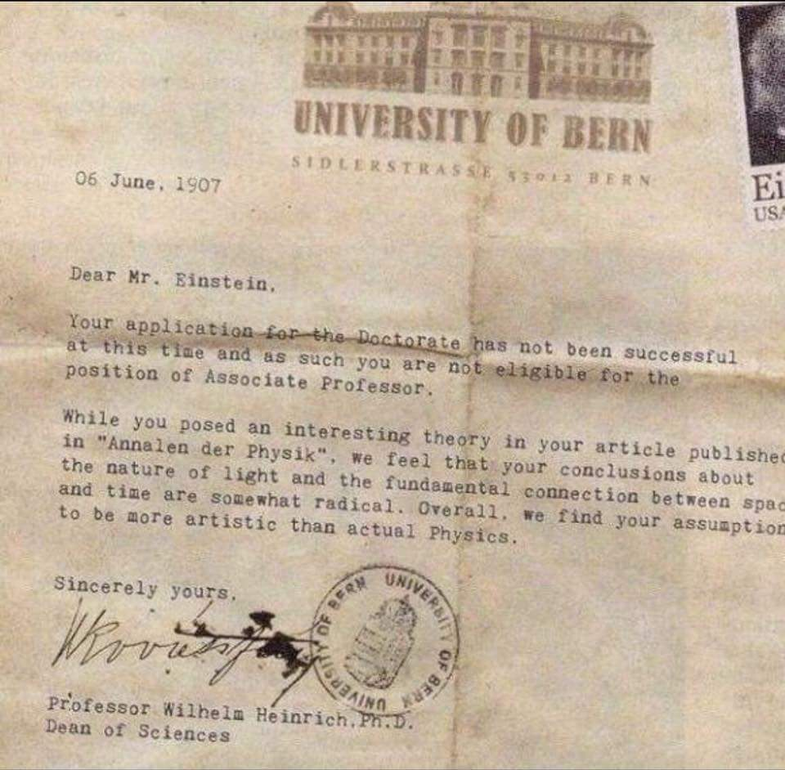

**Figure 1:** Figure description shall be written down the figure (non-italic)

* 1. **Heading**

Font size for the heading is 14. Use small letters and bold.

**1.1.1 Sub-Heading**

Font size for the sub-heading is 12. Use small letters and bold.

**Table 1:** Table description shall be on top of the table (non-italic)

|  |  |  |  |  |
| --- | --- | --- | --- | --- |
|  | Col1 | Col2 | Col2 | Col3 |
|  |  |  |  |  |
|  |  |  |  |  |
|  | 1 | 6 | 87837 | 787 |
|  | 2 | 7 | 78 | 5415 |
|  | 3 | 545 | 778 | 7507 |
|  | 4 | 545 | 18744 | 7560 |
|  | 5 | 88 | 788 | 6344 |
|  |  |  |  |  |

*Line1*

*Line2*

*Line3*

Chapter 2

*Line1*

Existing Systems

*Line1*

*Line2*

Text of chapter 2 starts here ..

2

*Line1*

*Line2*

*Line3*

Chapter 3

*Line1*

Proposed System

*Line1*

*Line2*

Chapter 3 text goes here ..

*Line1*

*Line2*

*Line3*

Chapter 4

*Line1*

Evaluation and Results

*Line1*

*Line2*

Evaluation and Results gained goes in Chapter 4 and starts here ..

*Line1*

*Line2*

*Line3*

Chapter 5

*Line1*

Conclusion and Future Work

*Line1*

*Line2*

**5.1 Conclusion**

Conclusion shall be written here ..

**5.2 Future Work**

Future work starts here ..

*Line1*

*Line2*

*Line3*

References

*Line1*

*Line2*

References starts here and shall be written in IEEE format. Use proper format for the References as mentioned in Microsoft Word or Latex. The student is free to use any of these two editors and their References formats (IEEE).

# References

1. Kelly, Heather (December 3, 2012). ["OMG, The Text Message Turns 20. But has SMS peaked?"](https://www.cnn.com/2012/12/03/tech/mobile/sms-text-message-20/index.html). *CNN*.

|  |  |
| --- | --- |
|  |  |

3. See the book Hillebrand, Trosby, Holley, Harris: SMS the creation of Personal Global Text Messaging, Wiley 2010

38.  [*"98% of the text messages are opened"*](https://theblog.adobe.com/marketing-with-98-percent-read-rate-and-10-more-compelling-stats/)*. 27 July 2015.*

10. See the book Hillebrand, Trosby, Holley, Harris: SMS the creation of Personal Global Text Messaging, Wiley 2010