

Final Year Project Proposal

**Wildfire Warning System**

Simon GABORIT

BEng(H) in Software & Electronic Engineering

Galway-Mayo Institute of Technology

Supervisor: Brian O’Shea

2021/2022

Project description

This system is a network of towers installed in a risk forest zones to detect the start of a wildfire and gives the possibility to monitor the direction and the speed of the fire. The project is based on the Software part of the project, which is a web page that will display a map of the zone monitored with the situation in real time. A second part of the project will be to predict the behaviour of the fire, based on the data received from the towers and the weather forecast. Finally, the last part of the project will be to develop a life-size and realistic simulation of a wildfire situation to show the different features of the project during the demonstration.

The goal of this system is to facilitate the work of the fire fighters and use their force in a more accurate way. It gives a real-time point of view of the situation.

In my opinion, the most difficult part of this project will be to create a realistic simulation. The number of towers will be high, and I still must figure out how to simulate the weather forecast on a define zone of test. I did the choice to develop a simulation rather than building a sample of the hardware, because it appeared to me that it would show a more relevant result during the demonstration. Moreover, the simulation is a specific software technique that I could link, to a certain extent, to my work placement in Jaguar/Land Rover with the Test team.

Software languages programming to be used:

For the Web page itself, React JS, CSS and HTLM will be used. This page will display a map with the positions of the towers, their real time status and the forecast. Hence, the code will be based on aesthetic and network programming.

The Web server will use Java to code the app that will be the centre of the software development. It will host all the calculations and sort the data from the cloud and from the weather forecast web site.

Architecture Diagram

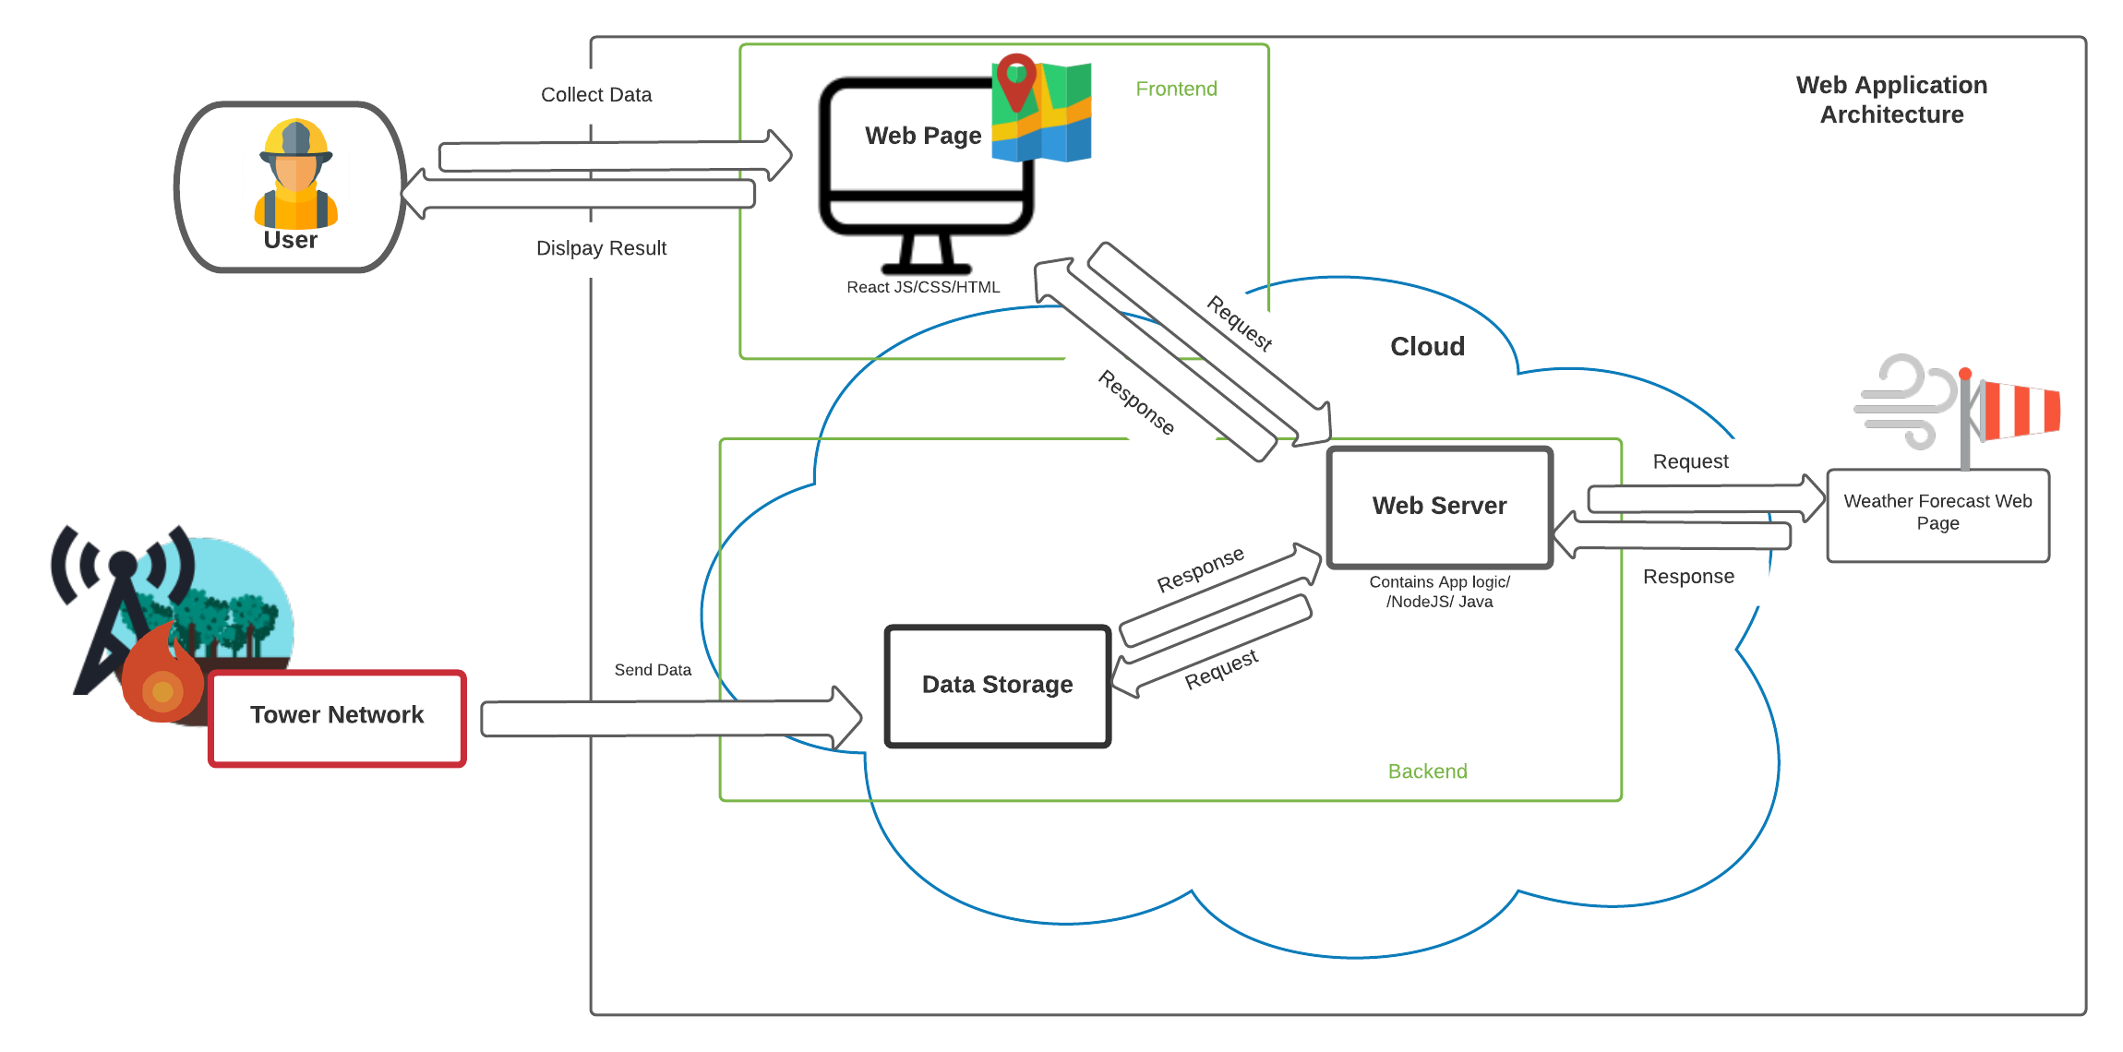

Timeline for deliverables

