## 《Linux 操作系统设计实践》实验五：图形界面

实验环境：Ubuntu 14.04.5 LTS

实验内容：

#include <gtk/gtk.h>

#include <stdlib.h>

int count = 1;

char s1[20], s2[20], s3[20], s4[100];

// interger to string

void get(char *s, long long t) {

int len = 0;

do {

s[len++] = t%10+'0';

t /= 10;

} while(t != 0);

s[len] = 0;

for (int l = 0, r = len-1; l < r; l++, r--) {

char tmp = s[l];

s[l] = s[r];

s[r] = tmp;

}

}

// s4 = s1+s2+s3

void gs4(char *s1, char *s2, char *s3, char *s4) {

int len = 0;

for (int i = 0; s1[i]; i++)

s4[len++] = s1[i];

s4[len++] = '+';

for (int i = 0; s2[i]; i++)

s4[len++] = s2[i];

s4[len++] = '=';

for (int i = 0; s3[i]; i++)

s4[len++] = s3[i];

s4[len] = 0;

}

GtkWidget *label;

void on_button_clicked (GtkWidget *button, gpointer userdata) {

int a = rand()%100, b = rand()%100;

long long c = (long long)a+b;

get(s1, a);

get(s2, b);

get(s3, c);

gs4(s1, s2, s3, s4);

gtk_label_set_text(GTK_LABEL(label), s4);

}

int main (int argc , char* argv[]) {

GtkWidget *box;

GtkWidget *window;

GtkWidget *button;

// initial the window

gtk_init(&argc, &argv);

window = gtk_window_new(GTK_WINDOW_TOPLEVEL);

g_signal_connect(G_OBJECT(window), "destroy", G_CALLBACK(gtk_main_quit), NULL);

gtk_window_set_title(GTK_WINDOW(window), "Random");

gtk_window_set_default_size(GTK_WINDOW(window), 1000, 750);

gtk_window_set_position(GTK_WINDOW(window), GTK_WIN_POS_CENTER);

gtk_container_set_border_width(GTK_CONTAINER(window), 20);

// initial the container

box = gtk_vbox_new(FALSE, 0);

gtk_container_add(GTK_CONTAINER(window), box);

// initial the label and button

label = gtk_label_new("yoo");

button = gtk_button_new_with_label("Generate");

// add the label and button to the container

gtk_box_pack_start(GTK_BOX(box), label, TRUE, TRUE, 3);

gtk_box_pack_start(GTK_BOX(box), button, TRUE, TRUE, 3);

// click the button

g_signal_connect(G_OBJECT(button), "clicked", G_CALLBACK(on_button_clicked), (gpointer)count);

gtk_widget_show_all(window);

gtk_main();

return FALSE;

}

运行结果：

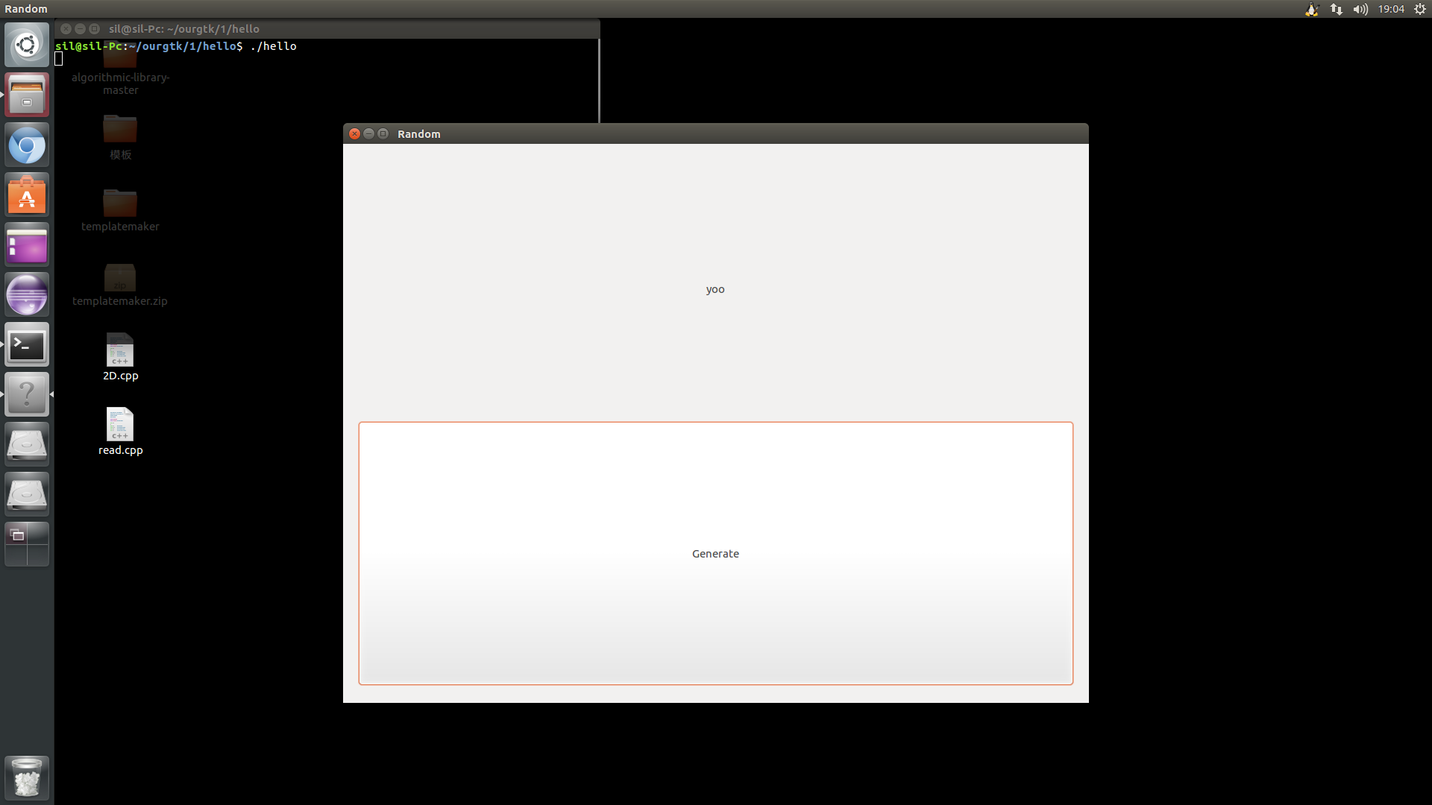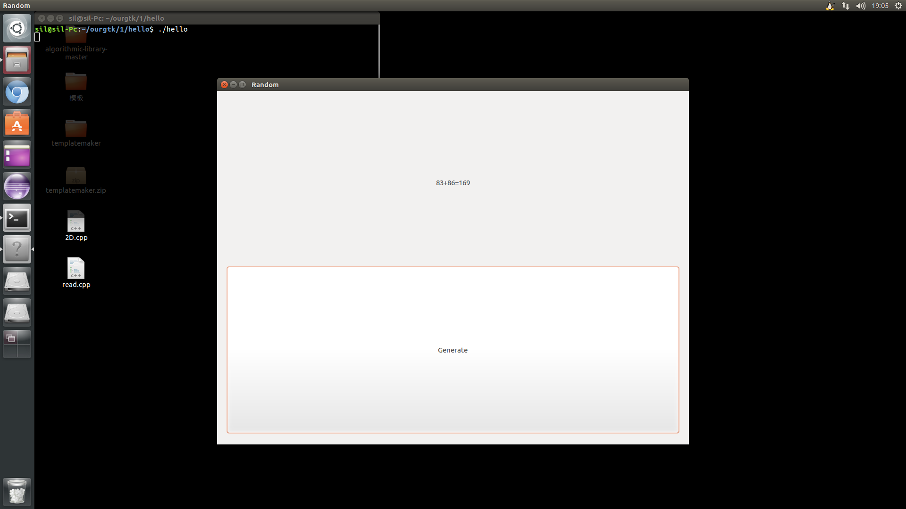

心得体会：学习了linux图形界面编程基本知识，掌握了gtk的使用方法。