#### 帖文（post）部分ER图

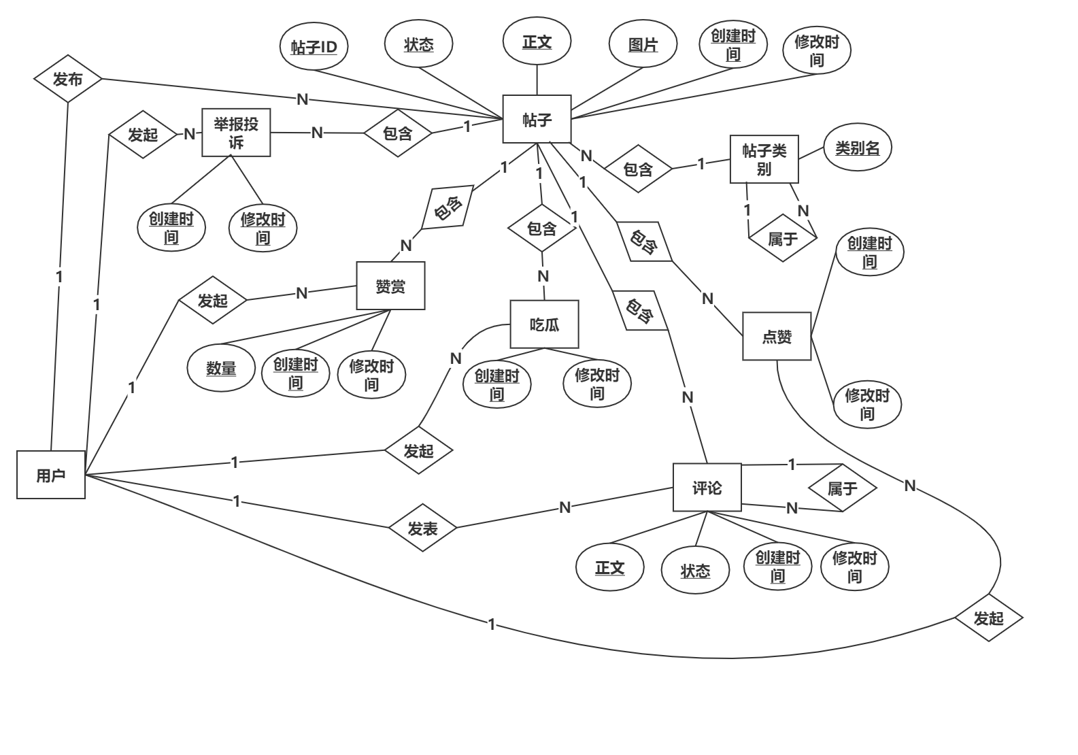

#### 帖文（post）部分数据库逻辑结构设计图

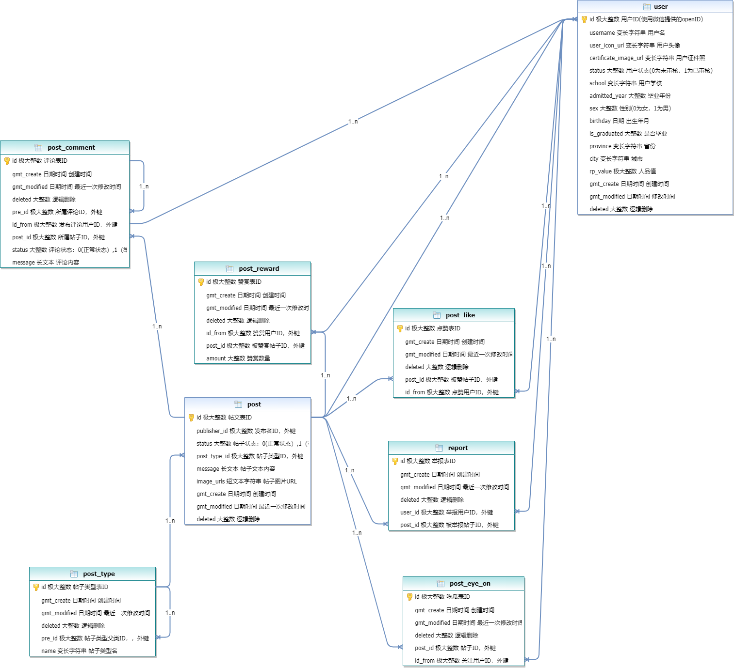

#### 帖文表Post

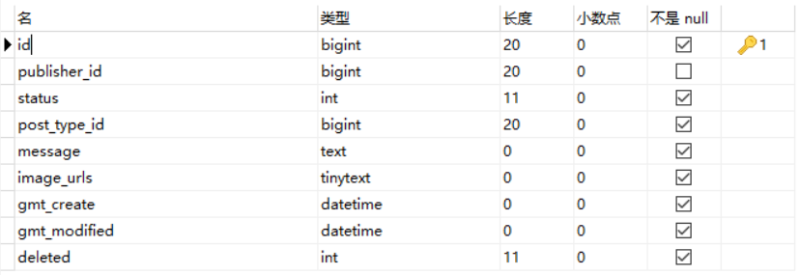

#### 帖文评论表Post_comment

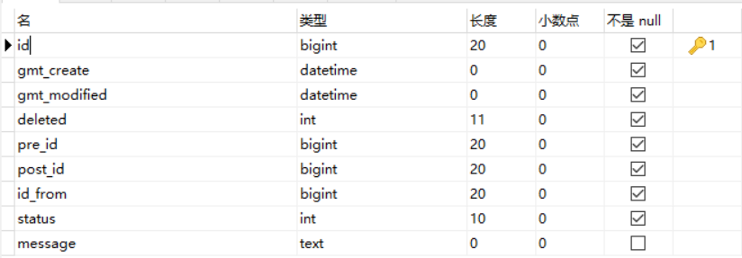

#### 帖文吃瓜表Post_eye_on

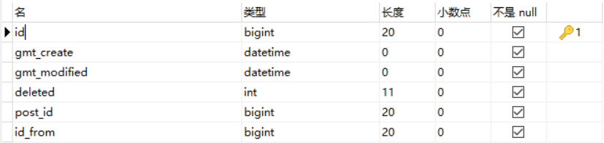

#### 帖文点赞表Post_like

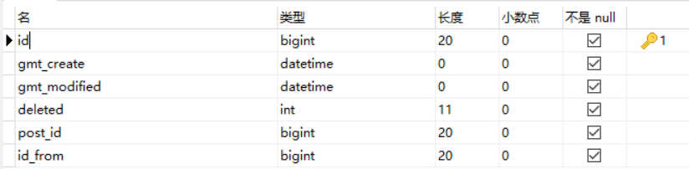

#### 帖文赞赏表Post_reward

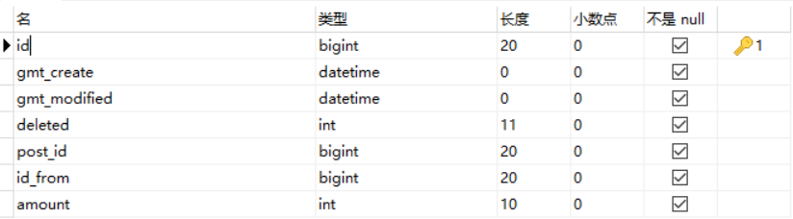

#### 帖文类型表Post_type

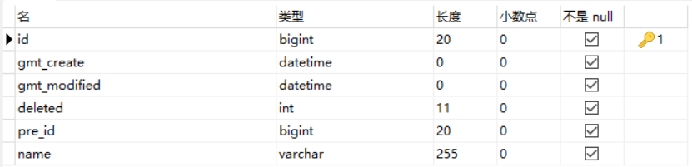

#### 举报表

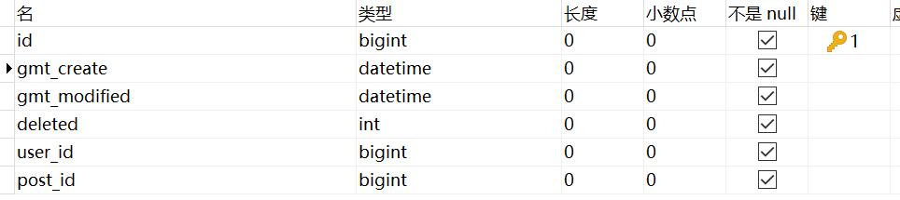

#### 建表语句

##### 1帖文表

DROP TABLE IF EXISTS `post`;

CREATE TABLE `post` (

`id` bigint(0) NOT NULL AUTO_INCREMENT COMMENT '帖文ID',

`publisher_id` bigint(0) NULL DEFAULT NULL COMMENT '发布者ID，外键',

`status` int(0) NOT NULL COMMENT '帖子状态：0(正常状态）,1（举报过多被挂起），2（已被删除）',

`post_type_id` bigint(0) NOT NULL COMMENT '帖子类型ID，外键',

`message` text CHARACTER SET utf8mb4 COLLATE utf8mb4_unicode_ci NOT NULL COMMENT '帖子文本内容',

`image_urls` tinytext CHARACTER SET utf8mb4 COLLATE utf8mb4_unicode_ci NOT NULL COMMENT '帖子图片URL',

`gmt_create` datetime(0) NOT NULL DEFAULT CURRENT_TIMESTAMP(0) COMMENT '创建时间',

`gmt_modified` datetime(0) NOT NULL DEFAULT CURRENT_TIMESTAMP(0) COMMENT '最近一次修改时间',

`deleted` int(0) NOT NULL DEFAULT 0 COMMENT '逻辑删除',

PRIMARY KEY (`id`) USING BTREE,

INDEX `post_publisher_id_fk0`(`publisher_id`) USING BTREE,

INDEX `post_post_type_id_fk0`(`post_type_id`) USING BTREE,

CONSTRAINT `post_post_type_id_fk0` FOREIGN KEY (`post_type_id`) REFERENCES `post_type` (`id`) ON DELETE RESTRICT ON UPDATE RESTRICT,

CONSTRAINT `post_publisher_id_fk0` FOREIGN KEY (`publisher_id`) REFERENCES `user` (`id`) ON DELETE RESTRICT ON UPDATE RESTRICT

) ENGINE = InnoDB AUTO_INCREMENT = 1 CHARACTER SET = utf8mb4 COLLATE = utf8mb4_unicode_ci ROW_FORMAT = Dynamic;

##### 2帖文评论表

DROP TABLE IF EXISTS `post_comment`;

CREATE TABLE `post_comment` (

`id` bigint(0) NOT NULL AUTO_INCREMENT COMMENT 'ID',

`gmt_create` datetime(0) NOT NULL DEFAULT CURRENT_TIMESTAMP(0) COMMENT '创建时间',

`gmt_modified` datetime(0) NOT NULL DEFAULT CURRENT_TIMESTAMP(0) COMMENT '最近一次修改时间',

`deleted` int(0) NOT NULL DEFAULT 0 COMMENT '逻辑删除',

`pre_id` bigint(0) NOT NULL COMMENT '所属评论ID，外键',

`post_id` bigint(0) NOT NULL COMMENT '所属帖子ID，外键',

`id_from` bigint(0) NOT NULL COMMENT '发布评论用户ID，外键',

`status` int(0) UNSIGNED NOT NULL COMMENT '评论状态：0(正常状态）,1（举报过多被挂起），2（已被删除）',

`message` text CHARACTER SET utf8mb4 COLLATE utf8mb4_unicode_ci NOT NULL COMMENT '评论正文',

PRIMARY KEY (`id`) USING BTREE,

INDEX `post_comment_pre_id_fk0`(`pre_id`) USING BTREE,

INDEX `post_comment_post_id_fk0`(`post_id`) USING BTREE,

INDEX `post_comment_id_from_fk0`(`id_from`) USING BTREE,

CONSTRAINT `post_comment_id_from_fk0` FOREIGN KEY (`id_from`) REFERENCES `user` (`id`) ON DELETE RESTRICT ON UPDATE RESTRICT,

CONSTRAINT `post_comment_post_id_fk0` FOREIGN KEY (`post_id`) REFERENCES `post` (`id`) ON DELETE RESTRICT ON UPDATE RESTRICT,

CONSTRAINT `post_comment_pre_id_fk0` FOREIGN KEY (`pre_id`) REFERENCES `post_comment` (`id`) ON DELETE RESTRICT ON UPDATE RESTRICT

) ENGINE = InnoDB AUTO_INCREMENT = 1 CHARACTER SET = utf8mb4 COLLATE = utf8mb4_unicode_ci ROW_FORMAT = Dynamic;

##### 3帖文吃瓜表

DROP TABLE IF EXISTS `post_eye_on`;

CREATE TABLE `post_eye_on` (

`id` bigint(0) NOT NULL AUTO_INCREMENT COMMENT 'ID',

`gmt_create` datetime(0) NOT NULL DEFAULT CURRENT_TIMESTAMP(0) COMMENT '创建时间',

`gmt_modified` datetime(0) NOT NULL DEFAULT CURRENT_TIMESTAMP(0) COMMENT '最近一次修改时间',

`deleted` int(0) NOT NULL DEFAULT 0 COMMENT '逻辑删除',

`post_id` bigint(0) NOT NULL COMMENT '帖子ID，外键',

`id_from` bigint(0) NOT NULL COMMENT '关注用户ID，外键',

PRIMARY KEY (`id`) USING BTREE,

INDEX `post_eye_on_post_id_fk0`(`post_id`) USING BTREE,

INDEX `post_eye_on_id_from_fk0`(`id_from`) USING BTREE,

CONSTRAINT `post_eye_on_id_from_fk0` FOREIGN KEY (`id_from`) REFERENCES `user` (`id`) ON DELETE RESTRICT ON UPDATE RESTRICT,

CONSTRAINT `post_eye_on_post_id_fk0` FOREIGN KEY (`post_id`) REFERENCES `post` (`id`) ON DELETE RESTRICT ON UPDATE RESTRICT

) ENGINE = InnoDB AUTO_INCREMENT = 1 CHARACTER SET = utf8mb4 COLLATE = utf8mb4_unicode_ci ROW_FORMAT = Dynamic;

##### 4帖文点赞表

DROP TABLE IF EXISTS `post_like`;

CREATE TABLE `post_like` (

`id` bigint(0) NOT NULL AUTO_INCREMENT COMMENT 'ID',

`gmt_create` datetime(0) NOT NULL DEFAULT CURRENT_TIMESTAMP(0) COMMENT '创建时间',

`gmt_modified` datetime(0) NOT NULL DEFAULT CURRENT_TIMESTAMP(0) COMMENT '最近一次修改时间',

`deleted` int(0) NOT NULL DEFAULT 0 COMMENT '逻辑删除',

`post_id` bigint(0) NOT NULL COMMENT '被赞帖子ID，外键',

`id_from` bigint(0) NOT NULL COMMENT '点赞用户ID，外键',

PRIMARY KEY (`id`) USING BTREE,

INDEX `post_like_post_id_fk0`(`post_id`) USING BTREE,

INDEX `post_like_id_from_fk0`(`id_from`) USING BTREE,

CONSTRAINT `post_like_id_from_fk0` FOREIGN KEY (`id_from`) REFERENCES `user` (`id`) ON DELETE RESTRICT ON UPDATE RESTRICT,

CONSTRAINT `post_like_post_id_fk0` FOREIGN KEY (`post_id`) REFERENCES `post` (`id`) ON DELETE RESTRICT ON UPDATE RESTRICT

) ENGINE = InnoDB AUTO_INCREMENT = 1 CHARACTER SET = utf8mb4 COLLATE = utf8mb4_unicode_ci ROW_FORMAT = Dynamic;

##### 5帖文赞赏表

DROP TABLE IF EXISTS `post_reward`;

CREATE TABLE `post_reward` (

`id` bigint(0) NOT NULL AUTO_INCREMENT COMMENT 'ID',

`gmt_create` datetime(0) NOT NULL DEFAULT CURRENT_TIMESTAMP(0) COMMENT '创建时间',

`gmt_modified` datetime(0) NOT NULL DEFAULT CURRENT_TIMESTAMP(0) COMMENT '最近一次修改时间',

`deleted` int(0) NOT NULL DEFAULT 0 COMMENT '逻辑删除',

`post_id` bigint(0) NOT NULL COMMENT '被赞赏帖子ID，外键',

`id_from` bigint(0) NOT NULL COMMENT '赞赏用户ID，外键',

`amount` int(0) UNSIGNED NOT NULL COMMENT '赞赏数量',

PRIMARY KEY (`id`) USING BTREE,

INDEX `post_reward_post_id_fk0`(`post_id`) USING BTREE,

CONSTRAINT `post_reward_post_id_fk0` FOREIGN KEY (`post_id`) REFERENCES `post` (`id`) ON DELETE RESTRICT ON UPDATE RESTRICT

) ENGINE = InnoDB AUTO_INCREMENT = 1 CHARACTER SET = utf8mb4 COLLATE = utf8mb4_unicode_ci ROW_FORMAT = Dynamic;

##### 6帖文类型表

DROP TABLE IF EXISTS `post_type`;

CREATE TABLE `post_type` (

`id` bigint(0) NOT NULL AUTO_INCREMENT COMMENT 'ID',

`gmt_create` datetime(0) NOT NULL DEFAULT CURRENT_TIMESTAMP(0) COMMENT '创建时间',

`gmt_modified` datetime(0) NOT NULL DEFAULT CURRENT_TIMESTAMP(0) COMMENT '最近一次修改时间',

`deleted` int(0) NOT NULL DEFAULT 0 COMMENT '逻辑删除',

`pre_id` bigint(0) NOT NULL COMMENT '帖子类型父类ID，外键',

`name` varchar(255) CHARACTER SET utf8mb4 COLLATE utf8mb4_unicode_ci NOT NULL COMMENT '帖子类型名',

PRIMARY KEY (`id`) USING BTREE,

INDEX `post_type_pre_id_fk0`(`pre_id`) USING BTREE,

CONSTRAINT `post_type_pre_id_fk0` FOREIGN KEY (`pre_id`) REFERENCES `post_type` (`id`) ON DELETE RESTRICT ON UPDATE RESTRICT

) ENGINE = InnoDB AUTO_INCREMENT = 1 CHARACTER SET = utf8mb4 COLLATE = utf8mb4_unicode_ci ROW_FORMAT = Dynamic;

##### 7举报表

DROP TABLE IF EXISTS `report`;

CREATE TABLE `report` (

`id` bigint(0) NOT NULL AUTO_INCREMENT COMMENT 'ID',

`gmt_create` datetime(0) NOT NULL DEFAULT CURRENT_TIMESTAMP(0) COMMENT '创建时间',

`gmt_modified` datetime(0) NOT NULL DEFAULT CURRENT_TIMESTAMP(0) COMMENT '最近一次修改时间',

`deleted` int(0) NOT NULL DEFAULT 0 COMMENT '逻辑删除',

`user_id` bigint(0) NOT NULL COMMENT '举报用户ID，外键',

`post_id` bigint(0) NOT NULL COMMENT '被举报帖子ID，外键',

PRIMARY KEY (`id`) USING BTREE,

INDEX `report_user_id_fk0`(`user_id`) USING BTREE,

INDEX `report_post_id_fk0`(`post_id`) USING BTREE,

CONSTRAINT `report_post_id_fk0` FOREIGN KEY (`post_id`) REFERENCES `post` (`id`) ON DELETE RESTRICT ON UPDATE RESTRICT,

CONSTRAINT `report_user_id_fk0` FOREIGN KEY (`user_id`) REFERENCES `user` (`id`) ON DELETE RESTRICT ON UPDATE RESTRICT

) ENGINE = InnoDB AUTO_INCREMENT = 1 CHARACTER SET = utf8mb4 COLLATE = utf8mb4_unicode_ci ROW_FORMAT = Dynamic;