**Optimization of Laboratory-Scale PEM Fuel Cell Operating Variables**

By

Eniayo Ayoola, 8311301

Hussein Elhakim, 8717917

Eran Ittah, 8862117

Minchul Kim, 8843950

Zachary Provost, 8524938

University of Ottawa, Department of Chemical and Biological Engineering



November 3rd, 2020

ABSTRACT

This experiment intended to determine the operating parameters and characteristics of a laboratory-scale PEM fuel cell as well as make conclusions about the optimization process of any fuel cell. Many characteristics were analyzed in order to determine which variable had an impact on the efficiency, fuel consumption, operating cost and total power output of a hydrogen fuel cell. Three different cell designs were used: serpentine-serpentine with a pump for air delivery, parallel-parallel with a pump for air delivery and serpentine with a fan for air delivery. It was found that the amperage limit imposed upon the experiment was insufficient to make substantial claims since maximal efficiency and maximal power output were not observed. A series of three different nitrogen dilutions were used in order to alter the concentration of hydrogen gas circulating in the fuel cell and these trials have shown within this experiment that hydrogen dilution had no measurable impact on the performance and efficiency of the cell. Parallel-parallel and serpentine-serpentine flow patterns were found to have a quite small difference in efficiency of approximately 2% although further experimentation is required in order to substantiate this claim. It was found that adding an excess of hydrogen gas when keeping the air feed constant had a negative impact on the voltage output and consequently the performance of the fuel cell thus indicating that cost savings are possible when considering a well-designed fuel cell that is fed an optimized amount of hydrogen and would also lead to a better performance. Overall, this experiment has shown that further experimentation is required at a higher current density in order to make conclusive claims concerning the optimal operating conditions for a fuel cell of this type.

Keywords: PEM, Hydrogen, Fuel Cell, Flow Pattern, Dilution

TABLE OF CONTENTS

ABSTRACT i

LIST OF FIGURES iii

LIST OF TABLES iv

NOMENCLATURE v

1.0 INTRODUCTION 1

1.1 Proposed Objectives 2

1.2 Background 3

1.2.1 Voltage Losses 3

1.3 Experimental Design 5

1.4 Fuel Cell Modelling and Elucidation of Ri and α Parameters 6

2.0 RESULTS AND DISCUSSION 15

2.1 Nitrogen Dilution 15

2.2 Flow Rate 17

2.3 Flow Pattern 20

2.4 Pressurized vs. Simple Active Air Delivery 22

3.0 CONCLUSIONS 24

REFERENCES 26

APPENDIX 28

A.0 SAMPLE CALCULATIONS 28

B.0 FINAL PROPOSAL 32

C.0 RELEVANT EQUATIONS 38

D.0 TIMELINE OF WORK 39

E.0 POLARIZATION CURVES AND STATISTICAL COMPARISON 41

F.0 PROCESS HAZARD ANALYSIS 42

G.0 USEFUL FIGURES 45

H.0 PROCESS FLOW DIAGRAM 48

LIST OF FIGURES

Figure 1: Generic fuel cell polarization curve [8] 4

Figure 2: Surface optimization of α and Ri parameters for a Serpentine-Serpentine configuration fuel cell operating at Low-Med H2-Air flowrate setting. 8

Figure 3: Comparison of simulator output and experimental model of a Serpentine-Serpentine fuel cell operating at Low-Med H2-Air flowrates 9

Figure 4: Surface optimization of α and Ri parameters for a Parallel-Parallel configuration fuel cell operating at Low-Low H2-Air flowrate setting. 10

Figure 5: Comparison of simulator output and experimental model of a Parallel-Parallel fuel cell operating at Low-Low H2-Air flowrates. 11

Figure 6: Surface optimization of α and Ri parameters for a Serpentine-Serpentine configuration fuel cell operating at a Low-Low-High H2-Air-N2 flowrate setting. 12

Figure 7: Comparison of simulator output and experimental model of a Serpentine-Serpentine fuel cell operating at Low-Low H2-Air flowrates with high N2 flow dilution. 13

Figure 8: Polarization Curve of Varying Nitrogen Content 16

Figure 9: Gradient Increasing with Flow, Air Flow Fixed at 110 Units, Parallel-Parallel Cell, Z-X View 17

Figure 10: Gradient Increasing with Flow, Air Flow Fixed at 110 Units, Parallel-Parallel Cell 18

Figure 11: Gradient Increasing with Flow, H2 Flow Fixed at 110 Units, Parallel-Parallel Cell 19

Figure 12: Gradient Increasing with Flow, H2 Flow Fixed at 110 Units, Parallel-Parallel Cell, Z-X View 20

Figure 13: Performance Plot of Parallel-Parallel Configuration 21

Figure 14: Performance Plot of Serpentine-Serpentine Configuration 21

Figure 15: Performance Curve for Serpentine Pattern Fuel Cell with Fan at Three Distinct H2 Operating Flowrates 23

Figure 16: Fuel cell polarization curve example contrasting two technical replicates and the pre-tuned model generated data. 41

Figure 17: Average polarization curves for all three repetitions of the Serpentine-Fan configuration. 45

Figure 18: Optimal average run for Parallel-Parallel configuration. Error bars are the standard deviation in the measurements for three replicates 46

Figure 19: Optimal run for Serpentine Serpentine with standard deviation error 47

LIST OF TABLES

Table 1: Comparison of α and Ri for Serpentine-Serpentine and Parallel-Parallel fuel cell configurations 14

Table 2: Fuel Cell Reactions and the Corresponding Nernst Equations 34

NOMENCLATURE

Part A: Constants

|  |  |  |  |
| --- | --- | --- | --- |
| **Symbol** | **Name** | **Value** | **Units** |
|  |  |  |  |
| R | Gas Constant | 8.314 |  |
| A | Fuel Cell Area | 25 | cm2 |
| kb | Boltzmann Constant | 1.38 x10-23 | J/K |
| H |  | 6.626x10-34 | J.s |
| F | Faradays Constant | 96485 |  |
| z | Number of Moving Electrons | 2 | - |
| W | Percentage of Water Vapor in Oxidant | 1 | % |
| x | Purity of Hydrogen Fuel | 99.5 | % |
| y | Mol Fraction of Oxygen in Oxidant Feed | 21 | % |
| Ncell | Number of Fuel Cells | 1 | - |
| ACell | Area of Individual Cell | 25 | cm2 |
| pAbs,Oxidant | Pressure of Air Supply | 1 | Atm |
| pAbs,reduce | Pressure of Hydrogen Supply | 1 | Atm |
| pAir | Pressure of Air | 1 | Atm |
|  |  |  |  |

Part B: Variables

|  |  |  |
| --- | --- | --- |
| **Symbol** | **Name** | **Units** |
|  |  |  |
| i | Fuel Cell Current | A |
| ifc | Fuel Cell Current Density | A |
| VO | Volumetric flowrate of Oxidant | lpm |
| Vh | Volumetric flowrate of Hydrogen | lpm |
| α | Amplification cation constant |  |
| il | Limiting Current Density | A |
| k | Mass transport constant |  |
| UO | Rate of consumption of Oxygen | Mol/min |
| UH | Rate of consumption of Hydrogen | Mol/min |
| T | Temperature | K |
| Tc | Temperature | C |
| pH2O | Partial pressure of Water | Atm |
| pH2 | Partial pressure of Hydrogen | Atm |
| pO2 | Partial pressure of Oxygen | Atm |
| iO | Activation loss | A |
| r | Area Specific Resistance | Ω/cm2 |
| Vact | Activation Loss Voltage | V |
| Vohmic | Ohmic Loss Voltage | V |
| ε | Efficiency | % |
| Vconc | Mass Transport Voltage Loss | V |
| En | Nernst Voltage | V |
| Vout | Output voltage | V |
| Vcell | Voltage Obtained from Oscillometer | V |
| Pout | Output Power | W |
|  |  |  |

# INTRODUCTION

Fuel cells (FCs) are an emerging power generation technology known for their low emissions, compact size, high energy density, and growing range of applications. Fuel cells are used as on-board auxiliary power units to provide non-propulsion power. Such cells are used to power electrical appliances, refrigeration, air conditioning, heating, and other vehicle functions that increase on-board electrical demand. Fuel cells are also used to power electric vehicles such as cars, buses, trucks, forklifts, wheelchairs, etc. Another application includes power generation in locations that are too far, or geographically obstructed from a power grid. [1] This is particularly useful as extending power grids to such locations is expensive. [2]

The main constituents of a fuel cell are two electrodes and an electrolyte between them. Reactions involving a fuel, and an oxidant occur at each electrode. Very often, hydrogen is used as a fuel, where it is oxidized at the anode, losing two electrons for each atom, and producing a hydrogen ion (shown below).

|  |  |  |
| --- | --- | --- |
|  | H2 2H+ + 2e- | (R-1) |

The electrons pass through an electrical circuit, producing electrical current, while the ions pass through the electrolyte, flowing towards the cathode. At the cathode, oxygen (often used alongside hydrogen as an oxidant) reacts with the electrons and hydrogen ion produced by the oxidation at the anode, forming water.

|  |  |  |
| --- | --- | --- |
|  | ½ O2 + 2e- + 2H+ H2O | (R-2) |

There are a number of subsystems involved with reactant preparation, water, and thermal management in the cell, etc. The collection of these subsystems is called the Balance of Plant, but the focus of this work will be on the constituents listed above.

The supply of oxygen (often in the form of air), back pressure (caused by the outflow of unreacted fuel), water supply, and fuel supply all have large influence on fuel cell operation and lifetime. [3] [4] Optimizing these variables is necessary to minimize operational costs, safety risks, and damage to the fuel cell. It is especially useful to know the optimal set of conditions that produce maximal voltage output from the cell, as this maximizes economic viability, and facilitates optimization of other cells.

This laboratory will consist of the analysis and investigation of a small-scale polymer electrolyte membrane fuel cell system. The fuel cell will be characterized through variation of the gas flow rates and the flow pattern used. Furthermore, the effect of impurities in the anode will be observed and different methods of purging these impurities. The objectives of this laboratory (listed below) mainly involve optimizing the operating variables of the fuel cell.

Throughout this laboratory it was determined that relative flowrates called low medium and high will be used. These correspond to a low, medium and high of 70 (28.7mL/min), 110 (56.6mL/min) and 150 (95mL/min) for hydrogen. For air flow the values of 70 (433mL/min), 110 (651mL/min) and 150 (844mL/min) are used as low, medium and high. For nitrogen flow the values of 20 (13.4mL/min), 90 (48.5mL/min) and 130 (73.6mL/min) are used as low, medium and high.

## Proposed Objectives

1. Determining the optimal nitrogen and hydrogen flow ratio for power generation by collecting a wide range of different flowrates in the system.
2. Qualitative analysis of optimal air flow source between a fan and a pump (both serpentine-serpentine flow pattern).
3. Qualitative and quantitative analysis of the optimal flow pattern between parallel-parallel and serpentine-serpentine gas flow patterns.
4. Quantitatively determine the relationship between anode and cathode flowrates to the actual voltage and the effect of impurities in the system.
5. Evaluation of fuel cell potential and efficiency.

## Background

A single fuel cell produces less than 1 V of potential [5], necessitating the need to join several cells together into a single device. A fuel stack is such a device, consisting of electrode plates, the electrolyte between them, and bipolar plates that join the opposite electrodes of each cell to one another. The bipolar plates have channels that allow the flow of gaseous reactants and liquid products. [6] These flow channels may have different arrangements. This study considers two arrangement types: parallel-parallel (air or fuel flow in parallel paths), serpentine-serpentine (gases flow in zig-zag paths). [7]

In the case of proton-exchange membrane fuel cells (PEMFCs), the electrolyte is a solid polymer that facilitates the flow of hydrogen ions (protons) from the anode to the cathode. PEMFCs are particularly popular due to their high-power density, high efficiency, their lack of liquid electrolyte, etc. [1]

The reactions in the fuel cell (see Section 1) occur at the electrode plates. The plates are porous and are coated in catalyst to increase the rate of reaction. The pores of the electrode contain active sites where the gas, catalyst, and electrode contact each other. This contact is described as having a three-phase boundary.

A typical hydrogen FC operating at 25 °C, atmospheric pressure, and assuming that system is thermodynamically reversible (for instance, no heat is lost to the operation of the cell) produces 1.229 V of electricity. This value is never met as the open circuit voltage is highly dependent on the reactant concentration. Since the experimental design uses air, it can have a difference as high as 250 mV. [7]

### Voltage Losses

FCs are subject to four main sources of irreversibility, which reduce the cell potential. These effects can be seen on a plot of voltage against current density (current per unit area of the cell).[6]

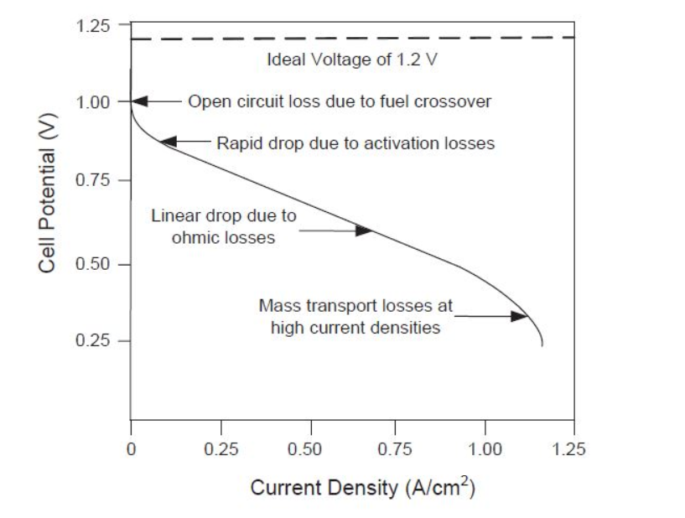

Figure 1: Generic fuel cell polarization curve [8]

This voltage-current density plot is called a polarization curve. Below is an explanation for each type of voltage loss.

1. *Activation Losses*: Each reaction at the electrodes requires energy to overcome an activation energy barrier. This additional energy requirement is supplied by the cell, overcoming the sluggish start-up of the reactions, but reducing the cell potential as a result.
2. *Internal Currents and Fuel Crossover*: Ideally, when the cell is open (not connected to an electrical load), there is no voltage across the cell. In reality, hydrogen is capable of leaking through the electrolyte to react with oxygen at the cathode directly (this leak is called fuel crossover). Hydrogen electrons may also leak to the cathode through the electrolyte. As a result, the net electrochemical potential of the reaction decreases since it is directly related to the amount of available fuel and oxidant – which are being used up by these phenomena – at any three-phase boundary. This reduction in potential causes a discrepancy between the experimental and theoretical open cell voltages.
3. *Ohmic Losses*: Ohmic losses are the more familiar source of electrical resistance common to electric circuits. They are caused by resistance to ionic flow in the electrolyte, electronic flow in the electrodes, and flow in the bipolar plates.
4. *Concentration / Mass-Transport Losses*: This form of irreversibility is caused by the reduction in concentration of gas at an electrode. As the reaction progresses, reactant is consumed, decreasing its concentration. Low concentration hinders the transport of reactant to the electrode, thus lowering cell potential.

## Experimental Design

This study uses three Pragma Industries ClearPakTM educational kit PEMFCs. Two of these fuel cells have a serpentine-serpentine flow pattern, and the third has a parallel-parallel flow pattern. One of the serpentine-serpentine cells is fan-mounted for air supply. Otherwise, air is supplied via compressor. Hydrogen and nitrogen are supplied from cylindrical tanks, with their flow rates regulated by graduated flow meters.

The first laboratory session was used in order to study the apparatus and understand the control layout for the flow of nitrogen, air and hydrogen. The operation of the power supply was studied as well.

The lowest and highest flow rates of gases as well as a midrange value to be used for each of the three fuel cells was determined experimentally. The power supply operating range was specified as being from 0.25A to 2.5A and the increments taken through this range were decided to be 0.25A yielding 9 steps through the amperage range for every configuration of gas flow rate. This yields a total of 9 combinations of flow rates of gas (low air/low H2, low air/mid H2, low air/high H2, mid air/low H2, mid air/mid H2, mid air/high H2, high air/low H2, high air/mid H2, high air/high H2) combined with 9 different steps through the amperage range for a combined total of 81 measurements taken per fuel cell configuration. Moreover, technical replicates were performed to determine the reliability of the data.

The lowest and highest gas flow rates obtainable through the use of the manually operated valves for air and H2 are approximately 70 and 150 relative units respectively on the graduated scale of the flowmeter. 150 is chosen as the maximum and a value of 110 is selected for the mid-range gas flow rate.

The measurement procedure consists of first attaching the air, hydrogen, and hydrogen-purge hoses to the fuel cell as well as the anode and cathode to the positive and negative leads from the power supply securely. Next the gas supplies are opened, and the pressure regulator is set to 20 psig. The purge valve is fully opened, and the air pump is activated. Then the air and hydrogen flow rates are set to a mid-range value using the manual valves. The power supply is then activated and an amperage of 2.5A is applied to start-up the fuel cell and generate some water to hydrate the membrane, ensuring stable results are obtained throughout subsequent tests. The power supply and manual valves for air and hydrogen are then varied according to the above design. The corresponding voltage and purge flow rate are measured and recorded for each iteration.

The data is then used to plot a polarization curve, allowing for characterization of the fuel cell and comparison of different fuel cell designs. Finally, the efficiency of the fuel cell as well as the power generated is calculated.

A timeline of work is included in Appendix D.0 to discuss a detailed description of the work to be performed throughout the three data collection sessions of the experiment. Data collected over the three experimental sessions will be analysed and compared to an originally developed fuel cell simulator to better understand the behavior of the experimental system and the relative performance of the system to that of the ideal model. Ultimately, this will allow for additional tuning of model parameters so that the simulation can more accurately account for voltage losses.

## Fuel Cell Modelling and Elucidation of Ri and α Parameters

As mentioned in Section 1.2, various types of potential losses each dominate at certain ranges of current density of the membrane and by extension the fuel cell itself. One of the most evident losses can be attributed to fuel crossover in the system (see the generic polarization curve in Figure 1). The discrepancy between experimental and theoretical open cell voltage, caused by fuel crossover, was not included in the model as no information regarding the state or nature of the fuel crossover could be determined. Thus, no reasonable calculation could be made to model this phenomenon. Instead, depending on the data set used, the experimentally recorded open current potential was inputted into the model as a starting point instead of using the ideal open current voltage of 1.229 V.

The simulation focuses primarily on the two dominating potential losses associated with a current density between 0.01 – 0.1 A/cm2. The primary dominating potential loss is associated with activation losses and the secondary significant contributor to these losses are associated with ohmic losses. This was determined primarily through comparing the weighted contribution of potential losses of each phenomenon using the corresponding equations for each individual voltage loss (see Appendix C.0 Relevant Equations) at a given applied current.

The simulation was conducted in MATLAB and employs experimental data to tune model parameters to better elucidate the contribution of each potential loss phenomenon. The model initially reads a spreadsheet containing all of the experimental data from one fuel cell configuration and sorts the raw data appropriately. The simulator then employs a regression analysis to fit the logarithm of the current density and the corresponding fuel cell potential to generate a Tafel plot (Appendix C.0 – Equation 2). From this analysis, the experimental value for the charge transfer coefficient (α) can be deduced. Knowing that the internal resistance (Ri) of the cell must lie within the range of values similar to what is observed in literature, a broad range of values for both α and Ri were generated. The simulation was then looped more than 250,000 times to elucidate which combination of α and Ri minimizes the sum of squares of the residual (SSR) between the model and the experimental polarization voltage obtained. The optimal values for α and Ri were then recorded and reintroduced into the simulation to visually depict the differences between the proposed model and the experimental data. Presented below are surface plots depicting the values of α and Ri for the two FC configurations, and two-dimensional plots comparing the experimental polarization curves to the model generated ones using the calculated values of α and Ri. It should be noted that α is unitless and Ri is in units of ω which is equivalent to Ω/cm2.

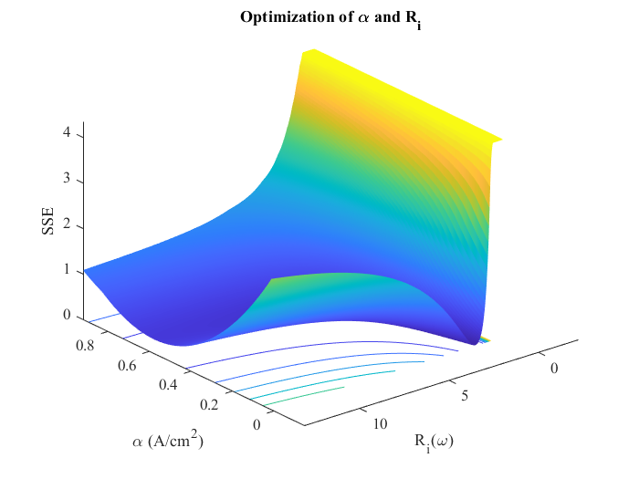



Figure 2: Surface optimization of α and Ri parameters for a Serpentine-Serpentine configuration fuel cell operating at Low-Med H2-Air flowrate setting.

The topography of the surface demonstrates that there exist only a very narrow range of values which would result in the minimization of the SSR for this system. From the optimization it is found that a value of α = 0.133 and Ri = 1.55 with an SSR of 0.00132.

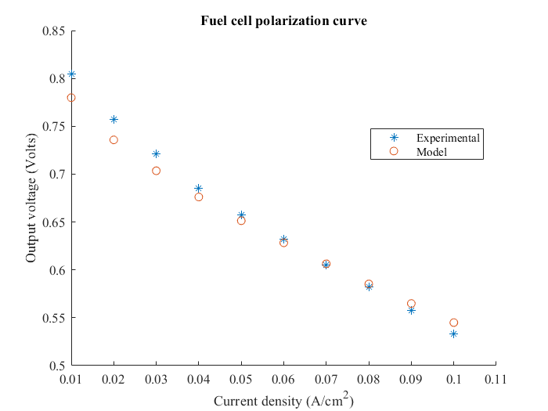

Figure 3: Comparison of simulator output and experimental model of a Serpentine-Serpentine fuel cell operating at Low-Med H2-Air flowrates

The small SSR obtained from tuning the parameters used to determine activation losses and ohmic losses lead to a model that behaves similar to the experimental setup. (See Appendix C.0: Relevant Equations). Moreover, this suggests that in our specific case, the internal resistance is a significant contributor to voltage losses that should be included in the simulation. The addition of a concentration loss term had virtually no effect on the simulated polarization curve output and was thus not included in the model.

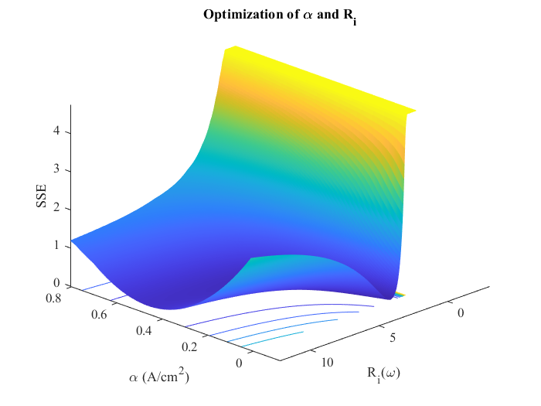



Figure 4: Surface optimization of α and Ri parameters for a Parallel-Parallel configuration fuel cell operating at Low-Low H2-Air flowrate setting.

The topography of the surface demonstrates that there exist only a very narrow range of values which would result in the minimization of the SSR for this system. From the optimization it is found that a value of α = 0.159 and Ri = 2.332 with an SSR of 0.00365. This suggests a high internal resistance of the system.

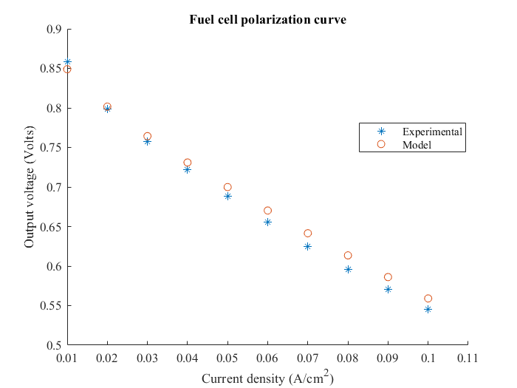

Figure 5: Comparison of simulator output and experimental model of a Parallel-Parallel fuel cell operating at Low-Low H2-Air flowrates.

The small SSR obtained from tuning the parameters used to determine activation losses and ohmic losses lead to a model that behaves similar to the experimental setup.

It was postulated that α and Ri parameter values should be intrinsic to the state of the membrane and the fuel cell itself and that these parameters were not dependent on flowrates or the purity of the fuel supplied. This was assumed since initial simulations revealed very little change in these parameters as a result of changes in flowrate. To demonstrate that these values were intrinsic parameters to the system, plots similar to Figures 2 through 5 were generated for a Serpentine-Serpentine fuel cell operating with nitrogen-diluted hydrogen feed.

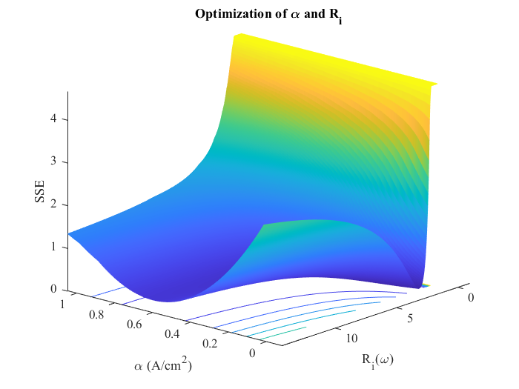



Figure 6: Surface optimization of α and Ri parameters for a Serpentine-Serpentine configuration fuel cell operating at a Low-Low-High H2-Air-N2 flowrate setting.

The topography of the surface demonstrates that there exist only a very narrow range of values which would result in the minimization of the SSR for this system. From the optimization it is found that a value of α = 0.141 and Ri = 1.52 with an SSR of 0.0102. This suggests a high internal resistance of the system compared to what was recorded in the literature.

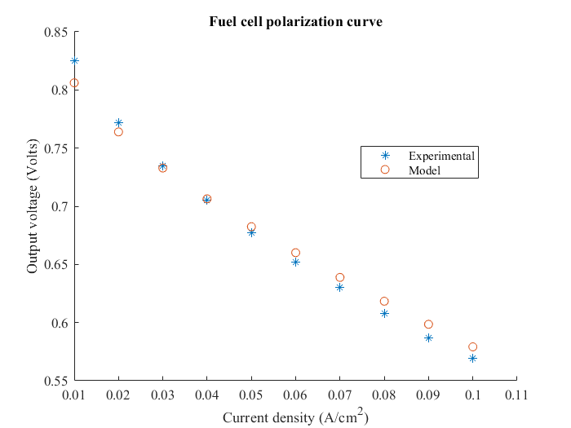

Figure 7: Comparison of simulator output and experimental model of a Serpentine-Serpentine fuel cell operating at Low-Low H2-Air flowrates with high N2 flow dilution.

The small SSR obtained from tuning the parameters used to determine activation losses and ohmic losses lead to a model that behaves similar to the experimental setup.

Although the current density loading range investigated in the experimental setup is primarily in the activation polarization region, the decision was made to include a term that accounts for ohmic losses in the system. Although ohmic losses, as a result of internal resistance, are not likely the dominating phenomenon responsible for these voltage losses, they are still considered a major contributor since there is no distinguishable threshold where it can be conclusively assumed that ohmic losses are an insignificant contributor. The mean α and Ri values obtained for each run are tabulated below. It should be noted that it was observed that the values do not differ significantly at different operating flowrates and thus it was assumed that α and Ri were intrinsic characteristics of the state of the fuel cell itself.

Table 1: Comparison of α and Ri for Serpentine-Serpentine and Parallel-Parallel fuel cell configurations

|  |  |  |  |
| --- | --- | --- | --- |
|  | **Serpentine-Serpentine** | **Parallel-Parallel** | **S-S N2 Dilution** |
|  |  |  |  |
| **μ - α** | 0.1416 | 0.1683 | 0.1483 |
| **σ – α** | 9.90E-04 | 1.60E-03 | 0.0112 |
| **μ - Ri** | 1.998 | 2.705 | 2.206 |
| **σ - Ri** | 0.055 | 0.0618 | 0.422 |
|  |  |  |  |

Experimentally observed Nafion PEM experiments determined that, at similar ambient operating parameters, the observed Ri should be approximately 0.5 ohm/cm2. Compared to the experimentally determined mean internal resistance in this case of approximately 2.303 ohm/cm2 [3]. In this case, the large internal resistance observed experimentally could be associated with membrane fouling as the membrane could have been nearing the end of its functional life. Membrane fouling could be the result of particulate accumulation on the membrane from the air pump. Moreover, it was observed that the contact points and wiring associated with the fuel cell were exposed and not properly seated in some key junctions which can also contribute to an increase in the determined value for Ri. Finally, it has been demonstrated that Ri varies considerably depending on the relative humidity and temperature of the membrane [4] and thus it is recommended that further investigations specifically focus on elucidating and fixing these variables prior to experimentation.

From the correlation of the experimental data employing the Tafel slope approach, it was found that the simulator determined optimal charge transfer coefficient was typically within +/-10% of the final value employed in the model suggesting more consistency in the observed and simulator derived values. Typically for engineering purposes α is fixed to a value of 0.5. From an electrochemical point of view, the α value typically represents how symmetric the resemblance of the transition state of the reaction is to the products and the reactants and is usually between a value of 0 to 1. Considering that the mean experimentally derived α value obtained was 0.12, this would suggest that the electrochemical reaction occurring on the Nafion membrane was not behaving as expected. It is possible that defects causing heterogeneities on the catalyst surface such as fouling may lead to a skewed value for α and it is less likely some factor is influencing the physical reaction mechanism occurring on the surface of the catalyst.

Ultimately, generating a simulation like the one discussed in this section has enabled us to successfully model the voltage losses associated with our particular laboratory scale fuel cell system. Furthermore, the simulations have facilitated an explanation as to why the system had performed sub-optimally. The fuel cell is heavily limited in its operating range and thus, with further tuning and experimentation, this model could be used in the future to extend the theoretical operating range of the cell to infer on how it would behave outside of the physical operating constraints of the laboratory fuel cell setup. Lastly, we propose that this model and the approach taken to estimate α and Ri may eventually be used as a diagnostic tool to determine when the fuel cell has reached the end of its useful life.

# RESULTS AND DISCUSSION

The paragraphs below document the findings of this study, discussing the effects of nitrogen dilution, air-flow source analysis, flow pattern analysis, and the effects of reactant flow rates on performance.

## Nitrogen Dilution

The three polarization curves, presented in Figure 8, were plot by diluting the hydrogen feed with 13.4 mL/min, 48.5 mL/min, and 73.6 mL/min of nitrogen (respectively labelled N2 Low, N2 Med and N2 High in the figure). The plots were made for a current density range of 0 to 0.1 A/cm2, each producing a maximum cell voltage below 0.85 V.

Figure 8: Polarization Curve of Varying Nitrogen Content

Figure 8 shows little variation in the polarization curves. Since the reaction occurs in the gas phase, diluting the hydrogen feed reduces its partial pressure and concentration. This lower concentration reduces the number of three-phase reaction sites in the anode, causing a reduction in the current density, which in turn reduces the voltage output of the cell. As described in Section 1.2, this phenomenon is known as concentration or mass-transport loss. Ideally, the plot for N2 Low would have higher voltage values than N2 Med, followed by N2 High. This behavior does not appear in Figure 8 most likely because of the small current range used. In this current density region, activation losses dominate.

Speculation suggests that the optimal nitrogen dilution amount would be the lowest amount of nitrogen as high concentrations of fuel in the anode increases the current density, increasing the cell voltage. Wang et. al confirm the effect of increased nitrogen dilution [9].

## Flow Rate

Another observed parameter is the flowrate of hydrogen and oxygen at the anode and cathode of the fuel cell. The experimental data was obtained by having one of the flow rates at a fixed value while varying the flow rate of the other component. This procedure was repeated for all possible scenarios varying from low, medium, and high flow rates of both hydrogen and oxygen. For the purpose of the discussion, the flow rate is fixed at the midpoint of the range, seen in Figures 9-12 below.

Figure 9: Gradient Increasing with Flow, Air Flow Fixed at 110 Units, Parallel-Parallel Cell, Z-X View

Figure 10: Gradient Increasing with Flow, Air Flow Fixed at 110 Units, Parallel-Parallel Cell

Looking at Figure 9 above, voltage decreases with increasing current, which is expected as there are various sources of voltage losses. This is just to confirm that the behavior of the polarization curve is reasonable. Focusing on the different flow rates of hydrogen, it can be seen that there are higher voltage losses with increasing flow rate. This is mainly due to the fuel cell’s reduced fuel-electrode-catalyst contact time at the anode, causing fewer hydrogen molecules to react at active sites.

In addition to the voltage losses, reduced contact time also indicates a decrease in performance, as can be seen in Figures 13 and 14. This is because the utilization factor (the ratio between the fuel consumed and the fuel supplied) decreases with increasing hydrogen flow rate. Due to the fixed maximum current, the consumption of hydrogen is also fixed (consumption is independent of flow rate), but the amount of hydrogen being supplied is increased, which ultimately causes the fuel cell to operate at a lower efficiency.

Figure 11: Gradient Increasing with Flow, H2 Flow Fixed at 110 Units, Parallel-Parallel Cell

With varying oxygen flow rate, very little change in performance is observed. This is due to the fact that the oxygen in the system is an oxidant to react with hydrogen ions to form water. This implies that as long as the oxygen consumption can keep up with the production of hydrogen ions, the oxygen flow rate has no direct impact on the electrochemistry of the fuel cell.

Figure 12: Gradient Increasing with Flow, H2 Flow Fixed at 110 Units, Parallel-Parallel Cell, Z-X View

## Flow Pattern

Another important aspect to look into when designing a fuel cell is the flow pattern on the field-flow plates. The main role of the plates is to distribute the reactant gases evenly throughout the cell to take advantage of the given surface area of the cell. It also plays a role in removing water and providing a route for the electrons. [10] Currently in the industry, there are multiple types of flow patterns available such as parallel, serpentine, mesh-type, and interdigitated designs. [11] For the purpose of the experiment, only parallel and serpentine flow patterns were observed. To compare the performance of the two types, it seemed fit to look into the efficiency versus power plot as shown in Figure 13 and Figure 14 below.

Figure 13: Performance Plot of Parallel-Parallel Configuration

Figure 14: Performance Plot of Serpentine-Serpentine Configuration

As it can be seen from the previous plots, both flow patterns are almost identical in performance. Comparing the maximum efficiencies achieved from both graphs, it is shown that the parallel-parallel configuration was 2% higher than the serpentine-serpentine. However, judging by the linear regression, if the serpentine pattern was to generate a higher power output, the efficiency would eventually reach the same value as the parallel configuration. Nonetheless, considering that both systems were performed under same conditions, it is experimentally shown that the parallel flow was able to achieve a higher efficiency. Depending on the scale of the experiment, the change may or may not be significant as some discrepancies are expected in experimental results. This behavior was unexpected because serpentine flow patterns are usually preferred as they provide a more even distribution of the reactant gases due to the limited availability of the flow pathway. It also helps with managing water and heat buildup in the plates due to the high velocity flow. A disadvantage of this design is that there is high flow resistance due to the narrow path and the short bends in the pattern.[11] On the other hand, parallel flow patterns allow lower pressure at the inlet to maintain stable flow rates of the reactant gases. However, due to poor design, efficiency is compromised due to uneven distribution of flow and flow resistance. [10]

Various factors may have influenced the similarity in data for both plots. The main factor is believed to be that the fuel cell used was on a small scale, allowing the field plates to evenly distribute the flow relatively easier than on an industrial scale. Since this is the main role of the flow pattern, if even distribution can be achieved with both types, then it makes sense for the performance to be similar. Another factor might be that although noticeable changes could have been present, the system was unable to capture it due to instrument limitations.

## Pressurized vs. Simple Active Air Delivery

Following the determination of the impact attributed to the dilution of the hydrogen source with inert gas and the comparison of serpentine-serpentine and parallel-parallel fuel cell flow patterns, a comparison between two air delivery methods was performed. For this comparison two nearly identical fuel cells were compared on their air delivery methods. One FC having air delivered via an external electric pump and the other having a small computer-monitored fan attached directly to the air delivery side of the fuel cell side. Both make use of a serpentine-serpentine flow pattern.

This set-up allowed comparison of the impact of providing positive pressure at the oxygen side of the reaction on the overall performance of the fuel cell when compared to a design with the oxygen side open to the environment. With the results obtained, it becomes easier to determine whether the inclusion of a pump is economically justified when scaling up a modular fuel cell design rather than the simpler and more cost-effective fan option.

Figure 15: Performance Curve for Serpentine Pattern Fuel Cell with Fan at Three Distinct H2 Operating Flowrates

Figure 15 illustrates the maximum power output that was generated with the use of a simple fan system. Power output ranges from 0.2W to a maximum of approximately 1.3W. It is also possible to observe that nearly no measurable difference in power output was obtained through the flowrates of hydrogen gas that were used. The trend seen in Figure 15 shows that there is still much headroom for increasing efficiency that has not been maximized through the experiments performed. A future experiment could replicate the findings of this study with a wider range of accessible applied amperage could further elucidate the maximal efficiency and power attainable with the fuel cell unit used. With nearly no curvature usable to extrapolate a possible efficiency maximum, it is safe to assume that the fuel cell was operating much lower than its maximal efficiency. The results obtained can only be compared over the non-maximal working range used throughout to other experiments performed that made use of a pump for air delivery. The efficiency range obtained extends from 3.5% to a maximum 24%. A reference value for the theoretical maximal efficiency for a hydrogen fuel cell is 83% efficient. [6]

Figure 14 shows the efficiency performance data obtained for a serpentine-serpentine fuel cell configuration which made use of a pump for forced air delivery. In this case a significant difference is noticed in the runs with differing hydrogen flowrates. This is in disagreement with the findings shown in Figure 15. An explanation for this could be that since the air delivery was fixed in the fan-based fuel cell, the cell was performing at its maximal power and efficiency trend while supplying even the lowest amount of hydrogen gas trialed and subsequent runs performed with even higher flowrates of hydrogen were redundant and yielded identical results. To better observe the efficiency variation and power behavior, it would have been necessary to revisit these experiments and perform them at a much lower overall flowrate of hydrogen. In comparison the runs performed with a pump in Figure 14, it can also be seen that the maximal efficiency is around 24 to 25%.

In Figure 6 the efficiency and power trend changed drastically when altering only the hydrogen flow rate which is the opposite of what was found in the runs performed with the fan. This shows that further investigation is required in order to determine how the observed behavior was obtained.

As can be seen in Figure 17 in the appendix, a change in hydrogen flowrate led to no significant change in the performance or efficiency of the cell. This leads to the conclusion that the fan used was either of insufficient capacity or did not work correctly with the fuel cell.

# CONCLUSIONS

In conclusion, to obtain viable data from the current experimental design, a higher current density would be required. It was possible to make certain determinations, such as the fact that nitrogen dilution in the hydrogen side of the fuel cell had nearly no impact on the performance or efficiency of the cell, and that a fan in place of a pump for air delivery has very little impact on the performance of the cell. However, these claims are not well founded since this experiment only allows for an observation into the early phase of a fuel cell’s operational stages.

This experiment should ideally be performed once more with significantly higher current density such as a value of 1.25 A/cm2 to 2 A/cm2 which is a frequently used value in literature polarization curves. The fact that the experimental apparatus is limited to a current density of 0.1 restricted investigation to only two main operating states of a fuel cell, which are the open-circuit phase followed by the activation loss phase. It is possible that much different behavior would manifest when operating a fuel cell closer to its maximal efficiency or maximal power output and that the conclusions made within this report would need to be revised.

When compared to model behavior, the fuel cell did perform similarly over the range of parameters assessed and it was possible to simulate and model the fuel cell, but some questions remain unanswered, such as why the variation of the hydrogen flow rate in the pump air delivery experiments had such a significant impact on the voltage produced when compared to the same experiments performed with a fan air delivery system with a comparable cell.

It is also worth reiterating that significant operational difficulties were encountered with wiring disconnection and apparent fouling on the fuel cell catalyst surface which could have contributed to the unpredictable nature of some of the data recorded.

REFERENCES

1. O. Z. Sharaf, M. F. Orhan, Renew. and Sustain. En. Revs. **2014**, 32, 810.
2. H. Liming, Renew. and Sustain. En. Revs. **2009**, 13, 1096.
3. H. Zhao, A. F. Burke, Journ. of Pow. Sour. **2009**, 186, 508.
4. N. Bizon, Optimization of the Fuel Cell Renewable Hybrid Power Systems, Springer Nature, Cham 2020, 185.
5. Fuel Cells, <https://www.energy.gov/sites/prod/files/2015/11/f27/fcto_fuel_cells_fact_sheet.pdf> (accessed October 2020)
6. L. Dicks, D. A. J. Rand, Fuel Cells Explained, 3rd ed., John Wiley & Sons Ltd., Hoboken 2018.
7. EG&G Technical Services Inc. “Fuel Cell Handbook (7th ed).” National Energy Technology Laboratory (2004): 56-71.
8. Spiegel, Colleen. PEM Fuel Cell Modeling and Simulation Using Matlab. Boston: Academic Press/Elsevier, 2008. Print.
9. W. Wang, W. Wang, S. Chen, *Internat. Journ. Of Hydgen. Ener.* **2016**, 41, 20680.
10. H. Dhahad, W. Alawee, A. Hassan, Experimental Study of the Effect of Flow Field Design to PEM Fuel Cells Performance **2019**, vol. 30, pg. 71
11. Flow Patterns for Proton Exchange Membrane Fuel Cells, <https://www.frontiersin.org/articles/10.3389/fenrg.2020.00013/full> (accessed: October 2020).
12. Benzinger, J. et al. The power performance curve for engineering analysis of fuel cells. Journal of Power Sources **2006**, 155, 272.
13. Saleh, M. et al. Exploring the effects of symmetrical and asymmetrical relative humidity on the performance of H2/air PEM fuel cell at different temperatures. Journal of Power Sources **2007**, 164, 503.
14. Spiegel, D. (n.d.). How to Predict Fuel Cell Performance, Retrieved October 04, 2020, from <https://www.fuelcellstore.com/blog-section/how-to-predict-fuel-cell-performance>.

APPENDIX

This Appendix contains sample calculations, the final proposal for the study, relevant equations, a timeline of the work completed, a comparison of the experimental and model polarization curves,

1. SAMPLE CALCULATIONS

The following sample calculations were performed under room temperature and atmospheric pressure for the Serpentine-Serpentine configuration.

1. The consumption of Oxygen and Hydrogen were calculated using the following equations:

|  |  |  |
| --- | --- | --- |
|  |  | (1) |
|  |  |  |
|  |  | (2) |
|  |  | (3) |

1. Partial pressures in the fuel cell calculations

|  |  |  |
| --- | --- | --- |
|  |  | (4) |
|  |  | (5) |
|  |  | (6) |
|  |  | (7) |
|  |  | (8) |

1. Activation loss determination

|  |  |  |
| --- | --- | --- |
|  |  | (9) |
|  |  |  |
|  |  | (10) |
|  |  |  |
|  |  | (11) |
|  |  |  |

1. Ohmic Loss calculation

|  |  |  |
| --- | --- | --- |
|  |  | (12) |

1. Mass Transport Losses calculations

|  |  |  |
| --- | --- | --- |
|  |  | (13) |
|  |  |  |

If the Mass transport Loss calculated was less then 0, it was assumed to be equal to 0.

1. Nernst Voltage Calculation

|  |  |  |
| --- | --- | --- |
|  |  | (14) |

1. Output Voltage Calculation

|  |  |  |
| --- | --- | --- |
|  |  | (15) |

If the output voltage calculated was a negative value, the value was then assumed to be equal to 0.

1. Power output calculation

|  |  |  |
| --- | --- | --- |
|  |  | (16) |

1. Efficiency

|  |  |  |
| --- | --- | --- |
|  |  |  |
|  |  |  |
|  |  |  |
|  |  |  |
|  |  | (17) |
|  |  |  |

1. FINAL PROPOSAL

Below is the final experiment proposal:

**Fuel Cell Laboratory – Group 4 Final Proposal**

Due: October 19th, 2020, 12:00

**Introduction**

Fuel cells are an emerging power generation technology known for their low emissions, compact size, high energy density, and growing range of applications. Fuel cells are used as on-board auxiliary power units to provide non-propulsion power. Such cells are used to power electrical appliances, refrigeration, air conditioning, heating, and other vehicle functions that increase on-board electrical demand. Fuel cells are also used to power electric vehicles such as cars, buses, trucks, forklifts, wheelchairs, etc. Another application includes power generation in locations that are too far, or geographically obstructed from a power grid. [4] This is particularly useful as extending power grids to such locations is expensive. [5]

The main constituents of a fuel cell are two electrodes and an electrolyte between them. Reactions involving a fuel, and an oxidant occur at each electrode. Very often, hydrogen is used as a fuel, where it is oxidized at the anode, losing two electrons for each atom, and producing a hydrogen ion (shown below).

|  |  |  |
| --- | --- | --- |
|  | H2 2H+ + 2e- |  |

The electrons pass through an electrical circuit, producing electrical current, while the ions pass through the electrolyte, flowing towards the cathode. At the cathode, oxygen (often used alongside hydrogen as an oxidant) reacts with the electrons and hydrogen ion produced by the oxidation at the anode, forming water. The electrodes are coated in catalyst to improve the rates of both reactions. [3]

|  |  |  |
| --- | --- | --- |
|  | ½ O2 + 2e- + 2H+ H2O |  |

There are a number of subsystems involved with reactant preparation, water, and thermal management in the cell, etc. The collection of these subsystems is called the Balance of Plant, but the focus of this work will be on the constituents listed above.

The supply of oxygen (often in the form of air), back pressure (caused by the outflow of unreacted fuel), water supply, and fuel supply all have large influence on fuel cell operation and lifetime. [6][7] Optimizing these variables is necessary to minimize operational costs, safety risks, and damage to the fuel cell. It is especially useful to know the optimal set of conditions that produce maximal voltage output from the cell, as this maximizes economic viability, and facilitates optimization of other cells.

This laboratory will consist of the analysis and investigation of a small-scale polymer electrolyte membrane fuel cell system. The fuel cell will be characterized through variation of the gas flow rates and the flow pattern used. Furthermore, the effect of impurities in the anode will be observed and different methods of purging these impurities. The objectives of this laboratory (listed below) mainly involve optimizing the operating variables of the fuel cell.

**Proposed Objectives**

1. Quantitatively determine the relationship between anode and cathode flowrates to the actual voltage and the effect of impurities in the system.
2. Qualitative and quantitative analysis of the optimal flow pattern between parallel-parallel and serpentine-serpentine flow.
3. Qualitative analysis of optimal air flow source between a fan and a pump (both serpentine-serpentine flow pattern)
4. Determining the optimal nitrogen and hydrogen flow ratio for power generation by collecting a wide range of different flowrates in the system.
5. Determination of fuel cell potential and efficiency through the use of Nernst equation.

**Relevant Theory**

**The first step** is to calculate the theoretical potential of a hydrogen–air fuel cell which can be calculated using the Nernst equation in the red box as follows:

Table 2: Fuel Cell Reactions and the Corresponding Nernst Equations

**The second step** is to calculate activation losses, the base voltage required to overcome the activation energy of the electrochemical reaction. This is accomplished by calculating the activation overpotential using the Butler-Volmer equation (1). The activation losses are then expressed through the use of equation (2). **The third step** consists of calculating the Ohmic Losses through equation (3). **The fourth step** consists of calculating concentration losses by the use of an adapted form of Fick’s first law of diffusion which is equation (4).

A second concept to consider regarding this experimental design is the effect of both anode and cathode flowrates. The basic power equation can be outlined by equation (5) which can be rearranged into equation (6). This also provides the fundamental relationship between the current and the voltage. By using equations (7) and (8) and substituting in the rearranged power equation, the following relationship between oxygen and hydrogen flowrates can be observed in equation (9) and (10).

Finally, all effects described in the above steps are combined in order to obtain the deviation from ideal voltage. The fuel cell polarization curve is modeled using equation (11) to identify the relationship between fuel cell potential and current density. The maximum efficiency of a fuel cell is defined through equation (12).

Once the polarization curve is obtained for a given set of parameters, it becomes possible to draw comparisons and conclusions between differing operational states and determine which variables if any have an impact on the overall performance of the fuel cell.

**Experimental Design & Plan**

The first laboratory session will be used in order to study the apparatus and understand the control layout for the flow of nitrogen, air and hydrogen. The operation of the power supply will be studied as well.

The lowest and highest flow rates of gases as well as a midrange value to be used for each of the three fuel cell designs (parallel-parallel, serpentine-serpentine, serpentine-serpentine with fan mount) will then be determined. The power supply operating range was specified as being from 0.25A to 2.5A and the increments taken through this range were decided to be 0.25A yielding 9 steps through the amperage range for every configuration of gas flow rates. This yields a total of 9 combinations of flow rates of gas (low air/low H2, low air/mid H2, low air/high H2, mid air/low H2, mid air/mid H2, mid air/high H2, high air/low H2, high air/mid H2, high air/high H2) combined with 9 different steps through the amperage range for a combined total of 81 measurements taken per fuel cell configuration. If time permits technical replicates will be performed in order to determine the reliability of the data.

The lowest and highest gas flow rates obtainable through the use of the manually operated valves for air and H2 were approximately 70 and 150 respectively on the graduated scale of the flowmeter. 150 was chosen as the maximum and a value of 110 was selected for the mid-range gas flow rate.

The measurement procedure will consist of first attaching the air, H2 and purge hoses to the fuel cell as well as the anode and cathode to the positive and negative leads from the power supply securely. Next the gas supplies are opened, and regulator set to 20 psig. The purge valve is fully opened, and air pump is activated. Then the air and H2 flowrates are set to a mid-range value using the manual valves. The power supply is then activated and an amperage of 2.5A is applied in order to start-up the fuel cell and generate some water so that stable results are obtained throughout the tests to be performed. The power supply and manual valves for air and H2 are then varied according to the above design and the voltage measured and purge flow rate are recorded for each iteration.

The data will then be used to plot a polarization curve (Appendix C - Figure 1) which allows the determination of the voltage obtained as a function of the current density. This will allow for characterization of the fuel cell and comparison of different fuel cell designs. Finally, the efficiency of the fuel cell as well as the power generated will be calculated.

A timeline of work has been added to appendix B to discuss a detailed description of the work to be performed throughout the 3 data collection sessions of the experiment. Data collected over the three experimental sessions will be processed and compared to a fuel cell simulator developed by our team to better understand the behavior of the experimental system and the relative performance of the system to that of the ideal model. Ultimately, this will allow for additional tuning of model parameters so that the simulation can more accurately account for voltage losses associated with the experimental apparatus.

**Bibliography**

1. EG&G Technical Services Inc. “Fuel Cell Handbook (7th ed).” National Energy Technology Laboratory (2004): 56-71.
2. Spiegel, D. (n.d.). How to Predict Fuel Cell Performance, Retrieved October 04, 2020, from <https://www.fuelcellstore.com/blog-section/how-to-predict-fuel-cell-performance>
3. L. Dicks, D. A. J. Rand, Fuel Cells Explained, 3rd ed., John Wiley & Sons Ltd., Hoboken 2018.
4. O. Z. Sharaf, M. F. Orhan, Renew. and Sustain. En. Revs. 2014, 32, 810.
5. H. Liming, Renew. and Sustain. En. Revs. 2009, 13, 1096.
6. H. Zhao, A. F. Burke, Journ. of Pow. Sour. 2009, 186, 508.
7. N. Bizon, Optimization of the Fuel Cell Renewable Hybrid Power Systems, Springer Nature, Cham 2020, 185.
8. RELEVANT EQUATIONS

The following equations outline the Nernst equation and its variations, along with its relationship with different types of resistances. It also shows the relationship between the actual voltage and the anode and cathode usage, which ultimately relates to the flowrate of hydrogen and air. Efficiency equation will be used to compare the experimental data to the theoretical data.

|  |  |  |
| --- | --- | --- |
|  |  | (1) |
|  |  | (2) |
|  |  | (3) |
|  |  | (4) |
|  |  | (5) |
|  |  | (6) |
|  |  | (7) |
|  |  | (8) |
|  |  | (9) |
|  |  | (10) |
|  |  | (11) |
|  |  | (12) |

1. TIMELINE OF WORK

|  |  |  |  |
| --- | --- | --- | --- |
| **Date/ Session#** | **Objectives** | **Manipulated parameters** | **Outcomes** |
|  |  |  |  |
| **06/10/2020 – Session 1** | Determine the lowest and highest flow rates of gases as well as a midrange value to be used for each of the three fuel cell designs. Determine the operating range for the input current and the increments required to generate an accurate polarization curve. | **Fuel cell configuration:** | Experimental design yielded a total of 9 combinations of experimental runs for each fuel cell configuration. Combined with 9 voltage measurements results in a total of 81 measurements per apparatus configuration. |
| (parallel-parallel, serpentine-serpentine, serpentine-serpentine with fan mount). |
| **Hydrogen Flowrate:** (3 separate flowrates are to be deduced – High: 150, Mid: 110, Low: 70 mm) |
| **Air Flowrate:** (3 separate flowrates are to be deduced – High: 150, Mid: 110, Low: 70 mm) | In addition, periodic temperature measurements will be made to elucidate the effect of the manipulated parameters on cell temperature. |
| **Current Input**: The power supply operating range was specified as being from 0.25A to 2.5A and the steps taken through this range were decided to be 0.25A yielding 9 steps through the amperage range for every configuration of gas flow rate |
|  |  |  |  |
|  |  |  |  |
|  | The introduction of varying amounts of nitrogen gas as a diluent will be investigated. Furthermore, the influence of varying purge regimes on fuel cell voltage output will be explored. If time permits, technical replicates of earlier experiments will be performed. | The same experimental approach as the first lab will be repeated and modified in this subsequent session to include modifications to the following: | Experimental design was modified to investigate three distinct nitrogen flowrates for each combination of H2 and Air flowrates established in the previous session employing only the S-S fuel cell configuration. |
| **13/10/2020 – Session 2** |
|  | The data will then be used to plot a polarization curve which allows for the determination of the voltage obtained as a function of the current density. This will allow for characterization of the fuel cell and comparison of different fuel cell designs. | **N2 Flowrate:** the N2 flowrate will be varied between 3 arbitrary consistent values (High: 130, Mid: 90, Low: 20 mm). | From the apparatus setup it was later found that control of purge flow can only be temporally controlled, and thus different purge timings were investigated |
|  |  |  |  |
|  |  |  |  |
| **20/10/2020 – Session 3** | At low current input – periodic purge to elucidate the effect of back pressure on fuel cell performance. In addition, more technical replicate runs will be conducted to interpret deviations more effectively in experimental measurements. | **H2 purge:** periodic purge flowrate will be investigated qualitatively to discern whether it will have an influence on the fuel cell performance. | Experimental design was modified to quantitatively elucidate the effect of back pressure on the performance of the system modulated by periodic purging. |
| The same experimental approach as the first lab will be repeated and modified in this subsequent session to include modifications to the following: |
| **H2 purge:** periodic purging at 10s intervals will be investigated. | Technical replicates in both major fuel cell configurations (S-S and P-P) were performed to better understand the deviation of measurements from each session. |
| **Technical Replicates:** Additional experiments will be conducted on the S-S and P-P fuel cell configurations employing the same experimental design approach used in previous sessions. |
|  |  |  |  |

1. POLARIZATION CURVES AND STATISTICAL COMPARISON

Figure 16: Fuel cell polarization curve example contrasting two technical replicates and the pre-tuned model generated data.

The polarization curve was generated using a fuel cell with a serpentine-serpentine configuration. The H2 and air flowrates in all three cases were at a high level corresponding to 91.7cm3/min flow. From initial tests, there exists approximately an average error of 3% between both runs. Further replicates will attempt to account for the deviation by determining whether it is a result of underlying environmental phenomena or is simply the result of measurement error. Finally, comparison of disparities between the general model and the experimental data will be used to explain voltage losses in the system.

1. PROCESS HAZARD ANALYSIS

|  |  |  |
| --- | --- | --- |
| **Deviation** | **Question/Topic** (cause of deviation, consequence of deviation) | **Answer/Recommendation** -safeguards, level of risk?(Recommendations in **Bold**) |
| **High Pressure** | Presence of high-pressure vessels. | **Ensure the vessels are not damaged or cracked as it might result in gas leakage. Make sure that the valves are closed when not using the gas.** High risk if there is leakage from the hydrogen vessel as hydrogen is flammable |
| **Low Pressure** | N/A no exposure to low pressure | **N/A** no risk |
| **Consideration of relief devices, design pressure of equipment/piping** | The hydrogen and nitrogen gases are supplied in high pressure cylinders. The regulator allows reduction of the pressure to a useable level. Proper regulation is essential. | **Should the regulator fail it is imperative the main valve on the cylinder be shut immediately in order to avoid excess or violent release of gas.** Moderate risk |
| **High Temperature** | N/A no exposure to temperatures above room temperature | **N/A** no risk |
| **Low Temperature** | N/A no exposure to temperatures below room temperature. | **N/A** no risk |
| **Consideration of design temperature of equipment/piping** | If the temperature of the fuel cell exceeds 60 ⁰C it will damage the fuel cell | **Shut the power supply first, and then turn off the gas supplies.** Low risk. |
| **High Flow** | N/A The flow rate of air, hydrogen and nitrogen is determined with a valve. The flow rate of an open valve will cause no risk | **N/A** no risk |
| **Low Flow** | N/A The flow rate of air, hydrogen and nitrogen is determined with a valve. The flow rate of a closed valve will cause no risk | **N/A** no risk |
|  | (PHA Contd.) |  |
| **Reverse/Undesired Flow** | N/A | **N/A** no risk |
| **Leak/Rupture** | If the hydrogen and nitrogen vessels are damaged or cracked | **Inspect the high-pressure vessels regularly.** Low risk |
| **Fire/Explosion** | Not likely, but hydrogen build up can cause explosions | **Ensure that the ventilation system is working properly at all times. Read the gas sensor regularly to make sure that the gas levels are within safety limits.** Low risk |
| **Chemical reaction, composition, pH, gases evolving** | N/A | **N/A** no risk |
| **Corrosion/Metallurgy** | N/A no corrosive chemicals in the lab | **N/A** no risk |
| **Loss of power or utilities** | Power outage will disrupt conducting the experiment, but it will not affect saving the data | Low risk |
| **Electrical Shock** | Power supply used in the range of 0.25 to 2.5 A. There was a bare wire connecting the fuel cell to the oscilloscope. | 0.1 A is enough to cause a heart attack in some cases. **Since water is being generated alongside currents of up to 2.5A care must be taken to ensure all electrical connections and apparatus are dry and well insulated in order to avoid short circuits and shocks. Provide multiple substitute wires.** Moderate risk |
| **Start-up/Shut-down issues** | Ensure that the appropriate valves are opened accordingly | **Open the air and hydrogen valves before opening the power, to avoid damaging the equipment.** Moderate risk |
| **Occupation health issues, toxicity, noise, air quality** | N/A The room where the experiment is conducted has high ceiling, and a ventilation system. | Low risk **if the ventilation system failed to work properly.** |
|  | (PHA Contd.) |  |
| **Physical hazards: slip, fall, crush, pinch** | N/A | **N/A** no risk |
| **Regulatory (TSSA, ESA, OHSA, Building Code, Fire Code, etc.)** | Fire Code. | **Review the building's evacuation plan with all members before the lab begins.** Low risk. |
| **Operability, ergonomic considerations** | N/A chairs were provided in the lab | **N/A** no risk |
| **Accessibility** | N/A | **N/A** no risk |
| **Maintenance** | Degradation of the fuel cell's catalyst | **Make sure to purge hydrogen regularly to increase the life span of the catalyst as it is expensive.** High risk |

1. USEFUL FIGURES

Figure 17: Average polarization curves for all three repetitions of the Serpentine-Fan configuration.

Figure 18: Optimal average run for Parallel-Parallel configuration. Error bars are the standard deviation in the measurements for three replicates

Figure 19: Optimal run for Serpentine Serpentine with standard deviation error

1. PROCESS FLOW DIAGRAM

