Final Year Design Project
Web based Smart Lost & Found Portal


By

Farah Mudassar (2022-FKW-7)
Umm-e-Habiba (2022-FKW-11)
Dania Azad (2022-FKW-41)
Tayiba Hanif (2022-FKW-35)

Under the supervision of
Mrs. Aisha Latif

Bachelors of Science in Information Technology (2022-2026)
FACULTY OF COMPUTING &
INFORMATION TECHNOLOGY (FCIT),
UNIVERSITY OF THE PUNJAB, LAHORE.
Web-based Smart Lost & Found Portal

A project presented to
University of the Punjab, Lahore

In partial fulfillment
Of the requirement for the degree of

Bachelors of Science in Information Technology
(2022-2026)

By
Farah Mudassar (2022-FKW-7)
Umm-e-Habiba (2022-FKW-11)
Dania Azad (2022-FKW-41)
Tayiba Hanif (2022-FKW-35)

FACULTY OF COMUTING &
INFORMATION TECHNOLOGY (FCIT)
UNIVERSITY OF THE PUNJAB, LAHORE

Declaration

We hereby declare that this software, neither whole or nor as a part has been copied out from any source. It is further declared that we have develop this software and accompanied report entirely on the basis of our personal efforts. If any part of the project is proved to be copied out from any source or found to be reproduction of some other, we will stand by the consequences.No portion of the work presented has been submitted of any application for any other degree or qualification of this or any other university or institute of learning.

Signature:--------------------- Signature:---------------------

Farah Mudassar [080067] Umm-e-Habiba [080072]

Signature:--------------------- Signature:------------------

Dania Azad [080040] Tayiba Hanif [080060]

CERTIFICATE OF APPROVAL

It is to certify that the final year design project (FYDP) of BS IT “ Lost and Found Portal (Find it)” was developed by Farah Mudassar (2022-fkw-7), Umm-e-Habiba (2022-fkw-11), Dania Azad (2022-fkw-41), and Tayiba Hanif (2022-fkw-35) under the supervision of Mrs. Aisha Latif. in my opinion; it is fully adequate, in scope and quality for the degree Of Bachelors of Science in Information technology.

Signature:----------------------
FYDP Supervisor:

Signature:------------------------------------

Head of FYDP Coordination Office:

Signature:--------------------------------------- Dated:_______________
Chairperson,Department of Information Technology

Executive Summary

Smart lost and found(Find It) is a web-based platform designed for our college FGDCW to help students and staff report and recover lost or found items easily. In college environment, students often misplace their belongings such as mobile phones, wallets, ID cards or any important document. To address this problem, our system provides an automated and digital solution.

This system allows users to create accounts, submit details about lost or found items and automatically match result based on keywords and location. This makes it faster and more reliable to reconnect lost items with their rightful owners. The primary objective of our system is to design a user friendly web portal for reporting and searching lost or found items ensuring a secure user authentication. It provide an internal chat communication between users for item verification and coordination. This system sends notifications to keep users update on their reports and any potential matches.

This design prioritizes simplicity and ease of use for all users. This system make sure a better item recovery efficiently by minimizing manual administrative involvement through automation and notification which saves time and effort.

Keywords: Find It, Smart item recovery, FGDCW Kharian Cantt.

Acknowledgement

We would like to thank to our respected supervisor, Mrs. Aisha Latif for her guidance, support, continuous encouragement and valuable feedback throughout the development of this project.

We also thank faculty and students of FGDCW Kharian Cantt for sharing valuable details about item recovery, user requirements, and practical challenges, which helped us design this project effectively.

Also, we are grateful to our families and friends for their constant support and encouragement throughout this journey.

Signature:--------------------------- Signature:-----------------------
Farah Mudassar (080067) Umm-e-Habiba (080072)

Signature:--------------------------- Signature:------------------------
Dania Azad (080040) Tayiba Hnif (080060)

Table of contents

Chapter 01 11
Introduction 11
1. Introduction 12
1.1. Background 12
1.2. Problem Statement 12
1.3. Problem solution 12
1.4. Objectives of proposed system 13
1.5. Scope 13
1.6. Assumptions: 14
1.7. Risks: 15
1.8. Success criteria: 15
1.9. Tools ,Libraries and Technologies: 15
1.10. Work Division 16
Chapter 02 17
Literature Review 17
2.1. Literature Survey: 18
2.2. Related work: 18
2.3. Gaps Analysis: 19
2.4. Summary: 19
Chapter 3 21
Software Requirements Specifications 21
3. Analysis 22
3.1 User classes and characteristics 22
3.2 Requirements Identifying Techniques 22
1. Use case 23
3.3. Functional Requirement 33
3.3.1. Functional Requirements X 34
3.4. Non- Functional Requirements 37
3.4.1. Performance Requirements 37
3.4.2 Security Requirements 37
3.4.3 Reliability Requirements 37
3.5 External Interface Requirements 37
3.5.1 User Interface Requirements 38
3.5.2. Software Interface Requirements 38
3.5.3. Hardware Interface Requirements 39
3.6. Summary 41
Chapter 4 42
Design and Architecture 42
4. System Design 43
4.1. Design Consideration 43
4.2. Requirement Tracibility Matrix................................................................44
4.3. Design model 45
Class Diagram 46
Sequence diagram 47
4.4 Architecture Design 48
UML Component Diagram 48
4.5 Data Design 49
4.5.1 Data Dictionary 50
4.6 User Interface Design 54
Screen Images 55
4.7 Behavioural Model 58
4.8 Design Decision 60
4.9 Summary 60
References...................................................................................................61

List of Tables

Table 1 : Tools & technologies 15
Table 2 : Work division 16
Table 3 : User classes & characteristics 22
Table 4 : Registration use case 24
Table 5 : Login use case 24
Table 6 : Report lost item 25
Table 7 : Report found item use case 25
Table 8 : Search item use case 26
Table 9 : View reported item 26
Table 10 : Claim found item 27
Table 11 : Chat with owener 27
Table 12 : Add review 27
Table 13 : Update profile 28
Table 14 : Logout use case 28
Table 15 : Admin login 29
Table 16 : Manage users 29
Table 17 : Review lost report 30
Table 18 : Review found reports 30
Table 19 : Manage system data 30
Table 20 : Remove fake reports 31
Table 21 : Dashboard monitoring 32
Table 22 : Resolve deputes 32
Table 23 : User registration 34
Table 24 : Manage users 34
Table 25 : Report found items 34
Table 26 : Search items 35
Table 27 : View reports 35
Table 28 : Messaging system 35
Table 29 : Admin login 35
Table 30 : Admin Dashboard 36
Table 31 : Admin manage lost item 36
Table 32 : Profile management 36
Table 33 : Entities, attributes & methods 49
Table 34 : Function and function parameters 50
Table 35 : Objects and their attributes 51
Table 36 : Methods and their parameters 52

List of Figures

Figure 1 : Usecase diagram 23
Figure 2 :User storyboard 32
Figure 3 :Admin storyboard 32
Figure 4 : Class diagram 46
Figure 5 : Sequence diagram 47
Figure 6 : UML component diagram 48
Figure 7 : Entity Relationship Diagram 49
Figure 8 : Home page 55
Figure 9 : Login page 56
Figure 10 : Report lost items page 57
Figure 11 : Report found items page 57
Figure 12 : Internal chat page 58
Figure 13 : Admin dashboard page 58
Figure 14 : Sequence diagram 59

Chapter 01

Introduction

- Introduction
  - Background
In today’s fast-paced environment, people often misplace their belongings such as ID cards, wallets, or mobile phones, especially in public or institutional areas. In our college FGDCW, many students lost their belongings and its hard for them to recover items. Since there is no efficient system exist in our college and rely on notice boards and admins involvement which is inefficient and also time consuming.
To address this problem, our portal which we named Find It provides a digital and automated solution. It allows students to quickly report lost or found items, store details in a centralized database, and use intelligent matching techniques to match reports efficiently.
  - Problem Statement
In our college it is very common that many students lose their important items like ID cards, wallets, or books in a rush and there is no proper digital system to help and find them easily. To solve this problem our college relies on notice boards and librarian as an admin which is not an efficient solution, time consuming as lost items stays on noticeboards for weeks. Also there is no proper verification system like any one can claim about item which makes it hard to return items to their real owners. Our project aims to solve this problem by creating a smart web portal where students can report lost or found items and get matched automatically, saving time and effort for everyone.
  - Problem solution
To solve the above mentioned problems , we propose a web-based portal which we named Find It. It’s a portal to report the lost and found items. It makes it easy to find the lost items as both lost and found item users can directly connect to each other without involving any third party or admin. This decreases the burden on admin as he only have to manage special cases of reports like fake claims about items or verification. It’s a user-based portal which can stay active by users. The keyword matching technique makes it easy to find lost items. The users can communicate through internal chat after item being matched,which make it easy for the user to decide the location and get their lost items. Also users can get reward after reporting found items offered by lost item owner.

1.4. Objectives of proposed system
The objectives of Find it are as follows:
- To automatically match lost and found reports using keywords.
- To allow secure communication between users through an internal chat system.
- To store and manage all user and item data in a structured database.
- To reduce manual effort and time in finding lost belongings.
- To implement a secure payment method using wallet.
- To create a user-friendly interface that anyone can use without technical skills.

1.5. Scope
The Find It is a web based system designed to manage lost and found items within FGDCW Kharian Cantt.
Deliverable: The main deliverables of the system are given below:
- User registrations and login : Allow users and staff to sign up and securely login.
- Report Lost Item: A user who has lost an item can submit a detailed report, including a description, the last known location, and the date of loss.
- Report Found Item:A user who has found an item can create a report with details such as the description, where it was found, the date, and a photo.
- Keyword matching:The system automatically or manually compares lost and found item reports based on criteria like description, category, and location to find potential matches.
- Internal chat:Once a match is confirmed user can chat securely within the portal.
- Feedback:The users can give their feedback about their experience and share their thoughts about the portal.
- Reward:The user who find the lost item and return it back to the owner will be rewarded.
- Admin:The admin manage the reports of the user and manage their accounts and database.
System boundaries: There are boundaries of the system which need to be fulfill.The students or staff must login to the portal for reporting items, it does not responsible for the recovery of items in physical ways. It only connect the user through communication. It also depends on accurate user reports to find their items effectively. Lost report users must pay after getting their item.
Stakeholder:
Admin:The admin is responsible for managing overall system.He manages user accounts, fake reports, scams and database.
Students/Staff: They are the main stakeholders who can report the lost or found items and can communicate through internal chat.

1.6 Assumptions:
- The users have access to internet, so they can interact with the portal.
- The users will found their lost item successfully.
- The users will give the accurate and correct data of lost and found item.
- The portal will be accessed through the desktops or smartphone.
- The portal will send the notification to the user about the found item.
- The user who find the lost item and return it will get the reward.

1.7. Risks:
- The scams and fake item report can damage the users trust.
- The downtime of the portal may cause temporary inaccessibility.
- Delays in admin verification could frustrate the user.
- The chances of lost items never be reported.

1.8. Success criteria:
After deployment our system will fulfil it’s basic functionality of reporting lost-items and found- items efficiently with keyword matching technique and allowing secure communication.

1.9. Tools, Libraries and Technologies:

Table 1: Tools & technologies

Tools,  Libraries,  And  Technologies | Tools | Version | Rationale
 | VS Code  MySQL workbench  Canva  Browser | 8.0  8.0  8.2 | VS code is user friendly supports HTML, CSS.  MYSQL is open source and fast  Canva is easy to use.  XAMPP provide complete local development server.
 | Technologies/ libraries | Version | Rationale
 | Django | 4.2 | Provide built in tools.  For routing and authentication.
 | Python  HTML, CSS, Java-script, Bootstrap | 3.10+  5 , 5.3 ,ES6  5.33 | Easy to learn support Django framework  Standard web technologies for responsive UI.

1.10. Work Division

Table 2: Work division
Sr. No | Roll Number | Name | Role Assignment & Work Division
1. | 080067 | Farah Mudassar | Backend+Frontend+Database
2. | 080072 | Umm-e-Habiba | Backend+Frontend+Database
3. | 080040 | Dania Azad | Frontend+Database
4. | 080060 | Tayiba Hanif | Frontend+Database

1.11. Conclusion
This chapter introduces Find It which is a web based online lost and found portal portal specifically designed for FGDCW Kharian Cantt. Find it focuses on smart item recovery and enhances college management with its problem solving nature.This chapter also defines the objectives, assumptions and Tools and Technologies for the Find It. Our system minimize manual efforts, improve efficiency, and ensure better item recovery. In future we can innovate it by using AI based matching.

Chapter 02

Literature Review

2.1. Literature Survey:
The problem of finding lost items has existed for decades, which is really hard for the people to find. The lost and found portal makes it easy for the user to find their lost items, without the hassle of searching manual records which is both difficult and time taking and in most cases turns out to be useless. We are making this portal because the previous ones were designated for a specific area but this portal is general based it can be used anywhere. Any company, Institution or in public area. Meanwhile we are making this portal for our college according to the need and requirements.
It also give benefits to the user who found the lost item by giving reward to them, according to the value of the lost item. It is a user friendly and fun to interact with portal.

2.2. Related work:
There are practical university projects and deployed campus solutions that focus on collecting reports and providing admin moderation but many rely on manual verification. People commonly used social media for finding their lost items by posting them on social media platforms because it is approachable to the large audience, but after some time, the posts get buried.
There is no verification mechanism exists like anyone can claim about item. This makes the social media unreliable for reporting lost items. Applications such as lost and found campus [1], Foundrop [2], Tile[3] and Stuff lost[4] allow users to find lost items. But these apps use geolocation tracking, QR code tagging. But they require external Bluetooth devices or tags, making them less suitable for general public use.
On the other hand, our portal does not require all these things .Our portal is easy to interact, a user without any knowledge about the IT can easily use the portal. In other apps, they use the wallet in which they have to pay beforehand they get their lost items, but in our portal the wallet secure the money until the user get their lost item, which make it secure portal.

2.3. Gaps Analysis:
In existing approaches, the apps are not secure for money transferring, they are complex for the people with the basic knowledge of technology. They use the geolocation tracking and QR code tagging for finding the lost item, which is hard for the users App like Tile[3] depend on Bluetooth, which can track the lost item in limited distance. Once the lost item is out of range, the tracking becomes inaccurate. It requires the hardware tracker to be attached with the lost item to find it, if the user forget to attach the tracker with the item the lost item can never be tracked.
It is very costly as user need to buy a tracker device to track the lost item, and it can also be misused as tracking the people secretly. It cannot used in public places as Tile[3] can used only for personal belongings only, not the lost item in public places like campuses, buildings,Malls and offices.
In our portal we have tried to fill up the gaps between the previous apps and in our portal. We have make the money transaction secure, the safe internal communication, trustworthy verification mechanism system, which make it more reliable and secure. It provide the real time updates and notification. The user can be worry free as there is no any third person who can misplace the thing or give the wrong information or update. It is also eco-friendly as it does not require the tracking device. It can also be used in public places like parks, offices and malls.
In our portal, the user can give their reviews, share about their experience and also grade the portal.

2.4. Summary:
The whole chapter shows that the traditional lost and found system is mostly rely on manual proceses such as physical registers, announcements and informal communication channels,which is time consuming, hard to maintain, and out of date.These methods are slow onorganized and low rate of recovery of lost items.
The existing apps hard to interact,they are not eco-freindly and are not able to use in institutional areas. But in our portal, we make sure to overcome from those drwa
backs as our portal is eco-friedly, easy to iteract with, and it solves a big hurdle of campus life.

Chapter 3

Software Requirements Specifications

3. Analysis
This chapter explains the requirements of smart lost and found including both functional and non-functional requirements. The main focus is on providing effective functional and user-friendly user interface.

3.1 User classes and characteristics
User classes are used to define the characteristics, responsibilities and key attributes of users.Following table show the user classes and characteristics of lost and found users.

Table 3: User classes & characteristics

User class | Description | User characteristics
Admin | The system administrator is responsible for overall management. | Can register and manage the users and responsible for management system.
User | Register user can report a lost item or found item. | User can register for reporting lost and found items. User should be able to send or receive messages when user can register their account.

3.2 Requirements Identifying Techniques
We use many techniques to identify requirements such as use case and storyboard. Use case is used to explain the functional requirements of the system from the Users perspective.Storyboard is used to provide a visual representation of Find IT. These helps us to clearly define what and how the system works and Meet the requirements.

Usecase Diagram
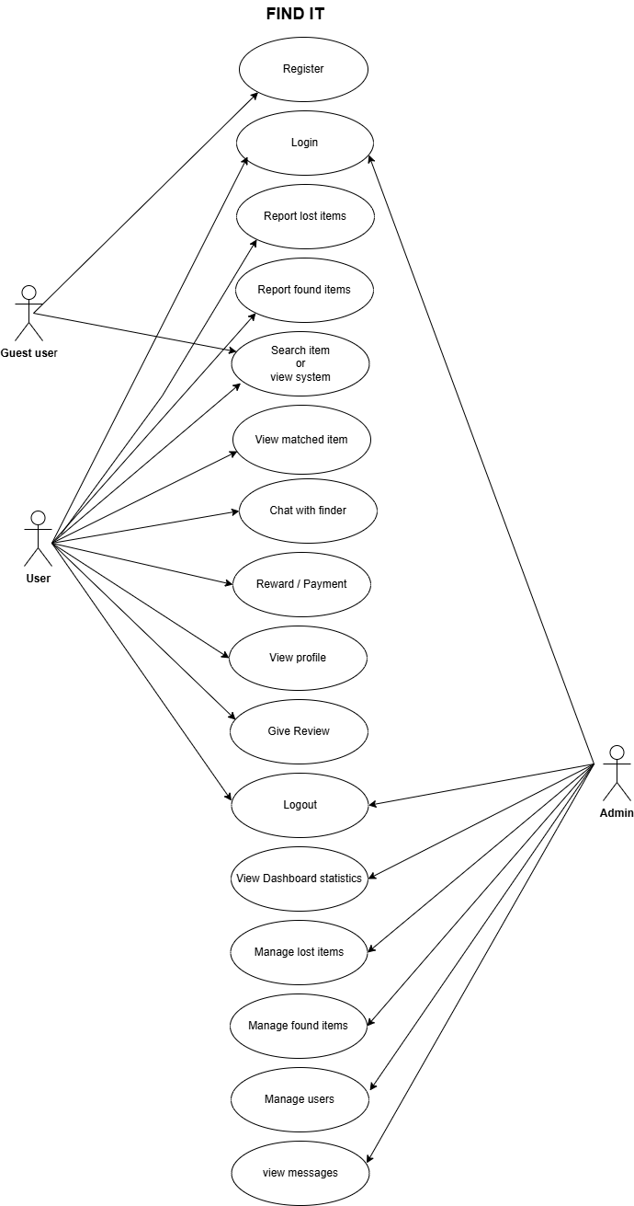

Figure 1: Usecase diagram

Find IT Use cases Description
Registration Use case:

Table 4: Registration use case
Use case No | UC-1
Use case name | User Registration
Purpose | Allow new users to create a secure and identifiable account in the system.
Priority | High
Pre-condition | User must have an internet connection.
Post condition | User Successfully registered into the system.
Actor | User
Main Success Scenario | After registration user will able to make report but item.
Alternative Flow | User enters invalid or incomplete information.  System shows an error message.  User re-enter correct data.
Include | None

Login Use Case:
Table 5: Login use case
Use case No | UC-2
Use case Name | Login
Purpose | Allow user to securely access dashboard.
Pre-Condition | User must be registered into the system.
Post condition | User successfully logged in.
Actor | Admin  User
Success Scenario | User enter the username and password to login.
Alternative Flow | If the user Enter invalid data or password then the system Allow to retry.
Include | None

Report Lost Item:
Table 6: Report lost item
Use case No | UC-3
Use case Name | Report lost item.
Purpose | Allow user to submit complete details of item so that the system can record and able to help match reported found items.
Pre-condition | User must be logged in  User must provide required details like category, location, date, Image upload(optional)
Post-condition | Lost item report is successfully saved in the system.
Actor | User
Main success scenario | User enters the details of the lost item
Alternat flow | Admin reviews and approves suspicious reports.
include | None

Report Found Item:
Table 7: Report found item use case
Use case No | UC-4
Use case Name | Report found item.
Purpose | To allow the users to report items they have found by providing details so the system can publish the information and help the owner locate and claim the item.
Priority | High
Pre-condition | User must be logged in.  User must have found an item and be willing to submit its details like date, location, Image upload.
Post condition | Found item report is successfully saved in the system.
Actor | User
Main success scenario | System Validates the information and saves the found item report.
Alternate Flow | Admin reviews the report before publishing.
Include | None

Search items:
Table 8: Search item use case
Use case No | UC-5
Use case Name | Search item
Purpose | Allow users to search for lost and found items using filters such as name, location, category.
Priority | High
Pre - condition | The system must have existing lost and found item records.
Post condition | The system displays a list of search results matching the user query.
Actor | User (Registered)
Main success Scenario | User click the search button and enters search keywords.
Include | None

View Reported items use case
Table 9: View reported item
Use case No | UC-6
Use case Name | View reported items
Purpose | To allow users to browse all items that have been reported as lost and found
Priority | High
Pre-condition | The system contains at least one reported Items
Post condition | User successfully views the list or details of reported items.
Actor | User
Main success Scenario | System Display items with essential details like category, location.
Alternate Flow | System Display updated filtered list.
Include | None

Claim found item use case:
Table 10: Claim found item
Use case No | UC-7
Use case Name | Claim Found Item
Purpose | To allow a user to claim an item that has been reported as found by another person.
Priority | High
Pre-condition | User must be logged in
Post condition | A claim request is submitted to the item finder
Actor | User
Main success Scenario | System Display full details of the items.  User submit the claim request.
Alternate Flow | System fails to submit the claim due to technical issues.
Include | None

Chat with Finder\Owner use case:

Table 11: Chat with owener
Use case No | UC-8
Use case Name | Chat with Finder\owner
Purpose | To allow communication between the person who lost an item and the person who found it in app messaging system.
Priority | High
Pre-condition | User must be logged in and item should be matched.
Post condition | Both users can exchange messages related to the items.
Actor | Registered users.
Main success Scenario | System displays the chat interface and the receiver gets notification.
Alternate Flow | Network or server error occurs.

Add Review use case:
Table 12: Add review
Use case No | UC-9
Use case Name | Add review
Purpose | To allow users to provide feedback or rate their experience after returning item.
Priority | Moderate
Pre-condition | User must be logged in  The system allows reviews for completed interaction.
Post condition | A review is stored in the system.
Actor | users
Main success Scenario | System displays the review form.
Alternate Flow | If the user tries to review again then the system display you have already submitted a review.
Include | None

Update Profile use case:

Table 13: Update profile
Use case No | UC-10
Use case Name | Updated Profile
Purpose | To allow users to update or modify their personal information such as name, phone number,
Priority | High
Pre-condition | User profile already exists in the system.
Post condition | User sees their updated profile details.
Actor | User
Main success Scenario | User clicks on Edit profile and the system saves the updates profile data.
Alternate Flow | If the user is not logged in then the system show please log in to update your profile

Logout use case
Table 14: Logout use case
Use case No | UC-11
Use case Name | Logout
Purpose | To allow the user to securely end their session and prevent unauthorized access to their account.
Priority | High
Pre-condition | User must be logged in.
Post condition | User can not access authenticated features without logging in again.
Actor | Registered user
Main success Scenario | User clicks on the logout button and user confirm logout.
Alternate Flow | System attempts to end the session but encounters a problem.

Admin Login use case
Table 15: Admin login
Use case no | UC-12
Use case name | Admin login
Purpose | Admin can access dashboard for managing users, items, and system.
Priority | high
Pre condition | Admin must have an account
Post condition | Admin can successfully login
actor | Admin
Main scenario | Creating secure admin session
Alternate flow | System might rejects the login attempts or display invalid username, password
include | None

Manage users use case
Table 16: Manage users
Use case No | UC-13
Use case Name | Manage users
Priority | High
Pre-condition | Admin must be logged in.  User account must be exist in the system.
Post condition | User information is updated.
Actor | Admin
Main success Scenario | System displays a list of registered users with basic details.
Alternate Flow | System updates the user records accordingly.
Purpose | To allow the admin to manage user accounts, including, viewing, editing, or deleting users in the system.
Include | None

Review lost Reports use case
Table 17: Review lost report
Use case No | UC-14
Use case Name | Review lost Report
Priority | High
Pre-condition | Admin must be logged in.  There must be lost item reports available in the system.
Post condition | Lost report status is updated approved or rejected.
Actor | Admin
Main success Scenario | System displays a list of all lost item reports.
Alternate Flow | System displays the filtered list.
Purpose | To allow the admin to view, verify, approve, or reject lost item reports submitted by users.

Review Found reports use case
Table 18: Review found reports
Use case No | UC-15
Use case Name | Review system data
Priority | High
Pre condition | Admin must be logged in.
Post condition | Admin successfully views system level data.  Admin may take actions based on cleanup and warnings
Actor | Admin
Main success Scenario | Admin analyzes data for trends, unusual activity or system performance issues.
Alternate Flow | System displays filtered data.
Purpose | To allow admin to view, verify, delete or approve reports.

Manage system data
Table 19: Manage system data
Use case No | UC-16
Use case Name | Manage system data
Priority | High
Pre-condition | Admin is logged in.  System data categories exist and are accessible.
Post condition | System data is successfully created, updated, or deleted.
Actor | Admin
Main success Scenario | Admin submits the changes.  Admin select a data category to manage the data.
Alternate Flow | System displays an error message indicating the missing or incorrect fields.
Purpose | To allow he admin to modify, organize, and maintain the system data secure and up to date
Include | Update database

Remove Fake\Duplicate Reports use case
Table 20: Remove fake reports
Use case No | UC-17
Use case Name | Remove Fake\Duplicate Reports
Priority | High
Pre-condition | Admin is logged into the system.  Reports and complaints have been submitted by users.
Post condition | Fake and duplicate reports are removed from the system.  System data becomes cleaner and more reliable.
Actor | Admin
Main success Scenario | Admin identifies fake, invalid or duplicate report  System removes the selected fake reports from the database
Alternate Flow | System fails due to technical issues.
Purpose | To maintain accuracy and reliability of the reporting system by removing false.
Include | None

Dashboard Monitoring use case
Table 21: Dashboard monitoring
Use case No | UC-18
Use case Name | Dashboard
Priority | High
Pre-condition | Admin is logged into the system. Dashboard components are correctly configured.
Post condition | Dashboard displays updated system information.
Actor | Admin
Main success Scenario | Admin open the Dashboard page.  Dashboard updates as new data arrives.
Alternate Flow | Admin reloads the dashboard or reports the issue.
Purpose | To allow the admin to monitor system activity, performance.
Include | None

Resolve Complaints use case
Table 22: Resolve deputes
Use case No | UC-19
Use case Name | Resolve Complaints
Priority | High
Pre-condition | A user has submitted a dispute or complaint.  The system has recorded the dispute details.
Post condition | The dispute is resolved and marked
Actor | Admin
Main success Scenario | System displays full dispute details, evidence, and related transaction info.
Alternate Flow | Admin requests additional information from the user.
Purpose | To ensure that user complaints and disputes are reviewed and resolved within the system.
Include | None

ii- Storyboard
Storyboard is used to visually show that how user interact with Find It. By using storyboard, it is easy to understand and design the user flow for admin and Users. This help make it easy and simple.

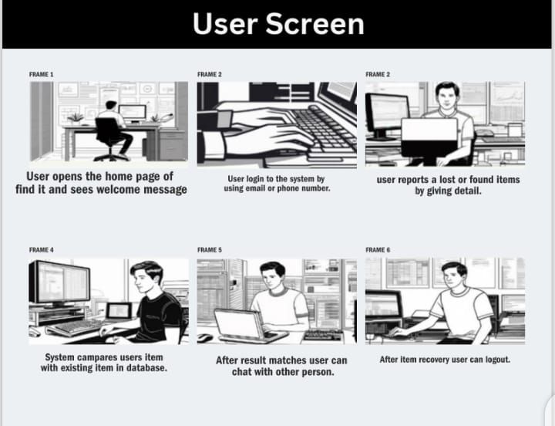
Figure 2:User storyboard

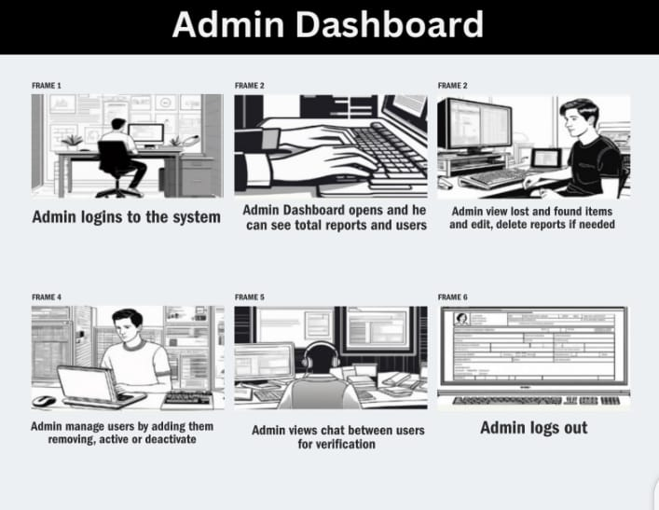

Figure 3:Admin storyboard

3.3. Functional Requirement
Functional requirements describe what the system should do, Detailing how it responds to user. These requirement guide developers to create features and completing their tasks effectively.

User account management:

FR-1: User Registration: Admins are able to register users with necessary details like email, phone number and password. The system must ensure login and logout functionally to protect user data.

FR-3: Manage users: Admin manages users by viewing, updating, deleting user accounts as needed.

FR-4: Report found item: User will be able to report found item with the name of item, location found, Description, date found.

FR-5: Search item: The system will help users to search using item name or category. The result will show matches and unmatched records.

FR-6: View lost and found item: Users will see a list of recently reported items on the homepage.

FR-7: Messaging system: The system Allow users to send messages regarding an item.

FR-8: Admin login: Admin have a separate login interface.

FR-9: Admin Dashboard: Admin will be able to view total reports, found reports, total registered users, recent reports.

FR-10: Admin-Manage lost items: Admin will view, filter, and update lost item reports. Admin will change status pending or matched.

FR-11: Profile Management: User will be able to manage their profile details.

3.3.1. Functional Requirements

Specific Functional Requirements are associated with each feature of Find It as describe here:

Table 23: User registration
Identifier | FR-1
Title | User registration
Requirement | Allow admin to register new users using valid credentials.
Source | Project Objective
Rationale | Only authorized user can access the system.
Business rule | Registration ensure that each user is uniquely identified.
Dependencies
Priority | High

Table 24: Manage users
Identifier | FR-2
Title | Manage Users
Requirement | System allow admin to view, update and remove users accounts.
Source | Project objective
Rationale | Ensure user data is accurate.
Business rule | Only admin can manage users as they have valid access permission.
Dependencies | User authentication
Priority | High

Table 25: Report found items
Identifier | FR-3
Title | Report Found item
Requirement | The system will allow a user to report a found item by submitting details such as item name description and optional photo,
Source | System users
Rationale | To enable users who find lost properly to easily report it and chances of returning the item rightful owner.
Business rule | Only registered and authorized users can report a found item.
Dependencies | Database for storing item reports.
Priority | High

Table 26: Search items
Title | Search item
Identifier | FR-4
Requirement | System will allow users to search for lost and found items using item name, category and status.
Source | User interviews
Rationale | Users need a fast and accurate way to check their lost item has been reported or found.
Business rule | Only verified \approved items reports should appear in results.
Dependencies | Reporting modules (lost item, Found item)
Priority | High

Table 27: View reports
Title | View lost and found items
Identifier | FR-5
Requirement | The system will allow users to view a list of lost and found items.
Source | User needs
Rationale | Users need an easy way to browse all reported items.
Business rule | The system will display the recent reports.
Dependencies | User interface for list display.
Priority | High

Table 28: Messaging system
Title | Messaging system
Identifier | FR-6
Requirement | The system will provide a messaging features that allow users to communicate securely.
Source | User requirements
Rationale | To allow item owners and finders to communicate safely.
Business rule | Personal phone number or emails not be displayed.
Dependencies | Database for storing message records.
Priority | High

Table 29: Admin login
Title | Admin login
Identifier | FR-7
Requirement | Only admin should allow admin to login in using correct username and password.
Source | Admin
Rationale | To make sure only trusted user can manage and control the system.
Business rule | Only admin can log in through the admin page.
Dependencies | Admin account
Priority | High

Table 30: Admin Dashboard
Title | Admin Dashboard
Identifier | FR-8
Requirement | The system should show an admin dashboard where the admin can easily see and manage things.
Source | Admin
Rationale | To give the admin one place to control and manage everything in the system.
Business rule | Admin should be able to view, edit, pr remove information if needed.
Dependencies | Admin login
Priority | High

Table 31: Admin manage lost item
Title | Admin manage lost items
Identifier | FR-9
Requirement | The system Allow the admin to view, edit, approve, or delete lost items.
Source | Admin requirements
Rationale | To make sure all lost item reports are correct, safe.
Business rule | Admin must check if the information is real before approving.
Dependencies | Lost item reporting system.
Priority | High

Table 32: Profile management
Title | Profile management
Identifier | FR-9
Requirement | The system Allow the user to view, edit and update their profile information.
Source | users
Rationale | Users need to change their details when user wants something change.
Business rule | Users must be logged in to edit their profile.
Dependencies | User registration already exists.
Priority | High

3.4. Non- Functional Requirements

Some important non-functional requirements of Find It are as follows:

3.4.1. Performance Requirements

The system will load quickly providing fast response time for all actions. It will support many users working at the same time without slowing down. The system should open pages with high speed even when many users are using it.

3.4.2 Security Requirements

User data including personal details must be stored securely. only registered users can access reporting features. The system must block people who enters the wrong password many times.

3.4.3 Reliability Requirements

Reliability requirements ensures that Find It have minimum downtime. User can access the platform easily when they needed.

3.5 External Interface Requirements

The Find It will interact easily with the users, systems, and hardware devices to ensures efficient functionality. Some external interface requirements include:

3.5.1 User Interface Requirements

The system must be easy for the users to understand and use without training. Each page must load in a few seconds to avoid confusing the user.

Readable text: Text must be easy to read with a clear font and good contrast.

3.5.2. Software Interface Requirements

The Find It interact with the following components.
Operating system supported: The system should work properly on common systems such as:
- Windows
- macOS
- Android
- iOS.

Web Browser supported: The system should work on all major web browsers including Google Chrome, Microsoft Edge, Firefox, safari. Pages should look and work the same on all supported browsers.
Back-end software Requirements: Back-end Requirements for Find It are follow as:
Python (Flask\Django) for server-side logic MySQL database for data storage.
Front-end Software: Front-end requirements for Find It are follow as:
HTML
JavaScript
CSS
Database interface: Database interface included in MySQL Connector\ Python connector.

3.5.3. Hardware Interface Requirements

Hardware Specification:
- RAM: 2 GB
- Processor: 1GHz
- Network: 1Mbps
- Storage: 200 MB free

Software specification:
- Operating system: Window 10 or above
- Browser: Google chrome
- Language: HTML, CSS, JavaScript

3.6. Summary
The Find It system is an online platform that helps students report items if they lost or found. User can create accounts and submit details about any items which is lost and discovered. People who find an item can upload information such as item name, description, location, then the system helps match lost items with found items.Admin manage the system by approving reports, handling, user issues, and keeping platform safe. The system also includes messaging so user can communicate without sharing personal details like phone number. The Find It system makes it easier, faster, and safer for students to recover lost things in college. .

Chapter 4

Software Design

Specifications

System Design
Find it is a web-based portal which is designed for FGDCW. Its main purpose to facilitate the users to find their lost item, through reporting the lost and found items. It is python based with My SQL, HTML, CSS, Java script with bootstrap and require an internet connection to connect with the portal. It connect the lost item user and found item user through the internal chat after keyword matching.

4.1. Design Consideration
Assumptions:
- The users have access to internet, so they can interact with the portal.
- The users will give the accurate and correct data of lost and found item.
- The portal will be accessed through the desktops or smartphone.
- The portal will send the notification to the user about the found item.
- The user who find the lost item and return it will get the reward.
Dependencies:
- The portal depends on the keyword matching to find the lost items.
- The accurate data of lost and found items submit by the users.
- The users play the active role on portal to report the lost and found items.
- The wallet which keep the reward for a while to give it to the found item user.

Limitations:
- The portal is not able to return the lost items physically, it can only facilitate the user through communication.
- The return of lost item depends on the honesty of the users, fake or scam can mislead the portal and user.

Risks:
- The scams and fake item report can damage the users trust.
- The downtime of the portal may cause temporary inaccessibility.
- Delays in admin verification could frustrate the user.
- The chances of lost items never be reported.

4.2. Requirement Traceability Matrix
Requirement traceability matrix keeps track of all functional requirements of Find It. It shows how each requirement is connected to its corresponding use case, its code file and the test case created to verify it. RTM makes sure that nothing is forgotten.

Table 33 Requirement Traceability Matrix
Requirement ID | FR Description | Design | Code file | Test case ID
FR 1 | System allow user to login | Login module | Login.html, login.py | TC-1
FR 2 | Report lost item | Lost item module | lost_item.py | TC-2
FR 3 | Report found item | Found item module | found_item.py | TC-3
FR 4 | User search items | Search module | search_controller.py | TC-4
FR 5 | Admin view lost reports | Admin lost reports | Admin_lost_item.py | TC-5
FR 6 | Admin view found reports | Admin found reports | Admin_found_item.py | TC-6
FR 7 | Admin manages users | Admin user management | Manage_user.py | TC-7
FR 8 | Exchange messages | Messaging module | Messsages.py | TC-8
FR 9 | Give Reviews | Review module | Review.py | TC-9
FR 10 | logout | Logout module | Logout.py | TC-10

4.3. Design model
Design model is an easy way to present the layout of the system.It is the blueprint of the system that represents how the system build. It shows the classes, attributes and relationships between them. It provides visual representation of system making it easy to understand also the developer can make changes easily through the design model.

Class diagram and sequence diagram will be used to make it easy to understand the system.
Class diagram shows classes, attributes, methods and relationships between two entities so it provides structural representation of system. Also sequence diagram shows that how the components of system work with each other and in what order. These diagrams are as follow

Class Diagram
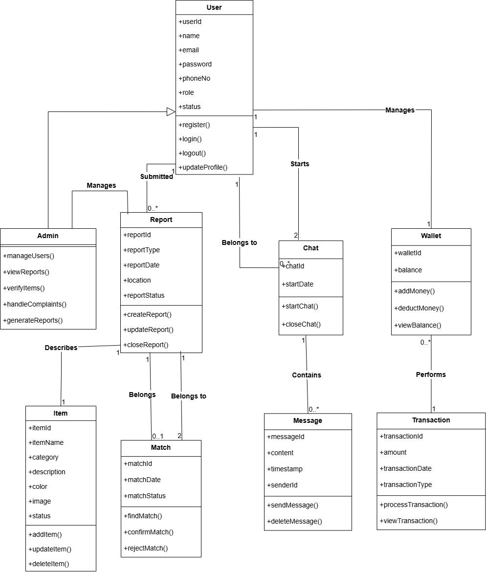
Figure 4: Class diagram

Sequence diagram
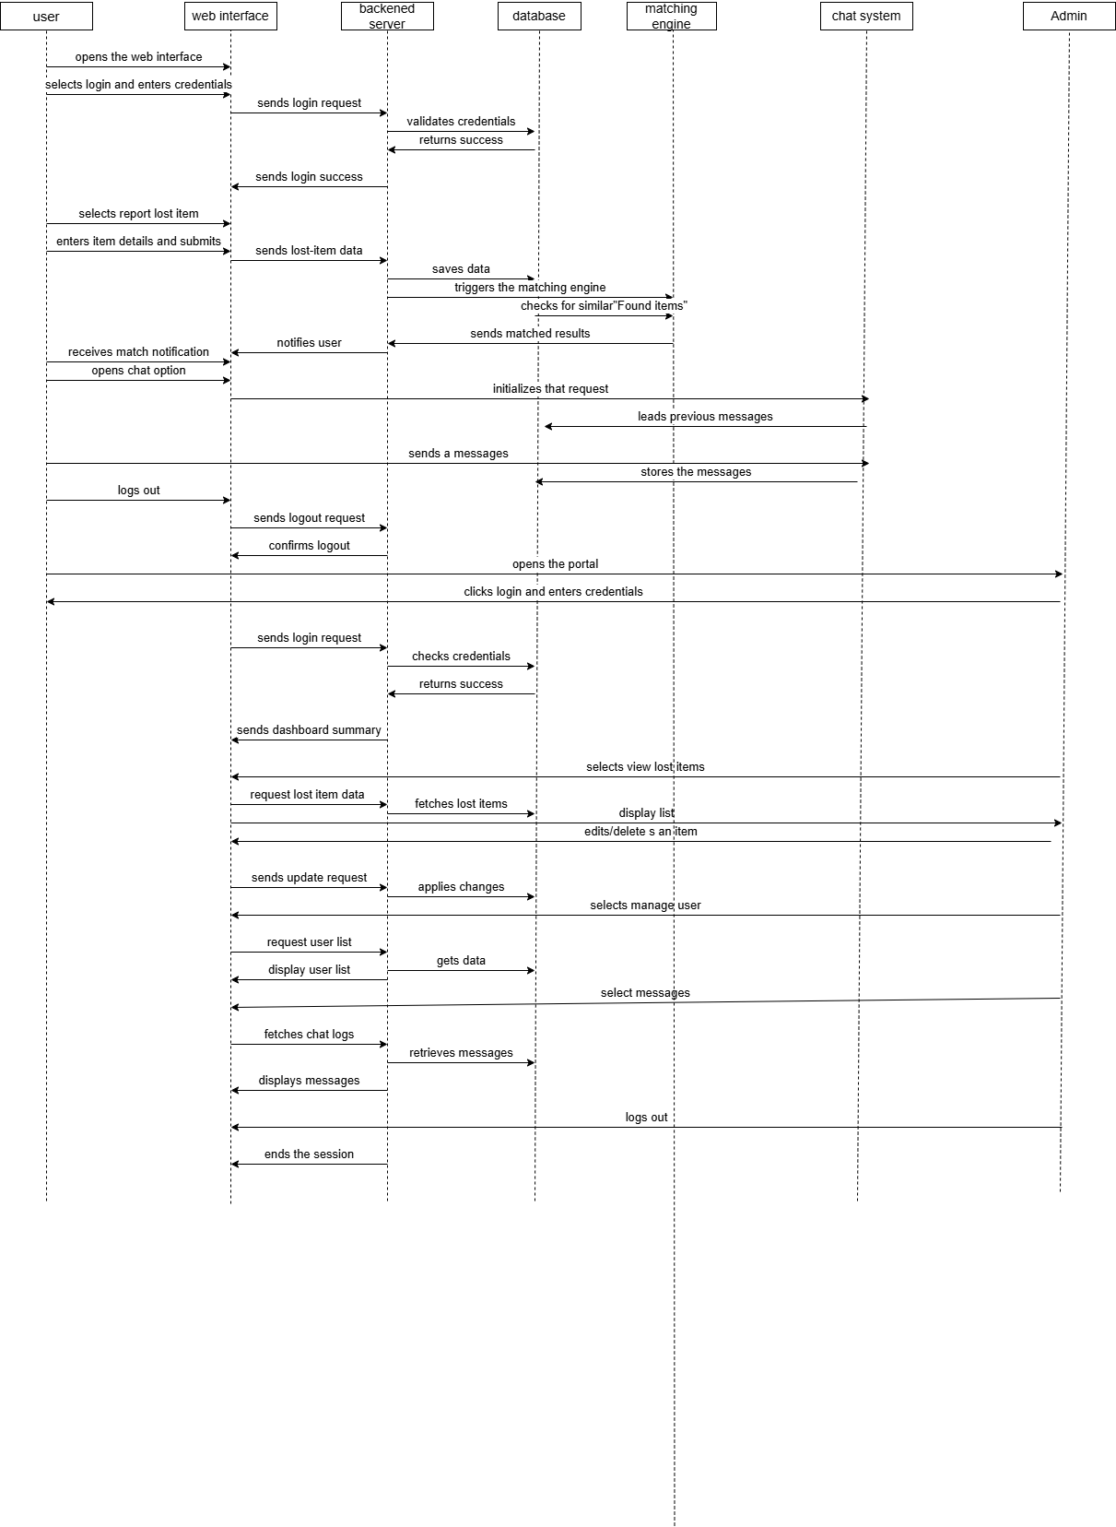
Figure 5: Sequence diagram

4.4. Architecture Design
Find It follows the MVC architecture for a , an efficient, and organized development process. It has three parts: Model, View, and Controller. The model manages the data and logic of the Find It such as user accounts, creating report, matching reports etc. View represents the user interface such as the dashboards, report forms, chat board etc. The controller is used to connect both model and the view. It accepts the input, updates the model and refreshes the view as needed.

UML Component Diagram
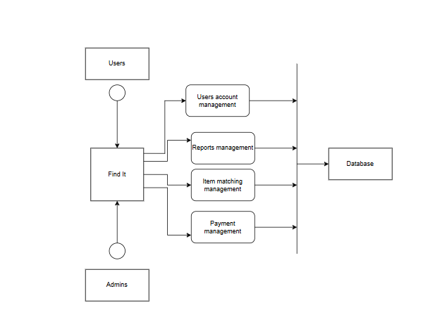
Figure 6: UML component diagram

4.5. Data Design
Data design shows how the information in the Find It is stored, organized, and managed. It keeps everything structured and easy to use. The system uses a MySQL database to save and organize data like users, lost items, found items, and chatting, ensuring smooth and efficient operations. The main parts of the Find It, like users, reports, reward, chats, and reviews, are stored in separate tables in the database. Each table has specific fields to save important details for that part of system. These tables are linked together using the relational structure making the data well organized easy to retrieve and consistent.
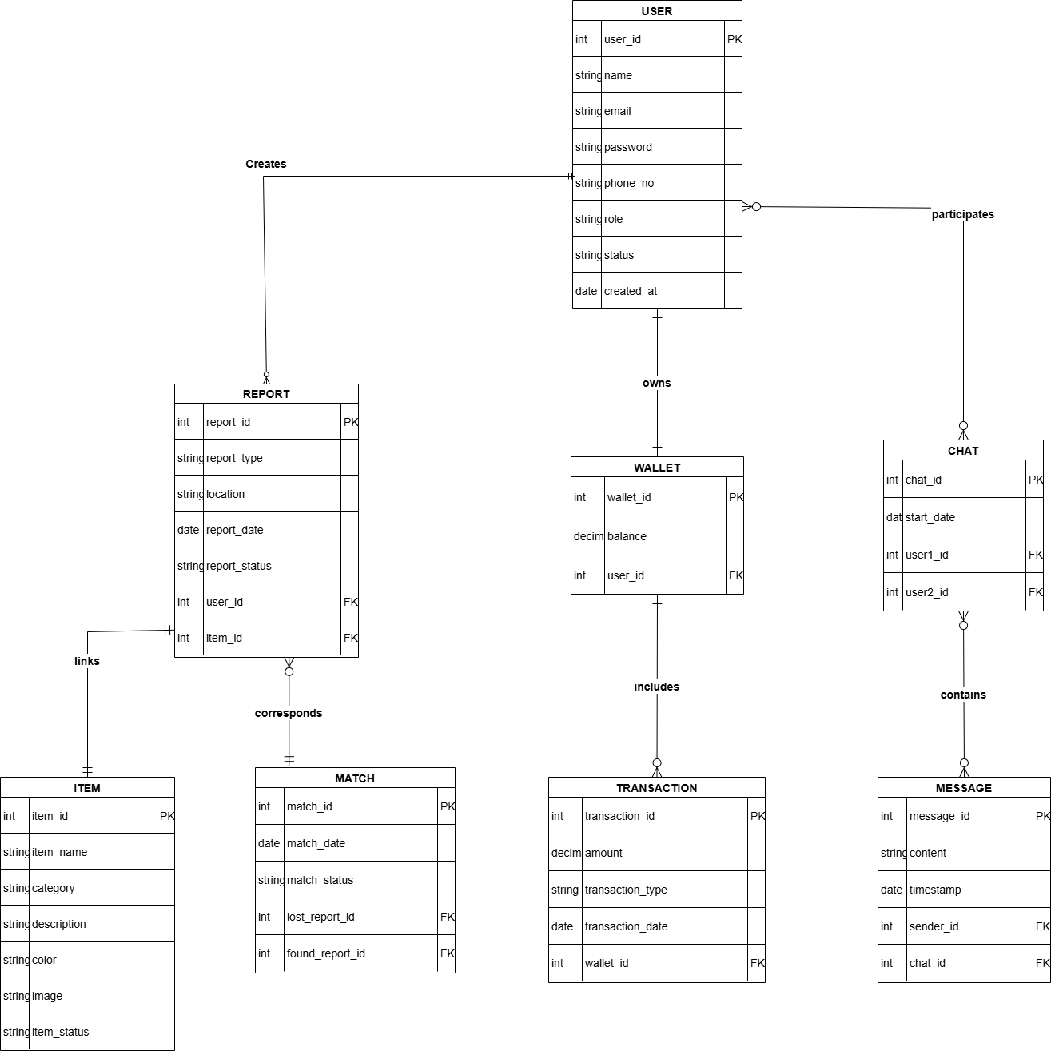
Figure 7: Entity Relationship Diagram

4.5.1 Data Dictionary
Data dictionary explains the data structures in Find It. It specifies each data field including its type, size, constraints and relationships.This ensure accurate, consistent and reliable data. An overview of key data tables and their attributes is given below.

Alphabetical List of System Entities or Major Data with Types and Description:

Table 34: Entities, attributes & methods
Entities/Attributes/Methods | Description
Admin_id | Unique id for each admin user (int)
Brand | Brand or company name of item (Var-char)
Category | Types of items (Var-char)
Chat_id | Unique id for every chat message (int)
Comments | Feedback or review by user (Text)
Color | Color of the lost/found item (Var-char)
Created_at | Auto stored time when record was created (DATETIME)
Description | Detailed explanation of item appearance or condition (Text)
Email | Email used for login and communication (Var char)
Found_id | Unique id for a found item report (int)
Found_date | Date when an item was found (Date)
Found_Location | Place where the item was found (Var-char)
Item_name | Name of item reported (Var-char)
Keywords | Keywords extracted for matching ( Var-char)
Lost_ date | Date when item was lost (DATE)
Lost_id | Unique id for a lost item report (int)
Lost _location | Location where user lost item (Var char)
Match_id | Unique id for each match item (int)
Match_score | Similarity score between items (int)
Match_status | Like varified, Rejected (Var-char)
Message | Text content in internal chat (Text)
Matched_date | Time when match was created (DATETIME)
Name | Full name of user and admin (Var-char)
Password | password for login (Var-char)
Phone | User contact number (Var-char)
Rating | User rating in review (int)
Review_id | Unique id for review record (int)
Status | Report status like pending, matched, closed (Var-char)
Timestamp | Time when chat message was send (DATETIME)
User_id | Unique id for every registered user (int)

Structured Approach: Function and Function parameters:
In this approach the system follows the function programming paradigm where each function is responsible for handling specific tasks within Find It. The following table provides a detailed list of functions including their parameters, data types and descriptions.

Table 35: Function and function parameters
Function name | Parameter | Description
registerUser() | Name, email, phone, password | Register a new user by saving their details in database
loginUser() | Email_or_phone, password | Validate users and log into the system
reportLostitem() | User_id, item_name, category, color, brand, lost_date, lost_location, description, reward | Creates new lost item report added to the database
reportFounditem() | User_id, item_name, category, color, brand, found_date,found_location, description | Stores a found item teport
KeywordMatching() | Lost_item, Found_item | Match lost and found items using keywords
generateMatchScore() | Lost_keyword, found_keyword | Generates a score based on matching similarity
startChat() | Sender_id, receiver_id, message | Creates a new chat message between two matched users
SubmitReview() | User_id, rating, comments | Store user’s feedback
verifyReport() | Admin_id, report_id, status | Admin verifies the authenticity of item reports
updateReportStatus() | Report_id, status | Changes the report status after matching

Object Oriented Approach: Objects, Attributes, Methods and Method Parameters:
In the Object-Oriented (OO) approach, the Find It system consists of various objects that interact with each other to perform specific functionalities. Each object has attributes (data members) and methods (functions) that define its behavior. The following table outlines key objects, their attributes, and associated methods along with method parameters and their descriptions.

Objects and their attributes:

Table 36: Objects and their attributes
Object name | Attributes | Description
User | User_id, name, email, phone,password, created_at, status | Represents a user who logs in, lost/found items, chat, and receive matches
LostItem | Lost_id, user_id, item_name, category,brand,color, lost_date,lost_location,  description,reward_amount, status, created_at | Represents an item that user has lost
FoundItem | Found_id, user_id, item_name, category, color,found_item,found_location, description, status | Represent an item someone found and reported on the portal
Match | Match_id, lost_id, found-id, score, match_date, status | Represent similarity result between lost and found portal
Chat | Chat_id,user1_id, user2_id, created_at | Show private chat screen
Message | Message_id, chat_id, sender_id, message_text, timestamp | Represents messages exchage between two users
Notifications | Notification_id, user_id, type, message, is_read, created_at | Send alerts to users when there is a match or any update
Review | Review_id, user_id, rating, comment, created_T | Represent user’s feedback about system
Admin | Admin_id, name, email, password, role | Represents admin who verifies reports, check fake cases and monitor the system

Methods and their parameters:

Table 37: Methods and their parameters
Methods | Parameters | Description
LoginUser() | Email_or_phone, password | User logs into the system
UpdateProfile() | User_id, name, phone, email | Allow users to edit their profile
submitReview() | User_id, rating, comment | User’s feedback about portal
createLostReport() | User_id, item_name, category, color, lost_date, lost_location, description, reward_amount | Creates new lost report
UpdateLostReport() | Lost_id, update_field | User can edit their lost report
viewlostDetails() | Lost_id | Show lost item information in detail
CreateFoundItem() | User_id, item_name, color, brand, lost_date, lost_location | Creates new found report
updateFoundReport() | Found_id, update_field | User can update the found report
viewFoundDetails() | Found_id | Show detail of found item
extractKeywords() | text | Extract words from report for matching
compareKeyword() | Lost_keyword, found_keyword | Compares two items for checking similarity
generateMatchScore() | Matched_words, total_words | Generate a percentage score between two reports
getBestMatch() | Lost_id, found_id | It returns the best match
Sendmessage() | Sender_id, reciever_id, message | Send message between two users
getChatHistory() | Chat_id | Can get full chat history
verifyReport() | Report-id, report_type | Admin verifies and approve the report
removeFakeReport() | Report_id | Admin can remove fake entries
ViewSystemStats() | - | Show total reports, users and matches
viewReviews() | - | Show all reviews
sendNotifications() | User_id, message, type | Sends alerts to users
getUserNotification() | User_id | Show user;s notifications

4.6. User Interface Design
The design of Find It provides a user friendly and smooth experience for users, and admins. Students can login to their accounts, report a lost or found items, can get access of internal chat after item matching, give reviews about system. Admins can manage users, their accounts and items.This design allow easy navigation and ensure

Screen Images
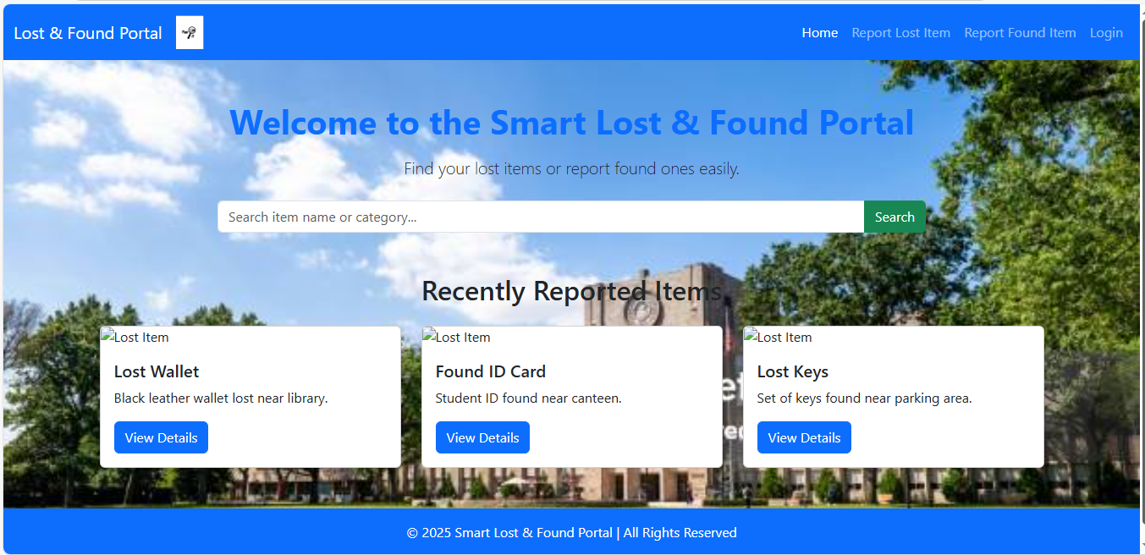
Figure 8: Home page

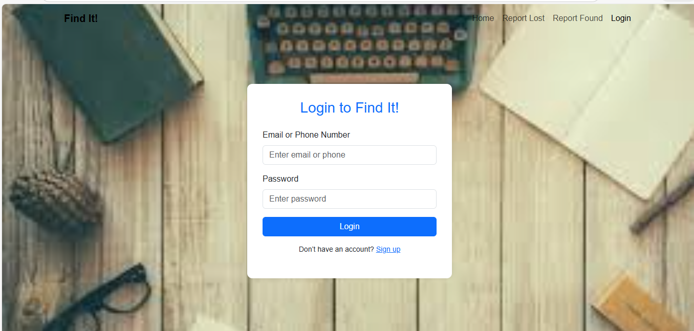
Figure 9: Login page

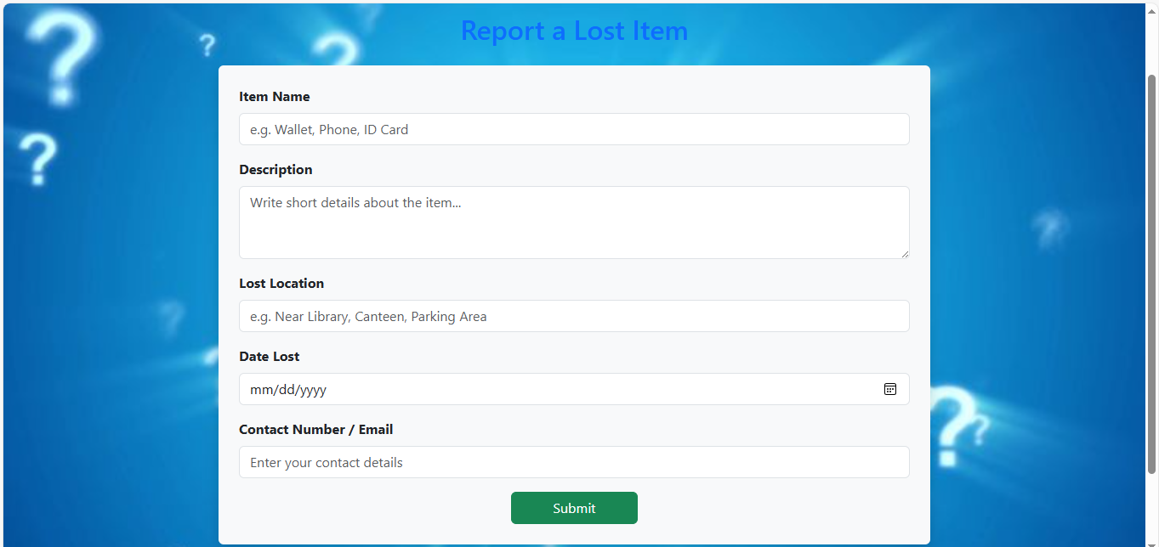
Figure 10: Report lost items page

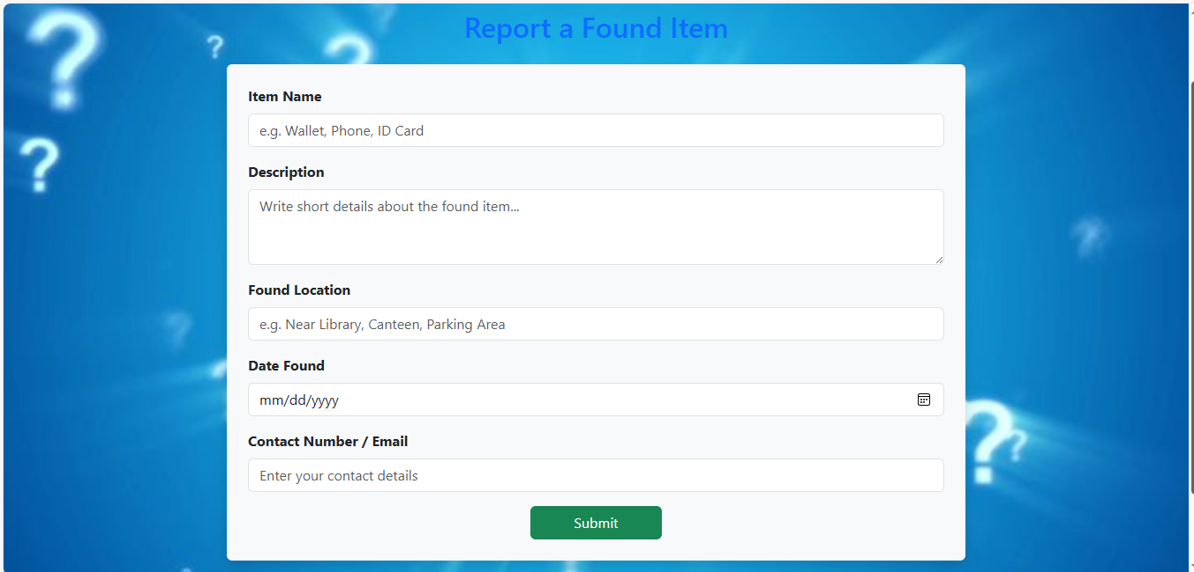

Figure 11: Report found items page

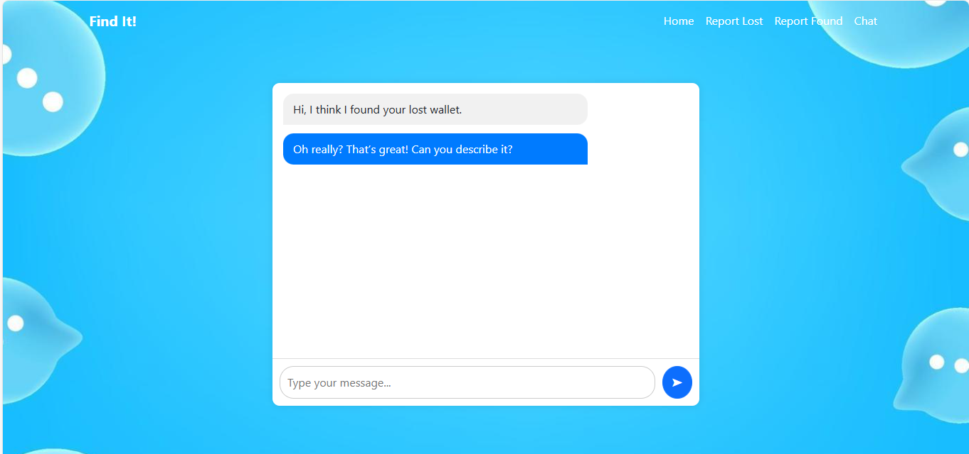
Figure 12: Internal chat page

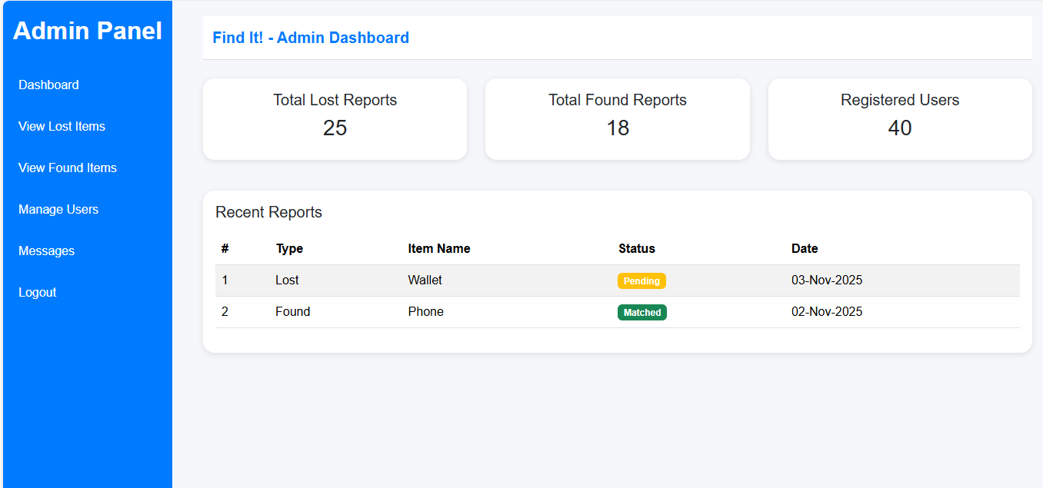

Figure 13: Admin dashboard page

4.7. Behavioural Model
Sequence Diagram
A sequence diagram shows how components work with one another and in what order. The following sequence diagram for the Find It shows interactions involving users and Admins as they perform various actions like logging into the system and reporting items. The diagram shows how these actors interact with the Find It and the database to complete tasks, highlighting the sequence of operations from start to completion. This visualization helps understand the flow and dependencies of the application’s processes.



Figure 14: Sequence diagram

4.8. Design Decision
While building the Find It we made some important choices to keep the system easy to use, manage, and expand. The major design decision and the reason are:

Architecture Pattern: We followed the Model-View-Controller (MVC) architectural pattern in our system. This design was chosen because it separates the logic (Model), presentation (View), and control flow (Controller), making the system modular, maintainable, and easier to update or expand.

Programming Approach: We used an Object-Oriented Design (OOD) approach. It organizes data and functionality into classes.This makes the system easy to understand and maintain Entities like User, Items, and Admins are represented as classes.

Database Design: We chose MySQL for our database because it is reliable and performs effectively. It keeps our data organized and consistent, which was important for our project. It is fast and easily meets our requirements, making it the perfect choice for our project.

4.9 Summary
This chapter explains how the Find It is designed. The system follows the MVC architecture, keeping the logic, design, and data separate for better organization. It uses object-oriented principles to make the structure simple and reusable. Login security is ensured with password. The user interface is created using HTML, CSS, and Bootstrap for a clean and responsive look. The system helps to find lost items easily and automates the manual systems saving time and effort. The design focuses on making the system easy to use, secure, and scalable to meet its goals.

References
- Books
- https://engineering.futureuniversity.com/BOOKS%20FOR%20IT/Software-Engineering-9th-Edition-by-Ian-Sommerville.pdf

- https://dn790001.ca.archive.org/0/items/bme-vik-konyvek/Software%20Engineering%20-%20Ian%20Sommerville.pdf

- World Wide Web
[1] https://lostandfoundcampusapp

[3] https://apps.apple.com/us/app/tile-find-lost-keys-phone/id664939913

