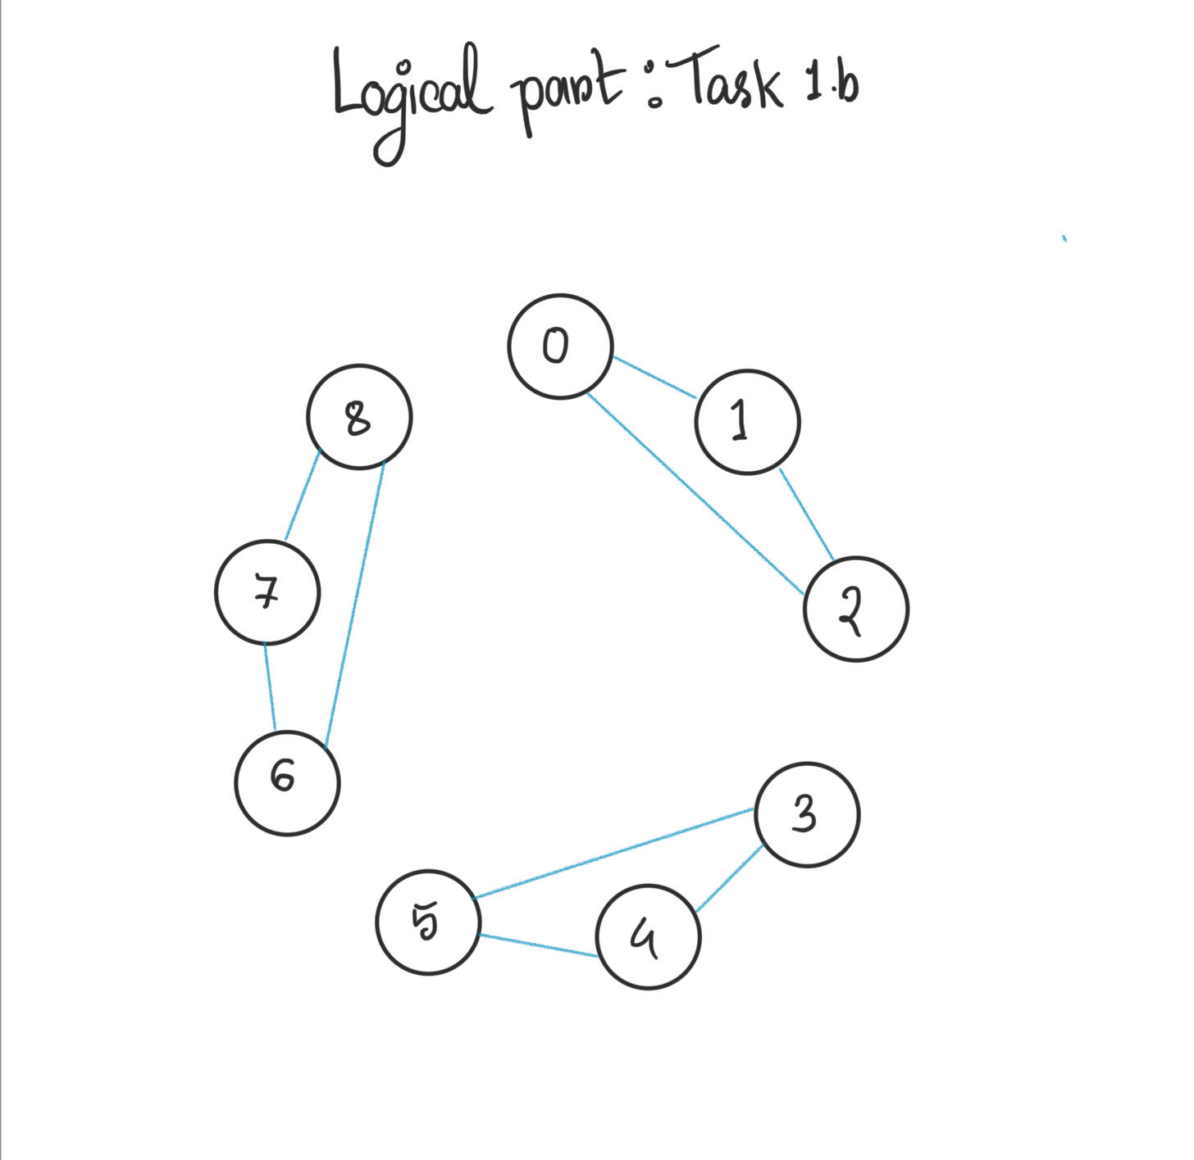

**Microcontroller Part**

**Task 1:**

Tinkercad link: <https://www.tinkercad.com/things/2IaUWSEYpZU-exquisite-uusam/editel?sharecode=FCO3kH3Q7FwdN-mc60ousqjF7I0Dt0VJeqwxiTw7i0Q>

**Task description:**

Using two Arduino Uno, I used I2C to communicate between the boards. I used Wire.h library for this. During transmission the strings are converted into bytes.

The master firsts sends data to the slave “Hi from Master” which is printed on the serial monitor on the slave Arduino. Then master sends a request to slave to send “Successful”. Master receives the message and prints it on the serial monitor.

The slave Arduino first receives “Hi from Master” without any request. The data is printed on the serial monitor after being received by slave. Then the master requests data from slave and slave sends the message “Successful” through .

**Problems I faced during the task:**

1. As this was my first time using Arduino, I had to first learn the basic setups
2. During running simulation, Tinkercad was showing “Invalid Header file” error even though all the header files were valid. This was due to an error in function parameters which took me one hour to resolve.
3. Transmitted datatype was byte so I had to convert my message into bytes and after receiving reconvert them into a string to print on the serial monitor.

**Task 2:**

Tinkercad link: <https://www.tinkercad.com/things/4fTwfquDbkJ-terrific-leelo/editel?sharecode=WvOHSF1bZYaM96U6i7WozbBMbwyzf-4_l9K3_T-KQLs>

**Task description:**

Using an Arduino Uno and a DC motor with encoder I controlled the motor with the Arduino and printed the speed in rpm in the serial monitor. To calculate speed in rpm I took the position of the motor every 1 second and the time elapsed in simulation using millis() function. Then I printed the result in the serial monitor.

**Problems I faced during the task:**

1. I wanted to calculate the instantaneous speed in rpm however an error occurred which I couldn’t debug , printing unrealistic values. So I printed the average speed in rpm as the simulation ran
2. The rpm is shown in integer format even though the calculations are done in float format. This was done to simplify the look. But there is a slight error/deviation from the original value which can be ignored.