From Silent Underachiever to High-Performer in 28 days

1-MINUTE QUIZ
Start by selecting your gender
Female
Male
By pressing “Female” or “Male” button you confirm you agree to our Terms & Conditions, Privacy Policy, Subscription Terms and Сookie Policy (e.g. Meta Pixel)

What’s your age?
It will help us get the correct summary based on your age group
18-35
36-45
46-55
56-64
65+

2,5 million+ people
have chosen Wisey
UN QUESTIONNAIRE WISEY à l’air de ca :
Ici comme tu peux le voir il y a 32 questions et le courriel et numéro de téléphone, optionnel, est demandé à la fin. 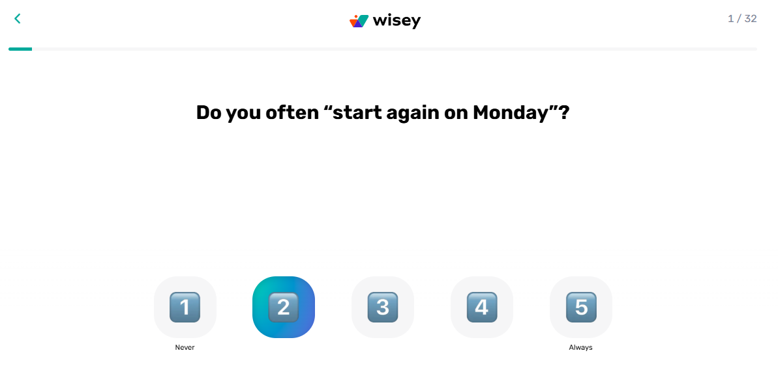

Continue
Do you often “start again on Monday”?

Do you get excited about new things, but lose interest quickly?
Absolutely not
Yes, very often
Do small problems sometimes feel too big?
Never
Always
When you feel stuck, do you often turn to YouTube/Netflix/games?
Always
Almost every day
Few times a week
Rarely
Never

Do you feel tired even when you didn’t do much?
Not really
Yes, often

Do you ever finish a day thinking, “I could’ve done more”?
Always
Every day
Few times a week
Rarely
Never

Most people never notice these patterns — the fact that you do already puts you ahead!
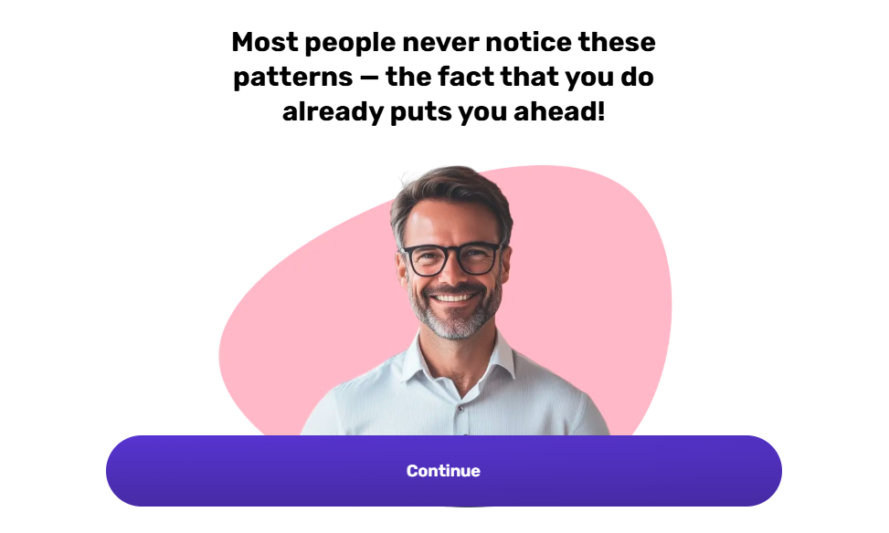
Continue
Do you think “tomorrow will be better,” but not much actually changes?
Never
Always
Do you feel you’re not using your full potential?
Not really
Absolutely Yes
Do you ever feel like others move ahead faster than you?
Never
Always
Do you break small promises to yourself?
Never
Always
Do you stay “busy” with small things instead of real ones?
Absolutely not
Yes, often
Do you collect tools or ideas but still don’t start?
Never
Always
Many high-ability people struggle with the same patterns — you’re not alone in this!
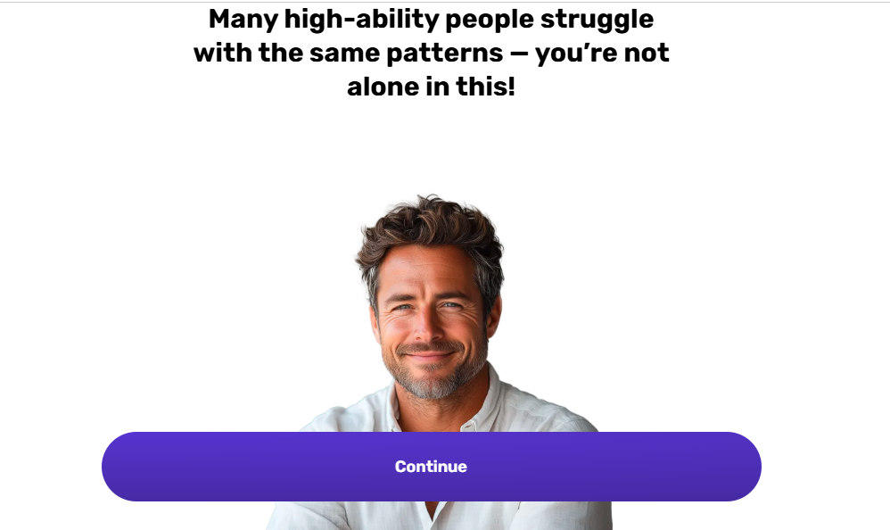
Continue

Do you agree with the following statement?
"I stay up late even though I want an easier morning"
No
Yes

Do you agree with the following statement?
“I overthink conversations or actions for a long time”
No
Yes
Do past mistakes stay in your mind for too long?
Never
Always
Do simple tasks sometimes feel harder than they should?
Absolutely not
Yes, much harder
Do detailed plans make you feel productive even if you don’t act?
Never
Always
Recognizing these deeper patterns takes honesty — and you just did that!

Continue
Do you scroll or watch something just to escape for a moment?
Never
Always

Do you agree with the following statement?
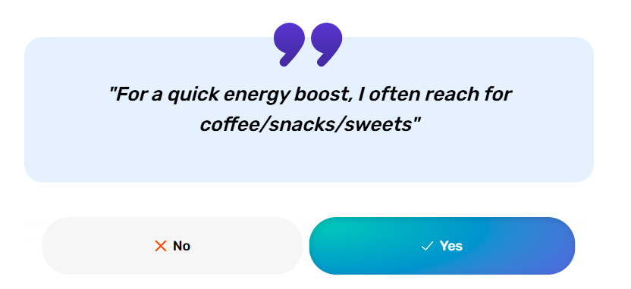
"For a quick energy boost, I often reach for coffee/snacks/sweets"
No
Yes
Is it hard for you to stick to a routine?
Not really
Yes, it's very hard

No more feelings of guilt of being labelled "lazy"
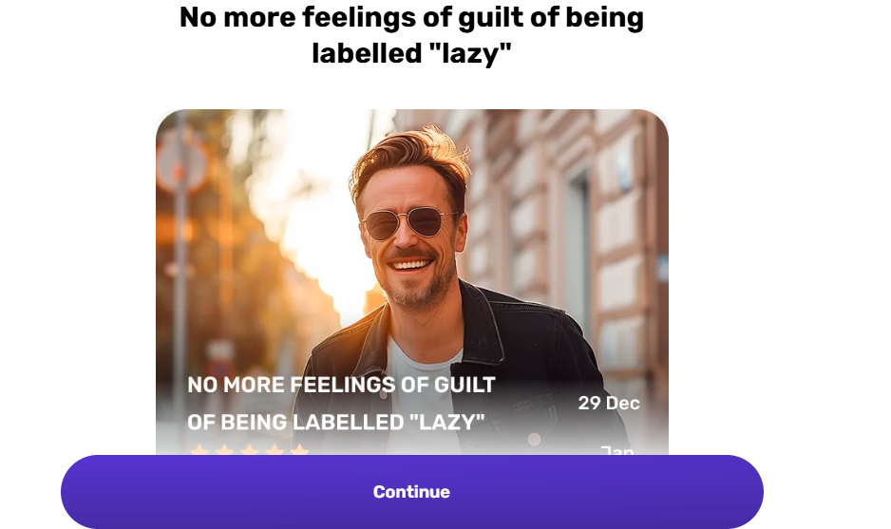
At school my teachers reported that i get distracted very easily. At last I can understand my brain without feeling guilty or being accused of being lazy. Taking on too many projects I now know is not good for me and is unhealthy. I can see a better lifestyle ahead. Thank you.
*Feedback in TrustPilot for 2025. Pictures are generated for privacy purposes
Continue
Are you afraid of what happens when you actually win?
Not really
Definitely yes
Do you often ignore tasks until they become urgent and stressful?
Never
Always
Do you ever feel like no matter what you do, it’s never enough?
Never
Always
How do these challenges affect your life?
Choose all that apply
Financial problems
Troubles at work
Chronic exhaustion
Spoiled relations with people
Pleasure chasing
Continue
How often do you doubt yourself?
Never
Always

I loved the direction as im taking the…
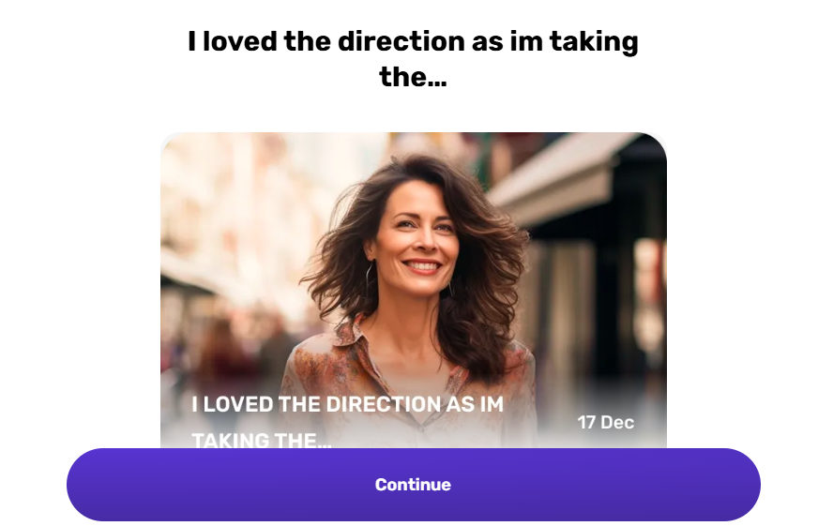
I loved the direction as I'm taking the course to remind me HOW to be successful and how to focus. The videos are short and reiterate the topic and info to encourage and not make you feel like a failure. There is a method and I just need to practice.
*Feedback in TrustPilot for 2025. Pictures are generated for privacy purposes
Continue
Do you often feel guilty for wasting time?
Never
Regularly
Which areas of your life would improve most if you became more consistent?
Choose as many as you like
High performance
Self-discipline
Productivity
Self-confidence
Relationships
Career growth
Continue

What do you want to get out of this journey?
Choose all that apply
Improve my well-being
Take control of my life
Perform better at work
Learn how to focus longer
Set achievable goals
Continue



Wisey was developed using evidence-based psychological practices
Your journey is based on decades of research
Continue
What’s the first win you want to see from yourself?
Choose as many as you like
Finish what I start
Stick to one routine
Keep my promises
Cut the scrolling
Take real action
Stop self-sabotaging
Continue

When was the last time you practiced a new skill?
This month
A few months ago
Last year
Not sure, but it’s been a while
Can’t even remember

How familiar are you with Cognitive Behavioral Therapy (CBT)?
Nothing at all
Not that much
A lot

Were you recommended Wisey by a therapist?
Yes
No

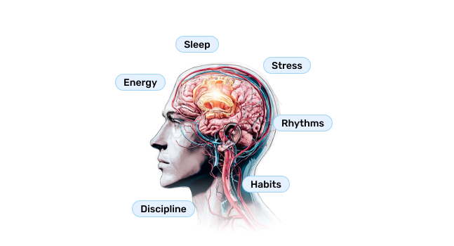

Your High-Potential Activation Plan will be crafted by group of Cognitive Psychologists
Using proven CBT principles, Wisey builds personalized strategies to help you strengthen focus, motivation, discipline and overall well-being.

Your Productivity profile

Productivity level
LOW
5075100DisciplineFocusBehaviorRoutinesHabitsSelf-regulation
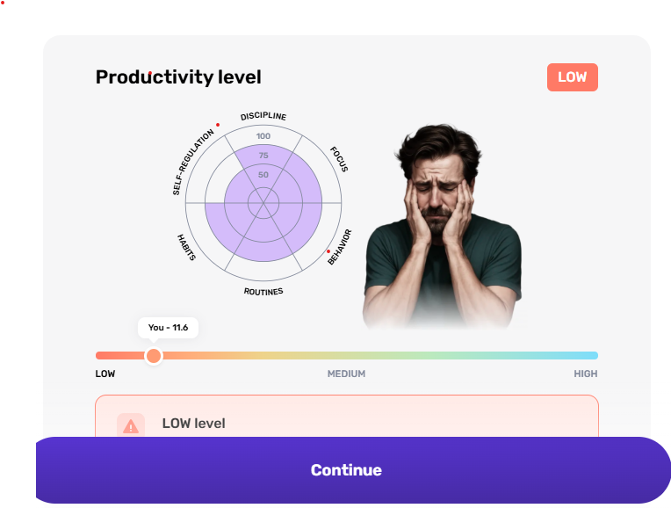
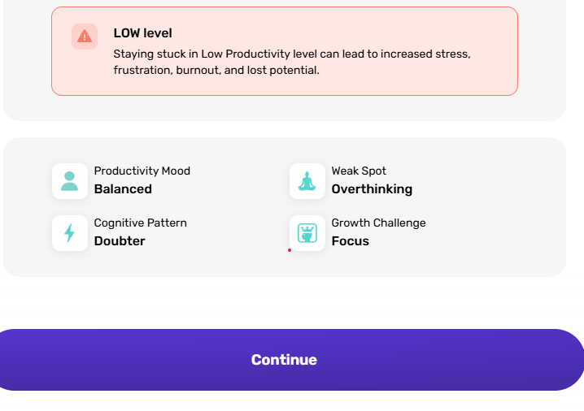
You - 11.6
LowMediumHigh

LOW level
Staying stuck in Low Productivity level can lead to increased stress, frustration, burnout, and lost potential.

Productivity Mood

Balanced

Weak Spot

Overthinking

Cognitive Pattern

Doubter

Growth Challenge

Focus
Continue

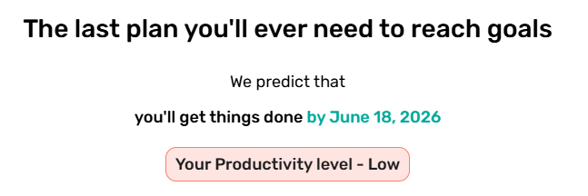
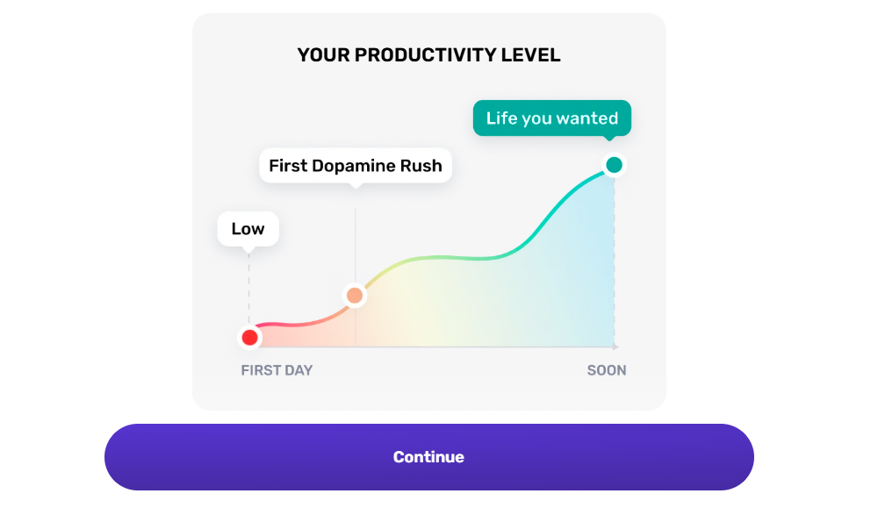

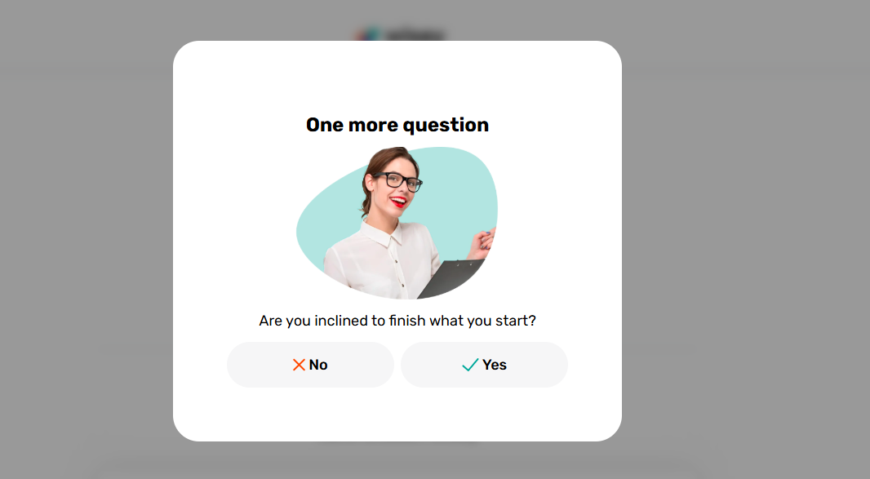

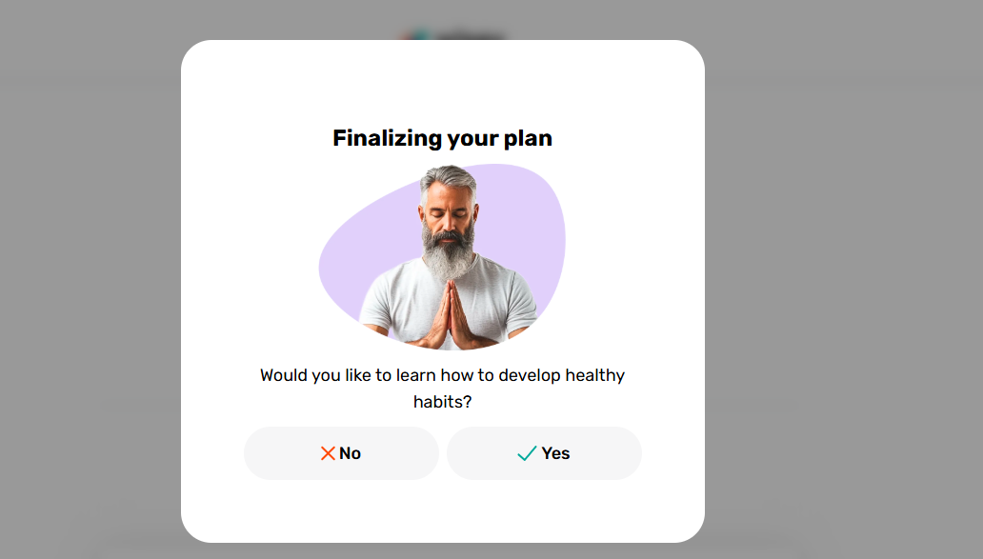

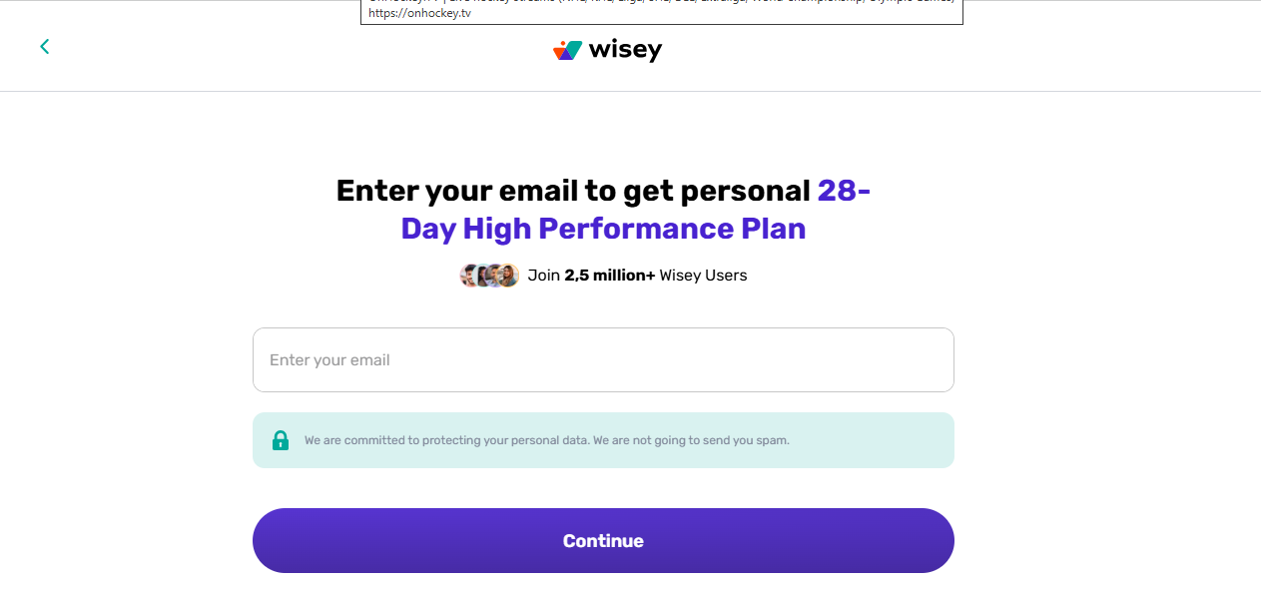

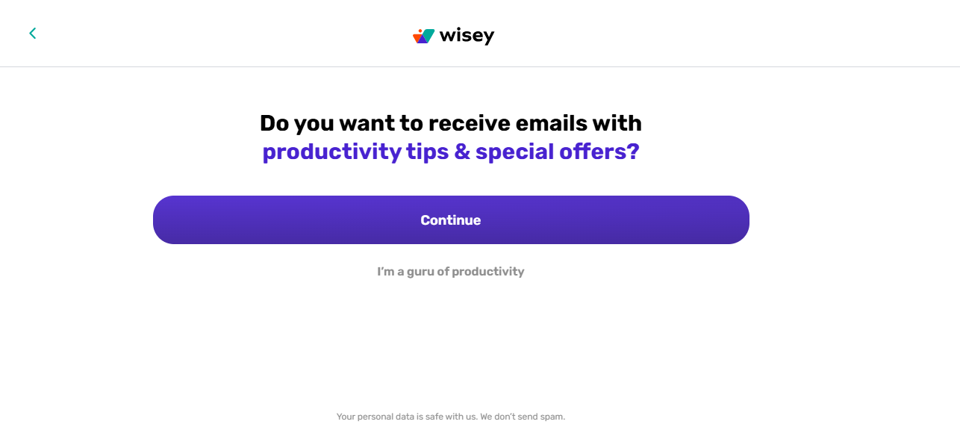

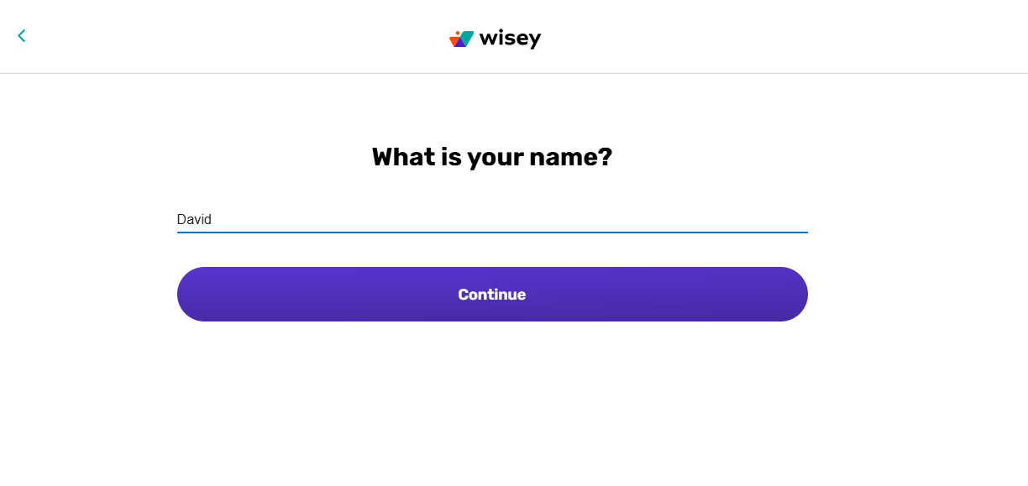
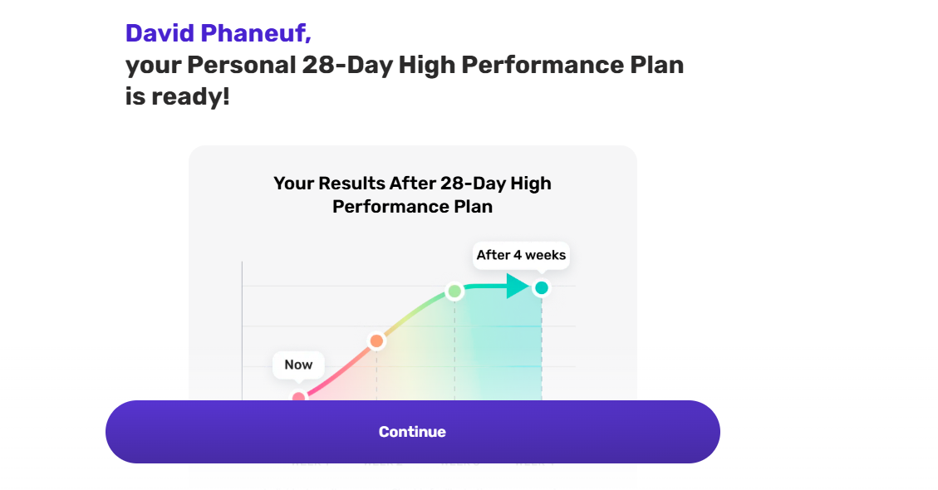
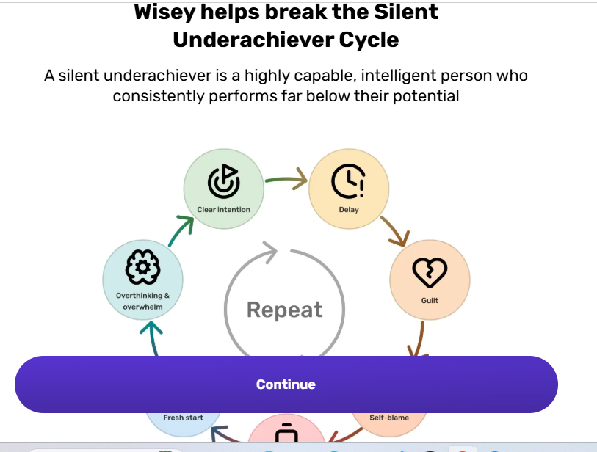

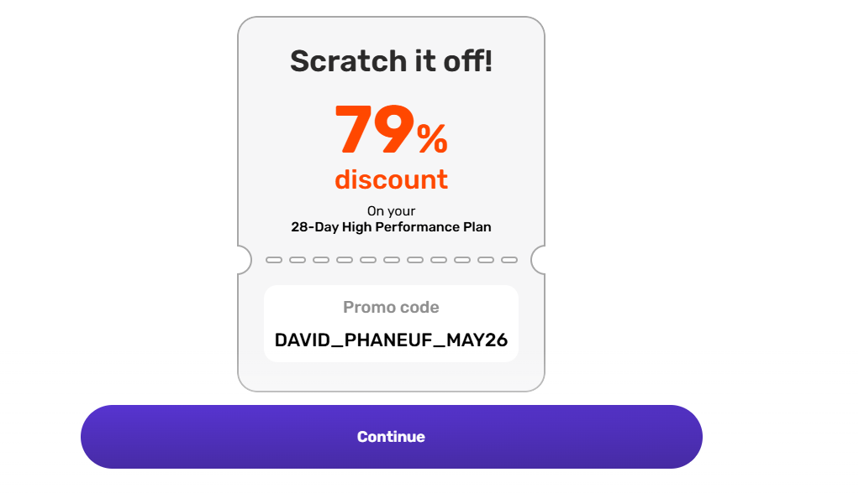

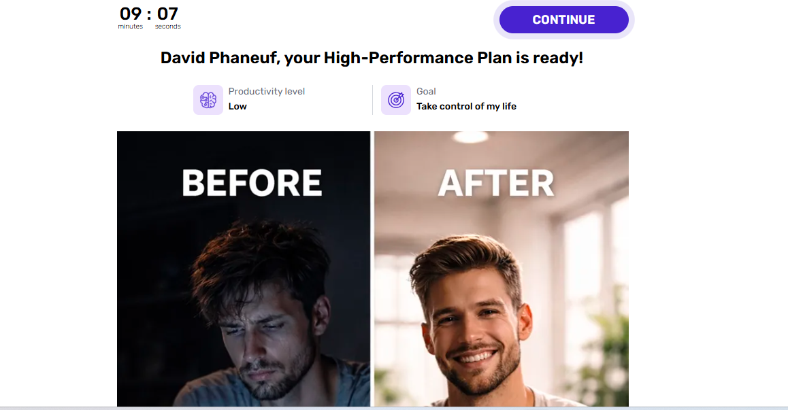
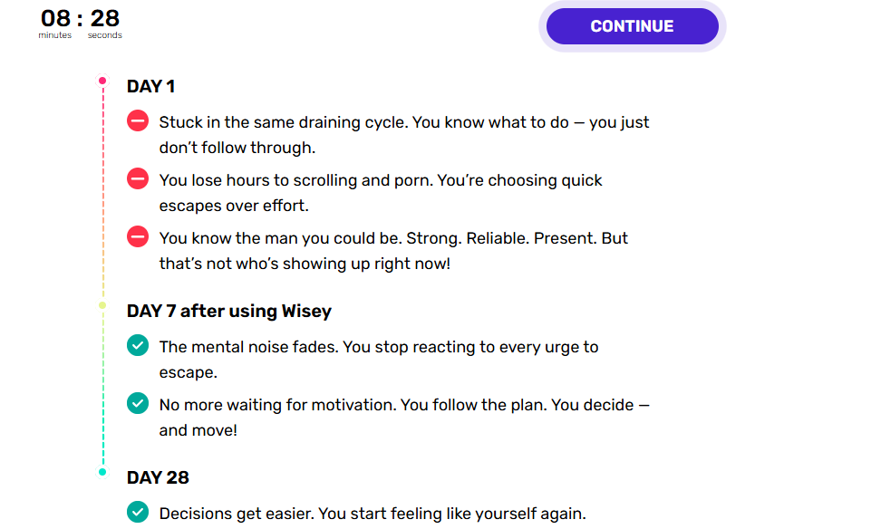
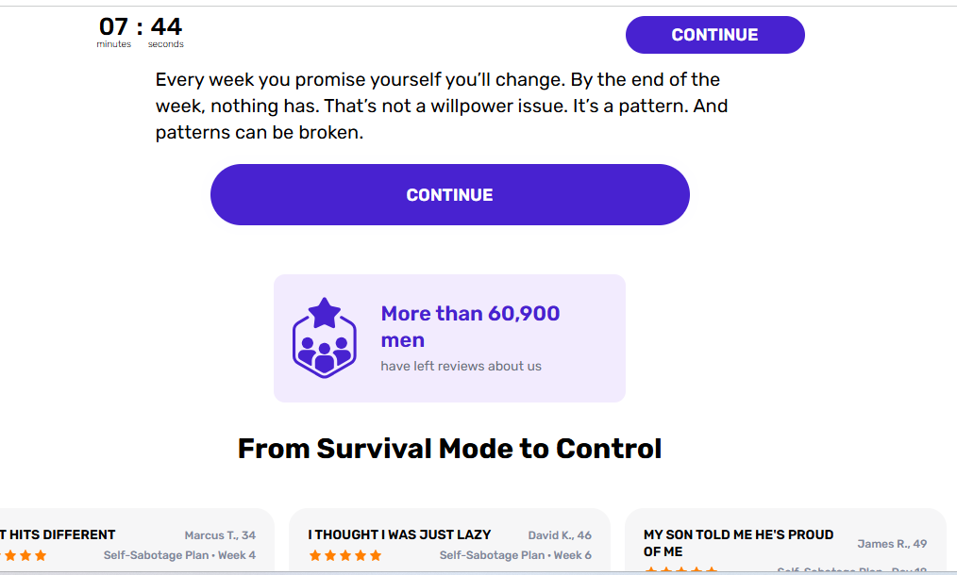

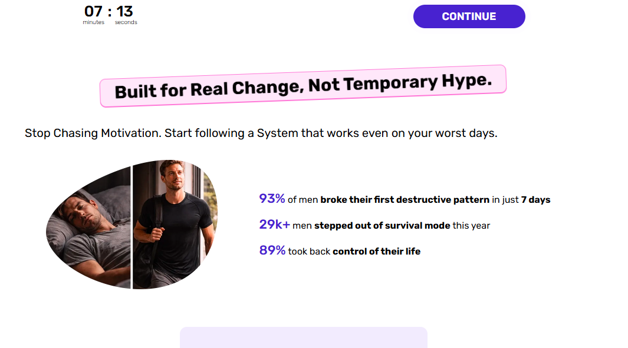
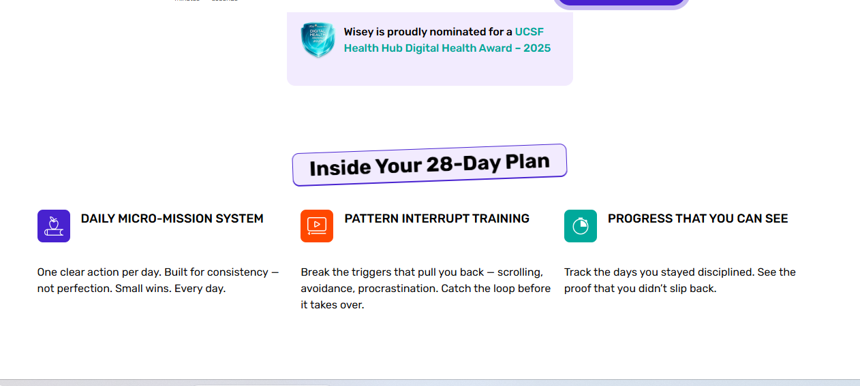
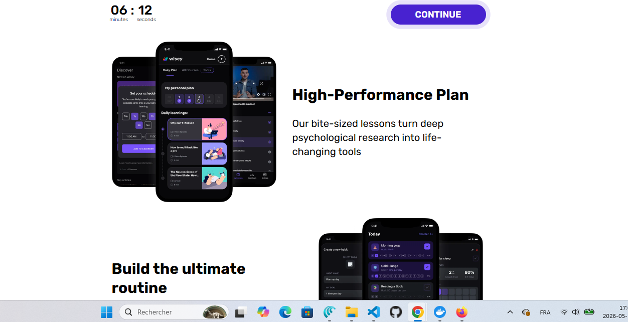

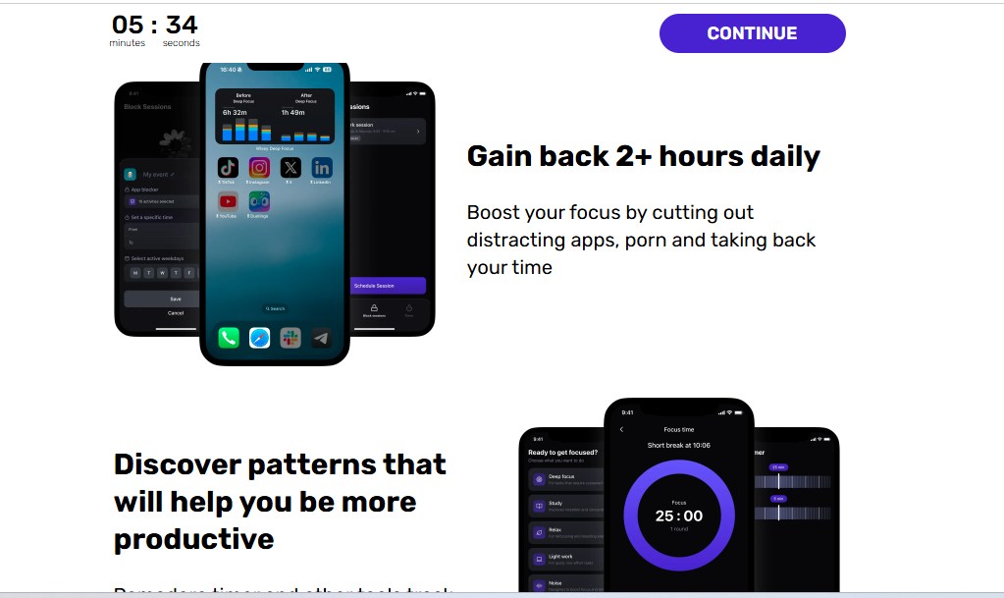

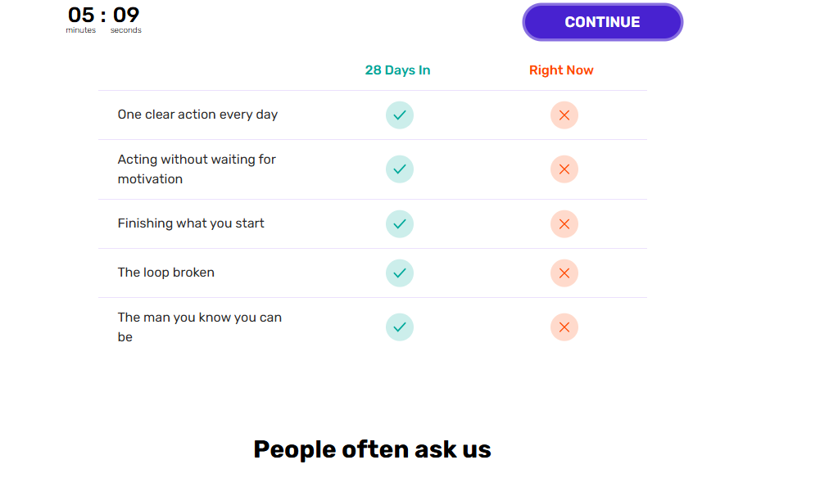
Et blablabla.

Le concept est bon, y’a beaucoup de blabla et c’est fastidieux de finaliser les 32 questions. Tu peux adapter ce format à nos idées. Proposes moi quelque chose de concret.

