JDBCluster

Inhaltsverzeichnis
1 Introduction 3
1 Components 3
1.1 Cluster 4
1.1 Domain Handling 6
1.1.1 get Set of valid domains 6
1.1.2 Checking Domains 7
1.2 Dao 9
1.3 CCFilter 10
1.4 ClusterType 11
1.5 ClusterContainer 12
1.6 Database Templates 12
1.7 Notification 12
1.7.1 NotificationServer 12
1.8 Configuration 12
2 Example 14

What is it good for

Meta Persistence
Hibernate simplifies as a O/R Mapper the creation of a persistence layer. But for existing database models the mapper layer often reflects the database model or access optimizations are needed.
In this cases its a good idea to create a meta persistence layer on top of the O/R Mapper layer, which is more practical for the Businesslogic. We call this meta persistence Cluster. Every instance of a Cluster has a link to one or more Dao Objects (f. e. Hibernate classes). The usage of these Clusters is completely transparent.
Figure 1: Meta Persistence
DB
HIBERNATE
Existing model
optimized access
Anwendung
Business
GUI Workflows
User
Business Logic
Meta
Persistence

On Rich Client Applications or on Web Technologies like Ajax the database objects have to be stored as a resultset of a database query. If they are displayed to the user the application has to keep track of any changes in the database. We call this a Notification. The ClusterContainer, which holds Cluster objects, automatically updates his contents if someone updates the objects (f. e. a third party software) in the database he contains. It uses the NotificationServer running on the database server.

The ClusterContainer holds the Cluster objects (our resultset) defined by a CCFilter. Own classes can be defined to support query parameter binding.

Components

- Cluster
The Meta Persistence
- CCFilter
Definitions of Result Sets with configurable binding classes
- ClusterType
describes the available Cluster classes
- ClusterContainer
holds the Result Set of Cluster and keeps track of Notifications
- Database Templates
Abstraction layer for the used persistence layer (currently available HIBERNATE)
- Notification Server
send notification messages to the existing ClusterContainer.

Cluster
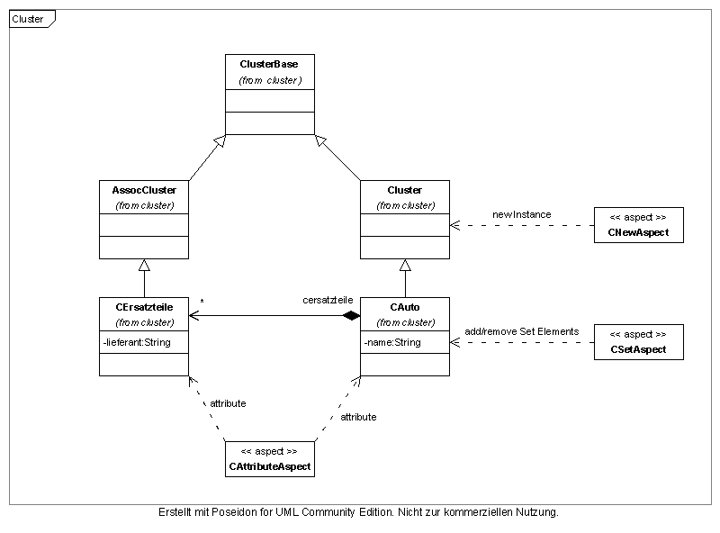Figure 2: Cluster
Cluster is the Baseclass of all available Cluster objects. Figure 2 Shows these classes and the example cluster CAuto and the 1 to n relation to CErsatzteile.
The Cluster classes are defined in the configuration file clustertype.xml.

Listing 1: ClusterType config XML
<clustertype>
<cluster id="auto" class="mycluster.CAuto">
</cluster>
<cluster id="fahrrad" class="mycluster.CFahrrad">
</cluster>
</clustertype>
The attribute “auto” is the ID you are using within your code to create new CAuto instances. F. e.
ClusterType cAutoType = ClusterTypeFactory.newInstance("auto");
CAuto bmw = ClusterFactory.newInstance(cAutoType);
The attribute class is the description where to find the Cluster class definition.
The transformation of operations on Cluster objects to operations on Dao objects is realized through Aspects shown also in Figure 2.
Clusters don't have default attributes like Daos because the normal way would be to set them through Spring.

Domain Handling
Cluster have properties or attributes. Some of these are of type String and these string-properties have a valid set of values, f.e. "RED", "GREEN" etc (in contrast to enums, these values should configurable.) . Some string properties are depending on other string properties.

get Set of valid domains
To provide the whole set of valid properties the interface DomainList has to be implemented. It has only one method to implement:
ValidDomainEntries<String> getDomainEntryList(String domainId);
This method has to return all valid property value. F. e:

Listing 2: Implementation example of DomainList interface
public class ColorTypeDomainList implements DomainList {

static ValidDomainEntries<String> vde =
new ValidDomainEntries<String>("Color", "BlackWhite", "None", "All");

public ValidDomainEntries<String> getDomainEntryList(String domainId) {
if (domainId.equals("ColorTypeDomain"))
return vde;
...
}
}
to configure this a entry in jdbcluster.conf.xml is needed:
Listing 3: configuration of domains
...
<domaindependancy>
<!-- define all "not" masterdomains -->
<domain domainid="ColorShadingDomain" domainlistclass="mycluster.domain.ColorShadingDomainList"/>
<!-- define master domain "ColorTypeDomain"-->
<domain domainid="ColorTypeDomain" domainlistclass="mycluster.domain.ColorTypeDomainList">
...
As shown in Listing 3 two domains are mapped to its DomainList interfaces.

Class DomainChecker provides some method to get the actual valid set of domain values. It pays attention to the property dependancies.

If a setter method should not be callable directly (its dependant from other attributes, so its better to provide a setter for the master and the slave domain), the annotation @DomainSetterReplaced is provided. If some uses the annotated setter a compiletime error is generated.

Checking Domains

Figure 3: Domain Dependancy Figure
ColorType
Color
ColorShading

ColorType | Color | ColorShading
Color | RED
Color | GREEN
Color | BLUE
BackWhite | BLACK
BackWhite | WHITE
BackWhite | GREY50%
None | -
All | ...all... incl. null

JDBCluster provides a check mechanism.
F. e. a property
String colorType;
can have a set of values like
Color, BlackWhite, None etc.
and a second property
String color;
depends on the values of colorType and has valid values for "Color"
RED, GREE, BLUE
and for "BlackWhite"
BLACK, WHITE, GREY50

These dependancies are defined through Annotations in instances of Cluster, like:

Listing 4: Domain Annotations
@DaoLink(dAOClass = Fahrrad.class)
public class CFahrrad extends Cluster {

@Domain(domainId="ColorTypeDomain")
String colorType;

@DomainDependancy(domainId="ColorDomain", dependsFromProperty="colorType")
String color;

@DomainDependancy(domainId="ColorShadingDomain", dependsFromProperty="color")
String colorShading;
...
Annotation @Domain is for Domains which have no properties they depend on.
Property color has the domain id ColorDomain (which is defined in the jdbcluster.conf.xml) and depends on the value of property colorType. If you call setColor(...) your value will be checked against its validation rules
Propery colorShading depends on property color, this is the second dependancy.
The configuration of the validation rules is done in the configuration file:
Listing 5: validation rules
<domaindependancy>
<!-- define master domain "ColorTypeDomain"-->
<domain domainid="ColorTypeDomain">
<!-- define entries for slave domain "ColorDomain" -->
<entry value="Color" slavedomainid="ColorDomain">
<valid value="RED"/>
<valid value="GREEN"/>
<valid value="BLUE"/>
</entry>
<entry value="BlackWhite" slavedomainid="ColorDomain">
<valid value="BLACK"/>
<valid value="WHITE"/>
<valid value="GREY50%"/>
</entry>
<entry value="None" slavedomainid="ColorDomain">
<invalid all="true"/>
</entry>
<entry value="All" slavedomainid="ColorDomain">
<valid all="true" null="true"/>
</entry>
</domain>
<!-- define master domain "ColorDomain"-->
<domain domainid="ColorDomain">
<!-- wildcard for all undefined master domain values-->
<entry value="*" slavedomainid="ColorShadingDomain"/>
<!-- except master domain value "RED" is checked -->
<entry value="RED" slavedomainid="ColorShadingDomain">
<valid value="LightRED"/>
<valid value="DarkRED"/>
</entry>
</domain>
</domaindependancy>
...

the following rules are defined:
- ColorTypeDomain defines 4 values (Color, BlackWhite, None and All). Other values for this "Master" domain are allowed, but will result in invalid values for "Slave" domain ColorDomain in any case (you can change that through a wildcard, see "Slave" domain ColorShadingDomain).
- Valid values for ColorDomain are
  - in case of master value Color: RED, GREEN, BLUE
  - in case of master value BlackWhite: BLACK, WHITE, GREY50
  - in case of master value None: All values are invalid except null value
  - in case of master valueAll: all values are valid including null value
- ColorDomain defines a wildcard ("*" value) for "Slave" domain ColorShadingDomain
- Valid values for ColorShadingDomain are
  - in case of master value RED: LightRED, DarkRED
  - in case of all other master values: all values are valid

Dao
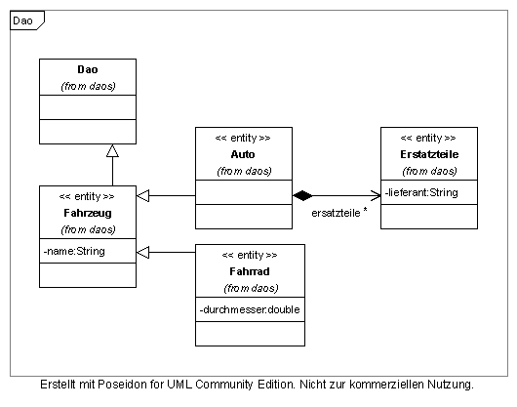Figure 4: Dao
The DAOs (in this case Hibernate POJOS or POPOS) used through the Aspects have to be organized like shown in Figure 4.
Dao can have predefined values set in the configuration file.

Listing 6: predefined propertie values as part of jdbcluster.conf.xml
<daotype>
<dao id="Auto" class="dao.Auto">
<property name="longitude">
<value>1.234</value>
</property>
<property name="latitude">
<value>5.678</value>
</property>
<property name="name">
<value>MyDefaultAutoName</value>
</property>
</dao>
</daotype>

CCFilter
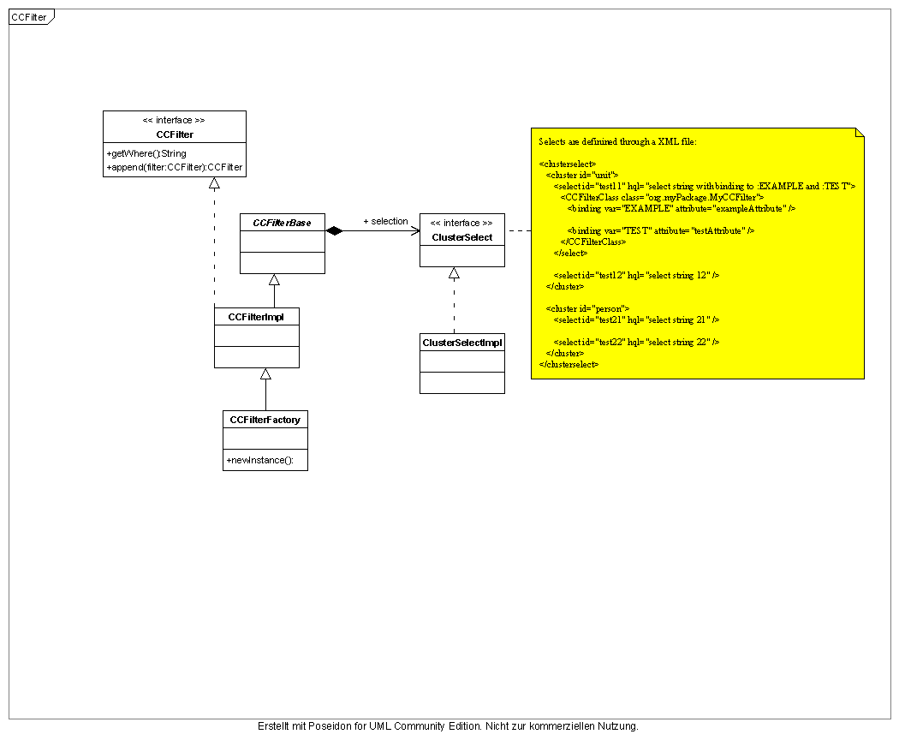Figure 5: CCFilter

CCFilter as shown in Figure 5 are used to define result sets of a query. The Filers can be configured through Listing 7.
Listing 7: select definition as part of jdbcluster.conf.xml
cluster id="auto" class="mycluster.CAuto">

<!--special filter "name" for cluster CAuto is available-->
<!--select: ...where NAME=test.testfilter.NameFilter.getName()-->
<select id="name" hql="NAME=:UNITNAME">
<FilterClass class="test.testfilter.NameFilter">
<binding var="UNITNAME" attribute="name"/>
</FilterClass>
</select>
<!--select for coordinates-->
<select id="position" hql="LATITUDE=:LAT and LONGITUDE=:LONG">
<FilterClass class="test.testfilter.PositionFilter">
<binding var="LONG" attribute="longitude"/>
<binding var="LAT" attribute="latitude"/>
</FilterClass>
</select>
<!--select only for LATITUDE-->
<select id="positionLatOnly" hql="LATITUDE=:LATONLY">
<FilterClass class="test.testfilter.PositionFilter">
<binding var="LATONLY" attribute="latitude"/>
</FilterClass>
</select>
</cluster>
Own classes for providing the query binding attributes can be defined through the “binding” tag. The values are taken from the objects through “get” + “attribute” value.

ClusterType
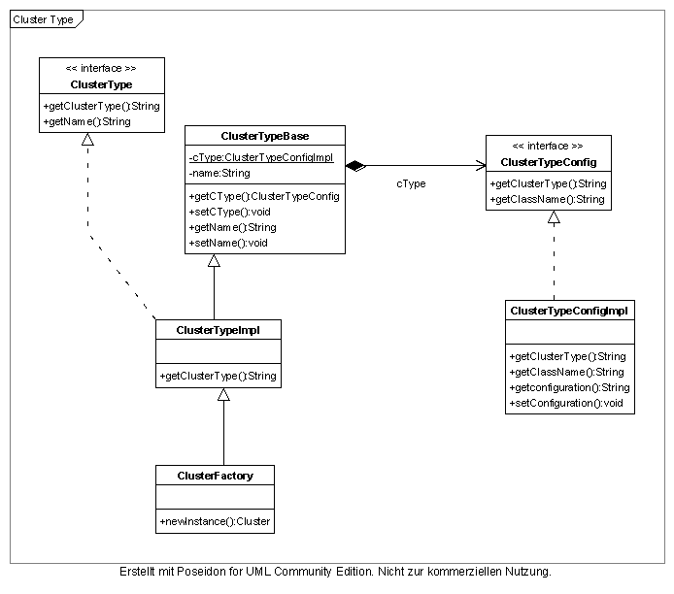Figure 6: Cluster Type

ClusterType is a dynamic „enum“ of available ClusterTypes defined in ClusterType configuration, see Listing 1.

ClusterContainer
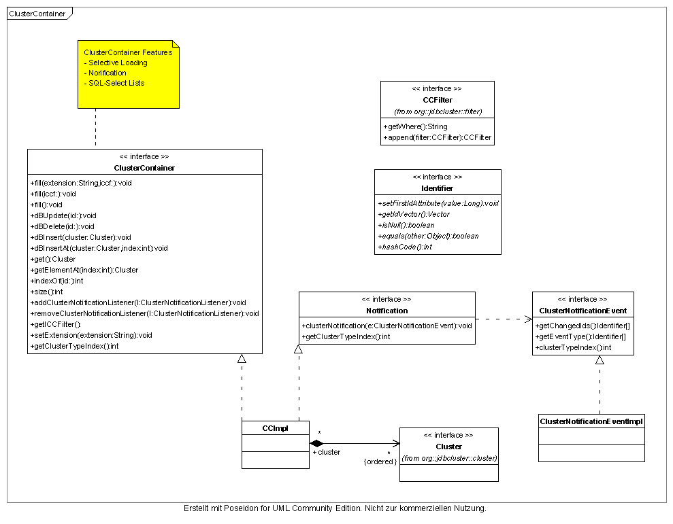Figure 7: ClusterContainer
The ClusterContainer holds the through a CCFilter defined result set of instances of type Cluster. It receives Notification messages from the running Notification Server and is forwarding them to the listening classes.

Database Templates
Datebase template are created to build a abstraction level to the used persistence layer. The templates are found in package org.jdbcluster.template.
You can configure JDBCluster to use the Hibernate implementation found in org.jdbcluster.template.hibernate.

Notification
Well known but unimplemented feature.

NotificationServer
Well known but unimplemented feature.

Configuration
JDBCluster uses several configurations.
- PropertyConfigurator.configure("xml/logging.properties");
configures Log4j
- ClusterTypeBase.setClusterTypeConfig(new ClusterTypeConfigImpl("xml/jdbcluster.conf.xml"));
Configures file which configures available Cluster classes
- CCFilterBase.setFilterConfig(new ClusterSelectImpl("xml/jdbcluster.conf.xml"));
Configures available selects, filters etc.
- ConfigurationFactory.setConfigurationClass("org.jdbcluster.template.hibernate.HibernateConfiguration");
Configures which O/R mapper implementation to use.

Class JDBClusterSimpleConfiguration can be used for simplified configuration.
So for a simple configuration only one file “jdbcluster.conf.xml” is needed and one for HIBERNATE.

Listing 8: example configuration file
<?xml version="1.0" encoding="UTF-8"?>
<jdbcluster xmlns:xsi="http://www.w3.org/2001/XMLSchema-instance"
xsi:noNamespaceSchemaLocation="jdbcluster.xsd">

<!-- Definition of available Cluster Objects-->
<clustertype>

<!--configure cluster CAuto-->
<cluster id="auto" class="mycluster.CAuto">

<!--special filter "name" for cluster CAuto is available-->
<!--select: ...where NAME=test.testfilter.NameFilter.getName()-->
<select id="name" hql="NAME=:UNITNAME">
<FilterClass class="test.testfilter.NameFilter">
<binding var="UNITNAME" attribute="name"/>
</FilterClass>
</select>
<!--select for coordinates-->
<select id="position" hql="LATITUDE=:LAT and LONGITUDE=:LONG">
<FilterClass class="test.testfilter.PositionFilter">
<binding var="LONG" attribute="longitude"/>
<binding var="LAT" attribute="latitude"/>
</FilterClass>
</select>
<!--select only for LATITUDE-->
<select id="positionLatOnly" hql="LATITUDE=:LATONLY">
<FilterClass class="test.testfilter.PositionFilter">
<binding var="LATONLY" attribute="latitude"/>
</FilterClass>
</select>
</cluster>

<!--configure cluster CFahrrad-->
<cluster id="fahrrad" class="mycluster.CFahrrad"/>

</clustertype>

<!--confure available dao classes-->
<daotype>

<!--configure dao class Auto-->
<dao id="Auto" class="dao.Auto">

<!--sets parameter longitude to 1.234-->
<property name="longitude">
<value>1.234</value>
</property>
<!--sets parameter latitude to 5.678-->
<property name="latitude">
<value>5.678</value>
</property>
<!--sets parameter name to MyDefaultAutoName-->
<property name="name">
<value>MyDefaultAutoName</value>
</property>
</dao>

</daotype>

</jdbcluster>

Example

Listing 9: Example Testcase
public class TestClusterAndDB extends TestCase {

SessionTemplate session;

@Override
protected void setUp() throws Exception {
// configuring logging
PropertyConfigurator.configure("xml/logging.properties");

JDBClusterSimpleConfig.setConfiguration("xml/jdbcluster.conf.xml");
JDBClusterSimpleConfig.setHibernateConfiguration(null, "mapping/hibernate.cfg.xml");

////////using HIBERNATE means
//get a Configuration instance
ConfigurationTemplate cf = ConfigurationFactory.getInstance();
//get a factory for sessions
SessionFactoryTemplate sf = cf.buildSessionFactory();
//and open one
session = sf.openSession();
super.setUp();
}

@Override
protected void tearDown() throws Exception {
session.close();
super.tearDown();
}

public void testCluster() {

//get a transaction
TransactionTemplate tx = session.beginTransaction();

//we use cluster auto now
ClusterType cAutoType = ClusterTypeFactory.newInstance("auto");

//create a Cluster and persist it
CAuto bmw = ClusterFactory.newInstance(cAutoType);
assertEquals("MyDefaultAutoName", bmw.getName());

bmw.setName("BMW");
session.save(bmw);
tx.commit();

//we want get our BMW back from DB
NameFilter nameFilter = CCFilterFactory.newInstance(cAutoType, "name");
nameFilter.setName("BMW");
QueryTemplate nameFilterQuery = session.createQuery(nameFilter);

List<CAuto> list = nameFilterQuery.list();
CAuto myQueriedAuto = list.get(0);
assertEquals("BMW", myQueriedAuto.getName());
}
}

